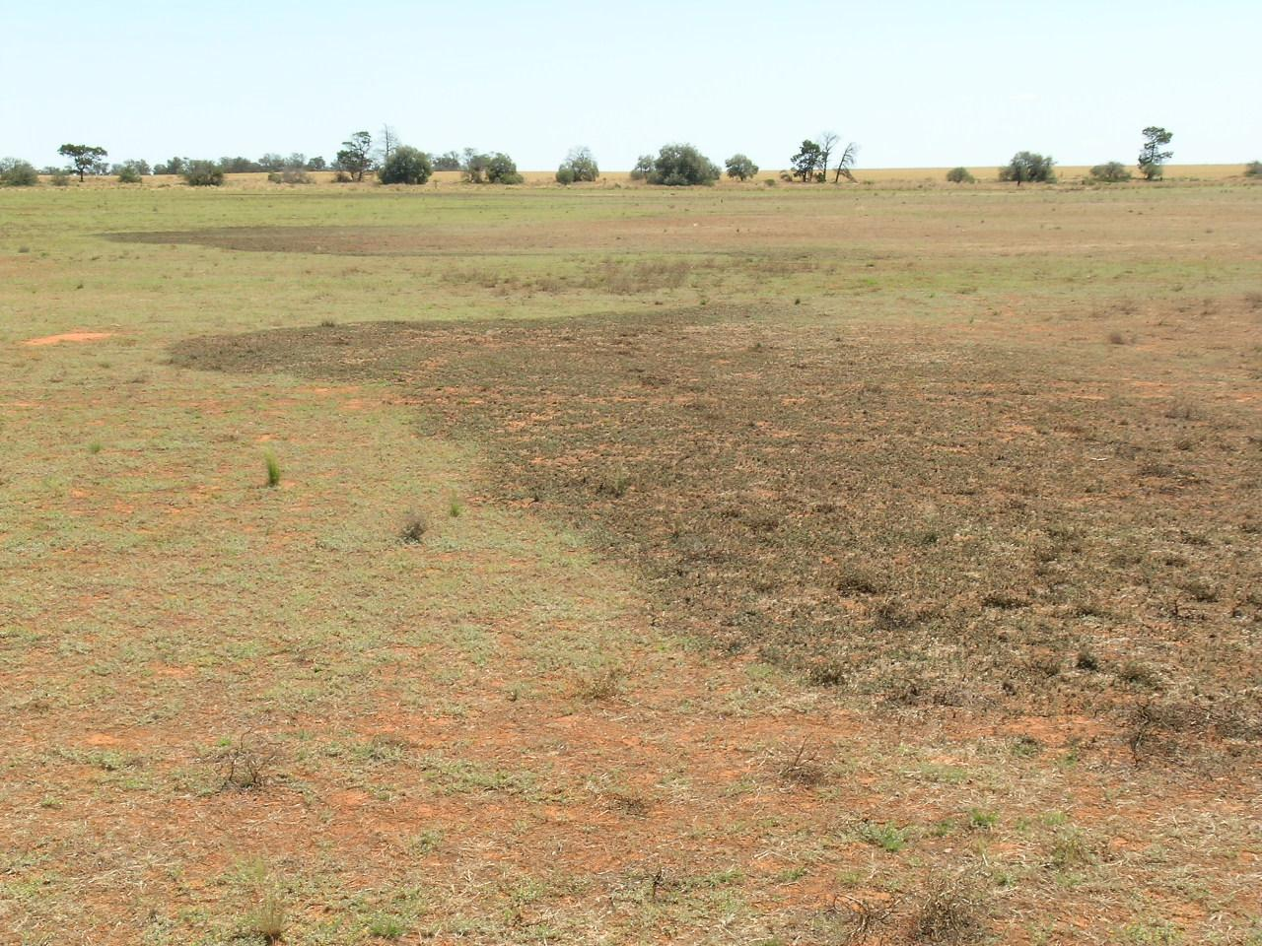

AUSTRALIAN PLAGUE

LOCUST COMMISSION

ANNUAL

REPORT

2009-10

**J:\APLC\APLC-Common\Logos\black\APLC_Logo.tif**

A joint venture of the Australian Government and the Member States of New South Wales, Victoria, South Australia and Queensland.

Contents

[Introduction 1](#_Toc263163105)

[APLC Charter 1](#_Toc263163106)

[Commissioners 2](#_Toc263163107)

[Review of 2009-2010 3](#_Toc263163109)

2009-10 [Locust situation 4](#_Toc263163110)

[Australian plague locust 4](#_Toc263163111)

[Spur-throated locust 14](#_Toc263163112)

[Migratory locust 15](#_Toc263163113)

[Operations 17](#_Toc263163114)

[Forecasting, information and survey 17](#_Toc263163115)

[Pesticide evaluation and application management 19](#_Toc263163116)

[Control operations and pesticide use 19](#_Toc263163117)

Locust Control Agents Stocks 22

[Environmental Management System 23](#_Toc263163118)

[Occupational Health & Safety 23](#_Toc263163119)

[Competency based training and assessment 24](#_Toc263163120)

[International linkages 24](#_Toc263163121)

[Administration 25](#_Toc263163122)

Governance 25

[Staffing 25](#_Toc263163123)

[Finance 27](#_Toc263163124)

[Key Performance Indicators 28](#_Toc263163125)

[Research 31](#_Toc263163126)

Purpose and [Research Areas](#_Toc263163127) 31

[Research Review Committee](#_Toc263163127) 31

[Summaries of research in progress](#_Toc263163129) 31

[Publications](#_Toc263163130) 37

**Figures**

[Figure 1 : Australian plague locust distribution: September 2009 9](#_Toc263163132)

[Figure 2 : Australian plague locust distribution: November 2009 10](#_Toc263163133)

[Figure 3 : Australian plague locust distribution: January 2010 11](#_Toc263163134)

[Figure 4 : Australian plague locust distribution: March 2010 12](#_Toc263163135)

[Figure 5 : Australian plague locust distribution: April 2010](#_Toc263163135) 13

[Figure 6 : Spur-throated locust distribution: A 2010](#_Toc263163135) 16

[Figure 7 : Nightly displacement of *Chortoicetes terminifera* over Bourke IMR](#_Toc263163135) 18

[Figure 8 : Map of locust control operations October 2009](#_Toc263163135) 21

[Figure 9 : Map of locust control operations March 2010 2](#_Toc263163135)1

[Figure 10 : Estimates of *Nomadacris septemfasciata* killing rates by *Metarhrizium*](#_Toc263163135) 32

[Figure 11 : Estimates of *Chortoicetes terminifera* killing rates by *Metarhrizium*](#_Toc263163135) 33

**Tables**

[Table 1 : Control operations 2009-10](#_Toc209581995) 20

[Table 2 : Area treated by pesticide type 2009-10](#_Toc209581995) 20

[Table 3 : Locust control agent stocks 2009-10](#_Toc209581995) 22

[Table 4 : Staffing position during 2009-10 26](#_Toc209581996)

[Table 5 : APLC 2009-10 Performance against KPI measures 28](#_Toc209581997)

**Annexes**

Annex 1 : Environmental Management System conformance ………………………………….. 38

# 

Annex 2 : Financial performance report 2009-10 ………………………40

# Introduction

The Australian Plague Locust Commission was established in 1974 and began operations in late 1976. The Commission is financed by the States of New South Wales, Victoria, South Australia and Queensland, with a matching contribution from the Australian Government. Funding allocations from the member states are in proportion to the agreed benefit delivered to that state by APLC operations, while the Australian Government contribution reflects that national benefit derived from APLC activities. The Commission is governed by six Commissioners: one from each contributing state, one from the Department of Agriculture, Fisheries and Forestry and one from the Department of the Environment, Water, Heritage and the Arts. APLC activities are managed by a Director assisted by staff based in Canberra HQ and at three field bases in NSW and Qld, who are all Commonwealth Public Sector employees. The Commission is accountable to the Australian Government Minister for Agriculture, Fisheries and Forestry and to the relevant Minister for Primary Industries in each member state.

## APLC Charter

In August 2002, a Memorandum of Understanding (MOU) was signed between the Department of Agriculture, Fisheries and Forestry (DAFF) on behalf of the Australian Government and participating member States effectively replacing the original (1974) Exchange of Letters under which the APLC was established. The MOU also incorporated a Charter that replaced the original terms of reference under which the APLC had operated since its establishment.

The purpose of the APLC, as defined in the Charter, is “to control locust populations in those situations where they have the potential to inflict significant damage to agricultural industries in more than one member state.” In fulfilling its charter the APLC is required to:

* Implement a preventive control strategy to minimise economic loss to agricultural industries caused by the Australian plague locust, spur-throated locust and migratory locust, with priority given to Australian plague locust.
* Minimise risk of locust control to the natural environment, human health and markets for Australian produce.
* Develop improved locust management practices through a targeted research program.
* Provide a monitoring and forecasting system for operations conducted by APLC and member states.
* Promote and facilitate adoption of best practice in locust control by member states.
* Participate in cooperative national and international programs for development of APLC expertise.
* Continually review APLC operations to ensure they keep pace with the expectations of industry, community and government.

# Commissioners (as at 01 April 2010)

Dr Colin Grant (Chair)

Executive Manager

Biosecurity Plant Division

Department of Agriculture, Fisheries and Forestry - Australia

GPO Box 858 Canberra ACT 2601

Mr Greg Plummer

Director, Risk Assessment Section

Department of Environment, Water, Heritage and the Arts

GPO Box 787 Canberra ACT 2601

Mr Ross Burton

Director, Emergencies and Animal Welfare

NSW Primary Industries

Locked Bag 21 Orange NSW 2800

Mr Gordon Berg

Principal Scientist, Plant Standards

Department of Primary Industries Victoria

Private Bag 15, Ferntree Gully DC, Vic 3156

Mr John Badgery

Manager, Emergency Management

Primary Industries and Resources SA

GPO Box 1671 Adelaide SA 5001

Mr Andrew Wilke

Operations Manager

Invasive Plants & Animals

Biosecurity Queensland

Department of Employment, Economic Development and Innovation

GPO Box 46

Brisbane QLD 4001

**Director**

Mr Chris Adriaansen

Australian Plague Locust Commission

Biosecurity Plant Division

Department of Agriculture, Fisheries and Forestry - Australia

GPO Box 858 Canberra ACT 2601

# 

Review of 2009-2010

The 2009-10 locust season proved to be one of the most engaging and active faced by the Australian Plague Locust Commission for many years.

An initial spring 2009 generation arose from hatching of over-wintering egg beds, with hatching in some areas peaking several weeks ahead of normal due to higher winter temperatures and good soil moisture levels. Consequently, an area of high density nymphal bands in the Coonamble area presented a moderate target for an APLC control campaign in October 2009. Hatching across much of the remaining habitat area was quite protracted, reflecting significant temperature and soil moisture variation across and between regions. While resultant nymphal populations were moderate, none were of sufficient density or extent to warrant APLC intervention.

The summer generation continued to build on the spring generation platform, but with widespread rainfall and improving habitat conditions, the level of aggregation observed in this generation did not facilitate any APLC control activities. Intensive surveillance and mapping was the limit of activities which APLC could legitimately undertake at this time, always vigilant for any opportunity to implement our standard early intervention strategy.

The opportunity for intervention came with the emergence of the autumn generation, but again weather conditions limited the ability to implement control. While dense and extensive nymphal populations established across large parts of southern Queensland and northern NSW, heavy rainfall and subsequent flooding limited the opportunity for APLC to implement control measures due to extensive surface water and limited windows between the rainfall systems which swept across eastern Australia in February, March and April 2010. A significant control campaign was mounted in March 2010, which eventually covered over 200,000 ha of nymph-infested grazing lands and National Parks.

While the March 2010 control campaign did have a significant impact on the locust population which subsequently migrated into southern NSW, northern Victoria and eastern South Australia, this impact would have been greatly increased (and subsequent migration and infestation elsewhere significantly decreased) had the control campaign been able to commence 7-10 days before it did and extend for a week beyond its actual completion date. However, the same rainfall events which supported high levels of locust survival and outstanding habitat conditions in autumn 2010 also severely hampered the ability to implement widespread control by APLC.

The subsequent migration of the autumn generation set up infestation levels across most parts of inland NSW, northern Victoria and eastern South Australia which had not been seen for more than 20 years. Multiple egg-laying by females was common, due to the extent of green vegetation and high soil moisture. Large egg beds were identified as sources of high density hatching to occur in spring 2010, and these areas were to become the focus of extensive planning efforts across four jurisdictional agencies to prepare for the expected “eruption” of the spring 2010 generation in three states.



Chris Adriaansen

Director APLC

# 2009-10 Locust situation

## Australian plague locust

### Overview

A plague cycle of *Chortoicetes terminifera* (Walker) was initiated in inland eastern Australia during 2009-2010. A sequence of three gregarious generations commenced in spring 2009 in NSW, with high density populations linked by migrations developing in different regions of NSW, southwest Queensland and South Australia during summer. These produced large numbers of swarms in autumn 2010 that migrated into northern Victoria, southern NSW and areas south of the Murray River in South Australia, establishing a plague situation affecting numerous regions. Extensive swarm egg laying occurred from March to May 2010.

The rapid increase in the *Chortoicetes* population level from November 2009 to March 2010 occurred across extensive areas of habitat, which became favourable for breeding, egg laying and nymphal survival as a result of widespread above-normal rainfall throughout inland eastern Australia. Higher than average rainfall occurred in parts of the arid and semi-arid inland during each month from November 2009 to January 2010 and there was widespread heavy inland rainfall during February. An intense la Nina ocean-atmosphere phase had developed by March 2010 and continued producing widespread rainfall and vegetation growth during autumn. Significant agricultural damage occurred in the autumn of 2010, when swarms impacted on emerging winter crops.

### New South Wales

High density egg laying occurred in parts of the Central West region and near Bourke during autumn 2009. Hatching of nymphs began in late August 2009 in the Central West region in response to temperatures several degrees above average during the month. By late September a large number of bands had developed in the Coonamble area and more sporadic band development was widespread throughout the Central West as far south as Parkes (Fig. 1). Localised nymphs and several bands also developed in the Ivanhoe–Menindee and Narrandera areas during October.

APLC carried out aerial control of nymphal bands in areas south and east of Coonamble in the Central West during 10–18 October, treating over 5,000 ha of infested land (Fig. 8). Fledging commenced during October in the Central West and by the end of the month swarm density young adults were found in the Coonamble–Baradine–Gulargambone, Warren–Trangie and Nyngan–Tullamore areas. Migrations from these areas and localised swarm egg laying were reported in early November. Cooler temperatures during October resulted in protracted fledging of remaining nymphs in the Central West and those in the Parkes area continued fledging in early November.

Many small swarms formed in the Coonamble–Warren area at the start of November, but swarm activity declined in the second half of the month, it continued in the Peak Hill–Tullamore area. Several swarms formed in the Binya–Barellan area in the Riverina in mid-November and there were medium density adults and low density nymphs throughout the western Riverina and the Ivanhoe area (Fig. 2). Medium density adults remained in the Central West during December but no significant second nymphal generation developed. Population remained generally low in other regions, however medium density nymphs and adults were recorded in the Deniliquin–Balranald area. There was heavy rainfall (>40 mm) in the Far West and Far Southwest regions during the second half of November.

Population densities remained generally low during December, but a localised second generation of nymphs was detected in parts of the Riverina and Far Southwest regions. Surveys in mid-January in the Tibooburra, Wanaaring, Bourke and Brewarrina areas of the Far West identified low density adults and occasional late instar nymphs. Localised high density adults with some swarms formed in late January in the Bourke–Brewarrina area, and in the Kyalite–Moulamein area of the western Riverina (Fig. 3). The swarms in the Riverina resulted from local breeding, but the population increase in the Far West is likely to have had an immigrant component from the large population of young adults in Southwest Queensland at that time. Reports of swarms were received from Hungerford, Bourke, Wanaaring and Brewarrina during the second half of January.

The situation changed rapidly in early February as a result of major migrations from Southwest Queensland, with many swarms subsequently appearing in the Far West of New South Wales. Swarms also formed in the Far Southwest, southern Central West and Riverina regions from fledging of local populations and migratory redistribution. Swarms were reported in the Tullamore–Condobolin–West Wyalong, Griffith–Coolamon, Ivanhoe–Menindee, Broken Hill, Hay–Balranald and Mossgiel–Booligal areas. Widespread heavy rains during the first two weeks of February initiated swarm egg laying throughout these areas. The highest intensity of egg laying occurred in the Tibooburra–Wilcannia area and first hatchings were reported in late February.

A large number of nymphal bands developed throughout habitat areas in the Far West, Far Southwest, Riverina and southern Central West regions during March. Further widespread heavy rainfall in early March provided suitable vegetation conditions for nymphal survival. Adult swarms persisted and sporadic egg laying continued throughout the month (Fig. 4). In the Tibooburra–Wilcannia area many very large bands of mid and late instar nymphs had developed by mid-March. APLC carried out aerial control of bands in the Tibooburra–White Cliffs area during 14–25 March and a total of 170,000 ha of infestation were treated within NSW (Fig. 9). Industry and Investment NSW conducted aerial control of 4,000 ha of bands in the Louth–Tilpa area. Many small bands were also reported from the Hillston–Booligal, Hay–Merriwagga, Balranald–Moulamein, Ivanhoe–Menindee and Narrandera–Weethalle areas in southern New South Wales. Livestock Health and Pest Authorities (LHPA) and landholders carried out ground control of bands.

Fledging of third generation nymphs commenced at the end of March and swarms developed in all inland regions except the Northwest Plains. Migrations in early and mid-April extended the distribution of swarms into previously lightly infested areas in the southern parts of Riverina and Western LHPA areas (Fig. 5). Adults remained in the Tibooburra–Wilcannia area in mid-April, but the low number of swarms detected was the result of both emigration and APLC control of nymphs during March. Surveys and reports identified swarms throughout grassland habitats in mid-April and high density egg laying occurred in many locations.

### Queensland

Surveys in Queensland during August–September identified low density adults in most regions. Occasional low density nymphs were detected in the Isisford area of the Central West in mid-September (Fig. 1). Conditions remained dry in most regions and were unsuitable for locust breeding. Surveys of Southwest, Central West and South Central Queensland in early November identified low density adults, with no locusts detected in Bulloo Shire (Fig. 2). However, reports and light trap records indicated migratory movements into Southwest Queensland in mid-November, and swarms were reported from the Jackson–Nacowlah area in Bulloo Shire at the end of the month. Wind trajectory analysis indicated that convergence associated with trough activity would have concentrated migrating locusts from a wide area of western Queensland into the Southwest. Immigration from the high density young adult population in the Bourke area and Central West New South Wales is likely to have contributed to the rapid increase. Widespread heavy rainfall in Southwest Queensland in late November provided suitable soil and vegetation conditions for locust breeding.

Surveys in mid-December identified a number of swarms with developed eggs in the Noccundra–Durham Downs–Mt Howitt area. There were further heavy rains in western Queensland in late December and early January. At the start of January bands of mid-instar nymphs were identified at several locations in that area. APLC aerial survey identified a number of late instar bands, but most were close to flooded areas. Fledging commenced in the second week of January. The first swarms formed at that time and continued to develop throughout the month. From 20 January swarms and high density adults were identified near Thargomindah, Eulo, Hungerford and Bulloo Downs (Fig. 3). Very high numbers of locusts were recorded at the Nooyeah Downs light trap during 10–28 January, with over 40,000 on 12 January, indicating migratory activity of young adults throughout the region and likely dispersal into adjacent regions, including New South Wales and northern South Australia. There were major southward migrations into Far West New South Wales and northern South Australia in early February and further widespread heavy rainfall events in western Queensland.

Flooding restricted ground access to parts of western Queensland during February. Limited APLC aerial survey in Quilpie Shire did not detect any high density locusts. Bands were subsequently identified in the area from Bransby south to the New South Wales border in Bulloo Shire. Aerial control of these bands was conducted during 20–25 March, covering a total area of 34,400 ha within Queensland (Fig. 9). High density adults formed in Bulloo Shire during April, but no swarms were identified on survey, partly as a result of the southward migrations.

### Victoria

The development of a local population in North Central Victoria and adjacent parts of the western Riverina during the season was overwhelmed by large immigrations during April that established a major infestation in this state. Low numbers of adults and mid-instar nymphs were reported from the area around Echuca in North Central Victoria in mid-October. In mid-December the Department of Primary Industries identified medium density adults in the Swan Hill–Chinkapook area of Northwest Victoria and, in February, adults and nymphs were collected from south of Kerang and Swan Hill. This paralleled population developments in the Kyalite–Moulamein area in New South Wales, which produced a number of swarms during February and may have contributed to population increases in Victoria during March.

Adult population levels increased throughout Victoria during March and isolated locusts were reported as far south as Melbourne. A number of small swarms were identified across northern Victoria from Swan Hill to Numurkah in mid-March and there were reports from the Bendigo and Shepparton areas.

Adult locust population levels increased dramatically in northern Victoria during April. There were several periods of immigration from the Riverina and Far Southwest New South Wales. Wind trajectories indicated significant southward movements were likely during 4–8 April and 16–20 April. An increase in swarm numbers was reported in the Mallee and Wimmera districts, from Swan Hill south to Maryborough and from Echuca to Bendigo. Swarms continued to move southwards during April and were reported near Stawell, St Arnaud, Horsham and Toolondo (Fig. 5). Dense swarms and egg laying were reported in the Northwest and North Central regions, with the intense activity reported from the Mildura–Ouyen–Sea Lake, Swan Hill–Boort–Wedderburn, Kerang–Mitiamo–Rochester and Hopetoun–Horsham areas. Swarm activity and sporadic egg laying continued during May in some areas. The extent of the autumn swarm infestation was more widespread in Victoria than any recorded since 1974.

### South Australia

Locust numbers were low during autumn 2009 and continued at low densities in mostly dry conditions during spring. Surveys detected very few locusts in September in the Far North region (Fig. 1). No APLC surveys were conducted during October or November due to staff commitments to control in other states and no locust activity was reported from South Australia. Heavy rainfall in the Far North region in late November provided the first opportunity for habitat response favourable to locusts and there was further moderate–heavy rainfall in late December.

APLC surveys in mid-December showed very low numbers of adults in the Far North and Northwest regions, while in the Northeast a localised low–medium density adult population was identified in the Orroroo–Hawker area of the Southern Flinders Ranges. No further APLC surveys were conducted in South Australia during the season, which limited subsequent estimates of locust distribution and density.

The first indications of locust activity in northern regions were light trap catches from early January at both Dulkaninna and Oodnadatta. The increase in locust numbers resulted from local egg laying following rainfall in late November and immigration from the fledging population in Southwest Queensland at that time. There was also a report from Arkaroola in late January.

Locust density increased in the Far North of South Australia during February, following further migrations from adjacent areas of Queensland and New South Wales. Light traps at Dulkaninna and Oodnadatta reported high activity from mid-February to early March and reports of high density adults were subsequently received from several locations in the Far North, in particular the Marree–Lyndhurst–Parachilna area. In late February locusts were also reported in the Northeast and Murray Valley regions. There were several periods of heavy rainfall across northern South Australia during February, establishing favourable conditions for breeding and nymphal development.

During March bands of nymphs were reported from the Dulkaninna, Marree–Lyndhurst and northern Flinders Ranges areas of the Far North region and the Parachilna–Hawker area in the Northeast region (Fig. 4). Residual adults continued to move south and sporadic high density egg laying was reported on the Eyre Peninsula in late March.

Significant southward migrations from the Far North region and from western New South Wales occurred during the first week of April, resulting in increased swarm activity in the southern Flinders Ranges area of the Northeast region and throughout the Riverland and Murray Mallee districts. Reports of swarm appearance in the Sturt Vale area, south of Yunta, on 4 April, followed by swarm reports from the Riverland indicate likely migrations from New South Wales. Further movement to the south in mid-April brought swarms as far south as Bordertown and Keith in the Southeast region (Fig. 5). Extensive swarm egg laying occurred in the Northeast and Murray Valley regions. On the eastern Eyre Peninsula adult numbers declined to medium densities by mid-April, after swarm egg laying in late March.

### Western Australia

Spring hatchings were reported on numerous properties in the Central and Southern Agricultural regions during October. The highest numbers of properties affected were in the eastern Shires of these regions, including Muckinbudin, Yilgarn, Westonia, Lake Grace, Esperance, Ravensthorpe and Gnowangerup. The subsequent adult generation did not develop at high enough densities for any significant swarm formation.

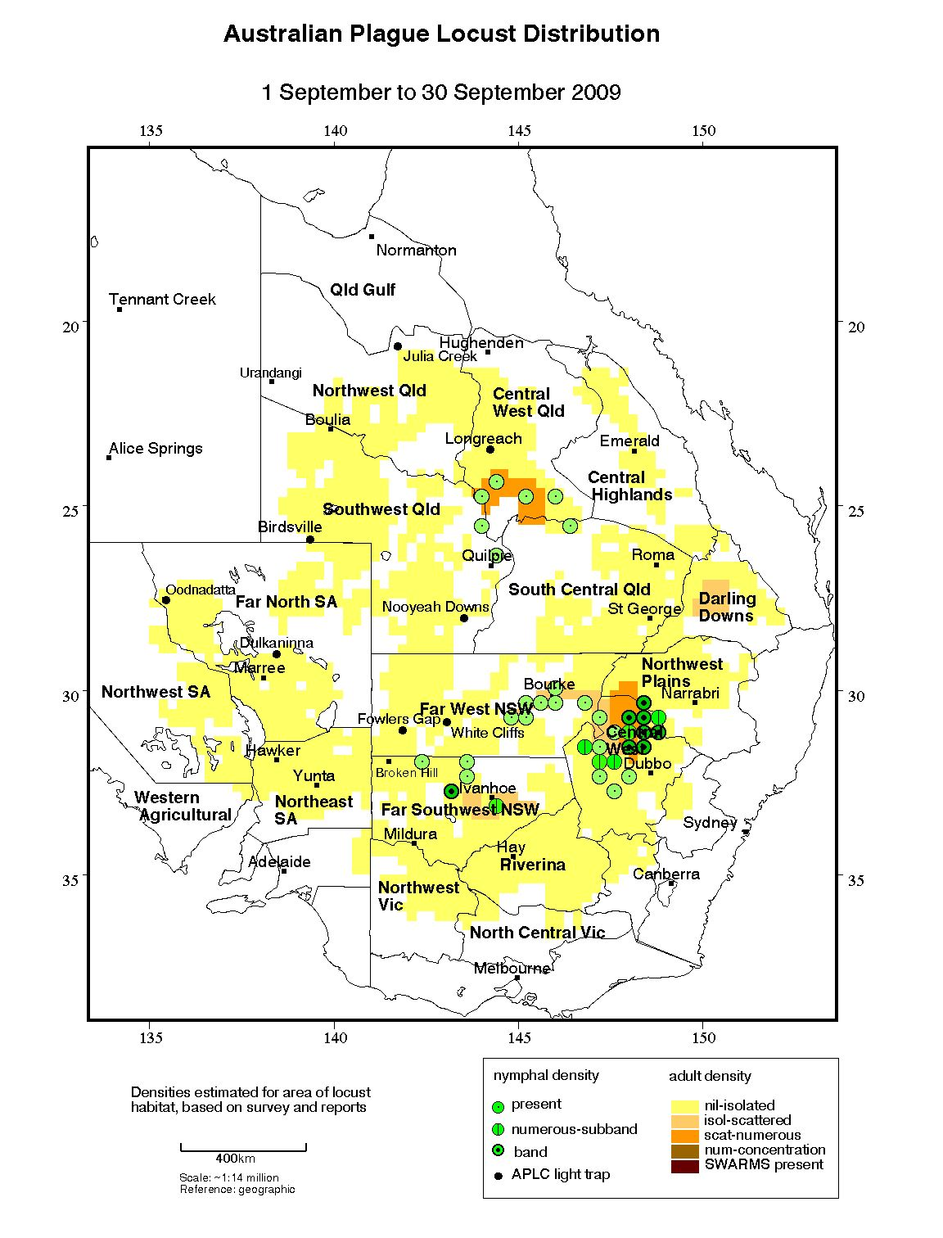

Figure 1 : Australian plague locust distribution: September 2009

**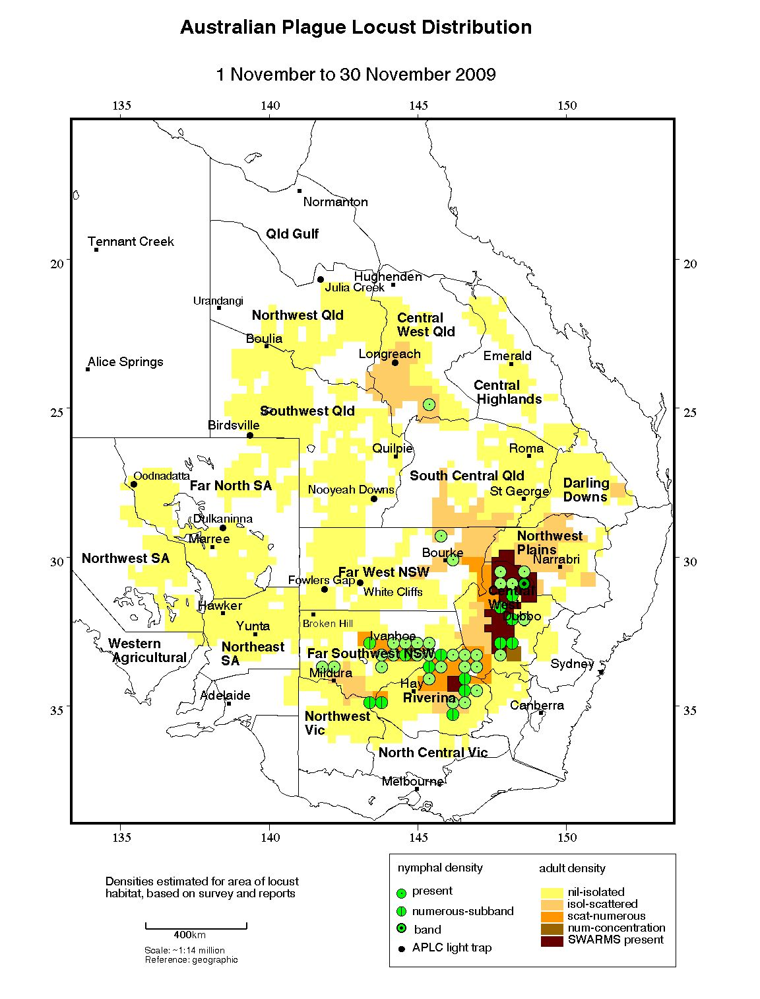**

Figure 2 : Australian plague locust distribution: November 2009

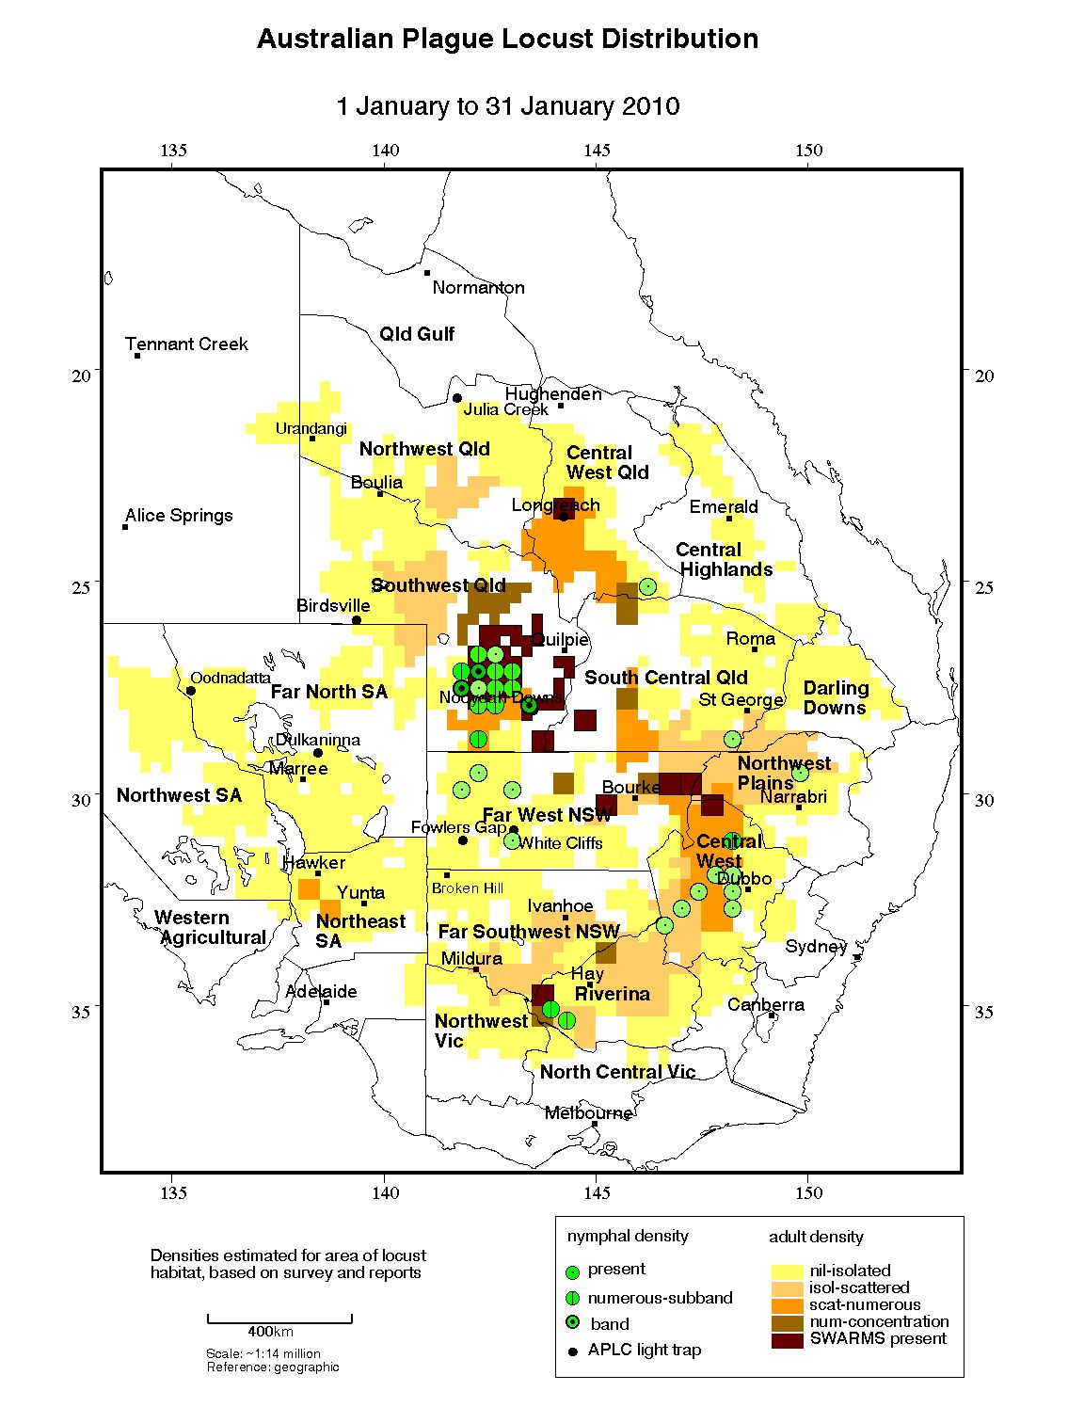

Figure 3 : Australian plague locust distribution: January 2010

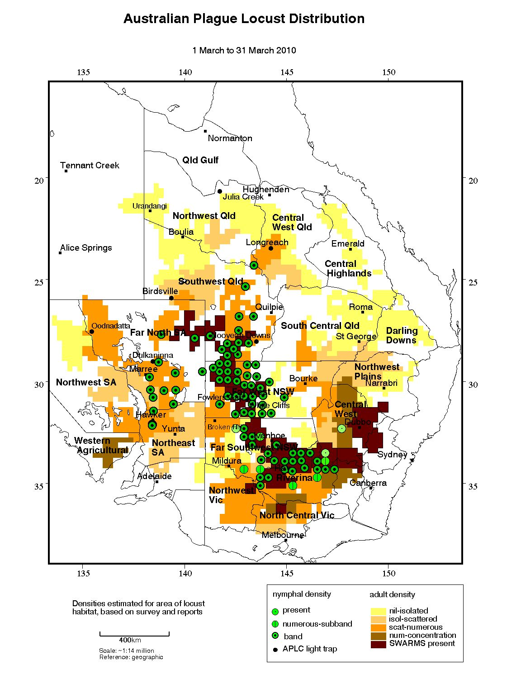

Figure 4 : Australian plague locust distribution: March 2010

Figure 5 shows the distribution of Australian plague locust across eastern Australia in April 2010

Figure 5 : Australian plague locust distribution: April 2010

## Spur-throated locust

The population level of this univoltine, largely tropical species increased significantly during 2009-2010, as a result of widespread successful breeding in inland regions of Queensland throughout the summer. In autumn swarms of young adults developed in Northwest, Central West and Southwest Queensland, and migrations increased adult densities in the Far West, Northwest Plains and Central West regions of New South Wales.

There were several reports of swarms in Northwest Queensland, north of Winton and around Dajarra, Richmond and Julia Creek during winter and further reports from Mt Isa and Cloncurry in October and November. The Julia Creek light trap recorded high numbers during August and September, but catches declined in October and November. Spring surveys identified a widespread medium density adult population in Central West Queensland, with low density adults in the Central Highlands and South Central Queensland, and the Northwest Plains of New South Wales.

Light traps at Julia Creek and Longreach recorded high numbers during December and January, reflecting migratory activity at the commencement of the breeding season. Consistent medium density adults, up to high density in some locations, were identified in the Longreach–Winton–Boulia area and widespread low density adults were recorded throughout Southwest and South Central Queensland, Far North South Australia and the Northwest Plains of New South Wales. The population level in Northwest and Central West Queensland was higher than was recorded in early summer for several years.

Nymphs were detected in Southwest and Central West Queensland in January, indicating that egg laying commenced in early December after the onset of summer rainfall in late November. The continued heavy rains throughout western Queensland in January and February allowed further breeding and the survival of nymphs already hatched. In New South Wales there were consistent low density adults in the Bourke and Brewarrina districts, and occasional adults in other districts of the Far West and Northwest Plains.

Nymphs at several development stages were widespread in inland Queensland during February. Low density nymphs were identified in Southwest, Northwest and Central West Queensland and reported from the South Central and Central Highlands regions. There were medium density nymphs in parts of Barcoo, Diamantina, Boulia and Winton Shires, and reports of higher density nymphs from near Winton and Georgetown.

Fledging of early hatched nymphs from early summer breeding commenced in February. During March and April late instar nymphs and recently fledged adults were identified in most regions inland Queensland. High density nymphs were reported from near Longreach and Winton, from the Alice Springs area in the Northern Territory and from Clayton in Far North South Australia. In late March, high densities and swarms of young adults were reported from near Nockatunga, Longreach and Augathella in western Queensland (Fig. 6).

Surveys in mid-April by APLC and Biosecurity Queensland identified consistent medium and some swarm density adults, along with late instar nymphs, in the Longreach, Barcaldine and Blackall-Tambo Regional Council areas, and in Bulloo Shire. Swarms moved into Longreach in early April, but densities in the township declined again two weeks later. Swarm reports were also received from Thargomindah, Blackall, Muttaburra, Tambo, Augathella, Charleville and Dirranbandi. Only low density adults and very few nymphs were detected in the Central Highlands and the Roma Regional Council areas. In Far West New South Wales high density fledglings and young adults were identified in the Brewarrina–Goodooga and Tibooburra areas, and were likely to have been more widespread in the region. In the Northwest Plains and Central West regions there were consistent medium density adults.

Light traps at Nooyeah Downs and Julia Creek caught high numbers during April, while at Dulkaninna and Fowlers Gap low numbers were caught during 17–20 April. At Nooyeah Downs, peak numbers of several hundred each night were caught during 5–12 and 16–22 April, also associated with migratory activity in *Chortoicetes*. At Nooyeah Downs over 1000 locusts were caught on 4 May, indicating the size of the population still in that area. At Oodnadatta in South Australia, there were moderate trap catches during 9–12 April.

The increase in adult numbers and formation of swarms of young adults in late autumn is usual for this species. Migratory activity of immature adults during autumn resulted in regional population redistributions. Adults form largely sedentary swarms during winter. The increase in population during 2009-2010 resulted from the high early season population of breeding adults and widespread repeated heavy summer rains in inland areas, providing suitable conditions for repeated egg laying and nymph survival. However, no significant population increase was identified in the Central Highlands and South Central Queensland.

## Migratory locust

Population levels of this species remained low throughout 2009–2010 in the regions where it commonly occurs. Early spring surveys identified only occasional adults near Goodooga in the NSW Northwest Plains and near Capella in the Queensland Central Highlands. APLC and Biosecurity Queensland surveys during January identified low density adults in the Emerald–Capella and Springsure areas.

The Longreach light trap recorded low numbers during February and surveys identified occasional adults north of Augathella. Further low numbers of adults were detected near Capella and Jericho during April. The Julia Creek light trap caught low numbers of this species on several nights during April.

# Figure 6 shows the distribution of spur-throated locust across eastern Australia in April 2010

# Figure 6 : Map of APLC spur-throated locust distribution: April 2010

# Operations

## Forecasting, information and survey

**Forecasting and Advice**

Nine Locust Bulletins were prepared and released during the period September 2009 through until May 2010. The advanced hatching of over-wintering eggs in some regions in August 2009 combined with developing population intensities in early spring warranted the release of a September Bulletin.

All Bulletins were simultaneously released via the APLC website and through direct delivery (electronic and printed copy) to stakeholders.

**Survey**

Extensive and repeated surveys were conducted across locust habitat areas of eastern Australia throughout 2009-10. This surveillance was targeted by location and time, informed by the intelligence developed through hatching and life stage forecasts, satellite and ground vegetation condition mapping, rainfall and other climatic information, light trap and insect monitoring radar data, and the observations and reports from APLC field staff, counterpart agencies, landholders and others.

Locust surveys by APLC commenced in the northern part of the habitat range in August in view of the known locations of overwintering egg beds and the forecast hatching times of these egg beds. APLC surveys continued throughout the 2009-10 season as locust population levels developed across the three seasonal generations and in response to widespread improvements in habitat conditions. Ground surveys were supplemented by aerial surveys dependent upon observed population densities, with these aerial surveys also used to identify and refine targets for subsequent locust control campaigns. It was necessary to balance the ongoing demand for comprehensive ground surveys by APLC staff with the implementation of control campaigns, especially in March 2010 when a large control campaign was implemented in the southwest Queensland – northwest NSW region. Linkages with state agency staff, landholders and others at such times were critical to maintain current knowledge of the locust situation while APLC staff were fully engaged in control activities.

**Insect Monitoring Radar**

The University of NSW Insect Monitoring Radar (IMR) at the Bourke airport was repaired in early January 2010 and operated for the remainder of the season (except for 12 days in mid-February). The IMR at Thargomindah airport was still offline during the season.

The IMR at Bourke detected frequent movements (104 nights) of insects with the characteristics of locusts during January–April, and on a few nights in May 2010 (Fig. 7). The seasonal movement directions over Bourke were not random (Kuiper test value 3.24 at P <0.001),or concentrated around the mean (273°) or median (277°). The general westward movement conformed to the background synoptic patterns.

Figure 7 is a graphical representation of nightly directional displacements of insects over the Bourke Insect Monitoring Radar

## Figure 7: Nightly Displacement of Chortoicetes terminifera over Bourke IMR

**Information management**

A Sun Ultra-45 workstation was purchased for application development. Software packages were installed for migrating APLC’s routine tasks and developing new applications. Python was chosen for developing a wind trajectory model with the access interface to NetCDF grid files.

The software for APLC’s field survey and locust control was repacked with all necessary database supports and graphics plug-ins for easy installation onHP iPAQ 212 devices. The AEMS OpsManager v3.01 control management software was repacked in an installer to ensure that required database and graphics support was available on field laptop computers. User guides were modified to help field staff to maintain these applications on their PDA and PC.

## Pesticide evaluation and application management

Extensive use was made of the ‘barrier application’ technique during the March 2010 locust control operations in Southwest Queensland and Far West NSW. This was the first time that this application technique, which involves discreet aerial spray runs of fipronil pesticide with (in this case) 300 metres between runs, was used as part of a large-scale campaign. Post-treatment evaluation of numerous targets where this technique was used indicated that mortalities were at least as good as standard blanket treatment with fenitrothion.

Following engagement by the APLC Director with the USDA National Rangeland Grasshopper Management program and with various technical specialists, a renewed effort to evaluate insect growth regulant (IGR) products as potential control agents was commenced. Information gathered from US specialists has addressed previous concerns regarding livestock residues, while discussions commenced with the Australian distributor of the most commonly-applied IGR regarding a possible development schedule.

## Control operations and pesticide use

The spring nymphal infestation in Central West NSW had produced a large number of bands in the Coonamble area by late September 2009. Numerous potential control targets were identified by ground and aerial surveys, and control commenced on 6 October. Over the following 12 days, fenitrothion insecticide was applied to 17 individual areas with a total area of 51.35 square kilometres (Fig. 8).

The widespread early autumn nymphal infestations and favourable habitat conditions produced the potential for a plague situation affecting several states. APLC control operations were carried out in the area of most intense infestations and which presented the highest risk of subsequent interstate migrations. A control campaign involving all APLC staff was launched on 14 March 2010, based at Tibooburra NSW. Over the following 11 days, a total of 73 targets covering 2,044 square kilometres (1,700 km2 in NSW plus 344 km2 in Queensland) were treated (Fig. 9). The large total area of control was achieved by the extensive use of fipronil barrier spraying techniques, accounting for some 70% of the total area covered. *Metarhizium* (Green Guard®) was used in areas within and near National Park, conservation reserve and organic production properties (Table 2).

Table 1: Control operations 2009-10

|  |  |  |  |  |
| --- | --- | --- | --- | --- |
| **Control Base** | **Type** | **Period** | **Number**  **of targets** | **Area Treated**  **(km2)** |
| Coonamble, NSW | Band | 6 – 18/10/2009 | 17 | 51.35 |
| Tibooburra, NSW | Band | 14 – 25/03/2010 | 73 | 2,044.04 |
| Total 2009-10 |  |  | **90** | **2,095.39** |

Table 2: Area treated (km2) by pesticide type 2009-10

|  |  |  |
| --- | --- | --- |
| **Fenitrothion** | **Fipronil** | Green Guard |
| 521.38 km2 | 1,476.31 km2 | 97.7 km2 |
| (24.9 %) | (70.5 %) | (4.7 %) |

Figure 8 is a map showing the extent of APLC locust control operations conducted in Central West region of New South Wales in October 2009

Figure 8 : Map of APLC locust control operations: October 2009

Figure 9 is a map showing the extent of APLC locust control operations conducted in the north-west of New South Wales and south-west of Queensland in March 2010

Figure 9: Map of APLC locust control operations: March 2010

## Locust control agent stocks

As a consequence of the two locust control campaigns undertaken in 2009-10 (in particular, the large campaign of March 2010), control agent stocks were depleted during the year. While some stocks were purchased in 2009-10 to replenish the Commission’s holdings, restocking will be required in early 2010-11 to ensure that sufficient stocks of all locust control agents are on hand to meet anticipated demand in 2010-11.

**Table 3: Locust control agent stock position for 2009-10**

|  |  |  |  |  |
| --- | --- | --- | --- | --- |
|  | ***Fenitrothion***  ***[Sumithion® ]***  ***(tonnes)*** | ***Fipronil***  ***[Adonis 3®]***  ***(litres)*** | ***Metarhizium***  ***[Green Guard®]***  ***(containers)*** | ***Malathion***  ***[Fyfanon®]***  ***(litres)*** |
| On Hand 1 July 2009 | 42.1 | 14,200 | 93 | 800 |
| Purchased 2009-2010 | 20.0 | 3,200 | 31 | Nil |
| Used 2009-2010 | -15.0 | -17,000 | -81 | Nil |
| Inventory @ 30 June 2010 | 47.1 | 400 | 43 | 800 |
| Approx. equivalent area (hectares) | 168,214 | 3,636 | 5,058 | 1,143 |
| Inventory Value 30 June 2010 | $664,581 | $6,716 | $90,574.34 | $6,400 |

The total inventory value of the APLC pesticide stocks held at 30 June 2009 is approximately $0.79 million. The above figures do not include 10 tonnes of fenitrothion held by APLC on behalf of Queensland.

Small quantities of pesticide are held at APLC field bases. The remainder (with the exception of the Green Guard stocks) is held in commercial premises in Dubbo, NSW.

Some 7,200 litres of the carrying agent for Green Guard (Summer Spray Oil) held in store are not included in the above figures.

Stocks of Green Guard include both formulated product and dry spore material. The quantities of Green Guard stock listed above are expressed in 14 litre container equivalents.

Green Guard stocks are held by the supplier, Becker Underwood. The shelf-life of Green Guard stored by the manufacturer [@ 4oC] is guaranteed for 2 years but is only for approximately 6 months in the field [@ 25oC]. Stored inventory is turned over and replaced when practicable.

## Environmental Management System

A report of the progress made by the APLC in meeting the objectives of its Environmental Management System (EMS) is provided at Annex 1.

Research into the use of passive sampling devices (PSDs) for fenitrothion and fipronil in water, collaboratively undertaken by the APLC and the National Research Centre for Environmental Toxicology since 2001, culminated in an operational deployment of PDMS-filled PSDs during spray operations in the Coonamble area (NSW). Fenitrothion was subsequently detected in all PSDs up to 3000 m downwind of spray operations. Atrazine and polyaromatic hydrocarbons were also detected in the deployed PSDs. A comparison was made with water and sediment samples collected using standard grab sampling techniques. The time-integrated nature of PSDs enabled the cumulative detection of fenitrothion in PSD samples up to seven days post-exposure, whereas the decreased sensitivity of grab sampling yielded decreasing levels of fenitrothion in water and sediment samples over the same period. The suitability of PDMS-filled PSDs for detecting fenitrothion in water have been confirmed by this work.

Updates to the NSW National Parks plains wanderer habitat maps were received and recorded in the Commission’s GIS and OpsManager systems, ensuring that the most up-to-date restricted area maps for this endangered species were available to APLC when planning locust control activities.

Comprehensive treatment records were maintained for all locust control areas treated during control operations, and detailed maps were delivered to individual landholders.

Post-control checks were carried out for 6 of the 17 individual areas treated around Coonamble (October 2009) and 12 of the 73 areas treated from Tibooburra (March 2010). No bird or mammal deaths were detected, and no adverse effects were reported from Sturt National Park. Some 9,770 ha were treated with the biopesticide *Metarhizium* (Green Guard ®), principally where high density nymphs were within conservation areas or organic production properties.

A total of 147,631 ha were treated with fipronil using the barrier treatment application technique. The 300 m wide interval spray track spacing leaves untreated areas as potential refuges for non-target organisms. More intensive research on the immediate and long-term impacts of this application technique on non-target organisms remains a research priority for APLC.

## Occupational Health & Safety

No accidents involving APLC vehicles or staff occurred in 2009-10. No aircraft safety incidents were reported despite the APLC treating 204,400 ha and conducting 390 flight hours during the Tibooburra campaign.

The policies of the revised APLC Aviation Procedures Manual were implemented during both the Coonamble and Tibooburra control operations. Training which reflected these new documented procedures was provided to all operational staff.

A revision of the APLC’s OH&S Manual was completed.

## Competency based training and assessment

In-operation training and assessment was provided for APLC field staff Laurie Sanchez, Clare Mulcahy and Scott Mander as part of the Coonamble control operations in October 2009.

Further in-operation training and assessment involving field staff Laurie Sanchez, Clare Mulcahy, Heather Brooks, Ashley Johnston and Jason Ullrich was undertaken during the March 2010 Tibooburra control operations.

Two new field staff Heather Brooks and Ashley Johnston were employed and progressed through the initial year of their training. Jason Ullrich applied for reappointment in a field officer position posted at Broken Hill, and continued into a second year of training.

Three APLC field staff (Scott Mander, Clare Mulcahy and Laurie Sanchez) continued to progress through their second year competency training programs. There was further opportunity during the 2009-10 season to conduct competency training in fixed wing aerial spotting, control and campaign management during the Coonamble and Tibooburra control campaigns. All four staff who had completed their second year of competency training were assessed as competent in fixed wing aerial band spotting and control. The two new field staff (Heather Brooks and Ashley Johnston) obtained training in fixed wing survey and control during the Tibooburra campaign.

No swarm control or helicopter operations were conducted during 2009-10 due to outstanding low-level operation risks which had yet to be resolved with all Member agencies.

## International linkages

APLC hosted two Timor Leste Ministry of Agriculture staff for two weeks during the Coonamble control operations in October 2009. This follows on from the UN-FAO and AusAid funded migratory locust control campaign undertaken in Timor Leste by APLC officers in 2007-08. These two staff received further valuable exposure to and experience in the planning, implementation and review of locust control campaigns.

APLC Director Chris Adriaansen undertook a two week engagement with the USDA National Rangeland Grasshopper Management Board and various technical specialists in January 2010. As considerable planning effort was underway across several US states for what was expected to be a significant rangeland grasshopper control season in the upcoming northern hemisphere summer, engagement between the US and Australian national program managers was regarded as very useful to both parties. Time spent with several technical specialists in the USDA program, particularly those involved in refining the US usage of insect growth regulator (IGR) compounds for grasshopper control, will also assist in APLC’s plans to evaluate and develop IGR usage for Australian locust control.

# Administration

## Governance

APLC Commissioners’ meetings were held on 2 November 2009 (65th APLC Commissioners meeting) and 6 May 2010 (66th APLC Commissioners meeting). In accordance with the APLC Memorandum of Understanding, the 2009-10 APLC Operational Plan was the main focus of the November meeting, while the 2010-11 budget and 2009-10 financial performance were key topics for the May meeting. The planned Strategic Review of APLC was also considered in detail at the May 2010 meeting.

Full records of the Commissioners meetings and all decisions taken are archived with APLC and held by all Member jurisdictions. An overview of the 2008-09 performance and outcomes of the Commission was contained in the 2008-09 APLC Annual Activity Report, released to Commissioners, stakeholders and the general public (via website posting) in November 2009.

Key governance issues covered by Commissioners and the APLC Director during 2009-10 included the revision and complete documentation of legislative coverage for APLC officers and activities under each of the Member states’ operative legislation, securing an independent consultant to review and advise on the risks and mitigation measures associated with low-level helicopter use, and establishment of a comprehensive framework and timetable for collaborative planning between the Commission and all Member states in preparation for the anticipated major locust plague in 2010-11.

## Staffing

Some movement within, additions to and departures from APLC were experienced during 2009-10.

Mr Ian Wright, who had been with APLC for in excess of 30 years in various capacities, retired in October 2009 from the Canberra-based position of Administration Officer. Ian had provided sterling service to APLC in both field base and HQ roles, having trained and mentored a multitude of new and ongoing staff during that time (including several APLC Directors!). Ian’s in-depth knowledge of the workings of the Commission and his understanding of the challenges faced by field staff established him as one of the Commission’s major assets. His knowledge and expertise will be sorely missed.

Three additional field staff joined APLC in October–November 2009. Heather Brooks and Ashley Johnson commenced as field officers at Narromine under the tutelage of John Nolan, while Jason Ullrich returned to a field officer role in Broken Hill, a position he had previously occupied before an absence of several years.

The vacant field officer position at Longreach was filled through the transfer of Clare Mulcahy from Narromine in late August 2009. Clare joins OIC Andrew Coleman to maintain an effective field presence covering western Queensland.

**Table 4 : APLC Staffing position during 2009-10**

| ***Officer*** | ***Position*** | ***Location*** | ***Period Employed*** |
| --- | --- | --- | --- |
| C. Adriaansen | Director | Canberra HQ | Throughout |
| W. Spratt | Deputy Director | Canberra HQ | Throughout |
| E. Deveson | Forecasting & Information Officer | Canberra HQ | Throughout |
| P. Spurgin | Control Officer | Canberra HQ | Throughout |
| P. Story | Environmental Officer | Canberra HQ | Throughout |
| J. Woodman | Entomologist | Canberra HQ | Throughout |
| H. Wang | GIS Officer | Canberra HQ | Throughout |
| H. McRae | OH&S/Training Officer | Canberra HQ | Throughout |
| I. Wright | Administration Officer | Canberra HQ | Until 23/10/09 |
| P Slattery | Administration Officer | Canberra HQ | From 01/11/09 |
| R. Graham | Officer in Charge | Broken Hill | Throughout |
| L. Sanchez | Field Officer | Broken Hill | Throughout |
| J. Ullrich | Field Officer | Broken Hill | From 26/10/09 |
| J. Nolan | Officer in Charge | Narromine | Throughout |
| H. Brooks | Field Officer | Narromine | From 02/11/09 |
| A. Johnson | Field Officer | Narromine | From 02/11/09 |
| A. Coleman | Officer in Charge | Longreach | Throughout |
| C. Mulcahy | Field Officer | Narromine & Longreach | Throughout |
|  |  |  |  |

\* Note that these figures do not include part-time staff employed to operate the APLC light trap network.

# Finance

Total revenue from all Member jurisdictions in 2009-10 amounted to some $4.612 million. Expenses recorded in the 2009-10 amounted to $4.323 million resulting in a net operating surplus of $0.288 million. The surplus was carried over to the 2010-11 financial year as part of the accumulated reserve, as shown in the Reserve Fund reconciliation which appears on the 2009-10 Financial Performance Report (Annex 2). This accumulation of surplus into the Reserve Fund is in accordance with the Memorandum of Understanding, a position that was reconfirmed by decision of the 62nd Commissioners Meeting in April 2008.

The addition of this net operating surplus to that carried forward into 2010-11 raises the level of total accumulated reserve to $2.186 million as at 30 June 2010. This fund would be drawn upon should the cost of control activities in any year exceed the annual allocation for control activities.

The surplus of income over expenditure for 2009-10 was delivered principally as a consequence of short-term vacancies in several field staff positions at the start of the financial year. Control operations expenditure (locust control agents, aircraft charter and associated costs totalling some $1.421 million) exceeded the allocated amount by some $331,000 as a consequence of the large control campaign undertaken in March 2010. This overspend was, however, more than offset by savings of some $350,000 in other operating and supplier expenses.

# Key Performance Indicators

The 2005 external review of the APLC suggested a number of Key Performance Indicators (KPIs) against which the future performance of the APLC could be measured. These KPIs have been adopted, with some modifications to provide additional semi quantitative measures, for reporting on an annual basis. Details of the KPIs and performance measures together with an assessment of the APLC’s performance in 2009-10 against these are summarised in Table 5.

Table 5 : APLC 2009-10 Performance against KPI measures

| **Key Performance Indicator** | **KPI Measures** | **Assessment/comments (2009-10)** |
| --- | --- | --- |
| Effectiveness of monitoring, prediction and control of locust populations | - Significant populations detected at early-mid instar stage  - Accuracy of forecasts of population scale, timing and location  - Majority of control measures against nymphal stage  - No adverse aerial spraying incidents | Significant plague locust populations in several New South Wales and Queensland locations were detected at early life stage through targeted ground and aerial surveillance, which utilised forecasts prepared for each generation.  100% of area subjected to control activities undertaken in 2009-10 was completed during the nymphal stage.  No adverse incidents were reported or were known to have occurred. |
| Availability and effectiveness of control agents | - Availability of existing agents  - Replacement agents identified and application rates/techniques verified | No change to availability of current control agents.  Issues raised in APVMA fenitrothion review were identified and responses prepared to address impacts upon APLC patterns of use. Further investigations to address drift buffer issues raised in APVMA review have been planned and will be undertaken in 2010-11.  Post-control monitoring was undertaken across numerous targets which were subjected to locust control activities in 2009-10. Of particular interest was demonstrating the efficacy of the wide-spaced barrier treatments with fipronil, applied as part of the March 2010 control campaign. This treatment was very effective and efficient. |
| Environmental impact of control | - No reported/observed significant adverse impacts | No adverse impacts observed or reported consequent to APLC control activities in 2009-10. |
| Trade risks minimised | - No adverse trade (residue) impacts | No adverse trade impacts resulted from APLC operations. Comprehensive advice was provided to state and local agencies to minimise the residue and trade risk of their locust control activities. |
| Cooperation with environmental, OH&S and other relevant agencies in developing and implementing plans for control programs | - Plans developed and agreed and reviewed on regular basis. | Current policy on locust control in habitat areas of endangered species and in other environmentally restricted areas was applied where appropriate.  Facilitated and collaborated with member state agencies in the preparation of state locust response plans for 2009-10, and the post-season review of these plans as the initial phase of planning for the 2010-11 season. |
| Ensuring OH&S of APLC staff, including aerial safety | - No significant OH&S incidents | No safety incidents reported in 2009-10.  Revised Aerial Operations Safety Manual implemented.  All aircraft operators engaged for surveillance and control activities were engaged against the specifications contained in the revised Manual.  Review of OH&S Manual completed to reflect outcomes of external review. |
| Improved management practices developed through a targeted research program | - Research findings incorporated into APLC control strategy and operations | Intelligence developed as part of previous investigations and development of application techniques regarding barrier application of fipronil were implemented through extensive and effective use of this technique during locust control operations in March 2010. In addition to improving operational efficiency and allowing coverage of larger areas at the optimum time, this technique is also considered to reduce environmental impact as it exposes only a portion of the target area to pesticide application. |
| APLC staff participation in national and international programs/scientific conferences | - APLC staff invited to participate in appropriate programs and conferences | National and international scientific and technical conferences and meetings were attended and addressed.  APLC staff were invited to participate in various international activities, including the USDA National Rangeland Grasshopper Management Board and FAO-sponsored locust control campaigns in Tanzania (Africa). |
| Development of effective strategic, operational and communication plans | - Plans developed, endorsed and implemented | APLC Business Cycle presented to and endorsed by Commissioners, establishing an ongoing process for planning and review at all levels. |

# Research

## Purpose and research areas

In carrying out its charter, the APLC identifies and undertakes applied and targeted research to plan for, and be responsive to, issues relating to its activities. These include, but are not limited to, the efficient monitoring and accurate forecasting of locust populations, the potential environmental and trade impacts of its control programs, the cost and efficacy of control agents, and the decision-making of locust control. An ongoing research program is essential to addressing these issues now and into the future. The three research areas are:

* Improvement in efficacy and reduction of risks associated with **control agents and application technology** addressing both immediate and future issues.
* Identification and measurement of **environmental** and trade (residue) risks potentially resulting from the APLC’s operations and integration of research results into the agencies’ core business.
* Improved understanding of the **population ecology** of locusts to improve the performance and effectiveness of existing surveillance and forecasting systems as well as improving early intervention strategies.

## 

## Research Review Committee

The Research Review Committee did not convene during the 2009-10 period.

## Summaries of research in progress

*The following research summaries provide an overview of current research activities being undertaken by the Australian Plague Locust Commission. The research summaries are not considered to constitute publication as the investigations are often incomplete and any results presented tentative.*

**1. Control agents and application technology**

#### 1.1: Simulation of Metarhizium development with locust body temperature variation

In order to evaluate the effectiveness of Green Guard® during locust control, a simulation model was reconstructed from published data for estimating locust body temperature from air temperatures and for *Metarhizium* fungus development in the locust body. Initial evaluation of the model during late March–April 2009 in the Coonamble area indicated that *Metarhizium* is effective at moderate temperatures, but that the duration from infection to death was longer than expected.

The program was developed under the freeware R environment. Geographic location (latitude and longitude) is used to calculate day length (sun rise and sun set time), which is then used to estimate the daily temperature variation regime (assuming the daily temperature minimum occurs right before sun rise). Daily temperature maxima and minima are used to simulate hourly temperature variation in a 24-hr period with non-symmetric sine wave. Locust body temperature is estimated from the simulated ambient temperature with a nonlinear sigmoid model, with consideration of behavioural fever generated by the locust after infection. A biophysical model was fitted to calculate the temperature-dependent development rate of *Metarhizium*. The number of spores deposited onto a single locust is introduced into the calculation of the duration to 50% and 90% mortality.

This model was first validated with observations from Coonamble and the results suggested the behavioural fever generated by the infected locusts may slow down fungus development during daytime at moderate temperatures. The dosage used (35 g/ha) is sufficient to kill more than 50% population within two weeks of application. The model also indicated the number of spores captured by individual locust nymph was about 2000 - 5000 with vegetation under 50 cm height. The model was tested during the band control in the Tibooburra area March 2010. Using the historic averages of daily temperature maxima and minima, and much higher spore deposition, the infected locust nymphs could be killed in 2 – 3 weeks. The model was also tested during the Red locust, *Nomadacris septemfasciata*, control program in Tanzania (Figure 10). With the much higher and denser vegetation (about 2 m) encountered there, the number of fungal spores of Green Muscle® deposited onto individual locust bodies was significantly less (estimated at ca. 600) than at Coonamble. However, even at that low dosage, most locusts showed infection after about 50 days.

Figure 10 is a graph of estimated killing rates of Nomadacris septemfasciata by Metarhrizium

Figure 10: Estimates of *Nomadacris septemfasciata* killing rates by *Metarhrizium*

Figure 11 is a graph of estimated time to achieve 50% and 90% mortality in Chortoicetes terminifera treated with Metarhrizium

Figure 11: Estimates of *Chortoicetes terminifera* killing rates by *Metarhrizium*

#### 1.2: Use of Fipronil (Adonis 3UL) with wide interval aerial application technique

#### During the 2010 autumn control operation in Far West New South Wales, a widespread population of nymphs in bands was treated with fipronil (Adonis 3UL), applied using a wide interval application technique (300 m interval between aircraft spray runs with a mean dose of 0.003 g a.i./ha). This allowed the rapid treatment of 37 blocks with an area of approximately 147,630 ha (average size of block of 3,990 ha) over a 10 day period. Post treatment monitoring of sprayed areas estimated that mortality of nymphs was extremely high (>95% kill) and observations indicated that the pesticide remained active for at least 7 days following spraying.

### 2. Environmental impact

#### 2.1 Quantifying the effects of pesticides used for locust control on Australian native vertebrates.

With the completion of previous collaborative research between the APLC, University of Wollongong, Texas Tech University and the National Research Centre for Environmental Toxicology (see APLC Annual Activity Statement 2007-2008) research effort has been focussed on the submission of manuscripts stemming from this research effort for publication to various peer-reviewed journals. Lab-based research outlined in the APLC's previous Annual Activity Statement (2007-2008) will now be developed further to incorporate field-based effects. To this end, additional funding applications are being prepared for submission in early 2009 to evaluate the ecological impacts of pesticides used for locust control in arid and semi-arid ecosystems.

#### 2.2 Comparative risk assessments of pesticide used for locust control throughout the world.

Several methods exist for building species sensitivity distributions (SSDs) using data relevant to several toxicity end points allowing the estimation of the probability of lethality as a result of pesticide exposure.  The APLC's Environmental Officer, Mr Paul Story, is currently working with Dr Pierre Mineau (Research Scientist and Program Leader, Pesticides Section, Environment Canada and Adjunct Professor at Carleton University) on the development of comparative risk assessments for pesticides used throughout the world for locust control.  Pesticides registered in Australia, USA, Canada, European Union as well as those on the World Food and Agriculture Groups (FAO) approved list will be evaluated.

An appeal for new and updated research data, specifically as it relates to pesticide residue values on either insects or vegetation, has been extended to the world-wide scientific community through various key researchers and research agencies.  It is envisaged that the incorporation of this data with new, more probabilistic risk assessment methods, will enable risk assessments for insecticides currently used for locust control to be updated and compared.  Risk assessments derived within this research project will potentially be more protective because we will first look for the influence of body-weight scaling on toxicity and use that as covariate before developing pesticide specific species sensitivity distributions.  Benefits to locust control agencies, such as the APLC, will flow from these improved comparative risk assessments, enabling improvements in their environmental performance through the selection of "environmentally softer" pesticides for spray operations.

#### 2.3: The impact of fipronil on ants and termites

This collaborative project was led by former APLC entomologist, Dr Martin Steinbauer. Data collection was concluded in November 2008 by APLC field staff and subsequent analysis and interpretation was led by James Woodman in collaboration with Martin and statisticians at BRS. This work targeted ants and termites due to Fipronil being a marketed termiticide that has previously shown severe, long-lasting impacts on termites from high dosage applications in Madagascar.

The results of this work are currently being evaluated in light of experimental design limitations identified during analysis and interpretation. As such, this work is presently being used to inform the planning of a successive research project. This work will quantify the off-target impacts of fipronil applied using current APLC application rates and barrier intervals (as opposed to blanket applications which have not been used since 2002‑03) for a greater number of invertebrate study species. This new study will also have a greater focus on the functional significance of these species to arid Australian ecology.

### 3. Population Ecology and Dynamics

#### 3.1: Cold tolerance of first-instar Australian plague locust nymphs

Whether sub-zero temperatures and frost can cause mortality in first instar *C. terminifera* nymphs has been a long standing question for locust monitoring and forecasting in Australia, as well as among concerned agricultural landholders. This is not surprising given that large variation in first instar nymphal survival is relatively poorly understood and yet undoubtedly important to the extent of aggregated band formation and likely crop and pasture losses. This work attempted to answer this question by evaluating the extent to which cold and frosty nights may contribute to nymphal mortality in the field. Nymph body fluids freeze at -13°C with only a slight difference between starved and fed individuals (total range across all individuals: -9.3 to -14.6). However, mortality at higher temperatures is possible relative to the rate of temperature decrease and the period of exposure. For example, if temperature rapidly falls to -3°C or below and persists for 3 hours (i.e. the typical period of stable minimum temperature at night) up to 50% mortality may be observed. Conversely, slower night temperature declines that are more common in the field allow nymphs to physiologically ‘harden’ and survive. In summary, high mortality from cold, frosty conditions is very unlikely. This work has now been published in the peer-reviewed literature.

#### 3.2: High-temperature survival relative to food availability in first-instar Australian plague locust nymphs

Thresholds for high temperatures and limited food availability causing mortality in first instar *C. terminifera* nymphs have been long standing knowledge gaps for locust monitoring and forecasting in Australia. This work attempted to answer this question by evaluating the extent to which hot and dry food limited conditions may contribute to nymphal mortality in the field. The critical upper limit for fed nymphs is very high at 53.3 ± 1.0°C, with death preceded by a progression of changes in behaviour, gas exchange, water loss and excretion. At more ecologically relevant temperatures, mortality from desiccation is dependent on food availability relative to exposure duration and maximum temperature as well as the rate of warming. While very high mortality occurs at temperatures of ≥45°C maintained for 6 h, a highly exposed and very poorly vegetated summer environment would be required for local population failures from current high temperatures and low humidity alone. This work is in preparation for publication in the peer-reviewed literature.

**3.3: Temporal change in diapause propensity and incidence of parasitism in *C. terminifera* eggs**

Eggs have been collected from 12 sites in the Riverina, NSW laid at approximately fortnightly intervals from mid February to mid May 2010 to assess the variation in the proportion of eggs entering diapause and the level of *Scelio* parasitism. The purpose was to examine the reliability of the development model that APLC uses to forecast hatching in spring. Results to date show that all eggs laid from mid March to mid April entered diapause. Diapause proportion declined for eggs laid after this period and all eggs laid in May directly developed. Parasitism by *Scelio* varied from 15 – 80% among sites.

#### 3.4: Genetic diversity in the Australian plague locust at the continental scale

The population genetics program at the University of Sydney has finalised the process of identifying genetic markers in *Chortoicetes terminifera* and comparing populations collected from 92 sites across the continent. Statistical analysis indicates that there is no significant genotypic differentiation between the samples from different locations suggesting that the distribution of the *C. terminifera* is panmictic. A panmictic population is one where all individuals are potential partners – i.e. there are no mating restrictions on the population and no localised geographic variation.

#### While this does not prove that east-west and west-east migration is common, it does suggest that such migration has occurred recently. Continent wide migration may therefore be a contributing factor to the development of outbreaks. This work remains in preparation for publication in the peer-reviewed scientific literature.

#### 3.5: Development of 3D wind trajectory model based on the Bureau of Meteorology’s ACCESS data for simulation of locust migration

#### The Bureau of Meteorology announced its plan to change its Numerical Weather Product (NWP) from LAPS (Limited Area Prediction System) to ACCESS (Australian Community Climate and Earth-System Simulator) in early 2010 and sample grid files were made available in later March 2010. The NWP was finalised in June 2010. Development of a new method of generating wind trajectories from BoM ACCESS data using the R statistical software and available interfaces for NetCDF format files was commenced.

#### The core part of the new model will be translated from the previously developed wind trajectory algorithm implemented in Python. The new model will be implemented in two stages: (1) 2D model for wind trajectories at equal-altitude levels with air temperature calculated – 3 months for programming and testing; (2) 3D model for wind trajectories following best locust migration layer.

Initial investigation revealed that the large dataset of ACCESS NetCDF (version 3 format) can be handled within R on both Windows and UNIX platforms, and an algorithm has been implemented to calculate the wind components of *x, y, z* directions and the temperature at any geographic position (3 dimensions: longitude, latitude, and altitude) and any time (4D domain).

# Publications

Berthier, K., Chapuis, M-P., Simpson, S.J., Ferenz, H-J., Habib Kane, C.M., Kang, L., Lange, A., Ott, S.R., Babah Ebbe, M.A., Rodenburg, K.W., Rogers, S.M., Torto, B., Vanden Broeck, J., van Loon, J.J.A., Sword, G.A. 2010. Laboratory populations as a resource for understanding the relationship between genotypes and phenotypes: A global case study in locusts. Advances in Insect Physiology 39:1-37.

Woodman, J.D. 2010. Cold tolerance of first-instar nymphs of the Australian plague locust, *Chortoicetes terminifera*. Journal of Insect Physiology 56, 376-379.

Annex 1: Environmental Management System conformance 2009-10

|  |  |  |
| --- | --- | --- |
| **Program** | **Sub-project** | **Progress (2009-10)** |
| 1. Excellence in all operational areas | Staff trained to full field competence | *New and second year staff progressed through their seasonal training requirements, with good opportunities arising during two band control campaigns. New aviation and operational safety requirements under the Aviation Procedures Manual were included in the competency training program.* |
| DGPS used in all aircraft | *dGPS continued to be used in all spray aircraft to provide accurate location of pesticide applications.* |
| Improved control efficiency | *APLC made efficient use of the three primary control agents, especially during the Tibooburra campaign where 204,403 ha were treated over 10 days due to the ability to use wide interval track spraying with fipronil.* |
| 2. All waste managed appropriately | Waste management contract | *No contract was in use this year and APLC negotiated appropriate disposal of waste through NSW I&I’s waste disposal.* |
|
| 3. Minimise the intensity, extent and duration of disturbance to native flora and fauna | Incidents effectively managed | *No environmental incidents or reports were received during the season. The ability to conduct post spray assessments varied between campaigns with 43% undertaken at Coonamble and only 16% at Tibooburra due to lack of staff and ground access difficulties due to remoteness of most targets.* |
|
| Reduce the proportional use of fenitrothion in control ops | *44% of the area treated in 2009-10 was with fenitrothion, 47% with Fipronil and 9% with Metarhizium. This is still a significant decrease over the long-term average use of fenitrothion, and is linked with the stated objective to increase APLC use of Metarhizium. The lower percentage use of Metarhizium this season is a reflection of the overall size of the Tibooburra campaign and the use of Fipronil wide interval spraying.* |
|
| Increased successful use of fipronil and larger track spacing | *147,500 ha were treated at 300m wide interval track spacing with Fipronil during the Tibooburra band campaign. This greatly reduced the total area that would have required blanket treatment with Fenitrothion in previous years.* |
|
| 4. Contribute to our understanding of natural and managed ecosystems | Develop risk assessment process for APLC pesticides, based on outcomes of environmental research. | *Passive sampler devices were field tested during the Coonamble campaign to determine their detectability of fenitrothion in downwind waterbodies from sprayed areas.* |
|
| Develop field protocols based on research | *Relevant research results still pending.* |
|
| 5. Avoid disturbance to protected sites/areas | Development of the GIS, OpsManager® and PDA handhelds sensitive area maps and database | *Updated Plain-wanderer habitat geo-spatial information was provided by NSW DEC and added to the APLC’s sensitive areas database. Mapping database of sensitive areas including National Park Boundaries was used operationally during both campaigns* |
| Procedures and buffers developed to avoid disturbance | *There were no changes to aerial spray buffers during the season* |
| 6. Ensure stakeholders are aware of all environmental obligations and they assist APLC achieve these. | Develop environmental aspect into APLC stakeholder training course. | *Training was conducted with NSW DPI and RLPB staff in NSW through September and October.* |
| Landholder consultation prior to and after pesticide application | *Extensive landholder consultation conducted during the two control campaigns.*  *Pre campaign discussion were conducted with NSW National Park staff to ensure potential impacts on sensitive areas within campaign risk zones were assessed.*  *Post control advice was issued within 2 weeks to all property owners.* |

Annex 2: Financial Performance Report 2009-10

