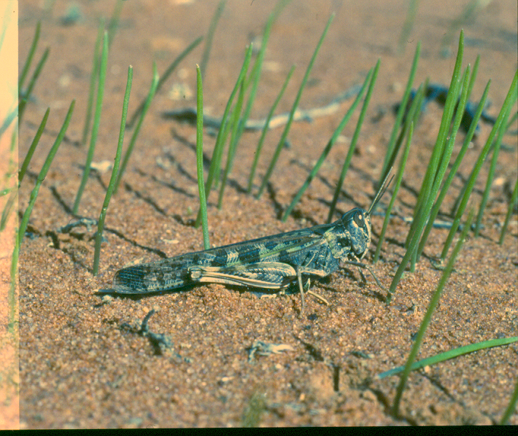

AUSTRALIAN PLAGUE

LOCUST COMMISSION

ANNUAL

REPORT

2013-14

**J:\APLC\APLC-Common\Logos\black\APLC_Logo.tif**

A joint venture of the Australian Government and the Member States of New South Wales, Victoria, South Australia and Queensland.

Contents

[Introduction 1](#_Toc263163105)

[APLC Charter 1](#_Toc263163106)

[Commissioners 2](#_Toc263163107)

[Review of 2013-2014 3](#_Toc263163109)

[Locust situation 5](#_Toc263163110)

[Australian plague locust](#_Toc263163111) 5

[Spur-throated locust](#_Toc263163112) 11

[Migratory locust 1](#_Toc263163113)1

[Operations 12](#_Toc263163114)

[Forecasting, information and survey 12](#_Toc263163115)

[Pesticide evaluation and application management 12](#_Toc263163116)

[Control operations and pesticide use 13](#_Toc263163117)

[Environmental Management System 14](#_Toc263163118)

[Workplace Health & Safety](#_Toc263163119) 14

[Competency based training and assessment](#_Toc263163120) 14

[International linkages](#_Toc263163121) 15

ADMINISTRATION 16

Governance 16

[Staffing](#_Toc263163123) 16

[Finance](#_Toc263163124) 18

[Key Performance Indicators](#_Toc263163125) 19

[Research](#_Toc263163126) 21

Purpose and research areas 21

[Research Collaborations](#_Toc263163128) 21

[Summaries of research in progress](#_Toc263163129) 22

[Publications](#_Toc263163130) 27

**Figures**

Figure 1: Australian plague locust distribution in September 2013 ................................................... 7

Figure 2: Australian plague locust distribution in December 2013 .................................................... 8

Figure 3: Australian plague locust distribution in March 2014 ............................................................ 9

Figure 4: Australian plague locust distribution in April – May 2014 ................................................... 10

Figure 5: Mean of weekly rainfall before high density *C. Terminifera* nymphs sighted ..................... 26

Figure 6: Median of weekly rainfall before high density *C. Terminifera* nymphs sighted .................. 26

**Tables**

[Table 1 : Locust control agent stocks 13](#_Toc209581995)

[Table 2 : 2013-14 APLC Staffing position](#_Toc209581996) 17

[Table 3 : 2013-14 APLC Key Performance Indicators](#_Toc209581997) 19

[Table 4 : 2013-14 APLC contribution to collaborative research projects](#_Toc209581998) 21

Table 5 : Total rainfall required for C. terminifera to develop to each instar ....................................... 26

**Annexes**

Annex 1: 2013-14 APLC Budget and Financial Performance ............................................................ 28

Annex 2: Environmental Management System conformance …………………....……………......….… 29

# 

# Introduction

The Australian Plague Locust Commission was established in 1974 and began operations in late 1976. The Commission is financed by the States of New South Wales, Victoria, South Australia and Queensland, with a matching contribution from the Australian Government. Funding allocations from the member states are in proportion to the agreed benefit delivered to that state by APLC operations, while the Australian Government contribution reflects that national benefit derived from APLC activities. The Commission is governed by six Commissioners: one from each contributing state, one from the Australian Government Department of Agriculture, Fisheries and Forestry and one from the Australian Government Department of Sustainability, Environment, Water, Population and Communities. Functional and operational management of the Commission is undertaken by a Director assisted by staff based in Canberra HQ and at three field bases in NSW and Qld. The Commission is accountable to the Ministers of Agriculture representing the five governments which finance APLC.

## APLC Charter

In August 2002, a Memorandum of Understanding (MOU) was signed between the Department of Agriculture, Fisheries and Forestry (DAFF) on behalf of the Australian Government and participating member States effectively replacing the original (1974) Exchange of Letters under which the APLC was established. The MOU also incorporated a Charter that replaced the original terms of reference under which the APLC had operated since its establishment.

The purpose of the APLC, as defined in the Charter, is “to control locust populations in those situations where they have the potential to inflict significant damage to agricultural industries in more than one member state.” In fulfilling its charter the APLC is required to:

* Implement a preventive control strategy to minimise economic loss to agricultural industries caused by the Australian plague locust, spur-throated locust and migratory locust, with priority given to Australian plague locust.
* Minimise risk of locust control to the natural environment, human health and markets for Australian produce.
* Develop improved locust management practices through a targeted research program.
* Provide a monitoring and forecasting system for operations conducted by APLC and member states.
* Promote and facilitate adoption of best practice in locust control by member states.
* Participate in cooperative national and international programs for development of APLC expertise.
* Continually review APLC operations to ensure they keep pace with the expectations of industry, community and government.

# Commissioners 2013-14

Mr Tom Aldred (Chair)

First Assistant Secretary

Biosecurity Plant Division

Department of Agriculture, Fisheries and Forestry - Australia

GPO Box 858 Canberra ACT 2601

(Vacant)

Department of Sustainability. Environment, Water, Population and Communities

GPO Box 787 Canberra ACT 2601

Mr Barry Kay

Director, Biosecurity Operations

NSW Primary Industries

Locked Bag 21 Orange NSW 2800

Mr Gordon Berg

Principal Officer Entomology   
Biosecurity Division, Regulation and Compliance   
Department of Environment and Primary Industries  
Private Bag 15 Ferntree Gully Delivery Centre VIC 3156

Mr Mark Ramsey

Principal Policy Officer

Biosecurity South Australia

Primary Industries and Resources SA

GPO Box 1671 Adelaide SA 5001

Mr Kevin Strong

Manager Operations

Invasive Plants & Animals

Biosecurity Queensland

GPO Box 4267

Brisbane QLD 4001

**Director**

Mr Chris Adriaansen

Australian Plague Locust Commission

GPO Box 858 Canberra ACT 2601

# 

# Review of 2013-2014

The 2013-14 locust season saw some of the lowest spring and summer locust activity levels recorded in the history of the Australian Plague Locust Commission (APLC), with very limited locust populations throughout the APLC area of operations. However a significant population increase occurred in autumn, following the onset of widespread rainfall in February and March. Some areas of south-western Queensland and north-western New South Wales supported a late-season upsurge in locust populations, with some scattered areas of moderate density adult locusts observed in other parts of NSW. Despite this small, late-season upsurge, however, no areas warranted control activity by the Commission in 2013-14, a repeat of the situation which existed in 2012-13.

The Commission continued with its ongoing regime of surveillance activity to ensure that no undetected locust population was developing which could later create an unexpected upsurge. Surveillance extended later than would normally be expected to cover the small areas of moderate population which persisted into late April – early May, a result of some third generation hatchings which achieved high survival rates. This also ensured that Member agencies and other stakeholders could remain confident in the intelligence being provided by APLC regarding the situation.

Due to the absence of control activity in the 2012-13 financial year, APLC started the 2013-14 financial year with a healthy balance in the Reserve Fund. By agreement of all Commissioners, it was determined that most of the funds in excess of $3 million would be applied to reducing the contributions required from Member agencies while still allowing APLC to maintain a full annual budget allocation. While this obviously represents an appropriate and timely use of funds, Member agencies must remain fully aware of the expectations this practice can establish. Once the Reserve Fund drops below the agreed “holding point” of $3 million, a return to full contributions will be required from all investing Member agencies, which Commissioners will need to be well positioned to explain.

Following lengthy analysis, consideration and review of the ongoing needs of APLC regarding its key information and intelligence systems, redevelopment of the Commission’s Geographical Information System (GIS) and the linked monitoring, data capture and forecasting elements commenced in June 2014. The proposed redevelopment and integration of these into one comprehensive new IT system is in line with the Strategic Review recommendation regarding redevelopment of these systems. While maintaining the integrity and independence of data and reporting functions driven by this GIS, the decision to operate within the Australian Government Department of Agriculture’s “Enterprise Solution” should facilitate an integrated system which will enable APLC to run a seamless GIS, monitoring and forecasting system which will allow continued access to critical information such as locust distribution, weather, habitat vegetation status and insect monitoring radar results.

The issue of risk management and liability exposure for APLC and its activities remains prominent for both Member agencies and the APLC Director. Multiple sets of legal advice over the past 10 years reinforces the nature of APLC being an unincorporated joint venture between the Member governments, meaning that liability for APLC is joint and several between those Members. When linked to the obligations of current national Work Health and Safety legislation, this puts more onus on the APLC Director and Commissioners (as designated representatives of the Member governments) to participate in decision making regarding risk management. In order to effectively address this obligation, and to maximise the effective management of APLC’s operational risks, a comprehensive Risk Register and risk decision policy has been established and endorsed by Commissioners. This policy, and the risk decision process which is a core part of it, ensures that all risks and mitigation measures pertaining to the Commission’s operations are subjected to greater levels of scrutiny by all liable parties.

Preliminary forecasts for the 2014-15 locust season indicate that there is unlikely to be a significant locust population present until late in the season, and then only if rainfall is sufficient to support reasonable levels of survival and breeding. The pockets of population identified late in the 2013-14 season could provide the platform for some moderate build-up over the first two seasonal generations, but only if there is suitable habitat response following spring and summer rainfall. APLC will maintain its monitoring and forecasting functions in order to meet the expectations of its investors and stakeholders, and will seek all suitable opportunities to undertake control operations which will deliver training opportunities for staff while implementing an effective “early intervention” approach to locust population management.



Chris Adriaansen

Director APLC

September 2014

# Locust situation

## Australian plague locust

### Overview

Locust population levels remained low in all regions throughout spring 2013 and summer 2013-14, primarily as a result of widespread dry conditions and extreme high temperatures during summer. A significant population increase only occurred during autumn, after heavy rainfall during February and March in Queensland and New South Wales. Successful breeding occurred in the Southwest, Northwest, Central West, South Central and the Central Highlands regions of Queensland, and in the Far West, Far Southwest, Central West and Riverina regions of New South Wales, resulting in a widespread low and medium density nymphal population during March and April. The subsequent autumn adult generation was recorded at medium densities in several regions, with high densities in parts of Southwest and South Central Queensland and swarms in a few locations in April. Southward migrations and redistributions during autumn increased adult numbers in several regions of New South Wales and South Central Queensland. Maturation of most adults did not occur until after mid-April and high density egg laying was only reported in a few locations in the Riverina and Central West New South Wales during May. The relatively late autumn egg laying was likely to have resulted in the production of a higher proportion of non-diapause eggs than in most seasons. This is expected to result in more protracted and somewhat later hatching of eggs in many areas during spring 2014.

### New South Wales

Small areas of high density locust nymphs were recorded in the Gilgandra–Coonamble and Dubbo–Dunedoo areas of Central West New South Wales during October, following localised adult activity in the previous autumn (Figure 1). Occasional low density nymphs were identified in a few other locations in the northern Central West region, but none were recorded in other regions. Despite several small swarms forming in the Collie–Armatree area in late October, and light–moderate rainfall in November and December, the overall adult density in the Central West declined to low levels by December. Medium density adults were recorded in the White Cliffs–Wanaaring area of the Far West region during September, but very low numbers of adults and no nymphs were detected in other regions during spring.

Adult numbers remained at very low levels in all regions during summer, but low density nymphs were recorded in several areas of the Riverina during January. Widespread very dry conditions limited opportunities for locust breeding. Moderate–heavy rainfall occurred in all regions during February and, although adult densities remained low during March, nymphs were identified in parts of the Riverina and Central West regions. Widespread low density breeding was likely to have also occurred in the Far West and Far Southwest regions and further rainfall in March provided suitable habitat conditions for nymphal survival. By April the adult population had increased to medium densities in these regions and the Central West. A small area of high density fledgling adults was identified in the Tibooburra area of the Far West in mid-April. Surveys in April and May continued to detect low and medium density nymphs in the Far West, Far Southwest, Central West and Riverina regions, indicating widespread low density egg laying occurred throughout March, and adults continued to mature during May. Southward migrations from the Tibooburra area to the Broken Hill–White Cliffs area, and possibly further south were detected during April, but no high density adults were recorded in these areas. Adult activity continued during April and May and egg laying continued into May and June in some areas.

### Queensland

Adult population densities were very low in all surveyed regions during spring, however low density nymphs were recorded near Quilpie and in the southern Central Highlands. Habitat conditions were dry in most regions and there was no significant rainfall before November. Localised heavy storm rainfall occurred in parts of the Winton and Longreach areas, and in the Central Highlands during December. These provided the first opportunity for locust breeding and there was more heavy rainfall in parts of the Central West, Southwest and Central Highlands regions during January. Survey in the Winton area in January identified low density nymphs and limited survey south from Longreach in mid-February detected nymphs on every transect. However, heavy rainfall in the Central West and more localised heavy storms in the Southwest and South Central regions restricted any further survey during February, so the geographic extent of the first significant breeding event was not determined.

By March there were widespread low and medium density late instar nymphs in Longreach, and Blackall-Tambo Regional Council (RC) areas, in northern Murweh Shire and in the southern Central Highlands RC area. Adults were still recorded at low densities in these areas and medium density young adults in southern Central Highlands. The Southwest and Northwest regions were not surveyed until April, when medium density nymphs were identified in Quilpie, Bulloo and Barcoo Shires. Adult densities remained generally low until May, except for a 50 km area of high density fledglings recorded in mid-April along the NSW border fence west of Bulloo Downs . Following a report of nymph bands near Windorah in mid-April, survey in early May identified medium and high density young adults in a 50 km area around Windorah. Migratory redistributions occurred during April and May, with many locusts moving to areas of green vegetation. In the South Central region, medium density adults were recorded in the Murweh and Paroo Shires in mid-April, and low densities in other districts. There was a population increase in the Maranoa RC area in early May, particularly around Roma where small areas of high density adults were recorded. The bulk of autumn egg laying is likely to have occurred during May, which could produce extended emergence of nymphs during spring.

### Victoria

Locust population levels remained low in Victoria throughout spring and summer, but a small increase in density occurred in the area south of Robinvale during March and April. Low density nymphs were identified by Department of Environment and Primary Industries staff near Wartook on the northwest side of the Grampians in November. Adults were collected near Bendigo in mid-February, and further low density adults were identified near Tungamah in March. Nymphs were reported hatching between Annuello and Manangatang in March, and in early May high density adults were reported on one property near Annuello.

### South Australia

Only very low density locusts were identified in surveyed areas of the Northeast and Far North regions during spring. There was some isolated moderate (20–40 mm) rainfall in those regions in late December, and widespread moderate–heavy falls in mid-February produced the first significant change in habitat conditions. However, surveys of the Far North, Northeast and Northwest regions in mid-March recorded only very low adult densities. There was a small increase in population level during April and May in the Innamincka–Cordillio Downs and the northern Flinders Ranges areas. Locusts were recorded at the Dulkaninna light trap on 21 April, at the same time that the Fowlers Gap trap in NSW was recording high numbers. This may indicate that migrations during that period may have occurred over the wider region.

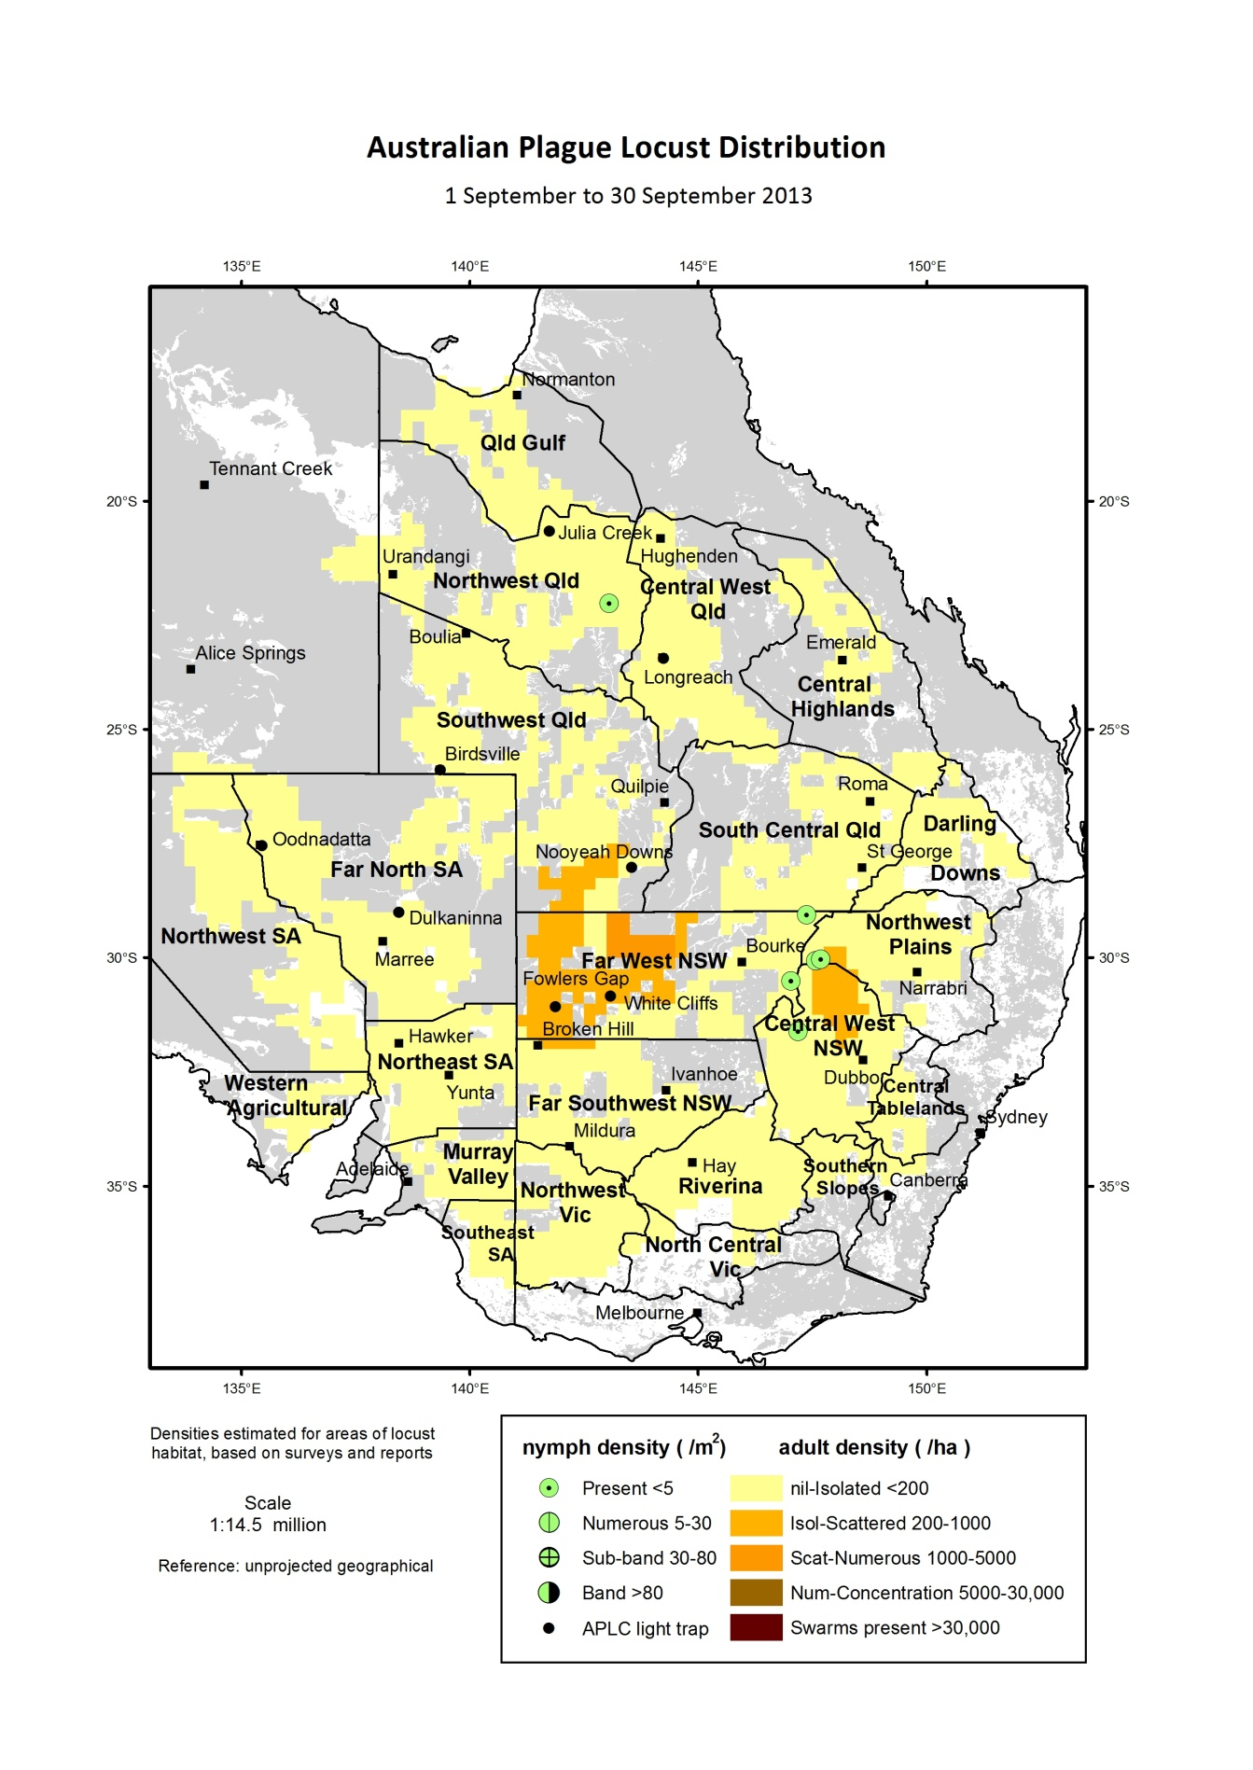

Figure 1 : Australian plague locust distribution in September 2013

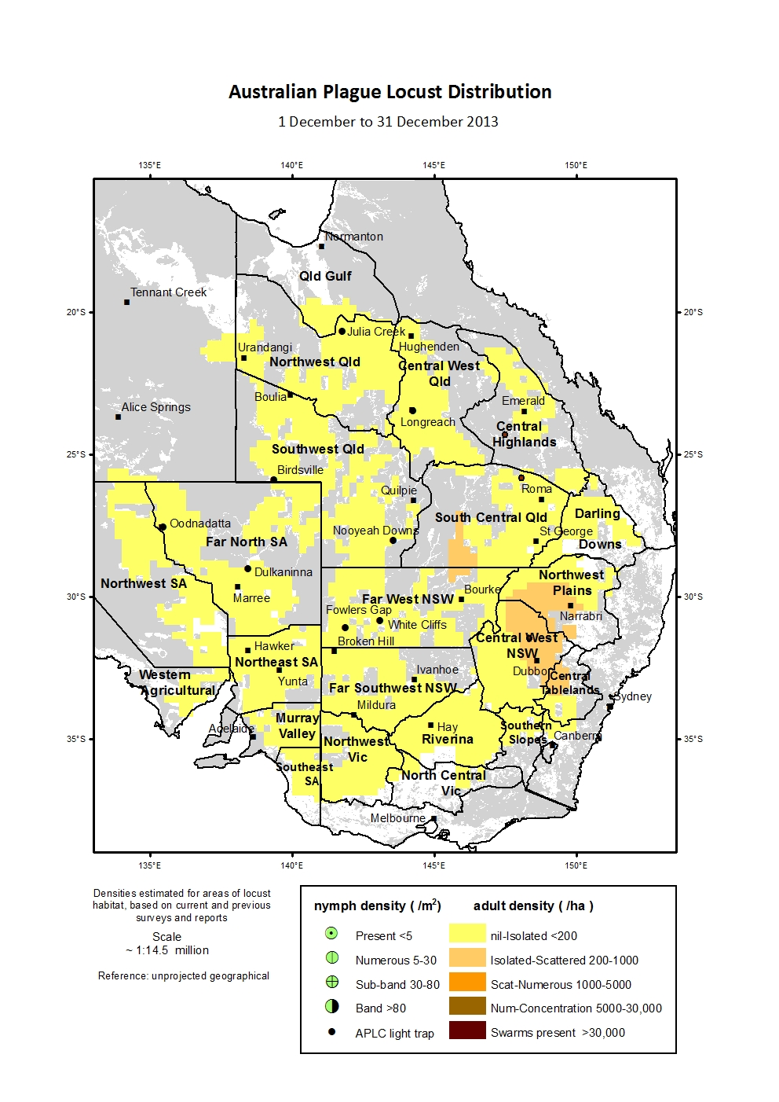

Figure 2 : Australian plague locust distribution in December 2013

**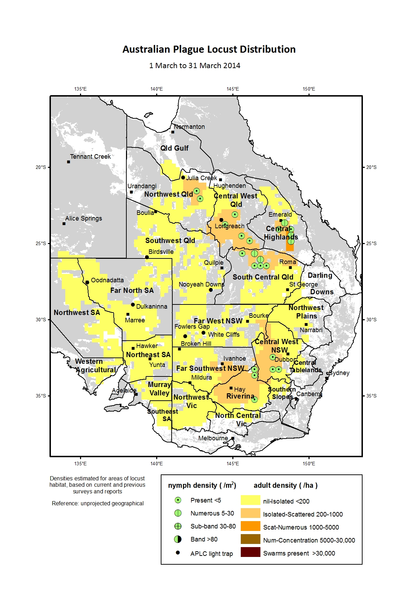**

Figure 3 : Australian plague locust distribution in March 2014

**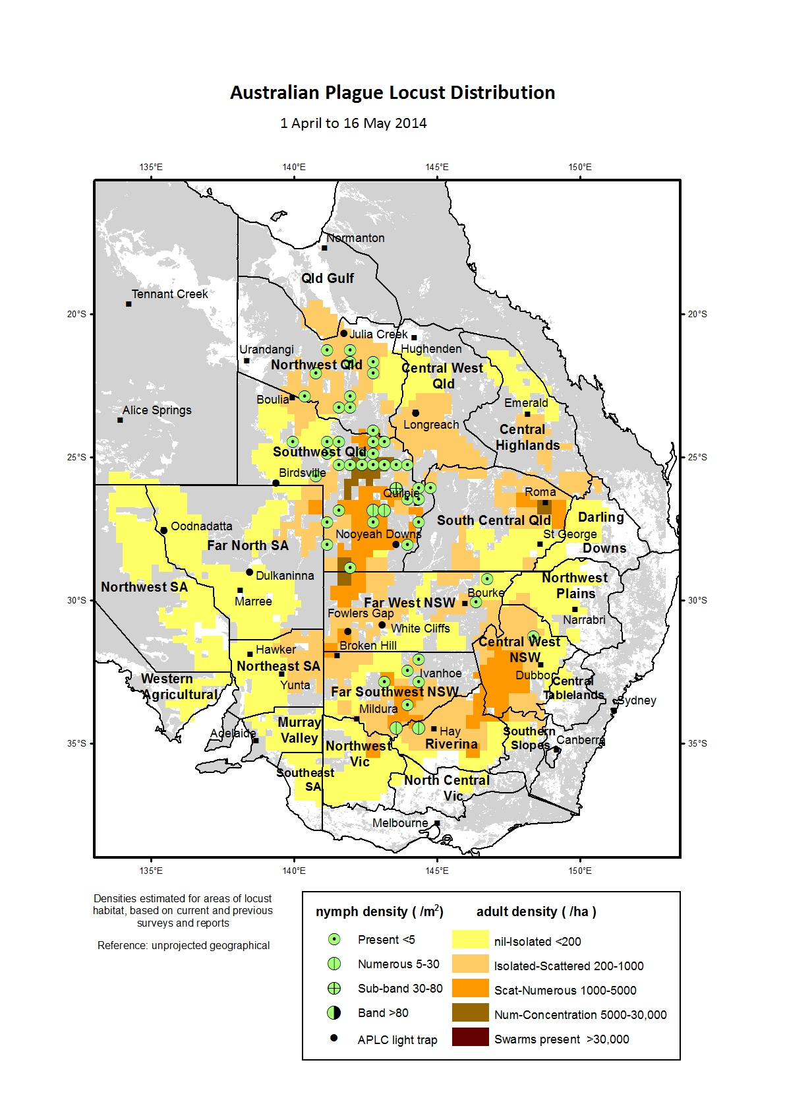**

Figure 4 : Australian plague locust distribution in April-May 2014

## Spur-throated locust

Recorded adult numbers remained at low densities throughout 2013-14, partly as a result of a lower than average overwintering population in spring and the late development of the wet season in Queensland. Spring and summer surveys identified only very low density adults in the Southwest, Central West and South Central West regions of Queensland, with more consistent low densities in the Central Highlands. Only occasional adults were recorded in northern areas of New South Wales. Nymphs were not detected by surveys until February, when occasional mid-instar nymphs were recorded in the Longreach area. Biosecurity Queensland received a report of high numbers of adults associated with crop on a property north of Biloela in the Central Highlands region in March.

Autumn surveys identified a small increase in adult numbers in Northwest, Southwest and Central West Queensland, but densities remained below the average level recorded in previous years. The low numbers and relatively late appearance of nymphs during 2013-14 indicated a restricted period and low level of breeding during summer.

## Migratory locust

The population level of this species remained very low throughout 2013–14, with only occasional adults detected in the Queensland Central Highlands during November and the Central West during March. However in mid-May low density adults were identified at several locations in the Emerald–Planet Downs–Arcadia Valley area of the southern Central Highlands.

# Operations

## Forecasting, information and survey

Eight Locust Bulletins were released during the period October 2013 to May 2014. Bulletins were simultaneously released via the APLC website and through direct delivery to stakeholders. Due to the low population levels which existed throughout the season, no interim Situation Updates were required.

Field survey for the presence and abundance of pest locust species continued throughout the 2013-14 season across the APLC area of operations. Staff from APLC’s three field bases at Narromine, Broken Hill and Longreach persisted with regular targeted surveys, despite the extreme heat experienced during December and January. All field survey information was recorded and stored as part of the APLC Geographic Information System.

The insect monitoring radar (IMR) at the Bourke airport was fully functional for the whole 2013-14 season, although there was little migration in its vicinity to be detected. The IMR at Thargomindah airport, however, malfunctioned at the beginning of November 2013 and was subsequently retrieved for repair. Additionally, its radar echoes had been significantly contaminated and compromised by surrounding large metal buildings which had been constructed in the 14 years after its original deployment at Thargomindah airport. Consequently, it was brought back to Canberra for repair and redeployment to a more suitable location. Investigations are currently underway to secure a suitable site in the western Riverina from which multi-directional migration would be detectable.

The soil moisture stations at Tambo and Nooyeah Downs (Qld) were been in operation during the season, recording soil and other climatic conditions. Minor repair was required to the Nooyeah Downs station after livestock damaged some cables, while disconnection of the existing network service as part of a national system revamp by the Department of Agriculture required installation of new modem arrangements to ensure that data could be transmitted for analysis in Canberra.

The GBM Mobile system currently operated by APLC to gather and transfer survey data (using a Windows mobile platform on hand-held PDAs) is being redeveloped to run on an iOS platform installed on the iPad devices recently issued to all APLC field staff. A demonstration version of this new platform was viewed by field staff at the end of the 2013-14 season, in anticipation of the new system being fully functional for the 2014-15 locust season. Use of this application and the Ops Manager system during locust control operations, both on iPad devices, is aimed at providing better, single-device integration for field staff, along with quicker and easier transmission of field data to APLC HQ for capture in the Commission’s Geographic Information System (GIS).

The feasibility study and operational considerations associated with migration of the APLC’s Decision Support System to the Department of Agriculture’s “GIS Enterprise Solution” has been finalised. In order to meet the APLC’s business requirements on both operations and research activities, APLC will upgrade its ESRI ArcGIS licenses to the latest version in addition to purchasing the additional licenses for spatial analysis and statistics and data interoperability, migrate file-based data into database-centric system, and implement data collection and processing into a virtual Linux environment.

## 

## Pesticide evaluation and application management

Work continued on data collection and analysis following the application of fipronil barrier and *Metarhizium* blanket treatments to the replicated research trial areas at Fowlers Gap Research Station in NSW.

These treatments were applied as part of the environmental research project being undertaken in collaboration with University of Wollongong, Macquarie University and Flinders University, and is reported in more detail in Section 2.1 of this Annual Report.

The absence of any level of treatable locust population in 2013014 has continued to delay work on identification and development of alternative control agents. Trials on an insect growth regulator compound used extensively overseas for locust and rangeland grasshopper control are unable to proceed with no in-field population against which to evaluate various formulations of this and other candidate compounds.

## 

## Control operations and pesticide use

No control activity was warranted in 2013-14 due to the absence of any significant locust populations.

Significant quantities of all control agents are currently on hand, having been further supplemented in 2013-14 by the donation of material previously held by the Victorian Government.

Table 1: Locust control agent stocks

|  |  |  |  |  |  |
| --- | --- | --- | --- | --- | --- |
|  | ***Fenitrothion***  ***[Sumithion® ]***  ***(litres)*** | ***Fipronil***  ***[Adonis 3®]***  ***(litres)*** | ***Metarhizium***  ***[Green Guard®]***  ***(≡ 14 lt ULV pails)*** | ***Summer Spray Oil***  ***(litres )*** | ***Malathion***  ***[Fyfanon®]***  ***(litres)*** |
| On Hand @ 1 July 2013 | **73,856** | **24,400** | **67.43** | **6,560** | **800** |
| Donated by Victoria 2014 | **0** | **10,000** | **0** | **9,430** | **0** |
| Purchased 2013-2014 | **0** | **0** | **0** | **0** | **0** |
| Used 2013-2014 | **0** | **0** | **0** | **0** | **0** |
| Inventory @ 30 June 2014 | **73,856** | **34,400** | **67.25** | **15,990** | **800** |
| Approx. equivalent area (hectares) | **351,696** | **312,727** | **8,070** | **N/A** | **1,143** |
| Inventory Value @ 30 June 2014 | **$1,663,665** | **$409,676** | **$141,667** | **$10,485** | **$6,400** |

During 2014, APLC was approached by the Commissioner representing Victoria with an offer to take possession of the stocks of fipronil ULV held by that jurisdiction. This material was purchased by Victoria in 2010 in preparation for the 2010-11 locust season, but was not required. As an alternative to disposal, Victoria offered this material to APLC. Full testing of this material was undertaken by APLC to ensure both efficacy and purity, with ownership of this material subsequently transferred to APLC on 1 May 2014. This material is now held as part of APLC stocks stored at commercial storage facilities in NSW. Subsequently, an amount of Summer Spray Oil (the carrier used for application of the biopesticide *Metarhizium*) was also gifted by Victoria to APLC and was transferred from Victoria to the APLC field base at Narromine.

The total inventory value of the APLC pesticide stocks held as at 30 June 2014 is approximately $2.23 million. The above figures do not include the 5 tonnes of fenitrothion held by APLC on behalf of Queensland or the value of material donated to APLC by the Victorian Government. The exclusion of the value of this material is to ensure correlation between the inventory value recorded by APLC and that recognised on the asset listing of the Australian Government Department of Agriculture.

Small quantities of pesticide are held at APLC field bases for immediate use during a control operation. The remainder (with the exception of the Green Guard stocks and the Summer Spray Oil donated to APLC by Victoria) is held at commercial storage premises in NSW.

Stocks of Green Guard include both formulated product and dry spore material. The quantities of Green Guard stock listed above are expressed in 14 litre container equivalents. Green Guard stocks are held by the manufacturer in controlled storage facilities. The shelf-life of Green Guard stored by the manufacturer [at 4oC] is guaranteed for 2 years but is only guaranteed for approximately 6 months in the field [at 25oC]. Stored inventory is turned over and replaced when practicable.

During 2013-14, APLC contracted for the collection and disposal of accumulated empty pesticide drums and associated waste held under its authority at the commercial storage facilities in NSW. While the pesticides procured by APLC are subject to a standard *Drum Muster* levy (meant to cover the collection and disposal of empty pesticide containers), it has not been possible to secure disposal through this process. *Drum Muster* have refused to accept empty pesticide containers from APLC as they have contained ULV formulations, and cannot be rinsed to the standard required by *Drum Muster*. Over 500 empty pesticide containers and some 20 containers of other waste material (such as drum washings and used protective equipment) were disposed of at APLC expense through an accredited hazardous waste disposal agent.

## 

## Environmental Management System

As there were no gregarious populations of locusts within the Commissions area of operations, no control campaign-related environmental assessment or work was undertaken.

A summary of APLC’s standing in relation to the performance indicators of our Environmental Management System (EMS) is provided at Annex 2.

## Workplace Health & Safety

There were no reportable Workplace Health & Safety incidents during the 2013 – 2014 operating period, a reflection of the sound practices and procedures developed and applied to all aspects of APLC operations and the very strong safety culture which persists within the Commission.

## Competency based training and assessment

Andrew Coleman rejoined the APLC as Officer-In-Charge [OIC] at Narromine (NSW) in January 2014. Andrew returns with considerable previous experience as an OIC and in locust control campaign operations. Andrew has been rapidly refreshing his experience and renewing any lapsed qualifications for this role.

Megan Pratt successfully completed the ‘Helicopter – Fly the Wire and Crew Resource Management [CRM]’ training course in August 2013.

A further season of low locust activity levels has severely limited opportunities for more specialised, first-hand competency-based training in locust control operations. This will be a priority once a suitable opportunity becomes available.

All operational employees continue to review and refresh core skills on a regular basis.

## International linkages

Three APLC officers (Chris Adriaansen, Peter Spurgin and James Woodman) were invited speakers at the 11th International Congress of Orthopterology, held in August 2014 in Kunming (China). Dr Woodman’s presentation covered several aspects of his locust physiology and ecology research. Mr Spurgin presented on his experiences implementing FAO-funded locust control work in Tanzania. Mr Adriaansen addressed the issue of early intervention for locust population management, a presentation which was supplemented by the experiences of Victorian APLC Commissioner, Mr Gordon Berg, in his presentation on communications and community engagement during locust control programs.

# Administration

## Governance

An APLC Commissioners Meeting was convened by teleconference on 12th September 2013 to consider and endorse the proposed 2013-14 APLC Budget.

A further Commissioners Meeting was held on 12th December 2013 (72nd APLC Commissioners Meeting). Commissioners agreed not to hold a meeting in the second half of 2013-14 as there were no issues requiring consideration at that time other than the 2014-15 APLC Budget, which would not be completed for proposal until after June 2013 (although a preliminary draft was provided in May 2014 to assist Commissioners in planning allocations from Member agencies). Commissioners were provided with quarterly financial performance reports during 2013-14, including explanation of major variances from planned expenditure.

Full records of the Commissioners Meeting and all decisions taken are archived with APLC and held by all Member jurisdictions.

Key governance decisions taken by APLC Commissioners in 2013-14 were to support various measures which ensured efficient and effective use of the Commission’s funds and resources. This included the acceptance of locust control agent stocks which Victoria proposed to gift to APLC only if testing of these materials proved acceptable purity and efficacy, to ensure that these stocks did not become a future disposal liability for APLC.

Commissioners also reviewed progress with the action plan prepared by the APLC Director in response to the recommendations from the Strategic Review completed in 2012. Particular attention was paid to the need to develop a clear rationale which explained the decision to commence and cease locust control action based on the principles of early intervention and population management, rather than any perception of a geographical location basis. The principles applying to budget and resource management were also refined, and have been applied in the development of the proposed 2014-15 APLC budget.

Commissioners also provided out-of-session endorsement of the APLC Risk Register, incorporating the APLC risk policy and risk decision process. An annual update of the risk register, highlighting any additional of changed risks or mitigation measures, will be provided to Commissioners in line with this agreed risk policy.

## Staffing

Limited changes occurred during 2013-14 to the staffing of APLC, although the impact of the loss of two long-term experienced staff cannot be underestimated.

Mr John Nolan, Officer-in-Charge at our Narromine field base who had originally joined APLC in 1997, resigned in order to relocate his family to southern NSW. In addition to the significant experience John held in locust survey and control operations, his expertise in training new field staff was of great value to the Commission.

Mr Andrew Coleman rejoined APLC in January 2014 to fill the vacant Narromine OIC position. Andrew was previously OIC at APLC Longreach, having left that position in October 2009, and brings back the wealth of experience developed during his prior time with the Commission.

Mr Heath McRae, Training and Safety Officer at APLC HQ, ceased his employment with APLC following a period acting in a WH&S officer role with the Department of Agriculture in north Queensland. Heath was responsible for the training resources developed by APLC over many years and for the ongoing management of our safety management system. The value of these resources and Heath’s contribution to the Commission over some 20 years is well-recognised.

Ms Danielle McKay resigned as Field Officer based at Longreach in May 2014 to take up a role with NSW Local Land Services in the southern NSW area.

As indicated in the Director’s Report, a number of APLC field staff have not participated in any significant locust control work since commencing their employment with the Commission. This limited experience will have to be addressed at the first available opportunity, and will also require a number of experienced HQ officers to participate in any control operations which may occur in 2014-15.

**Table 2: 2013-14 APLC Staffing position**

|  |  |  |  |
| --- | --- | --- | --- |
| **Officer** | **Position** | **Location** | **Period**  **Employed** |
| C. Adriaansen | Director | Canberra HQ | Throughout |
|  |  |  |  |
| W.Spratt | Deputy Director | Canberra HQ | Throughout |
|  |  |  |  |
| E.Deveson | Forecasting & Information Officer | Canberra HQ | Throughout |
|  |  |  |  |
| P.Spurgin | Application & Control Officer | Canberra HQ | Throughout |
|  |  |  |  |
| P.Story | Environmental Officer | Canberra HQ | Throughout |
|  |  |  |  |
| J.Woodman | Entomologist | Canberra HQ | Throughout |
|  |  |  |  |
| H.McRae | OH&S & Training Officer | Canberra HQ | Ceased 14 April 2014 |
|  |  |  |  |
| H.Wang | GIS and Information Officer | Canberra HQ | Throughout |
|  |  |  |  |
| L.Veness | Business Support Officer | Canberra HQ | Throughout |
|  |  |  |  |
| R.Graham | Officer-in-Charge | Broken Hill | Throughout |
|  |  |  |  |
| N.Green | Field Assistant | Broken Hill | Throughout |
|  |  |  |  |
| M. Pratt | Field Assistant | Broken Hill | Throughout |
|  |  |  |  |
| J.Nolan | Officer-in-Charge | Narromine | Ceased 4 October 2013 |
|  |  |  |  |
| A. Coleman | Officer-in-Charge | Narromine | Commenced 6 January 2014 |
|  |  |  |  |
| K. Arnall | Field Assistant | Narromine | Throughout |
|  |  |  |  |
| C.Mulcahy | Officer-in-Charge | Longreach | Throughout |
|  |  |  |  |
| D. McKay | Field Assistant | Longreach | Ceased 8 May 2014 |
|  |  |  |  |
| R.Knapp | Field Assistant | Longreach | Throughout |

Note: The above staffing table does not include the part-time (casual) staff employed to operate the APLC light trap network.

# Finance

Total revenue in 2013-14 amounted to $4.699 million, including a “draw down” of $2 million from the APLC Reserve Fund. This reduced the funds required of the Australian and Member State Governments to $2.699 million (down from $4.049 million in 2011-12). With the attribution of additional expenditure items to APLC by the Australian Government Department of Agriculture (DA) late in the financial year, an additional $203,000 was allocated by DA to cover these additional expenses.

Expenses recorded in the 2013-14 period amounted to $3.578 million resulting in a net operating surplus of $1.324 million. The surplus was carried over to the 2014-15 financial year as part of the accumulated reserve, as shown in the 2013-14 financial performance report *(Annex 1)*. The balance of the APLC Reserve Fund at the start of the 2014-15 financial year consequently stood at $4.326 million. This accumulation of surplus into the reserve fund is in accordance with the Memorandum of Understanding, a position that was reconfirmed by decision of the 62nd Commissioners Meeting in April 2008.

The surplus of income over expenditure for 2013-14 was delivered principally as a consequence of no control operations or expenditure occurring during the year. Staff vacancies at various times during the year also contributed to this result. A further saving resulted from renegotiation of lease arrangements for several APLC vehicles, and the return of funds where the sale price of replaced APLC vehicles exceeded the lease residual value.

In accordance with APLC budgeting policy endorsed by Commissioners in May 2012, the value of the Reserve Fund will be held at (or close to) $3 million, with accumulated reserve in excess of that amount to be applied to a reduction in funding contributions requested of investing jurisdictions for the following financial year. As a consequence, contributions requested for the 2014-15 APLC budget are likely to reflect the application of at least $1.3 million of reserve funds.

# Key Performance Indicators

The 2005 external review of the APLC suggested a number of Key Performance Indicators (KPIs) against which the future performance of the APLC could be measured. These KPIs have been adopted with some modifications to provide additional semi quantitative measures for reporting on an annual basis. Details of the KPIs and performance measures together with an assessment of the APLC’s performance in 2013-14 against these are summarised in Table 3.

Table 3: APLC 2013-14 Performance against KPI measures

| **Key Performance Indicator** | **KPI Measures** | **Assessment/comments (2013-14)** |
| --- | --- | --- |
| Effectiveness of monitoring, prediction and control of locust populations | - Significant populations detected at early-mid instar stage  - Accuracy of forecasts of population scale, timing and location  - Majority of control measures against nymphal stage  - No adverse aerial spraying incidents | - No significant populations were detected in 2013-14, despite extensive scheduled surveillance.  Forecast information was appropriately limited, reflecting population levels.  No control activity undertaken during 2013-14  Not applicable, as no control activity. |
| Availability and effectiveness of control agents | - Availability of existing agents  - Replacement agents identified and application rates/techniques verified | No change to availability of current control agents.  Issues raised in APVMA fenitrothion review are subject to continued discussion with APVMA  Ongoing discussions held with Aust agent for major IGR product, with evaluation trial designed. Trial permit will be secured once locust population levels increase to levels where trials can be conducted. |
| Environmental impact of control | - No reported/observed significant adverse impacts | Preliminary results from collaborative environmental research project indicate that the use of the Adonis 3UL ULV formulation of fipronil as a barrier treatment for locust control in arid regions of central Australia presents a low risk to soil microbial community function, reptile and termite populations. |
| Trade risks minimised | - No adverse trade (residue) impacts | Not applicable, as no control activity. |
| Cooperation with environmental, OH&S and other relevant agencies in developing and implementing plans for control programs | - Plans developed and agreed and reviewed on regular basis. | No change required to current agreements and arrangements. |
| Ensuring OH&S of APLC staff, including aerial safety | - No significant OH&S incidents | No OH&S incidents were recorded – this can be attributed to sound practices and procedures as well as a very strong safety culture. |
| Improved management practices developed through a targeted research program | - Research findings incorporated into APLC control strategy and operations | Research activities (detailed in Research section of this report) linked to key strategic issues of APLC operations, including environmental impact and pesticide application technology.  Major longitudinal study of environmental impact commenced, which will identify where current practices should be modified to further reduce off-target impact. |
| APLC staff participation in national and international programs/scientific conferences | - APLC staff invited to participate in appropriate programs and conferences | National and international scientific and technical conferences and meetings were attended and addressed. |
| Training of member state staff | - APLC training course developed and core of trained member state staff available | No training requested for Member State agency staff. |

# Research

## Purpose and research areas

In carrying out its charter, the APLC identifies and undertakes research to plan for, and be responsive to, issues relating to its activities. These include, but are not limited to, the efficient monitoring and accurate forecasting of locust populations, the potential environmental and trade impacts of its control programs, the cost and efficacy of control agents, and the decision-making of locust control. An ongoing research program is essential to addressing these issues now and into the future. The three research areas are:

* Improvement in efficacy and reduction of risks associated with **control agents and application technology** addressing both immediate and future issues.
* Identification and measurement of **environmental** and trade (residue) risks potentially resulting from the APLC’s operations and integration of research results into the agencies’ core business.
* Improved understanding of the **population ecology** of locusts to improve the performance and effectiveness of existing surveillance and forecasting systems as well as improving planning, preparedness and early intervention strategies.

## Research Collaborations

The value of the collaborative research strategy adopted by APLC is demonstrated in Table 4. In addition to the significant intellectual power which is being harnessed from (in particular) the university sector to undertake locust research, APLC investment through Australian Research Council (ARC) linkage projects is securing a total value of research in the order of $1.6 million for the direct investment by APLC of less than $0.5 million over the four year project life of the current ARC funded project listed below.

Table 4: 2013-14 APLC contribution to collaborative research projects

|  |  |  |  |  |  |
| --- | --- | --- | --- | --- | --- |
| Project title | Collaborators | 2013-14 APLC Contribution | | | 2013-14 Total project value (all investors) |
| Cash | In-kind | Total |
|  |  |  |  |  |  |
| Ecosystem-wide impacts of various locust control methods | University of Wollongong; Macquarie University; Flinders University | $105,186 | $48,104 | $153,290 | $359,624 |
|  |  |  |  |  |  |

## Summaries of research in progress

*The following research summaries provide an overview of current research activities being undertaken by the Australian Plague Locust Commission. The research summaries are not considered to constitute publication as the investigations are often incomplete and any results presented tentative.*

### 1. Control agents and application technology

**1.1 Identification of alternative control agents**

The APLC carries out aerial control of infestations of the Australian plague locust, *Chortoicetes terminifera*, throughout eastern and central Australia. Nymphs and adult swarms are treated using a range of ULV pesticides (fenitrothion, fipronil and the biopesticide Green Guard). In rangeland grazing areas spray targets can be very large (up to 100 km2) and contain large populations of nymphs concentrated in marching groups referred to as bands (20 m up to 5 km in length at densities of 2,000-5,000 nymphs/m2) that are usually visible from survey aircraft.

Depending on temperature and vegetation conditions bands in these areas can move 50-500 m/day. In this type of situation fipronil (Adonis 3UL) is applied as either an irregular blanket treatment (aircraft spraying in a crosswind) or as a barrier treatment (aircraft spraying parallel to the wind). In both cases a 300 m interval between spray runs is used. These application methods allow large areas to be treated rapidly with high efficacy as banded nymphs moving through sprayed areas are controlled effectively by direct contact or as they feed on or come into contact with treated vegetation (observed mortalities of >95%, 7-10 days after spraying).

Diflubenzuron (Dimilin OF60) is an insect growth regulator pesticide that is used successfully overseas (USA and Africa) for control of locust and grasshopper nymphs in rangeland areas using similar aerial application methods to those employed by the APLC with fipronil. It acts on the immature nymph stages after ingestion of treated vegetation, interfering with the formation of chitin and blocking the normal moulting process between instars. It has proved to have less impact on a range of arthropod and vertebrate non-target species than conventional pesticides. Field trial to evaluate Dimilin as a suitable control agent for APLC aerial control programs and a possible replacement for fipronil are planned when suitable populations of Australian plague locust nymphs occur.

**1.2 Pre-lethal effects of *Metarhizium anisopliae* var. *acridum* infection on the Australian plague locust**

This study aims to describe and quantify the progression of pre-lethal effects from *Metarhizium* *acridum* infection in the Australian plague locust using measures of food intake and activity. The experimental design for this work is largely completed and awaiting the opportunity to collect locust eggs from the field.

### 2. Environmental impact

#### 2.1 Australian Research Council Linkage project ((LP110200105): Is locust control a low cost to the environment? Ecosystem-wide impacts of different locust control methods.

The APLC is collaborating with the University of Wollongong, Macquarie University and Flinders University to quantify and compare the extent and duration of ecological impacts resulting from applications of the phenyl pyrazole insecticide, fipronil and the biopesticide *Metarhizium* *acridum* (Green Guard®), on the structure and function of semi-arid grassland ecosystems. Specifically, this project will determine the impact on, and recovery rate of:

(a) Non-target invertebrate assemblages following aerial fipronil and Green Guard® applications

(b) Decomposition and mineralisation processes and those invertebrate and microbial assemblages involved in these processes within treated areas, and

(c) Herpetological assemblages as important insectivores in semi-arid grassland ecosystems as a model predator-prey system.

The data collection component of this project is now complete and data analysis and manuscript preparation is ongoing. Preliminary results indicate that the use of the Adonis 3UL ULV formulation of fipronil as a barrier treatment for locust control in arid regions of central Australia presents a low risk to soil microbial community function, reptile and termite populations. Data quantifying the effects of this specific use pattern for firponil on invertebrate populations is still being collated.

**2.2 Effects of fenitrothion and fipronil on the stripe-faced dunnart (*Sminthopsis macroura*).** A research collaboration between the Australian Plague Locust Commission (APLC) and the Commonwealth Scientific and Industrial Research Organisation (CSIRO, Black Mountain Laboratories, Canberra, ACT, Australia).

The scarcity of information on the effects of pesticides on native Australian vertebrates constrains the development of biologically relevant risk assessments in Australia for the registration of pesticides. The concern that endemically old and unique Australian vertebrate fauna might display high sensitivity to pesticides used for locust control, based primarily on a lack of information on the responses of Australian native species to fenitrothion and fipronil, provoked the establishment of a research collaboration between the APLC and the CSIRO. This collaboration will examine the impacts of pesticides used for locust control on dasyurids, using the stripe-faced dunnart, *Sminthopsis macroura*, as a model dasyurid organism.

Specifically, this research project will examine physiological responses of *S. macroura* to fipronil through the quantification of:

* A median lethal dose
* Pesticide dietary intake data through quantification of residue on locusts during spray operations coupled with laboratory-based feeding rate and aversion studies
* Metabolic fate of fipronil and it’s metabolites in *S. macroura*, and
* Maternal transfer of fipronil and its metabolites and subsequent effects on reproductive physiology in this species.

Additionally, we will investigate the sublethal effects of fenitrothion on;

* Thermal metabolism of *S. macroura*, with specific attention paid to the 24 hr torpor cycle
* Interference with a dunnarts ability to utilise torpor for energy conservation, and
* Feeding behaviour associated with intake of pesticide-contaminated prey.

### This is a long-term research collaboration. Field collection of dunnarts required to seed a captive colony was undertaken during 2013-2014 and the development of the breeding colony is underway.

### 3. Population Ecology and Dynamics

**3.1: Overwintering physiology of pre-reproductive adult Spur-throated locusts**

This study aims to describe and quantify the physiological basis to overwintering in *Austracris guttulosa* as part of a broader objective to improve our understanding of Australian locust population ecology. The first cold tolerance phase of this work is published in the peer-reviewed literature and further work to understand the regulation of development and other aspects of physiological tolerance are planned and pending the availability of field sampling opportunities.

**3.2: Parasitism rates, life history and reproductive biology of *Scelio fulgidus***

*Scelio fulgidus* is a widely distributed egg endoparasitoid of the Australian plague locust that can exert considerable influence on locust population dynamics. The first phase of this work reports *S. fulgidus* longevity from different seasonal histories at 5 diurnal temperature regimes in the laboratory. Longevity was sensitive to temperature and means ranged from 5 - 28 d in males and 10 - 33 d in females at 35/20°C and at 15/0°C (day/night) respectively. Maximum female longevity in the cooler 20/5°C and 15/0°C treatments was 78 and 74 d respectively. There was no significant difference in the longevity of *S. fulgidus* drawn from different seasonal populations, or those from diapause eggs exposed to 15oC in soil for 100 d before hatching. These data considerably increase individual maximum longevity for the species. This work is now published in the peer-reviewed Australian Journal of Entomology (see publication list below). The second phase of this work has assessed *S. fulgidus* parasitism from 23 locust egg bed sites in the New South Wales Riverina over a sequence of three host generations during the 2010–2011 *C. terminifera* plague cycle. Parasitism was locally variable but relatively high in each generation, with >90% egg parasitism during the summer 2010 host generation, exceeding previously reported data. There was evidence to support facultative diapause of up to one-third of *S. fulgidus* larvae in host eggs laid during March–May, with temporal change in proportions similar to diapause incidence in host eggs. This work has now been published in the peer-reviewed journal, Austral Entomology (see publication list below). Further work is planned on other aspects of the life history and reproductive biology of the species.

**3.3: Effects of inundation on Australian plague locust egg development and viability**

This study is quantifying the effects of different inundation durations at different temperatures on locust egg development and viability. Development rates, egg survival, hatchling condition and nymph survival to 2nd instar have been quantified to estimate the impacts of flooding on population dynamics in the field. Results show that most eggs can survive > 14 d, unless soil temperature is ≥ 25°C. Additionally, the embryonic development stage at the time of flooding is important whereby eggs inundated at later stages face higher mortality. This work is in the final stages of preparation for publication in the peer-reviewed literature.

**3.4: Immersion tolerance of first-instar Australian plague locust nymphs**

This study was undertaken as an extension of the egg flooding project above and aimed to quantify the survival of first-instar *C. terminifera* nymphs to range of water immersion periods and temperatures. Results show that survival is strongly dependent on immersion temperature whereby survival times ranged from time to 50% mortality (LT50) = 8.12 ± 0.26 h at 15˚C to 4.93 ± 0.30 h at 25˚C. These findings suggest that first-instar nymphs would be able to survive most instances of transient, localised pooling of water associated with heavy rainfall in the field. However, flooding that could trap individuals for > 5 h (including nymphs still underground within the egg pod prior to emergence to the soil surface) has the potential to cause high mortality, particularly during summer and early autumn when water temperatures may be high. This work is now published in the peer-reviewed Australian Journal of Zoology (see publication list below).

**3.5: Embryonic diapause initiation relative to cumulative photoperiod change in the Australian plague locust**

This study was undertaken to approximate natural photoperiod changes during late summer and autumn (i.e. declines of -0.5, -0.75, -1.0, -1.25, -1.5, -1.75, -2.0 h in a 24 h period) to quantify any effect on the subsequent production of diapause eggs. Induction of diapause was significantly affected by accumulated photoperiod decline experienced by the parental generation throughout all stages of development from mid-instar nymph to fledgling adult. The incidence of diapause ranged from nil at -0.5 h to 86.6% at -2.0 h. Continued declines in photoperiod for post-teneral locusts (transitioned from -1.0 h until fledging to -1.75 h) produced a further increase in the proportion of diapause eggs. Results of this work have direct implications for the seasonal timing processes of photoperiodism in *C. terminifera* given the high migratory capacity and latitudinal cline in the timing of diapause egg production across a broad geographic range. This work has been prepared and submitted to the peer-reviewed Journal of Insect Physiology.

#### 3.6: Physiological regulation of feeding and responses to starvation in Orthoptera

To date laboratory work has investigated the metabolic and hygric consequences of feeding and starvation using the black field cricket as a model species. Subsequent work will use locusts to investigate the biochemical and physiological regulation of feeding and starvation with applied relevance in understanding how different species and different life stages respond to food availability and tolerate poor conditions. There is also the potential for discovering specific biochemical targets for disrupting the capacity to process ingested food material. This work will form the basis for developing a larger collaborative project involving post-graduate research students with Dr Paul Cooper at the Australian National University.

#### 3.7: A review of the population ecology of the Australian plague locust

This project is acquiring and synthesising all relevant information on the key factors that influence locust population size. The planned publication will improve APLC’s knowledge base and identify important knowledge gaps and priorities for future research.

#### 3.8: Locust immunity and native disease organisms as possible new control agent candidates

Stemming from the mass epizootic near Hillston in November 2010, this project aims to (i) identify and quantify the microbiota occurring in *C. terminifera* populations across seasons and regions, (ii) compare immune function and disease resistance in locust populations from different regions, (iii) quantify the effects of locust nutritional state on immune function and disease resistance, (iv) study the pathogenicity of *Pseudomonas* sp. collected in 2010 as well as any other identified candidate disease organisms, and (v) explore the effects of pathogens on locust ecology and behaviour. An ARC linkage application with Professor Stephen Simpson and Dr Rob Graham at the University of Sydney is in development.

#### 3.9: Physiological aspects of locust survival: effects of soil salinity on locust oviposition behaviour and embryonic development

This project is part of a long-term ongoing research program to quantify physiological tolerance to different environmental conditions that may be encountered in the field and impact on locust population dynamics. Specifically, this work is quantifying the effects of different substrate salinity levels (control, 4, 8, 12, 16, 20, 24, 28 ppt) on female oviposition behaviour (e.g. test drilling propensity), embryonic development (i.e. potential for quiescence) and survival to hatching. The first module of laboratory work is now completed and preliminary results suggest embryonic developmental arrest by quiescence at ≥ 16 ppt NaCl due to altered osmotic gradients.

#### 3.10: High-density Australian Plague Locust populations in association with habitat greenness and rainfall

Routine locust survey by the Australian Plague Locust Commission during 2003 and 2011 is investigated in relation to the habitat greenness derived from the fortnightly 250 m composites of Normalized Difference Vegetation Index (NDVI), and the rainfall amount from the weekly 5 km grids of modelled precipitation, using the spatial analysis and statistics of ESRI ArcGIS. The sighting dates of high-density locust nymphs (band and sub-band) were assigned into 5 groups corresponding to the nymphal development stages, and the fortnightly NDVI values and weekly rainfall totals for the locust locations were extracted for the previous 13 weeks. The averaged NDVI values for locust habitats showed a slight increase of 0.04-0.13 from initially 0.23-0.29 within 4-7 weeks before 2nd-5th instar bands and sub-bands were sighted. The median values of NDVI increase were on an equivalence scale of 0.05-0.15 from the background of 0.21-0.26; the increments were equal to 12-37% in the historical range from 13-22% and equal to 38-59% from the 11-18% of seasonal maxima, which indicated by normalized NDVI anomalies that the majority of high-density nymphs had all experienced a period of better than average conditions in both historical and seasonal perspectives. However, 5th-instar bands and sub-bands were consistently found in slightly dried habitats, while 1st-instar bands were mostly seen in much green areas but on the trend of dry-off. The time-series of habitat greenness for 1st-instar bands illustrated a very different pattern from the others, which could have resulted from the limited dataset mainly from the winter rain zone. Significant single rainfall of 25-30 mm was required to trigger the locust breeding sequence, and in excess of 40-50 mm total rainfall for locusts to survive the entire nymphal period. These findings will improve the understanding of locust plague mechanisms related to habitat condition, potentially provide practical means to monitor locust habitat conditions remotely and improve the underlying basis for locust survey and population management in Australia.

|  |  |
| --- | --- |
| Figure 5 is a graph of the mean weekly rainfall received before high density Chortoicetes terminifera nymphs were sighted for each of five instar stages  Figure 5: Mean of weekly rainfall received before  high-density *C. terminifera* nymphs sighted | Figure 6 is a graph of the median weekly rainfall received before high density Chortoicetes terminifera nymphs were sighted for each of five instar stages  Figure 6: Median of weekly rainfall received before  high-density *C. terminifera* nymphs sighted |

Table 5: Total rainfall required for *C. terminifera* to develop to each instar

|  |  |  |  |  |  |
| --- | --- | --- | --- | --- | --- |
| Instar | First\* | Second | Third | Fourth | Fifth |
| Total Mean (mm) | 65.8±6.6 | 141.6±16.8 | 143.8±15.4 | 152.2±11.1 | 129.5±7.0 |
| Total Median (mm) | 21.2 | 41.2 | 48.1 | 49.9 | 30.2 |
| Peak Median (mm) | 14.4 | 25.8 | 27.1 | 29.2 | 16.0 |

\*Totals are the sums from the 4th week before NDVI increased suddenly up to the survey date, *e.g.* for the 2nd instar the accumulation is from the 7th week up to the survey date, and for the 1st instar from the 6th week. Peak values are the 4-week sums right before the NDVI increase (peak value for the 2nd instar is from the 7th to the 4th week, and for the 1st. instar is from the 6th to the 3rd week).

# Publications

Deveson, E.D. (2013) Satellite normalized difference vegetation index data used in managing Australian plague locusts. Journal of Applied Remote Sensing, 7(1):075096, 1-21.

Deveson, T., Woodman, J.D. 2013. Longevity relative to temperature of *Scelio fulgidus* (Hymenoptera: Platygastridae) emerging from Australian plague locust (*Chortoicetes terminfera*) eggs. Australian Journal of Entomology 52, 277-281.

Deveson, T., Woodman, J.D. 2014. Observations of *Scelio fulgidus* (Hymenoptera: Platygastridae) parasitism and development in southern NSW during the 2010 *Chortoicetes terminifera* (Orthoptera: Acrididae) locust plague. Austral Entomology 53, 133-137.

Story PG, Mineau P, and Mullie WC (2013). Insecticide residues in Australian Plague Locusts (*Chortoicetes terminifera* Walker) after ultra-low volume application of the organophosphorus insecticide fenitrothion. Environmental Toxicology and Chemistry 32(12): 2792-2799

Woodman, J.D. 2013. Temperature affects immersion tolerance of first-instar nymphs of the Australian plague locust, *Chortoicetes terminifera*. Australian Journal of Zoology 61, 328-331.

**Annex 1 : 2013-14 APLC Budget and Financial Performance**



Annex 2: Environmental Management System conformance 2013-14

|  |  |  |
| --- | --- | --- |
| **Program** | **Sub-project** | **Progress (2013-14)** |
| 1. Excellence in all operational areas | Staff trained to full field competence | Recently-appointed staff continued to progress through competency training in all areas of field operations as possible, with no control operations training possible due to absence of locust population. |
| DGPS used in all aircraft | DGPS remains a standard requirement for all aircraft engaged by APLC for application of locust control agents. |
| Improved control efficiency | Absence of control operations has not allowed for operational improvements to be identified and/or implemented. |
| 2. All waste managed appropriately | Waste management contract | Empty locust control pesticide containers and associated waste collected and disposed of by approved waste management contractor.  Laboratory waste was similarly disposed of through an accredited contractor. |
|
| 3. Minimise the intensity, extent and duration of disturbance to native flora and fauna | Incidents effectively managed | Not applicable, as no control activity undertaken |
|
| Reduce the proportional use of fenitrothion in control ops | Not applicable, as no control activity undertaken |
|
| Increased successful use of fipronil and larger track spacing | Not applicable, as no control activity undertaken |
|
| 4. Contribute to our understanding of natural and managed ecosystems | Develop risk assessment process for APLC pesticides, based on outcomes of environmental research. | The Australian Research Council’s Linkage-funded project to quantify the comparative effects on ecological processes of two locust control agents used by APLC (the chemical pesticide fipronil (Adonis 3UL) and the biopesticide *Metarhizium anisopliae* var. *acridum*) continued in 2013-14, with further data collection and analysis. Final analysis will assist in testing current risk assessment processes. |
|
| Develop field protocols based on research | Relevant research results still pending. |
|

|  |  |  |
| --- | --- | --- |
| **Program** | **Sub-project** | **Progress (2013-14)** |
| 5. Avoid disturbance to protected sites/areas | Development of the GIS, OpsManager® and PDA handhelds sensitive area maps and database | Options to upgrade OpsManager and surveillance software identified, with improved integration with mapping layers and enhanced display through new field devices. Operating systems for new device platforms under development to implement these improvements. |
| Procedures and buffers developed to avoid disturbance | No change necessary – current agreed protocols remain appropriate. The potential for locust spray operations to overlap with areas sensitive to chemical pesticide application are reviewed continuously during the locust season and reviewed as needed in collaboration with the relevant environmental authority. |
| 6. Ensure stakeholders are aware of all environmental obligations and they assist APLC achieve these. | Develop environmental aspect into APLC stakeholder training course. | No external stakeholder training requested or undertaken |
| Landholder consultation prior to and after pesticide application | Not applicable, as no control activity undertaken |