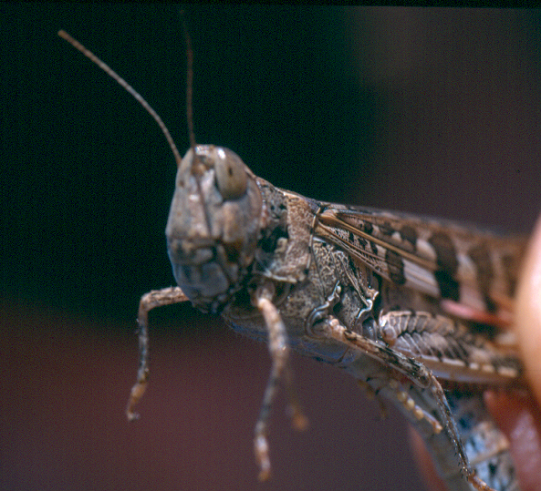

AUSTRALIAN PLAGUE

LOCUST COMMISSION

ANNUAL

REPORT

2015–16

**J:\APLC\APLC-Common\Logos\black\APLC_Logo.tif**

A joint venture of the Australian Government and the Member States of New South Wales, Victoria, South Australia and Queensland.

Contents

[Introduction 1](#_Toc474752394)

[APLC Charter 1](#_Toc474752395)

[Director’s Report: 2015–16 2](#_Toc474752396)

[Overview of 2015–16 locust situation 4](#_Toc474752397)

[Australian plague locust 4](#_Toc474752398)

[Spur-throated locust 8](#_Toc474752399)

[Migratory locust 8](#_Toc474752400)

[Achievement of Key Performance Indicators 10](#_Toc474752401)

[Operations 13](#_Toc474752403)

[Survey 13](#_Toc474752404)

[Forecasting and information 13](#_Toc474752405)

[Control operations and pesticide use 15](#_Toc474752406)

[Organisational Management 16](#_Toc474752407)

[Staffing 16](#_Toc474752408)

[Workplace Health & Safety 16](#_Toc474752409)

[Competency based training and assessment 16](#_Toc474752410)

[Environmental Management System 17](#_Toc474752411)

[National and International linkages 19](#_Toc474752412)

[Administration 20](#_Toc474752413)

[Governance 20](#_Toc474752414)

[Financial Management 21](#_Toc474752415)

[Research 24](#_Toc474752416)

[Purpose and research areas 24](#_Toc474752417)

[Research and Development Collaborations 24](#_Toc474752418)

[Summaries of research in progress 26](#_Toc474752419)

[Publications 31](#_Toc474752420)

[Appendix 1: APLC Commissioners 2015–16 32](#_Toc474752421)

[Appendix 2: Detailed 2015–16 locust situation for each Member State 33](#_Toc474752422)

**Figures**

[**Figure 1:** Australian plague locust distribution November 2015 5](#_Toc475704395)

[**Figure 2:** Australian plague locust distribution February 2016 6](#_Toc475704396)

[**Figure 3:** Australian plague locust distribution April 2016 7](#_Toc475704397)

[**Figure 4:** Spur-throated locust distribution February–April 2016 9](#_Toc475704398)

[**Figure 5:** APLC 2015-16 ground survey coverage and intensity 14](#_Toc475704399)

[**Figure 6:** Temperature, nutrient intake rate and mortality of Australian plague locusts challenged by GreenGuard®. 28](#_Toc475704400)

**Tables**

[Table 1 : APLC performance against KPI measures 10](#_Toc475611254)

[Table 2 : Locust control agent stocks 15](#_Toc475611255)

[Table 3 : APLC Environmental Management System conformance 17](#_Toc475611256)

[Table 4 : APLC 2015-16 financial performance report 22](#_Toc475611257)

[Table 5 : Cost Sharing of Endorsed 2015-16 Budget 22](#_Toc475611258)

[Table 6 : APLC Reserve Fund Reconciliation 23](#_Toc475611259)

# Introduction

The Australian Plague Locust Commission was established in 1974 and began operations in late 1976. The Commission is financed by the Member States of New South Wales, Victoria, South Australia and Queensland, with a matching contribution from the Australian Government. Funding allocations from the Member States are in proportion to the agreed benefit delivered to that state by APLC operations, while the Australian Government contribution reflects the broader national benefit derived from APLC activities. These five governments constitute the Member Parties of the Commission.

## APLC Charter

A Memorandum of Understanding (MOU) was signed between the Member Parties in 2002, and incorporates a Charter that replaced the original terms of reference under which the APLC had operated since its establishment.

The purpose of the APLC, as defined in that Charter, is “to control locust populations in those situations where they have the potential to inflict significant damage to agricultural industries in more than one Member State.” In fulfilling its charter the APLC is required to:

* implement a preventive control strategy to minimise economic loss to agricultural industries caused by the Australian plague locust, spur-throated locust and migratory locust, with priority given to Australian plague locust
* minimise risk of locust control to the natural environment, human health and markets for Australian produce
* develop improved locust management practices through a targeted research program
* provide a monitoring and forecasting system for operations conducted by APLC and Member States
* promote and facilitate adoption of best practice in locust control by Member States
* participate in cooperative national and international programs for development of APLC expertise
* continually review APLC operations to ensure they keep pace with the expectations of industry, community and government.

# Director’s Report: 2015–16

The 2015-16 locust season presented few operational challenges to the Australian Plague Locust Commission due to the limited locust population during the season. One notable challenge of the season was in completing surveys to monitor populations in the more remote parts of Southwest Queensland, northern South Australia and Northwest NSW, where repeated rainfall significantly restricted road access.

The Central West region of New South Wales represented the only real area of locust presence for the season, with even that population declining as the season progressed. Widespread rainfall in western Queensland and northern South Australia in January 2016 provided suitable conditions for egg laying, and this was accompanied by an aggregation of low-level background populations into these suitable areas. The subsequent autumn generation was still, however, only at moderate density in numerous areas. Mid-autumn rainfall in the Southwest Queensland and Far North South Australia regions, with concurrent swarm egg laying, resulted in moderate nymphal densities in these regions in mid-April 2016. Subsequent high-density egg laying after heavy rainfall was observed in these regions in May, and indicates that a more substantial nymphal population may emerge in these regions in spring 2016.

On several occasions, APLC investigated the opportunities for aerial survey and control operations purely to allow training of new field staff and refresh the skills of experienced staff. However, the population neither persisted nor developed to an extent which would enable a training exercise to be undertaken. Continued skills maintenance is a core responsibility expected of the Commission by its Member Parties, as this both enables APLC to implement a response at short notice, and to facilitate a rebuilding of capabilities within other agencies as the need arises.

As projected in the 2014-15 Director’s Report, a significant effort was required to complete the aerial services tendering process in 2015-16. The use of the Australian Government’s “AusTender” process added several levels of procedural and documentary complexity, while further legal advice was required to clarify that APLC (and not any of the individual Member Parties) was the contracting entity. The tender was formally released at the start of March 2016 with tender submissions closing at the end of April. Evaluations of tender submissions was completed in May 2016, with 15 successful tenders received across the five service categories advertised (fixed-wing survey, fixed-wing spray, helicopter survey, helicopter spray and ground support services). The successful tenderers identified from this process represent a reasonable geographical spread across APLC’s area of operations, and provide adequate capacity for the likely workload across those five service categories. They will be contracted for an initial three year period, with the option to extend contracts for another two year period.

**Focus and Challenges for 2016–17**

Following the decision of APLC Commissioners in December 2015 that APLC had addressed all outstanding safety and operational concerns previously raised regarding the low-level use of helicopters for locust survey, it will be necessary to secure a formal acceptance of the residual risk of this operation by all Member Parties. In accordance with the Work Health and Safety Act 2011 and the APLC Risk Decision policy, if the level of a fully treated risk remains High then an authorised officer of each Member Party must formally accept the residual risk, as the risk of all APLC operations is shared jointly-and-severally among all Member Parties. This formal risk acceptance will enable APLC to resume its use of helicopters for locust survey (particularly for definition of adult swarms), which may become a more pressing need in the 2016-17 season.

Having identified a panel of aerial services providers through the 2015-16 tendering process, APLC will need to engage each of the identified businesses under a service contract. Negotiating and finalising these contracts will require differing amounts of work, depending upon the structure and nature of each business entity engaged.

The need to advance the limited work completed in 2015-16 to identify and screen potential new locust control agents will also be a priority in 2016-17, with an expectation that some of the current control agents applied by APLC will face further regulatory and other challenges within the next five years.



Chris Adriaansen

Director APLC

December 2016

# Overview of 2015–16 locust situation

## Australian plague locust

High density nymphs developed in Central West and Northwest New South Wales during spring, following swarm egg laying in eastern parts of these regions in autumn 2015. Hatchings were reported in the Dubbo, Nyngan, Coonabarabran, Gunnedah and Narrabri areas during September, and numerous nymph bands developed during October. By mid-November a number of swarms formed in areas east and south of Dubbo (Figure 1). Low density hatchings were recorded in Far West and Far Southwest New South Wales. Hatching also occurred in the Tambo area of Central West Queensland in September, where late instar nymphs were identified at several locations in early October. The resulting adults persisted at medium densities in the Tambo district during November. Adult densities remained low in all other regions during spring.

Swarms persisted in Central West New South Wales during December and habitat conditions were suitable for breeding, but no egg laying and very few nymphs were subsequently reported. Adult numbers remained low elsewhere in NSW and in other states during December and January. However, several widespread heavy rainfall events in western Queensland and northern South Australia during January resulted in a significant change in locust populations. There was widespread egg-laying in early January and light traps indicated redistribution and aggregation of locust populations during the month. Surveys were subsequently limited by flooding and road closures, but in mid-February late instar nymphs were detected at low densities in habitat areas of Southwest and southern Central West Queensland, and in the Far North region of South Australia (Figure 2). Nymphs fledged in late February and there were several migrations from these regions during March. Moderate population increases were recorded in early March in Far West and Far Southwest New South Wales and in Northeast South Australia. Small increases in locust numbers were reported after mid-March in the Western Agricultural region of South Australia, the Riverina region of NSW and northern Victoria.

An unusual sequence of two autumn breeding events occurred in Southwest Queensland and the Far North region of South Australia, which resulted in a nymph generation developing during winter. There was widespread egg laying by summer generation adults in early March after further heavy rainfall. Medium density, mid-instar nymphs were recorded in many areas of Southwest and part of Northwest Queensland in mid-April. A number of bands were identified in the Birdsville area and in adjacent parts of northern South Australia (Figure 3). This nymph generation fledged in late April and in mid-May high density adults and several swarms were recorded in the Birdsville area. There was additional high density egg laying after heavy rainfall in May, with adults persisting in Southwest Queensland and the Far North of South Australia in June. A subsequent generation of nymphs was identified in early August in the same habitat areas of these regions. The only previous record of significant late autumn egg laying in these regions was in April 1981.

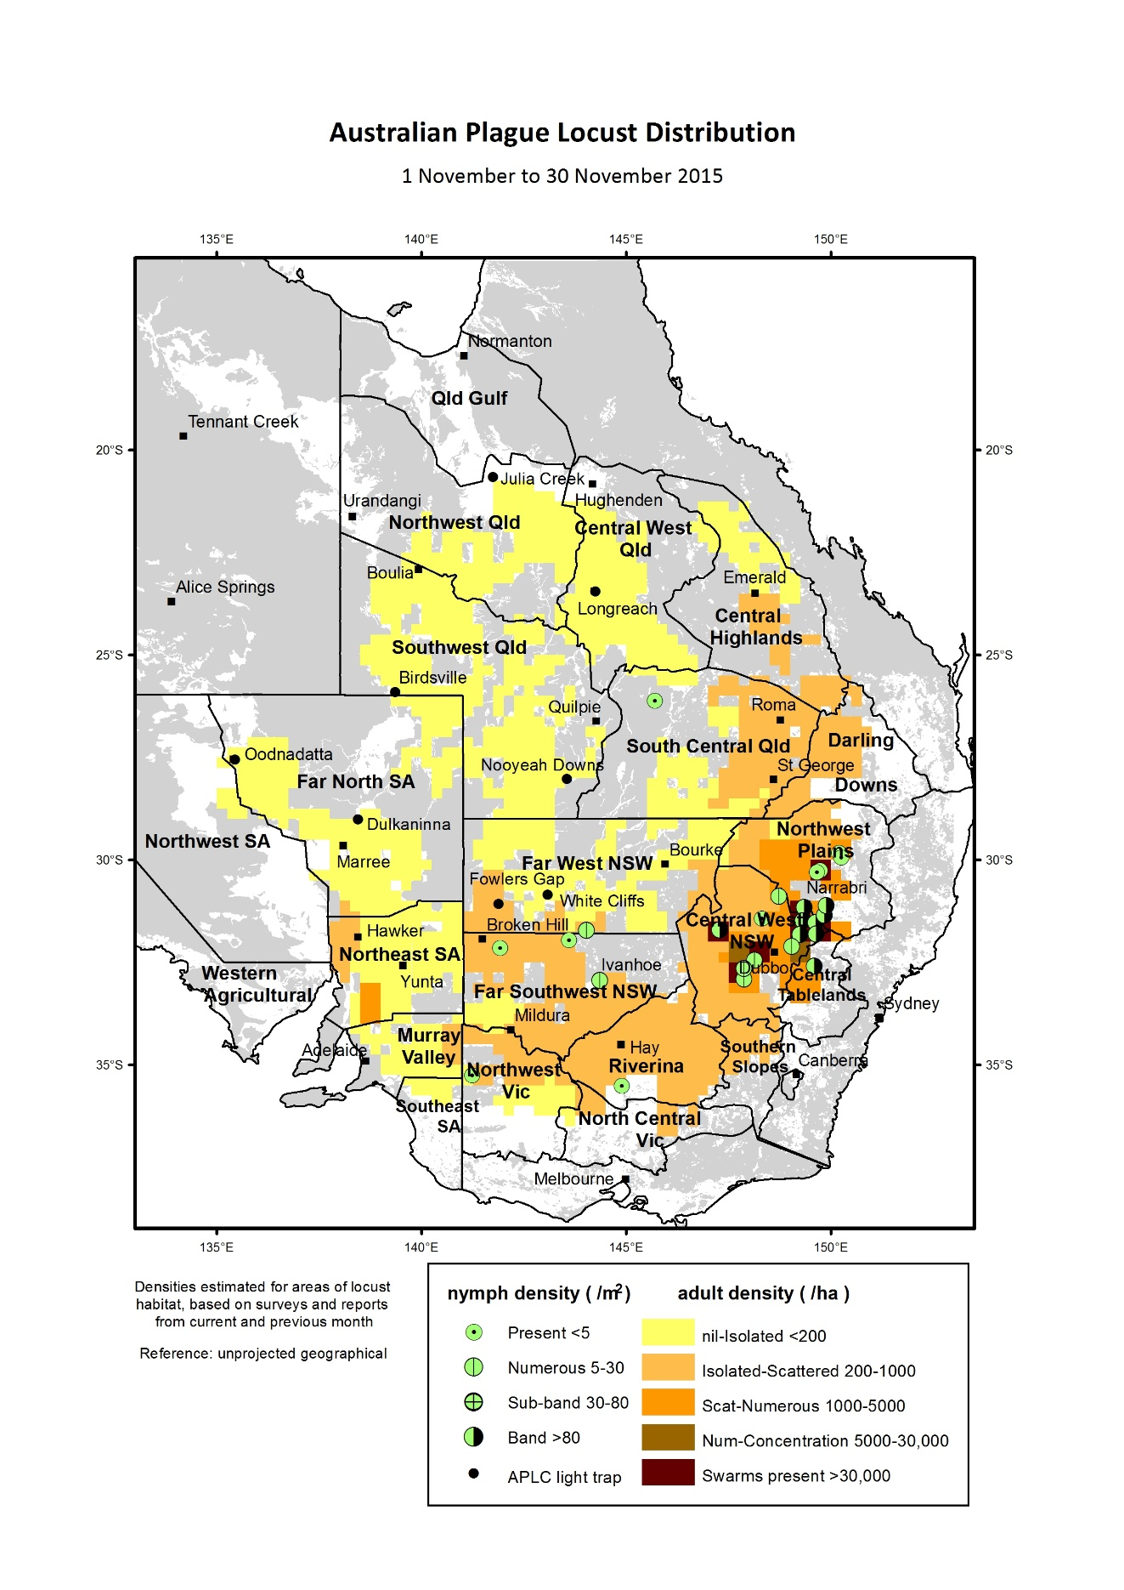

**Figure 1:** Australian plague locust distribution November 2015

## Mapped distribution of Australian plague locust in February 2016.

**Figure 2:** Australian plague locust distribution February 2016

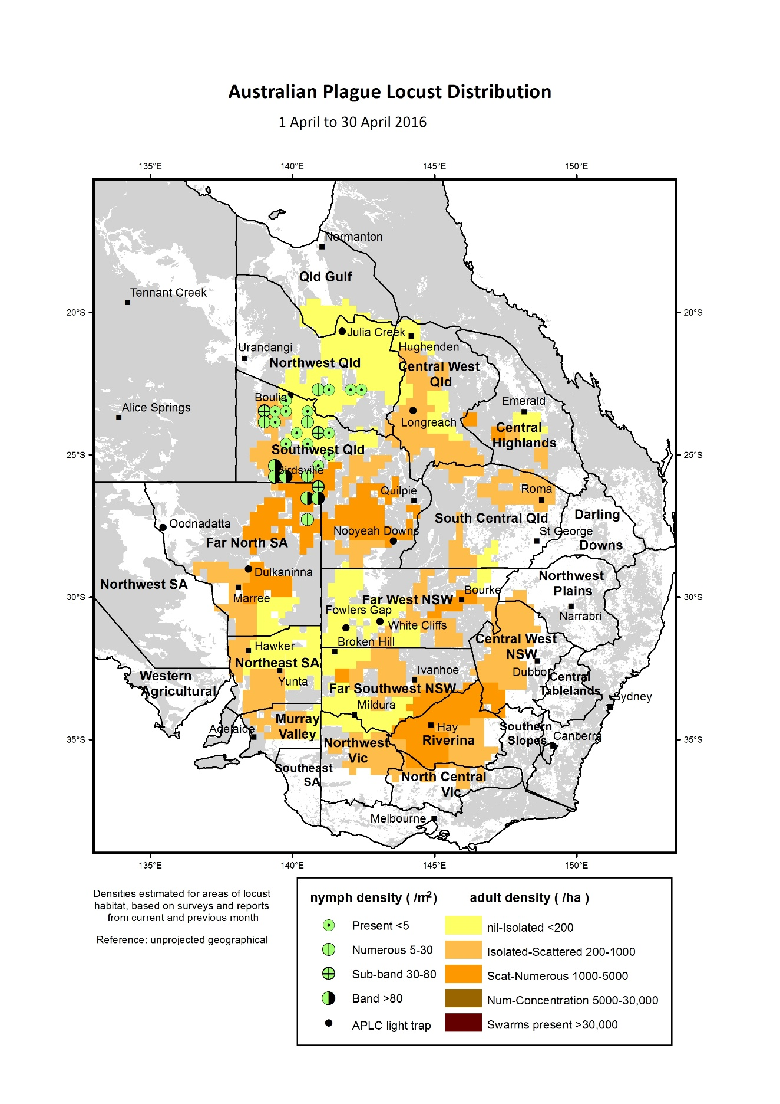

**Figure 3:** Australian plague locust distribution April 2016

## Spur-throated locust

There was a widespread low-density adult population in the Central West, Central Highlands and South Central regions of Queensland during spring. Only occasional adults were recorded in the Southwest, Northwest and South Central regions. However, a swarm was reported from the Tarcombe–Bimerah district of the Longreach Regional Council (RC) area at the start of November and high density adults were subsequently identified at several locations along the Thomson River north of Tarcombe. These locusts were likely to have been immigrants from the north and numbers returned to low densities in that area in the following week. Medium density adults were recorded elsewhere in the Central West and in the Central Highlands in November and December, but no nymphs were detected.

Heavy rainfall in most regions of Queensland during December and at the start of January produced favourable habitat conditions for egg laying and nymph survival. Adult numbers remained at low–medium densities during January and occasional low density early instar nymphs were detected in the Central Highlands around Clermont, and in the Mitchell–Roma area of the South Central region. During February, however, low density nymphs were recorded at many locations in the Central West and in the Windorah are of the Southwest region. Only low numbers of adults and no nymphs were recorded in Quilpie, Bulloo and Paroo Shires, or in northern New South Wales and South Australia.

With the fledging of nymphs from summer breeding, adult population levels increased markedly in Northwest and Central West Queensland during March. Nymphs at various development stages were still widespread in these regions and in the Central Highlands, indicating breeding continued during January and February. In late March, high density young adults and several small swarms, along with residual late instar nymphs, were identified in the Muttaburra–Hughenden, Winton–Kynuna and Julia Creek–Richmond areas (Figure 4). Similar population increases were likely in the Central Highlands and Queensland Gulf regions and in adjacent regions of the Northern Territory, where habitat conditions remained favourable. An increase in population and the formation immature adult swarms during autumn is usual for this species. The overall increase in population level was similar to the previous year.

## Migratory locust

The population level of this species remained low throughout 2015-16, with only low numbers recorded in the Central Highlands, Central West and South Central regions of Queensland during spring and summer. Medium density adults were identified at one location near Alpha in November. Nymphs were only detected in the Arcadia Valley of the Central Highlands during March.

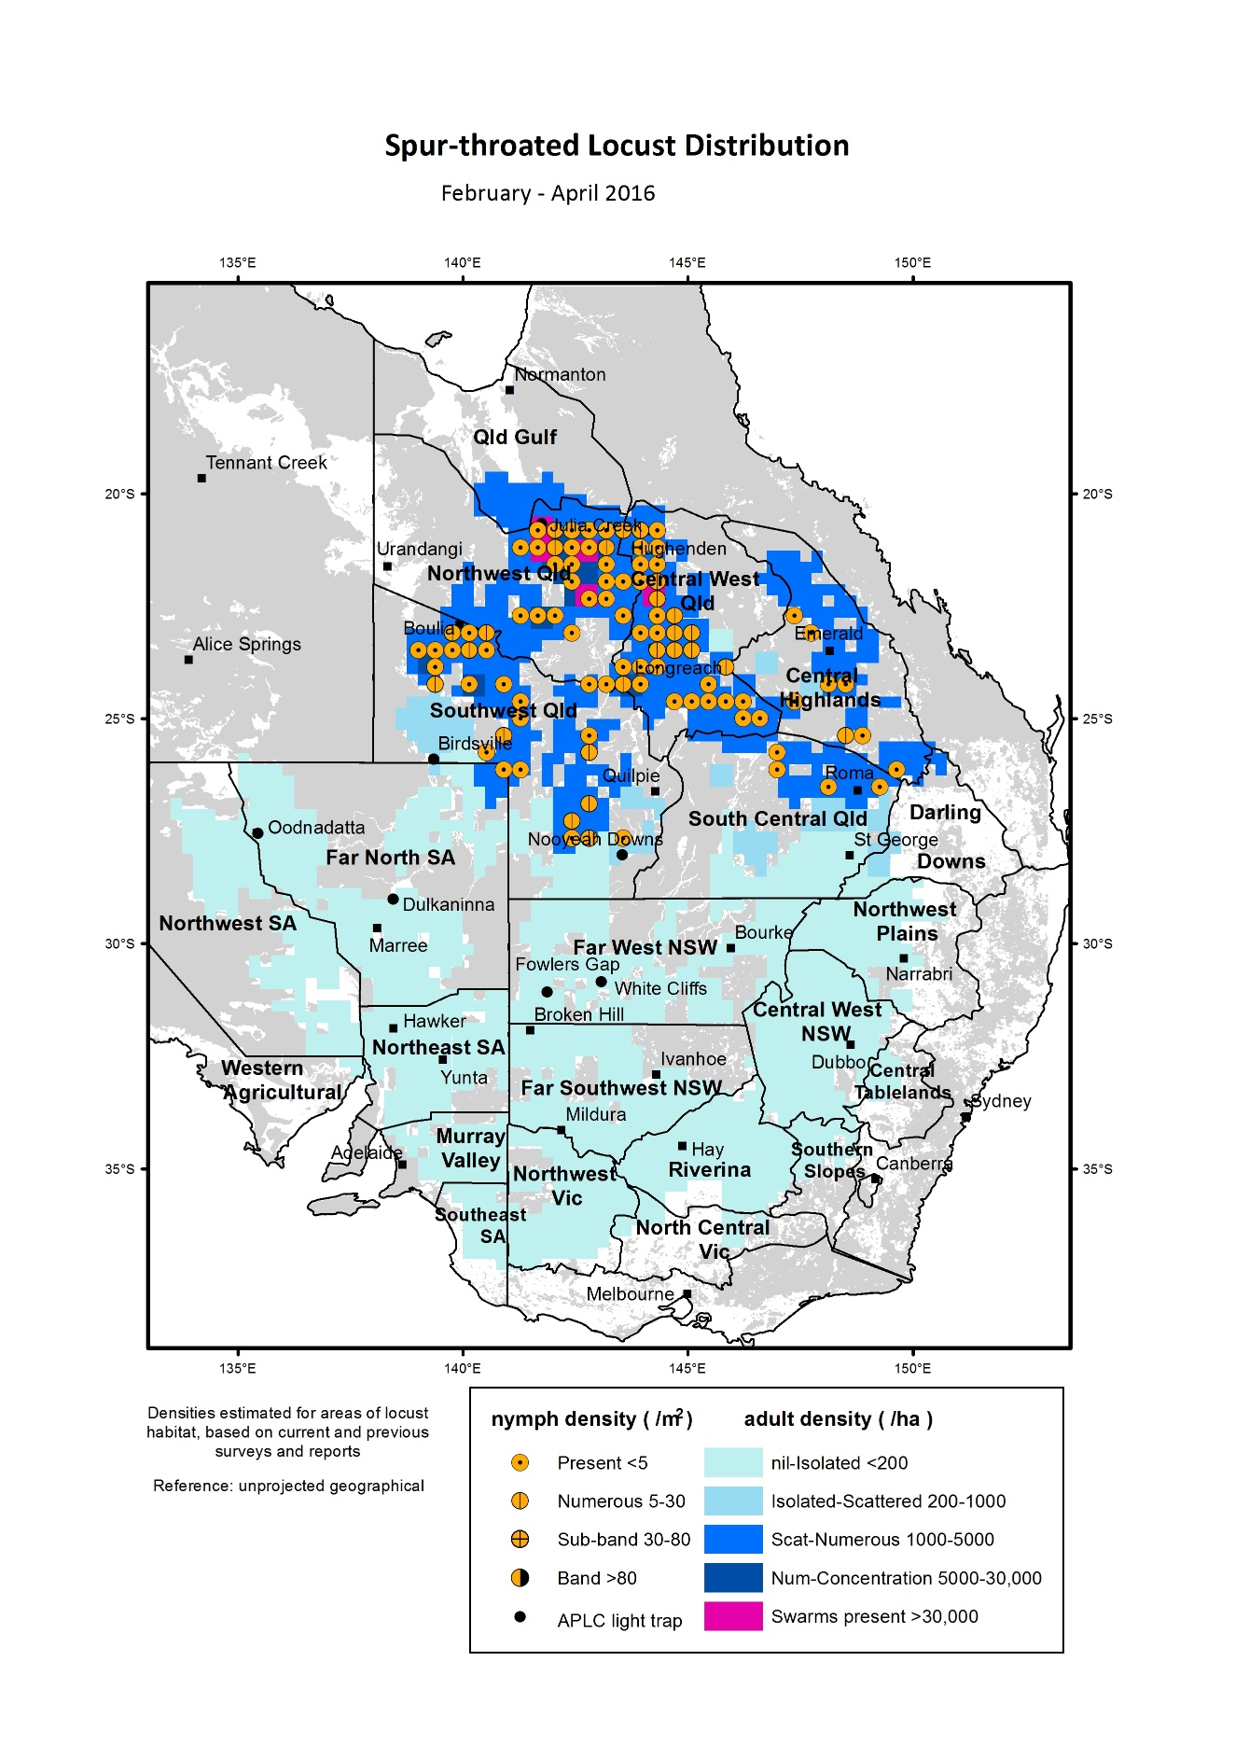

**Figure 4:** Spur-throated locust distribution February–April 2016

# Achievement of Key Performance Indicators

The 2005 external review of the APLC suggested a number of Key Performance Indicators (KPIs) against which the future performance of the APLC could be measured. These KPIs have been adopted with some modifications to provide additional measures for reporting on an annual basis. Details of the KPIs and performance measures, together with an assessment of the APLC’s performance in 2015–16 against each, are summarised in Table 1.

Table : APLC performance against KPI measures

| **Key Performance Indicator** | **KPI Measures** | **Assessment/comments (2015-16)** |
| --- | --- | --- |
| Effectiveness of monitoring, prediction and control of locust populations | Significant populations detected at early-mid instar stage  Accuracy of forecasts of population scale, timing and location  Majority of control measures against nymphal stage  No adverse aerial spraying incidents | Limited populations were detected in 2015-16 , either through APLC survey or through reports received which were confirmed through subsequent survey.  Forecasts accurately indicated consistent low levels with only short-duration and localised higher density infestations.  No control activity undertaken during 2015-16  Not applicable, as no control activity. |
| Availability and effectiveness of control agents | Availability of existing agents  Replacement agents identified and application rates/techniques verified | No change to availability of current control agents.  Issues raised in APVMA fenitrothion review have been further discussed with APVMA. Proposed registration changes recognise the outcomes of pesticide drift research completed by APLC.  Control agent development plan prepared, identifying several candidate agents. Full program for evaluation and verification in preparation, to be implemented from 2017. |
| Environmental impact of control | No reported/observed significant adverse impacts | No observed or reported adverse impacts due to an absence of control operations in 2015-16.  The APLC’s extensive environmental research program continues. Data collation and publication of results from a collaborative longitudinal environmental study in western NSW are nearing completion. Publication of legacy research projects are also nearing completion. APLC research into the effects of specific pesticides on dasyurids is continuing. |
| Trade risks minimised | No adverse trade (residue) impacts | Not applicable, as no control activity undertaken in 2015-16. |
| Cooperation with environmental, OH&S and other relevant agencies in developing and implementing plans for control programs | Plans developed and agreed and reviewed on regular basis. | Review of various WHS documents undertaken, primarily as part of preparing new specifications and standards for aerial services tender process.  Various aerial operations risks addressed through new task protocols and operational requirements, reviewed and approved by relevant external authorities.  Several current environmental policies reviewed as part of preparing responses to national plans dealing with rare & threatened species. |
| Ensuring OH&S of APLC staff, including aerial safety | No significant OH&S incidents | No OH&S incidents were recorded. This can be attributed to sound practices and procedures as well as a very strong safety culture among all personnel. |
| Improved management practices developed through a targeted research program | Research findings incorporated into APLC control strategy and operations | Research activities (detailed in Research section of this report) are linked to key strategic issues of APLC operations, including environmental impact and pesticide application technology.  Major longitudinal study of environmental impact to identify where current practices could be modified to further reduce off-target impact is nearing completion. Emphasis on analysis and publication of legacy environmental research project to facilitate incorporation into risk assessments for pesticide impacts. |
| APLC staff participation in national and international programs/scientific conferences | APLC staff invited to participate in appropriate programs and conferences | National and international scientific and technical conferences and meetings were attended and addressed. Continuing environmental research with international collaborators to enable comparison of APLC practices with international environmental benchmarks. |
| Training of member state staff | APLC training course developed and core of trained member state staff available | No training requested for Member State agency staff during 2015-16. |

# Operations

## Survey

Field survey for the presence and abundance of pest locust species continued throughout the 2015–16 season across the APLC area of operations and in adjacent areas of suitable habitat. Staff from APLC’s three field bases at Narromine, Broken Hill and Longreach undertook regular targeted ground surveys during the season. All field survey information was recorded and stored as part of the APLC Geographic Information System (GIS).

Ground survey operations covered a total distance of over 145,000 kilometres during the season, and focussed on the areas where locust presence was known or anticipated from previous surveys and reports, overlaid by rainfall and habitat condition information. A further level of information regarding the timing of hatching and development for the range of geographical areas was also considered in deciding the timing and location of ground surveys. Figure 5 shows the areas where APLC ground surveillance was conducted during the 2015–16 season, and the intensity of this surveillance. The total distance covered by survey operations in 2015-16 was lower than that recorded for 2014-15, reflecting the low locust population levels and restricted access to some areas as a result of flooding during 2015-16.

No aerial surveillance was undertaken in 2015-16 due to the absence of any significant locust infestations.

## Forecasting and information

The locust surveillance application has now been fully migrated to the iPad platform from the pocket PDA platform used previously. It was developed in house using iCMTGIS III (<http://www.cmtinc.com>), a professional GIS application for iPad IOS, with all of the functions which were previously available in the GBM Mobile package on PDA. It provides drop-down lists for quick selection of locust species, stage, and density. In addition, the iCMTGIS III has built-in FTP and email facilities which make real-time data collection and sharing possible. APLC field officers were trained in the use of this iPad application during the 2015 pre-season meeting and carried out field trials during their routine early season survey alongside the previous PDA application. The new locust survey application has been in operation since February 2016.

The locust survey and control data archived by APLC has been transferred and stored as Oracle databases within the Enterprise Solution system for spatial data processing, operated by the Australian Government Department of Agriculture and Water Resources. This aims to deliver full implementation of a database-centric system to upgrade the current file-based decision-support system. Other archived map and meteorological data will also be transferred into these databases for subsequent comparative analysis where required.

The UNSW insect monitoring radar (IMR) at Bourke airport, NSW was in operation during the whole of the 2015-16 season, but no significant locust migration event was detected, reflecting the overall low population levels. The IMR unit previously located at Thargomindah, Qld, was upgraded with modern hardware and interfaces built to replace the unit which was decommissioned in September 2014. Software for automatically operating the radar, digitising and processing radar signals had been redeveloped in collaboration with the University of NSW (UNSW) – Australian Defence Force Academy. The new IMR system will be able to run constantly during the locust season, providing a more detailed vertical profile of migrant insects, and be accessible for real-time observation and data transfer. Following investigation of possible sites for relocation of this IMR, a suitable location has now been identified at the UNSW Hay Research Station in the NSW Riverina. Trial operations will commence during the 2016-17 season.

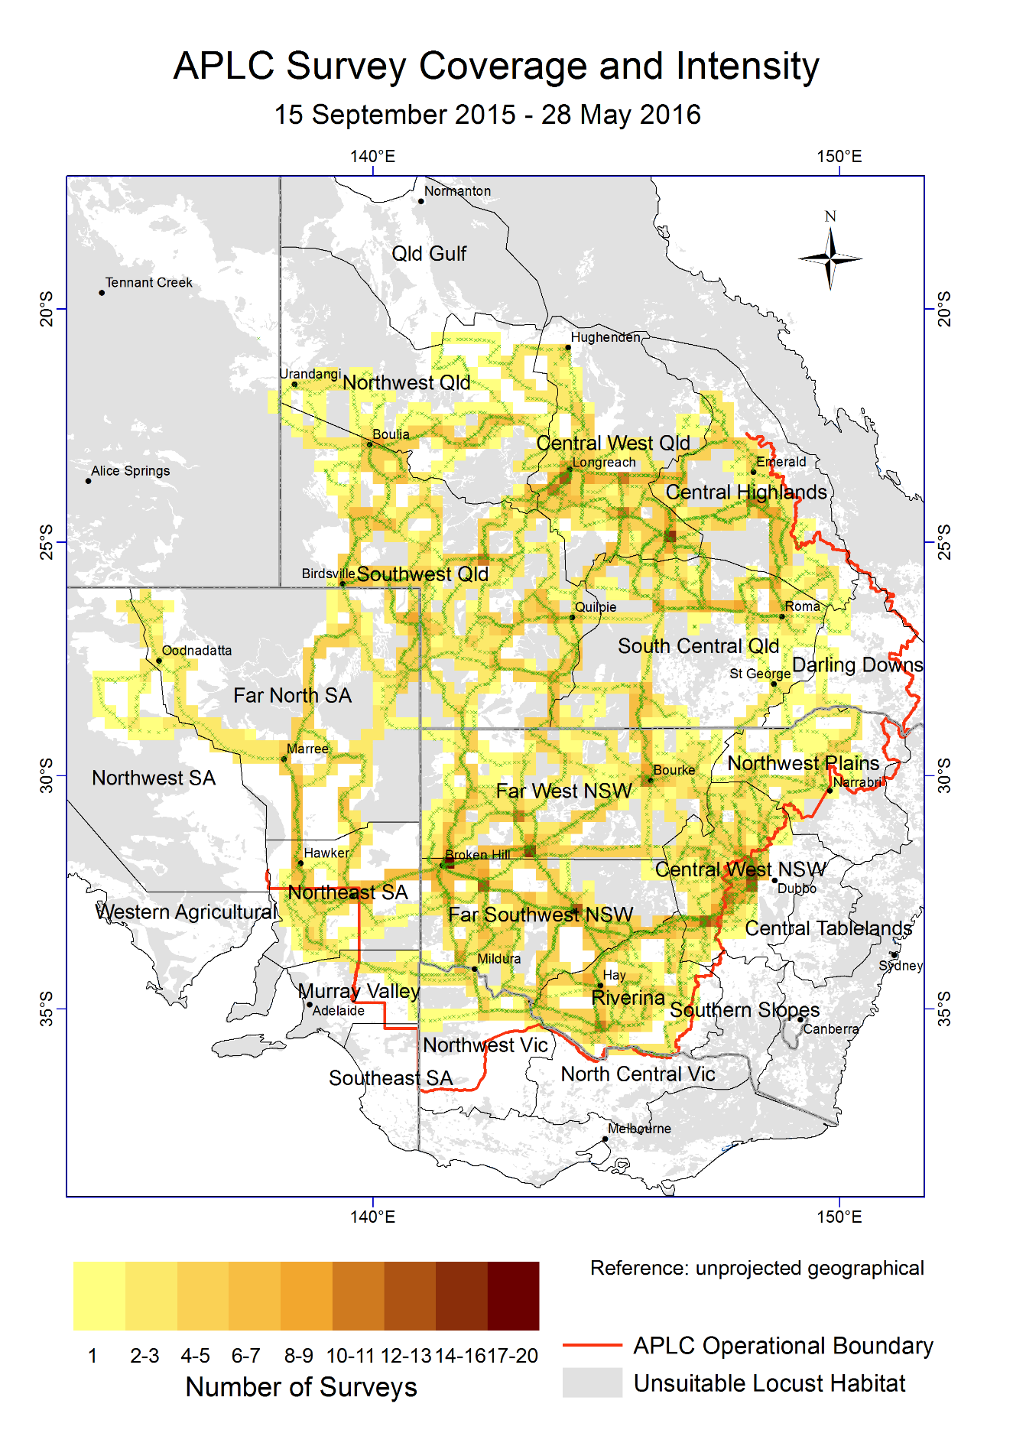

**Figure 5:** APLC 2015-16 ground survey coverage and intensity

## Control operations and pesticide use

No control activity was warranted in 2015–16 due to the absence of any significant locust populations.

Significant quantities of all control agents are currently on hand, as detailed in Table 1.

Table : Locust control agent stocks

|  | ***Fenitrothion***  ***[Sumithion® ]***  ***(litres)*** | ***Fipronil***  ***[Adonis 3®]***  ***(litres)*** | ***Metarhizium***  ***[Green Guard®]***  ***(≡ 14 lt ULV pails)*** | ***Summer Spray Oil***  ***(litres )*** | ***Malathion***  ***[Fyfanon®]***  ***(litres)*** |
| --- | --- | --- | --- | --- | --- |
| On Hand @ 1 July 2015 | **73,856** | **34,400** | **67.25** | **15,990** | **800** |
| Purchased 2015-2016 | **0** | **0** | **0** | **0** | **0** |
| Used 2015-2016 | **0** | **0** | **0** | **0** | **0** |
| Inventory @ 30 June 2016 | **73,856** | **34,400** | **67.25** | **15,990** | **800** |
| Approx. equivalent area (hectares) | **351,696** | **312,727** | **8,070** | **N/A** | **1,143** |
| Inventory Value @ 30 June 2016 | **$1,682,640** | **$409,676** | **$141,398** | **$10,147** | **$6,400** |

The total inventory value of the APLC pesticide stocks held on 30 June 2016 remains at approximately $2.25 million (based on cost at purchase). The above figures do not include the 5 tonnes of fenitrothion still held by APLC on behalf of Queensland or the value of material donated to APLC by the Victorian Government in 2014. The exclusion of the value of this material is to ensure correlation between the inventory value recorded by APLC and that recognised on the asset listing of the Australian Government Department of Agriculture & Water Resources.

Small quantities of pesticide can also be held at APLC field bases for immediate use during a control operation. The remainder (with the exception of the Green Guard stocks) is held at commercial storage premises in NSW.

The majority of Green Guard material is held as dry spores with only a very small quantity routinely held as formulated product. The quantity of Green Guard stock listed above is expressed as 14 litre container equivalents. Green Guard stocks are held by the manufacturer in controlled storage facilities, and were last tested for viability in May 2016. Four batches of spores totalling 21.24 kg fell below the minimum viability specification and are scheduled for disposal in 2016 - 2017. The shelf-life of Green Guard stored by the manufacturer [at 4oC] is guaranteed for 2 years but is only guaranteed for approximately 6 months in the field [at 25oC]. Stored inventory is turned over and replaced when practicable.

# Organisational Management

## Staffing

A number of changes to the staffing of APLC occurred during 2015-16.

Bill Gordon commenced with APLC on the 13 July 2015 as Application and Control Officer, replacing the previous long-standing incumbent Peter Spurgin. Unfortunately, Bill left APLC on 18 June 2016 to pursue interests in the commercial arena. During his time with APLC, Bill was able to establish a matrix of criteria against which new locust control agents should be identified and evaluated. This matrix and the outcomes of his initial work will form a sound basis for the new appointee to this position.

Mathew Connelly commenced with APLC on the 4 November 2015 as Training and Safety Officer. Mathew has commenced a complete revision of APLC’s training materials and operations manuals to ensure currency of both information and format, and to ensure that all relevant regulatory requirements are met.

Two new field assistants commenced duty on 15 February 2016 to fill vacant positions at Longreach and Narromine field bases. William Randall was posted to the Longreach field base, and Genevieve Buckton was posted to Narromine. Both have completed an initial period of intensive training to ensure their safe and effective operation in the field.

## Workplace Health & Safety

During the 2015-16 period there was one minor incident reported to the department. The cause of this incident was due to office furniture. The staff member had an ergonomics assessment to replace office furniture with more suitable furniture and underwent four sessions of physiotherapy.

All operations personnel satisfactorily completed the annual pre-season fitness for duty medical evaluation.

## Competency based training and assessment

Relevant APLC personnel satisfactorily completed or renewed qualifications in Dangerous Goods Transport, Heavy Vehicle Licencing, First Aid and Driver Safety in addition to completing training required to address any outstanding elements of field operations.

Operations personnel have progressed their Competency-Based Training Program elements, with completion of further elements now dependent on controllable locust populations for development and assessment of the complete skill set.

# Environmental Management System

As there were no gregarious populations of locusts within the Commission’s area of operations, no control campaign-related environmental assessment or work was undertaken.

A summary of APLC’s standing in relation to the performance indicators of our Environmental Management System (EMS) is provided in Table 3 below.

Table : APLC Environmental Management System conformance

| **Program** | **Sub-project** | **Progress (2015–16)** |
| --- | --- | --- |
| 1. Excellence in all operational areas | Staff trained to full field competence | Recently-appointed staff continued to progress through competency training in all areas of field operations, other than control operations training which has not been possible due to the absence of a significant locust population. |
| DGPS used in all aircraft | DGPS remains a standard requirement for all aircraft engaged by APLC for application of locust control agents, and is stipulated for all control aircraft in the new aerial services contract specifications. |
| Improved control efficiency | Absence of control operations has not allowed for improvements in control operations to be identified and/or implemented. |
| 2. All waste managed appropriately | Waste management contract | Empty locust control pesticide containers and associated waste collected and disposed of by approved waste management contractor.  Laboratory waste was disposed of through an accredited contractor. |
|
| 3. Minimise the intensity, extent and duration of disturbance to native flora and fauna | Incidents effectively managed | Not applicable, as no control activity undertaken |
|
| Reduce the proportional use of fenitrothion in control ops | Not applicable, as no control activity undertaken |
|
| Increased successful use of fipronil and larger track spacing | Not applicable, as no control activity undertaken |
|
| 4. Contribute to our understanding of natural and managed ecosystems | Develop risk assessment process for APLC pesticides, based on outcomes of environmental research. | Research enabling more relevant pesticide risk assessments for locust control is the primary focus of the APLC Environmental Research Program. The Australian Research Council’s Linkage-funded project to quantify the comparative effects on ecological processes of two locust control agents used by APLC (the chemical pesticide fipronil (Adonis 3UL) and the biopesticide *Metarhizium* *acridum*) was finalised and data analysis and preparation of publications continued throughout 2015-16. A subsequent ARC Linkage proposal to continue this work was submitted, and was successfully awarded an ARC Linkage grant (refer to Research Collaborations section of this report for further details). |
|
| Develop field protocols based on research | Aquatic sampling systems for pesticide residue are now fully developed for operational deployment. Development of passive air samplers for pesticide detection during locust control operations continues. Incorporation of passive sampling into the APLC’s EMS is planned as an environmental monitoring tool to be deployed during future control campaigns. |
|
| 5. Avoid disturbance to protected sites/areas | Development of the GIS, OpsManager® and PDA handhelds sensitive area maps and database | As reported elsewhere in this report, a new platform for survey and other operations has been developed and implemented as part of APLC control operations. The migration of all map layers, including sensitive and restricted sites, is part of this continued development. |
| Procedures and buffers developed to avoid disturbance | No change necessary – current agreed protocols remain appropriate and have been recognised in the APVMA review of locust control agents. The potential for locust spray operations to overlap with areas sensitive to chemical pesticide application are reviewed continuously as needed in collaboration with the relevant environmental authority. |
| 6. Ensure stakeholders are aware of all environmental obligations and they assist APLC achieve these. | Develop environmental aspect into APLC stakeholder training course. | No external stakeholder training requested or undertaken |
| Landholder consultation prior to and after pesticide application | Not applicable, as no control activity undertaken |

# National and International linkages

Dr James Woodman and Ted Deveson participated in continuing research collaboration with Dr Michael Kearney and James Maino from the University of Melbourne toward development of predictive modelling of locust population dynamics.

Dr James Woodman actively maintained a key linkage with Dr Fiona Clissold at the University of Sydney for collaborative access to a captive colony of Australian plague locusts throughout 2015-16 to support various entomology research projects.

# Administration

## Governance

The Commission is governed by six Commissioners: one from each of the four Member States, one from the Australian Government Department of Agriculture and Water Resources and one from the Australian Government Department of Environment. Functional and operational management of the Commission is undertaken by a Director assisted by staff based in Canberra HQ and at three field bases in NSW and Qld. The Commission is accountable to the Ministers of Agriculture representing the five governments which finance APLC. Details of the 2015–16 APLC Commissioners and Director are provided in **Appendix 1.**

A single face-to-face meeting of APLC Commissioners was held in December 2015 to address a number of policy and operational matters, including resolution of low-level helicopter operations for locust survey by APLC. Teleconference discussions of Commissioners were also held in August 2015 to further discuss the 2015-16 APLC budget and funding arrangements (following presentation of the preliminary budget in May 2015), and in May 2016 to present Commissioners with a preliminary 2016-17 budget and funding strategy.

Full records of the Commissioners Meeting and all decisions taken are archived with APLC and held by all Member jurisdictions.

# Financial Management

Total revenue in 2015-16 from all sources amounted to $4.596 million. Of this, $3.496 million was contributed directly by the Member Parties. The remainder ($1.1 million) was drawn from the APLC Reserve Fund, which had an accumulated balance of some $4.255 million at the end of the 2014‑15 financial year. The actual contribution of the Commonwealth was amended from the planned $1,909,500 (as shown in the cost sharing detail below) to $1,799,500. This reduction of $110,000 reflected the lower than expected cost of Government Process overheads (for which there is a direct offset by the Commonwealth) and an adjustment required to restore the correct balance between the Commonwealth and the Member States in the proportions of the accumulated Reserve Fund. Details of these adjustments were provided to and endorsed by APLC Commissioners at the time.

Expenses recorded in the 2015–16 period amounted to $3.757 million, resulting in a net operating surplus of $0.949 million. This surplus was carried over to the 2015–16 financial year as part of the accumulated Reserve Fund, as shown in the 2015–16 financial performance report (Table 4). The balance of the APLC Reserve Fund at the start of the 2016-17 financial year consequently stands at approximately $3.993 million (Table 5). This accumulation of surplus into the reserve fund is in accordance with the Memorandum of Understanding, a position that was reconfirmed by decision of the 62nd Commissioners Meeting in April 2008.

The surplus of income over expenditure was delivered principally as a consequence of the absence of control operations and associated expenditure during the year. Staff vacancies at various times during the year also contributed to this result. Further savings resulted from renegotiation of lease arrangements for several APLC vehicles, and the return of funds where the sale price of replaced APLC vehicles exceeded the lease residual value. Travel costs were substantially below budget, as the absence of significant locust populations and access restrictions caused by road flooding reduced the extent of field survey activities during the 2015‑16 season.

In accordance with APLC budgeting policy established at the 69th Commissioners Meeting in May 2012, the value of the Reserve Fund will be held at (or close to) $3 million, with accumulated reserve in excess of that amount to be applied as a reduction in funding contributions requested from Member Parties for the following financial year. As a consequence, Member Party contributions requested for the 2016-17 APLC budget will reflect the application of $0.993 million of reserve funds. The adjustment effected through the reduced Commonwealth contribution in 2015-16 ensures that the level of the Reserve Fund is now correctly balanced between the Commonwealth and the Member States.

Table : APLC 2015-16 financial performance report

| **Expense** | Approved Budget 2015-16 | Actual Expenditure 2015-16 | Expenditure Variance 2015-16 |  |
| --- | --- | --- | --- | --- |
| Leave and other Entitlements | **162,000** | **178,000** | **- 16,000** |  |
| Other benefits-allowances | **85,000** | **52,000** | **33,000** |  |
| Employee benefits-superannuation | **271,000** | **233,000** | **38,000** |  |
| Wages and salaries | **1,288,000** | **1,203,000** | **85,000** |  |
| Staff development and recruitment | **20,000** | **29,000** | **- 9,000** |  |
| **Total Employee Expenses** | **1,826,000** | **1,695,000** | **131,000** |  |
| Aerial Services - Helicopter | **0** | **0** | **0** |  |
| Aerial Services - Survey Aircraft | **140,000** | **0** | **140,000** |  |
| Aerial Services - Spray Aircraft | **80,000** | **0** | **80,000** |  |
| Aerial Services - Aviation Fuel | **10,000** | **0** | **10,000** |  |
| Insecticide - expensed | **100,000** | **0** | **100,000** |  |
| Bio-Insecticide - expensed | **100,000** | **0** | **100,000** |  |
| Control Ops: Equipment & freight | **20,000** | **0** | **20,000** |  |
| Control Ops: Travel/accommodation | **25,000** | **0** | **25,000** |  |
| **Control Operations** | **475,000** | **0** | **475,000** |  |
| Contractors, consultants & research | **215,000** | **121,000** | **94,000** |  |
| IT & telecommunications | **124,000** | **139,000** | **- 15,000** |  |
| Office equipment, consumables | **9,000** | **17,000** | **- 8,000** |  |
| Other technical & field expenses | **60,000** | **26,000** | **34,000** |  |
| Vehicle leasing and other charges | **300,000** | **248,000** | **52,000** |  |
| Legal Services AGS | **15,000** | **6,000** | **9,000** |  |
| Other administrative expenses | **9,000** | **5,000** | **4,000** |  |
| Conferences, memberships, fees | **3,000** | **3,000** | **0** |  |
| Subscriptions, publications, data | **11,000** | **2,000** | **9,000** |  |
| Communications, media, advertising | **3,000** | **1,000** | **2,000** |  |
| Light trap operations | **20,000** | **12,000** | **8,000** |  |
| Rent, offsite storage & property | **120,000** | **86,000** | **34,000** |  |
| Travel | **270,000** | **130,000** | **140,000** |  |
| **Total Supplier Expenses** | **1,159,000** | **796,000** | **363,000** |  |
| Corporate - Government process | **209,000** | **193,000** | **16,000** |  |
| Corporate - Business overheads | **755,000** | **736,000** | **19,000** |  |
| DA Divisional support costs | **173,000** | **150,000** | **23,000** |  |
| Program overheads | **31,000** | **94,000** | **- 63,000** |  |
| Depreciation & amortisation | **78,000** | **93,000** | **- 15,000** |  |
| **Total Overhead Expenses** | **1,246,000** | **1,266,000** | **- 20,000** |  |
| **TOTAL** | **4,706,000** | **3,757,000** | **949,000** |  |
|  |  |  |  |  |

Table : Cost Sharing of Endorsed 2015-16 Budget

|  |  |  |  |  |
| --- | --- | --- | --- | --- |
| **Member Jurisdiction** | **% Share** | **Core Contribution** | **Govt Process Overhead** | **Total** |
| **Reserve Draw-down** |  | $1,100,000 |  | **$1,100,000** |
| **Commonwealth** | 50 | $1,696,500 | $213,000 | **$1,909,500** |
| **New South Wales** | 32.5 | $1,102,725 |  | **$1,102,725** |
| **Victoria** | 10 | $339,300 |  | **$339,300** |
| **South Australia** | 5 | $169,650 |  | **$169,650** |
| **Queensland** | 2.5 | $84,825 |  | **$84,825** |
|  |  |  |  | **$4,706,000** |

Table : APLC Reserve Fund Reconciliation

|  |  |
| --- | --- |
| Opening balance 01 July 2015 | $4,254,881 |
| Total revenue received 2015-16 | $3,496,052 |
| **Total funds available 2015-16** | **$7,750,993** |
| Total actual expenditure 2015-16 | $3,757,458 |
| **Closing balance 30 June 2016** | **$3,993,475** |

# Research

## Purpose and research areas

In carrying out its charter, the APLC identifies and undertakes research to plan for, and be responsive to, issues relating to its activities. These include, but are not limited to, the efficient monitoring and accurate forecasting of locust populations, the potential environmental and trade impacts of its control programs, the cost and efficacy of control agents, and the decision-making associated with locust control. An ongoing research program is essential to addressing these issues now and into the future. The three research areas targeted are:

* Improvement in efficacy and reduction of risks associated with **control agents and application technology** addressing both immediate and future issues
* Identification and measurement of **environmental** and trade (residue) risks potentially resulting from the APLC’s operations and integration of research results into the core business of APLC and Member State agencies
* Improved understanding of the population ecology of locusts to improve the effectiveness of existing surveillance and forecasting systems as well as improving planning, preparedness and early intervention strategies.

## Research and Development Collaborations

During 2015-16, APLC established two new research collaborations with external entities with whom we have maintained previous successful collaborations.

From 2011 to 2015, APLC provided significant partnership investment (both cash and in-kind) to an Australian Research Council (ARC) Linkage Program project led by the University of Wollongong, which also involved specialist researchers from Macquarie University and Flinders University. APLC’s cash contribution to this project of some $395,000 generated a total project investment from all parties of just under $1.6 million over the life of the project, and secured $575,000 of funding from ARC. In addition to the financial leverage gained by APLC from this research project, significant scientific expertise was accessed from the three collaborating universities to achieve robust outcomes across a wider range of technical areas than could have been covered by APLC alone.

In addition to the planned outcomes and numerous international scientific publications generated (reported in previous and current APLC Annual Reports), this project also identified opportunities for further extensive work to quantify the effect of APLC’s locust control activities, with these results enabling APLC to manage and (where appropriate) modify its locust control activities to minimise environmental impact, and to demonstrate our sound environmental approach. APLC and the three collaborating universities consequently worked in 2015-16 to develop a further project for submission to ARC for this further work.

In order to maintain momentum and to retain the strong collaborative links between the researchers and institutions involved, APLC and the University of Wollongong agreed to fund and conduct a short-term partnership project during 2015-16. This project was designed to generate information which, while of value in itself, would also ensure that any new longer-term project would commence from a more advanced base. APLC invested $37,000 in cash and a further $27,000 in-kind for this one-year partnership project, with the University of Wollongong providing $50,000 in-kind support and securing a $19,000 grant from university funds. Macquarie University and Flinders University collectively invested some $25,000 of in-kind support to this project.

While this partnership project was being undertaken, the collaborators from APLC and the three universities involved prepared a new three year ARC Linkage project application, scheduled to commence at the end of 2016. This application was also successful, resulting in a project with a total value of $1.52 million to be conducted over the 2016-17, 2017-18 and 2018-19 financial years. Further detail of this project are presented below, with the initial outcomes to be reported in future APLC Annual Reports.

APLC had previously engaged with the University of Sydney in an ARC Linkage project from 2008 to 2011 to investigate the factors which determine the movement of locust nymphal bands. Towards the end of this project in November 2010, significant concentrations of nymphal mortality occurred in some areas which warranted detailed investigation to determine the casual organism and/or factors. Following initial investigations, it was agreed to construct a new ARC Linkage project application to take this work further.

After a number of rounds of unsuccessful application, the new ARC Linkage project was funded to commence in late 2015 and conclude in mid-2018. Details of the project objectives and progress are reported below in the “Summaries of research in progress” section.

This project brings together expertise and effort from two Australian universities, one UK university, BASF (the manufacturer of the current locust bio-pesticide Green Guard®) and APLC. Over the life of this project, APLC will invest $135,000 in cash and a further $405,000 in-kind to secure a total project worth $1.25 million (including $385,000 of cash grant from the Australian Research Council).

APLC has also maintained its long-standing relationships with both the Australian National University (ANU) and the CSIRO Wildlife Ecology division to further certain elements of both the entomology and environmental research areas. Details of these collaborations are reported below. There has also been continued engagement with specialists from the University of NSW – Australian Defence Force Academy (ADFA) to further develop and refine the insect monitoring radar capacity operated by APLC and ADFA.

In all instances, the collaboration between APLC and these institutions and agencies has added significant value to the APLC research portfolio. APLC officers are able to gain access to facilities and equipment which are not available to them within the APLC laboratory areas, primarily because their frequency of use does not justify the investment required. More importantly, however, APLC and its researchers build intellectual capital and expertise which not only expands the APLC knowledge base, but also provides a professional point of reference for APLC researchers operating in relatively narrow technical areas.

## Summaries of research in progress

*The following research summaries provide an overview of current research activities being undertaken by the Australian Plague Locust Commission. The research summaries are not considered to constitute publication as the investigations are often incomplete and any results presented tentative.*

### Entomology Program

**Understanding adaptations and limitations in locust eggs oviposited in dry substrates**

This project aims to better understand the effects of embryonic quiescence and diapause on locust population dynamics. The first phase of this work is focussing on how long eggs remain viable in quiescence and diapause in dry substrate in the laboratory. The extent to which hatchling body condition (and subsequent vitality/survival) is dependent on water availability and temperature before, during and after different quiescent periods is also being investigated. Results to date indicate survival beyond 14 weeks in quiescence in dry substrate at 30°C. To this point, there appears to be little effect on hatchling nymph body condition and only a slight decrease in survival to second instar.

**Effects of inundation on Australian plague locust egg development and viability**

This study has quantified the effects of different inundation durations at different temperatures on locust egg development and viability. Development rates, egg survival, hatchling condition and nymph survival to 2nd instar have been quantified to estimate the impacts of flooding on population dynamics in the field. Results show that most eggs can survive >14 days, unless soil temperature is ≥25°C. Additionally, the embryonic development stage at the time of flooding is important, with higher mortality in eggs inundated at later stages. This work has now been published.

**Physiological regulation of feeding and responses to starvation in Orthoptera**

An Honours student at the Australian National University, Canberra, under the supervision of Dr James Woodman has characterised the structure and physiology of the foregut in different locust species to begin to understand its role in digestion. Results have revealed intricate patterns of arranged spines on the interior surface that may shred ingested food and then pass it into the mid-gut with the assistance of contractions from a network of associated musculature. This work indicates a previously undescribed role of the fore-gut in processing food before passage to the mid-gut. The next phase of this work is now analysing this morphological data for species and sex differences. Experiments are also underway to understand the initiation and termination of the muscle contractions. Preliminary results are showing clear patterns of muscular contraction associated with digestion and that these patterns can be stimulated or inhibited by different amines (neurohormones). This project is part of a broader research direction to understand the regulation of feeding behaviour and digestion for locust species with different feeding ecologies. There is also the potential for discovering specific biochemical targets for disrupting the capacity to process ingested food.

This work has been undertaken in collaboration with Dr Paul Cooper at the Australian National University, Canberra.

**A review of the population ecology of the Australian plague locust**

This project has been restructured and is on-going as a collaborative initiative with Dr Fiona Clissold (University of Sydney) and Dr Jerome Buhl (University of Adelaide). The work will acquire and synthesise all relevant information on the key factors that influence locust population size. The planned publication will improve APLC’s knowledge base and identify important knowledge gaps and priorities for future research.

**Physiological aspects of locust survival: effects of soil salinity on locust oviposition behaviour and embryonic development**

This project is part of a long-term ongoing research program to quantify physiological tolerance to different environmental conditions that may be encountered in the field and impact on locust population dynamics. Specifically, this work has recently quantified the effects of different substrate salinity levels (control, 4, 8, 12, 16, 20, 24, 28 ppt NaCl) on female oviposition behaviour (e.g. test drilling propensity), embryonic development (i.e. potential for quiescence) and survival to hatching. Results indicate embryonic developmental arrest by quiescence at ≥16 ppt NaCl due to altered osmotic gradients. The work has now been accepted for publication and is in press.

**Dynamic energy budget modelling for *Chortoicetes terminifera***

**(with the University of Melbourne)**

This work is a collaborative initiative with Dr Michael Kearney and Dr James Maino at the University of Melbourne and has progressed to having a parameterised dynamic energy budget model for predicting *C. terminifera* phenology. This type of model makes use of life history, eco-physiological and environmental data to predict phenology in a more sophisticated way than previously available. The model now requires validation testing.

### Control Agents and Application Technology Program

**Locust immunity and native disease organisms as possible new control agent candidates**

***[Australian Research Council Linkage Project LP150100479]***

Stemming from the mass nymphal mortalities observed near Hillston in November 2010 during a previous ARC Linkage project in collaboration with the University of Sydney, this new collaborative project aims to:

* identify and quantify the microbiota occurring in *C. terminifera* populations across seasons and regions
* compare immune function and disease resistance in locust populations from different regions,
* quantify the effects of temperature and locust nutritional state on immune function and disease resistance
* study the pathogenicity of *Pseudomonas* sp. collected in 2010 as well as any other identified candidate disease organisms, and
* explore the effects of pathogens on locust ecology and behaviour.

The current *Metarhizium* locust biopesticide GreenGuard*®* will be used as both a basis for comparing the efficacy of any new organisms identified, and for evaluating the ability of locusts to deal with microorganism infections across various temperature and nutritional profiles.

Field sampling to identify candidate disease organisms is expected to begin in spring 2016, with APLC field staff to collect and preserve specimens taken from higher-density nymphal populations for later screening at the University of Sydney. The sampling protocol has been established and preservation kits provided to all APLC field staff.

Research has commenced with the assistance of an honours student at University of Sydney to investigate the role of nutritional status in the progression of *Metarhizium* infection. This has established a profile of locust nymph disease resistance / susceptibility across temperature and nutritional gradients, as shown in Figure 6 below. The intake rates of protein and carbohydrate of locust nymphs challenged by *Metarhizium* is temperature dependant (as shown by the black lines in all three plots presented in Figure 6), with intake rates lowest at 26°C and highest at 41°C. All locusts exposed to *Metarhizium* died at 26°C when ingesting a diet where protein was excessive to requirements, while locusts showed the greatest resistance to *Metarhizium* infection when carbohydrate was supplied in excess of requirements at temperatures above 38°C.

Additionally, it has been found that the development rate of locust nymphs is severely retarded when challenged with *Metarhizium*. This aspect will be further investigated to determine its implications for the timing of GreenGuard*®* application.

A literature review of the population ecology of *C. terminifera* has also commenced as a tangent to this work and is identifying knowledge gaps which will assist in prioritising future research.

### A series of three graphs showing the level of mortality of Australian plague locusts challenged by GreenGuard infection related to temperature exposure, carbohydrate and protein intake of those locusts.

**Figure 6**: Temperature, nutrient intake rate and mortality of Australian plague locusts challenged by GreenGuard®.

### Environmental Program

**The effect of fipronil on the fauna of arid grasslands**

***[University of Wollongong SMAH Research Partnership Grant]***

Continuing the APLC’s research collaboration with the University of Wollongong (UoW), and as a pilot study for an Australian Research Council (ARC) Linkage grant detailed below, a successful application for a Research Partnership grant from the UoW enabled a study to develop methodologies for quantifying vegetation characteristics to assess pesticide residue deposition in a manner relevant to the organisms inhabiting these ecosystems.  Additionally, population distribution and abundance of 4 target species, stripe-faced dunnart (*Sminthopsis macroura*), bearded dragon (*Pogona viticeps*), white winged fairy wren (*Malurus leucopterus*) and the ant species, *Rhytidoponera mayri*, were evaluated, as well as techniques for animal gorge feeding and radio telemetry studies.  Specifically, the pilot study aimed to;

* collect information on populations densities of the 4 fauna species which have been subject to minimal previous study in Australia.  One species, *S. macroura*, is considered threatened and responses of this species to pesticide exposure can be used as a model for other endangered marsupials.
* develop a new technique for measuring habitat complexity to understand spray deposition patterns, which will be used in other ecosystems to understand deposition of pesticides. This represents a globally-relevant approach that will allow more informed decisions on locust control both in Australia and elsewhere by enabling direct comparisons of biologically available residue data and pesticide risk assessments.
* assess the ability to replicate the dosage levels of insects exposed to pesticides in a near natural setting.

This Partnership project focused on developing and optimising some of the methods planned for the new Linkage project outlined below. The Partnership project was successful in assessing the feasibility of tracking two target species and began quantifying techniques for measuring vegetation structure and dosing locusts with pesticide for use in gorge feeding studies. Based on our preliminary results from radio tracking, both bearded dragons and stripe-faced dunnarts will provide a feasible field model for pesticide exposure studies. During late summer, individuals are likely to move only short distances, allowing researchers to re-locate and monitor individual movements and condition on a small scale. The vegetation cover and nest density of the ant species *R. mayri* were surveyed in the grasslands at Fowlers Gap Research Station. The results of these surveys were used to begin developing monitoring techniques for ant activity and characterizing ecosystem compartments in arid-zone native vegetation communities. Laboratory work has begun to identify the optimum procedure for dosing live locusts with realistic levels of pesticides, which will entail immersing individuals in low dose concentrations of pesticides that do not cause immediate mortality.

The impact of pesticides on wildlife is an important consideration during registration and permit review of agricultural chemicals. The primary exposure route used to assess the hazard of pesticides to wildlife is direct oral ingestion, yet conflicting data exists on its importance as an exposure pathway. Routes of exposure other than ingestion are seldom considered in risk assessments for wildlife due to a lack of data. More specifically, Australian endemic species are not included in the species tested for impacts and no allowance is made for the high intake levels which result from gorge feeding.  Previous research identified few broad long-term impacts of fipronil application at the ecosystem level but we did not sample for pesticide residues during a locust outbreak and therefore missed the opportunity to quantify impacts of dietary exposure in arid zone-adapted, gorge feeding vertebrate species. Furthermore, we did not capture the very short-term (< 2 weeks) acute impacts of aerial spraying on key invertebrate and vertebrate taxa as part of the previous Linkage project, nor did we investigate the relative importance of dermal exposure or ingestion (gorge-feeding) on toxicity for non-target organisms.

As a result there is a need to develop an understanding of how different organisms encounter pesticides in the environment, and how this influences their ability to survive. In the Linkage and Partnership studies we will focus on identifying residue pathways and assessing changes in activity and behaviour in the field for four different arid zone species.

**Impacts of locust control pesticides on arid-zone fauna**

***[Australian Research Council Linkage Project LP160100686]***

Following on from a previous ARC Linkage project (LP110200105), this research continues the productive collaboration between the APLC, University of Wollongong, Macquarie University and Flinders University. This research aims to improve our understanding of how different organisms encounter pesticide in the landscape through quantifying residue deposition in arid grasslands and investigating how pesticides used to control locust plagues impact on the behaviour and physiology of key target fauna. Two pesticides currently used for aerial control of locusts; the organophosphate pesticide, fenitrothion, and the phenyl pyrazole pesticide, fipronil, will be investigated. Specifically, this project will;

* develop a spray deposition model of aerial ultra-low volume (ULV) applications of fipronil and fenitrothion, incorporating residue depletion profiles over time within different ecosystem compartments in arid-zone native vegetation communities
* determine the short-term impact of aerially sprayed fipronil and fenitrothion on the behavior and condition of free-ranging target fauna that use the environment differently, including a small marsupial mammal, lizards of different sizes, small birds and an ant species
* quantify the relative importance of dietary and non-dietary pesticide exposure routes in vertebrates to gauge the importance to behaviour on pesticide exposure for key target animals.

This research will improve understanding of how different animals encounter pesticides in the landscape through quantifying residue deposition in arid grasslands and investigating how pesticides used to control locust plagues impact on fauna. This project will develop a deposition model for aerial pesticide spraying, determine the short-term impact of sprayed pesticides on the behaviour and condition of free-ranging target fauna that use the environment differently and quantify the relative importance of dietary and non-dietary exposure routes to gauge the importance of animal behaviour on pesticide exposure. The results will contribute to biologically relevant risk assessments for the registration of pesticides and improve existing knowledge of the spray deposition behaviour of fipronil and fenitrothion applications, and their impacts on native fauna, to inform the APLC regarding the future use of these pesticides.

**Sensitivity of *Sminthopsis macroura* (Gould 1845) to the phenyl pyrazole insecticide, fipronil**

A lack of data quantifying responses of Australian native mammals to agricultural pesticides prompted an investigation into the sensitivity of the stripe-faced dunnart, *Sminthopsis macroura* (Gould 1845) to the phenyl pyrazole locusticide, fipronil. Using the Up-And-Down method for determining acute oral toxicity in mammals (devised by the Organisation for Economic Co-operation and Development, OECD) median lethal dose estimates of 990 mg kg-1 (95% CI = 580.7 – 4770 mg kg-1) and 270.4 mg kg-1 (95% CI = 0 - >20,000 mg kg-1) were resolved for male and female *S. macroura* respectively. Concern over the difference between median lethal dose estimates for males and females being influence by the increased age of 2 female dunnart included in the trial, resulted in further modelling of dunnart responses to fipronil using the assumptions (a) death at 2000 mg kg-1, (b) survival at 500 mg kg-1 and (c) a differential response (both survival and death) at 990 mg kg-1, based on response patterns of dunnarts during the experiment. This modelling revealed median lethal dose estimates for female *S. macroura* of 669.1 mg kg-1 (95% CI = ;550 – 990 mg kg-1), assuming death at 990 mg kg-1, and 990 mg kg-1(95% CI = 544.7 – 1470 mg kg-1) assuming survival at 990 mg kg-1.

The unexpectedly high median lethal dose estimates identified in the current study are 3 - 10 fold higher than the only available LD50 value for a similarly sized eutherian mammal, *Mus musculus* (L. 1758; 94 mg kg-1), and that available for *Rattus norvegicus* (Birkenhout 1769; 97 mg kg-1). Behavioural responses of dunnarts dosed with fipronil were also recorded during the experiment and these are currently being coded and analysed using The Observer software (Noldus Pty Ltd) so that timeline of toxicological signs can be developed.

This project was undertaken as part of the APLC’s ongoing collaboration with CSIRO Wildlife Ecology division at its Black Mountain Laboratories.

# Publications

Adriaansen, C, Woodman, JD, Deveson, E & Drake, VA 2016, ‘The Australian Plague Locust – Risk and Response’, *Biological and Environmental Hazards, Risks, and Disasters*, Elsevier, Oxford, UK.

Deveson, E 2016, ‘Parasites, politics and public science: the promotion of biological control in Western Australia, 1900-1910’, *British Journal for the History of Science*, vol. 49, pp. 231-258.

Maute, K, French, K, Bull, CM, Story, P, & Hose, G 2015, ‘Current insecticide treatments used in locust control have less of a short-term impact on Australian arid-zone reptile communities than does temporal variation’, *Wildlife Research*, vol. 42, pp. 50-59.

Maute, K, French, K, Story, P, Bull, CM & Hose, GC 2016, ‘Effects of two locust control methods on wood-eating termites in arid Australia’, *Journal of Insect Conservation*, vol. 20, pp. 107-118.

Story, PG, French, K, Astheimer, LB & Buttemer, WA 2016, ‘Fenitrothion, an organophosphorus insecticide, impairs locomotory function and alters body temperatures in *Sminthopsis macroura* (Gould 1845) without reducing metabolic rates during running endurance and thermogenic performance tests’, *Environmental Toxicology and Chemistry*, vol. 35, pp. 152-162.

Woodman, JD 2015, ‘Surviving a flood: effects of inundation period, temperature and embryonic development stage in locust eggs’, *Bulletin of Entomological Research*, vol. 105, pp. 441-447.

### Appendix 1: APLC Commissioners 2015–16

Dr Sally Troy (Chair)

Assistant Secretary, Plant Health Policy

Department of Agriculture, Fisheries and Forestry - Australia

GPO Box 858 Canberra ACT 2601

Mr Andrew McNee

Assistant Secretary - Chemicals and Waste Branch

Environment Standards Division

Department of the Environment

GPO Box 787 Canberra ACT 2601

Mr Barry Kay

Director - Emergency Operations, Intelligence and Programs

Department of Primary Industries

Locked Bag 21 Orange NSW 2800

Mr Gordon Berg

Principal Officer – Entomology

Biosecurity Division

Department of Economic Development

Private Bag 15, Ferntree Gully Delivery Centre VIC 3156

Mr Mark Ramsey

Principal Policy Officer – Biosecurity SA

Primary Industries and Regions SA

GPO Box 1671 Adelaide SA 5001

Mr Kevin Strong

Manager Operations - Invasive Plants and Animals   
Biosecurity Queensland   
Department of Agriculture and Fisheries

GPO Box 46, Brisbane. Qld. 4001.

**Director**

Mr Chris Adriaansen

Australian Plague Locust Commission

50 Collie Street, Fyshwick ACT 2609

### Appendix 2: Detailed 2015–16 locust situation report for each Member State

### Specific details regarding locust population densities and locations can be found in the monthly Locust Bulletins issued for the 2015-16 season, available from the APLC web pages at agriculture.gov.au/pests‑diseases‑weeds/locusts/bulletins.

### New South Wales

There was an infestation in the eastern parts of Central West and Northwest New South Wales during spring, following swarm egg laying in autumn 2015. First hatchings were reported from the Narrabri, Gunnedah and Coonabarabran areas in mid-September. Bands developed in October, with many reports from the Dubbo–Gulargambone and Coonabarabran–Mullaley areas (Figure 1). Nymphs and some bands were also reported in the Gunnedah, Narrabri, Mudgee, Condobolin, Nyngan and Forbes areas. Landholders and state agency staff carried out control of bands during spring. Low density nymphs were recorded in the Far West and Far Southwest regions in October, with medium density mid-instar nymphs detected near Broken Hill and Bourke. Only occasional adults were identified in the Far West, Far Southwest and Riverina regions.

A number of swarms formed in the Central West during November, but the adult population gradually declined during December and no subsequent nymph generation was reported, despite rainfall in December. Adult densities also declined in the Northwest Plains, Far West and Far Southwest regions and remained low in the Riverina. Numbers remained generally low during January and February, with medium density adults only recorded in localised areas of the Ivanhoe, Wentworth and Bourke districts in the Far Southwest and Far West regions. A small area of high density adults and residual late instar nymphs was identified near Moolbong in the Hillston–Ivanhoe area, indicating localised breeding occurred in late December (Figure 2).

There were several periods of migration activity during March and locust numbers increased in western NSW after movements from large populations that had developed in Southwest Queensland and northern South Australia. Landholders in the Broken Hill area reported locusts appearing in early March and surveys identified an increase to medium densities in the Broken Hill, White Cliffs, Wilcannia, Ivanhoe, Wentworth and Balranald districts. Locust numbers also increased in the western Riverina and further migrations within NSW in mid-March resulted in movement to the Deniliquin district of the southern Riverina. Densities declined again in the Far West, Far Southwest and Riverina during April, but small areas of medium density adults persisted in localised favourable habitats south of Broken Hill and Hillston–Booligal areas.

### Queensland

Locust population levels were low in most Queensland regions during spring, but localised high density nymphs and medium density young adults were identified in the Tambo–Charleville area of the Central West region in late September. Adult numbers remained at medium densities in that area during spring, while only low densities were detected in other regions. During December and January only low density adults and occasional nymphs were recorded, although populations of several grasshopper species, including *Gastrimargus musicus* and *Oedaleus australis*, were widespread in the Central West and Central Highlands.

Widespread heavy rainfall at the start of January and again in mid-January initiated breeding in the Southwest, Central West and part of South Central Queensland. Nymphs were detected at many locations in Quilpie and Barcoo Shires, and in Longreach and Blackall-Tambo Regional Council areas during February, along with medium density young adults in some locations (Figure 2). Adult numbers increased following the fledging of nymphs in late February and there was some migration to Far West NSW and northern South Australia during March.

Breeding occurred again in early March, as habitat conditions remained favourable after further heavy rainfall in Southwest and Northwest Queensland. Another nymph generation developed during April, with medium density nymphs recorded in many areas of Diamantina, Barcoo, Boulia and Winton Shires. Several bands of mid-instar nymphs were identified in the Birdsville area in mid-April (Figure 3). Adults from that generation that remained in the Southwest were able to breed again after unseasonal widespread heavy rainfall in May. A further nymph generation developed during winter and was detected as mid–late instar nymphs in early August.

### Victoria

The locust population level remained low in Victoria throughout spring and summer, with only low density adults recorded in the North Central and Northwest regions. An increase in adult numbers was reported in the Echuca area on 10 March, and near Mitiamo on 22 March. These immigration events coincided with the passage of low pressure weather systems and there were redistributions within Victoria during March and April. Locusts were reported from the Kerang, Wycheproof, Quambatook and St Arnaud areas in mid-April, but numbers remained generally low during autumn.

### South Australia

Spring population levels remained low in most regions during spring. Medium density nymphs were detected at one location north of the Flinders Ranges in September and nymphs were reported near Burra in October. Numerous density adults were recorded near Burra in November, but only occasional adults were detected in other parts of the Northeast.

Adult numbers remained low in the Northeast and Far North regions during December, but heavy rainfall in early January produced favourable breeding conditions. Light traps at Dulkaninna and Oodnadatta detected nocturnal locust activity during the first half of January, indicating population redistribution in the Far North. Medium and high density nymphs developed in the Clifton Hills and Cordillo Downs areas during February, and high density young adults were recorded at some locations in mid-February (Figure 2).

Heavy rainfall during March initiated further breeding in the Far North, and in mid-April medium density nymphs and several bands were detected in the Cordillo Downs area (Figure 3). An increase in locust numbers was reported in agricultural districts on the Eyre Peninsula in April, indicating some migration from northern regions. There was further localised breeding in the Far North during May, and adults were reported to be active in the Innamincka area as late as June.