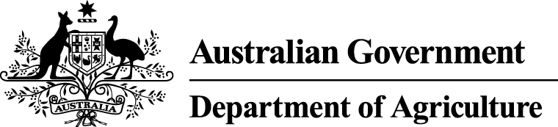

Review of National Marine Pest Biosecurity
Discussion Paper
Animal Biosecurity Branch
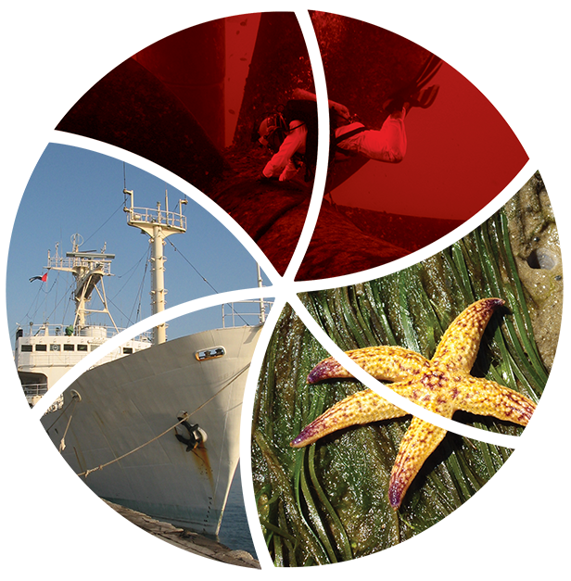
© Commonwealth of Australia 2015
Ownership of intellectual property rights
Unless otherwise noted, copyright (and any other intellectual property rights, if any) in this publication is owned by the Commonwealth of Australia (referred to as the Commonwealth).
Creative Commons licence
All material in this publication is licensed under a Creative Commons Attribution 3.0 Australia Licence, save for content supplied by third parties, logos and the Commonwealth Coat of Arms.

Creative Commons Attribution 3.0 Australia Licence is a standard form licence agreement that allows you to copy, distribute, transmit and adapt this publication provided you attribute the work. A summary of the licence terms is available from creativecommons.org/licenses/by/3.0/au/deed.en. The full licence terms are available from creativecommons.org/licenses/by/3.0/au/legalcode.
The Commonwealth of Australia does not necessarily endorse the content of this publication.
Inquiries about the licence and any use of this document should be sent to copyright@agriculture.gov.au.
This publication (and any material sourced from it) should be attributed as: Department of Agriculture 2015, Review of National Marine Pest Biosecurity: Discussion Paper.

This publication is available at agriculture.gov.au/publications.
Department of Agriculture
Postal address GPO Box 858 Canberra ACT 2601
Switchboard +61 2 6272 2000
Facsimile +61 2 6272 2001
Web agriculture.gov.au
The Australian Government acting through the Department of Agriculture has exercised due care and skill in preparing and compiling the information and data in this publication. Notwithstanding, the Department of Agriculture, its employees and advisers disclaim all liability, including liability for negligence and for any loss, damage, injury, expense or cost incurred by any person as a result of accessing, using or relying upon any of the information or data in this publication to the maximum extent permitted by law.

Image credits: John Lewis ES Link Services Pty Ltd and Neptune Marine Services Pty Ltd
Contents
Purpose of the discussion paper 4
Submission process 5
Part A: Context 7
Australian Government approach to marine pest biosecurity 7
National marine pest biosecurity arrangements 9
Part B: Discussion of issues 13
Issue: Limited commitment and resource allocation to implement the National System 13
Issue: Current biofouling requirements are not consistent across jurisdictions 14
Issue: The ‘species-based’ approach to manage biofouling 15
Issue: Minimise the cost to industry of domestic ballast water management requirements 16
Issue: Incomplete implementation of the National Monitoring Strategy 17
Appendix A: Terms and Acronyms 19

Purpose of the discussion paper

The Review of National Marine Pest Biosecurity
The government has committed $5 million over four years for a review and strategic analysis into invasive marine pest species with a view to removal or eradication of these marine pests.
The Review of National Marine Pest Biosecurity is being undertaken by the Department of Agriculture in the 2014–15 financial year. The review will investigate whether the current framework is functioning well and what elements could be improved. The review’s report will provide recommendations for Australian Government investment that are effective, simple and provide a high return on investment to strengthen national marine pest biosecurity. Subject to government agreement, recommendations in the report will be implemented in 2015–18 through the Department of Agriculture’s Strengthening National Marine Pest Biosecurity project.

Stakeholder consultation
The review involves an issues paper and discussion paper consultation phases.
The issues paper consultation phase involved the release of a paper for a six week comment period in October 2014. The department received 22 written submissions, which are available on the department’s website (at agriculture.gov.au/marinepestreview).
During the issues paper consultation period the review team attended meetings, workshops, and teleconferences with 33 organisations or individuals involved in or affected by national marine pest biosecurity activities. The outcomes of discussions, comments and written submissions have been used by the Department of Agriculture to develop this discussion paper.
The discussion paper consultation phase involves a public release of this discussion paper and a series of workshops held in major capital cities, which will focus on some of the key issues identified by stakeholders and the department.

Content of discussion paper submissions
The issues and questions in this discussion paper refer to some of the key issues synthesised from issues paper submissions and comments from stakeholders in consultations. Other issues were identified in the issues paper submissions. Although they are not dealt with in this discussion paper, they are being considered by the department.
We seek your consideration of the questions in this discussion paper. Comment on any other issues or aspect of national marine pest biosecurity are also welcome.

Next steps
The outcomes of discussions, comments and written submissions will be used by the Department of Agriculture to develop a final report to the government with recommendations to strengthen the national marine pest biosecurity system.
Not all issues and proposals raised in the issues paper and discussion paper consultation periods will form part of the Department’s final report to government
Submission process
Stakeholders are invited to provide comment on the issues, proposals and policy ideas contained in the discussion paper and provide further policy considerations or proposals. Submissions must be lodged with the department on or before 4 May 2015.
Submissions will only be accepted when accompanied by a submission cover sheet, available from agriculture.gov.au/marinepestreview.
If your submission is more than three (3) pages in length, please include a summary of your key comments and recommendations at the front.

Submissions can be made
By email: marinepests@agriculture.gov.au
By mail: The Marine Pests Unit
Animal Biosecurity Branch
Department of Agriculture
GPO Box 858
CANBERRA ACT 2601

Further information
If you require further information on making a submission please contact the department’s Marine Pests Unit by email to marinepests@agriculture.gov.au.

Publication of submissions
Submissions will be made available for public review through the department’s website (at agriculture.gov.au/marinepestreview) unless clearly indicated that you wish your submission or parts thereof to be treated as confidential.
The Australian Government reserves the right to refuse to publish submissions, or parts of submissions, which contain offensive language, potentially defamatory material or copyright infringing material.

Making a confidential submission
If you wish your whole submission to be kept in confidence, this should be clearly indicated on the submission cover sheet.
If you want only part of your submission to be confidential, please mark it clearly and put that part on a separate page(s).
We will endeavour to keep any such submissions confidential but cannot provide an absolute guarantee of confidentiality because certain confidential information may be required to be disclosed by law or to the Parliament under the Freedom of Information Act 1982 (Cth). Such requests will be determined in accordance with provisions under that Act.

Privacy notice
‘Personal information’ means any information or opinion about an identified, or reasonably identifiable, individual.
‘Sensitive personal information’ means any information or opinion about an individual’s racial or ethnic origin, political opinion or association, religious beliefs or affiliations, philosophical beliefs, sexual preferences or practices, trade or professional associations and memberships, union membership, criminal record, health or genetic information and biometric information or templates.
The collection of personal information by the Department of Agriculture (the department) in relation to this submission is for the purposes of considering your submission and related purposes. If all relevant personal information requested is not provided by you, the department may be unable to consider your submission.
Personal information may be disclosed to other Australian agencies, persons or organisations where necessary for these purposes, provided the disclosure is consistent with relevant laws, in particular the Privacy Act 1988. Your personal information will be used and stored in accordance with the Privacy Principles.
By completing and sending your submission you consent to the collection of all personal information, including sensitive personal information, contained in the submission cover sheet and submission.
The department’s Privacy Policy, including information about access to and correction of your personal information, is available on the department’s website.
To contact the department about your personal information or to make a complaint:
Phone +61 2 6272 3933
Email privacy@agriculture.gov.au
Post Privacy Contact Officer
Department of Agriculture
GPO Box 858
Canberra ACT 2601
Part A: Context

Australian Government approach to marine pest biosecurity

Risk based approach to biosecurity
The Department of Agriculture adopts a formal risk-based approach to the management of biosecurity risks to the economy, the environment, and the community, of pests and diseases entering, establishing and spreading.
The risk-based approach involves a three step assessment of the biosecurity risk:
- assessment of the likelihood of a pest or disease entry, establishment and spread in Australia
- assessment of biological and economic consequences should this occur
- estimation of the unrestricted risk.
The conclusions from the assessment of likelihood and consequence are used to estimate the unrestricted risk and whether this meets Australia’s Appropriate Level of Protection (ALOP), also known as the appropriate level of risk. These conclusions are also used in consideration of what biosecurity measures are justified to reduce the level of risk to very low but not zero risk.
The department considers guidance and standards developed at international organisations in undertaking risk assessments and implementing risk management measures. These organisations include the World Trade Organisation, World Organization for Animal Health (OIE), International Plant Protection Convention (IPPC) and Codex Alimentarius (Codex). The OIE, IPPC and Codex cover animal (including aquatic animal) health, plant health and food safety respectively. Australia may choose to implement more stringent measures than those set by these organisations to protect Australia’s animal, plant and food industries.
Where a biosecurity hazard is identified, but the information is considered to be insufficient to estimate the unrestricted risk, the department may adopt interim measures (often voluntary) while the department seeks to better inform the assessment of the biosecurity risk. This approach has been taken for a number of biosecurity risks facing terrestrial animal and plant industries, and in the marine pest sector.
A significant amount of information and knowledge is required to estimate biosecurity risk. The information and data required for a comprehensive understanding and assessment of the potential (or actual) impacts of non-native marine species to Australia are incomplete. However, the risk of entry and establishment of non-native marine species through vectors and pathways is better understood. By appropriately managing vectors such as vessel biofouling and ballast water, the cumulative risks of entry and establishment of many non-native marine species can be managed. This enables the department to apply biosecurity measures to address risks of non-native marine species associated with those vectors and pathways.
The international community, through representation at the International Maritime Organisation (IMO), considers vessel ballast water and biofouling to be high risk pathways for the transfer of marine species. In assessing the appropriate management of marine pest biosecurity risk pathways the Department of Agriculture takes into account guidelines and instruments developed by the IMO. The Biosecurity Bill 2014 currently before the Australian Parliament contains provisions to implement the International Convention for the Control and Management of Ships’ Ballast Water and Sediments 2004 developed by the IMO.

Australian government’s responsibilities and activities
This review is focussing on the Australian Government’s responsibilities and activities in national marine pest biosecurity. However, we recognise that it may be difficult to limit commentary and submissions to areas that are solely the responsibility of the Australian Government.
Under the Australian constitution the Commonwealth is responsible for marine pest biosecurity matters relating to the border. This responsibility applies to the Commonwealth marine environment, which is generally Australian waters beyond the three nautical mile limit of state/territory waters.
The Department of Agriculture administers the Quarantine Act 1908 (Quarantine Act), which is the primary Commonwealth legislation covering marine pest biosecurity and the protection of Australia’s border from incursion of marine pests. The Department of Agriculture has primary carriage of Australian government responsibilities for marine pest biosecurity activities offshore and at the border. The Department of Agriculture also contributes to biosecurity activities within Australia where there is a discernible national interest. These activities are conducted in partnership with state and territory governments, industry and other stakeholders.
The Department of the Environment administers the Environment Protection and Biodiversity Conservation Act 1999 (the EPBC Act) which is the central piece of Commonwealth environment legislation. Under the EPBC Act, invasive species that threaten or may threaten the survival, abundance or evolutionary development of a native species or ecological community can be listed as key threatening processes and may then become the subject of a national threat abatement plan. This process has not yet occurred for any marine pest species.
The Department of Agriculture and the Department of Environment work cooperatively in national marine pest biosecurity planning. These departments also work with other agencies, state and territory governments, marine industries and scientists to implement the National System for the Prevention and Management of Marine Pest Incursions (the National System), through the Marine Pest Sectoral Committee and the National Biosecurity Committee.

National marine pest biosecurity arrangements

What is the National System?
The National System is a suite of measures that the Australian, state and Northern Territory governments, marine industry, researchers and conservation groups are developing and implementing to manage the invasion of marine pests.
The National System provides a framework for the collaborative and cohesive efforts of stakeholders towards developing national marine pest biosecurity.
Figure 1 shows the major components of National System biosecurity measures to manage the risks posed by marine pest invasions (prevention; emergency response; preparedness; and ongoing management and control) and the supporting arrangements (monitoring; communication, education and training; research and development; and evaluation and review). Further information on the components of the National System is publicly available through the national system website (at marinepests.gov.au/national-system).
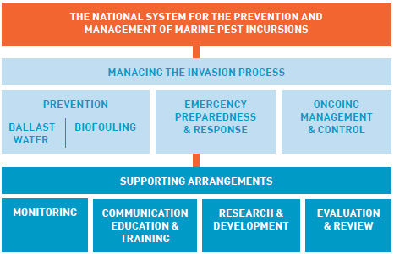
Figure 1: Measures and supporting arrangements of the National System for the Prevention and Management of Marine Pest Incursions.

How does the National System fit in with Australian Government roles and responsibilities?
The National System is part of a broader national biosecurity system being developed through the National Biosecurity Committee (NBC), and is underpinned by the Intergovernmental Agreement on Biosecurity (2012) and the National Environmental Biosecurity Response Agreement (2012).
The Department of Agriculture and the Department of Environment are represented on the Marine Pest Sectoral Committee (MPSC) and the National Biosecurity Committee. The responsibilities of these governance bodies include overseeing the continued development and implementation of the National System.
The Australian Government has a vital coordination and leadership role in the National System. The government also has responsibilities as a regulator and asset holder under each major component of the National System.

Shared responsibility principle
The Australian Government considers the management of the risks of marine pests to the economy, the environment and the community to be a shared responsibility of governments, industry, natural resource managers, custodians or users and the community. The Australian, states and territory governments’ commitment to the shared responsibility principle is also detailed in the Intergovernmental Agreement on Biosecurity (IGAB) 2012.
Sharing responsibility and working collaboratively on collective goals requires a clear understanding of the roles and responsibilities of the parties involved. In this context, the review is looking at the National System framework as a whole, and whether it provides an effective platform for future Australian Government investment in collaborative and coordinated effort of stakeholders.
The Australian Government has recently used the Generalised Invasion Curve concept (developed by the Victorian Government Department of Environment and Primary Industries) depicted in Figure 2, to explain:
- the key categories of actions appropriate to the stage of a pest incursion
- how the roles of stakeholders change as activities to respond to a pest incursion change
- an indicative return on investment at each stage of an incursion.
The responsibility for biosecurity activities are not shared equally amongst all stakeholders for all marine pest risk management measures. Governments have a greater responsibility in the prevention and eradication stages, whereas those best placed to protect assets at risk from established marine pests are generally the owners of those assets (public or private).
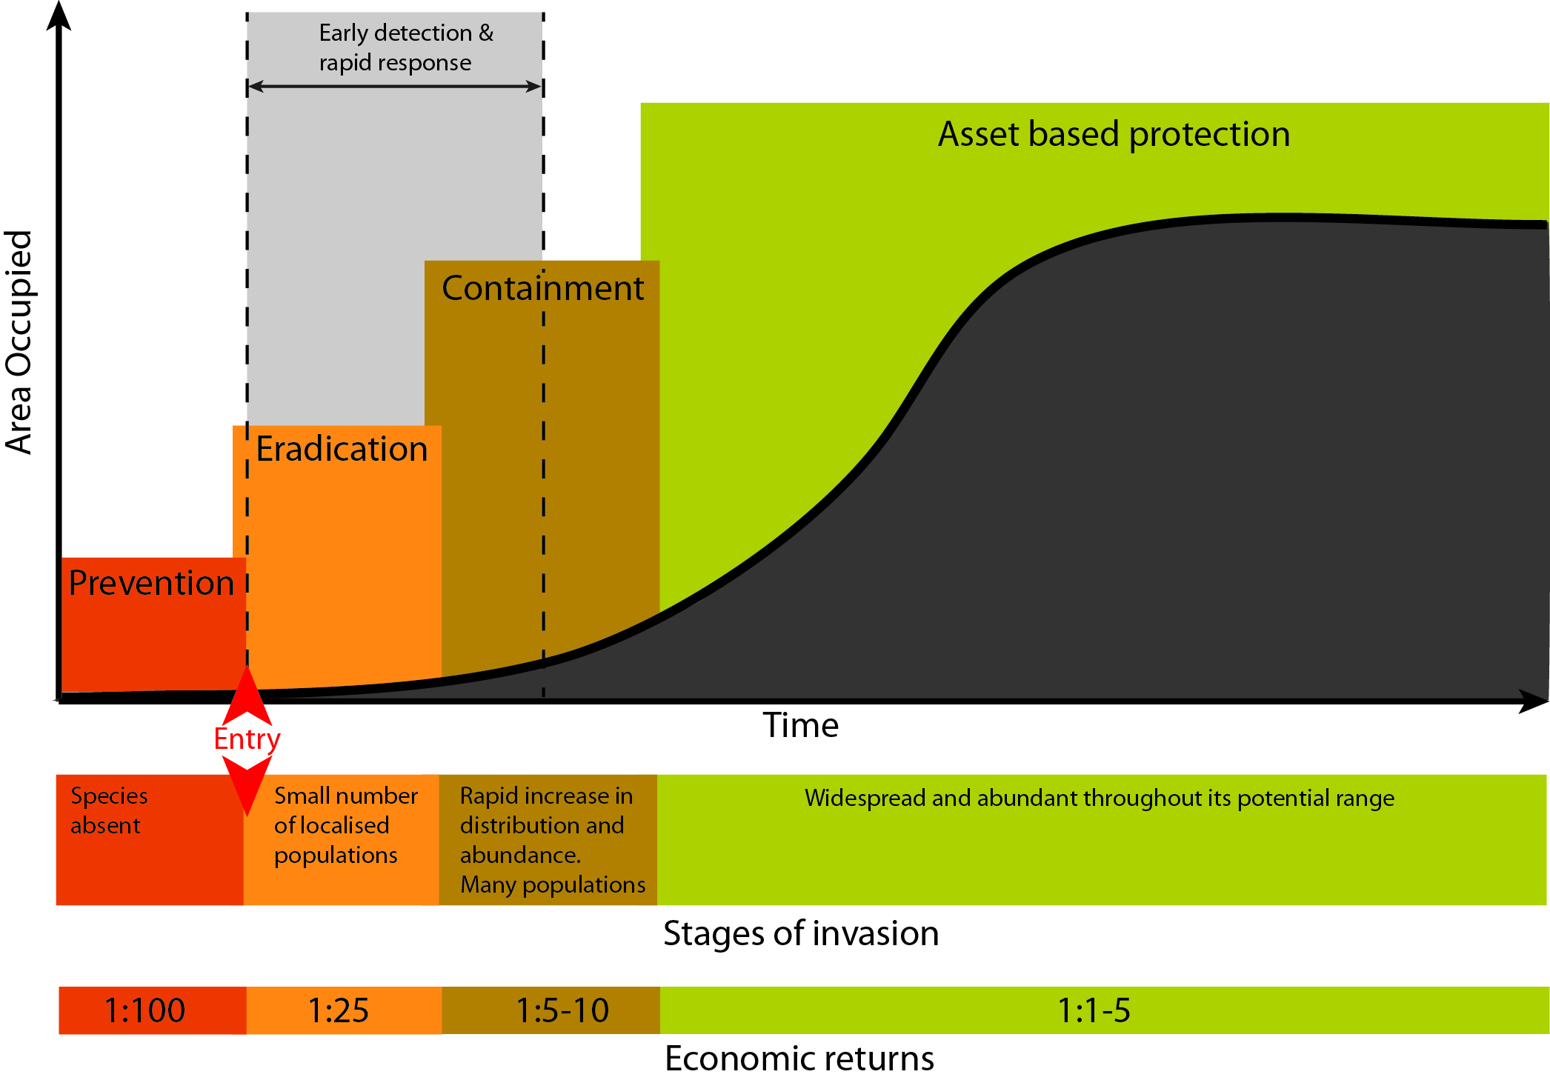
Figure 2: Stages of invasion and generalised invasion curve (Source: Department of Agriculture)

Components of the National System
Through this review the Australian government is also examining the activities involved in managing a marine pest incursion, and where Australian Government investment to strengthen national marine pest biosecurity will be most cost-effective.
The Generalised Invasion Curve can be used to provide an indicative return on investment in biosecurity activities. The review is taking a closer look at the cost effectiveness of activities in each stage (prevention, eradication, containment and asset protection) of a marine pest invasion through an Australian Bureau of Agricultural and Resource Economics and Sciences (ABARES) project. The outcomes of the ABARES project will be used in the report to government.
This discussion paper focuses on key issues and questions identified in consultations and submissions for each component and activity of marine pest biosecurity, and proposals to change the current arrangements.

Potential changes to marine pest biosecurity arrangements
There are a number of Australian Government and national biosecurity governance committees’ activities that may affect current marine pest biosecurity arrangements. Some of these are outlined below and other activities are mentioned in the discussion of specific issues and proposals contained in Part B:
- The Biosecurity Bill 2014 and supporting legislation were introduced into parliament on 27 November 2014. The Biosecurity Bill provides a framework for Australia to work towards ratification of the International Convention for the Control and Management of Ships’ Ballast Water and Sediments.
- The NBC has established an Intergovernmental Agreement on Biosecurity Taskforce to drive the implementation of priority reforms in the areas of decision making and investment, emergency preparedness and response, the management of established pests and diseases, collaboration in surveillance and diagnostics, the management of biosecurity information, and communications and engagement. The reforms are outlined in the Intergovernmental Agreement on Biosecurity (2012), available at agriculture.gov.au/biosecurity/partnerships/nbc/intergovernmental-agreement-on-biosecurity.
- The NBC sectoral committees (marine, animals, plants and invasive species) are developing communication and engagement strategies and the NBC is developing an overarching strategy to engage environmental stakeholders and the broader community.
- The NBC is also developing arrangements for aquatic animal diseases and weeds as they currently sit outside of existing emergency response deeds.
- The Australian Government is developing a platform for marine pests within the IBIS biosecurity intelligence gathering and analysis application. IBIS is an open source tool that locates relevant online articles and information relating to international biosecurity issues on a daily basis.
- The MPSC is currently developing a new Australian Priority Marine Pest List, to replace the existing Consultative Committee on Introduced Marine Pest Emergencies Trigger List. The list is being populated according to a set of criteria approved by the MPSC.
- The MPSC is progressing the development of an outcomes-focused National Marine Pest Biosecurity Strategy. The strategy will outline how government, industry and the community will work together to protect Australia’s marine biodiversity from marine pests. The strategy will be circulated to stakeholders prior to implementation.
- The MPSC is working to identify and develop a cost sharing or cost recovery funding model for marine pest monitoring in priority locations around Australia under the National Monitoring Network. The model will be consistent with national and state cost recovery guidelines.
- The MPSC also aims to review and develop aspects of Australia’s diagnostic capacity to manage marine pest issues.

Part B: Discussion of issues
Through submissions and consultations during the issues paper consultation period, a number of key issues have been identified by stakeholders and consolidated by the Department of Agriculture. The following pages cover some of the issues and proposals currently being considered by the department. The questions posed in this discussion paper will also form the basis of stakeholder workshops to explore some of the high priority issues.
The issues which the department is specifically seeking further stakeholder input on are:
• Issue: Limited commitment and resource allocation to implement the National System
• Issue: Current biofouling requirements are not consistent across jurisdictions
• Issue: The ‘species based’ approach to manage biofouling
• Issue: Minimise the cost to industry of domestic ballast water management requirement
• Issue: Incomplete implementation of the National Monitoring Strategy

Issue: Limited commitment and resource allocation to implement the National System
A key issue identified from the issues paper submissions was the lack of commitment and on-going funding for national marine pest biosecurity arrangements. A number of reasons were provided for the lack of commitment, including: limited government resources; lack of information on the impacts (consequences) of marine pests; and lack of clear direction and coordination. Most stakeholders commented that a lack of resourcing and on-going funding impacted either on their ability to deliver components of the National System, perform activities to manage invasive marine pests, or to interact with government departments on marine pest issues.
During consultations some stakeholders suggested the level of resourcing required to fully develop and implement the National System would not be committed without added stimulus similar to that provided by the 1999 detection of the black-striped mussel (Mytilopsis sallei) in Darwin. Some submissions argued that stronger evidence of the impacts of marine pests is needed to substantiate marine pest biosecurity actions and investment in managing the risks. A potential link was also drawn between the current level of commitment and funding, and a lack of demonstrated impacts of invasive marine species on economy, the environment, and the community. One submission commented:
‘The subsequent dwindling priority, commitment to, and resourcing of the National System across Government and most jurisdictions seems to reflect the lack or realisation of predicted impacts of established invasive species...’.
Stakeholders commented on the lack of consistent funding arrangements, including cost recovery, and the impact of this on the development of effective arrangements, monitoring activities, on-going management activities or research and development. Some commented that funding was available at the moment, but continued funding was difficult to justify when other jurisdictions or industries were not making a similar commitment, and funding may be on a non-ongoing basis linked to available grant funding.

Stakeholder suggestions for a way forward
Stakeholders proposed different approaches to address the lack of resourcing. One proposal was to revisit the basis and justification of the National System, clearly assign responsibility and resourcing to elements that are justifiable. Stakeholders also identified a number of elements of marine pest biosecurity that should be consistently resourced, including, research and development, on-going management activities and public education.
Others suggested assigning a nationally consistent funding model that included infrastructure for cost recovery from risk creators and beneficiaries. Another, more direct comment was for cost recovery by the Commonwealth, then a return of funds to states proportional to the biosecurity services they delivered.
Questions:
- What do you consider to be the main impacts (consequences) from marine pests to your business, industry, activities or the environment?
- What activities should the Australian Government do to manage the biosecurity risks associated with marine pests to an acceptable level (to protect your business, industry, activities or the environment)?
- What information or data should the Australian Government collect to support ongoing national commitment to managing marine pest biosecurity

Issue: Current biofouling requirements are not consistent across jurisdictions
There was a strong theme across submissions that biofouling risk needs to be addressed consistently across jurisdictions. Submissions noted the Commonwealth has been working with jurisdictions and industry to develop international biofouling regulations. This process has been underway since 2005. In the absence of Commonwealth regulations, Western Australia and the Northern Territory have implemented their own biofouling management requirements.
Stakeholders commented that inconsistent biofouling management practices across jurisdictions have caused increased costs, time delays, uncertainties and misunderstandings. Some submissions noted that recreational yachts and moveable structures (such as petroleum installations) were potentially the highest risk vectors for biofouling.
The Commonwealth’s current position regarding domestic biofouling regulation follows recommendations of the Independent Review of Australia’s Quarantine and Biosecurity Arrangements (The Beale Review). Recommendation 5 of the Beale Review reads:
‘In relation to biofouling, the Commonwealth’s legislative reach should be restricted to international vessels arriving in Australia, with states and territories retaining responsibility for domestic biofouling requirements. The Commonwealth should promote the development of an international convention covering biofouling through the International Maritime Organization.’

Stakeholder suggestions for a way forward
Many submissions supported introduction of regulations by the Commonwealth to manage international biofouling risks. Some submissions considered that current guidelines lack ‘teeth’ and there is little incentive for vessel operators to comply with a voluntary set of guidelines. Stakeholders also noted the development of any regulatory measures should consider the biofouling risk from all vessels, including commercial vessels, yachts, cruise ships, recreational fishing vessels and moveable structures.
Questions:
- What are the best ways to manage and monitor the biosecurity risks of biofouling on vessels?
- If the Commonwealth progresses to regulate the management of biofouling on international vessels, what role should it take in the development of domestic controls by the states and territories?

Issue: The ‘species-based’ approach to manage biofouling
The Department of Agriculture is currently developing biofouling management strategies, including regulation proposals, to manage the risk of biofouling on vessels arriving in Australia from overseas. Concerns were raised in some submissions about the department’s use of a Species of Concern list (SOC List) for the proposed regulation approach contained in the consultation Regulation Impact Statement (consultation RIS)(available at agriculture.gov.au/biosecurity/avm/vessels/biofouling). Those submissions viewed the SOC List as subjective, and noted that positively identifying a suite of species in ‘real time’ would be taxonomically challenging and involve significant costs and training.
The ‘species based’ approach to regulation currently proposed in the consultation RIS has two elements. Firstly, a biofouling risk assessment tool is used to rate a vessel’s general biofouling risk and help determine if the vessel can enter, and any restrictions to be set on the length of time the vessel can operate in Australian waters. Secondly, if a vessel seeks to extend its operating time it must have an inspection to clear it of all species on a SOC List.
Stakeholders noted that the costs of maintaining and updating a SOC list are considerable and ongoing. The administrative burden of managing vessels with operating time restrictions under this regulatory model would also be significant.

Stakeholder suggestions for a way forward
Two submissions suggested an approach that encourages or requires adoption of the International Maritime Organization’s Biofouling Guidelines (IMO Biofouling Guidelines). Not using the ‘species-based’ approach because of difficulties associated with implementing and maintaining a SOC List, and the requirement for significant knowledge and information on potential impacts of non-indigenous marine species.
Some respondents suggested the Commonwealth use a ‘level of fouling’ approach instead of a ‘species-based’ approach. The level of fouling approach involves a vessel operator demonstrating appropriate efforts have been made to manage the level of fouling on the vessel. This could be demonstrated by having an up-to-date Biofouling Management Plan and Record Book, or using a risk assessment tool. However, there are questions about whether the biofouling risk assessment tool could fit into this approach.
The biofouling risk assessment tool asks specific questions about a vessel’s biofouling management practices and is aligned with principles of the IMO Biofouling Guidelines. However, the use of the biofouling risk assessment tool requires it to be validated on a ‘species’ (by utilising a species of concern list) or ‘level of fouling’ (percentage cover) basis to ensure that it is accurately determining biofouling risk. Validation would also be required to ensure the adoption of IMO Biofouling Management Plan and Record Book appropriately minimises vessel biofouling risk. In consultations some stakeholders noted the use of a biofouling risk assessment tool may be more appropriate for recreational yachts.
Similar approaches to ‘level of fouling’ are being adopted by New Zealand and California. The level of fouling approach would also enable the department to closely align compliance check processes to those currently used by Australia for international ballast water risk.
Some stakeholders also suggested moving away from the ‘species based’ approach that underpins other aspects of the National System, including risk assessment tools for ballast water movements and port sampling protocols.
Questions:
- Should the department consider a regulatory framework for international biofouling management that is:
- a species-based approach (as currently proposed in the Biofouling RIS) or
- an approach based on a requirement for vessel operators to adopt IMO Biofouling Guidelines, including onboard biofouling management plan and record book.

Issue: Minimise the cost to industry of domestic ballast water management requirements
Submissions outlined stakeholders concerns with current differences in regulatory approaches to marine pest management between government jurisdictions, and highlighted the complications this causes, including additional costs to industry.
Submissions were generally supportive of the Australian Government’s intention to harmonise ballast water management requirements, and progress implementation of the International Convention for the Control and Management of Ships’ Ballast Water and Sediments (BWM Convention), through the Biosecurity Bill 2014.
Whilst consistent marine pest management arrangements were supported, the following additional costs to the shipping industry for domestic ballast water management were highlighted as a concern:
- ballast water treatment systems can cost from half a million to four million dollars in addition to ancillary costs
- dry-docking and installation of ballast water treatment systems
- development of ballast water management plans.

Stakeholder suggestions for a way forward
Exemptions from managing domestic ballast water on low risk voyages were identified as an important avenue for vessel operators to reduce costs. The Australian government has maintains a Ballast Water Risk Assessment (BWRA) tool that assesses the ballast water risk for vessels on movements between Australian ports. This can be utilised to provide an exemption from ballast water management practices where the ballast water on board presents a low risk.
If monitoring was completed at more Australian ports, more vessel movements between Australian ports may be considered low risk, reducing the costs of compliance with the new ballast water arrangements. The BWRA tool assumes that within an un-monitored port a marine pest is presumed present if that species can complete its lifecycle in that port (based on available scientific data).
Restricting domestic ballast water movements between suitably determined regions of Australia was proposed to reduce costs and the reliance on monitoring to support the BWRA. The proposal would require ballast water management for the movement and discharge of ballast water between zones, but would reduce the potential for exemptions to be provided for movements between ports in different zones.
One submission also suggested a co-management approach should be considered as an option for good industry performers to reduce costs.
Avoiding requirements being placed on vessel operators to undertake activities that may go beyond the requirements of the BWM Convention was identified as an imposition and costs to industry that should be avoided.
Questions:
- How can the Australian Government cost-effectively manage domestic ballast water risks, while preventing the spread of established marine pests?
- Should species-specific assessments of port-to-port movements, with associated monitoring, be used?
- Should we restrict ballast water movements between suitably determined regions?

Issue: Incomplete implementation of the National Monitoring Strategy
Stakeholders expressed concern that only five out of 18 priority locations have been monitored to the standard agreed under the National Monitoring Strategy (NMS). The submissions also reflect that many jurisdictions consider they are unable to resource monitoring in accordance with the strategy.
The intent of the NMS is that 18 National Monitoring Network locations will be monitored to an agreed standard every two years. The NMS has multiple aims, which cannot be achieved with the current level of implementation. Components of the National System also cannot operate as designed with the current level of monitoring data.
The Australian, state and Northern Territory governments agreed to a NMS to collect data that will:
- inform the risk assessment of vectors to inform National System prevention measures
- provide earliest detection possible to trigger and inform emergency response arrangements in the event of an incursion
- inform decision making for the ongoing management and control of established marine pest populations, including informing risk assessments
- inform broader policy decisions on marine pest management.
The shipping industry expressed concern that if domestic ballast water management arrangements are implemented, the incomplete monitoring data will result in more vessel movements being automatically deemed ‘high risk’.
There was widespread concern with a lack of monitoring to provide an early detection system for the introduction of marine pests, due to few locations being monitored and the low frequency of monitoring at any location. Stakeholders felt this would delay detection and reduce the likelihood of success of any eradication attempt.

Stakeholder suggestions for the way forward
Stakeholders suggested that the national monitoring strategy be re-designed to:
- redefine its purpose and objectives to ensure they are necessary and cost effective
- incorporate more cost effective technologies including those that enable early detection of pests
- accept a wider range of data and sources including citizen science activities
- consider diver safety incorporating, where possible, diver-less methods
- clarify the involvement of museum taxonomists
- include microsporidia in the list of species for detection.
The Department has engaged ABARES to examine the National Monitoring Strategy and suggest where it could be improved to better meet the needs of marine pest biosecurity in Australia. ABARES has consulted individually with jurisdictions and many organisations involved with monitoring for marine pests. ABARES’ findings will be incorporated into the final report to government.
Questions:
- What are the most important aim(s) for monitoring in a cost-effective national marine pest biosecurity system?
- How should this monitoring be achieved?

Appendix A: Terms and Acronyms
The following terms and acronyms are used throughout the discussion paper.

Terms
Appropriate Level of Protection | The level of protection deemed appropriate by a country establishing a sanitary or phytosanitary measure to protect human, animal or plant life or health within its territory. Australia’s Appropriate Level of Protection is expressed as providing a high level of sanitary and phytosanitary protection aimed at reducing risk to a very low level, but not to zero. This level risk is consistent with the public’s expectations for biosecurity management.
Ballast water | Water taken up by ships to assist with vessel stability and balance.
Biofouling | The accumulation of aquatic organisms such as micro-organisms, plants and animals on surfaces and structures immersed in or exposed to the aquatic environment.
Biosecurity | The management of the risks to the economy, the environment, and the community, of pests and diseases entering, emerging, establishing or spreading.
Biosecurity measures | Activities undertaken to manage biosecurity risks.
Biosecurity risks | The potential of a disease or pest entering, emerging, establishing or spreading in Australia; and the disease or pest causing harm to the environment, or economic or community activities.
Compliance | Status whereby all aspects of product, facilities, people, programmes, and systems meet regulatory requirements and, where applicable, importing jurisdiction’s official requirements.
Emergency response | The actions taken in anticipation of, during and immediately after, an outbreak to ensure that its impacts are minimised and may include: actions constituting an initial response to an outbreak; and actions that form part of a national biosecurity incident response.
Environment | Includes: ecosystems and their constituent parts, including people and communities; natural and physical resources; the qualities and characteristics of locations, places and areas; and freshwater, estuarine and marine environments.
IMO Biofouling Guidelines | Refers to the International Maritime Organization’s guidelines for commercial vessels, 2011 Guidelines for the control and management of ships’ biofouling to minimize the transfer of invasive aquatic species, and for recreational craft, Guidance for minimizing the transfer of invasive aquatic species as biofouling (hull fouling) for recreational craft.
Biofouling Management Plan | A plan which details the biofouling management measures to be undertaken on a ship, as outlined in the IMO Biofouling Guidelines.
Introduction | Deliberate or unintentional human-assisted movement of a species to any location that is not part of its natural (native) range.
Invasive | Ability of an introduced species to spread across natural or semi-natural habitats by its own means and form dominant populations.
Jurisdictions | Refers collectively to the Commonwealth of Australia and state and territory governments.
Marine pest | Any exotic marine species that poses a threat to Australia’s marine environment or industry, if introduced, established or translocated.
National Biosecurity Committee | The committee responsible for biosecurity matters, and tasked with managing a national, strategic approach to emerging and ongoing biosecurity policy issues.
National biosecurity system | Encompasses the full range of activities undertaken by governments, organisations and individuals across the biosecurity continuum, including prevention, emergency preparedness, detection, response, recovery and on-going management of pests and diseases.
National System | National System for the Prevention and Management of Marine Pest Incursions
National Monitoring Strategy | Information contained with the national monitoring guidelines, available at the marine pest website marinepests.gov.au/national-system/how-it-works/Pages/Monitoring.aspx.
Pathway | Route taken by vector/s from point A to point B.
Record Book | A record of biofouling management practices that have been undertaken on a ship, as outlined in the IMO Biofouling Guidelines.
Regulation | A rule or order, as for conduct, prescribed by authority; a governing direction or law.
Risk analysis | Assessment of the level of biosecurity risk associated with the entry, emergence, establishment and spread of pests and diseases and the identification of options to limit the level of biosecurity risk. Includes risk assessment, risk management and risk communication.
Risk assessment | The evaluation of the likelihood and the biological and economic consequences of entry, establishment, or spread of a pest or disease within the territory of an importing country.
Risk management | The process of identifying, selecting and implementing measures that can be applied to reduce and manage the level of biosecurity risk.
Species of Concern list | A high risk subset of non-indigenous marine species. No national species of concern (SOC) list is currently active. The current proposed SOC list includes 41 species. The 41 SOC were selected based on their inoculation, establishment and spread risk. Each species can be transported by biofouling and, if established, could negatively affect Australia’s environment, economic, social or human health values.
Vector | The physical means, agent or mechanism which facilitates the transfer of organisms, or their propagules, from one place to another.
Vessel | Any ship, barge, mobile drilling unit, work boat, craft, launch, submersible etc.

Acronyms
ABARES | Australian Bureau of Agricultural and Resource Economics and Sciences
ALOP | Appropriate Level of Protection
BWM Convention | International Convention for the Control and Management of Ships’ Ballast Water and Sediments
BWRA | Ballast Water Risk Assessment
Consultation RIS | Consultation Regulation Impact Statement
IGAB | Intergovernmental Agreement on Biosecurity
IMO | International Maritime Organization
MPSC | Marine Pest Sectoral Committee
NBC | National Biosecurity Committee
NEBRA | National Environmental Biosecurity Response Agreement
SOC | Species of Concern

