# Outcomes report: International Clean Seed Pathway Workshop

7-8 June 2018, Brisbane, Australia

Biosecurity Plant Division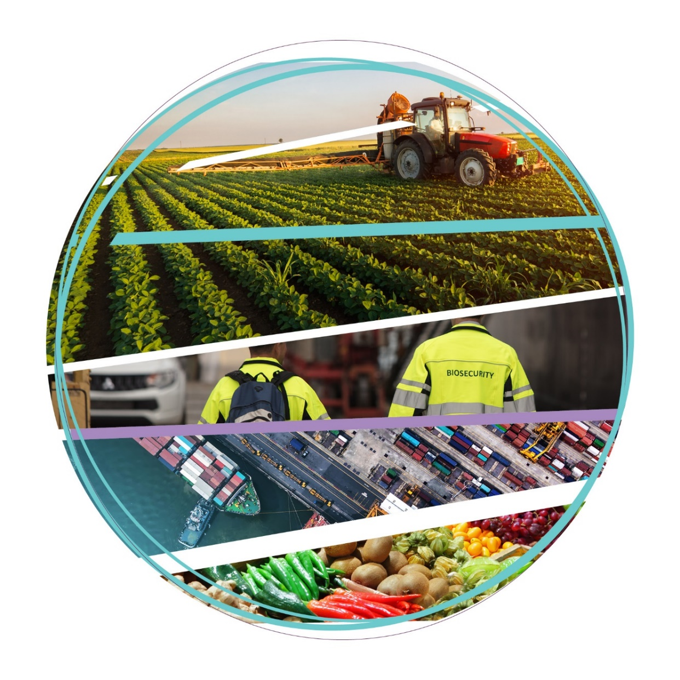

© Commonwealth of Australia 2019

**Ownership of intellectual property rights**

Unless otherwise noted, copyright (and any other intellectual property rights) in this publication is owned by the Commonwealth of Australia (referred to as the Commonwealth).

**Creative Commons licence**

All material in this publication is licensed under a [Creative Commons Attribution 4.0 International Licence](https://creativecommons.org/licenses/by/4.0/legalcode) except content supplied by third parties, logos and the Commonwealth Coat of Arms.

Inquiries about the licence and any use of this document should be emailed to [copyright@agriculture.gov.au](mailto:copyright@agriculture.gov.au).

C:\Documents and Settings\west merryn\Local Settings\Temporary Internet Files\Content.Word\by.png

**Cataloguing data**

This publication (and any material sourced from it) should be attributed as: Biosecurity Plant Division, 2019, *Outcomes report:* *International clean seed pathway workshop, 7-8 June 2018, Brisbane, Australia,* Department of Agriculture, Canberra, September, CC BY 4.0.

ISBN 978-1-76003-233-3

This publication is available at http://www.agriculture.gov.au/import/goods/plant-products/seeds-for-sowing/international-clean-seed-pathway-workshop

Department of Agriculture

GPO Box 858 Canberra ACT 2601

Telephone 1800 900 090

Web [agriculture.gov.au](http://agriculture.gov.au/)

The Australian Government acting through the Department of Agriculture has exercised due care and skill in preparing and compiling the information and data in this publication. Notwithstanding, the Department of Agriculture, its employees and advisers disclaim all liability, including liability for negligence and for any loss, damage, injury, expense or cost incurred by any person as a result of accessing, using or relying on any of the information or data in this publication to the maximum extent permitted by law.

Contents

Executive summary iii

1 Introduction 1

1.1 Context 1

1.2 Representatives 2

2 Sessions 3

2.1 Session 1 – Driver for a single scheme 3

2.2 Session 2 – Does the system meet the need? 11

2.3 Session 3 – Emerging risks 14

2.4 Session 4 – System verification 16

2.5 Session 5 – Pathway to adoption 17

3 Conclusion 19

3.1 Post-Workshop Survey Results 19

## Executive summary

In June 2018 the Department of Agriculture (the department) held the International Clean Seed Pathway Workshop (the workshop) in Brisbane, Australia. The workshop brought together representatives from the national plant protection organisations of Australia, Canada, India, Indonesia, Malaysia, New Zealand, Thailand (Minister Counsellor for Agriculture), and the United States of America; Australian state and territory governments; researchers and diagnosticians; and industry involved in the seed trade and seed production. The goals of the workshop were to provide a forum to discuss the concept of an integrated system pathway approach for regulating the phytosanitary health of seed, and to promote and enhance global movement of clean seed.

The workshop was comprised of five sessions, each of which included topical presentations and an interactive element involving electronic polling, table discussion, and plenary discussion.

* Session 1, ‘Driver for single scheme’, explored the background, drivers, and proposed principles for a global systems approach for the production and trade of clean seed.
* Session 2, ‘Does the system meet the need?’, explored some critical components of a system that meets a broad range of participant needs, and the highest priorities for implementation.
* Session 3, ‘Emerging risks’, explored the challenges and opportunities in the identification and management of emerging and newly emerged risks within a systems approach framework.
* Session 4, ‘System verification’, explored the complexity of verification in a global system of clean seed production and trade, and how to ensure ongoing integrity of the system.
* Session 5, ‘Pathway to adoption’, explored the options and activities to progress the global seed concept through the International Plant Protection Convention.

The workshop resulted in overwhelming support for a single systems approach for the global trade of clean seed. There was a general agreement on some underpinning concepts for a systems approach to ensure the system is based on addressing plant risk, underpinned by robust assessment and management of critical control points.

Since the workshop, the North American Plant Protection Organisation (NAPPO) made a submission to the 2018 International Plant Protection Convention (IPPC) call for topics for an annex to ISPM 38 – International movement of seeds. The submission was made to the Task Force on Topics (TFT) with the explicit support of National Plant Protection Organisations including Australia, Regional Plant Protection Organisations, and industry bodies. Following TFT recommendation, the submission was adopted at the 14th Session of the Commission on Phytosanitary Measures in April 2019 and added to the Standards Committee list of topics for development

## Introduction

In response to the increase in the global movement of seeds for planting and associated phytosanitary regulation, the department held the International Clean Seed Pathway Workshop in Brisbane, Australia on 7-8 June 2018. The objectives of the workshop were to:

* provide a forum for seed producers and users, importers, exporters, researchers and regulators to discuss the concept of an integrated system pathway approach for regulating the phytosanitary health of seed
* promote and enhance global movement of clean seed pathways.

### Context

Today’s seed industry is a global enterprise. Seed companies have located production operations in many different countries to take advantage of climate, logistics and economics. Expanding markets mean companies are conducting more international business. The volume and number of seed shipments have increased significantly, as have the number of seed species traded internationally. The global nature of seed trade means that re-export is a necessary business practice. Additionally, the number of additional declarations for specific pests required by importing countries and the variation in import requirements are escalating.

In the face of these challenges, certifying officials in exporting and re-exporting countries must issue hundreds of thousands of phytosanitary certificates each, resulting in a strain on National Plant Protection Organisation (NPPO) resources.

Phytosanitary certification of small seed lots used to support research and breeding programs around the world are an additional challenge for NPPOs to address with current approaches. The small size of these lots and their high value make statistically significant sampling and testing of individual consignments inherently difficult.

An alternative to the traditional approach of consignment-by-consignment phytosanitary certification that provides equivalent phytosanitary security is viewed as a potential solution to these issues. Companies that move seed internationally utilise quality management systems and best practices, which may help manage phytosanitary risk. ISPM 38 recognises that these seed production practices, when combined under a systems approach (ISPM 14), can manage phytosanitary risk to a level consistent with the pest risk involved. However, ISPM 38 does not address the issue of how to apply a systems approach as an alternative to consignment-by-consignment phytosanitary certification.

One approach under consideration is the adaptation of existing industry practices under regulatory oversight to create a risk-based systems approach to manage the phytosanitary risks of international seed trade.

The workshop was planned in the context of international momentum towards establishing a clean seed pathway for the global movement of clean seed under a systems approach framework. There are several international initiatives that aspire to establish systems that will facilitate the movement of clean seed, however there is yet to be global organisation on the issue.

### Representatives

The workshop was attended by 61 representatives from national plant protection organisations (NPPOs), Australian state and territory governments, researchers and diagnosticians, industry bodies and seed production companies. There was representation from the NPPOs of Australia, Canada, India, Indonesia, Malaysia, New Zealand, Thailand (Minister Counsellor for Agriculture), and the United States of America. The New South Wales, Northern Territory, Queensland, Victorian and Western Australian governments also sent representatives. National and international industry bodies were well-represented with attendees from: Asia and Pacific Seed Association, Australian Organic, Australian Seed Federation, AUSVEG, Chilean Seed Association, International Seed Federation, Nursery and Garden Industry Australia, and Plantum. Further industry representation was provided through the attendance of seed production companies: Bayer Cropscience, Monsanto, Rijk Zwann, Seedtech, South Pacific Seeds, and Syngenta Australia. This broad representation allowed for a balanced and collaborative discussion across all five sessions.

## Sessions

The workshop was comprised of five sessions:

1. Driver for a single scheme
2. Does the system meet the need?
3. Emerging risks
4. System verification
5. Pathway to adoption

Each session consisted of presentations to lay the groundwork for discussion, and interactive sessions (e.g. table discussion, plenary discussion and live participant polling).

### Session 1 – Driver for a single scheme

Initial presentations focussed on the need for a global systems approach for the movement of clean seed from both a regulatory and industry perspective. Information was presented on initiatives being progressed in other parts of the world to improve the global movement of clean seed.

A high level concept for a global clean seed system (principles and assumptions) jointly developed by the Australian Government and industry was presented and discussed. Participant views on the need for a single global clean seed trading system and the principles and assumptions that should underpin such a system were captured through online polling.

#### Presentations

1. *Overview of current system for seed production and movement (why is the global concept of clean seed pathway important/needed),* Dennis Johnson, International Seed Federation
2. *Expectation/importance/concern (needs for germplasm, impact of incursion, quarantine pests vs quality pests),* Callum Fletcher, AUSVEG
3. *Development of Systems Approach – Australia,* Luigi Paglia, Department of Agriculture
4. *Systems that are currently used or being developed that contribute to clean seed pathway – NSHAPP and ReFreSH,* Dr Edward Podleckis, Animal and Plant Health Inspection Service, USDA
5. *Disease prevention program,* Bram Koebrugge, Rijk Zwaan Distribution B.V
6. *A systems approach that recognises industry practices,* Dr Merel Langens, Bayer Vegetable Seeds; Chair of the ISF Working Group Systems Approach

#### Interactive session

The objectives of this session were to discuss the need for a single global clean seed trading system and determine the principles that should underpin such a system. The polling tool ‘Poll Everywhere’ was used to gauge levels of agreement or disagreement. The tool proved effective, with an average engagement rate of 86% for session 1 participants.

The first question on the need for a single system resulted in 86% of respondents agreeing on the need for a single system, and the remaining 14% of respondents answering that they were unsure.

The next poll questions tested consensus on 13 principles relating to the adoption of a single global clean seed trading system that focuses on plant health which were introduced in the Session 1 presentation Development of systems approach – Australia by the department’s Luigi Paglia. During discussions after each poll question, a general concern was raised with the use of the word ‘principle’, specifically that it is premature to refer to principles and it is more accurate to use the term ‘concept’. From the principle 3 question onwards, respondents answered the questions in the context of ’13 concepts’ rather than ’13 principles’.

**Poll Responses**

Question 1: To what extent do you agree or disagree with Principle 1: The system should be a global clean seed trading system that solely address plant health?

To what extent do you agree or disagree with Principle 1:  The system should be a global clean seed trading system that solely address plant health?
Responses: 45 (88%) of participants responded to this question, with 21 strongly agreeing, 16 agreeing, 4 neutral or unsure, 3 disagreeing and 1 strongly disagreeing.

45 (88%) of participants responded to this question, with 21 strongly agreeing, 16 agreeing, 4 neutral or unsure, 3 disagreeing and 1 strongly disagreeing.

Audience comments:

* Perhaps the system should also look at other risks, for example weed seeds.
* Focusing on diseases can be a starting point and more risks could be incorporated later.

Question 2: To what extent do you agree or disagree with Principle 2: Additional processes may be applied for phytosanitary risk management of consignments for weed seed, insects, soil and other contaminants?

To what extent do you agree or disagree with Principle 2: Additional processes may be applied for phytosanitary risk management of consignments for weed seed, insects, soil and other contaminants?
Responses:
47 (92%) of participants responded to this question, with 21 strongly agreeing, 20 agreeing, 5 neutral or unsure, 1 disagreeing and 0 strongly disagreeing.


47 (92%) of participants responded to this question, with 21 strongly agreeing, 20 agreeing, 5 neutral or unsure, 1 disagreeing and 0 strongly disagreeing.

Audience comments:

* The question is not clear enough.
* The initial focus should be on pathogen risk.
* It is premature to use the word ‘principle’; the word ‘concept’ should be used instead.

Question 3: To what extent do you agree or disagree with Principle 3: The system should apply a HACCP-based systems approach (ref. ISPM 14) to produce high health seed that is free from soil-borne and seed transmitted pest, as defined in ISPM 38, and applied by reputable seed companies through their assurances to their customers?

To what extent do you agree or disagree with Principle 3: The system should apply a HACCP-based systems approach (ref. ISPM 14) to produce high health seed that is free from soil-borne and seed transmitted pest, as defined in ISPM 38, and applied by reputable seed companies through their assurances to their customers?
Responses:
45 (88%) of participants responded to this question, with 10 strongly agreeing, 20 agreeing, 11 neutral or unsure, 4 disagreeing and 0 strongly disagreeing.


45 (88%) of participants responded to this question, with 10 strongly agreeing, 20agreeing, 11 neutral or unsure, 4 disagreeing and 0 strongly disagreeing.

Audience comments:

* The question should have used the word “capable” rather than “reputable”.

Question 4: To what extent do you agree or disagree with Principle 4: The system should be one global system that is available to all, but need not be used by all?

To what extent do you agree or disagree with Principle 4: The system should be one global system that is available to all, but need not be used by all?
Responses:
48 (94%) of participants responded to this question, with 26 strongly agreeing, 18 agreeing, 2 neutral or unsure, 2 disagreeing and 0 strongly disagreeing.


48 (94%) of participants responded to this question, with 26 strongly agreeing, 18 agreeing, 2 neutral or unsure, 2 disagreeing and 0 strongly disagreeing.

There were no comments or discussion on this principle.

Question 5: To what extent do you agree or disagree with Principle 5: The system can be applied to large and small seed lots, including breeder lines?

To what extent do you agree or disagree with Principle 5: The system can be applied to large and small seed lots, including breeder lines?
Responses:
47 (92%) of participants responded to this question, with 17 strongly agreeing, 19 agreeing, 9 neutral or unsure, 2 disagreeing and 0 strongly disagreeing.


47 (92%) of participants responded to this question, with 17 strongly agreeing, 19 agreeing, 9 neutral or unsure, 2 disagreeing and 0 strongly disagreeing.

Audience comments:

* Breeding lines for research may not fit. Producing sufficient quantities to do testing is not practical.
* Small seed lots may still need to be addressed differently.

Question 6: To what extent do you agree or disagree with Principle 6: The system should be evidence-based and transparent?

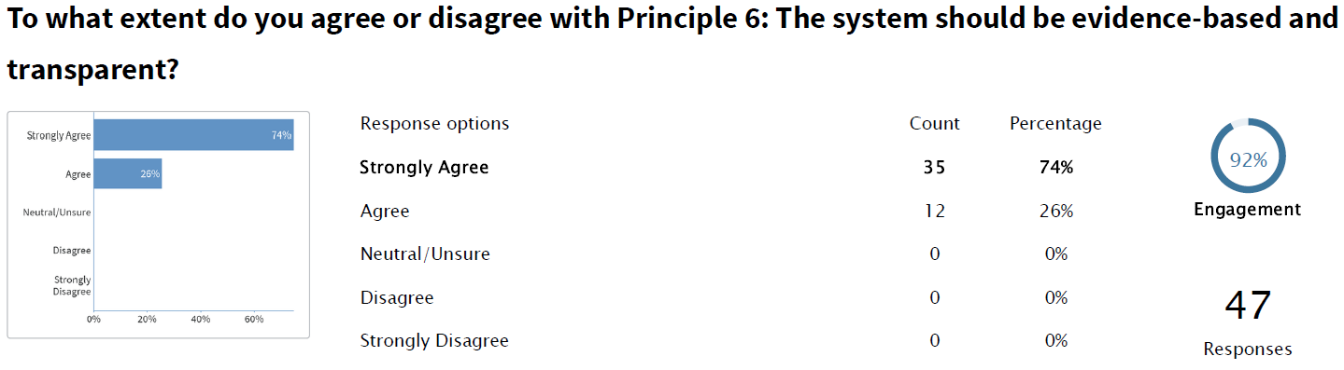

47 (92%) of participants responded to this question, with 35 strongly agreeing, 12 agreeing, 0 neutral or unsure, 0 disagreeing and 0 strongly disagreeing.

There were no comments or discussion on this principle.

Question 7: To what extent do you agree or disagree with Principle 7: The system should be robust and auditable?

To what extent do you agree or disagree with Principle 7: The system should be robust and auditable?
Responses: 48 (94%) of participants responded to this question, with 38 strongly agreeing, 9 agreeing, 1 neutral or unsure, 0 disagreeing and 0 strongly disagreeing.


48 (94%) of participants responded to this question, with 38 strongly agreeing, 9 agreeing, 1 neutral or unsure, 0 disagreeing and 0 strongly disagreeing.

Audience comments:

* What is ‘robust’? The term needs defining.
* Robust implies we have more than sufficient evidence to support the concept.
* Audits should be able to be performed by independent auditors so that no matter the auditor they approach it the same and reach the same conclusion.

Question 8: To what extent do you agree or disagree with Principle 8: The system should include requirements for review and performance reporting to drive continuous improvement?

To what extent do you agree or disagree with Principle 8: The system should include requirements for review and performance reporting to drive continuous improvement?
Response:
45 (88%) of participants responded to this question, with 24 strongly agreeing, 19 agreeing, 2 neutral or unsure, 0 disagreeing and 0 strongly disagreeing.


45 (88%) of participants responded to this question, with 24 strongly agreeing, 19 agreeing, 2 neutral or unsure, 0 disagreeing and 0 strongly disagreeing.

There were no comments or discussion on this principle.

Question 9: To what extent do you agree or disagree with Principle 9: The system should integrate strong traceability?

To what extent do you agree or disagree with Principle 9: The system should integrate strong traceability?
47 (92%) of participants responded to this question, with 38 strongly agreeing, 8 agreeing, 1 neutral or unsure, 0 disagreeing and 0 strongly disagreeing.


47 (92%) of participants responded to this question, with 38 strongly agreeing, 8 agreeing, 1 neutral or unsure, 0 disagreeing and 0 strongly disagreeing.

There were no comments or discussion on this principle.

Question 10: To what extent do you agree or disagree with Principle 10: The system should incorporate all seeds that are moved through international trade?

To what extent do you agree or disagree with Principle 10: The system should incorporate all seeds that are moved through international trade?

Response: 47 (92%) of participants responded to this question, with 11 strongly agreeing, 18 agreeing, 11 neutral or unsure, 7 disagreeing and 0 strongly disagreeing.


47 (92%) of participants responded to this question, with 11 strongly agreeing, 18 agreeing, 11 neutral or unsure, 7 disagreeing and 0 strongly disagreeing.

Audience comments:

* Allowing all seed may not be appropriate as there is only sufficient knowledge on the most commonly traded species.
* What about seeds for human consumption or stockfeed? Should it be limited to seeds for planting?

Question 11: To what extent do you agree or disagree with Principle 11: The system should use recognised third parties to ensure the rigour and efficacy of the system, including independent auditing?

To what extent do you agree or disagree with Principle 11: The system should use recognised third parties to ensure the rigour and efficacy of the system, including independent auditing?
Responses:
44 (86%) of participants responded to this question, with 9 strongly agreeing, 27 agreeing, 8 neutral or unsure, 0 disagreeing and 0 strongly disagreeing.


44 (86%) of participants responded to this question, with 9 strongly agreeing, 27 agreeing, 8 neutral or unsure, 0 disagreeing and 0 strongly disagreeing.

Audience comments:

* The word “could” should be used instead of “should”.

Question 12: To what extent do you agree or disagree with Principle 12: The system should use the international Phytosanitary Certificate for assuring the phytosanitary status of internationally traded seed lots?

To what extent do you agree or disagree with Principle 12: The system should use the international Phytosanitary Certificate for assuring the phytosanitary status of internationally traded seed lots?
Responses:
44 (86%) of participants responded to this question, with 14 strongly agreeing, 17 agreeing, 13 neutral or unsure, 0 disagreeing and 0 strongly disagreeing.


44 (86%) of participants responded to this question, with 14 strongly agreeing, 17 agreeing, 13 neutral or unsure, 0 disagreeing and 0 strongly disagreeing.

Audience comments:

* Something geographically independent could be used, in similar vein to the ISPM 15 stamp.
* Investigating an alternative to using the Phytosanitary Certificate should not be a high priority, as the Phytosanitary Certification is already existing and demonstrated to work.

Question 13: To what extent do you agree or disagree with Principle 13: The system should be recognised by the Commission of the International Plant Protection Convention (IPPC) as an official instrument to implement requirements and achieve phytosanitary outcomes from the implementation of ISPM 38?

To what extent do you agree or disagree with Principle 13: The system should be recognised by the Commission of the International Plant Protection Convention (IPPC) as an official instrument to implement requirements and achieve phytosanitary outcomes from the implementation of ISPM 38?
44 (86%) of participants responded to this question, with 12 strongly agreeing, 23 agreeing, 9 neutral or unsure, 0 disagreeing and 0 strongly disagreeing.


44 (86%) of participants responded to this question, with 12 strongly agreeing, 23 agreeing, 9 neutral or unsure, 0 disagreeing and 0 strongly disagreeing.

Audience comments:

* Strongly agree as the intention is for this to be globally accepted.

A final question was posed on whether additional concepts should be included. The suggestions included:

* Inclusion of a dispute resolution process
* Harmonisation of requirements and acceptance of equivalent measures
* International technical organisation to govern mutual recognition and decide on acceptable testing methods
* Reinforcement of shared responsibility and collaborative development of the system between industry and NPPOs
* Based on industry best practice and building on current systems
* Flexibility to allow for innovation

### Session 2 – Does the system meet the need?

Presentations on the Indonesian seed production system and pest management practices, and a case study of an existing Australian national systems approach developed for the nursery industry, BioSecure HACCP, provided further information to participants to discuss how a global clean seed system would achieve their respective needs. A presentation from the American Seed Trade Association explored situations that might require specific requirements.

#### Presentations

1. *Indonesian seed production system and seed pest disease management*, Dr Nurjanah, Indonesian Agricultural Quarantine Agency
2. *Criteria on factors/situation that would necessitate specific requirements*, Dr Samantha Thomas, (on behalf of) American Seed Trade Association
3. *BioSecure HACCP,* John McDonald, Nursery and Garden Industry Australia

#### Interactive session

This interactive session was facilitated by Dr Gabrielle Vivian-Smith and made use of table and plenary discussion to explore:

* what flexibility looks like
* how to deal with targets that are not well understood and to what extent we can generalise
* when there will be a need for specific requirements to augment general requirements
* the highest priorities for implementation
* the possibility of using an ISPM 15 stamp-inspired certification to certify seed produced under the system.

**Flexibility**

Discussion on flexibility in the system showed a focus on outcome-based criteria with acceptance of equivalent measures, the participation and involvement of industry, and the limitations and issues caused by flexibility.

There was strong support for an outcomes-based approach that is not too prescriptive. There was support for accepting equivalent measures and allowing for multiple ways to satisfy outcome-based criteria. A choice in measures to achieve the same outcome may be necessary due to differing country or business practices. However it was recognised that this type of approach will have challenges. Alternate measures must be demonstrably efficacious before they can be considered equivalent, and how this assessment will occur and by whom needs to be clarified.

Flexibility in participation was also a key topic for discussion. All industry members should be able to participate in the system regardless of their size; they should not be limited by the scale or scope of their operation. However, industry members should also have the ability to opt-in or opt-out of participation in the system. An important benefit of flexibility for industry is that it allows innovation and the ability to change approach quickly in response to an emerging risk or opportunity. It was also recognised that capabilities will differ between industry members and between facilities, making a flexible approach with multiple paths to the same outcome necessary to facilitate full industry participation. It was suggested that industry members should continue to write their own procedures, but within boundaries established by the system.

Building flexibility into the system will have limitations and issues. The system must be able to dynamically adapt to changes in risk, but it must do so while not overreacting. Flexibility must be limited; requirements and procedures must be meaningful enough to allow for consistent audit outcomes. It was further recognised that some aspects, procedures and requirements will be more flexible and others more rigid.

**Targets that are not well understood**

Table groups also had a discussion on targets that are not well understood and to what extent we can generalise. While it was accepted that a robust system incorporating requirements for pest and pathogen control would greatly contribute to managing targets that are not well understood, it was also accepted that the system should always seek to build an understanding of the targets rather than rely solely on generalisation. Generalisation could include grouping targets and responses.

It was noted that actions taken at critical control points should be designed to identify unknown targets in addition to known targets. In conjunction with this, the system should facilitate the communication of pest and pathogen data without repercussion as this will help build understanding of targets. There is also a need for the system to have the capability to rapidly investigate and make decisions on unknown targets or targets that are not well understood.

**Specific requirements**

The question on when specific requirements would be needed in the system exposed some of the greatest challenges in designing a system. A common response was that specific requirements would be needed to address high risk or high impact pests but should be host-specific and considerate of pest distribution. However, different countries have different thresholds for what they consider to be an appropriate level of protection (ALOP) and different views on what constitutes a high risk or high impact pest.

Another common scenario for when specific requirements would be required was to address an emerging risk where it is not clear whether general requirements are sufficient to manage the risk. This raised the question of who would be responsible for identifying the emerging risk and who would be responsible for determining whether specific requirements are necessary and what those requirements would be. As a starting point, it was suggested that a list of currently regulated pests around the world be compiled and assessed.

It was also suggested that specific testing requirements for asymptomatic pests will be required in order to detect the pest and track pest movement. Small seed lots and breeder lines may also need specific requirements to account for the difficulty in detecting pathogens through testing small lots and the high value of such seeds.

In devising specific requirements, a principle of only applying specific requirements where it is determined that general requirements are not sufficient was considered appropriate. Additionally, areas of freedom, the environmental conditions at different production facilities and different production practices could also be considered when developing specific requirements.

**Highest priorities for implementation**

A discussion of implementation priorities brought forward several ideas:

* An agreed framework under the International Plant Protection Convention (IPPC)
* Focus on highly traded seed and seed of high economic value
* Establishing a pilot:

1. A simple pilot that can continue to be expanded
2. Multiple concurrent pilots to assess different system models
3. A commodity with known risks and economic impact

* More communication between NPPOs and industry, including the development of industry documents
* Building pest lists for the most commonly traded seeds

**ISPM 15 stamp-inspired seed certification**

The idea of an IPSM 15 stamp-inspired seed certification being a geographically independent method of certification that can travel with seed lots, as opposed to the country of export issuing a phytosanitary certificate to the country of import was discussed. Most agreed the certification could be electronic, to reduce fraud and enable traceability of seed lot movement. While there was little resistance to this idea, it was viewed as aspirational only and not a priority as certification can already occur with phytosanitary certificates.

### Session 3 – Emerging risks

The presentations on ‘Emerging risks’, discussed the challenges and opportunities in the identification and management of emerging and newly emerged risks within a systems approach framework.

#### Presentations

1. *ISFs Regulated Pest List Initiative*, Dr Radha Ranganathan, International Seed Federation
2. *Diagnostic tools and challenges*, Dr Fiona Constable, Agriculture Victoria Research
3. *System components that would identify new/emerging pest risks and how this would be managed*, Dr Samantha Thomas, Monsanto
4. *Epidemiology of seed borne pathogens; identification and response to new/emerging pest risks*, Dr Nancy K. Osterbauer, United States Department of Agriculture

#### Interactive session

Scenario-based analysis of information sharing, pest risk analyses and the management of emerging and newly emerged risks revealed some shared ideas related to emerging risk management. Table groups were provided with one of four scenarios and asked to explore those scenarios using some focus questions.

1. Scenario one: There has been a change in pest status in a seed production area
2. Scenario two: New scientific information has become available that indicates that a host range of a specific seed borne pathogen has expanded to include more species
3. Scenario three: New scientific information has become available that a specific pathogen is seed borne, when it was previously thought to not be seed borne
4. Scenario four: The effectiveness of measures currently used to manage a specific seed borne pathogen is becoming uncertain

**How will information be shared and communicated? When, by whom, and to whom?**

Discussions on communication regarding emerging risks evoked many views, ideas and questions, including:

* Industry needs to be able to communicate without trade repercussions
* Communication would start internally within the company and would involve investigating procedures, checking for false positives and considering alternative measures
* Communication should commence as soon as possible
* Emerging risks could be reported by researchers, producers, growers, regulators, auditors or industry
* Is reporting required or is this covered by audits? Reporting may be required if only one measure is available. If more than one management measure is available, then is reporting required?
* Stages of communication and reporting. For example, stage one may be internal communication, stage two may be communication with the NPPO, stage three may be communication with all NPPOs
* Is reporting of detections required for NPPO trust in the system to manage those detections?
* NPPOs should use the existing process to notify other NPPOs
* Industry would notify the NPPO of the possible issue after internal verification, which could trigger an NPPO verification process
* There needs to be a feedback loop with industry and NPPOs
* There could be a portal notification system (maybe hosted by the IPPC), including exchange of data, which could assist in quality diagnosis
* Communication between industry and NPPOs may be informal at first detection, pending outcomes of investigation and verification activities
* New scientific information on changes to a host range should trigger considerations about the reliability of information, source, repeatability, robustness, and verification of new information
* The quality management system of the systems approach should include reporting procedures and monitoring for non-compliance with reporting procedures.

Plenary discussion on current reporting requirements revealed that while most countries have informal or formal reporting mechanisms, the requirements for reporting vary. It was concluded that the discrepancy indicated a need for a formal communication procedure as part of the system.

**At what point would a pest risk analysis be required and who would be responsible for undertaking it?**

There was significant shared thinking on what could trigger a pest risk analysis. A commonly discussed trigger was instances where a trend becomes apparent either within a country or across countries that indicates a new risk is emerging. This necessitates a capability for the system to detect trends through reporting and available data. There was also a view that a pest risk analysis would not need to be triggered until it was clear that the pest is of consequence and that a full pest risk analysis may not be required if some of the existing available measures were demonstrably effective.

There was some discussion that perhaps industry, a third party, or a joint committee could be responsible for undertaking the pest risk analyses to ensure consistency in approach. It was also discussed that some NPPOs have a legal obligation to conduct independent pest risk analyses, however they could make use of the technical expertise within the seed production industry. It was made clear that industry want faster turnarounds on pest risk analyses, and an idea was raised that a global database of pest risk analyses could improve efficiency in the process.

**Would you expect the scenarios to trigger a risk review?**

On whether the scenarios under discussion would trigger a review, there were a few differing views. It was suggested that whether a review is required should be dependent on the hosts; the trade volumes and economic impacts. An alternative is that a review should only be required in the instances where all currently available measures are proving ineffective. Other participants made the argument that a regulatory response may not be appropriate at all; the system should be capable of managing the risk, so a root cause analysis should be all that is required in most circumstances.

**What should happen if effective measures to manage the risk are not identified in a timely manner?**

The actions that should be taken when no effective measures to manage a risk are identified in a timely manner would depend on the circumstances. Containment of the risk, where possible, would be the immediate action to take. This should be followed by further research into measures and an investigation into the cause in instances of changed pest statuses. Additionally, the point was made that broad protocols, and automatically triggered measures and procedures should be capable of managing the risk in the context of a resilient and flexible system.

### Session 4 – System verification

The presentations and discussion on ‘System verification’ explored how to ensure ongoing integrity of the system.

#### Presentations

1. *System verification, critical control points and evidence,* Patricia McAllister, Canadian Food Inspection Agency
2. *System verification, critical control points and evidence,* Craig Scheibel, Department of Agriculture

#### Interactive session

This interactive session used a combination of table discussion, plenary discussion and audience polling to investigate questions related to the responsibility of accreditation and verification, the responsibility of developing and approving criteria for accreditation and verification, the ramifications of non-compliance, and the responsibility of certification.

Differing views existed on whether NPPOs or a third-party should have responsibility for accreditation and verification, however there was a consistent view that NPPOs should hold responsibility for certification.

For accreditation and verification criteria, most agreed that NPPOs should either be responsible for developing them or responsible for endorsing them if industry-developed. Amongst several components for accreditation and verification suggested by participants, three components emerged as the most common; transparency, traceability and consistency.

In response to non-compliance, most participants agreed that actions could range from warnings or corrective action notices for minor non-compliance, through to suspension from the system for major or repeat non-compliance. It was also noted that the system should incorporate a dispute resolution process.

### Session 5 – Pathway to adoption

The presentations and discussion on the ‘Pathway to adoption’ explored the options and activities to progress the global seed concept through the IPPC.

#### Presentations

1. *Phytosanitary expert consultation summary: challenges and opportunities,* Dr Kanokwan Chodchoey, Asia and Pacific Seed Association
2. *ISPM 38 (linkage for systems approach), IPPC requirements process/timeline*, Dr Marion Healy, Department of Agriculture

#### Interactive session

The Pathway to Adoption interactive session of the workshop highlighted the next steps to progress a systems approach for clean seed. These next steps, including meetings and dialogue, will be coordinated by NPPOs from Australia, Canada, New Zealand and USA.

Most workshop participants (91%) agreed that the IPPC is a logical forum for global adoption of the system; 81% of participants agreed that the proposal should be ready for the 2018 call for topics. Those opposed raised the feasibility of an international standard.

A proposal of an international systems approach for clean seed be submitted in the 2018 Call for topics: Standards and Implementation, as an annex to Section 2.5 of ISPM 38 was supported. The submission is to be initiated by the North American Plant Protection Organization (NAPPO).

As agreed by 91% of workshop participants, the next steps would be to determine an appropriate case study that will be adopted to trial the system and determine its functionality. A case study was preferred to a pilot, as it will better help define, scope and develop the system and will help to guide the overarching framework, whereas a pilot assumes that the system is functional and immediately adoptable. The case study would help define the scope and restrict the framework to focus on achievable control points. Those who voted against the case study in the poll voted as such because the question was worded as a ‘pilot (or test case)’ rather than a ‘case study’, and there were views that it is too early to do a pilot as this will take time to plan and develop.

Development of a case study would include establishment of parameters, such as type of seed, seed lot sizes, NPPO participation, and timeframe. Many responses suggested that the initial case studies and pilots should be small, with a few crops and participants. Tomatoes and cucurbits were the most strongly suggested crops. Industry would progress a case study to provide additional information.

## Conclusion

The workshop resulted in overwhelming support for a single systems approach for the international trade of clean seed. There was a general agreement on the 13 concepts identified in Session 1 for a systems approach to ensure the system is based on addressing plant risk, underpinned by assessments and critical control points. Presentations of existing system approach concepts, for example the USDA’s Regulatory Framework for Seed Health (ReFreSH), demonstrated to industry and NPPOs the benefits and challenges of a single system.

There were multiple themes identified throughout the workshop that should be considered for the systems approach.

These include:

* System availability to all but not mandatory
* Assurance that the system can be applied to all seeds and seed lot sizes that are moved though international trade
* Accreditation
* Trust, transparency and shared approach
* Traceability, audits and verification
  1. Notification and alert systems
  2. Proactive reporting
  3. Recognition of third parties, including independent auditing
* Data and evidence-based
* Documented business management practices
* Application of learnings from similar models previously implemented
* Interpretation and application of science in relation to emerging pests
  1. Acknowledgement of field experience and risk appetite
  2. Applying and harmonising diagnostics.

The proposed system will be underpinned by phytosanitary processes and will be recognised by the Commission of the IPPC as an official instrument to implement requirements and achieve phytosanitary outcomes from the implementation of ISPM 38.

Since the workshop, the North American Plant Protection Organisation (NAPPO) made a submission to the 2018 International Plant Protection Convention (IPPC) call for topics for an annex to ISPM 38 – International movement of seeds. The submission was made to the Task Force on Topics (TFT) with the explicit support of National Plant Protection Organisations including Australia, Regional Plant Protection Organisations, and industry bodies. Following TFT recommendation, the submission was adopted at the 14th Session of the Commission on Phytosanitary Measures in April 2019 and added to the Standards Committee list of topics.

### Post-Workshop Survey Results

Of the 30 participants that completed the Workshop Evaluation survey, over 93% (28 participants) stated that the Workshop met or exceeded their expectations and were satisfied with the structure of the Workshop and the facilitated discussions. The survey also demonstrated that the main objectives of the Workshop were content, networking and building relationships.

The main themes from the survey that emerged from the question ‘What did you like about the Workshop’ were:

* The breadth of attendees and commitment from numerous NPPOs
* The use of Poll Everywhere which enabled all participants to provide anonymous input, and initiated and stimulated discussions
* Collaborative, stimulating, open and respectful discussions between Government and industry
* A good balance of interesting talks, panel time and interactive sessions
* Effective facilitated discussions and excellent facilitators
* Presentation of issues from a global perspective, which was suitable for the international forum
* Clear direction and alignment regarding the issues and next steps between all groups of participants
* A specific outcome coming from the Workshop, with clear next steps identified.

Most survey responders suggested that extending the invitation to additional industry members, such as vegetable growers, would capture viewpoints across the entire continuum. There were some alternative views expressed that the inclusion of industry at such early discussions was not appropriate, especially in early inter-Government consideration of proposals to the IPPC. It was also suggested that presentations from seed industry could have provided more case studies (and less overlapping content). The absence of many NPPOs (especially Europe and Asia) and seed industries at the Workshop was noted and attributed to be due to limited notice of the event. It was suggested that further background information should have been provided prior to the event, to allow those with little knowledge of the topic to gain an understanding of the issues and prepare for discussions.

Personal communications and the post-Workshop survey indicated that participants appreciated the detailed organisation and smooth-running of the event, professionalism of the organisers, the layout and contents of the program, and the progress that was achieved by the end of the event (although some stated that some discussions and details were premature). Most respondents advised that the workshop met all of their expectations (and provided more), and they had no suggestions for improvement.