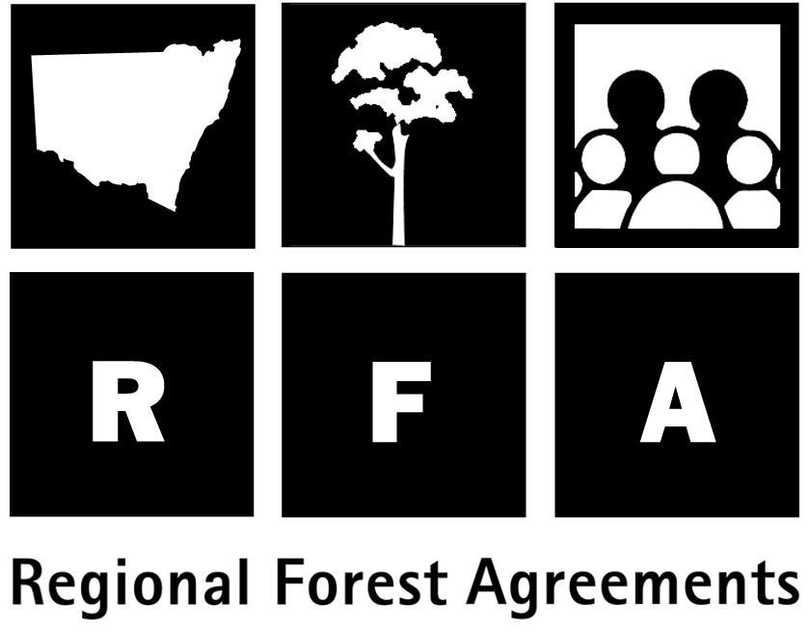 Background to the RFA

Regional Forest Agreements

Regional Forest Agreements (RFAs) are one of the principal means of implementing the National Forest Policy Statement of 1992, under which the Commonwealth and all State and Territory governments agreed to work towards a shared vision for Australia’s forests.

Eden is the first of four regions for which NSW and the Commonwealth are developing agreements on the future use and management of the State’s eastern native forests. The Eden RFA will be for 20 years, subject to five-yearly reviews, and aims to provide certainty for industry, conservation and forest-dependent communities. The RFA has three main objectives:

- to protect environmental values in a world class system of national parks and other reserves;

- to encourage job creation and growth in forest-based industries, including wood products, tourism and minerals; and

- to manage all native forests in an ecologically sustainable way.

RFAs have also been completed for Tasmania, Western Australia and two regions in Victoria. Three more are under way for Victoria, and another is nearing completion for South East Queensland. All are scheduled for completion by the end of 1999.

Steps towards the RFA

1995/96 A Deferred Forest Agreement (DFA) was made between the Commonwealth and NSW Government which identified areas in current wood production tenures to be set aside for possible inclusion in a CAR reserve system.

1996/97 NSW undertook an Interim Forest Assessment, refining the deferred forest areas and, as an outcome of this process, announced a number of new reserves (refer map).

- Recognising that a key element of the management of forests was improved management arrangements through Ecologically Sustainable Forest Management, NSW passed legislation (Forestry and National Park Estate Act 1998) establishing NSW Forest Agreements, including a Forest Agreement between NSW Ministers for the Eden region.

- The RFA was completed, creating a Commonwealth-State framework for forest management for the Eden region and providing certainty in forest management, export arrangements and the meeting of international commitments for 20 years.

The RFA had three phases:

- Phase 1: Comprehensive Regional Assessments (CRAs). These provided the information base for the RFA and involved scientific assessments of the environmental, heritage, social and economic uses and values of the forests. Representatives of key stakeholder groups were active members of the technical committees and made a major contribution to project selection, specification and management of projects. A number of projects also involved input from the Eden Regional Forest Forum and other community members.

- Phase 2: Scenario development and consultation. Assessment data was merged to develop different scenarios for the RFA. Key stakeholders were involved in developing a range of scenarios for conservation and timber supply and a scenario for Aboriginal Issues, developed by the Bega, Eden and Merrimans Aboriginal Forest Management Committee. These were published in a public comment paper, Towards an Eden Regional Forest Agreement. Information days were held at towns within the region and more than 20,000 public submissions were made on the issues raised in the paper. Throughout the Eden CRAs and subsequent scenarios development, the Eden Regional Forest Forum provided an important communication link with the community. It also raised a number of community issues to be considered in the preparation of the RFA.

- Phase 3: The Eden RFA. Taking public submissions into account, the Commonwealth and State governments negotiated the final Eden RFA.

.

