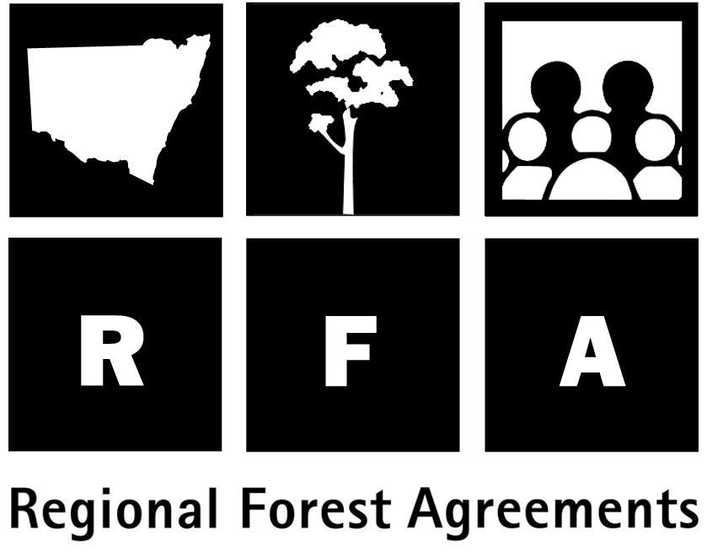 Indigenous interests

The RFA was developed over three years in consultation with forest stakeholders, including Indigenous communities and organisations, who participated in a range of projects conducted as part of the environmental, cultural, social and economic assessments.

A number of scenarios for the Eden RFA were developed by stakeholders, including a preferred scenario developed by the Bega, Eden and Merrimans Aboriginal Forest Management Committee (BEMAFMC). The Committee includes representatives from the Bega, Eden and Merrimans Local Aboriginal Land Councils, the Yuin Elders, the Monaro-Ngarigo-Cheruipirn Elders Council and the Djirranganj People.

The scenario outlined preferred land tenure arrangements, including Aboriginal freehold, ownership with leaseback to the Crown and joint management arrangements by Aboriginal people and NSW.

Indigenous heritage

The RFA contains a package of measures for implementation by NSW to ensure the appropriate management of Indigenous heritage, including the maintenance of traditional uses and values. It is recognised that such heritage is not confined to archaeological sites and artefacts but may include natural values such as flora, fauna and landforms.

These measures include a commitment to develop Indigenous management arrangements which consider Indigenous culture and values and enable Indigenous people to gain access to, and use of, land for traditional, cultural and socio-economic purposes.

Indigenous ownership

The NSW Government has provided for Aboriginal people to own lands of cultural significance under specific State acts. The NSW Forestry and National Parks Estate Act 1998 included the transfer of the following lands to Aboriginal management :

- Three small portions of East Boyd, Nadgee and Nullica State Forests totalling approximately 800 hectares (Wonboyn, Fisheries Beach and Kiah areas) have been transferred to Eden Local Aboriginal Land Council. Five other small portions of Crown land totalling approximately 390 hectares, primarily lands reserved from sale or lease, have been transferred to Bega Local Aboriginal Land Council, subject to resolving existing interests and future public requirements.

- The new Act adds Biamanga National Park to Schedule 14 of the National Parks and WildlifeAct 1974, making it the sixth national park available to be negotiated for joint management with Aboriginal people. This follows the recent successful hand over of Mootwingee National Park.

Indigenous community development

In recognition of the clear need to provide Aboriginal peoples with increased opportunities to pursue traditional cultural activities and new economic ventures and to be involved in the management of their cultural heritage, suitable infrastructures need to be developed to: support economic ventures such as aquaculture at Fisheries Beach and Wonboyn; support ecological and cultural tourism on joint management areas suitable for cultural camps and guided tours; efficiently manage Aboriginal cultural heritage, e.g. through training to enable site identification and recording, management of site databases, consultation with traditional owners and the provision of advice concerning monitoring and protection of sites.

Consultation and employment initiatives

- Four positions in the National Parks and Wildlife Service in Eden have been dedicated for additional Aboriginal employment.
- The National Parks and Wildlife Service consults with Aboriginal communities on a variety of issues including the development of information management systems for Indigenous heritage.
- State Forests maintains an open and ongoing dialogue with the Aboriginal communities at Eden. As part of pre-harvest planning, community members are encouraged to share knowledge of places forming part of their cultural heritage and are involved in, and remunerated for, the identification and management of sites.
BEMAFMC and State Forests have agreed in principle to joint planning and management of areas such as Flora Reserves and culturally significant sites. A co-operative framework for developing forest-based cultural and economic opportunities has been established, which should lead to further involvement of Aboriginal people and benefits to the Aboriginal community.

