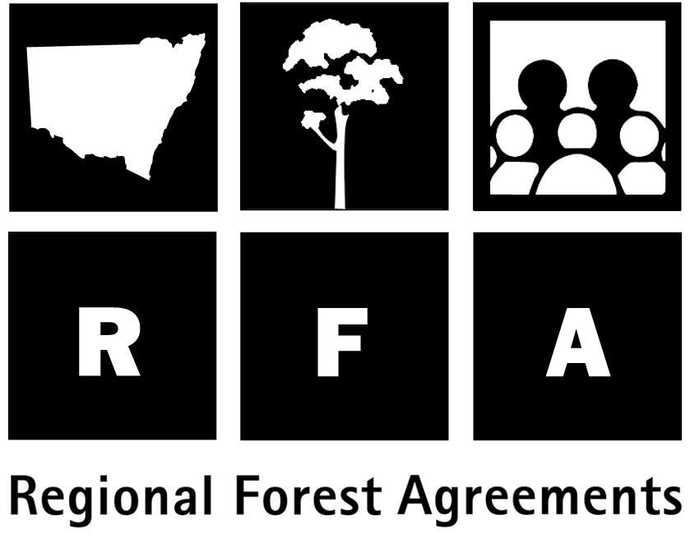 Background to the RFA

Regional Forest Agreements

Regional Forest Agreements (RFAs) are one of the principal means of implementing the National Forest Policy Statement of 1992, under which the Commonwealth and all State and Territory governments agreed to work towards a shared vision for Australia’s forests.

The North East NSW RFA covers both the Upper North East (UNE) and Lower North East (LNE) forest regions. It is one of three agreements being developed between the Commonwealth and NSW governments on the future use and management of the State’s native forests.

The RFA will be for 20 years, subject to five-yearly reviews, and aims to provide certainty for industry, conservation and forest-dependent communities. It has three main objectives:

- to protect environmental values in a world class Comprehensive Adequate and Representative (CAR) Reserve System of national parks and other reserves;

- to encourage development in an internationally competitive timber industry; and

- to manage native forests in an ecologically sustainable way.

In NSW, an RFA was completed for the Eden region in August 1999, and a third is nearing completion for the Southern region. Elsewhere RFAs are in place for Tasmania, Western Australia, and three regions of Victoria. A further two Victorian RFAs and one for South-East Queensland are under way. All are scheduled for completion by 31 March 2000.

Steps towards the RFA

1995/96 A Deferred Forest Agreement (DFA) was made between the Commonwealth and NSW Government which identified areas in current wood production tenures to be set aside for possible inclusion in a CAR reserve system.

1996/97 NSW undertook an Interim Forest Assessment, refining the deferred forest areas and, as an outcome of this process, announced a number of new reserves.

- Recognising that a key element of the management of forests was improved management arrangements through Ecologically Sustainable Forest Management, NSW passed legislation (Forestry and National Park Estate Act 1998) establishing NSW Forest Agreements, including a Forest Agreement between NSW Ministers for the Eden, Upper North East and Lower North East regions.

Mar2000 The RFA was completed, creating a Commonwealth-State framework for forest management for the North East NSW region and providing certainty in forest management, export arrangements and the meeting of international commitments for 20 years.

The RFA had three phases:

- Phase 1: Comprehensive Regional Assessments (CRAs). These provided the information base for the RFA and involved scientific assessments of the environmental, heritage, social and economic uses and values of the forests. Representatives of key stakeholder groups were active members of the technical committees and made a major contribution to selection, specification and management of projects. A number of projects also involved input from the Upper and Lower North East Regional Forest Forums and other community members.

- Phase 2: Consultation. Assessment data was summarised in an information package, which was circulated for public comment and submissions. In addition, the NSW Government conducted extensive negotiations with key stakeholders prior to its land use decisions for Upper and Lower North East regions in November 1998.

- Phase 3: The North East NSW RFA. Taking public submissions into account, the Commonwealth and State governments negotiated the final RFA.

.

