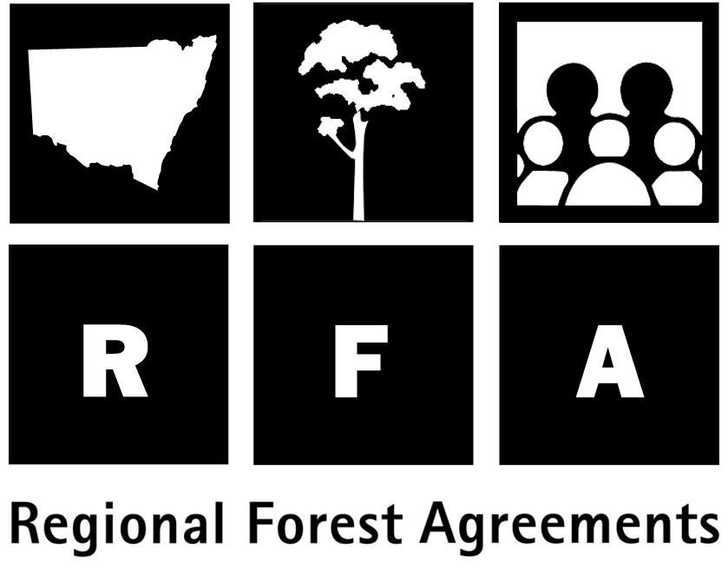 Future Forest management

Ecologically Sustainable Forest Management

The North East RFA will be in place for 20 years, with provision for five-yearly reviews. Ecologically Sustainable Forest Management (ESFM) of both reserves and production forests is a key objective of the agreement.

The RFA recognises that many of the existing NSW systems and processes for the North East region are designed to ensure the region’s forests are managed sustainably, and provide a sound basis for further development of integrated, complementary and strategic systems capable of responding to new information.

The NSW Forestry and National Park Estate Act 1998 forms the principal framework for managing NSW forests. The Act enables NSW Ministers to make Forest Agreements for each CRA/RFA region and to grant Integrated Forestry Operations Approvals (IFOAs) for the operational aspects of timber harvesting.

Under the RFA, NSW will undertake a number of forest management improvements, including those outlined below.

- The development by the National Parks and Wildlife Service (NPWS) of an Environmental Management System for lands dedicated under the National Parks and Wildlife Act 1974.
- The development by State Forests of an Environmental Management System (called the Native Forest Management System) for its lands.
- The development of regional ESFM plans for State forests.

- The incorporation of integrated feral animal and weed control programs within the regional ESFM plans (State Forests) and plans of management under the NPWS Act 1974.

- NPWS and State Forests will developjoint arrangements for bushfire prevention, detection and suppression.

- The preparation by State Forests of management plans for large areas of rainforest, high conservation value old growth and other areas of State forest excluded from production by forest management prescription and informal reserves.

- The preparation by NPWS of plans of management for dedicated reserves under the National Parks and Wildlife Act and Crown reserves.
- The implementation by State Forests of a Forest Management Zoning system.
- The monitoring of, and reporting against, nationally agreed criteria and indicators for ESFM.
- The public reporting on compliance with relevant Integrated Forestry Operations Approvals and the establishment of regular audits of compliance and reviews of codes of practice, eco-field guides and regional prescriptions.
- The implementationof the NSW Biodiversity Strategy.
- The establishment of Regional Vegetation Management Plans and Codes of Practice for timber harvesting for private land.
- The documentation of the basis for silvicultural practices and the publication of silvicultural guidelines for commercial forest types.

- The implementation of cultural heritage management guidelines which include protection for the National Estate and Indigenous heritage.

- The adoption of reviews of sustainable yield.

- The development of an information management system, as well as other coordinating mechanisms to improve sharing of data and integration of management between all levels of government.

