Systematic vertebrate fauna survey project
stage iiB - assessment of habitat quality for priority species in southeast queensland bioregion

QUEENSLAND CRA/RFA STEERING COMMITTEE
systematic Vertebrate fauna survey project
stage ii - assessment of habitat quality for priority species in southeast queensland bioregion
Department of Natural Resources, Department of Environment, and Environment Australia
QUEENSLAND CRA/RFA STEERING COMMITTEE
For more information contact:
Regional Forest Assessments, Department of Natural Resources
Block C, 80 Meiers Road
INDOOROOPILLY QLD 4068
phone: 07 3896 9836
fax: 07 3896 9858
Forests Taskforce, Department of Prime Minister and Cabinet
3-5 National Circuit
BARTON ACT 2600
phone: 02 6271 5181
fax: 02 6271 5511

© Queensland Government 1997© Commonwealth of Australia 1997
Forests Taskforce Department of Prime Minister and Cabinet

This work is copyright. Apart from fair dealing for the purpose of private study, research, criticism or review as permitted under the Copyright Act 1968, no part of this document may be reproduced by any means without the joint permission from the Joint Commonwealth and Queensland RFA Steering Committee.

This project has been jointly funded by the Queensland and Commonwealth Governments. The work undertaken within this project has been managed by the joint Queensland / Commonwealth CRA RFA Steering Committee and overseen by the Environment and Heritage Technical Committee.

Disclaimer
The views and opinions expressed in this report are those of the author and do not necessarily reflect the views of the Queenland and Commonwealth governments. The Queensland and Commonwealth governments do not accept responsibility for any advice or information in relation to this material.

Acknowledgements
Senior Authors and Report Preparation | Generation of expert models and Mapping Support Third RTD workshop
Teresa Eyre, DNR | David Barratt, EA
David Barratt, EA | Teresa Eyre, DNR
Melanie Venz, DEH | Jane Wickers, DoE
Contributions to report | Application of SPMODEL
Murray Haseler, DEH | David Barratt, EA
Barney Hines, DEH
GIS Support | Convenor of Third Response to Disturbance expert workshop
Jane Wickers, DEH | Anita Smyth, DNR
 | Valerie Olson-King, DNR
Expert Panel – data review and model validation – many many thanks | Data Preparation
Patrina Birt | Teresa Eyre, DNR
Adrian Borsboom | David Hannah, DEH
Chris Burwell | George Kreiger, DEH
Greg Czechura | Mel Venz, DEH
Stephen Debus | Murray Haseler, DEH
Teresa Eyre | Barney Hines, DEH
Greg Ford | Richard Johnson, DEH
Greg Gordon
Ian Gynther
David Hannah
Murray Haseler
Barney Hines
Harry Hines
Luke Hogan
Richard Johnson
George Kreiger
Ray Leggett
Pat McConnell

David McFarland
Peter O’Reilly
Chris Pavey
Maritza de Oliveira
Don Sands
Martin Schulz
Geoff Smith
Anita Smyth
Mel Venz
Stephen Wilson

CONTENTS
Acknowledgements v
CONTENTS vii
1. iNTroduction 1
1.1 Background 1
1.1.1 Species Distribution Modelling 2
1.1.2 Generalised Linear and Generalised Additive Modelling Procedures 3
1.1.3 Comparative Performance of Statistical and Rule-based Species Modelling Procedures 4
1.2 Study Area 5
1.3 Objectives of the project 5
1.4 Limitations of the project 5
2. methods 7
2.1 The environmental database used for modelling 7
2.1.1 Vegetation 7
2.1.2 Landzones 7
2.1.3 National Wilderness Inventory – Biophysical Naturalness 9
2.1.4 Feral predator surfaces 10
2.1.5 Topography 10
2.2 Target taxa - Priority species 11
2.3 datasets used for modelling priority species habitat 11
2.3.1 CRA systematic vertebrate fauna survey data set 11
2.3.2 External systematic fauna survey data sets 11
2.3.3 Greater Planning Certainty database (Fauna data audit) 11
2.4 preparation and Preprocessing of species and environmental data 12
2.4.1 Investigating the suitability of species data for statistical or expert (rule-set) habitat modelling techniques 12
2.4.2. Criteria for selecting habitat modelling techniques for individual species 13
2.5 Habitat modelling and mapping 15
3. habitat quality for priority species 18
3.1 Invertebrates 22
3.1.1 Argyreus hyperbius inconstans Australian fritillary 22
3.1.2 Acrodipsas illidgei Illidge’s ant-blue butterfly 22
3.1.3 Junonia hedonia zelima brown soldier 22
3.1.4 Tisiphone abeona morrisi swordgrass brown 23
3.1.5 Nameria insularis Burleigh Heads spider 23
3.1.6 Lissapterus sp. nov. a stag beetle 23
3.1.7 Sphaenognathus sp. nov. a stag beetle 24
3.1.8 Neogeoscapheus barbare a giant burrowing cockroach 24
3.1.9 Euastacus monteithorum Monteith crayfish 24
3.1.10 Euastacus urospinosus Conondale crayfish 24
3.2 Fish 32
3.2.1 Nannoperca oxleyana Oxleyan pygmy perch 32
3.2.2 Pseudomugil mellis honey blue-eye 32
3.2.3 Rhadinocentrus ornatus ornate rainbowfish 32
3.2.4 Maccullochella peelii mariensis Mary River cod 32
3.2.5 Kuhlia rupestris jungle perch 33
3.2.6 Porochilus cf. rendahli Rendahl’s catfish type 33
3.2.7 Gadopsis marmoratus river blackfish 33
3.2.8 Galaxias olidus marbled galaxias 33
3.3 Frogs 44
3.3.1 Adelotus brevis tusked frog 44
3.3.2 Crinia tinnula wallum froglet 44
3.3.3 Limnodynastes salmini salmon-striped frog 45
3.3.4 Mixophyes fleayi Fleay’s barred-frog 45
3.3.5 Mixophyes iteratus giant barred-frog 45
3.3.6 Rheobatrachus silus southern platypusfrog 46
3.3.7 Taudactylus diurnus southern dayfrog 46
3.3.8 Taudactylus pleione Kroombit tinkerfrog 47
3.3.9 Litoria brevipalmata green-thighed frog 47
3.3.10 Litoria freycineti wallum rocketfrog 48
3.3.11 Litoria olongburensis wallum sedgefrog 48
3.3.12 Litoria pearsoniana cascade treefrog 49
3.3.13 Litoria revelata whirring treefrog 49
3.3.14 Litoria sp. cf. barringtonensis (Kroombit Tops) no common name 50
3.3.15 Litoria sp. cf. cooloolensis (North Stradbroke Is) no common name 50
3.4 Reptiles 70
3.4.1 Elseya sp. cf. dentata Burnett River turtle type 70
3.4.1 Elusor macrurus Mary River turtle 70
3.4.2 Delma plebeia common delma 70
3.4.3 Delma torquata collared delma 71
3.4.4 Paradelma orientalis brigalow scaly-foot 71
3.4.5 Chlamydosaurus kingii frilled lizard 71
3.4.6 Anomalopus leuckartii no common name 72
3.4.7 Eremiascincus richardsonii broad-banded sand swimmer 72
3.4.8 Eroticoscincus graciloides elf skink 72
3.4.9 Nangura spinosa Nangur skink 73
3.4.10 Ophioscincus truncatus truncatus no common name 73
3.4.11 Saiphos equalis no common name 74
3.4.13 Furina dunmalli Dunmall’s snake 75
3.4.14 Hemiaspis dameli grey snake 75
3.4.15 Hoplocephalus bitorquatus pale-headed snake 75
3.4.16 Hoplocephalus stephensii Stephen’s banded snake 76
3.4.17 Pseudechis guttatus spotted black snake 76
3.5 Birds 84
3.5.1 Erythrotriorchis radiatus red goshawk 84
3.5.2 Lophoictinia isura square-tailed kite 84
3.5.4 Turnix melanogaster black-breasted button-quail 85
3.5.5 Geophaps scripta scripta squatter pigeon (southern subspecies) 85
3.5.7 Calyptorhynchus lathami glossy black-cockatoo 86
4.3.8 Cyclopsitta diophthalma coxeni Coxen’s fig-parrot 86
3.5.9 Ninox strenua powerful owl 87
3.5.10 Tyto novaehollandiae masked owl 87
3.5.11 Tyto tenebricosa sooty owl 88
3.5.12 Podargus ocellatus plumiferus plumed frogmouth 89
3.5.13 Menura alberti Albert’s lyrebird 89
3.5.14 Atrichornis rufescens rufous scrub-bird 90
3.5.15 Climacteris erythrops red-browed treecreeper 90
3.5.16 Dasyornis brachypterus eastern bristlebird 91
3.5.17 Lichenostomus melanops yellow-tufted honeyeater 91
3.5.18 Melithreptus gularis black-chinned honeyeater 92
3.5.20 Poephila cincta cincta black-throated finch (white-rumped form) 92
3.6 Mammals 113
3.6.1 Ornithorhynchus anatinus platypus 113
3.6.2 Antechinus swainsonii dusky antechinus 113
3.6.3 Dasyurus hallucatus northern quoll 113
3.6.4 Dasyurus maculatus maculatus spotted-tailed quoll (southern subspecies) 114
3.6.5 Phascogale tapoatafa brush-tailed phascogale 115
3.6.6 Phascolarctos cinereus koala 115
3.6.7 Cercartetus nanus eastern pygmy-possum 116
3.6.8 Petaurus australis australis yellow-bellied glider 116
3.6.9 Petaurus norfolcensis squirrel glider 117
3.6.10 Petauroides volans greater glider 118
3.6.11 Pseudocheirus peregrinus common ringtail possum 118
3.6.12 Aepyprymnus rufescens rufous bettong 119
3.6.13 Potorous tridactylus long-nosed potoroo 120
3.6.14 Macropus agilis agile wallaby 120
3.6.15 Macropus dorsalis black-striped wallaby 120
3.6.16 Petrogale herberti Herbert’s rock-wallaby 121
3.6.17 Petrogale penicillata brush-tailed rock-wallaby 121
3.6.18 Thylogale stigmatica red-legged pademelon 122
3.6.19 Nyctimene robinsoni eastern tube-nosed bat 122
3.6.20 Pteropus alecto black flying-fox 123
3.6.21 Pteropus poliocephalus grey-headed flying-fox 123
3.6.22 Pteropus scapulatus little red flying-fox 123
3.6.23 Syconycteris australis common blossom-bat 124
3.6.24 Hipposideros semoni Semon’s leafnosed-bat 124
3.6.25 Taphozous georgianus common sheathtail-bat 125
3.6.27 Chalinolobus dwyeri large-eared pied bat 125
3.6.28 Chalinolobus picatus little pied bat 125
3.6.29 Falsistrellus tasmaniensis eastern false pipistrelle 126
3.6.30 Kerivoula papuensis golden-tipped bat 126
3.6.31 Miniopterus australis little bentwing-bat 127
3.6.32 Miniopterus schreibersii common bentwing-bat 128
3.6.34 Scotorepens sanborni northern broad-nosed bat 128
3.6.35 Scotorepens sp. (Parnaby 1992) unidentified broad-nosed bat 129
3.6.36 Vespadelus darlingtoni large forest bat 129
3.6.37 Vespadelus regulus southern forest bat 129
3.6.38 Vespadelus troughtoni eastern cave bat 130
3.6.39 Vespadelus vulturnus little forest bat 130
3.6.40 Pseudomys novaehollandiae New Holland mouse 131
3.6.41 Pseudomys oralis Hastings River mouse 131
3.6.42 Pseudomys patrius eastern pebble-mound mouse 132
3.6.43 Xeromys myoides false water-rat 132
APPENDICES 154
Appendix 1 Vegetation legend for 1:100 000 vegetation mapping in the SEQ Bioregion (from Queensland Herbarium, 1998). 154
Appendix 2 Forest-dependent species of conservation concern as identified by the Response to Disturbance project (DNR, DoE and EA 1998) 162
Appendix 3 Summary data on the distribution of priority vertebrate fauna species in the south east queensland bioregion for the purposes of statistical and expert modelling 166

REFERENCES 173
GLOSSARY 187
ABBRIEVIATIONS 189

LIST OF TABLES

Table 2.1 Environmental predictors available for use in modelling habitat quality of priority fauna species 8
Table 2.2 Description of Grouped Vegetation Units 9
Table 2.3 Land zone classes occurring in the SEQ bioregion 9
Table 2.4 Summary of BN values and associated level of disturbance 10
Table 3.1 Summary of model type and accuracy as assessed by the expert panel for habitat quality for each priority species 19

LIST OF FIGURES

2.1 Flowchart of the generation of priority species habitat quality map 17
3.1.1 Predicted habitat distribution map of Macropanesthia barbarae Beetle 27
3.1.2 Predicted habitat distribution map of Junonia hedonia zelima Brown Soldier 28
3.1.3 Predicted habitat distribution map of Tisiphone abeona morrisi Swordgrass Brown (Gold Coast) 29
3.1.4 Predicted habitat distribution map of Nameria insularis Burleigh Heads Spider 30
3.1.5 Predicted habitat distribution map of Euastacus urospinosus Connondale Crayfish 31
3.2.1 Predicted habitat distribution map of Nannoperca oxleyana Oxyelan Pygmy Perch 36
3.2.2 Predicted habitat distribution map of Pseudomugil mellis Honey Blue-eye 37
3.2.3 Predicted habitat distribution map of Rhadinocentrus ornatus Ornate Rainbowfish 38
3.2.4 Predicted habitat distribution map of Maccullochella peelii mariensis Mary River Cod 39
3.2.5 Predicted habitat distribution map of Kuhlia rupestris Jungle Perch 40
3.2.6 Predicted habitat distribution map of Porochilus cf. Rendahli Rendahl’s Catfish type 41
3.2.7 Predicted habitat distribution map of Gadopsis marmoratus River Blackfish 42
3.2.8 Predicted habitat distribution map of Glaxias olidus Marbled Galaxias 43
3.3.1 Predicted habitat distribution map of Adelotus brevis Tusked Frog 53
3.3.1a Predicted habitat distribution map of Statistical Output for Adelotus Brevis Tusked Frog 54
3.3.2 Predicted habitat distribution map of Crinia tinnula Wallum Froglet 55
3.3.3 Predicted habitat distribution map of Mixophyes fleayi Fleay’s Barred-Frog 56
3.3.3a Statstical Output for Mixophyes fleayi Fleary’s Barred-Frog 57
3.3.4 Predicted habitat distribution map of Rheobatrichus silus Southern Platypusfrog 58
3.3.5 Predicted habitat distribution map of Taudactylus diurnus Southern Dayfrog 59
3.3.6 Predicted habitat distribution map of Taudactylus pleione Kroombit Tinkerfrog 60
3.3.7 Predicted habitat distribution map of Litoria brevipalmata Green-thighed Frog 61
3.3.7a Statstical Output for Litoria brevipalmata Green-thighed Frog 62
3.3.8 Predicted habitat distribution map of Litoria freycineti Wallum Rocketfrog 63
3.3.9 Predicted habitat distribution map of Litoria olongburensis Wallum Sedgefrog 64
3.3.9a Statistical Output for Litoria olongburensis Wallum Sedgefrog 65
3.3.10 Predicted habitat distribution map of Litoria pearsoniana Cascade Treefrog 66
3.3.10a Statistical Output for Litoria pearsoniana Cascade Treefrog 67
3.3.11 Predicted habitat distribution map of Litoria revelata Whirring Treefrog 68
3.3.12 Predicted habitat distribution map of Litoria cooloolensis sp. nov. Stradbroke Island type 69
    - Predicted habitat distribution map of Chalamydosaurus kingii Frilled-necked Lizard 78
3.4.1a Statstical Output for Chalamydosaurus kingii Frilled-necked Lizard 79
3.4.2 Predicted habitat distribution map of Ophioscincus truncatus truncatus 80
3.4.3 Predicted habitat distribution map of Acanthophis antarcticus Common Death Adder 81
3.4.4 Predicted habitat distribution map of Hoplocephalus stephensii Stephen’s Banded Snake 82
3.4.4a Statstical Output for Hoplocephalus stephensii Stephen’s Banded Snake 83
3.5.1 Predicted habitat distribution map of Erythroricochis radiatus Red Goshawk 95
3.5.2 Predicted habitat distribution map of Lophoictinia isura Square-tailed Kite 96
3.5.3 Predicted habitat distribution map of Turnix melanogaster Black-breasted Button-quail 97
3.5.3a Statistical Output for Turnix melanogaster Black-breasted Button-quail 98
3.5.4 Predicted habitat distribution map of Calyptorhynchus lathami Glossy Black-Cockatoo 99
3.5.4a Statistical Outpus for Calyptorhychus lathami Glossy Black-Cockatoo 100
    - Predicted habitat distribution map of Cyclopsitta diophthalma coxeni
Double-eyed Fig-Parrot 101
3.5.6 Predicted habitat distribution map of Ninox strenua Powerful Owl 102
3.5.7 Predicted habitat distribution map of Tyto novaehollandiae Masked Owl 103
3.5.7a Statistical Output for Tyto novaehollandiae Masked Owl 104
3.5.8 Predicted habitat distribution map of Tyto tenebricosa Sooty Owl 105
3.5.8a Statistical Output for Tyto tenbricosa Sooty Owl 106
3.5.9 Predicted habitat distribution map of Podargus ocellatus plumiferus
Marbled Frogmouth (Plumed) 107
3.5.9a Statistical Output for Podargus ocellatus plumiferus Marbled Frogmouth (Plumed) 108
3.5.10 Predicted habitat distribution map of Climacteris erythrops Red-browed Treecreeper 109
3.5.11 Predicted habitat distribution map of Lichenostomus melanops Yellow-tufted Honeyeater 110
3.5.11a Statistical Output for Lichenostomus melanops Yellow-tufted Honeyeater 111
3.5.12 Predicted habitat distribution map of Melithreptus gularis Black-chinned Honeyeater 112
3.6.1 Predicted habitat distribution map of Phascogale tapoatafa Brush-tailed Phascogale 135
3.6.1a Statistical Output for Phascogale tapoatafa Brush-tailed Phascogale 136
3.6.2 Predicted habitat distribution map of Phascolarctos cinereus Koala 137
3.6.2a Statistical Output for Phascolarctos cinereus Koala 138
3.6.3 Predicted habitat distribution map of Petaurus australis australis
Yellow-bellied Glider sth subsp. 139
3.6.3a Statistical Output for Phascolarctos cinereus Koala 140
3.6.4 Predicted habitat distribution map of Petaurus norfolcensis Squirrel Glider 141
3.6.5 Predicted habitat distribution map of Petauroides volans Greater Glider 142
3.6.5a Statistical Output for Petauroides volans Greater Glider 143
3.6.6 Predicted habitat distribution map of Pseudocheirus peregrinus Common Ringtail Possum 144
3.6.7 Predicted habitat distribution map of Aepyprymnus rufescens Rufous Bettong 145
3.6.7a Statistical Output for Aepyprymnus rufescens Rufous Bettong 146
3.6.8 Predicted habitat distribution map of Thylogale stigmatica Red-legged Pademelon 147
3.6.9 Predicted habitat distribution map of Nyctimene robinsoni Eastern Tube-nosed Bat 148
3.6.9a Statistical Output for Nyctimene robinsoni Estern Tube-nosed Bat 149
3.6.10 Predicted habitat distribution map of Syconycteris australis Common Blossom-bat 150
3.6.10a Statistical Output for Syconycteris australis Common Blossom-bat 151
3.6.11 Predicted habitat distribution map of Kerivoula papuensis Golden-tipped Bat 152
3.6.11a Statistical Output for Kerivoula papuensis Golden-tipped Bat 153

iNTroduction

1.1 Background
The National Forest Policy Statement (NFPS 1992) establishes that a forest reserve system should be based on the principles of comprehensiveness, adequacy and representativeness. The representativeness principle states that “those sample areas of the forest that are selected for inclusion in reserves should reasonably reflect the biotic diversity of the communities” (NFPS 1992).

This principle is designed to ensure that the diversity within each forest ecosystem is sampled within the reserve system. Many species, particularly animals, have distributions that are not easily predicted by surrogates such as forest ecosystems, and information on species distributions and genetic variation should be used in reserve design. The focus of these methods should be on those species that that depend on reservation for protection (JANIS 1997).

National criteria for the conservation of forest biodiversity have been developed to help design CAR reserve systems in forests bearing in mind the uncertainties regarding forest values and their conservation status, the differences between regions in the nature of their forests and the different levels of data which are available in the States and Territories. The development and application of explicit procedures for modelling the distribution of species and assemblages of both flora and fauna contributes to meeting the requirements of CAR biodiversity criteria 5 and 6. Biodiversity Criteria 5 states that “The reserve system should seek to maximise the area of high quality habitat for all known elements of biodiversity wherever practicable, but with particular reference to:

• the special needs of rare, vulnerable or endangered species;

• special groups of organisms, for example species with complex habitat requirements, or migratory or mobile species;

• areas of high species diversity, natural refugia for flora and fauna, and centres of endemism; and

• those species whose distributions and habitat requirements are not well correlated with any particular forest ecosystem”
(JANIS 1997)

Biodiversity criteria 6 states that “Reserves should be large enough to sustain the viability, quality and integrity of populations” (JANIS 1997).

Habitat models are important inputs to the identification of key areas for both on and off-reserve conservation management. Spatial habitat modelling increases the likelihood that critical habitat will be identified and incorporated into the reserve system, both formal and informal. The practical basis for species or habitat distribution modelling lies in the pervasive correlation that can be found between all components of the environment at whatever scale of analysis chosen (Hone et al. 1992). Thus, for example, the distribution of fauna species at a regional scale can sometimes be related to areas defined on the basis of their predominant vegetation; such as the greater glider in tall open forests. The theoretical basis for such correlations resides with the ecological concept of a plant or animal species having a unique set of environmental limits. Individuals of the species can survive, grow and reproduce only within this 'environmental envelope' or niche (Hone et al. 1992).

If the niche of any species could be defined explicitly, it would presumably be possible to predict its distribution and abundance accurately, given knowledge of the spatial and temporal pattern of key controlling factors in the environment (Hone et al. 1992). However, because of the dynamic nature of the niche and incomplete knowledge of niches, this approach remains an ideal. Hence, it is necessary to rely on more general relations in predicting distribution and abundance. These are commonly ones concerning the links between species and habitats defined in terms of their general environmental and ecological attributes. Because a habitat usually provides niches for a variety of species, the spatial relationships between habitats and species are a less precise set than those between a species and its niche (Hone et al. 1992).

1.1.1 Species Distribution Modelling
Any information about the geographical locations of biological entities such as species or assemblages of species has some potential for modelling the spatial distributions of those entities. This is subject to assumptions about spatial generalisation of the data, adequacy of sampling, changes in distribution over time, accuracy of identification and completeness of data coverage (Belbin et al. 1995). Given adequate, georeferenced biological data, regional environmental data coverages can be used to model spatial distributions of biota. Where environmental variables that contribute directly to determining the occurrence and/or absence of entities are not available, other related environmental variables may be used as surrogates to the true causal variables.
Several approaches to predicting the distribution of ecosystem components, including species, at a regional scale are the subject of current research and application. One approach is to model the climatic elements of a niche by considering known or estimated climatic indices for sites at which the species has been found and then determining the geographic distribution of all sites with the same or similar climatic conditions. Based on interpolation of climate data, recent implementations of this approach using applications such as BIOCLIM have a resolution of between 0.5° and 0.1° latitude/longitude (Busby 1991), and in the north Queensland rainforests, climate simulations used a grid of 12 seconds or approximately 300m (Nix & Switzer 1991). Examples of the application of this approach include the distribution of elapid snakes by Nix (1986), koalas (Murray 1988) and corroboree frogs (Osborne et al. 1991). Explicit algorithms, such as BIOCLIM, are empirical models and are sensitive to sample distribution and bias.

A different but related approach is the use of general-purpose geographic information systems to build distribution models for species and groups of species. The intuitive production of maps and can be undertaken using most biological data sets and is known as subjective empirical modelling. As well as using climatic data, such systems can incorporate topographic, geologic and vegetative attributes to predict species distribution. These systems have more commonly been developed for predicting plant species distribution, but are equally applicable to fauna provided there are sufficient survey data for the species of interest. Intuitive models may, in fact, be very good, but it is not possible to judge them independently.

Modelling approaches such as logistic regression (statistical modelling) or rule-based computer induction (regression trees and genetic algorithms) can be used to generate a probability that any particular species will be present in a given location defined in terms of its environmental attributes (Austin et al. 1984, Margules & Stein 1989, Walker 1990). Two assumptions are often applied in interpreting the outputs of models that generate spatially gridded predicted probabilities of occurrence of species across the landscape. Firstly, predicted probability of occurrence is assumed to be positively correlated with relative abundance, and secondly, relative abundance is assumed to be a surrogate for habitat quality. By definition then, spatial variation in the predicted probability of occurrence of a species is taken to reflect spatial variation in habitat quality for that species. Locations where predicted probabilities of occurrence are highest indicate areas potentially containing the best quality habitat for the species.

Where data are insufficient to model individual species it may be possible to predict for groups of ecologically related species. Braithwaite et al. (1983, 1984a) related distribution and richness of arboreal mammal faunas to vegetation and soil parent materials.

It must be stressed that predictive modelling is based on interpolation and extrapolation from sites where the species of interest have already been recorded. Thus, as in all such situations, the model is based on environmental correlations determined for a particular geographic region, which may or may not apply outside that region. These models are not based on a refined knowledge of the direct causal linkages operating between organisms and their environment and hence cannot be translated unthinkingly to other areas (Hone et al. 1992).

1.1.2 Generalised Linear and Generalised Additive Modelling Procedures
Generalised additive modelling is a recent extension of generalised linear modelling (Nelder and Wedderburn 1972; McCullagh and Nelder 1989) that relaxes previous assumptions concerning the functional form of species' responses to environmental variables. Generalised linear modelling (GLM) has been used widely to model species distributions, most commonly as a logistic regression with a binomial (presence versus absence) response (e.g. Austin, Cunningham and Flemming 1984; Buckland and Elston 1993; Lenihan 1993; Pearce, Burgman and Franklin l994). Generalised additive modelling (GAM) has only recently been applied to species distribution modelling. Published examples are limited (Yee and Mitchell 1991; Norton and Mitchell 1993), although additional papers have promoted the potential contribution of generalised additive modelling to this field (e.g. Huisman, Olff and Fresc 1993; Austin et al. 1994).

The principal difference between GAMs and GLMs in modelling species distributions is that GAMs allow the survey data to determine the shape of response curves, instead of being constrained by specified parametric forms. In other words, fewer assumptions are made about how species respond to their environment.

GAMs overcome some, but not all, of the limitations of GLMs. An important limitation of GAMs that is shared with GLMs and linear regression is the assumption of additivity. It is assumed that the effects of the individual predictors on the response are additive, and therefore there is no interaction (not to be confused with correlation) between the predictors (see Yee and Mitchell 1991 for a detailed discussion of additivity and interaction in species distribution modelling). An example of interaction would be a species that responded positively to increasing rainfall at high temperatures, but negatively at low temperatures. It is usually assumed that interactions of this sort are rare, and therefore no special measures are currently taken to detect or compensate for interaction.

1.1.3 Comparative Performance of Statistical and Rule-based Species Modelling Procedures
A review by Austin et al. (1995a) of techniques for modelling landscape patterns and processes including species distributions, concluded that statistical methods such as Generalised linear modelling and Generalised additive modelling remain the most rigorous available. The relative performances of regression tree models developed using the software ‘TREE’, the genetic algorithm procedure ‘GARP’, and GLM’s, GAM’s were evaluated by Austin and Meyers (1995) using the CSIRO southeastern NSW data set. This data set contains presence/absence data for 171 tree species from 8377 sites collated from surveys undertaken by numerous institutions and individuals. Austin and Meyers (1995) concluded that spatial prediction success was more dependent on selecting the best environmental predictors than on selecting particular methods of modelling. However, a mixed strategy of GLM and GAM methods was recommended for spatial modelling. The GARP method was thought to have potential but its predictive accuracy was not as great as GLM.

The performance of the modelling procedures GLM, GAM, TREE and Neural Nets has also been evaluated using simulated data sets (Austin et al. 1995b). The modelling methods GLM, GAM and TREE, were found to be acceptable for practical applications, using direct environmental predictors. Using indirect environmental data that are commonly the only available data drastically reduced model performance (predictive accuracy, selection of predictors and shape of responses). The estimation of suitable environmental predictors was found to be more important than the choice of spatial prediction method. GAMs performed best overall, but were more prone than GLMs to include random variables as significant predictors. GLMs were sometimes misleading with respect to the shape of species responses, unless extensive and time-consuming procedures are adopted. The decision tree technique, TREE, was less satisfactory than either GLMs or GAMs. It gave crude approximations to the shape of responses, predicted low but positive abundances where the species were known to be absent and the conditional rules were difficult to interpret. Neural nets were also generally unsatisfactory. To obtain reasonable results required time and specialised skills, and interpretation was difficult (Austin et al., 1995b).

The report recommended that in general, a combination of GAM and GLM methods should be used to model the distribution of species. Computer induction techniques, such as regression trees, may have a supplementary role. Neural nets only have a role where statistical methods cannot be applied and it is important to obtain an explicit answer, rather than use expert opinion. All spatial modelling methods require a high level of skill and experience in ecology, statistics, data analysis, environmental science and computer software use; this requires teams of people with complementary skills (Austin et al. 1995b).

The spatial modelling procedure preferred by the Commonwealth for use in species biodiversity assessments is statistical modelling. In addition to the recommendations of the report outlined above, generalised linear modelling and generalised additive modelling are preferred for the following reasons:

- generalised linear modelling and generalised additive modelling incorporate better developed procedures for estimation and prediction of error terms than other non-parametric techniques (decision trees, neural networks etc.)

- generalised additive modelling builds on the sound theoretical base of generalised linear modelling, already widely and successfully applied to modelling of species distributions

- generalised linear models and generalised additive models lend themselves to clear graphical presentation and interpretation, including statistical summaries, plots of the response of dependent variables (species presence or abundance) to predictors, and model performance diagnostics; and

- generalised additive modelling removes a constraint of generalised linear modelling as applied to modelling of species distributions; the need to specify parametric species-environment response functions. By supporting non-parametric response functions generalised additive modelling provides much of the flexibility offered by more exotic non-parametric techniques such as neural networks and decision tree modelling.

1.2 Study Area
The region for which distribution maps of habitat quality for priority species were generated included the Southeast Queensland Bioregion Regional Forest Agreement area. Though the RFA scoping agreement between the Commonwealth and the Queensland state governments includes the Blackdown Tableland, which is separate from the SEQ Bioregion, habitat quality for priority species was assessed for the SEQ Bioregion only.

1.3 Objectives of the project
The primary objective of the Assessment of Habitat Quality for Priority Fauna Species project was to identify areas in the SEQ Bioregion of medium and high habitat quality for priority fauna species for use in the integration phase of the Comprehensive Regional Assessment of the Bioregion. An environmental GIS database was established for the interpolation of fauna survey results and expert knowledge throughout the unsurveyed or unknown parts of the SEQ Bioregion.

1.4 Limitations of the project
Due to tight timeframes, there were a number of factors that limited the scope of the Assessment of Habitat Quality for Priority Fauna Species project, as follows.

- Only priority species were selected for modelling. Most species were identified by the 1st Response to Disturbance project as priority due to their rarity in the SEQ Bioregion. This meant that for many species there was insufficient data available to either statistically or expertly identify medium or high habitat quality.

- Validation of the generated priority species distribution maps relied on expert assessment. Not all experts were able to attend the 3rd Response to Disturbance workshop where the statistical models were validated and expert maps generated, which may have resulted in gaps of knowledge.

- Not all spatial variables were ready in time for use in the generation of statistical and expert models for priority species eg. variables from the Old Growth Forest Project including forest structure information and disturbance data.

- Other than the 1:100 000 vegetation mapping, spatial variables were not available for Blackdown Tableland, and expert knowledge of this area was limited. It was therefore not possible to generate statistical or expert distribution models for priority species with the Blackdown Tableland area.

Nomenclature used in this report
Nomenclature in this report follows the Department of Environment WILDNET Fauna Species Taxonomy list current to February, 1998.
In the first reference to a species, both the scientific and common names are provided. Thereafter, only the scientific names for frogs, reptiles and mammals, and common names for birds, are used.
Gaps in the known taxonomy of some microchiropteran bat species meant that individuals of a particular genus were not identified to species level, pending outcomes of electrophoresis studies currently being conducted by T. Reardon of the South Australian Museum. Microchiropteran bat genera which were not identified to species level included Myotis, Mormopterus (other than the M.beccarii), and Scotorepens (other than S.balstoni and S.orion).
Invertebrate and freshwater fish species names were obtained from the Queensland Museum. G.Montieth (Queensland Museum) informed on the recent name change of M barbare to Neogeoscapheus barbare.

2. methods

2.1 The environmental database used for modelling
Ferrier (1994) listed two principles that form an important basis for the establishment of a GIS database that will be used for spatial modelling of species distributions:

- The environmental attributes (variables or spatial layers) to be included in the database must be those most likely to be good predictors of biological distribution, based on either ecological theory or empirical experience.

- These attributes must be established at a spatial resolution and accuracy suitable for modelling biological distributions at a regional scale.

The environmental predictor variables which were generated for the Assessment of Habitat Quality for Priority Species project, or were currently available in digital format at the time of modelling, are summarised in Table 2.1. All predictors were stored as raster GIS spatial layers at a 250m grid resolution.

2.1.1 Vegetation
The South-east Queensland Bioregion 1:100 000 remnant vegetation mapping project, which identified approximately 216 map units throughout the region was available as a potential predictor variable for the generation of expert models. For a more detailed description of the vegetation units see the Vegetation Mapping CRA report (Qld Herbarium, 1998).

Grouped vegetation units
Since it was not feasible to use the remnant vegetation mapping for statistical modelling due to 1. Heterogeneity of mapped polygons; and 2. The large number of vegetation units making statistical modelling impractical, the vegetation units were classified into 20 broad groups by P. Young (DoE), J. Neldner (Qld Herbarium, DoE), A. Kelly (DNR) and T. Eyre (DoE). The 20 groups are described in Table 2.2. The classification of all remnant vegetation units into the 20 broad vegetation groupings is described in Appendix 1.

2.1.2 Landzones
Landzones are geological/landform units which were derived to reflect structural geological relationships and/or major geological formations. This coverage was synthesised by the Department of Environment from the Australian 1:250 000 geological series, and eight classes exist in the SEQ Bioregion. The landzones of SEQ are described in Table 2.3. Further information on the landzones in SEQ can be obtained from Young (1998).
Table 2.1 Environmental predictors available for use in modelling habitat quality of priority fauna species

Variable | Variable type | Units/Scale | Custodian
Vegetation Mapping | Categorical | 1:100 000 | Queensland Herbarium, DoE
Grouped Vegetation | Categorical | 1:100 000 | Queensland Herbarium, DoE
Landzones | Categorical | Constructed from 1:250 000 geological mapping series | Queensland DoE
Biophysical Naturalness | Categorical | 1:250 000 | National Wilderness Inventory, EA
Feral cat distribution | Continuous | Modelled distribution using 250m grid | Generated by D.Barratt, EA
Fox distribution | Continuous | As above | Generated by D.Barratt, EA
Feral dog and dingo distribution | Continuous | As above | Generated by D.Barratt, EA
Stream flow disturbance index | Continuous | 250m grid, generated for Wild Rivers Project | Commonwealth Australian Heritage Commission
Digital Elevation Model | Categorical | 50m DEM resampled to 250m grid cell size, and classified into 100m categories | Generated by Queensland DoE
Eastness | Continuous | 250m grid based on 50m DEM | Generated by Queensland DoE
Southness | Continuous | As above | Generated by Queensland DoE
Slope | Continuous | Derived from 50m DEM, resampled to 250m grid | Generated by Queensland DoE
Summer solar exposure | Continuous | Generated from 50m DEM, resampled to 250m | Generated by D.Ward, DNR
Summer solar exposure incl. radiation | Continuous | Generated from 50m DEM, resampled to 250m | Generated by D.Ward, DNR
Winter solar exposure | Continuous | Generated from 50m DEM, resampled to 250m | Generated by D.Ward, DNR
Winter solar exposure including radiation | Continuous | Generated from 50m DEM, resampled to 250m | Generated by D.Ward, DNR
Topographic position | Categorical | Generated from 50m DEM, resampled to 250m | Generated by D.Ward, DNR
Annual precipitation | Continuous | Generated using BIOCLIM and 250m grid DEM | Generated by D.Ward, DNR
Highest period moisture index | Continuous | Generated using BIOCLIM and 250m grid DEM | Generated by D.Ward, DNR
Lowest period moisture index | Continuous | Generated using BIOCLIM and 250m grid DEM | Generated by D.Ward, DNR
Highest period radiation | Continuous | Generated using BIOCLIM and 250m grid DEM | Generated by D.Ward, DNR
Isothermality | Continuous | Generated using BIOCLIM and 250m grid DEM | Generated by D.Ward, DNR
Mean diurnal temperature range | Continuous | Generated using BIOCLIM and 250m grid DEM | Generated by D.Ward, DNR
Mean temperature of the coldest quarter | Continuous | Generated using BIOCLIM and 250m grid DEM | Generated by D.Ward, DNR
Mean temperature of hottest quarter | Continuous | Generated using BIOCLIM and 250m grid DEM | Generated by D.Ward, DNR
Precipitation of driest period | Continuous | Generated using BIOCLIM and 250m grid DEM | Generated by D.Ward, DNR
Precipitation of wettest period | Continuous | Generated using BIOCLIM and 250m grid DEM | Generated by D.Ward, DNR
Precipitation seasonality | Continuous | Generated using BIOCLIM and 250m grid DEM | Generated by D.Ward, DNR
Radiation seasonality | Continuous | Generated using BIOCLIM and 250m grid DEM | Generated by D.Ward, DNR
Moisture index seasonality | Continuous | Generated using BIOCLIM and 250m grid DEM | Generated by D.Ward, DNR
Temperature annual range | Continuous | Generated using BIOCLIM and 250m grid DEM | Generated by D.Ward, DNR

Table 2.2 Description of Grouped Vegetation Units

Grouped Vegetation Unit | Description
1a | Wet forest with E.grandis, E.microcorys, E.cloeziana and Syncarpia glomerifera
1b | E.saligna dominated wet forest
2 | Wet to mixed forest dominated by E.pilularis
3a | Higher quality dry forests dominated by C.citriodora
3b | Lower quality dry forests dominated by C.citriodora
4a | Mixed dry forest with E.siderophloia, E.propinqua, E.intermedia
4b | E.tereticornis on alluvial lowlands
5a | Coastal dry eucalypt forests dominated by E.racemosa, E.intermedia, A.leiocarpa
5b | Dry western forests including ironbark forest dominated by E.crebra, E.melanophloia
6a | Upland cool rainforest CNVF/MVF
6b | Lowland cool rainforest CNVF/MVF
6c | Auraucaria dominated rainforest
6d | Vine forest SEVT
7 | Rainforest with Eucalypt emeregents
8a | Melaleuca woodlands
8b | Other non-eucalypt dominated forests and woodlands (Callitris, Casuarina)
9 | Non-Eucalypt non-forest vegetation (heathland, Banksia forest Mangrove, low coastal complex <5m)
10 | Non-vegetation (sand blows, water bodies)
11 | Plantations (hoop and exotic)
12 | Mixed eucalypts

Table 2.3 Land zone classes occurring in the SEQ bioregion

Land Zone Class | Description
1 | Quaternary saline alluvials
2 | Quaternary dune sands and coastal sediments
3 | Alluvial plains
5 | Cainozoic sand plains and remnant surfaces with deep red soils
8 | Cainozoic igneous rocks; some limited valley basalt flows
9/10 | Coarse and fine grained sedimentary rocks
11 | Permian age and older sedimentary rocks that have been subject to folding and metamorphism
12 | Pre-Cainozoic igneous rocks

2.1.3 National Wilderness Inventory – Biophysical Naturalness
Environment Australia provided the Biophysical Naturalness (BN) spatial layer generated for the National Wilderness Inventory database. There are five BN indicator values that represent the variation of disturbance throughout the SEQ Bioregion. Table 2.4 provides a summary of BN values and how they were assigned to reflect level of disturbance, based on data collected from the SEQ Bioregion. See the Wilderness CRA report (EA 1998) for further information.

Table 2.4 Summary of BN values and associated level of disturbance

Indicator value | NWI Descriptor for SEQ Bioregion
5 High | No evidence of logging or grazing. Natural vegetation cover, free from disturbance.
4 | Pre 1950’s logging, regrowth or evidence of slight disturbance to the canopy with no associated records of logging in areas of rainforest or natural canopy cover.
3 | Evidence of disturbance by light grazing or disturbance to canopy in unlogged or pre 1950’s logged areas including grazed land.
2 | Grazed lands under altered canopy cover.
1 Low | Clear-felled logging since 1950 with minimal regrowth.

2.1.4 Feral predator surfaces
Habitat models for feral cats, foxes, and dogs/dingoes were generated using all known records for each, and the same environmental data that was used to model the habitat quality of SEQ priority fauna species. Spatial predictions of the likelihood of occurrence of these predators were calculated for all cells of a grid of the same resolution as the environmental data (ie. 250x250 m). These gridded surfaces were subsequently made available for selection by habitat models of priority fauna species in SEQ.

The predator distribution surfaces reflected the spatial pattern of the environmental data from which they were derived; particularly if few variables were selected by the predator model. The feral cat model, for example, contained only two BIOCLIM variables - Lowest Monthly Moisture Index and Isothermality (where Isothermality is defined as the mean diurnal temperature range divided by the annual temperature range). These variables are spatial surrogates of other causal factors of importance in determining the distribution of feral cat sightings, which appeared to be biased toward coastal and populated areas. The spatial patterns of these two environmental variables were evident in the feral cat likelihood of occurrence surface. Consequently, the distribution of site records of priority fauna species may have been related to the spatial pattern of the climatic variables underlying the feral cat surface, at least as much as to their representation of the distribution of feral cat records. During the model building process, the stepwise variable selection algorithm may subsequently have selected predator variables as surrogates for interaction effects such as a moisture/temperature interaction factor.

2.1.5 Topography
Topographic variables, including slope, summer solar exposure, summer solar exposure including radiation, winter solar exposure, winter solar exposure including radiation and topographic position were derived from the 50m Digital Elevation Model. Because aspect refers to angular data, this variable was transformed to a linear measure, a format more suitable for statistical analysis by decomposing the information for each 250m grid cell into a north-south (southness) and an east-west (eastness) component. This followed the methodology developed by Pereira and Itami (1991), which has been used in Australia by Zerger (1995).

2.2 Target taxa - Priority species
Due to the high biodiversity of the SEQ Bioregion, and the limited time available to model and generate habitat quality maps, only target taxa were dealt with. Taxa which were selected for assessment of habitat quality were the priority species identified by the RtoD project (see DNR, DoE and EA, 1998, for details on criteria used for the selection of priority species). The list of priority species, including invertebrates, freshwater fish and terrestrial vertebrates, for SEQ Bioregion is provided in Appendix 2.

2.3 datasets used for modelling priority species habitat

2.3.1 CRA systematic vertebrate fauna survey data set
The majority of systematic data, essential for abundance and presence/absence data, was obtained from the SEQ Systematic Vertebrate Fauna Survey project (see Eyre et al., 1998a for details on survey methodology).

2.3.2 External systematic fauna survey data sets
Data from three systematic fauna survey projects were provided to increase the number of systematic site data, and therefore abundance or P/A data, for a number of priority species. These data sets also assisted in filling both geographical and seasonal gaps in the CRA systematic survey data set. The survey methods used to obtain the systematic data were compatible with those used by the CRA systematic survey (see Eyre et al. 1998a for more details). The external data sets included:

- The SEQ Frog Survey Project – provided by Harry Hines, DoE, contributed 78 systematic survey sites for priority frog species.
- The Conondale Range Plumed Frogmouth Survey – provided by Geoff Smith, DNR, contributed 15 systematic survey sites for Podargus ocellatus plumiferus.
- The Yellow-bellied Glider Survey – provided by Teresa Eyre, DNR, contributed 60 systematic survey sites for priority arboreal mammal and owl species.

2.3.3 Greater Planning Certainty database (Fauna data audit)
Incidental species records were obtained from the Fauna Data Audit project (See Eyre et al., 1998), to be used as presence only data. Only priority species records obtained since 1975 and with a location accuracy < 900m were used from the database.

2.4 preparation and Preprocessing of species and environmental data
Once all spatial and priority species site data were collated, a number of steps were required before the habitat quality maps could be generated. These steps are summarised in the flowchart shown in Figure 2.1 and outlined below.

2.4.1 Investigating the suitability of species data for statistical or expert (rule-set) habitat modelling techniques
Two methodologies were available to generate habitat maps for priority fauna species. The method referred to here as ‘expert modelling’ involved re-classifying one or more environmental data coverage’s to reflect the distribution of habitat for a species. The second method involved using statistical modelling techniques (GLMs and GAMs) applied to biological site data and environmental data coverage’s to generate a map showing gridded (approx. 250x250m grid cells) predicted probabilities of occurrence for a species.

Criteria were necessary for selecting a habitat modelling procedure for each species to ensure resources were used efficiently in only modelling species for which the available data suggested the resulting models would likely be an accurate representation of medium and high quality habitat.

The major decisions made were in relation to:

- the type of model which might be constructed - abundance, presence/absence, or presence only; and

- whether the available data are likely to be adequate to construct a ‘good’ model for any of the types of model from above.

Given accurate count data from an adequate sample of environmentally and spatially stratified systematic surveys, abundance modelling can be expected to provide a better representation of habitat quality than presence/absence or presence-only modelling techniques. Evidence in support of this is provided by Lindenmayer (1991) who found that a Poisson regression model produced the best representation of habitat quality for Leadbeaters Possum (LP) in the Central Highlands of Victoria. Lindenmayer (1991) also found that, in forests of the Central Highlands, abundance models over-predicted the occurrence of LP and that approximately 40% of all predicted high quality sites didn’t contain any LP’s. This indicates that even ‘good’ spatial abundance models may fail to accurately predict at sites, though they may still accurately represent relative abundance in the landscape. For example, if the best available LP habitat rarely has more than 60 % of sites occupied at any point in time, then the model is appropriately predicting high quality habitat, in spite of over-predicting animal density.

It should be noted that the reliability of count data for abundance modelling needs to be assessed even more carefully than presence/absence data for modelling probability of occurrence. This is because accurate count data is inherently more difficult to collect than accurate data on the presence or absence of a species at a site. Sampling abundance requires a greater number of assumptions to be made and increases the opportunity for error and bias.

2.4.2. Criteria for selecting habitat modelling techniques for individual species
Selection of the most appropriate modelling technique for each species was based on the criteria listed below.

Option a. Abundance modelling
A negative binomial / logistic regression (abundance) model was generated for a species if:

- there were more than 20 sites from systematic surveys for the species with counts greater than 0
and
- at least 75% of site locations were based on an environmentally and spatially stratified survey design
and
- there were appropriate spatial ecological variables available for model fitting (RtoD project outcomes were used to identify key ecological variables)
and
- agency experts are confident the taxonomic information is accurate for all site records
and
- the spatial resolution of site data was better than (<) 300m (10 seconds)
and
- data was collected since 1975

Option b. Presence/absence modelling
A logistic regression (p/a) model was generated for a priority species if:

- count data were not available or not reliable
and
- all criteria described in option (a) were met with respect to p/a data
and
- evidence from previous modelling studies has shown that a p/a model is mapping relative abundance / habitat quality for that species
or
- Response to Disturbance data was sufficiently well specified that a sound ecological model can be developed using appropriate spatial layers for each of the key habitat components or disturbances.

Option c. Expert (rule-set) modelling
An expert model was generated for a priority species, either by agency staff, or at workshops using Response to Disturbance outputs and all other relevant available data if:

- data were not adequate for negative binomial or logistic regression modelling (options a & b)
and
- experts agreed that an expert rule-based model based on the best available ecological data including all relevant site data, R to D outputs and spatial layers, was likely to predict high quality habitat
and
- experts agreed that an expert rule-based model based on the best available ecological data including all relevant site data, Response to Disturbance outputs and spatial layers, was likely to be more accurate than a presence-only model
and
- the spatial resolution of available site data was better than (<) 900m (10 seconds)

Option d. Presence-only modelling
A presence-only model was generated for a species if:

- data was not adequate for negative binomial or logistic regression modelling (options a & b)
and
- experts agreed that a presence-only model based on the best available ecological data including all relevant site data, Response to Disturbance outputs and spatial layers, was likely to predict high quality habitat
and
- experts agreed that a presence-only model based on the best available ecological data including all relevant site data and spatial layers, was likely to be more accurate than an expert rule-based model
and
- the spatial resolution of site data was better than (<) 900m (10 seconds)

Option e. Site data
Site data was used to represent high quality habitat of a priority species if:

- the relevant experts agreed that high quality habitat for the species could not be accurately mapped using any of the above techniques
and
- the spatial resolution of site data was better than (<) 900m (10 seconds)

Experts reviewed the distribution and number of site data of the priority species prior to selection of modelling techniques. Appendix 3 provides the results of this process. If data was adequate, then abundance modelling was considered the preferred technique for mapping species habitat quality. If data weren’t adequate for abundance modelling, then presence/absence modelling was considered. If data was not suitable for either abundance modelling or presence/absence modelling, then an expert model was developed using rule sets based on available mapped environmental data. Alternatively presence only models were developed if agreement to use this technique was reached between experts during the data review process.

Some expert models were also derived in instances where statistical models were extrapolated and consequently rejected during the model validation process. No models, expert or statistical, were derived where both data and expert knowledge was inadequate. In these cases, the available information was mapped as site locations only.

2.5 Habitat modelling and mapping
Statistical modelling of species habitat was done using the Species Distribution Modelling Toolkit (SPMODEL) software. Relationships between the presence of a species and mapped environmental variables were generated using GLM and GAM regression modelling techniques. These models could then be used to predict the probability of occurrence of a species at any given location, defined in terms of its environmental attributes. Interpolating model results using selected environmental variables produced regional maps of the predicted probability of occurrence of species. For those priority fauna species for which statistical models were produced, output grid coverages showing predicted probabilities of occurrence were re-classified by ecological experts to reflect high and moderate quality habitat.

The expert modelling process involved firstly selecting environmental data coverages to use as surrogates of species habitat and then re-classifying these coverages to reflect high and moderate quality habitat areas. The work was conducted using ecological experts in a workshop forum. Available environmental data coverages included BIOCLIM climate surfaces, Landzones, Vegetation, Elevation, Topography and a Biophysical Naturalness layer. The Vegetation layer was most commonly used as a habitat surrogate, occasionally in association with the Elevation layer.

Details of the probability classes used to define moderate and high quality habitat for each species whose habitat was modelled using statistical techniques and the variables and classes selected for each species whose habitat was modelled using the expert process are given in Chapter 3. A forest mask was applied to the mapped outputs from both modelling processes to exclude ‘habitat’ in non-forest environments.

Habitat maps for each species derived using one or other (or both) of the techniques described above were reviewed by ecological experts and recommendations for amending and improving the maps were made on hard-copy print-outs using felt-tip colour marker pens. An assessment was also provided as to whether the overall accuracy of the final habitat maps (given the suggested amendments) could be considered high, moderate or low. David Barratt and Rohan Fernando from Environment Australia digitally reworked maps to incorporate the recommendations made by experts, for all habitat maps rated as highly or moderately accurate. The work involved is described below.

First, all coverages and classified grids were converted to ArcView shapefiles, a forest mask having already been applied. This process resulted in the distortion of some grid cells to triangular shapes, though the change in spatial information in a landscape context was considered insignificant. Amendments to the habitat models, including upgrading and downgrading habitat quality (from moderate to high, or high to moderate) and completely removing habitat areas, was done in ArcView by selecting polygons and editing the shapefile attribute table. Habitat was added to a map by selecting polygons from a second coverage (usually the Vegetation map) that closely approximated the habitat area described by experts and intersecting these polygons with the original habitat shapefile. Where habitat polygons did not adequately match areas drawn by experts on hard-copy print-outs, existing polygons were manipulated using the polygon editing tools in ArcView, or new polygons were drawn in by hand, also using the ArcView tools.

In most instances, experts provided additional information on the location of exceptional areas for each species and the ranked importance of these areas. Information on ranked importance of exceptional habitat areas was recorded in a field named 'Exceptional areas' added to the shapefile attribute table. Final mapped products of species habitat quality are shown in Chapter 3.
Figure 2.1 Flowchart of the generation of priority species habitat quality maps
Identify potentially relevant and available spatial environmental variables
GLM and GAM statistical modelling:
abundance
presence/absence
presence only
Produce final distribution maps to show high and medium habitat quality
Identify appropriate analysis type for each species
Expert review of extrapolated GLM and GAM models to determine best model
Validate each distribution map by experts and assign accuracy rating
Expert review of species data and spatial environmental data
Construct digital GIS database
Systematic survey data:
Abundance
Presence /Absence
Presence Only
Sites Only
Incidental data:
presence only
sites only
Collate target fauna data
Digitally adjust linework on high and medium accuracy distribution maps to reflect expert validation
Expert modelling or sites only

3. habitat quality for priority species
The modelling procedure used to generate a habitat quality map for each priority species is shown in table 3.1. Also shown is an expert assessment of the accuracy of the final habitat quality map produced for each species. Species habitat maps assessed as being of low accuracy have not ben reproduced in this report. Models which generated habitat maps assessed as being of moderate or high accuracy were distributed as follows: Presence/Absence GLM = 6, Presence/Absence GAM = 2, Presence Only GLM = 11, Presence Only GAM = 2, Expert = 33. Final maps based on these models are provided in the following section, where habitat is illustrated as either medium or high quality. Where habitat distributions were extrapolated from statistical models, summary statistics and plots showing the modelled relationships between environmental variables and the likelihood of occurrence of the species are also provided. Where models were based on Presence/Absence data, then this likelihood represents the probability of detecting the species at a site. Where models were based on Presence Only data, confidence intervals were not calculated and the likelihood of occurrence represents a relative index ranging between 0 and 1, that cannot be interpreted as a probability (See NSW NPWS 1994 for more details).

Table 3.1 Summary of model type and accuracy as assessed by the expert panel for habitat quality for each priority species

SCIENTIFIC NAME | COMMON NAME | INITIAL ANALYSIS | RESULT | ACCURACY
Invertebrates
Sphaenognathus sp. nov. | Stag Beetle | Sites | Expert | Low
Lissapterus sp. nov. | Cockroach | None | Not mapped
Macropanesthia barbarae | Beetle | Expert | Expert | High
Argyreus hyperbius inconstans | Australian Fritillary Butterfly | None | Not mapped
Acrodipsas illedgei | Illidge's Ant-blue Butterfly | None | Not mapped
Junonia hedonia zelima | Brown Soldier | Expert | Expert | High
Tisiphone abeona morrisi | Swordgrass Brown (Gold Coast) | Expert | Expert | High
Nameria insularis | Burleigh Heads Spider | Expert | Expert | High
Euastacus monteithorum | Monteith Crayfish | None | Not mapped | Low
Euastacus urospinosus | Connondale Crayfish | Expert | Expert | Med
Neogeoscapheus barbarae | Giant burrowing cockroach | Expert | Not mapped
Fish
Maccullochella peelii mariensis | Mary River Cod | Expert | Expert | High
Kuhlia rupestris | Jungle Perch | Expert | Expert | High
Porochilus cf. rendahli | Rendahl's Catfish type | Expert | Expert | Med
Gadopsis marmoratus | River Blackfish | Expert | Expert | Med
Nannoperca oxleyana | Oxyelan Pygmy Perch | Expert | Expert | High
Pseudomugil mellis | Honey Blue-eye | Expert | Expert | High
Rhadinocentrus ornatus | Ornate Rainbowfish | Expert | Expert | High
Galaxias olidus | Marbled Galaxias | Expert | Expert | Med
Frogs
Adelotus brevis | Tusked Frog | P/A | P/A - GLM | Med
Crinia tinnula | Wallum Froglet | Expert | Expert | High
Limnodynates salmini | Salmon-striped Frog | Sites | Sites | Low
Mixophyes fleayi | Fleay's Barred-Frog | P/A | P/A - GAM | High
Mixophyes iteratus | Giant Barred-Frog | Sites | Sites | Med
Rheobatrachus silus | Southern Platypusfrog | Sites | Expert | High
Taudactylus diurnus | Southern Dayfrog | Sites | Expert | High
Taudactylus pleione | Kroombit Tinkerfrog | Sites | Expert | High
Litoria brevipalmata | Green-thighed Frog | PO | PO - GLM | High
Litoria freycineti | Wallum Rocketfrog | Sites | Expert | High
Litoria olongburensis | Wallum Sedgefrog | PO | PO - GLM | High
Litoria pearsoniana | Cascade Treefrog | P/A + Expert | P/A - GLM | High
Litoria revelata | Whirring Treefrog | Sites | Expert | High
Litoria cooloolensis sp. nov. | Stradbroke Island type | Sites | Expert | High
Reptiles
Elyseya sp. cf. dentata | Burnett River Turtle Type | Sites | Expert | High
Elusur macrurus | Mary River Turtle | Sites | Expert | High
Delma plebia | Common Delma | Sites | Sites | n.a
Delma torquata | Collared Delma | Sites | Sites | n.a
Anomalopus leuckartii | No common name | Sites | Sites | n.a
Eremiascincus richardsonii | Broad-banded Sand-swimmer | Sites | Sites | n.a
Eroticoscincus graciloides | Elf Skink | Sites | Sites | n.a
SCIENTIFIC NAME | COMMON NAME | INITIAL ANALYSIS | RESULT | ACCURACY
Reptiles (continued)
Nangura spinosa | Nangur Skink | Sites | Sites | n.a
Chlamydosaurus kingii | Frilled Lizard | PO | PO-GLM | High
Ophioscincus truncatus truncatus | No common name | Expert | Expert | High
Saiphos equalis | No common name | PO | PO - GLM | Low
Acanthophis antarcticus | Common Death Adder | Sites | Expert | Med
Denisonia maculata | Ornamental Snake | None | Not mapped
Furina dunmalli | Dunmall's Snake | Sites | Sites | Low
Hemiaspis damelii | Grey Snake | Sites | Sites | Med
Hoplocephalus bitorquatus | Pale-headed Snake | Sites | Sites | Low
Hoplocephalus stephensii | Stephen's Banded Snake | PO + Expert | PO - GLM | High
Pseudechis guttatus | Spotted Black Snake | Sites | Sites | Low
Birds
Climacteris erythrops | Red-browed Treecreeper | Expert | Expert | High
Dasyornis brachypterus | Eastern Bristlebird | Sites | Sites | n.a.
Lichenostomus melanops | Yellow-tufted Honeyeater | P/A + PO | PO - GLM | Med
Melithreptus gularis | Black-chinned Honeyeater | PO | Expert | Med
Poephilia cincta cincta | Black-throated Finch (sth subsp.) | None | Not mapped
Erythroriorchis radiatus | Red Goshawk | Sites | Expert | Med
Lophoictinia isura | Square-tailed Kite | Sites | Expert | Med
Turnix melanogaster | Black-breasted Button-quail | P/A + PO | P/A - GLM | Med
Geophaps scripta scripta | Squatter Pigeon (sth subsp.) | Sites | Sites | Low
Calyptorhynchus lathami | Glossy Black-Cockatoo | PO | PO - GLM | Med
Cyclopsitta diophthalma coxeni | Coxen’s Fig-Parrot | Sites | Expert | Med
Ninox strenua | Powerful Owl | P/A | Expert | Med
Tyto novaehollandiae | Masked Owl | PO | PO - GAM | Med
Tyto tenebricosa | Sooty Owl | PO | PO - GLM | High
Podargus ocellatus plumiferus | Marbled Frogmouth (Plumed) | P/A | P/A - GAM | High
Menura alberti | Albert's Lyrebird | Sites | Sites | n.a.
Atrichornus rufescens | Rufous Scrub-bird | Sites | Sites | n.a.
Mammals
Ornithorhynchus anatinus | Platypus | Expert | Sites | Low
Antechinus swainsonii | Dusky Antechinus | None | Not mapped
Dasyurus hallucatus | Northern Quoll | Sites | Sites | Low
Dasyurus maculatus maculatus | Spotted-tailed Quoll (sth subsp.) | PO | PO - GLM | Low
Phascogale tapoatafa | Brush-tailed Phascogale | PO | PO - GLM | Med
Phascolarctos cinereus | Koala | P/A | P/A - GLM | High
Cercartetus nanus | Eastern Pygmy-Possum | Sites | Sites | n.a.
Petaurus australis australis | Yellow-bellied Glider (sth subsp.) | P/A + PO | P/A - GLM | Med
Petaurus norfolcensis | Squirrel Glider | P/A | Expert | Med
Petauroides volans | Greater Glider | P/A | P/A - GLM | Med
Pseudocheirus peregrinus | Common Ringtail Possum | P/A | Expert | High
Aepyprymnus rufescens | Rufous Bettong | PO | PO - GLM | Med
Potorous tridactylus | Long-nosed Potoroo | Sites | Sites | Med
Macropus agilis | Agile Wallaby | Sites | Sites | n.a.
Macropus dorsalis | Black-striped Wallaby | PO | PO - GLM | Low
Petrogale herberti | Herbert's Rock-wallaby | Sites | Sites | Low
Petrogale penicellata | Brush-tailed Rock-wallaby | Sites | Sites | Low
Thylogale stigmatica | Red-legged Pademelon | PO | Expert | Med
Nyctimene robinsoni | Eastern Tube-nosed Bat | PO | PO - GLM | High
SCIENTIFIC NAME | COMMON NAME | INITIAL ANALYSIS | RESULT | ACCURACY
Mammals (continued)
Pteropus alecto | Black Flying-fox | Expert | Sites | Med
Pteropus poliocephalus | Grey-headed Flying-fox | Expert | Sites | Low
Pteropus scapulatus | Little Red Flying-fox | Expert | Sites | Low
Syconycteris australis | Common Blossom-bat | PO | PO - GAM | Med
Hipposideros semoni | Semon's Leafnosed-bat | Sites | Sites | Low
Taphozous georgianus | Common Sheathtail-bat | PO + Expert | Sites | Low
Chalinolobus dwyeri | Large-eared Pied Bat | Sites | Sites | Med
Chalinolobus picatus | Little Pied Bat | Sites | Sites | Med
Falsistrellus tasmaniensis | Eastern False Pipistrelle | Sites | Sites | Low
Kerivoula papuensis | Golden-tipped Bat | PO + Expert | PO - GLM | High
Miniopterus australis | Little Bentwinged-bat | P/A | Sites | Med
Miniopterus schreibersii | Common Bentwinged-bat | P/A | Sites | Med
Myotis adversus | Large-footed Myotis | PO + Expert | Sites | Med
Scotorepens sanborni | Northern Broad-nosed Bat | Sites | Sites | Low
Vespadelus darlingtoni | Large Forest Bat | Expert | Sites | Med
Vespadelus regulus | Southern Forest Bat | None | Not mapped
Vespadelus troughtoni | Eastern Cave Bat | Sites | Sites | Med
Vespadelus vulturnus | Little Forest Bat | Sites | Sites | Med
Pseudomys novaehollandiae | New Holland Mouse | Sites | Sites | Low
Pseudomys oralis | Hastings River Mouse | Sites | Sites | Med
Pseudomys patrius | Eastern Pebble-mound Mouse | Expert | Sites | Low
Xeromys myoides | False Water-rat | Sites | Sites | Med
n.a. = not assessed

3.1 Invertebrates

3.1.1 Argyreus hyperbius inconstans Australian fritillary
A member of a cosmopolitan genus, Argyreus hyperbius is widely distributed in south-east Asia and New Guinea (Schwencke and Jordan 1997). The distribution of the subspecies A. h. inconstans is, however, much more restricted. Commonly known as the Australian fritillary, A. h. inconstans historically occurred from Gympie, south to just north of Port Macquarie (Common and Waterhouse 1981). However, this distribution has significantly contracted, with Dexter, et al. (1993) reporting an 80% range contraction.

The species breeds on the arrowhead violet, Viola betonicifolia, a small herb of Melaleuca wetlands. Habitat destruction and fragmentation are likely causes of this species’ decline. Other processes, such as grazing and changes in fire regimes may also be involved (Schwencke and Jordan 1997). The Australian fritillary was observed at two locations in Caboolture Shire in 1992. Other known sites for this species include locations south of Gympie and near Coolum. However, this species has not been observed for several years (Schwencke and Jordan 1997) and may be extinct in Queensland. At the third workshop, the expert panel assessed the final habitat quality map as Low Accuracy, and was therefore not reworked digitially.

3.1.2 Acrodipsas illidgei Illidge’s ant-blue butterfly
Illidge’s ant-blue butterfly, Acrodipsas illidgei, is a small butterfly restricted to mangrove and adjacent Allocasuarina glauca communities is southern Queensland and northern New South Wales (Beale and Zalucki 1995). The species has an unusual reproductive cycle, dependent on Crematogaster ants. Adult butterflies lay their eggs near colonies of this species, where the larvae are carried into the nests by the ants upon hatching. Within the nest, the caterpillars feed on the larvae of the ants, while at the same time producing ‘appeasement’ secretions for the adults. The butterfly pupates within the colony, and on emergence, is covered in hairs and scales which provide protection from attack by the adult ants (Samson 1987, 1989). The known distribution of Acrodipsas illidgei is restricted to three localised areas, two of which are subject to development proposals. The reasons why this species has such a highly restricted distribution are unknown, but may relate to factors affecting the ant-butterfly interaction (Monteith 1990). Greater habitat protection and further studies into the possible factors affecting the species’ distribution are required for the conservation of this butterfly. The expert panel rated the resulting habitat distribution map as Low Accuracy.

3.1.3 Junonia hedonia zelima brown soldier
The genus Junonia has a very wide ranging distribution with diversity being particularly rich in the Old World tropics. Only four species occur in Australia, none of which is endemic. One of these, the brown soldier, Junonia hedonia zelima, commonly occurs in coastal and subcoastal areas in Arnhem Land, Cape York and down the east coast of Queensland to about Mackay (Common and Waterhouse 1981). South of Mackay it is much less common and is in decline. Its past distribution extended to the Gold Coast area.

The brown soldier is dependent on Melaleuca wetland communities, where its host plant Hygrophila salicifolia grows. The main threat to this species is the clearing or alteration of this habitat (Common and Waterhouse 1981). The current distribution map is described by the expert panel as High Accuracy.

3.1.4 Tisiphone abeona morrisi swordgrass brown
Swordgrass brown is a small, endemic butterfly which lays it eggs on the swordgrass plant, Gahnia (Cyperaceae), after which it is named. Its distribution extends along the coastal fringe of south-eastern Australia, from Gympie south to south-eastern South Australia (Common and Waterhouse 1981). This particular subspecies, Tisiphone abeona morrisi, was once found in coastal wetland areas of the Gold Coast, down to the Macleay River. However, many of these wetland areas have since been destroyed such that the subspecies may now be extinct in Queensland (Common and Waterhouse 1981, Dunn and Dunn 1991). Land clearing and drainage of coastal swamps remain as threats to this subspecies in other parts of its range. The expert panel rate the current distribution map as High Accuracy.

3.1.5 Nameria insularis Burleigh Heads spider
Spiders of the genus Nameria belong to a group known as the curtain-web spiders, so named after the ‘domains’ or webs they build in the lee of rocks and logs. These domains are large, often approaching the size of a football, and contain an internal tunnel of woven web, in which the spider resides. The external surface of the domain is used to catch prey. The spider senses movements of animals entangled in the web and emerges from its tunnel to seize prey. A wide variety of prey is taken, including snails, insects, crustaceans and other arthropods (pers comm., R. Raven).

Nameria spiders are thought to take three to five years to mature. Mating occurs in winter, with egg sacs having been observed from December through to June. The females exhibit parental care, with the young staying in the mother’s domain for the first two months.

Nameria insularis occurs only at Burleigh Heads NP (Raven 1984) where it appears to be relatively common and secure. Possible threats to the species include fire, human disturbance and collecting. The current distribution map is described by the expert panel as High Accuracy.

3.1.6 Lissapterus sp. nov. a stag beetle
Stag beetles are so named because of the enlarged and spectacular mandibles of the males which are used for ritualized combat. Lissapterus is considered an unusual genus, in that members of this group do not possess wings. Lissapterus stag beetles feed on rotting wood and are usually found under large and heavily decayed logs.

Lissapterus sp. nov. is the most northerly distributed member of the genus. It is only known from the Cooran Tableland, an area of wet sclerophyll forest and rainforest located to the south-west of Gympie. Logging and fires are considered threats to this species as they reduce the supply of logs on the forest floor. The current distribution map is described by the expert panel as Low Accuracy (pers. comm., G. Montieth).

3.1.7 Sphaenognathus sp. nov. a stag beetle
Members of the genus Sphaenognathus are predominantly South American, with only two species known from Australia. One of these occurs at Mt Lewis and on the Windsor Tableland in north Queensland; the second species, Sphaegnathus sp. nov., is known only from the Blackdown Tableland and from Mt Moffat on the south-western side of Carnavon Gorge.

Like other stag beetles, this undescribed species lives and feeds on the underside of large rotting logs. It is difficult to find, and despite repeated searches, only two beetles and a larvae have ever been located in the Blackdown area. The larvae of the species are very large, some 40 mm long, and are extremely slow growing. Large larvae collected in the field have still not pupated after two years in captivity.

Fire and logging are considered the main threats to this species as these processes reduce the amount of heavy timber on the forest floor (pers. comm., G. Montieth). The current distribution map is described by the expert panel as Medium Quality.

3.1.8 Neogeoscapheus barbare a giant burrowing cockroach
Members of Neogeoscapheus are commonly referred to as giant burrowing cockroaches. The genus is endemic to Australia (Walker, et al. 1994) and contains some 20 - 30 species, most of which occur in Queensland. They are unique in being the only subterranean nesting cockroaches in the world, creating deep burrows with a discrete entrance. They feed on dead leaves, which they harbour in burrows in miniature compost heaps. Giant cockroaches usually take three years to mature. Breeding occurs annually, with females producing live young that cohabit burrows for the first two years.

Neogeoscapheus barbare is a rare species known from two narrowly separated locations (Walker et al. 1994), both of which are on private lands. It grows to a length of about 5 cm. The species is threatened by land clearing and the effects of cattle trampling their burrows (pers. comm., G. Montieth). The expert panel rate the current distribution map as Low Accuracy.

3.1.9 Euastacus monteithorum Monteith crayfish
The Monteith crayfish is a small burrowing crayfish known only from Kroombit National Park and the adjacent State forest (A. Borsboom pers. comm.). There are few threats within this range- creek areas have been fenced off and there is no logging or feral pig activity (A. Borsboom pers. comm.). The distribution of potential habitat was not mapped for this species, since the expert panel rated the expert derived model as Low Accuracy.

3.1.10 Euastacus urospinosus Conondale crayfish
The Conondale crayfish is restricted to the rainforested upland streams of the Mary River catchment, specifically those within the Conondale National Park and Mapleton State Forest (Borsboom 1998). There it inhabits burrows in the stream banks, although the young may be free living (Borsboom 1998). Its habitat is secure in both areas with logged areas being protected by stream buffers (A. Borsboom Pers comm.). Feral pigs rooting and destroying burrows are a potential threat throughout their range (A. Borsboom pers comm.). The distribution map is considered by the expert panel to be of Medium Accuracy.

Mapped habitat distributions of Priority invertebrate species in the south east Queensland bioregion.

- Macropanesthia barbarae beetle

- Junonia hedonia zelmia brown soldier

- Tisiphone abeona morrisi swordgrass brown (Gold Coast)

- Nameria insularis Burleigh Heads Spider

- Euastacus urospinosus Conondale crayfish

3.2 fish

3.2.1 Nannoperca oxleyana Oxleyan pygmy perch
This small (max. 5.0 cm) fresh water fish inhabits the tanned, acidic waters of creeks, swamps and lakes of the coastal heathlands, but is restricted to slow flowing waters where aquatic vegetation offers shelter (Arthington and Eisdale 1994; Arthington and Marshall 1993, 1996). Wager and Jackson (1993) give their probable former distribution as “most wallum swamps and streams between the Richmond River in northern New South Wales...to Fraser Island”. While the current distribution spans the same latitudes, it has been greatly fragmented by residential development, forestry plantations, mining and agriculture (Wager and Jackson 1993). It is currently known from only 14 locations in Queensland (Arthington and Eisdale 1994). The expert panel rated the final distribution map as Low Accuracy, and was therefore not mapped.

3.2.2 Pseudomugil mellis honey blue-eye
The honey blue-eye is found in the same wallum habitats as the Oxleyan pygmy perch and in similarly few (19) localities (Arthington and Eisdale 1994). Its former distribution may have extended from Fraser island to the Queensland - New South Wales border, with a possible isolate in the Shoalwater Bay area (Wager and Jackson 1993; Arthington et al. 1994; Trnski et al. 1994). This range has contracted north to Caboolture and has been fragmented between there and Fraser Island by residential development, forestry plantations, mining and agriculture (Schmida 1985; Arthington and Marshall 1993; Wager and Jackson 1993). Wager and Jackson (1993) report it as being relatively abundant on Fraser island and in the Noosa River. The current distribution map is described by the expert panel as High Accuracy.

3.2.3 Rhadinocentrus ornatus ornate rainbowfish
Ornate rainbow fish share the restricted wallum streams and swamps of the Oxleyan pygmy perch and the honey blue-eye, but also occurs in other slow moving streams with dense overhanging vegetation and leaf litter (Wager 1993). The species occurs from Shoalwater Bay on the central Queensland coast to Coffs Harbour in north-east New South Wales (Allen 1989; Trnski et al. 1994; Leggett 1995). The mainland populations in Queensland are concentrated from the Noosa basin south to northern NSW, with island populations on North Stradbroke, Moreton and Fraser islands (Wager 1993). The ornate rainbow fish distribution has likely contracted as a consequence of urban and rural development and the attendant altered hydrology and water quality (Arthington and Marshall 1993; DNR, DoE and EA, 1998). The expert panel described the current distribution map as High Accuracy.

3.2.4 Maccullochella peelii mariensis Mary River cod
The Mary River cod is a large fresh water fish, recently distinguished from the Murray river cod and subsequently listed as endangered (Wager and Jackson 1993). The known former distribution is the entire Mary river basin, but the species may be identical to now extinct populations that occurred in the Brisbane, Logan, Albert and Coomera drainage basins (Wager and Jackson 1993; Simpson and Jackson 1996). The Mary River cod is now only known from a few tributaries of the Mary river basin (Wager and Jackson 1993; Simpson 1994). This is due to siltation caused by forestry and agricultural practices and habitat destruction due to dam construction, removal of riparian vegetation and dredging (Wager and Jackson 1993; DNR, DoE and EA, 1998). Some translocations have been made but their success is uncertain (Wager 1993). The expert panel described the current distribution map as High Accuracy.

3.2.5 Kuhlia rupestris jungle perch
In Australia the jungle perch is confined to the coastal ranges between Iron Range (Cape York) and the Brisbane River, including Fraser Island (Allen 1989; Wager 1993). It requires fast flowing clear fresh to brackish water and is presumed to require access to estuaries (Allen 1989; Wager 1993), although it may breed in fresh water (R. Leggett pers. comm.). The latter requirement has reduced populations of jungle perch above impoundments (Wager 1993). While secure and abundant in the north, the distribution of the jungle perch is patchy and fragmented in the south (Wager 1993), only occurring in a few streams on Fraser Island. The current distribution map is described as High Accuracy by the expert panel.

3.2.6 Porochilus cf. rendahli Rendahl’s catfish type
Porochilus rendahli is known over much of northern Australia, but the few dispersed records suggest it is rare over a large range (Wager 1993). In the disjunct portion of the distribution in SEQ there are records of the possibly distinct Porochilus cf. rendahli from the Brisbane, Pine and Mary basins (Wager 1993; J. Johnson pers. comm.). Porochilus rendahli prefers shallow, slow to fast moving channels, streams and billabongs that may be clear or turbid (Allen 1989). The substrate may be rock, gravel or sand with aquatic vegetation (Schmida 1985; Allen 1989; Paxton et al. 1989). The expert panel described the quality of the distribution map as High Accuracy.

3.2.7 Gadopsis marmoratus river blackfish
The river blackfish occurs through south-eastern Australia from South Australia to the Queensland border, only extending into Queensland in the upper reaches of the border rivers basin, and the Severn and Balonne-Condamine River basins (Allen 1989; Wager 1993), all western flowing rivers in the south-west corner of the region. The species requires still to flowing streams and pools of clear water and the cover of rocks, snags and overhanging banks (Merrick and Schmida 1984; Allen 1989). Its distribution is patchy with some upstream and downstream movements associated with spawning (Merrick and Schmida 1984). Suspected threatening processes are the removal of snags, siltation, predation by introduced species, habitat destruction by clearing or logging and the construction of dams (Jackson 1978; Merrick and Schmida 1984; Anon. 1996; DNR, DoE and EA, 1998). The expert derived distribution map was considered by the expert panel to be of Medium Accuracy.

3.2.8 Galaxias olidus marbled galaxias
Like the river blackfish, the marbled galaxias occurs through south-eastern Australia and is at the northern limit of its range in Queensland (Wager 1993). It occurs in relatively few of the small, upland streams flowing west into the Balonne-Condamine and border rivers basins (Wager 1993). There it requires clear water flowing over sand, gravel or cobble substrates (Merrick and Schmida 1984; Paxton et al. 1989; Wager 1993). Contraction of its national distribution and abundance is a consequence of predation by and competition with introduced species (Merrick and Schmida 1984) and habitat degradation through logging and clearing activities (Anon. 1996; DNR, DoE and EA, 1998). The distribution map was considered by the expert panel to be of Medium Accuracy.

Mapped habitat distributions of Priority Fish species in the South East Queensland bioregion.

- Nannoperca oxleyana Oxyelan pygmy perch

- Pseudomugil mellis honey blue-eye

- Rhadinocentrus ornatus ornate rainbowfish

- Maccullochella peelii mariensis Mary River cod

- Kuhlia rupestris jungle perch

- Porochilus cf. rendahli Rendahl’s catfish type

- Gadopsis marmoratus river blackfish

- Galaxias olidus Marbled galaxias

3.3 frogs

3.3.1 Adelotus brevis tusked frog
This species is a medium sized pond or stream dwelling frog. Although common in some areas of south-east Queensland, possible extinction in parts of its range is raising concerns amongst biologists (H. Hines pers. comm.). There appears to be no recent records from the New England Tableland (New South Wales), the western flowing streams of Main Range, or from the Lockyer Valley in south-east Queensland. It has also declined in highland streams in the Eungella Range near Mackay (Ingram and McDonald 1993).

This species was statistically modeled using presence/absence data to predict the potential distribution of the species’ habitat quality throughout the SEQ bioregion. Extrapolations of both the GAM and GLM models were viewed by the expert panel, and the GLM model was accepted as most accurate. The GLM model incorporated five predictor variables, including high monthly moisture index, grouped vegetation, isothermality, east-west aspect and stream flow. Moderate habitat quality was defined as probability of A. brevis occurrence between 0.3 and 0.6, whereas high habitat quality was defined as > 0.6. The model predicted the occurrence of quality habitat for A. brevis throughout the SEQ bioregion, including the wetter forests of Fraser Island. However Fraser Island was identified by the expert panel as an exclusion area. Following final adjustment of the potential distribution of quality habitat, the expert panel rated the final distribution map as Medium Accuracy.

3.3.2 Crinia tinnula wallum froglet
Crinia tinnula belongs to a group of frogs known as acid frogs (Ingram and Corben, 1975), so named for their ability to breed in waters of low pH (high acidity) which are characteristic of the coastal wetlands. Within this group, C. tinnula is restricted in its distribution to the coastal heath and wetlands from Littabella NP, near Bundaberg, to Taree, New South Wales (Ehmann, 1996a). Large areas of coastal heath in this bioregion have already been cleared or modified for housing development, agriculture and plantation forestry. Although the species has been recorded in disturbed areas (Ingram and McDonald 1993), the low nutrient and pH status of their preferred habitats are adversely affected by runoff and drainage associated with these developments.

Expert modeling of C. tinnula’s habitat distribution was considered appropriate by the expert panel, as the habitat requirements and current distribution of this species are relatively well understood. Therefore, an expert model was produced to map medium to high quality C. tinnula habitat throughout the SEQ bioregion. This model developed using the grouped vegetation types 8a, 5a, and 9 (ie, wallum types), restricted to within 30 km of the coastline. The expert panel made only one minor adjustment to the distribution map, excluding small patches of forest south of Mt Tambourine. The final distribution map was then judged by the expert panel to be of High Accuracy.

3.3.3 Limnodynastes salmini salmon-striped frog
Limnodynastes salmini is a large burrowing frog, which occurs across south-east Queensland, and central inland New South Wales. Cogger (1996) records that the species spends much of the year buried, but after heavy rain they can be found during the day sheltering under logs, loose bark and rocks near breeding ponds. Males call from swamps, culverts, and ephemeral pools in tall grassland, from September to April, and eggs are laid as foamy egg mass (Davies and Watson 1994). Although its preferred habitat is recorded as low alluvial flats and marshes (Davies and Watson 1994), the detailed habitat requirements of the species are poorly understood. Historically, L. salmini appears to have been widespread within the SEQ bioregion (Ingram and Raven 1991; Davies and Watson 1994). However, the species has since declined in the greater Brisbane area (Czechura 1995a) and records since 1974 suggest a decline throughout the bioregion.

A lack of recent records in south-east Queensland precluded the statistical modeling of quality L. salmini habitat. Similarly, knowledge of this species was insufficient to allow expert modeling of its habitat in the SEQ bioregion. A map showing all known site locations since 1974 can be referred to in Eyre et al. (1998).

3.3.4 Mixophyes fleayi Fleay’s barred-frog
First described in 1987, Mixophyes fleayi is a large, ground-dwelling frog, that is restricted to wet forests of far north-east New South Wales and south-east Queensland (Corben and Ingram, 1987). In south-east Queensland it is known from the Conondale, McPherson and Main ranges, usually in association with permanent rocky streams. Mixophyes fleayi is a cryptic species, with most calling activity occurring after wet periods in the warmer months. At other times it shelters by burrowing into leaf litter and friable soil. The species appears to have declined for as yet unknown reasons, and remaining populations may be affected by habitat alteration or loss (eg. cattle grazing), and the impacts of feral plants and animals (H. Hines pers. comm.).

The distribution of potential M. fleayi habitat was predicted from presence/absence data, using GAM and GLM statistical models. Predicted distributions extrapolated from both models were viewed by the expert panel, and the GAM model was accepted as being the most representative of the true habitat distribution. This model selected six habitat variables, including average summer temperature, disturbance, cat distribution, seasonality of rainfall, summer solar exposure, and slope, as being the best predictors of M. fleayi habitat. The expert panel were satisfied overall with the resultant habitat distribution map, but opted to make number of alterations. These included, downgrading all ‘high quality’ habitat areas around the Bunya Mountains to ‘moderate quality’, and excluding the Bay Islands and Mt Glorious from the distribution map. Habitat of moderate quality was defined as having a probability of occurrence of between 20 - 50%, whilst high quality habitat had a greater than 50% probability. The final habitat distribution map was judged by the expert panel to be of High Accuracy.

3.3.5 Mixophyes iteratus giant barred-frog
The largest of the barred-frogs, Mixophyes iteratus reaches the northern limits of its distribution in the Conondale Range, with the majority of the species’ range in north-eastern New South Wales (Gilmore and Parnaby 1994). In south-east Queensland, it was historically known from the Bunya Mountains, Main Range and Border Ranges area (Straughan 1968; Ingram and Raven 1991), but the species appears to have declined in the bioregion (SEQ Frog Survey Project in Eyre et al. 1998). Currently, M. iteratus is known from only a few populations north of Brisbane: in the Upper Stanley and Caboolture rivers, Six Mile and Yabba creeks near Jimna, and in tributaries of the Mary and Maroochy rivers north of Mapelton (Eyre et al. 1998). Mixophyes iteratus has been found in rocky creeks at high altitude (Barker, Grigg and Tyler 1995), but its preferred habitat seems to be deep, slow-flowing creeks with overhanging banks in riverine rainforest, particularly at mid-altitude and lowland areas (Gilmore and Parnaby 1994; Mahony, Knowles and Pattinson 1996; E. Meyer pers. comm.)

The distribution of quality M. iteratus habitat could not be accurately mapped using statistical or expert models due to a lack of available data and insufficient knowledge about the habitat requirements of the species. The distribution of site locations throughout south-east Queensland can be referred to in Eyre et al. (1998).

3.3.6 Rheobatrachus silus southern platypusfrog
Rheobatrachus silus is a nocturnal, and an entirely aquatic species, found in permanent rocky mountain streams and adjacent pools in rainforest and wet sclerophyll forests. The species is best known for its unusual reproductive behaviour - gastric brooding, where the development of the egg and tadpole stages occur in the female’s stomach.

Rheobatrachus silus is known only from the Blackall and Conondale Ranges in south-east Queensland, and has declined rapidly since it was first described in 1973 (Liem 1973). The last frog to be seen in the wild was in 1981 in the Blackall Range (Richards, McDonald and Alford 1993), and it is now considered likely that the species is extinct (eg. Czechura 1995a). The causes of the disappearance of this frog have not been identified (Martin, McDonald and Hines 1997).

Insufficient data was available to allow statistical modeling to predict R. silus’ habitat distribution. Instead, the expert panel considered that the species’ habitat range could be adequately mapped based on known site locations and remnant forest cover. An area in the Blackall and Conondale ranges was delineated as a single polygon, which was considered to be of medium to high quality habitat by the expert panel. The mapped distribution of predicted R. silus habitat was given a High Accuracy rating by the expert panel.

3.3.7 Taudactylus diurnus southern dayfrog
Taudactylus diurnus is a small, delicate and agile species which is known only from three rainforest areas within the SEQ bioregion, Mount Glorious, the Conondale Ranges, and Kondalilla, near Montville. They have been found in vegetation, debris, and among rocks, in and beside pools and streams, and generally within 10m of water (Czechura and Ingram 1990). They are considered to be a relatively conspicuous frog, being diurnal, terrestrial, easily observed, and active throughout the year (Czechura and Ingram 1990). Like Rheobatrachus silus the species declined rapidly in the late 1970’s, and was last wild frog was seen in 1979 in the Conondale Ranges (Czechura and Ingram 1990). It is now probably extinct. The cause of the sudden decline is unclear, although habitat changes caused by feral animals, weed infestation and disease have been implicated (Richards, McDonald and Alford 1993).

Statistical modeling of T. diurnis habitat throughout south-east Queensland was not possible, due to a lack of accurate site data. However, expert knowledge and remnant forest cover was used to map areas in the Conondale and Blackall ranges, and around Mt Glorious. These areas were identified by the expert panel as medium to high quality T. diurnis habitat. The expert panel were satisfied that the resultant map was of High Accuracy.

3.3.8 Taudactylus pleione Kroombit tinkerfrog
This small, ground-dwelling frog has an extremely restricted distribution, as it is only known from rainforest streams on Kroombit Tops in south-east Queensland. Taudactylus pleione is a very cryptic species, and is most readily detectable during summer, when males advertise with their loud and distinctive call from within leaf litter or rock crevices in the headwaters of mountain streams. Czechura (1986a) records that during the period from winter to early summer the frogs are hidden deep within their rock pile or crevice retreats. The species was recently detected during the SEQ Frog Survey Project, at several new sites in the very steep headwaters of easterly flowing streams in Kroombit NP (Eyre et al. 1998). At these sites, T. pleione was found in rainforested scree slopes, usually in close proximity to seepage zones at the heads of gullies.

Due to the extremely restricted distribution of the species, and the paucity of site locations, statistical modeling of potential T. pleione habitat was not possible. Expert knowledge was then used to map areas known to be of high habitat quality (ie, at Kroombit Tops), and areas that have been identified as potential habitat of moderate quality during survey effort (ie, Many Peaks TR and Bulburin SF). Although the final habitat distribution map was assigned a rating of High Accuracy, the experts recognized that the delineated polygons could be further refined using 1:25 000 topographic mapping, if available.

3.3.9 Litoria brevipalmata green-thighed frog
This rare frog occurs along the coastal ranges from near Gosford (Ehmann 1996b) to south-east Queensland. Recent surveys have extended the known range of the species north to Cordalba SF, near Childers (Eyre et al. 1998). It breeds in ephemeral pools, permanent ponds and flooded areas, in or adjacent to, dry forest (Czechura 1978). It is usually encountered after heavy summer rains in noisy aggregations at breeding ponds (Barker, Grigg and Tyler 1995). Such high rainfall events occur infrequently during the warmer months of the year, and breeding lasts just a few days. When not calling, L. brevipalmata is cryptic and rarely encountered (F. Lemckert, pers. comm.; E. Meyer, pers. comm.), making it a very difficult species to survey.

Because this species is so poorly understood in the region, the expert panel recommended that statistical modeling could be used to predict L. brevipalmata’s potential habitat distribution. Presence/only data was used to run GLM and GAM statistical models, and the mapped products of these models was then viewed by the expert panel. The GLM model was accepted as being the better predictor of quality L. brevipalmata habitat. The model showed that slope and isothermality best predicted the habitat distribution of the species. Areas of high habitat quality, (defined as having a greater than 60% probability of occurrence), were patchily distributed throughout the bioregion, with the exception of the northern coastal strip and an area north of the Bunya Mountains. The model mapped an area of predominantly moderate quality (30 - 60% probability of occurrence) from the Great Sandy Region south to the Bay Islands. However, the expert panel considered that all high quality habitat in these regions should be downgraded to ‘moderate’, due to uncertainty about its suitability for L. brevipalmata. With these minor alterations, the panel judged that the model’s predicted areas of L. brevipalmata habitat supported current knowledge and expert opinion. Hence, the final distribution map was rated as High Accuracy.
(Figure 4.1.9).

3.3.10 Litoria freycineti wallum rocketfrog
Litoria freycineti is a terrestrial frog, which is restricted to coastal lowland areas from Fraser Island (Ingram and Raven 1991) south to central New South Wales (Cogger 1996). In south-east Queensland, it appears to be restricted to wallum areas, where it is active during the spring and early summer breeding season. It is less active during other times of the year, although males will call throughout summer, autumn and late winter, whenever wet weather prevails (E. Meyer pers. comm.). In the SEQ bioregion, threats to this species relate to the destruction of their restricted habitat for real estate development and pine plantations (Ingram and McDonald 1993).

Potential habitat distributions for this species could not be statistically modeled due to the lack of available site data. However, the expert panel agreed that this species’ habitat requirements and current distribution were similar to that of L. olongburensis, another species from the acid frog group. Therefore, it was considered that the predictive model created for L. olongburensis would be suitable for use with L. freycineti. The resultant distribution map of medium to high quality habitat was accepted by the expert panel as being of High Accuracy.

3.3.11 Litoria olongburensis wallum sedgefrog
Litoria olongburensis is confined to the coastal lowlands of south-east Queensland (Ingram and Raven 1991) and north-east New South Wales (Ehmann 1996c) . Within the SEQ bioregion it occurs on Fraser, Moreton, Bribie and Stradbroke Islands. It also occurs on the mainland, with records from the Beerwah, Perigian and Cooloola area. The species is dependent on low-nutrient wetlands, with acidic waters, which occur on coastal sand deposits (Liem and Ingram 1977). It is usually found in dense vegetation associated with permanent water bodies. Like the other acid frogs, L. olongburensis is threatened by habitat loss to urban development and forestry plantations (Ingram and McDonald 1993).

The distribution of quality habitat for this species was predicted using presence only data in GAM and GLM statistical models. Potential habitat distributions were extrapolated from the predictive models, and the resultant maps were assessed by the expert panel. The GLM model was accepted as most accurately representing the actual habitat distribution of the species. Two habitat variables, rainfall in the driest month, and slope, were incorporated into the model, with rainfall of driest month being the most significant variable. Litoria olongburensis habitat of moderate quality was defined as having a probability of occurrence between 70 and 95%, with high quality habitat having a greater than 95% probability. High quality habitat was predicted throughout the Great Sandy region, and on all of south-east Queensland’s coastal islands, which coincides with expert opinion on the distribution of quality habitat. Some areas of medium-to-high quality habitat were predicted for the Border and Main ranges, however these non-wallum areas were rejected by the expert panel, and excluded from the distribution map. Following these adjustments, the panel considered the habitat distribution map to be of High Accuracy.

3.3.12 Litoria pearsoniana cascade treefrog
Litoria pearsoniana is a tree-frog endemic to south-east Queensland and north-east New South Wales. It occurs in rainforest and thickly forested gullies, in association with flowing rocky streams (McDonald and Davies 1990). In winter L. pearsoniana is known aggregate under rocks, or in cracks in rocks or wooden bridge girders (McDonald and Davies 1990). However, the species is relatively conspicuous in spring and summer, when males call from overhanging riparian vegetation or from rocks in or near streams. Whilst this species is often found in elevated areas (McDonald and Davies 1990), recent surveys have located the frog at elevations as low as 100m (Eyre et al. 1998). This indicates that the species is not limited by elevation, as long as stream and vegetation requirements are met (Gilmore and Parnaby 1994; Eyre et al. 1998).

Litoria pearsoniana suffered a major population decline in the late 1970s to early 1980s (Ingram and McDonald 1993), the reasons for which are poorly understood. McGuigan et al. (in press) record that population densities appear to have recovered at some sites, and their frequent occurrence in suitable habitat during the CRA and SEQ Frog surveys supports this (Eyre et al. 1998).

The habitat distribution of L. pearsoniana in south-east Queensland was predicted using GLM and GAM statistical models supplied with accurate presence/absence data. Distribution maps based on these models were provided to an expert panel, who rated them according to their expert knowledge of the actual habitat distribution of the species. The GLM model, which incorporated six predictor variables (vegetation, seasonality of rainfall, average summer temperature, isothermality, highest monthly moisture index, and topographic position) was accepted by the expert panel. Whilst the model was considered to be a good predictor of L. peasoniana habitat, the map was further refined by the expert panel. The small amounts of high quality (probability of L. peasoniana occurrence >0.6) habitat predicted in the Brisbane Valley region were rejected by the expert panel, and excluded from the distribution map. Similarly, predicted quality habitat in western areas near the Bunya Mountains (?) and Yarraman were downgraded from high quality to moderate quality (probability of occurrence 0.3-0.6). The expert panel agreed that the adjusted distribution map was of High Accuracy.

3.3.13 Litoria revelata whirring treefrog
This medium-sized treefrog appears to be distributed in three disjunct populations along the east coast of Australia (Ingram, Corben and Hosmer 1982), but within the bioregion, it occurs only in the south-east corner, in the McPherson Range (Ingram and Raven 1991). Here, inhabits montane forests, where it breeds in still water. Litoria revelata is most easily detected during its late summer to early autumn breeding season, when the males call from emergent or overhanging vegetation (Ingram, Corben and Hosmer. 1982). It can also be detected at other times of the year in suitable wet weather.

Due to the restricted distribution, and low number of site locations for this species, statistical modeling of habitat distributions was not attempted. The expert panel viewed a map the distribution of known site locations (refer to Eyre et al. 1998) in the SEQ bioregion, and decided that expert knowledge was sufficient to expertly map high quality L. revelata habitat. Areas of known and potential habitat were delineated at the southern limits of the bioregion, around the McPherson and Main ranges. The distribution map was then rated as High Accuracy by the expert panel.

3.3.14 Litoria sp. cf. barringtonensis (Kroombit Tops) no common name
This small hylid, which inhabits the margins of streams in Kroombit Tops, has previously been assigned to the species Litoria pearsoniana (eg. Czechura, 1986a). However, recent genetic studies indicate that this taxa is more closely aligned to L. barringtonensis (Mahony and Knowles, 1994; K. McGuigan pers. comm.), a species found only in New South Wales. Furthermore, sufficient genetic differences occur between the Kroombit Tops population and L. barringtonensis to consider a revision of this animal’s taxonomic status.

Litoria sp. cf. barringtonensis inhabits rainforest, closed and open forest, closely associated with mountain streams. In spring and summer, males call from rocks and overhanging riparian vegetation. This frog appears to have an extremely restricted distribution, even within Kroombit Tops, and is currently known only from the headwaters of Kroombit, Three Moon and Munholme creeks at Kroombit Tops (SEQ Frog Survey records in Eyre et al. 1998).

A statistical model of the predicted L. sp. cf. barringtonensis habitat distribution could not be generated due to a lack of available presence data. Furthermore, the expert panel were not confident that the extent of this species’ core habitat could be adequately mapped by experts. Until more is known of this frog, potential habitat can only be inferred from site locations (refer to Eyre et al. 1998).

3.3.15 Litoria sp. cf. cooloolensis (North Stradbroke Is) no common name
Recent studies of the Cooloola sedgefrog, Litoria cooloolensis, show that the isolated North Stradbroke Island population has considerable differences, in both genetics and mating call, from mainland populations (James 1996). Although further work is required to clarify the taxonomic status of the North Stradbroke Island population, it is treated here as a separate taxa, L. sp. cf. cooloolensis, based on the reported differences and the large geographical separation from typical L. cooloolensis.

Litoria sp. cf. cooloolensis is restricted to reed beds surrounding the island’s acid lakes and swamps. Little of this habitat is reserved, with the majority of its distribution under mining leases (H. Hines, pers. comm.), which has already caused the lowering of water tables at several lakes (Durbidge and Covacevich 1981). Other threats to the species includes tourist development and the extraction of drinking water from the island’s swamps.

Statistical modeling of potential L. sp. cf. cooloolensis habitat was not attempted, due to the low number of site locations, and its highly restricted distribution. Expert modeling was considered appropriate, as the distribution of the species seems to be defined by the presence of swamps and lakes on the island. The final distribution map was rated by the expert panel, as being of High Accuracy.

Mapped habitat distributions of Priority frog species in the South East Queensland bioregion.

NB graphics apply to statistical models only

- Adelotus brevis tusked frog

- Crinia tinnlua wallum froglet

- Mixophys fleayi Fleay’s barred-frog

- Rheobatrachus silus southern platypusfrog

- Taudactylus diurnus southern dayfrog

- Taudactylus pleione Kroombit tinkerfrog

- Litoria brevipalmata green-thighed frog

- Litoria freycineti wallum rocketfrog

- Litoria olongburensis wallum sedgefrog

- Litoria pearsoniana cascade treefrog

- Litoria revelata whirring treefrog

- Litoria sp. cf. cooloolensis (North Stradbroke Island)

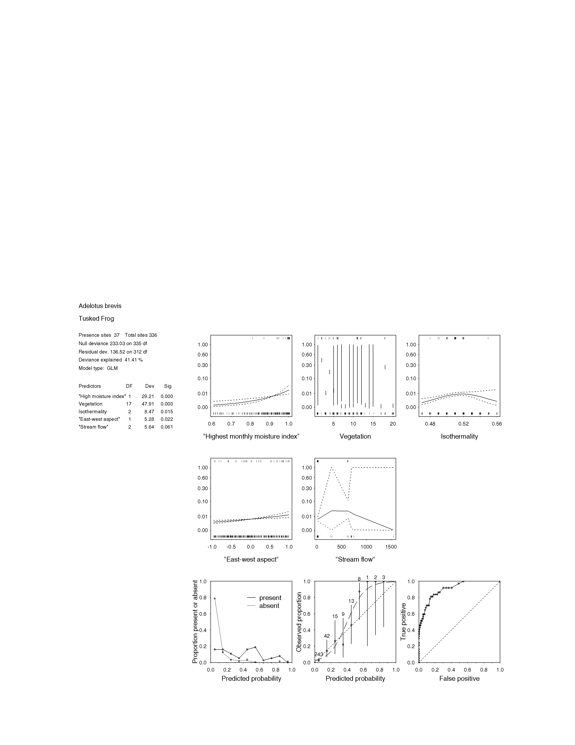

FIGURE 3.3.1a STATISTICAL OUTPUT FOR Adelotus brevis (tusked frog)

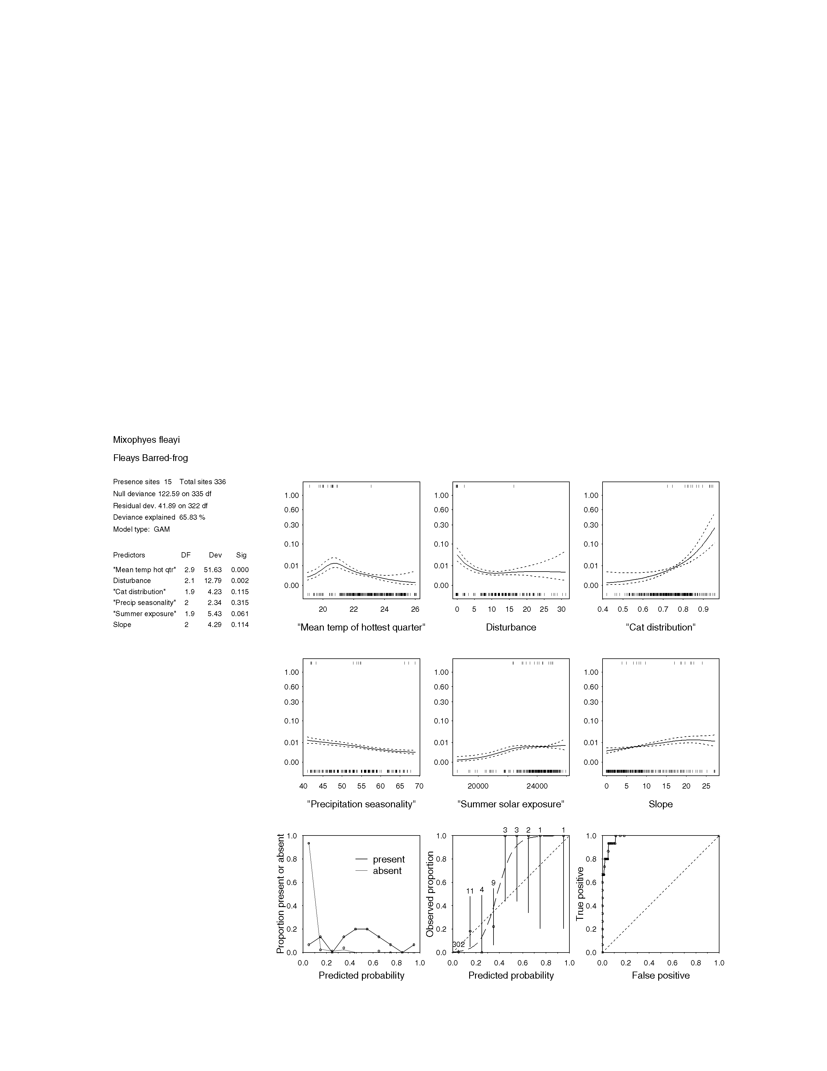FIGURE 3.3.3a statistical OUTPUT FOR Mixophys fleayi (Fleay’s barred-frog)

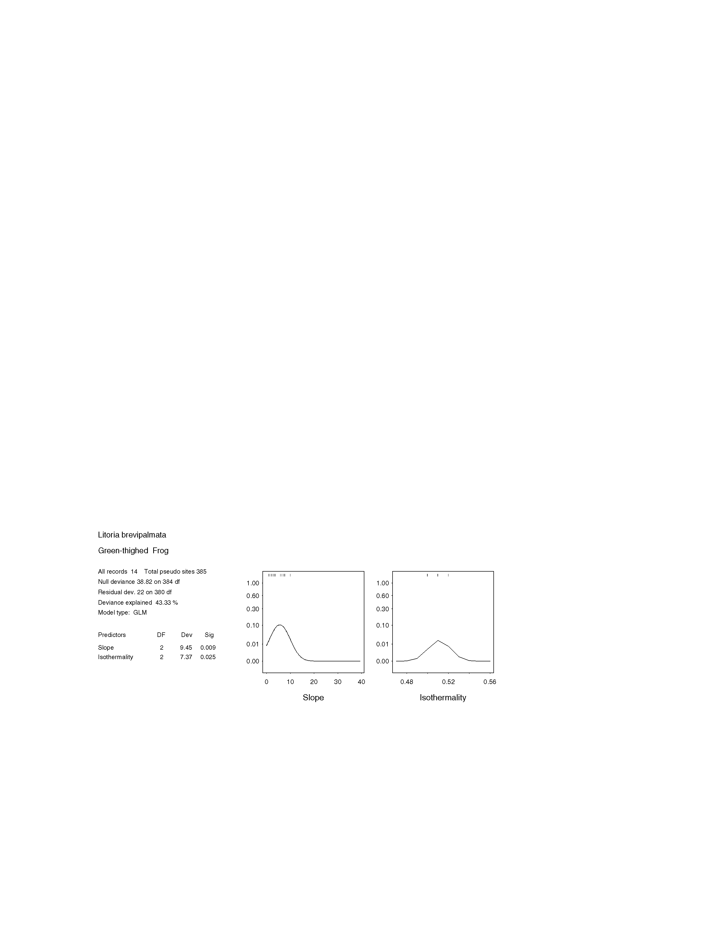

FIGURE 3.3.7a statistical output for litoria brevipalmata (green-thighed frog)

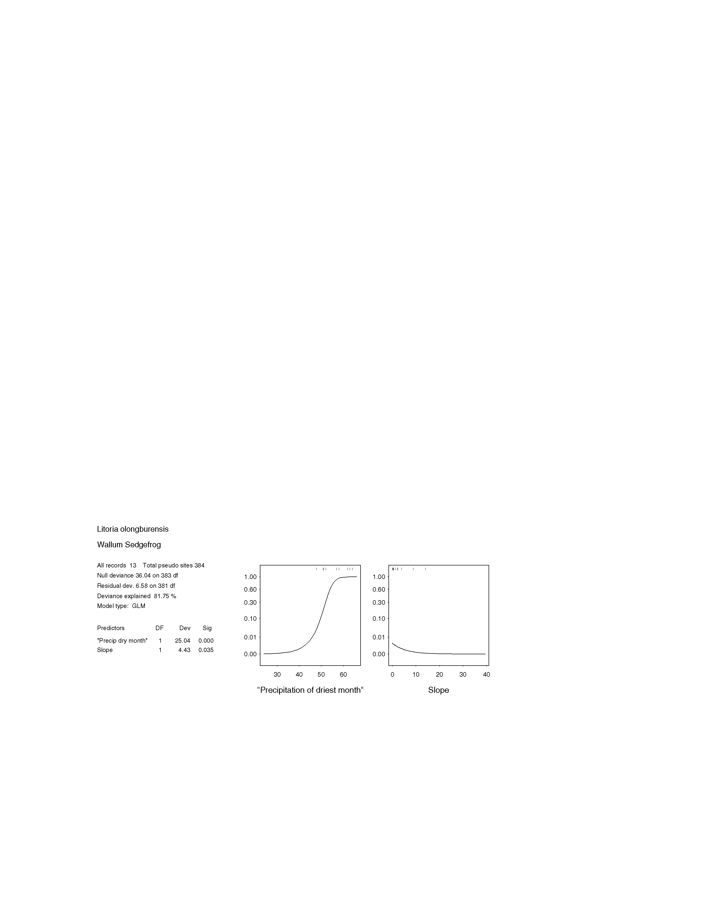
figure 3.3.9a statistical output for Litoria olongburensis (wallum sedgefrog)

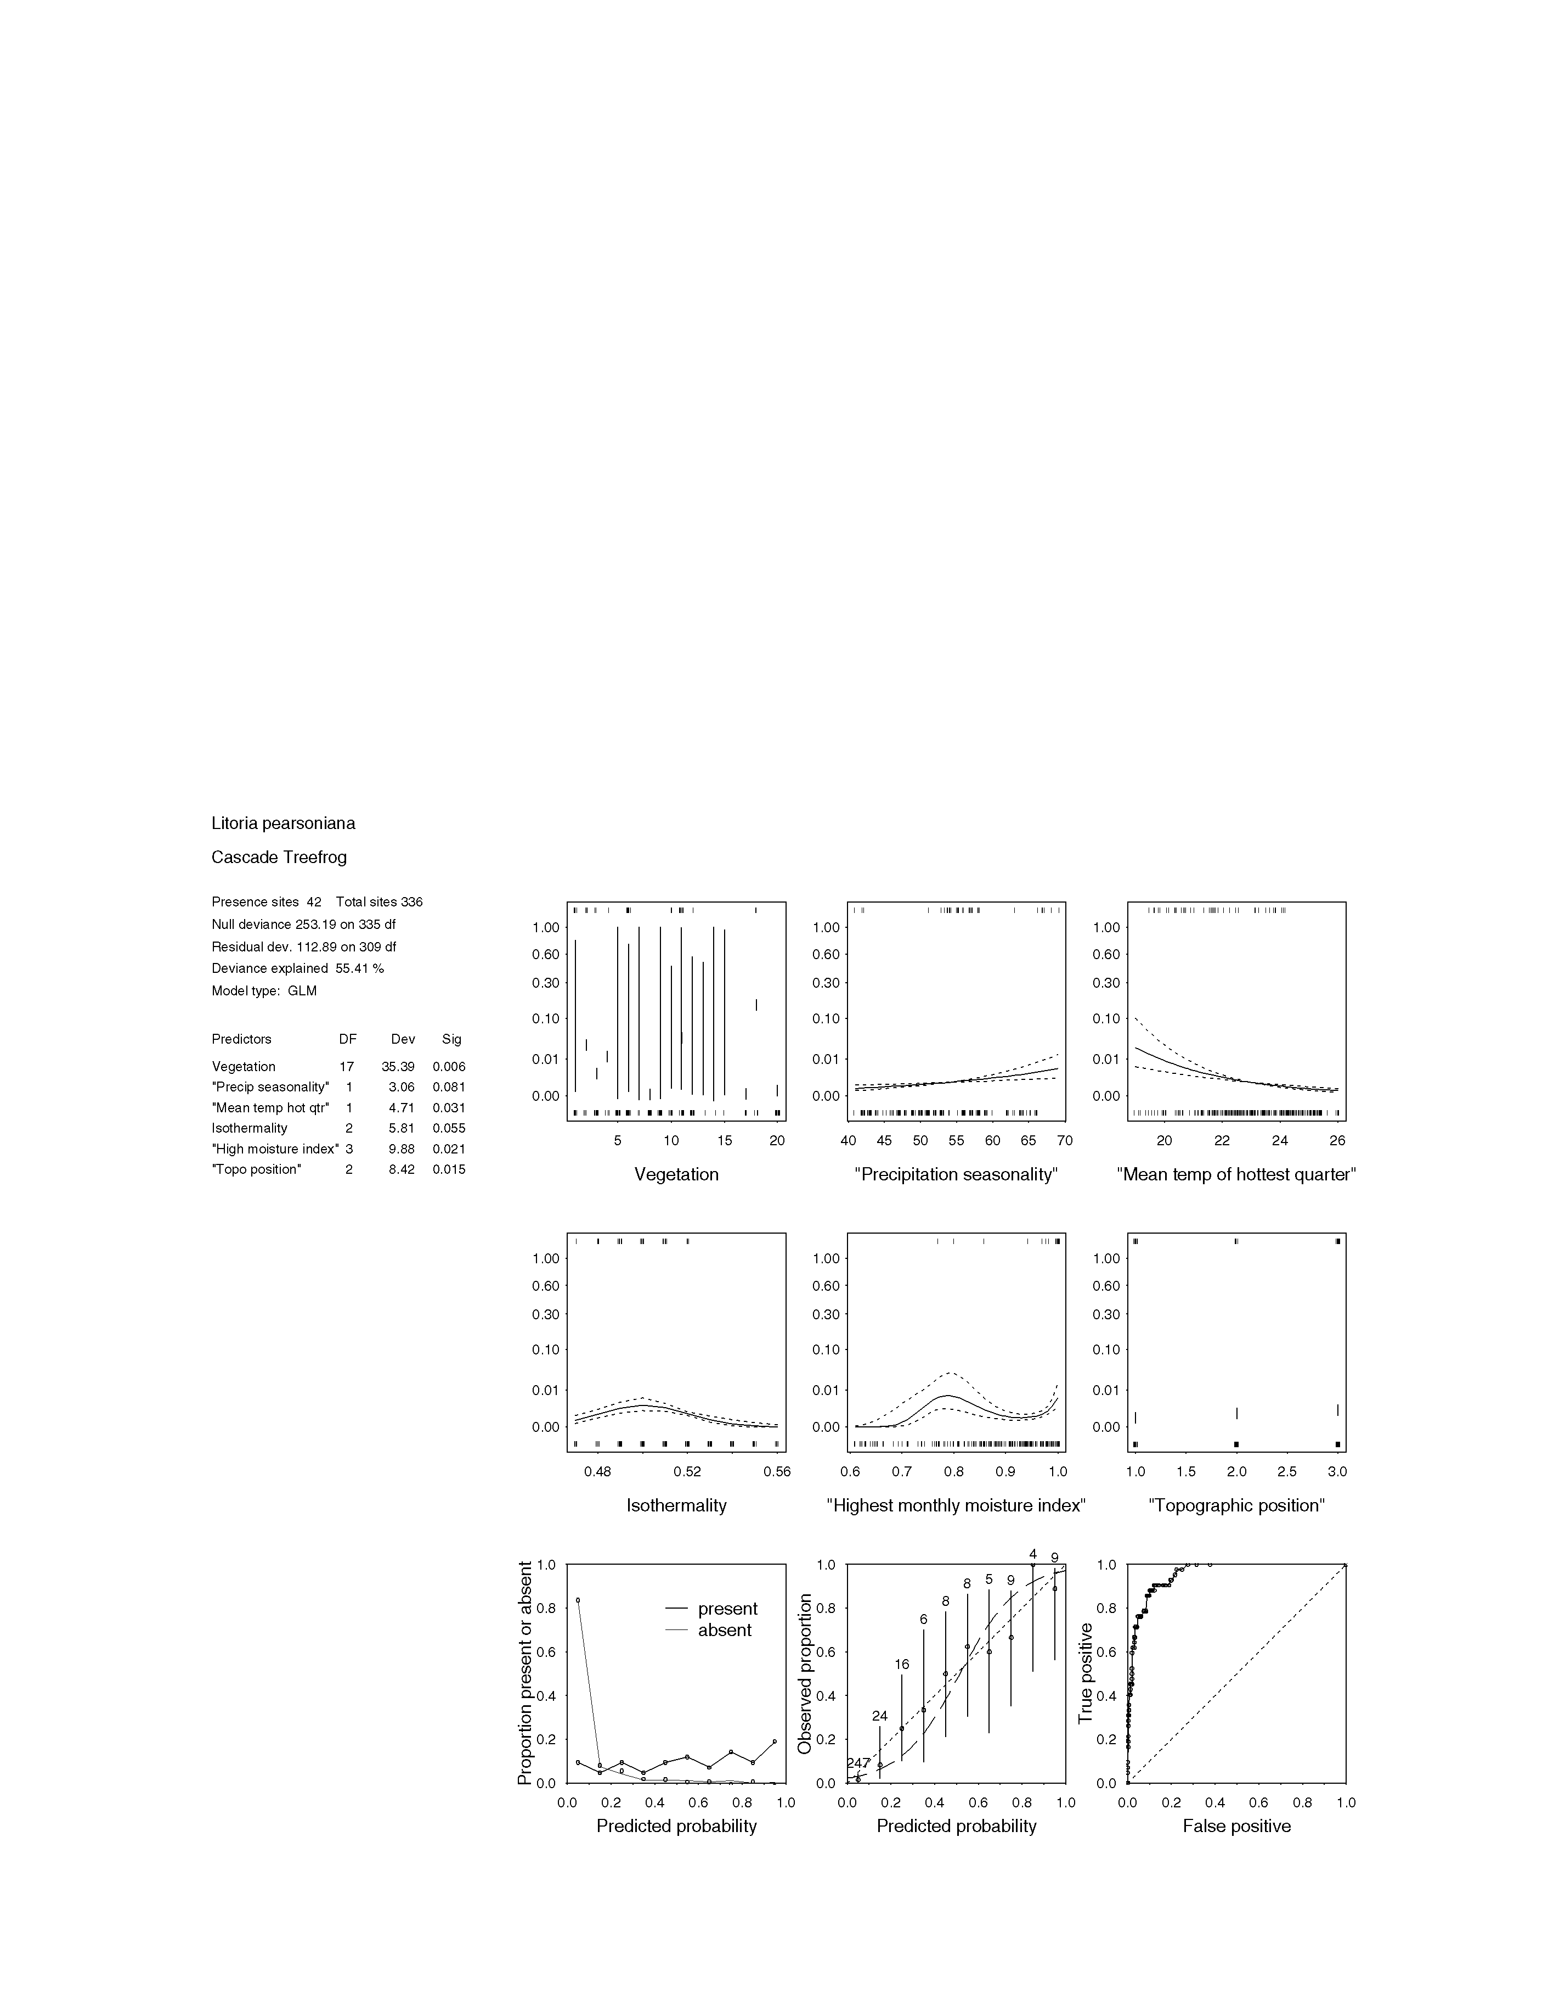

FIGURE 3.3.10a STATISTICAL OUTPUT FOR Litoria pearsoniana (cascade treefrog)

3.4 reptiles

3.4.1 Elseya sp. cf. dentata Burnett River turtle type
The Elseya dentata group consists of a complex of five species, only one of which is described, in the coastal rivers of Queensland between Gympie and Cairns, and northern Australia. The Burnett River population has long been recognized as a separate species (see review in Georges and Adam 1992) for many years, but the species is yet to be formerly described. This turtle is found in permanent water, particularly with rock, submerged logs, riparian vegetation and overhanging stream banks (T. Tucker pers. comm.). Sandy areas on stream banks are required for egg incubation during breeding season.

Expert modeling was considered to be the most appropriate method of predicting the extent of this turtle’s habitat in south-east Queensland. Based on their expert knowledge, the panel mapped areas of high quality habitat in the Baffle Creek, Burnett and Mary River drainage systems, and were satisfied that the final distribution map was of High Accuracy.

3.4.1 Elusor macrurus Mary River turtle
This recently described species has a distribution that appears to be confined to the Mary River drainage area in south-east Queensland (Cann and Legler, 1994). Elusor macrurus is omnivorous, and shares many behavioural characteristics with other species of short-necked turtle (Cann and Legler, 1994). Nesting occurs from late October, in favourable areas of riparian habitat, but illegal collecting of eggs and hatchlings is known to occur (S. Flakus, pers. comm.). Other threats to this species include the clearing of riparian vegetation, sand mining, damming, and heavy cattle grazing throughout the catchment.

Statistical modeling of the potential habitat of this little-known chelid was not attempted. Instead, expert knowledge of the habitat requirements of the species was used to produce a potential distribution map. The expert panel delineated area of core E. macrurus habitat in the Mary Catchment area, and agreed that this represented an expert model of High Accuracy.

3.4.2 Delma plebeia common delma
Delma plebeia is a large legless lizard, endemic to south-east Queensland and northern New South Wales. The northern limits of its distribution are recorded from the Gympie area (Ingram and Raven 1991), although more northerly areas remain poorly surveyed. The species is restricted to dry sclerophyll forests and woodlands, usually with a grassy understorey.

With very few available records of this species in south-east Queensland, statistical modeling of its potential habitat was not possible. Furthermore, a lack of expert knowledge means that the distribution of its habitat can only be inferred from existing site locations (see Eyre et al. 1998).

3.4.3 Delma torquata collared delma
First described in 1974, Delma torquata is a small and rare legless lizard (Kluge, 1974). The known range of this species is largely restricted to the south-east corner of Queensland from Gympie, west to the Bunya Mountains, and south to the western suburbs of Brisbane. However, the species was detected at three new localities during recent surveys, including a significant range extension north to Blackdown Tableland (Eyre et al. 1998). This, and a historical record from Gladstone, represent the only two records for this species north of the Gympie area. Whilst little is known of its ecology or habitat requirements, it has been found in heavy, black, cracking clay soils, in iron bark woodland and hoop pine scrub (Eyre et al. 1998).

Delma torquata is known only from 13 sites within the SEQ bioregion, which was insufficient data to generate a statistical model of its potential habitat distribution. Likewise, the expert panel could not confidently predict the extent of its habitat, or even the extent of its range. Mapped site locations can, however, be referred to in Eyre et al. (1998).

3.4.4 Paradelma orientalis brigalow scaly-foot
Paradelma orientalis is a large, robust legless lizard. Little is known of its biology. It is largely restricted to the Brigalow bioregion, although some records also occur in the Gladstone area, including Boyne Island. Habitat has been recorded as predominantly ironbark Eucalyptus crebra woodland situated on basalt derived, cracking clay soils; Acacia harpophylla woodland and on Boyne Island, Acacia falciformis woodland (Schulz and Eyre, 1997). Much of the habitat within this species’ range is heavily disturbed and under threat from further land clearing (McDonald, et al. 1991).

Since this species appears to be extra-limital in the SEQ bioregion, it was excluded from all statistical and expert modeling processes. A map showing the one known P. orientalis location in south-east Queensland can be found in Eyre et al. (1998).

3.4.5 Chlamydosaurus kingii frilled lizard
These large and spectacular lizards are widespread across northern Australia in subhumid to semi-arid grassy woodlands and dry sclerophyll forests (Wilson and Knowles 1988). South-east Queensland represents the southern most limit of their distribution, and in this area, they appear to be restricted to lowland woodlands. Primarily arboreal, Chlamydosaurus kingii show a preference for perches high in the dense canopies of tall trees (Griffiths and Christian 1996a). The diet consists of a diverse range of invertebrates, and food is more accessible after fire due to the removal of ground vegetation (Griffiths and Christian 1996b).

In south-east Queensland, C. kingii have experienced a dramatic population decline since the 1960s (Wilson and Knowles 1988). These populations remain threatened by continued clearing for agriculture and coastal development, and possibly through the effects of changing fire regimes.

Statistical models, using presence only data, were generated to predict the distribution of potential C. kingii habitat in south-east Queensland. Predicted distributions produced by both the GLM and GAM models were analyzed by the expert panel, who favoured the GLM model. According to the GLM model, the average winter temperature was the most significant habitat variable for predicting the distribution of C. kingii habitat. This predicted a band of high quality habitat (>0.65 probability of occurrence) along the northern coastal regions, as far south as Fraser Island. Patchy areas of moderate quality habitat (with a 0.45 -0.65 probability of occurrence) were predicted elsewhere in the bioregion, with the exception of central western and south western areas such as the Bunya Mountains and Main Range. To improve the quality of the final distribution map, the expert panel supported a number of alterations. These included increasing the southerly extent of high quality habitat along the coastal fringe, as far south as Caboolture, and excluding the Moreton and Stradbroke Island from the distribution map. With these changes, the final product was given a High Accuracy rating by the expert panel.

3.4.6 Anomalopus leuckartii no common name
Anomalopus leuckartii is a fossorial skink often encountered in soft soil beneath rocks, logs or leaf litter in eucalypt and callitris forests and woodlands (Wilson and Knowles 1988; Cogger 1996). It has a patchy distribution within south-east Queensland (Ingram and Raven, 1991) and also occurs on the western slopes and ranges of northern New South Wales (Cogger 1996). Suspected threatening processes for this species include modification of microhabitats from grazing and inappropriate fire regimes.

This burrowing skink is known from only eight site locations in the bioregion, which is too few data points to generate GLM or GAM statistical models of its potential habitat distribution. With so few records, and a lack of field experience of the species, the panel considered that an expert model would be unreliable. All known records of the species in the SEQ bioregion (to December 1997) are shown in Eyre et al. (1998).

3.4.7 Eremiascincus richardsonii broad-banded sand swimmer
Eremiascincus richardsonii is a nocturnal, burrowing skink found in a wide variety of arid or drier habitats, including woodlands, shrublands or hummock grasslands, on sandy or loam soils (Wilson and Knowles 1988; Cogger 1996). Its distribution extends over most of semi-arid and arid Australia. In the SEQ bioregion, this species appears to have a marginal distribution, and is known from only a few localities. These include the dry areas of the Lockyer and Brisbane valleys, and two records from the Eurimbula area in the north (Ingram and Raven, 1991).

Eremiascincus richardsonii is poorly known in the bioregion, and field records have not yielded sufficient information to develop either statistical or expert models of its potential habitat in south-east Queensland. For the present, the extent of this species’ habitat can only be inferred from mapped site locations (see Eyre et al. 1998).

3.4.8 Eroticoscincus graciloides elf skink
Eroticoscincus graciloides is a small lizard, endemic to south-east Queensland (Cogger, 1996). It occurs in isolated populations in vine thickets, rainforests and wet sclerophyll forests of lowlands and coastal ranges from Fraser Island south to the Ipswich area. This species lives in deep litter and under logs and rocks in shady, damp areas (Wilson and Czechura 1995), especially near streams. It is intolerant of sunlight, and possible threats to the species include habitat loss or alteration (such as clearing and selective logging) which may open canopy cover, lower moisture levels and reduce litter accumulation.

Whilst E. graciloides is known from numerous locations from the D’Aguilar Ranges north to Fraser Island, many of these site locations were recorded with >300m precision - which was considered to be too inaccurate for use with GLM and GAM statistical models. The exclusion of these site locations meant that not enough data remained to successfully run the statistical models. The panel also considered that expert modeling would be unreliable, because the detailed habitat requirements of this species are not fully understood. Although mapping of potential E. graciloides habitat was not possible, all known site locations (with a precision of <900m) can be referred to in Eyre et al. (1998).

3.4.9 Nangura spinosa Nangur skink
Nangura spinosa is a distinctively spiny, burrowing skink, which until recently was known only from one locality. This consisted of a 300 metre section of dry, gently sloping creek embankment within a semi-evergreen vine thicket in Nangur SF, north of Murgon, south-east Queensland (Horsup et al., 1993). A new population of N. spinosa was discovered during the CRA surveys, in a patch of Auraucarian notophyll vine forest in Oakview SF (Hannah et al. 1997). Searches in similar vegetation types within the bioregion failed to reveal any further evidence of this species (Eyre et al. 1998). The species is considered vulnerable due to its highly restricted distribution, and possible threats include disturbance by hoop pine logging operations, controlled burning, fire break clearing, and soil disturbance from cattle grazing. Collecting and poaching are also considered risks to this species.

With only two known N. spinosa localities, there are insufficient records at present for statistical or expert models of habitat distributions to be developed (see Eyre et al. 1998 for a map of site locations). The expert panel recommended that a map of vine thicket coverage in the bioregion could be a useful guide to its potential habitat. However, a reliable model of potential habitat cannot be generated until more is known about this cryptic species.

3.4.10 Ophioscincus truncatus truncatus no common name
Ophioscincus truncatus is a small fossorial skink endemic to south-east Queensland and northern New South Wales (Cogger 1996). Its burrowing lifestyle makes it difficult to detect, and consequently the species is poorly understood. However, it is known that two subspecies of O. truncatus exist, with O. t. monswilsonensis being restricted to the moist forests of the McPherson and Blackall Ranges. By comparison, O. t. truncatus, the subspecies of concern here, occurs in drier forests on the islands of Moreton Bay.

The expert panel determined that expert, rather than statistical modeling could best map the distribution of O. t. truncatus habitat in south-east Queensland. Therefore, an expert model was developed, incorporating remnant forest cover, confined to the Bay Islands. The resultant distribution map showed potential habitat occurring on Moreton and North Stradbroke islands, and also on South Stradbroke and Bribie islands. These latter two area were excluded from the distribution map by the expert panel, on the grounds that the species has not been found in these well surveyed areas. The final distribution map was judged to be of High Accuracy by the expert panel.

3.4.11 Saiphos equalis no common name
Saiphos equalis is a slender burrowing skink, common in New South Wales, where it is often found in gardens and composts (Cogger 1996). It is however, much rarer in south-east Queensland, where it reaches the northern limits of its known range. Within the bioregion, its distribution is poorly known. It occurs within the McPherson Range, and along the Main Range north to the Toowoomba area. Scattered records also occur from further north along the western edge of the bioregion, and from what appears to be an isolated population at Kroombit Tops (Ingram and Raven 1991). Little is known of the species’ habitat requirements, but it tends to be found on areas of volcanic soils.

Because this species’ habitat requirements are so poorly known, expert modeling of its potential habitat was considered unsuitable. Sufficient presence only site data was available, and GLM and GAM statistical models were generated. Distribution maps, extrapolated from these models, were then viewed by the expert panel. The GLM model, which incorporated only one predictor variable (average winter temperature), was accepted by the panel in preference to the GAM model. The model predicted high quality S. equalis habitat (probability of occurrence >0.8) in the cooler areas of the bioregion, for example in the southern and south-western margins of the bioregion. Moderate quality habitat, defined as having a 0.35 to 0.8 probability of occurrence, was predicted elsewhere throughout the bioregion, with the exception of a coastal band north of Gympie. The expert panel noted that many of the known S. equalis site locations, such as at Kroombit Tops and Cherbourg SF, were assigned as either moderate, or low quality habitat by the model. The panel suggested that the single predictor variable ‘average winter temperature’ did not adequately explain the distribution of the species. Correspondingly, the GLM model was judged to be of Low Accuracy.

3.4.12 Acanthophis antarcticus common death adder
Acanthophis antarcticus is widely distributed throughout continental Australia except for the far north, central desert regions and wetter parts of Victoria and south-east New South Wales (Cogger 1996). It inhabits a wide range of forest types, including rainforest, dry sclerophyll forest, wet sclerophyll forest, and woodlands. The species also occurs in mixed coastal forest and heathland, usually on well drained soils with a deep leaf litter layer. Within the bioregion, the species is known from both mainland and island populations.

The wide range of vegetation types that this species inhabits makes it difficult to isolate the factors that may define the species’ distribution. Although this species has been associated with deep litter layers and sandy soils - these habitat variables were not available for use in any of the models. Hence, it was considered that statistical and expert modeling of potential A. antarcticus habitat would be unreliable. Whilst the expert panel could not confidently map the distribution of potential habitat, a number of areas that are known to support good populations, namely the Border Ranges, Fraser Is and the D’Aguilar Ranges were emphasized. Until more detailed spatial layers can be incorporated into the modeling, the habitat of this species can be inferred from sites only. Mapped site locations can be referred to in Eyre et al. (1998).

3.4.13 Furina dunmalli Dunmall’s snake
Furina dunmalli is an extremely rare snake that is endemic to Queensland. Its distribution appears to be largely restricted to the Brigalow Belt (McDonald et al. 1991) with just a few records occurring in the SEQ bioregion. These include museum specimens from the Tarong and Gladstone areas and sightings from Rosedale near Bundaberg (Cogger et al. 1993). The decline of F. dunmalli has largely been attributed to the loss of brigalow vegetation communities to which it seems to depend (McDonald et al. 1991). The majority of the Brigalow region has been cleared and little of the remnant vegetation is free from disturbance.

Little is known of the ecology or biology of F. dunmalli, other than that it is nocturnal and feeds on skinks (Shine 1981). With so few site locations, and such a paucity of expert knowledge about this animal, it was not possible to apply either statistical or expert modeling to map the distribution of its potential habitat. Known site locations in the SEQ bioregion can be found in Eyre et al. (1998).

3.4.14 Hemiaspis dameli grey snake
Hemiaspis dameli is a small snake, growing to about 50 cm in length. Its distribution extends from the interior districts of central New South Wales, northwards into the Darling Downs (Wilson and Knowles 1988). The species appears to be extra-limital in the SEQ bioregion, with small populations occurring in woodland and wetland areas situated on heavy cracking clays. These populations are under constant threat from agriculture and urban development.

Field records failed to provide sufficient data to statistically model the potential habitat distribution of H. dameli in south-east Queensland. The expert panel identified a number of exceptional areas for the species, but were uncertain that an expert model would be accurate. The exceptional areas outlined by the panel were: the cracking clay floodplains around Lowood, Gatton, Flagstaff Ck and Ipswich. Hemiaspis dameli site locations that occur in these areas can be referred to in Eyre et al. (1998).

3.4.15 Hoplocephalus bitorquatus pale-headed snake
Hoplocephalus bitorquatus has a patchy distribution which extends along the coast, ranges and western slopes of eastern Australia from north of Sydney, New South Wales, to Cape York Peninsula, Queensland (Cogger 1996). It is a nocturnal and arboreal species which shelters beneath decorticating bark on trees, or in hollow trunks and limbs of dead trees, especially in the vicinity of watercourses (Wilson and Knowles 1988). Threats include forest management processes such as timber harvesting and prescribed burning; processes which result in the loss of large trees that provide suitable shelter (Gilmore and Parnaby 1994).

Statistical modeling of potential H. bitorquatus habitat was not possible, due to a lack of accurate site data. The expert panel considered that an expert model could be attempted, since the specialised habitat requirements of this species are relatively well understood. However, since the extent of hollows and decorticating bark are not mapped throughout south-east Queensland, this predictor variable was could not be incorporated into an expert model. Hence, potential habitat could not be statistically or expertly modeled for this species. South-east Queensland records of this snake, since 1974, can be referred to in Eyre et al. (1998).

3.4.16 Hoplocephalus stephensii Stephen’s banded snake
Hoplocephalus stephensii occurs in the coastal ranges from near Gosford, New South Wales, north to Kroombit Tops in Queensland. It is found in a wide variety of habitats including dry rainforest, sub-tropical rainforest, wet and dry sclerophyll forests and rocky outcrops (Wilson and Knowles 1988; Cogger 1996). Gilmore and Parnaby (1994) note that an important feature of its habitat appears to be the close proximity of mesic and xeric forest formations. Hoplocephalus stephensii is an arboreal species which utilizes gaps between decorticating bark and tree trunks for daytime shelter (Gilmore and Parnaby 1994). It is predominantly nocturnal, feeding on small vertebrates such as small mammals, lizards, frogs and possibly birds.

Sufficient presence only data was available to apply statistical modeling techniques, predicting the extent of potential H. stephensii habitat in the bioregion. Mapped distributions, generated by the GLM and GAM statistical models were assessed by the expert panel. The GLM model was then accepted as most accurately representing the habitat distribution of the species. The model predicted that the average summer temperature and an index of the lowest monthly moisture were the habitat variables that best defined the distribution of the species. That is, wet areas with average summer temperatures in the low 20s, were predicted as high quality habitat, or having a greater than 65% probability of the species occurring. Moderate quality habitat was defined as having a lower probability of occurrence - of between 30 and 65%. Core habitat was predicted throughout the SEQ bioregion, but most notably in the D’Aguilar, Blackall, Conondale, McPherson, Border, and Main ranges; as well as the Bunya Mountains and Kroombit Tops. The expert panel were satisfied that this distribution map was of High Accuracy, and accepted it with no further changes.

3.4.17 Pseudechis guttatus spotted black snake
Pseudechis guttatus inhabits a variety of subhumid, habitats including black-soil river floodplains, dry sclerophyll forest and woodlands (Wilson and Knowles 1988; Cogger 1996). In these habitats, the species utilizes fallen timber, abandoned burrows and soil cracks for shelter (Gilmore and Parnaby 1994). Its distribution extends from mid-eastern New South Wales to south-east Queensland, although within this region it is most widespread west of the Dividing Range (Wilson and Knowles 1988). Within the SEQ bioregion, P. guttatus was once common on the black soil plains of the Lockyer Valley. However, it is now scarce at this and other locations, possibly due to increased rural development in these areas.

With only ten accurate site records of this species in south-east Queensland since 1974, statistical modeling of P. guttatus habitat was not attempted. Additionally, field records have not yielded enough information about the detailed habitat requirements of the species to allow an expert model to be developed. Although an expert model was not possible, the expert panel stressed the importance of a number of known locations, particularly in the Gatton, Flagstone Ck and Ipswich areas. These locations can be referred to in Eyre et al. (1998).

Mapped Habitat distribution of Priority reptile species in south east queensland bioregion

NB graphics apply to statistical models only

- Chlamydosaurus kingii frilled lizard

- Ophioscincus trucatus truncatus

- Acanthopis antarcticus common death adder

- Holocephalus stephensii Stephen’s banded snake

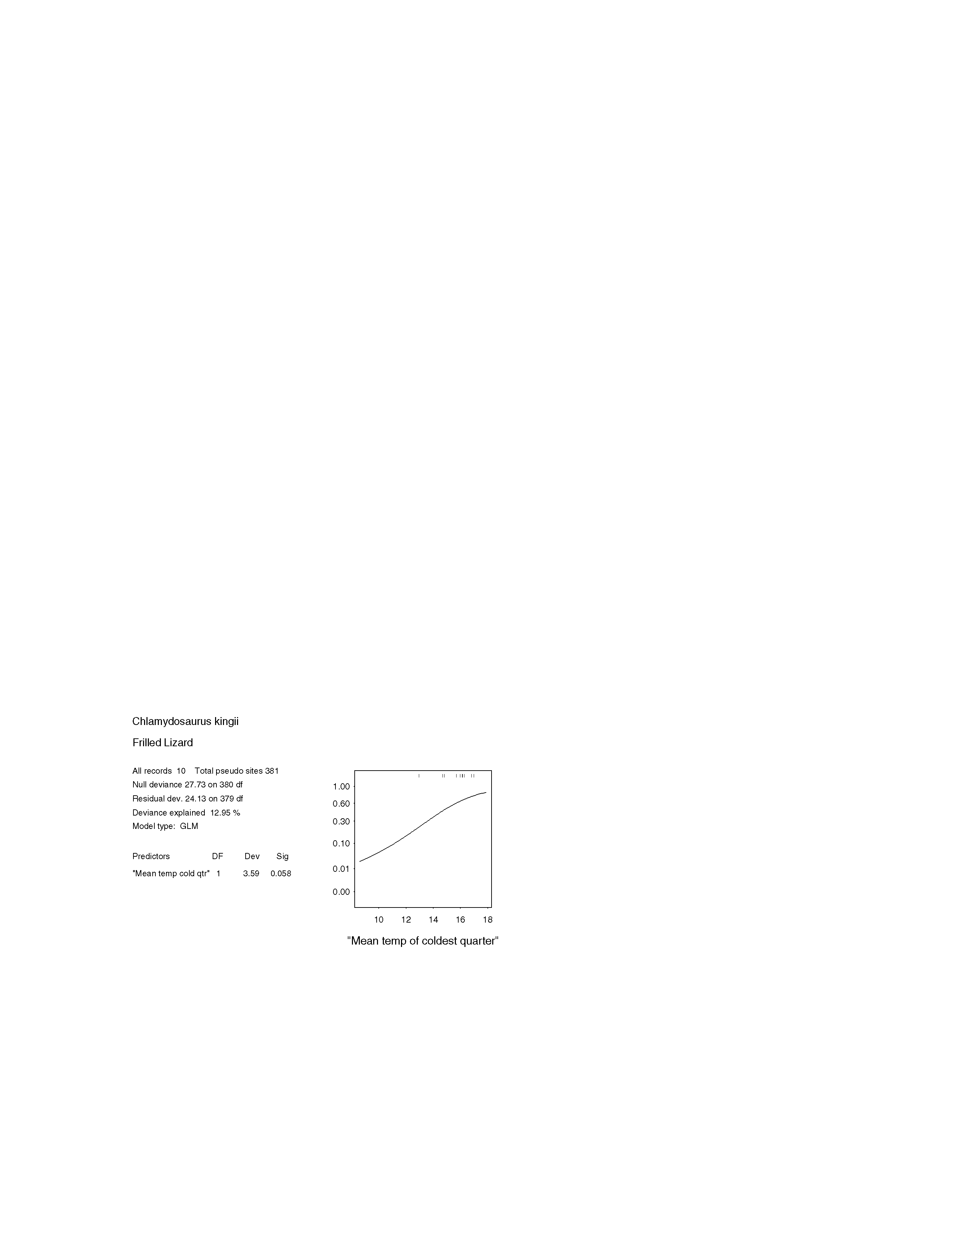
FIGURE 3.4.1a STATISTICAL OUTPUT FOR Chlamydosaurus kingii (frilled lizard)

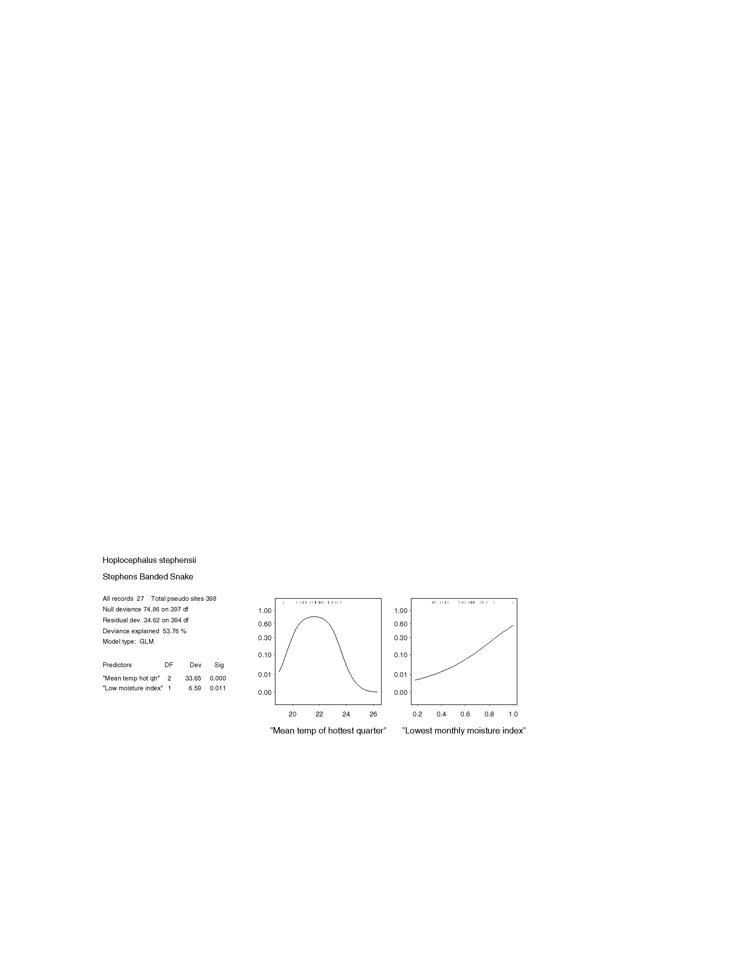

FIGURE 3.4.4a STATISTICAL OUTPUT FOR Holocephalus stephensii (Stephen’s banded snake)

3.5 Birds

3.5.1 Erythrotriorchis radiatus red goshawk
The red goshawk is difficult to observe and is seldom encountered due to its solitary, skulking habits. It occurs in coastal and subcoastal areas from north-eastern New South Wales north to Cape York and west across the Top End to the Kimberley region (Blakers, Davies and Reilly 1984, Debus 1998). Its preferred habitats are comprised of forest and woodland with a mosaic of vegetation types, permanent water and large populations of birds (Aumann and Baker-Gabb 1991, Marchant and Higgins 1993). Prey consists predominantly of birds, but less frequently it takes mammals (predominantly flying-foxes), reptiles and large insects (Marchant and Higgins 1993). Prey is captured by a range of techniques, typically ambush-hunting from concealed perch sites; seizing prey as the result of stealth glides or by direct aerial pursuit. As a result of these feeding techniques it prefers forests of intermediate density, or the ecotones between habitats of differing densities. Such habitats are open enough to allow aerial pursuits to occur, but also provide enough cover for ambush hunting (Marchant and Higgins 1993).

There are few documented red goshawk breeding records. Nests are typically located in tall, living trees, in open forest or woodland, within a kilometre of permanent water. Although probably always uncommon, this species has declined and the breeding range has contracted in the southern parts of its range, probably as the result of extensive habitat loss through land clearing, drainage of wetlands and the establishment of extensive pine plantations (Marchant and Higgins 1993, Debus 1998).

It was suggested by a number of members of the expert panel that the red goshawk’s core habitat would not model well using statistical methods, due to its wide ranging nature and broad habitat requirements. An expert model was recommended as the preferred method of mapping the species’ potential habitat. After viewing a map of red goshawk records in south-east Queensland, (including the results of the Queensland Museum’s Red Goshawk Survey) the expert panel delineated areas of known or potential habitat. This included most large areas of remnant forest throughout the bioregion. Areas that are known to support breeding pairs were given special emphasis by the panel. Whilst the expert panel were satisfied that the distribution of known red goshawk habitat was adequately mapped, they were less certain about the predictive value of the model. The final distribution map was assigned a Medium Accuracy rating.

3.5.2 Lophoictinia isura square-tailed kite
The square-tailed kite has been described as a “tree-top harrier”, specializing at flying low and slowly through or adjacent to the canopy of trees or shrubs. Here it plunges after prey, including passerines, eggs and young in bird nests and insects (Schulz 1983, Marchant and Higgins 1993, Debus 1998). It is widespread, but sparsely distributed throughout mainland Australia, occurring mainly in the coastal and subcoastal areas (Marchant and Higgins 1993). It mainly occurs in open forests and woodlands, particularly those on fertile soils and with abundant passerines (Storr 1973, Marchant and Higgins 1993). There are few documented breeding records throughout its range, but nests are typically located in mature living trees in forest or woodland of at least several hundred hectares in size (Marchant and Higgins 1993). Although probably always uncommon, the square-tailed kite is thought to have declined due to the extensive clearing of suitable forest and woodland habitat (Debus and Czechura 1989, Debus 1998).

A statistical model of potential square-tailed kite habitat was not produced, because much of the site data was clustered around Brisbane and the Sunshine Coast (see Eyre et al. 1998 for a map of site locations). The number of sightings in these areas may be a reflection of this raptor’s seasonal movements (Blakers, Davies and Reilly 1984), and occasional individuals straying into suburban areas to feed on introduced or native passerines (Czechura 1995b). However, these developed areas are considered to be low quality habitat by the expert panel, and a statistical model using this clustered data would have skewed the model predictions to these areas, rather than to the square-tailed kite’s core habitat.

The panel attempted to expertly map this raptor’s known and potential habitat in south-east Queensland. Large areas of medium to high quality habitat were delineated throughout the bioregion and the panel rated the Accuracy of this distribution map as Medium.

3.5.4 Turnix melanogaster black-breasted button-quail
Black-breasted button-quail are quiet, cryptic, ground-dwelling insectivores that forage in the litter of dense, low vegetation, such as dry rainforests and shrubby woodlands. Small isolated populations are confined to restricted habitat in the SEQ bioregion (Hamley, Flower and Smith 1997). Black-breasted button-quail aggregate in small parties of four to five individuals, usually comprising a female and several males. Movements are within a defended territory.

The distribution of potential Black-breasted button-quail habitat was predicted from presence/absence data, using GLM and GAM statistical models. The expert panel viewed the mapped distributions extrapolated from both models, but rejected the GAM model. The GLM model incorporated five predictor variables; rainfall of the wettest month, disturbance, seasonality of rainfall, stream flow, and north-south aspect. Predicted areas of moderate quality habitat were defined as having a 70-90% probability of the species occurring there, with high quality habitat having a greater than 90% probability. The model predicted areas of moderate to high quality habitat particularly in the central districts of the bioregion, encompassing the Bunya Mountains to the Blackall and Conondale ranges. The Border and Main Ranges, Fraser Island and the area from Mt Perry to Kroombit Tops was also predicted. The expert panel made no adjustments to the distribution map, other than to emphasize several important areas for the species. These were the Yarraman district, Deongwar SF, Wrattens SF and Fraser Island. However, the panel was not entirely satisfied with the final distribution map, and rated it Medium Accuracy.

3.5.5 Geophaps scripta scripta squatter pigeon (southern subspecies)
Squatter pigeons are largely ground foraging birds that feed on the seeds of grasses in woodlands and river flats, usually close to water (Frith 1988). They occur east of the Great Divide from the base of Cape York to Gladstone, extending inland further south (Blakers, Davies and Reilly 1984). This southern inland extension appears to have contracted in historical times, probably caused by increased grazing pressure . The distribution encompasses most of the bioregion but records are sparse south of Bundaberg (Blakers, Davies and Reilly 1984).

With very few available records in south-east Queensland, statistical modeling of potential squatter-pigeon habitat was not possible. Furthermore, the expert panel considered that an expert model would be unreliable. Therefore, the distribution of the species in the SEQ bioregion can be known only from site locations (see map in Eyre et al. 1998).

3.5.7 Calyptorhynchus lathami glossy black-cockatoo
Glossy black cockatoos are wide ranging specialist seed-eaters that are conspicuous due to their large size and distinctive call. The species occurs in south-east Australia, from Eungella NP in Queensland to eastern Victoria, and its preferred habitat is fruiting allocasuarina trees in forests, woodlands and timbered watercourses (Saunders 1988). Particularly in western parts of its range, the species is also known from eucalypt and native cypress (Callitris) forests, and brigalow scrub (Pizzey and Knight 1997). They live in groups of two to nine individuals, but pairs or families of up to four individuals will roost separately (Blakers, Davies and Reilly 1984). Tree hollows are required for nesting. Glossy black cockatoos are found throughout the SEQ bioregion, where suitable habitat exists.

Predictive statistical models were developed to map the distribution of glossy-black cockatoo habitat in south-east Queensland. Presence only data was used to generate GLM and GAM models, and distribution maps based on these models were then supplied to the expert panel. The GLM model, which incorporated five predictor variables (average summer temperature, disturbance, slope, winter solar exposure, and fox distribution), was accepted by the expert panel as the best representation of the cockatoo’s distribution. Although ‘fox distribution’ was considered to be an anomaly. The experts further refined the model by emphasizing the of a number of significant areas for the species, including the area from Mt Perry to Kroombit Tops, and the Main and Border ranges. Cordalba SF was included as moderate quality habitat, (having a 40 - 80% probability of the species occurrence), and the Bunya Mountains were downgraded from high quality habitat (>80% probability of occurrence) to moderate quality. The resultant distribution map was judged to be of Medium Accuracy.

4.3.8 Cyclopsitta diophthalma coxeni Coxen’s fig-parrot
Fig-parrots Cyclopsitta diophthalma are small, dietary specialists, feeding predominantly on the seeds of figs. The southern race, Coxen’s fig-parrot C. d. coxeni, occurs in rainforest and open forest, and has been documented feeding in isolated trees in cleared areas. Its preferred habitat originally appears to have been lowland rainforest in south-east Queensland and north-east New South Wales, however, much of this has now been cleared and fragmented. The subspecies is now extremely rare, with few records known from within the bioregion in the last decade, and these are restricted to the McPherson, Main and Conondale ranges (Garnett 1992; Gynther 1998). These areas are higher altitude forests that are still largely intact. However, there have been a number of unconfirmed sightings from coastal and riparian forest near Bundaberg (I. Gynther pers. comm. 1998).

The expert panel recommended that an expert model of potential habitat be developed, as this species’ habitat requirements are relatively well understood. Additionally, a lack of recent site data precluded the use of statistical models. The expert model incorporated a number of predictor variables based on remnant rainforest vegetation types: grouped vegetation types 1a, 1b, 2, 6a, 6b, 6c, and 7. The model predicted Coxen’s fig-parrot habitat sparsely throughout the bioregion, but most prominently around the Blackall and Conondale ranges, and north to Fraser Island. Areas with known populations, such as Lamington, Conondale and Main Range national parks, were delineated as high quality habitat by the panel. In addition, a number of areas considered by the panel to be potential habitat - but were not predicted by the model - were added to the distribution map. These included Eurimbula NP and TR and remnant riparian vegetation along Baffle Ck and the Burnett and Kolan rivers. No areas of predicted habitat were excluded from the distribution map by the expert panel. The final product was given a Medium Accuracy rating.

3.5.9 Ninox strenua powerful owl
The distribution of the powerful owl was known to extend along the Great Divide from southern Victoria to the Rockhampton area of central Queensland (Blakers, Davies and Reilly 1984). However, a recent record from the Clarke Range has extended the known range of this species to the north of Eungella (Eyre and Schulz 1996). Powerful owls are large birds which maintain territories of up to 1000 hectares. Their territories can include a variety of forest types, although they are essentially birds of open and tall open eucalypt forest (Debus and Chafer 1997). The species preys predominantly on small to medium sized arboreal mammals, as well as flying foxes. They are also known to feed on small birds (Pavey, 1994).

Due to the broad habitat requirements, and wide ranging nature of the species, it was considered that the species distribution would not model well using GLM and GAM statistical methods. An expert model was considered to be more appropriate, and a model was developed by applying a forest mask of all grouped vegetation units, with the exception of 6a and 6b (rainforest types). The resultant distribution map predicted that powerful owls should occur in almost all of the remnant forested lands in south-east Queensland. The expert panel made no alterations to the model, other than to highlight three exceptional areas, known to support high densities of powerful owls. These areas were: the Burnett and Dawes ranges north to Kroombit Tops, the Conondale and Blackall ranges and the D’Aguilar Range. Following discussion, the map was rated Medium Accuracy by the expert panel.

3.5.10 Tyto novaehollandiae masked owl
The masked owl inhabits sclerophyll forests, in coastal and subcoastal Australia. It appears to be widespread within its range, although it usually occurs in low densities. Their home ranges usually include an open or cleared area beside a forest edge, from which they hunt. However, recent evidence has shown that the species may hunt in closed forests as well as more open forest types (Kavanagh and Murray 1996; Eyre et al. 1998). Masked owls nest in caves, or large hollows within tall live or dead trees (Debus and Rose 1994; Gilmore and Parnaby 1994). Individuals feed on a variety of prey, including small to medium-sized mammals, particularly rats. Threatening processes relate primarily to habitat reduction, particularly the loss of large hollow trees, and possibly a reduction in prey availability (Debus and Rose 1994; Schodde and Mason 1980).

Whilst the masked owl is considered to be the least readily detected of the large forest owls (Debus 1995), sufficient presence only data was available to generate statistical models of its potential habitat. Masked owl distributions, predicted from GLM and GAM models, were assessed by the expert panel. The GLM model was rejected by the panel, who considered the GAM model to be more representative of masked owl distribution. According to the GAM model, ‘average summer temperature’, and ‘slope’ were the habitat variables that best defined the distribution of the species. Moderate quality habitat was defined as that which had a 0.3 to 0.7 probability of masked owl occurrence: and was predicted throughout much of the bioregion. The distribution of high quality habitat (probability of the species’ occurrence >0.7) was more restricted, but included areas such as the Conondale/Blackall ranges, the Bunya Mountains, the Great Sandy NP, Kroombit Tops, and the southern margins of the bioregion. The coastal band north of Fraser Island was predicted by the model as being low quality habitat (ie, <0.3 probability of finding the species). The experts disagreed with this prediction and included this area as medium quality habitat. An upgrade from medium-low, to high quality habitat was also recommended for the Mooloolah River area. Despite these adjustments to the expert panel was not satisfied about the reliability of the final distribution map, and rated it as Low Accuracy.

3.5.11 Tyto tenebricosa sooty owl
Sooty owls occur on the eastern side of the Great Dividing Range, from Victoria north to south-east Queensland. Within Queensland, they occur as far north as Cooloola and the Conondale ranges (Blakers, Davies and Reilly 1984), with recent records of isolated populations at Eungella NP and Kroombit Tops (Hobcroft 1997). Sooty Owls are restricted to rainforests and tall wet forests and predominantly feed on small terrestrial and arboreal mammals (Calaby 1988). They maintain territories of two to eight square kilometres (Blakers, Davies and Reilly 1984), and so may venture some distance into open country.

The distribution of quality habitat for this species was predicted using presence only data in GAM and GLM statistical models. Predicted habitat distributions were extrapolated from the models, and the resultant maps were assessed by the expert panel. The GLM model was accepted as most accurately representing the actual habitat distribution of the species. Five habitat variables, (average summer temperature, cat distribution, seasonality of rainfall, rainfall in the driest month, and stream flow), were incorporated into the model, although ‘cat distribution’ was considered an anomaly. Sooty owl habitat was defined as being of low, medium, or high quality on the probability of the species occurrence in that area. For this model, moderate quality habitat had a probability of between 30 and 70%, with high quality habitat having a greater than 70% probability. Medium to high quality habitat was predicted in a number of distinct areas throughout the bioregion, all of which coincided with expert opinion about the distribution of quality sooty owl habitat. These areas included the north of the bioregion, particularly Bulburin SF and Kroombit Tops, the D’Aguilar, Conondale and Blackall ranges, the McPherson and Main ranges, and the Bunya Mountains. No alterations were made to the mapped distributions other than to emphasize the importance of some of these areas, which are known to support good populations of these owls. The panel was confident that model, and the habitat distribution map, was of High Accuracy.

3.5.12 Podargus ocellatus plumiferus plumed frogmouth
The plumed frogmouth is a large, nocturnal insectivore and predator of small vertebrates, that is restricted to rainforests and rainforest margins (Chapman 1988). Pairs maintain year round territories of several hectares (Smith et al. 1994). They are nocturnal and cryptic in dense habitat but have loud distinctive calls and respond readily call playback. The plumed frogmouth is restricted to suitable habitat on the eastern side of the Great Dividing Range, between Lismore in northern New South Wales, north to the Many Peaks Range within the SEQ bioregion (Corben and Roberts 1993). This species has declined in south-east Queensland due to clearing and fragmentation of its habitat (Corben and Roberts 1993).

The distribution of quality plumed frogmouth habitat was predicted from presence/absence data, using GAM and GLM statistical models. Predicted distributions extrapolated from both models were viewed by the expert panel, and the GAM model was accepted as being the most representative of the true habitat distribution. This model selected six habitat variables, including vegetation, rainfall of the wettest month, biophysical naturalness, average daily temperature range, disturbance, and summer solar exposure, as being the best predictors of plumed frogmouth habitat. The expert panel were satisfied overall with the resultant habitat distribution map, but made a number of alterations. These included, downgrading all ‘high quality’ habitat areas around the Cooloola, Kroombit Tops and west of Cordalba SF (**? I don’t know the name of the SF**) ‘moderate quality’, and excluding all of the sand islands (ie, Fraser Is, Stadbroke, etc.) from the distribution map. Habitat of moderate quality was defined as having a 20 - 50% probability of plumed frogmouth occurrence, whilst high quality habitat had a greater than 50% probability. Exceptional areas for the species (eg, the Conondale and Blackall ranges, Bulburin SF, the D’Aguilar Range, etc.) were also outlined by the expert panel, on the basis of high plumed frogmouth densities, and/or extensive areas of suitable habitat. Following these adjustments, the final habitat distribution map was judged by the expert panel to be of High Accuracy.

3.5.13 Menura alberti Albert’s lyrebird
Albert’s lyrebirds are large, mostly ground dwelling insectivores, which forage in the litter of upland wet sclerophyll forests and rainforest (Robinson 1988). The species is readily detectable during the winter breeding season, when males vocalize with loud and distinctive calls. They have a very restricted range, which straddles the Queensland-New South Wales border from the lower Richmond Valley, New South Wales, to the Mistake Range in south-east Queensland. A population isolate occurs at Tambourine mountain (Gilmore and Parnaby 1994). Blakers, Davies and Reilly (1984) comment that the population on Tambourine mountain may be too small and isolated to survive.

The expert panel determined since the distribution and habitat requirements are sufficiently well known, - expert knowledge, rather than statistical modeling could best map Albert’s lyrebird habitat in south-east Queensland. Therefore, core habitat was delineated, based on known site locations and remnant forest cover. The resultant distribution map showed lyrebird habitat occurring in three distinct areas: the high altitudinal rainforests of Main Range, the McPherson Ranges and Mt Tambourine. The final distribution map was judged to be of High Accuracy by the expert panel.

3.5.14 Atrichornis rufescens rufous scrub-bird
Rufous scrub-birds are small, ground-dwelling birds that feed in thick leaf litter in upland temperate rainforests (Smith 1988). This habitat is restricted to the crest of ranges, from Mt. Mistake, Queensland, south to Barrington Tops, New South Wales (Blakers, Davies and Reilly 1984). It has also been recorded in high altitude heath at Mt Barney NP (D. Stewart, pers. comm.). Within its rainforest habitat, the rufous scrub-bird is restricted to areas of dense ground cover (Gilmore and Parnaby 1994), where it occurs at low densities. Males occupying large territories, for example four individuals per square kilometre within prime habitat (Smith 1988). Rufous scrub-birds are cryptic and are rarely seen within the dense ground cover that they inhabit. However, during the breeding season, which extends through winter and into early spring (Smith 1988), males emit a loud territorial song, which greatly increases the detectability of the species.

Insufficient data was available to allow statistical modeling to predict the rufous scrub-bird’s habitat distribution. Instead, the expert panel considered that the species’ habitat range could be adequately mapped based on the three known populations at the southern limits of the bioregion. Mt Mistake, Mt Barney and Lamington NP were delineated as high quality habitat, and the surrounding areas of the Main, McPherson and Border ranges were considered to be potential, or moderate quality habitat by the expert panel. The mapped distribution of rufous scrub-bird habitat was given a High Accuracy rating by the expert panel.

3.5.15 Climacteris erythrops red-browed treecreeper
The red-browed treecreeper is an ecological specialist, gleaning insects from the bark of eucalypt trees, particularly smooth-barked species with long ribbons of decorticating bark. In south-east Queensland, where this bird is at its northern limits (Blakers, Davies and Reilly 1984), it has a scattered distribution within upland wet sclerophyll forests and rainforests with emergent eucalypts. It is threatened by clearing, wildfire, and the logging and thinning of forests (Loyn 1985; Kutt, 1996).

Expert modeling of the red-browed treecreeper’s habitat distribution was considered appropriate by the expert panel, as its habitat requirements and current distribution are relatively well understood. Furthermore, much of the available site information about this species was recorded without the level of precision required for statistical modeling. Therefore, an expert model was produced to map medium to high quality red-browed treecreeper habitat throughout the SEQ bioregion. This model incorporated a number of predictor variables, including **** grouped vegetation types (ie, 1a,1b, 2, 4a, 7 in Young 1998) and elevation (*?*). The expert model predicted red-browed treecreeper habitat in areas such as the Conondale, Blackall and D’Aguilar ranges, and the McPherson and Main ranges in the south. Suitable habitat was also predicted in the more northern rainforested areas such as Kroombit Tops and Bania SF. However, the experts excluded all areas north of Great Sandy NP, as the northern extent of this bird’s range appears to be around Noosa. The Bunya Mountains area was also excluded from the final distribution map. Following these changes, the expert panel judged the mapped distribution to be of High Accuracy.

3.5.16 Dasyornis brachypterus eastern bristlebird
Eastern bristlebirds are small omnivores, whose distribution is restricted to three disjunct areas, between eastern Victoria and south-eastern Queensland. The population centres are located in northern NSW and south-east Queensland; the Illawarra Basin; and East Gippsland. Populations within these areas are small and often widely separated from each other. The majority of the northern population occurs within the SEQ bioregion, where they are known from the McPherson, Main and Conondale ranges (Holmes 1989).

Individuals of the northern populations differ in their habitat requirements from those further south. Optimum habitat within south-east Queensland appears to be open eucalypt forest with a grassy understorey (Hartley and Kikkawa 1994). Eastern Bristlebirds have also been located in high altitude heath within Mt Barney NP (Holmes 1989). The northern populations occur adjacent to areas of rainforest, which the birds use as a refuge from fire. The eastern bristlebird is a cryptic and largely ground-dwelling species, but can be detected by its loud and distinctive call, and is known to respond to call playback. Populations within the bioregion are small, all containing less than 12 animals (D. Stewart pers. comm.). Eighteen animals are currently known from the state. The populations within the bioregion are threatened by inappropriate fire regimes, grazing, disturbance by pigs, and predation by pest species (Hartley and Kikkawa 1994)

Due to the rarity of the eastern bristlebird in the SEQ bioregion, statistical modeling of its habitat was not possible. The expert panel did not feel confident that an accurate map of potential eastern bristlebird habitat could be developed, based on their expert knowledge. Therefore, the core habitat of this rare species can be known from site locations only (see Eyre et al. 1998).

3.5.17 Lichenostomus melanops yellow-tufted honeyeater
The yellow-tufted honeyeater is a relatively large, gregarious, nectar dependent honeyeater of open eucalypt woodland and forest. It is sparsely distributed throughout its range, along south-eastern Australia from Naracoorte, South Australia, to Noosa in south-east Queensland (Blakers, Davies and Reilly 1984). Its preferred habitat is dense undergrowth, usually associated with creeklines and gullies within more open woodland (Crome 1988). These honeyeaters often live in discrete colonies of 10-100 individuals, within which small family groups maintain territories of up to ten hectares (Blakers, Davies and Reilly 1984). The species may roam more widely outside the breeding season (Crome 1988).

These are large and active birds, with a bold and curious nature, and are unlikely to be missed on any standard survey. As a consequence, a sufficient amount of accurate site data was available for statistical modeling of the distribution of yellow-tufted honeyeater habitat. Presence/absence, as well as presence only data was used to run GLM and GAM statistical models, and the mapped products of these models were then viewed by the expert panel. The ‘presence only’ GLM model was accepted as being the better predictor of quality habitat. The model showed that disturbance, biophysical naturalness, an index of lowest monthly moisture, and annual temperature range, best predicted the habitat distribution of the species. Areas of medium to high habitat quality, (defined as having a 0.6-0.85, and >0.85 probability of the species’ occurrence, respectively), were predicted throughout the bioregion, particularly in central and northern areas. However, the expert panel considered that a number of areas predicted to contain high quality habitat should be downgraded to ‘moderate’, due to uncertainty about its suitability for this honeyeater. This included areas north of Mt Perry (with the exception of Kroombit Tops), a coastal band from Maryborough to Woodgate, and a large area in the south, encompassing the Yarraman district, south to Mt Mistake, and east to the D’Aguilar Range. Likewise, areas of ‘moderate’ quality habitat in the dry forests from Glenbar SF to Cordalba SF, and at Kroombit Tops, were upgraded to ‘high’ quality. Lastly, the expert panel excluded the coastal sand islands from the distribution map. With these alterations, the panel judged that the final distribution map supported current knowledge and expert opinion. However, concern was expressed that some ‘presences’ may be confusing, as some are due to resident birds, and others are from sighting of nomadic individuals. Hence, the final distribution map was rated as Medium Accuracy.

3.5.18 Melithreptus gularis black-chinned honeyeater
There are at least two subspecies of the black-chinned honeyeater. Melithreptus gularis gularis, the golden backed form, occurs in eastern Australia, while M. g. laetior is distributed across the northern half of the continent (Blakers, Davies and Reilly 1984). Like other Melithreptus honeyeaters, black-chinned honeyeaters consume more insects and manna than nectar, typically through gleaning the undersides of branches and twigs. Such a diet lessens their dependence on the flowering of eucalypts and probably allows them to be more sedentary than many other honeyeaters (B. Trail pers. comm.). Abbott (1988) comments that M. gularis are the most sedentary of the Melithreptus, but that the size of their home range is so large that at small scales they can appear nomadic. Barry Trail (pers. comm.) considers the species to be mostly restricted to larger forest blocks and to be present at very low densities (0.1 birds/ 10 ha). For much of their range black-chinned honeyeaters live as pairs or small colonies, often breeding communally (Abbott 1988; Pizzey and Knight 1997).

The expert panel recommended that an expert model of potential habitat be developed, as this species’ habitat requirements are relatively well understood. The expert model incorporated a number of predictor variables based on remnant vegetation coverage of dry Eucalypt and Corymbia forest types (grouped vegetation types 3a, 3b, 4b, 5a and 5b). The model predicted black-chinned honeyeater habitat patchily distributed throughout the bioregion, with the exception of the sand islands and a coastal fringe from Caboolture north to Bundaberg. The expert panel made no changes to the distribution map, other than to upgrade two areas, Cherboug SF and the dry forests from Glenbar SF to Cordalba SF, to ‘high’ quality habitat. No areas of predicted habitat were excluded from the distribution map by the expert panel. The final product was given a Medium Accuracy rating.

3.5.20 Poephila cincta cincta black-throated finch (white-rumped form)
The black-throated finch feeds on seeds in dense grasses beneath open woodlands, and move about in flocks of up to 20 individuals. Historically, this species was found over all but the south-western parts of Queensland. Within this distribution, three separate races are known. The northern two races, P. c. nigrotecta and P. c. atropygialis, range over Cape York to just south of Cairns. The third subspecies, P. c. cincta, was once distributed from the south of Cairns to just over the New South Wales border, and well inland, but is now extremely rare in the bioregion. A small, outlying population remains on the New England Tableland in northern New South Wales (Pizzey and Knight 1997). The causes of the black-throated finch’s decline are unknown, but probably relate to grazing pressure on its habitat.

The black-throated finch is poorly known in the bioregion, and field records have not yielded sufficient information to develop either statistical or expert models of its potential habitat in south-east Queensland. Blakers, Davies and Reilly (1984) provide a few historical records of the species, but it is now possibly extinct in the SEQ bioregion.

Mapped habitat distribution of priority bird species in south east queensland bioregion

NB graphics apply to statistical models only

- Erythrotriorchis radiatus red goshawk

- Lophoictinia isura square-tailed kite

- Turnix melanogaster black-breasted button-quail

- Calyptorhynchus lathami glossy black-cockatoo

- Cyclopsitta diophthalma coxeni Coxen’s fig-parrot

- Ninox strenua powerful owl

- Tyto novaehollandiae masked owl

- Tyto tenebricosa sooty owl

- Podargus ocellatus plumiferous plumed frogmouth

- Climacteris erythrops red-browed treecreeper

- Lichenostomus melanops yellow-tufted honeyeater

- Melithreptus gularis black-chinned honeyeater

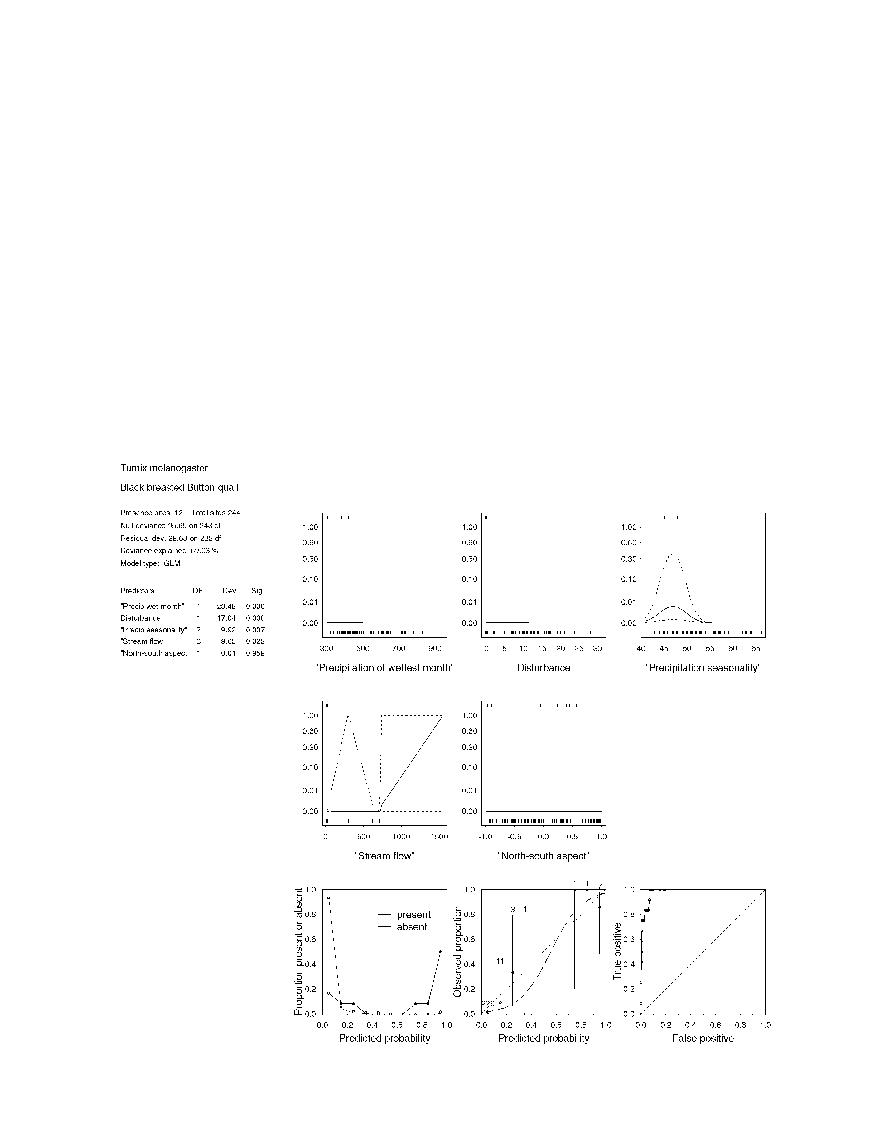
FIGURE 3.5.3a STATISTICAL OUTPUT FOR Turnix melanogaster (black-breasted button-quail)

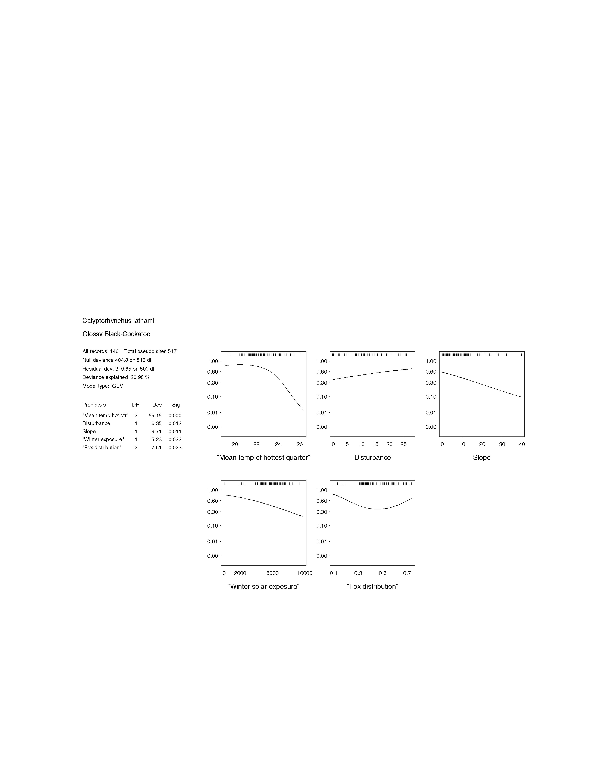

figure 3.5.4a statistical output for calyptorhynchus lathami (glossy black-cockatoo)

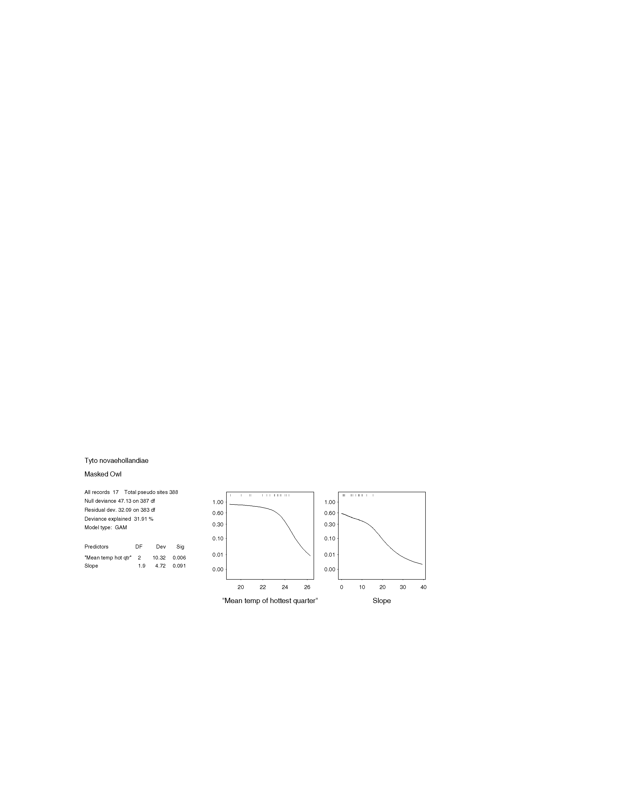
figure 3.5.7a statistical output for tyto novaehollandiae (masked owl)

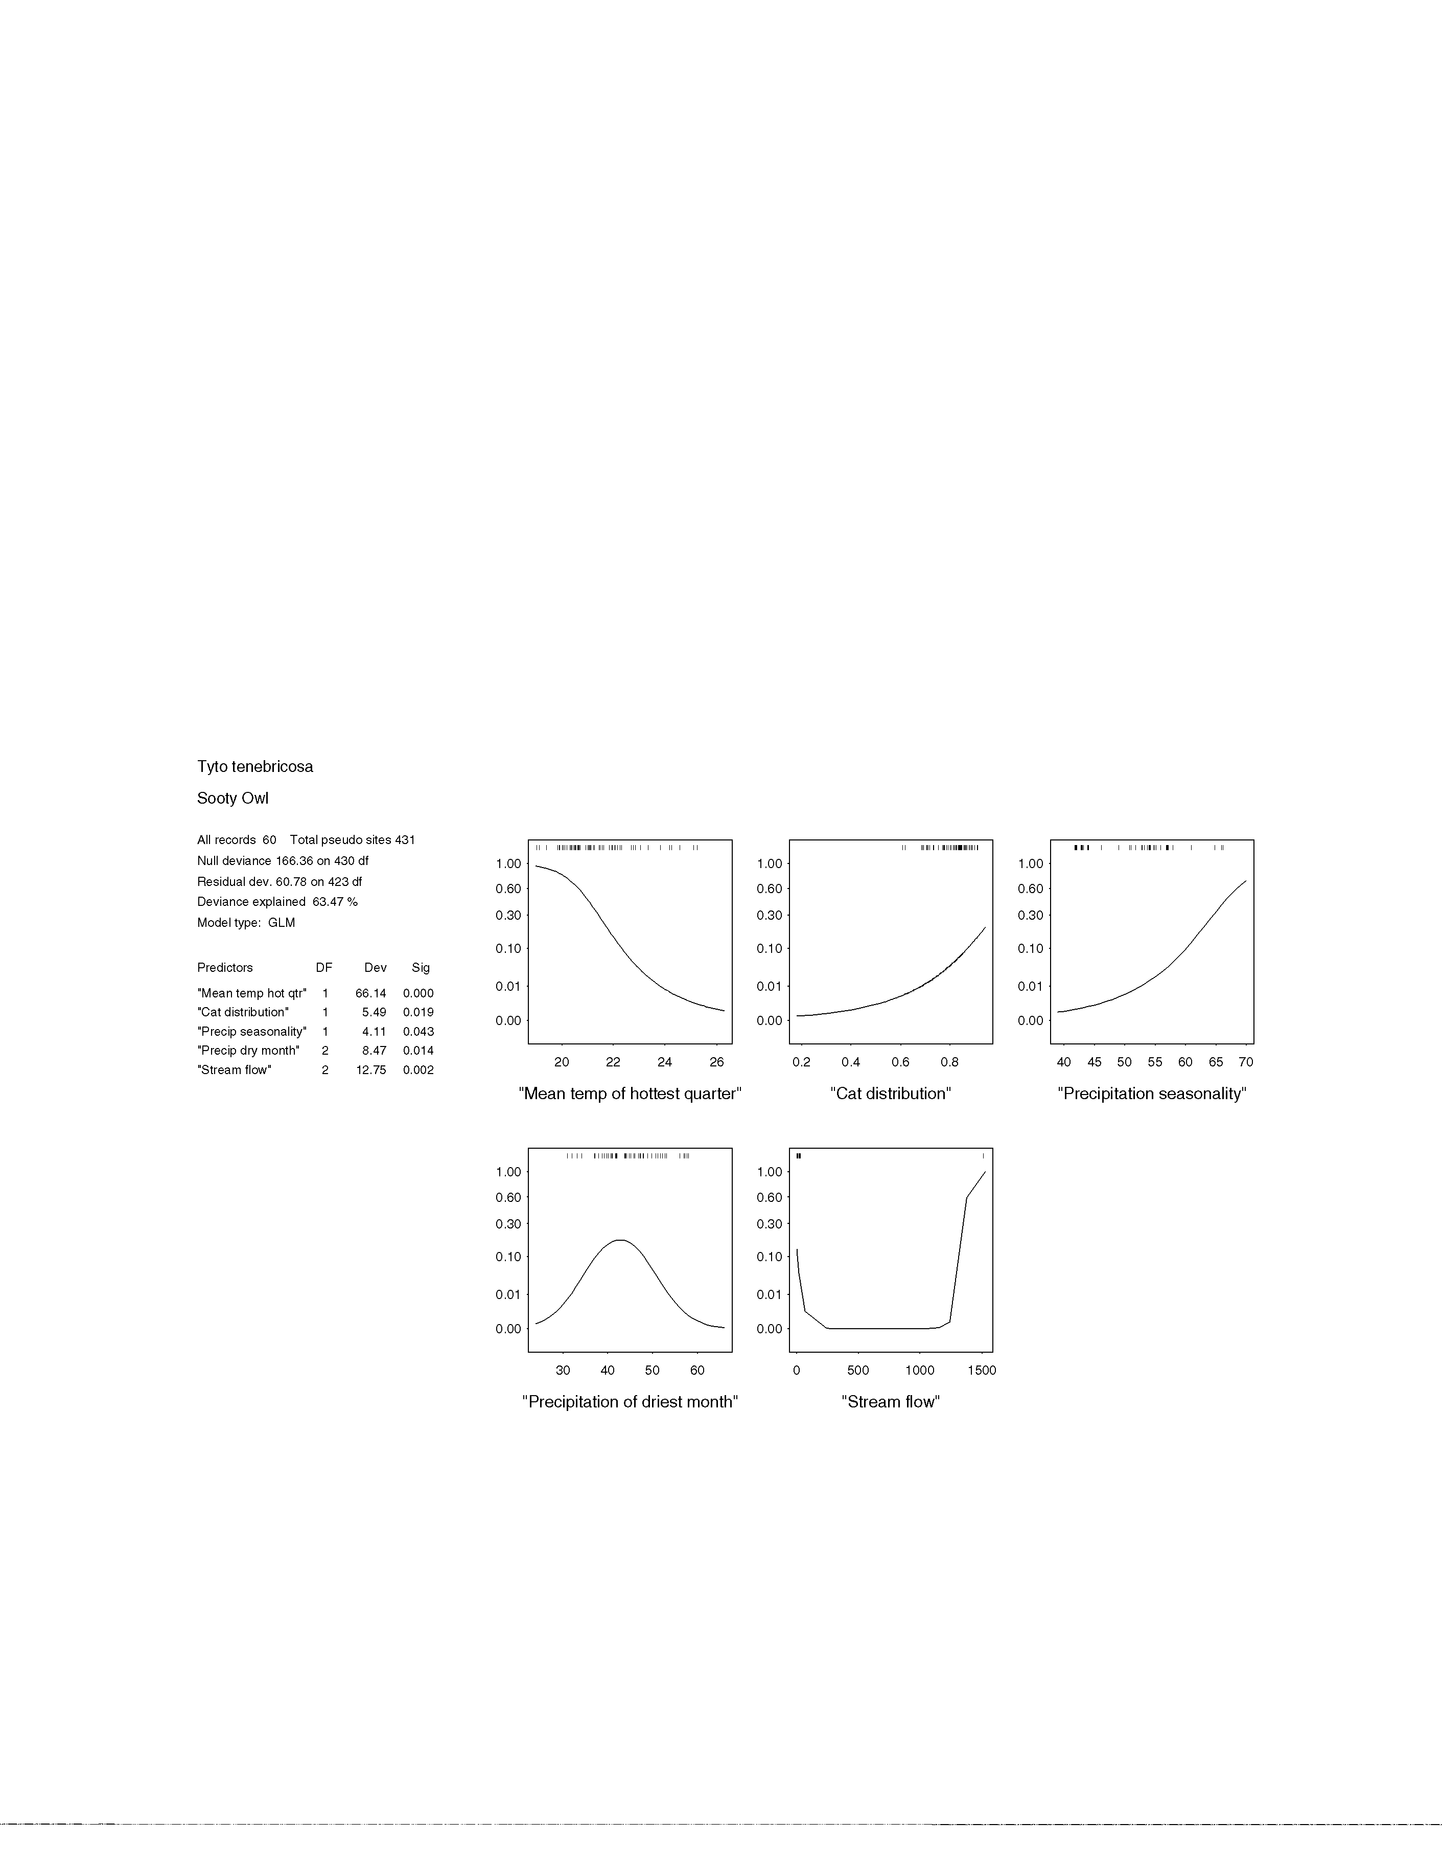
figure 3.5.8a STATISTICAL OUTPUT FOR Tyto tenebricosa (sooty owl)

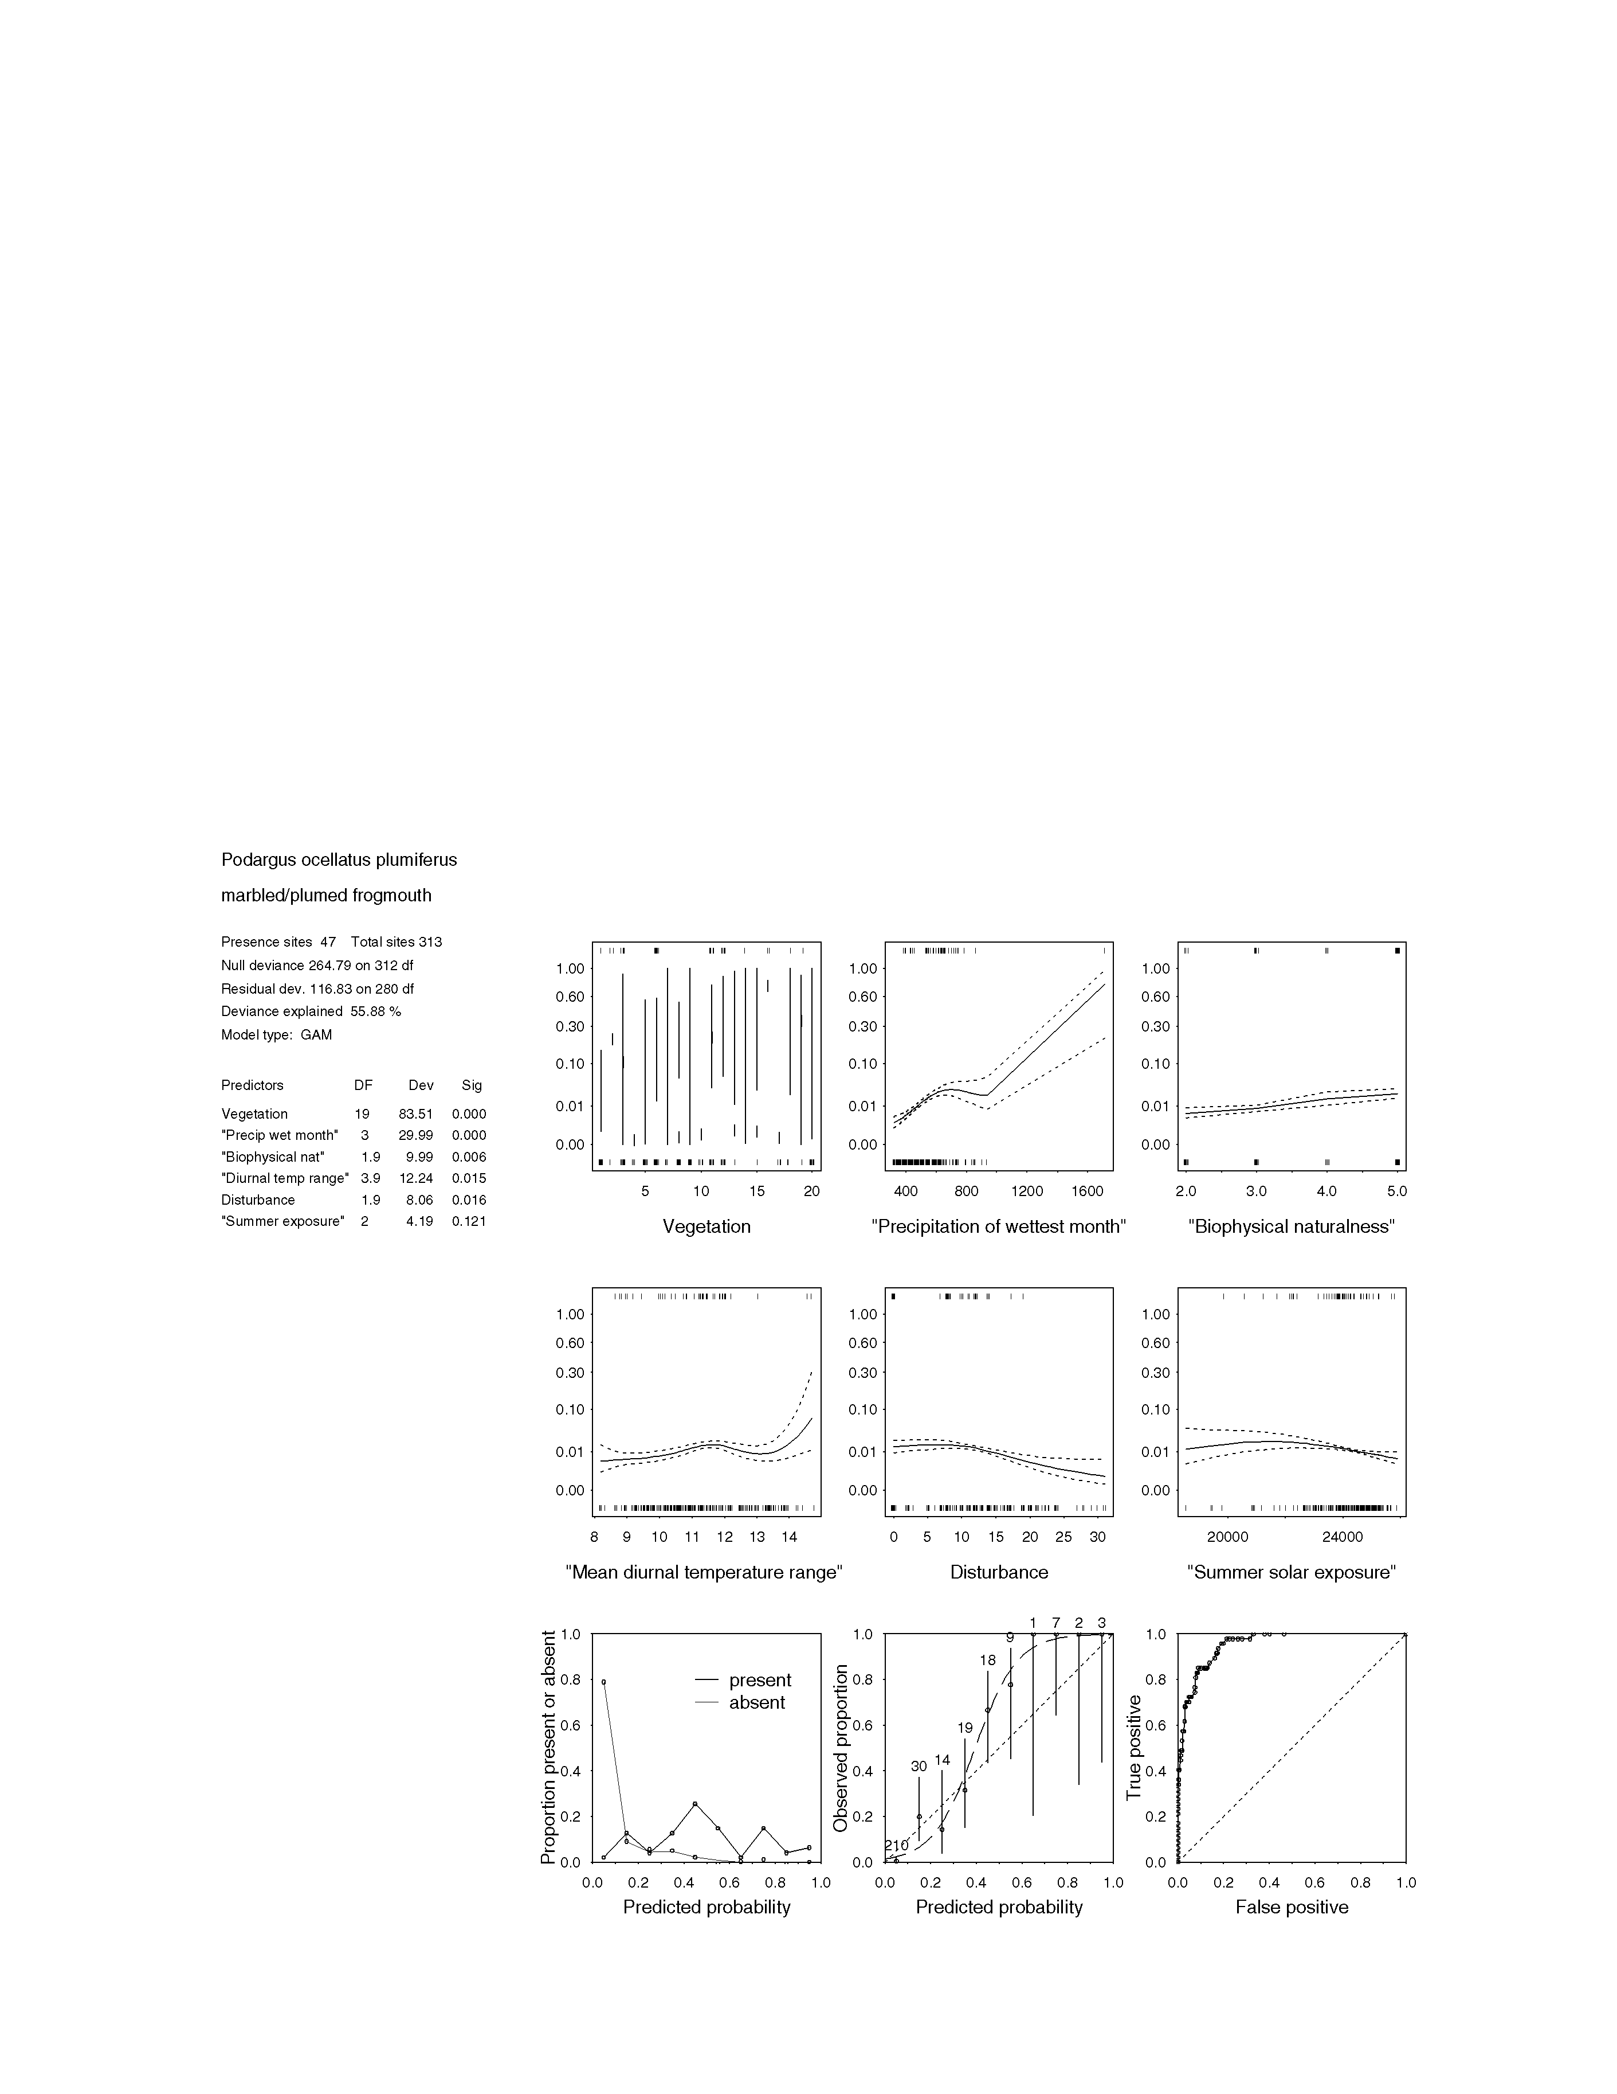figure 3.5.9a STATISTICAL OUTPUT FOR Podargus ocellatus plumiferous (plumed frogmouth)

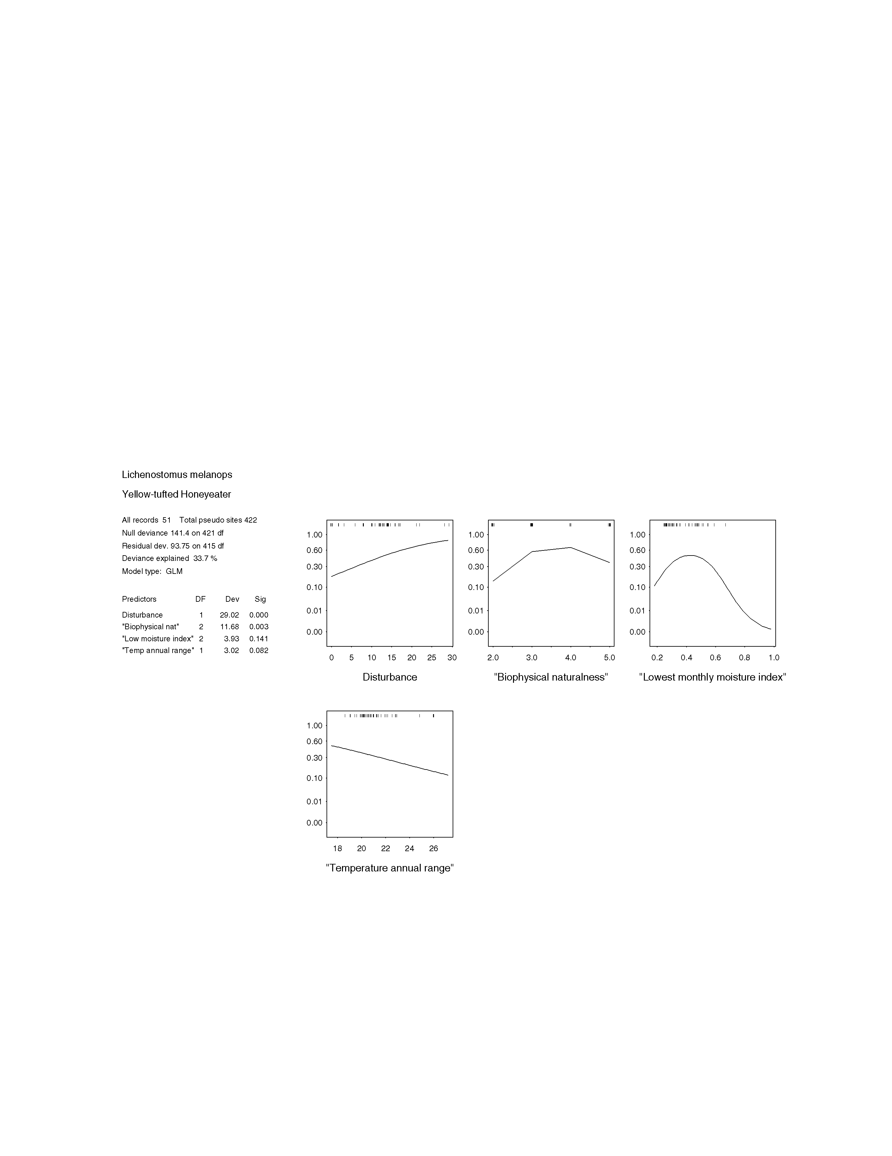
figure 3.5.11a STATISTICAL OUTPUT FOR Lichenostomus melanops (yellow-tufted honeyeater)

3.6 mammals

3.6.1 Ornithorhynchus anatinus platypus
Ornithorhynchus anatinus is an aquatic and oviparous mammal, whose distribution extends from coastal far north Queensland to south-eastern Australia including Tasmania (Carrick 1995). Its habitat is permanent streams and watercourses, where it forages for benthic fauna, including insects, molluscs and worms. Males and females occupy overlapping home ranges, varying from three to seven kilometres long in the case of males (Gardner and Serena 1995). Activity patterns are crepuscular, and during the day it occupies burrows in the stream banks. Ornithorhynchus anatinus seem to be able to tolerate a degree of disturbance, but threatening processes include impoundment of streams, reduced water quality and the effects of grazing (Gilmore and Parnaby 1994; Carrick 1995).

Expert, rather than statistical modeling was the preferred method of predicting the extent of platypus habitat in south-east Queensland, since the habitat requirements of this species are well known. The expert model was developed using the drainage spatial layer as a predictor of platypus habitat. Extensive areas of potential habitat were predicted throughout the bioregion, with the exception of the much of the Moreton Basin, and the South Burnett provinces. The experts agreed that the expert derived model was not sufficiently refined, and was considered low accuracy. The experts felt that he model and would benefit from the incorporation of more predictor variables, for example deep pools in streams and rivers

3.6.2 Antechinus swainsonii dusky antechinus
Antechinus swainsonii is a small, ground dwelling species, with a distribution that extends from Tasmania, to its northern limits at the Queensland and New South Wales border (Dickman 1995). Within its range, A. swainsonii inhabits heath, and tall open forest with a dense understorey of fern and shrub. The species is also known from rainforest communities in south-east Queensland (Van Dyck and Ogilvie 1977). It feeds on soil invertebrates and small fruits (Dickman 1995). The species is threatened by processes that remove dense ground cover, such as controlled burning, and the creation of pine plantations (Lunney, Cullis and Eby 1987; Dickman 1995).

In the SEQ bioregion, the only known location of the species is Lamington NP, where it occurs at elevations above 800 m (G. Krieger pers. comm.). With such a paucity of field data on this species in south-east Queensland, A. swainsonii was excluded from expert and statistical modeling processes.

3.6.3 Dasyurus hallucatus northern quoll
Dasyurus hallucatus occurs across northern Australia from the Pilbara region of Western Australia to south-eastern Queensland (Braithwaite and Begg 1995). Historical records of this species indicate that its distribution within the SEQ bioregion extends from Kroombit Tops in the north to the Main Range in the south (Watt 1993). It is found in broken rocky country and eucalypt woodland, within 150 km of the coast. The smallest of all the quolls, it is both arboreal and terrestrial, and feeds on small mammals, insects, small reptiles and birds (Braithwaite and Begg 1995). The minimum size of activity areas for D. hallucatus has been shown to vary from 5-1109 ha (King 1989). The species has declined considerably since European settlement (Braithwaite and Begg 1995), and current threats include the impacts of the introduced cane toad (Bufo marinus) (Burnett 1997).

Difficulties with detection methods, low population densities and a scattered distribution create problems in determining the extent of this species’ potential habitat within the region. Field records failed to provide sufficient data for a statistical model to be developed, and similarly the panel was uncertain that an expert model would be reliable. For the present, the potential habitat of D. hallucatus in south-east Queensland can only be inferred from known site locations (see Eyre et al. 1998).

3.6.4 Dasyurus maculatus maculatus spotted-tailed quoll (southern subspecies)
Dasyurus maculatus maculatus is the largest extant marsupial carnivore on the Australian mainland (Edgar and Belcher 1995), with a distribution ranging across eastern Australia from Victoria to south-east Queensland. A separate subspecies, D. m. gracilis also occurs in northern Queensland. The species has declined in Victoria (Mansergh 1983) and in south-east New South Wales (Catling and Burt 1994) and is no longer found in South Australia (Aitken 1983). Within the bioregion, the species has declined in the last 20 years, and is no longer found in the greater Brisbane area (Watt 1993; Van Dyck 1995b). Known remaining populations occur at the Blackall/Conondale ranges, Main Range, Lamington Plateau and the McPherson and Border ranges (Watt 1993). The present distribution of this species in the region suggests that populations are fragmented. The absence of recent records from the coastal plains within the region suggests that habitat loss and modification has contributed substantially to the decline of populations in these areas (Watt 1993). Dasyurus m. maculatus is an opportunistic predator, with a diet including small to medium sized mammals, birds, reptiles, insects and carrion (Ride, 1970). It is an inhabitant of rainforests and dense woodlands where it nests in hollow logs, trees, caves and rock crevices (Watt 1993).

Despite a patchy distribution, and low population densities in the region, sufficient presence only site data was available to generate GLM and GAM statistical models of the extent of D. m. maculatus habitat. Distribution maps, extrapolated from these models, were then viewed by the expert panel. The GLM model, which incorporated three predictor variables (average summer temperature, biophysical naturalness, and disturbance), was accepted by the panel in preference to the GAM model. The model predicted high quality D. m. maculatus habitat (probability of quoll occurrence >0.75) in the cooler areas of the bioregion, for example around Bunya Mountains and the scenic rim. Moderate quality habitat, defined as having a 0.4 to 0.75 probability of occurrence, was predicted elsewhere throughout the bioregion, but particularly in Great Sandy NP and the Conondale/Blackall ranges. However, the Cooloola area and all coastal sand islands were considered to be outside the range of the species, and were excluded from the distribution map. Overall, the panel considered that the model’s predictor variables did not adequately explain the distribution of the species, particularly north of the scenic rim. Correspondingly, the GLM model was judged as Low Accuracy.

3.6.5 Phascogale tapoatafa brush-tailed phascogale
Phascogale tapoatafa is an arboreal, carnivorous marsupial that is sparsely distributed throughout dry sclerophyll forests and woodlands, to vine forest and wet sclerophyll forests of Australia. The range of the subspecies, P. t. tapoatafa, is from Victoria north along the coastal ranges to about Gympie, with isolated records from Rockhampton (Ingram and Raven, 1991). Phascogale tapoatafa are entirely nocturnal, and are dependent on mature trees for nest hollows, and for their main food source of bark-associated invertebrates (Rhind 1996). As such, forest management practices such as clearfelling, selective logging, and burning are considered to be threatening processes.

Due to their cryptic nature, low population densities and patchy distribution, phascogales are generally regarded as a difficult animal to survey (Traill and Coates 1993). However, sufficient presence only site data was available to generate statistical models of potential P. tapoatafa habitat in the SEQ bioregion. Distribution maps, based on the GLM and GAM predictive models were assessed by the expert panel, who rated them according to their expert knowledge. The GLM model, which incorporated three predictor variables (average winter temperature, isothermality, and an index of lowest monthly moisture), was accepted by the exert panel. The model predictions also had a forest mask applied, so that potential habitat would be confined to forested areas. The model predicted patches of moderate to high quality habitat throughout the bioregion, with the exception of a coastal band, north of Noosa. Habitat quality was defined by the probability of phascogale occurrence in any particular area: moderate quality habitat had a probability of between 0.45 and 0.75, with high quality habitat >0.75. The expert panel made no alterations to the distribution map, other than to exclude the areas predicted on the Bay Islands. However, the expert panel suspected that phascogale habitat had been over-predicted, and rated the final distribution map as Medium Accuracy.

3.6.6 Phascolarctos cinereus koala
Phascolarctos cinereus is an arboreal folivore, restricted in its distribution to the eucalypt forests and woodlands of eastern Australia. In the SEQ bioregion, high population densities of this species occur in fragmented areas of remnant vegetation within the Brisbane, Redlands and Ipswich City council boundaries. Food trees preferred in this area include blue gum (E. tereticornis), grey gum (E. propinqua), tallowwood (E. microcorys) and flooded Gum (E. grandis) (Martin and Handasyde 1995). The populations with the highest densities tend to occur in eucalypt communities growing on higher-nutrient soils, although it also occurs in forest growing on poorer coastal soils (Martin and Handasyde 1995). Phascolarctos cinereus is solitary, and individuals have distinct home ranges which vary according to population density and the abundance of mature food trees (Martin and Handasyde 1995). Major threats to the species, particularly in the lowland areas, are land clearing, traffic, and predation from domestic dogs (Van Dyck, 1995b).

The distribution of quality P. cinereus habitat was predicted from presence/absence data, using GAM and GLM statistical models. Predicted distributions extrapolated from both models were viewed by the expert panel, and the GLM model was accepted as being the most representative of the true habitat distribution. This model selected five habitat variables, including disturbance, cat distribution, landzone, stream flow and fox distribution, as being the best predictors of P. cinereus habitat. However, cat and fox distribution were considered to be anomalous. Habitat of moderate quality was defined as having a 33 - 66% probability of koala occurrence, whilst high quality habitat had a greater than 66% probability. The distribution of moderate quality habitat was predicted in subcoastal areas of the bioregion, particularly around the McPherson and Main ranges, and from the D’Aguilar Range northwards to Kroombit Tops. Habitat of high quality was sparsely predicted within these areas. Other areas of note were the Bunya Mountains and Cherbourg SF. Exceptional areas for the species (eg, the shires of Redland, Esk, and Ipswich) were outlined by the expert panel, on the basis of high koala densities, and increasing threat from urban encroachment. The expert panel were satisfied overall with the resultant habitat distribution map, and made no alterations, judging it as High Accuracy.

3.6.7 Cercartetus nanus eastern pygmy-possum
Cercartetus nanus has a distribution which extends across south-eastern Australia, from Tasmania north to the Border Ranges of Queensland and New South Wales (Turner and Ward 1995). The

southern border of the SEQ bioregion forms the northern limits of the species’ range. The species is generally nocturnal and mainly arboreal, although it has been caught in pitfall and Elliott traps indicating that it comes to the ground at times (Turner and Ward 1995). It feeds mainly on nectar, pollen and invertebrates and is found in a range of habitats including rainforest, sclerophyll forest and tree heath (Turner and Ward 1995).

Within the bioregion, C. nanus is restricted to areas of high elevation (above 800 m) of Lamington and Mt Barney national parks. Since this species appears to be extra-limital in the SEQ bioregion, with very few site locations, it was excluded from all statistical and expert modeling processes. A map showing the known C. nanus locations in south-east Queensland can be found in Eyre et al. (1998).

3.6.8 Petaurus australis australis yellow-bellied glider
Petaurus australis is a large, active and vocal petaurid, that inhabits eucalypt forest and woodlands in eastern Australia (Russell 1995). The southern subspecies, P. a. australis occurs from Victoria to the central coast of Queensland, near Mackay (Russell 1995). Whilst the species has an extensive distribution, it occurs at low densities, with small family groups maintaining exclusive home ranges of approximately 30-65 ha (Craig 1985; Goldingay and Kavanagh 1991). The species has a varied diet consisting mainly of plant and insect exudates (sap, nectar, honeydew and manna), supplemented by pollen and bark-associated invertebrates (Goldingay 1990). The availability of each component of the diet can vary seasonally, and as such, particular combinations and assemblages of tree species are critical determinants of this glider’s distribution (Goldingay 1986; Kavanagh 1987). For example, in south-east Queensland P. australis tends to be associated with gum-barked and winter flowering eucalypt species (Eyre and Smith 1997, Eyre et al. 1998). Mature and old growth forests also provide tree hollows as nesting sites, which can be reduced in logging events. Logging is considered to be the principal threatening process throughout the species’ range (Goldingay and Kavanagh 1991).

Whilst P. australis are somewhat difficult to observe, they are easily detected from their loud and distinctive calls, that can be heard from up to 400 m away (Biggins 1984). Petaurus australis responds readily to playback of recorded forest owl calls (eg. Davey 1990) and can also be identified from the distinctive V-shaped feeding marks on the trunks of their feed trees. The species is unlikely to be missed in any standard survey, and hence, sufficient high quality data was available for predictive modeling. Presence/absence data was used to run GLM and GAM statistical models, and extrapolations of these models were then viewed by the expert panel. The GLM model - with a forest mask applied - was accepted as most accurately reflecting the true distribution of this glider’s habitat. The model showed that the habitat variables ‘rainfall of driest month’, ‘isothermality’, ‘vegetation’, ‘index of highest monthly moisture’ and ‘fox distribution’, best predicted the habitat distribution of the species. However, the predictor variable ‘fox distribution’ was considered to be an anomaly. Areas of medium to high habitat quality, (defined as having a 0.33-0.55, and >0.55 probability of the species’ occurrence, respectively), were predicted throughout the bioregion, particularly in northern and central districts. However, the panel considered that the distribution map could be further refined, based on expert knowledge. Three areas predicted as quality habitat (Grongah SF, the Rathdowney/Beaudesert, and the Esk areas) were excluded from the distribution map, since P. australis are known not to occur there. Similarly, several areas with known glider populations were upgraded from low to moderate quality habitat. These included Watalgan SF, Deongwar SF and the non-rainforested areas of Main Range. Lastly, the expert panel outlined four exceptional areas with extensive tracts of suitable habitat; ie, spotted gum and grey gum forests. With these alterations, the panel judged that overall, the final distribution map supported current knowledge and expert opinion, but could still be further refined. Hence, the final distribution map was rated as Medium Accuracy.

3.6.9 Petaurus norfolcensis squirrel glider
These medium-sized gliders are agile arboreal creatures that inhabit dry sclerophyll forests and woodlands in eastern Australia, from western Victoria to Charters Towers in Queensland (Suckling 1995). Its range extends into coastal and even moist forests in south-east Queensland and north-eastern New South Wales (Suckling 1995). Petaurus norfolcensis lives in family groups, with individual home ranges of between 2.5 and 4 hectares (Quinn 1995). Activity is principally nocturnal, with individuals foraging widely for eucalypt sap, nectar, insect exudates, pollen and bark-associated invertebrates (Menkorst and Collier 1988). The species is dependent on hollow-bearing trees for nest sites, and as such, threatening processes include clearing and unsympathetic forest management practices. The species may be endangered in the southern parts of its range, and south-east Queensland appears to be an important refuge (Quinn 1995).

Petaurus norfolcensis is regarded as the most difficult of the petaurids to survey, as their eyes reflect poorly, they rarely call, and they tend to forage in the upper part of the canopy (Davey 1984; Menkorst, Weavers and Alexander 1988; Davey 1990). However, sufficient presence/absence data was available to generate GLM and GAM statistical models of potential habitat. Distributions based on these models were viewed by the expert panel, who rejected both the GLM and GAM models on the grounds that they poorly represented the actual P. norfolcensis distribution. Therefore an expert model was developed, incorporating grouped remnant vegetation types 3a, 3b, 4a and 5a (Eucalyptus and Corymbia dry forest types). The resultant distribution map showed quality P. norfolcensis habitat throughout the bioregion, although more sparsely distributed in western areas between Esk and Mt Perry. Although no alterations were made to the mapped distribution, the expert panel recognized that it could yet be further refined, and rated the final distribution map as Medium Accuracy.

3.6.10 Petauroides volans greater glider
The largest of the gliding marsupials, Petauroides volans is an ecological specialist, having an almost exclusive diet of eucalypt leaves (Hume et al. 1984). Ranging from Victoria to the Barron River in north Queensland, this species inhabits a variety of vegetation types, from mixed coastal forests, to tall forests, to the low woodlands west of the Dividing Range (McKay 1995). Two subspecies are recognized, but only the southern subspecies P. volans volans occurs in south-east Queensland. Petauroides volans is nocturnal and essentially solitary, having small home ranges of approximately 1.5 ha. Within these home ranges, individuals have numerous den trees, but only a few are used regularly (Kehl and Borsboom 1984). Because P. volans is dependent on mature forest with tree hollows, it is threatened by clearing and selective logging (McKay 1995).

Predictive statistical models were developed to map the distribution of P. volans habitat in south-east Queensland. Presence/absence data was used to generate GLM and GAM models, and distribution maps based on these models were then supplied to the expert panel. The GLM model, which incorporated five predictor variables (index of highest monthly moisture, disturbance, north-south aspect, biophysical naturalness, and stream flow), was accepted by the expert panel as the best representation of the glider’s distribution. The experts firstly emphasized a number of significant areas for the species, including the non-rainforested areas from Mt Perry to Kroombit Tops, and the Main and Conondale ranges. These areas were recognized as important due to extensive areas of suitable habitat and high glider densities. The distribution map was further refined by the inclusion of Cherbourg SF, Fraser Is and the Mount Tambourine area as moderate quality habitat, (defined as having a 20 - 50% probability of the species occurrence). Likewise, areas such as the Main, D’Aguliar and Conondale ranges, Lockyer SF and the blackbutt forests of Fraser Is were assigned as high quality habitat (>50% probability of occurrence) by the expert panel. However, the expert agreed that quality habitat may have been under-predicted by the model, and the resultant distribution map was judged to be of Medium Accuracy.

3.6.11 Pseudocheirus peregrinus common ringtail possum
Pseudocheirus peregrinus inhabits coastal bushland to moist forests along the east coast of mainland Australia and Tasmania (McKay and Ong 1995). Four subspecies are currently recognized, with P. peregrinus peregrinus and P. p. pulcher occupying the northern and southern parts of SEQ bioregion respectively. Unlike many other species of possum and gliders, P. peregrinus are not restricted to forests that provide tree hollows, due to its ability to construct nests or dreys. However, both sexes will utilize tree hollows for nesting if they are available. Several nest sites are in use at any one time, with individuals occupying home ranges of approximately 2.5 ha (Augee et al. 1996). Threatening processes for this species relate to habitat destruction, and the effects of introduced species such as foxes and cats (McKay and Ong 1995).

The species is considered to be relatively difficult to survey, since the dense foliage of their preferred habitat may obscure detection or identification (Barry 1984; Davey 1984). P. peregrinus were found inhabiting a variety of vegetation types, from eucalypt forest to vine forest and rainforest, but each was characterized by the presence of dense foliage or a complex midstorey.

Although much of the existing P. peregrinus site data is highly skewed toward the populated greater Brisbane and Sunshine Coast areas (reflecting both an observer bias and urban P. peregrinus populations), sufficient data of high accuracy was available to generate a predictive model of habitat distribution. Extrapolations of both GLM and GAM statistical models were viewed by the expert panel, but both were considered inaccurate and were rejected by the expert panel. An expert model was then developed, using forest cover of grouped vegetation types 1a, 1b, 2, 6a, 6b, 6c, 6d, and 7 (see Young 1998). The resultant map showed the distribution of rainforest and wet sclerophyll vegetation types throughout south-east Queensland. Except for central areas around the Conondale/Blackall ranges, and the scenic rim, these vegetation types occur sparsely throughout the bioregion. Extensive areas of P. peregrinus habitat were emphasized by the expert panel, including the McPherson and Main ranges, the Bunya Mountains, Wrattens/Kandanga SFs, Mount Glorious, and the Conondales. These areas were assigned as high quality habitat. Bulburin SF, and much of Great Sandy NP were also included in the P. peregrinus habitat distribution map, assigned as moderate quality habitat. The expert panel were satisfied that the final distribution map was of High Accuracy.

3.6.12 Aepyprymnus rufescens rufous bettong
Aepyprymnus rufescens is the largest of the potoroids (Dennis and Johnson, 1995). It also has the largest extant distribution of all the bettongs, ranging from far north Queensland to northern New South Wales. Within this area, it is usually found from coastal regions to slightly west of the divide, in habitats ranging from tall wet sclerophyll, to low open woodland (Dennis and Johnson, 1995). Both males and females maintain large home ranges; 75-110 ha and 45-60 ha respectively, and individuals may travel up to 4.5 km in a normal night’s foraging (Dennis and Johnson 1995). Aepyprymnus rufescens appears to be secure in the region (Dennis and Johnson 1995), but threats to this species include changing fire regimes, over-grazing, urban encroachment and predation from cats, dogs, and foxes (Schlager 1981; Van Dyck 1995b).

The distribution of potential A. rufescens habitat was predicted from presence only data, using GLM and GAM statistical models. The expert panel viewed mapped distributions extrapolated from both models, but rejected the GAM model. The GLM model incorporated five predictor variables; disturbance, rainfall of driest month, stream flow, slope, and average summer temperature. Predictions were limited to forested areas, through the application of a forest cover mask. Predicted areas of moderate quality habitat were defined as having a 33-80% probability of the species occurring there, with high quality habitat having a greater than 80% probability. The model predicted areas of moderate to high quality habitat in almost all forested areas of the bioregion, with the exception of Great Sandy NP and the Bay Islands. The expert panel made no adjustments to the distribution map, other than to downgrade the forest between Maryborough and Woodgate from high to moderate quality habitat, because of the preponderance of pine plantations in this area. Whilst the panel was satisfied overall with the models predictions, they felt it could perhaps be further refined, and rated the final distribution map as Medium Accuracy.

3.6.13 Potorous tridactylus long-nosed potoroo
The known range of Potorous tridactylus extends across south-east Australia, from south-west Victoria, and reaches its northern limits of its distribution at Bulburin SF in south-east Queensland. In addition, a small population isolate has recently been discovered in south-west Western Australia (Johnston 1995). The species is found in wet and dry sclerophyll forests with an annual rainfall exceeding 760 mm and requires a dense understorey of grass and shrubs for shelter (Johnston 1995). This nocturnal species prefers forests on lighter soils, where it digs for the fungi, roots, tubers, and invertebrates that comprise its diet (Seebeck, Bennet and Scotts 1989; Claridge, Cunningham and Tanton 1993). It is threatened by clearing, unplanned fire, grazing and competition with introduced herbivores (Jarman and Johnston 1977).

Although P. tridactylus is cryptic and rarely seen, the lack of available field data and site locations is a reflection of the scarcity of this species in the region. The paucity of information on this macropod precluded statistical modeling of its potential habitat, and the expert panel were not convinced that expert modeling of its distribution in south-east Queensland would be reliable. Until the results of targeted surveys on P. tridactylus are available, the extent of this species’ habitat can only be inferred from known site locations (see Eyre et al. 1998).

3.6.14 Macropus agilis agile wallaby
This medium sized macropod occurs in coastal areas of tropical Australia, but within the SEQ bioregion, Macropus agilis is found on North and South Stradbroke and Peel Islands (Van Dyke 1995b). Isolated records have also been obtained from the southern Moreton Bay area (Woogoompah Island) and from the adjacent mainland near Ormeau (I. Gynther pers. comm.). This species is abundant north of Rockhampton where its preferred habitats is along rivers and streams in open forest close to grasslands (Merchant 1995). In the bioregion, the diet is a variety of grasses, forbs and sedges, and M. agilis also forages on coastal dune spinifexes (Ramsey and Wilson 1997). Its habits are gregarious; living in groups of up to ten, and even greater numbers aggregating in feeding areas (Merchant 1995).

Macropus agilis is poorly known in the bioregion, and field records have not yielded sufficient information to develop either statistical or expert models of its potential habitat in south-east Queensland. However, mapped site locations can be referred to in Eyre et al. 1998.

3.6.15 Macropus dorsalis black-striped wallaby
A habitat specialist, Macropus dorsalis has a range extending from northern New South Wales, to around Townsville in the north, but a restricted distribution within the region (Kirkpatrick 1995). The species shelters in the dense cover of closed forests or other suitably thick vegetation during the day, feeding in adjacent open grassy areas at night. Home ranges are large, approximately 91 ha (Evans 1996), but M. dorsalis is rarely seen more than a few hundred metres from dense cover. The species has declined in much of its range, possibly due to habitat loss and disturbance as a result of forest clearing for pastures and cropping, and predation by foxes (Gilmore and Parnaby 1994).

Although the species prefers dense habitat, the survey results probably reflect the species’ relative scarcity and narrow habitat preference, rather than detectability. The final map, which was extrapolated from Presence Only GLM was assessed as Low accuracy by the expert panel.

3.6.16 Petrogale herberti Herbert’s rock-wallaby
Petrogale herberti has a restricted distribution within the SEQ bioregion, being found from Nanango, northward to the south bank of the Fitzroy River at Rockhampton (Eldridge and Close 1995). Like P. penicillata, this species is often found in association with rugged terrain, favouring hilly areas where suitable rocky outcrops or boulder fields occur (Clancy and Close 1997). In the northern portion of the region, the species utilizes dry rainforest communities and drier type open forests adjacent to rocky outcrops. In the southern portion of its range, P. herberti contacts P. penicillata and a narrow hybrid zone is formed (Eldridge and Close 1995). This hybrid zone is currently under pressure from mining and urban developments, but in suitable habitat elsewhere the region in the species is considered to be common (Clancy and Close 1997).

Because the habitat requirements of this species are well understood, expert modeling of potential habitat was considered appropriate. However, the physical landform characteristics that explain rock wallaby distribution, (ie, rocky outcrops and boulder fields, etc) were not available for use in an expert model. Hence, an expert model could not be developed. Whilst the expert panel could not confidently map the distribution of potential habitat, the Kroombit Tops was emphasized as an area with a high P. herberti density and extensive high quality habitat. Until more detailed spatial layers can be incorporated into the modeling, the potential habitat of this species cannot be adequately mapped. Site locations can be referred to in Eyre et al. (1998).

3.6.17 Petrogale penicillata brush-tailed rock-wallaby
Petrogale penicillata reaches the northern limits of its known range within the southern portion of the SEQ bioregion. It extends into New South Wales and is marginal in Victoria (Jarman and Bayne 1997). It is found in suitable rocky areas either on scree or cliff lines, in a range of vegetation types, including rainforest gullies, wet and dry sclerophyll forest, and open woodland. Diet consists mainly of grasses and forbs as well as seeds, fruit and flowers which are eaten opportunistically (Short 1989). Petrogale pencillata exhibits high site fidelity, spending the day in habitually used refuges and traveling at night to forage within a limited distance of the refuges (Jarman and Bayne 1997). This extreme site fidelity makes them vulnerable to predators that may locate a colony (Jarman and Bayne 1997).

Prior to 1915, P. penicillata was relatively abundant and widespread in New South Wales and northern Victoria (Short and Milkouits 1990), but has since declined significantly due to competition from introduced herbivores such as rabbits and goats and predation from foxes (Eldridge and Close 1995). Within the SEQ bioregion, significant populations exist within Boonah Shire in the Moogerah Peaks and Main Range National Parks, but the species is nonetheless considered to be vulnerable to extinction (Clancy and Close 1997).

Like P. herberti, P. pencillata’s potential habitat in south-east Queensland could not be expertly or statistically mapped, because the required spatial layers (eg, rocky outcrop and scree slope coverage) were not available. Whilst the expert panel were not confident that they could accurately delineate potential habitat on a map, they did emphasize the importance of areas such as the Moogerah Peaks, Main Range, the Helidon Hills, and Crows Nest. Mapped site locations in these, and other areas in south-east Queensland can be referred to in Eyre et al. (1998).

3.6.18 Thylogale stigmatica red-legged pademelon
The known range of Thylogale stigmatica extends along the east coast of Australia from New South Wales through to north Queensland. However, the distribution of this species is discontinuous, which largely reflects its dependence on dense vegetation for shelter (Johnson and Vernes 1995). In south-east Queensland, this small macropod is largely confined to the interior of vine forests and rainforests. Home-ranges are relatively small, around 2.5 ha (Vernes, Marsh and Winter 1995), and the diet is composed of leaves, fruit, ferns, native grasses and fungi (Vernes 1995).

Although this pademelon is particularly difficult to see in its preferred habitat, sufficient presence only data was available to generate GLM and GAM statistical models of potential habitat. Distributions based on these models were viewed by the expert panel, who rejected both the GLM and GAM models on the grounds that they poorly represented the actual T. stigmatica distribution. Therefore an expert model was developed, incorporating grouped remnant vegetation types 6a, 6b, 6c and 7. The resultant distribution map showed quality T. stigmatica habitat occurring particularly in central districts from the Bunya Mountains to the Conondales and Gympie, along the scenic rim, and more sparsely distributed elsewhere throughout the bioregion. The expert panel made only one alteration to the mapped distribution, excluding the Great Sandy region. However, the expert panel recognized that it could yet be further refined, and rated the final distribution map as Medium Accuracy.

3.6.19 Nyctimene robinsoni eastern tube-nosed bat
Nyctimene robinsoni is a poorly known species which is associated with lowland rainforest (Gilmore and Parnaby 1994; Richards 1995). Very little is known of its roosting ecology, however in north Queensland, it was found to roost solitarily or in small groups in canopy foliage of the rainforest, feeding on rainforest fruits at night (Gilmore and Parnaby 1994). Being an inhabitant of rainforest, the status of N. robinsoni is threatened by clearance and fragmentation of lowland rainforest areas in south-eastern Queensland.

Sufficient presence only data was available to apply statistical modeling techniques, predicting the extent of potential N. robinsoni habitat in the bioregion. Mapped distributions, generated by the GLM and GAM statistical models were assessed by the expert panel. The GLM model was then accepted as most accurately representing the habitat distribution of the species. The model predicted that the ‘rainfall of the wettest month’, ‘biophysical naturalness’ and ‘seasonality of rainfall’ were the habitat variables that best defined the distribution of the species. That is, relatively undisturbed areas with a high and regular rainfall, were predicted as high quality habitat, or having a greater than 67% probability of the species occurring. Moderate quality habitat was defined as having a lower probability of occurrence - of between 33 and 67%. Core habitat was predicted throughout the SEQ bioregion, but most notably in the McPherson ranges, from the D’Aguilar Range north to Fraser Is, and north of Bulburin SF. Although not predicted by the model, the experts included the Bunya Mountains as moderate quality habitat. The only other alteration was to exclude the small amounts of moderate quality habitat predicted on Moreton and North Stradbroke islands. The expert panel were satisfied that the final distribution map was of High Accuracy.

3.6.20 Pteropus alecto black flying-fox
Pteropus alecto is distributed widely around the northern Australian coastline extending from northern Western Australia, the northern half of the Northern Territory, Queensland and north-eastern NSW (Gilmore and Parnaby 1994). It roosts communally in camps of up to several thousand individuals, often in association with other Pteropus species, and their preferred roost sites are generally in mangroves and paperbark swamps, and occasionally in rainforest patches (Hall 1995a). The species feeds largely on the blossom of eucalypts and paperbarks in natural circumstances, but are often forced to raid domestic and agricultural fruit crops in areas where their natural habitat is greatly reduced. Threat facing P. alecto include disturbance at camps, clearing and development of feeding habitat.

While the megabats were not specifically targeted during the CRA surveys by field survey methods, they are readily detectable by their loud calls and can be easily observed feeding on blossom or fruit.

3.6.21 Pteropus poliocephalus grey-headed flying-fox
The largest of the flying-foxes, Pteropus poliocephalus ranges from about Townsville in the tropical north, south along the east coast, and into southern Victoria (Tideman 1995a). P. poliocephalus roosts communally, often in hundreds of thousands, in gullies with dense vegetation canopy, and feeds on rainforest fruits, blossom from eucalypts, angophoras, banksias and tea-trees (Tideman 1995a).

P. poliocephalus was detected in dry sclerophyll forests with flowering Corymbia citriodora. Observations of P. poliocephalus were usually of single or small groups feeding on eucalypt blossom As with other species of flying foxes in the bioregion, P. poliocephalus is threatened by destruction of camp areas, clearing and development of feeding habitat.

3.6.22 Pteropus scapulatus little red flying-fox
Pteropus scapulatus is the most widespread if the Pteropus species in Australia, ranging from the dry inland to the coast in eastern Australia and the Northern Territory, and along the northern coast of Western Australia (McCoy 1995). P. scapulatus eats predominantly eucalypt blossom, often migrating great distances to follow seasonal flowering episodes. The species roosts diurnally in tall vegetation, forming large groups of up to 1000 000 individuals in some cases (McCoy 1995). Roost sites are often shared with other, more sedentary Pteropus species.

Pteropus scapulatus at Blackdown Tableland, a group of approximately 20 individuals were recorded feeding on a Blackdown stringybark Eucalyptus sphaerocarpa. Most observation were from either dry sclerophyll forest or vine forest.

3.6.23 Syconycteris australis common blossom-bat
Syconycteris australis is a specialised nectar-feeding bat which in southern Queensland, feeds almost exclusively on nectar from Melaleuca, Banksia, Callistemon and some Eucalyptus species (Law and Spencer 1995). In subtropical areas, it is thought to roost in subcanopy layers within lowland rainforest patches adjacent to heathlands which provide those food resources (Law and Spencer 1995). It occurs throughout the coastal areas from Cape York Peninsula to mid eastern New South Wales (Hall and Richards 1979; Law and Spencer 1995); although within the bioregion, it has been captured up to 75 km from the coast (Eyre et al. 1998). The major threats to the conservation status of this species are disturbance and destruction of habitat (eg. clearing of rainforest patches and development of heathlands).

The distribution of potential S. australis habitat was predicted from presence only data, using GAM and GLM statistical models. Predicted distributions extrapolated from both models were viewed by the expert panel, and the GAM model was accepted as being the most representative of this bat’s distribution. This model selected the index of highest monthly moisture, and seasonality of rainfall, as the best predictors of S. australis habitat. A forest mask was also applied, to confine the model predictions to forested areas. The expert panel were satisfied overall with the resultant habitat distribution map, but opted to make number of alterations. These included, downgrading all ‘high quality’ habitat areas predicted to occur around Main Range, and subcoastal areas from Mount Glorious to Maryborough, to ‘moderate quality’. The experts felt that this was appropriate, as the species has not been recorded in much of this area, despite reasonable survey effort. Habitat of moderate quality was defined as having a probability of S. australis occurrence of between 33 - 80%, whilst high quality habitat had a greater than 80% probability. Whilst the expert panel agreed with most of the model’s predictions, they felt that the upland and inland areas had possibly been overpredicted by the model. Consequently, the habitat distribution map was rated as Medium Accuracy.

3.6.24 Hipposideros semoni Semon’s leafnosed-bat
Little is known about the distribution, habitat preferences and biology of Hipposideros semoni. Individuals have been recorded roosting in caves, mines and rock fissures (Hall 1995; de Oliveira and Schulz 1996). It has also been encountered roosting in a variety of other situations including tree hollows, deserted buildings, the door handle of a car, a clothes closet, an oven and a picture rail (Hall 1995). No maternity colonies have been located. This species occurs from Cape York Peninsula south to Townsville, with an isolated record from a cave in Kroombit Tops SF, west of Gladstone (Schulz and de Oliveira 1995). Habitat ranges from vine thicket to open eucalypt woodland (Hall 1995, de Oliveira and Schulz 1996). Ultrasonic calls from an unidentified bat recorded from St. Marys SF, south west of Maryborough, were suspected to be from this species (de Oliveira and Pavey 1995). However, an intensive trapping effort failed to capture the bat. Calls subsequently recorded from known H. semoni (de Oliveira and Schulz 1996) suggest the St Marys bat to be different and its identity remains problematic (M. de Oliveira pers. comm.). Little is known about threats facing this bat in the region.

Given the scarcity of information on the species, statistical and expert modeling of its habitat was not attempted. Much greater search effort (eg. extensive cave searches) needs to be conducted to determine its distribution in south-east Queensland, particularly in the Kroombit Tops area. The one known site location is mapped in Eyre et al. (1998).

3.6.25 Taphozous georgianus common sheathtail-bat
Taphozous georgianus is among the largest of the insectivorous bats occurring throughout northern Australia and reaches its southern distributional limits in the extreme north of the SEQ bioregion (Jolly 1995). It is an obligate cave-dweller, commonly found in overhangs, rock crevices, and near the entrance to deeper caves and mineshafts (Jolly 1995).

Within the SEQ bioregion, this species is known only from caves at Kroombit Tops (Schultz and De Oliveira 1995). Unconfirmed ultrasonic calls of Taphozous spp. have been recorded during recent surveys at Kroombit Tops SF, Many Peaks TR, Warro SF and Glenbar SF (Eyre et al. 1998). Further survey effort is required to confirm the presence of T. georgianus at Glenbar SF, which would constitute a significant southern range extension. The recordings from Warro SF may represent T. australis (M. de Oliveira pers. comm.), but due to difficulties separating Taphozous calls ultrasonically, the presence of T. australis in these areas remains uncertain. With no confirmed records of this species in the bioregion other than at Kroombit Tops, it was excluded from all statistical and expert modeling processes.

3.6.27 Chalinolobus dwyeri large-eared pied bat
Few Chalinolobus dwyeri records exist throughout its range from southern New South Wales to central eastern Queensland (Hoye and Dwyer 1995). The majority of records are from the drier forest types, including subalpine woodland. In north-eastern New South Wales the majority of records are from dry sclerophyll forest adjacent to rainforest or wet sclerophyll forest with a rainforest sub-canopy (Parnaby 1986; NSW NPWS 1994; M. Schulz unpubl. records). Little is known about the roosting requirements of C. dwyeri, though it has been recorded utilizing disused mine tunnels, caves, rock overhangs and abandoned fairy martin (Hirundo ariel) nests (Hoye and Dwyer 1995; Schulz 1998). The only records of this species within the SEQ bioregion are from open forests at Lamington NP (I. Gynther and G. Ford unpubl. records), Gambubal SF (I. Gynther unpubl. records), forest adjacent to the Mount Mistake section of Main Range NP (M. Schulz unpubl. records), and individuals found roosting in disused fairy martin nests in the Wivenhoe Dam and Lake Moogerah areas (Schulz 1998).

Targeted survey work is required to determine the distribution, habitat preference and roosting requirements of the species in the bioregion, before any predictive modeling can be undertaken. Although this species was too poorly known to develop statistical of expert models of its potential habitat in south-east Queensland, its known localities are mapped in Eyre et al. (1998).

3.6.28 Chalinolobus picatus little pied bat
Chalinolobus picatus is described as an arid to semi-arid adapted species (Ayers 1995) extending from the mallee region in South Australia (Reardon and Flavel 1987) into the dry areas of western New South Wales and southern Queensland to just north of the Tropic of Capricorn (Hall and Richards 1979; Richards 1995). It occurs in a wide range of vegetation communities including mallee, brigalow, bimble box, eucalypt woodlands and open forests. In the past the species was regarded as either a cave, mine or rock shelter roosting species (Hall and Richards 1979; Richards 1995). However, recent observations indicate that C. picatus also utilizes tree hollows as roosts (Tidemann 1988; Schulz, de Oliveira and Eyre 1994). Until recently, the distribution of C. picatus in the SEQ bioregion was known from only three localities, Lockyer SF (S. Debus unpubl. records), Cordalba SF (DNR unpubl. records), and Eurimbula NP (Schulz unpubl. record). Recent surveys located this species in seven new areas in south-east Queensland, mostly from dry forests dominated by Corymbia citriodora and ironbark species (Eyre et al. 1998). These surveys have also detected the species in previously undocumented habitat types: from Auracarian notophyll vine forest gullies in Cordalba and Benarkin state forests, and mixed coastal lowland forest at Bingera SF near Bundaberg represents a previously undocumented habitat type for the species.

With only 13 confirmed records in the SEQ bioregion, insufficient data was available to generate a statistical model of potential C. picatus habitat. Furthermore, the recent discovery of this species in different vegetation types indicates that the detailed habitat requirements are still poorly understood. Hence, the panel considered that an expert model would be unreliable. However, mapped site locations, including the records of new locations, can be referred to in Eyre et al. (1998).

3.6.29 Falsistrellus tasmaniensis eastern false pipistrelle
Falsistrellus tasmaniensis has a widespread distribution from Tasmania, through southern Victoria and eastern New South Wales, and reaches the northern limit of its geographic range in south-east Queensland (Phillips 1995). The species appears to have a Bassian distribution, being restricted to cooler high elevation forests in the northern parts of its range. Falsistrellus tasmaniensis primarily roost in the tree hollows, with a maximum colony of 91 males recorded (Phillips et al.. 1985; Parnaby 1998).

Within the SEQ bioregion F. tasmaniensis is only known from Lamington in the south (I. Gynther unpubl. records) with an isolated record from the Bunya Mountains (B. Thompson unpubl. records). This species is locally common on the New South Wales side of the border in the Brindle Creek and Levers Plateau areas (M. Schulz unpubl. records). There have been difficulties associated with the identification of ultrasonic calls from the species, due to the incorrect identification of the original voucher call (L. Lumsden pers. comm.).

Since this species appears to be extra-limital in the SEQ bioregion, it was excluded from all statistical and expert modeling processes. Targeted survey work is required in the bioregion to determine the distribution, habitat preferences and roosting requirements of the species. A map showing the known F. tasmaniensis locations in south-east Queensland can be found in Eyre et al. (1998).

3.6.30 Kerivoula papuensis golden-tipped bat
Kerivoula papuensis is a small insectivorous bat whose distribution appears localized; having been recorded from a scattering of localities from Mumbla SF in south-east New South Wales, north along the east coast to Cape York Peninsula (Woodside, 1995). Kerivoula papuensis has been recorded from sea level to over 1200 m in altitude (Parnaby and Mills 1994; Schulz unpubl. records), and has been recorded from a variety of rainforest types, ranging from tropical mesophyll vine forest to semi-evergreen vine thickets, and tall eucalypt open forest with a rainforest subcanopy. A small number of records are from dry and wet sclerophyll forests lacking a rainforest subcanopy, riparian Casuarina cunninghamiana dominated forest, coastal Melaleuca forests and several individuals have been recorded inside houses on the edge of residential areas (Schulz unpubl. records).

Kerivoula papuensis has been found roosting in disused, suspended nests of the yellow-throated scrubwren (Sericornis citreogularis) and to a lesser extent the brown gerygone (Gerygone mouki) (Schulz 1995b; Schulz in prep.), and also in a hollow of a rainforest subcanopy tree (Schulz and de Oliveira 1995). A maternity site was utilized in two successive years in a hollow of a rainforest canopy tree in the Richmond Range NP (Schulz, in prep.). Outside Australia, this species has been recorded in caves and in buildings (Flannery 1995a, b).

Until relatively recently, K. papuensis was poorly known south-east Queensland. The overall paucity of records may be a reflection of the difficulty of capturing this species using standard trapping techniques and ultrasonically detecting the species with commonly used bat detector systems (Schulz 1995a). However, sufficient presence only data was available to generate a statistical model of the extent of potential K. papuensis habitat in south-east Queensland. Mapped distributions, generated by the GLM and GAM statistical models were assessed by the expert panel. The GLM model was then accepted as most accurately representing the habitat distribution of the species. ‘Biophysical naturalness’, ‘average winter temperature’, and slope were predicted by the model as the habitat variables that best defined the distribution of the species. Kerivoula papuensis habitat was defined as being of low, medium, or high quality on the probability of the species occurrence in that area. Moderate quality habitat had a probability of between 37 and 69%, with high quality habitat having a greater than 69% probability. Core habitat was predicted across much of the bioregion, with the exception of the coastal lowlands north of Maryborough. Habitat of high quality was predicted particularly for the scenic rim, the Conondale/Blackall ranges, Cooloola, and the bioregion’s north-west - all of which coincided with expert opinion about the distribution of K. papuensis habitat. No alterations were made to the mapped distributions other than to emphasize the importance of some of these areas, and to exclude predicted habitat on the Bay Islands. The panel was confident that model, and the habitat distribution map, was of High Accuracy.

3.6.31 Miniopterus australis little bentwing-bat
The distribution of Miniopterus australis extends along eastern Queensland from Cape York to central New South Wales (Dwyer 1995). Though recent evidence indicates that M. australis may roost in tree hollows (Schulz 1997), the species is known to predominantly roost in caves, usually near dense vegetation types such as rainforest, wet sclerophyll forest and coastal Banksia heath (Dwyer 1968; Gilmore and Parnaby 1994). The species is highly mobile, with movements of up to 32 kilometres recorded (Gilmore and Parnaby 1994). Miniopterus australis requires substantial numbers within maternity colonies to increase the ambient roost temperature (Dwyer 1968). No maternity roosts are known within the SEQ bioregion, other than a large roost in a natural cave in Tarong NP, which may be a maternity colony (B. Thompson unpubl. records). open eucalypt forest, vine scrub and rainforest.

During the recent CRA surveys, M. australis was one of the more commonly recorded microbat species, from harp trapping and ultrasonic detection (Eyre et al. 1998): yielding sufficient presence/absence data to generate GLM and GAM statistical models of the extent of M. australis habitat. Distribution maps, extrapolated from these models, were then viewed by the expert panel. However, both statistical models were rejected by the experts, as poorly representing the distribution of the species. Based on the wide range of vegetation types utilized by this species, the expert panel assigned all remnant forest in the bioregion as moderate quality habitat. Additionally, all known roosts, and suspected maternity colonies at Tarong and Kroombit Tops were assigned as high quality habitat. However, the expert panel were not satisfied that this distribution map outlined the extent of core habitat in the region. Correspondingly, the habitat distribution map was judged as Low Accuracy.

3.6.32 Miniopterus schreibersii common bentwing-bat
Miniopterus schreibersii has a widespread distribution throughout eastern Australia, from south-east South Australia through to the Northern Territory and northern Western Australia. The species has a complex pattern of roost utilization which varies in response to climatic conditions, seasons, reproductive cycles and social organization (Dwyer 1963). Banding studies have documented extensive movements of individuals between roost sites in several regions of New South Wales and Victoria, with one individual recorded moving 1300 km (Dwyer and Hamilton-Smith 1965, Dwyer 1969). Miniopterus schreibersii has been recorded in a diverse range of habitats ranging from rainforest, wet and dry sclerophyll forest, woodlands, heath, and grasslands (Dwyer 1995; Parnaby 1998).

Statistical models, using presence/absence data, were generated to predict the extent of this bat’s quality habitat in south-east Queensland. However, as for M. australis, the predictions of both the GLM and GAM models were considered inaccurate by the expert panel, and the models subsequently rejected. The expert panel agreed that since statistical modeling was ineffective, that the best available method of mapping core habitat would be to assign all remnant forest in the bioregion as moderate quality habitat, and all known roosts and maternity colonies as high quality habitat. But whilst the species is widely distributed throughout the SEQ bioregion, M. schreibersii’s roost sites have been poorly documented, with no maternity colonies known (L. Hall pers. comm.). Therefore, the expert panel considered that the distribution map poorly delineated important M. schreibersii habitat, and rated the distribution map as Low Accuracy.

3.6.34 Scotorepens sanborni northern broad-nosed bat
The known distribution of Scotorepens sanborni is considered to extend throughout the tropical regions of North Queensland as far south as the Rockhampton district (Hall 1995c). Little is known about the biology or habitat preferences of the species, though it has been recorded roosting in tree hollows (Hall 1995c). There is currently some uncertainty regarding the taxonomic status of Scotorepens species, and valid identification of individuals to species level (either morphologically or by ultrasonic call) is problematic (H. Parnaby pers. comm.; M. Schulz unpubl. records).

Based on existing records, S. sanborni has not been recorded in the SEQ bioregion (Ingram and Raven 1991; Hall 1995c), and for this reason, the species was excluded from all expert and statistical modeling efforts.

3.6.35 Scotorepens sp. (Parnaby 1992) unidentified broad-nosed bat
As with Scotorepens sanborni, the confusion surrounding the taxonomy and field identification (including ultrasonic call identification) of broad-nosed bats (Scotorepens spp) has resulted in considerable uncertainty about the validity of records attributed to this species or the closely related S. greyii (Parnaby 1995). This bat occurs from coastal central New South Wales north to south-east Queensland, although currently it is not known how far north its range extends (Parnaby pers. comm.). In New South Wales this species has only been recorded from coastal and subcoastal forests, mainly in drier forest types (NSW NPWS 1994). Nothing is known of its roosting or feeding requirements.

Many records attributed to this species must be considered doubtful, given the documented difficulty in separating this bat in the hand or ultrasonically from S. greyii and possibly S. sanborni (Parnaby 1992; 1995). Based on existing records in south-east Queensland, little is known about its distribution or habitat preferences. For this reason, predictive models of this broad-nosed bat’s habitat distribution could not be developed. Since this species has been identified as a nationally threatened species (Richards and Hall 1997), field identification difficulties urgently need to be resolved and targeted surveys undertaken to identify the distribution, habitat preferences and threats facing the species in the SEQ bioregion.

3.6.36 Vespadelus darlingtoni large forest bat
Vespedelus darlingtoni reaches its northern limit at the New South Wales/ Queensland border. It roosts predominantly in tree hollows, although it has also been located roosting under loose bark and in person-made structures (Hoye 1995; Lumsden and Bennett 1995). In the southern part of its range this species ranges from sea level to an altitude of approximately 1300 m and occurs in a wide variety of vegetation types including wet and dry sclerophyll forest and rainforest. In Victoria, its inland limit of distribution corresponds approximately to the 500 mm isohyet (Lumsden and Bennett 1995). In the SEQ bioregion it appears restricted to high altitude tall open forest and rainforest above 300 m in the extreme south such as at McPherson Range and Main Range. However, an isolated record has been obtained from dry forest at Squirrel Creek SF, near Nanango (Eyre et al. 1998). This species is abundant in adjacent areas of the granite belt, such as Girraween NP (M. Schulz, unpubl. records). Since nothing is known of the biology of this species at the northern extremity of its range; little can be said of threats facing this species.

This species is known from only 13 site locations in the bioregion, which is too few data points to generate GLM or GAM statistical models of its potential habitat distribution. The expert panel attempted to delineate core habitat in south-east Queensland, but were dissatisfied with the resultant distribution. For the present, this species’ quality habitat can be inferred from sites only. All known records of the species in the SEQ bioregion (to December 1997) are shown in Eyre et al. (1998).

3.6.37 Vespadelus regulus southern forest bat
There is considerable confusion in separating this species from other Vespadelus spp. (Parnaby 1992). It appears that a number of records from northern New South Wales, particularly from coastal sites, may have been the result of miss-identifications (H. Parnaby and D. Mills pers. comm.). Identification is further confused by a smaller, paler variant which may possibly be a separate cryptic species (Parnaby 1995). This pale variant has been variously confused with V. vulturnis and V. darlingtoni. In the northern part of its range this species appears confined to various forest types in high to mid-altitude areas.

There does not appear to be any previously documented records from the region (Ingram and Raven 1991), even though distribution maps in mammal texts frequently extend it into the bioregion (Parnaby 1992; Tideman 1995b). The nearest documented records of the species is from Boonoo Boonoo NP (NSW CRA Fauna Surveys). The pale variant has been recorded from Eena SF (north-west of Inglewood); south-west of the bioregion (Forest Wildlife Section, DNR unpubl. records). Targeted surveys in high altitude sections of the McPherson and Main Range areas and possibly the Bunya Mountains need to be undertaken to determine whether this bat is present in the bioregion. Since this species appears to be extra-limital in the SEQ bioregion, it was excluded from all statistical and expert modeling processes.

3.6.38 Vespadelus troughtoni eastern cave bat
Vespadelus troughtoni was first recognized as a distinct species in 1987 (Kitchener, Jones and Caputi 1987). Very little is known about the distribution, habitat preferences and biology of this species (Parnaby 1998). Within its range it appears extremely localized, with for example, very few records obtained in northern New South Wales during recent intensive bat surveys. This bat is commonly regarded as a cave roosting species (Parnaby 1995). However, recent studies have shown this bat to commonly use cracks and crevices in bridges and culverts, abandoned fairy martin (Hirundo ariel) nests and inside buildings (Schulz 1998; M. Schulz pers. comm.). A number of roosts located by Schulz (1998) were situated many kilometres from the nearest rock outcrops or known caves, suggesting this species to be more widely distributed than previously thought. Apart from human disturbance at roosts, nothing is known about threats facing this bat in the bioregion.

This bat appears to have a widespread, but localized distribution in south-east Queensland, but does not appear to be readily detected by conventional techniques. For example, at Brooyar SF, no individuals were trapped or ultrasonically detected; while two individuals were located in roosting in disused Fairy Martin nests.

3.6.39 Vespadelus vulturnus little forest bat
Vespedelus vulturnus is typically depicted as only extending as far as northern south-east Queensland (Tidemann 1995c). However, recent records have been obtained from a number of localities in inland southern Queensland to as far north as Duaringa (Forest Wildlife Section, DNR unpubl. records; Schulz, de Oliveira and Eyre 1994) and into south western Queensland such as Idalia NP (Young and Ford in press). Within its range in inland southern Queensland, it appears to be common, frequently comprising over 50% of bats captured in harp traps or by triplining (eg. Barakula SF, Forest Wildlife Section, DNR unpubl. records). Care is required to separate this species from the pale variant of V. regulus (Parnaby 1995).

Although there has been a degree of taxonomic certainty associated with the Vespadelus species since the review of Kitchener et al., (1987), recent findings suggest that there may yet be one or more hitherto undescribed species in the SEQ bioregion (B. Thomson pers. comm.). If this is the case, then it is possible that some confusion still exists over the identity and distribution of some Vespadelus species discussed above. But with only four confirmed records in the bioregion, all from the Yarraman district, insufficient data was available to develop either expert or statistical models of the distribution of V. vulturnus habitat. However, these records can be referred to in Eyre et al. (1998).

3.6.40 Pseudomys novaehollandiae New Holland mouse
This little known ground dwelling mammal was once thought to be extinct, but was rediscovered in 1967 at Ku-ring-gai Chase NP in New South Wales (Kemper 1995). Since then, records indicate that its distribution ranges along the east coast, from Tasmania, to south-east Queensland. Pseudomys novaehollandiae is known from three locations in the SEQ bioregion, two from animals caught using Elliott traps at Crows Nest and at Glenrock, south of Gatton. The third record was obtained from bone material collected from an area known as “Big Rooster” which is also south of Gatton. The habitat preference in the region appears to be limited to tall dry open forest communities with an understorey of heath dominated by Xanthorrhoea species. Elsewhere within its range in Australia this species is found in coastal heath as well as elevated areas such as Barrington Tops, New South Wales. Because of its broader habitat preferences in the northern extent of its distribution Van Dyck and Lawrie (1997) have suggested that it could occur in coastal areas of Queensland particularly North and South Stradbroke Islands, Moreton Island and the Great Sandy Region. Threatening processes for this species include competition with introduced house mice (Mus musculus), land clearing, changing fire regimes and predation by cats (Wilson 1991; Kemper 1995; Quinn and Williamson 1996).

Factors that may have affected the detection of this species in the past are its very limited distribution, low abundance and possibility of misidentification. With so few records, and a lack of field experience of this species, expert and statistical models could not be employed to predict the extent of P. novaehollandiae habitat in the region. However, the known locations for this species in south-east Queensland are mapped in Eyre et al. (1998).

3.6.41 Pseudomys oralis Hastings River mouse
Pseudomys oralis is known from north-east New South Wales along the Great Dividing Range to the Main and McPherson Range area of south-east Queensland. Within the bioregion, it is restricted to elevated areas above 500 m in Gambubal SF and from five sites within the western sector of Lamington NP (Poole 1994; Gynther and O’Reilly 1995; I. Gynther pers. comm.). Earlier historical records exist in the form of bones which were collected in 1976 from owl pellets from near Mapleton in the Blackall Ranges, but there are no recent records from this location. This small rodent has a diet of leaves, seeds and insects (Fox et al. 1994), and occurs in open forests with a well developed layer of shrubs, herbs, sedges and ferns as well as sites with a more open understorey. Until recently the presence of this species was thought to be associated with either permanent water or stands of sedges. Some of the recently recorded Lamington sites has neither of these characteristics, which has led researchers to broaden their search effort to other potential habitats within the region (Gynther and O’Reilly 1995).

With very few accurate site records of this species in south-east Queensland, statistical modeling of P. oralis habitat was not attempted. Additionally, field records have not yielded enough information about the detailed habitat requirements of the species to allow an expert model to be developed. Although an expert model was not possible, the expert panel stressed the importance of a number of known locations, particularly in the Lamington NP and Gambubal SF. These locations can be referred to in Eyre et al. (1998).

3.6.42 Pseudomys patrius eastern pebble-mound mouse
Pseudomys patrius was recently rediscovered in 1991 after not being seen since 1907, when six specimens were collected from Mt Inkerman, near Ayr in central Queensland (Van Dyck 1996a). It is now known to occur on the Great Dividing Range and associated ranges from northern Queensland southwards to near Kilkivan in south-east Queensland (Van Dyck 1996a). Recent surveys have located this species in eight new locations, all on elevated areas and on a diversity of geologies (Eyre et al. 1998). The records served to fill gaps in the known range of the species between Springsure and Kilkivan, and extended it eastward in the SEQ bioregion to the Gin Gin area (Warro SF) (Eyre et al. 1998). It is found in dry open forests and woodlands on shallow to skeletal soils with abundant rock and a supply of regular-sized pebbles. Grass seeds, other plant material and insects are known to be eaten by this rodent. It may be threatened by overgrazing, fire, clearing, weed invasion and selective logging (Van Dyck 1996a).

Expert modeling of this species’ habitat distribution was considered appropriate by the expert panel, as its habitat requirements are becoming better understood. Therefore, an expert model was produced to map medium to high quality P. patrius habitat throughout the SEQ bioregion. This model incorporated the coverage of dry forest types. The expert model predicted P. patrius habitat in a patchy distribution throughout much of the remnant forest in the bioregion, with the exception of much of the coastal fringe, and in extensive areas of wet forest. However, the experts rejected this model, as the vegetation types alone poorly explained the distribution of the species. For example, geological factors were probably required in the expert model. The experts did not feel confident that they could successfully delineate the distribution of core habitat in the bioregion, but did emphasize areas with known populations, eg, Marodian and Grongah state forests, Mt Walsh, etc. These site locations can be referred to in Eyre et al. (1998).

3.6.43 Xeromys myoides false water-rat
The distribution of X. myoides is poorly known, but it appears to be restricted to coastal northern Australia, with isolated records from the Western Australia/Northern Territory border, to the Coomera River in SEQ (Van Dyck 1995b). Xeromys myoides has been collected from a variety of coastal habitats, including mangrove forests, freshwater lagoons, and sedged lakes close to foredunes and swamps (Van Dyck 1995b). It is a nocturnal, ground-dwelling animal, and whilst it is associated with water and is an adept swimmer, it does not appear to be truly aquatic (Van Dyck 1995b).

Xeromys myoides nests in either large termitarium-like mounds, or in simple tunnels in the supralittoral bank (eg. Magnussen, Webb and Taylor 1976; Van Dyck 1996b). Van Dyck (1996b) found that individuals nocturnally left their communal nests to follow the receding tide through sedgelands to mangroves, where they foraged over home ranges of less than one hectare (approximately). The diet consists of crustaceans, bivalves and other invertebrates (Van Dyck 1996b).

This species has been detected by capturing animals in Elliott traps, from its distinctive nest structures, and also from remains in crocodile stomachs (Magnussen, Webb and Taylor 1976, Van Dyck 1996b). Targeted methods are required to adequately survey X. myoides, including searching for nests and trapping within suitable habitat.

Expert, rather than statistical modelling of X. myoides’ habitat distribution was considered appropriate by the expert panel, as its habitat requirements and current distribution are relatively well understood. However, the grouped vegetation units that were available for expert modeling were not precise enough to map core X. myoides habitat. For example, the grouped vegetation unit (9) that encompassed mangrove habitat, also included heathland, Banksia forest, low coastal complexes, etc. As such, an expert model incorporating all ‘non-eucalypt, non-forest vegetation’ would have proved inaccurate. Until more detailed spatial layers are available, the extent of potential habitat cannot be predicted. Accurate records since 1974 in south-east Queensland are mapped in Eyre et al. (1998).

Mapped habitat distributions of priority mammal species in the South East Queensland Bioregion

NB graphics apply to statistical models only

- Phascogale tapoatafa brush-tailed phascogale

- Phascolarctos cinereus koala

- Petaurus australis australis yellow-bellied glider

- Petaurus norfolcensis squirrel glider

- Petauroides volans greater glider

- Pseudocheirus peregrinus common ringtail possum

- Aepyprymnus rufescens rufous bettong

- Thylogale stigmatica red-legged pademelon

- Nyctimene robinsoni eastern tube-nosed bat

- Syconycteris australis common blossom-bat

- Kerivoula papuenis golden-tipped bat

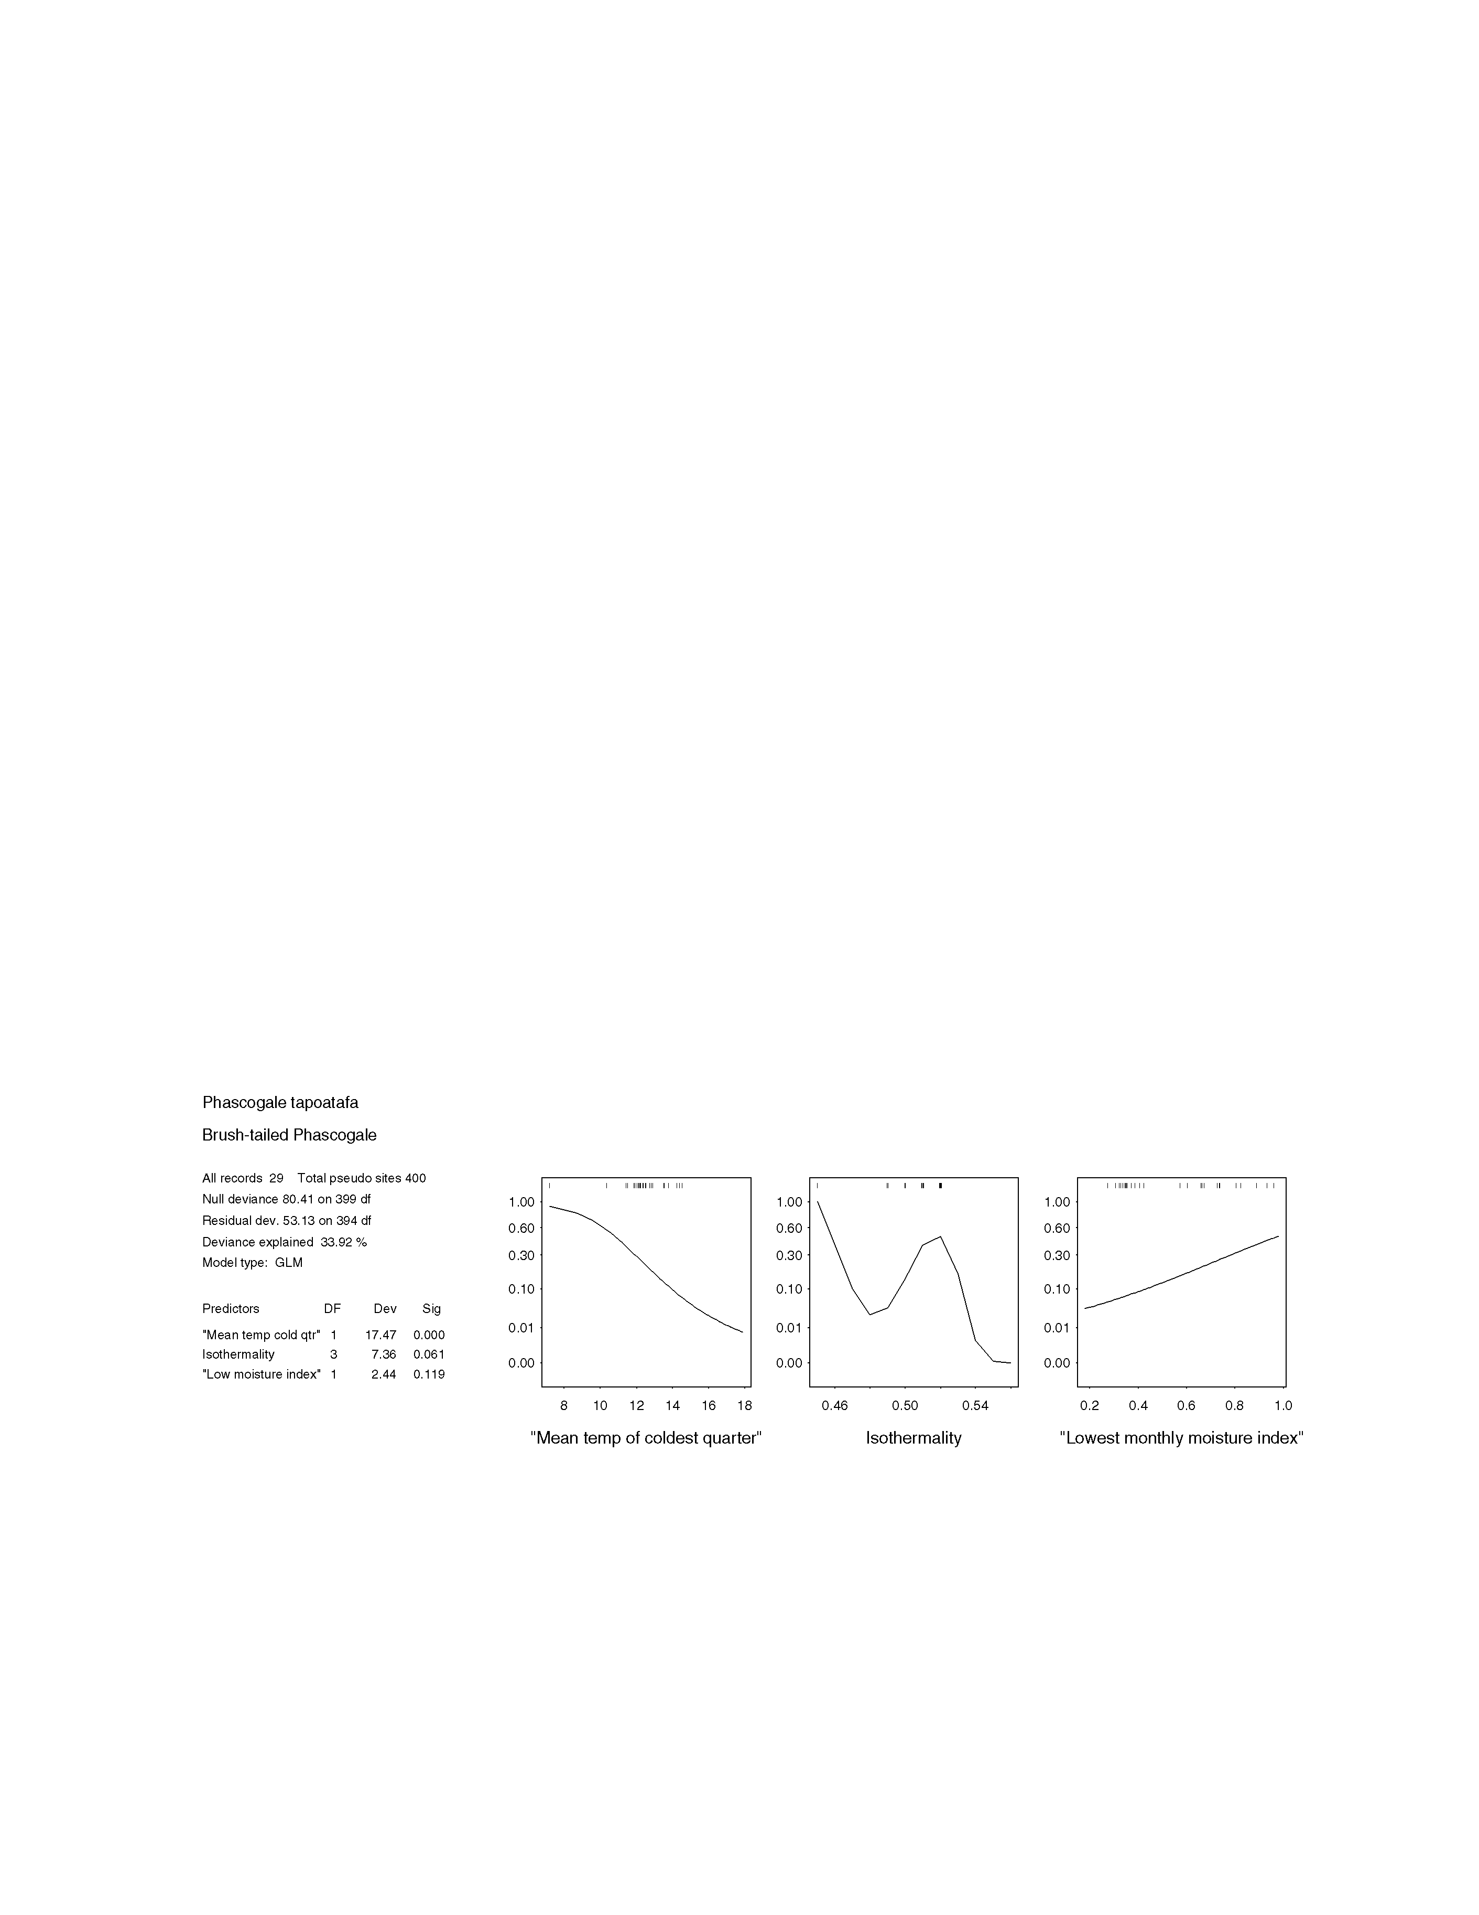
FIGURE 3.6.1A

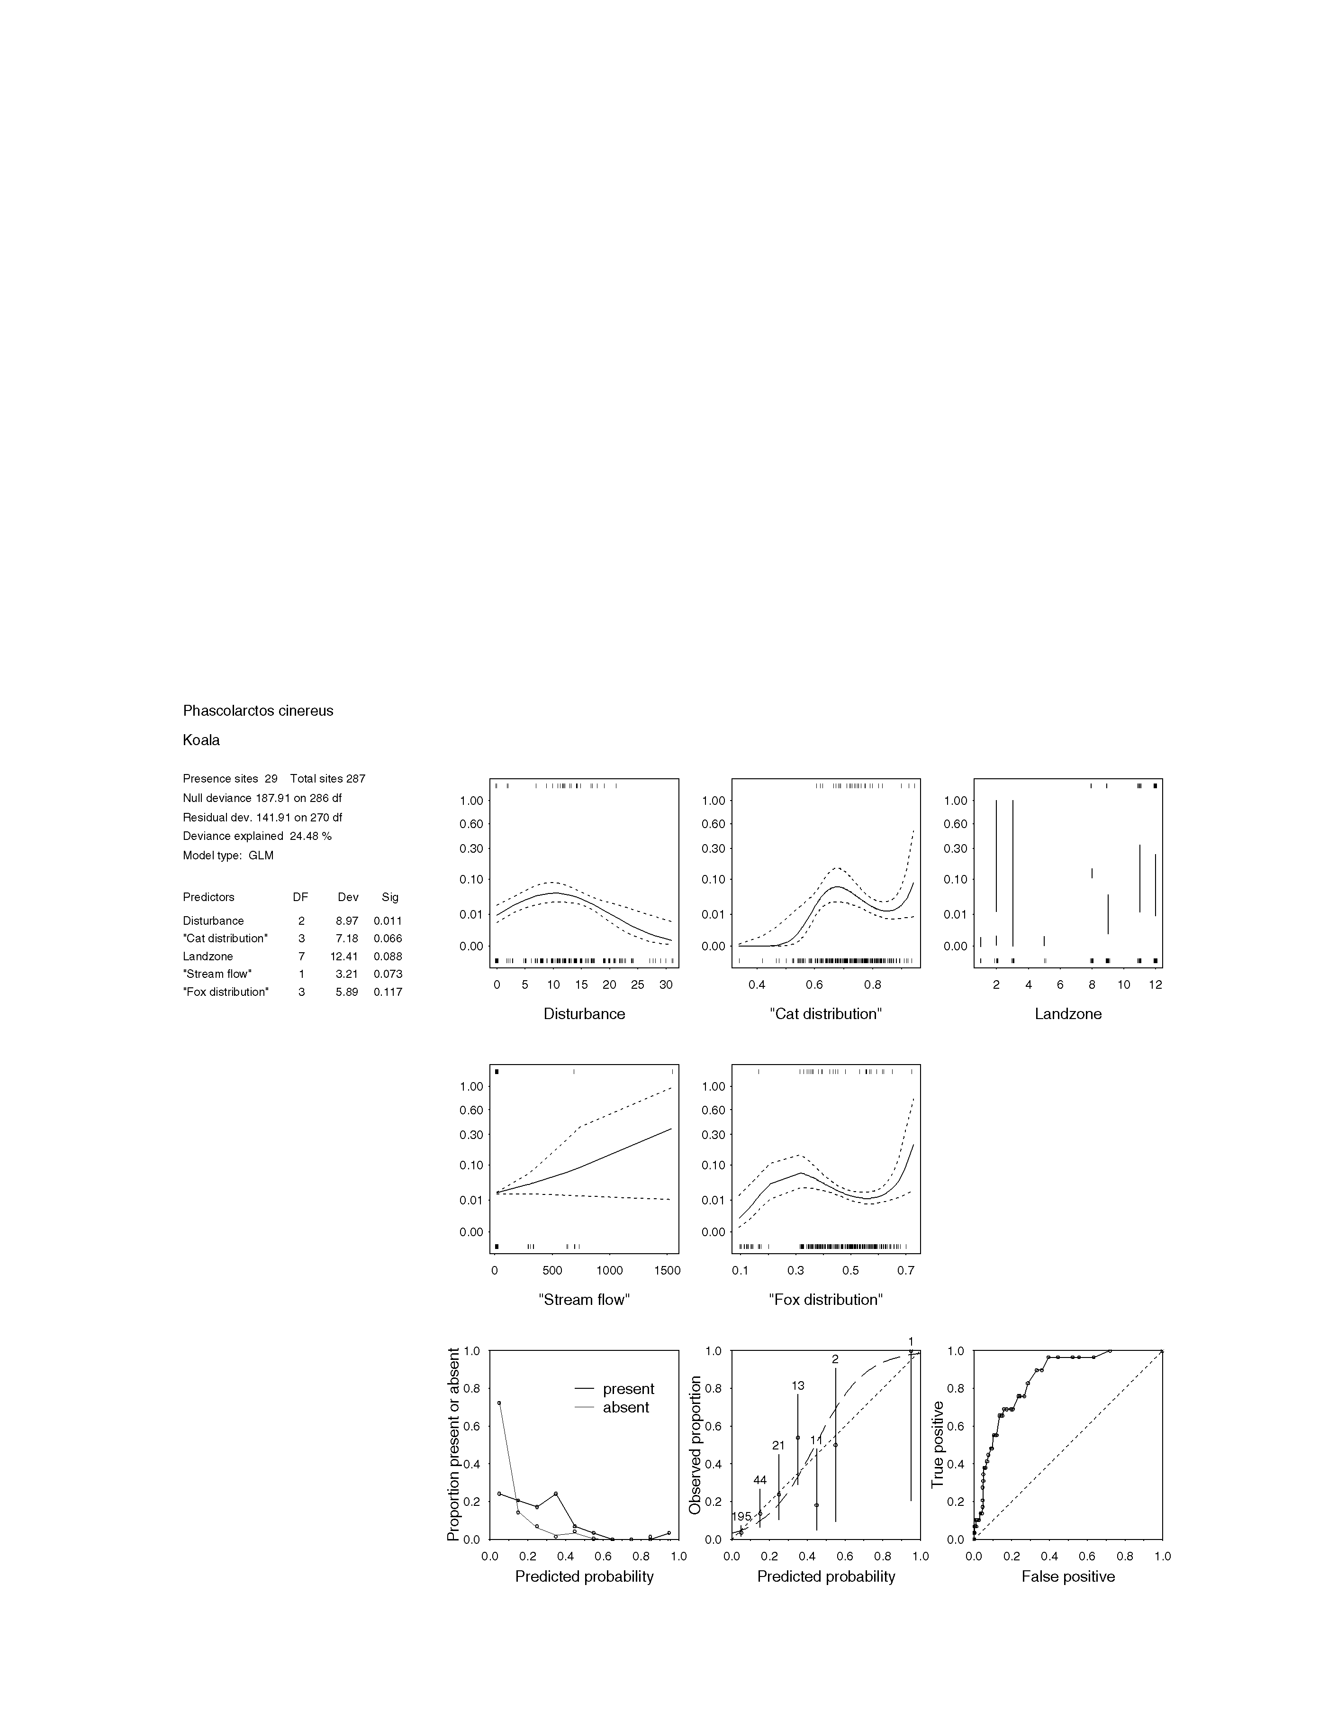
figure 3.6.2a statistical output for phascolarctos cinerus (koala)

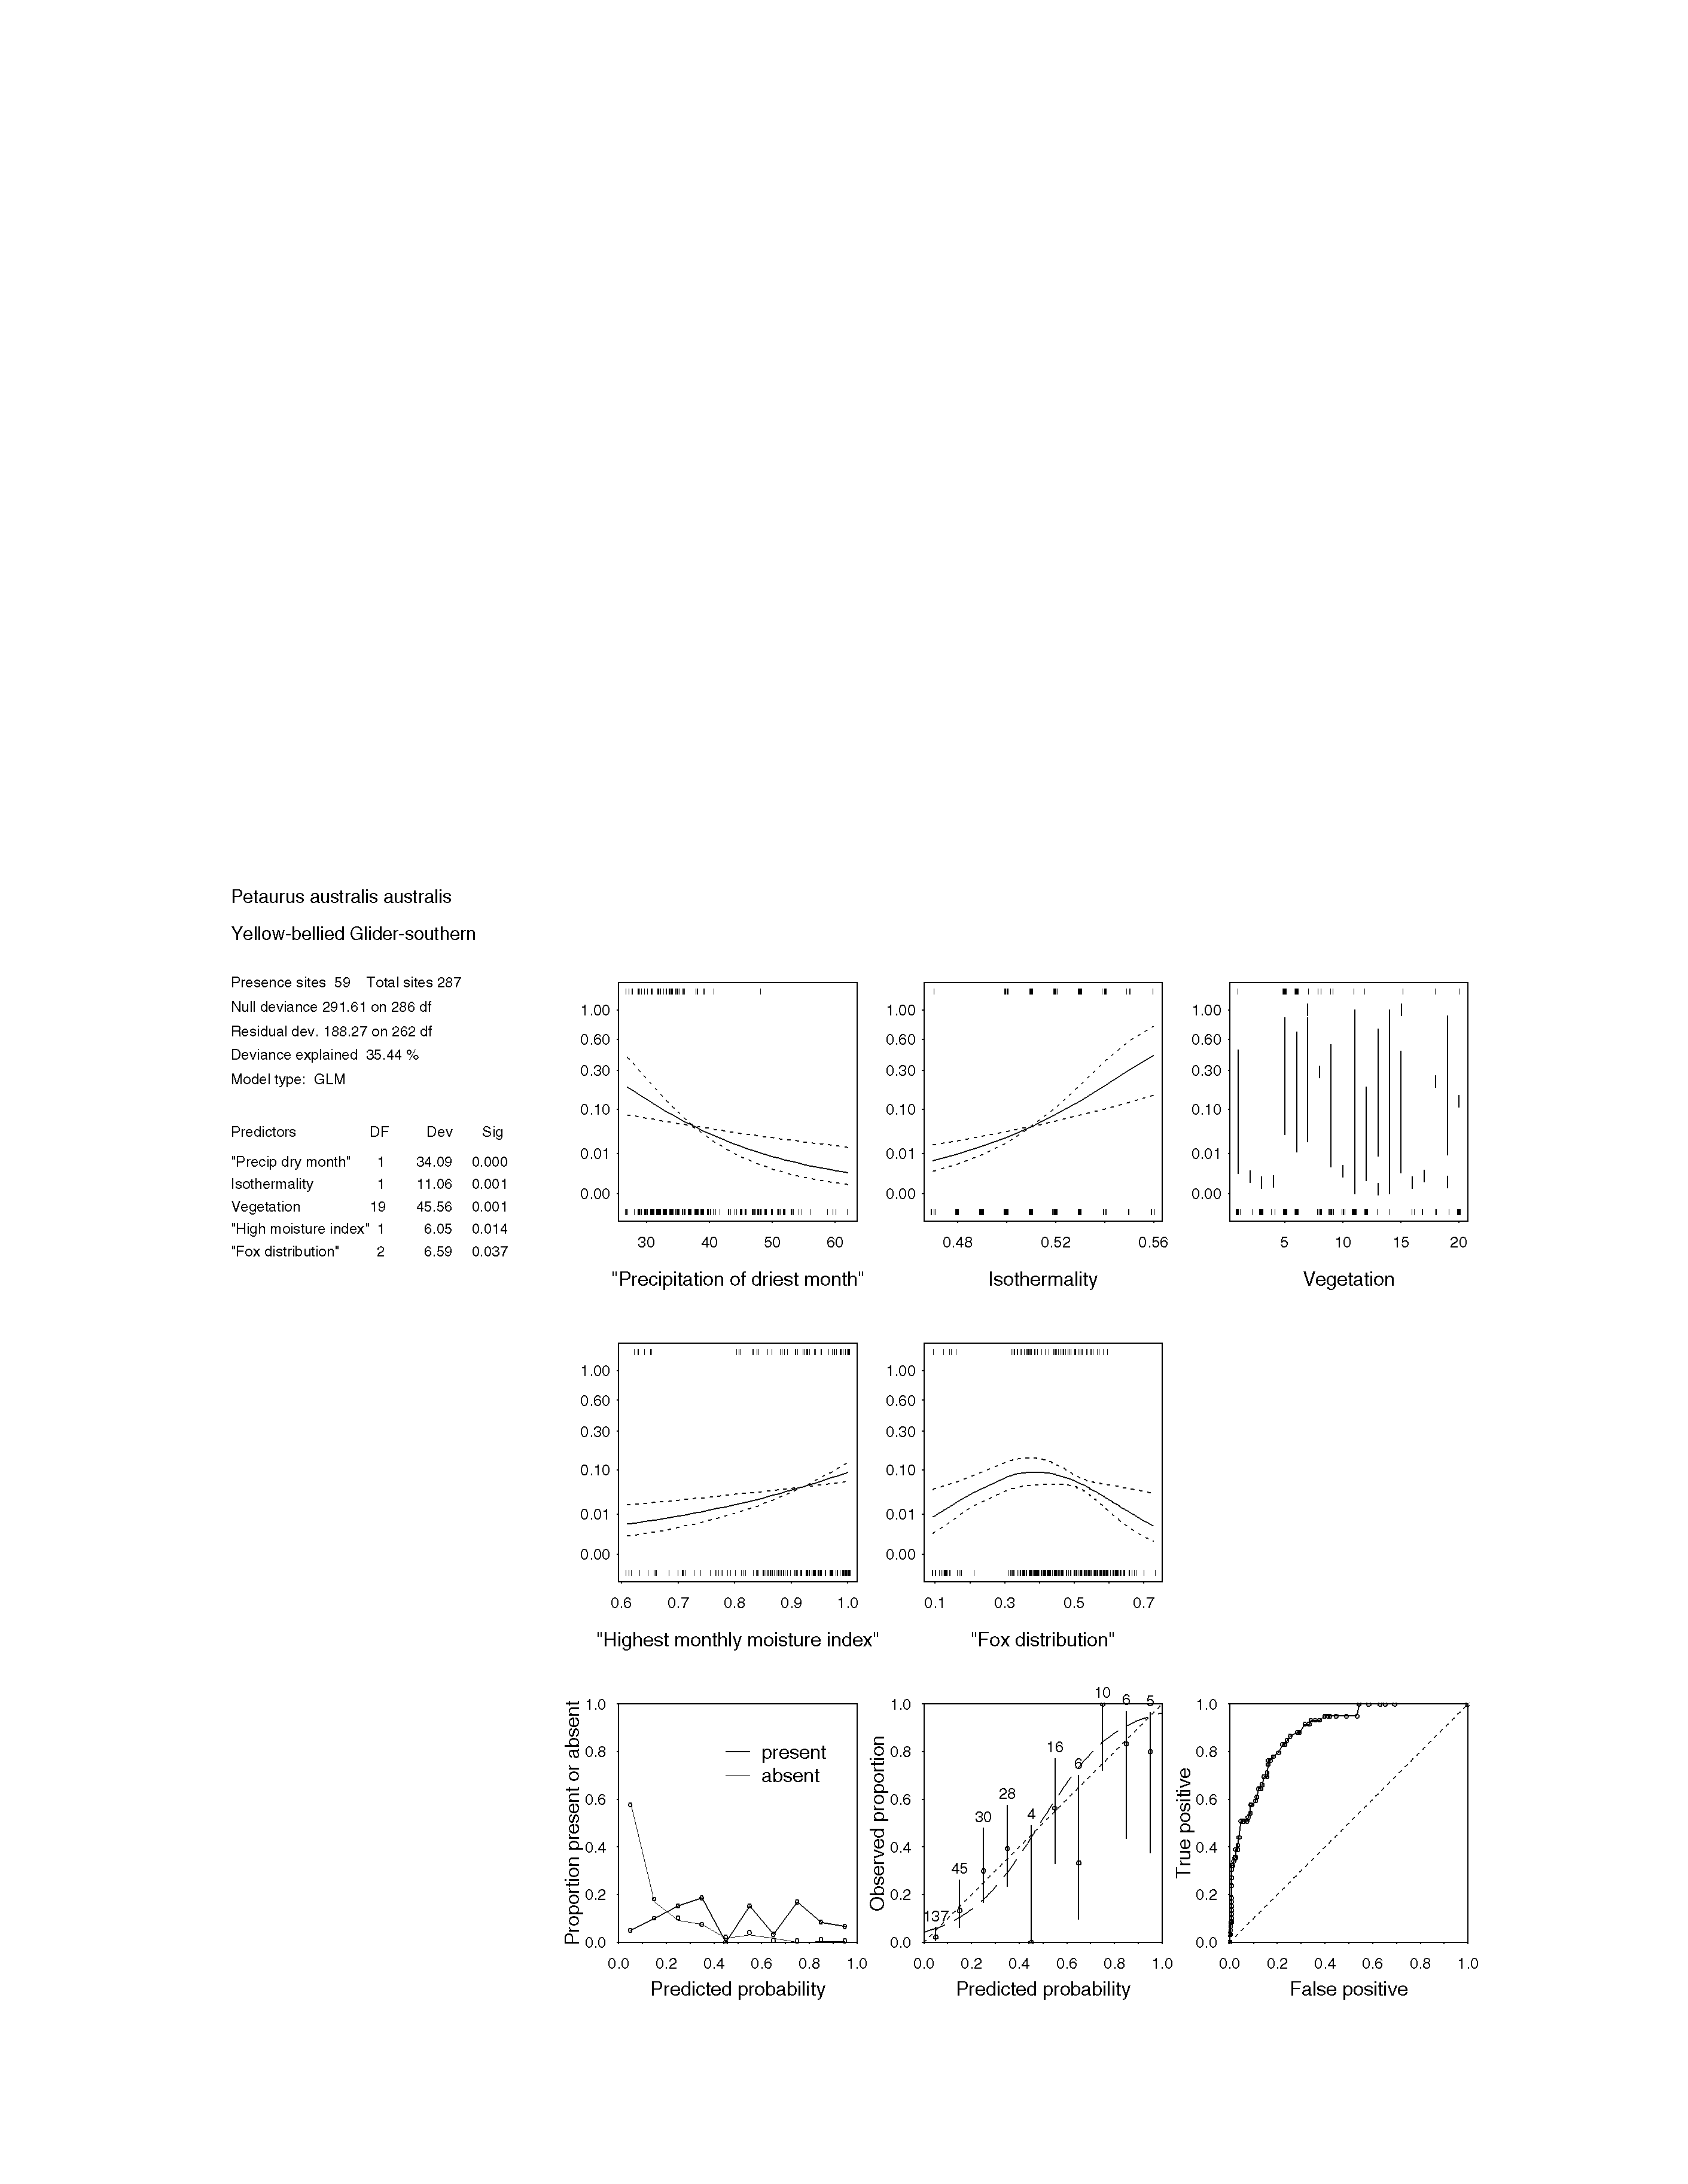
figure 3.6.3a statistical output for petaurus australis australis (yellow-bellied glider)

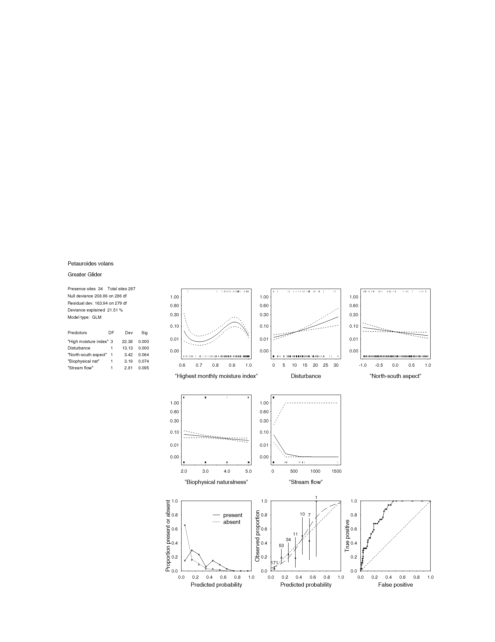
figure 3.6.5a statistical output for petauroides volans (greater glider)

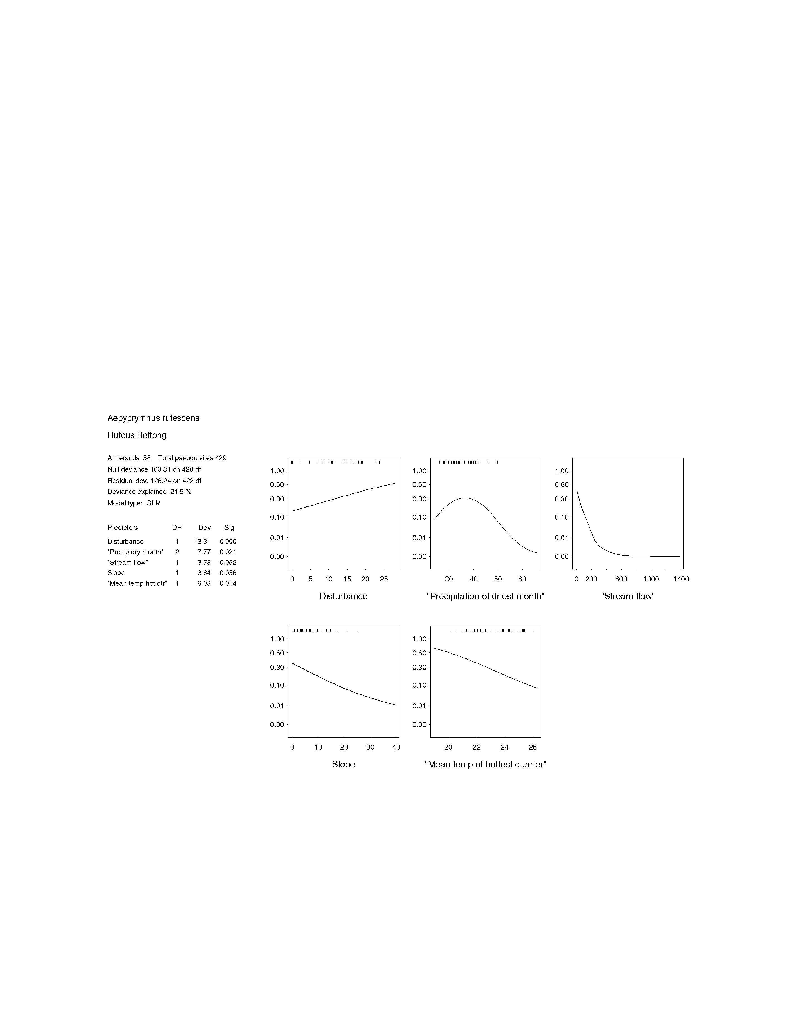
figure 3.6.7a statistical output for aepyprymnus rufescens (rufous bettong)

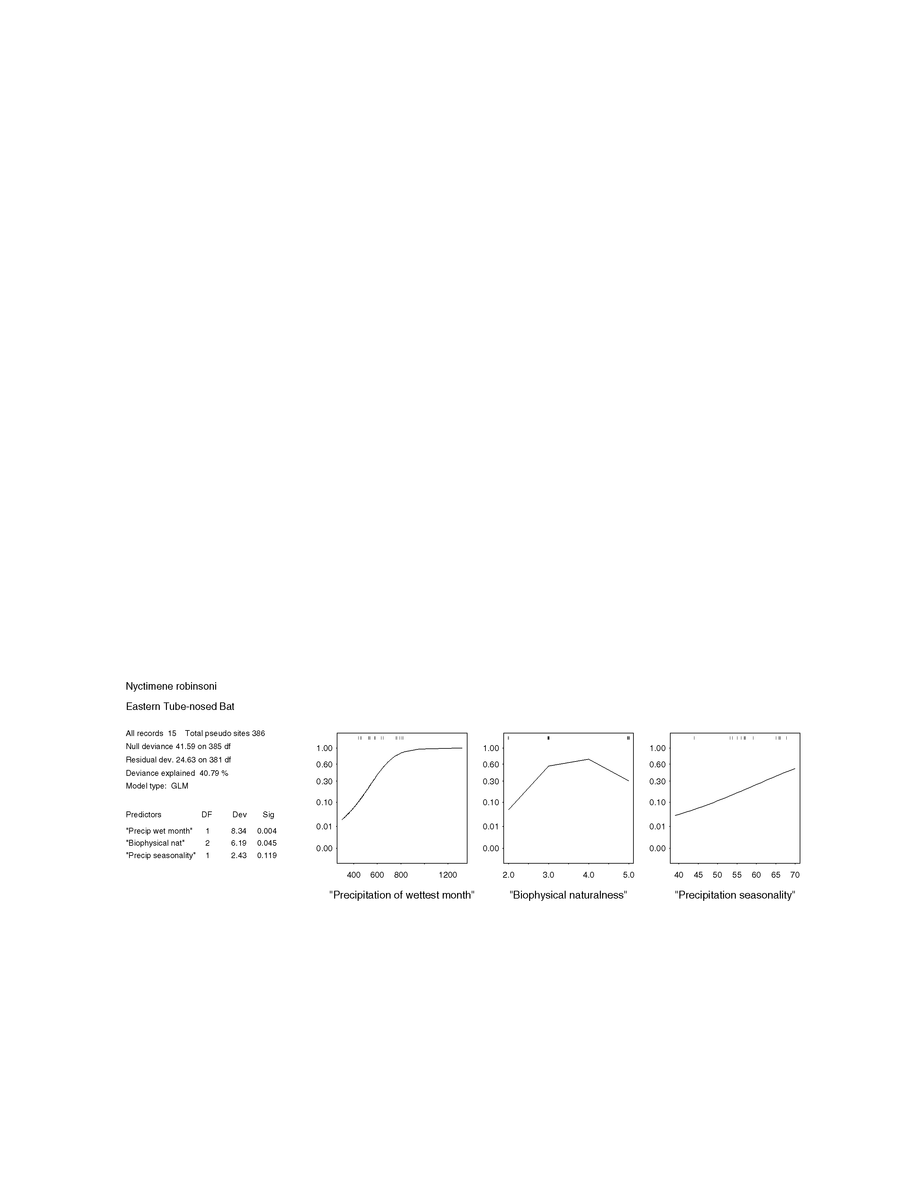
figure 3.6.9a statistical output for nyctimene robinsoni (eastern tube-nosed bat)

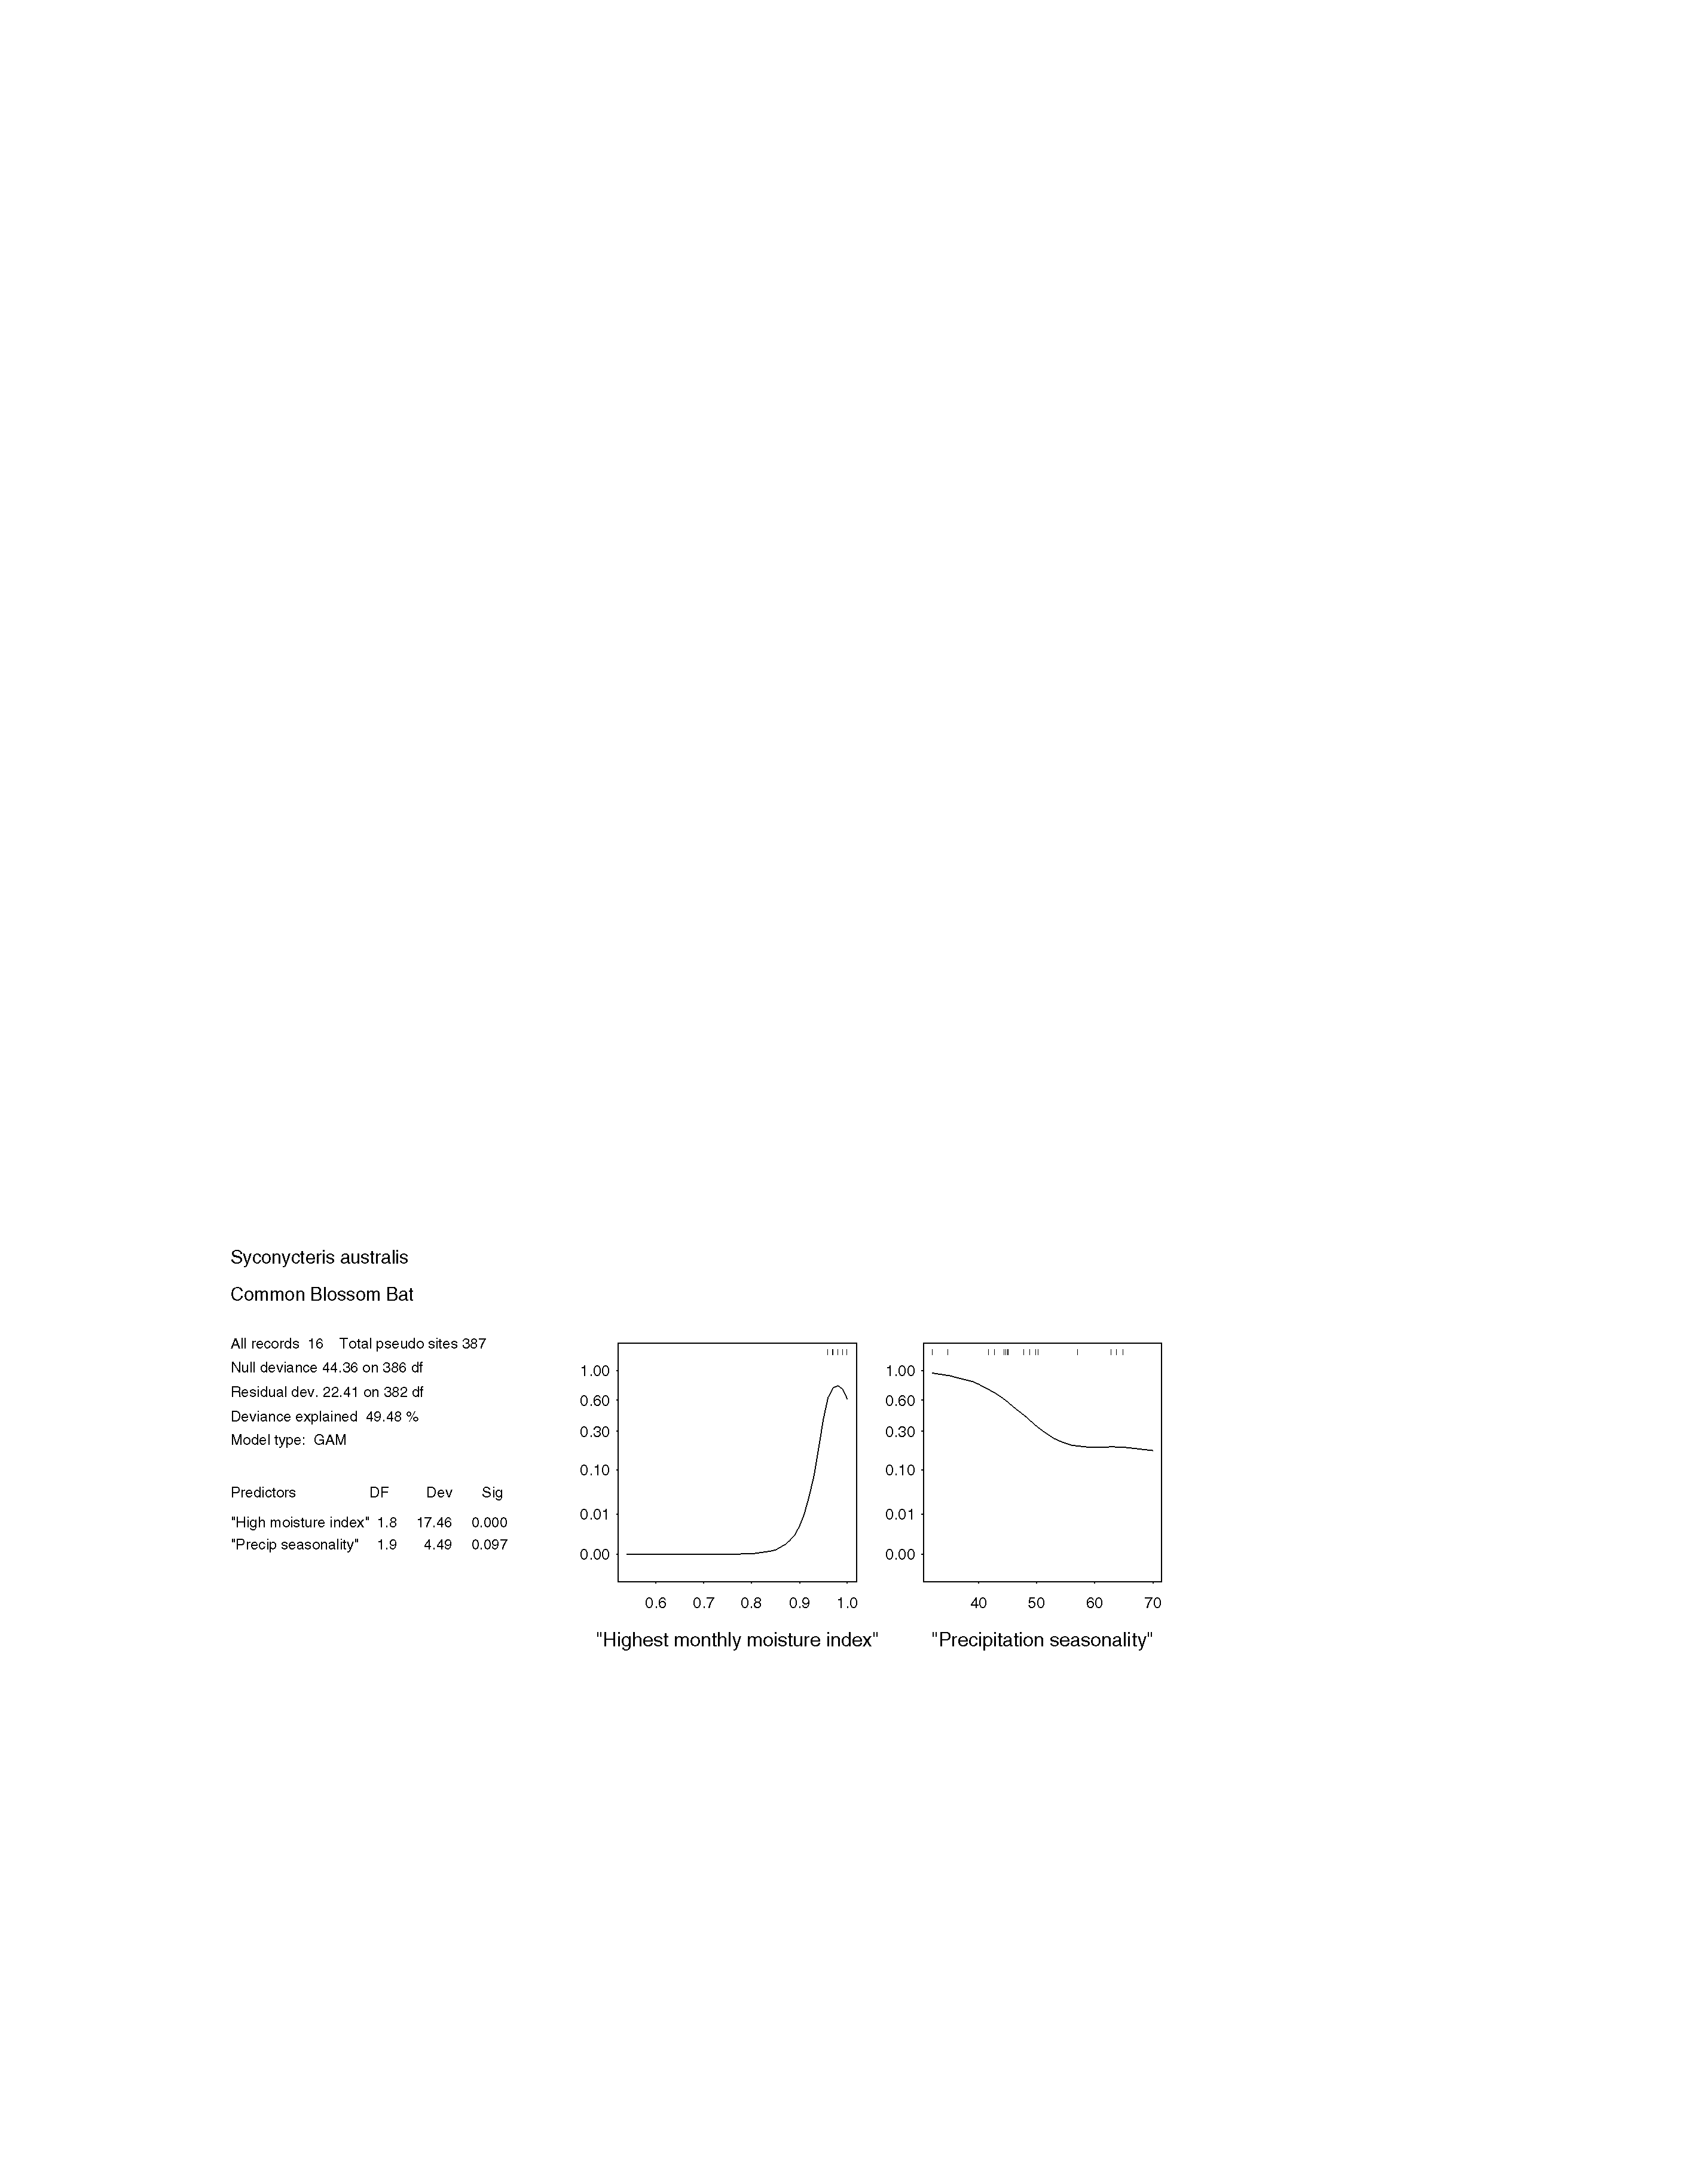
figure 3.6.10a statistical output for syconycteris australis (common blossom-bat)

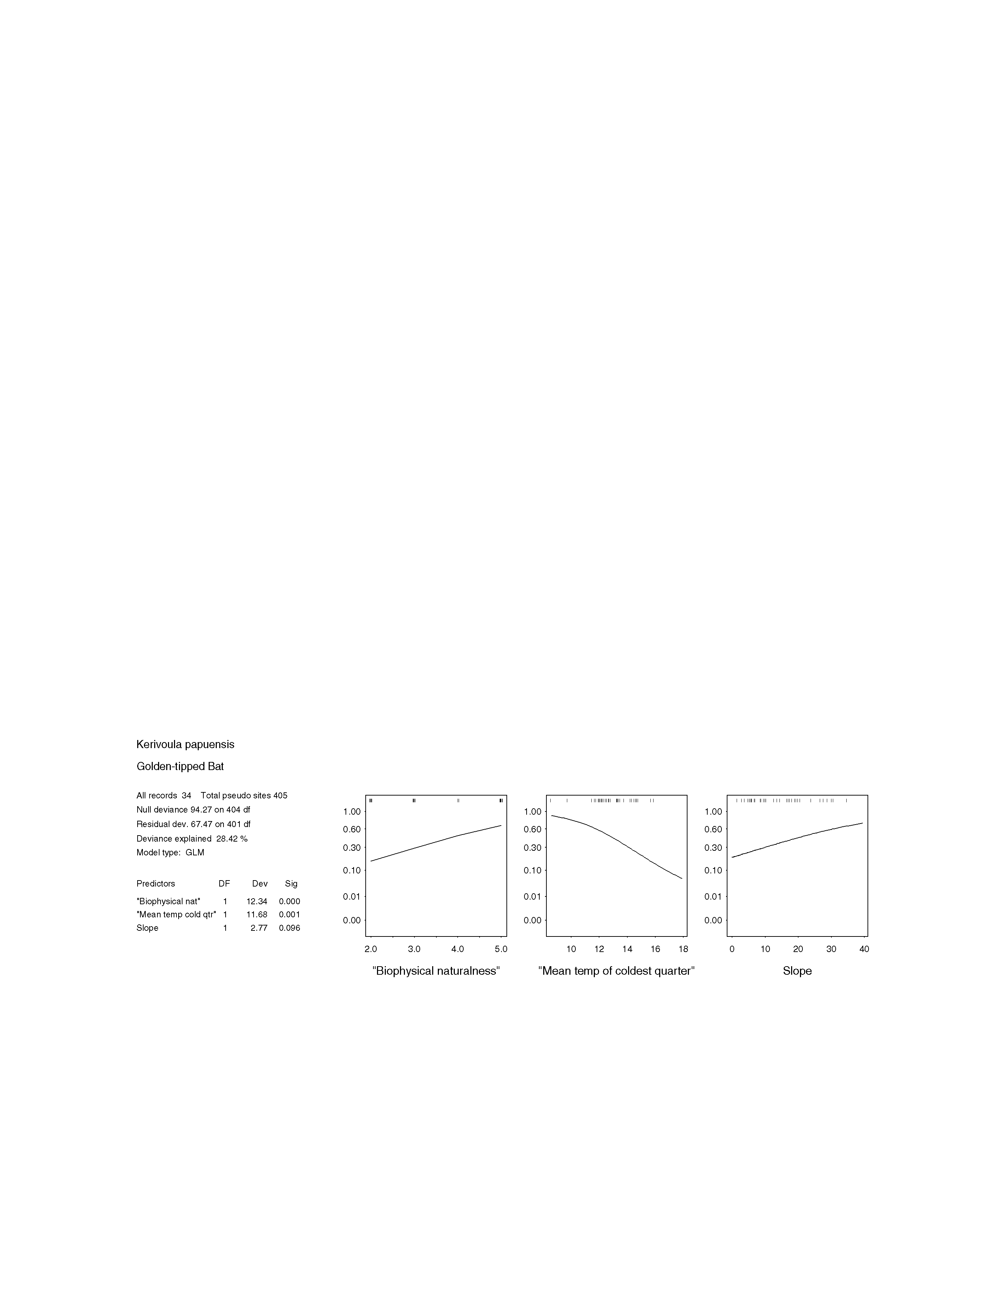
figure 3.6.11a statistical output for Kerivoula papuenis (golden-tipped bat)

APPENDICES

Appendix 1 Vegetation legend for 1:100 000 vegetation mapping in the SEQ Bioregion (from Queensland Herbarium, 1998).

 | Grouped Unit Code | Ungrouped Unit Code | Veg Description
A ESTUARINE
SHRUBLANDS/OPEN WOODLANDS to CLOSED FORESTS
 | 9 | A1. | Mangrove communities - Avicennia marina, Rhizophora stylosa
WOODLANDS
 | 8b | A2. | Casuarina glauca
HERBLANDS/GRASSLANDS
 | 9 | A3. | Saltmarsh communities - Sporobolus virginicus, Halosarcia spp.
 |  |  | a. Sporobolus virginicus
 |  |  | b. Schoenoplectus validus
 |  |  | c. Schoenoplectus litoralis
 |  |  | d. Halosarcia spp.
 |  |  | e. Eleocharis spiralis
 |  |  | f. Bothriochloa decipiens
 |  |  | g. Baumea spp.
 |  |  | h. Saltflats (bare of vegetation)
B COASTAL DUNES, SWALES, BEACHES & HEADLANDS
CLOSED FORESTS
 | 9 | B1. | Dune/swale scrub - Acacia spp., Acronychia imperforata, Cupaniopsis anacardioides, Banksia integrifolia
 | 6b | B2. | NVF ( Araucaria cunninghamii, Agathis robusta emergents, areas of Archontophoenix cunninghamiana (Fraser Island, Cooloola)
 | 6b | B3. | NVF with Lophostemon confertus, Syncarpia hillii (Stanton's unit 2)
 | 6b | B4. | MVF/T - (Backhousia) with Araucaria cunninghamii, Agathis robusta (Fraser Island, Cooloola)
 | 6b | B5. | NVF/T - Coastal scrubs, mostly on sand
 |  |  | a. Coastal scrubs, mostly on sand
 |  |  | b. Deepwater NP
 | 6b | B6. | (A)NVF - Mixture of beach ridges and underlying sediments (Littabella, Dundowran, River Heads)
 |  |  | a. Coastal low dunes (Littabella)
 |  |  | b. Lowland rainforest (Dundowran/River Heads)
OPEN FORESTS
 | 5a | B7. | Corymbia tessellaris and/or Melaleuca dealbata, etc
 |  |  | a. Melaleuca dealbata, Eucalyptus tereticornis, Corymbia intermedia
 |  |  | b. Corymbia tessellaris, Eucalyptus tereticornis, Callitris columellaris
 | 2 | B8. | Eucalyptus pilularis, Corymbia intermedia, Lophostemon confertus, Syncarpia hillii
 | 5a | B9. | Eucalyptus racemosa, Corymbia intermedia, etc. - high dunes
 | 5a | B10. | Lophostemon confertus, Corymbia intermedia, Callitris columellaris, Banksia spp.
WOODLANDS
 | 9 | B11. | Acacia spp. ( Corymbia tessellaris, C. intermedia - dunes
 | 5a | B12. | Banksia aemula, Eucalyptus racemosa, Corymbia gummifera &/or C. planchoniana
 | 9 | B13. | Banksia aemula with Leptospermum attenuatum, Ricinocarpos pinifolius (scrubby) - beach ridges
 | 9 | B14. | Casuarina equisetifolia and Spinifex sericeus
 |  |  | a. Casuarina equisetifolia
 |  |  | b. Spinifex sericeus grassland

 | Grouped Unit Code | Ungrouped Unit Code | Veg Description
 | 8b | B15. | Callitris columellaris, Casuarina equisetifolia
 | 8a | B16. | Melaleuca leucadendra
SHRUBLANDS
 | 9 | B17. | Acacia spp., Grevillea banksii - headlands
 |  |  | a. Acacia julifera
 |  |  | b. Grevillea banksii
 |  |  | c. Melaleuca nervosa
 | 9 | B18. | Banksia integrifolia ( Acacia spp., Casuarina equisetifolia - low dunes
 | 9 | B19. | Pandanus tectorius, Casuarina equisetifolia - headlands
GRASSLANDS
 | 9 | B20. | Themeda triandra -headlands
MISCELLANEOUS
 | 10 | B21. | Sand blows
C WETLANDS
OPEN FORESTS
 | 8b | C1. | Casuarina glauca
 | 8a | C2. | Melaleuca quinquenervia - permanently and semi-permanently inundated
WOODLANDS
 | 8a | C3. | Melaleuca quinquenervia, Eucalyptus robusta
 | 8a | C4. | Melaleuca quinquenervia, Eucalyptus tereticornis, Lophostemon suaveolens
 | 8a | C5. | Melaleuca irbyana
HEATHLANDS
 | 9 | C6. | Banksia robur, Melaleuca nodosa (( Schoenus brevifolius patches)
 |  |  | a. Banksia robur
 |  |  | b. Melaleuca nodosa
 |  |  | c. Schoenus brevifolius
 | 9 | C7. | Wet heath - Leptospermum spp., Epacris spp., Empodisma minus, Sprengelia sprengelioides - poorly drained lowlands
SEDGELANDS
 | 9 | C8. | Baumea spp., etc
 |  |  | a. Baumea spp., Lepironia articulata
 |  |  | b. Eleocharis equisetina
 |  |  | c. Baumea spp., Eleocharis spp., Juncus spp.
 | 9 | C9. | Gahnia sieberiana ( Lepironia articulata, Gleichenia microphylla
 |  |  | a. Gahnia sieberiana, Lepironia articulata, Gleichenia microphylla
 |  |  | b. Gahnia sieberiana
MISCELLANEOUS
 | 10 | C10. | Natural freshwater bodies
D COASTAL SANDPLAINS
OPEN FORESTS
 | 9 | D1. | Allocasuarina littoralis, Lophostemon confertus, L. suaveolens, Callitris columellaris, etc
 | 4a | D2. | Eucalyptus acmenoides,Corymbia intermedia - coastal lowlands, red earths or deep sands
 | 1b | D3. | Eucalyptus robusta, E. resinifera, Syncarpia glomulifera, Endiandra sieberi
 | 4a | D4. | Syncarpia glomulifera, Corymbia trachyphloia, Eucalyptus acmenoides, Corymbia intermedia - low rises in coastal sandplains
WOODLANDS
 | 5a | D5. | Eucalyptus bancroftii, Corymbia intermedia - Battery Hill, Caloundra
 | 5a | D6. | Eucalyptus hallii, Corymbia intermedia, Angophora leiocarpa ( E. umbra, C. trachyphloia)
 | 5a | D7. | Eucalyptus racemosa, Corymbia intermedia, Syncarpia glomulifera, E. umbra - low rises in coastal sandplains
 | 5a | D8. | Eucalyptus racemosa, Corymbia intermedia, etc.
 | 5a | D9. | Eucalyptus umbra, Corymbia intermedia, C. trachyphloia, Angophora leiocarpa

 | Grouped Unit Code | Ungrouped Unit Code | Veg Description
OPEN WOODLANDS
 | 8a | D10. | Melaleuca viridiflora +/- Eucalyptus exserta
HEATHLANDS
 | 9 | D11. | Banksia aemula ( malleed Eucalyptus umbra with heathy ground layer - sandplains and occasionally undulating dunes (eg. Moreton Is.)
 | 9 | D12. | Dry heath
E ALLUVIUM
CLOSED FORESTS
 | 6b | E1. | CNVF (( Araucaria cunninghamii)
 |  |  | a. Brisbane and Pine Rivers floodplains
 |  |  | b. Mooloolah River floodplains (Jowarrah)
 | 6b | E2. | N/MVF on fan, alluvial flats (Watalgan Range)
 | 6b | E3. | Dry riverine rainforest - Agathis robusta, etc. (Lenthalls Dam, Brooweena drainage lines)
 | 6b | E4. | Mundurun Ck N of Targinnie, Baffle Ck, Pine Ck
 | 6b | E5. | Riverine:- terraces, etc. - Dysoxylum, etc; slightly drier - Waterhousea floribunda, Castanospermum australe (Burnett, Kolan, Mary Rivers)
 |  |  | a. Riverine - Burnett, Kolan Rivers
 |  |  | b. Kolan River - slightly drier community
WOODLANDS
 | 4a | E6. | Eucalyptus microcarpa/moluccana, E. melliodora, E. conica - alluvials, west of Main Range
 | 5b | E7. | Eucalyptus moluccana
 | 5b | E8. | Eucalyptus populnea
 | 4b | E9. | Eucalyptus siderophloia, E. tereticornis ( Corymbia intermedia - coastal alluvial flats
 | 4b | E10. | Eucalyptus tereticornis ( Corymbia tessellaris, etc - alluvial flats away from the coast
 | 4b | E11. | Eucalyptus tereticornis, Casuarina cunninghamiana - riparian
 | 4b | E12. | Eucalyptus tereticornis, Casuarina cunninghamiana, Melaleuca fluviatilis - riparian
 | 4a | E13. | Syncarpia glomulifera, Corymbia intermedia - creek flats
OPEN WOODLANDS
 | 4b | E14. | Eucalyptus platyphylla, Lophostemon suaveolens
F LATERITIC DURICRUSTS - GENTLY UNDULATING TO MOUNTAINOUS TERRAIN
WOODLANDS
 | 5b | F1. | Corymbia trachyphloia, Lysicarpus angustifolius, Eucalyptus crebra, E. exserta
G BASALT - GENTLY UNDULATING TO MOUNTAINOUS TERRAIN
CLOSED FORESTS
 | 6b | G1. | CNVF - basalt, esp. at moderate to low altitudes
 |  |  | a. McPherson Range, Mt Tamborine
 |  |  | b. Mt Glorious
 |  |  | c. Mt Mee (drier)
 | 6a | G2. | (C)NVF - Cool STRf
 |  |  | a. McPherson Range
 |  |  | b. Main Range
 | 6c | G3. | ANVF - Drier STRf, McPherson Range, Main Range and spurs, Bahrs Scrub
 | 6a | G4. | MMF - Nothofagus moorei; also Caldcluvia paniculosa, Doryphora sassafras, Orites excelsa along McPherson Range (Crest of McPherson Range, Lamington NP, Mt Ballow area)

 | Grouped Unit Code | Ungrouped Unit Code | Veg Description
 | 6a | G5. | MMF - Acmena smithii, Acacia melanoxylon (Main Range crests, also Bunya Mts)
 |  |  | a. Main Range crests
 |  |  | b. Bunya Mts crests eg. Mt Kiangarow
 | 6d | G6. | Stoney Range, W of Gin Gin (basalt scree)
 | 6d | G7. | SEVT (Softwood, lacks bottle trees) - Basalt hills near Thangool, Malakoff, Callide Range N, W foothills Kroombit Tops, Bunya Mts dry foothills
 | 6c | G8. | Ecotones - Araucaria cunninghamii ( Corymbia citriodora, Eucalyptus crebra, etc. - often very disturbed by logging (Goodnight Scrub)
 | 6c | G9. | AN/MVF (Yarraman/Nanango/Benarkin)
 | 6b | G10. | Argyrodendron, Choricarpia, Dissillaria, etc - wetter, better soils than 320
 |  |  | a. Jimna-Imbil-Gallangowan-Kilkivan
 |  |  | b. Base of Mt Urah - moist outwash situations
 | 6c | G11. | (A)NVF - Argyrodendron trifoliolatum, A. sp.(Kin Kin) (Granite Creek State Forest, Bania, etc)
 |  |  | a. Granite Ck, Colosseum Ck, Norton Ck, Edinburgh Mts, NE of Arthurs Seat
 |  |  | b. Bania SF
 |  |  | c. Seaview Range, Scrubby Ck, Mt Goonaneman, Mt Bauple
 |  |  | d. Marsupial LA, S of Granite Ck (cf. 19?)
 | 8b | G12. | Acacia harpophylla, Casuarina cristata, Geijera parviflora - generally on heavy clay soils, derived form sediments and basalt
 |  |  | a. Acacia harpophylla, Casuarina cristata
 |  |  | b. Acacia harpophylla, Eucalyptus tereticornis
 | 6c | G13. | MVF ( Araucaria cunninghamii
 |  |  | a. The Hummock - no hoop - cf Yarrol?
 |  |  | b. Isis, Booyal and Goodnight Scrubs- hoop emergents
 | 6d | G14. | MVF-SEVT - no Araucaria cunninghamii (Lockyer Scrubs, Western Main Range and Fassifern)
 | 6b | G15. | (C)NVF in (near) coastal situations
 |  |  | a. Burleigh Heads
 |  |  | b. Buderim Mt upper slopes
 | 6a | G16. | Araucaria bidwillii, Argyrodendron, Dendrocnide, Castanospermum australe (Bunya Mountains upland rainforest)
 | 6c | G17. | Araucaria bidwillii/A. cunninghamii, Argyrodendron, etc. (Bunya Mountains moist mid and lower slopes)
 | 6c | G18. | AMVF - basalt (and some sediments?) (Bunya Mountains dry midslopes, also includes areas of Marburg, Rosewood scrubs)
 |  |  | a. Bunya Mts, SE of Mt Binga, N of Crows Nest, Marburg/Rosewood Scrubs, Veresdale Scrub
 |  |  | b. W of Crows Nest, S of Cooyar
 |  |  | c. Blackbutt Range
 |  |  | d. W of Crows Nest
OPEN FORESTS
 | 1a | G19. | Eucalyptus campanulata
 |  |  | a. Eucalyptus campanulata, E. biturbinata
 |  |  | b. Eucalyptus campanulata, E. saligna, E. biturbinata - Helidon, basalt
 |  |  | c. Eucalyptus campanulata, Lophostemon confertus
 | 1a | G20. | Eucalyptus cloeziana, Corymbia citriodora, E. longirostrata, E. major - lateritized basalt
 | 1a | G21. | Eucalyptus dunnii
 | 1b | G22. | Eucalyptus grandis, E. microcorys, Lophostemon confertus - colluvium, usually from basalt
 | 2 | G23. | Eucalyptus pilularis - high altitude, basalt
 | 1a | G24. | Eucalyptus saligna, etc.
 | 7 | G25. | Eucalyptus saligna with rainforest
 | 4a | G26. | Eucalyptus tereticornis, E. melliodora, E. biturbinata - basalt, wetter areas
 | 1a | G27. | Lophostemon confertus - wetter units

 | Grouped Unit Code | Ungrouped Unit Code | Veg Description
WOODLANDS
 | 8b | G28. | Acacia rhodoxylon
 | 4a | G29. | Corymbia trachyphloia, Eucalyptus longirostrata - red soil plateaux; lateritised basalt
 | 1a | G30. | Eucalyptus campanulata, E. laevopinea
 | 5b | G31. | Eucalyptus crebra, E. melliodora, E. tereticornis, E. albens - basalt, drier version of 222, mostly west of Great Dividing Range
 | 5b | G32. | Eucalyptus crebra, E. melliodora, E. tereticornis - basalt, drier version of 222, east of Great Dividing Range
 | 4a | G33. | Eucalyptus melanoleuca, E. longirostrata, Corymbia intermedia with scrub understorey
 | 4a | G34. | Eucalyptus moluccana - ridges
 | 2 | G35. | Eucalyptus montivaga, E. pilularis
 | 4b | G36. | Eucalyptus nobilis
 | 5b | G37. | Eucalyptus orgadophila, E. crebra
 | 4a | G38. | Eucalyptus tereticornis, Corymbia intermedia, Angophora subvelutina/A floribunda, Allocasuarina torulosa - heavy soils, high altitude
 | 4a | G39. | Eucalyptus tereticornis, Corymbia intermedia - red soils, undulating terrain
OPEN WOODLANDS
 | 5b | G40. | Eucalyptus crebra with rainforest understorey
 | 5b | G41. | Eucalyptus crebra, E. melanophloia, Corymbia erythrophloia - northern mapsheets; also on granites
GRASSLANDS
 | 9 | G42. | Poa labillardieri
H SEDIMENTARY - GENTLY UNDULATING TO MOUNTAINOUS TERRAIN
CLOSED FORESTS
 | 6d | H1. | SEVT ( Acacia harpophylla, Casuarina cristata - mostly on sediments
 | 6d | H2. | SEVT - on limestone (Yarrol Rd, SE of Monto)
 | 6d | H3. | MVF - Brachychiton spp. not conspicuous (Koolkoorum, Nagoorin, Pine Mtn, Boynedale-Wietalaba) - ?mixed volcanics, sediments
 | 6d | H4. | On sediments (mudstone) (Dan Dan, Catfish Scrubs)
 | 6d | H5. | MVF/SEVT - lacks Araucaria cunninghamii, but denser, more diverse than "typical" softwood (Yarrol Scrub)
 |  |  | ?a. ANVF
OPEN FORESTS
 | 8b | H6. | Callitris baileyi, Eucalyptus crebra
 | 8b | H7. | Callitris columellaris
 | 4a | H8. | Eucalyptus acmenoides, E. propinqua, E. siderophloia with dense scrub understorey
 | 4a | H9. | Eucalyptus cloeziana, E. melanoleuca, E. sphaerocarpa
 | 5b | H10. | Eucalyptus melanoleuca, E. baileyana, E. hendersonii, E. bunites ( E. suffulgens
 | 2 | H11. | Eucalyptus pilularis - coastal sandstone
 | 2 | H12. | Eucalyptus pilularis - Helidon Hills area, sandstone
 | 1a | H13. | Eucalyptus saligna, Corymbia intermedia, E. mensalis, E. sphaerocarpa
 | 5a | H14. | Eucalyptus tindaleae, E. racemosa, E. pilularis, Corymbia gummifera
 | 8b | H15. | Lophostemon confertus - drier units
WOODLANDS
 | 3b | H16. | Angophora leiocarpa, Corymbia citriodora
 | 5a | H17. | Angophora woodsiana, Eucalyptus umbra
 | 5a | H18. | Angophora woodsiana, E. resinifera
 | 3b | H19. | Corymbia citriodora +/- Eucalyptus crebra and/or E. acmenoides - also on granite, etc
 | 3b | H20. | Corymbia citriodora, Eucalyptus crebra, C. trachyphloia, E. acmenoides - quartzose sandstone
 | 3a | H21. | Corymbia citriodora, Eucalyptus major, E. carnea, E. siderophloia
 | 4a | H22. | Corymbia intermedia, Lophostemon suaveolens
 | 5b | H23. | Corymbia trachyphloia, Eucalyptus crebra

 | Grouped Unit Code | Ungrouped Unit Code | Veg Description
 | 4a | H24. | Eucalyptus acmenoides, Angophora leiocarpa, Corymbia intermedia +/- C. trachyphloia =- also on granite
 | 4a | H25. | Eucalyptus acmenoides, Corymbia trachyphloia, Angophora woodsiana - Helidon Hills
 | 4a | H26. | Eucalyptus acmenoides, E. eugenioides
 | 5b | H27. | Eucalyptus crebra, Angophora leiocarpa
 | 5b | H28. | Eucalyptus decorticans
 | 4a | H29. | Eucalyptus fibrosa +/- Corymbia citriodora, E. acmenoides, C. henryi
 | 4a | H30. | Eucalyptus fibrosa, E. sideroxylon
 | 4a | H31. | Eucalyptus major, Corymbia intermedia, Angophora leiocarpa, C. trachyphloia
 | 4a | H32. | Eucalyptus melanoleuca, E. major, Corymbia trachyphloia
 | 4a | H33. | Eucalyptus propinqua, Syncarpia glomulifera
 | 5a | H34. | Eucalyptus racemosa, Corymbia intermedia, C. trachyphloia and/or Angophora leiocarpa
 | 5b | H35. | Eucalyptus rhombica
 | 5a | H36. | Eucalyptus seeana
 | 5b | H37. | Eucalyptus suffulgens ( E. acmenoides
 | 5a | H38. | Eucalyptus tereticornis, Corymbia intermedia, E. siderophloia, Angophora leiocarpa - Cooloola; slopes and ridges, sandstone
 | 3a | H39. | Nerang-Beenleigh alliance
OPEN WOODLANDS
 | 3b | H40. | Eucalyptus corynodes, Lophostemon confertus
SHRUBLANDS
 | 9 | H41. | Angophora leiocarpa, Eucalyptus exserta, Callitris, Leptospermum spp.
MISCELLANEOUS
 | 10 | H42. | Cliffs, other outcrops
I METAMORPHIC - GENTLY UNDULATING TO MOUNTAINOUS TERRAIN
CLOSED FORESTS
 | 6c | I1. | (A)N/MVF - somewhat like Imbil/Jimna ANVF's, but moister than Yarraman/Benarkin (Kalpowar, Bulburin)
 | 6b | I2. | NVF - dry gully rainforest (Watalgan Range)
 | 6d | I3. | SEVT with Backhousia kingii prominent (W side Kroombit Tops)
 | 6c | I4. | AMVF - large Araucaria cunninghamii on steep rocky sites (E & W slopes Kroombit, Amys Peak, etc) - Muncon Volcanics - ?cf. metasediments
 | 6b | I5. | NMV/F? (Mt Sugarloaf, Mt Larcom, E of Baffle Ck)
 | 6c | I6. | NVF - drier type, lacks Argyrodendron
 |  |  | a. Bucca Range, slopes of Bulburin plateau - rocky type
 |  |  | b. Lacks Booyong - Deep Ck, Coalston Lakes, Coongarra Rock, Mt Walsh
 | 6b | I7. | NVF
 |  |  | a. Moist subcoastal ranges Moreton region
 |  |  | b. Conondale Ranges
 |  |  | c. Buderim Mt moist footslopes
 |  |  | d. Buderim Mt drier footslopes
 |  |  | e. Kin Kin Scrub remnants
OPEN FORESTS
 | 1a | I8. | Eucalyptus cloeziana, Corymbia intermedia, E. propinqua, E. grandis
 | 4a | I9. | Eucalyptus tereticornis, E. microcorys, Lophostemon confertus and scrub
WOODLANDS
 | 4a | I10. | Eucalyptus acmenoides, Corymbia trachyphloia ( Angophora sp.nov., C. citriodora, E. crebra
 | 5b | I11. | Eucalyptus crebra ( E. melanophloia - southern mapsheets
 | 4a | I12. | Eucalyptus propinqua, E. siderophloia - also on sandstones
 | 5b | I13. | Eucalyptus tereticornis, Corymbia tessellaris, E. crebra, E. melanophloia, etc - undulating to low hilly terrain

 | Grouped Unit Code | Ungrouped Unit Code | Veg Description
J GRANITE, TRACHYTE, RHYOLITE - GENTLY UNDULATING TO MOUNTAINOUS TERRAIN
CLOSED FORESTS
 | 6b | J1. | NVF - moist, generally higher altitudes
 |  |  | a. Mt Walsh, Kroombit Tops, etc.
 |  |  | b. Woowoonga Range
 | 6c | J2. | Araucaria cunninghamii/Archidendropsis thozetiana ( Argyrodendronspp.,Brachychiton, Backhousia angustifolia (Planted Ck, Mt Urah, Mudlow Gap, N side Mt robert, Mt Colosseum E of Miriam Vale, Woowoonga Range, Goodnight Scrub, Deep ck
OPEN FORESTS
 | 5b | J3. | Callitris glaucophylla, Eucalyptus crebra, E. melanophloia, E. exserta
 | 4a | J4. | Corymbia trachyphloia, C. intermedia, Syncarpia glomulifera
 | 1a | J5. | Eucalyptus campanulata, E. oreades
 | 5a | J6. | Eucalyptus racemosa, Corymbia gummifera, E. tindaleae
WOODLANDS
 | 5a | J7. | Corymbia intermedia, Eucalyptus exserta
 | 5b | J8. | Corymbia trachyphloia, Eucalyptus carnea, E. crebra, Leptospermum luehmanii - Glasshouse Mts
 | 5b | J9. | Corymbia watsoniana, C. trachyphloia, Eucalyptus apothalassica, E. fibrosa
 | 4a | J10. | Eucalyptus acmenoides, Corymbia intermedia - gently undulating terrain, also on sandstone
 | 4a | J11. | Eucalyptus acmenoides, Corymbia intermedia ( E. crebra - hilly terrain to high altitude mountain ranges
 | 4a | J12. | Eucalyptus acmenoides, Corymbia trachyphloia, Angophora leiocarpa - rhyolite
 | 4a | J13. | Eucalyptus acmenoides, Corymbia trachyphloia ( C. citriodora, E. crebra - granite and granodiorite
 | 4a | J14. | Eucalyptus acmenoides, E. crebra, E. eugenioides, C. intermedia - trachyte
 | 4a | J15. | Eucalyptus decolor
 |  |  | a. Eucalyptus decolor, Corymbia trachyphloia, E. acmenoides
 |  |  | b. Eucalyptus decolor, Corymbia trachyphloia, Syncarpia glomulifera
 |  |  | c. Eucalyptus acmenoides, Eucalyptus decolor, Corymbia trachyphloia
 | 5b | J16. | Eucalyptus dura, Corymbia trachyphloia, E. acmenoides
 | 4a | J17. | Eucalyptus eugenioides, E. biturbinata/longirostrata, E. melliodora/tereticornis, E. crebra, E. melanophloia - poor soils
 | 5b | J18. | Eucalyptus exserta, Casuarina inophloia, Triodia mitchellii
 | 4a | J19. | Eucalyptus montivaga - predominantly on trachyte or granite, but can also be on sandstone
 | 5b | J20. | Xanthorrhoea glauca with eucalypts - dolerite
OPEN WOODLANDS
 | 9 | J21. | Allocasuarina luehmanii, Melaleuca nervosa
 | 3b | J22. | Eucalyptus carnea, Lophostemon confertus, Acacia spp. - Mt Coolum
 | 5b | J23. | Eucalyptus crebra/E. exserta ( E. clarksoniana - northern mapsheets
SHRUBLANDS
 | 9 | J24. | Acacia melanoxylon, Banksia integrifolia, Doryanthes palmeri
 | 9 | J25. | Calytrix tetragona, Eucalyptus exserta
 | 9 | J26. | Eucalyptus codonocarpa ( E. notabilis
 | 9 | J27. | Leptospermum microcarpum
 | 9 | J28. | Leptospermum neglectum ( Eucalyptus exserta, Araucaria cunninghamii
 | 9 | J29. | Leptospermum neglectum
 | 9 | J30. | Lophostemon sp. aff. confertus shrubland - high altitude, skeletal soils
 | 9 | J31. | Triplarina volcanica
K SERPENTINITE - GENTLY UNDULATING TO MOUNTAINOUS TERRAIN
WOODLANDS
 | 5b | K1. | Eucalyptus acmenoides, E. tereticornis, Corymbia intermedia, Xanthorrhoea glauca - serpentinite

Appendix 2 Forest-dependent species of conservation concern as identified by the Response to Disturbance project (DNR, DoE and EA 1998)

Status refers to QLD state legislation Nature Conservation Act Wildlife Regulations 1994; E=Endangered, V=Vulnerable, R=Rare.

FRESHWATER CRAYFISH
Genus | Species | Common name | Status
Euastacus | urospinosus
Euastacus | monteithorum

BUTTERFLIES
Genus | Species | Common name | Status
Argyreus | hyperbius inconstans | Australian Fritillary Butterfly | E
Acrodipsas | illidgei | Illidge's Ant-blue Butterfly | E
Junonia | hedonia | Brown Soldier
Tisiphone | abiona morrissi | Gold Coast Swordgrass Brown

LOWER INSECTS
Genus | Species | Common name | Status
Lissapterus | sp nov | Cockroach
Sphaenognathus | sp. nov. | Stag beetle
Neogeoscapheus | barbarae | Giant burrowing cockeroach

SPIDERS
Genus | Species | Common name | Status
Trittame | mccolli
Namirea | insularis
Bymainiella | terraereginae

FISH
Genus | Species | Common name | Status
Galaxias | olidus | Marbled Galaxis
Pseudomugil | mellis | Honey Blue-eye | V
Nannoperca | oxleyana | Oxleyan Pygmy Perch | V
Gadopsis | marmoratus | River Blackfish
Rhadinocentrus | ornatus | Ornate Rainbow Fish
Kuhlia | rupestris | Jungle Perch
Maccullochella | peelii mariensis | Mary River Cod
Porochilus | cf. rendahli | Rendall’s Catfish type

AMPHIBIANS
Genus | Species | Common name | Status*
Adelotus | brevis | tusked frog
Mixophyes | fleayi | Fleay's barred-frog | E
Mixophyes | iteratus | giant barred-frog | E
Rheobatrachus | silus | southern platypusfrog | E
Taudactylus | diurnus | southern dayfrog | E
Taudactylus | pleione | Kroombit tinkerfrog | V
Litoria | brevipalmata | green-thighed frog | R
Litoria | freycineti | wallum rocketfrog
Litoria | olongburensis | wallum sedgefrog
Litoria | pearsoniana | cascade treefrog
Litoria | revelata | whirring treefrog
Litoria | sp. cf. cooloolensis
Litoria | sp. cf. barringtonensis
Crinia | tinnula | wallum froglet
Limnodynastes | salmini | salmon-striped frog

REPTILES
Genus | Species | Common name | Status
Elseya | sp.
Elusor | macrurus | Mary River turtle | V
Chlamydosaurus | kingii | frilled lizard
Eroticoscincus | graciloides | elf skink | R
Nangura | spinosa | Nangur skink | R
Delma | torquata | collared delma
Delma | plebia | common delma
Paradelma | orientalis | brigalow scaly-foot
Ophioscinus | truncatus truncatus
Eremiascinus | richardsonii | broad-banded sand swimmer
Anomalopus | leuckartii
Saiphos | equalis
Acanthophis | antarcticus | common death adder | R
Denisonia | maculata | ornamental snake | V
Furina | dunmalli | Dunmall's snake | V
Hemiaspis | damelli | grey snake
Hoplocephalus | bitorquartos | pale-headed snake
Hoplocephalus | stephensii | Stephen’s banded snake
Pseudechis | guttatus | spotted black snake

BIRDS
Genus | Species | Common name | Status*
Lophoictinia | isura | square-tailed kite | R
Erythrotriorchis | radiatus | red goshawk | E
Turnix | melanogaster | black-breasted button-quail | V
Geophaps | scripta scripta | squatter pigeon (sth subsp.) | V
Ptilinopus | superbus | superb fruit-dove | R
Calyptorhynchus | lathami | glossy black-cockatoo | V
Cyclopsitta | diophthalma coxeni | Coxen's fig-parrot | E
Ninox | strenua | powerful owl | V
Tyto | tenebricosa | sooty owl | R
Tyto | novaehollandiae | masked owl | R
Podargus | ocellatus plumiferus | plumed frogmouth | V
Menura | alberti | albert's lyrebird | R
Atrichornis | rufescens | rufous scrub-bird | V
Climacteris | erythrops | red-browed treecreeper | R
Dasyornis | brachypterus | eastern bristlebird | E
Lichenostomus | melanops | yellow-tufted honeyeater | R
Melithreptus | gularis | black-chinned honeyeater | R
Poephila | cincta cincta | black-throated finch (sth subsp.) | V

MAMMALS
Genus | Species | Common name | Status*
Ornithorhynchus | anatinus | platypus
Antechinus | swainsonii | dusky antechinus
Dasyurus | hallucatus | northern quoll
Dasyurus | maculatus maculatus | spotted-tailed quoll (sth subsp.) | V
Phascogale | tapoatafa | brush-tailed phascogale
Phascolarctos | cinereus | koala
Cercartetus | nanus | eastern pygmy possum
Petaurus | australis australis | yellow-bellied glider (sth subsp.)
Petaurus | norfolcensis | squirrel glider
Petauroides | volans | greater glider
Pseudocheirus | peregrinus rubidus | common ringtail possum
Aepyprymnus | rufescens | rufous bettong
Potorous | tridactylus | long-nosed potoroo
Macropus | agilis | agile wallaby
Macropus | dorsalis | black-striped wallaby
Petrogale | herberti | Herbert’s rock-wallaby
Petrogale | penicillata | brush-tailed rock-wallaby | V
Thylogale | stigmatica | red-legged pademelon
Nyctimene | robinsoni | eastern tube-nosed bat
Pteropus | alecto | black flying-fox
Pteropus | poliocephalus | grey-headed flying-fox
Pteropus | scapulatus | little red flying-fox
Syconycteris | australis | common blossom bat
Taphozous | georgianus | common sheathtail-bat
Mormopterus | norfolkensis | eastern freetail-bat
Hipposideros | semoni | Semon’s leafnosed-bat
Chalinolobus | dwyeri | large-eared pied bat | R
Chalinolobus | picatus | little pied bat | R
Falsistrellus | tasmaniensis | eastern false pipistrelle
Kerivoula | papuensis | golden-tipped bat | R
Miniopterus | australis | little bentwing-bat
Miniopterus | schreibersii | common bentwing-bat
Myotis | sp. | large-footed myotis
Scotorepens | sanborni | northern broad-nosed bat
Scotorepens | sp.
Vespadelus | darlingtoni | large forest bat
Vespadelus | regulus | southern forest bat
Vespadelus | troughtoni | eastern cave bat
Vespadelus | vulturnus | little forest bat
Pseudomys | novaehollandiae | New Holland mouse
Pseudomys | oralis | Hastings river mouse | V
Pseudomys | patrius | eastern pebble-mound mouse
Xeromys | myoides | false water rat | V

Appendix 3 Summary data on the distribution of priority vertebrate fauna species in the south east queensland bioregion for the purposes of statistical and expert modelling

Eyre, T. Barratt, D.
Forest Assessment Unit, Forest Taskforce
DoE Environment Australia

Expert input during pre-processing provided by:

David Barratt | EFT | Richard Johnson | DoE
Teresa Eyre | DoE | George Kreiger | DoE
Greg Ford | DoE | Michael Mathesion | DNR
Ian Gynther | DoE | David McFarland | DoE
Dave Hannah | DoE | Geoff Smith | DNR
Murray Haseler | DoE | Martin Schulz | DNR
Harry Hines | DoE | Melanie Venz | DoE
Barney Hines | DoE

Points to Note:

Data has been obtained from:
* The Queensland CRA Systematic Fauna Survey Database and
* The Greater Planning Certainty Incidental Fauna Database
* Records provided by experts

Only data collected within the South-east Queensland Bioregion (Excluding the Blackdown Tableland isolate) have been collated for this exercise.

Only data from the CRA systematic surveys will be used for the presence/absence modelling. Species for which additional systematic presence/absence data where provided by experts is indicated and acknowledged.

The following Search Criteria applies to the “Greater Planning Certainty Incidental Fauna Database” only:

- The accuracy of site locations has been divided into two groups: less than 301 m, and less than 901m.
- All records are post 1974.
- Each species record is treated as a single site location.
- Duplicate records removed

The following species which were listed in the “Response to Disturbance” priority list do not appear in this report due to nil records in either the Queensland CRA Database or the Greater Planning Certainty Database: These species are:

Mammals | Herpetofauna
Vespedelus regulus | Litoria sp. cf. cooloolensis
Pseudomys novaehollandiae  New Holland Mouse | Litoria sp. cf. pearsoniana

Acknowledgments:

Many, many thanks to the CRA Systematic Fauna Survey Team, DoE, in particular D.Hannah, B.Hines, M.Venz, G.Kreiger and M.Haseler for long hours spent collating and compiling species data files. Thanks also to Harry Hines and B.Dadds for quickly collating frog data and getting it to us on time.

Dave Barratt from Environment Australia conducted the statistical modelling for presence/absence and presence only species, and Jane Wickers from Dept of Environment produced the expert “envelopes”.

Abundance Modelling:

No species to be abundance modelled.

Presence/absence modelling

GENSPEC | COMMON NAME |  | No. Presence Sites  (< 301 m) |  | No. of survey sites
Herpetofauna
Adelotus brevis |  | Tusked Frog |  | 37 |  | 336***
Litoria pearsoniana |  | Cascade Treefrog |  | 42 |  | 336***
Mixophyes fleayi |  | Fleay’s Barred Frog |  | 15 |  | 336***
Birds
Turnix melanogaster |  | Black-breasted Button-quail |  | 22 |  | 244
Ninox strenua |  | Powerful Owl |  | 31 |  | 350*
Podargus ocellatus plumiferus |  | Marbled/plumed Frogmouth |  | 47 |  | 313**
Lichenostomus melanops |  | Yellow-tufted Honeyeater |  | 26 |  | 279
Mammals
Phascolarctos cinereus* |  | Koala |  | 29 |  | 287*
Petaurus norfolcensis* |  | Squirrel Glider |  | 33 |  | 287*
Petaurus australis australis* |  | Yellow-bellied Glider- southern pop |  | 59 |  | 287*
Petauroides volans* |  | Greater Glider |  | 34 |  | 287*
Miniopterus australis |  | Little Bent-wing Bat |  | 88 |  | 446
Miniopterus schreibersii |  | Common Bent-wing Bat |  | 25 |  | 446

* additional presence/absence sites provided by Teresa Eyre (Yellow-bellied Glider survey)
and DNR Forest Wildlife Section Spotted Gum survey.

**additonal presence/absence data provided by DNR Forest Wildlife Section Marbled Frogmouth Survey (Geoff Smith).

***additional presence/absence data provided by Harry Hines, Dept Environment.

Species Selected for Presence Only Modelling

bold type indicates precision records to include

GENSPEC | COMMON NAME |  | No. Sites  (< 301 m) |  | No. Sites  (< 901 m)
Herpetofauna
Litoria brevipalmata |  | Green-thighed Frog |  | 14 |  | 29
Litoria olongburensis |  | Wallum Sedgefrog |  | 13 |  | 52
Chlamydosaurus kingii |  | Frilled Lizard |  | 10 |  | 28
Saiphos equalis |  | no common name |  | 9 |  | 20
Hoplocephalus stephensii |  | Stephen’s Banded Snake |  | 9 |  | 27
Mammals
Aepyprymnus rufescens |  | Rufous Bettong |  | 40 |  | 58
Macropus dorsalis |  | Black-striped Wallaby |  | 19 |  | 38
Syconycteris australis |  | Common Blossom Bat |  | 16 |  | 38
Kerivoula papuensis |  | Golden-tipped Bat |  | 25 |  | 34
Myotis mollucarrum (adversa) |  | Large-footed Myotis |  | 17 |  | 21
Phascogale tapoatafa |  | Brush-tailed Phascogale |  | 7 |  | 29
Dasyurus maculatus maculatus |  | Spotted-tail Quoll |  | 2 |  | 43
Thylogale stigmatica |  | Red-legged Pademelon |  | 8 |  | 35
Nyctimene robinsoni |  | Eastern Tube-nosed Bat |  | 9 |  | 15
Birds
Turnix melanogaster |  | Black-breasted Button-quail |  | 74 |  | 207
Calyptorhynchus lathami |  | Glossy Black-Cockatoo |  | 68 |  | 146*
Tyto tenebricosa |  | Sooty Owl |  | 60 |  | 87
Tyto novaehollandiae |  | Masked Owl |  | 17 |  | 47
Lichenostomus melanops |  | Yellow-tufted Honeyeater |  | 51 |  | 72
Melithreptus gularis |  | Black-chinned Honeyeater |  | 38 |  | 61

* all < 901m precision records < 1980 deleted for analysis.

Species Selected for Expert Modelling

GENSPEC | COMMON NAME |  | No. Sites  (< 301 m) |  | No. Sites  (< 901 m)
Herps
Crinia tinnula |  | Wallum Froglet |  | 15 |  | 75
Mixophys fleayi |  | Fleay’s Barred Frog |  | 6 |  | 9
Ophioscincus truncatus truncatus |  |  |  | 2 |  | 29
Hoplocephalus stephensii |  | Stephen’s Banded Snake |  | 6 |  | 35
Birds
Cyclopsitta diophthalma coxeni |  | Double-eyed Fig Parrot (Coxen's) |  | 17 |  | 24
Menura alberti |  | Albert's Lyrebird |  | 16 |  | 76
Erythrotriorchis radiatus |  | Red Goshawk |  | 4 |  | 19
Climacteris erythrops |  | Red-browed Treecreeper |  | 19 |  | 51
Dasyornis brachypterus |  | Eastern Bristlebird |  | 87 |  | 100
Mammals
Ornithorhynchus anatinus |  | Platypus |  | 11 |  | 86
Pteropus poliocephalus |  | Grey-headed Flying-fox |  | 31 |  | 147
Pteropus scapulatus |  | Little Red Flying-fox |  | 10 |  | 74
Pteropus alecto |  | Black Flying-fox |  | 5 |  | 50
Kerivoula papuensis |  | Golden-tipped Bat |  | 25 |  | 42
Myotis adversus |  | Large-footed Myotis |  | 17 |  | 43
Vespadelus darlingtoni |  | Large Forest Bat |  | 11 |  | 13
Petrogale herberti |  | Herbert's Rock-wallaby |  | 5 |  | 18
Petrogale penicillata |  | Brush-tailed Rock-wallaby |  | 11 |  | 38
Pseudomys patrius |  | Queensland Pebble-mound Mouse |  | 15 |  | 16

Species recommended by experts to remain as Sites only data

GENSPEC | COMMON NAME | No. Sites  (< 301 m ) | No. Sites  (<901 m )
Herpetofauna
Mixophyes iteratus | Giant Barred-Frog | 6 |  | 3
Taudactylus diurnus | Southern Dayfrog | 0 |  | 6
Elusor macrurus | Mary River Tortoise | 0 |  | 4
Nangura spinosa | Nangur Skink | 2 |  | 2
Denisonis maculata | Ornamental Snake | 0 |  | 0
Furina dunmalli | Dunmall’s Snake | 0 |  | 1
Rheobatrachus silus | Southern Platypusfrog | 0 |  | 11
Taudactylus pleione | Kroombit Tinkerfrog | 1 |  | 6
Litoria freycineti | Freycinet's frog | 3 |  | 18
Litoria revelata | Whirring Treefrog | 6 |  | 15
Lymnodynastes salmini | Salmon-striped Frog | 0 |  | 2
Eroticoscincus graciloides | Elf Skink | 9 |  | 31
Delma torquata | Collared Delma | 4 |  | 14
Delma plebeia | Common Delma | 1 |  | 24
Paradelma orientalis | Brigalow Scaly-foot | 1 |  | 1
Eremiascincus richardsonii | Broad-banded Sand-swimmer | 0 |  | 8
Anomalopus leuckartii | no common name | 4 |  | 8
Acanthophis antarcticus | Common Death Adder | 4 |  | 26
Hemiaspis damelli | Grey Snake | 1 |  | 11
Hoplocephalus bitorquartos | Pale-headed Snake | 1 |  | 12
Pseudechis guttatus | Spotted Black Snake | 0 |  | 10
Birds
Lophoictinia isura | Square-tailed Kite | 5 |  | 56
Rallus pectoralis | Lewin’s Rail | 0 |  | 37
Geophaps scripta scripta | Squatter Pigeon - southern race | 0 |  | 19
Ptilinopus superbus | Superb Fruit-Dove | 1 |  | 45
Atrichornis rufescens | Rufous Scrub-bird | 0 |  | 16
Xanthomyza phrygia | Regent Honeyeater | 0 |  | 3
Mammals
Antechinus swainsonii | Swainson’s Antechinus | 0 |  | 4
Cercatetus nanus | Eastern Pygmy Possum | 4 |  | 8
Potorous tridactylus | Long-nosed Potoroo | 5 |  | 24
Macropus agilis | Agile Wallaby | 0 |  | 15
Mormopterus norfolkensis | Eastern Free-tail Bat | 3 |  | 21
Hipposideros semoni | Semon’s Leafnosed Bat | 1 |  | 1
Chalinolobus dwyeri | Large-eared Pied Bat | 1 |  | 2
Falsistrellus tasmaniensis | Eastern False Pipistrelle | 1 |  | 1
Scotorepens sp. (Parnaby) | no common name | 6 |  | 6
Scotorepens sanborni | Little Broad-nosed Bat | 0 |  | 0
Vespadelus vulturnis | Little Forest Bat | 3 |  | 4
Pseudomys oralis | Hastings River Mouse | 5 |  | 9
Xeromys myoides | False Water Rat | 18 |  | 39

REFERENCES
Abbott, I. 1988, ‘Black-chinned Honeyeater, Melithreptus gularis (Gould, 1837)’, in Reader’s Digest Complete Book of Australian Birds, eds R. Schodde and S.C. Tidemann, Readers Digest Services, Sydney.
Aitken, P.F. 1983, ‘Mammals’, in Natural History of the South East, eds M.J. Tyler, G.R. Twidale, J.W. Holmes, Royal Society of South Australia.
Allen, G.R. (1989). Freshwater Fishes of Australia. T.F.H. Publications : Neptune City, N.J.
Anon. (1996). Comprehensive Regional Assessment - East Gippsland: Environment and Heritage Report. Joint Commonwealth and Victorian Regional Forest Agreement Steering Committee : Canberra.
Arthington, A., Esdaile, J. & Thompson, C. (1994). Recovery plan for the Oxleyan Pygmy Perch, Nannoperca oxleyana - Recovery plan research phase. Final report to Queensland Department of Environment & Heritage. CCISR, Griffith University : Nathan, Qld.
Arthington, A.H. & Esdaile, J. (1994).Distribution, ecology and conservation status of the Honey Blue-eye and Oxleyan Pygmy Perch. In : Conservation and Management of two vulnerable freshwater fishes, the Oxleyan Pygmy Perch (Nannoperca oxleyana) and Honey Blue-eye (Pseudomugil mellis). Queensland Department of Environment : Brisbane.
Arthington, A.H. & Marshall, C.J. (1993). Distribution, ecology and conservation status of the Honey Blue-eye, Pseudomugil mellis. Final report to Australian National Parks & Wildlife Service. CCISR, Griffith University : Nathan, Qld.
Augee, M. L., Smith, B., and Rose, S. 1996, ‘Survival of wild and hand-reared Ringtail Possums (Pseudocheirus peregrinus) in bushland near Sydney’ Wildlife Research, 23: 99-108.
Aumann, T. and Baker-Gabb, D.J. 1991, The ecology and status of the Red Goshawk in northern Australia, RAOU Report No. 75, RAOU, Melbourne.
Austin M.P., Cunningham, R.B. and Fleming, P.M. (1984). New approaches to direct gradient analysis using environmental scales and curve-fitting procedures. Vegetatio , 55, 11-27.
Austin, M. P., Nicholls, A. 0., Doherty, M. D. and Meyers, J. A., (1994) Determining species response functions to an environmental gradient by means of a P-function. Journal of Vegetation Science 5:215-28.
Austin, M.P. and Meyers, J.A. (1995) Real data case study, Sub-project 4, Modelling of landscape patterns and processes using biological data. Division of Wildlife and Ecology, CSIRO, Canberra.
Austin, M.P., Meyers, J.A. and Doherty, M.D. (1994) Predictive models for landscape patterns and processes, Sub-project 2, Modelling of landscape patterns and processes using biological data. Division of Wildlife and Ecology, CSIRO, Canberra.
Austin, M.P., Meyers, J.A., Belbin, L. and Doherty, M.D. (1995) Simulated data case study, Sub-project 5, Modelling of landscape patterns and processes using biological data. Division of Wildlife and Ecology, CSIRO, Canberra.
Ayers, D. 1995, ‘Little Pied Bat Chalinolobus picatus’ in Endangered Fauna of Western New South Wales: Western Region Biodiversity Conservation Project, N.S.W. National Parks and Wildlife Service.
Barker, J., Grigg, G.C., and Tyler, M.J. 1995, A field guide to Australian frogs, Surrey Beatty and Sons, Chipping Norton.
Barry, S. J. 1984, ‘Small mammals in a south-east Queensland rainforest: the effects of soil fertility and past logging disturbance’ Australian Wildlife Research, 11, 31-9.
Beale, J.P and Zalucki, M.P. 1990, Status and distribution of Acrodipsas illidgei (Waterhouse and Lyell) (Lepidoptera: Lycaenidae) at Redland Bay, southeastern Queensland, and a new plant-association record’, Journal of Australian Entomological Society, 34: 163-168.
Belbin L., Austin, M.P., Margules, C.R., Cresswell, I.D. and Thackway, R. (1994) Data suitabiliity, Sub-project 1, Modelling of landscape patterns and processes using biological data. Division of Wildlife and Ecology, CSIRO, Canberra.
Bennett, S., Bugg, A., and Barratt, D. 1996, Data Audit Methodology (DAM) Toolkit. Environment Forest Group, Environment Australia.Bennett, S., Watson, G., and Barratt, D. 1997, Species Distribution Modelling Toolkit (SPMODEL). User’s Manual (Working Draft). Environment Forest Group, Environment Australia.
Biggins, J. G. 1984, ‘Communications in possums: a review’, in Possums and Gliders, eds A. P. Smith and I. D. Hume, Australian Mammal Society, Sydney.
Blakers, M., Davies, S.J.J.F., Reilly, P.N. (eds) 1984, The atlas of Australian Birds, Royal Australasian Ornithologists Union, Melbourne University Press, Melbourne.
Boorsboom,A. (1998) Aspects of the biology and ecology of the Australian freshwater crayfish, Euastacus urospinosus (Decapoda: Parastacidae). Proc. Linn. Soc. N.S.W., 119:87-99.
Braithwaite, L.W, Turner, J. and Kelly, J. (1984) Studies on the arboreal marsupial fauna of eucalypt forests being harvested for wood-pulp at Eden, NSW III. Relationships between fauna densities, eucalypt occurrence and foliage nutrients, and soil parent materials. Australian Wildlife Research, 11, 41-48.
Braithwaite, L.W., Dudzinski, M.L. and Turner, J. (1983). Studies on the arboreal marsupial fauna of eucalypt forests being harvested for wood-pulp at Eden, NSW II. Relationship between the fauna density,, richness and diversity and measured variables of habitat. Australian Wildlife Research, 10, 231-247.
Braithwaite, R.W. and Begg, R.J. 1995, ‘Northern quoll Dasyurus hallucatus’, in The Mammals of Australia, ed R. Strahan, Australian Museum and Reed Books, Sydney.
Buckland, S. T. and Elston, D. A., 1993. Empirical models for the spatial distribution of wildlife. Journal of applied Ecology 3 0:478-95.
Burnett, S. 1997, ‘Colonising cane toads cause population declines in native predators: reliable anecdotal information and management implications’, Pacific Conservation Biology, 3(1): 65-72.
Busby, J.R. (1991). BIOCLIM - A bioclimate analysis and prediction system. In Nature Conservation: Cost-effective Biological Surveys and Data Analysis, eds C.R. Margules and M.P. Austin, CSIRO, Australia, pp.
Calaby, J. 1988, ‘Sooty Owl, Tyto tenebricosa (Gould, 1845)’, in Reader’s Digest Complete Book of Australian Birds, eds R. Schodde and S.C. Tidemann, Readers Digest Services, Sydney.
Cann, J., and Legler, J. M. 1994, ‘The Mary River Tortoise: A New Genus and Species of Short-nected Chelid from Queensland, Australia (Testudines: Pleurodira)’, Chelonian Conservation and Biology, 1(2): 81-96.
Carrick, F.N.1995. Platypus Ornithorhynchus anatinus, in The Mammals of Australia, ed R. Strahan, Australian Museum and Reed Books, Sydney.
Catling, P.C. and Burt, R.J. 1994, ‘Studies of the ground-dwelling mammals of Eucalypt forest in south-east NSW: the species, their abundance and distribution’, Wildlife Research 21:219-39.
Chapman, G. 1988, ‘Marbled Frogmouth, Podargus ocellatus (Quoy and Gaimard, 1830)’, in Reader’s Digest Complete Book of Australian Birds, eds R. Schodde and S.C. Tidemann, Readers Digest Services, Sydney.
Clancy, T.F. and Close, R.L. 1997. The Queensland rock-wallabies - an overview of their conservation status, threats and management’, Australian Mammology, 19: 169-74.
Claridge, A.W., Cunningham, R.B. and Tanton, M.T. 1993, ‘Foraging patterns of the long-nosed potoroo (Potorous tridactylus) for hypogeal fungi in mixed-species and regrowth eucalypt forest stands in south-east Australia’, Forest Ecology and Management, 61 (1-2): 75-90.
Cogger, H. 1996, Reptiles and Amphibians of Australia, 5th Edition’, Reed Books Australia, Port Melbourne.
Cogger, H. G., Cameron, E.E., Sadlier, R.A. and Eggler, P. 1993, The Action Plan for Australian reptiles, Australian Nature Conservation Agency, Canberra.
Common, I.F.B. and Waterhouse, D.F. 1981, ‘Butterflies of Australia’, Angus and Robertson,
Corben, C. J., and Ingram, G.J. 1987, ‘A new barred river frog (Myobatrachidae: Mixophyes)’, Memoirs of the Queensland Museum, 25 (1):233-7.
Corben, C. J., and Robers, R. 1993, ‘Some recent records of the plumed frogmouth Podargus ocellatus plumiferus, The Sunbird, 23(3): 61-72.
Craig, S. A. 1985, ‘Social organisation, reproduction and feeding behaviour of a population of yellow-bellied gliders, Petaurus australis (Marsupialia: Petauridae)’, Australian Wildlife Research, 12: 1-18.
Crome, F. 1988, ‘Yellow-tufted Honeyeater, Lichenostomus melanops (Latham, 1801)’, in Reader’s Digest Complete Book of Australian Birds, eds R. Schodde and S.C. Tidemann, Readers Digest Services, Sydney.
Czechura, G. V. 1986b, ‘Kroombit Tops Torrent Frog Taudactylus pleione, with a key to the species of Taudactylus’, Queensland Naturalist, 27(1-4): 68-71.
Czechura, G. V. 1986a, ‘Distant exiles: frogs and reptiles recorded from Kroombit Tops, southeast Queensland’, Queensland Naturalist, 27(1-4): 61-67.
Czechura, G. V. and Ingram, G. J. 1990, ‘Taudactylus diurnus and the case of the disappearing frogs’, Memoirs of the Queensland Museum, 29: 361-65.
Czechura, G.V. 1995a, ‘Frogs’, in Wildlife of Greater Brisbane, ed M. Ryan, , Queensland Museum, Brisbane.
Czechura, G.V. 1991, ‘The Blackall-Conondale Ranges: frogs, reptiles and fauna conservation’, in The Rainforest Legacy, vol. 2, eds G. Werren and P. Kershaw, Australian Heritage Publication Series, Number 7 (2), AGPS, Canberra.
Czechura, G.V. 1995b. ‘Hawks, eagles and falcons’, in Wildlife of Greater Brisbane, ed M. Ryan, Queensland Museum, Brisbane.
Czechura, G.V., 1978, A new locality for Litoria Brevipalmata (Anura: Pelodryadidae) from southeast Queensland. Victorian Naturalist 95: 150-151.
Davey, S. M. 1984, ‘Habitat preferences of arboreal marsupials within a coastal forest in southern New South Wales’, in Possums and Gliders, Eds A. P. Smith and I. D. Hume, Australian Mammal Society, Sydney.
Davey, SM. 1990, Methods for surveying the distribution of arboreal marsupials in a South Coast Forest of New South Wales. Australian Wildlife Research. 17:427-45.
Davies, M., and Watson, G. F. 1994, ‘Morphology and reproductive biology of -Limnodynastes salmini, L. convexiusculus and Megistolotis lignarius (Anura: Leptodactylidae: Limnodynastinae)’, Transactions of the Royal Society of South Australia, 118(3):149-169
de Oliveira, M.C. and Schulz, M. 1996, ‘Echolocation and roost selection in Semon’s Leaf-nosed Bat Hipposideros semoni’, Memoirs of the Queensland Museum, 42: 158.
Debus, S. 1995, ‘Surveys of large forest owls in northern New South Wales: Methodology, calling behaviour and owl responses’, Corella, 19(2): 38-50.
Debus, S. 1998, The Birds of Prey of Australia. A Field Guide to Australian Raptors, Oxford University Press, Melbourne.
Debus, S.J.S. and Chafer, C.J. 1997, ‘The Powerful Owl Ninox strenua in New South Wales’, Australian Birds, 28: 21-38.
Debus, S.J.S. and Czechura, G.V.1989, The Sqare-tailed Kite, Lophoictina isura: a review, Australian Bird Watcher, 13: 81-97.
Debus, S.J.S. and Rose, A.B., 1994, ‘The Masked Owl Tyto novaehollandiae in New South Wales’, Australian Birds, 28: 40-59.
Dennis, A.J. and Johnson, P.M. 1995, ‘Rufous Bettong Aepyprymnus rufescens’, in The Mammals of Australia, ed R. Strahan, Australian Museum and Reed Books, Sydney.
Department of Natural Resources, Department of Environment and Environment Australia (1998). Towards Reserve Options for Forest Taxa in South-east Queensland: Taxa at Risk, Threats, Conservation Requirements and Recovery Planning. Draft report to Queensland CRA/RFA Steering Committee.
Dexter, E.M., Dunn, K.L. and Kitching, R.L. 1993, ‘Conservation status of the butterflies of New South Wales: Report to the World Wide Fund for Nature’. pp. 180-181.
Dickman, C.R. 1995. ‘Dusky Antechinus, Antechinus swainsonii’, in The Mammals of Australia, ed R. Strahan, Australian Museum and Reed Books, Sydney.
Dunn, K.L. and Dunn, L.E. 1991, ‘Review of Australian Butterflies: Distribution, Life History and Taxonomy. Part 4: Family Nymphalidae’, Dunn & Dunn, Melbourne.
Durbidge, E. and Covacevich, J. A. 1981, North Stradbroke Island, Stradbroke Island Management Committee, Amity Point.
Dwyer, P. D. 1995a, ‘Little Bentwing-bat Miniopterus australis’, in The Mammals of Australia, ed R. Strahan, Australian Museum and Reed Books, Sydney.
Dwyer, P.D. 1968. ‘The biology, origin, and adaptation of Miniopterus australis in New South Wales’, Australian Journal of Zoology, 16: 49-68.
Dwyer, P.D. 1969, ‘Population ranges of Miniopterus schreibersii (Chiroptera) in south-eastern Australia’, Australian Journal of Ecology, 17: 665-686.
Dwyer, P.D. 1995b, ‘Common Bentwing-bat Miniopterus schreibersii’, in The Mammals of Australia, ed R. Strahan, Australian Museum and Reed Books, Sydney.
Dwyer, P.D. and Hamilton-Smith, E. 1965, ‘Breeding caves and maternity colonies of the Bent-wing Bat in south-eastern Australia’, Helictite. 4: 3-21.
Dywer, P.D. 1963. ‘The breeding biology of Miniopterus schreibersii blebotis in north-eastern New South Wales’, Australian Journal of Zoology, 11: 219-240.
Edgar, R. and Belcher, C. 1995, ‘Spotted-tailed Quoll Dasyurus maculatus’, in The Mammals of Australia, ed R. Strahan, Australian Museum and Reed Books, Sydney.
Ehmann, H. 1996a, ‘The Wallum Froglet, Crinia tinnula’, in Threatened frogs of New South Wales: Habitats, status, and conservation, ed H. Ehmann, Frog and Tadpole Study Group of NSW, Sydney.
Ehmann, H. 1996b, ‘The Green-thighed Frog, Litoria brevipalmata’, in Threatened frogs of New South Wales: Habitats, status, and conservation, ed H. Ehmann, Frog and Tadpole Study Group of NSW, Sydney.
Ehmann, H. 1996c, ‘The Wallum Sedgefrog, Litoria olongburensis’ in Threatened frogs of New South Wales: Habitats, status, and conservation, ed H. Ehmann, Frog and Tadpole Study Group of NSW, Sydney.
Eldridge, M.D.B. and Close, R.I. 1995, ‘Herbert’s Rock Wallaby Petrogale herberti Thomas 1926’, in The Mammals of Australia, ed R. Strahan, Australian Museum and Reed Books, Sydney.
Environment Australia 1998, National Wilderness Inventory. Draft report submitted to the Queensland CRA/RFA Environment and Heritage Technical Committee.
Evans, M. 1996, ‘Home ranges and movement schedules of sympatric bridled nailtail and black-striped wallabies’, Wildlife Research, 23 (5): 547-56.
Eyre, T.J., Krieger, G., Venz, M., Haseler, M., Hines, B., Hannah, D. and Schulz, M. 1998, Systematic Vertebrate Fauna Survey in South East Queensland Bioregion – Part A. Report to the Joint Commonwealth and Queensland Regional Forest Agreement Steering Committee. Department of Environment, Brisbane.
Eyre, T. J, and Smith, A. P. 1997, ‘Floristic and structural habitat preferences of yellow-bellied gliders (Petaurus australis) and selective logging impacts in southeast Queensland, Australia’, Forest Ecology and Management, 98: 281-95.
Eyre, T. J., and Schulz, M. 1996, ‘Northern range extension of the Powerful Owl Ninox strenua’, Australian Bird Watcher, 16(7): 296-298.
Ferrier, S. 1994, Towards a Biological Information Base for Regional Forest Conservation Planning in North-East New South Wales. North-East Forests Biodiversity Study. NSW National Parks and Wildlife Service, Armidale.
Flannery, T. 1995a, Mammals of New Guinea, Reed Books, Sydney.
Flannery, T. 1995b, Mammals of the South-west Pacific & Moluccan Islands, Reed, Sydney.
Forshaw, J. and Cooper, W. 1978, Parrots of the World, 2nd edn, Lansdowne, Melbourne.
Fox, B.J., Read, D.G., Jefferys, E., and Luo, J. 1994. ‘Diet of the Hastings River Mouse (Pseudomys oralis)’, Wildlife Research 21 (5): 491-505.
Frith, H.J. 1988, ‘Squatter Pigeon, Geophaps scripta (Temminck, 1821)’, in Reader’s Digest Complete Book of Australian Birds, eds R. Schodde and S.C. Tidemann, Readers Digest Services, Sydney.
Gardner, J. L., and Serena, M. 1995, ‘Spatial Organisation and Movement Patterns of Adult Male Platypus, Ornithorhynchus anatinus (Monotremata: Ornithorrhynchidae)’, Australian Journal of Zoology, 43: 91-103.
Garnett, S. 1992, The Action Plan for Australian Birds. Australian National Parks and Wildlife Service, Endangered Species Program, Project No. 121, Canberra.
Gilmore, A. and Parnaby, H. 1994, Vertebrate fauna of conservation concern in north-east NSW Forests, North East Forests Biodiversity Study Report No. 3e, unpublished report, NSW National Parks and Wildlife Service.
Goldingay, R. L. 1986, ‘Feeding behaviour of the yellow-bellied glider Petaurus australis (Marsupialia: Petauridae), at Bombala, New South Wales’, Australian Mammalogy, 9:17-25.
Goldingay, R. L. 1990, ‘Foraging behaviour of a nectar feeding marsupial Petaurus australis’, Oecologia (Berlin), 85: 191-99.
Goldingay, R. L., and Kavanagh, R. P. 1991, ‘The Yellow-bellied Glider: a review of its ecology, and management considerations’, in Conservation of Australia’s Forest Fauna, ed D. Lunney, Royal Zoological Society of NSW, Mosman.
Griffiths, A.D. and Christian, K.A. 1996a, ‘Diet and habitat use of frillnecked lizards in a seasonal tropical environment’, Oecologia (Berlin) 106 (1): 39-48.
Griffiths, A.D. and Christian, K.A. 1996b, ‘The effects of fire on the frillneck lizard (Chlamydosaurus kingii) in northern Australia’. Australian Journal of Ecology 21(4): 386-98.
Gynther, I.C. 1998, The Coxen’s Fig-Parrot Recovery Plan 1998-2002, preliminary draft, Department of Environment, Brisbane.
Gynther, I.C., O’Reilly, P.S. 1995, ‘A new locality for hastings river mouse, Pseudomys oralis, in south east Queensland’, Memoirs of the Queensland Museum 38(2): 513-518.
Hall, L. S. 1995b, ‘Semon’s Leafnosed-bat Hipposideros semoni’, in The Mammals of Australia, ed R. Strahan, Australian Museum and Reed Books, Sydney.
Hall, L., and Richards, G.C. 1979, Bats of Eastern Australia, Queensland Museum Booklet No. 12., Queensland Museum, Brisbane.
Hall, L.S. 1995a, ‘Black Flying-fox Pteropus alecto’, in The Mammals of Australia, ed R. Strahan, Australian Museum and Reed Books, Sydney, pp 432-433.
Hall, L.S. 1995c, ‘Northern broad-nosed bat Scotorepens sanborni’, in The Mammals of Australia, ed R. Strahan, Australian Museum and Reed Books, Sydney.
Hamley, T., Flower, P. and Smith, G.C. 1997, ‘Present and past distribution Black-breasted Button-quail Turnix melanogaster (Gould) in Queensland’, Sunbird, 27(1):1-21.
Hannah, D., Agnew, G., Hamley, B., and Hogan, L. 1997, ‘New information on the narrowly-restricted skink, Nangura spinosa’, Memoirs of the Queensland Museum, 42(1): 90.
Hartley, S.L. and Kikkawa, J. 1994, The population management of the Eastern Bristlebird (Dasyornis brachypterus). Findings on the biology, threats and management of the Easatern Bristlebird in Queensland and northern NSW. Final report to the Department of Environment and Heritage, Queensland; NSW NPWS and the University of Queensland, Brisbane, Queensland.
Hobcroft, D. 1997, ‘Sooty Owl Tyto tenebricosa at Eungella National Park and Kroombit Tops, Queensland’, Australian Birdwatcher, 17: 103-104.
Holmes, G. 1989, Eastern Bristlebird, Species Management Plan for Northern Populations, draft, Queensland National Parks and Wildlife Service and New South Wales National Parks and Wildlife Sevice.
Holmes, G. 1990, The Biology and Ecology of Coxen’s Fig-Parrot, RAOU Report No. 65, RAOU, Melbourne.
Hone, J., Williams, D., Osborne, W., Georges, A., and R. Stoutjesdijk. 1992. Wildlife survey techniques for ecological assessment. Report for the ACT Planning Authority, 59 pp.
Horsup, A., James, C. and Porter, G., 1993, Vertebrates of dry rainforest of south and mideastern Queensland. Memoirs of the Queensland Museum. 34(1): 215-228
Hoye, G. A. 1995, ‘Large Forest Bat Vespadelus darlingtoni’, in The Mammals of Australia, ed R. Strahan, Australian Museum and Reed Books, Sydney.
Hoye, G.A. and Dwyer, P.D. 1995, ‘Large-eared Pied Bat Chalinolobus dwyeri’, in The Mammals of Australia, ed R. Strahan, Australian Museum and Reed Books, Sydney.
Huisman, J., Olff, H. and Fresc, L. F. M., 1993. A hierarchical set of models for species response analysis. Journal of Vegetation Science 4:37-46.
Ingram, G. J., and Corben, C.J. 1975, ‘The frog fauna of North Stradbroke Island with comments on the “acid frogs” of the wallum’, Proceedings of the Royal Society of Queensland, 86: 49-54.
Ingram, G. J., Corben, C. J. And Hosmer, W. 1982, ‘Litoria revelata: a new species of tree-frog from eastern Australia’, Memoirs of the Queensland Museum, 28(2): 475-78.
Ingram, G.J. and Raven, R.J. (eds) 1991, An Atlas of Queensland’s frogs, reptiles, birds and mammals, Queensland Museum, Board of Trustees, Brisbane.
Ingram, G.J., and McDonald, K. R. 1993, ‘An update on the decline of Queensland’s frogs’, Herpetology in Australia, 6: 297-303.
Jackson, P.D. (1978). Spawning and early development of the River Blackfish, Gadopsis marmoratus Richardson (Gadopsiformes : Gadopsidae) in the McKenzie River, Victoria. Aust. J. Mar. Freshwater Res. 29, 293-298.
James, C. 1996, Conservation Genetics of Island and Mainland Populations of the Sedge Frogs Litoria cooloolensis and Litoria olongburensis. A Conservation Research Grant Report for the Queensland Department of Environment and Heritage (Queensland National Parks and Wildlife Service).
Jarman, P.J. and Bayne, P. 1997, ‘Behavioral ecology of Petrogale pencillata in relation to conservation’ Australian Mammalogy’ 19:219-228.
Jarman, P.J. and Johnson, K.A. 1997, ‘Exotic mammals, indigenous mammals and land use’ Proceedings of the Ecological Society of Australia, 10: 146-166.
Johnson, P.G. 1995, ‘Long-nosed potoroo Potorous tridactylus’, in The Mammals of Australia, ed R. Strahan, Australian Museum and Reed Books, Sydney.
Johnson, P.M. and Vernes, K.A. 1995, ‘Red-legged Pademelon Thylogale stigmatica’, in The Mammals of Australia, ed R. Strahan, Australian Museum and Reed Books, Sydney.
Jolly, S. 1995, ‘Common Sheathtail-bat Taphozous georgianus’, in The Mammals of Australia, ed R. Strahan, Australian Museum and Reed Books, Sydney, pp 472-74.
Kavanagh, R. and Murray, M. 1996, ‘Home range, habitat and behaviour of the masked owl Tyto novaehollandiae near Newcastle, New South Wales’, Emu 96: 250-257.
Kavanagh, R.P. 1987, ‘Forest phenology and its effect on foraging behaviour and selection of habitat by the yellow-bellied glider, Petaurus australis Shaw’, Australian Wildlife Research, 14: 371-84
Kehl, J., and Borsboom, A. 1984, ‘Home range, den tree use and activity in the Greater Glider, Petauroides volans’, in Possums and Gliders, eds A. P. Smith and I. D. Hume, Australian Mammal Society, Sydney.
Kemper, C. 1995. ‘New Holland Mouse Pseudomys novaehollandiae’, in The Mammals of Australia, ed R. Strahan, Australian Museum and Reed Books, Sydney.
King, D.R. 1989, ‘An assessment of the hazard posed to northern quolls (Dasyurus hallacutus) by aerial baiting with 1080 to control dingoes’, Australian Wildlife Research, 16(5): 569-74.
Kirkpatrick, T.H. 1995, ‘Black-striped wallaby Macropus dorsalis’, in The Mammals of Australia, ed R. Strahan, Australian Museum and Reed Books, Sydney.
Kitchener, D. J., Cooper, N. and Maryanto, I. 1995, ‘The Myotis adversus (Chiroptera: Vespertilionidae) species complex in Eastern Indonesia, Australia, Papua New Guinea and the Solomon Islands’, Records of the Western Australian Museum, 17(2): 191-212.
Kitchener, D., Jones, B. and Caputi, N. 1987, ‘Revision of Australian Eptesicus’, Records of the Western Australian Museum, 13: 427-500.
Kluge, A.G. 1974, ‘A taxonomic revision of the lizard family Pygopodidae’, Miscellaneous Publication of the Museum of Zoology, University of Michigan, 152: 1-72.
Kutt, A. 1996, ‘Bird population density in thinned, unthinned and old lowland regrowth forst, East Gippsland, Victoria’, Emu, 96: 213-230.
Law, B.S. and Spencer, H.J. 1995, ‘Common Blossom-bat Syconyteris australis’, in The Mammals of Australia, ed R. Strahan, Australian Museum and Reed Books, Sydney, pp 423-425.
Leggett, R. (1995). Freshwater Fish. In : Wildlife of Greater Brisbane. (Ed. Ryan, M.), pp. 121-129. Queensland Museum & Brisbane City Council : Brisbane.
Lenihan, J. M., 1993. Ecological response surfaces for North American boreal tree species and their use in forest classification. Journal of Vegetation Science 4:667-80.
Liem, D. S. 1973, ‘A new genus of frog of the family Leptodactylidae from south-east Queeensland, Australia’, Memoirs of the Queensland Museum,16: 459-70.
Liem, DS. and Ingram, GJ. 1977, Two new species of frogs (Anura: Myobatrachidae, Pelodryadidae) from Queensland and New South Wales. Victorian Naturalist 94(6):255-62
Loyn, R. 1985, ‘Bird populations in successional forests of Mountain Ash, Eucalyptus regnans, in Central Victoria’, Emu 85: 213-230.
Lumsden, L.F. and Bennett, A.F. 1995, ‘Large Forest Bat Vespadelus darlingtoni’, in Mammals of Victoria, ed P.W. Menkhorst, Oxford University Press, Melbourne, pp 195-196.
Lumsden, L.F. and Menkhorst, P.W. 1995, ‘Large-footed Myotis Myotis adversus’, in Mammals of Victoria, ed P.W. Menkhorst, Oxford University Press, Melbourne.
Lunney, D., Cullis, B., and Eby, P. 1987, ‘Effects of logging and fire on small mammals in Mumbulla State Forest, near Bega, New South Wales (Australia)’, Australian Wildlife Research, 14 (2): 163-182.
Magnussen, WD, Webb, GJW. and Taylor, JA. 1976, Two new locality records, a new habitat and a nest description of Xeromys myoides Thomas (Rodentia, Muridae). Australian Wildlife Research 3:153-157.
Mahony, M. and Knowles, R., 1994, A taxonomic review of selected frogs of north-east NSW forests. North East Forests Biodiversity Study Report. No.3b. Report to NSW National Parks and Wildlife Service.
Mahony, M., Knowles, R., and Pattinson, L. 1996, ‘The Gold-eyed Barred Frog, Mixophyes iteratus’, in Threatened frogs of New South Wales: Habitats, status, and conservation, ed H. Ehmann, Frog and Tadpole Study Group of NSW, Sydney.
Mansergh, I. 1983, ‘The status, distribution and abundance of Dasyurus maculatus (Tiger Quoll) in Australia, with particular reference to Victoria’, Australian Zoologist, 21 (2): 109-21.
Marchant, S. and Higgins, P.J. 1993, Handbook of Australian, New Zealand & Antarctic Birds, Volume 2, Raptors to Lapwings, Oxford University Press, Melbourne.
Martin, R.W.and Handsyde K.A. 1995 ‘Koala Phascolarctos cinereus ’, in The Mammals of Australia, ed R. Strahan, Australian Museum and Reed Books, Sydney.
Martin, W.E., McDonald, K.R. and Hines, H.B. 1997, Recovery plan for Rheobatrachus silus and Taudactylus dirunis, unpublished report to Environment Australia - Biodiversity Group, Canberra.
McCoy, M. 1995, ‘Little Red Flying-fox Pteropus scapulatus’, in The Mammals of Australia, ed R. Strahan, Australian Museum and Reed Books, Sydney, pp 441-43.
McCullagh, P. and Nelder, J. A., 1989. Generalized Linear Models. 2nd ed. Chapman and Hall, London.
McDonald K. R. and Davies, M. 1990, ‘Morpology and biology of the Australian tree frog Litoria pearsoniana (Copland) (Anura: Hylidae)’, Transactions of the Royal Society of South Australia, 114: 145-56.
McDonald, K. R., Covacevich, J.A., Ingram, G.J., and Couper, P.J. 1991. ‘The status of frogs and reptiles’ in An Atlas of Queensland’s frogs, reptiles, birds and mammals, eds G. J. Ingram and Raven, R.J., Queensland Museum
Board of Trustees, Queensland Museum, Brisbane.
McGuigan, K., McDonald, K., Parris, K., and Moritz, C. 1998, ‘Mitochondrial DNA diversity and historical biogeography of a wet forest-restricted frog (Litoria pearsoniana) from mid-east Australia’, Molecular Ecology, 7, in press.
McKay, G. M. 1985, ‘Greater Glider, Petauroides volans’, in The Mammals of Australia, ed R. Strahan, Australian Museum and Reed Books, Sydney.
Menkhorst, P. W., Weavers, B. W. and Alexander, J. S. A. 1988, ‘Distribution, habitat and conservation status of the squirrel glider Petaurus norfolcensis (Petauridae: Marsupialia) in Victoria’ Australian Wildlife Research. 15(1), 59-71.
Menkhorst, P.W. and Collier, M. 1987, Diet of the Squirrel glider Petaurus norfolcensis (Petauridae: Marsupialia) in Victoria. Australian Mammals 11:109-16
Merchant, J.C. 1995, ‘Agile Wallaby, Macropus agilis’, in The Mammals of Australia, ed R. Strahan, Australian Museum and Reed Books, Sydney.
Merrick, J.R. & Schmida, G.E. (1984). Australian Freshwater Fishes. Biology and Management. Griffin Press : Netley, S.A.
Monteith, G.B. 1990, ‘Illidges’s Ant-blue Butterfly, Acrodipsas illidgei W&L. Summary of available information’, unpublished report, Queensland Museum, Brisbane.
Murray, W. (1988). The distribution of' the koala, Phascolarctos cinereus (Goldfuss) predicted by computer analysis of selected environmental factors. M. App. Sci. Thesis, Canberra College of Advanced Education, Canberra.
Nelder, J. A. and Wedderburn R. W. M., 1972. Generalized linear models. Journal of the Royal Statistical Society of America 13 5:3 70- 84.
Nix, H.A and Switzer, M.A. (1991). Rainforest Animals. Atlas of Vertebrates Endemic to Australia's Wet Tropics. Kowari 1, ANPWS, Canberra.
Nix, H.A. (1986). A biogeographic analysis of'Australian elapid snakes. In Atlas of Elapid Snakes of Australia, ed. R. Longmore, Australian Flora and Fauna Series Number 7, AGPS, Canberra, pp. 4-5.
Norton, T. W. and Mitchell, N. D., 1993. Application of generalised additive models to wildlife modelling and population viability analysis. In Proceedings of the 7th Annual Symposium on Geographic Information Systems in forestry, environments and natural resources. Ministry of Supply and Services, Vancouver.
NSW NPWS, 1994, Fauna of north-east NSW forests. North East Forests Biodiversity Study, Report Number 3, unpublished report, NSW National Parks and Wildlife Service.
Osborne, W.S., Lintermans, M. and Williams, K.D. (1991). Distribution and conservation status of the endangered pink-tailed legless lizard Aprasia parapulchella (Kluge). ACT Parks and Conservation Service, Research Report 5, Canberra.
Parnaby, H. 1986, A survey of bats of the rainforests of north-east New South Wales, Report to Australian National Parks and Wildlife Service and New South Wales National Parks and Wildlife Service.
Parnaby, H. 1992, An Interim Guide to Identification of Insectivorous Bats of South-eastern Australia. Technical Reports of the Australian Museum, No. 8., Australian Museum, Sydney.
Parnaby, H. 1995, ‘Identification criteria and taxonomic clarification of some problematic bat species in north-eastern New South Wales’, in Vertebrates of Upper North East New South Wales, NSW NPWS, Hurstville.
Parnaby, H. 1998, The management of bats in timber-production forests of New South Wales, Report to NSW NPWS, Hurstville, In prep.
Parnaby, H. And Mills, D. 1994, ‘A record of the Golden-tipped Bat from the escarpment forests of southern New South Wales’, Australian Zoologist 29: 245-249.
Pavey, C.R. 1994 ‘Records of the food of the powerful owl Ninox strenua from Queensland’, Sunbird, 24(2): 30-39.
Paxton, J.R., Hoese, D.F., Allen, G.R. & Hanley, J.E. 1989, Zoological Catalogue of Australia. Vol. 7 Pisces - Petromyzontidae to Carangidae. Australian Government Publishing Service : Canberra.
Pearce, J. L., Burgman, M. A. and Franklin, D. C., 1994. Habitat selection by Helmeted Honeyeaters. Wildlife Research 21:53-63.
Pereira, J.M.C., and Itami, R.M. 1991, GIS-based habitat modelling using logistic multiple regression: A study of the Mt Graham Red Squirrel. Photogrammetric Engineering and Remote Sensing 57 (11): 1475-1486.
Phillips, W. 1995, ‘Eastern False Pipistrelle Falsistrellus tasmaniensis’ in The Mammals of Australia, ed R. Strahan, Australian Museum and Reed Books, Sydney.
Phillips, W., Tidemann, C.R., Inwards, S.J. and Winderlich, S. 1985, ‘The Tasmanian Pipistrelle: Pipistrellus tasmaniensis Gould 1858: annual activity and breeding cycles’ Macroderma 1: 1.
Pizzey, G. and Knight, F. 1997, The field guide to the birds of Australia, HarperCollins Publishers, Sydney.
Poole, M.A. 1994. The Hastings River Mouse, Pseudomys oralis, from Gambubal State Forest, southeast Queensland. Memoirs of the Queensland Museum, 37 (1): 280.
Queensland Herbarium, Department of Environment 1998, Vegetation Map Unit Mapping and Analysis. Draft report submitted to the Queensland CRA/RFA Environment and Heritage Technical Committee.
Quin, D.G. 1995, ‘Population Ecology of the Squirrel Glider (Petaurus norfolcensis) and the Sugar Glider (P. breviceps) (Marsupialia: Petauridae) at Limeburners Creek, on the Central North Coast of New South Wales’, Wildlife Research, 22: 471-505.
Quinn, B.R., Williamson, R.C. 1996. ‘New Holland mouse Pseudomys novaehollandiae (Rodentia: Muridae) in South Gippsland, South Victoria: Part two - conservation and management’, Victorian Naturalist, 113 (6): 281-288.
Ramsey, D.S.L. and Wilson, J.C. 1997, ‘The impact of grazing by macropods on coastal foredune vegetation in south-east Queensland’, Australian Journal of Ecology, 22(3): 547-56.
Raven, R. 1984, ‘Systematics of the Australian curtain-web spiders (Ischnothelinae: Dipluridae: Chelicerata)’, Australian Journal of Zoology, Supplementary Series No 33.
Reardon, T. B. and Flavel, S. C. 1987, A Guide to the Bats of South Australia, South Australian Museum and Field Naturalists’ Society of South Australia, Adelaide.
Rhind, S. G. 1996, ‘Habitat tree requirements and the effects of removal during logging on the marsupial brush-tailed phascogale (Phascogale tapoatafa tapoatafa) Western Australia’, Western Australian Naturalist, 21(1): 1-22.
Richards, G.C. 1995, ‘Little Pied Bat Chalinolobus picatus’, in The Mammals of Australia, ed R. Strahan, Australian Museum and Reed Books, Sydney.
Richards, G.C., and Hall, L.S. 1996, The Action Plan for Australian Bats. Draft Report to Australian Nature Conservation Agency, Canberra.
Richards, S.J., McDonald, K. R. & Alford, R. A. 1993, ‘Declines in populations of Australia’s endemic tropical rainforest frogs’, Pacific Conservation Biology, 1, 66-77.
Ride, W.D.L. 1970, A guide to the native mammals of Australia, Oxford University Press, Melbourne.
Robinson, N. 1988, ‘Albert’s Lyrebird, Menura alberti (Bonaparte, 1850)’, in Reader’s Digest Complete Book of Australian Birds, eds R. Schodde and S.C. Tidemann, Readers Digest Services, Sydney.
Russell R. 1995, ‘Yellow-bellied glider Petaurus australis’, in The Mammals of Australia, ed R. Strahan, Australian Museum and Reed Books, Sydney.
Samson, P.R. 1987, ’The blue connection: Butterflies, ants and Mangroves’, Australian Natural History, 22 (4): 177-181.
Samson, P.R. 1989, ‘Morphology and biology of Acrodipsas illidgei (Waterhouse and Lyell), a myrmecophagous Lycaenid (Lepidoptera: Lycaenidae: Theclinae)’, Journal of Australian Entomological Society, 28: 161-168.
Saunders, D. 1988, ‘Glossy Black-Cockatoo, Calyptorhynchus lathami (Temminck, 1807)’, in Reader’s Digest Complete Book of Australian Birds, eds R. Schodde and S.C. Tidemann, Readers Digest Services, Sydney.
Schlager, F.E. 1981, The Distribution and Status of the Rufous Rat-Kangaroo, Aepyprymnus rufescens, and the Long-nosed Potoroo, Potorous tridactylus, in northern New South Wales, Department of Ecosystems Management, UNE Armidale. Project Report No 18.
Schmida, G. (1985). The Cold-blooded Australians. Doubleday Australia : Sydney.
Schodde, R. and Mason, I.J., 1980, Nocturnal birds of Australia, Lansdowne, Melbourne.
Schulz, M. 1983, ‘Nesting of the Square-tailed Kite in south-eastern New South Wales’, Australian Birds, 18: 6-8.
Schulz, M. 1995a, A preliminary investigation of the Golden-tipped Bat Kerivoula papuensis in the Wet Tropics, north-eastern Queensland, Report to the Wet Tropics Management Authority, Cairns.
Schulz, M. 1995b, ‘Utilisation of suspended bird nests by the Golden-tipped Bat (Kerivoula papuensis) in Australia’, Mammalia, 59: 280-283.
Schulz, M. 1997, ‘The Little Bent-wing Bat Miniopterus australis roosting in a tree hollow’, Australian Zoologist, 30(3): 329.
Schulz, M. 1998, ‘Bats and other fauna in disused Fairy Martin Hirundo aerial (Hirundinidae) nests’, Emu, in press.
Schulz, M. and de Oliveira, M. C. 1995,. ‘Microchiropteran fauna of Kroombit Tops, central Queensland, including a discussion on survey techniques’, Australian Zoologist, 30(1): 71-77.
Schulz, M., and Eyre, T.J., 1997, ‘New distribution and habitat data for the Pygopodid Paradelma orientalis (Günther, 1876)’, Memoirs of the Queensland Museum, 42 (1): 212.
Schulz, M., deOliveira, M.C., and Eyre, T. 1994, ‘Notes on the Little Pied Bat Chalinolobus picatus in Central Queensland’, Queensland Naturalist, 33: 35-38.
Schwencke, H. and Jordan, F. 1997, ‘Australian Fritillary Project’, unpublished report to the Department of Environment, Butterfly and other Invertebrates Club.
Seebeck, J.H., Bennet, A.F. and Scotts, D.J. 1989, ‘Ecology of the Potoroidae - a review’, in Kangaroos, Wallabies and Rat Kangaroos, eds G. Grigg, P. Jarman, and I. Hume, Australian Mammal Society and Surrey Beatty and Sons, Sydney.
Shine, R. 1981, ‘Ecology of Australian elapid snakes of the genera Furina and Glyphodon’, Journal of Herpetology, 15(2): 219-224
Short, J. 1989, ‘The diet of the brush-tailed rock-wallaby in New South Wales’, Australian Wildlife Research, 16:11-18.
Short, J. and Milkouits, G. 1990, ‘Distribution and status of the Brush-tailed Rock-wallaby in south-eastern Australia’, Australian Wildlife Research, 17: 169-179.
Simpson, R. & Jackson, P. (1996). The Mary River Cod Research and Recovery Plan. Queensland Department of Primary Industries, Fisheries Group : Brisbane.
Simpson, R. (1994). An investigation into the habitat preferences and population status of the endangered Mary River Cod (Maccullochella peelii mariensis) in the Mary River system, south-eastern Queensland. Department of Primary Industries, Fisheries Division : Brisbane.
Smith, G.C., Hamley, B.J., Park, K.M., and Kehl, J.C. 1994, ‘Home range of the Plumed Frogmouth Podargus occellatus plumiferus during the non-breeding season as shown by radio tracking’, Emu, Vol 94(2): 134-137.
Smith, G.T. 1988, ‘Rufous Scrub-bird, Atrichornis rufescens (Ramsay, 1867)’, in Reader’s Digest Complete Book of Australian Birds, eds R. Schodde and S.C. Tidemann, Readers Digest Services, Sydney.
Storr, G.M. 1973, ‘List of Queensland birds’, Special Publications of the Western Australian Museum, 5: 1-177.
Straughan, I.R. 1968, ‘A taxonomic review of the genus Mixophyes, (Anura, Leptodactylidae)’, Proceedings of the Linean Society of New South Wales, 93 (1): 52-59.
Suckling, G.C. 1995, ‘Squirrel glider Petaurus norfolcensis’, in The Mammals of Australia, ed R. Strahan, Australian Museum and Reed Books, Sydney.
Tideman, C.R. 1995a, ‘Grey-headed Flying-fox Pteropus poliocephalus’, in The Mammals of Australia, ed R. Strahan, Australian Museum and Reed Books, Sydney, pp 439-41.
Tideman, C.R. 1995b, ‘Southern Forest Bat Vespadelus regulus’, in The Mammals of Australia, ed R. Strahan, Australian Museum and Reed Books, Sydney, pp 543-44
Tideman, C.R. 1995c, ‘Little Forest Bat Vespadelus vulturnus’, in The Mammals of Australia, ed R. Strahan, Australian Museum and Reed Books, Sydney, pp 546-47.
Tidemann, C.R. 1988, ‘A survey of the mammal fauna of the Willandra Lakes World Heritage region, New South Wales’, Australian Zoologist, 24: 197-204.
Traill, B. J., and Coates, T.D. 1993, ‘Field observations on the Brush-tailed Phascogale Phascogale tapoatafa (Marsupialia: Dasyuridae)’, Australian Mammology, 16: 61-65.
Trnski, T, Bray, D., Leis, J., McGrouther, M. & Reader’s, S. (1994). Survey of Fishes of Shoalwater Bay Training Area, Queensland. In : Commonwealth Commission of Inquiry into Shoalwater Bay - Research Reports. Report No. 5 Volume A. (Ed. Commonwealth Commission of Inquiry), pp. 235-281. Australian Government Publishing Service : Canberra.
Turner, V.T. and Ward, S.J. 1995, ‘Eastern Pygmy-possum Cercartetus nanus’, in The Mammals of Australia, ed R. Strahan, Australian Museum and Reed Books, Sydney.
Van Dyck, S. 1996a, Pebble-mound mice, Pseudomys patrius and Pseudomys sp. (Rodentia: Muridae), in Queensland, Final report to the Australian Nature Conservaton Agency. Queensland Museum, Brisbane.
Van Dyck, S. 1996b, ‘Xeromys myoides Thomas, 1889 (Rodentia: Muridae) in mangrove communites of North Stradbroke Island, southeast Queensland’, Memoirs of the Queensland Museum, 42 (1): 337-366.
Van Dyck, S. and Ogilvie, P. 1977. Antechinus swainsonii (Waterhouse, 1840) The dusky marsupial mouse, an addition to the mammal fauna of Queensland. Memoirs of the Queensland Museum 18:69-73.
Van Dyck, S., Lawrie, B., 1997, ‘The New Holland mouse Pseudomys novaehollandiae (Rodentia: Muridae), an addition to the mammal fauna of Queensland’, Memoirs of the Queensland Museum 42(1): 367-376.
Vernes, K., and Marsh, H., and Winter, J. 1995, ‘Home-range characteristics and movement patterns of the red-legged pademelon (Thylogale stigmatica) in a fragmented tropical rainforest’, Wildlife Research, 22 (6): 699-708.
Wager, R. (1993). The distribution and conservation status of Queensland freshwater fish. Department of Primary Industries, Fisheries Division : Brisbane.
Wager, R. and Jackson, P. (1993). The Action Plan for Australian Freshwater Fishes. Australian Nature Conservation Agency : Canberra.
Walker, J.A., Rugg, D., and Rose, H.A. 1994, ‘Nine new species of Geoscapheinae (Blattodea: Blaberiedae) from Australia’, Memoirs of the Queensland Museum, 35 (1): 263-284.
Walker, P.A. (1990). Modelling wildlife distributions using a geographic information system: kangaroos in relation to climate. Journal of Biogeography, 17, 279 - 289.
Watt, A. 1993, Conservation status and draft management plan for Dasyurus maculatus and D. hallucatus in Southern Queensland. Internal report to the Queensland Department of Environment and Heritage and The Commonwealth Department of the Environment, Sport and Territories.
Wilson, B.A. 1991, ‘The ecology of Pseudomys novaehollandiae (Waterhouse, 1843) in the Eastern Otway Ranges, Victoria (Australia)’, Wildlife Research 18 (2): 233-248.
Wilson, S.K. and Knowles, D.G. 1988, Australia’s Reptiles, Collins Publishers, Sydney.
Woodside, D.P. 1995, ‘Golden-tipped Bat Kerivoula papuensis’, in The Mammals of Australia, ed R. Strahan, Australian Museum and Reed Books, Sydney.
Yee, T. W. and Mitchell, N. D., 1991. Generalised additive models in plant ecology. Journal of Vegetation Science 2:587-602.
Young, P.A.R. 1998, ‘Southeast Queensland’, in Conservation Status of Queensland’s Bioregional Ecosystems, eds Sattler, P.S and Williams, R.D., Conservation Technical Report, Department of Environment, Brisbane.
Young, R. A. and Ford, G. I. in press, ‘Range extension of the little forest bat Vespadelus vulturnus (Chiroptera: Vespertilionidae) into a semi-arid area of central Queensland, Australia’, Australian Zoologist.
Zerger, A. 1995, The role of ground sample resolution and spatial dependence in the prediction of vegetation communities using digital elevation models. Masters Thesis, University of Melbourne, Victoria.

GLOSSARY

BIOCLIM – Bioclimate Analysis and prediction system.

PSM - Predictive Species Modelling: an S-plus species modelling application, utilising GLM and GAM statistical methodologies.

SPMODEL - Species Distribution Modelling toolkit: an GIS based companion application to PSM. SPMODEL is based on the ARC/INFO arc and grid packages and is used to prepare input for and map output from the PSM package.

ABBRIEVIATIONS
BN Biophysical Naturalness
CRA Comprehensive Regional Assessment
DAM Data Audit Methodology
DEM Digital Elevation Model
DNR Department of Natural Resources Queensland
DoE Department of Environment Queensland
DTM Digital Terrain Model
EA Environment Australia
FAU Forest Assessment Unit, Department of Environment
GIS Geographical Information System
JANIS Joint Australian and New Zealand Environment and Conservation Council/Ministerial Council on Forestry, Fisheries and Aquaculture Implementation Committee
P/A Presence/Absence
PSM Predictive Species Methodology
RFA Regional Forest Agreement
RtoD Response to Disturbance
SEQ South East Queensland

