# Module to the National Water Initiative (NWI) Policy Guidelines for Water Planning and Management

Considering Climate Change and Extreme Events in Water Planning and Management (2017)

A module to support water planners and managers consider and incorporate possible impacts from climate change and extreme events on water resources

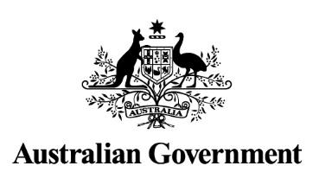

**This module was developed by the Australian and state and territory governments**

Contents

Introduction 3

Section 1: Climate change and Australia’s water resources 4

1.1 Northern Australia 5

1.2 Southern Australia 7

1.3 Eastern Australia 11

1.4 Communicating climate risk for water users 13

Section 2: Climate change and water planning and management over the near term (up to 20 years) 19

2.1 Managing water resources under uncertainty 20

2.2 Managing climate risk in water planning 24

2.2.1 Types of water planning and management approaches to respond to climate risk 24

2.2.2 Case studies: implementation of approaches currently used by water planners 26

2.3 Climate risk and local circumstances 29

2.3.1 Level of water resource development 29

2.3.2 Type of water supply system 30

2.3.3 Trade off considerations: environmental versus consumptive water 32

Section 3: Water management in extreme circumstances 33

3.1 Managing extreme events in water planning 33

3.1.2 Trigger responses and managing for extreme conditions 33

3.2 Implications of climate change on extreme dry events 35

Section 4: Climate change and long-term strategic water planning 36

Concluding Remarks 40

Useful links 41

References 42

## Introduction

The *Considering Climate Change and Extreme Events in Water Planning and Management Module* (the module) is a supporting document to the [National Water Initiative (NWI) Policy Guidelines for Water Planning and Management](https://www.coag.gov.au/node/461) (2010) (the NWI Policy Guidelines). Its purpose is to provide guidance to jurisdictions on how to consider and incorporate possible impacts from climate change and extreme events in water planning and management.

Climate change and extreme events are significant challenges for water planners and managers. Climate change causes changes in water availability and reliability in some regions, and in the frequency and severity of droughts. This will impact on the environment and industries such as agriculture, mining and electricity generation. In addition, water infrastructure may be damaged by more extreme weather events such as floods, cyclones, heatwaves and bushfires, and other climate changes such as sea level rise and increases in extreme sea level events.

The Millennium Drought that affected southeast Australia from 1997–2009, followed by widespread flooding in eastern Australia in 2010–2012, demonstrates the benefit of adopting a risk based approach to managing water resources that considers both climate change and extreme events.

Climate change may also affect the demand for water. For example, demand patterns for water may vary with changes in the seasonal distribution of rainfall. Further, in regions with reduced water availability, there will be increased demand and competition for water among urban, irrigated agricultural, mining, industrial and environmental users.

The [National Water Initiative](http://nwc.gov.au/__data/assets/pdf_file/0008/24749/Intergovernmental-Agreement-on-a-national-water-initiative.pdf) (NWI) identifies water access entitlement holders as responsible for bearing the risks of any reduction in water allocation, including the reliability of water allocation, resulting from:

* seasonal or long term changes in climate, and
* periodic natural events such as bushfires and drought *(NWI, 2004: clause 48)*.

This approach aligns with a key ‘driver for good adaptation’ where climate risks are well understood and clearly allocated to those best placed to manage them (DIICCSRTE, 2013).

The NWI also identifies that changes to water availability due to climate change is an area where there are significant knowledge and capacity building needs to ensure effective management of water resources *(NWI, 2004: clause 98)*.

The NWI Policy Guidelines provide guidance to assist in the development of NWI-consistent water planning and management arrangements, and includes some principles and approaches that consider climate change and extreme events. The [Risk Assessment Module](http://www.environment.gov.au/system/files/pages/0ce50acd-ce27-4950-b8f9-8b2303873704/files/risk-module.pdf) (2010) provides guidance on developing a risk-informed approach to water planning and management, and climate risks can be considered within this approach. This module aims to enhance this content.

The climate events of most concern to water planners and managers are those that reduce the availability and reliability of water supplies, including the occurrence of prolonged dry periods (droughts). The module therefore focuses on these types of dry events rather than extreme wet events such as floods.

## Section 1: Climate change and Australia’s water resources

Understanding the impacts of climate change on water supply is essential for water planners and managers to ensure resources are best able to meet future demand for water. This section provides an assessment of the observed changes to Australia’s water resources and likely projected impacts.

Water resource availability is highly dependent on the amount and distribution of rainfall. Australia’s rainfall is variable, with rainfall patterns strongly seasonal and influenced by large scale atmospheric circulation drivers such as the El Niño Southern Oscillation, the Indian Ocean Dipole and the Southern Annular Mode. Variability in Australia’s rainfall makes it difficult to determine significant trends over time and to predict how rainfall may change in the future. However, there are some discernible rainfall changes that have occurred over recent decades, and climate projections show some distinct regional changes for the future.

Sections 1.1 to 1.3 focus on climate change impacts on water resources for three regions: northern Australia, southern Australia and eastern Australia. These regions cover the key water resource management areas across Australia, and align with the ‘NRM super-clusters’ for the 2015 Climate Change in Australia projections (Figure 1). The projections come from the archive of global climate models (GCMs) developed by modelling groups from around the world through the Coupled Model Intercomparison Project phase 5 (CMIP5), and underpin the science of the Intergovernmental Panel on Climate Change (IPCC) Fifth Assessment Report. All products associated with the projections can be found at [www.climatechanginaustralia.gov.au](http://www.climatechanginaustralia.gov.au).

Figure 1: NRM super-clusters for the 2015 Climate Change in Australia projections. Note lighter shades denote coastal waters included in the clusters to encompass offshore islands.

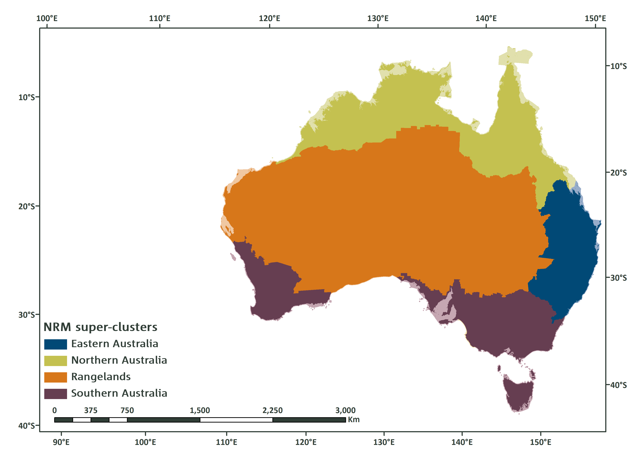

**Source:** [www.climatechangeinaustralia.gov.au](http://www.climatechangeinaustralia.gov.au)

### 1.1 Northern Australia

Northern Australia is strongly affected by the seasonal migration of the monsoon across the equator. This results in a distinct dry season (May to September) and wet season (October to April), with the latter part of the wet season characterised by monsoonal activity.

Rainfall in northern Australia has been above average since the mid-1990s, particularly for the northern wet season (Figure 2) (CSIRO and BoM, 2014). The largest increases in rainfall since the 1980s are found in the northwest in summer (increased monsoonal rainfall) and autumn (possible extension of wet season rainfall) (Figure 2) (CSIRO and BoM, 2015a).

Figure 2: Rainfall deciles from 1995 to 2015 for the northern wet season (October to April).

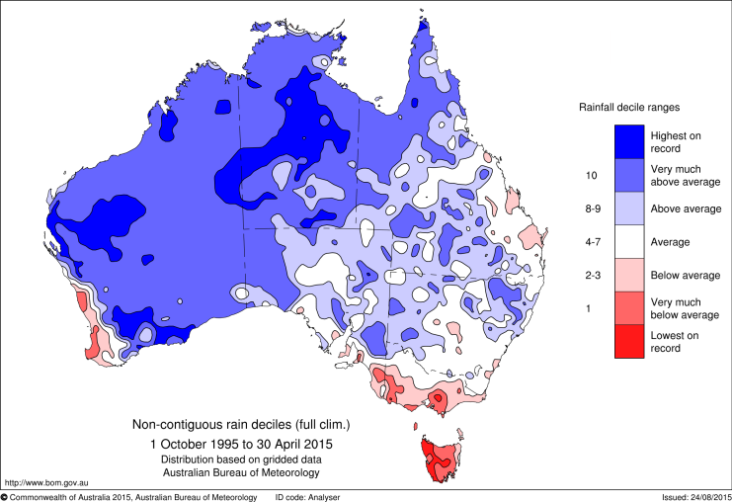

Climate projections for this region show that natural climate variability, including distinct dry and wet seasons, is expected to remain the major driver of rainfall changes over the near future (2030) (CSIRO and BoM, 2015b). Long term (2090) projected changes are small compared to natural variability under low and medium emissions scenarios (Figure 3b, c). Under a high emissions scenario both substantial increases and substantial decreases are possible with the projected change in summer rainfall ranging from -25 to +25 per cent by 2090 (Figure 3a). Further, it is expected that a larger proportion of rain will fall during extreme rainfall events, which are projected to become more intense. This has implications for aquifer recharge processes, particularly for aquifers that are recharged through seepage rather than filled through rivers and streams. Projections also show increases in evapotranspiration in all seasons.

Figure 3: Rainfall for 1900-2100 for northern Australia for (a) high, (b) medium and (c) low emissions scenarios. The central line is the median value, and the shading is the 10th and 90th percentile range of 20-year means (inner) and single year values (outer).

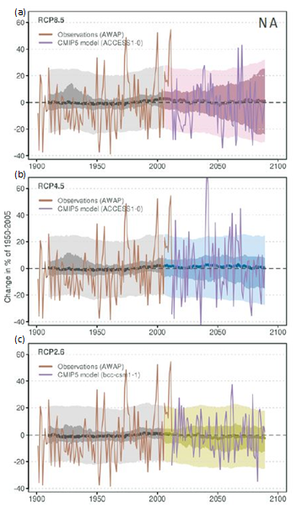

**Source:** CSIRO and BoM, 2015b.

Water planning and management frameworks in northern Australia already incorporate natural climate variability including distinct dry and wet seasons, the influence of seasonal rainfall events such as tropical cyclones, and the risk of drier than average wet-seasons. These conditions are expected to remain the major driver of rainfall over the next few decades, so current water planning approaches that manage variability will be more practical and realistic than anticipating a different future climate.

### 1.2 Southern Australia

Southern Australia is influenced by the seasonal north-south transition of the sub-tropical ridge which brings rain bearing cold fronts to the region during the cool season (late autumn, winter, early spring) and generally dry conditions in summer. There has been an observed reduction in both annual and cool season rainfall for southwest and southeast Australia (Figure 4). This is most significant in southwest Australia where there has been a decline in rainfall over the 20th century, while a decline in southeast Australia rainfall has been observed since 1960 (CSIRO and BoM, 2015b). Over recent decades southeast Australia has also experienced significant rainfall variability, including the record breaking Millennium Drought (1997–2009) and the two wettest years on record for Australia (2010–2011) (CSIRO, 2012).

Figure 4: Rainfall deciles from 1995 to 2014 for (a) annual rainfall (b) cool season rainfall (April to November).

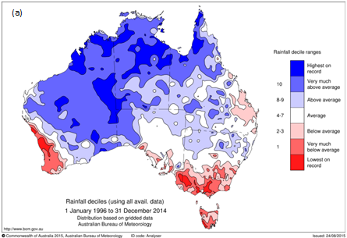

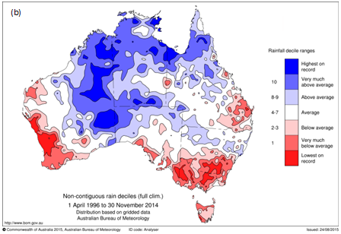

The decline in rainfall in southern Australia is resulting in larger decreases in runoff. Southwest Australia has experienced a 17 per cent decline in average winter rainfall since 1970, resulting in a reduction in runoff of more than 50 per cent over this period (CSIRO and BoM, 2014). Similarly, the southeast has experienced a 15 per cent decline in late autumn and early winter rainfall since the mid-1990s (CSIRO and BoM, 2014), coupled with larger decreases in runoff. For example, during the Millennium Drought a 13 per cent reduction in rainfall in the southern Murray-Darling Basin resulted in a 44 per cent decline in streamflow (CSIRO, 2012).

It is significant that the Millennium Drought was characterised by no ‘very wet months’ for 180 consecutive months (Figure 5). Even during the breaking of the Millennium Drought, only one wet month was recorded during the cool season, with most of the rainfall occurring during the warm season (CSIRO, 2012).

The decline in rainfall is linked to large scale atmospheric circulation changes, including an increase in the intensity and southward migration of the sub-tropical ridge and an expansion of the tropics. These changes are causing a southward shift of winter rain-bearing systems, resulting in more rain falling over the ocean rather than the southern part of Australia. This has implications for water supply in southern Australia, with the possibility that the traditional ‘filling season’ for water supply systems will become less reliable, and replenishment of water may be more dependent on spring and summer rainfall events.

Figure 5: Number of very wet months in each year from 1900 to 2012 for southeast Australia. ‘Very wet’ is defined as being above the 90th percentile of rainfall. Source: CSIRO, 2012.

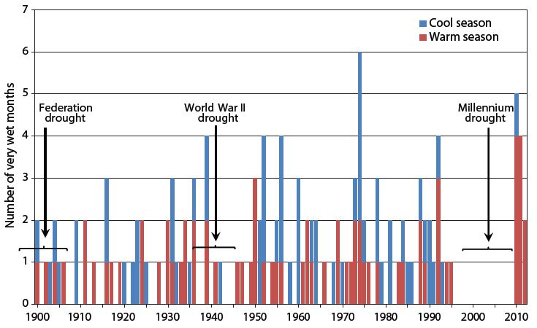

Projections show a drying trend in southern Australia under all emissions scenarios (Figure 6), with annual rainfall changes from -25 to +5 per cent in 2090 under a high emissions scenario (CSIRO and BoM, 2015b). Winter and spring rainfall is projected to decrease across southern Australia, with the exception of Tasmania where little change or an increase in winter rainfall is expected. The winter decline is particularly significant for southwest Australia, with projections showing a decline of up to 50 per cent by 2090 under the highest emissions scenario (Figure 7) (CSIRO and BoM, 2015c). Projections also show declines in runoff and soil moisture and increases in drought duration, strongly driven by the expected decline in annual rainfall along with increases in evapotranspiration. Further, it is expected that a larger proportion of rain will fall during extreme rainfall events, which are projected to become more intense.

Water planning and management in southwest Australia has been adapting to a drying climate over recent years. These conditions are expected to continue with further reductions in rainfall and runoff and increases in drought. With continuing drying expected, water planners and managers need to revise and reset water availability through new water allocation plans. Focus should be given to managing water allocations in the most practical way to reduce risks associated with expected declines in rainfall and runoff. Incorporating new information, for example as updated climate projections become available, will provide guidance on what reduction in rainfall and runoff should be used to determine water allocations, and will also assist in determining timeframes for revising water allocation plans.

Water planning and management in southeast Australia already incorporates significant climate variability including prolonged droughts and extreme flooding. Climate projections indicate that it will be important for water planning and management processes to be robust and adaptive across a wide range of possible climate futures, and that they are subject to regular review. Approaches that were adopted through the Millennium Drought will be important to manage the ongoing climate variability, the potential for future occurrences of extreme drought and the expected decline in cool season rainfall. These approaches include adaptive planning cycles that incorporate revision of water plans, flexible water allocations that are informed by seasonal and inter-annual water availability, and including options that trigger responses to manage the risks of extreme drought.

Figure 6: Rainfall for 1900-2100 for southern Australia for (a) high, (b) medium and (c) low emissions scenarios. The central line is the median value, and the shading is the 10th and 90th percentile range of 20-year means (inner) and single year values (outer).

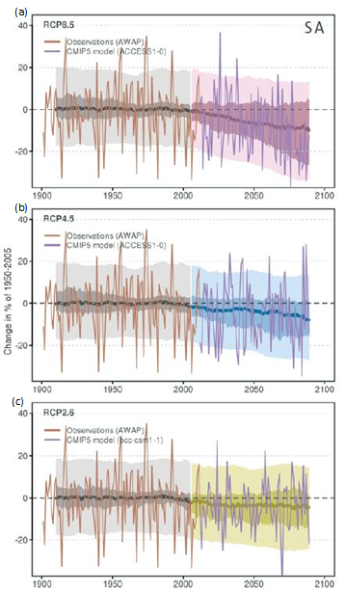

**Source:** CSIRO and BoM, 2015b.

Figure 7: Rainfall for 1900-2100 for southwest Western Australia for a high emissions scenario. The central line is the median value, and the shading is the 10th and 90th percentile range of 20-year means (inner) and single year values (outer). The projections are for the ‘southern Western Australia sub-cluster’ of the ‘Southern and South-Western Flatlands cluster’, part of the suite of products that make up the Climate Change in Australia projections.

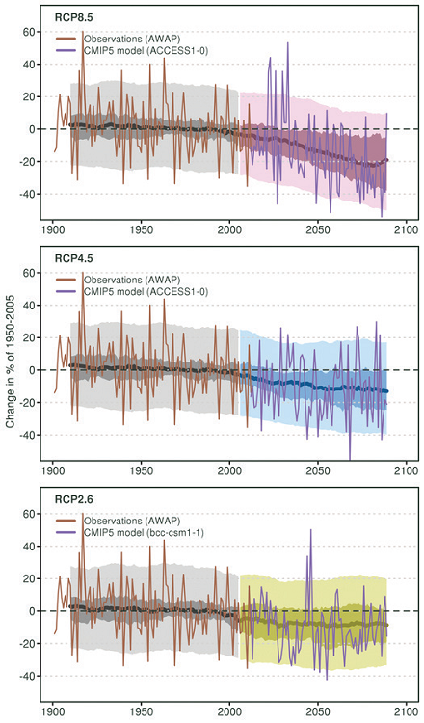

**Source:** CSIRO and BoM, 2015c.

### 1.3 Eastern Australia

Eastern Australia is characterised by a range of climates from sub-tropical in the north through to temperate in the south, with a typically drier winter and wetter summer. Eastern Australia is also influenced by large scale atmospheric circulation drivers, particularly the El Niño Southern Oscillation, leading to high variability and the occurrence of droughts and floods. On the eastern Australia coast the formation of East Coast Lows can also have a significant impact on water resources, resulting in episodic large inflows to water catchments. Eastern Australia has not experienced a distinct change in rainfall patterns over recent decades, and has been subject to considerable climate variability including the Millennium Drought and the two wettest years on record for Australia (2010–2011) as a result of two strong La Niña events (CSIRO, 2012).

Projections of rainfall change in eastern Australia are the most uncertain of any broad region of Australia (CSIRO and BoM, 2015b). Models show a range of projections for mean annual rainfall, from a substantial decrease to a substantial increase (Figure 8), and a similar level of uncertainty for seasonal rainfall projections. There is medium agreement from climate models for substantial annual rainfall reductions by 2090 under a high emissions scenario, driven largely by rainfall declines in winter and spring (CSIRO and BoM, 2015b). Changes in all seasons by 2030 are small relative to natural variability. Further, there is high confidence in projections of an increase in the intensity of extreme rainfall events, with a larger proportion of rainfall occurring during these extreme events.

Similar to southeast Australia, water planning and management in eastern Australia already incorporates significant climate variability including prolonged droughts and extreme flooding. The high level of uncertainty for climate projections in eastern Australia means that it will be important for water planning and management processes to be adaptive and able to respond to a wide range of possible climate futures.

Figure 8: Rainfall for 1900-2100 for eastern Australia for (a) high, (b) medium and (c) low emissions scenarios. The central line is the median value, and the shading is the 10th and 90th percentile range of 20-year means (inner) and single year values (outer).

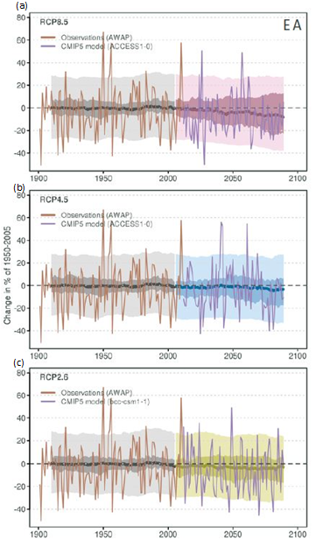

**Source:** CSIRO and BoM, 2015b.

### 1.4 Communicating climate risk for water users

The NWI highlights the need for water users to manage their own risk associated with changes in water availability resulting from climate change and natural events. However, there is a role for water planners to communicate to water users the risks of climate variability and change on water resources and to develop possible responses.

The use of historical rainfall and runoff records is used to help communicate the risks associated with climate variability. Climate risks within a water planning period are also informed by rainfall and runoff information services. For example, the Bureau of Meteorology provides information such as biennial Australian Water Resources Assessments, seasonal streamflow forecasts (Box 1) and updates to the state of the El Niño Southern Oscillation and Indian Ocean Dipole. These tools can be used to understand when dry sequences are likely to emerge, allowing water planners to respond.

**Box 1:** [**Seasonal Streamflow Forecasts**](http://www.bom.gov.au/water/ssf/index.shtml) **(Bureau of Meteorology)**

The Bureau of Meteorology issues regular streamflow forecasts for the next three months for parts of Australia, including Victoria, eastern New South Wales, southern and northern Queensland, and a small number of sites in the Northern Territory, Western Australia and South Australia.

Seasonal streamflow forecasts are used by water managers to make informed decisions on seasonal water allocation outlooks, reservoir operations, environmental flow management, water markets and drought response strategies.

Southern New South Wales and Victoria seasonal streamflow forecasts for August to October 2015.

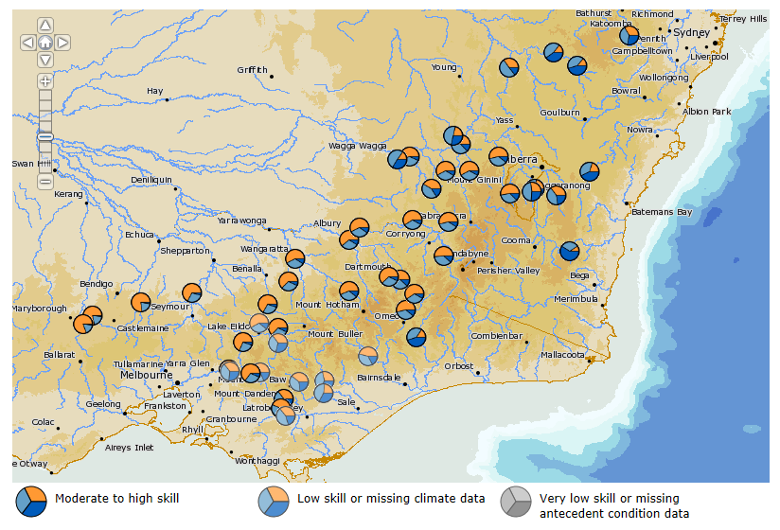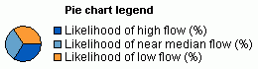

Communicating longer-term climate change risks aims to provide information so water users can understand the longer-term context. Regional climate and hydrological projections, along with research that improves understanding of the underlying atmospheric processes associated with the changing climate, will assist water users to understand their climate risks. Incorporating this information into decision making frameworks, and ensuring information is updated over time, will be important for water planners and managers to adequately understand and manage climate risk.

Over recent years state and territory governments, often in partnership with the Australian Government, have invested in regional initiatives that provide climate change information and guidance for decision makers. For example:

* [*South Eastern Australian Climate Initiative*](http://www.seaci.org/) *(SEACI)* (2005–2012):SEACI improved understanding of the nature and causes of the climate variability and change in south-eastern Australia in order to better manage climate impacts on the region’s water resources (Box 2). The research programme involved a partnership between CSIRO, the Australian Government, the Murray-Darling Basin Authority, the Victorian Government and the Bureau of Meteorology.
* [*Victorian Climate Initiative*](http://cawcr.gov.au/projects/vicci/) *(VicCI)* (2013–2016): VicCI builds on research undertaken under SEACI and aims to improve forecasts of water availability over seasonal and interannual timescales, and improve assessment of the risks to water supplies from changes in climate over the medium to longer term. The research is funded by the Victorian Government with in-kind contributions from CSIRO and the Bureau of Meteorology.

**Box 2:** [**South Eastern Australian Climate Initiative**](http://www.seaci.org/) **(SEACI)**

SEACI improved understanding of the causes of climate variability and change and associated impacts on water resources in south-eastern Australia. The initiative was established during the Millennium Drought when there was significant pressure on the region’s water resources. Research outcomes were tailored for a range of water policymakers and water managers. The research was delivered under three themes involving a multidisciplinary approach that incorporated both climate and hydrological research:

* understanding past hydroclimate variability and change in south-eastern Australia
* long-term hydroclimate projections in south-eastern Australia, and
* seasonal hydroclimate prediction in south eastern Australia.

This approach ensured a holistic understanding of how climate has already changed in south-eastern Australia, what drives the climate in the region and expected impacts on water resources over the long term. SEACI also played a key role in the development of a seasonal (3–12 months) climate and streamflow forecasting capability.

From a water planning and management perspective, a key implication of the SEACI research is that the traditional ‘filling season’ for water supply systems across most of south-eastern Australia, historically the cool season, may not be as reliable in the future. The cool season drying for south-eastern Australia is evidenced by both observed changes in rainfall (Figure a), along with projected changes in rainfall and runoff (Figure b). A significant component of the SEACI research included understanding the processes driving the observed drying trend, including whether the changes could be attributed to climate change.

Figure a: Rainfall distribution map for the Millennium drought (1997-2009).

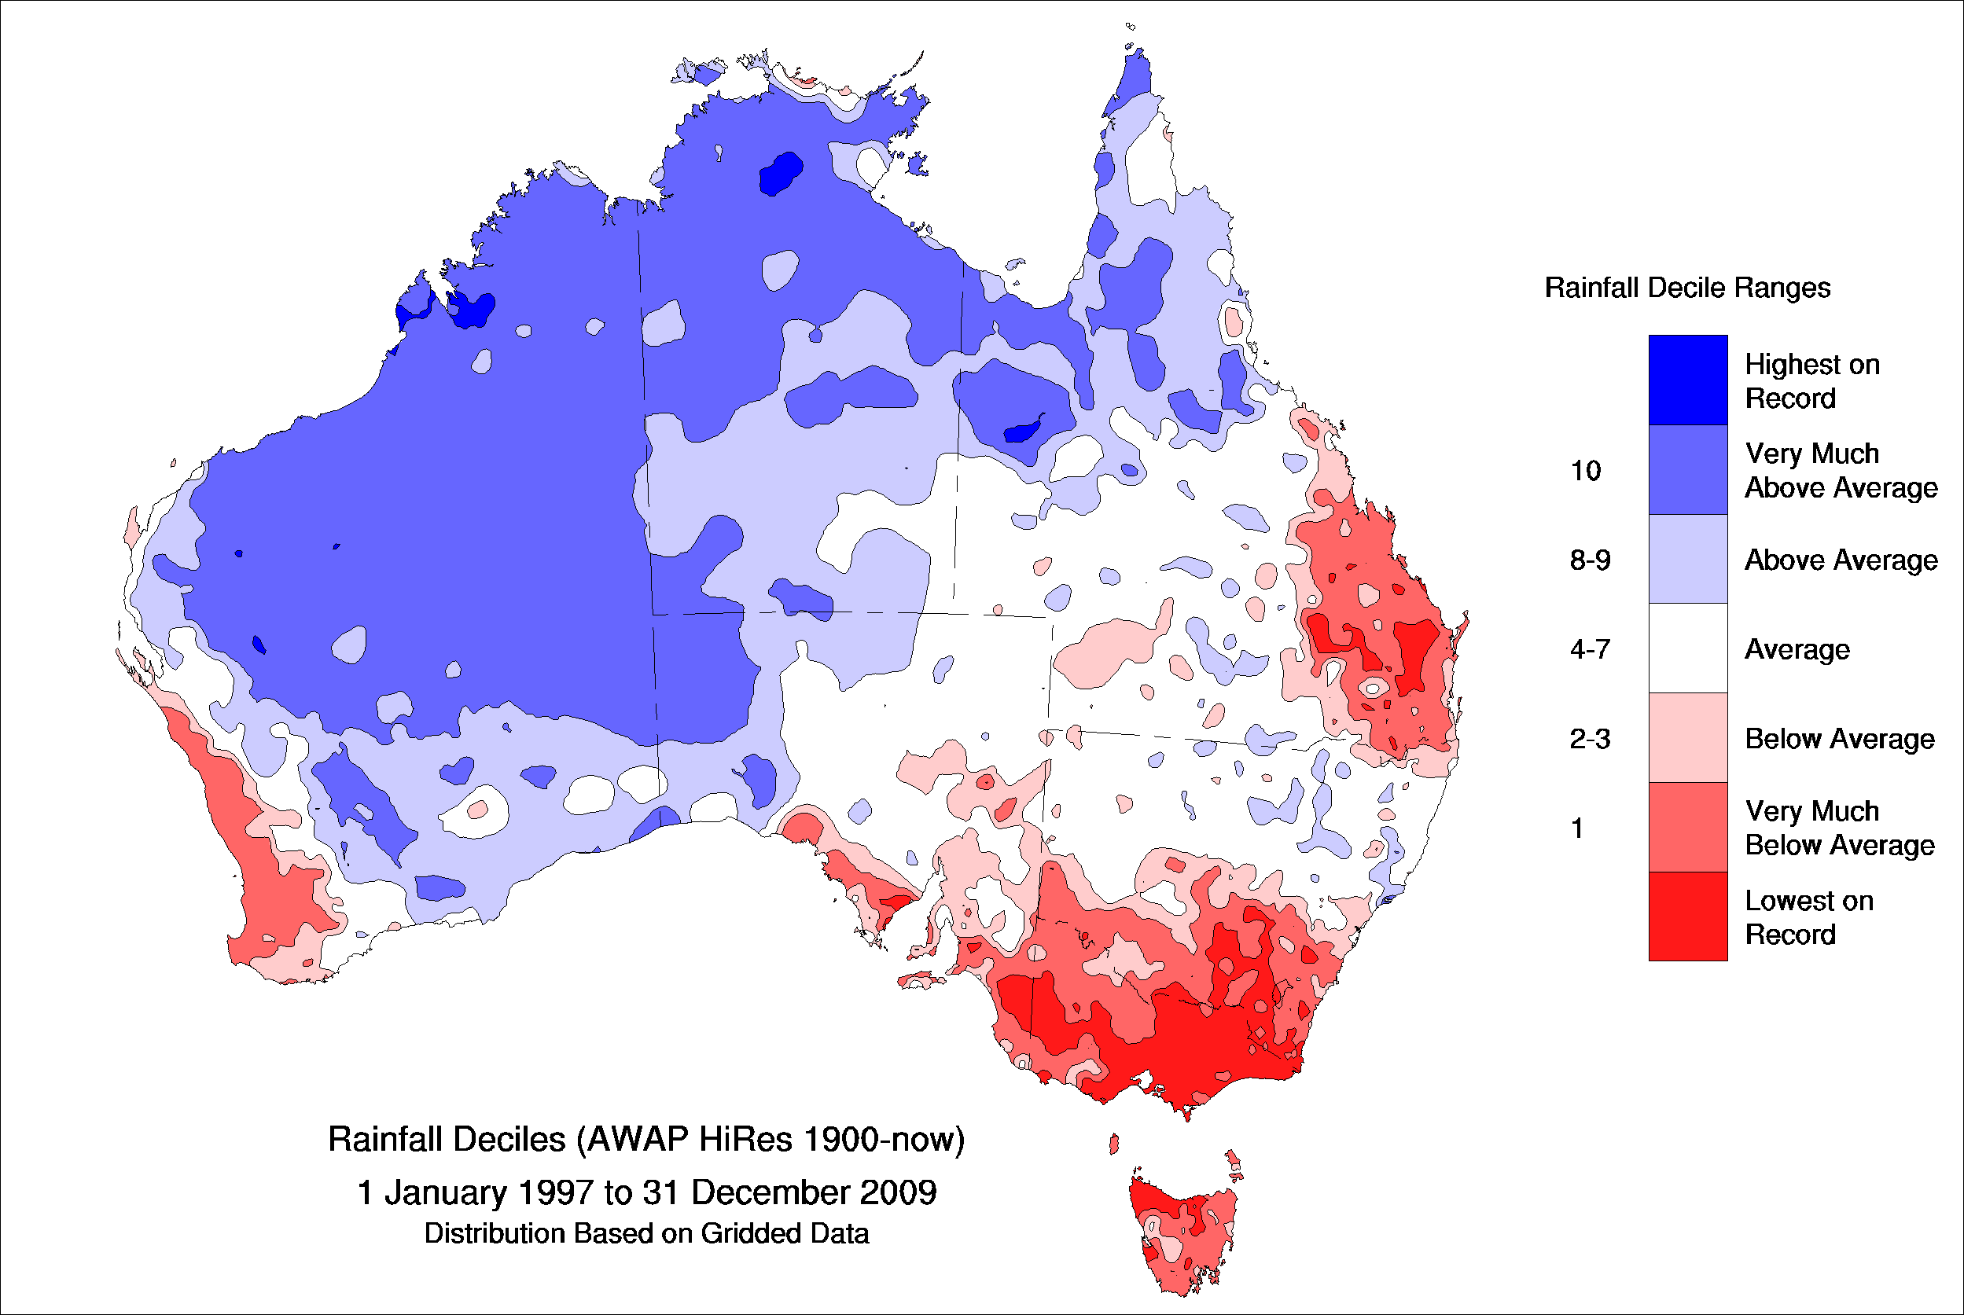

Figure b: Projected change in rainfall and runoff for south-eastern Australia for a 1°C global warming, which is the best estimate of annual average warming for Australia by 2030.

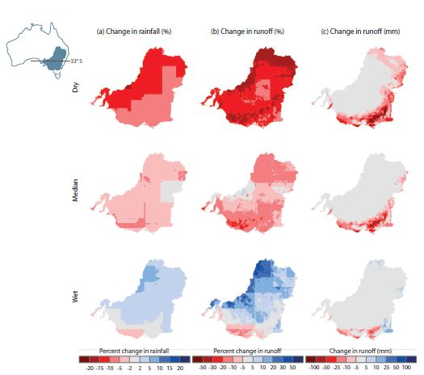

* [*NSW/ACT Regional Climate Modelling Project*](http://www.ccrc.unsw.edu.au/NARCliM/) *(NARCliM)* (2011, ongoing): NARCliM is developing new, high resolution climate projections for southeast Australia to assist in managing the impacts of climate change on health, settlements, agriculture, weather extremes and services such as water and energy supplies. The project is being supported by the NSW and ACT governments and delivered by the University of NSW.
* [*Indian Ocean Climate Initiative*](http://www.ioci.org.au/) *(IOCI)* (1997–2012):IOCI investigated the causes of the changing climate and developed projections of future climate for Western Australia. The research programme involved a partnership between CSIRO, the Bureau of Meteorology and the Western Australia Government.
* *Selection of future climate projections for Western Australia* (in preparation): The Western Australia Department of Water is developing a climate projections tool which allows the identification of future wet, medium and dry downscaled projections. The tool was developed using those global climate models that demonstrate higher skill in modelling Western Australia’s climate. The Department of Water is now using the tool for all future water planning in the south-western regions of Western Australia. The tool will ensure that water resource management decisions incorporate climate projections in a consistent and transparent way. It will also support better communication and engagement with stakeholders about the range of possible water futures that may result from climate change and how we can adapt to them.
* [*Climate Futures for Tasmania*](http://www.dpac.tas.gov.au/divisions/climatechange/adapting/climate_futures)(2010–2012): Climate Futures for Tasmania produced high resolution regional climate projections across Tasmania to support decision making across multiple sectors (Box 3). The project was funded by the Tasmanian Government and delivered in partnership with research, government and industry organisations.

**Box 3:** [**Climate Futures for Tasmania: Water and Catchments**](http://www.dpac.tas.gov.au/__data/assets/pdf_file/0015/151125/CFT_-_Climate_Modelling_Technical_Report.pdf)

The water and catchments component of Climate Futures for Tasmania produced projections and analysis of changes to runoff and river flows as a result of climate change. Regional climate modelling was combined with hydrological models to project future catchment yields, with river flows modelled for 78 river catchments and covering more than 70 per cent of Tasmania.

Projections show that:

* annual rainfall in the central highlands is expected to decline by 2100 in all seasons
* summer and autumn rainfall in eastern Tasmania is expected to increase
* rainfall in western Tasmania is expected to decline in summer but increase in winter
* runoff is expected to decline significantly in the central highlands by 2100, but is likely to increase in the agricultural regions of the Derwent Valley and the midlands.

The water and catchments component was driven by information requirements of water planners and managers. For example, the project identified 32 river systems that showed projected changes in annual flows of more than ±10 per cent. Changes on this scale can have major implications for water management and infrastructure development. In particular, there are significant implications for managers of the large irrigation storages fed by runoff from the central highlands due to the expected declines in rainfall and runoff in this region for all seasons.

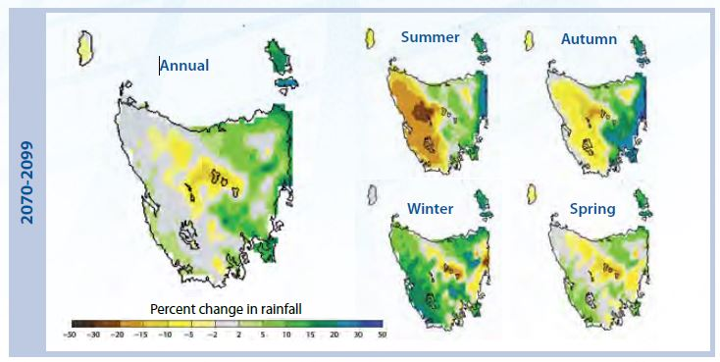

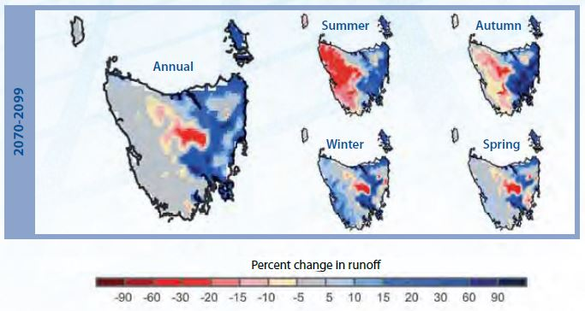

* [*Consistent Climate Scenarios Project*](https://dsewpac.pws.gov.au/workspaces/02/Documentation/MC/2014/348/MC14-012348/The%20water%20project.pdf) *(CCS)* (2009–2012): The CCS project developed climate projections across Australia at around 5 km resolution in a format suitable for biophysical modelling. The project was undertaken by the Queensland Government with funding from the Australian Government.
* *Agreed Climate Change Projections for South Australia* (2010–2015): The [Goyder Institute for Water Research](http://goyderinstitute.org/) provides targeted research related to water management issues for South Australia. The Institute is funded by the South Australia Government and delivered in partnership with CSIRO and universities. The Goyder Institute’s agreed climate change projections project has undertaken research to identify the primary drivers of climate for South Australia, particularly for rainfall variability (Box 4).

**Box 4:** [**Goyder Institute for Water Research**](http://goyderinstitute.org/)**: Agreed Climate Change Projections for South Australia**

The Goyder Institute’s climate change projections project developed downscaled climate projections for South Australia to support adaptation in water resource planning and management. The projections were developed in close consultation with end users from a suite of agreed global climate model projections.

The task of selecting projected data sets focused research on understanding which climate models account for the climate drivers with the most influence on South Australian climate, including:

* the impacts of the El Niño-Southern Oscillation cycle, the Pacific Decadal Oscillation, the Indian Ocean Dipole, the Southern Annular Mode and their interactions
* the influence of local synoptic systems (such as cut-off lows, atmospheric blocking, and density, intensity, and tracks of low and high pressure systems)
* identification of which CMIP5 climate models simulate the observed processes, and
* criteria for selecting models for the projection of future climate in South Australia.

Figure: Eight South Australian natural resource management regions and correlations between rainfall and climate drivers: (a) Southern Oscillation Index (SOI) (b) Dipole Mode Index (DMI) and (c) Niño3.4. Red solid circles indicate rainfall stations where significant correlations exist, with the size of the circle indicating significance level – large size 1% and small size 5% significance levels respectively. Monthly average rainfall is indicated by the figure shading.

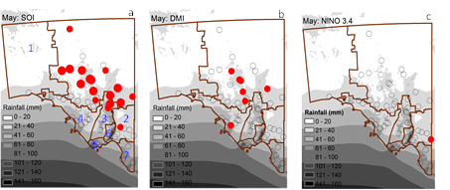

The outcomes of the research enabled the selection of a subset of fifteen of the CMIP5 suite of climate models that most represent the identified drivers of climate in South Australia. Projections from these models for South Australian climate through the 21st century were then downscaled using a statistical downscaling approach to generate projected climate datasets for individual sites across the state. The climate variables available include temperature, rainfall and potential evapotranspiration in daily time steps. These datasets will provide a consistent approach to develop climate change adaptation strategies within South Australia, and are expected to be applied to a range of sectors such as health and agriculture.

## Section 2: Climate change and water planning and management over the near term (up to 20 years)

This section builds on the assessment of the likely impacts of climate change on Australia’s water resources provided in Section 1 and provides guidance on the types of tools and approaches that may be used by water planners to respond over the near term (up to 20 years).

In terms of the regional impacts presented in Section 1 there is a logical water management approach for particular regions (Table 1). Section 2 aims to provide guidance for water planners so that approaches can be refined for particular regions and circumstances, and will include:

* managing water resources under uncertainty and the role of risk management
* the types of approaches currently used to incorporate climate risk into water planning and management, and
* how the choice of approaches adopted may vary depending on local circumstances.

Table 1: Summary of likely impacts of climate change for water resources and possible water management response.

| **Region** | **Climate Change Projections** | **Water Management Response** |
| --- | --- | --- |
| Northern Australia | Natural climate variability, including distinct wet and dry seasons, likely to remain the major driver of rainfall over the next few decades. | **Water planning and management that responds to climate variability.** Examples include mid-term reviews of water plans, water allocations evaluated annually and adjusted depending on the seasonal and annual outlooks, and carryover or reserve policies. |
| Southwest Australia | The observed drying trend, particularly during the cool season, is expected to continue. | **Water planning decisions that are based on climate change projections.** Future water availability revised downward to drive water efficiency measures and explore possible new water sources. |
| Southeast Australia and Eastern Australia | Natural climate variability, including the occurrence of extreme droughts, likely to remain the major driver of rainfall changes for the next few decades. Late in the century cool season rainfall is expected to decline (southeast Australia). | **Water planning and management that is adaptive across a wide range of possible climate futures.** Examples include adaptive planning cycles with review provisions, flexible water allocations informed by seasonal and annual outlooks, supporting an active water market and triggers for managing extreme drought. Future water availability may need to be revised downward (southeast Australia). |

### 2.1 Managing water resources under uncertainty

Australian water managers are accustomed to working with high levels of uncertainty about future water availability and the need to consider the potential for serious adverse outcomes. It is not possible to eliminate uncertainties with the future climate, so water planners and managers need to adopt strategies to assist in decision making. Developing a flexible approach to water allocation planning is one way to manage climate uncertainties.

A risk management approach provides a useful framework for climate change decision making, particularly iterative risk management which involves an ongoing process of assessment, action, reassessment and response that continues over time (refer [NWI Risk Assessment Module](http://www.environment.gov.au/system/files/pages/0ce50acd-ce27-4950-b8f9-8b2303873704/files/risk-module.pdf)).

Many water planners and managers already use iterative risk management where water plans are monitored and updated over time. For example, the NSW water planning framework involves a cyclic pattern of planning, implementation, monitoring and evaluation, returning to further planning and repeat of the cycle. This allows for incorporation of new information, along with improved mechanisms and measures for managing water resources. In circumstances where there is significant uncertainty, such as rainfall projections for eastern Australia, it may be prudent to develop water plans of short duration with planning cycles that include more regular review. In Western Australia, where the *direction* of rainfall change for southwest Australia is clear but the *magnitude* is not, water planners apply an annual evaluation to check how water resources and water use are tracking, and adjust management actions in response.

Other possible approaches for decision making under uncertainty include:

* considering a range of plausible futures and scenarios (Box 5)
* considering a range of possible responses, based on an understanding of the potential likelihood and consequences of climate variability and change, and favouring actions that are affordable, robust to uncertainties, reversible and/or are no-regrets
* use of adaptation planning tools such as AdaptWater (Box 6) to assist in understanding risks from climate change and identifying possible adaptation actions
* monitoring results and updating climate change information (e.g. after the release of IPCC Assessment Reports and when new climate projections become available), and
* updating planning and management frameworks for the allocation and use of available water in light of new information (NWC, 2010).

The incorporation of climate information into water plans improves the transparency of water planning decisions, and allows water users to identify and manage climate risks. It is important that water planners clearly identify and demonstrate how climate trends and projections have been considered in developing water plans, planning frameworks and supporting documentation. This includes the need to describe objectives, how water will be managed to take account of climate variability within a planning period, and how water planning approaches may need to transition over time to respond to potential longer-term climate impacts.

**Box 5: Australian Climate Futures**

The Australian Climate Futures tool, a free web-based tool, enables users to consider a range of scenarios by assisting users to select regional climate projection datasets that are representative of futures of particular interest. Projections are provided for eight regional ‘clusters’ that are based on Australia’s natural resource management regions.

The tool includes projections data from the global climate models that informed the IPCC’s 2007 Fourth Assessment Report and 2013 Fifth Assessment Report, the 2015 national downscaled projections, as well as a range of dynamically and statistically downscaled projections. Projections can be explored for up to 13 time steps from 2030 to 2090 and for seven emissions scenarios. Users can tailor the information for their interests, and can identify ‘best’, ‘worst’ and ‘maximum consensus’ climate futures to inform decision making.

A range of climate variables are represented including:

* mean temperature
* maximum temperature
* minimum temperature
* rainfall
* downward solar radiation
* wind speed
* relative humidity
* areal potential evapotranspiration
* drought
* extreme daily rainfall (1 in 20 year event)
* extreme daily wind (1 in 20 year event)

Projected changes from all available climate models are classified into broad categories defined by two climate variables, for example, the change in annual mean temperature and rainfall. Model results can then be sorted into different climate futures such as ‘Warmer and Wetter’ or ‘Hotter and Much Drier’ and represented in a matrix that shows the likelihood of each climate future based on the spread of the model results (see Figure).

Figure: Example display of projections in the Australian Climate Futures Matrix showing annual average changes in surface temperature and rainfall. The matrix includes results from global climate models (GCM) and downscaled models (DS). Colour shadings indicate the degree of model consensus: pale yellow = very low likelihood; yellow = low likelihood; dark yellow = likely.

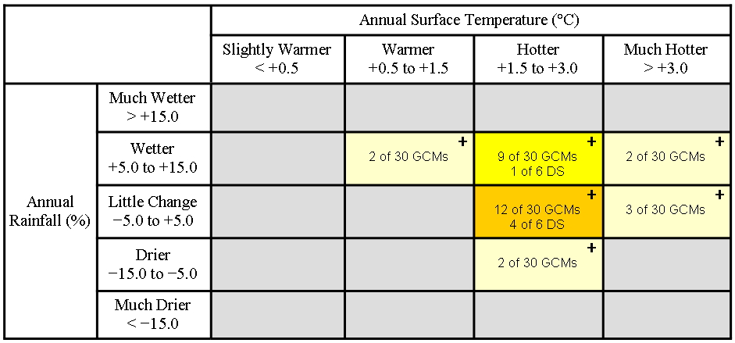

The Australian Climate Futures tool is fully integrated with the Climate Change in Australia website ([www.climatechangeinaustralia.gov.au](http://www.climatechangeinaustralia.gov.au)), which also allows users to access projections information in a range of formats and to display and download datasets, GIS layers, maps and figures from the climate models.

**Box 6:** [**AdaptWaterTM**](https://www.wsaa.asn.au/WSAAPublications/Documents/AdaptWater%20Final%20Report.pdf)

AdaptWater is an online risk and cost-benefit analysis tool for urban water utilities which allows users to:

* quantify climate change risks to multiple water and sewerage infrastructure assets
* identify and compare adaptation options, and
* undertake economic modelling for investment decisions.

The AdaptWater tool enables users to run scenarios and determine the impact on multiple water and sewerage assets. Users can then identify and compare adaptation options to find the most cost effective solution to ensure assets perform reliably under a range of climate change scenarios.

The tool allows users to assess the following climate change hazards, depending on interest:

* coastal inundation
* salt water ingress
* riverine flooding
* extreme wind
* bushfires, and
* heatwaves.

The likelihood of a hazard event occurring in a particular location is then determined using spatial data for current hazards, and is projected for any year into the future. To quantify the impact, the tool determines the extent to which each individual asset is vulnerable to the selected hazard.

AdaptWater was developed in partnership with the Water Services Association of Australia (WSAA), Sydney Water and Climate Risk Pty Ltd, with support from water utilities including Melbourne Water, SA Water, Queensland Urban Utilities, City West Water and Water Corporation (Western Australia) and co-funding from the Australian Government.

### 2.2 Managing climate risk in water planning

Australia’s high temporal and spatial climate variability means that it is difficult to identify how water resources may be affected over the timeframe and scale of a water plan. Water plans must be resilient, robust and able to respond to a range of intra-annual and inter-annual variations.

The nature of climate variability across Australia means that jurisdictions are already incorporating adaptive approaches to manage water resources. Past and ongoing water reforms that have secured water rights, facilitated trade, and allowed carry over storage assist water entitlement holders to manage the risks of natural climate variability along with long-term climate change (NWC, 2010). These approaches allow water planners and managers to respond to climate risks that arise during a planning period, and help position water planners to manage longer-term climate impacts. Adoption of particular approaches in water planning and management will depend on the type of water resource, the level of demand for water and expected climate risks.

Approaches currently used to incorporate climate risk into water planning and management are listed below, with case studies highlighted to provide further guidance.

#### 2.2.1 Types of water planning and management approaches to respond to climate risk

##### *Water planning cycles and review provisions*

* Adopting planning cycles of 10 – 20 years. The optimal timeframe may vary depending on circumstances and needs to be long enough to provide certainty for water users and short enough to enable new knowledge to be incorporated effectively.
* Including mid-term provisions in water plans to review whether plans are meeting stated objectives, and evaluating water plans at the end of the term to assess whether plan outcomes were met.
* Evaluating plan implementation annually to review whether water allocations are appropriate for the seasonal and annual outlooks.

##### *Climate information*

* Identifying what climate information is needed for water planning such as historical records, future projections, driest years and length of dry sequences.
* Use of hydrological and climate modelling that incorporates historical climate variability and future projections (where relevant) to determine sustainable water use.
* Considering the suitability and flexibility of management frameworks to respond to climate before setting an allocation or a consumptive pool.
* Use of robust scientific assessments of possible and likely climate change impacts to develop specific actions or strategies.
* Ensuring water plans can be reviewed in light of new scientific information.

##### *Water allocation*

* Reserving water from allocation to accommodate uncertainties in current knowledge.
* Allocating water on an annual basis to provide flexibility to accommodate inter-seasonal variability in water availability (Box 7).
* Providing for carryover or reserve policies (where possible) to allow entitlement holders to manage the risk of climate uncertainties by drawing on any remaining allocations that have been carried over from the previous year in future years (Box 8, Box 9).
* Note this approach will only be practical where water is expected to be available in future years.
* Reducing allocations when triggered by annual, mid-term or full term evaluation of plan.

##### *Water markets*

* Supporting an active water market (where suitable) to enable water users to manage their own risk through the trading of water (Box 10).
* Water markets are likely to have the greatest benefit in large, interconnected surface water systems where water users have varying water use demands and flexibility in managing water allocations.
* This allows water dependent industries to self-adjust at least economic cost, to changes in the climate, without requiring government intervention.

##### *Transitioning water plans to respond to long-term impacts*

* Implementing water reduction pathways in order to increase the resilience of water systems, where there is clear evidence for the need to reduce water use.
* Considering how changes in water demand from climate change and other pressures such as population increases may affect water planning strategies for the future.

Note: Section 4 provides further discussion on long-term strategic water planning.

#### 2.2.2 Case studies: implementation of approaches currently used by water planners

**Box 7:** [**Southern Basins and Musgrave Water Allocation Plans (Eyre Peninsula)**](http://www.naturalresources.sa.gov.au/eyrepeninsula/land-and-water/water-allocation-plans/Have-your-say-version-southern-basin-musgrave)

Allocation of water on an annual basis is a common approach in water resource management that helps ensure water allocation does not exceed sustainable levels. The new [Draft Water Allocation Plan for the Southern Basins and Musgrave Prescribed Wells Areas](http://www.naturalresources.sa.gov.au/eyrepeninsula/land-and-water/water-allocation-plans/Have-your-say-version-southern-basin-musgrave) strengthens the annual allocation model and proposes that annual allocations will be based on the percentage changes in aquifer storage from the 1993 baseline figures. This is considered to be an improved method of measuring the condition of the resource compared to the method currently used, which is based on annual rainfall and recharge. It will be coupled with the use of triggers that will change the rate at which allocations are varied in recognition of the relative ‘stress’ the resource is deemed to be under.

A high level of storage indicates the aquifer condition is good and the maximum volume of water available for licensed purposes would be higher than in years when the level of storage is low. The level of storage will be determined annually.

The annual allocation mechanism allows water planners to manage the volumes of water extracted in a way that deals with the uncertainties in how and when climate is predicted to change in the future.

**Box 8: South Australia Policy for the Release of Unallocated Water**

The South Australian Government has published a [*Release of Unallocated Water Policy*](https://www.waterconnect.sa.gov.au/Content/Publications/DEWNR/Release%20of%20Unallocated%20Water%20Policy.pdf) which provides a process for identifying unallocated water and granting licences to access this water. This policy also describes when the Minister may decide to reserve all or a portion of excess water at any time, in accordance with the *Natural Resources Management Act 2004* (the Act).

Excess water can be reserved if the Minister is satisfied that it is necessary or desirable for the management of the water resource to reserve all or part of the pool of excess water, either from allocation under any circumstances or for allocation subject to restrictions.

The Department of Environment, Water and Natural Resources and the relevant Natural Resource Management Board can advise the Minister on whether to reserve water on the basis of uncertainties or risks that have been identified because of:

* knowledge gaps relating to ecosystems and ecosystem functions
* environmental water requirements
* the capacity of the resource
* impacts of climate change on the water resource
* unknown levels of use (for example stock and domestic dams or forestry interception)
* unresolved Native Title claims
* any appeals against the issue of water access entitlements to existing users upon prescription of a water resource in accordance with section 164N of the Act, and
* the variation of licences to be consistent with a changed Water Allocation Plan in accordance with section 149 of the Act.

**Box 9:** [**Carryover in regulated water supply systems in Victoria**](http://waterregister.vic.gov.au/water-entitlements/carryoverhttp:/waterregister.vic.gov.au/water-entitlements/carryover)

Carryover was introduced in northern Victoria in 2007. It allows holders of water shares to keep their unused water allocation in the storages for use in the following season. Carryover is a tool to redistribute water between years that enables all water users – irrigators, urban water corporations and environmental managers – to manage their own reserves and their own risk. It encourages the efficient use of water by giving water shareholders more flexibility to use their water when it is of greatest value to them.

Carryover is a particularly important tool in low allocation years because, provided the distribution system is operational, it provides water at the beginning of the season when seasonal allocations may be low. It can also offer more certainty about the minimum volume of water available in any season. Together with trade, which allows water to be redistributed between users, carryover gives individuals greater control over their own water supplies.

Further information can be found at: <http://waterregister.vic.gov.au/water-entitlements/carryover>

**Box 10: Water markets in the Murray-Darling Basin**

Water trading has been progressively introduced in the Murray-Darling Basin since the late 1980s, with trading in both water entitlements and allocations now possible within and between states (NWC, 2012b).

In areas where new water entitlements are not available, water trading is the main way for individuals to access additional supplies. It enables rural water users, industries, urban water corporations and environmental managers to buy and sell water entitlements, which provides a means for water users to manage the impact of climate variability on their business. Trading can encourage more efficient use of water resources, without increasing water entitlements in an area.

Water markets are a fair and effective way to reallocate water to meet changing needs of individuals and the community in the short and long term. In times of water scarcity, it is a voluntary way to move water between uses. Without trade, irrigators could not buy additional water when allocations are too low to support their crops. Likewise, other irrigators could not sell their allocations to generate revenue.

The principles embedded in the National Water Initiative provide essential prerequisites for water market development, including:

* setting an effective cap on total sustainable water extractions
* water resource plans and water access entitlements that provide long term security of access by water users to their share of the water resource
* sound regulatory and governance frameworks within which water trading can take place, and
* good water management such as metering and water accounting.

These actions underpin confidence to invest in water infrastructure and water management approaches, including investments that can help adapt to climate change (NWC, 2012a).

There is evidence that the water market mitigated economic losses to the irrigated agricultural sector in the Murray-Darling Basin during the Millennium Drought by facilitating the transfer of water towards higher value uses. At the peak of the Millennium Drought, the proportion of water allocations traded in the southern Murray-Darling Basin increased from around 5 per cent in 2001 to over 30 per cent in 2007 (NWC, 2012b). A decline of 67 per cent in irrigation water use over the Millennium Drought resulted in a decline of only 20 per cent in gross irrigated agricultural production (Kirby et. al., 2012). The volumes of water traded provide evidence that irrigators use the market to adapt to changing conditions.

### 2.3 Climate risk and local circumstances

The previous section (Section 2.2) provides a suite of approaches to managing climate risk in water planning, yet the adoption of particular approaches will vary depending on local circumstances. These include expected climate change impacts, the level of development of the water resource and the type of water supply system (for example, groundwater or surface water, connected or non-connected system).

#### 2.3.1 Level of water resource development

Climate risk may be determined by the level of vulnerability of the water system to changes in climate (water availability), along with the level of development of the water system (Figure 9).

Figure 9: Risk profile for water resource development and climate change (adapted from NWC, 2010).

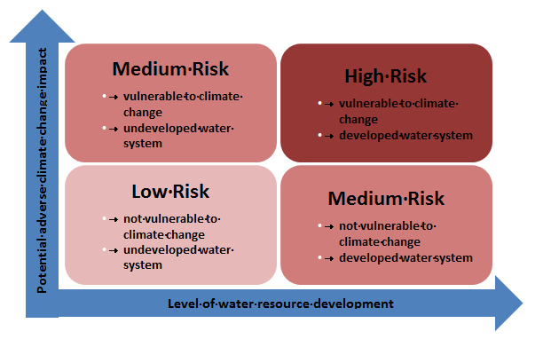

Water systems that are undeveloped, and where climate change is not expected to impact adversely, may be described as low risk. Many catchments in northern Australia (particularly the monsoonal north region) would fit this description due to climate projections indicating natural climate variability is expected to remain the major driver of rainfall changes over the next few decades, coupled with low current demand for water. In these systems adopting a few simple approaches such as a 10–20 year planning cycle and mid-term reviews of plans may be adequate.

Medium risk regions could include water systems that are either characterised by a low level of development but high potential for adverse climate change (such as eastern South Australia and western Tasmania), or water systems with high levels of development and low potential for adverse climate change (such as eastern Tasmania). Medium risk regions may benefit from a range of planning approaches such as mid-term reviews of water plans, providing for carryover or reserve policies and allocating water on an annual basis. In regions where climate change is expected to significantly impact water resources, even if the water resources are not currently developed, it would be prudent to transition planning and management frameworks to respond to these long-term impacts.

High risk regions include water systems that are characterised by a high level of development and where significant adverse climate change impacts are expected. Areas of the southern Murray-Darling Basin and southwest Western Australia may be described as high risk, where it is prudent to adopt a broader range of approaches to manage these risks. Southeast Australia, where climate projections indicate ongoing climate variability, potential declines in cool season rainfall and the sporadic occurrence of wet years, poses additional challenges for planning and managing water resources. In general, developed water systems which are characterised by high levels of demand for water, and where adverse climate change impacts are expected, will require a more comprehensive approach to water planning and management.

#### 2.3.2 Type of water supply system

The type of water supply system, such as whether the system involves surface water or groundwater (or both), and whether the system is large and connected or small and non-connected, may also influence the choice of approaches used to respond to climate risk.

Large surface water systems with a connected distribution system are generally well suited to water trading, which can be an effective approach for managing climate risk. In contrast, small self-supply, non-connected surface water systems may be best managed by ensuring high reliability allocation limits are set for each catchment within the system, and benchmarked for the driest expected year. In this situation environmental needs could be allowed for before the allocation limit, and variable needs met through catchment inflows and bypass flows.

Groundwater systems, whether large or small, require additional considerations for groundwater dependent ecosystems and to ensure the groundwater resources receive adequate recharge. In regions where a drying climate is expected, such as southwest Western Australia, planning for a reduction in water extraction may be required (Box 11).

##### Box 11: Gnangara groundwater system

The [Gnangara groundwater system](http://www.water.wa.gov.au/Understanding+water/Groundwater/Gnangara+Mound/default.aspx) is the largest single quality fresh water resource in the Perth region, and is a significant source of supply for Western Australia’s Integrated Water Supply Scheme, as well as for parks, gardens, public open space and horticulture. Groundwater levels have declined significantly over the last 30 years due to a combination of increased water extraction for irrigation and public water supply, declining rainfall and those changes in land use which limit recharge.

The Western Australia Department of Water is undertaking a range of measures to adapt to the declining water levels including:

* staged reduction of water extraction towards a new water balance that better reflects the current recharge from rainfall
* optimise the use of water through water use efficiency and demand management measures
* protect groundwater dependent ecosystems from direct impacts associated with extraction
* adapt management of the water resource based on annual evaluation of water use, monitoring data and the condition of the resource, and
* move to alternative water sources.

These changes, combined with some land use changes, have reduced the rate of groundwater level decline in some locations.

#### 2.3.3 Trade off considerations: environmental versus consumptive water

Changes in water resource availability may require reconsideration of water made available for human uses and that set aside for the environment. If water availability declines due to climate change, the relative allocation of water for consumptive versus environmental use will reflect a complex mix of allocation rules (Box 12). These rules will affect the priority of access to the available pool for specific uses versus general water entitlements for non-prescribed use. For example, water sharing plans may require that water for human needs and minimum environmental flow conditions be met before allocation of water for general use. If water planning rules prioritise critical needs, a greater proportion of overall water resources will be shifted to meet these critical needs. The share of water available for entitlement holders, including governments holding water entitlements on behalf of the environment, will decline (NWC, 2010).

##### Box 12: Releasing water for the environment in southwest Western Australia

In southwest Western Australia there are relatively few large water supply reservoirs. Much of the water supply is accessed from groundwater, small self supply surface water dams and desalination.

The Integrated Water Supply Scheme and irrigation cooperative reservoirs are mostly single storages on short winter-flowing streams. Despite the much reduced inflows, in the wetter dry years, they still provide an essential part of the water supply mix and reduce pressure on groundwater in those years.

The Department of Water is adjusting water releases to optimise the water captured by scheme dams so that downstream environmental and diversion benefits are achieved, while also ensuring there is as much surface water input to the public water supply and irrigation schemes as possible.

The current releases already reflect drying climate – with less released in dry years and higher and more variable flows only in wetter years. To respond to another step down in rainfall, releases need to be further refined to optimise water for competing purposes and allow for more dry years and an overall drying trend.

Instead of just reflecting annual variation, releases will be targeted to climate-adjusted ecological objectives, and downstream diverters encouraged towards alternative water use arrangements. The challenge is to make the best use of the limited volume of water available for releases in low-rainfall years.

To support these changes we needed to reduce uncertainty about future climate.

The future climate projection tool can identify a future wet, medium and dry downscaled climate projection for each 5 km2 grid across the state for four future time horizons up to 2100. The tool was developed using verifiable emissions scenarios, and those global climate models that demonstrate higher skill in modelling WA’s climate (Marillier et al., in prep).

Using local downscaled climate projections applied to the water balance models for each reservoir we are able to more precisely project future wet, medium and dry scenario inflows for each dam.

These projections are applied to a risk assessment framework, to score how well different water release regimes meet downstream and supply objectives. There is a particular focus on balancing downstream releases with storage recovery after dry sequences. The risk assessment will be used to set future water release regimes for scheme dams and they will be implemented through water licences.

## Section 3: Water management in extreme circumstances

Extreme weather or climate events include heatwaves, bushfires, droughts, tropical cyclones, cold snaps and extreme rainfall events (storms, hail, floods). Extreme events are usually defined as the occurrence of a weather or climate variable above (or below) a threshold value near the upper (or lower) end of the range of observed values (IPCC, 2012). Some extreme events, such as droughts and floods, may be the result of an accumulation of weather or climate events that are not extreme on their own, but their accumulation is extreme. A significant example includes the Millennium Drought that affected southeast Australia from 1997 to 2009 which was the result of a number of consecutive dry years, corresponding to a number of El Niño events. Other extreme water events include severe water quality issues, such as blue-green algae outbreaks.

Within the context of water planning and management, prolonged dry periods (droughts) are the most significant extreme event that water planners must prepare for and respond to. Emergency management responses are in place to deal with other extreme events such as bushfires, flooding and severe water quality issues. Thus, this section of the module focuses on water management under drought conditions.

### 3.1 Managing extreme events in water planning

The NWI Policy Guidelines note that water plans should include clear rules or processes to describe how extreme situations will be managed. This will allow water users to understand and manage their own risk profiles.

Water plans should include measures to allow water resources to be managed during prolonged dry periods to address the issues associated with reduced water availability, and to avoid delays caused by the need to either amend the water plan or suspend its operation.

Abrupt changes in water availability due to extreme events may impact how objectives in water plans are realised. Water plans contain economic, social and environmental objectives, and reductions in water availability may result in a trade-off between consumptive, social and environmental uses. In developing water plans it is important that the basis of any potential trade-off as a result of extreme events within a water planning period is clearly articulated.

In particular, water plans must include measures for meeting critical human water needs during extreme events. The way extreme events are managed could be part of the water allocation framework in the water plan, with the plan describing how water is allocated to different types of entitlements in different circumstances. The decision rules and trigger points in that allocation framework can be designed to ensure that critical human needs are met and that the balance between social, economic and environmental objectives is maintained. For example, the Murray-Darling Basin Plan outlines arrangements that will apply when there is a risk to meeting critical human needs during periods of drought (Box 13).

#### 3.1.2 Trigger responses and managing for extreme conditions

In addition to the approaches for managing climate risk that are included at Section 2.2.1, there are a number of additional approaches that may be useful to manage for extreme conditions.

* Developing water plans that provide a series of options that can be triggered in response to particular events or climate conditions enabling a flexible management response (Box 13).
* Including response triggers to manage the risks of low inflows and recharge. For example, extractions could only be permitted once flow exceeds defined thresholds, protecting flows for water-dependent ecosystems during periods of low inflows, adjusting environmental flows to match rainfall.
* Enabling measures for timely implementation to secure water for critical human needs in critically dry periods.
* It is important to note that drought times are the worst times to be triggering responses for critical human needs, and that without forward consideration, there may not be sufficient time to ensure these needs are met.
* ‘Stress test’ water plans for extreme events such as droughts to ensure they can operate in foreseeable circumstances.
* Providing clear, transparent and timely information so that water users can understand what will be implemented under specific conditions.

##### Box 13: Water sharing arrangements to meet critical human needs in the Murray-Darling Basin

Following the significantly low flows in the Murray-Darling Basin during 2006, the Prime Minister and the Premiers of Queensland, NSW, Victoria and South Australia agreed to a suite of measures to ensure water was available for critical human water consumption needs. Key measures implemented during 2007 included:

* temporary suspension of the water sharing provisions of the Murray-Darling Basin Agreement
* disconnection of certain wetlands, with further wetlands identified for disconnection in 2007-08 if required, and
* development of a strategic reserve to ensure critical urban water supplies in the event a dry scenario eventuated in 2007-08 (*Murray-Darling Basin Dry Inflow Contingency Planning: Overview Report to First Ministers, 2007)*.

In order to reduce the need for such unexpected and drastic measures in the future, the Murray-Darling [Basin Plan](http://www.comlaw.gov.au/Details/F2012L02240) includes a tier-based mechanism to deal with the impact of potential low flows in the River Murray system. The tiers for water sharing provide responses to be initiated when there is not enough water available to ensure that critical human water needs are met.

Tier 1 provides for normal water sharing arrangements, while Tier 2 arrangements are triggered when there is enough water for critical human water needs but a shortfall to deliver this water. Tier 3 arrangements are triggered when ‘extreme and unprecedented’ circumstances affect either the quality or quantity of water available for critical human water needs (refer Chapter 11, Basin Plan).

It is important for water plans to describe how water resources will be managed during extreme events to allow water users and managers to respond should these events occur. Improving the transparency of the decision-making process will assist in a timely and efficient response during extreme events, and help avoid delays caused by the need to amend or suspend water plans. Jurisdictions may consider including information in water plans such as:

* indicators that will be used to assess whether an event is classified as ‘extreme’, along with the powers of relevant state and territory ministers to declare an extreme event
* water management actions that will be implemented in response to a declared extreme event, such as restrictions on water use, policies for determining the level and timing of restrictions, and how water will be provided to the point of use
* roles and responsibilities relating to the management of water resources during the extreme event, such as changes in the way water allocation rules are applied
* alternative water management rules that will come into effect when managing water resources during extreme events
* estimates of the volume of water required to meet critical human water needs, and
* circumstances under which a water plan may be amended or suspended, including what mechanisms will be used to help avoid against unnecessary plan suspension.

### 3.2 Implications of climate change on extreme dry events

There is increasing evidence that the frequency and intensity of many extreme events, including extreme dry events such as drought, are changing due to climate change (IPCC, 2012; IPCC, 2013). For example, research through SEACI provides evidence that the Millennium Drought affecting south-eastern Australia from 1997–2009 was the worst drought of the instrumental record (since 1865), and that the observed rainfall decline was at least partly attributed to climate change (CSIRO, 2012). However, a number of climatic factors contribute to extreme events and it is not always clear to what extent a given event can be attributed to climate change.

Climate change projections indicate that drought frequency and severity is likely to increase in southern Australia (CSIRO and BoM, 2014; CSIRO and BoM, 2015b). It is important for water planning and management frameworks to consider the potential for the frequency and/or intensity of droughts to change in the future. For example, events that were once considered extreme may occur more regularly. Suspending water plans may be appropriate in the most extreme circumstances, yet this approach should not be relied upon for frequent events due to the large disruptions and uncertainties for water users.

Water planning and management frameworks should be flexible enough to incorporate expected changes in extreme events into water plans. This may include reviewing an existing water plan if new evidence warrants a need to manage water resources differently.

## Section 4: Climate change and long-term strategic water planning

Regional water planning enables water planners and managers to consider available water resources and communicate potential longer term impacts on water supplies. Embedding longer term strategies within shorter term planning frameworks helps with transitioning to future water plans which may require different approaches to managing water resources and supply.

In preparing for long-term water management it is important to prepare for a range of possible futures, but to only implement water management strategies once there is sufficient evidence (Figure 10).

Figure 10: Process for preparing for long-term water planning and management (adapted from Western Australia Department of Water, 2013).

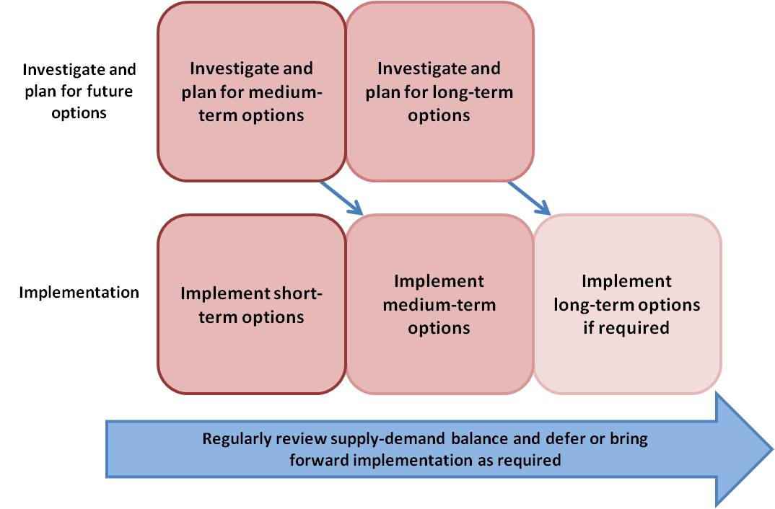

While water plans typically cover between 10–20 years, many jurisdictions have also prepared long-term (10–50 years) strategic water plans that identify potential changes to water resources due to climate change (Boxes 14, 15, 16). These strategies include a range of climate and non-climate considerations for the longer term future, including potential changes in:

* water supply, taking climate change impacts on water resources into account, and
* water demand, including population projections and taking into account changes in industry activities such as irrigated agriculture, mining and natural resource development.

Approaches to respond to reduced water availability over the long-term may include:

* continuing to manage natural surface and groundwater resources sustainably so they remain part of the long-term water supply mix, as well as maintaining or transitioning environmental and amenity values in balance with climate
* constraining water use through demand management, restrictions, using fit for purpose water, innovative urban design, more precise water application technologies
* diversifying towards new and alternative water sources that are less climate dependent such as recycling, stormwater reuse, desalination, water harvesting and storage, managed aquifer recharge, and
* creating infrastructure networks to move water between locations and promote integrated water management (NWC, 2012a).

**Box 14:** [**Queensland Regional Water Supply Planning**](http://www.dews.qld.gov.au/water-supply-regulations/regional-water-supply)

Between 2006 and 2012 the Queensland Government developed four strategies – Central Queensland, Far North Queensland, North West Queensland and South East Queensland – which aimed to balance water demand and supply requirements as well as to provide regional water supply solutions over the long term. The strategies drew upon climate change projections, but provided different approaches for addressing risk. For example, the Central Queensland strategy adopted a risk management approach which identified potential climate risks and risk treatments. The South East Queensland strategy adopted a scenario approach that included scenarios for population growth, demand and climate change. The South East Queensland strategy assumed a 10 per cent reduction in water surface storages due to climate change.

As part of the action to achieve the goals of [*WaterQ*](http://statements.qld.gov.au/Content/MediaAttachments/2014/pdf/WaterQ%2030-year%20strategy.pdf), the Queensland Government is currently progressing regional water security planning with the purpose of ensuring that security of water supply is maintained in the long term despite rising pressures such as population growth, changes to agricultural and mining activities, climate variability and climate change.

In 2014, the Queensland Government commenced work in partnership with water service providers and regional councils on a three year program to advance Regional Water Supply Security Assessments (RWSSA) for high growth regions. RWSSA will forecast (30 years) water demand, water availability and supply risk under various population growth scenarios for regional centres. These assessments will take into account local water supply system capability and performance, multiple water users—such as urban and agriculture— sharing the resources of the region and the effects of changing climate conditions, including drought and flood. The assessments use stochastic modelling to account for a wider variation of potential climatic scenarios than indicated by the historical record. These assessments will provide a shared understanding of potential future water demand and water security for these areas, as well as enable councils to have an appreciation of water security in their regional context.

Water service providers will be responsible for determining and implementing water supply solutions to ensure future water supply security for their communities. Infrastructure solutions, as well as demand management and water efficiency options, will be considered as part of an overall solution.

**Box 15:** [**ACT Water Strategy 2014-44: Striking the Balance**](http://www.environment.act.gov.au/water/act_water_strategy)

In 2014 the ACT Government released the *ACT Water Strategy 2014-44: Striking the Balance*, which sets out how to manage the ACT’s water resources over the next 30 years to meet urban, environmental and regional responsibilities.

The Strategy recognises that climate change is expected to impact on the region’s water supplies, and on river and wetland ecosystem health, due to potential declines in cool season rainfall and runoff and increased risk of bushfires and drought.

The Strategy outlines a number of actions that will continue to build resilience to climate change, including:

* enhancing knowledge and planning capacity for catchment management, for example, through improved climate and hydrological modelling
* developing a more flexible and resilient water supply system through water trading, and investigating alternative water supply options to provide flexibility during dry periods, and
* encouraging more efficient use of water.

**Box 16:** [**Water Forever: Whatever the Weather**](http://www.watercorporation.com.au/~/media/files/about%20us/planning%20for%20the%20future/perth-10-year-water-supply-strategy.pdf)

In 2011 the Western Australia Water Corporation developed a 10 year strategy for Perth’s Integrated Water Supply Scheme to ensure secure water supplies for customers in response to the observed drying trend. Southwest Western Australia’s rainfall and streamflow has been declining for several decades, but this trend has become more noticeable over the past 10 years.

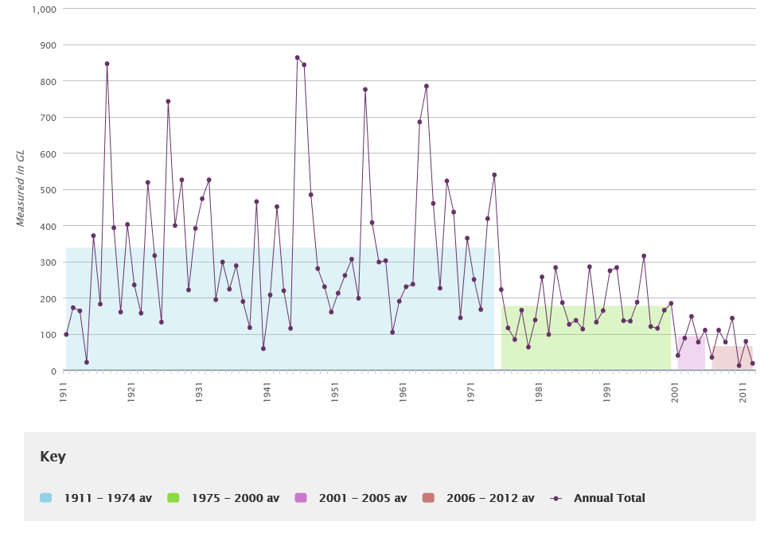

The Water Corporation strategy discusses the need to reduce reliance on shallow groundwater and dams, and develop non-traditional water sources such as:

* water use efficiency and demand management
* recycling of treated wastewater through groundwater replenishment and recovery
* reduced abstraction from superficial (unconfined) aquifers, especially in the vicinity of groundwater dependent ecosystems
* more scientifically informed location of abstraction from and replenishment to deep groundwater aquifers
* groundwater replenishment, and
* seawater desalinisation.

Transparent relationships between long-term strategies and shorter-term water plans can be achieved through:

* including information in water plans on potential changes to water resources over the long-term due to climate and other influences
* describing how current water plans will transition to future water plans, and
* describing how specific ‘triggers’ will work to determine when new water supply sources will be developed and when water demand management will be initiated.

Improving the transparency of water resource management decisions over the longer term will help with communicating and engaging with stakeholders about the range of possible water futures that may result from climate change and how water planning will adapt to them. For example, Western Australia is conducting a review into how to maintain effective environmental releases from scheme dams and achieve storage recovery after very dry periods (Box 12).

Incorporating longer-term outlooks into water plans may assist in managing stakeholder expectations when new water plans are developed, if there is a decision that water resources need to be managed differently.

## Concluding Remarks

Climate change and extreme events are significant challenges for water planners and managers. If these risks are not sufficiently incorporated into planning and management, this increases the possibility of water systems becoming over-allocated, and water security concerns and environmental degradation worsening. Recent climate events such as the Millennium Drought that affected southeast Australia, and the observed decline in rainfall in southwest Australia, have highlighted the need for water plans and management approaches to be flexible and able to respond to climate risks.

This module outlines a range of approaches that may assist water planners to respond to reduced water availability during a planning period, while also positioning water planners to manage longer-term impacts. By providing a suite of options for managing climate risks, water planners can develop a tailored approach that suits their local circumstances such as the type of water resource, the level of demand for water and expected climate risks.

## Useful links

**NWI Policy Guidelines, 2010:** *National Water Initiative policy guidelines for water planning and management*, Council of Australian Governments (COAG) Reform Council, Canberra. [www.coag.gov.au/sites/default/files/Water%20Planning%20Guidelines.doc](http://www.coag.gov.au/sites/default/files/Water%20Planning%20Guidelines.doc)

**NWI Risk Assessment Module, 2010:** Module to the *National Water Initiative policy guidelines for water planning and management*.

[www.environment.gov.au/system/files/pages/0ce50acd-ce27-4950-b8f9-8b2303873704/files/risk-module.pdf](http://www.environment.gov.au/system/files/pages/0ce50acd-ce27-4950-b8f9-8b2303873704/files/risk-module.pdf)

**Climate Change in Australia**: National, downscaled climate change projections for Australia produced by CSIRO and the Bureau of Meteorology (2015). Includes access to a suite of brochures and reports, summary statements about regional projections, and interactive tools and data associated with the projections. [www.climatechangeinaustralia.gov.au](http://www.climatechangeinaustralia.gov.au)

**South Eastern Australia Climate Initiative (SEACI):** [www.seaci.org](http://www.seaci.org)

**Victorian Climate Initiative (VicCI):** <http://cawcr.gov.au/projects/vicci/>

**NSW/ACT Regional Climate Modelling Project (NARCLIM):** [www.ccrc.unsw.edu.au/sites/default/files/NARCliM/index.html](http://www.ccrc.unsw.edu.au/sites/default/files/NARCliM/index.html)

**Indian Ocean Climate Initiative (IOCI) – Western Australia:** [www.ioci.org.au](http://www.ioci.org.au)

**Climate Futures for Tasmania:** [www.dpac.tas.gov.au/divisions/climatechange/adapting/climate_futures](http://www.dpac.tas.gov.au/divisions/climatechange/adapting/climate_futures)

**Consistent Climate Scenarios Project (CCS) – Queensland:** [www.longpaddock.qld.gov.au/climateprojections/about.html](http://www.longpaddock.qld.gov.au/climateprojections/about.html)

**Goyder Institute for Water Research – South Australia:** <http://goyderinstitute.org/>

**Bureau of Meteorology Seasonal Streamflow Forecasts:** [www.bom.gov.au/water/ssf](http://www.bom.gov.au/water/ssf)

**AdaptWater:** [www.wsaa.asn.au/WSAAPublications/Documents/AdaptWater%20Final%20Report.pdf](http://www.wsaa.asn.au/WSAAPublications/Documents/AdaptWater%20Final%20Report.pdf)

**WaterQ – Queensland:** [www.dews.qld.gov.au/policies-initiatives/water-sector-reform/30-year-strategy](http://www.dews.qld.gov.au/policies-initiatives/water-sector-reform/30-year-strategy)

**ACT Water Strategy 2014-44: Striking the Balance:** [www.environment.act.gov.au/water/act_water_strategy](http://www.environment.act.gov.au/water/act_water_strategy)

**Planning for the future – Western Australia:** [www.watercorporation.com.au/about-us/planning-for-the-future](http://www.watercorporation.com.au/about-us/planning-for-the-future)

**Carryover – Victoria:** <http://waterregister.vic.gov.au/water-entitlements/carryover>

**Releasing unallocated water – South Australia:** [www.waterconnect.sa.gov.au/Content/Publications/DEWNR/Release%20of%20Unallocated%20Water%20Policy.pdf](http://www.waterconnect.sa.gov.au/Content/Publications/DEWNR/Release%20of%20Unallocated%20Water%20Policy.pdf)

## References

CSIRO, 2012: *Climate and water availability in south-eastern Australia: A synthesis of findings from Phase 2 of the South Eastern Australian Climate Initiative (SEACI)*. CSIRO, Australia.

CSIRO and BoM, 2014: *State of the Climate* 2014.

CSIRO and BoM, 2015a: *Climate Change in Australia Projections Cluster Report: Monsoonal North*, CSIRO, Australia.

CSIRO and BoM, 2015b: *Climate Change in Australia Projections: Technical Report*, CSIRO, Australia.

CSIRO and BoM, 2015c: *Climate Change in Australia Projections Cluster Report: Southern and South-Western Flatlands*, CSIRO, Australia.

Basin Plan, 2012. Federal Register of Legislative Instruments F2012L02240. [www.comlaw.gov.au/Details/F2012L02240](http://www.comlaw.gov.au/Details/F2012L02240)

DIICCSRTE (Department of Industry, Innovation, Climate Change, Science, Research and Tertiary Education), 2013. *Climate Adaptation Outlook: A Proposed National Adaptation Assessment Framework*, Australian Government, Canberra.

IPCC, 2012: *Special Report on Managing the Risks of Extreme Events and Disasters to Advance Climate Change Adaptation (SREX)*. Intergovernmental Panel on Climate Change.

IPCC, 2013: *Climate Change 2013: The Physical Science Basis*. Working Group I Contribution to the Intergovernmental Panel on Climate Change Fifth Assessment Report.

IPCC, 2014: Climate Change 2014: *Impacts, Adaptation and Vulnerability*. Working Group II Contribution to the Intergovernmental Panel on Climate Change Fifth Assessment Report.

Kirby, M. J., Connor, R., Bark, E., Qureshi, S., Keyworth, S, 2012: The economic impact of water reductions during the Millennium Drought in the Murray-Darling Basin. In: *56th AARES Annual Conference, 7-10 February 2012, Fremantle, Australia*, Australian Agricultural and Resource Economics Society, Canberra.

NWI (2004). COAG (Council of Australian Governments) 2004, *Intergovernmental Agreement on a National Water Initiative between the Commonwealth of Australia, and the Governments of New South Wales, Victoria, Queensland, South Australia, the Australian Capital Territory and the Northern Territory*, Commonwealth of Australia, Canberra. <http://www.nwc.gov.au/__data/assets/pdf_file/0008/24749/Intergovernmental-Agreement-on-a-national-water-initiative.pdf>

NWI Policy Guidelines, 2010: *National Water Initiative policy guidelines for water planning and management*, Council of Australian Governments (COAG) Reform Council, Canberra. <https://www.coag.gov.au/sites/default/files/Water%20Planning%20Guidelines.doc>

NWI Risk Assessment Module, 2010: Module to the *National Water Initiative policy guidelines for water planning and management*. [www.environment.gov.au/system/files/pages/0ce50acd-ce27-4950-b8f9-8b2303873704/files/risk-module.pdf](http://www.environment.gov.au/system/files/pages/0ce50acd-ce27-4950-b8f9-8b2303873704/files/risk-module.pdf)

NWC, 2010: *Incorporating climate change in water allocation planning*. National Water Commission, Canberra.

NWC, 2011: *National Water Planning Report Card 2011*. National Water Commission, Canberra.

NWC, 2012a: *Water policy and climate change in Australia*. National Water Commission, Canberra.

NWC, 2012b: *Impacts of water trading in the southern Murray-Darling Basin between 2006-07 and 2010-11*. National Water Commission, Canberra.

Marillier, B, Hall, J, Durrant, J (in prep): *Selection of future climate projections for Western Australia, Water Science Technical Series*, report no. 72, Department of Water, Western Australia.

Southern Basins and Musgrave Water Allocation Plans (Eyre Peninsula): [www.naturalresources.sa.gov.au/eyrepeninsula/land-and-water/water-allocation-plans/southern-basin-musgrave](http://www.naturalresources.sa.gov.au/eyrepeninsula/land-and-water/water-allocation-plans/southern-basin-musgrave)

Water Corporation 2009, Water Forever: Towards Climate Resilience, Water Corporation, Perth.

Western Australia Department of Water, 2013: *Pilbara regional water supply strategy – A long-term outlook of water demand and supply*.