Queensland Murray Darling Basin Environmental Works and Measures Feasibility Program

Summary Report for Milestones 3 and 6 – Delivery of feasibility and pre-feasibility investigations.

This publication has been compiled by Cate Hargraves, Steve Goudie and Orren Farrington of Water Services, South Region, Department of Natural Resources and Mines.
© State of Queensland, 2013.
The Queensland Government supports and encourages the dissemination and exchange of its information. The copyright in this publication is licensed under a Creative Commons Attribution 3.0 Australia (CC BY) licence.
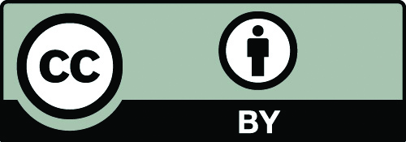

Under this licence you are free, without having to seek our permission, to use this publication in accordance with the licence terms.
You must keep intact the copyright notice and attribute the State of Queensland as the source of the publication.
For more information on this licence, visit http://creativecommons.org/licenses/by/3.0/au/deed.en
The information contained herein is subject to change without notice. The Queensland Government shall not be liable for technical or other errors or omissions contained herein. The reader/user accepts all risks and responsibility for losses, damages, costs and other consequences resulting directly or indirectly from using this information.

Contents
1
Contents ii
Summary 1
Background 4
Outcomes and Outputs 4
Stage 1 4
Part A 4
Part B (Recovery of Overland Flow in the Lower Balonne) 5
Stage 2 6
Yambocully Water Supply Scheme 7
Callandoon Water Supply Scheme 7
Bifurcation Weirs and Offstream Storage in the Lower Balonne 8
Fishways on Structures 9
Multi-level offtake on Glenlyon Dam 10
Milestone Completion 10
Further Work and Actions 10
Appendices 12
Appendix 1 – Milestone Linkages 13
Appendix 2 – Part A executive summary – RPS Aquaterra 14
Appendix 3 – Part B summary – RPS Aquaterra 18
Appendix 4 - Summary Alluvium Report 21
Appendix 5 – Fishway options report – executive summary - DPI 33
Appendix 6 – Pre-feasibility report for Glenlyon Dam Multi-Level offtake - executive summary - SunWater 37

Summary

The Queensland Murray Darling Basin (QMDB) Environmental Works and Measures Feasibility Project aims to identify possible works and measures that may offset proposed reductions in diversion limits as identified in the Commonwealth Water Act 2007 - Basin Plan 2012 (the Basin Plan).
This overview report addresses Milestones 3 and 6 of the Project Agreement for the Environmental Works and Measures Feasibility Project. The linkages between the Project Agreement milestones and the Department of Natural Resources and Mines (DNRM) project plan milestones have been mapped and appear in Appendix 1.
Under Milestones 3 & 6, the Project Agreement identifies that Queensland is responsible for delivering;
- Investigations/assessments - completed as per the project management plan
- information - provided to assist determination of potential Sustainable Diversion Limits (SDL) offsets.
When commencing this program of work it was not immediately apparent to DNRM whether there were any significant proposals that would achieve SDL offsets in the QMDB area. Hence a two stage approach was developed.

Stage 1 was completed in two parts by consultant’s RPS Aquaterra (in association with JTA Australia). In this stage, ideas for environmental works and measures in priority locations were identified (Part A), and investigation into possible recovery of overland flow (OLF) water licences in the lower Balonne was completed (Part B).
Stage 1 culminated in the compilation of potential projects into 4 recommended packages that would benefit from further assessment. Under the project agreement there were two levels of assessment. Feasibility assessment was undertaken for projects identified as having the greatest potential for achieving SDL offsets. Pre-feasibility assessment was undertaken for project ideas suggested by the community for which the possibility of SDL adjustments was unknown.

The packages recommended for feasibility assessments were;
Package 1 – Piping proposal for the Callandoon and Yambocully Water Supply Schemes.
Package 2 – Lower Balonne Works and Measures,
- strategic acquisition of Overland Flow Licences and the implementation of associated works and measures where relevant – Part B recommendations and
- Upgrade of outlet works on Bifurcation Weirs and Commonwealth use of off-stream storages in the Lower Balonne.

The packages recommended for pre-feasibility assessments were:
Package 3 – Fishways on structures including possible removal of some structures; in the Condamine, Balonne and Border Rivers catchments in conjunction with the strategic acquisition and management of regulated water entitlements.
Package 4 – Multi-Level offtakes from Glenlyon Dam to reduce thermal pollution.

The stage 1 outputs (see appendix 2 - Part A executive summary) delivered, in a preliminary sense, against parts a) and b) of milestones 3 & 6.

Stage 2 consisted of undertaking more detailed feasibility and pre-feasibility work. This stage was also completed in two parts with the feasibility assessments for package 1 & 2 (which were aligned with Milestone 3) being completed by Alluvium Consulting Australia (Alluvium). The pre-feasibility assessments for package 3 & 4 (aligned with Milestone 6) were completed by Department of Primary Industries (DPI) (NSW) and SunWater respectively.
The indicative costs and water savings for each of the priority project package options are summarised below.
 | Scheme Cost | Water Savings | $/ML | Comments
Package 1 - Piping proposals (Border Rivers)
Yambocully | $6990709 | 400ML | $17445 | Water savings are equivalent to onfarm savings and not SDL offset. Economically unviable.
Callandoon | $6360549 | 1600ML | $3944 | Water savings are equivalent to onfarm savings and not SDL offset. Potential for further consideration by the board under Healthy Headwaters Water Use Efficiency (HHWUE) program.
Package 2 – Bi-furcation weirs (Lower Balonne Works and Measures)
Modification of Bifurcation weirs | $500,000 | 29,055ML | $17 | Water savings indicated is the reduction in buyback volume to achieve the same target flow volume for the Narran Lakes, however, it does not account for reduction in flow to other streams. Hence the initial attractiveness presented here needs to be considered in a broader context.
Offstream storage |  |  |  | Preliminary investigations indicate potential to realise potential SDL offsets if operated in conjunction with bifurcation weir proposal. Opportunity to improve environmental benefits.
Package 3 - Fishways on structures (Border Rivers)
Glenarbon | $800,000 | 0ML | NA | Installation of vertical slot fishway
Cunningham | $650,000 | 0ML | NA | Removal of structure
Bonshaw | $1,150,000 | 0ML | NA | Used Glenarbon as a surrogate for cost estimation.
Boggabilla | $1,000,000 | 0ML | NA | Upgrade to be considered in conjunction.
Package 4 - Multi-Level offtake for Glenlyon Dam (Border Rivers)
Telescopic curtain | $4,000,000 | 0ML | NA | Based on Burrendong Dam NSW cost.
Bulkhead gates | $2,663,600 | 0ML | NA | Recommended option though not economically feasible.
Permanent valves | $3,600,000 | 0ML | NA

Package 1: Assuming the option of full funding by the Commonwealth and full transfer of water savings to the Commonwealth, the findings reached were;
- the Yambocully scheme was not feasible under any circumstances (due primarily to economic considerations), and
- the option proposed for the Callandoon scheme is expensive, however the scale of the proposal could be altered should the Callandoon Water Board wish to consider other options to improve the economic feasibility.
Due to the water for these systems being measured at the offtake from the river, with losses attributed to the Water Allocation holders, there is limited potential for direct SDL offsets. There is however, the potential to save water through improvements to the supply works, hence improving the efficiency of water delivery. This is a similar vein to current HHWUE projects which result in water saved (or part thereof) being transferred to the Commonwealth.

Package 2: This proposal can be considered a constraint measure (where only work on the bifurcation weirs is considered). It is likely to be able to be considered a supply measure too, particularly if operated in accordance with a management framework and in conjunction with offstream storage. The potential for significant water savings (that may form a SDL offset) at a low cost provides a possible opportunity to reduce the water recovery burden in this key area. The department is keen to further explore the benefits of combining the bifurcation weir modifications with use of offstream storages to maximise the water delivery benefits while minimising the effects. The project plan for the remaining milestones 7 and 8 within the Program Agreement will focus on exploring this package further.

Package 3: This project is not economically feasible on the basis of high cost and no potential for SDL offsets. There is however potential for significant environmental benefits.

Package 4: This project is not economically feasible on the basis of high cost and no potential for SDL offsets. Additionally the current environmental effect/s are unknown.

Background

A Project Agreement for Queensland Murray-Darling Basin Environmental Works and Measures Feasibility Program between the State of Queensland and the Australian Government, was signed by the State Minister for Environment and Resource Management and the Australian Minister for Sustainability Environment Water Population and Communities (SEWPaC) in November 2011

The agreement is for Commonwealth funding contribution of $1.8 million to assist Queensland to:-
- deliver feasibility investigations, including the costs, risks and benefits, of sustainable diversion limit (SDL) offset environmental works and measures project, and
- deliver a State-led local process involving the development of local networks to enable engagement with local communities to assist the development of community based proposals for environmental works and measures and test the shortlisted community identified sub-projects through pre-feasibility assessment.

The project aimed to identify the prospects for environmental works and measures in priority locations for diversion limit reductions such as the Lower Balonne catchment of Queensland. Individual projects were identified and shortlisted for further development in close consultation with existing community groups and key stakeholders.

Feasibility assessments were then completed for the identified priority project packages. The assessments included development of preliminary cost estimates and economic viability. Assessments were also completed for the OLF options in the Lower Balonne.

This Report (for milestones 3 & 6) deals with the more detailed full feasibility and pre-feasibility investigations and assessments of the priority project packages that were determined through Stage 1 of the process, together with the outcomes of the investigations into Lower Balonne Overland Flow Licence acquisition and assessment of offstream storages. See appendix 1.

Outcomes and Outputs
DNRM is responsible for delivering feasibility investigations of potential SDL offset projects under the Project Agreement. This work forms the 3rd and 6th milestones to be delivered under the Project Agreement and has been carried out in two stages.

Stage 1
Stage 1 was completed in two parts by RPS Aquaterra (in association with JTA Australia). In this stage, the prospects for environmental works and measures in priority locations were identified (Part A), and investigation into possible recovery of overland flow (OLF) water licences in the lower Balonne was completed (Part B).

Part A
The Part A report (see appendix 2 – executive summary) identifies a number of ideas that have been shortlisted by a gateway process developed in consultation with the department and SEWPaC. A priority list of potential works and measures was developed. See table below from RPS Aquaterra report.
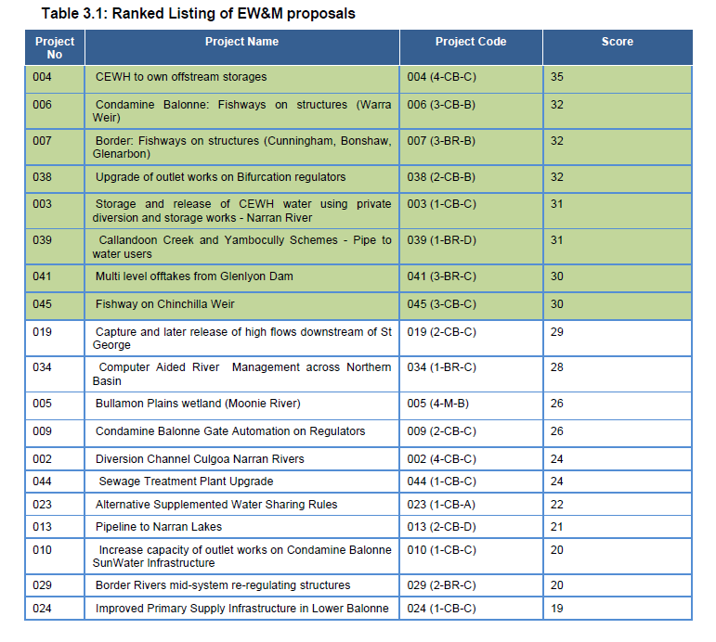
Following a further review of the shortlisted proposals outlined above, and following the results of the Part B - Overland Flow Licence retirement investigations, the project team engaged with the DNRM Steering Committee to recommend the following proposals which would benefit from further full feasibility assessment or pre-feasibility investigations;
Recommended Feasibility Assessments
Package 1 – Piping proposal for the Callandoon and Yambocully Water Supply Schemes.
Package 2 – Lower Balonne Works and Measures, incorporating:
  - Strategic acquisition of Overland Flow Licences and the implementation of associated works and measures – Part B recommendations;
  - Upgrade of outlet works on Bifurcation Weirs; and
  - Commonwealth use of off-stream storages in the Lower Balonne.
Recommended Pre-Feasibility Investigations
Package 3 – Fishways on structures (including the possible removal of some structures) in the Condamine, Balonne and Border Rivers Basin, in conjunction with the strategic acquisition and management of regulated water entitlements.
Package 4 – Multi-level Offtakes from Glenlyon Dam.

The recommended feasibility investigations (package 1 & 2 above) were aligned with progressing of milestone 3, while the recommended pre-feasibility assessments (package 3 & 4 above) were aligned with milestone 6.

Part B (Recovery of Overland Flow in the Lower Balonne)

The Part B report focussed specifically on identifying possible mechanisms and opportunities to allow for the recovery of overland flow (OLF) water in the Lower Balonne. The consultants engaged all water licence holders in the Lower Balonne in the development of the report and included specific property details including those owners potentially interested in participating in water recovery. Accordingly this report has not been released as a public document. A summary report of the outcomes of the Part B report has been produced to provide general information about the opportunities to recover water (appendix 3).

The summary report notes that the Commonwealth is only seeking to recover water from willing sellers and that there was considerable level of interest from the 14 water licence holders. Two distinct methods of controlling OLF diversions were identified to achieve a reduction in take;
- an audit process, where there is an ability to measure and audit diversions to ensure they remain consistent with the remaining take of water, and
- physical works, where a small number of identified storages would need physical decommissioning to return the flows to a more natural state.
The report provided an assessment of the total volume of water recovery that could be delivered through recovery of OLF licences and provided an indicative assessment of the costs involved, together with the potential costs for decommissioning. The report recommends that the process for moving forward with OLF recovery should establish a market value for OLF water, and present the best opportunity to deliver sustainable environmental outcomes.

Subsequent work by the Department furthered the thinking around using the existing ‘willing seller’ model to acquire OLF entitlements. This thinking has now matured with SEWPaC developing eligibility criteria for OLF and the latest tender process now calling for expressions of interest, (including OLF) that allow for purchase of OLF licences.
See http://www.environment.gov.au/water/programs/entitlement-purchasing/2012-13-lower-balonne.html

For further details on this assessment see the reports;
- Queensland Murray Darling Basin Environmental Works and Measures feasibility project – Part B: Lower Balonne Overland Flow Licences retirement investigations – RPS Aquaterra
- Queensland Murray Darling Basin Environmental Works and Measures feasibility project – Part B: Summary Paper – RPS Aquaterra
- Recovering Overland Flow Water Licences in the Lower Balonne, Advancing another Bridging the Gap Opportunity – DNRM

Stage 2

The department decided that the packages recommended in the Stage 1 report for both the feasibility investigations and pre-feasibility investigations would be put forward for further assessment to be completed as Stage 2.
Stage 2 was completed in two parts. The feasibility assessments for package 1 & 2 (which relate to milestone 3) were completed by Alluvium. The pre-feasibility assessments for package 3 & 4 (which relate to milestone 6) were completed separately.
The consultants (Alluvium) were tasked with developing feasibility assessments for the following packages identified in Stage 1;
- Water savings in the Yambocully and Callandoon Water Supply Schemes and a reduced scope of package 2
- Upgrade of Bifurcation Weirs in the Lower Balonne. Additional assessment work on utilisation of offstream storages in the Lower Balonne was included in the Invitation to Offer.

Several options for the above projects were put forward by Alluvium to the Steering Committee for the two packages in a draft options report. These options were further refined by the Steering Committee and the Yambocully and Callandoon Water Supply Scheme assessments were progressed on the basis that a channel delivery system would be significantly more cost effective than piping. Due to the water for these systems being measured at the offtake from the river with losses attributed to the Water Allocation holders, there is no potential for an SDL offset. There is however, the potential to save water through improvements to the supply works. This would result in water saved being transferred to the Commonwealth, similar in style to current HHWUE projects.

The feasibility assessments include sufficient information including costs, potential water savings (for determination of potential SDL offsets where applicable), and possible ecological benefits of the projects to fulfil the requirements of milestone 3 of the program agreement.

Yambocully Water Supply Scheme
An investigation into the feasibility of a number of options to convey both supplemented and unsupplemented water to users in this scheme was completed. This resulted in a feasibility assessment being completed for a channel system.

The report (see Alluvium summary - appendix 4) covers the design of a channel system on an alignment utilising the existing pumping station and extension of the current channel. Investigation of Board operations enabled an assessment of potential water savings to be completed and an economic analysis was also completed. Environmental consideration indicates that there would be relatively little effect, with the proposal moving the system closer to a natural (pre-development) flow regime. The proposed channel alignment would also require a number of approval processes to be completed.

The results of the cost benefit analysis indicate that the Yambocully Water Supply Scheme proposal represents an extremely high cost of securing water for the environment. With potential water savings being a relatively small volume weighted against the significant cost of constructing the works, the proposal is not feasible and is not recommended to proceed beyond the level of assessment already completed.
For further details on this assessment see the report; Assessment of water saving options for the Lower Balonne catchment and Yambocully/Callandoon water supply schemes by Alluvium, April 2013.

Callandoon Water Supply Scheme
An investigation into the feasibility of a number of options to convey both supplemented and unsupplemented water to users in this scheme was completed. This resulted in a feasibility assessment being completed for a channel system.
The report covers the selection of a suitable alignment and design of a channel and pumping station. Investigation of Board operations enabled an assessment of potential water savings to be completed and an economic analysis was also completed. Environmental consideration indicates that there is relatively little effect, with the proposal moving the system closer to a natural (pre-development) flow regime.

While the boards practice of ‘piggybacking’ supplemented water on unsupplemented flows (to minimise losses) means that significant water savings are not available, it also reduces the environmental effect as the unsupplemented flows would still pass through the system.
The results of the cost benefit analysis indicate that the Callandoon Water Supply Scheme proposal represents a marginally feasible cost of securing water for the environment. While the project is not feasible from a SDL offset point of view, it is noted that the proposal significantly improves the Boards’ Water Allocation holder’s access to supplemented water. It identifies that further work by the Board on this option (or variation) may improve the attractiveness of the project as a water recovery measure.

For further details on this assessment see the report; Assessment of water saving options for the Lower Balonne catchment and Yambocully/Callandoon water supply schemes by Alluvium, April 2013.

Bifurcation Weirs and Offstream Storage in the Lower Balonne

The assessment of package 2 (Lower Balonne bifurcation weirs plus use of off stream storages (see appendix 4 - Alluvium report summary) had two aims:
- to investigate the feasibility of improved regulation of bifurcation weirs in the Lower Balonne to direct low flows.
- to investigate utilising offstream storage in the Lower Balonne area for storage and later release of environmental water purchased by the Commonwealth to improve environmental outcomes – primarily for Narran Lakes.

The report covers possible engineering solutions to regulate existing low flows at the 1st and 2nd bifurcations, to enable better control to preferentially deliver water to the Narran River (and terminal lakes). The report also concludes that there is little benefit in regulating the 3rd and 4th bifurcation structures. The feasibility assessment was therefore progressed on the basis of modifications to two bifurcation structures only. The work completed indicates that this option has a very high likelihood of improving the management of environmental water flows in the Lower Balonne area, in particular, acting to improve the flow to the Narran Lakes during low flows.

The following extract from the summary to the Alluvium report details the investigation of the use of off stream storages.
The Narran River water harvesting entitlements purchased by the Commonwealth could be used to fill existing offstream storages. Towards the end of an event, the harvested water could be released back into the river to ensure efficient delivery to the Narran Lakes to assist meeting ecological requirements.
The initial understanding of the system is that there are already storage systems with spare capacity because of the current buy back of water and that there are a number of additional landholders who would be willing to sell water and make their storages available. Ideally the storages would be below Bifurcation Weir 2 on the Balonne Minor system and upstream of the refuge assets on the Culgoa system. An initial discussion with landholders as part of the consultation process indicated there is likely to be around 56GL of capacity on the Narran River (downstream of Weir 2) and 90GL on the Bokhara and Culgoa system. These storages are largely gravity fed and discharged so there would be few ongoing pumping costs.
It is proposed that the use of offstream storages could have a dramatic impact on the efficiency of water delivered to the Narran Lakes. If the Commonwealth operated an offstream storage facility on the Narran River that it filled using a portion of its purchased water entitlements, then it could have stored water available to release into the Narran River at the critical times.

A second option was considered where instead of a permanent change to the weirs directing water preferentially to the Narran River, the weirs are adjusted according to seasonal conditions and antecedent flows to direct water to where it is most needed on an event by event basis. This aligns with the philosophy of providing water to ecological assets in accordance with the Annual Environmental Watering Priorities developed by Queensland under the Basin Plan environmental management framework.
While the option of a permanent change to the operation of the weirs could be modelled using DNRM’s Integrated Quantity and Quality Model (IQQM) this was not possible for temporary changes. Improvements to the IQQM would be needed to assess the impacts of ongoing active management of the upgraded weirs.

The conclusion of the Alluvium report is:
We therefore propose that whilst the bifurcation weir modification option essentially takes water from one system to deliver more to another, there is still the potential for water savings. Proceeding with a combination of modification to the weirs and offstream storage use could substantially increase the efficiency of delivering the water currently owned by the Commonwealth to key ecological assets. The extent of the water savings is not able to be specified at this stage and requires further investigation.
The modelled outcomes are useful to understand the extent of the benefit that could be provided to the Narran Lakes if a permanent change to the operation of the weirs was made, but it does not adequately reflect the proposed operation where the gates would be continually adjusted based on previous and anticipated flow events, and only for limited lengths of time
It is proposed that this combination approach is potentially a smart and efficient way to manage the Lower Balonne system and will more efficiently deliver the environmental water already purchased.
For further details on this assessment see the report; Assessment of water saving options for the Lower Balonne catchment and Yambocully/Callandoon water supply schemes by Alluvium, May 2013.
See also http://www.environment.gov.au/ewater/publications/private-storages-report.html

Fishways on Structures
The Department has utilised a body of work completed (previously) by NSW DPI. See appendix 5 – DPI fishway report executive summary. This work identified 12 priority weirs of which half were in the QMDB area. Three of these were located in the Border Rivers basin area identified in package 3 and, along with consideration of upgrading of existing structures, are tabled below.

Weir | Stream | Fishway Type | SDL Offset | Cost
Glenarbon | Dumaresq | Vertical slot | 0ML | $800,000
Cunningham | Dumaresq | Removal of structure | 0ML | $650,000
Bonshaw | Dumaresq | Vertical slot | 0ML | $1,150,000
Boggabilla | Macintyre | Upgrade of existing Vertical slot | 0ML | $1,000,000

Essentially these are significant costs and there is no potential for SDL offsets. Consideration of this work fails to meet the Commonwealth’s definition of supply, constraint or efficiency measures in the Commonwealth Water Act 2007 – Basin Plan 2012. Despite this, consideration of fish ecology and migration indicates there is opportunity for significant environmental benefit, through improvement of fish passage conditions.
For further details on this assessment see the report; Fishway options for weirs of the Northern Murray – Darling Basin by DPI (NSW).

Multi-level offtake on Glenlyon Dam

Pre-feasibility assessment of package 4, proposed modification of the existing single low level offtake tower at Glenlyon Dam into a multi-level offtake, was carried out by SunWater.
Three options for modification were weighed up; telescopic curtain, bulkhead gates, and permanent valves. Consideration of the operation and design of the existing tower, ease of operation and cost formed the primary criteria. Evaluation of these options led to the recommendation of the removable bulkhead option, in particular the option of utilising new 4.0m combination trash screen and bulkhead gate. See appendix 6 - SunWater report executive summary.

Option | Water Savings | Scheme Cost
Telescopic curtain | 0ML | $4,000,000
Bulkhead gates (4m gate option) | 0ML | $2,663,600
Permanent valves | 0ML | $3,600,000

Preliminary consideration of the design of this option resulted in two alternatives being considered. These were for construction of 1.83m bulkhead gates to fit in with existing trash screens and construction of new combination trash screen/bulkhead gates at 4.0m that could replace the existing screens. Weight considerations would require the 4m gates to be constructed of aluminium.

The bulkhead gates option is simple and proven, makes best use of the existing asset, minimises initial cost and allows for future modifications. Bulkhead gates have been used successfully on other SunWater dams to manipulate the level of draw and the design of the gates draws on the design of the Boondooma Dam gates.

To fully assess the benefits of the proposal further work is required to determine the environmental effects of the current release operations, particularly the extent and impact of any cold water (thermal) pollution, Despite the potential for environmental benefit, the proposal does not provide any opportunity for a SDL offset and is not aligned with supply, efficiency or constraint measures.
For further details on this assessment see the report; Glenlyon Dam – pre-feasibility study into modification of offtake tower into a multi-level offtake by SunWater, April 2013.

Milestone Completion

The Stage 1 and Stage 2 consultancies have provided a number of reports that detail the project journey from stakeholder engagement and identification of potential projects through to feasibility and pre-feasibility investigations/assessments of the priority projects. The reports completed for the four prioritised projects (packages) include work on costs and benefits, potential water savings for SDL offsets (where applicable) and sufficient infrastructure detail that can be used to enable a decision to be made on whether either or part of the projects should progress further to the design, financing and construction phases.

Further Work and Actions

DNRM supports a number of recommendations that were made through the work comprising this milestone. Many of these involve improved modelling to allow the increasingly complex water delivery and management scenarios to be readily tested. DNRM is keen to discuss proposed improvement to existing or new models with the Commonwealth and to use these to further progress assessment of the Lower Balonne bifurcation weirs/use of off stream storages proposal.

As stated in the Alluvium report: there is scope to develop an operational plan of manipulating the weir flows to provide both a better ecological outcome for the Narran Lakes and no detrimental impacts to any other part of the system. The ecological assessment needs to be much more detailed to integrate with the modelling. In particular the refuge areas of the Culgoa need to be better understood in the context of fewer low flows. The current Northern Basin Workplan being implemented by the MDBA will be reviewing the science on which the Ecological Sustainable Level of Take for the Basin Plan was based. This should include an assessment of whether the existing ecological targets and flow indicators are suitable. Any findings can be incorporated into future ecological assessments.

With the Commonwealth water recovery group having implemented processes to enable the recovery of overland flow water licences in the Lower Balonne, the department is committed to continuing to work with the Commonwealth on developing and implementing processes to maximise the environmental benefits of this water. The work to date on offstream storages will inform this discussion. Again this discussion can be advanced by improvement to the existing models.

The recommended work or actions that have been raised in the feasibility and pre-feasibility assessments have been ranked based on consideration of the importance to the furthering of the Commonwealths water recovery program.

 | Work / Action | Ranking
Lower Balonne catchment

1 | Model development / improvement to allow more complex proposals for water delivery and water management options to be tested. | High
2 | Engage stakeholders re – bifurcation weir options including operation and management protocols and opportunities to integrate use of existing or new offstream storage. | High
3 | Work to increase the knowledge and understanding of the environmental water requirements of Lower Balonne assets (other than Narran Lakes and the Culgoa floodplain). | High
4 | Continued support of OLF licence buyback activities | Medium
Border Rivers catchment

5 | Engage Callandoon Water Board with a view to handing the proposal over to them for further work on alternative options for consideration under the HHWUE program. May require changes to current HHWUE eligibility criteria. | Medium
6 | Develop methodology to determine the value of improved fish passage against water recovery program. | Low
7 | Specific studies to improve understanding of thermal pollution caused by operation of Glenlyon Dam | Low

After the completion of this phase (Milestone 3 & 6) of the project, two milestones remain. These milestones support continued engagement on environmental works and measures across the basin over the following two years. The department has commenced drafting a project plan to map activities over these two years, and, based on the outcomes of milestone 3 & 6, the primary focus will be on the Lower Balonne bifurcation weirs and use of off stream storages proposal.

Appendices
- Appendix 1 – Milestone linkages
- Appendix 2 – Stage 1 Part A report - executive summary – RPS Aquaterra report
- Appendix 3 – Stage 1 Part B summary paper – RPS Aquaterra
- Appendix 4 – Stage 2 summary – Assessment of water saving options for the Lower Balonne catchment and Yambocully/Callandoon water supply schemes - Alluvium
- Appendix 5 – Stage 2 Fishway options report – executive summary - DPI
- Appendix 6 – Stage 2 Multi-level offtake report – executive summary – SunWater

Appendix 1 – Milestone Linkages

Appendix 2 – Part A executive summary – RPS Aquaterra

Appendix 3 – Part B summary – RPS Aquaterra

Appendix 4 - Summary Alluvium Report
Alluvium (2013) Assessment of water saving options for the Lower Balonne catchment and Yambocully/Callandoon water supply schemes. Final report by Alluvium Consulting Australia for DNRM, Toowoomba Qld
Under the Water for the Future initiative, the Australian Government has recently made available funds from the Sustainable Rural Water Use and Infrastructure Program for an Environmental Works and Measures Feasibility Program.
The Environmental Works and Measures Program aims to improve the health of our river systems by making the best use of water for the environment. Works and Measures programs fund infrastructure to deliver and manage water at icon and other important sites.
To date there have been limited opportunities in Queensland to undertake these kinds of activities largely due to the unregulated nature of Queensland Murray-Darling Basin rivers. This contrasts with the situation in the Southern Basin where rivers are heavily regulated by infrastructure.
This work follows a preceding project which sought to identify a large range of potential Works and Measures opportunities across the Murray Darling system in Queensland. The shortlisted options included proposals to improve fish passage, upgrade bifurcation flow regulating structures on the Lower Balonne system, pipe the Callandoon and Yambocully schemes, install a multi-level off-take on Glenlyon Dam and the use of offstream storages downstream of St George on the Narran River.
The report from that project identified the two highest priority options were to pipe the Callandoon and Yambocully Water Supply Schemes, and an upgrade of outlet works on Bifurcation Weirs in the Lower Balonne. Those two options are further progressed in this report.
Definition of water in the study area
It is valuable to understand the types of water within these systems in order to understand how they are represented in discussion within this document. The types of water used by landholders and the environment are presented below:
Table 1. Descriptions of the types of water referred to in this report.
Types of water | Description
Environment, Stock and Domestic water (ESD) | ESD is also referred to as ‘compensation’ flow and applies only in the Lower Balonne. This is provided under the operational rules of Beardmore Dam, by which the first 730 ML of daily flow into the dam is considered to be in this category. Normally the flow will be passed through the dam directly, but there are provisions to store for later release. The extent to which water may be stored depends on the available air space in Beardmore Dam.  Following an extended dry period a volume of 30-35,000 ML is required to be released at the correct rate to ensure a flow through the major watercourses to replenish stock and domestic supplies.
Supplemented water allocation | An entitlement to water from major infrastructure (i.e. Beardmore Dam) that is owned and operated by a Water Supply Provider.
Unsupplemented water allocation | An entitlement to take water from higher level river flows (i.e. in excess of supplemented water allocation requirements) that is managed by the resource manager (DNRM).
Overland flow water licences | These are licences that exist to harvest water directly from the floodplain (in floodplain dams).

Callandoon and Yambocully Water Supply Schemes

The Yambocully and Callandoon Creeks run within the Queensland area of the Border Rivers Catchment which lies across the Queensland and NSW border. A significant part of the state boundary is located along major rivers in the Border Rivers Catchment, such as the Dumaresq, Macintyre and Barwon Rivers.
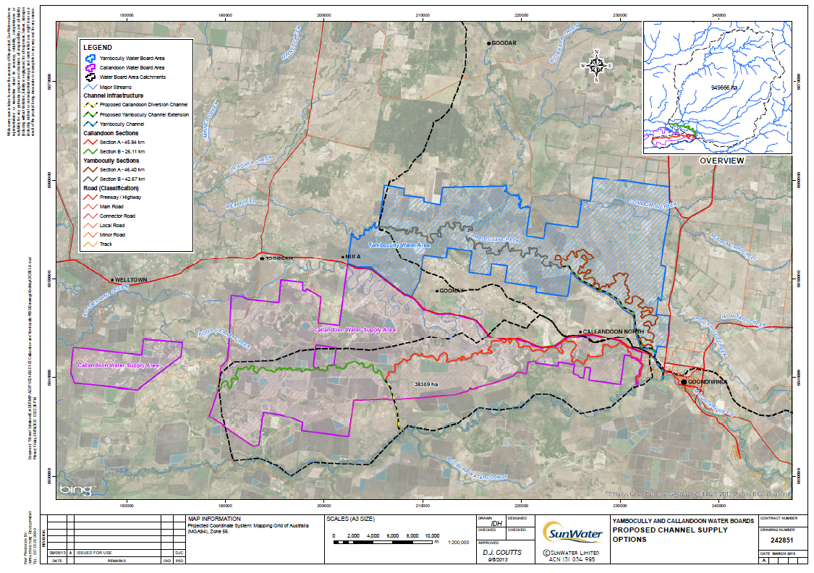
Figure 1. Location of Yambocully and Callandoon water supply schemes

The Callandoon and Yambocully Water Boards are statutory bodies under the Water Act 2000. Each of the boards has been issued with a distribution operations licence to authorise water distribution infrastructure and to divert water from the Macintyre River for the benefit of their members.
The Water Boards provide rural landholders with water to support stock and domestic and irrigated cropping enterprises. Both schemes provide a mix of supplemented and unsupplemented allocations from the Border Rivers Water Supply Scheme. Generally, most irrigators within these schemes also have access to water harvesting and overland flow diversions and use on farm storages to manage their water supplies. Supplemented annual allocations however are relatively small and accessibility is low (average availability of 45%) while unsupplemented annual allocations are more significant and typically have higher announced allocations.
The Callandoon Water Board uses a 50 kilometre section of Callandoon Creek for the distribution of supplemented water (4,500 ML of nominal volume) and unsupplemented water (8,800 ML of nominal volume).
The Yambocully Water Board uses a 45 kilometre section of Piggy Piggy, Crooked & Yambocully Creeks and Weir River for the distribution of supplemented water (5,800 ML of nominal volume) and unsupplemented water (7,600 ML of nominal volume).
Within these two supply schemes it appears that most losses are generated from the need to refill water holes after a dry period, although there are some known sandy sections in Callandoon Creek. Options that target opportunities to reduce the length of natural watercourses used in the distribution system would be the most effective for water savings. To this end, six options were identified for the Yambocully and Callandoon water supply schemes which include a combination of channel, partial pipe and full pipe for each scheme.
Our initial investigation indicated that the investment in pipelines will be a high cost alternative and there is a real potential to over-capitalise in capacity. We found that piping for high flow deliveries is considered a costly and impractical option. Piping for supplemented allocations could achieve irrigator benefits but not significant water savings, as the losses associated with delivering unsupplemented allocations will still be incurred.
Our review of the options also included an initial assessment of environmental considerations and we found the Basin Plan process had not identified any significant environmental assets in the creeks that require particular water targets. The ecological character of the creeks is actually relatively unknown.
Through discussion on economic, social and environmental considerations it was decided in conjunction with the Project Steering Committee to progress the conceptual design of a channel option for each system. It should be noted that the analysis was based on the best data available and used the coarse NASA surface data for topography.
Based on the savings in length of watercourse eliminated from the distribution systems, the preliminary estimate of water savings that might be generated from the two channel options would be 1,600 ML from the Callandoon system and 400 ML from the Yambocully system. The savings would be across both supplemented and unsupplemented water, as losses in the system are proportional to scheme share of these water types.
The capacity of the channels in the design was based on the existing diversion and pump stations capacities which included; 500 ML/d (5.8 m³/s) for Yambocully and 1,000 ML/d for Callandoon. However in the Callandoon system one existing user had established an independent pump station and, as such, capacity for this allocation would not be required. Based on the reduction in unsupplemented allocation, the required capacity is to be approximately 860 ML/d (10 m³/s) for the Callandoon system.
Through our analysis we found the optimal components for the channel supply options to provide both supplemented and unsupplemented allocations (with the former piggy-backed on the latter as per the current delivery method) include:
Table 2. Optimal components for the Callandoon and Yambocully channel supply options.
Callandoon channel supply options | Yambocully channel supply options
6 m channel bed width | 6 m channel bed width
1800 DIA rising main | Inclusion of 13 bridge deck crossings
Pump duty of 10 m3/s at 5 m lift | Piped siphons at 6,250m and 9,300m
Pump configuration of 3 x Batescrew 32-60-16 axial flow pumps | Piped outlet and Goodar Road Crossing at end

A Benefit Cost Analysis (BCA) was conducted for the channel works for the Callandoon and Yambocully systems, the key findings of which are presented below. For the water supply schemes this analysis was conducted for three alternative uses of water saved:
- Water for environmental flows (the Commonwealth receives all benefits and covers all costs)
- Water used to increase irrigation (irrigators receive all benefits and cover all costs).
- Shared benefits and costs (all capital, ongoing costs and 75% of benefits allocated to the Commonwealth, whilst no costs and the remaining 25% of benefits allocated to irrigators).
This work also included sensitivity analysis for key inputs and parameters to determine if and how different input values and assumptions would materially change the outcome of the analysis. The outcomes of the BCA are shown in the table below. Red text shows where the economic measure indicates that the project is not economically viable.

Table 3. Results of benefit cost analysis.
Economic measure | Pessimistic | Most likely | Optimistic
Callandoon
Water used for environmental flows
Net present value | -$4,980,000 | -$1,790,000 | $1,860,000
Benefit cost ratio | 0.28 | 0.72 | 1.33
Water used to increase irrigation
Net present value | -$4,720,000 | -$3,040,000 | -$1,370,000
Benefit cost ratio | 0.32 | 0.52 | 0.76
Shared benefits and costs – the Commonwealth perspective
Net present value | -$5,470,000 | -$2,920,000 | -$20,000
Benefit cost ratio | 0.21 | 0.54 | 1.00
Shared benefits and costs – irrigators perspective
Net present value | $560,000 | $820,000 | $1,080,000
Benefit cost ratio | N/A | N/A | N/A
Yambocully
Water used for environmental flows
Net present value | -$7,180,000 | -$5,850,000 | -$4,390,000
Benefit cost ratio | 0.06 | 0.16 | 0.30
Water used to increase irrigation
Net present value | -$6,130,000 | -$5,260,000 | -$4,390,000
Benefit cost ratio | 0.20 | 0.25 | 0.3
Shared benefits and costs – the Commonwealth perspective
Net present value | -$7,310,000 | -$6,130,000 | -$4,870,000
Benefit cost ratio | 0.05 | 0.12 | 0.23
Shared benefits and costs – irrigators perspective
Net present value | $390,000 | $430,000 | $470,000
Benefit cost ratio | N/A | N/A | N/A

Callandoon
Under the channel parameters in the concept design, the BCA indicates that where the water is used to increase environmental flows, the project may be viable under an optimistic set of assumptions. The project’s viability is particularly susceptible to the actual savings achieved and the economic value placed on additional water provided to the environment. Given the location of the project and the fact any environmental flows delivered are of a lower-order priority for the Commonwealth, it is less likely this project would present value for money as a source of increased environmental flows.
The BCA also indicates that the project is not economically viable for increased irrigation production as the costs exceed the benefits. In addition where the benefits and costs are shared, the project is not viable for the Commonwealth. Where the benefits and costs are shared, the project is viable for irrigators. However, that is simply due to the fact that 25% of the savings benefit irrigators while all of the costs are covered by the Commonwealth.
Yambocully
Under the channel parameters in the concept design, the BCA indicates that the project is not viable under any circumstances, irrespective of whether water savings are used to enhance environmental flows or increase irrigation production. Under all circumstances costs exceed any benefits.
The exception to this is where benefits and costs are shared between the Commonwealth and irrigators. Under this scenario, the project is not viable for the Commonwealth, but beneficial to irrigators. Again, that is simply due to the fact that 25% of the savings benefit irrigators while all of the costs are covered by the Commonwealth.
Cost effectiveness analysis and benchmarking
A Cost-effectiveness analysis (CEA) was also used to compare options for this project. Firstly, a benchmarking exercise was undertaken to compare the lifecycle cost of securing a ML of water. This is particularly useful for comparing options to return water to the environment. Secondly, the levelised cost was calculated (essentially the average $/ML/annum). This is particularly useful when comparing the savings achieved to other supply options.
Results of the benchmarking exercise indicate the following:
- Callandoon. The benchmarked costs are higher than prices paid under the Restoring the Balance water tender, but generally in line with other infrastructure-based savings measures. The project may have some limited appeal to the Commonwealth as a means of securing environmental flows. However, this would be highly dependent on the relevant site-specific ecological benefits that could be derived from the use of the water or the delivery of water to other locations further afield. The levelised cost of achieving water savings $224-334/ML/annum is a relatively costly means of securing water and is unlikely to be of any real interest to investors in water supply augmentation and /or savings projects given the dominant crops in the region and the limited reliability of the water supply.
- Yambocully. This project would be an extremely high cost means of securing water for environment flows. It is highly unlikely that the Commonwealth would have any interest in investing in this project as a way of enhancing environmental flows. The levelised cost of achieving water savings $990-1,479/ML/annum is significantly higher than the current cost per ML of water supplied by the Boards ($34.20/ML/annum based on Board’s reported costs and water delivered in 2011-12).
Consistent with the BCA, the application of different types of CEA indicate that the Callandoon project justifies further detailed analysis, while the Yambocully project should not proceed beyond the current level of analysis.
Currently the supplemented water for these systems needs to be provided on the back of an unsupplemented flow to mitigate the very large transmission losses. The project however may have more success if viewed only from better management of supplemented water and the value that landholders would put on having improved assurance of its delivery, including when they want it. In such a scenario the infrastructure costs would be downsized and so would the cost of the scheme.
There may be scope for direct negotiation between the Commonwealth and the Scheme Boards to cover the cost of construction of the pipe asset in return for being gifted the equivalent value in unsupplemented allocation. This option has not been considered in any detail as part of this report.

Conclusion
Our conclusion is that the original concept of constructing a channel to provide unsupplemented and supplemented allocations, whilst feasible as a potential efficiency measure under the SDL adjustment mechanism, does not provide a sufficient economic argument to proceed. The work has however identified some other options that may be feasible and warrant further communication with the irrigators in these two areas.

Upgrade of outlet works on Bifurcation Weirs in the Lower Balonne

The Lower Balonne catchment area is part of the Condamine-Balonne Catchment which covers approximately 14% of the Murray Darling Basin and has a 1.6 million hectare floodplain situated at the downstream end of the catchment. Approximately 30% of the Lower Balonne River Floodplain System is in Queensland and 70% is in New South Wales.

As with many Australian river systems, flow and flood events are highly variable. The median annual flow at St George is 1,300 GL and as low as zero flow during droughts. Flow events usually occur in summer and autumn and are generally small and stay within channel. Frequency of flood events can range from five years without a flow to several flows in a single year.
The natural system is ephemeral, but is now subject to regulation from releases through Beardmore Dam, upstream of St George. Regulated releases provide for environmental purposes, stock and domestic water supply and irrigation diversions.
The Lower Balonne River system is a braided series of waterways that are distributed across the floodplain to the south of St George in Queensland. The waterways split from the Balonne River channel and mostly re-combine downstream in NSW, in the Barwon River. Downstream of the town of St George the Balonne feeds a braided network of channels, waterholes and floodplains of the Narran, Bokhara/Birrie, Ballandool and Culgoa rivers, and Briarie Creek. During flood events these channels carry a significant proportion of the areas overland flow.

Principal environmental assets currently recognised by stakeholders in the system are the instream habitats and floodplain wetlands of the Culgoa floodplain and the Narran Lakes. The latter are essentially terminal lakes at the end of the Narran River and are a Ramsar listed wetland. Murray Darling Basin Authority (MDBA) studies based on limited data have determined ecological targets and flow indicators for those assets (MDBA 2012 and 2012a). Other environment assets for which targets and indicators have not been determined by MDBA are streams and floodplain wetlands in the distributary streams between the Culgoa and Narran Rivers.
Until environmental water requirements for these assets are better understood, water management options in this study are assessed within the context of the Queensland Water Resource (Condamine and Balonne) Plan 2004 (WRP), the Condamine and Balonne Resource Operations Plan 2008 (ROP) and ecological targets and flow indicators developed by the Murray Darling Basin Authority when determining the Ecologically Sustainable Level of Take for the Basin Plan (MDBA 2012, MDBA 2012a).
The WRP sets out outcomes, including ecological outcomes, for the plan area. Water is to be allocated and managed in a way that seeks to achieve a balance in those outcomes. The ROP contains event management rules (environmental management and water sharing rules) for managing low flows, managing medium flows and managing Narran Lakes filling flow events.
The ecological targets and flow indicators developed by MDBA for the Lower Balonne River Floodplain are to be measured at the Brenda gauge on the Culgoa River. The ecological targets and flow indicators developed by MDBA for Narran Lakes are to be measured at the Wilby Wilby gauge on the Narran River.
There have already been Commonwealth Government water entitlement purchases in the Lower Balonne system. At this stage, the purchased water is left in the river to help return the system closer to a pre-development condition.
The bifurcation weirs have been designed to redistribute flows up to about 1,500 ML/d (as measured at St George), but are particularly designed for the Environmental Stock and Domestic (ESD) flow of 730 ML/d from Beardmore Dam so that this is equitably distributed among the four distributary streams on the basis of stream length. The weirs are in pairs and are located a short distance downstream of the bifurcation points in the waterway. They are fixed crest sheet pile structures with shallow rectangular slots. At medium flow rates (>1,500 ML/d at Jack Taylor Weir in St George) the weirs overtop and they quickly drown out as flows increase, meaning they only have influence during the low flow releases. The actual flow redistribution proportions vary for different flow rates.
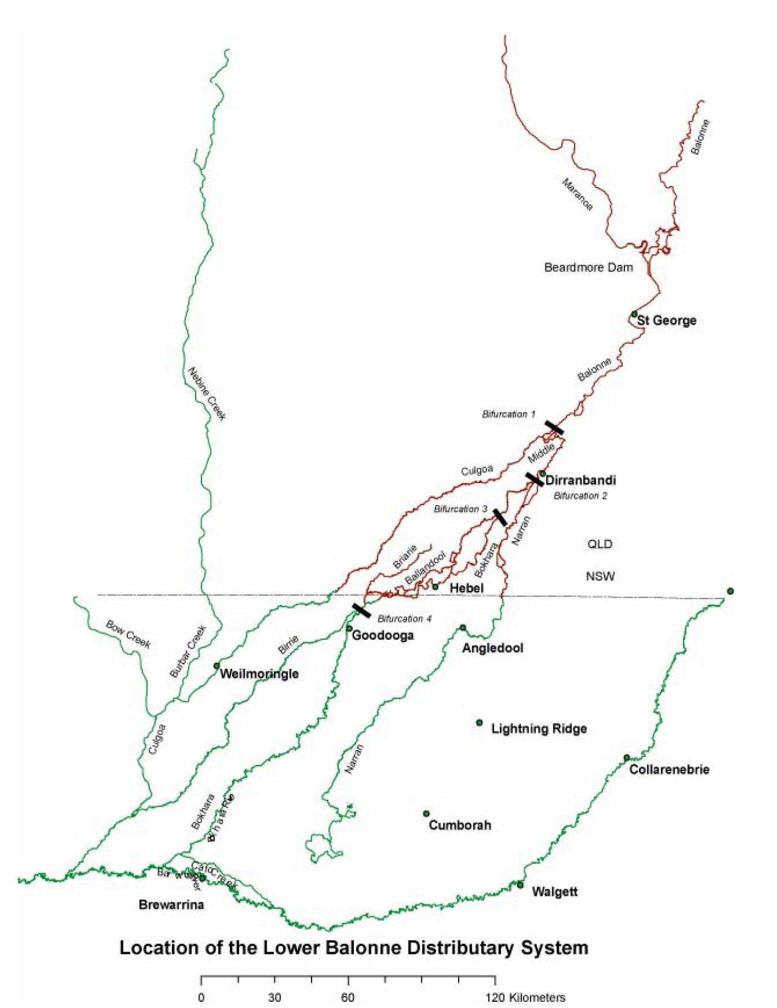
Figure 2. Lower Balonne distributary system and location of bifurcation weirs (from NRW 2007).

We identified three options to better manage flows in the Lower Balonne including; providing regulation gates at Bifurcation Weirs 1 and 2; providing regulators on all 4 bifurcation weir pairs; and raising all the weirs so that larger flows (i.e. low to medium flows) can be regulated were all aligned with the project scope. We also identified a fourth option which considered the use of offstream storages downstream of St George.
Through discussion on economic, social and environmental considerations it was decided in conjunction with the Project Steering Committee to progress the conceptual design of providing regulation gates at Bifurcation Weirs 1 and 2, as well as building a narrative around the potential use of offstream storages.
With the adoption of such an outcome (Options 1 and 4) it was proposed that the system would have the potential to deliver water allocated for environmental purposes to offstream storages on the Narran River. This could then be released from the storages to be added to, or follow on from, flow events in the Narran to enhance environmental outcomes downstream in the Narran Lakes. In this way the water can be delivered to the Narran Lakes at flow rates that minimise losses. The flexibility of this system would also allow operators to direct flows into the Culgoa, Balonne Minor, or Narran systems separately to replenish refugia waterholes during drought periods if required.
The adjustment to Bifurcation Weirs 1 and 2 involve installing a gate into the slot in the exiting weirs so that one or other of the waterways can receive flows preferentially. Given in stream debris is a key consideration it was proposed to use lay flat gates and options of both air bellow and hydraulic ram actuation were considered acceptable.
The hydrology model for the Lower Balonne is built in the Integrated Quantity and Quality Model (IQQM) and its ability to model a system that has ongoing changes to the parameters, (such as continually adjusting the weir crest height based on flow volume and duration) was beyond its capability. A decision was made to understand how effective a change in the low flow would be on the health of the Narran Lakes if there was a permanent change in the direction of the low flows. In order to simulate this the flows for the B1 weirs were adjusted to allow 10% of the low flows go down the Culgoa and 90% down the Balonne –Minor, and for the B2 weirs, 10% to go down the Balonne –Minor and 90% down the Donnegri to the Narran. Flows over the low flow (>1,500 ML/d at Jack Taylor Weir in St George) obviously follow the normal pre development flow distribution.
The results indicated an exceptionally good outcome for the Narran Lakes where the gauge at Wilby Wilby (upstream of the lakes) saw the flows in the low flow segment almost returned to pre development conditions.
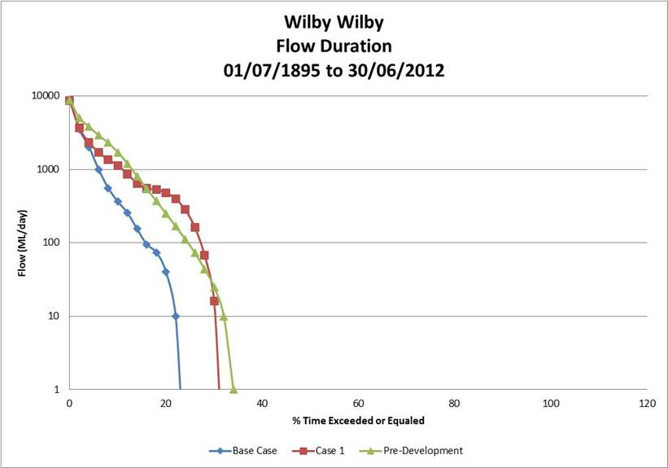
- Figure 3. Gauge data for Wilby Wilby.

However, given there is no additional water in the system the impact on the western side of the system (Culgoa) drove the system further from the pre development case.

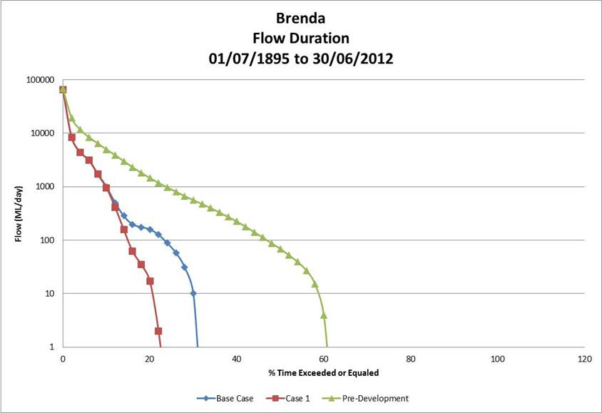
- Figure 4. Gauge data for Brenda.

The modelling outcomes are useful to understand the extent of the benefit that could be provided to the Narran Lakes, but it does not adequately reflect the proposed operation where the gates would be continually adjusted based on previous and anticipated flow events, and only for limited lengths of time.
The relative value of this concept design therefore comes down to the perceived environmental gain in the Narran Lakes as opposed to the perceived environmental loss in the Culgoa system. The environmental assets and ecosystem services that were considered of primary importance for the Lower Balonne system included:
- Narran River system: the Narran Lakes terminal wetlands system (including Narran Lakes Ramsar site – wetlands of international importance)
- Culgoa River system: Lower Balonne Floodplain wetlands and distributaries – (includes the largest number of wetlands in any part of the Murray-Darling Basin)
- In-stream pools and habitat refuges for aquatic invertebrates, fish, frogs, waterbirds, etc. (particularly in the Culgoa River system where longitudinal connectivity in the Murray Darling system is important for native fish passage during migrations).
We note that for any water management options developed to be comprehensive in addressing the environmental water requirements of the Lower-Balonne system, science-based ecological targets and flow indicators also need to be established for the distributary streams located between the Culgoa and Narran Rivers. However until this is resolved, we have assessed options within the context of the existing Water Resource (Condamine and Balonne) Plan 2004 (WRP), Resource Operations Plan (ROP) and ecological targets and flow indicators developed by the Murray Darling Basin Authority (MDBA) for the Lower Balonne River Floodplain and Narran Lakes
If the Commonwealth considered meeting the ecological needs in the Narran Lakes were a higher priority than those of the Culgoa river system, then the proposed concept is a functional and cheap way to achieve this outcome.
However, with further consideration of the use of offstream storages, there is the opportunity to add substantial value to the regulation of the bifurcation weirs. In a general flow event, the water quickly rises above the river banks, spilling onto the floodplain and it is understood that only a small proportion of the water flowing into the Narran System will reach Narran Lakes (meaning that only a small portion of the water purchased by the Commonwealth is actually delivered to the Narran Lakes).
When releases are made for Environmental, Stock & Domestic purposes, it takes in excess of 6,000 ML of total release from St George to get the water to Bifurcation Weir 2. It is estimated another 30,000 ML of water is required to be released to complete the flow through the whole system. There have been occasions in the past when it is time to release stored ESD water before the summer, that the available volume has only been 6,000 ML or less. Although the whole river system required replenishment, the limited water didn’t even reach Dirranbandi.
It is understood that only 14% of the daily rate of water released from St George in an ESD event passes the Narran River Gauging Station 422206A (QLD) at the Dirranbandi – Hebel Road. Therefore only 4,200 ML of the 36,000 ML released from St George passes down the Narran/Donnegri system.
The Narran River water harvesting entitlements purchased by the Commonwealth could in this case be used to fill existing offstream storages. Towards the end of an event, the harvested water could be released back into the river to ensure efficient delivery to the Narran Lakes to assist meeting ecological requirements.
Our initial understanding of the system is that there are already storage systems with spare capacity because of the current buy back of water and that there are a number of additional landholders who would be willing to sell water and make their storages available. Ideally the storages would be below Bifurcation Weir 2 on the Balonne Minor system and upstream of the refuge assets on the Culgoa system. An initial discussion with landholders as part of the consultation process indicated there is likely to be around 56GL of capacity on the Narran River (downstream of Weir 2) and 90GL on the Bokhara and Culgoa system. These storages are largely gravity fed and discharged so there would be few ongoing pumping costs.
It is proposed that the use of offstream storages could have a dramatic impact on the efficiency of water delivered to the Narran Lakes. If the Commonwealth operated an offstream storage facility on the Narran River that it filled using a portion of its purchased water entitlements, then it could have stored water available to release into the Narran River at the critical times.
Benefit costs analysis results
A BCA was conducted for Option 1 (Bifurcation Weirs 1 and 2). In the case of this BCA, costs are based on the estimated capital, operating and renewals annuity costs associated with the weirs.
A comparison with the results of a buyback option suggests that the improvement in the MDBA flow indicators for Narran Lakes (MDBA 2012a) from modification of the weirs would be better than buying back 29,055 ML of allocation along the Balonne-Minor and Narran-Donnegri streams. This analysis also included sensitivity analysis for key inputs and parameters to determine if and how different input values and assumptions would materially change the outcome of the analysis.
Assuming the estimates of substitutability are correct (i.e. modifying the weirs is a substitute for 29,055 ML of water purchases), the net benefits of the weir modifications are very significant. Even where a low benefit is estimated for the water of $608/ML, the potential benefits are worth approximately $18 million dollars.
Even though the substitutability of the weirs for buyback is not well understood, the threshold analysis indicates the lifecycle cost of the weirs is roughly equivalent to the cost of purchasing between 800 and 1,260ML on the open market (depending on cost assumptions used).

Table 4. Results of benefit cost analysis – modification of bifurcation weirs and impacts on Narran Lakes.
Economic measure | Pessimistic | Most likely | Optimistic
Net present value | $16,000,000 | $18,100,000 | $20,000,000
Benefit cost ratio | 20 | 31 | 38
Threshold (minimum savings in water purchases required to justify weirs | 1,260 | 890 | 800

The initial analysis indicates that there is significant economic benefit from modifying the weirs and the project should proceed. Clearly the benefit cost ratio for the modification of the weirs is a superior option to buybacks.
Cost effectiveness analysis and benchmarking
In terms of getting environmental flow to key assets, the modification of the weirs can be seen as a substitute for purchasing more water allocations for environmental flows.
An economic benchmarking exercise was undertaken to compare the lifecycle cost of securing a ML of water from the weirs. This was done under the assumption that modifying the weirs is a substitute for the purchase of 29,055 ML of water in the Lower Balonne. This is particularly useful for comparing options to return water to the environment. Results of the analysis are shown in the table below. Results of the benchmarking exercise indicate that modifying the bifurcation weirs is economically a very attractive option to improve environmental flows. They are significantly more cost effective than other options currently on the table and should be assessed in more detail.
- Table 5. Results of benefit cost analysis.
Benchmarking - $/ML | Pessimistic | Most likely | Optimistic
Bifurcation weirs | $29 | $21 | $19
Restoring the Balance tender ($/ML) | $1,795 | $1,532 | $1,432
Healthy Headwaters ($/ML) | $4,500 | $3,500 | $2,500
On-farm water use efficiency ($/ML) | $5,148 | $4,298 | $3,448

Regarding the offstream storages, a hypothetical example where an off stream storage was purchased and operated that had an effective 20,000ML capacity was explored. If the purchase price was $20 million, the pump assets had a replacement cost of $1 million and a 30 year life, and pumping operating cost were $15/ML, the lifecycle cost per ML would be $1,200/ML. This compares favourably with the cost of recent water purchases via the Restoring the Balance Tender.
Conclusion
We therefore propose that whilst the bifurcation weir modification option essentially takes water from one system to deliver more to another, there is still the potential for water savings. Proceeding with a combination of modification to the weirs and offstream storage use could substantially increase the efficiency of delivering the water currently owned by the Commonwealth to key ecological assets. The extent of the water savings is not able to be specified at this stage and requires further investigation.
The modelled outcomes are useful to understand the extent of the benefit that could be provided to the Narran Lakes if a permanent change to the operation of the weirs was made, but it does not adequately reflect the proposed operation where the gates would be continually adjusted based on previous and anticipated flow events, and only for limited lengths of time
It is proposed that this combination approach is potentially a smart and efficient way to manage the Lower Balonne system and will more efficiently deliver the environmental water already purchased.
Further Work
If the Commonwealth wishes to progress this combination of options on the Lower Balonne system there are a number of tasks that would need to be undertaken to better understand the value proposition.
- The IQQM modelling is restrictive and an approach is required that can be more flexible in accommodating rules associated with changes to the flow characteristics of Bifurcation Weirs 1 and 2, along with the ability to model the extraction and return of water from offstream storages.
- Essentially a model is required that can be used to optimise the system. The modelling would need to be fine enough to represent the ability to extract, store and release water on the tail of higher flows (or as per other key ecological measures). The release would be designed to provide the most appropriate flow regime to shepherd the water to the assets and meet volume, frequency and duration targets. The model would optimise the storages along with manipulation of Bifurcation Weirs 1 and 2.
- We think it would be valuable for the Commonwealth to engage with landholders who own offstream storages to canvass their views on selling water to the Commonwealth and utilising effectively redundant systems in key locations. With a clearer understanding of the opportunity the modelling can be further optimised.
- There is scope to develop an operational plan of manipulating the weir flows to provide both a better ecological outcome for the Narran Lakes and no detrimental impacts to any other part of the system. The ecological assessment needs to be much more detailed to integrate with the modelling. In particular the refuge areas of the Culgoa need to be better understood in the context of fewer low flows. The current Northern Basin Workplan being implemented by the MDBA will be reviewing the science on which the Ecological Sustainable Level of Take for the Basin Plan was based. This should include an assessment of whether the existing ecological targets and flow indicators are suitable. Any findings can be incorporated into future ecological assessments.
- In addition it would be recommended that further work investigate additional options for location and design of fish passage structures on weirs in the Lower-Balonne system. These will include assessment of fish passage needs at instream structures beyond those considered in this study.

Appendix 5 – Fishway options report – executive summary - DPI

Appendix 6 – Pre-feasibility report for Glenlyon Dam Multi-Level offtake - executive summary - SunWater

Based on observed willingness to pay for water for environmental flows from the Restoring the Balance tender and the Healthy Headwaters programmes. Pessimistic value based on lowest average tender sales. Optimistic value based on top end of prices paid under Healthy Headwaters project. Most likely value is the average of the two extremes in values.
Most likely outcome. This is the outcome based on the actual engineering and scientific assessments and the average economic estimates drawn from previous studies, modelling etc. Optimistic outcome. This is the outcome based on an optimistic assessment of potential benefits and costs. Estimates of benefits used are 10% higher than the average used in the most likely outcome, while costs are 10% lower. Pessimistic outcome. This is the outcome based on a pessimistic assessment of potential benefits and costs. Estimates of benefits used are 10% lower than the average used in the most likely outcome, while costs are 10% higher.
http://www.nrm.qld.gov.au/water/trading/pdf/trading_reports/water-report-supp-feb-2013.pdf http://www.nrm.qld.gov.au/water/trading/pdf/trading_reports/water-report-unsupp-feb-2013.pdf
Based in indicative costs to Australian Government for water secured for environmental flows through the Healthy Headwaters program.
Source: National Centre for Engineering in Agriculture and FSA Consulting (2010) An Appraisal to Identify and Detail Technology for Improving Water Use Efficiency in Irrigation in the Queensland Murray Darling Basin

