

Economic output of groundwater dependent sectors in the Great Artesian Basin

A REPORT COMMISSIONED BY THE AUSTRALIAN GOVERNMENT AND GREAT ARTESIAN BASIN JURISDICTIONS BASED ON ADVICE FROM THE GREAT ARTESIAN BASIN COORDINATING COMMITTEE
August 2016

Economic output of groundwater dependent sectors in the Great Artesian Basin

Executive summary v
1 Introduction 1
1.1 Purpose and scope of this report 1
1.2 The GAB 1
1.3 Structure of this report 7
2 Historical role of GAB groundwater 8
2.1 Introduction 8
2.2 Role in Indigenous life and culture 8
2.3 Early development of the GAB 8
2.4 Maintaining the GAB 9
2.5 Challenges 9
3 Economic value of GAB water using activities 12
3.1 Stock use 14
3.2 Irrigation use 17
3.3 Energy and Earth Resources 21
3.4 Urban Water use 30
3.5 Other industries (including tourism) 34
4 Investment in water infrastructure in the GAB 38
4.1 Private On-farm investment 38
4.2 Public investment — GABSI 39
4.3 Value of investment 40
5 Concluding comments 42
Appendix 1: Agricultural data issues and the alignment of GAB to ABS regions 44
Appendix 2: Water licence information 52
References 55

Economic output of groundwater dependent sectors in the Great Artesian Basin
Figures
Figure 1: GAB water use from coal seam gas production in Queensland (ML/yr) viii
Figure 2: Regions of the GAB 2
Figure 3: Land use across the Surat region 3
Figure 4: Land use across the Central Eromanga region 4
Figure 5: Land use across the Western Eromanga region 5
Figure 6: Land use across the Carpentaria region 7
Figure 7: Environmentally valuable sites in the GAB 11
Figure 8: The location, number and size of feedlots throughout Australia 16
Figure 9: Operating mines, new mining infrastructure and mineral processing centres 22
Figure 10: Australia’s gas facilities 23
Figure 11: NSW CSG wells 24
Figure 12: CSG in SE Queensland 26
Figure 13: CSG in central Queensland 26
Figure 14: Associated water from coal seam gas production in the Surat Basin 27
Figure 15: Total tourism expenditure in 2007-08 36
Figure 16: NRM regions 45
Figure 17: NSW and Queensland SA4 regions 46
Figure 18: South Australian and Northern Territory SA4 regions 47

Tables
Table 1: Values dependent on GAB water resources ($ million per year) vi
Table 2: GAB Water licences and estimated use 12
Table 3: Estimated GAB stock water use 14
Table 4: Livestock in GAB regions, 2013-14 15
Table 5: Gross value of livestock industries in GAB regions ($ million), 2013-14 15
Table 6: GAB irrigation water access licences 17
Table 7: Value of GAB irrigated agricultural output 21
Table 8: Queensland mining output that is GAB-dependent 25
Table 9: South Australian mining output that is GAB-dependent 28
Table 10: Estimated value of GAB-dependent mining 29
Table 11: GAB Urban water licences 31
Table 12: Licence Volumes for Local Water Utilities Access Licences in the NSW GAB 31
Table 13: Populations Queensland towns relying on GAB water for urban supply 32
Table 14: GAB Urban water licences and estimated value 33
Table 15: Key tourism and recreation sites supported by the GAB 34
Table 16: Tourism Indicators 2013-14 36
Table 17: GAB bore depth and estimated replacement cost ($ million) 38
Table 18: Government funding over the phases 1-3 of GABSI (nominal $ million) 40
Table 19: Water efficiency investments outside of GABSI 40
Table 20: Estimated government investment by Basin jurisdiction (real $ million 2016) 41
Table 21: Values dependent on GAB water resources ($ million per year) 42
Table 22: Livestock in GAB SA4 regions, 2013-14 48
Table 23: Gross value of livestock industries in GAB SA4 regions ($ million), 2013-14 48
Table 24: Gross value of livestock industries in GAB NRM regions ($ million), 2013-14 49
Table 25: Gross value of crop industries in GAB regions ($ million), 2013-14 50
Table 26: Gross value of Agricultural Production in GAB NRM regions ($ million), 2013-14 51
Table 27: Access Licences and water requirement, GAB NSW 52
Table 28: Water licences and entitlement volumes, GAB Queensland 53
Table 29: Water usage volumes, GAB South Australia 53
Table 30: Estimated NT GAB extraction volumes 54

Executive summary
The Great Artesian Basin (GAB) is a highly valuable water resource which provides locationally diverse benefits and opportunities. The waters of the GAB have:
- been an intrinsic part of social lifestyle and cultural values developed and maintained by Indigenous Australians in arid landscapes
- provided opportunities for the development of low-rainfall areas of Australia through secure access to water
- created economic value through a range of uses including livestock and domestic consumption, irrigation and industrial/mining.
- supported the quality of life and development of more than 120 towns and settlements and economic activity
- sustained infrastructure, lifestyles and local cultures in sparsely populated outback regions
- played host to unique groundwater dependent ecosystems at naturally occurring springs.
Arguably, most of the economic activity in GAB regions is dependent on access to GAB water resources. Without GAB water, economic development in many areas would not have been able to occur. It is also hard to imagine much of the town/urban water use and domestic water use in GAB regions being possible without access to GAB water. In many localities, alternative water supplies are prohibitively costly and total reliance on surface water would significantly reduce liveability. In other areas, such as eastern regions and the far north, other water sources are available and we are unable to differentiate the contributions of GAB water and these other sources of water to regional economic activity.
We estimate that the consumptive use of GAB water is integral to at least $12.8 billion of production annually (Table 1). The provision of drinking water through domestic bores and town water supply has been essential to the development of GAB regions. The non-consumptive benefits of GAB water resources include groundwater dependent ecosystems.
The consumptive water uses by stock (pastoral and intensive), irrigation, and mining, electricity and gas industries are all of high economic value (Table 1). The use of the GAB water resource provides economic value-add to regional resources (land and minerals), and underpins much of the economic activity and employment across the GAB region. For example:
- Stock: There are over 14 million beef cattle for meat production and over 11 million sheep and lambs in GAB regions. Annually the gross value of beef production alone is in excess of $4 billion and sheep contribute a further $600 million.
- Irrigation: While high levels of sodium render untreated GAB water unsuitable for irrigation in many locations, it provides a valuable supplement to surface water for irrigated fodder and horticultural production in some areas. It is estimated that irrigated production using GAB water is valued in excess of $60 million annually.
- Energy and Earth resources: Mining, gas and other opportunities are dispersed across the GAB regions and are valuable economic uses of GAB water. The total value of mining output dependent on GAB water is estimated to exceed $6 billion annually. In addition, coal seam gas (CSG) which is produced by pumping groundwater to release gas from coal seams in the Surat Basin (a sub-basin of the GAB) has grown quickly to $1.7 billion in 2014-15 and could increase further.
The distribution of this production between the GAB jurisdictions (NSW, Queensland, South Australia and the Northern Territory) depends on the location of the companion inputs to production such as grazing land and mineral deposits. Table 1 below sets out the estimated distribution.
Table 1: Values dependent on GAB water resources ($ million per year)
Sector | NSW | Qld | SA | NT | Total
Estimated annual value of output that is dependent on GAB water resources
Stock | 1094.5 | 3004.4 | 105.1 | 463.7 | 4667.7
Mining | 568.3 | 2980.7 | 2801.7 | 0 | 6350.7
CSG | 7.7 | 1693.4 | 0 | 0 | 1701.1
Electricity | 0 | 0.1 | 0 | 0 | 0.1
Irrigated Agriculture | 30.4 | 27.7 | 0 | 0 | 58.1
Urban water | 7.4 | 34.0 | 1.8 | 0.1 | 43.3
Total Value of output | 1708.3 | 7740.3 | 2908.6 | 463.8 | 12821.0
Other values related to GAB water resources
(noting environmental values could not be monetised)
Tourism expenditure | 100.5 | 311.0 | 150.0 | 163.0 | 724.5  (per year)
GABSI Infrastructure expenditure | 118.9 | 148.0 | 13.8 | 0.0 | 280.7  (asset total)
Private Infrastructure investment |  |  |  |  | 5000-15000  (asset total)

Source: Frontier Economics analysis
This report examines the direct economic activity of those sectors dependent on GAB water resources. There are also second- and third-round economic effects related to these sectors. For example, up and down-stream industries that provide inputs and process outputs of the sectors (i.e. farm supplies, mechanics, processors), and the local economy servicing the people working in all these industries. Hence, it could be argued that all of the economic activity in GAB regions is dependent on access to GAB water resources where other water sources are not available.
Significant public and private funds have been dedicated to develop and protect this resource to support its economic, social and environmental values. On-farm investment has been significant with 34,951 bores across the GAB. The vast majority of these bores are less than 200 metres deep, however some bores are deeper than 1200 metres.
The Great Artesian Basin Sustainability Initiative (GABSI) and related state and Territory water planning initiatives have entailed significant effort to manage the GAB water resource to reduce water extractions and maintain or increase pressure. Government funding for GABSI has exceeded $280 million in total (in 2016 dollars). These initiatives have achieved significant reductions in stock and domestic water usage by the pastoral sector, while maintaining or increasing the economic output of the sector. This has been possible because investments have targeted water savings, thereby reducing inefficient usage (uncontrolled bores and open drains).
Looking forward, GAB management will be challenged by new or increased water demand from new or expanding industries:
- The information available on GAB water resource use is limited, with much of the stock and domestic use estimated.
- There are limited opportunities to reallocate water use between existing uses and from existing to new uses. Water trading is hampered due to the challenges associated with hydrologically complex groundwater resources.
- Producing gas resources necessarily involves taking water as a by-product [associated water] which can be significant. The volumes taken tend to diminish over time. There is thus a high degree of uncertainty associated with volumes and reliability over time. In recent years, growth in GAB water volumes extracted by CSG in Queensland’s section of the Surat Basin (Figure 1) has increased significantly.
Figure 1: GAB water use from coal seam gas production in Queensland (ML/yr)
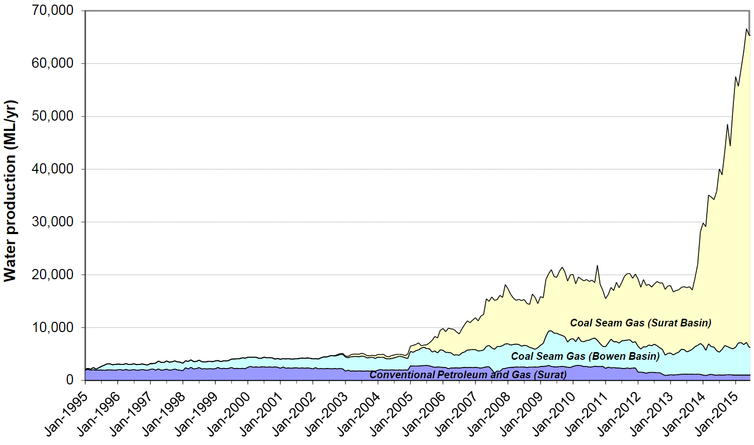

Source:.DNRM 2016, p. 62.

Introduction

Purpose and scope of this report
This report provides an overview of the economic output of groundwater dependent sectors in the Great Artesian Basin (GAB).
The report intent is to provide clarity around current and future water use and users in the GAB and the value of the industries or sectors dependent on GAB water. It is anticipated that the analysis will inform the work of identifying future policy, funding options and incentives for the continued renewal and replacement of the GAB water infrastructure. It will also help inform the development of a new Strategic Management Plan for the GAB.
The report will be a useful resource for GAB stakeholders, particularly the Great Artesian Basin Coordinating Committee (GABCC). The economic value of GAB water was identified by the GABCC as a significant gap in the knowledge of the Basin to inform planning and management decisions within the GAB. The report will help the GABCC achieve an improved understanding of the economic activity within the GAB and allow the committee to provide more informed advice to GAB governments.
It is important to note that this project encountered significant data challenges, which meant that it was not possible to fully isolate the economic value derived directly from GAB groundwater from the other water resources available in the geographic basin.

The GAB
The GAB is one of the largest underground freshwater reservoirs in the world. It underlies approximately 22% of Australia – occupying an area of over 1.7 million square kilometres beneath arid and semi-arid parts of Queensland, New South Wales, South Australia and the Northern Territory. Approximately 70% of the GAB lies within Queensland.
The GAB has been divided into four assessment regions (Figure 2):
- Surat — The Surat region is bounded by the Great Dividing Range to the east and the Eulo and Nebine ridges to the west.
- Central Eromanga — The Central Eromanga region is bounded by major geological structures including: the Birdsville Track Ridge and Toomba Fault to the west, the Euroka Arch to the north, and the Great Dividing Range and the Eulo and Nebine ridges to the east.
- Western Eromanga — The Western Eromanga region is bounded by major geological structures including: the Birdsville Track Ridge and Toomba Fault to the east, the Northern Flinders and Willoran ranges to the south, and several older geological basins to the west and north-west (e.g. the Arckaringa, Pedirka, Warburton and Amadeus basins).
- Carpentaria — The Carpentaria region is bounded by major geological structures including: the Euroka Arch to the south, and the Great Dividing Range to the east of the Carpentaria Basin and to the west of the Laura Basin.
Figure 2: Regions of the GAB
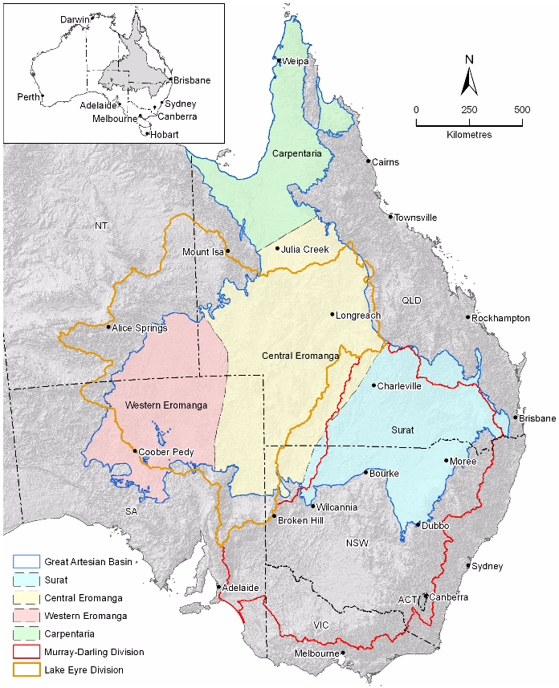

Source: Smerdon et al 2012.

Surat region
The Surat region occupies an area of 440,000 km² of south-eastern Queensland and north-central New South Wales. The Surat Basin in southern Queensland encompasses the Maranoa, Toowoomba and Western Downs regional council areas. Across the border in NSW, the basin extends south as far as Dubbo. As noted in the Surat Basin Regional Planning Framework (2011):
The Surat Basin is renowned for agriculture and quality food production, and energy resources for both domestic and international consumption. These sectors represent the foundations of both population and economic growth, and are vital in securing the quality of life within local and regional communities such as those found in the Surat Basin…While the Surat Basin has, and will retain, a strong and traditional agricultural foundation, it also contains more than six billion tonnes of proven thermal coal reserves which are largely undeveloped and suitable for power generation, both domestically and abroad. The area also has significant reserves of coal seam gas (CSG). CSG is predominantly methane gas, which is also suitable for domestic power generation and export to international markets as liquefied natural gas (LNG).
Figure 3: Land use across the Surat region
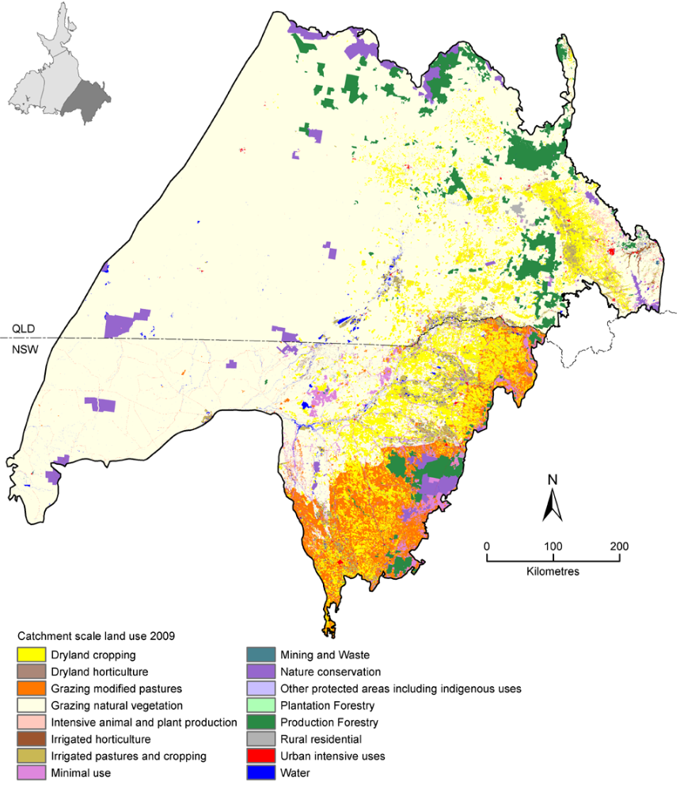

Source: Smerdon and Ransley 2012a.

Central Eromanga region
The Central Eromanga region occupies an area of around 690,000 km² roughly covering the central part of the GAB. It covers parts of Queensland, the Northern Territory, South Australia, and New South Wales. In Queensland and South Australia, the Eromanga Basin has been explored and developed for petroleum production.
Figure 4: Land use across the Central Eromanga region
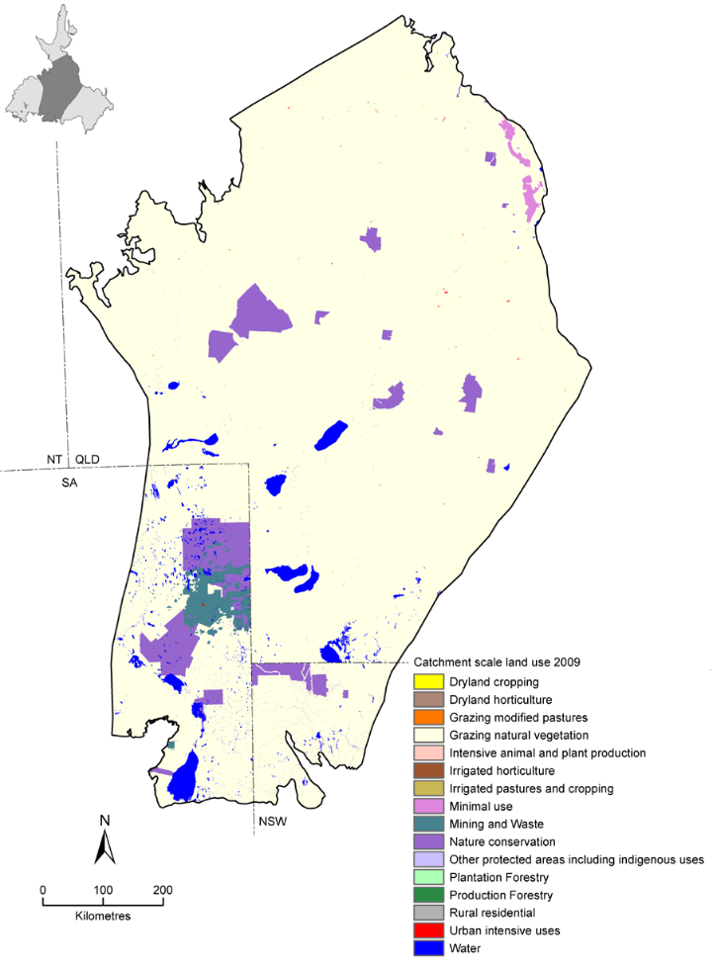

Source: Smerdon and Ransley 2012b.

Western Eromanga region
The Western Eromanga region occupies an area of approximately 370,000 km² and includes the western margin of the GAB.
The Western Eromanga region is centred on the sparsely populated areas of far north-east South Australia, the south-west corner of Queensland and the south-east corner of the Northern Territory. The South Australian portion of the Western Eromanga region includes the Local Government Area of Coober Pedy, while the Queensland portion falls within the Shire of Diamantina. Parts of the western margin of the region also fall within Aboriginal freehold lands of the Maralinga Tjarutja and the Anangu Pitjantjatjara peoples.
Pastoralism is the predominant land use in the region, primarily being beef cattle with some sheep.
Figure 5: Land use across the Western Eromanga region
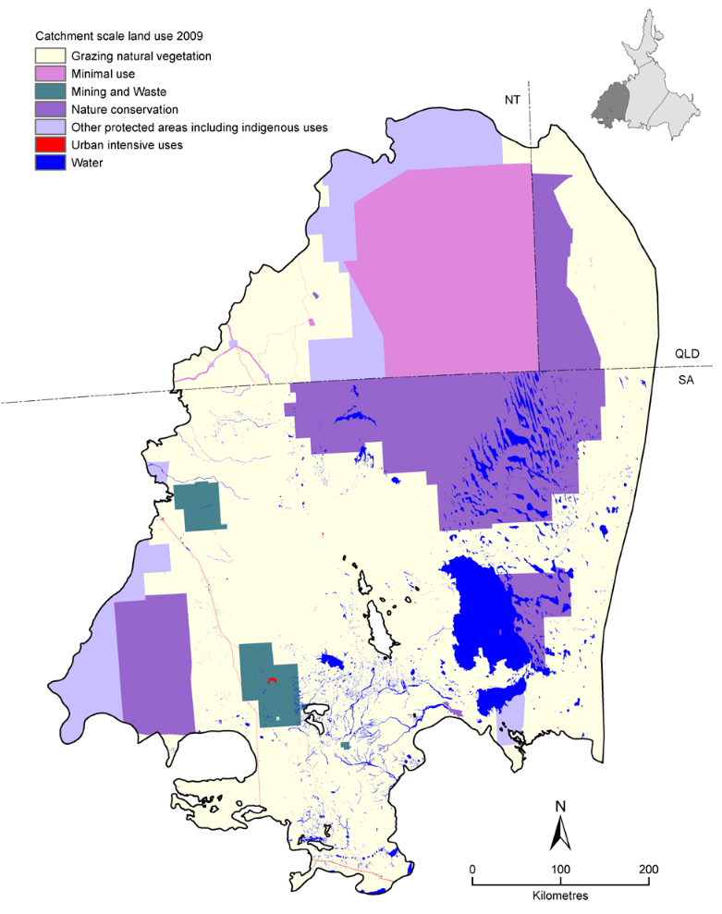

Source: Smerdon, Welsh and Ransley 2012a.
Currently, the main users of water in the GAB in the Western Eromanga region are spring discharge and associated wetlands, pastoralism, the mining and petroleum industries, wetlands, and town and other domestic water supplies. As a collective, the pastoral industry is currently the largest non-environmental user of groundwater in the Western Eromanga region, with bores mainly located in areas south and west of Lake Eyre. However, the biggest single entity extractor of groundwater in the Western Eromanga region is the Olympic Dam mining operation, located just outside the southern extent region. Groundwater for this operation is extracted from two borefield areas within the region located near Lake Eyre South, permitted through a special licensing agreement under the Roxby Downs (Indenture Ratification) Act 1982 (SAALNRMB, 2009).

Carpentaria region
The Carpentaria region occupies an area of 250,000 km² almost entirely within northern Queensland and a small portion of the Northern Territory where the region meets the Gulf of Carpentaria. It includes the Laura Basin (just north of Cooktown), the Carpentaria Basin and the Karumba Basin.
Figure 6: Land use across the Carpentaria region
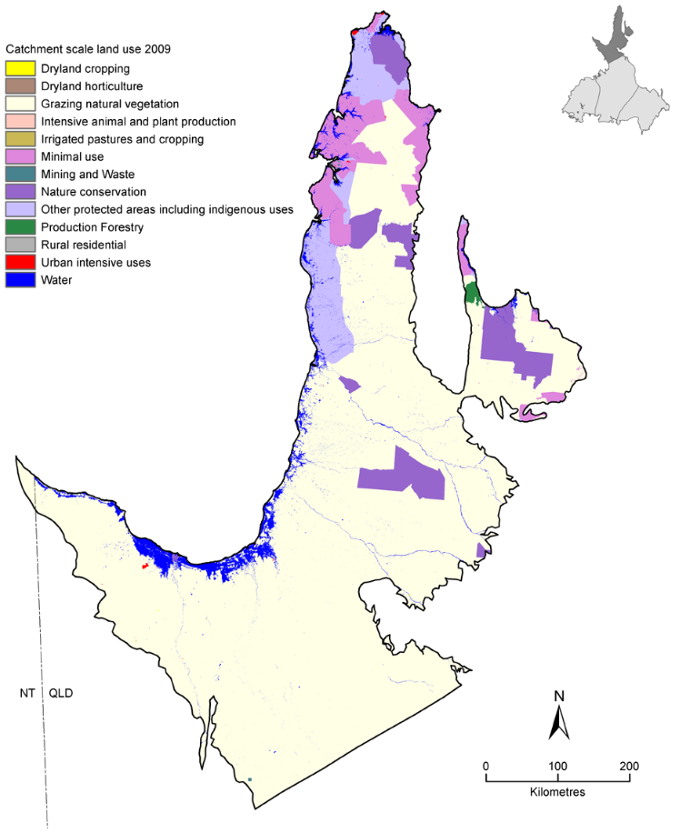

Source: Smerdon, Welsh and Ransley 2012b.

Structure of this report
The remainder of this report is structured as follows:
- Section 2 provides information on the historical role of GAB groundwater.
- Section 3 examines the economic value of key GAB water using sectors.
- Section 4 considers investment in water infrastructure in the GAB.
- Section 5 provides concluding comments and observations.

Historical role of GAB groundwater

Introduction
In order to contextualise the role of the GAB in groundwater dependent sectors today, it is first helpful to understand how the role of the GAB has evolved historically in contributing to the economic, social/cultural and environmental values of the GAB region.

Role in Indigenous life and culture
The first people to make use of GAB water were Indigenous tribes for whom it was critical to survival. Indeed, there is evidence that the GAB sustained Aboriginal people for thousands of years prior to European settlement.
The natural springs of the GAB provided a critical source of fresh water, and supported valuable food sources including birds, mammals, reptiles, crustaceans and insects, creating an abundant hunting ground for local tribes. The plants and trees around the artesian springs were used for food, medicine, materials and shelter. The springs provided semi-permanent oases in the desert and supported trade and travel routes which evolved around them.
The springs also played a key part in the spiritual and cultural beliefs of Aboriginal people. Ceremonies and other events were held at spring wetland areas which remain precious cultural and sacred sites. Numerous Creation stories feature a connection to groundwater.

Early development of the GAB
The springs also sustained life for drovers along the stock routes before the first bores were drilled.
European discovery of GAB groundwater occurred in 1878, when a shallow bore near Bourke in New South Wales produced flowing water. Further discoveries followed quickly—in 1886, at Back Creek east of Barcaldine, and near Cunnamulla, the following year. By 1899 some 524 bores had been sunk. Most bores were allowed to flow freely onto the ground, running into open drains to water stock because the infrastructure to control this flow was not developed.
The discovery and use of water held underground in the GAB opened up thousands of square miles of country away from rivers in inland New South Wales, Queensland, and South Australia, previously unavailable for pastoral activities.
This heralded the arrival of the so-called ‘Artesian age’ where the GAB became an important water supply for cattle stations, irrigation, and livestock and domestic usage. Thousands of kilometres of bore drains from the GAB underpinned the development of many rural communities, providing water for a host of activities. The early settlers used bore water to run steam trains, finally making it possible to travel through the desert in relative speed and safety. Farmers sunk bores on their properties to provide a reliable water source for life on the stock routes. (GABCC 2008).
Bore water was used to clean wool before it was sold overseas. This boosted the value of fleece, and saved money on transport since farmers were no longer paying to ship dirt. (GABCC 2008).
Many inland towns relied on bore water for their everyday needs. Since the 1960's, bore water has been used for the mining of copper, gold, lead, zinc, uranium and silver, as well as oil and gas, and tourists travel from all over the world to explore the incredible landscapes of the GAB region. (GABCC 2008)
The role that GAB water resources have played in the development of areas of inland Australia has also made it culturally significant to non-indigenous Australians as embodied in Banjo Paterson’s Song of the Artesian Water (December 1896).

Maintaining the GAB
Ongoing concerns about groundwater extraction and in particular falling artesian pressures due to inefficient water use and the related natural resource problems, such as erosion around bores and weed invasion, drove the development of a Strategic Management Plan (SMP) for the GAB in the late 1990s. The SMP was agreed to in 2000 and is the first whole-of-basin management plan adopted by GAB jurisdictions. In 1999, the Great Artesian Basin Sustainability Initiative (GABSI), a joint programme between the Australian government and state GAB jurisdictions (New South Wales, Queensland, South Australia and the Northern Territory), was introduced to provide for capping of uncontrolled bores and piping of open bore drains. The GABSI aims to better manage the water by controlling its use, and most importantly, by minimising wastage. The program is now in its fourth phase (GABSI 4) and is due to end in 2016-17 unless further extended.

Challenges
Water has historically been extracted from the GAB at a greater rate than recharge. Many bores were unregulated or abandoned, and a large proportion of the water drawn from the Basin was lost to seepage, and evaporation from bore drains. Even though technologies, practices and regulations have improved, these problems persisted for many decades.
Infrastructure investment, to address this issue of losses and to maintain aquifer pressure, has also brought the challenge of funding that infrastructure maintenance which, if not done, risks the loss of the benefits from investment to date.
There are further challenges posed by newer industries of CSG and shale gas production and also climate change.
While this study focuses on the economic uses of groundwater in the GAB (see section 3), it is important to also recognise other significant values which need to be protected. The Aboriginal cultural values of groundwater-dependent sites remain poorly understood by many non-Aboriginal people. Planning for the future use of GAB water needs to recognise these cultural values. For example, the Water Sharing Plan for the NSW GAB Groundwater Sources acknowledges that access to traditional sources of GAB water may be necessary for continuing Indigenous cultural practices. South Australian and Queensland water management also identifies and protects Aboriginal cultural values. The urgency of these tasks is elevated by the current development pressures placed on the GAB.
The GAB is also important environmentally and its unique ecosystems are home to a host of native plant and animal species, many of which are not found anywhere else in the world (GABCC 2008). As many of the mound springs have dried up, the communities of native species which depend on the natural discharge of groundwater have been declared as endangered ecological communities under the Commonwealth Environment Protection and Biodiversity Act 1999 (GABCC 2014). Figure 7 maps environmentally valuable sites in the GAB.
Figure 7: Environmentally valuable sites in the GAB
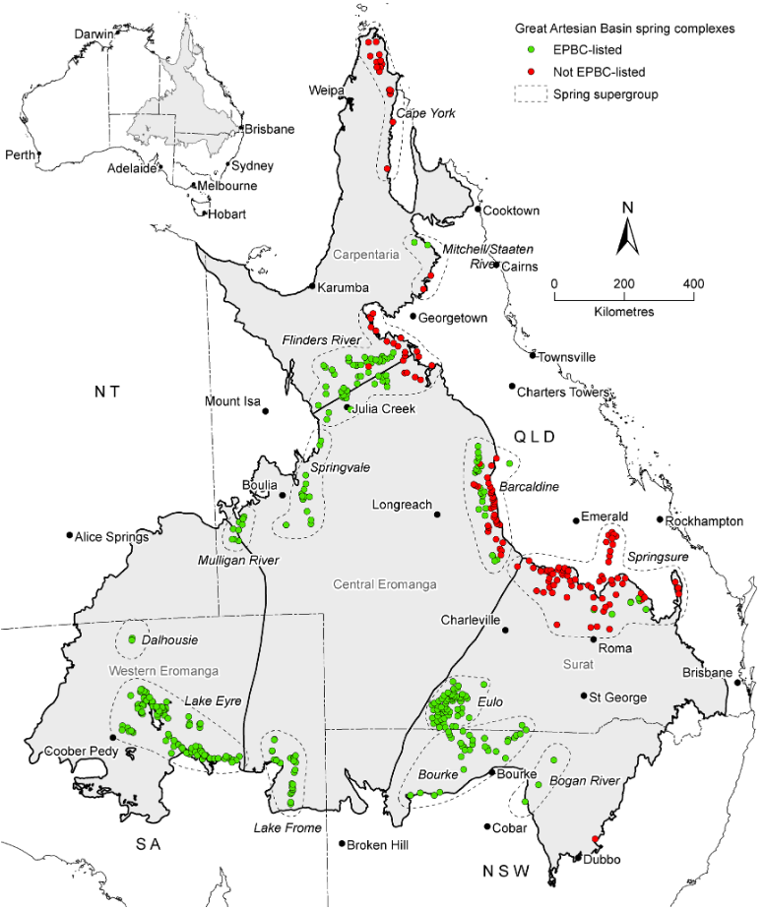

Source: Smerdon et al 2012.

Economic value of GAB water using activities
GAB water resources sustain the lives of more than 180 000 people and 7600 enterprises. Basin water is used in households in more than 120 towns and settlements and on hundreds of properties (GABCC nd).
This report brings together information on the range of economic activities that rely on GAB water resources. The focus of the assessment is on the value of output that is dependent on access to GAB water, and the distribution of this across the GAB jurisdictions.
Arguably most of the output of these areas is due to access to GAB water resources. Without it there might be no towns or industry, except where other water resources are available. The report focuses on primary outputs and their location to inform the future planning for the management and development of the GAB.
The activities undertaken across the GAB regions vary in the nature and extent of their use of groundwater. It is difficult to determine the volume and the use to which all GAB water is applied. In NSW, licences are not granted with particular approved purposes. In Queensland and South Australia, multiple purposes may be listed. In the Northern Territory, stock and domestic water use predominates. Further, the volume of stock and domestic water access across the GAB is generally estimated (not metered) based on regional characteristics (such as stocking rates).
Table 2 below sets out estimated GAB water use / water licence information for the GAB jurisdictions. Further detail is presented in Appendix 2.
Table 2: GAB Water licences and estimated use
Jurisdiction | GAB Estimated Use / Access Licence Volume (ML/yr)
New South Wales  Stock and Domestic  Local Water Utility  Irrigation  Other uses | 56,270  7,028  76,758  11,641
Queensland  Stock and Domestic  Local Water Utility  Irrigation  Mining, Industrial and Commercial  Stock intensive (feedlots)  Gas extraction | 121,759  32,057  32,341  30,909  16,098  65,000
South Australia  Stock and Domestic¹  Local Water Utility ²  Irrigation ³  Mining ⁴  Industrial and Commercial  Co-Produced water  Bore Fed Wetland | 10,438  1,579  115  24,200  934  21,900  2,025
Northern Territory  Stock and Domestic  Local Water Utility  Environmental discharge | 3,150  70  250

Notes: ¹ Based on the licensed allocation which assumes delivery through a water tight delivery system (ie tank and trough). Under current licence conditions, the water tight delivery system will become mandatory in 2019. ² Includes water supply for mining camps. ³ A single licence lists irrigation as a listed use, and other listed uses include Commercial, Bore Fed Wetland and Domestic. ⁴ Includes Olympic Dam.
Source: Appendix 2.
The relative use of GAB water in different activities has informed the following categorisation of GAB water using industries:
- Stock water use (which support pastoral activities), including stock intensive water use
- Irrigation
- Energy and Earth Resources (including Mining, Electricity and Gas)
- Urban Water and Domestic Use
- Other industries (including tourism).
The following discussion looks at each of these activities. For each activity we examine current patterns of water use, the economic value of the activity, and potential future water use taking into account prospects for the sector.

Stock use
Stock and domestic water use and licences for intensive stock water use (such as feedlots) support stock industries reliant on GAB water resources. Stock and domestic includes the pastoral beef and sheep industries that rely on GAB water to keep stock watered.
The availability of GAB water is crucial to this sector, as low and unreliable rainfall makes a sole reliance on surface water risky and impractical for the volumes of water required. A key resource management challenge arises because stock and domestic usage of water is generally unmetered.
Intensive lot feeding of stock has become an important use of GAB water in recent years. While lot feeding to finish cattle and other stock is a distinct activity from the pastoral industry, its economic value is incorporated in Australian Bureau of Statistics (ABS) data on livestock industries and so is included in the discussion.

Patterns of water use
The pastoral industry has long been the largest user of GAB water, although much stock and domestic water use is not metered (volume is estimated) (Table 3).
Table 3: Estimated GAB stock water use
Jurisdiction | GAB Estimated Use / Access Licence Volume (ML/yr)
New South Wales — Stock and Domestic | 56,270
Queensland — Stock and Domestic  Stock intensive (feedlots) | 121,759  16,098
South Australia — Stock and Domestic | 11,846
Northern Territory — Stock and Domestic | 3,150

Source: Appendix 2.
GAB regions are home to vast numbers of beef cattle and sheep. The most recent ABS data indicates that there are more than 14 million beef cattle for meat production and over 11 million sheep and lambs. Stock numbers fluctuate considerably during drought periods.
The majority of cattle grazing on GAB regions are in northern zones (Queensland, NT and northern areas of NSW), while sheep are more prevalent in the southern zones of SA and NSW (Table 4).
Table 4: Livestock in GAB regions, 2013-14
Jurisdiction  (GAB region) | Livestock - Meat cattle - Total (no.) | Livestock - Sheep and lambs - Total (no.) | Total beef and sheep in region (no.)
NSW | 2,292,216 | 8,449,233 | 10,741,449
Qld | 9,447,571 | 2,328,966 | 11,776,537
SA | 252,365 | 260,000* | 512,365
NT | 2,158,388 | - | 2,158,388
Total | 14,150,540 | 11,038,199 | 25,188,739

Note: * This figure was provided by SA DEWNR given the ABS figure of 2,807,084 includes sheep outside of the GAB.
Source: ABS 7121.0

Economic value of the sector
The challenges of accessing agricultural data that is relevant to GAB regions is discussed in Appendix 1 to this report. In this section we attempt to value the sector by using data based on the Australia Bureau of Statistics’ SA4 regions that overlay the GAB.

Production
As shown in Table 5, the value of production from these livestock is in excess of $4 billion annually for beef cattle and $800 million for sheep (meat and wool). In order to confirm these estimates of economic value of production, the ABS data for NRM regions was also analysed and this found a similar total (Appendix 1).
Table 5: Gross value of livestock industries in GAB regions ($ million), 2013-14
Jurisdiction  (GAB region) | Gross value from livestock slaughtered and other disposals - Cattle and calves ($m) | Gross value from livestock slaughtered and other disposals - Sheep and lambs ($m) | Gross value from Wool  ($m) | Total  ($m)
NSW | 629.2 | 207.2 | 258.1 | 1094.5
Qld | 2864.1 | 60.4 | 79.9 | 3004.4
SA | 84.3 | 11.8* | 9.0* | 105.1
NT | 463.7 | 0 | 0 | 463.7
Grand Total | 4041.1 | 279.4 | 347.0 | 4667.7

Note: *Prorated based on the adjustment to the estimated number of SA sheep.
Source: ABS 7503.0

Feedlots
While not reported separately, the gross value of production of feedlots across Australia is significant ($2.5 billion).
Most of the feedlots in Queensland are in the shires overlaying the GAB (Figure 8). NSW commercial feedlots are predominantly in the Eastern Recharge Groundwater Source.
Figure 8: The location, number and size of feedlots throughout Australia
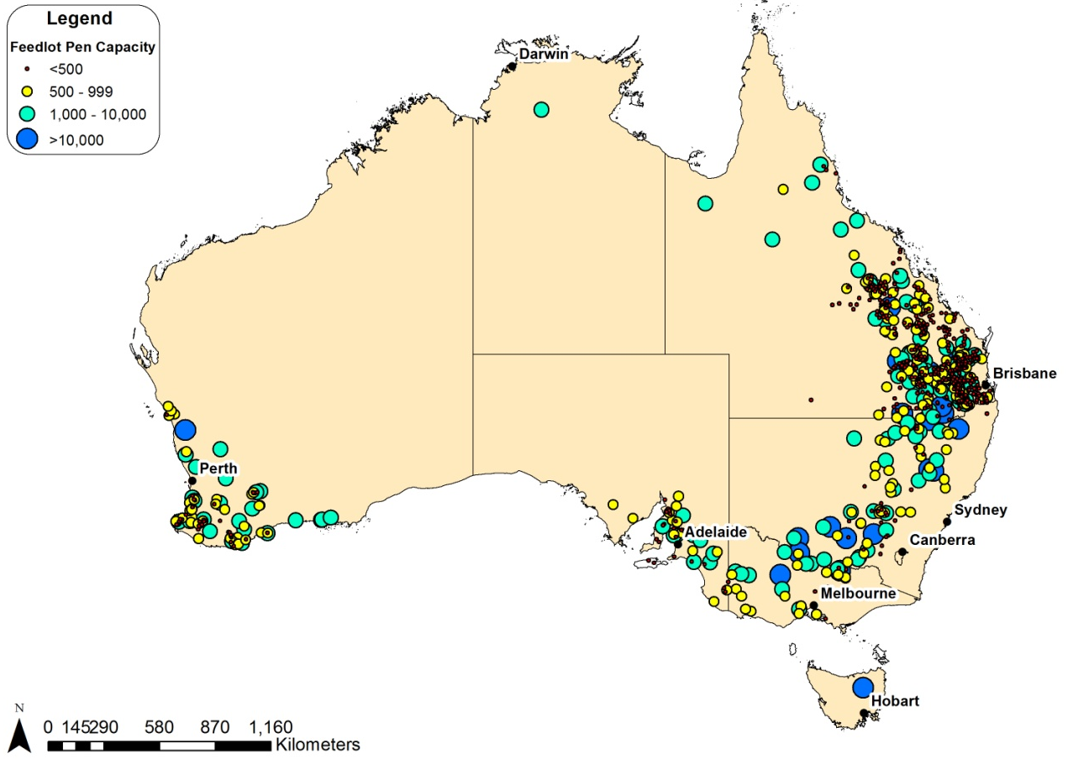

Source: ALFA 2016
Water is used by feedlots for cattle drinking, effluent management, cooling cattle and dust abatement. (ACIL Tasman 2005). ACIL Tasman (2005) report that other intensive stock industries are important GAB water users too, and use piggeries as an example. Deloitte (2015) notes that where a feedlot relies on GAB water, the water is a crucial element in its function and location.
We understand from the ABS data the value of feedlot output is included in the Queensland total value for cattle slaughtered of $2.86 billion.

Potential future water use
The future water use for stock purposes is expected to increase in efficiency as free-flowing bores are progressively capped and bore drains are replaced with pipes and troughs.
Efficient water consumption (inclusive of losses) does not mean reduced industry output. In fact, production could be maintained or increased since the improved infrastructure reduces losses and provides water in a more controlled way that aids farm management (Moore (1992) notes the value of water quality to livestock productivity and the ability to more effectively control undesirable animal pests and weeds). This more efficient management of GAB water will still support the economic outcomes of stock and domestic water use while using less of the GAB resource.
The increasing use of metering should contribute to improved resource use information. For example, in Queensland, mandated meter installation was completed in the Mulgildie and Eastern Downs management areas in 2007 and in the Gatton-Esk Road Implementation Area in 2010. In addition to the mandated metered entitlements, a number of licences in areas such as the Surat, Flinders, Gulf East, Barcaldine West and Barcaldine North management areas have a condition that requires them to meter their take of water (DNRM 2015).

Irrigation use
The use of GAB water for irrigation is localised due to water quality issues. Some GAB groundwater has high levels of sodium or other salts, which renders the water unusable for irrigation in some places, while soil condition may also reduce the viability of irrigation. Water quality and sodicity issues can build up over time with regular irrigation. There are also challenges due to isolation from other farmers, agronomic advice and farm technology providers and the distance to potential markets.
Despite this, a number of different irrigated crop types have been reported using GAB water, including sorghum, lucerne and cotton. GAB water is also used to irrigated limited horticultural crops (such as avocados, mandarins and grapes) though often GAB water is a backup source given both the water quality issues and the higher relative pumping cost compared to using surface water.

Patterns of water use
The table below sets out the volumes of water access licences associated with irrigation water use.
Table 6: GAB irrigation water access licences
Jurisdiction | GAB Access Licence Volume (ML/yr)
New South Wales | 76,758
Queensland | 32,341
South Australia | 115
Northern Territory | -

Source: Appendix 2.

Queensland
The areas overlying and neighbouring the GAB are important contributors to Queensland’s irrigated agricultural area. However, a minimal proportion of this area would use GAB water as the irrigation water source (ACIL 2005).
A current search of the Water Management Database of the Department of Natural Resources and Mines identified total entitlements with irrigation as an approved purpose are 32,341ML per annum spread over 578 licences. In addition to this, there are 154 area-based licences (predominantly in Mulgildie and Clarence Moreton management areas), with irrigable area totalling approximately 5,850 hectares.
Industry contacts suggest that irrigation using GAB water occurs around Goondiwindi.
ACIL (2005) identified that:
- Most irrigation using GAB water is for small areas of fodder production for supplementary feeding of sheep and cattle during dry seasons or to boost fodder quality for particular classes of stock, such as weaner cattle, lambs or dairy cattle.
- Some producers are using GAB water to irrigate lucerne or other crops for sale such as hay, but there are relatively few producers involved. Higher transport costs for fodder from other areas have encouraged the development of these enterprises to supply local markets, especially in western areas of the state.
- There is some limited application for horticulture (tree crops and grapes) in Queensland and typically GAB water is mixed with surface storage water given the high mineral content and high temperatures of GAB water.
Often the GAB entitlement is a backup source given both the water quality issues and the higher relative pumping cost compared to using surface water sources. These other sources could include water captured from overflow and stored on farm dams or publicly owned dams on watercourses (where a water supply charge may apply as well as pumping costs).

NSW
In the past two decades an irrigation industry reliant on GAB water has developed in the Eastern and Southern Recharge Groundwater Sources, where water quality is suitable (NSW Office of Water 2009).
Parts of these areas have been developed for high volume irrigation extraction at two main locations: North Star – Croppa Creek at the northern end of the Eastern Recharge; and near Narromine at the southern end of the Southern Recharge Groundwater Source. Industry contacts suggested that irrigation occurs around Walgett, Moree, Narrabri, and Coonamble, and that GAB water may be blended with surface water for irrigation.
The NSW Department of Primary Industries identified that irrigation would be the primary use for virtually all of the aquifer access licences in Eastern Recharge, Southern Recharge and the 3 Lower Macquarie zones. The Department suggested that there was no significant irrigation in the other water sources.
Therefore, from the licence data presented in Appendix 2, the volume of GAB access licence entitlement associated with irrigation use is estimated to be 76,758 unit shares (if each unit share is utilised to provide 1ML, this would correspond to irrigation use of 76,758 ML).

SA
A single licence lists irrigation as a listed use to the volume of 115 ML per year.

NT
No irrigation using GAB water is reported in the Northern Territory.

Economic value of the sector

Irrigated production (surface and groundwater)
The gross values of crops that may be irrigated with groundwater are difficult to estimate since ABS data does not differentiate between crops irrigated with groundwater and crops irrigated with surface water. There is also the challenge of aligning ABS data regions to focus on the GAB resource. As discussed in Appendix 1, neither ABS SA4 regions nor NRM regions used by the ABS concord very closely with the geographical boundaries of the GAB. When data from NRM regions is considered, the estimates of production from broadacre crops (such as cereal for grain and seed and others) are much lower (as compared to estimates for meat cattle and sheep which were similar between SA4 and NRM approaches). This suggests that the SA4 estimate for broadacre crops above (in excess of $4 billion) is not attributable to production reliant on the GAB.
For this reason, an alternative approach is used to estimate irrigated output dependent on GAB water resources (see below).

Estimated irrigated output (groundwater only)
In light of the difficulties using ABS data that aggregates surface and groundwater irrigated production, we have estimated the value of irrigated agricultural production by considering the volumes of groundwater available that could be applied to different potential crops.
The farm budget (DPI 2012a) for NSW Northern Zone irrigated sorghum (surface irrigation using diesel pump from bore) uses an irrigation rate of 3.8 ML per hectare and suggests a central estimate of yield is 8 tonnes per hectare. An estimate of the on farm value of sorghum can be obtained from daily contract prices, which were around $180 per tonne in March-April 2016 (Broadbent Grain 2016).
The sorghum farm budget (central estimate) suggest that the NSW irrigation volume licences of 76,758 ML (assuming 1ML per unit share) could produce an irrigated crop valued at approximately $29.1 million.
If the northern NSW sorghum farm budget (central estimate) is applied to Queensland, it suggest that the Queensland irrigation volume licences of 32,341 ML could produce an irrigated crop valued at approximately $12.3 million. Using the same farm budget assumptions, the additional area-based licences for 5850 hectares could produce an irrigated crop valued at approximately $8.4 million. This provides a total potential Queensland sorghum crop valued at $20.7 million.
The farm budget (DPI 2012b) for NSW Northern Zone irrigated lucerne (surface irrigation of an established stand) uses an irrigation rate of 8.75 ML to achieve 7 cuts of 1.9 tonne per hectare (giving a central estimate for total yield of 13.3 tonnes per hectare).
The lucerne farm budget (central estimate) suggests that the Queensland irrigation volume licences of 76,758 ML (assuming 1ML per unit share) could produce an irrigated crop valued at approximately $31.8 million.
If the northern NSW lucerne farm budget (central estimate) is applied to Queensland, it suggests that the Queensland irrigation volume licences of 32,341 ML could produce an irrigated crop valued at approximately $13.4 million. Using the same farm budget assumptions, the additional area licences for 5850 hectares could produce an irrigated crop valued at approximately $21.2 million. This leads to a total potential Queensland lucerne farm crop valued at $34.6 million.
No information on irrigated agriculture in SA and NT that relies on GAB water was identified. Therefore it is assumed that the output of GAB-reliant irrigated agriculture in SA and NT is negligible.
Table 7: Value of GAB irrigated agricultural output
GAB Jurisdiction | Value | Central estimate
NSW | $29.1-31.8 million | $30.4 million
Queensland | $20.7-34.6 million | $27.7 million
South Australia | - | 0
Northern Territory | - | 0
Total GAB | $49.8-66.4 million | $58.1 million

Source: Frontier analysis
Given that GAB water is known to also be used for higher value crops such as horticulture, the above estimates based on sorghum/lucerne represents a lower bound estimate.

Potential future water use
The Queensland Department of Agriculture, Fisheries and Forestry identifies potential for further significant agricultural development across Queensland (DAFF 2014). In its 2014 Agricultural Land Audit report, it identified that, based on the biophysical conditions, there is potential for future broadacre cropping particularly in the Surat and Surat East management areas, as well as annual and perennial horticulture opportunities in many areas across the state including the Cape and Surat management areas. There is also potential to increase pasture production in many areas across the state, including the south eastern part of the plan area. License applications for additional water indicate demand from the intensive livestock sector.
Research has recently been undertaken on the potential for intensive, irrigated cropping and livestock production along the alluvial floodplains of the Flinders and Gilbert rivers as part of the North Queensland Irrigated Agriculture Strategy where limited shallow groundwater is available.

Energy and Earth Resources
GAB water resources can be used to directly generate electricity by geothermal generation. Earth resources include mineral and ores, as well as coal, oil and gas, the extraction and processing of which involve GAB water resources.
Mining for copper, uranium, bauxite and opals depend on a reliable supply of GAB water. The extraction of oil and gas from the GAB results in the simultaneous extraction of substantial amounts of water as a waste product. Coal seam gas (CSG) is a rapidly expanding industry, and uses large amounts of water for the life of those projects. Opportunities are being explored for using associated water for economic uses.

Patterns of water use
Mining activity is relatively limited in GAB regions as compared to other parts of Australia. The figure below shows the significant exclusion of mining activity over the blue-shaded area of the map which corresponds to the GAB. The figure presents the operating mines (as at February 2015), mineral processing centres (as at February 2014) and new mining infrastructure (as at November 2013). The numbered sites are discussed in the subsection associated with each Basin jurisdiction.
Figure 9: Operating mines, new mining infrastructure and mineral processing centres
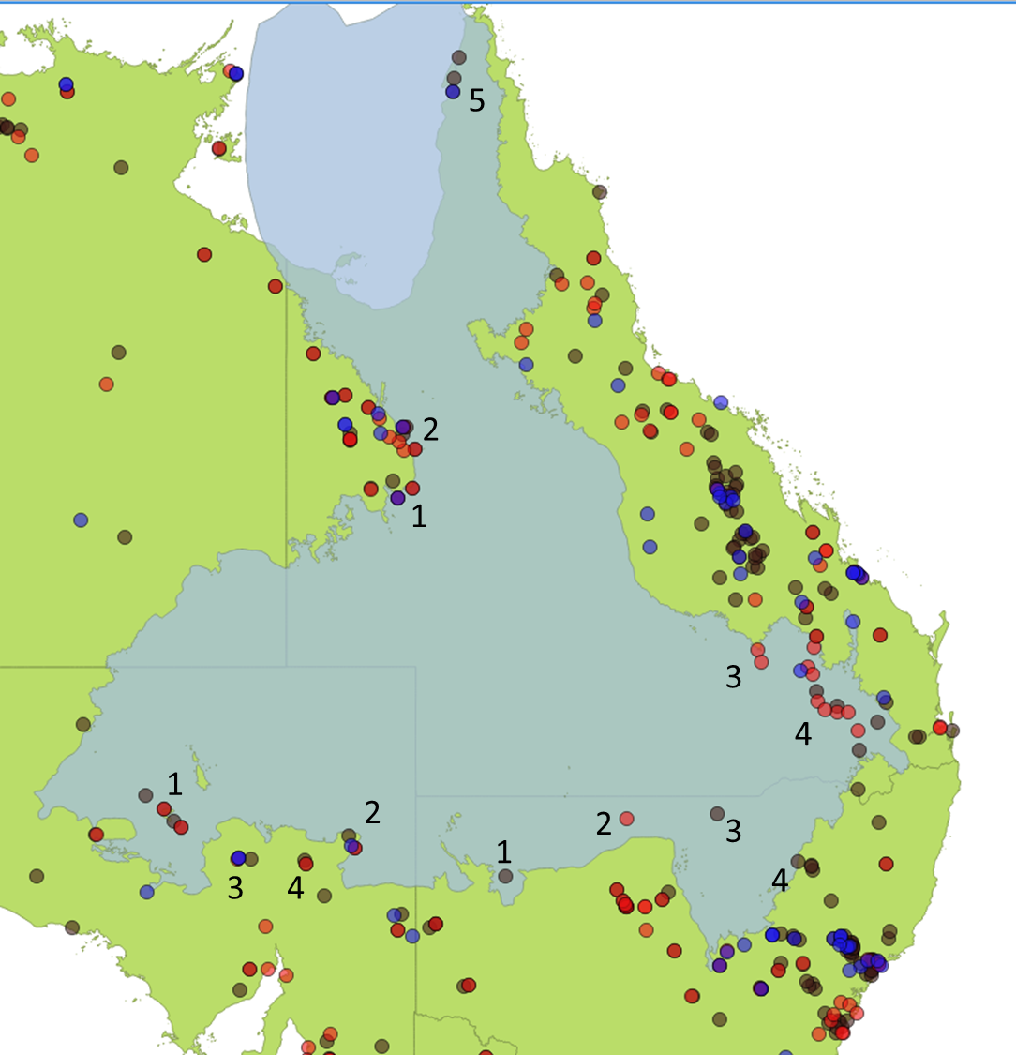

Legend: Brown markers represent operation mines, red markers represent processing plants, and blue markers represent planned developments.
Source: Australian Mines Atlas 2015; Geoscience Australia 2016.
The distribution of CSG projects is concentrated on the eastern parts of the GAB, in Queensland and New South Wales. The GAB underlies much of the Eastern Gas Market and gas basin (Figure 10).
Figure 10: Australia’s gas facilities
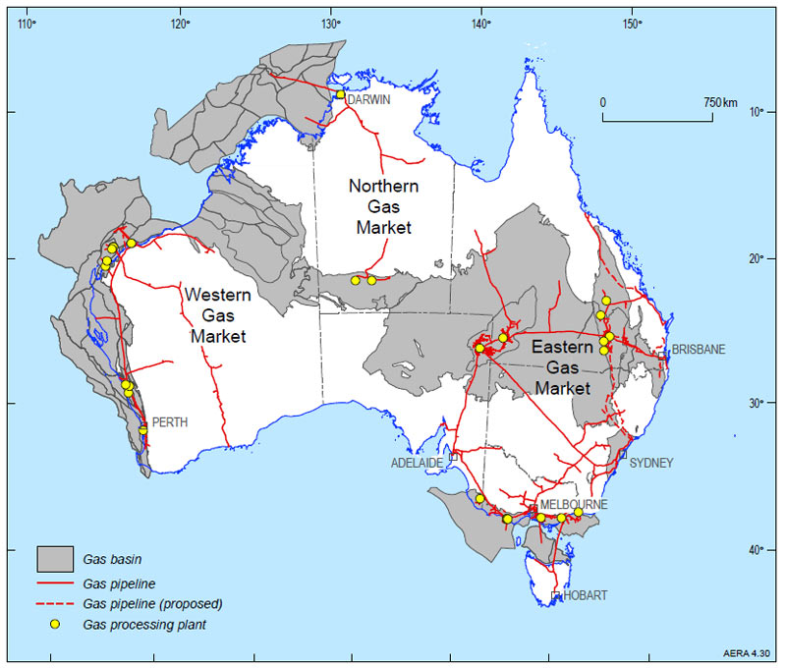

Source: Geoscience Australia nd.

NSW
Mine sites that are overlaying the GAB water resource (Figure 9) include:
  - NSW 1 — overlaying GAB: White Cliffs (Opal) operating mine.
  - NSW 3 — overlaying GAB: Lightning Ridge (Opal) operating mine.
  - NSW 4 — overlaying GAB: Narrabri (Coal – black)
  - (The Australia Mine Atlas entry for NSW 2 is actually an error in the database for Three Springs (WA))
Mining is a modest user of artesian water in NSW and this is primarily associated with the opal mining in the Lightning Ridge and White Cliffs areas (NSW WSP 2009). Water use for Lightning Ridge varies from year to year, but is in part related to the number of agitators operating and the rainfall, and was 25-173ML per year in the period 1997-2002 (the only time series identified) (NSW DPI 2004).
Production of coal at Narrabri was reported to be 7.2Mt in 2015 (Whitehaven Coal 2016).
According to the NSW Government data mapped in Figure 11, there are no producing CSG wells in the NSW areas of the GAB. However, there is still some reported CSG produced as part of exploration activities around Narrabri, of 0.2PJ in 2014 and 1.6PJ in 2015 (pers. comm., APPEA, 6 May 2016).
Figure 11: NSW CSG wells
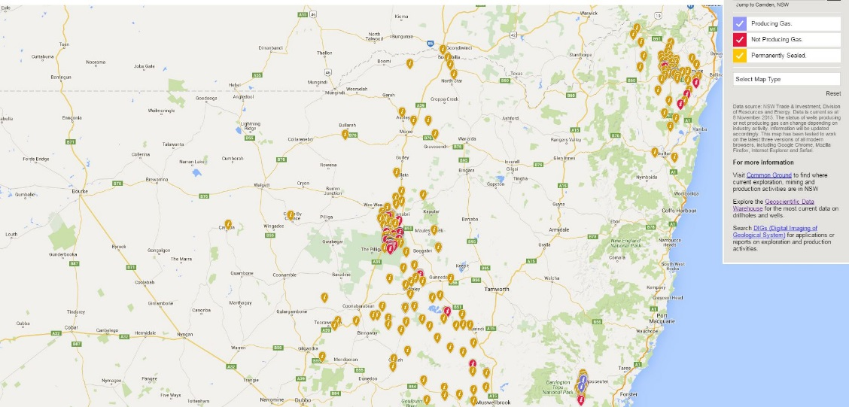

Source: NSW DIRE 2015; NSW Government 2016.

Queensland
Mining industries in Queensland use GAB water for both mineral extraction (mining) and mineral processing. Water use is concentrated in the shires of Cook, Monto, Chinchilla and Jondaryan. Mine sites that overlie the GAB water resource (Figure 9) include:
  - QLD 1 — overlaying GAB: Cannington (Lead, Silver, Zinc, Bismuth, Antimony) operating mine and processing plant; Osborne (Copper, Gold) operating mine, processing plant and proposed magnetite development.
  - QLD 2 — parts of the Mt Isa region overlaying GAB: include Eloise (Copper, Gold, Silver) operating mine and processing plant; Mount Margaret (Copper Gold, Uranium, Uranium Oxide) operating; Ernest Henry (Copper, Gold, Magnetite, Iron ore, Iron) operating mine, processing plant and proposed underground copper mine.
  - QLD 3 — overlaying GAB: Fairview (Coal Bed Methane) processing plant; Spring Gully (Coal Bed Methane) processing plant.
  - QLD 4 — overlaying GAB: Commodore (Coal – black) operating mine; New Acland (Coal – black) operating mine; Kogan Creek (Coal – black) operating mine; Cameby Downs (Coal – black) operating mine; eight Coal Bed Methane processing plants.
  - QLD 5 — overlaying GAB: Skardon River (Kaolin) operating mine; Ely (Bauxite) operating mine; Weipa (Alumina, Bauxite) operating mine and proposed expansion.
These mines produce significant volumes of a range of outputs (Table 8).
Table 8: Queensland mining output that is GAB-dependent
Mining product | Unit | Output
Copper | t | 102,680
Gold | kg | 1,412
Silver | t | 844
Coal | t | 12,836,905
Zinc | t | 69,611
Lead | t | 196,293

Note: This table aggregates production from the following mines: Cannington, Osbourne, Eloise, Mount Margaret, Ernest Henry, Commodore, New Acland, Kogan Creek, Cameby Downs.
Source: Queensland Government 2016a; Queensland Government 2016b.
Coal seam gas (CSG) is another prominent industry in Queensland that interacts with GAB water resources. The Queensland 5-year review of the GAB Water Resource Plan considered the impacts of the CSG industry on GAB groundwater (DNRM 2012).
The largest concentration of CSG wells in the GAB is in south-eastern Queensland (Figure 12), coincident with the coal methane bed processing plants identified in Figure 9. Each yellow marker represents an active CSG well using the most current available data from state websites (as at April 2016). There are also a number of CSG wells in central Queensland (Figure 13).
CSG extraction within the GAB area occurs in the Bowen and Surat Basins (although production from the Bowen Basin occurs from formations deeper than those dealt with in the plan). In the GAB, the CSG industry is most intensively developed in the Walloon Coal Measures (a series of volcanolithic sandstones, coal, mudstones and siltstones, extending over wide areas of the Surat Basin) (Kear and Hamilton-Bruce 2011).

Figure 12: CSG in SE Queensland
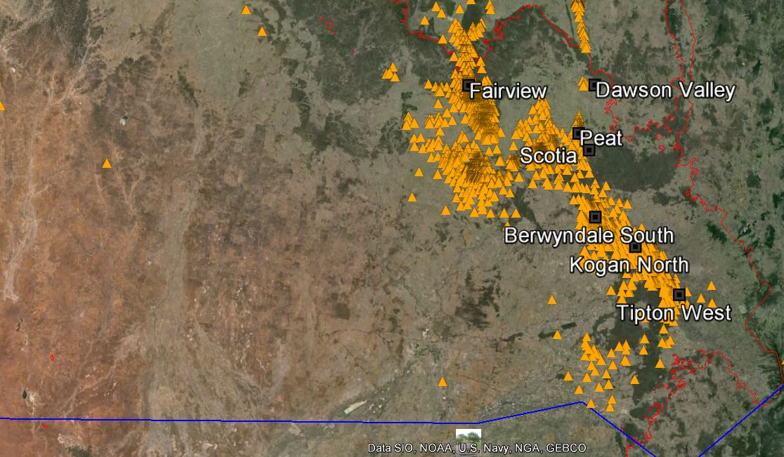

Source: Queensland Government 2015; Geoscience Australia 2016.
Figure 13: CSG in central Queensland
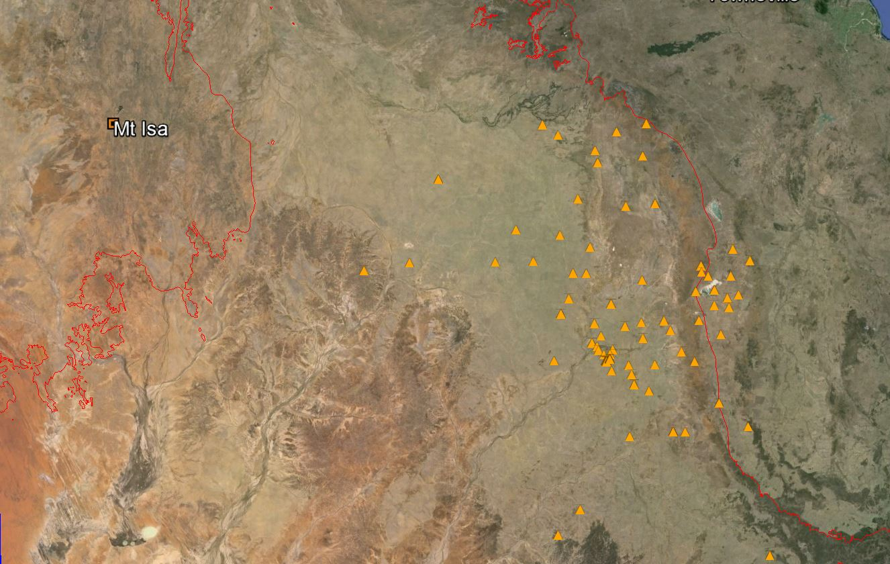

Source: Queensland Government 2015; Geoscience Australia 2016.
There has been an almost four-fold increase in the volume of associated water production from the Surat Basin from 2005 to 2013 (OGIA 2015). The number of producing CSG wells almost doubled in the first half of 2014 and this has increased associated water extraction significantly (DNRM 2015, p. 30).
This increasing trend has continued. The most recent estimate (July 2015) of water extraction from CSG in Queensland is 64,000ML per year (Figure 14). There is also an estimated 1,000 ML per year of water extracted for conventional petroleum and gas. This totals an estimated 65,000ML per year for groundwater extraction associated with Queensland’s petroleum and gas developments. This is not managed under the water entitlement framework, rather through a comprehensive regulatory framework that aims to minimise and or mitigate the impacts of mining and gas development on primary producers and the environment. (pers. comm., DNRM, 11 May 2016).
Figure 14: Associated water from coal seam gas production in the Surat Basin

Source:.DNRM 2016, p. 62.
Conventional gas production (as opposed to CSG) also occurs in GAB regions. A significant resource for this gas is the Cooper Basin, which underlies the GAB. The Queensland Gas Fields Commission (2015) reports that relatively small volumes of groundwater are extracted as a by-product during conventional gas production. SA DEWNR (pers. comm., 28 July 2016)) noted that some Cooper Basin operations in SA currently access GAB water as well as using co-produced water (for example, Santos (2015) report that 1622ML of groundwater was extracted from their SA operations). SA DEWNR also noted that industry is now moving towards using the co-produced water to extract unconventional gas from the Cooper Basin, with this type of extraction is expected to increase in the future.
GAB water is also used for geothermal electricity generation in Birdsville. The plant specification is for water use at 27 litres per second (Ergon 2015), which is 850 ML per year if being continuously operated. The geothermal power station provides 80kW of electricity for customer use which is about 30% of the town’s needs.

South Australia
Mines sites that are overlaying the GAB water resource (Figure 9) include:
  - SA 1 — overlaying GAB: Cairn Hill (Iron, Copper, Gold, Iron Ore) operating mine and processing plant; Coober Pedy (Opal) operating mine; Southern Iron- Peculiar Knob (Iron Ore, Iron) operating mine; Prominent Hill (Copper, Gold, Silver) operating mine and processing plant.
  - SA 2 — overlaying GAB (or very close): Mount Fitton (Talc) operating mine; Beverly (Uranium, Uranium Oxide) operating mine and processing plant; Four Mile potential uranium mine.
  - SA 3 — not overlaying GAB: Olympic Dam (Uranium, Gold) operating mine, processing plant and planned expansion; Andamooka (opal) operating mine
  - SA 4 — not overlaying GAB: Leigh Creek (Coal – black) operating mine (now closed); Mountain of Light (Copper) operating mine and processing plant.
These mines produce significant volumes or a range of outputs (Table 8).
Table 9: South Australian mining output that is GAB-dependent
Mining product | Unit | Output
Copper | t | 284905
Uranium Oxide | t | 4901
Gold | oz | 217555
Silver | oz | 1487349
Iron ore | Mt | 1.235

Note: This table aggregates production from Peculiar Knob, Prominent Hill, Beverly, Four Mile and Olympic Dam.
Source: SA DSD 2016.
The Olympic Dam underground copper and uranium mine is South Australia’s largest mining water user. The primary water supply for the existing Olympic Dam operation is groundwater extracted from Wellfields A and B located in the GAB, about 120 and 200 km north of Olympic Dam, respectively.

Economic value of the sector

Mining
The value of GAB dependent mining outputs was estimated using production data from mines sites that are overlaying the GAB water resource in combination with representative prices for the output commodities. It is important to note that it was outside the scope of the project to confirm that every mine site overlaying the GAB water resource was dependent on GAB water. The Minerals Council of Australia were unable to assist with the provision of this information (MCA, pers. comm., 12 May 2016).
The total value is estimated to be in excess of $6 billion annually, with the bulk of this from Queensland and South Australian production (Table 10).
Table 10: Estimated value of GAB-dependent mining
Jurisdiction | Estimated value ($ million)
New South Wales | 568.3
Queensland | 2,980.7
South Australia | 2,801.7
Northern Territory | -
Total | 6,350.8

Source: Quantity data from tables above. Price data from Indexmundi 2016a-h, and NSW DIRE nd.

CSG
The Queensland area of the Surat Basin produced 352.8 PJ of CSG in 2014-15 (which was 77% of the state’s CSG production) (DNRM 2016).
The value of the Queensland CSG output may be inferred from the Brisbane wholesale gas market where the price was $4.80 per GJ at the Wallumbilla hub (at the end of March 2016) (AEMO 2016). This suggests that a market price of $1 693.4 million for the 352.8PJ.
The reported NSW production of 1.6PJ in 2015 would be valued at $7.7 million if valued on the same basis as above.

Electricity
The Birdsville geothermal plant provides 520,116kWh. Using a representative electricity tariff of 24.462 cents per kWh (Ergon 2016), this can be valued at a maximum of $127,000.

Potential future water use
Two instances of increased future water use have been identified for geothermal power generation in Queensland.
- Ergon Energy is expanding the 80 kW plant to completely meet Birdsville's electricity requirements (from 25%).
- Winton Shire Council resolved to design and construct two 150kW geothermal plants which uses GAB water at a temperature of 86°C, and at a flow rate of 72 litres per second (Reneweconomy 2015).
As the CSG industry continues to expand in Queensland, the amount of associated water taken for gas fields is expected to increase (DNRM 2015).
The Surat Basin Regional Planning Framework (2011) identified that:
The Surat Basin will experience rapid growth over the next 30 years in the mining and gas sector due to increasing domestic and international demand for energy resources. However, it is difficult to accurately predict levels of resource demand. Consumption of thermal coal and CSG for power generation and material production will fluctuate with global economic conditions and the emergence of innovative and cleaner technology for energy production may also impact on demand.
The Minister’s Performance Assessment Report (DNRM 2015, p.20) notes that the current GAB Water Resource Plan (WRP) does not currently consider the potential magnitude of water that may be taken by potential new industries such as the shale gas industry. Queensland is currently reviewing the WRP and water that may be potentially made available to new users will be re-evaluated using updated hydrogeological and environmental assessments.
In South Australia, GAB water use by gas operations may increase in the future due to the use of co-produced water to extract unconventional gas from the underlying Cooper Basin (SA DEWNR, pers. comm., 28 July 2016).

Urban Water use

Patterns of water use
Basin water is used in more than 120 towns and settlements across the GAB. Many of these towns rely on GAB water in combination with surface water supplies, while others are wholly dependent on GAB water for urban supplies. For example, although urban water supplies in Queensland represent only 5% of the total water use from the GAB, a large proportion of towns overlying the resource rely solely on this supply (Cox and McKay 2006).
GABCC (2012) reports total entitlements for urban use from the GAB was 40 341 ML per annum. Town water includes domestic uses as well as limited commercial and specified industrial uses. Domestic uses include drinking water, bathing, washing, watering gardens and other external uses.
Information provided to this report is broadly consistent with this, identifying 40847 ML of licenced annual use (Table 11). Overall, GABCC (nd) reports that GAB water sustains more than 180,000 people.
Table 11: GAB Urban water licences
Local Water Utility jurisdiction | GAB Estimated Use / Access Licence Volume (ML/yr)
New South Wales | 7,028
Queensland | 32,057
South Australia | 1,692¹
Northern Territory | 70
Total | 40,847

Note:¹ This is different to the local water utility licence volume of 630ML/yr since it includes town water use from mining camp licences. The majority of this entitlement was for Roxby Downs (876 ML p.a.), Coober Pedy (475 ML p.a.) and Oodnadatta (32.9 ML p.a.).
Source: Appendix 2.

New South Wales
NSW towns accounted for 7028 ML of entitlement per annum (Table 12). In NSW, at least 42 communities currently source GAB water for town water and domestic supplies.
Table 12: Licence Volumes for Local Water Utilities Access Licences in the NSW GAB
Local Water Utility | Entitlement (ML/yr) | Population
Bourke Shire Council | 252 | 3095
Coonamble Shire Council | 1541 | 4030
Gilgandra Shire Council | 2020 | 4355
Moree Plains Shire Council | 925 | 13429
Narrabri Shire Council | 179 | 14000
Walgett Shire Council | 707 | 7199
Warren Shire Council | 740 | 2900
Warrumbungle Shire Council | 264 | 9808
Brewarrina Shire Council | 50 | 2193
Narromine Shire Council | 350 | 6800
Total | 7028 | 67809

Note: The entitlement (Access Licence Volume) is sourced from DPI Corporate database. The population information is sourced from the web sites of the relevant councils.
Source: Pers. comm., NSW DPI, 6 May 2016.

Queensland
Queensland is the largest user of GAB water for town supply. In Queensland, GAB aquifers supply water for more than 85 towns or settlements. Some 25 towns had an entitlement of less than 100 ML per year, 44 had an entitlement of between 100 and 500 ML per year and 16 had entitlements greater than 500 ML per year. These include Aramac, Barcaldine, Blackall, Charleville, Cunnamulla, Dalby, Longreach, Miles, Millmerran, Mitchell, Quilpie, Roma and St George (ACIL Tasman 2005).
Table 13: Populations Queensland towns relying on GAB water for urban supply
Town | Population
Aramac | 299
Barcaldine | 1655
Blackall | 1588
Charleville | 3728
Cunnamulla | 1641
Dalby | 12,299
Longreach | 3356
Miles | 1588
Millmerran | 1566
Mitchell | 1311
Quilpie | 574
Roma | 6906
St George | 3292

Source: ABS Populations Census 2011.

South Australia
Towns in South Australia accounted for some 1,692 ML of entitlements per annum in 2007. The majority of this entitlement was for Roxby Downs (876 ML p.a.), Coober Pedy (475 ML p.a.) and Oodnadatta (32.9 ML p.a.).

Northern Territory
In the Northern Territory, Power & Water Corp is licensed for 96 ML per year for supply to Finke, but generally extract approximately 60ML per year. The population of Finke is 162 (ABS Population Census 2011).

Economic value of the sector
Clean, reliable and affordable water and wastewater services are fundamental to life, health outcomes and the economy in urban areas across Australia (WSAA 2015). Infrastructure Australia’s recent audit estimated that the urban water sector makes a Direct Economic Contribution of some $10.6 billion across the economy (Infrastructure Australia, 2015).
Like all urban areas, access to water for regional centres and settlements across the GAB is vital to their continued existence and their quality of life. In this sense water is critical to the ability of these centres to service industries and economic activity in the surrounding regions.
In order to estimate the value of urban water provision dependent on GAB water resources, a representative water tariff can be applied to the volume of licenced urban use. Using a representative tariff of the Longreach region charge of $1.06 per kL, provides the results in Table 14.
Table 14: GAB Urban water licences and estimated value
Local Water Utility jurisdiction | Estimated Use / Access Licence Volume (ML/yr) | Estimated value ($ million)
New South Wales | 7,028 | 7.4
Queensland | 32,057 | 34.0
South Australia | 1,692¹ | 1.8
Northern Territory | 70 | 0.1
Total | 40,847 | 43.3

Note:¹ This is different to the local water utility licence volume of 630ML/yr since it includes town water use from mining camp licences and other sources. The majority of this entitlement was for Roxby Downs (876 ML p.a.), Coober Pedy (475 ML p.a.) and Oodnadatta (32.9 ML p.a.).
Source: Appendix 2.

Potential future water use
Additional water supply may be required to support population growth, changes in population distribution, loss of access to surface water, or in response to reduced availability or quality of GAB water at particular sites.
As noted by Infrastructure Australia (2015), growth in the number of properties served by urban water suppliers will generally grow in line with regional population growth. This is likely to vary significantly across the GAB depending on the future growth or contraction of different economic activities (e.g. mining and gas exploration and development).

Other industries (including tourism)

Patterns of water use
GAB water is also a key input into other economic activities across the GAB.
In particular, many tourist attractions and developments across the Basin rely on artesian water. In some areas, artesian water is used in mineral spas and tourists are attracted by the cultural and natural history of springs that are developed as visitor sites. The tourism industry, includes baths, camel treks, Indigenous heritage sites and the Ghan railway. (GABCC 2008). In NSW and Queensland, flowing and non-flowing artesian bores are used for spa-bath tourist facilities in places such as Moree, Lightning Ridge, Boomi, Mitchell, Bedourie and Burren Junction. (Moree Plains Shire Council, 2001).
A list of the key regions and specific tourism and recreations sites partly supported by the GAB is provided in Table 15.
Table 15: Key tourism and recreation sites supported by the GAB
Jurisdiction | Key tourism and recreation sites
NSW | - Moree, various locations - a number of accommodation houses that have access to private artesian spas.  - Bourke, Comeroo Camel Station - multi-faceted tourist retreat with camel riding, private artesian spas, and a working sheep station.  - Pilliga Bore Baths  - Burren Junction Bore Baths – also has accommodation and facilities.  - Lightning Ridge Bore Baths – has several accommodation houses and Bore Baths.
QLD | - Blackall Aquatic Centre - aquatic centre with artesian spa.  - Mitchell Great Artesian Spa Complex - Mitchell's major tourist attraction.  - Cunnamulla, Charlotte Plains Farmstay - a working sheep and cattle property with bore baths.  - Ilfracombe Artesian Spa  - Bedourie Artesian Spa – 22 person Therapeutic Spa and provides for an aquatic centre (built in 2000)  - Cunnamulla Fella Centre – Artesian Time Tunnel, Paroo Shire Council, Eromanga Basin
SA | - Wabma Kadarbu Mound Springs Conservation Park – Blanche Cup and The Bubbler mound springs  - Witjira National Park – Dalhousie Springs

Source: SKM 2014.
While the tourism sector is not in itself a major consumptive user of GAB water, the ongoing health of the GAB springs is vital to the attraction of these sites as tourism destinations.

Economic value of the sector
It has not been possible to estimate the proportion of tourism that is dependent on GAB water resources directly.
As discussed elsewhere in this report, arguably, most of the economic activity in GAB regions is reliant on access to the GAB water resource. Without the water access, economic development would not be viable where other reliable water sources are not available.
Tourism expenditure in GAB regions is significant, however, small compared to tourism in other regions. This is demonstrated in 2011 report by Tourism Research Australia estimates the economic importance of tourism in Australian regions (Figure 15).
The reporting regions for tourism data do not align well with GAB boundaries. This only region clearly relevant is the Queensland outback. Many other tourism indicator regions include GAB regions and also include significant areas of non-GAB areas (and often with greater population density). However, based on the data underlying the above map, an estimate of the tourism expenditure in areas dependent on the GAB is $725 million (Table 16).
In the GAB region of Outback Queensland the economic importance of tourism (as a proportion of the regional economy) was found to be 6.5% (TRA 2011).

Figure 15: Total tourism expenditure in 2007-08
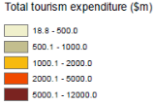
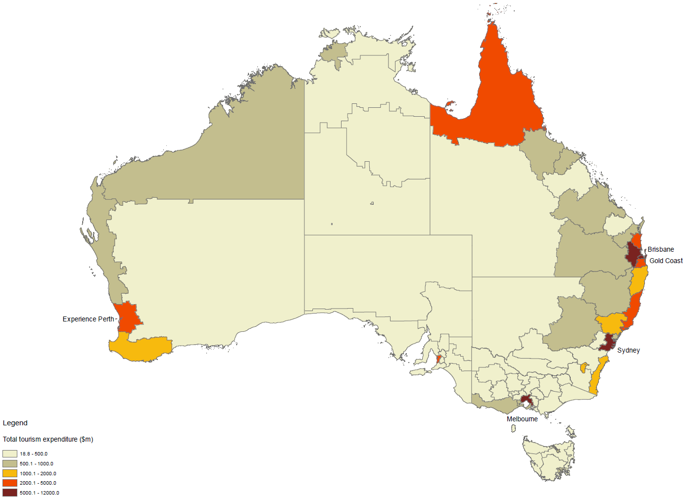

Source: TRA 2011
Table 16: Tourism Indicators 2013-14
Region | Total overnight visitors (‘000) | Tourism Businesses* | Tourism expenditure ($m)
Outback Queensland | 237 | 611 | 311
Outback NSW | 347 | 500 | 201
Darling Downs | 1832 | 3057 | 1201
Tropical North Queensland | 2317 | 3643 | 2752
SA Flinders Ranges and Outback | 451 | 550 | 300
NT Lasseter | 257 | 9 | 326
Estimate for GAB-type regions^ | 765 | 1141 | 725

Notes: * 2012-13 since 2013-14 not reported. ^ A conservative estimate includes all of tourism activity in Outback Queensland, and half of tourism activity in Outback NSW, SA Flinders Ranges and Outback, and NT Lasseter. Tropical North Queensland and Darling Down are excluded due to the expectation that most activity tourism activity in these areas is outside of GAB overlaying regions and not reliant on GAB water access.
Source: TRA 2016.

Potential future water use
Natural springs and environmental tourism depend on GAB water pressure being maintained.
The overall size of the tourism industry is small in most of the GAB area. Although there may be a gradual increase in visitation and spend there is no information expecting a rapid change. At present there are few water-related attractions and water’s key role is in sustaining tourism infrastructure.

Investment in water infrastructure in the GAB
This study also sought information on the asset value of capping and piping infrastructure in the GAB based on replacement value.
In doing so we have drawn on public information where available and input from jurisdictions.

Private On-farm investment
There are an estimated 34,591 bores across the GAB (Table 17). The vast majority of these bores are less than 200 metres deep, however some bores are deeper than 1200 metres.
Table 17: GAB bore depth and estimated replacement cost ($ million)
Bore depth (m) | Number of bores | Estimated replacement cost ($ million)*
0-200 | 23507 | 952.7
200-400 | 4879 | 684.7
400-600 | 1687 | 459.6
600-800 | 722 | 244.3
800-1000 | 441 | 198.8
1000-1200 | 385 | 201.4
>1200 | 1162 | 2011.9
No depth data | 1808 | 73.3^
Total | 34591 | 4826.6

Note: *Estimated replacement cost is based on the GABCC estimate for SA, NT and NSW bores and extrapolated across Queensland bores. ^ Assuming bores with no depth data are 0-200m deep.
Source: GABCC 2016; Queensland DNRM, pers. comm., 12 April 2016.
It is estimated, that 87% of bores in Queensland are landholder owned. Since 1954, all artesian bores have had to supply water via fully reticulated water systems. This means that the majority of bores which are for water supply would therefore have surface pipes, tanks and troughs.
The private benefits of capping and piping are wide ranging and significant. CIE (2003) identified potential benefits including:
- The elimination of all costs associated with bore drain maintenance and repairs, such as delving, repairing breakouts and bore drain inspections
- Reduced mustering times and much simplified mustering processes
- Better utilisation of all natural resources on the property through better water distribution
- more flexible and efficient property management — by controlling watering points, properties can be rotationally grazed, improving native vegetation and livestock performance
- having clean water for stock to drink
- having pressure and clean water at the homestead
- ability to better control vertebrate pests, thereby reducing control costs
- reduced costs of controlling weeds which can be spread along bore drains
- increased pumping costs avoided where artesian wells might otherwise turn subartesian
- increased security of water supplies, thereby reducing management anxiety
- improved scope to better manage in times of drought.

Public investment — GABSI
GABSI funding for phases 1–4 has totalled $230 million over fifteen years (Table 18). Between 1999-00 and 2012-13, 647 bores have been controlled, 19,178 kilometres of bore drains deleted, and 28,345 kilometres of piping installed. These works have resulted in estimated annual water savings of 204,527ML. These savings are distributed between the states as follows: New South Wales (64,971 ML per year); Queensland (119,217 ML per year) and South Australia (20,338 ML per year) (SKM 2014).
The GABSI has involved extensive funding and facilitation by governments (see Table 17 below), and landholder contributions (both cash and in-kind). For example, in Queensland, during Stage 3 of GABSI alone it is estimated that landholders contributed $12.8 million in cash and about $4.7 million through in-kind contributions, across 230 projects (DNRM 2014). Over the 15 years of this program a total of $53 million dollars and in-kind investment was provided by landholders. In New South Wales, landholder contributions are estimated to have been $87.1 million. In South Australia, landholder contributions have been $3.7 million.

Table 18: Government funding over the phases 1-3 of GABSI (nominal $ million)
Funding source | Phase 1 (1999/2000 – 2003/2004) | Phase 2 (2004/2005 – 2008/2009) | Phase 3 (2009/2010 – 2012/2013) | Remaining Phase 3 (2013/2014) | Total
Commonwealth | 28.39 | 39.89 | 30.95 | 15.83 | 115.06
South Australia | 1.75 | 0.20 | 2.25 | 1.60 | 5.8
New South Wales | 12.34 | 15.79 | 13.00 | 7.40 | 48.53
Queensland | 13.23 | 23.88 | 16.49 | 6.83 | 60.43
Total (government) | 55.71 | 79.76 | 62.69 | 31.66 | 229.82

Source: SKM 2014
GABSI built on earlier initiatives that targeted uncontrolled bores, and inefficient bore drains. For example, in Queensland, the GAB Rehabilitation Program was active 1989 to 1998, and the Bore Drain Replacement Program was active 1994 to 2000. Table 18 sets out water savings from water efficiency investments outside of GABSI.
Table 19: Water efficiency investments outside of GABSI
Flow Saved
(ML/annum)
NSW | 9,051
Queensland | 69,141
South Australia | 39,420

Source: SKM 2014; Data request responses from jurisdictions.

Value of investment
The value of this investment is significant. One approach to estimating this value is the cost of the infrastructure, where recent build cost would approximate replacement cost.
The GABSI investment in each Basin jurisdiction can be estimated by prorating the Commonwealth contributions to GABSI between the Basin jurisdictions in line with their contributions. Given these investments have occurred over an extended timeframe, the expenditure can be compared by inflating these estimates by CPI to obtain estimated funding in 2016 dollars (Table 20).
Table 20: Estimated government investment by Basin jurisdiction (real $ million 2016)
 | Phase 1 | Phase 2 | Phase 3 | Phase 4 | Total
NSW | 36.1 | 39.5 | 28.0 | 15.3 | 118.9
Queensland | 38.7 | 59.7 | 35.5 | 14.1 | 148.0
South Australia | 5.1 | 0.5 | 4.8 | 3.3 | 13.8
Northern Territory | 0.0 | 0.0 | 0.0 | 0.0 | 0.0
Total | 280.7

Source: Frontier Economics analysis
The total cost of surface water infrastructure in the Basin may be extrapolated across all GAB water supply bores using data from the GABSI program as it is likely that water distribution systems put in place are of similar scale, with or without rehabilitation funding.
If this approach is applied to the 34,591 bores across the GAB, rather than the 647 bores controlled under GABSI, then the expected replacement cost of all bores and associated water distribution systems is in the order of $15 billion dollars.
GABCC data suggests that the replacement cost of the 34,591 bores only is estimated to be nearly $5 billion (Table 17).
The value of private investment is therefore expected to lie in the range of $5-15 billion.

Concluding comments
The GAB is a highly valuable water resource which provides locationally diverse benefits and opportunities. Arguably, most of the economic activity in GAB regions is dependent on access to GAB water resources. Without GAB water, economic development in many areas would not have been able to occur. It is also hard to imagine much of the town/urban water use and domestic water use in GAB regions being possible without access to GAB water. In many localities, alternative water supplies are prohibitively costly and total reliance on surface water would significantly reduce liveability. In other areas, such as eastern regions and the far north, other water sources are available and we are unable to differentiate the contributions of GAB water and these other sources of water to regional economic activity.
We estimate that the consumptive use of GAB water is integral to at least $12.8 billion of production annually (Table 21). The provision of drinking water through domestic bores and town water supply has been essential to the development of GAB regions. The non-consumptive benefits of GAB water resources include groundwater dependent ecosystems.
Table 21: Values dependent on GAB water resources ($ million per year)
 | NSW | Qld | SA | NT | Total
Estimated annual value of output that is dependent on GAB water resources
Stock | 1094.5 | 3004.4 | 105.1 | 463.7 | 4667.7
Mining | 568.3 | 2980.7 | 2801.7 | 0 | 6350.7
CSG | 7.7 | 1693.4 | 0 | 0 | 1701.1
Electricity | 0 | 0.1 | 0 | 0 | 0.1
Irrigated Agriculture | 30.4 | 27.7 | 0 | 0 | 58.1
Urban water | 7.4 | 34.0 | 1.8 | 0.1 | 43.3
Total Value of output | 1708.3 | 7740.3 | 2908.6 | 463.8 | 12821.0
Other values related to GAB water resources
(noting environmental values could not be monetised)
Tourism expenditure | 100.5 | 311.0 | 150.0 | 163.0 | 724.5  (per year)
GABSI Infrastructure expenditure | 118.9 | 148.0 | 13.8 | 0.0 | 280.7  (asset total)
Private Infrastructure investment |  |  |  |  | 5000-15000  (asset total)

Source: Frontier Economics analysis
This report examines the direct economic activity of those sectors dependent on GAB water resources. There are also second- and third-round economic effects related to these sectors. For example, up and down-stream industries that provide inputs and process outputs of the sectors (i.e. farm supplies, mechanics, processors), and the local economy servicing the people working in all these industries. Hence, it could be argued that all of the economic activity in GAB regions is dependent on access to GAB water resources where other water sources are not available.
The GABSI and related state and territory water planning initiatives have entailed significant effort to manage the GAB water resource to reduce water extractions and maintain pressure.
These initiatives have achieved significant reductions in stock and domestic water usage of the pastoral sector, while maintaining or increasing the economic output of the sector. This has been possible because investments have targeted water savings, thereby reducing inefficient usage (uncontrolled bores and open drains).
Developments in the gas industry require additional access to GAB water, and these volumes can be substantial. In recent years, growth in water volumes extracted by CSG in Queensland has increased significantly. This finding is based on data up to July 2015, and no information was available for the following 11 months to establish if the trajectory of high growth had continued.

Appendix 1: Agricultural data issues and the alignment of GAB to ABS regions
The ABS report agricultural data down to the SA4 and NRM level. However, concordance of the boundaries of these regions with the hydrological boundaries of the GAB is poor.
Previous analysis has attributed economic activity in proportion to the overlapping area of the ABS region, however this assumes that the economic activity is evenly distributed across the ABS region. In fact, economic activity is unevenly distributed to the location of population, farms and businesses. The distribution can by more uneven when more specialised economic activities are considered — such as mining, with is highly localised at the mine site.
The most accurate measure would be to obtain customised ABS datasets which are matched to GAB regions. This is possible since ABS data is geocoded. It may be possible to obtain such data, however data will not be released if the number of relevant data point drops below the minimum that may jeopardise privacy. The use of customised boundary data would not aid in identification of output from irrigation with surface or groundwater since this much of the irrigation of land overlying the GAB uses surface water.
The NRM regions relevant to the GAB include:
- NSW
  - The GAB is contained within the North West, Central West and Western NRM regions. However, significant amounts of these NRM regions are also outside the area of the GAB.
  - Other NRM regions not associated with the GAB are Central Tablelands, Greater Sydney, Hunter, Murray, Northern Tablelands, Northern Coast, Riverina, South East.
- Queensland
  - The GAB underlies significant areas of the NRM regions South West Queensland, Border Rivers Maranoa–Balonne, Fitzroy, Desert Channels, Southern Gulf, Northern Gulf, and Cape York regions, as well as small areas of Condamine and Burnett Mary NRM regions.
  - Other NRM regions not associated with the GAB are Burdekin, Mackay Whitsunday, South East Queensland, Torres Strait, Wet Tropics.
- South Australia
  - South Australian Arid Lands
  - Other areas (Alinytjara Wilurara, Eyre Peninsula, Kangaroo Island, Adelaide and Mount Lofty Ranges ,South Australian Murray Darling Basin, Northern and Yorke, South East) are mostly/all outside the GAB
- NT
  - NT — the entire Northern Territory is a single NRM region. The GAB underlies only a small proportion of this region.
Figure 16: NRM regions
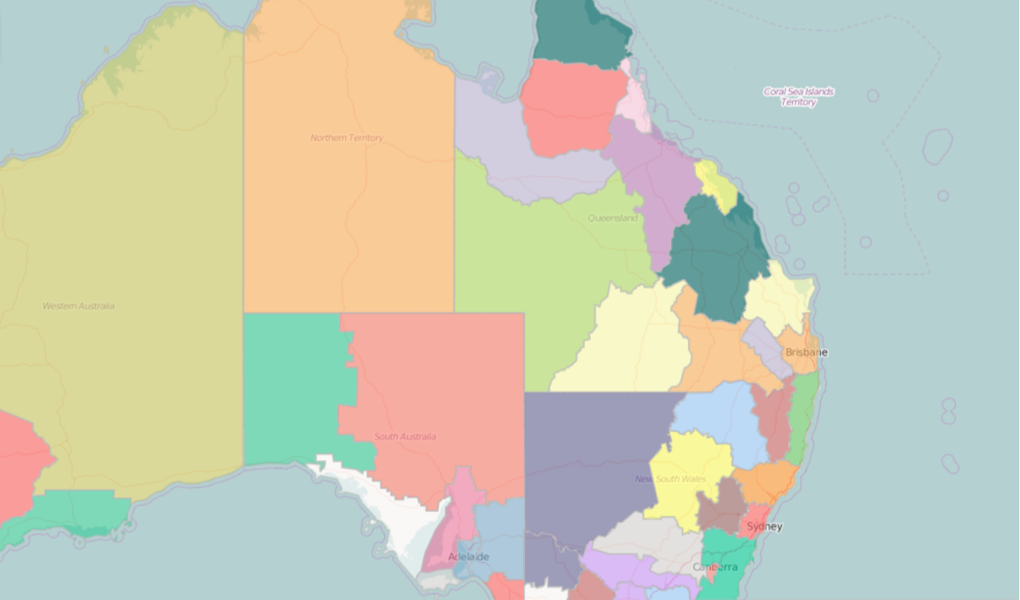

Source: http://nrmregionsaustralia.com.au/nrm-regions-map/
The ABS SA4 concordance is similarly problematic. The SA4 regions relevant to the GAB include:
- NSW
  - The GAB underlies significant areas of the SA4 regions Far West and Orana (105) and New England and North West (110).
- Queensland
  - The GAB underlies significant areas of the SA4 regions Queensland – Outback (315), Darling-Downs – Maranoa (307). It also underlies some of Fitzroy (308), and very small amounts of Townville (318), Wide Bay (319) and Mackay (312).
- South Australia
  - SA – Outback (406), although significant amounts of this region is also outside the area of the GAB.
- NT
  - NT – Outback (702), although the vast majority of this region is also outside the area of the GAB.
Figure 17: NSW and Queensland SA4 regions
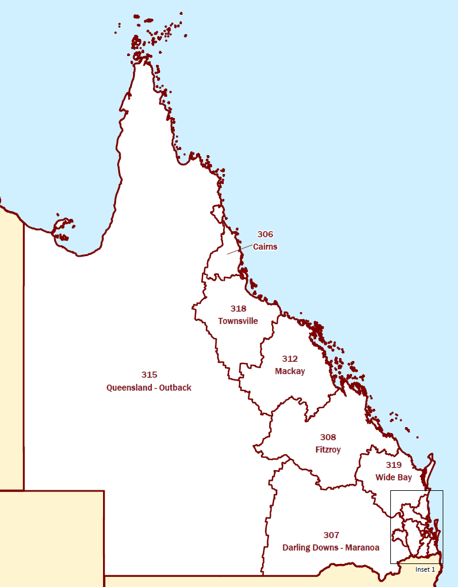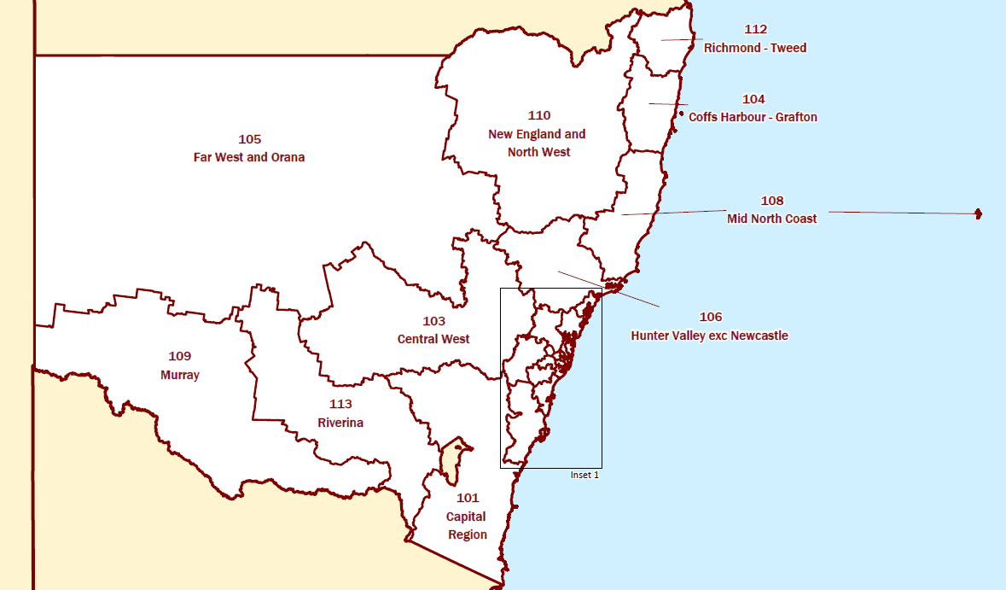

Source: ABS 1270.0.55.001
Figure 18: South Australian and Northern Territory SA4 regions
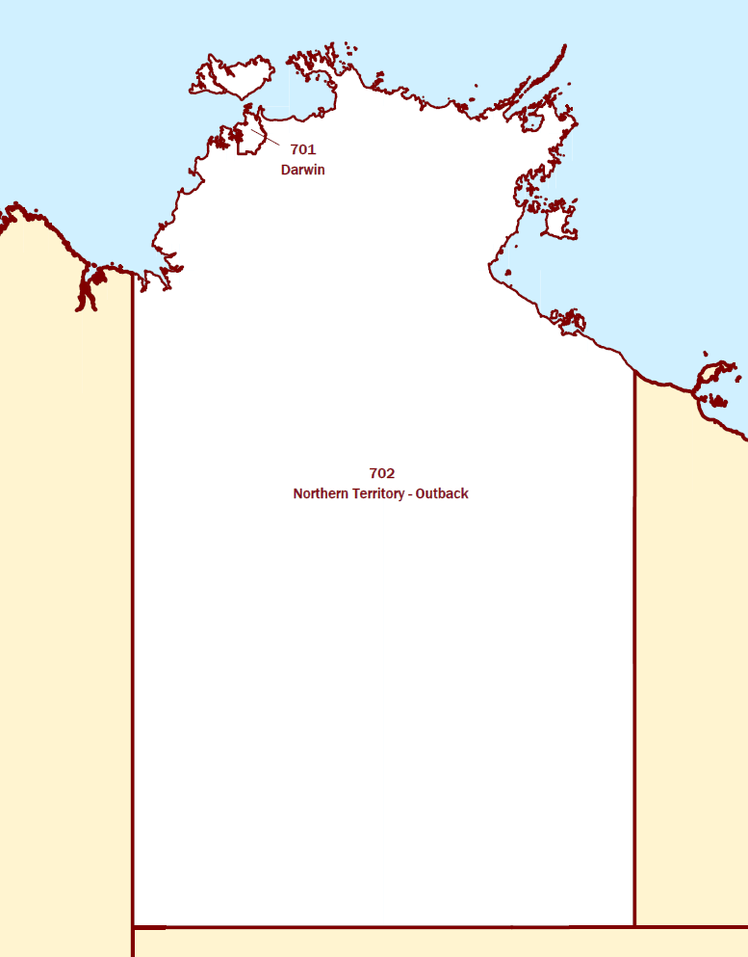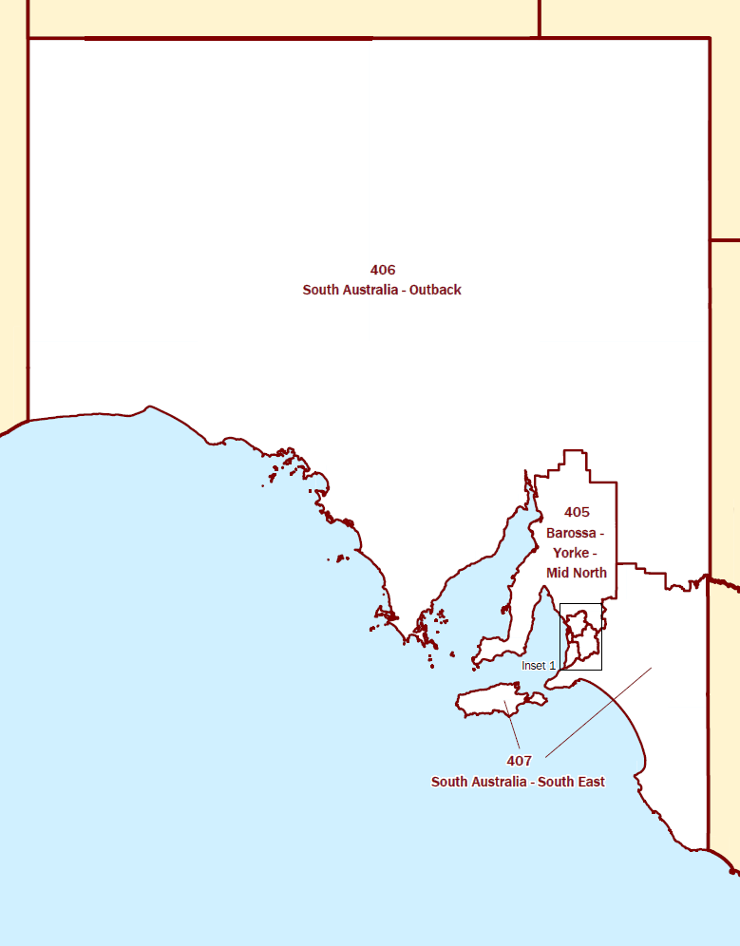

Source: ABS 1270.0.55.001

Data on livestock
For livestock industries, the value of production is broadly consistent using ABS SA4 or ABS data for NRM regions (Table 23 and Table 24).
Table 22: Livestock in GAB SA4 regions, 2013-14
GAB region  (ABS SA4) | Livestock - Meat cattle - Total (no.) | Livestock - Sheep and lambs - Total (no.) | Total beef and sheep in region (no.)
Darling Downs - Maranoa | 2,065,894 | 748,815 | 2,814,709
Far West and Orana | 748,308 | 5,491,014 | 6,239,322
Fitzroy | 2,738,238 | 423 | 2,738,661
New England and North West | 1,543,908 | 2,958,219 | 4,502,127
Northern Territory - Outback | 2,158,388 |  | 2,158,388
Queensland - Outback | 4,643,439 | 1,579,728 | 6,223,167
South Australia - Outback | 252,365 | 2,807,084 | 3,059,449
Grand Total | 14,150,540 | 13,585,283 | 27,735,823

Notes: ABS 7121.0
Table 23: Gross value of livestock industries in GAB SA4 regions ($ million), 2013-14
GAB region  (ABS SA4) | Gross value from livestock slaughtered and other disposals - Cattle and calves ($m) | Gross value from livestock slaughtered and other disposals - Sheep and lambs ($m) | Gross value from Wool  ($m)
Qld - Darling Downs - Maranoa | 630.5 | 18.7 | 25.7
NSW - Far West and Orana | 203.7 | 138.8 | 167.7
Qld - Fitzroy | 823.6 | 0.0 | 0.0
NSW - New England and North West | 425.5 | 68.4 | 90.4
Northern Territory - Outback | 463.7 | 0.0 | 0.0
Queensland - Outback | 1410.0 | 41.7 | 54.2
South Australia - Outback | 84.3 | 127.3 | 97.2
Grand Total | 4041.1 | 394.9 | 435.3

Source: ABS 7503.0
Table 24: Gross value of livestock industries in GAB NRM regions ($ million), 2013-14
GAB region  (ABS NRM) | Production from meat cattle | Production from sheep and other livestock
Qld - Border Rivers Maranoa-Balonne | 343.04 | 57.79
Qld - Cape York | 25.46 | 0.06
NSW - Central West | 236 | 300.49
Qld - Desert Channels | 495.29 | 70.8
Qld - Fitzroy | 1075.86 | 33.42
Qld - Northern Gulf | 329.04 | 1.05
Northern Territory | 929.7 | 46.32
South Australian Arid Lands | 74.22 | 80.9
South West Queensland | 172.9 | 28.63
Qld - Southern Gulf | 362.38 | 3.54
NSW - Western | 42.47 | 146.23
Grand Total | 4086.36 | 769.23

Source: ABS 7503.0

Data on irrigated agriculture
The ABS estimates of gross value of crops that may be irrigated with groundwater in the GAB region is presented in Table 25. Caution is required, however, in interpreting this data because much of the production of broadacre crops and hay/silage would be expected to rely on rainfall, or where there is irrigation, from surface water resources. Similarly, it is difficult to ascertain what proportion of the fruit and nut production in reliant on GAB water resources.

Table 25: Gross value of crop industries in GAB regions ($ million), 2013-14
GAB region  (ABS SA4) | Broadacre crops - Total | Fruit and nuts (excluding grapes) - Total | Hay and Silage - Total
Darling Downs - Maranoa | 1,113.7 | 76.4 | 48.6
Far West and Orana | 698.2 | 1.1 | 9.7
Fitzroy | 277.9 | 19.9 | 12.5
New England and North West | 1,433.1 | 11.9 | 37.8
Northern Territory - Outback | 0.1 | 3.3 | 7.8
Queensland - Outback | 18.3 | 60.6 | 5.5
South Australia - Outback | 723.9 | 0.0 | 8.6
Grand Total | 4,265.2 | 173.2 | 130.5

Notes: ABS 7503.0
There is also the challenge of aligning ABS data regions to focus on the GAB resource. As discussed above, neither ABS SA4 regions nor NRM regions used by the ABS concord very closely with the geographical boundaries of the GAB. When data from the NRM regions is considered (see Table 26), the data on production from broadacre crops (such as cereal for grain and seed and others) is much lower. This suggests that the high estimate for broadacre crops above (in excess of $4 billion) is not attributable to production reliant of the GAB.

Table 26: Gross value of Agricultural Production in GAB NRM regions ($ million), 2013-14
GAB region  (ABS NRM) | Cereals for grain and seed (a) | Cotton (b) | Dairy production (d) | Fruit and nuts (excluding grapes) | Grapes | Hay | Nurseries, cut flowers and cultivated turf | Other broadacre crops
Border Rivers Maranoa-Balonne | 208.79 | 475.61 | 1.89 | 48.52 | 7.26 | 20.82 | 20.99 | 44.23
Cape York | 0.22 |  |  | 9.15 |  | 0.21 |  | 0.21
Central West | 319.67 | 188.48 | 2.18 | 58.61 | 2.63 | 20.46 | 7.49 | 50.81
Desert Channels | 0.57 |  | 0.06 |  |  | 1.68 |  | 0.09
Fitzroy | 192.17 | 95.32 | 9.02 | 19.32 | 33.03 | 13.1 | 7.41 | 51.77
Northern Gulf | 0.01 |  |  | 44.86 | 1.1 | 0.48 |  | 0.05
Northern Territory |  |  |  | 47.94 | 8 | 16.62 | 0 | 0.04
South Australian Arid Lands | 0.98 |  |  |  |  | 0.27 |  | 0.16
South West Queensland | 0.91 |  |  |  | 2.15 | 0.08
Southern Gulf |  |  |  |  |  | 3
Western | 10.3 | 91.06 |  | 0.86 | 0.52 | 0.15 |  | 2.58
Grand Total | 733.62 | 850.47 | 13.15 | 229.26 | 54.69 | 76.87 | 35.89 | 149.94

Source: ABS 7503.0

Appendix 2: Water licence information
Table 27: Access Licences and water requirement, GAB NSW
Groundwater Source | Domestic & Stock Water requirement (ML/yr) | Local Water Utility Access Licences | Aquifer Access Licences (Share Units)
Eastern Recharge | 2,000 | 0 | 35,006
Southern Recharge | 3,000 | 3,058 | 25,908
Surat | 28,100 | 3,318 | 5,527
Warrego | 14,300 | 252 | 406
Central | 4,900 | 0 | 39
GAB Surat Shallow | 978 | 50 | 5,662
GAB Warrego Shallow | 650 | 0 | 0
GAB Central Shallow | 1,162 | 0 | 7
Lower Macquarie Zone 3 | 520 | 350 | 8,264
Lower Macquarie Zone 4 | 215 | 0 | 5,103
Lower Macquarie Zone 5 | 445 | 0 | 2,477
Total  Estimated total irrigation*  Estimated other uses | 56,270 | 7,028 | 88,399  76,758  11,641

Note: *The NSW Department of Primary Industries identified that irrigation would be the primary use for virtually all of the aquifer access licences in Eastern Recharge, Southern Recharge and the 3 Lower Macquarie zones. The Department suggested that there was no significant irrigation in the other water sources
Source: NSW DPI

Table 28: Water licences and entitlement volumes, GAB Queensland
Main approved purpose | Number of licences/ allocations/ entitlements! | Estimated total GAB water use  (ML/yr)
Commercial | 31 | 617
Irrigation/ agriculture | 578 | 32,341
Stock and domestic | 5,476 | 121,759
Stock intensive | 248 | 16,098
Urban (town water supply) | 105 | 32,057
Industrial and Mining | 83 | 30,292
P&G / CSG | (not currently licensed) | 65,000
Total licences | 6,521
Total GAB water extracted |  | 298,164

Source: DNRM provided data from Water Management Database.
Table 29: Water usage volumes, GAB South Australia
Use type | ML/yr
Bore Fed Wetland | 2,025
Camp Water | 948
Commercial | 79
Co-Produced Water | 21,900
Domestic | 915
Industrial | 850
Irrigation | 115
Mining | 24,200
Recreation | 6
Stock | 9,524
Town Water Supply | 630
Total | 61,191

Source: DEWNR provided data WILMA Records for the Far North Prescribed Water Resource Area; pers. comm. DEWNR, 6 June 2016.
Table 30: Estimated NT GAB extraction volumes
Use | Volume (ML/yr)
Stock and Domestic | 3150
Environmental discharge | 250
Local water supply  (Apatula Community) | 70

Source: Fulton 2012.

References
ACIL Tasman 2005, GAB economic and Social Assessment, http://www.southwestnrm.org.au/sites/default/files/uploads/ihub/great-artesian-basin-economic-and-social-assessment.pdf
AEMO 2016, Benchmark Price, http://nemweb.com.au/Reports/Current/GSH/Benchmark_Price
ALFA (Australian Lot Feeders’ Association) 2016, Submission in response to the Office of Groundwater Impact Assessment (OGIA) draft Underground Water Impact Report 2016, April.
APLNG 2015a, Coal seam gas production and the Great Artesian Basin, www.aplng.com.au/pdf/factsheets/Coal_seam_gas_production_and_the_Great_Artestian_Basin.pdf
APLNG 2015b, Project benefits, www.aplng.com.au/pdf/factsheets/Projectbenefits.pdf
Australian Broadcasting Corporation (ABC) 2015, BHP announces about 380 job losses as Olympic Dam operations are reviewed in South Australia, 9 August.
Australian Mines Atlas 2015, http://www.australianminesatlas.gov.au/
BHP 2009, Olympic Dam Expansion, Draft Environmental Impact Statement.
BHP 2015, Annual report.
Broadbent Grain 2016, Daily Contract Prices: Queensland, http://broadbentgrain.com.au/?wpdmact=process&did=NDEuaG90bGluaw==
CIE 2003, Farm costs, benefits and risks from bore capping and piping in the GAB, Prepared for Agriculture, Fisheries and Forestry — Australia, July.
Cox and Barron, 1998 - in Fulton 2012
DEWNR 2013, South Australian Arid Lands Demand and Supply Statement 2013, https://www.environment.sa.gov.au/files/a4e43348-7a4b-4e5f-8a50-a28901041465/arid-lands-demand-and-supply-statement-2013-gen.pdf
DLGP (Department of Local Government and Planning: Queensland Government) 2011, Surat Basin Regional Planning Framework: A framework for a prosperous and sustainable community, An initiative of the Surat Basin Future Directions Statement, July
DNRM (Department of Natural Resources and Mines: Queensland Government) 2012, Great Artesian Basin Water Resource Plan: Five Year Review, www.dnrm.qld.gov.au/__data/assets/pdf_file/0018/106029/5year-wrp-review.pdf
DNRM (Department of Natural Resources and Mines: Queensland Government) 2015, Minister’s Performance Assessment Report: Water Resource (Great Artesian Basin) Plan 2006 and Great Artesian Basin Resource Operations Plan 2007, September
DNRM 2016, Queensland’s petroleum and coal seam gas: 2014–15, www.dnrm.qld.gov.au/__data/assets/pdf_file/0020/238124/petroleum.pdf
DNRM 2016, Underground Water Impact Report for the Surat Cumulative Management Area: Consultation draft, March https://www.dnrm.qld.gov.au/__data/assets/pdf_file/0007/345616/uwir-surat-basin-2016.pdf
DPI 2012a, Surface irrigated sorghum, http://www.dpi.nsw.gov.au/__data/assets/pdf_file/0011/175916/Irrigated-sorghum-12-13.pdf
DPI 2012b, Surface irrigated lucerne, http://www.dpi.nsw.gov.au/__data/assets/pdf_file/0008/175922/Irrigated-surface-lucerne-12-13.pdf
Ergon 2015, Birdsville geothermal brochure, www.ergon.com.au/__data/assets/pdf_file/0008/4967/EGE0507-birdsville-geothermal-brochure.pdf
Ergon 2016, General supply tariffs, https://www.ergon.com.au/retail/residential/tariffs-and-prices/general-supply-tariffs
Fensham and Price 2004 – in Fulton 2012
Fulton S. 2012, Technical Report Great Artesian Basin Resource Assessment Report 14/2012A October, https://landresources.nt.gov.au/__data/assets/pdf_file/0020/254621/GAB-WAP-Technical-Final-DLRM.pdf
Fulton S.A. 2012, Technical Report Great Artesian Basin Resource Assessment, Department of Land Resource Management, Report 14/2012A, Darwin, October 2012. https://landresources.nt.gov.au/__data/assets/pdf_file/0020/254621/GAB-WAP-Technical-Final-DLRM.pdf
GABCC 1998, Great Artesian Basin Resource Study 1998, http://www.gabcc.gov.au/system/files/resources/69eff9d9-18c9-49e4-bb9a-dc1a15fe6ca0/files/resource-study-1998.pdf
GABCC 2000, Great Artesian Basin Strategic Management Plan, September.
GABCC 2008 https://www.environment.gov.au/water/publications/video-water-down-under-great-artesian-basin-story
GABCC 2010, Great Artesian Basin Resource Study Update 2010, http://www.gabcc.gov.au/system/files/resources/66540f98-c828-4268-8b8b-b37f8193cde7/files/resource-study-2010-update.pdf
GABCC 2011, Briefing note No. 2: Coal seam gas extraction in the GAB — Further considerations of key policy, regulatory and community issues, http://www.gabcc.gov.au/sitecollectionimages/resources/e7b89c54-e9ff-4ce0-b8ce-663f3978f70b/files/briefing-note-2-coal-seam-gas-extraction-gab.pdf
GABCC 2014, GAB Springs, http://www.gabcc.gov.au/basin/gab-springs & http://www.gabcc.gov.au/system/files/resources/48e8612d-cf2b-4f9d-b3b2-4326e58ddb26/files/groundwater-dependent-ecosystems-gab-factsheet.pdf
GABCC 2016, GAB bore data update, GABCC 35, March.
GABCC nd, http://www.gabcc.gov.au/basin/people-and-gab
GABPG 2015a http://www.gabpg.org.au/great-artesian-basin
GABPG 2015b http://www.gabpg.org.au/great-artesian-basin/management-history
Geoscience Australia 2016, GAB hydrogeological boundary .shp file from https://data.gov.au/dataset/great-artesian-basin-hydrogeology-and-extent-boundary/resource/d4a27f81-b316-49c8-926a-9c0269bd1ce9
Geoscience Australia nd, Gas, http://www.ga.gov.au/scientific-topics/energy/resources/petroleum-resources/gas
IMX Resources 2013, Cairn Hill Magnetite-Copper-Gold Mining Project MINING AND REHABILITATION COMPLIANCE REPORT (MARCR) 2012 – 2013, www.minerals.statedevelopment.sa.gov.au/__data/assets/pdf_file/0015/250602/Cairn_Hill_ML6303_MARCR_2012-2013_FINAL_Rev0_14062013.pdf
Indexmundi 2016a, Copper, http://www.indexmundi.com/commodities/?commodity=copper&currency=aud
Indexmundi 2016b, Uranium, http://www.indexmundi.com/commodities/?commodity=uranium&currency=aud
Indexmundi 2016c, Gold, http://www.indexmundi.com/commodities/?commodity=gold&currency=aud
Indexmundi 2016d, Silver, http://www.indexmundi.com/commodities/?commodity=silver&currency=aud
Indexmundi 2016e, Iron Ore, http://www.indexmundi.com/commodities/?commodity=iron-ore&currency=aud
Indexmundi 2016f, Australian thermal coal, http://www.indexmundi.com/commodities/?commodity=coal-australian&months=60&currency=aud
Indexmundi 2016g, Zinc, http://www.indexmundi.com/commodities/?commodity=zinc&currency=aud
Indexmundi 2016h, Lead, http://www.indexmundi.com/commodities/?commodity=lead&currency=aud
Kear, B.P. & Hamilton-Bruce, R.J., 2011, Dinosaurs in Australia, Mesozoic life from the southern continent, CSIRO Publishing.
Lewis, C. 1997, Expansion at Olympic Dam, Second Conference on Nuclear Science and Engineering, Sydney, http://www.iaea.org/inis/collection/NCLCollectionStore/_Public/29/016/29016300.pdf
Longreach Regional Council 2015, SCHEDULE OF RATES AND CHARGES 2015/2016, http://www.longreach.qld.gov.au/documents/40185809/40712289/Schedule%20of%20Rates%20and%20Charges%202015-2016%20-%20adopted%20Res-2015-08-178.pdf
Moore, W. 1992, Economic appraisal of water conservation options in the Great Artesian Basin, NSW DWR Technical Service Division, http://www.southwestnrm.org.au/sites/default/files/uploads/ihub/economic-appraisal-water-conservation-options-great-artesian-basin.pdf
NSW DIRE 2015, Map of CSG wells, http://www.resourcesandenergy.nsw.gov.au/landholders-and-community/coal-seam-gas/facts-maps-links/map-of-csg-wells
NSW DIRE nd, Mining overview, http://www.resourcesandenergy.nsw.gov.au/miners-and-explorers/applications-and-approvals/opal-mining/mining-overview
NSW DPI 2004, Opal Mining within the Narran-Warrambool Reserve, Lightning Ridge Review of Environmental Factors, April
NSW Government 2016, Coal Seam Gas: Informing the Community, http://cdn.digitalservicesnsw.com/csg/mapv2.7/index.html
NSW Office of Water, Water Sharing Plan: NSW Great Artesian Basin Groundwater Sources – Background document, January, www.water.nsw.gov.au/__data/assets/pdf_file/0007/547927/wsp_nsw_gab_background.pdf
NWC 2010, Coal Seam Gas: Position Statement, http://www.nwc.gov.au/nwi/position-statements/coal-seam-gas
Queensland Gas Fields Commission 2015, Groundwater Systems in the Cooper Basin , http://www.gasfieldscommissionqld.org.au/gasfields/water-and-salt-management/groundwater-systems-in-the-cooper-basin.html
Queensland Government 2015, Queensland Globe, CSG layer for Google Earth from https://www.business.qld.gov.au/business/support-tools-grants/services/mapping-data-imagery/queensland-globe
Queensland Government 2016a, Production by individual mines, https://data.qld.gov.au/dataset/coal-industry-review-statistical-tables/resource/9c3c1aaf-0afa-4e58-b67c-75c0d3574abd
Queensland Government 2016b, Quantity and value of minerals produced 2014–15, https://data.qld.gov.au/dataset/annual-mineral-metal-and-petroleum-statistics/resource/23d3e863-9646-4ec9-8cd9-d109b96436e1
Reneweconomy 2015, Queensland councils to tap geothermal to slash energy costs, http://reneweconomy.com.au/2015/queensland-councils-to-tap-geothermal-to-slash-energy-costs-34432
SA DSD (Department of State Development) 2016, South Australia's Major Operating/Approved Mines Resource Estimates and Production Statistics, https://sarig.pir.sa.gov.au/CrystalRunner/Report/Export/1?exportName=MajorProjects
Santos 2015, Santos Sustainability Report, https://www.santos.com/media/3312/2015_sustainability_report.pdf
Singh D 2015, A new and innovative approach to the estimation of stock and domestic groundwater use in the Surat Cumulative Management Area, Queensland, www.connectedwaters.unsw.edu.au/sites/all/files/news_file_attachments/AGC2015%20Abstract%20booklet.pdf, p.26
SKM 2014, Great Artesian Basin Sustainability Initiative (GABSI) Value for Money Review, FINAL REPORT for the Department of the Environment, January.
Smerdon BD and Ransley TR (eds) (2012a) Water resource assessment for the Surat region. A report to the Australian Government from the CSIRO Great Artesian Basin Water Resource Assessment. CSIRO Water for a Healthy Country Flagship, Australia
Smerdon BD and Ransley TR (eds) (2012b) Water resource assessment for the Central Eromanga region. A report to the Australian Government from the CSIRO Great Artesian Basin Water Resource Assessment. CSIRO Water for a Healthy Country Flagship, Australia
Smerdon BD, Ransley TR, Radke BM and Kellett JR (2012) Water resource assessment for the Great Artesian Basin. A report to the Australian Government from the CSIRO Great Artesian Basin Water Resource Assessment. CSIRO Water for a Healthy Country Flagship, Australia.
Smerdon BD, Welsh WD and Ransley TR (eds) (2012a) Water resource assessment for the Western Eromanga region. A report to the Australian Government from the CSIRO Great Artesian Basin Water Resource Assessment. CSIRO Water for a Healthy Country Flagship, Australia
Smerdon BD, Welsh WD and Ransley TR (eds) (2012b) Water resource assessment for the Carpentaria region. A report to the Australian Government from the CSIRO Great Artesian Basin Water Resource Assessment. CSIRO Water for a Healthy Country Flagship, Australia
SoilFutures Consulting 2014, Great Artesian Basin Recharge Systems and Extent of Petroleum and Gas Leases, Report prepared for the Artesian Bore Water Users Association, October, https://d3n8a8pro7vhmx.cloudfront.net/sunriseproject/pages/316/attachments/original/1415316407/GAB-Report.pdf
TRA (Tourism Research Australia) 2011, The Economic Importance of Tourism in Australia’s Regions, April, http://industry.gov.au/Office-of-the-Chief-Economist/SkilledOccupationList/Documents/2015Submissions/Australian-Hotels-Association-Attachment-3.pdf
TRA 2016, Tourism Indicators, using data from TRA International Visitor Survey and National Visitor Survey and TRA, Tourism Businesses in Australia 2010-2013, http://tra.gov.au/Tourism_Indicators/TourismIndicators
Whitehaven Coal 2016, Narrabri North Mine, http://www.whitehavennews.com.au/narrabri-north-mine/

Frontier Economics Pty Ltd in Australia is a member of the Frontier Economics network, which consists of separate companies based in Australia (Melbourne, Sydney & Brisbane) and Europe (Brussels, Cologne, Dublin, London & Madrid). The companies are independently owned, and legal commitments entered into by any one company do not impose any obligations on other companies in the network. All views expressed in this document are the views of Frontier Economics Pty Ltd.
Disclaimer
None of Frontier Economics Pty Ltd (including the directors and employees) make any representation or warranty as to the accuracy or completeness of this report. Nor shall they have any liability (whether arising from negligence or otherwise) for any representations (express or implied) or information contained in, or for any omissions from, the report or any written or oral communications transmitted in the course of the project.

FRONTIER ECONOMICS
MELBOURNE | SYDNEY | BRISBANE
Frontier Economics Pty Ltd 395 Collins Street Melbourne Victoria 3000
Tel: +61 (0)3 9620 4488 Fax: +61 (0)3 9620 4499 www.frontier-economics.com.au
ACN: 087 553 124 ABN: 13 087 553 124

A stock and domestic right is a water right held by rural landowners for domestic, on-farm purposes. Stock and domestic means uses such as household purposes, watering of animals kept as pets, watering of cattle or other stock and irrigation of a kitchen garden.
Pers. comm., Mr Ed Fessey, 14 May 2016.
The farm budget translates this yield to 320 bales/ha of AFIA Grade A1 (valued at approximately $8/bale), 106 bales/ha of AFIA Grade B2 (valued at approximately $6/bale) and 106 bales/ha of AFIA Grade C3 (valued at approximately $4/bale).
Reported to not use GAB water (IMX Resources 2013).
Reported to not use GAB water (DEWNR 2013).
Although CSG production around Fairview and Spring Gully are in areas overlaying the GAB, the CSG extraction is technically Bowen Basin. For the combined Surat/Bowen Basin, CSG production 2014-15 was 408.8 PJ and CSG production for 12 months calendar year 2015 was 631.9 PJ (pers. comm. APPEA, 6 May 2016).
Pers. comm., NT DLRM, 14 January 2016.
$1.06/kL is the charge for the first 300kL of excess consumption above the allowance in the Longreach, Ilfracombe, Isisford/Yaraka areas (Longreach Regional Council 2015).
Pers. comm., NSW DPI, 31 May 2016.
Pers. comm., SA DEWNR, 9 May 2016.

