







FINAL REPORT AUGUST 2015

Water Entitlement Market Prices
Murray-Darling Basin
(June Quarter 2015)

Report prepared for Australian Government
Department of the Environment

Marsden Jacob Associates
Financial & Economic Consultants

ABN 66 663 324 657
ACN 072 233 204

Internet: http://www.marsdenjacob.com.au
E-mail: economists@marsdenjacob.com.au

Melbourne office:
Postal address: Level 3, 683 Burke Road, Camberwell
Victoria 3124 AUSTRALIA Telephone: 03 9882 1600
Facsimile: 03 9882 1300

Perth office:
Level 1, 220 St Georges Terrace, Perth Western Australia, 6000 AUSTRALIA Telephone: 08 9324 1785
Facsimile: 08 9322 7936

Sydney office:
Rod Carr 0418 765 393
Phillip Pickering 0434 884 220

Author: Rod Carr Nadja Arold Jeremy Cheesman

This report has been prepared in accordance with the scope of services described in the contract or agreement between Marsden Jacob Associates Pty Ltd ACN 072 233 204 (MJA) and the Client. Any findings, conclusions or recommendations only apply to the aforementioned circumstances and no greater reliance should be assumed or drawn by the Client. Furthermore, the report has been prepared solely for use by the Client and Marsden Jacob Associates accepts no responsibility for its use by other parties.

Copyright © Marsden Jacob Associates Pty Ltd 2015

MARSDEN JACOB ASSOCIATES

TABLE OF CONTENTS

Page

1. Introduction .................................................................................................................. 1

2. Southern Murray-Darling Basin ...................................................................................... 4
2.1 SA Murray: Class 3a ..................................................................................................................... 5
2.2 VIC Murray above Barmah Choke: High Reliability ....................................................................... 6
2.3 VIC Murray above Barmah Choke: Low Reliability ........................................................................ 7
2.4 VIC Murray below Barmah Choke: High Reliability ....................................................................... 8
2.5 VIC Murray below Barmah Choke: Low Reliability ........................................................................ 9
2.6 Goulburn: High Reliability .......................................................................................................... 10
2.7 Goulburn: Low Reliability............................................................................................................ 11
2.8 Campaspe: High Reliability ........................................................................................................ 12
2.9 Loddon: High Reliability .............................................................................................................13
2.10 NSW Murray: General Security .................................................................................................. 14
2.11 NSW Murray: High Security ........................................................................................................15
2.12 NSW Murray Irrigation Limited .................................................................................................. 16
2.13 Murrumbidgee: General Security ................................................................................................ 17
2.14 Murrumbidgee: High Security .................................................................................................... 18
2.15 Lower Darling: General Security ................................................................................................ 19
2.16 Lower Darling: High Security ..................................................................................................... 20

3. Northern Murray-Darling Basin .................................................................................... 21
3.1 Macquarie: General Security ...................................................................................................... 22
3.2 Namoi: General Security ............................................................................................................ 23
3.3 Gwydir: General Security ........................................................................................................... 24
3.4 NSW Border Rivers: General Security ......................................................................................... 25
3.5 Barwon Darling: Unregulated .................................................................................................... 26
3.6 Lachlan: General Security ...........................................................................................................27
3.7 Queensland ............................................................................................................................... 28

Appendix 1: Regions and water sources ................................................................................ 29

1. Introduction

This June 2015 quarter water entitlement1 market prices report was prepared by Marsden Jacob Associates (Marsden Jacob) for the Australian Government Department of the Environment. The report includes:

▪ Southern MDB market activity and price information by region and entitlement type (Section 2);
and

▪ Northern MDB market activity and price information by region and entitlement type (Section 3);

▪ Catchment and water sources list (Appendix 1).

Region, entitlements and key statistics

The entitlement price report is broadly split into southern and northern Murray-Darling Basin (MDB), as detailed in Table 1. Interactive maps showing the location of these trading regions are available
on the Murray-Darling Basin Authority’s website2. The water sources included in each of the regions
are listed in Appendix 1.

Table 1: Regions and entitlement types

Southern MDB Northern MDB

Region Entitlement Type Region Entitlement Type
SA Murray | Class 3a | Macquarie | General Security
VIC Murray above Barmah  Choke | High Reliability | Namoi | General Security
VIC Murray above Barmah  Choke | Low Reliability | Gwydir | General Security
Vic Murray below Barmah  Choke | High Reliability | NSW Border Rivers | General Security
Vic Murray below Barmah  Choke | Low Reliability | Barwon Darling | Unregulated
Goulburn | High Reliability | Lachlan | General Security
Goulburn | Low Reliability | Condamine Balonne (St  George) | Supplemented
Campaspe | High Reliability | Condamine Balonne (Upper Condamine and Lower Balonne) | Unsupplemented
Campaspe | Low Reliability | Upper Condamine  Alluvium Groundwater (1,  2, 3 and 4) | Groundwater  (Sub Areas 1, 2, 3 and 4)
Loddon | High Reliability | QLD Border Rivers | Supplemented
NSW Murray | General Security | QLD Border Rivers | Unsupplemented
NSW Murray | High Security | Lower Balonne | Overland Flow
NSW Murray Irrigation  Limited | General Security
Murrumbidgee | General Security

1 Water access entitlement is a perpetual or ongoing entitlement to exclusive access to a share of water from a specified consumptive pool as defined in the relevant water plan, Source: Schedule B(ii), Intergovernmental Agreement on a National Water Initiative (NWI)

2 http://www.mdba.gov.au/what-we-do/managing-rivers/water-trade/water-markets-product-info http://www.mdba.gov.au/what-we-do/managing-rivers/water-trade/southern-connected-trading-zones

Southern MDB Northern MDB

Region Entitlement Type Region Entitlement Type
Murrumbidgee | High Security
Lower Darling | General Security
Lower Darling | High Security

As requested by the Department, for each of the regions and water entitlement categories Marsden
Jacob reports a range of measures, subject to data availability and the number of trades:

▪ volume weighted average prices (VWAP);

▪ median price;

▪ mean price;

▪ mode price;

▪ percentile price 25th and 75th;

▪ price quintiles;

▪ trade volume;

▪ number of trades; and

▪ water trading exchange prices.

Data sources

The data sources for this report are:

▪ National Water Market Register data, up to 30 June 2014;

▪ State Government water registers and websites;

▪ Water exchange and broker noticeboard prices; and

▪ Information on Commonwealth acquisitions through purchase and infrastructure trades.

Notes

Entitlement prices in the State Government water registers can lag the exchange date of contracts or the water sale agreement by periods of days to several months, this means the entitlement prices shown in the monthly and quarterly VWAPs may not reflect exchanges during the month.

Entitlement prices that do not appear to reflect arms-length transactions have been excluded in the data cleaning process. Removing these values reduces price distortions in the reporting. This means prices in this report may differ from prices shown in registers where these transactions have not been removed.

Marsden Jacob uses a two stage process to clean the data, which is based on the approach used by the Australian Bureau of Agricultural and Resource Economics and Sciences (ABARES) and the former National Water Commission (NWC):

1. Removing prices that may not be genuine, e.g. removing transactions where the price was reported to be null ($0 per ML); and

2. Reviewing and potentially removing transactions outside two standard deviations from the average price of water entitlements by region (or trading zone) and by water product.

Marsden Jacob does not necessarily remove all trades that fall outside two standard deviations as some of these reflect arms-length trades. If trades which fall outside two standard deviations are retained in the regional dataset this is noted in the region and entitlement specific reports.

2. Southern Murray-Darling Basin

Figure 1: Price correlation in the Southern Basin: High Security / Reliability / Class 3a

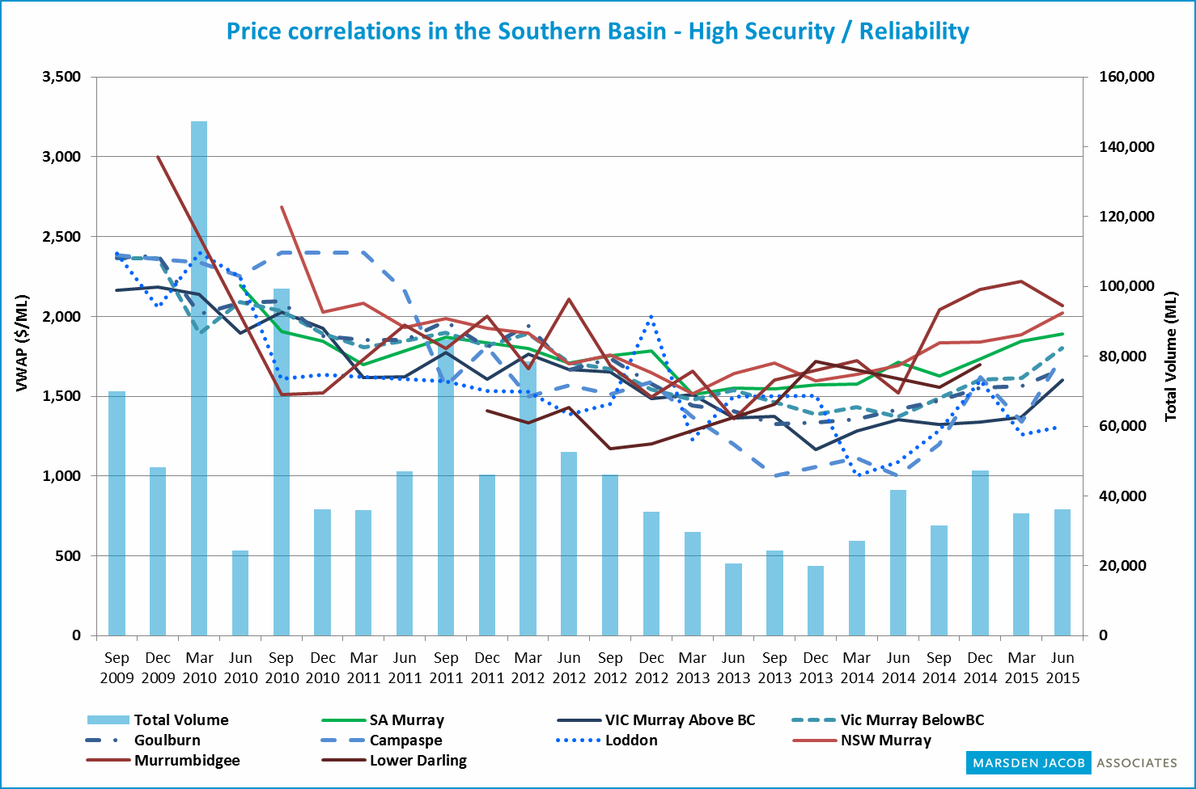

Source: Marsden Jacob analysis, 2015

Figure 2: Price correlation in the Southern Basin: General Security / Low Reliability

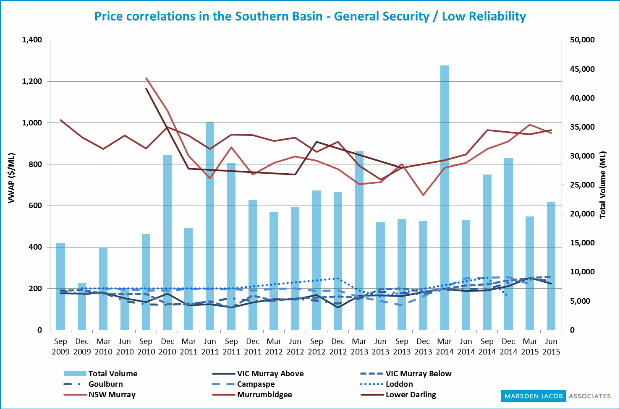

Source: Marsden Jacob analysis, 2015

Note: Where possible, zero values have been interpolated in these charts so they differ slightly from the region and entitlement specific charts.

2.1 SA Murray: Class 3a

Figure 3: Entitlement market prices and volumes

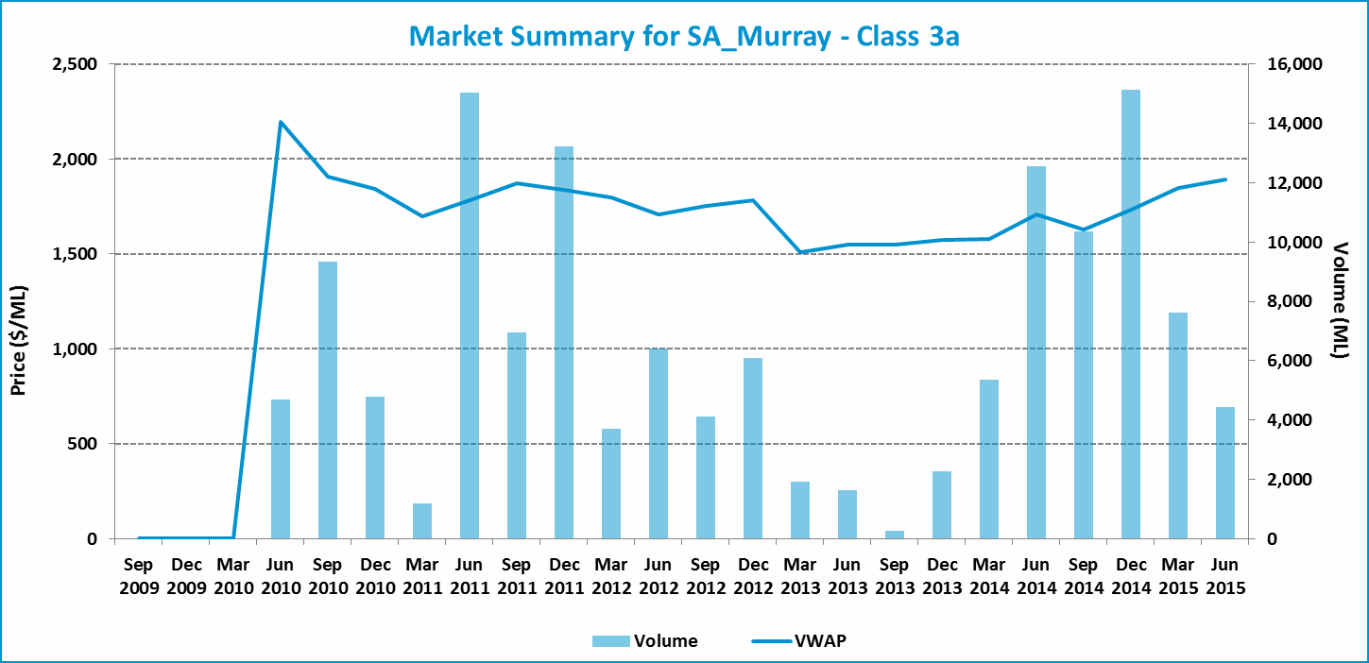

Table 2: Entitlement market prices and volumes

Volume weighted average price ($/ML)  Month of June 2015  June 2015 Quarter YTD |  | June 2015  Quarter  Volume  (ML) | June 2015 Market Spot  Quarter #  of trades Price ($/ML)
 | June 2015 Quarter (in $/ML) | June 2015  Quarter  Volume  (ML) | June 2015 Market Spot  Quarter #  of trades Price ($/ML)
 | 25th 75th  percentile percentile Median Mean Mode | June 2015  Quarter  Volume  (ML) | June 2015 Market Spot  Quarter #  of trades Price ($/ML)

1,937 1,891 1,747 1,508 2,100 2,038 1,867 1,500 4,425 58 2,150 – 2,400

Figure 4: Entitlement market price range by volume

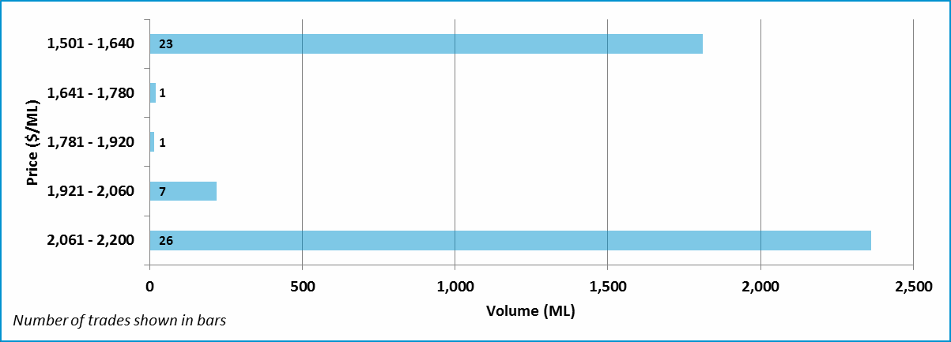

Data Sources: SA Water Register (www.waterconnect.sa.gov.au/Systems/WTR/Pages/default.aspx), National Water Exchange
(www.waterexchange.com.au), Waterfind (www.waterfind.com.au)

2.2 VIC Murray above Barmah Choke: High Reliability

Figure 5: Entitlement market prices and volumes

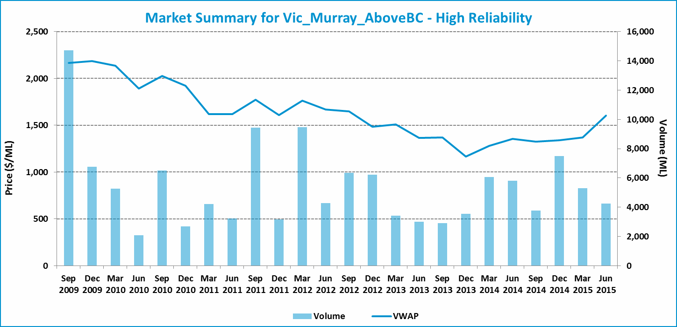

Table 3: Entitlement market prices and volumes

Volume weighted average price ($/ML)  Month of June 2015  June 2015 Quarter YTD |  | June 2015  Quarter  Volume  (ML) | June 2015 Market Spot  Quarter #  of trades Price ($/ML)
 | June 2015 Quarter (in $/ML) | June 2015  Quarter  Volume  (ML) | June 2015 Market Spot  Quarter #  of trades Price ($/ML)
 | 25th 75th  percentile percentile Median Mean Mode | June 2015  Quarter  Volume  (ML) | June 2015 Market Spot  Quarter #  of trades Price ($/ML)

1,770 1,603 1,398 1,363 1,700 1,500 1,553 1,500 4,242 62 2,000 – 3,000

Figure 6: Entitlement market price range by volume

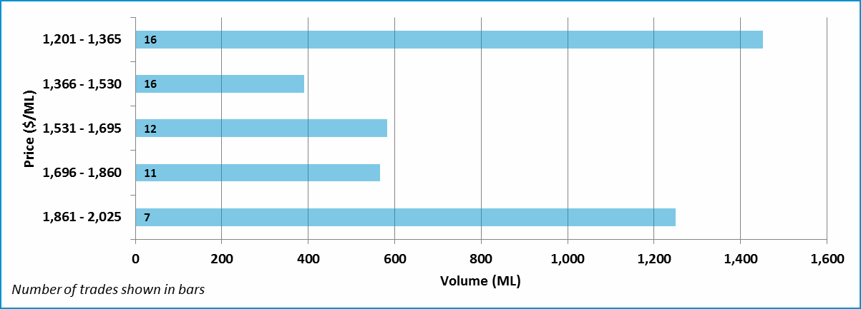

Data Sources: VIC Water Register (waterregister.vic.gov.au/water-trading/water-share-trading), National Water Exchange
(www.waterexchange.com.au), Waterfind (www.waterfind.com.au)

2.3 VIC Murray above Barmah Choke: Low Reliability

Figure 7: Entitlement market prices and volumes

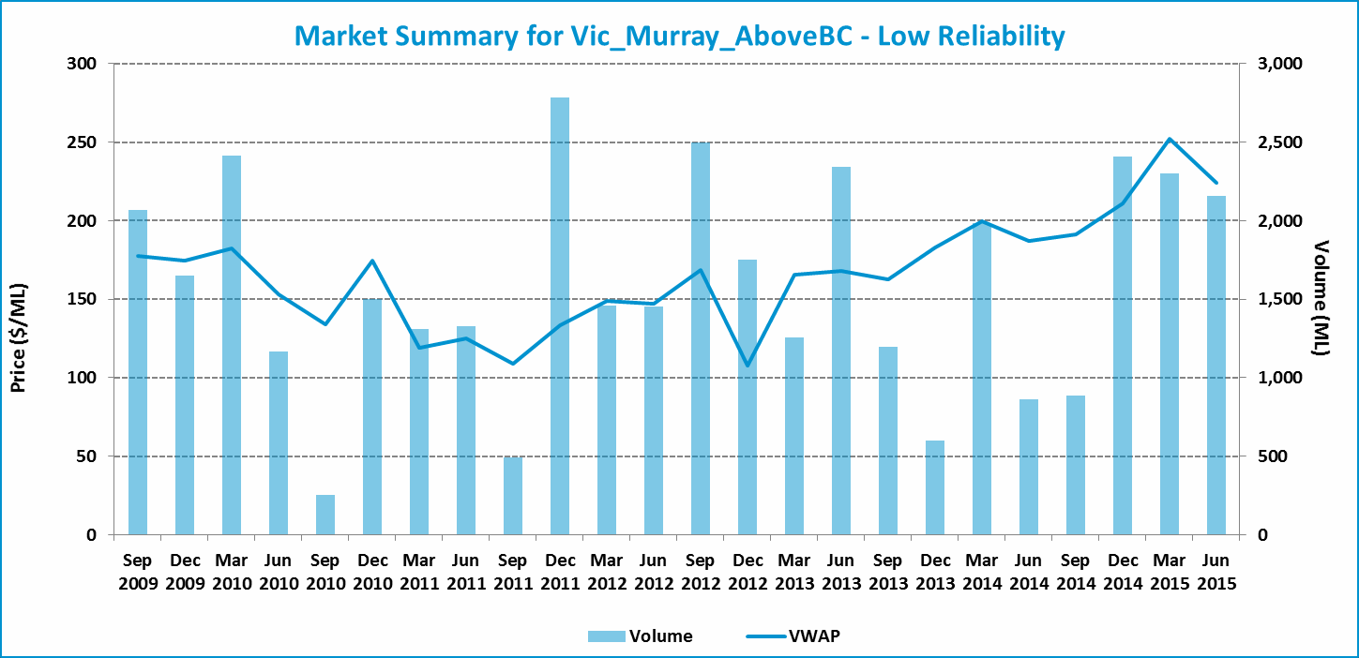

Table 4: Entitlement market prices and volumes

Volume weighted average price ($/ML)  Month of June 2015  June 2015 Quarter YTD |  | June 2015  Quarter  Volume  (ML) | June 2015 Market Spot  Quarter #  of trades Price ($/ML)
 | June 2015 Quarter (in $/ML) | June 2015  Quarter  Volume  (ML) | June 2015 Market Spot  Quarter #  of trades Price ($/ML)
 | 25th 75th  percentile percentile Median Mean Mode | June 2015  Quarter  Volume  (ML) | June 2015 Market Spot  Quarter #  of trades Price ($/ML)

206 224 225 200 270 250 237 200 2,159 29 220 – 300

Figure 8: Entitlement market price range by volume

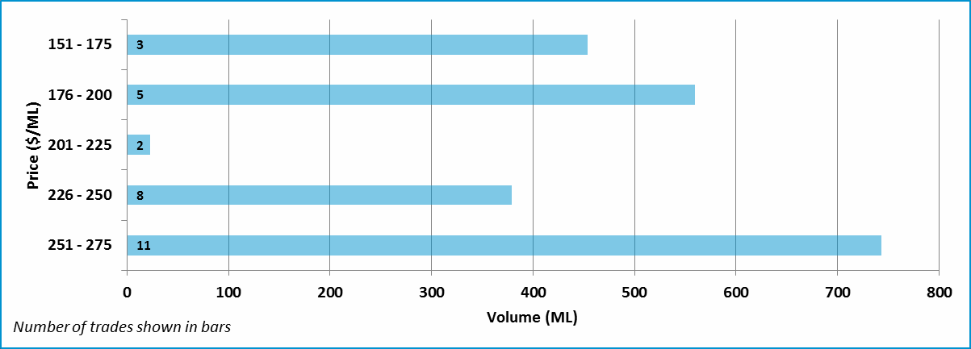

Note: Some trades which are outside two standard deviations of the average price of water entitlements have been included for this region.

Data Sources: VIC Water Register (waterregister.vic.gov.au/water-trading/water-share-trading), National Water Exchange
(www.waterexchange.com.au), Waterfind (www.waterfind.com.au)

2.4 VIC Murray below Barmah Choke: High Reliability

Figure 9: Entitlement market prices and volumes

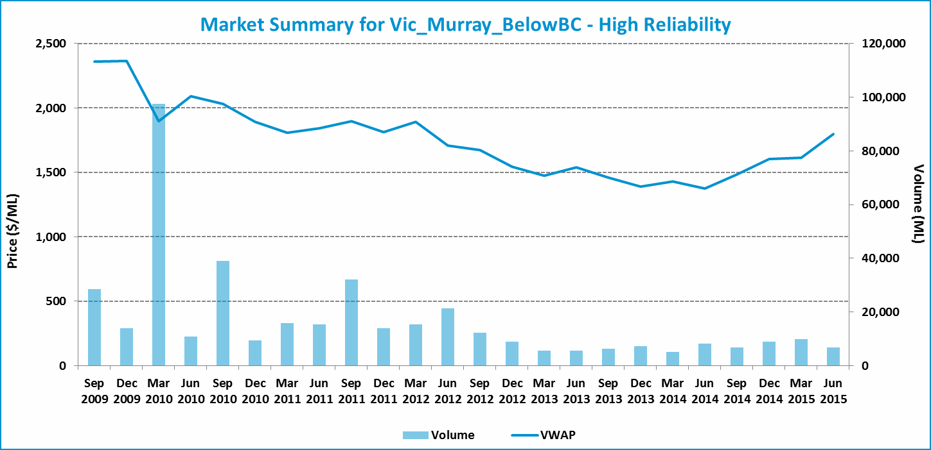

Table 5: Entitlement market prices and volumes

Volume weighted average price ($/ML)  Month of June 2015  June 2015 Quarter YTD |  | June 2015  Quarter  Volume  (ML) | June 2015 Market Spot  Quarter # of  trades Price ($/ML)
 | June 2015 Quarter (in $/ML) | June 2015  Quarter  Volume  (ML) | June 2015 Market Spot  Quarter # of  trades Price ($/ML)
 | 25th 75th  percentile percentile Median Mean Mode | June 2015  Quarter  Volume  (ML) | June 2015 Market Spot  Quarter # of  trades Price ($/ML)

1,951 1,800 1,623 1,500 1,995 1,800 1,757 1,800 6,794 207 2,000 – 3,000

Figure 10: Entitlement market price range by volume

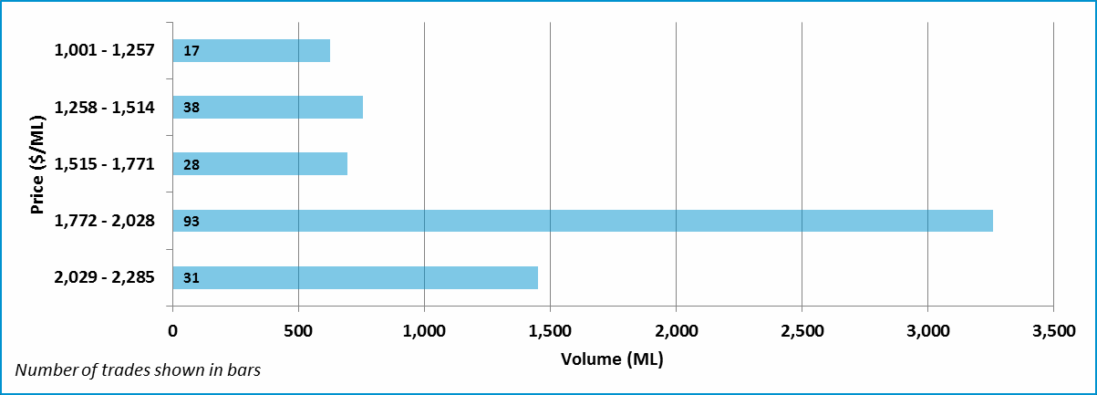

Note: Some trades which are outside two standard deviations of the average price of water entitlements have been included for this region.

Data Sources: VIC Water Register (waterregister.vic.gov.au/water-trading/water-share-trading), National Water Exchange
(www.waterexchange.com.au), Waterfind (www.waterfind.com.au)

2.5 VIC Murray below Barmah Choke: Low Reliability

Figure 11: Entitlement market prices and volumes

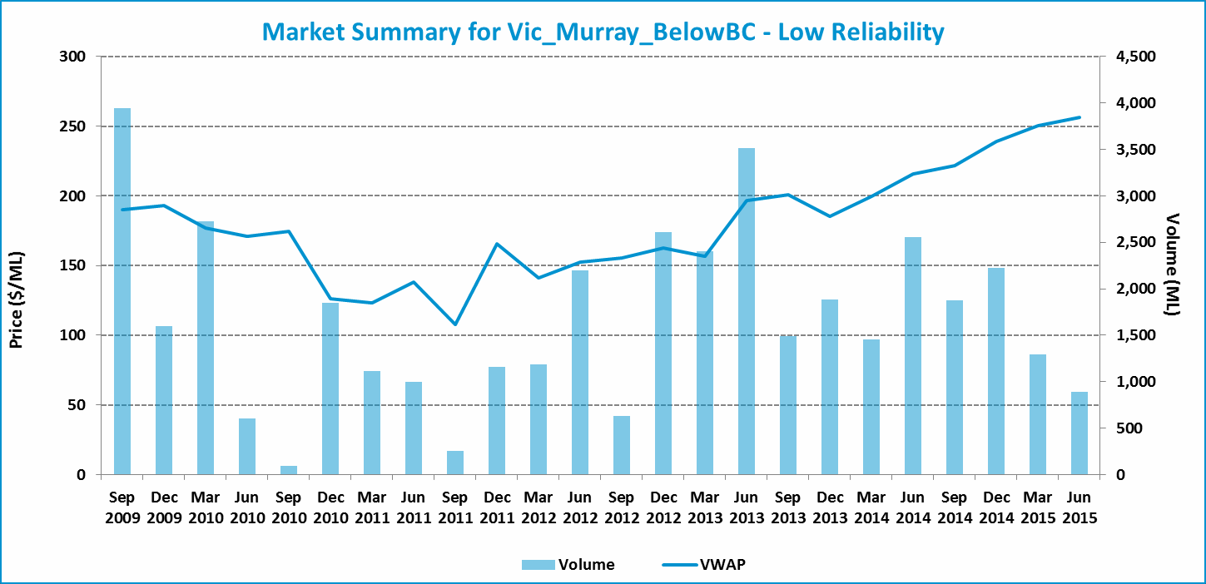

Table 6: Entitlement market prices and volumes

Volume weighted average price ($/ML)  Month of June 2015  June 2015 Quarter YTD |  | June 2015  Quarter  Volume  (ML) | June 2015 Market Spot  Quarter #  of trades Price ($/ML)
 | June 2015 Quarter (in $/ML) | June 2015  Quarter  Volume  (ML) | June 2015 Market Spot  Quarter #  of trades Price ($/ML)
 | 25th 75th  percentile percentile Median Mean Mode | June 2015  Quarter  Volume  (ML) | June 2015 Market Spot  Quarter #  of trades Price ($/ML)

246 257 239 200 265 220 217 200 894 25 220 – 300

Figure 12: Entitlement market price range by volume

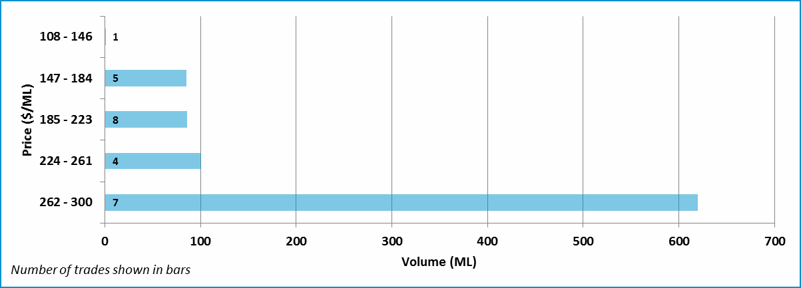

Note: Some trades which are outside two standard deviations of the average price of water entitlements have been included for this region.

Data Sources: VIC Water Register (waterregister.vic.gov.au/water-trading/water-share-trading), National Water Exchange
(www.waterexchange.com.au), Waterfind (www.waterfind.com.au)

2.6 Goulburn: High Reliability

Figure 13: Entitlement market prices and volumes

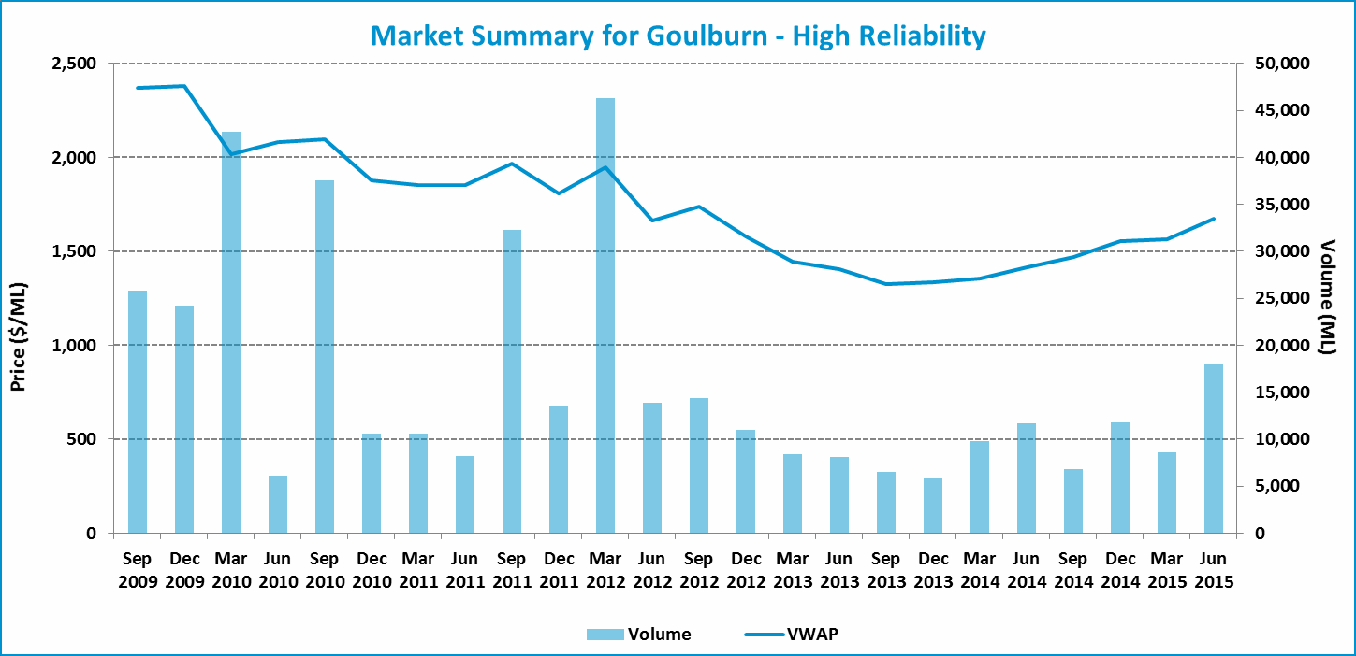

Table 7: Entitlement market prices and volumes

Volume weighted average price ($/ML)  Month of June 2015  June 2015 Quarter YTD |  | June 2015  Quarter  Volume  (ML) | June 2015 Market Spot  Quarter #  of trades Price ($/ML)
 | June 2015 Quarter (in $/ML) | June 2015  Quarter  Volume  (ML) | June 2015 Market Spot  Quarter #  of trades Price ($/ML)
 | 25th 75th  percentile percentile Median Mean Mode | June 2015  Quarter  Volume  (ML) | June 2015 Market Spot  Quarter #  of trades Price ($/ML)

1,698 1,673 1,591 1,400 1,850 1,750 1,658 1,400 18,071 254 1,700 – 2,400

Figure 14: Entitlement market price range by volume

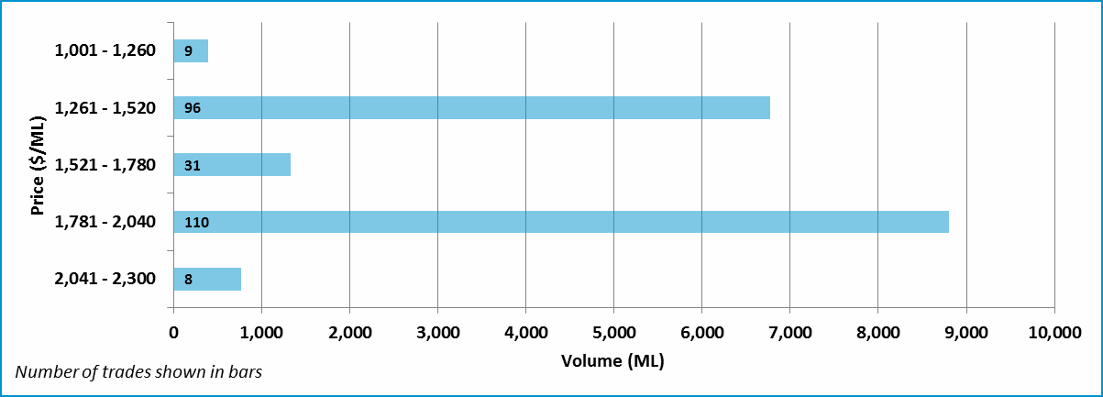

Note: Some trades which are outside two standard deviations of the average price of water entitlements have been included for this region.

Data Sources: VIC Water Register (waterregister.vic.gov.au/water-trading/water-share-trading), National Water Exchange
(www.waterexchange.com.au), Waterfind (www.waterfind.com.au)

2.7 Goulburn: Low Reliability

Figure 15: Entitlement market prices and volumes

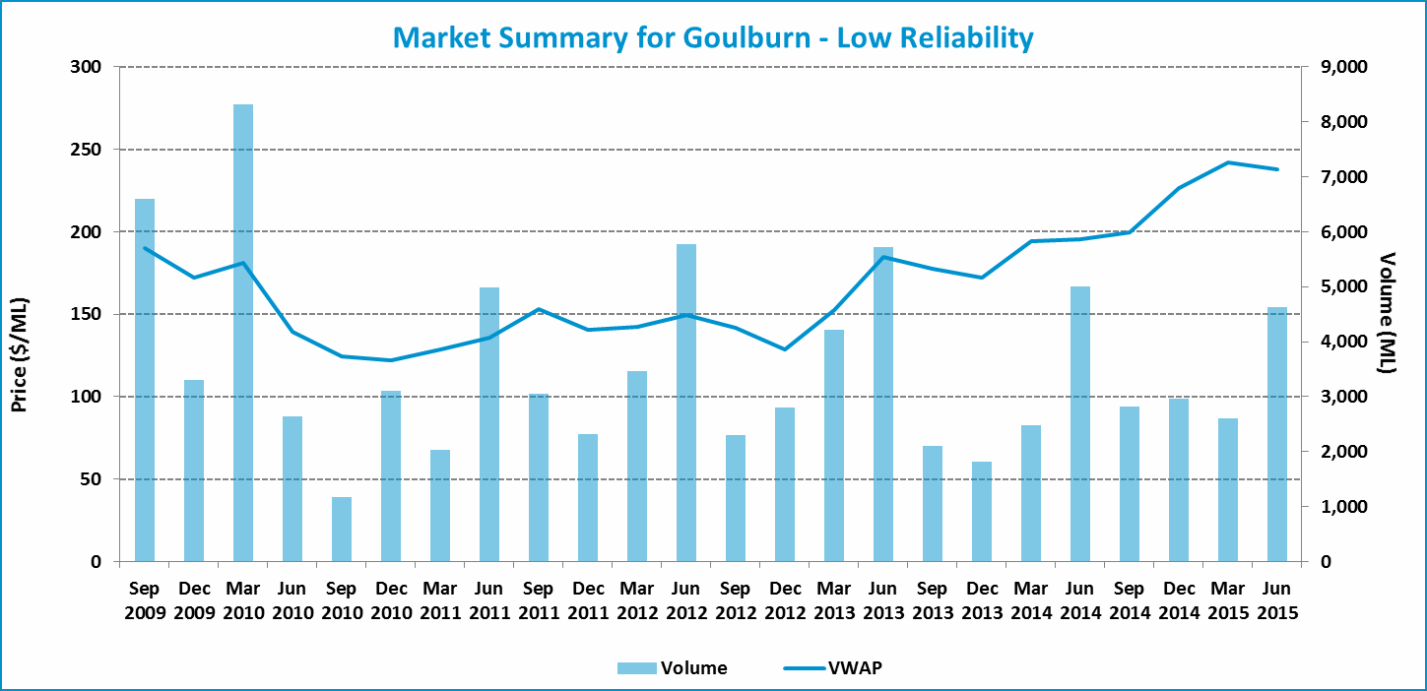

Table 8: Entitlement market prices and volumes

Volume weighted average price ($/ML)  Month of June 2015  June 2015 Quarter YTD |  | June 2015  Quarter  Volume  (ML) | June 2015 Market Spot  Quarter #  of trades Price ($/ML)
 | June 2015 Quarter (in $/ML) | June 2015  Quarter  Volume  (ML) | June 2015 Market Spot  Quarter #  of trades Price ($/ML)
 | 25th 75th  percentile percentile Median Mean Mode | June 2015  Quarter  Volume  (ML) | June 2015 Market Spot  Quarter #  of trades Price ($/ML)

240 238 228 200 263 250 229 250 4,625 84 220 – 300

Figure 16: Entitlement market price range by volume

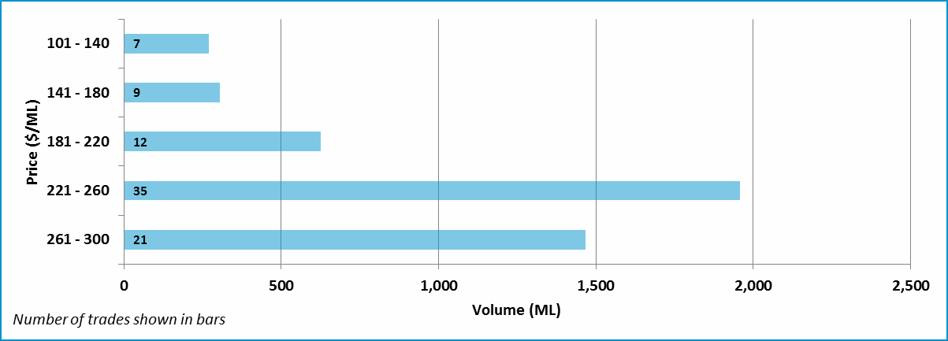

Note: Some trades which are outside two standard deviations of the average price of water entitlements have been included for this region.

Data Sources: VIC Water Register (waterregister.vic.gov.au/water-trading/water-share-trading), National Water Exchange
(www.waterexchange.com.au), Waterfind (www.waterfind.com.au)

2.8 Campaspe: High Reliability

Figure 17: Entitlement market prices and volumes

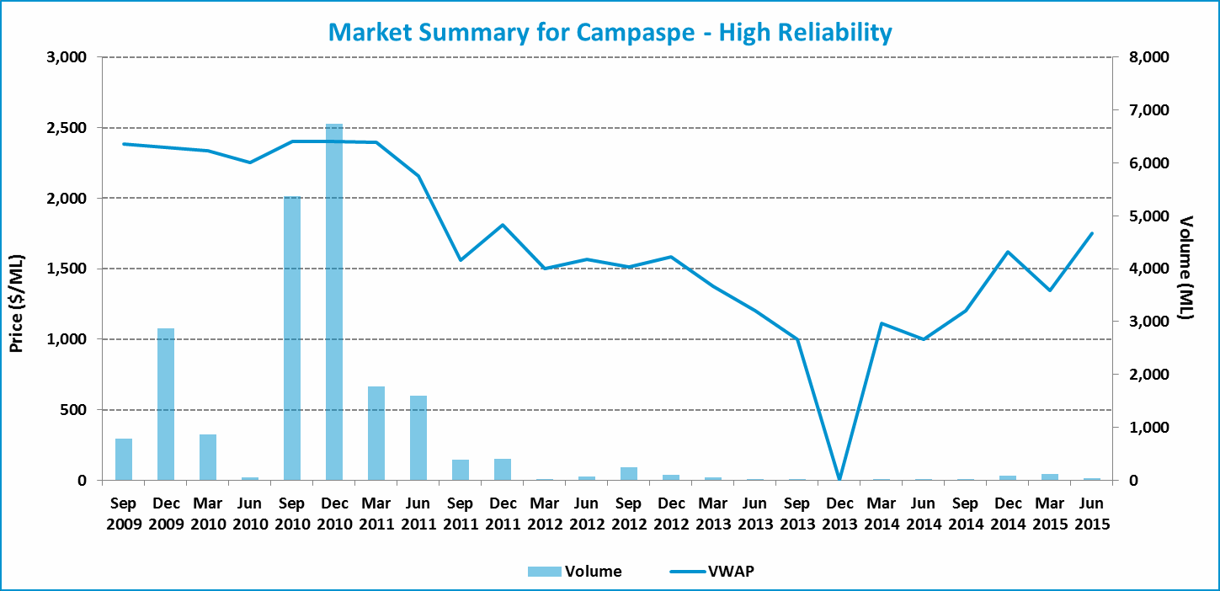

Table 9: Entitlement market prices and volumes

Volume weighted average price ($/ML)  Month of June 2015  June 2015 Quarter YTD |  | June 2015  Quarter  Volume  (ML) | June 2015 Market Spot  Quarter #  of trades Price ($/ML)
 | June 2015 Quarter (in $/ML) | June 2015  Quarter  Volume  (ML) | June 2015 Market Spot  Quarter #  of trades Price ($/ML)
 | 25th 75th  percentile percentile Median Mean Mode | June 2015  Quarter  Volume  (ML) | June 2015 Market Spot  Quarter #  of trades Price ($/ML)

1,750 1,750 1,498 - - - - 30 1 1,550

Data Sources: VIC Water Register (waterregister.vic.gov.au/water-trading/water-share-trading), National Water Exchange
(www.waterexchange.com.au), Waterfind (www.waterfind.com.au)

2.9 Loddon: High Reliability

Figure 18: Entitlement market prices and volumes

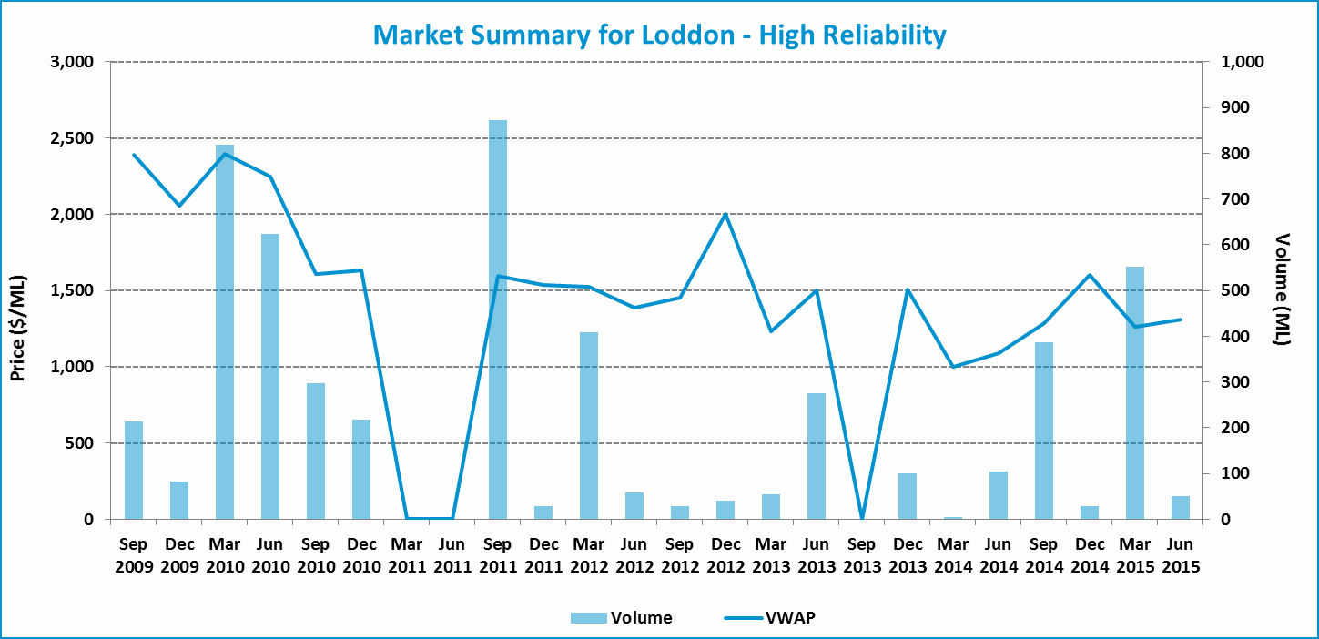

Table 10: Entitlement market prices and volumes

Volume weighted average price ($/ML)  Month of June 2015  June 2015 Quarter YTD |  | June 2015  Quarter  Volume  (ML) | June 2015 Market Spot  Quarter #  of trades Price ($/ML)
 | June 2015 Quarter (in $/ML) | June 2015  Quarter  Volume  (ML) | June 2015 Market Spot  Quarter #  of trades Price ($/ML)
 | 25th 75th  percentile percentile Median Mean Mode | June 2015  Quarter  Volume  (ML) | June 2015 Market Spot  Quarter #  of trades Price ($/ML)

1,450 1,310 1,282 1,301 1,400 1,351 1,351 51 2 1,500 – 2,400

Figure 19: Entitlement market price range by volume

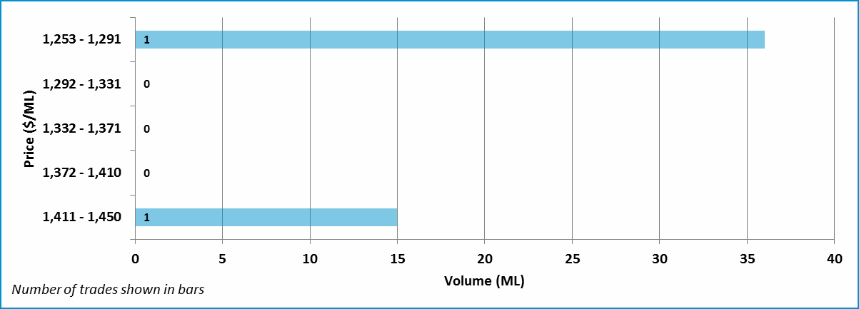

Data Sources: VIC Water Register (waterregister.vic.gov.au/water-trading/water-share-trading), National Water Exchange
(www.waterexchange.com.au), Waterfind (www.waterfind.com.au)

2.10 NSW Murray: General Security

Figure 20: Entitlement market prices and volumes

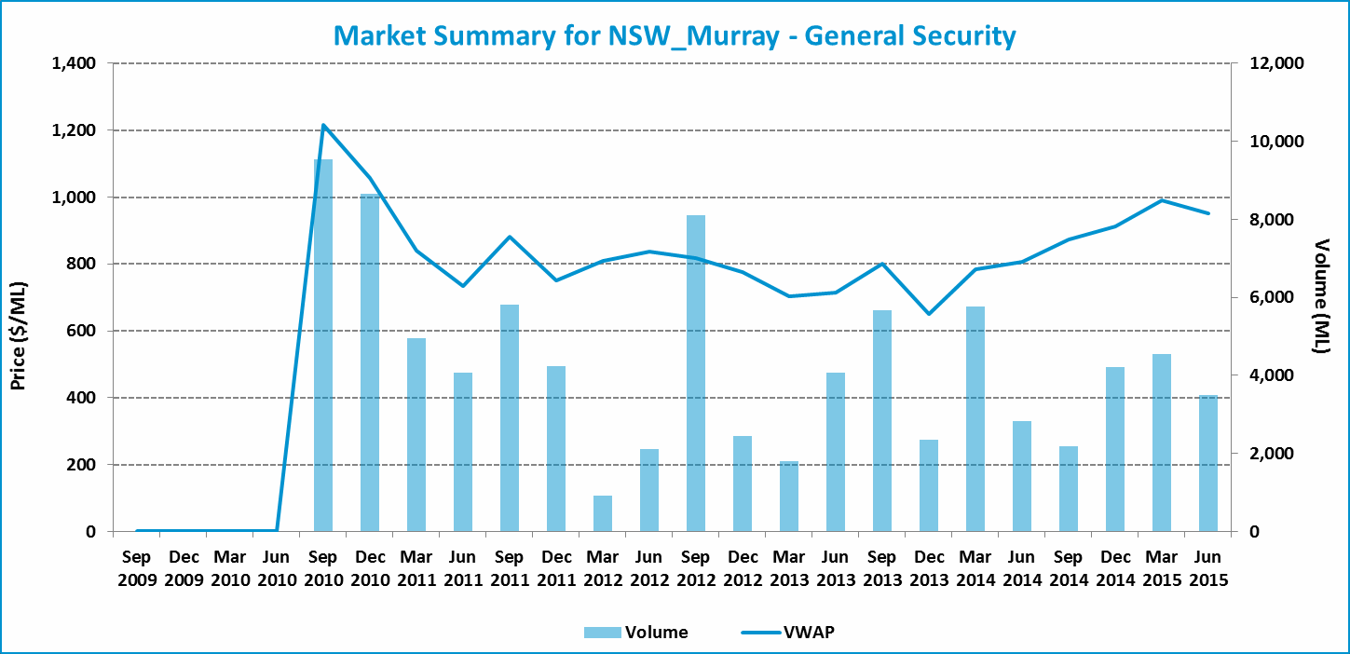

Table 11: Entitlement market prices and volumes

Volume weighted average price ($/ML)  Month of June 2015  June 2015 Quarter YTD |  | June 2015  Quarter  Volume  (ML) | June 2015 Market Spot  Quarter #  of trades Price ($/ML)
 | June 2015 Quarter (in $/ML) | June 2015  Quarter  Volume  (ML) | June 2015 Market Spot  Quarter #  of trades Price ($/ML)
 | 25th 75th  percentile percentile Median Mean Mode | June 2015  Quarter  Volume  (ML) | June 2015 Market Spot  Quarter #  of trades Price ($/ML)

950 951 940 863 1,015 995 975 850 3,502 22 1,000 – 1,300

Figure 21: Entitlement market price range by volume

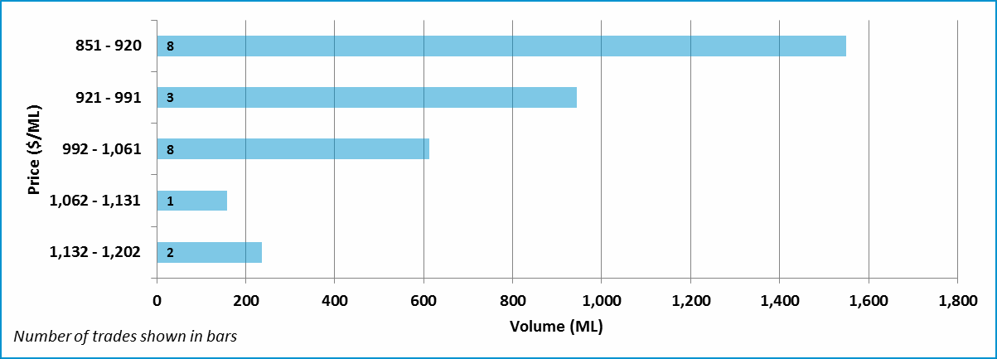

Note: Some trades which are outside two standard deviations of the average price of water entitlements have been included for this region.

Data Sources: NSW Water Register (http://registers.water.nsw.gov.au/wma/WaterShareIntraWSLocSearch.jsp?selectedRegister=WaterShare, http://www.water.nsw.gov.au/water-licensing/registers), National Water Exchange (www.waterexchange.com.au), Waterfind (www.waterfind.com.au)

2.11 NSW Murray: High Security

Figure 22: Entitlement market prices and volumes

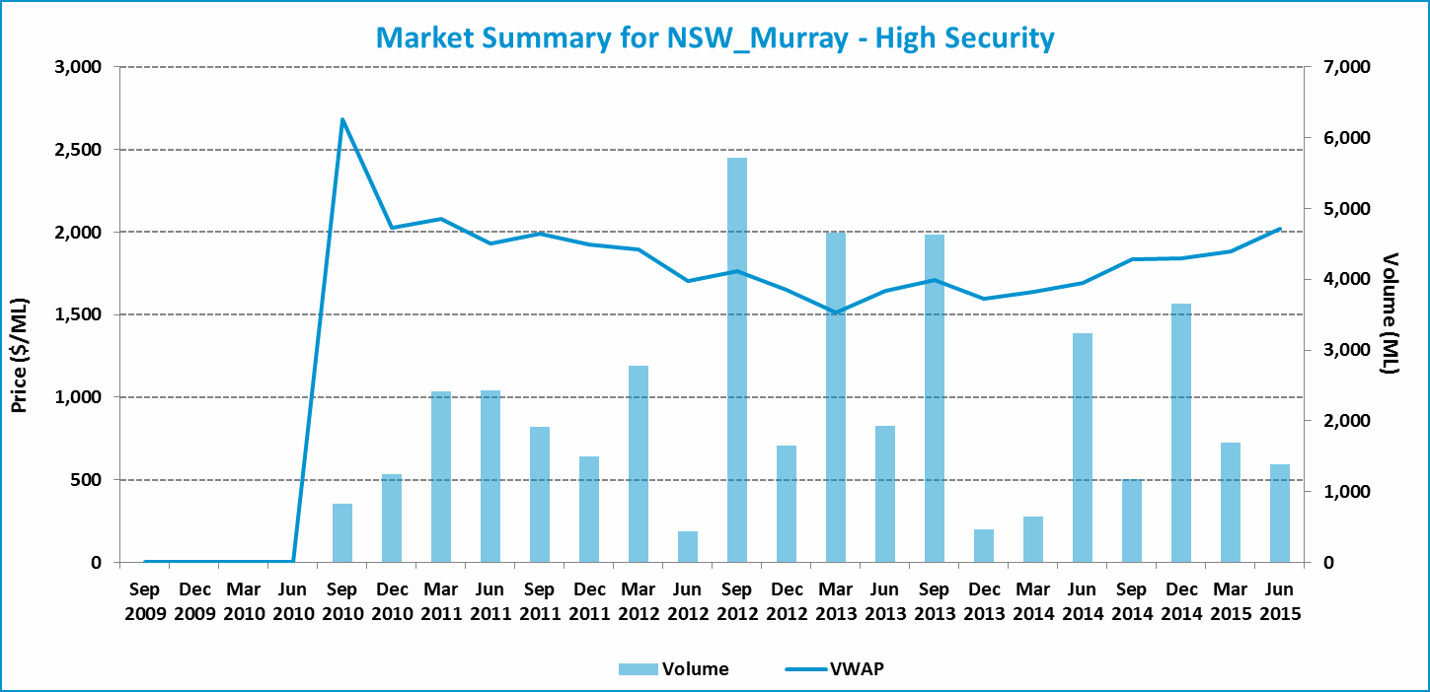

Table 12: Entitlement market prices and volumes

Volume weighted average price ($/ML)  Month of June 2015  June 2015 Quarter YTD |  | June 2015  Quarter  Volume  (ML) | June 2015 Market Spot  Quarter #  of trades Price ($/ML)
 | June 2015 Quarter (in $/ML) | June 2015  Quarter  Volume  (ML) | June 2015 Market Spot  Quarter #  of trades Price ($/ML)
 | 25th 75th  percentile percentile Median Mean Mode | June 2015  Quarter  Volume  (ML) | June 2015 Market Spot  Quarter #  of trades Price ($/ML)

2,052 2,023 1,882 1,758 2,095 2,031 1,962 1,700 1,388 22 2,750 – 3,000

Figure 23: Entitlement market price range by volume

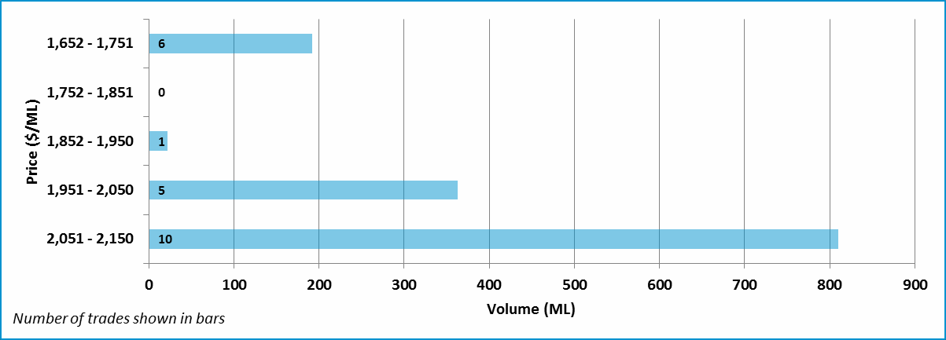

Data Sources: NSW Water Register (http://registers.water.nsw.gov.au/wma/WaterShareIntraWSLocSearch.jsp?selectedRegister=WaterShare, http://www.water.nsw.gov.au/water-licensing/registers), National Water Exchange (www.waterexchange.com.au), Waterfind (www.waterfind.com.au)

2.12 NSW Murray Irrigation Limited

Figure 24: Entitlement market prices and volumes

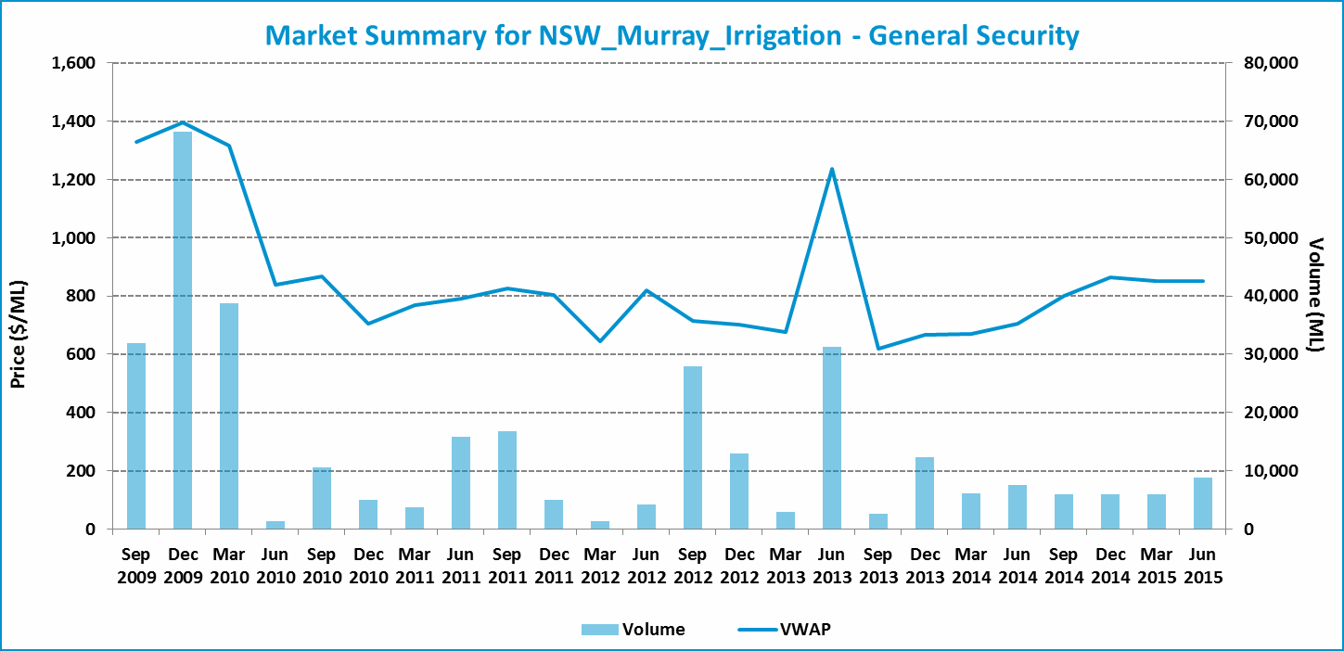

Table 13: Entitlement market prices and volumes

Volume weighted average price ($/ML)  Month of June 2015  June 2015 Quarter YTD |  | June 2015  Quarter  Volume  (ML) | June 2015 Market Spot  Quarter #  of trades Price ($/ML)
 | June 2015 Quarter (in $/ML) | June 2015  Quarter  Volume  (ML) | June 2015 Market Spot  Quarter #  of trades Price ($/ML)
 | 25th 75th  percentile percentile Median Mean Mode | June 2015  Quarter  Volume  (ML) | June 2015 Market Spot  Quarter #  of trades Price ($/ML)

848 850 843 850 850 850 843 850 8,889 50 700 – 1,075

Figure 25: Entitlement market price range by volume

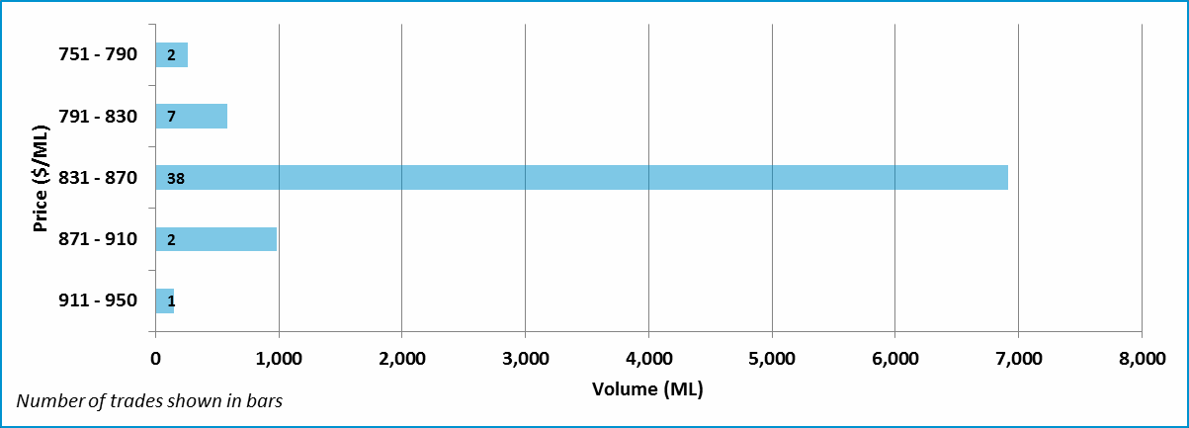

Note: Some trades which are outside two standard deviations of the average price of water entitlements have been included for this region.

Data Sources: Murray Irrigation Limited (www.murrayirrigation.com.au)

2.13 Murrumbidgee: General Security

Figure 26: Entitlement market prices and volumes

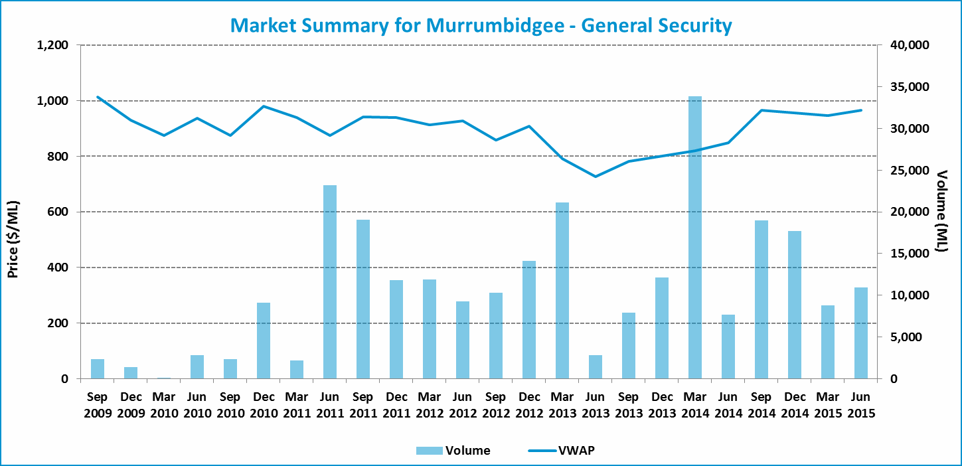

Table 14: Entitlement market prices and volumes

Volume weighted average price ($/ML)  Month of June 2015  June 2015 Quarter YTD |  | June 2015  Quarter  Volume  (ML) | June 2015 Market Spot  Quarter #  of trades Price ($/ML)
 | June 2015 Quarter (in $/ML) | June 2015  Quarter  Volume  (ML) | June 2015 Market Spot  Quarter #  of trades Price ($/ML)
 | 25th 75th  percentile percentile Median Mean Mode | June 2015  Quarter  Volume  (ML) | June 2015 Market Spot  Quarter #  of trades Price ($/ML)

975 965 959 950 1,030 1,000 967 1,030 10,904 20 1,250 – 1,500

Figure 27: Entitlement market price range by volume

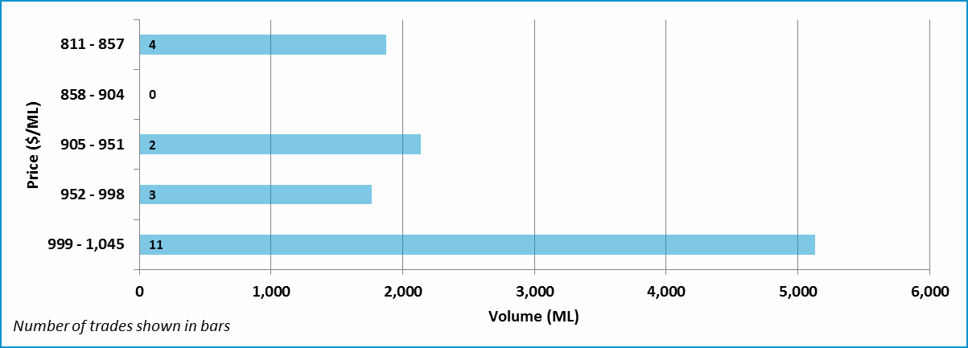

Data Sources: NSW Water Register (http://registers.water.nsw.gov.au/wma/WaterShareIntraWSLocSearch.jsp?selectedRegister=WaterShare, http://www.water.nsw.gov.au/water-licensing/registers), National Water Exchange (www.waterexchange.com.au), Waterfind (www.waterfind.com.au)

2.14 Murrumbidgee: High Security

Figure 28: Entitlement market prices and volumes

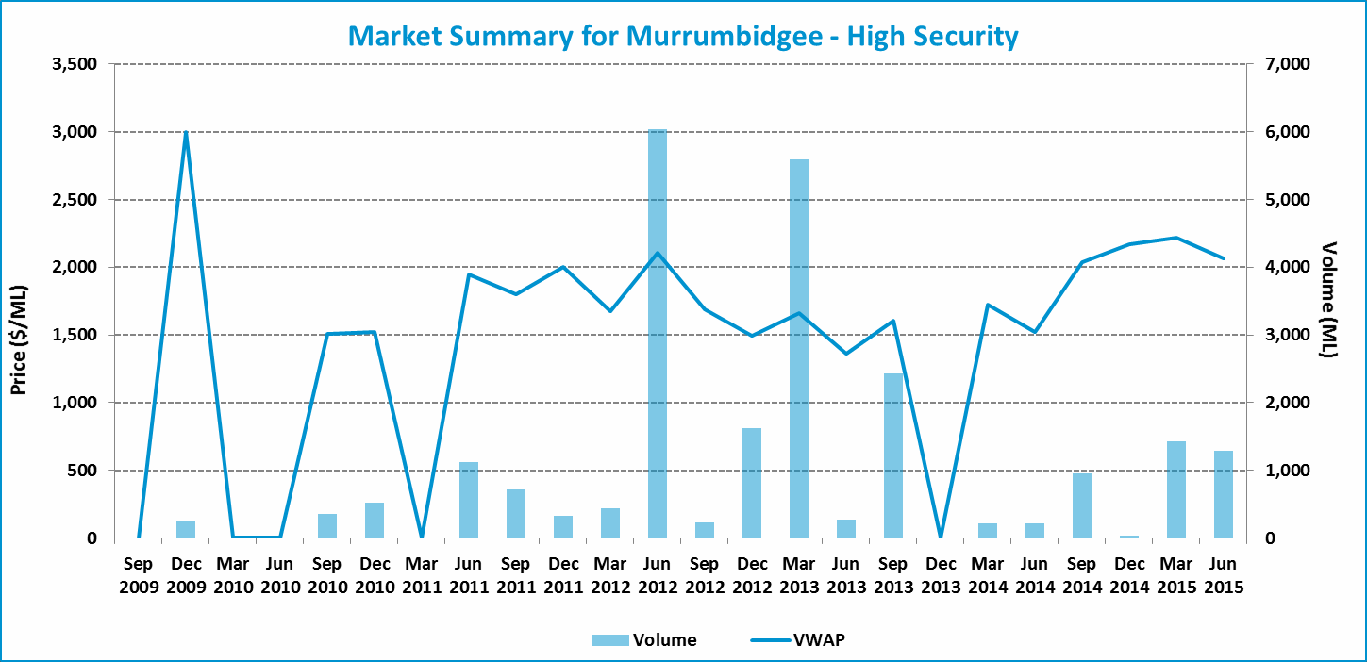

Table 15: Entitlement market prices and volumes

Volume weighted average price ($/ML)  Month of June 2015  June 2015 Quarter YTD |  | June 2015  Quarter  Volume  (ML) | June 2015 Market Spot  Quarter #  of trades Price ($/ML)
 | June 2015 Quarter (in $/ML) | June 2015  Quarter  Volume  (ML) | June 2015 Market Spot  Quarter #  of trades Price ($/ML)
 | 25th 75th  percentile percentile Median Mean Mode | June 2015  Quarter  Volume  (ML) | June 2015 Market Spot  Quarter #  of trades Price ($/ML)

2,175 2,065 2,118 2,110 2,175 2,163 2,123 2,175 1,290 4 2,800 – 3,300

Figure 29: Entitlement market price range by volume

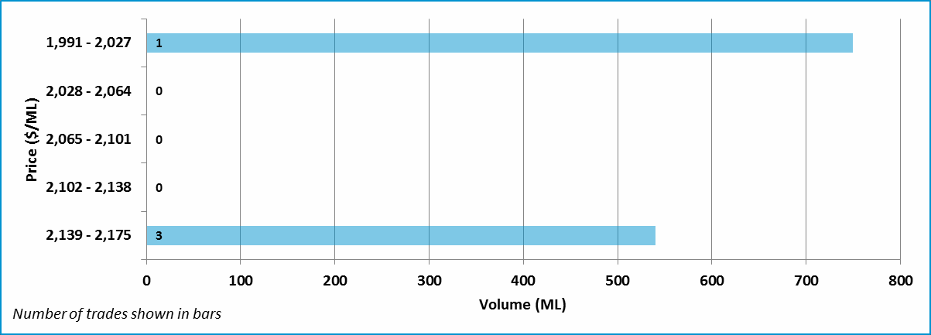

Data Sources: NSW Water Register (http://registers.water.nsw.gov.au/wma/WaterShareIntraWSLocSearch.jsp?selectedRegister=WaterShare, http://www.water.nsw.gov.au/water-licensing/registers), National Water Exchange (www.waterexchange.com.au), Waterfind (www.waterfind.com.au)

2.15 Lower Darling: General Security

Figure 30: Entitlement market prices and volumes

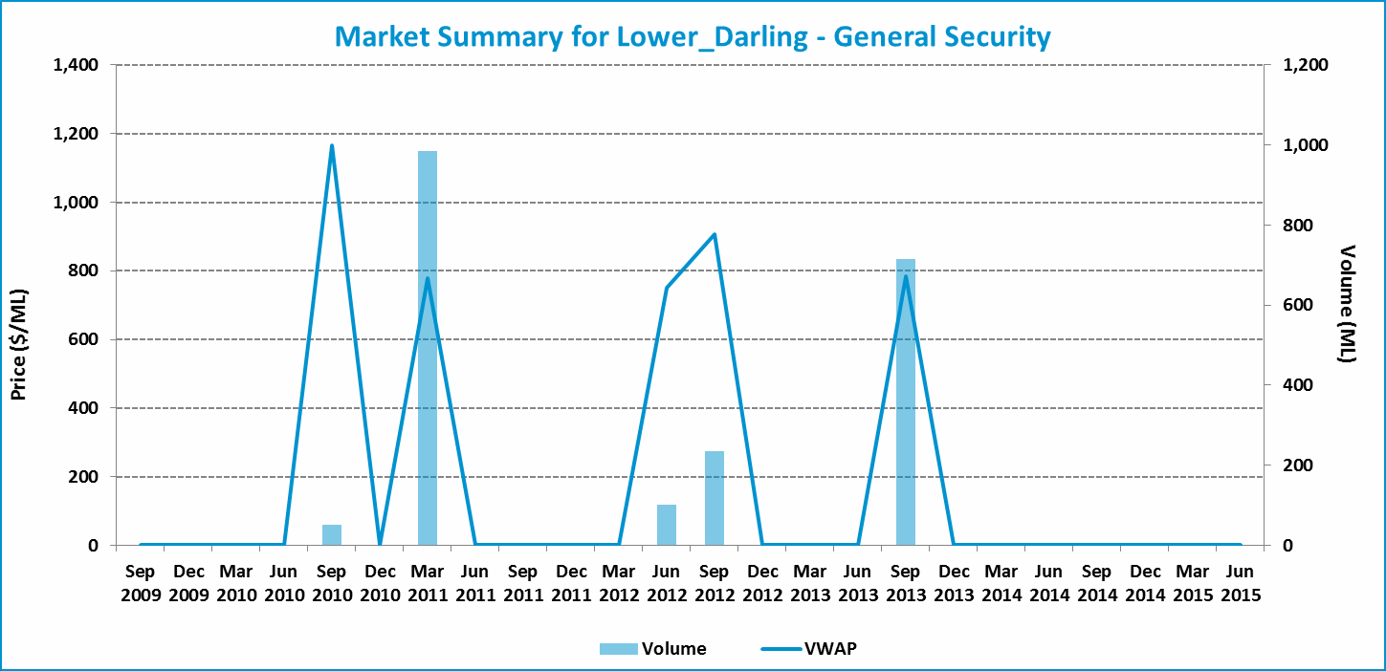

Table 16: Entitlement market prices and volumes

Volume weighted average price ($/ML)  Month of June 2015  June 2015 Quarter YTD |  | June 2015  Quarter  Volume  (ML) | June 2015 Market Spot  Quarter #  of trades Price ($/ML)
 | June 2015 Quarter (in $/ML) | June 2015  Quarter  Volume  (ML) | June 2015 Market Spot  Quarter #  of trades Price ($/ML)
 | 25th 75th  percentile percentile Median Mean Mode | June 2015  Quarter  Volume  (ML) | June 2015 Market Spot  Quarter #  of trades Price ($/ML)

- - - - - - - - - - No listings

Data Sources: NSW Water Register (http://registers.water.nsw.gov.au/wma/WaterShareIntraWSLocSearch.jsp?selectedRegister=WaterShare, http://www.water.nsw.gov.au/water-licensing/registers), National Water Exchange (www.waterexchange.com.au), Waterfind (www.waterfind.com.au)

2.16 Lower Darling: High Security

Figure 31: Entitlement market prices and volumes

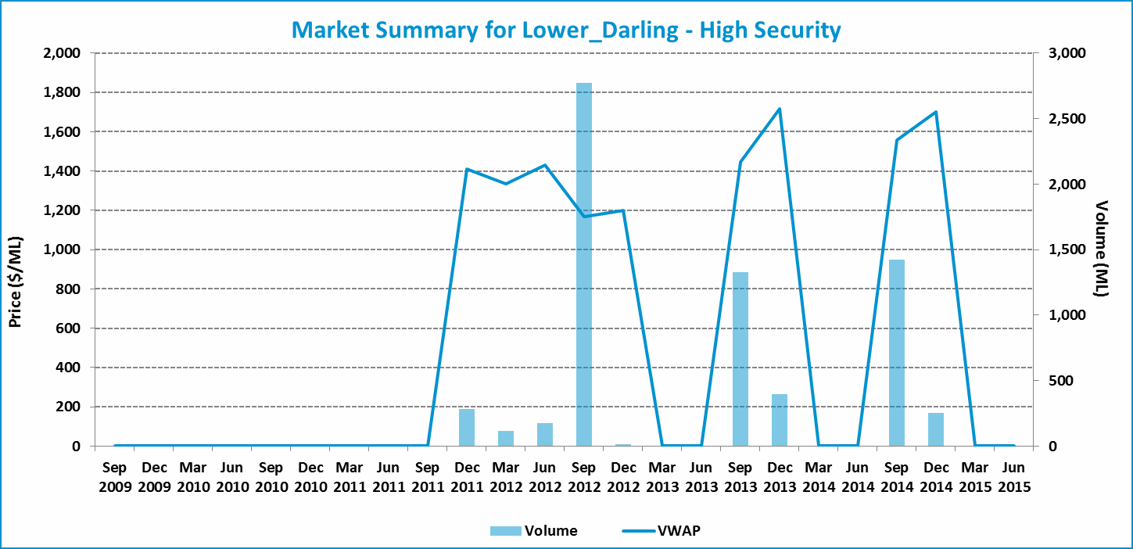

Table 17: Entitlement market prices and volumes

Volume weighted average price ($/ML)  Month of June 2015  June 2015 Quarter YTD |  | June 2015  Quarter  Volume  (ML) | June 2015 Market Spot  Quarter #  of trades Price ($/ML)
 | June 2015 Quarter (in $/ML) | June 2015  Quarter  Volume  (ML) | June 2015 Market Spot  Quarter #  of trades Price ($/ML)
 | 25th 75th  percentile percentile Median Mean Mode | June 2015  Quarter  Volume  (ML) | June 2015 Market Spot  Quarter #  of trades Price ($/ML)

- - 1,580 - - - - - - - No listings

Data Sources: NSW Water Register (http://registers.water.nsw.gov.au/wma/WaterShareIntraWSLocSearch.jsp?selectedRegister=WaterShare, http://www.water.nsw.gov.au/water-licensing/registers), National Water Exchange (www.waterexchange.com.au), Waterfind (www.waterfind.com.au)

3. Northern Murray-Darling Basin

Figure 32: Price correlation in the Northern Basin: General Security

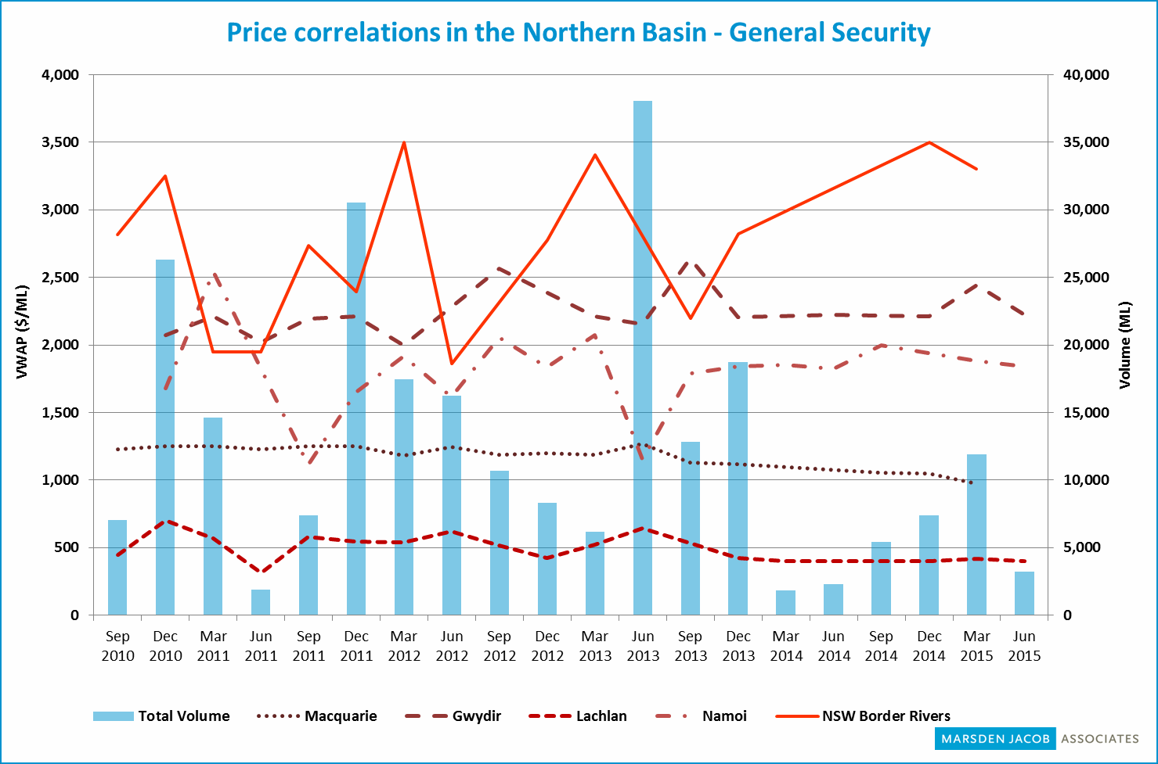

Source: Marsden Jacob analysis, 2015

Note: Zero values have been interpolated in this chart so it differs from the region and entitlement specific charts.

3.1 Macquarie: General Security

Figure 33: Entitlement market prices and volumes

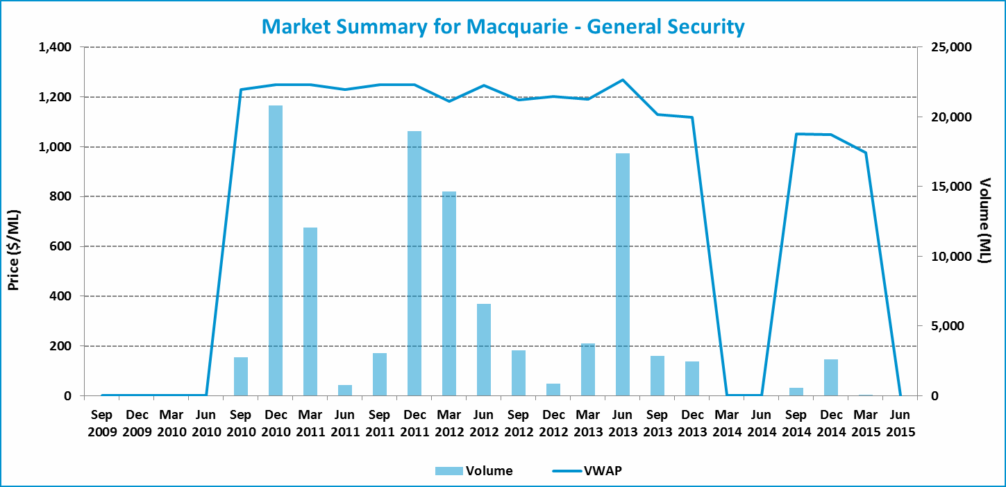

Table 18: Entitlement market prices and volumes

Volume weighted average price ($/ML)  Month of June 2015  June 2015 Quarter YTD |  | June 2015  Quarter  Volume  (ML) | June 2015 Market Spot  Quarter #  of trades Price ($/ML)
 | June 2015 Quarter (in $/ML) | June 2015  Quarter  Volume  (ML) | June 2015 Market Spot  Quarter #  of trades Price ($/ML)
 | 25th 75th  percentile percentile Median Mean Mode | June 2015  Quarter  Volume  (ML) | June 2015 Market Spot  Quarter #  of trades Price ($/ML)

- - 1,049 - - - - - - - 900 – 1,500

Data Sources: NSW Water Register (http://registers.water.nsw.gov.au/wma/WaterShareIntraWSLocSearch.jsp?selectedRegister=WaterShare, http://www.water.nsw.gov.au/water-licensing/registers), Waterfind (www.waterfind.com.au)

3.2 Namoi: General Security

Figure 34: Entitlement market prices and volumes

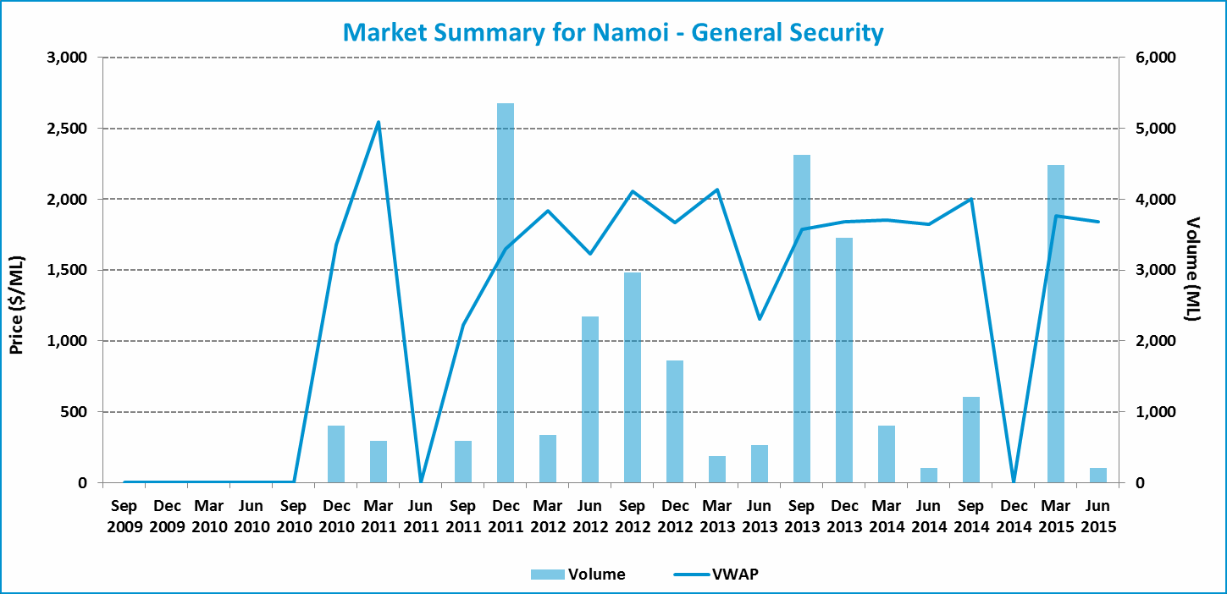

Table 19: Entitlement market prices and volumes

Volume weighted average price ($/ML)  Month of June 2015  June 2015 Quarter YTD |  | June 2015  Quarter  Volume  (ML) | June 2015 Market Spot  Quarter #  of trades Price ($/ML)
 | June 2015 Quarter (in $/ML) | June 2015  Quarter  Volume  (ML) | June 2015 Market Spot  Quarter #  of trades Price ($/ML)
 | 25th 75th  percentile percentile Median Mean Mode | June 2015  Quarter  Volume  (ML) | June 2015 Market Spot  Quarter #  of trades Price ($/ML)

1,812 1,841 1,906 1,800 1,907 1,825 1,882 1,800 210 4 No listings

Figure 35: Entitlement market price range by volume

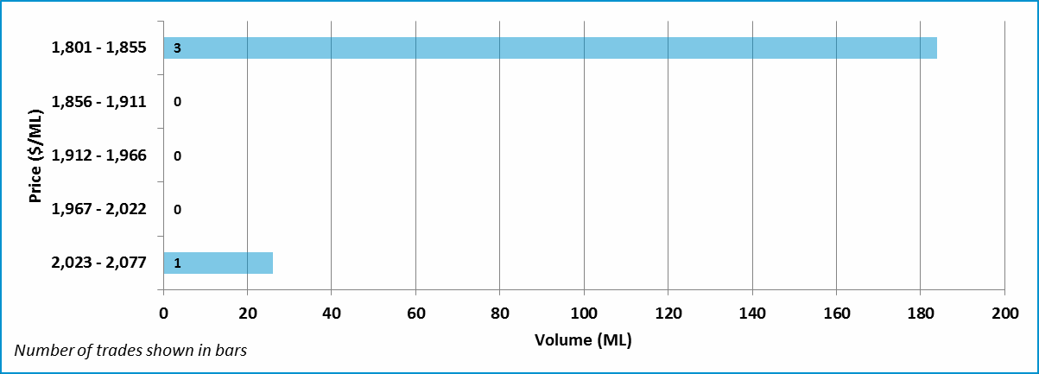

Data Sources: NSW Water Register (http://registers.water.nsw.gov.au/wma/WaterShareIntraWSLocSearch.jsp?selectedRegister=WaterShare, http://www.water.nsw.gov.au/water-licensing/registers), Waterfind (www.waterfind.com.au)

3.3 Gwydir: General Security

Figure 36: Entitlement market prices and volumes

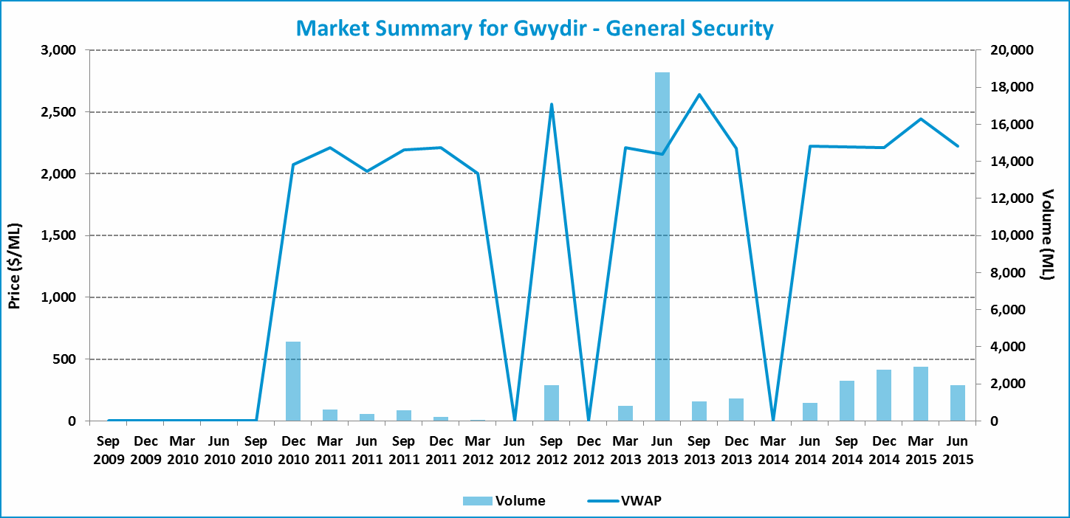

Table 20: Entitlement market prices and volumes

Volume weighted average price ($/ML)  Month of June 2015  June 2015 Quarter YTD |  | June 2015  Quarter  Volume  (ML) | June 2015 Market Spot  Quarter #  of trades Price ($/ML)
 | June 2015 Quarter (in $/ML) | June 2015  Quarter  Volume  (ML) | June 2015 Market Spot  Quarter #  of trades Price ($/ML)
 | 25th 75th  percentile percentile Median Mean Mode | June 2015  Quarter  Volume  (ML) | June 2015 Market Spot  Quarter #  of trades Price ($/ML)

- 2,226 2,285 - - - - - 1,944 1 No listings

Data Sources: NSW Water Register (http://registers.water.nsw.gov.au/wma/WaterShareIntraWSLocSearch.jsp?selectedRegister=WaterShare, http://www.water.nsw.gov.au/water-licensing/registers), Waterfind (www.waterfind.com.au)

3.4 NSW Border Rivers: General Security

Figure 37: Entitlement market prices and volumes

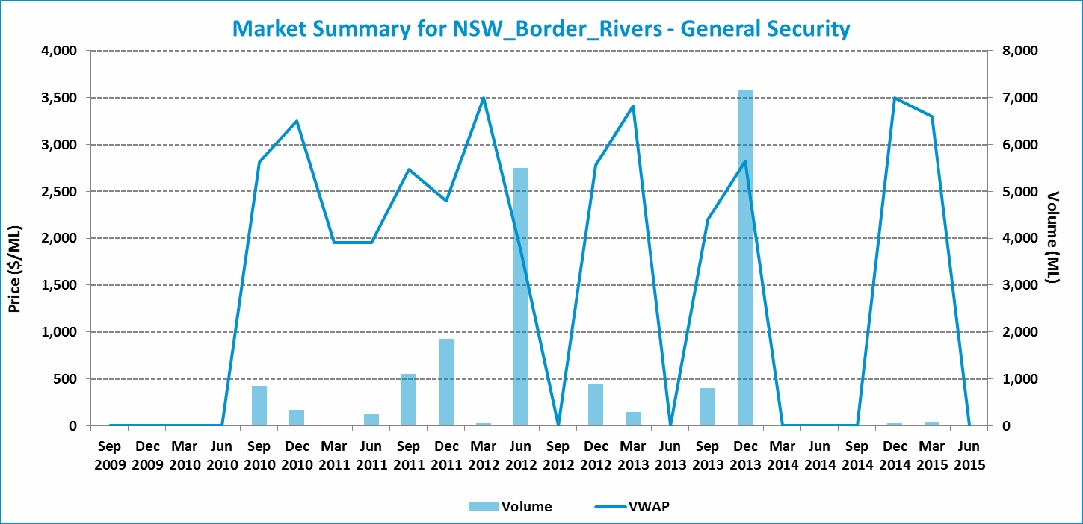

Table 21: Entitlement market prices and volumes

Volume weighted average price ($/ML)  Month of June 2015  June 2015 Quarter YTD |  | June 2015  Quarter  Volume  (ML) | June 2015 Market Spot  Quarter #  of trades Price ($/ML)
 | June 2015 Quarter (in $/ML) | June 2015  Quarter  Volume  (ML) | June 2015 Market Spot  Quarter #  of trades Price ($/ML)
 | 25th 75th  percentile percentile Median Mean Mode | June 2015  Quarter  Volume  (ML) | June 2015 Market Spot  Quarter #  of trades Price ($/ML)

- - 3,398 - - - - - - - 2,300

Data Sources: NSW Water Register (http://registers.water.nsw.gov.au/wma/WaterShareIntraWSLocSearch.jsp?selectedRegister=WaterShare, http://www.water.nsw.gov.au/water-licensing/registers), Waterfind (www.waterfind.com.au)

3.5 Barwon Darling: Unregulated

Figure 38: Entitlement market prices and volumes

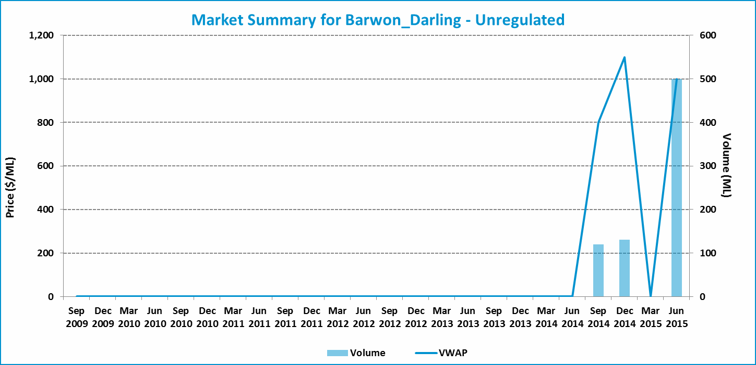

Table 22: Entitlement market prices and volumes

Volume weighted average price ($/ML)  Month of June 2015  June 2015 Quarter YTD |  | June 2015  Quarter  Volume  (ML) | June 2015 Market Spot  Quarter #  of trades Price ($/ML)
 | June 2015 Quarter (in $/ML) | June 2015  Quarter  Volume  (ML) | June 2015 Market Spot  Quarter #  of trades Price ($/ML)
 | 25th 75th  percentile percentile Median Mean Mode | June 2015  Quarter  Volume  (ML) | June 2015 Market Spot  Quarter #  of trades Price ($/ML)

- 1,000 985 - - - - - 500 1 No listings

Data Sources: NSW Water Register (http://registers.water.nsw.gov.au/wma/WaterShareIntraWSLocSearch.jsp?selectedRegister=WaterShare, http://www.water.nsw.gov.au/water-licensing/registers), Waterfind (www.waterfind.com.au)

3.6 Lachlan: General Security

Figure 39: Entitlement market prices and volumes

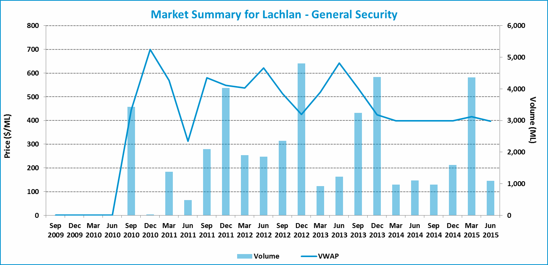

Table 23: Entitlement market prices and volumes

Volume weighted average price ($/ML)  Month of June 2015  June 2015 Quarter YTD |  | June 2015  Quarter  Volume  (ML) | June 2015 Market Spot  Quarter #  of trades Price ($/ML)
 | June 2015 Quarter (in $/ML) | June 2015  Quarter  Volume  (ML) | June 2015 Market Spot  Quarter #  of trades Price ($/ML)
 | 25th 75th  percentile percentile Median Mean Mode | June 2015  Quarter  Volume  (ML) | June 2015 Market Spot  Quarter #  of trades Price ($/ML)

500 398 408 400 400 400 417 400 1,088 5 No listings

Figure 40: Entitlement market price range by volume

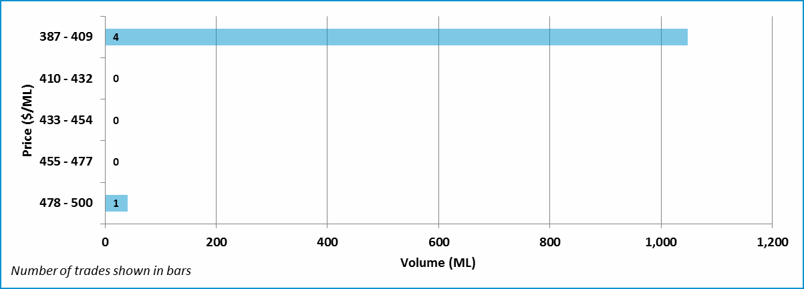

Data Sources: NSW Water Register (http://registers.water.nsw.gov.au/wma/WaterShareIntraWSLocSearch.jsp?selectedRegister=WaterShare, http://www.water.nsw.gov.au/water-licensing/registers), Waterfind (www.waterfind.com.au)

3.7 Queensland

The markets in Queensland are very thin, with only limited trading of entitlements occurring.

Queensland does not maintain a publicly available trade register. Information on entitlement trades is provided on an aggregated monthly basis.

Table 24: Entitlement market prices and volumes

Resource
Operation Plan
Water Supply
Scheme / Water

Type of Entitlement
Volume weighted average price ($/ML) June 2015
Quarter
June 2015
Quarter

Management Area
Month of June
2015
June 2015
Quarter
YTD $/ML
Volume (ML)
# of trades

QLD Border Rivers Border Rivers/ Macintyre Brook

Supplemented 868 1,217 1,816 423 4

QLD Border Rivers | Border Rivers | Unsupplemented | 350 | 1,719 | 1,745 | 1,376 | 4
Condamine- Balonne | St. George | Supplemented | - | - | 2,425 | - | -
Condamine- Balonne | Condamine Balonne /  Lower Balonne / | Unsupplemented | 1,500 | 1,500 | 1,567 | 636 | 3
 | Upper Condamine
Condamine- ab
Balonne Upper Condamine Alluvium Ground-water - - 1,800 - -

Condamine-
Balonne Lower Balonne Overland Flow - - - - -

Note: a. Data is only available for July 2014-December 2014 on the QLD Government website: https://www.dnrm.qld.gov.au/__data/assets/pdf_file/0004/217156/central-condamine-alluvium- water-licence-relocation-report.pdf. b. Three trades occurred in sub-area 4
Data Sources: Queensland Business and industry portal (https://www.business.qld.gov.au/industry/water/managing-accessing/markets-trading/market-information)

Appendix 1: Regions and water sources

Table 25: Water Sources (Southern MDB)

Region Water Source
SA Murray | River Murray Prescribed Water Course (Class 3a)
VIC Murray above Barmah Choke | 6 Vic Murray Dart to Barmah
Vic Murray below Barmah Choke | 7 Vic Murray Barmah to SA  6B Lower Broken Creek
Goulburn | 1A Greater Goulburn  1B Boort  3 Lower Goulburn
Campaspe | 4A Campaspe Eppalock to WWC  4C Lower Campaspe
Loddon | 5A Loddon – Coliban Channel to Lower Weir Pool  5B Bullarook
NSW Murray | New South Wales Murray Regulated River Water Source
Murrumbidgee | Murrumbidgee Regulated River Water Source
Lower Darling | Lower Darling Regulated River Water Source

Table 26: Water Sources (Northern MDB)

Region Entitlement Type
Macquarie | Macquarie and Cudgegong Regulated Rivers Water Source
Namoi | Lower Namoi Regulated River Water Source  Upper Namoi Regulated River Water Source
Gwydir | Gwydir Regulated River Water Source
NSW Border Rivers | Border Rivers Regulated River Water Source
Barwon Darling | Barwon Darling Unregulated River Water Source
Lachlan | Lachlan Regulated River Water Source

