# Water entitlement market prices

# Murray–Darling Basin

# (June quarter 2016)

**Report prepared for Australian Government Department of Agriculture and Water Resources**

Marsden Jacob Associates

Financial & Economic Consultants

ABN 66 663 324 657

ACN 072 233 204

Internet: <http://www.marsdenjacob.com.au>

E-mail: [economists@marsdenjacob.com.au](mailto:economists@marsdenjacob.com.au)

Melbourne office:

Postal address: Level 3, 683 Burke Road, Camberwell

Victoria 3124 AUSTRALIA

Telephone: 03 9882 1600

Facsimile: 03 9882 1300

Perth office:

Level 1, 220 St Georges Terrace, Perth

Western Australia, 6000 AUSTRALIA

Telephone: 08 9324 1785

Facsimile: 08 9322 7936

Sydney office:

119 Willoughby Rd Crows Nest

New South Wales, 2065 AUSTRALIA

Authors: Rod Carr, Oliver Baxter

|  |
| --- |
| This report has been prepared in accordance with the scope of services described in the contract or agreement between Marsden Jacob Associates Pty Ltd ACN 072 233 204 (MJA) and the Client. Any findings, conclusions or recommendations only apply to the aforementioned circumstances and no greater reliance should be assumed or drawn by the Client. Furthermore, the report has been prepared solely for use by the Client and Marsden Jacob Associates accepts no responsibility for its use by other parties. |

Copyright © Marsden Jacob Associates Pty Ltd 2016

Contents

1. Introduction 1

1.1 Regions, entitlements and key statistics 1

1.2 Data sources 3

1.3 Notes 3

2. Southern Murray–Darling Basin 4

2.1 South Australian Murray: Class 3a 5

2.2 Victorian Murray above Barmah Choke: high reliability 6

2.3 Victorian Murray above Barmah Choke: low reliability 7

2.4 Victorian Murray below Barmah Choke: high reliability 8

2.5 Victorian Murray below Barmah Choke: low reliability 9

2.6 Goulburn: high reliability 10

2.7 Goulburn: low reliability 11

2.8 Campaspe: high reliability 12

2.9 Loddon: high reliability 13

2.10 New South Wales Murray: general security 14

2.11 New South Wales Murray: high security 15

2.12 New South Wales Murray Irrigation Limited 16

2.13 Murrumbidgee: general security 17

2.14 Murrumbidgee: high security 18

2.15 Lower Darling: general security 19

2.16 Lower Darling: high security 20

3. Northern Murray–Darling Basin 21

3.1 Macquarie: general security 22

3.2 Namoi: general security 23

3.3 Gwydir: general security 24

3.4 New South Wales Border Rivers: general security 25

3.5 Barwon–Darling: unregulated 26

3.6 Lachlan: General security 27

3.7 Queensland 28

Appendix A: Regions and water sources 29

Appendix B: Outliers removed 30

## Introduction

This June 2016 quarter water entitlement market prices report has been prepared by Marsden Jacob Associates (Marsden Jacob) for the Australian Government Department of Agriculture and Water Resources.

A water access entitlement is a perpetual or ongoing entitlement to exclusive access to a share of water from a specified consumptive pool, as defined in the relevant water plan.

The report includes:

* southern Murray–Darling Basin (MDB) market activity and price information, by region and entitlement type (Section 2)
* northern MDB market activity and price information, by region and entitlement type (Section 3)
* a list of catchments and water sources (Appendix A)
* a list of data outliers removed from the trade data (Appendix B).

### Regions, entitlements and key statistics

The entitlement price report is broadly split into the southern and the northern MDB, as detailed in Table 1 and Table 2. Interactive maps showing the location of these trading regions are available on the [Murray–Darling Basin Authority's website](http://www.mdba.gov.au/managing-water/water-markets-trade/interstate-water-trade). The water sources included in each of the regions are listed in Appendix A.

Table 1: Regions and entitlement types, southern MDB

| **Region** | **Entitlement type** |
| --- | --- |
| SA Murray | Class 3a |
| Vic. Murray above Barmah Choke | High reliability |
| Vic. Murray above Barmah Choke | Low reliability |
| Vic. Murray below Barmah Choke | High reliability |
| Vic. Murray below Barmah Choke | Low reliability |
| Goulburn | High reliability |
| Goulburn | Low reliability |
| Campaspe | High reliability |
| Loddon | High reliability |
| NSW Murray | General security |
| NSW Murray | High security |
| NSW Murray Irrigation Limited | General security |
| Murrumbidgee | General security |
| Murrumbidgee | High security |
| Lower Darling | General security |
| Lower Darling | High security |

Table 2: Regions and entitlement types, northern MDB

| **Region** | **Entitlement type** |
| --- | --- |
| Macquarie | General security |
| Namoi | General security |
| Gwydir | General security |
| NSW Border Rivers | General security |
| Barwon–Darling | Unregulated |
| Lachlan | General security |
| Condamine–Balonne (St George) | Supplemented |
| Condamine–Balonne (Upper Condamine and Lower Balonne) | Unsupplemented |
| Central Condamine Alluvium Groundwater (1, 2, 3 and 4) | Groundwater (sub areas 1, 2, 3 and 4) |
| Upper Condamine Alluvium Groundwater (Dalrymple Creek) | Groundwater |
| Upper Condamine Alluvium Groundwater (Oakey Creek) | Groundwater |
| Qld Border Rivers | Supplemented |
| Qld Border Rivers | Unsupplemented |
| Lower Balonne | Overland flow |

As requested by the department, for each of the regions and water entitlement categories Marsden Jacob reports a range of measures, subject to data availability and the number of trades:

* volume weighted average price (VWAP)
* median price
* mean price
* mode price
* 25th and 75th percentile prices
* price quintiles
* trade volume
* number of trades
* water trading exchange prices.

### Data sources

The data sources for this report are:

* National Water Market Register data, up to 31 December 2013
* state government water registers and websites
* water exchange and broker noticeboard prices.

### Notes

Entitlement prices in the state government water registers can lag the exchange date of contracts or water sale agreements by periods of days to several months. This means the entitlement prices shown in the monthly and quarterly VWAPs may not reflect all exchanges during the month.

Entitlement prices that do not appear to reflect arm’s-length transactions have been excluded in the data cleaning process (see Appendix B). Removing these values reduces price distortions in the reporting. This means prices in this report may differ from prices shown in registers where these transactions have not been removed.

Marsden Jacob uses a two-stage process to clean the data, which is based on the approach used by the Australian Bureau of Agricultural and Resource Economics and Sciences and the former National Water Commission:

1. Removing prices that may not be genuine; for example, removing transactions where the price was reported to be null ($0 per ML)
2. Reviewing and potentially removing transactions outside two standard deviations from the average price of water entitlements by region (or trading zone) and by water product.

Marsden Jacob does not necessarily remove all trades that fall outside two standard deviations, as some of them reflect arm’s-length trades. If trades that fall outside two standard deviations are retained in the regional dataset, this is noted in the region- and entitlement-specific reports.

## Southern Murray–Darling Basin

Figure 1 Price correlations in the southern MDB, high security, high reliability, Class 3a, September 2009 to June 2016

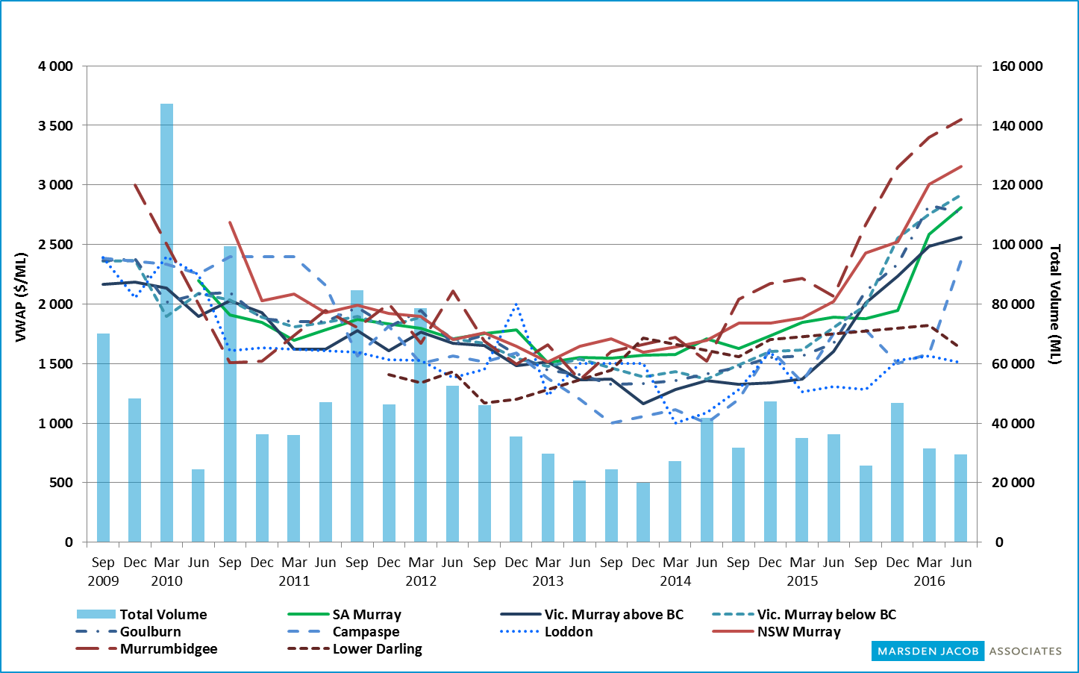

Source: Marsden Jacob analysis, 2016.

Figure 2 Price correlations in the southern MDB, general security, low reliability, September 2009 to June 2016

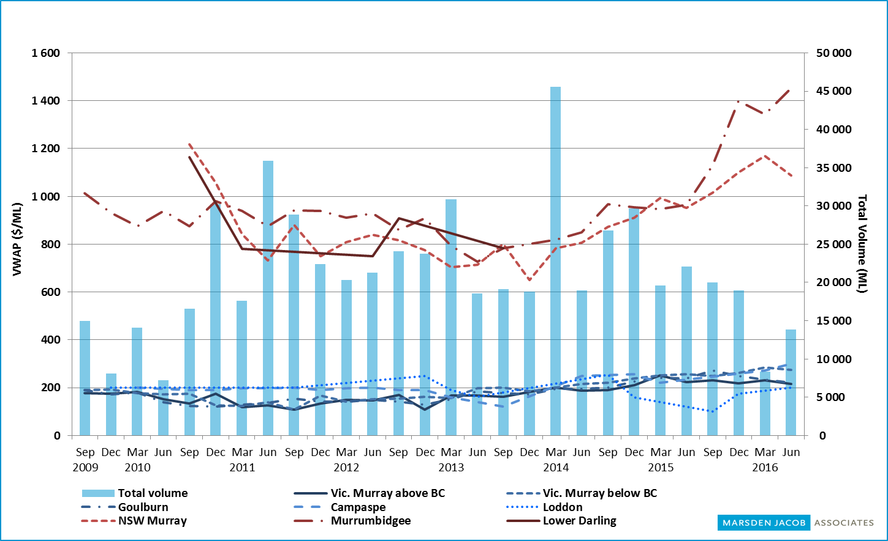

Note: Where possible, zero values have been interpolated in these charts, so they differ slightly from the region- and entitlement-specific charts.

Source: Marsden Jacob analysis, 2016.

### South Australian Murray: Class 3a

Figure 3 Entitlement market prices and volumes, SA Murray, Class 3a, September 2009 to June 2016

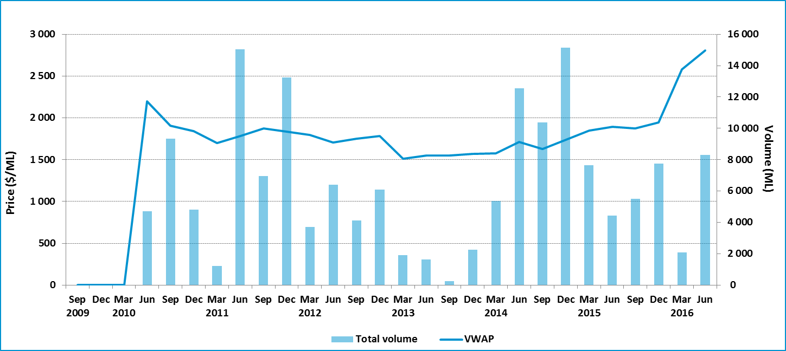

Table 3 Entitlement market prices and volumes, SA Murray, Class 3a

| **Volume weighted average price ($/ML)** | | | **June quarter ($/ML)** | | | | | **June quarter volume (ML)** | **June quarter no. of trades** | **Broker buy/sell range ($/ML)** |
| --- | --- | --- | --- | --- | --- | --- | --- | --- | --- | --- |
| **June 2016** | **June quarter** | **YTD** | **25th percentile** | **75th percentile** | **Median** | **Mean** | **Mode** |
| 3 011 | 2 808 | 2 288 | 2 900 | 3 000 | 2 950 | 2 961 | 3 000 | 8 304 | 29 | 2 800–3 200 |

Figure 4 Entitlement market price range, SA Murray, Class 3a, by volume, June quarter 2016

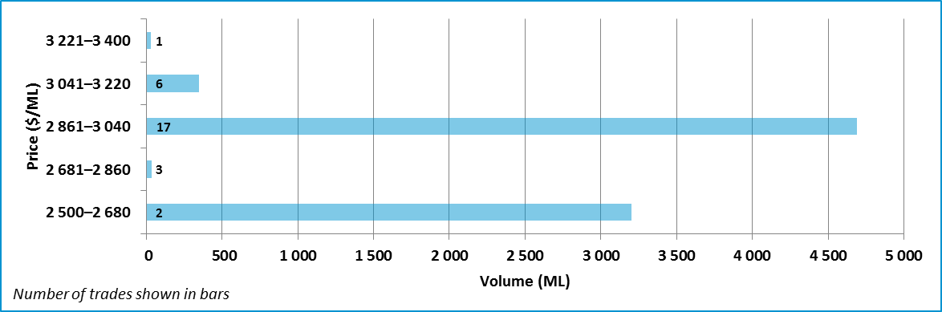

Data sources: [H2OX](http://www.h2ox.com/), [National Water Exchange](http://www.waterexchange.com.au/), [SA Water Register](http://www.waterconnect.sa.gov.au/Systems/WTR/Pages/default.aspx), [Waterfind](http://www.waterfind.com.au/).

### Victorian Murray above Barmah Choke: high reliability

Figure 5 Entitlement market prices and volumesVic. Murray above Barmah Choke, high reliability, September 2009 to June 2016

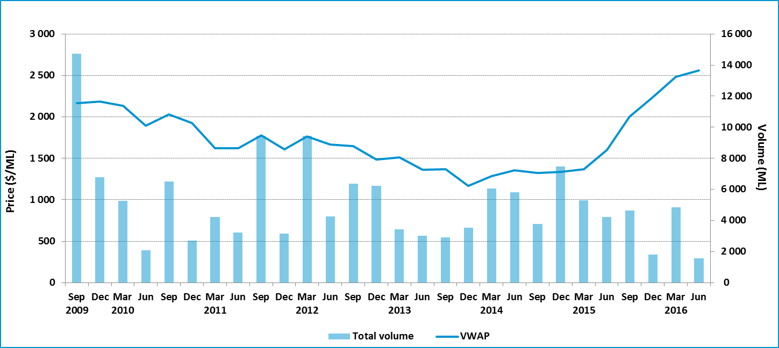

Table 4 Entitlement market prices and volumes, Vic. Murray above Barmah Choke, high reliability

| **Volume weighted average price ($/ML)** | | | **June quarter ($/ML)** | | | | | **June quarter volume (ML)** | **June quarter no. of trades** | **Broker buy/sell range ($/ML)** |
| --- | --- | --- | --- | --- | --- | --- | --- | --- | --- | --- |
| **June 2016** | **June quarter** | **YTD** | **25th percentile** | **75th percentile** | **Median** | **Mean** | **Mode** |
| 2 484 | 2 559 | 2 287 | 2 225 | 2 600 | 2 500 | 2 393 | 2 500 | 1 579 | 30 | No listings |

Figure 6 Entitlement market price range, Vic. Murray above Barmah Choke, high reliability, by volume, June quarter 2016

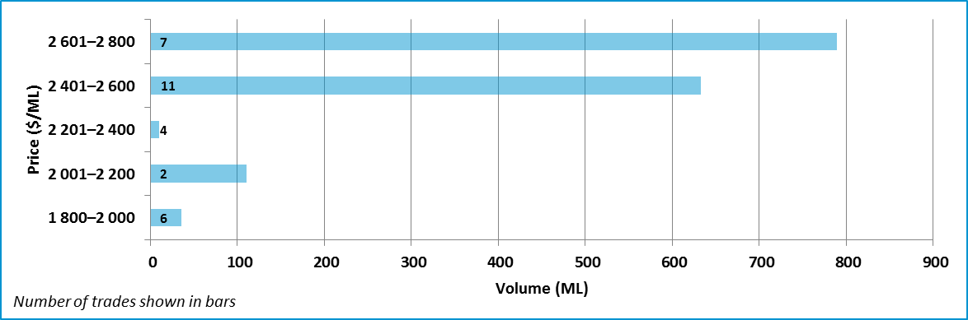

Data sources: [H2OX](http://www.h2ox.com/), [National Water Exchange](http://www.waterexchange.com.au/), [Victorian Water Register](http://waterregister.vic.gov.au/water-trading/water-share-trading), [Waterfind](http://www.waterfind.com.au/).

### Victorian Murray above Barmah Choke: low reliability

Figure 7 Entitlement market prices and volumes, Vic. Murray above Barmah Choke, low reliability, September 2009 to June 2016

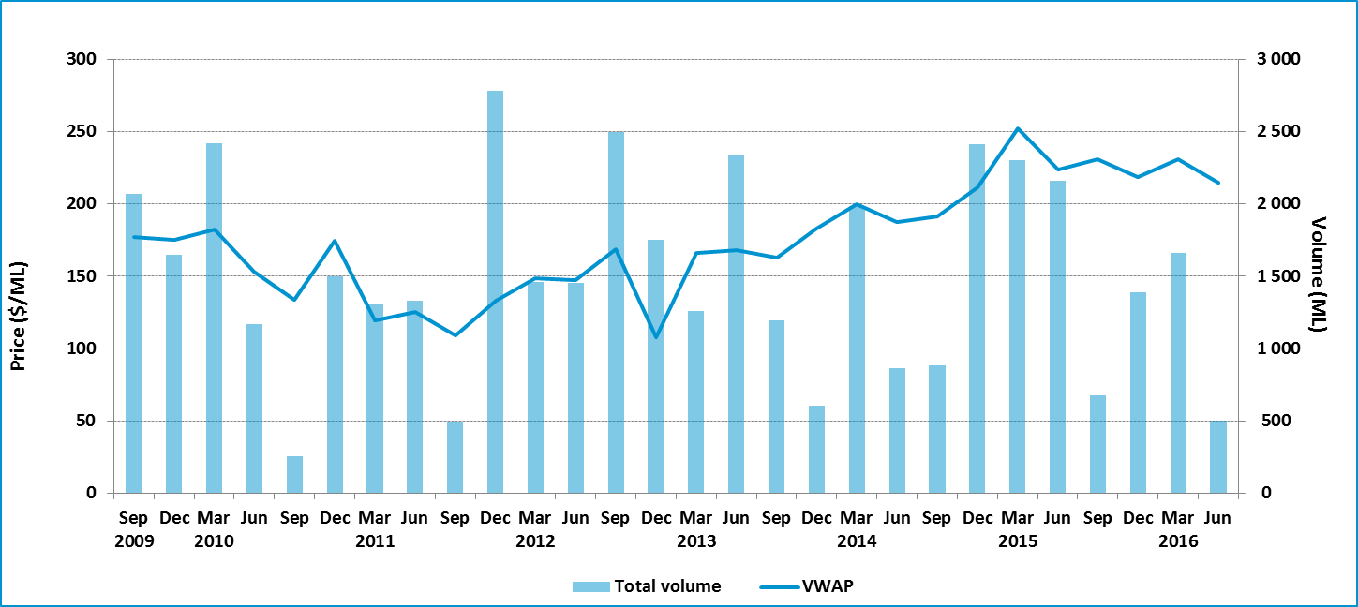

Table 5 Entitlement market prices and volumes, Vic. Murray above Barmah Choke, low reliability

| **Volume weighted average price ($/ML)** | | | **June quarter ($/ML)** | | | | | **June quarter volume (ML)** | **June quarter no. of trades** | **Broker buy/sell range ($/ML)** |
| --- | --- | --- | --- | --- | --- | --- | --- | --- | --- | --- |
| **June 2016** | **June quarter** | **YTD** | **25th percentile** | **75th percentile** | **Median** | **Mean** | **Mode** |
| 212 | 214 | 225 | 200 | 220 | 210 | 216 | 200 | 504 | 13 | 215 |

Figure 8 Entitlement market price range, Vic. Murray above Barmah Choke, low reliability, by volume, June quarter 2016

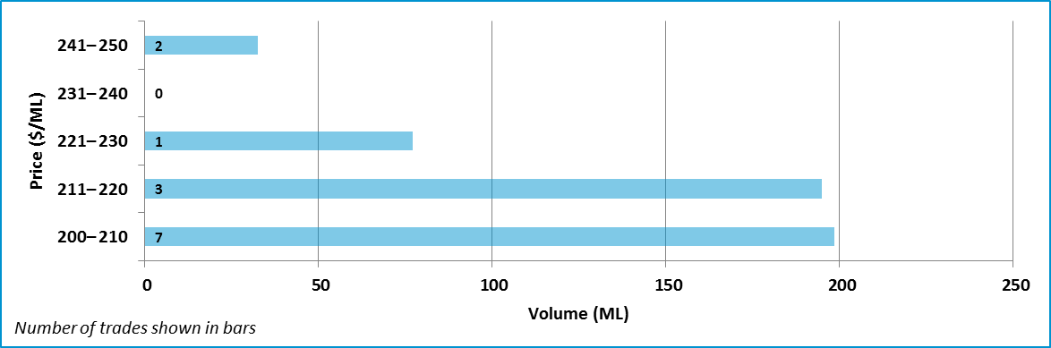

Data sources: [H2OX](http://www.h2ox.com/), [National Water Exchange](http://www.waterexchange.com.au/), [Victorian Water Register](http://waterregister.vic.gov.au/water-trading/water-share-trading), [Waterfind](http://www.waterfind.com.au/).

### Victorian Murray below Barmah Choke: high reliability

Figure 9 Entitlement market prices and volumes, Vic. Murray below Barmah Choke, high reliability, September 2009 to June 2016

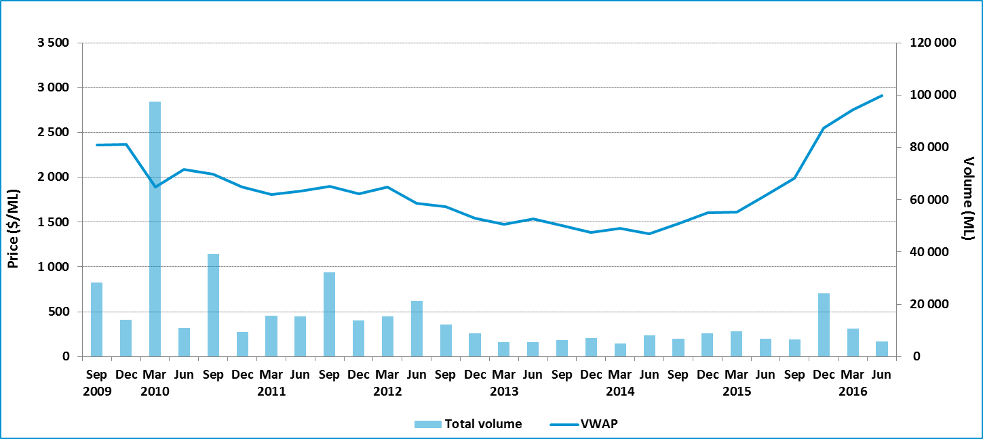

Table 6 Entitlement market prices and volumes, Vic. Murray below Barmah Choke, high reliability

| **Volume weighted average price ($/ML)** | | | **June quarter ($/ML)** | | | | | **June quarter volume (ML)** | **June quarter no. of trades** | **Broker buy/sell range ($/ML)** |
| --- | --- | --- | --- | --- | --- | --- | --- | --- | --- | --- |
| **June 2016** | **June quarter** | **YTD** | **25th percentile** | **75th percentile** | **Median** | **Mean** | **Mode** |
| 2 919 | 2 914 | 2 565 | 2 500 | 3 000 | 2 950 | 2 682 | 3 000 | 5 682 | 164 | 2 500–3 200 |

Figure 10: Entitlement market price range, Vic. Murray below Barmah Choke, high reliability, by volume, June quarter 2016

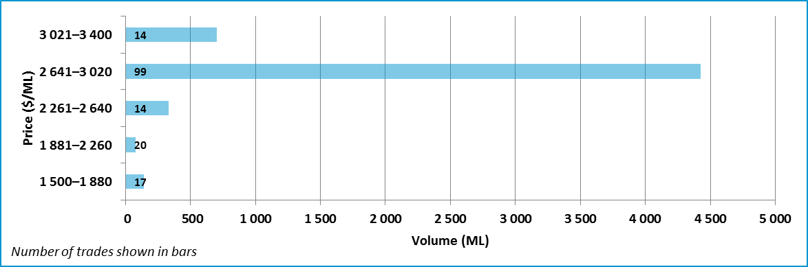

Note: Six trades which are outside two standard deviations of the average price of water entitlements have been included for this region. Five of the six trades were valued at $1 500 per ML, they occurred on 6 April, 4 May, 20 May, 31 May, and 15 June. One trade on 3 June was valued at $1 520 per ML.

Data sources: [H2OX](http://www.h2ox.com/), [National Water Exchange](http://www.waterexchange.com.au/), [Victorian Water Register](http://waterregister.vic.gov.au/water-trading/water-share-trading), [Waterfind](http://www.waterfind.com.au/).

### Victorian Murray below Barmah Choke: low reliability

Figure 11 Entitlement market prices and volumes, Vic. Murray below Barmah Choke, low reliability, September 2009 to June 2016

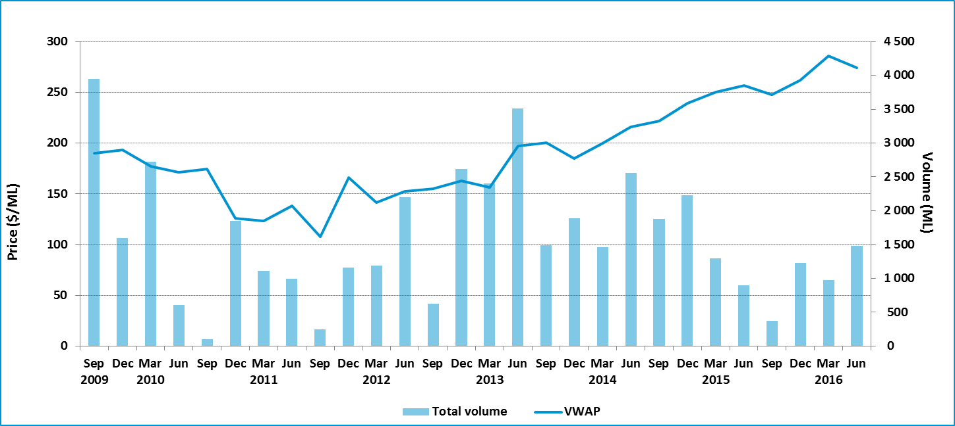

Table 7 Entitlement market prices and volumes, Vic. Murray below Barmah Choke, low reliability

| **Volume weighted average price ($/ML)** | | | **June quarter ($/ML)** | | | | | **June quarter volume (ML)** | **June quarter no. of trades** | **Broker buy/sell range ($/ML)** |
| --- | --- | --- | --- | --- | --- | --- | --- | --- | --- | --- |
| **June 2016** | **June quarter** | **YTD** | **25th percentile** | **75th percentile** | **Median** | **Mean** | **Mode** |
| 249 | 274 | 271 | 235 | 276 | 250 | 250 | 250 | 1 481 | 20 | 230–300 |

Figure 12 Entitlement market price range, Vic. Murray below Barmah Choke, low reliability, by volume, June quarter 2016

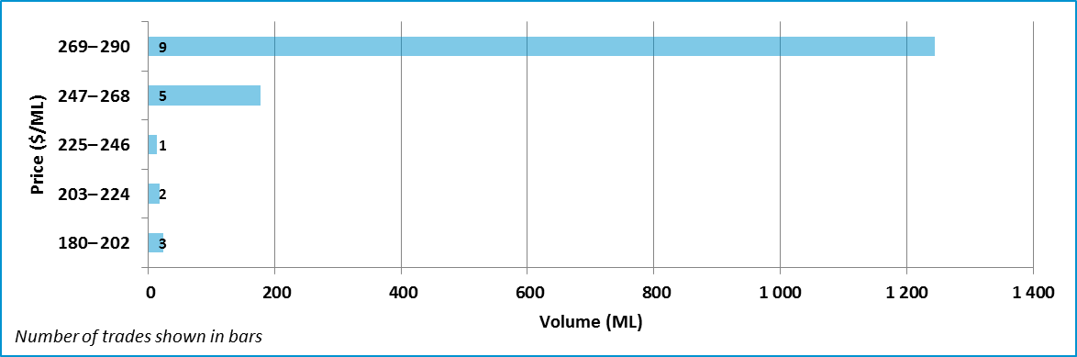

Note: Two trades that were outside two standard deviations of the average price of water entitlements have been included for this region.

Data sources: [H2OX](http://www.h2ox.com/), [National Water Exchange](http://www.waterexchange.com.au/), [Victorian Water Register](http://waterregister.vic.gov.au/water-trading/water-share-trading), [Waterfind](http://www.waterfind.com.au/).

### Goulburn: high reliability

Figure 13 Entitlement market prices and volumes, Goulburn, high reliability, September 2009 to June 2016

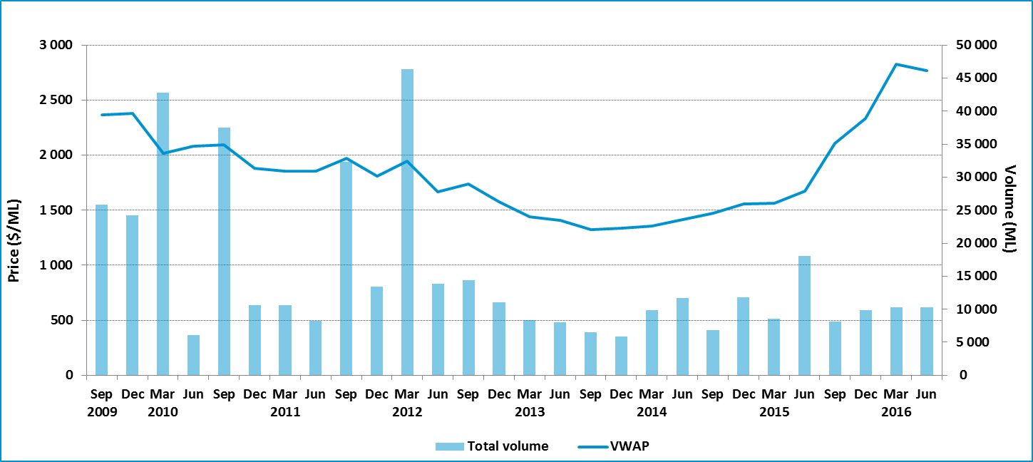

Table 8 Entitlement market prices and volumes, Goulburn, high reliability

| **Volume weighted average price ($/ML)** | | | **June quarter ($/ML)** | | | | | **June quarter volume (ML)** | **June quarter no. of trades** | **Broker buy/sell range ($/ML)** |
| --- | --- | --- | --- | --- | --- | --- | --- | --- | --- | --- |
| **June 2016** | **June quarter** | **YTD** | **25th percentile** | **75th percentile** | **Median** | **Mean** | **Mode** |
| 2 643 | 2 766 | 2 535 | 2 400 | 2 800 | 2 750 | 2 579 | 2 800 | 10 335 | 182 | 2 200–2 750 |

Figure 14 Entitlement market price range, Goulburn, high reliability, by volume, June quarter 2016

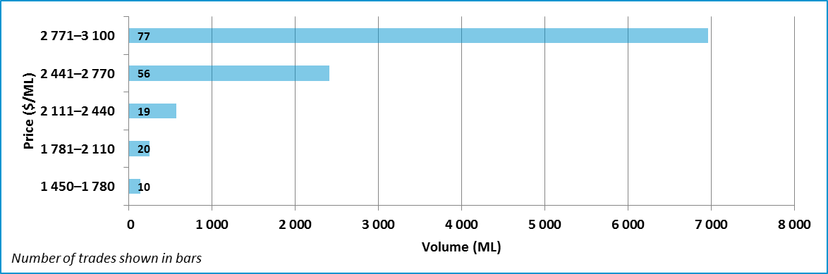

Data sources: [H2OX](http://www.h2ox.com/), [National Water Exchange](http://www.waterexchange.com.au/), [Victorian Water Register](http://waterregister.vic.gov.au/water-trading/water-share-trading), [Waterfind](http://www.waterfind.com.au/).

### Goulburn: low reliability

Figure 15 Entitlement market prices and volumes, Goulburn, low reliability, September 2009 to June 2016

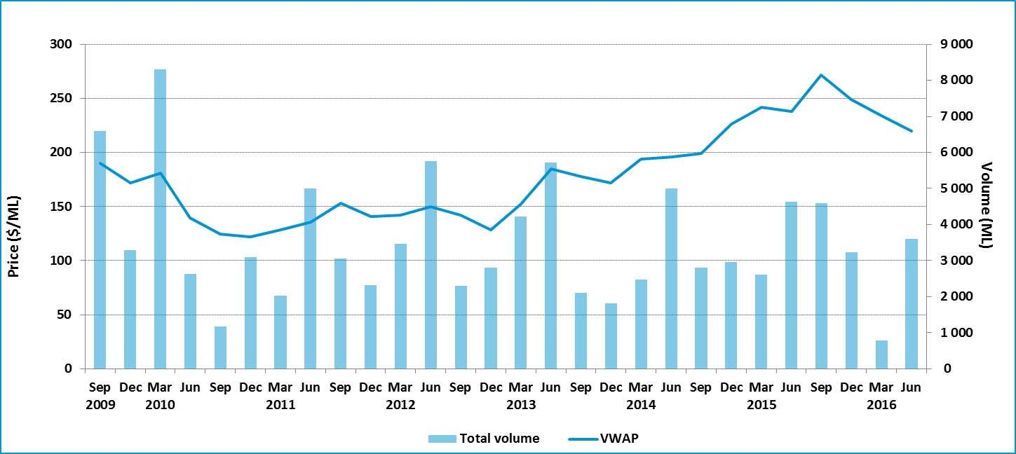

Table 9 Entitlement market prices and volumes, Goulburn, low reliability

| **Volume weighted average price ($/ML)** | | | **June quarter ($/ML)** | | | | | **June quarter volume (ML)** | **June quarter no. of trades** | **Broker buy/sell range ($/ML)** |
| --- | --- | --- | --- | --- | --- | --- | --- | --- | --- | --- |
| **June 2016** | **June quarter** | **YTD** | **25th percentile** | **75th percentile** | **Median** | **Mean** | **Mode** |
| 224 | 220 | 248 | 200 | 230 | 220 | 219 | 220 | 3 604 | 68 | 180–235 |

Figure 16 Entitlement market price range, Goulburn, low reliability, by volume, June quarter 2016

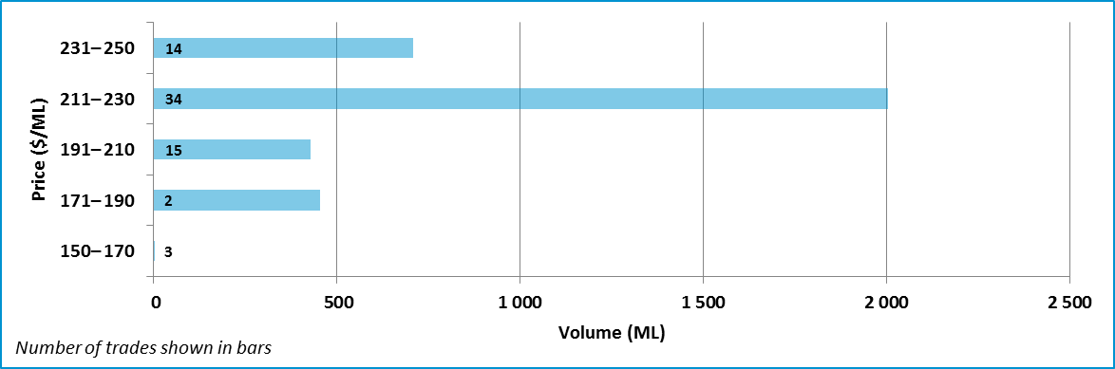

Data sources: [H2OX](http://www.h2ox.com/), [National Water Exchange](http://www.waterexchange.com.au/), [Victorian Water Register](http://waterregister.vic.gov.au/water-trading/water-share-trading), [Waterfind](http://www.waterfind.com.au/).

### Campaspe: high reliability

Figure 17 Entitlement market prices and volumes, Campaspe, high reliability, September 2009 to June 2016

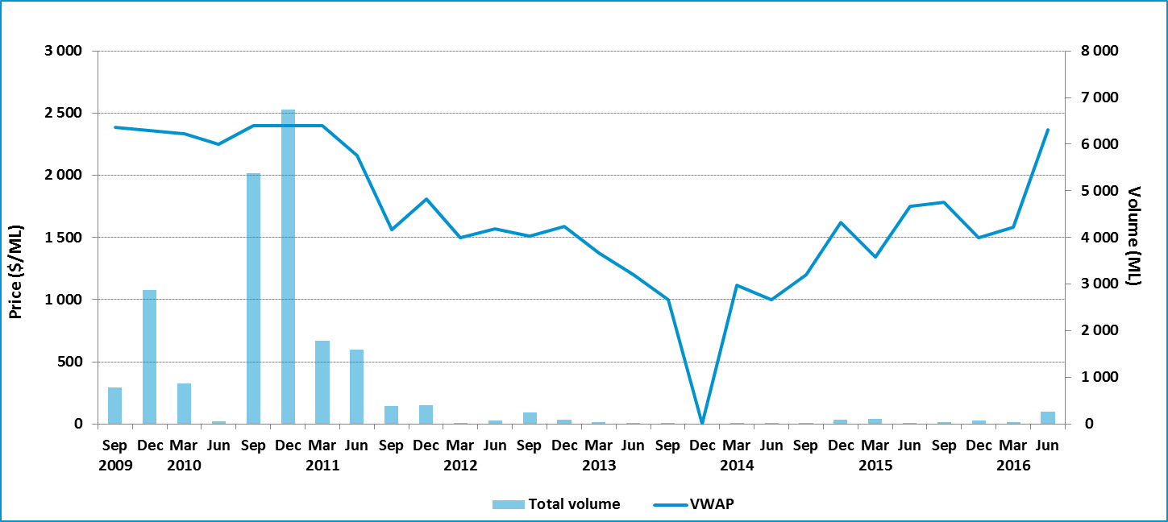

Table 10 Entitlement market prices and volumes, Campaspe, high reliability

| **Volume weighted average price ($/ML)** | | | **June quarter ($/ML)** | | | | | **June quarter volume (ML)** | **June quarter no. of trades** | **Broker buy/sell range ($/ML)** |
| --- | --- | --- | --- | --- | --- | --- | --- | --- | --- | --- |
| **June 2016** | **June quarter** | **YTD** | **25th percentile** | **75th percentile** | **Median** | **Mean** | **Mode** |
| 2 414 | 2 365 | 2 091 | 2 400 | 2 437 | 2 400 | 2 375 | 2 400 | 257 | 7 | No listing |

Figure 18 Entitlement market price range, Campaspe, high reliability, by volume, June quarter 2016

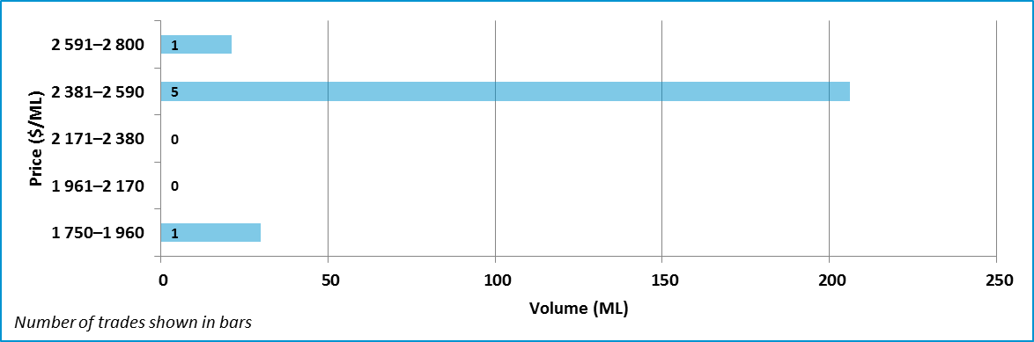

Data sources: [H2OX](http://www.h2ox.com/), [National Water Exchange](http://www.waterexchange.com.au/), [Victorian Water Register](http://waterregister.vic.gov.au/water-trading/water-share-trading), [Waterfind](http://www.waterfind.com.au/).

### Loddon: high reliability

Figure 19 Entitlement market prices and volumes, Loddon, high reliability, September 2009 to June 2016

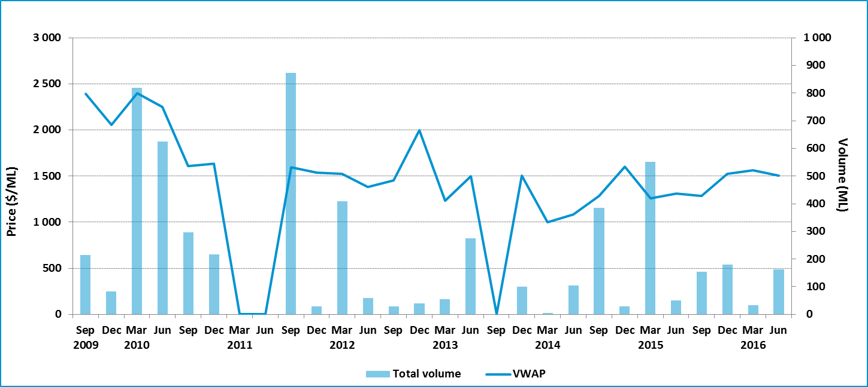

Table 11: Entitlement market prices and volumes, Loddon, high reliability

| **Volume weighted average price ($/ML)** | | | **June quarter ($/ML)** | | | | | **June quarter volume (ML)** | **June quarter no. of trades** | **Broker buy/sell range ($/ML)** |
| --- | --- | --- | --- | --- | --- | --- | --- | --- | --- | --- |
| **June 2016** | **June quarter** | **YTD** | **25th percentile** | **75th percentile** | **Median** | **Mean** | **Mode** |
| 1 493 | 1 505 | 1 451 | 1 513 | 1 658 | 1 625 | 1 572 | – | 162 | 3 | No listing |

Figure 20 Entitlement market price range, Loddon, high reliability, by volume, June quarter 2016

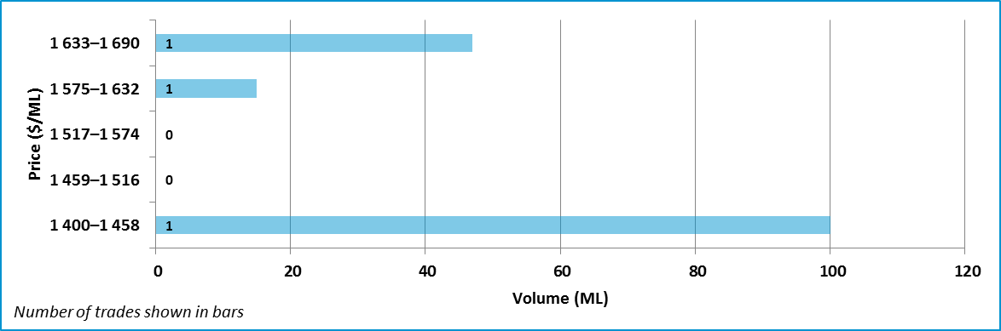

Data sources: [H2OX](http://www.h2ox.com/), [National Water Exchange](http://www.waterexchange.com.au/), [Victorian Water Register](http://waterregister.vic.gov.au/water-trading/water-share-trading), [Waterfind](http://www.waterfind.com.au/).

### New South Wales Murray: general security

Figure 21 Entitlement market prices and volumes, NSW Murray, general security, September 2009 to June 2016

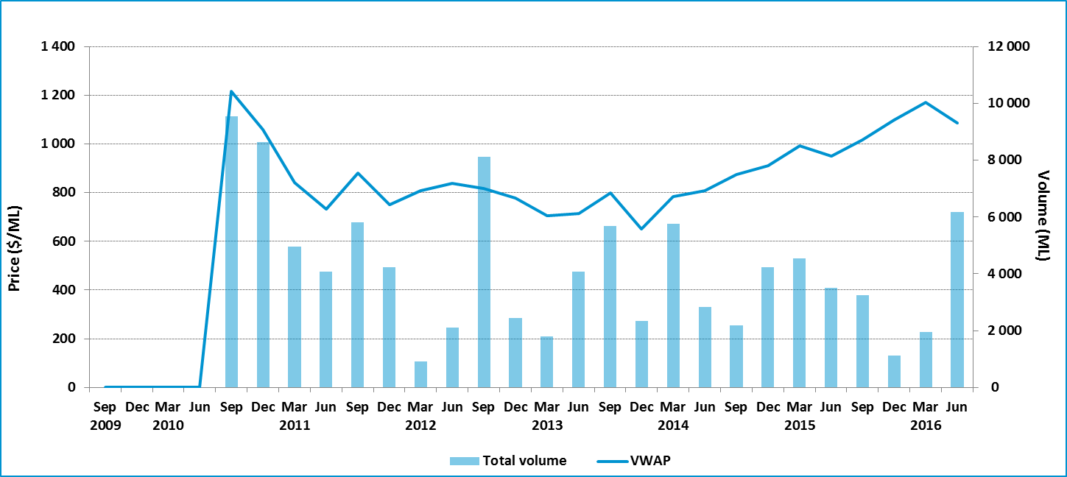

Table 12: Entitlement market prices and volumes, NSW Murray, general security

| **Volume weighted average price ($/ML)** | | | **June quarter ($/ML)** | | | | | **June quarter volume (ML)** | **June quarter no. of trades** | **Broker buy/sell range ($/ML)** |
| --- | --- | --- | --- | --- | --- | --- | --- | --- | --- | --- |
| **June 2016** | **June quarter** | **YTD** | **25th percentile** | **75th percentile** | **Median** | **Mean** | **Mode** |
| 1 153 | 1 087 | 1 083 | 1 000 | 1 278 | 1 200 | 1 085 | 1 280 | 6 167 | 19 | 1 175–1 300 |

Figure 22 Entitlement market price range, NSW Murray, general security, by volume, June quarter 2016

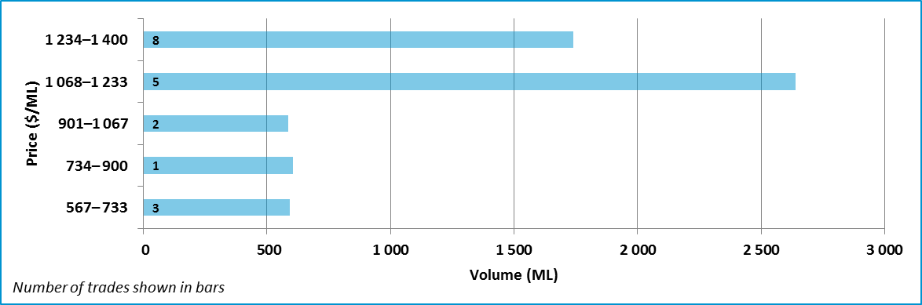

Note: One trade that was within two standard deviations of the average price of water entitlements has been excluded for this region.

Data sources: [H2OX](http://www.h2ox.com/), [National Water Exchange](http://www.waterexchange.com.au/), [Waterfind](http://www.waterfind.com.au/), [NSW Water Register](http://www.water.nsw.gov.au/water-licensing/registers).

### New South Wales Murray: high security

Figure 23 Entitlement market prices and volumes, NSW Murray, high security, September 2009 to June 2016

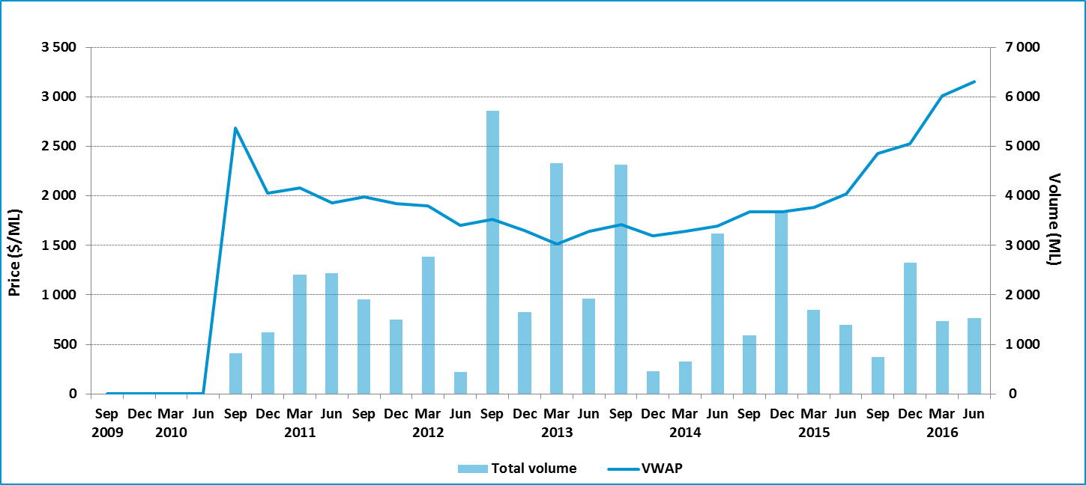

Table 13 Entitlement market prices and volumes, NSW Murray, high security

| **Volume weighted average price ($/ML)** | | | **June quarter ($/ML)** | | | | | **June quarter volume (ML)** | **June quarter no. of trades** | **Broker buy/sell range ($/ML)** |
| --- | --- | --- | --- | --- | --- | --- | --- | --- | --- | --- |
| **June 2016** | **June quarter** | **YTD** | **25th percentile** | **75th percentile** | **Median** | **Mean** | **Mode** |
| 3 125 | 3 155 | 2 774 | 3 000 | 3 320 | 3 100 | 3 155 | 3 000 | 1 535 | 20 | 3 120–3 810 |

Figure 24 Entitlement market price range, NSW Murray, high security, by volume, June quarter 2016

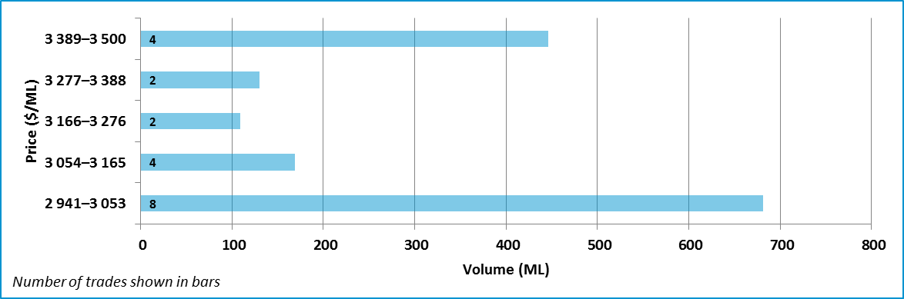

Data sources: [H2OX](http://www.h2ox.com/), [National Water Exchange](http://www.waterexchange.com.au/), [Waterfind](http://www.waterfind.com.au/), [NSW Water Register](http://www.water.nsw.gov.au/water-licensing/registers).

### New South Wales Murray Irrigation Limited

Figure 25 Entitlement market prices and volumes, NSW Murray Irrigation Limited, general security, September 2009 to June 2016

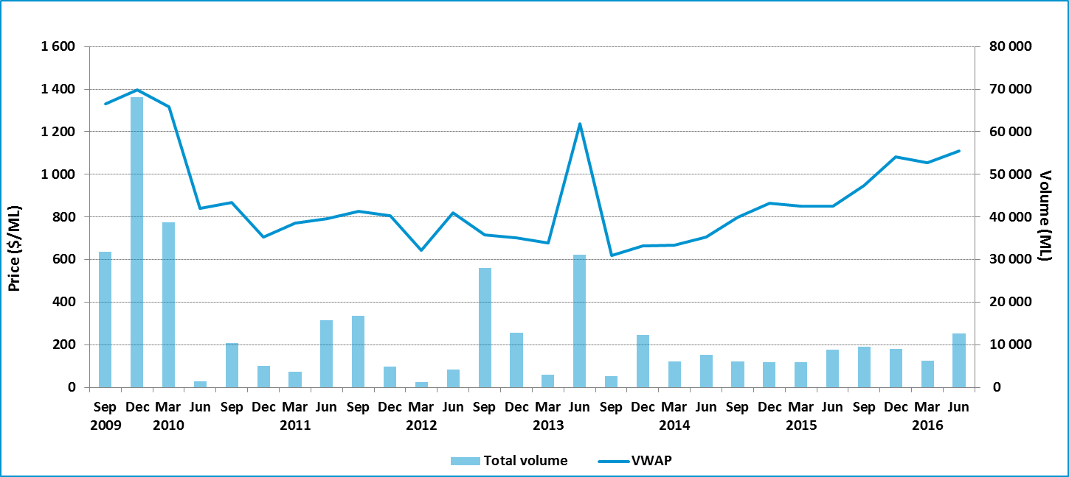

Table 14 Entitlement market prices and volumes, NSW Murray Irrigation Limited, general security

| **Volume weighted average price ($/ML)** | | | **June quarter ($/ML)** | | | | | **June quarter volume (ML)** | **June quarter no. of trades** | **Broker buy/sell range ($/ML)** |
| --- | --- | --- | --- | --- | --- | --- | --- | --- | --- | --- |
| **June 2016** | **June quarter** | **YTD** | **25th percentile** | **75th percentile** | **Median** | **Mean** | **Mode** |
| 1 190 | 1 109 | 1 052 | 1 069 | 1 219 | 1 150 | 1 118 | 850 | 12 639 | 30 | No listing |

Figure 26: Entitlement market price range, NSW Murray Irrigation Limited, general security, by volume, June quarter 2016

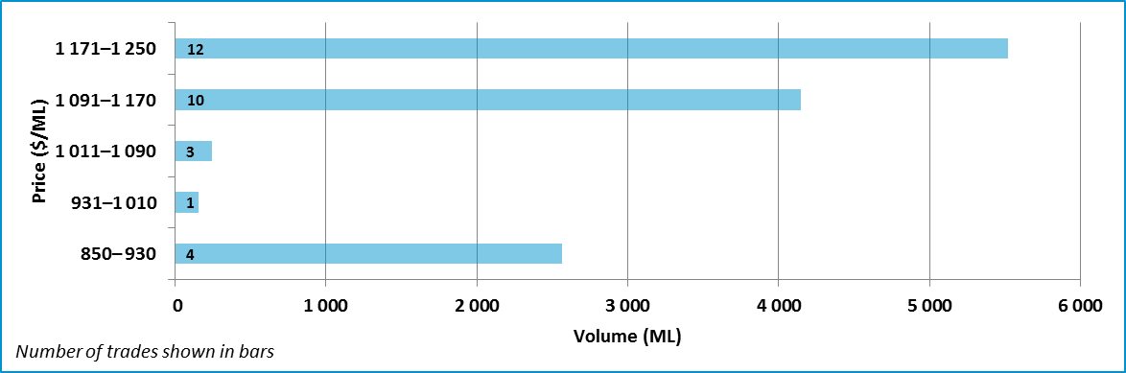

Data source: [Murray Irrigation Limited](http://www.murrayirrigation.com.au/).

### Murrumbidgee: general security

Figure 27 Entitlement market prices and volumes, Murrumbidgee, general security, September 2009 to June 2016

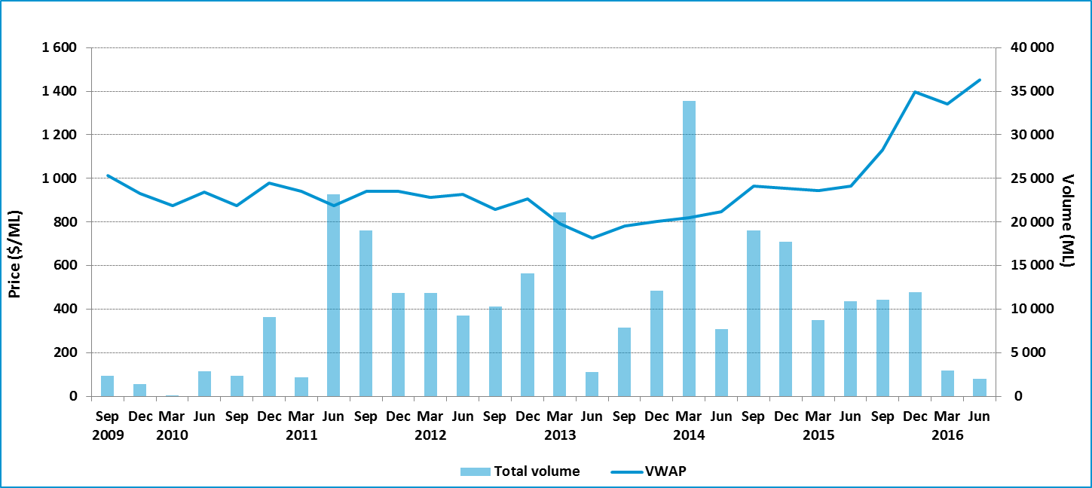

Table 15 Entitlement market prices and volumes, Murrumbidgee, general security

| **Volume weighted average price ($/ML)** | | | **June quarter ($/ML)** | | | | | **June quarter volume (ML)** | **June quarter no. of trades** | **Broker buy/sell range ($/ML)** |
| --- | --- | --- | --- | --- | --- | --- | --- | --- | --- | --- |
| **June 2016** | **June quarter** | **YTD** | **25th percentile** | **75th percentile** | **Median** | **Mean** | **Mode** |
| 1 467 | 1 452 | 1 290 | 1 415 | 1 490 | 1 460 | 1 436 | 1 500 | 1 994 | 11 | 1 400 |

Figure 28 Entitlement market price range, Murrumbidgee, general security, by volume, June quarter 2016

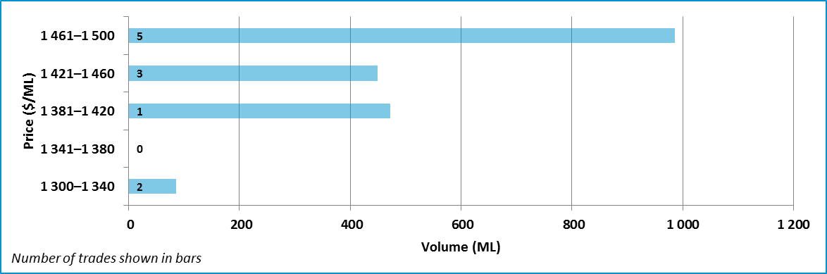

Data sources: [H2OX](http://www.h2ox.com/), [National Water Exchange](http://www.waterexchange.com.au/), [Waterfind](http://www.waterfind.com.au/), [NSW Water Register](http://www.water.nsw.gov.au/water-licensing/registers).

### Murrumbidgee: high security

Figure 29 Entitlement market prices and volumes, Murrumbidgee, high security, September 2009 to June 2016

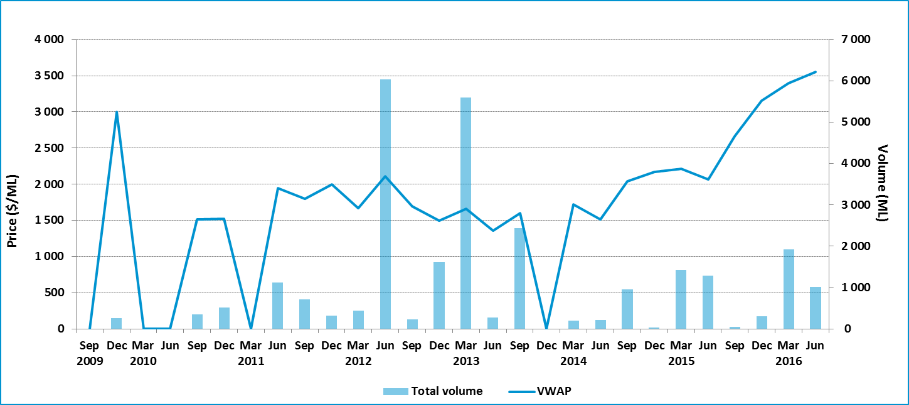

Table 16 Entitlement market prices and volumes, Murrumbidgee, high security

| **Volume weighted average price ($/ML)** | | | **June quarter ($/ML)** | | | | | **June quarter volume (ML)** | **June quarter no. of trades** | **Broker buy/sell range ($/ML)** |
| --- | --- | --- | --- | --- | --- | --- | --- | --- | --- | --- |
| **June 2016** | **June quarter** | **YTD** | **25th percentile** | **75th percentile** | **Median** | **Mean** | **Mode** |
| 3 599 | 3 553 | 3 415 | 3 475 | 3 688 | 3 600 | 3 589 | 3 800 | 1 022 | 8 | 3 400 |

Figure 30 Entitlement market price range, Murrumbidgee, high security, by volume, June quarter 2016

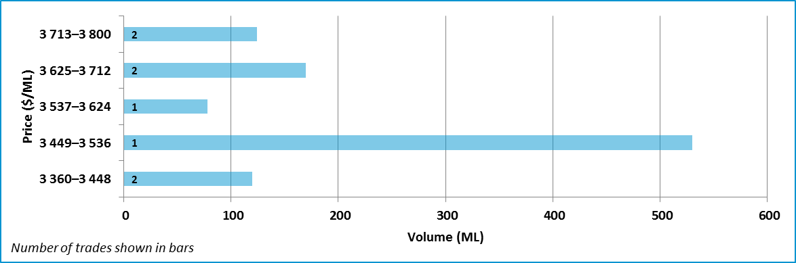

Data sources: [H2OX](http://www.h2ox.com/), [National Water Exchange](http://www.waterexchange.com.au/), [Waterfind](http://www.waterfind.com.au/), [NSW Water Register](http://www.water.nsw.gov.au/water-licensing/registers).

### Lower Darling: general security

Figure 31 Entitlement market prices and volumes, Lower Darling, general security, September 2009 to June 2016

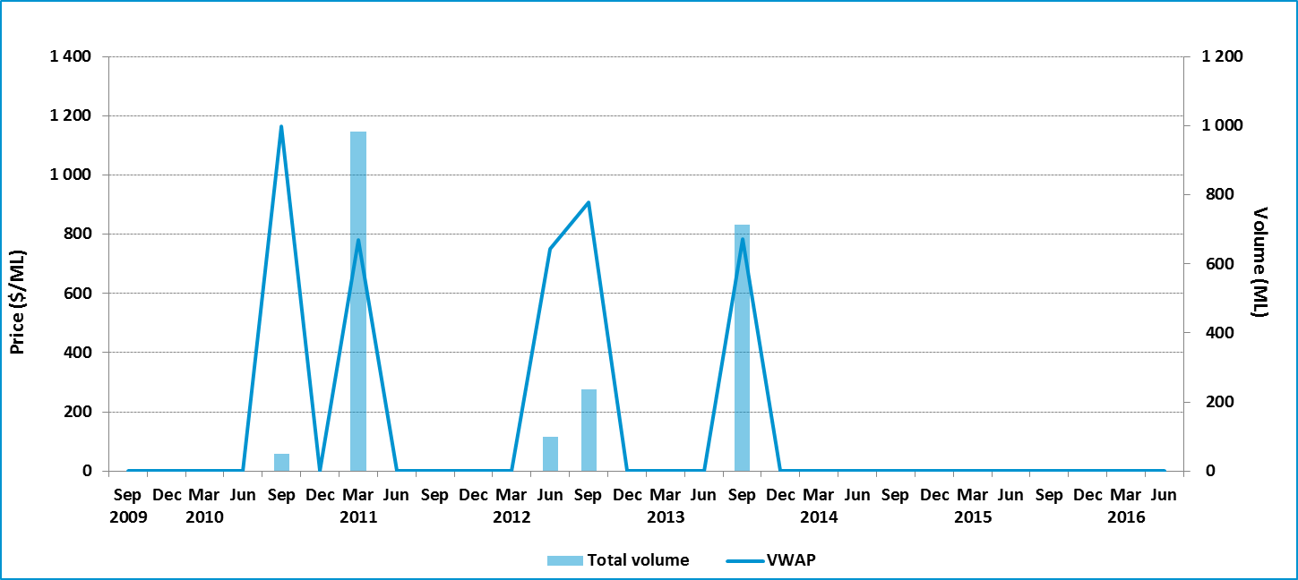

Table 17 Entitlement market prices and volumes, Lower Darling, general security

| **Volume weighted average price ($/ML)** | | | **June quarter ($/ML)** | | | | | **June quarter volume (ML)** | **June quarter no. of trades** | **Broker buy/sell range ($/ML)** |
| --- | --- | --- | --- | --- | --- | --- | --- | --- | --- | --- |
| **June 2016** | **June quarter** | **YTD** | **25th percentile** | **75th percentile** | **Median** | **Mean** | **Mode** |
| – | – | – | – | – | – | – | – | – | – | No listings |

Data sources: [H2OX](http://www.h2ox.com/), [National Water Exchange](http://www.waterexchange.com.au/), [Waterfind](http://www.waterfind.com.au/), [NSW Water Register](http://www.water.nsw.gov.au/water-licensing/registers).

### Lower Darling: high security

Figure 32 Entitlement market prices and volumes, Lower Darling, high security, September 2009 to June 2016

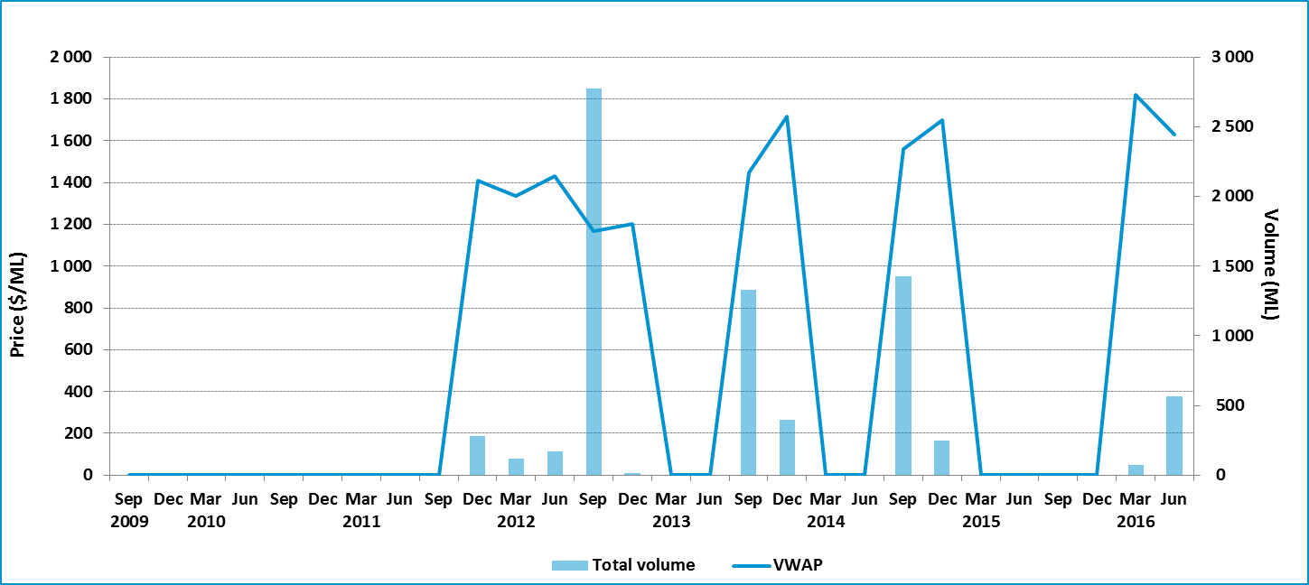

Table 18: Entitlement market prices and volumes, Lower Darling, high security

| **Volume weighted average price ($/ML)** | | | **June quarter ($/ML)** | | | | | **June quarter volume (ML)** | **June quarter no. of trades** | **Broker buy/sell range ($/ML)** |
| --- | --- | --- | --- | --- | --- | --- | --- | --- | --- | --- |
| **June 2016** | **June quarter** | **YTD** | **25th percentile** | **75th percentile** | **Median** | **Mean** | **Mode** |
| 1 820 | 1 628 | 1 650 | 1 674 | 1 771 | 1 723 | 1 723 |  | 566 | 2 | No listings |

Figure 33 Entitlement market price range, Lower Darling, high security, by volume, June quarter 2016

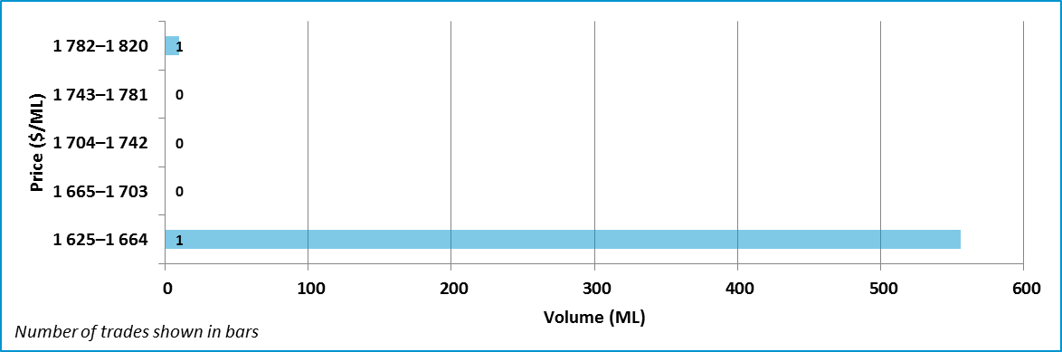

Data sources: [H2OX](http://www.h2ox.com/), [National Water Exchange](http://www.waterexchange.com.au/), [Waterfind](http://www.waterfind.com.au/), [NSW Water Register](http://www.water.nsw.gov.au/water-licensing/registers).

## Northern Murray–Darling Basin

Figure 34 Price correlations in the northern MDB, general security, September 2010 to June 2016

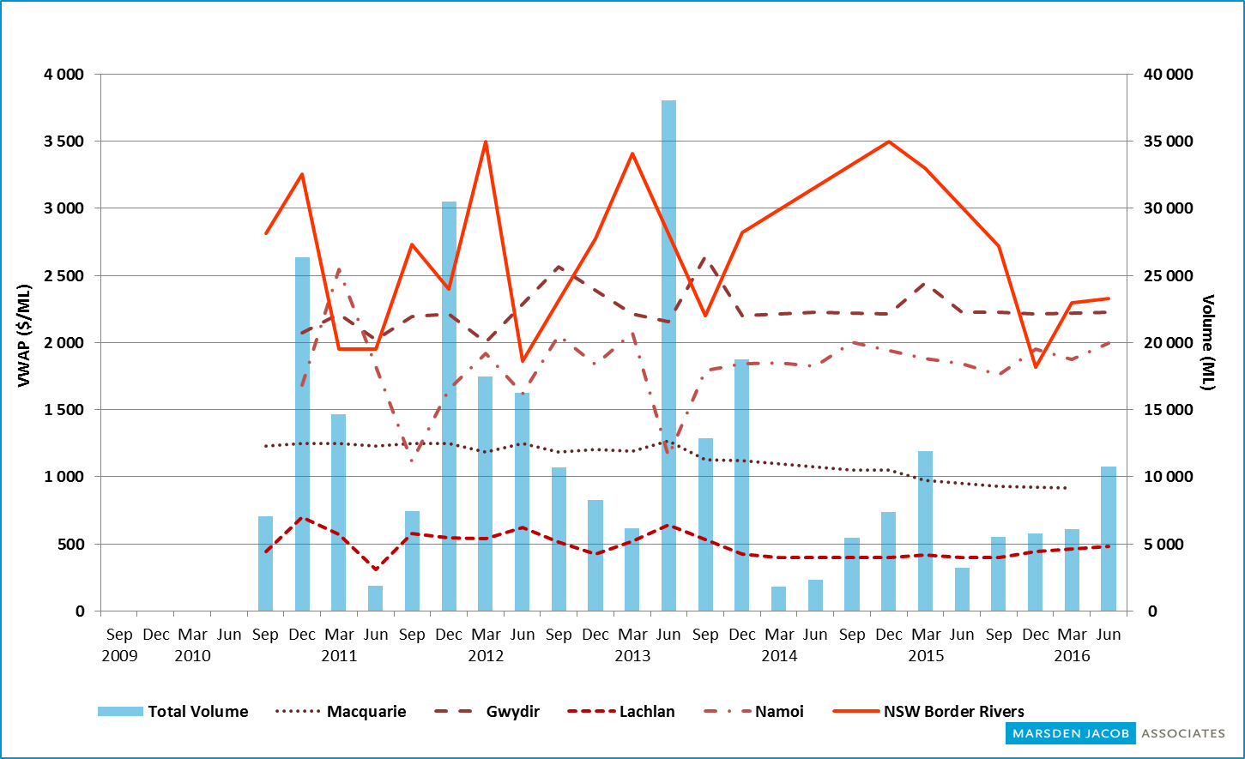

Note: Zero values have been interpolated in this chart, so it differs from the region- and entitlement-specific charts.

Source: Marsden Jacob analysis, 2016.

### Macquarie: general security

Figure 35 Entitlement market prices and volumes, Macquarie, general security, September 2009 to June 2016

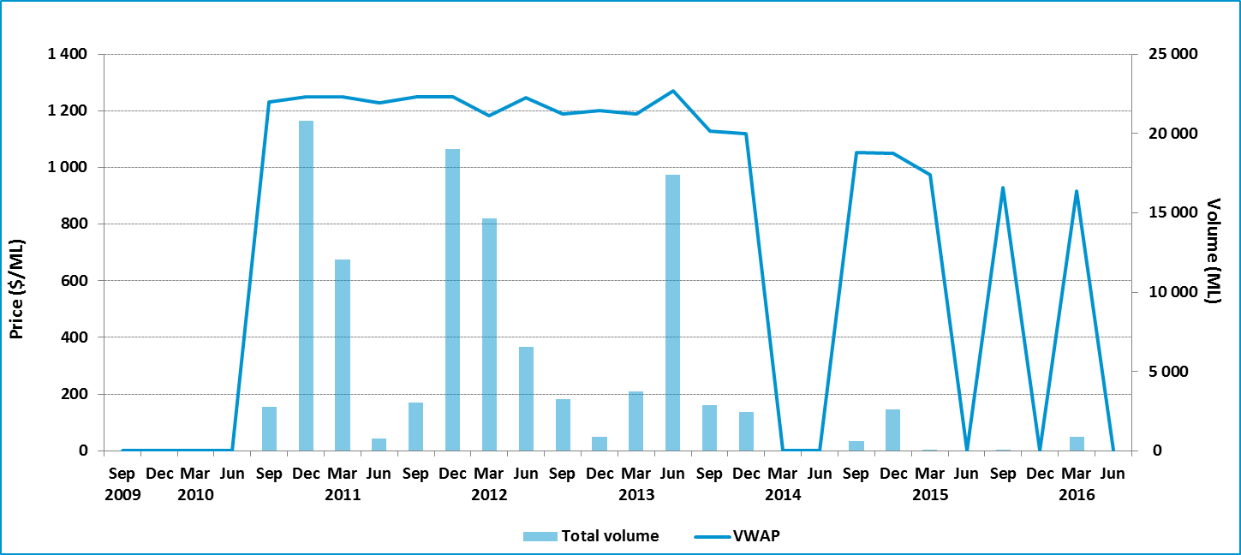

Table 19: Entitlement market prices and volumes, Macquarie, general security

| **Volume weighted average price ($/ML)** | | | **June quarter ($/ML)** | | | | | **June quarter volume (ML)** | **June quarter no. of trades** | **Broker buy/sell range ($/ML)** |
| --- | --- | --- | --- | --- | --- | --- | --- | --- | --- | --- |
| **June 2016** | **June quarter** | **YTD** | **25th percentile** | **75th percentile** | **Median** | **Mean** | **Mode** |
| – | – | 918 | – | – | – | – | – | – | – | 900–1 500 |

Data sources: [NSW Water Register](http://www.water.nsw.gov.au/water-licensing/registers), [Waterfind](http://www.waterfind.com.au/).

### Namoi: general security

Figure 36 Entitlement market prices and volumes, Namoi, general security, September 2009 to June 2016

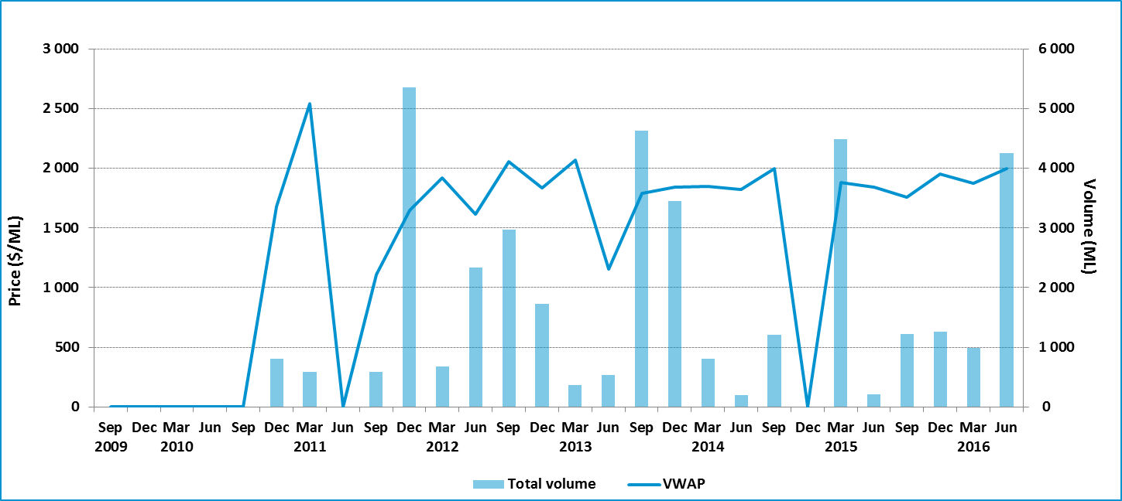

Table 20: Entitlement market prices and volumes, Namoi, general security

| **Volume weighted average price ($/ML)** | | | **June quarter ($/ML)** | | | | | **June quarter volume (ML)** | **June quarter no. of trades** | **Broker buy/sell range ($/ML)** |
| --- | --- | --- | --- | --- | --- | --- | --- | --- | --- | --- |
| **June 2016** | **June quarter** | **YTD** | **25th percentile** | **75th percentile** | **Median** | **Mean** | **Mode** |
| – | 1 998 | 1 936 | 1 886 | 2 000 | 1 950 | 1 936 | 2 000 | 4 248 | 4 | No listing |

Figure 37: Entitlement market price range, Namoi, general security, by volume, June quarter 2016

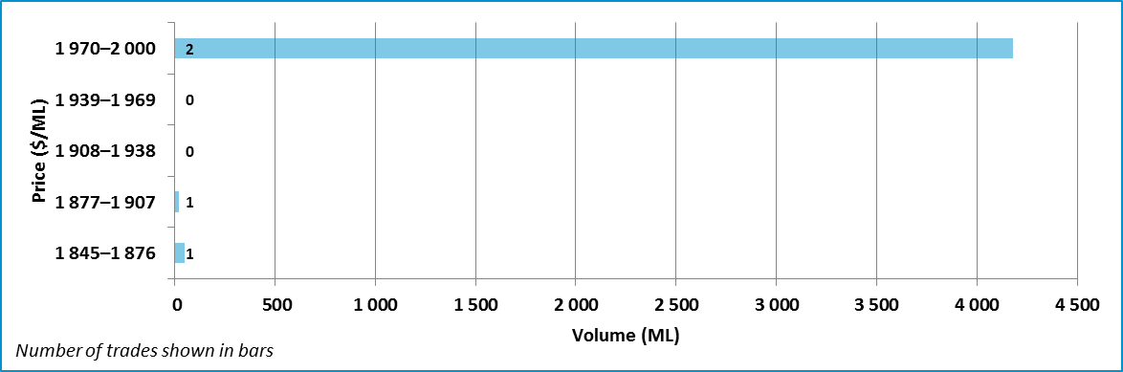

Data sources: [NSW Water Register](http://www.water.nsw.gov.au/water-licensing/registers), [Waterfind](http://www.waterfind.com.au/).

### Gwydir: general security

Figure 38 Entitlement market prices and volumes, Gwydir, general security, September 2009 to June 2016

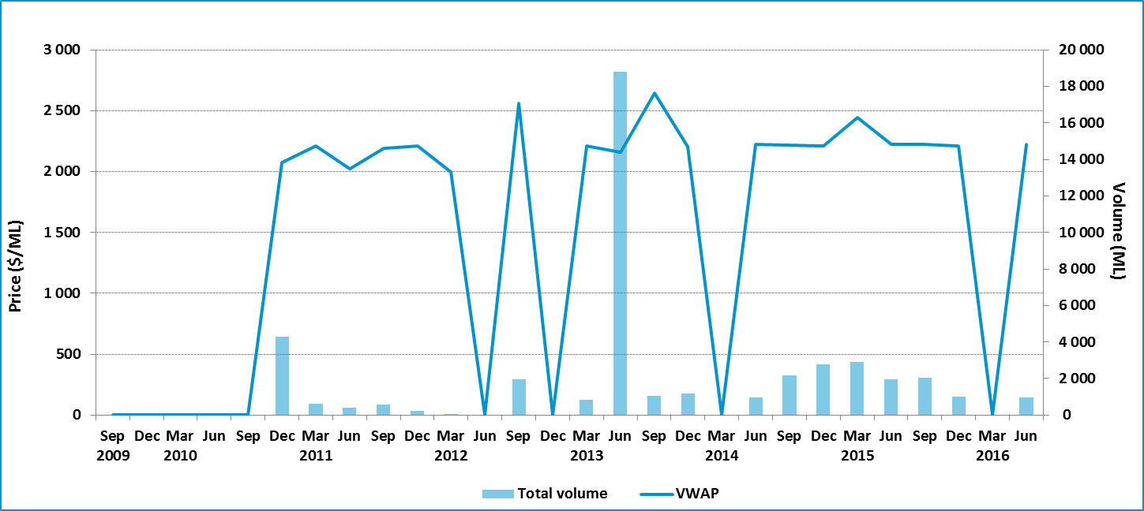

Table 21 Entitlement market prices and volumes, Gwydir, general security

| **Volume weighted average price ($/ML)** | | | **June quarter ($/ML)** | | | | | | **June quarter volume (ML)** | | **June quarter no. of trades** | **Broker buy/sell range ($/ML)** |
| --- | --- | --- | --- | --- | --- | --- | --- | --- | --- | --- | --- | --- |
| **June 2016** | **June quarter** | **YTD** | **25th percentile** | **75th percentile** | **Median** | **Mean** | **Mode** | |
| – | 2 226 | 2 222 | 2 226 | 2 226 | 2 226 | 2 226 | – | 972 | | 1 | | No listing |

Figure 39 Entitlement market price range, Gwydir, general security, by volume, June quarter 2016

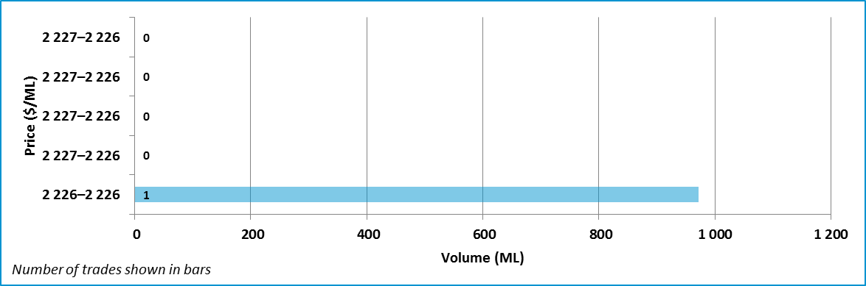

Data sources: [NSW Water Register](http://www.water.nsw.gov.au/water-licensing/registers), [Waterfind](http://www.waterfind.com.au/).

### New South Wales Border Rivers: general security

Figure 40 Entitlement market prices and volumes, NSW Border Rivers, general security, September 2009 to June 2016

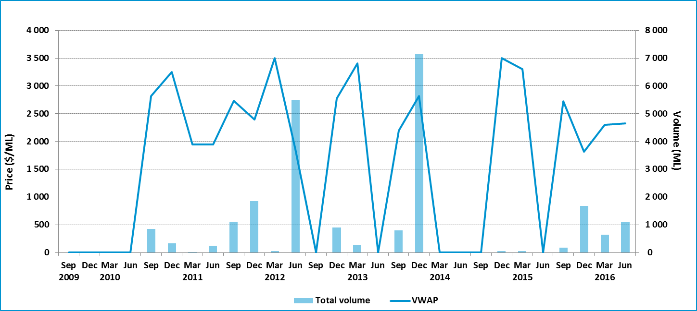

Table 22 Entitlement market prices and volumes, NSW Border Rivers, general security

| **Volume weighted average price ($/ML)** | | | **June quarter ($/ML)** | | | | | **June quarter volume (ML)** | **June quarter no. of trades** | **Broker buy/sell range ($/ML)** |
| --- | --- | --- | --- | --- | --- | --- | --- | --- | --- | --- |
| **June 2016** | **June quarter** | **YTD** | **25th percentile** | **75th percentile** | **Median** | **Mean** | **Mode** |
| 2 119 | 2 326 | 2 105 | 2 998 | 4 000 | 4 000 | 3 332 | 4 000 | 1 092 | 3 | No listing |

Figure 41 Entitlement market price range, NSW Border Rivers, general security, by volume, June quarter 2016

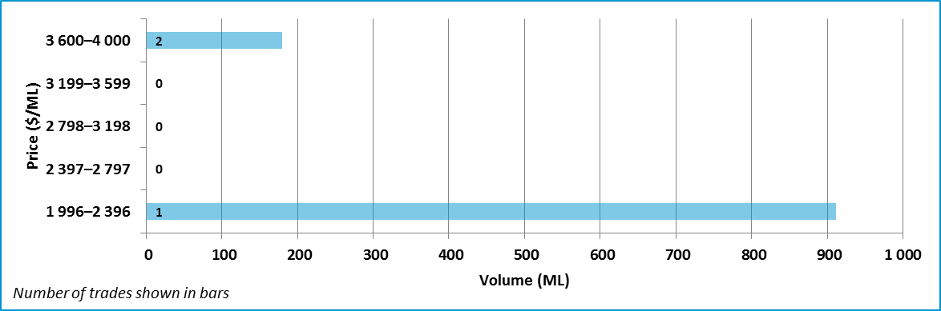

Data sources: [NSW Water Register](http://www.water.nsw.gov.au/water-licensing/registers), [Waterfind](http://www.waterfind.com.au/).

### Barwon–Darling: unregulated

Figure 42 Entitlement market prices and volumes, Barwon–Darling, unregulated, September 2009 to June 2016

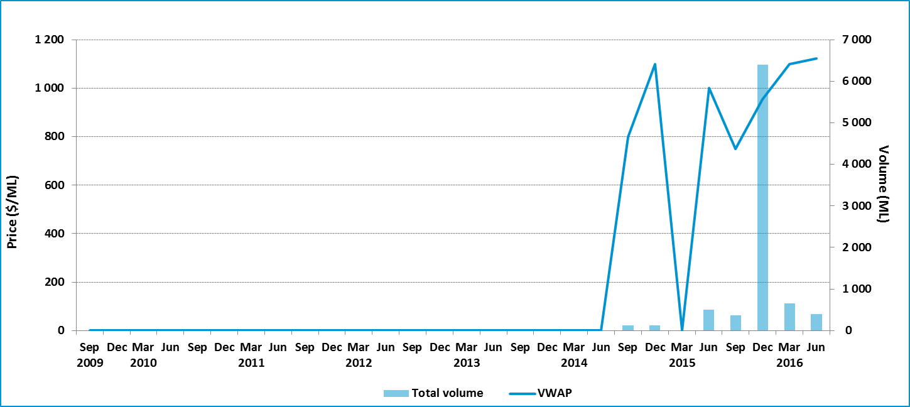

Table 23 Entitlement market prices and volumes, Barwon–Darling, unregulated

| **Volume weighted average price ($/ML)** | | | **June quarter ($/ML)** | | | | | **June quarter volume (ML)** | **June quarter no. of trades** | **Broker buy/sell range ($/ML)** |
| --- | --- | --- | --- | --- | --- | --- | --- | --- | --- | --- |
| **June 2016** | **June quarter** | **YTD** | **25th percentile** | **75th percentile** | **Median** | **Mean** | **Mode** |
| – | 1 123 | 966 | 1 138 | 1 246 | 1 192 | 1 192 | – | 394 | 2 | No listing |

Figure 43 Entitlement market price range, Barwon–Darling, unregulated, by volume, June quarter 2016

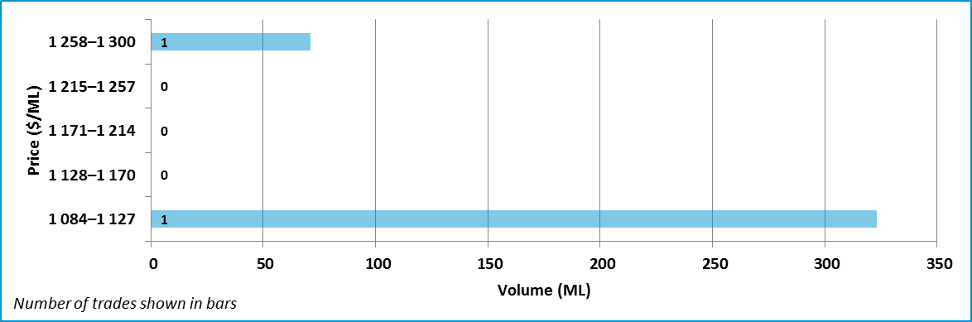

Data sources: [NSW Water Register](http://www.water.nsw.gov.au/water-licensing/registers), [Waterfind](http://www.waterfind.com.au/).

### Lachlan: General security

Figure 44 Entitlement market prices and volumes, Lachlan, general security, September 2009 to June 2016

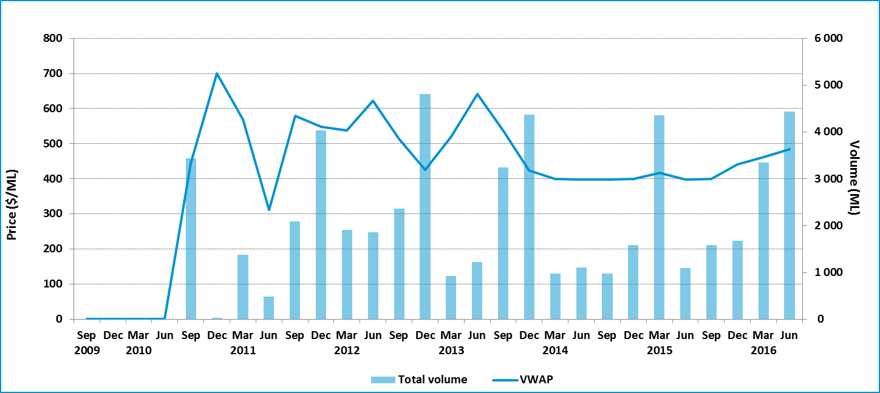

Table 24 Entitlement market prices and volumes, Lachlan, general security

| **Volume weighted average price ($/ML)** | | | **June quarter ($/ML)** | | | | | **June quarter volume (ML)** | **June quarter no. of trades** | **Broker buy/sell range ($/ML)** |
| --- | --- | --- | --- | --- | --- | --- | --- | --- | --- | --- |
| **June 2016** | **June quarter** | **YTD** | **25th percentile** | **75th percentile** | **Median** | **Mean** | **Mode** |
| 494 | 484 | 459 | 471 | 489 | 485 | 479 | 485 | 4 440 | 8 | No listing |

Figure 45 Entitlement market price range, Lachlan, general security, by volume, June quarter 2016

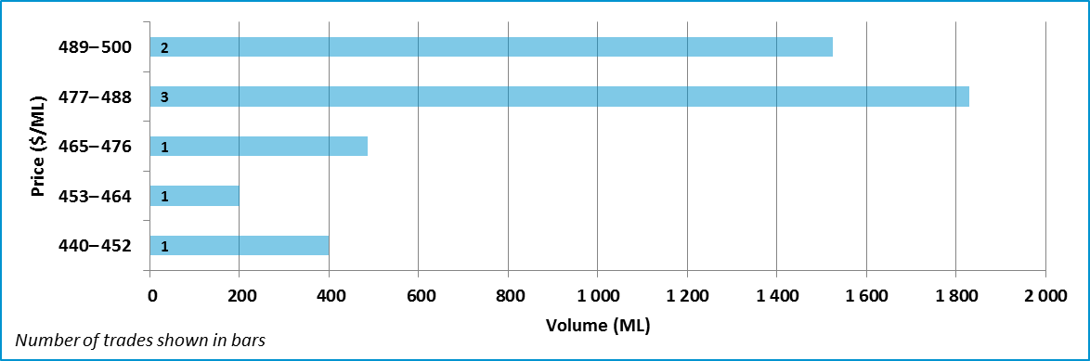

Data sources: [NSW Water Register](http://www.water.nsw.gov.au/water-licensing/registers), [Waterfind](http://www.waterfind.com.au/).

### Queensland

The markets in Queensland are very thin. Only limited trading of entitlements occurs.

Queensland does not maintain a publicly available trade register. Information on entitlement trades is provided on an aggregated monthly basis.

Table 25 Entitlement market prices and volumes, Queensland

|  |  |  |  |  |  |  |  |
| --- | --- | --- | --- | --- | --- | --- | --- |
| **Resource operation plan** | **Water supply scheme / water management area** | **Type of entitlement** | **Volume weighted average price ($/ML)** | | | **June quarter volume (ML)** | **June quarter no. of trades** |
| **June 2016** | **June quarter** | **YTD $/ML** |
| Qld Border Rivers | Border Rivers/ Macintyre Brook | Supplemented | No trade | No trade | 599 | – | – |
| Qld Border Rivers | Border Rivers | Unsupplemented | No trade | 1 523 | 1 779 | 277 | 2 |
| Condamine–Balonne | St George / Upper Condamine | Supplemented | No trade | 1 180 | 2 152 | 858 | 2 |
| Condamine–Balonne | Condamine–Balonne / Lower Balonne / Upper Condamine | Unsupplemented | No trade | 1 344 | 1 439 | 1 911 | 7 |
| Condamine–Balonne | Central Condamine Alluvium Groundwater (1, 2, 3 and 4) | Alluvium groundwater | – | – | – | – | – |
| Condamine–Balonne | Upper Condamine Alluvium Groundwater (Dalrymple Creek) | Alluvium groundwater | – | – | – | – | – |
| Condamine–Balonne | Upper Condamine Alluvium Groundwater (Oakey Creek) | Alluvium groundwater | – | – | – | – | – |
| Condamine–Balonne | Lower Balonne | Overland flow | – | – | – | – | – |

Data source: [Queensland Business and Industry Portal](https://www.business.qld.gov.au/industry/water/managing-accessing/markets-trading/market-information) and [Queensland Government website](https://www.dnrm.qld.gov.au/__data/assets/pdf_file/0004/217156/central-condamine-alluvium-water-licence-relocation-report.pdf).

## Appendix A: Regions and water sources

Table A1 Water sources (southern MDB)

| **Region** | **Water source** |
| --- | --- |
| SA Murray | River Murray Prescribed Water Course (Class 3a) |
| Vic. Murray above Barmah Choke | 6 Vic. Murray Dart to Barmah |
| Vic. Murray below Barmah Choke | 7 Vic. Murray Barmah to SA  6B Lower Broken Creek |
| Goulburn | 1A Greater Goulburn  1B Boort  3 Lower Goulburn |
| Campaspe | 4A Campaspe Eppalock to WWC  4C Lower Campaspe |
| Loddon | 5A Loddon–Coliban Channel to Lower Weir Pool (now 5A Loddon – CC/Tull to LWP)  5B Bullarook |
| NSW Murray | New South Wales Murray Regulated River Water Source |
| Murrumbidgee | Murrumbidgee Regulated River Water Source |
| Lower Darling | Lower Darling Regulated River Water Source |

Table A2 Water sources (northern MDB)

| **Region** | **Water source** |
| --- | --- |
| Macquarie | Macquarie and Cudgegong Regulated Rivers Water Source |
| Namoi | Lower Namoi Regulated River Water Source  Upper Namoi Regulated River Water Source |
| Gwydir | Gwydir Regulated River Water Source |
| NSW Border Rivers | Border Rivers Regulated River Water Source |
| Barwon–Darling | Barwon–Darling Unregulated River Water Source |
| Lachlan | Lachlan Regulated River Water Source |

## Appendix B: Outliers removed

Table B1 shows outliers removed from the trade data in the June 2016 quarter.

Table B1 Outlier removed from trade data

| **Date** | **Catchment** | **Product name** | **Volume (ML)** | **Price ($)** | **Price per ML ($/ML)** |
| --- | --- | --- | --- | --- | --- |
| 13/05/2016 | Broken | High reliability | 150.0 | $2 | $0.01 |
| 13/05/2016 | Broken | Low reliability | 31.5 | $1 | $0.03 |
| 18/04/2016 | Goulburn | High reliability | 3.6 | $1 800 | $500.00 |
| 26/04/2016 | Goulburn | High reliability | 65.0 | $280 000 | $4 307.69 |
| 4/05/2016 | Goulburn | High reliability | 1.0 | $1 000 | $1 000.00 |
| 30/05/2016 | Goulburn | High reliability | 2.0 | $2 300 | $1 150.00 |
| 31/05/2016 | Goulburn | High reliability | 6.0 | $500 | $83.33 |
| 6/06/2016 | Goulburn | High reliability | 3.0 | $4 200 | $1 400.00 |
| 16/06/2016 | Goulburn | High reliability | 180.8 | $2 | $0.01 |
| 16/06/2016 | Goulburn | High reliability | 5.0 | $2 500 | $500.00 |
| 17/06/2016 | Goulburn | High reliability | 1.0 | $1 | $1.00 |
| 3/05/2016 | Goulburn | Low reliability | 5.3 | $530 | $100.00 |
| 31/05/2016 | Goulburn | Low reliability | 96.5 | $28 950 | $300.00 |
| 31/05/2016 | Goulburn | Low reliability | 0.5 | $150 | $300.00 |
| 1/06/2016 | Goulburn | Low reliability | 18.2 | $10 920 | $600.00 |
| 15/06/2016 | Goulburn | Low reliability | 0.5 | $175 | $350.00 |
| 16/06/2016 | Goulburn | Low reliability | 82.1 | $1 | $0.01 |
| 16/06/2016 | Goulburn | Low reliability | 19.7 | $250 | $12.69 |
| 29/06/2016 | Goulburn | Low reliability | 1.9 | $190 | $100.00 |
| 3/05/2016 | Gwydir | General security | 27 216.0 | $2 150,064 | $79.00 |
| 3/05/2016 | Gwydir | General security | 27 216.0 | $6 449,920 | $236.99 |
| 3/05/2016 | Gwydir | General security | 27 216.0 | $8 599,984 | $315.99 |
| 13/04/2016 | Murrumbidgee | General security | 300.0 | $180 000 | $600.00 |
| 30/05/2016 | Murrumbidgee | General security | 0.0 | $0 | $1.00 |
| 13/04/2016 | Namoi | General security | 128.0 | $600 | $4.69 |
| 19/04/2016 | Namoi | General security | 243.0 | $600 | $2.47 |
| 19/04/2016 | Namoi | General security | 51.0 | $600 | $11.76 |
| 26/05/2016 | Namoi | General security | 243.0 | $600 | $2.47 |
| 26/05/2016 | Namoi | General security | 128.0 | $600 | $4.69 |
| 26/05/2016 | Namoi | General security | 51.0 | $600 | $11.76 |
| 11/05/2016 | NSW Border Rivers | General security | 8 261.0 | $8 261 | $1.00 |
| 8/06/2016 | NSW Border Rivers | General security | 533.0 | $533 | $1.00 |
| 4/05/2016 | NSW Murray | General security | 0.0 | $0 | $1.00 |
| 6/05/2016 | NSW Murray | General security | 9.0a | $18 000 | $2 000.00 |
| 24/05/2016 | NSW Murray | General security | 0.0 | $0 | $3 000.00 |
| 25/05/2016 | NSW Murray | General security | 210.0 | $616 741 | $2 936.86 |
| 7/06/2016 | NSW Murray | General security | 10.0 | $1 | $0.10 |
| 27/06/2016 | NSW Murray | General security | 25.0 | $1 | $0.04 |
| 27/06/2016 | NSW Murray | General security | 606.0 | $5 000 | $8.25 |
| 28/06/2016 | NSW Murray | General security | 50.0 | $1 | $0.02 |
| 28/06/2016 | NSW Murray | General security | 851.6 | $97 934 | $115.00 |
| 25/05/2016 | NSW Murray | High security | 30.0 | $1 | $0.03 |
| 26/05/2016 | NSW Murray | High security | 12.0 | $1 | $0.08 |
| 6/06/2016 | NSW Murray | High security | 100.0 | $270 000 | $2 700.00 |
| 29/4/2016 | SA Murray | Class 3a | 5.0 | $10 000 | $2 000.00 |
| 6/5/2016 | SA Murray | Class 3a | 67.0 | $114 570 | $1 710.00 |
| 12/04/2016 | Vic. Murray above BC | High reliability | 1.0 | $1 000 | $1 000.00 |
| 9/05/2016 | Vic. Murray above BC | High reliability | 2.0 | $1 500 | $750.00 |
| 31/05/2016 | Vic. Murray above BC | High reliability | 21.0 | $21 000 | $1 000.00 |
| 31/05/2016 | Vic. Murray above BC | Low reliability | 17.0 | $17 000 | $1 000.00 |
| 1/06/2016 | Vic. Murray above BC | Low reliability | 2.3 | $5 722 | $2 487.76 |
| 9/06/2016 | Vic. Murray above BC | Low reliability | 4.6 | $1 | $0.22 |
| 5/04/2016 | Vic. Murray below BC | High reliability | 220.0 | $900 000 | $4 090.91 |
| 22/04/2016 | Vic. Murray below BC | High reliability | 4.1 | $5 740 | $1 400.00 |
| 12/05/2016 | Vic. Murray below BC | High reliability | 10.0 | $3 000 | $300.00 |
| 14/06/2016 | Vic. Murray below BC | High reliability | 2.0 | $2 600 | $1 300.00 |
| 17/06/2016 | Vic. Murray below BC | High reliability | 3.0 | $3 000 | $1 000.00 |
| 16/06/2016 | Vic. Murray below BC | Low reliability | 1.4 | $7 | $5.00 |

BC = Barmah Choke.

a Trades are within the bounds of two standard deviations for the catchment, but have been excluded.