

Final Report
Water Entitlement Market Prices
Murray-Darling Basin
(March Quarter 2016)

Report prepared for Australian Government Department of Agriculture and Water Resources

Marsden Jacob Associates
Financial & Economic Consultants

ABN 66 663 324 657
ACN 072 233 204

Internet: http://www.marsdenjacob.com.au
E-mail: economists@marsdenjacob.com.au

Melbourne office:
Postal address: Level 3, 683 Burke Road, Camberwell
Victoria 3124 AUSTRALIA
Telephone: 03 9882 1600
Facsimile: 03 9882 1300

Perth office:
Level 1, 220 St Georges Terrace, Perth
Western Australia, 6000 AUSTRALIA
Telephone: 08 9324 1785
Facsimile: 08 9322 7936

Sydney office:
Rod Carr 0418 765 393
Phillip Pickering 0434 884 220

Author: Rod Carr
Nadja Arold
Jeremy Cheesman

This report has been prepared in accordance with the scope of services described in the contract or agreement between Marsden Jacob Associates Pty Ltd ACN 072 233 204 (MJA) and the Client. Any findings, conclusions or recommendations only apply to the aforementioned circumstances and no greater reliance should be assumed or drawn by the Client. Furthermore, the report has been prepared solely for use by the Client and Marsden Jacob Associates accepts no responsibility for its use by other parties.

Copyright © Marsden Jacob Associates Pty Ltd 2016

Table of Contents
Page
1. Introduction 1
2. Southern Murray-Darling Basin 4
2.1 SA Murray: Class 3a 5
2.2 VIC Murray above Barmah Choke: High Reliability 6
2.3 VIC Murray above Barmah Choke: Low Reliability 7
2.4 VIC Murray below Barmah Choke: High Reliability 8
2.5 VIC Murray below Barmah Choke: Low Reliability 9
2.6 Goulburn: High Reliability 10
2.7 Goulburn: Low Reliability 11
2.8 Campaspe: High Reliability 12
2.9 Loddon: High Reliability 13
2.10 NSW Murray: General Security 14
2.11 NSW Murray: High Security 15
2.12 NSW Murray Irrigation Limited 16
2.13 Murrumbidgee: General Security 17
2.14 Murrumbidgee: High Security 18
2.15 Lower Darling: General Security 19
2.16 Lower Darling: High Security 20
3. Northern Murray-Darling Basin 21
3.1 Macquarie: General Security 22
3.2 Namoi: General Security 23
3.3 Gwydir: General Security 24
3.4 NSW Border Rivers: General Security 25
3.5 Barwon Darling: Unregulated 26
3.6 Lachlan: General Security 27
3.7 Queensland 28
Appendix 1: Regions and water sources 29
Appendix 2: Outliers removed 30

- Introduction
This March 2016 quarter water entitlement market prices report has been prepared by Marsden Jacob Associates (Marsden Jacob) for the Australian Government Department of Agriculture and Water Resources. The report includes:
- Southern MDB market activity and price information by region and entitlement type (Section 2)
- Northern MDB market activity and price information by region and entitlement type (Section 3)
- Catchment and water sources list (Appendix 1)
- Outliers (Appendix 2)
Region, entitlements and key statistics
The entitlement price report is broadly split into southern and northern Murray-Darling Basin (MDB), as detailed in Table 1. Interactive maps showing the location of these trading regions are available on the Murray-Darling Basin Authority’s website. The water sources included in each of the regions are listed in Appendix 1.
Table 1: Regions and entitlement types
Southern MDB |  | Northern MDB
Region | Entitlement Type | Region | Entitlement Type
SA Murray | Class 3a | Macquarie | General Security
VIC Murray above Barmah Choke | High Reliability | Namoi | General Security
VIC Murray above Barmah Choke | Low Reliability | Gwydir | General Security
Vic Murray below Barmah Choke | High Reliability | NSW Border Rivers | General Security
Vic Murray below Barmah Choke | Low Reliability | Barwon Darling | Unregulated
Goulburn | High Reliability | Lachlan | General Security
Goulburn | Low Reliability | Condamine Balonne (St George) | Supplemented
Campaspe | High Reliability | Condamine Balonne (Upper Condamine and Lower Balonne) | Unsupplemented
Campaspe | Low Reliability | Upper Condamine Alluvium Groundwater (1, 2, 3 and 4) | Groundwater  (Sub Areas 1, 2, 3 and 4)
Loddon | High Reliability | QLD Border Rivers | Supplemented
NSW Murray | General Security | QLD Border Rivers | Unsupplemented
NSW Murray | High Security | Lower Balonne | Overland Flow
NSW Murray Irrigation Limited | General Security
Murrumbidgee | General Security
Murrumbidgee | High Security
Lower Darling | General Security
Lower Darling | High Security
As requested by the Department, for each of the regions and water entitlement categories Marsden Jacob reports a range of measures, subject to data availability and the number of trades:
- volume weighted average prices (VWAP);
- median price;
- mean price;
- mode price;
- percentile price 25th and 75th;
- price quintiles;
- trade volume;
- number of trades; and
- water trading exchange prices.
Data sources
The data sources for this report are:
- National Water Market Register data, up to 31 December 2013;
- State Government water registers and websites; and
- Water exchange and broker noticeboard prices.
Notes
Entitlement prices in the State Government water registers can lag the exchange date of contracts or the water sale agreement by periods of days to several months. This means the entitlement prices shown in the monthly and quarterly VWAPs may not reflect all exchanges during the month.
Entitlement prices that do not appear to reflect arms-length transactions have been excluded in the data cleaning process (see Appendix 2). Removing these values reduces price distortions in the reporting. This means prices in this report may differ from prices shown in registers where these transactions have not been removed.
Marsden Jacob uses a two stage process to clean the data, which is based on the approach used by the Australian Bureau of Agricultural and Resource Economics and Sciences (ABARES) and the former National Water Commission (NWC):
- Removing prices that may not be genuine, e.g. removing transactions where the price was reported to be null ($0 per ML); and
- Reviewing and potentially removing transactions outside two standard deviations from the average price of water entitlements by region (or trading zone) and by water product.
Marsden Jacob does not necessarily remove all trades that fall outside two standard deviations as some of these reflect arms-length trades. If trades which fall outside two standard deviations are retained in the regional dataset this is noted in the region and entitlement specific reports.

- Southern Murray-Darling Basin
Figure 1: Price correlation in the Southern Basin: High Security / Reliability / Class 3a
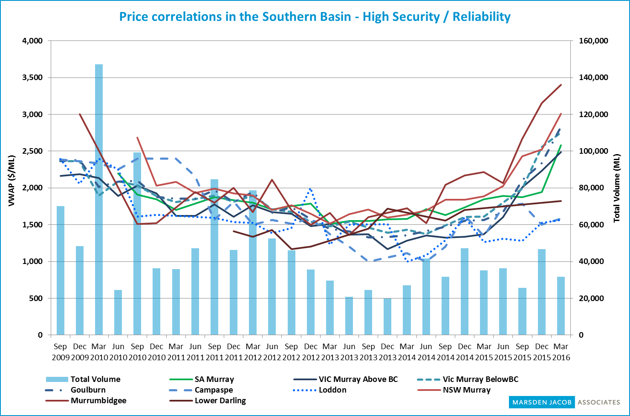
Source: Marsden Jacob analysis, 2016
Figure 2: Price correlation in the Southern Basin: General Security / Low Reliability
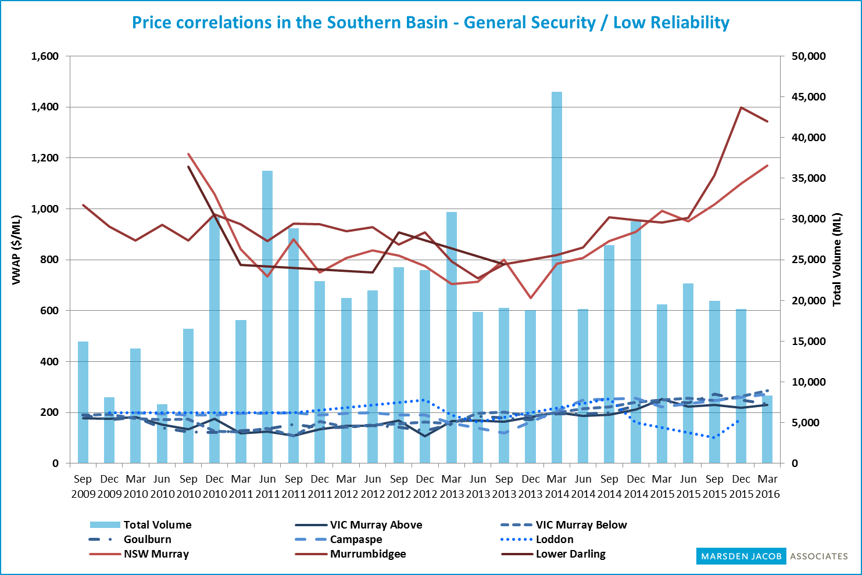
Source: Marsden Jacob analysis, 2016
Note: Where possible, zero values have been interpolated in these charts so they differ slightly from the region and entitlement specific charts.
  - SA Murray: Class 3a
Figure 3: Entitlement market prices and volumes
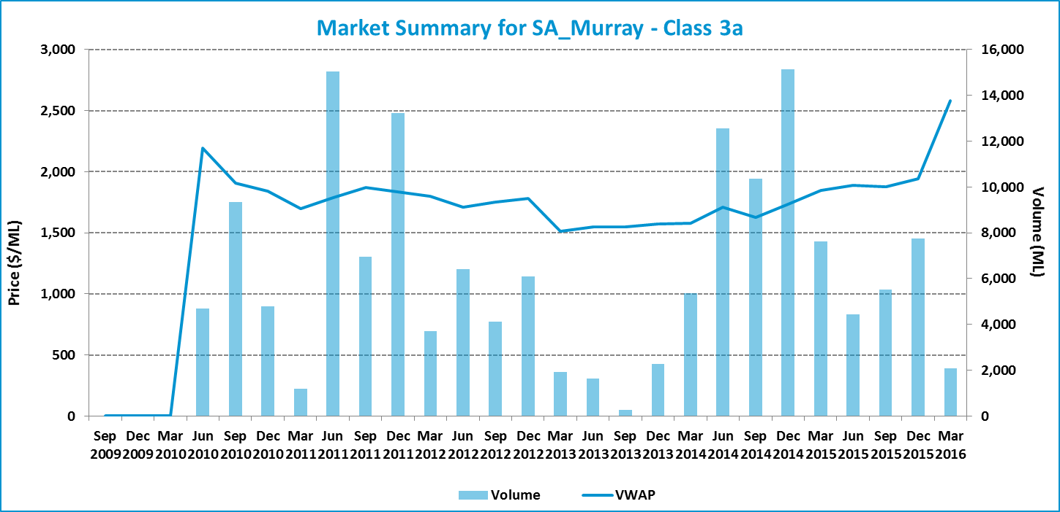

Table 2: Entitlement market prices and volumes
Volume weighted average price ($/ML) |  |  | March 2016 Quarter (in $/ML) |  |  |  |  | Mar 2016 Quarter Volume (ML) | Mar 2016 Quarter # of trades | Broker buy/sell range  ($/ML)
Month of Mar 2016 | Mar 2016 Quarter | YTD | 25th percentile | 75th percentile | Median | Mean | Mode | Mar 2016 Quarter Volume (ML) | Mar 2016 Quarter # of trades | Broker buy/sell range  ($/ML)
2,953 | 2,582 | 2,007 | 2,588 | 3,000 | 2,938 | 2,706 | 2,950 | 2,096 | 16 | 2,700 – 3,200

Figure 4: Entitlement market price range by volume
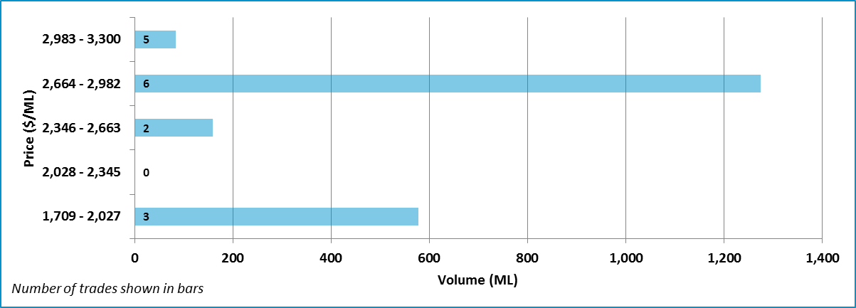

Data Sources: SA Water Register (www.waterconnect.sa.gov.au/Systems/WTR/Pages/default.aspx), National Water Exchange (www.waterexchange.com.au), Waterfind (www.waterfind.com.au), H2OX (www.h2ox.com)

  - VIC Murray above Barmah Choke: High Reliability
Figure 5: Entitlement market prices and volumes
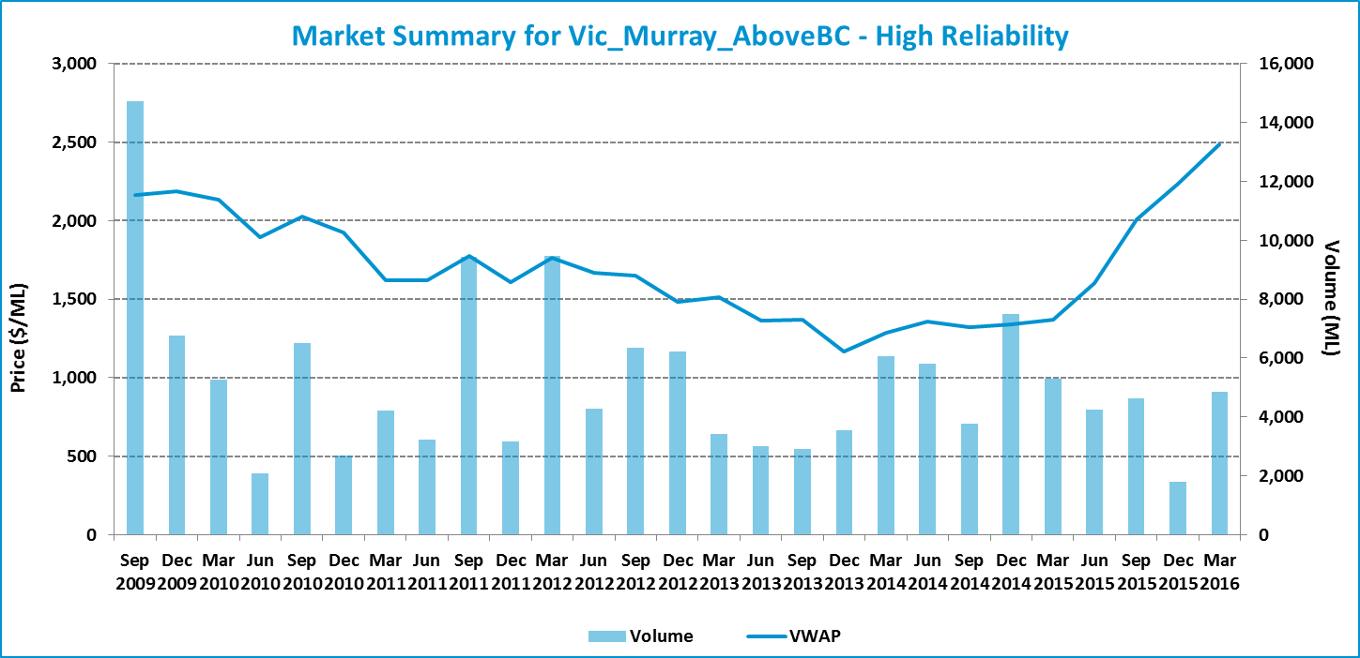

Table 3: Entitlement market prices and volumes
Volume weighted average price ($/ML) |  |  | March 2016 Quarter (in $/ML) |  |  |  |  | Mar 2016 Quarter Volume (ML) | Mar 2016 Quarter # of trades | Broker buy/sell range  ($/ML)
Month of Mar 2016 | Mar 2016 Quarter | YTD | 25th percentile | 75th percentile | Median | Mean | Mode | Mar 2016 Quarter Volume (ML) | Mar 2016 Quarter # of trades | Broker buy/sell range  ($/ML)
2,541 | 2,485 | 2,249 | 2,230 | 2,900 | 2,600 | 2,474 | 2,900 | 4,843 | 56 | 2,200 – 2,900

Figure 6: Entitlement market price range by volume
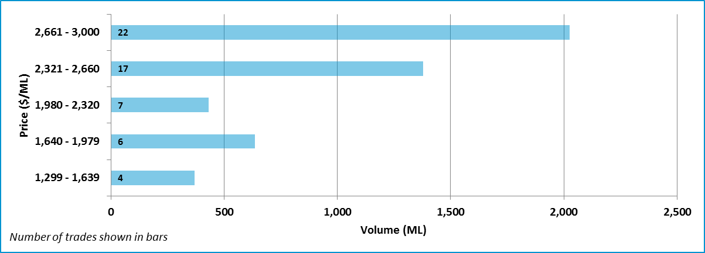

Note: One trade which is outside two standard deviations of the average price of water entitlements has been included for this region.
Data Sources: VIC Water Register (waterregister.vic.gov.au/water-trading/water-share-trading), National Water Exchange (www.waterexchange.com.au), Waterfind (www.waterfind.com.au), H2OX (www.h2ox.com)

  - VIC Murray above Barmah Choke: Low Reliability
Figure 7: Entitlement market prices and volumes
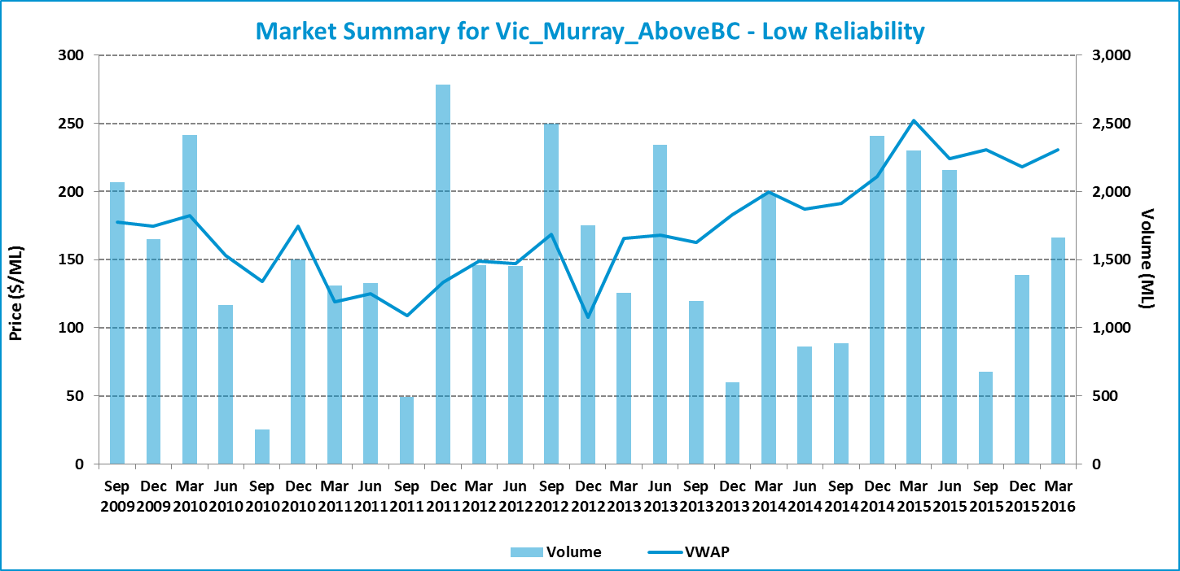

Table 4: Entitlement market prices and volumes
Volume weighted average price ($/ML) |  |  | March 2016 Quarter (in $/ML) |  |  |  |  | Mar 2016 Quarter Volume (ML) | Mar 2016 Quarter # of trades | Broker buy/sell range  ($/ML)
Month of Mar 2016 | Mar 2016 Quarter | YTD | 25th percentile | 75th percentile | Median | Mean | Mode | Mar 2016 Quarter Volume (ML) | Mar 2016 Quarter # of trades | Broker buy/sell range  ($/ML)
229 | 231 | 226 | 203 | 250 | 250 | 226 | 250 | 1,661 | 18 | 200 – 260

Figure 8: Entitlement market price range by volume
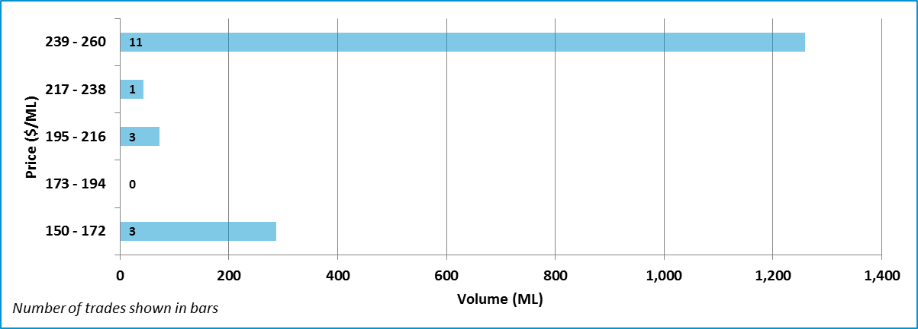

Data Sources: VIC Water Register (waterregister.vic.gov.au/water-trading/water-share-trading), National Water Exchange (www.waterexchange.com.au), Waterfind (www.waterfind.com.au), H2OX (www.h2ox.com)
  - VIC Murray below Barmah Choke: High Reliability
Figure 9: Entitlement market prices and volumes
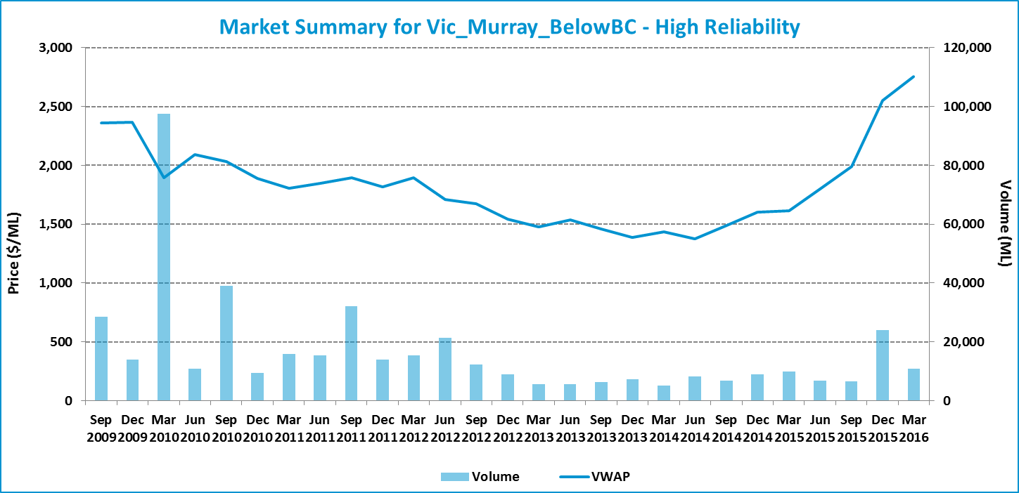

Table 5: Entitlement market prices and volumes
Volume weighted average price ($/ML) |  |  | March 2016 Quarter (in $/ML) |  |  |  |  | Mar 2016 Quarter Volume (ML) | Mar 2016 Quarter # of trades | Broker buy/sell range  ($/ML)
Month of Mar 2016 | Mar 2016 Quarter | YTD | 25th percentile | 75th percentile | Median | Mean | Mode | Mar 2016 Quarter Volume (ML) | Mar 2016 Quarter # of trades | Broker buy/sell range  ($/ML)
2,874 | 2,753 | 2,517 | 2,000 | 3,000 | 2,800 | 2,628 | 2,000 | 10,816 | 185 | 2,500 – 3,200

Figure 10: Entitlement market price range by volume
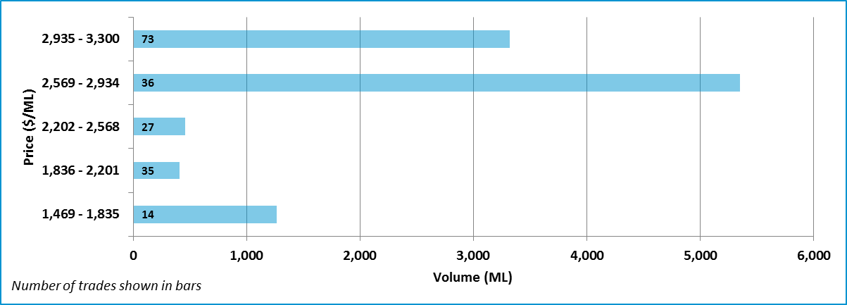

Note: One trade which is outside two standard deviations of the average price of water entitlements has been included for this region. One trade which is within two standard deviations of the average price of water entitlements has been excluded for this region.
Data Sources: VIC Water Register (waterregister.vic.gov.au/water-trading/water-share-trading), National Water Exchange (www.waterexchange.com.au), Waterfind (www.waterfind.com.au), H2OX (www.h2ox.com)
  - VIC Murray below Barmah Choke: Low Reliability
Figure 11: Entitlement market prices and volumes
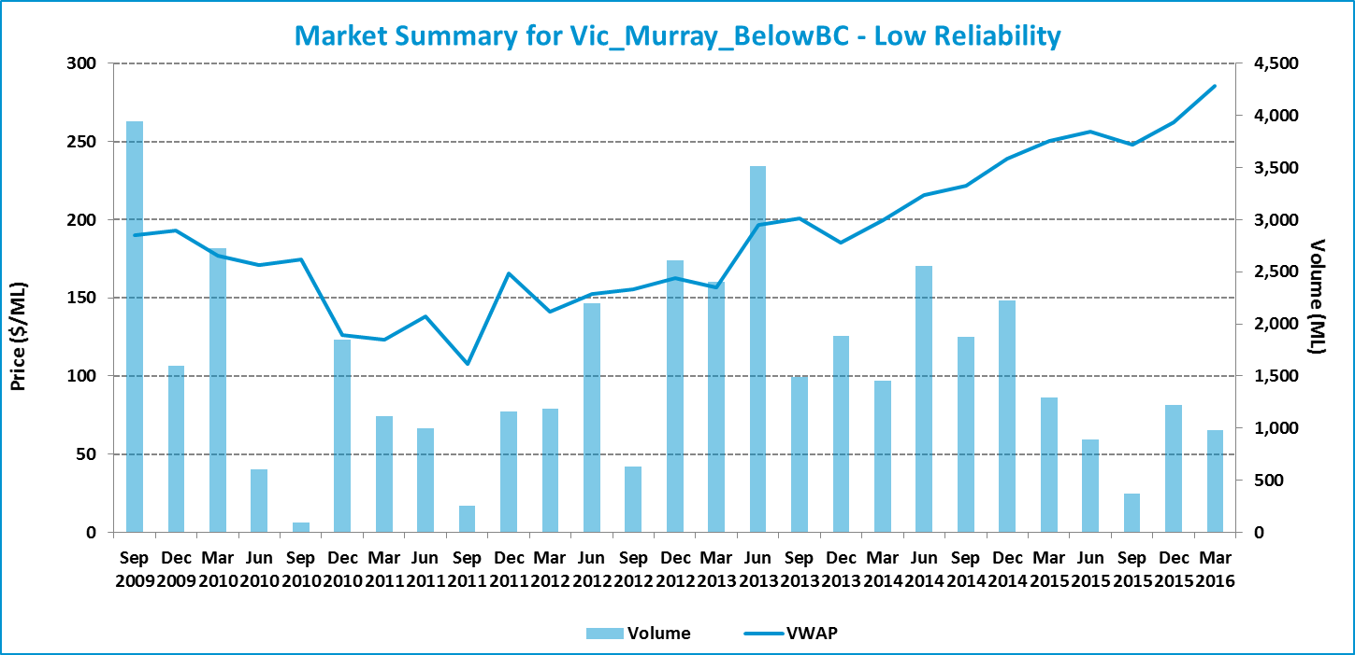

Table 6: Entitlement market prices and volumes
Volume weighted average price ($/ML) |  |  | March 2016 Quarter (in $/ML) |  |  |  |  | Mar 2016 Quarter Volume (ML) | Mar 2016 Quarter # of trades | Broker buy/sell range  ($/ML)
Month of Mar 2016 | Mar 2016 Quarter | YTD | 25th percentile | 75th percentile | Median | Mean | Mode | Mar 2016 Quarter Volume (ML) | Mar 2016 Quarter # of trades | Broker buy/sell range  ($/ML)
250 | 286 | 269 | 250 | 290 | 250 | 267 | 250 | 975 | 17 | 230 – 300

Figure 12: Entitlement market price range by volume
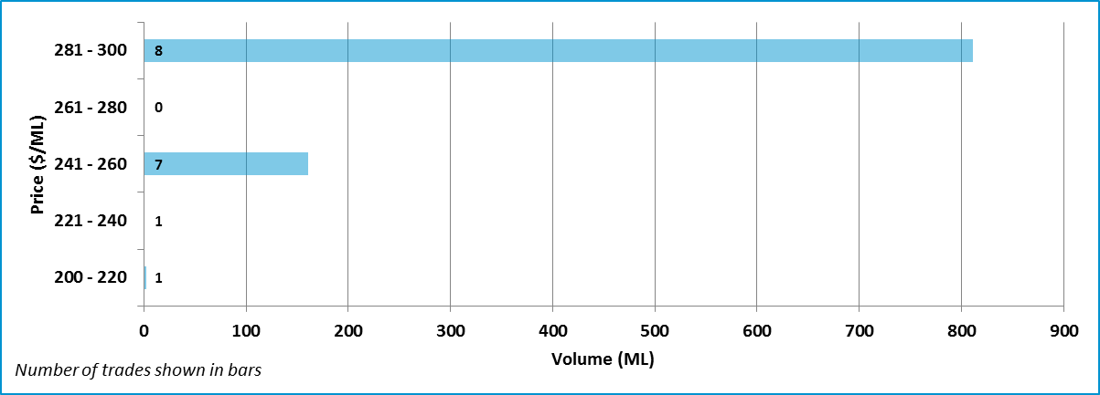

Data Sources: VIC Water Register (waterregister.vic.gov.au/water-trading/water-share-trading), National Water Exchange (www.waterexchange.com.au), Waterfind (www.waterfind.com.au), H2OX (www.h2ox.com)

  - Goulburn: High Reliability
Figure 13: Entitlement market prices and volumes
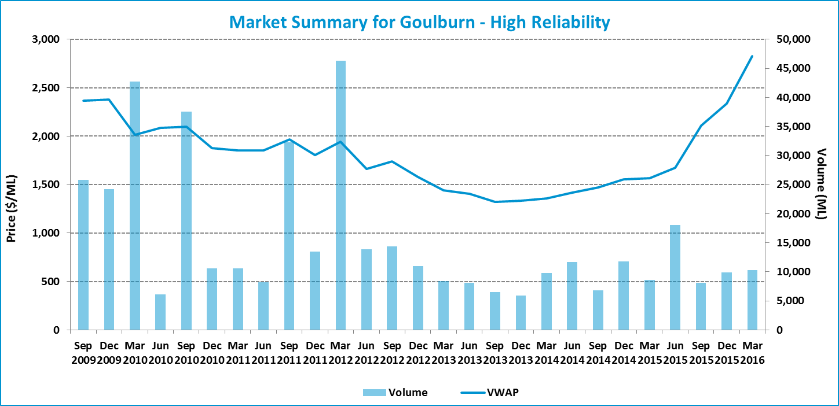

Table 7: Entitlement market prices and volumes
Volume weighted average price ($/ML) |  |  | March 2016 Quarter (in $/ML) |  |  |  |  | Mar 2016 Quarter Volume (ML) | Mar 2016 Quarter # of trades | Broker buy/sell range  ($/ML)
Month of Mar 2016 | Mar 2016 Quarter | YTD | 25th percentile | 75th percentile | Median | Mean | Mode | Mar 2016 Quarter Volume (ML) | Mar 2016 Quarter # of trades | Broker buy/sell range  ($/ML)
2,901 | 2,827 | 2,450 | 2,300 | 2,913 | 2,675 | 2,548 | 3,000 | 10,297 | 195 | 2,800 – 3,200

Figure 14: Entitlement market price range by volume
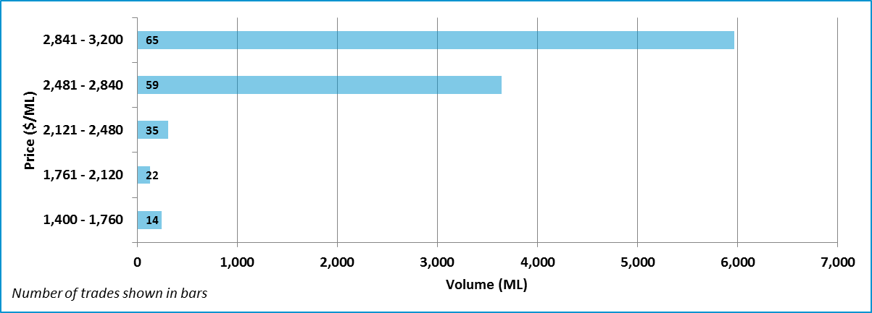

Note: A number of trades which are outside two standard deviations of the average price of water entitlements have been included for this region.
Data Sources: VIC Water Register (waterregister.vic.gov.au/water-trading/water-share-trading), National Water Exchange (www.waterexchange.com.au), Waterfind (www.waterfind.com.au), H2OX (www.h2ox.com)

  - Goulburn: Low Reliability
Figure 15: Entitlement market prices and volumes
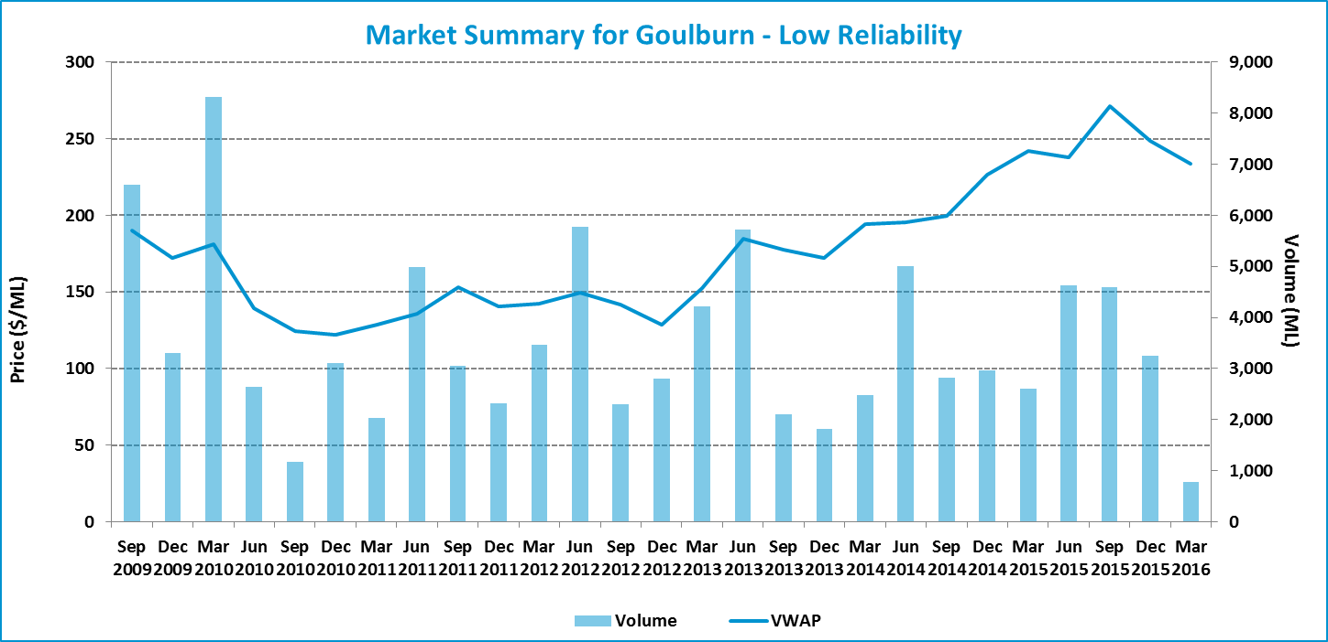

Table 8: Entitlement market prices and volumes
Volume weighted average price ($/ML) |  |  | March 2016 Quarter (in $/ML) |  |  |  |  | Mar 2016 Quarter Volume (ML) | Mar 2016 Quarter # of trades | Broker buy/sell range  ($/ML)
Month of Mar 2016 | Mar 2016 Quarter | YTD | 25th percentile | 75th percentile | Median | Mean | Mode | Mar 2016 Quarter Volume (ML) | Mar 2016 Quarter # of trades | Broker buy/sell range  ($/ML)
230 | 234 | 259 | 200 | 240 | 220 | 220 | 200 | 779 | 21 | 225 – 260

Figure 16: Entitlement market price range by volume
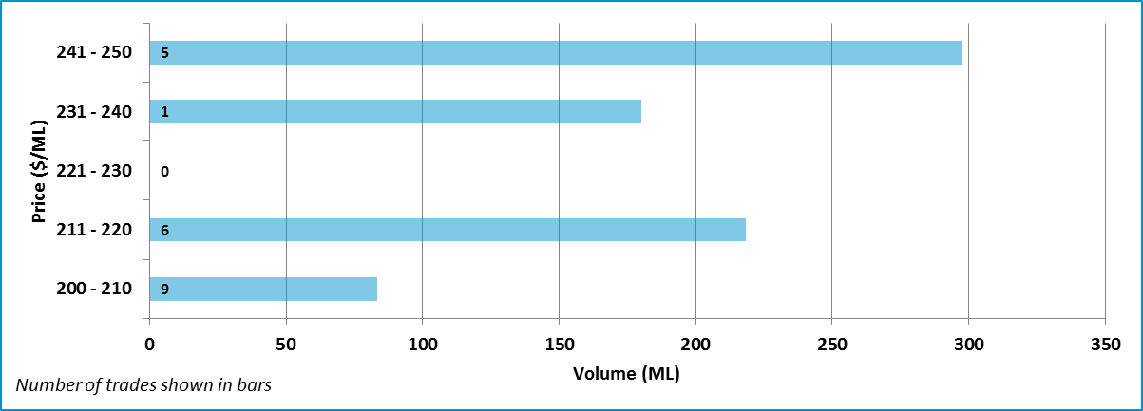

Note: Three trades which are within two standard deviations of the average price of water entitlements have been excluded for this region.
Data Sources: VIC Water Register (waterregister.vic.gov.au/water-trading/water-share-trading), National Water Exchange (www.waterexchange.com.au), Waterfind (www.waterfind.com.au), H2OX (www.h2ox.com)

  - Campaspe: High Reliability
Figure 17: Entitlement market prices and volumes
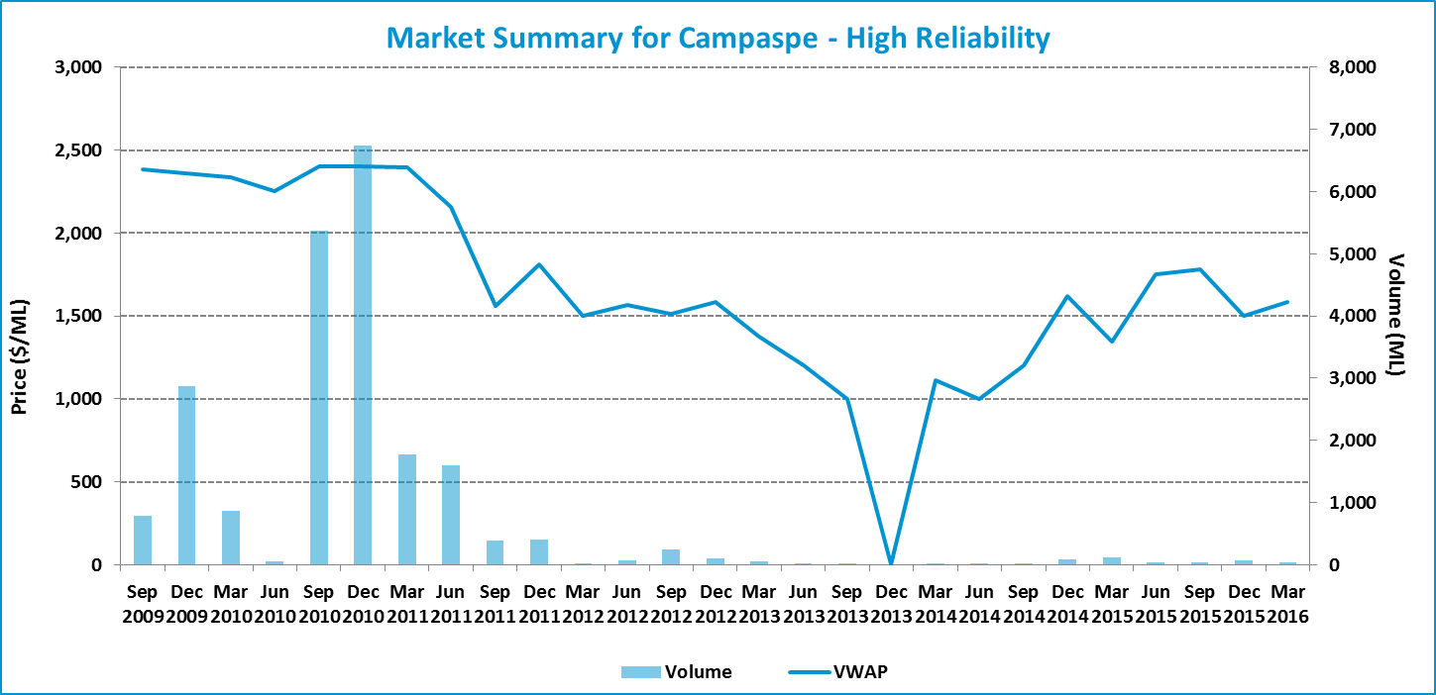

Table 9: Entitlement market prices and volumes
Volume weighted average price ($/ML) |  |  | March 2016 Quarter (in $/ML) |  |  |  |  | Mar 2016 Quarter Volume (ML) | Mar 2016 Quarter # of trades | Broker buy/sell range  ($/ML)
Month of Mar 2016 | Mar 2016 Quarter | YTD | 25th percentile | 75th percentile | Median | Mean | Mode | Mar 2016 Quarter Volume (ML) | Mar 2016 Quarter # of trades | Broker buy/sell range  ($/ML)
1,541 | 1,582 | 1,597 | 1,364 | 2,100 | 2,100 | 1,863 | 2,100 | 33 | 5 | 2,800 – 3,200

Figure 18: Entitlement market price range by volume
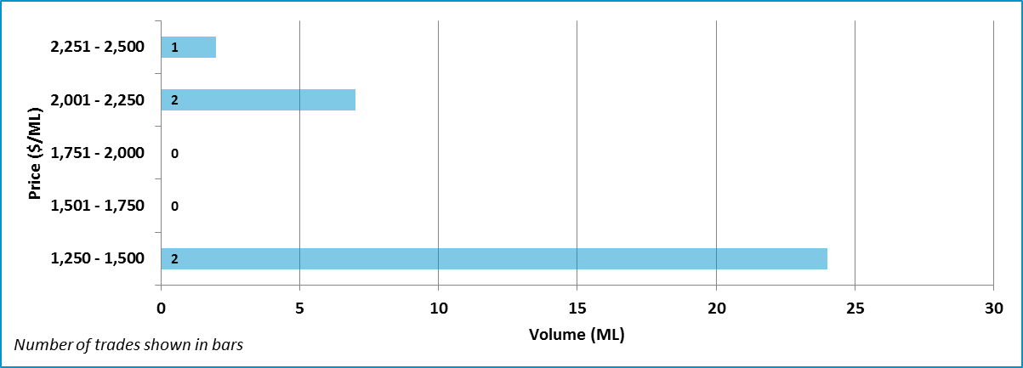

Data Sources: VIC Water Register (waterregister.vic.gov.au/water-trading/water-share-trading), National Water Exchange (www.waterexchange.com.au), Waterfind (www.waterfind.com.au), H2OX (www.h2ox.com)

  - Loddon: High Reliability
Figure 19: Entitlement market prices and volumes
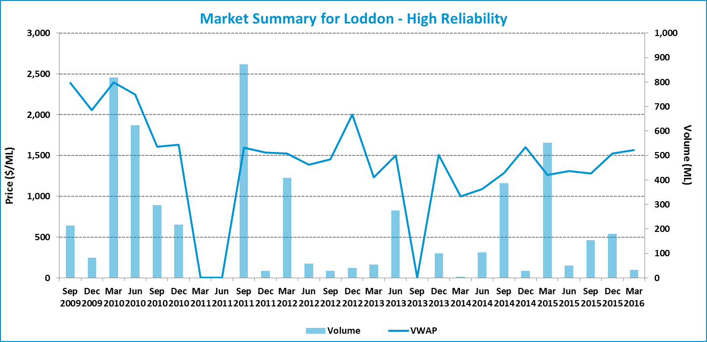

Table 10: Entitlement market prices and volumes
Volume weighted average price ($/ML) |  |  | March 2016 Quarter (in $/ML) |  |  |  |  | Mar 2016 Quarter Volume (ML) | Mar 2016 Quarter # of trades | Broker buy/sell range  ($/ML)
Month of Mar 2016 | Mar 2016 Quarter | YTD | 25th percentile | 75th percentile | Median | Mean | Mode | Mar 2016 Quarter Volume (ML) | Mar 2016 Quarter # of trades | Broker buy/sell range  ($/ML)
- | 1,564 | 1,427 | 1,577 | 1,611 | 1,594 | 1,594 | - | 32 | 2 | 1,500

Figure 20: Entitlement market price range by volume
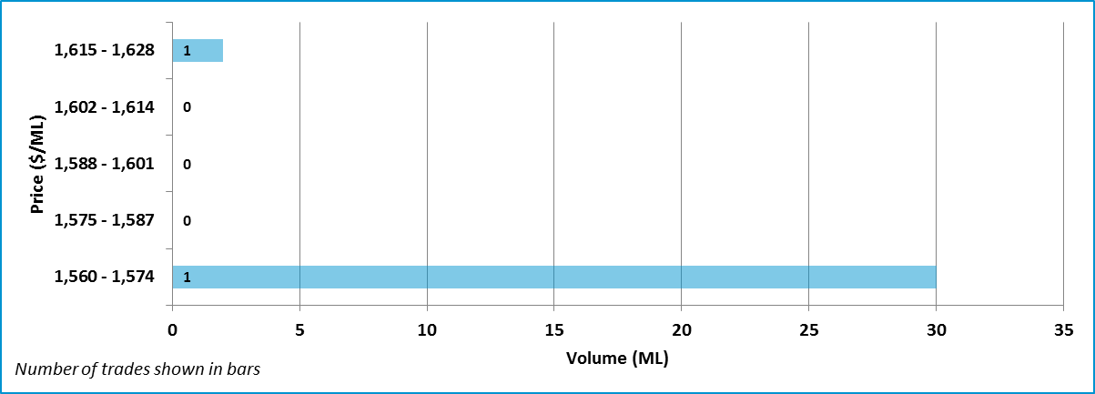

Data Sources: VIC Water Register (waterregister.vic.gov.au/water-trading/water-share-trading), National Water Exchange (www.waterexchange.com.au), Waterfind (www.waterfind.com.au), H2OX (www.h2ox.com)

  - NSW Murray: General Security
Figure 21: Entitlement market prices and volumes
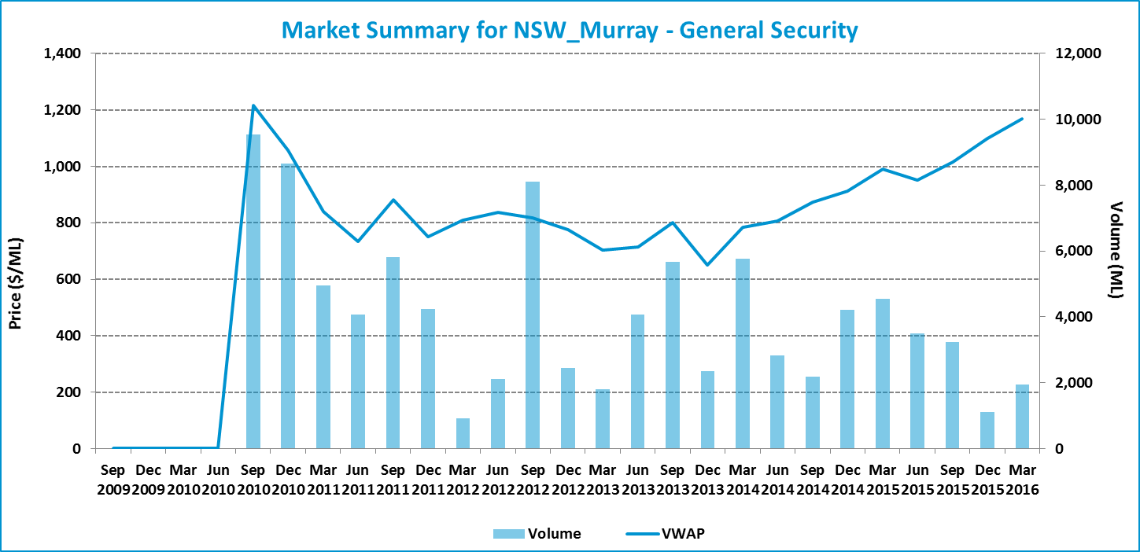

Table 11: Entitlement market prices and volumes
Volume weighted average price ($/ML) |  |  | March 2016 Quarter (in $/ML) |  |  |  |  | Mar 2016 Quarter Volume (ML) | Mar 2016 Quarter # of trades | Broker buy/sell range  ($/ML)
Month of Mar 2016 | Mar 2016 Quarter | YTD | 25th percentile | 75th percentile | Median | Mean | Mode | Mar 2016 Quarter Volume (ML) | Mar 2016 Quarter # of trades | Broker buy/sell range  ($/ML)
1,169 | 1,170 | 1,078 | 1,100 | 1,220 | 1,200 | 1,155 | 1,200 | 1,944 | 24 | 1,000 – 1,400

Figure 22: Entitlement market price range by volume
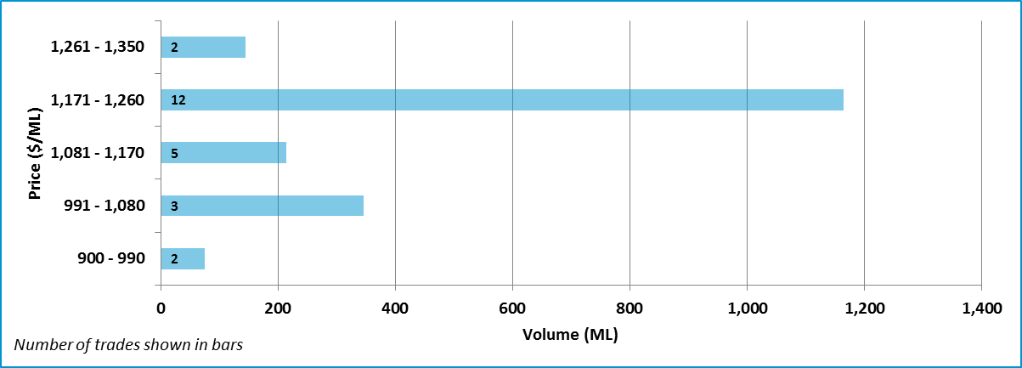

Data Sources: NSW Water Register (http://registers.water.nsw.gov.au/wma/WaterShareIntraWSLocSearch.jsp?selectedRegister=WaterShare, http://www.water.nsw.gov.au/water-licensing/registers), National Water Exchange (www.waterexchange.com.au), Waterfind (www.waterfind.com.au), H2OX (www.h2ox.com)
  - NSW Murray: High Security
Figure 23: Entitlement market prices and volumes
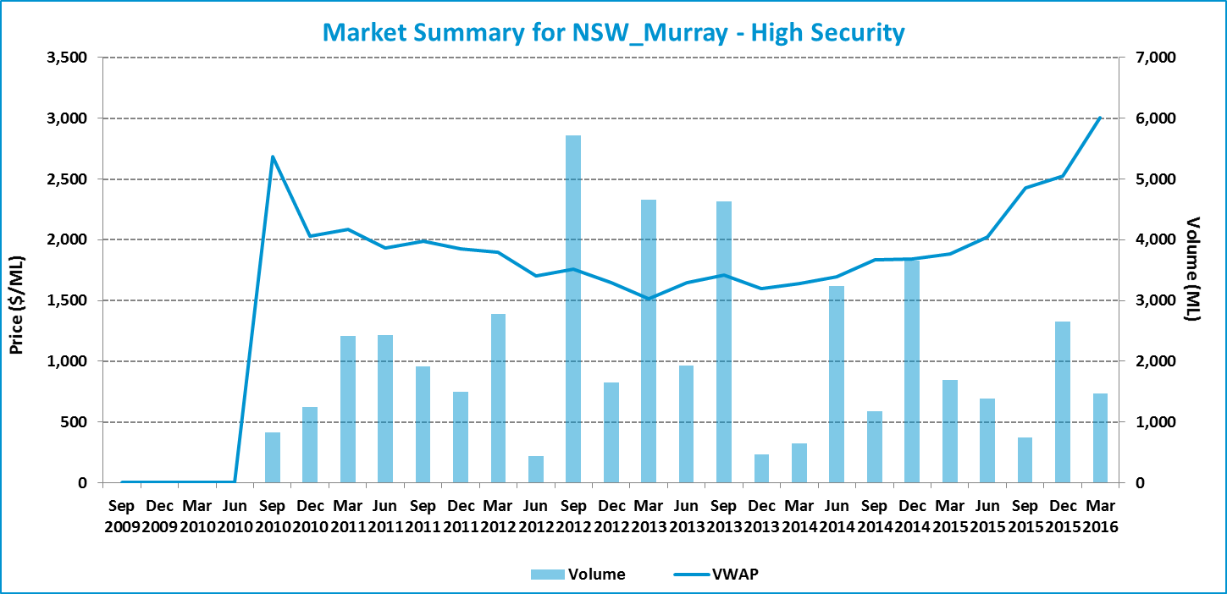

Table 12: Entitlement market prices and volumes
Volume weighted average price ($/ML) |  |  | March 2016 Quarter (in $/ML) |  |  |  |  | Mar 2016 Quarter Volume (ML) | Mar 2016 Quarter # of trades | Broker buy/sell range  ($/ML)
Month of Mar 2016 | Mar 2016 Quarter | YTD | 25th percentile | 75th percentile | Median | Mean | Mode | Mar 2016 Quarter Volume (ML) | Mar 2016 Quarter # of trades | Broker buy/sell range  ($/ML)
3,024 | 3,007 | 2,655 | 2,805 | 3,200 | 3,000 | 2,931 | 3,200 | 1,467 | 19 | 3,000 – 3,400

Figure 24: Entitlement market price range by volume
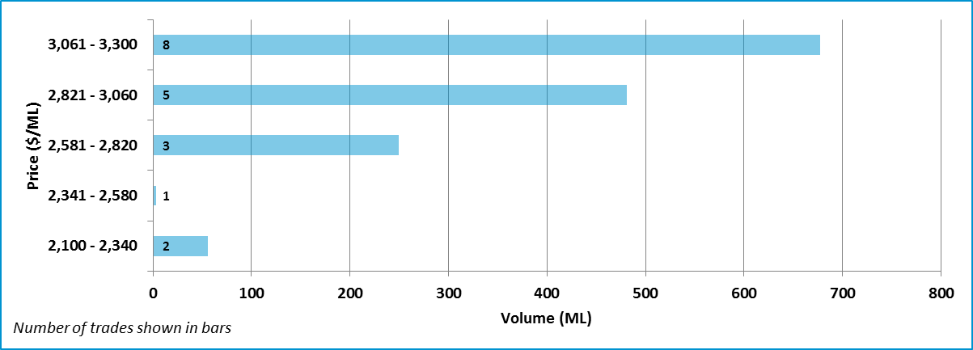

Note: Two trades which are within two standard deviations of the average price of water entitlements have been excluded for this region.
Data Sources: NSW Water Register (http://registers.water.nsw.gov.au/wma/WaterShareIntraWSLocSearch.jsp?selectedRegister=WaterShare, http://www.water.nsw.gov.au/water-licensing/registers), National Water Exchange (www.waterexchange.com.au), Waterfind (www.waterfind.com.au), H2OX (www.h2ox.com)

  - NSW Murray Irrigation Limited
Figure 25: Entitlement market prices and volumes
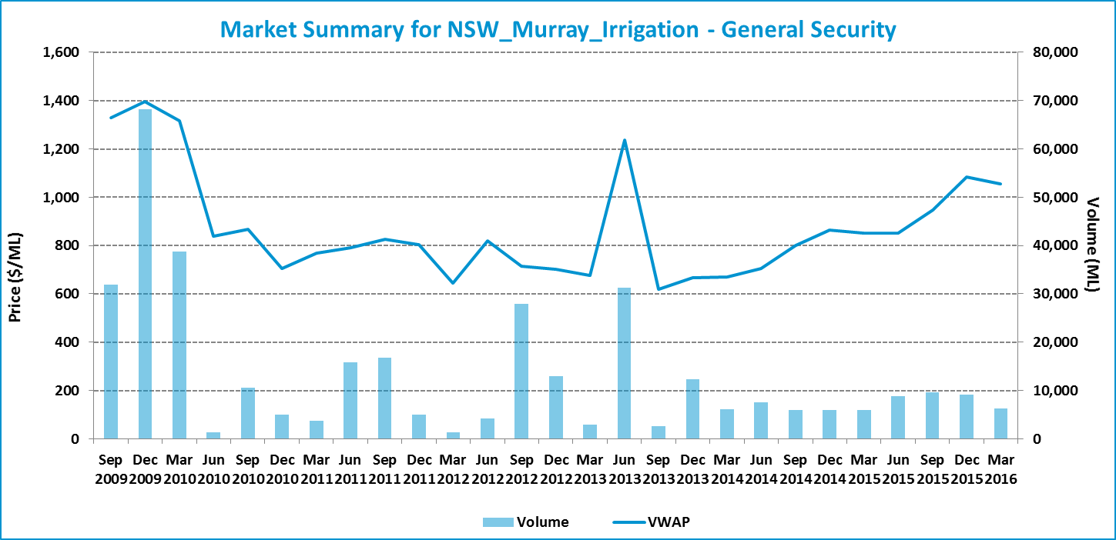

Table 13: Entitlement market prices and volumes
Volume weighted average price ($/ML) |  |  | March 2016 Quarter (in $/ML) |  |  |  |  | Mar 2016 Quarter Volume (ML) | Mar 2016 Quarter # of trades | Broker buy/sell range  ($/ML)
Month of Mar 2016 | Mar 2016 Quarter | YTD | 25th percentile | 75th percentile | Median | Mean | Mode | Mar 2016 Quarter Volume (ML) | Mar 2016 Quarter # of trades | Broker buy/sell range  ($/ML)
1,013 | 1,056 | 1,024 | 950 | 1,150 | 1,078 | 1,042 | 1,150 | 6,261 | 28 | 1,150

Figure 26: Entitlement market price range by volume
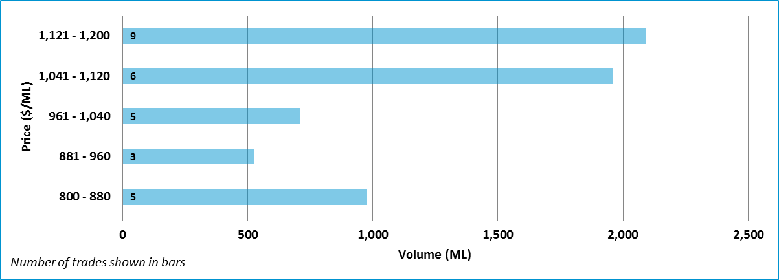

Data Sources: Murray Irrigation Limited (www.murrayirrigation.com.au)

  - Murrumbidgee: General Security
Figure 27: Entitlement market prices and volumes
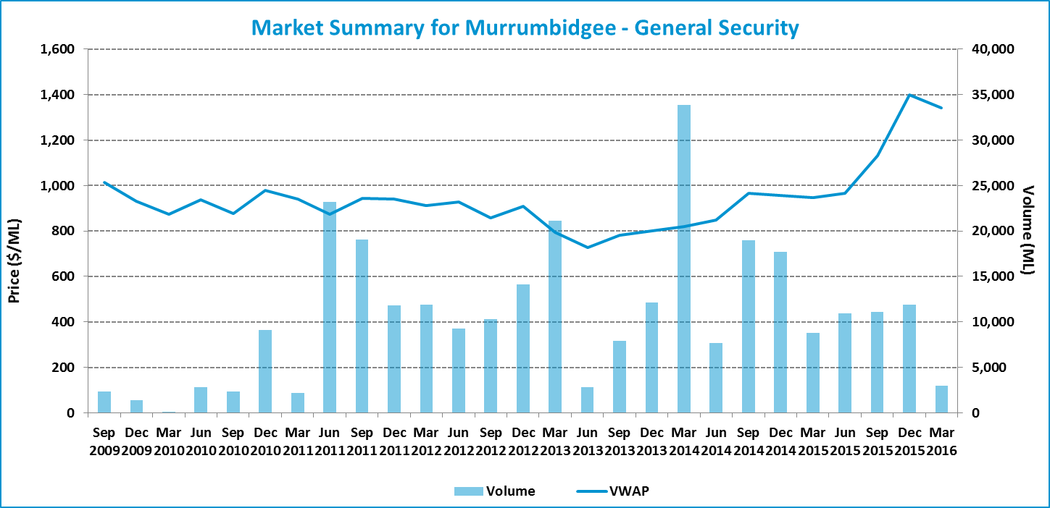

Table 14: Entitlement market prices and volumes
Volume weighted average price ($/ML) |  |  | March 2016 Quarter (in $/ML) |  |  |  |  | Mar 2016 Quarter Volume (ML) | Mar 2016 Quarter # of trades | Broker buy/sell range  ($/ML)
Month of Mar 2016 | Mar 2016 Quarter | YTD | 25th percentile | 75th percentile | Median | Mean | Mode | Mar 2016 Quarter Volume (ML) | Mar 2016 Quarter # of trades | Broker buy/sell range  ($/ML)
1,381 | 1,343 | 1,277 | 1,283 | 1,460 | 1,400 | 1,364 | 1,500 | 2,947 | 9 | 1,100 – 1,600

Figure 28: Entitlement market price range by volume
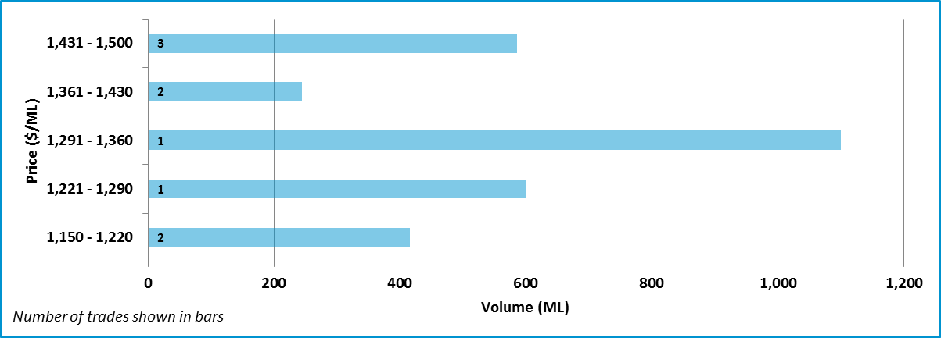

Data Sources: NSW Water Register (http://registers.water.nsw.gov.au/wma/WaterShareIntraWSLocSearch.jsp?selectedRegister=WaterShare, http://www.water.nsw.gov.au/water-licensing/registers), National Water Exchange (www.waterexchange.com.au), Waterfind (www.waterfind.com.au), H2OX (www.h2ox.com)

  - Murrumbidgee: High Security
Figure 29: Entitlement market prices and volumes
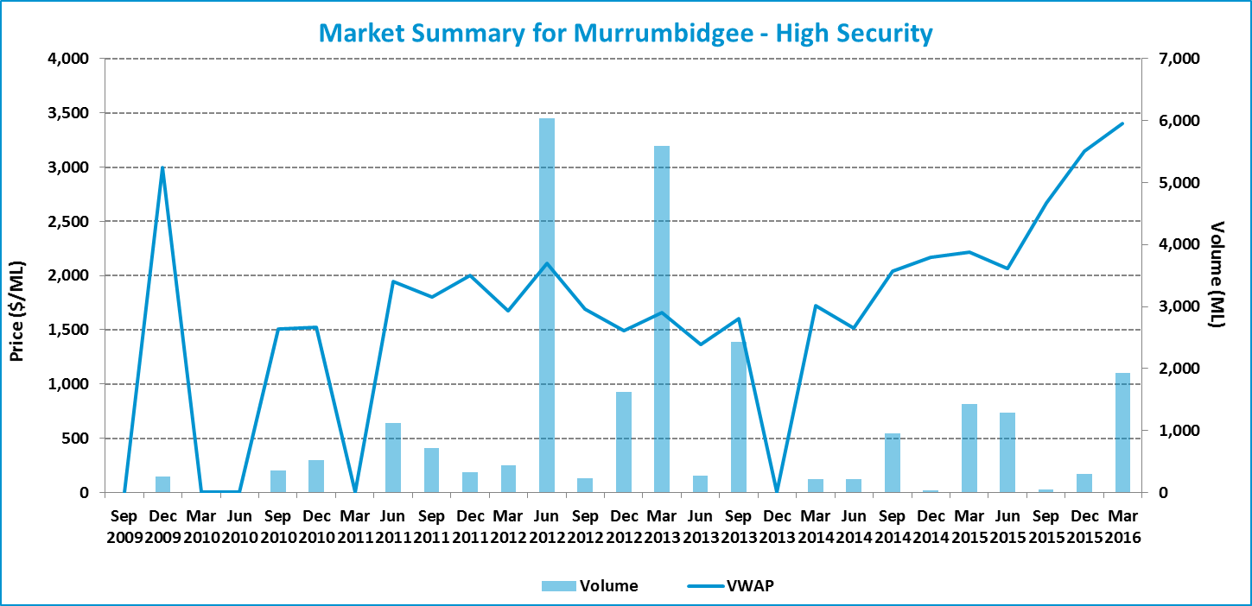

Table 15: Entitlement market prices and volumes
Volume weighted average price ($/ML) |  |  | March 2016 Quarter (in $/ML) |  |  |  |  | Mar 2016 Quarter Volume (ML) | Mar 2016 Quarter # of trades | Broker buy/sell range  ($/ML)
Month of Mar 2016 | Mar 2016 Quarter | YTD | 25th percentile | 75th percentile | Median | Mean | Mode | Mar 2016 Quarter Volume (ML) | Mar 2016 Quarter # of trades | Broker buy/sell range  ($/ML)
3,479 | 3,401 | 3,353 | 3,350 | 3,400 | 3,400 | 3,399 | 3,400 | 1,926 | 9 | 3,000 – 3,600

Figure 30: Entitlement market price range by volume
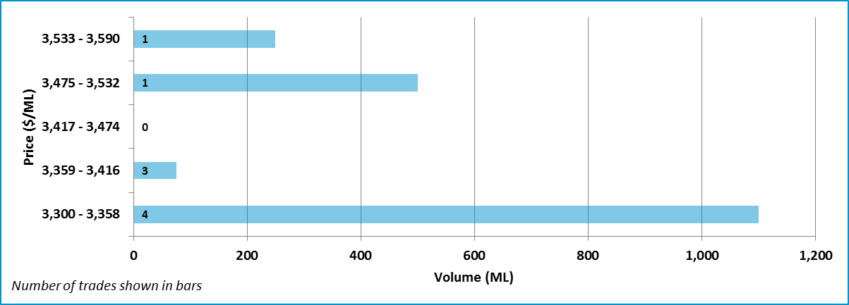

Data Sources: NSW Water Register (http://registers.water.nsw.gov.au/wma/WaterShareIntraWSLocSearch.jsp?selectedRegister=WaterShare, http://www.water.nsw.gov.au/water-licensing/registers), National Water Exchange (www.waterexchange.com.au), Waterfind (www.waterfind.com.au), H2OX (www.h2ox.com)
  - Lower Darling: General Security
Figure 31: Entitlement market prices and volumes
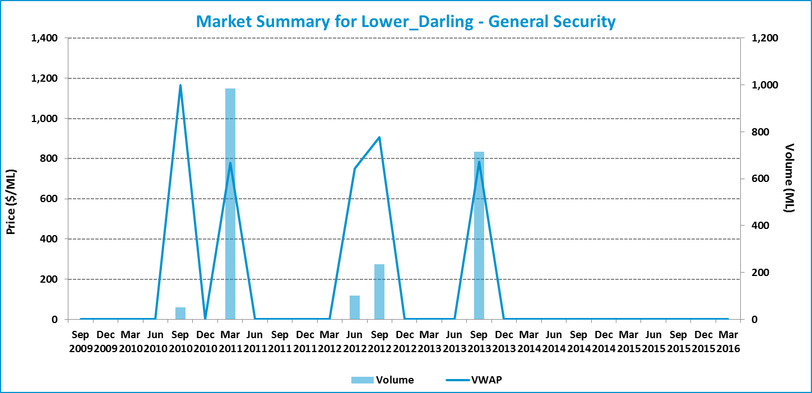

Table 16: Entitlement market prices and volumes
Volume weighted average price ($/ML) |  |  | March 2016 Quarter (in $/ML) |  |  |  |  | Mar 2016 Quarter Volume (ML) | Mar 2016 Quarter # of trades | Broker buy/sell range  ($/ML)
Month of Mar 2016 | Mar 2016 Quarter | YTD | 25th percentile | 75th percentile | Median | Mean | Mode | Mar 2016 Quarter Volume (ML) | Mar 2016 Quarter # of trades | Broker buy/sell range  ($/ML)
- | - | - | - | - | - | - | - | - | - | No listings

Data Sources: NSW Water Register (http://registers.water.nsw.gov.au/wma/WaterShareIntraWSLocSearch.jsp?selectedRegister=WaterShare, http://www.water.nsw.gov.au/water-licensing/registers), National Water Exchange (www.waterexchange.com.au), Waterfind (www.waterfind.com.au), H2OX (www.h2ox.com)

  - Lower Darling: High Security
Figure 32: Entitlement market prices and volumes
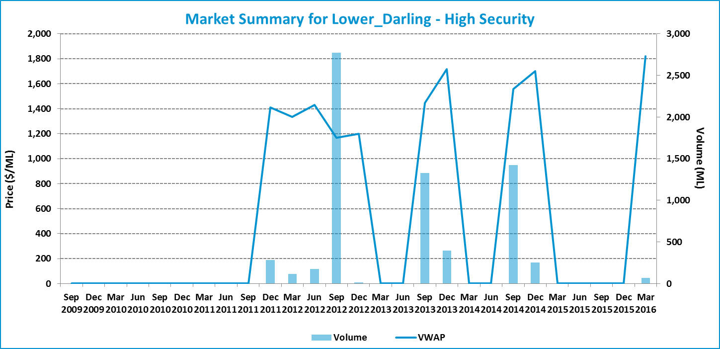

Table 17: Entitlement market prices and volumes
Volume weighted average price ($/ML) |  |  | March 2016 Quarter (in $/ML) |  |  |  |  | Mar 2016 Quarter Volume (ML) | Mar 2016 Quarter # of trades | Broker buy/sell range  ($/ML)
Month of Mar 2016 | Mar 2016 Quarter | YTD | 25th percentile | 75th percentile | Median | Mean | Mode | Mar 2016 Quarter Volume (ML) | Mar 2016 Quarter # of trades | Broker buy/sell range  ($/ML)
1,820 | 1,820 | 1,820 | - | - | - | - | - | 70 | 1 | No listings

Data Sources: NSW Water Register (http://registers.water.nsw.gov.au/wma/WaterShareIntraWSLocSearch.jsp?selectedRegister=WaterShare, http://www.water.nsw.gov.au/water-licensing/registers), National Water Exchange (www.waterexchange.com.au), Waterfind (www.waterfind.com.au), H2OX (www.h2ox.com)

- Northern Murray-Darling Basin
Figure 33: Price correlation in the Northern Basin: General Security
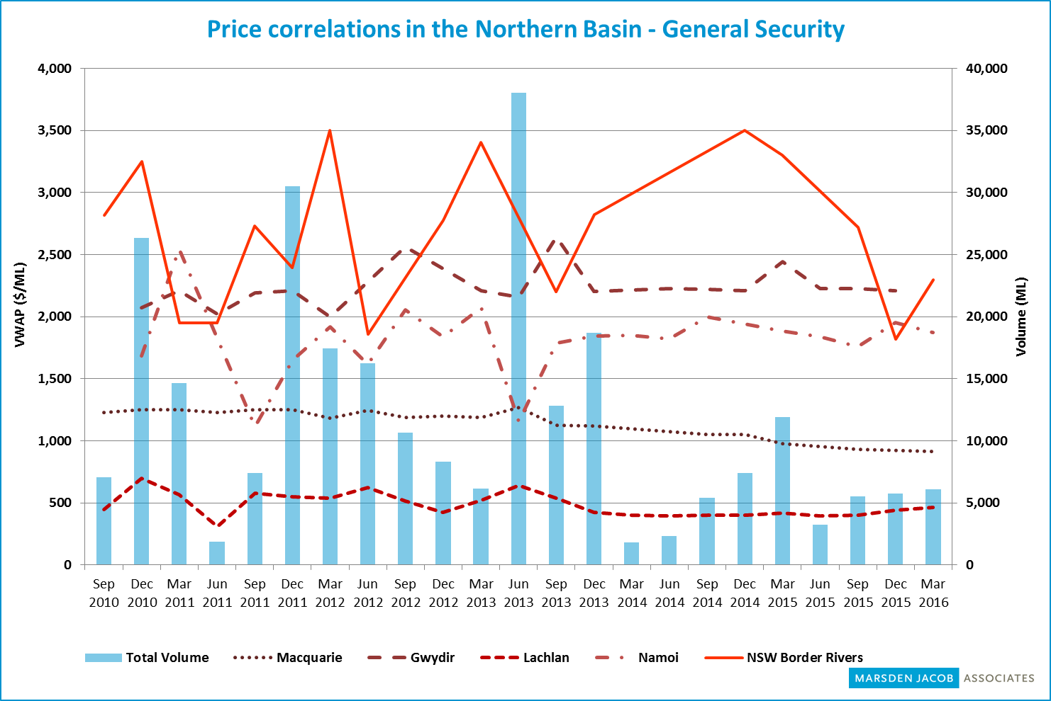
Source: Marsden Jacob analysis, 2016
Note: Zero values have been interpolated in this chart so it differs from the region and entitlement specific charts.

  - Macquarie: General Security
Figure 34: Entitlement market prices and volumes
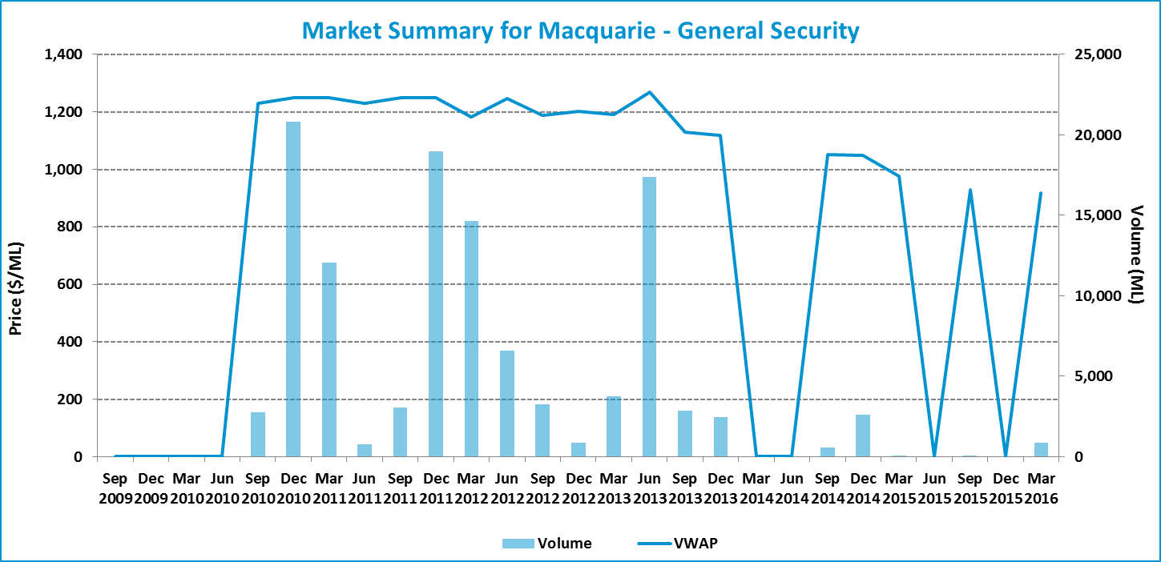

Table 18: Entitlement market prices and volumes
Volume weighted average price ($/ML) |  |  | March 2016 Quarter (in $/ML) |  |  |  |  | Mar 2016 Quarter Volume (ML) | Mar 2016 Quarter # of trades | Broker buy/sell range  ($/ML)
Month of Mar 2016 | Mar 2016 Quarter | YTD | 25th percentile | 75th percentile | Median | Mean | Mode | Mar 2016 Quarter Volume (ML) | Mar 2016 Quarter # of trades | Broker buy/sell range  ($/ML)
900 | 917 | 918 | 900 | 916 | 900 | 916 | 900 | 853 | 4 | 900 – 1,500

Figure 35: Entitlement market price range by volume
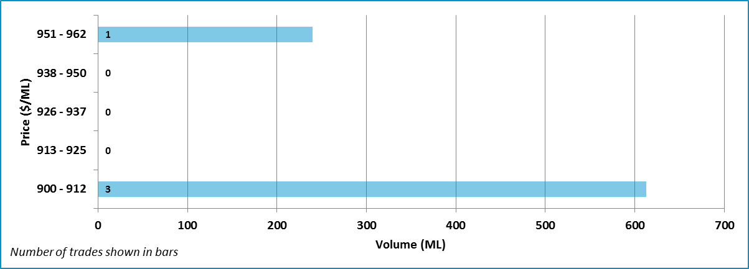

Data Sources: NSW Water Register (http://registers.water.nsw.gov.au/wma/WaterShareIntraWSLocSearch.jsp?selectedRegister=WaterShare, http://www.water.nsw.gov.au/water-licensing/registers), Waterfind (www.waterfind.com.au)

  - Namoi: General Security
Figure 36: Entitlement market prices and volumes
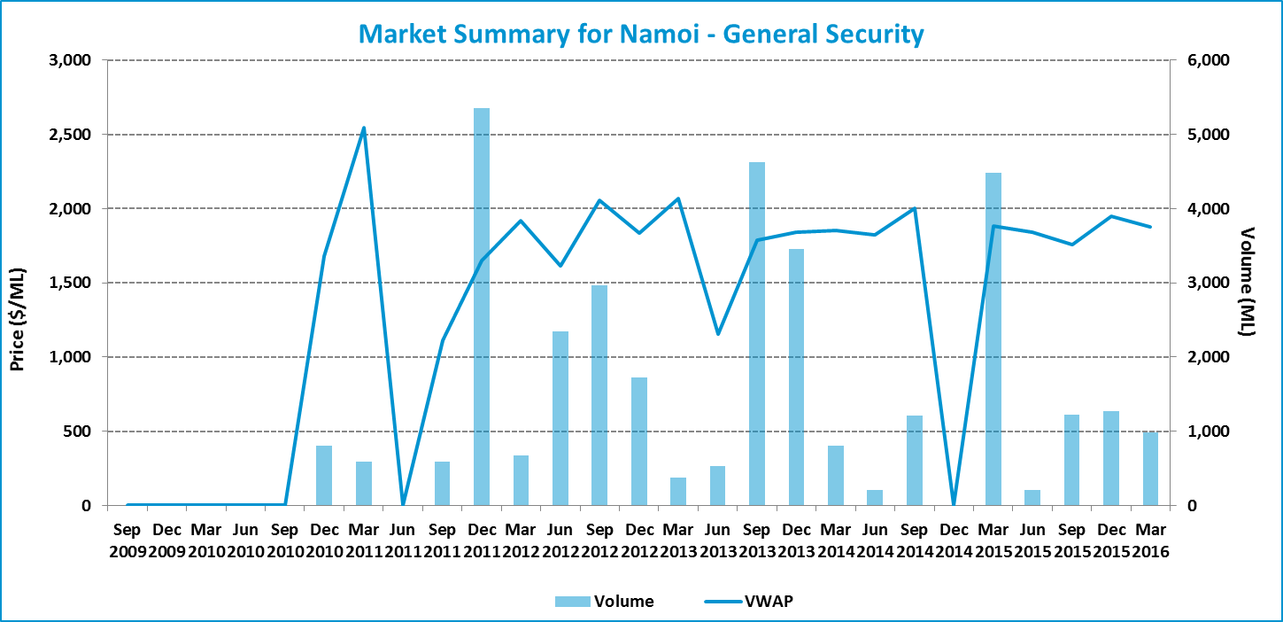

Table 19: Entitlement market prices and volumes
Volume weighted average price ($/ML) |  |  | March 2016 Quarter (in $/ML) |  |  |  |  | Mar 2016 Quarter Volume (ML) | Mar 2016 Quarter # of trades | Broker buy/sell range  ($/ML)
Month of Mar 2016 | Mar 2016 Quarter | YTD | 25th percentile | 75th percentile | Median | Mean | Mode | Mar 2016 Quarter Volume (ML) | Mar 2016 Quarter # of trades | Broker buy/sell range  ($/ML)
- | 1,875 | 1,861 | 1,875 | 1,900 | 1,900 | 1,883 | 1,900 | 983 | 3 | 1,950

Figure 37: Entitlement market price range by volume
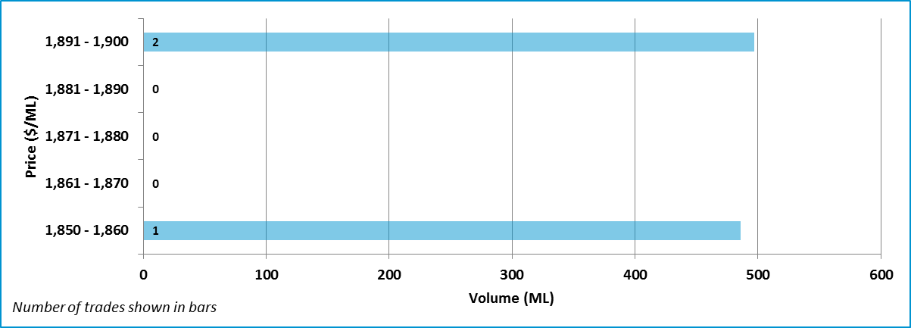

Data Sources: NSW Water Register (http://registers.water.nsw.gov.au/wma/WaterShareIntraWSLocSearch.jsp?selectedRegister=WaterShare, http://www.water.nsw.gov.au/water-licensing/registers), Waterfind (www.waterfind.com.au)

  - Gwydir: General Security
Figure 38: Entitlement market prices and volumes
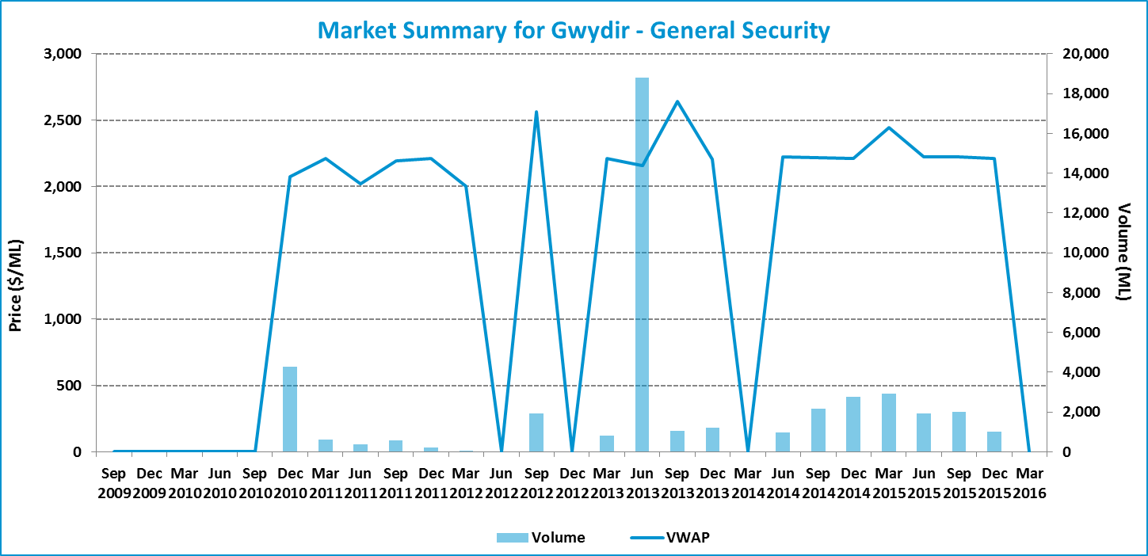

Table 20: Entitlement market prices and volumes
Volume weighted average price ($/ML) |  |  | March 2016 Quarter (in $/ML) |  |  |  |  |  | Mar 2016 Quarter Volume (ML) |  | Mar 2016 Quarter # of trades |  | Broker buy/sell range  ($/ML)
Month of Mar 2016 | Mar 2016 Quarter | YTD | 25th percentile | 75th percentile | Median | Mean | Mode |  |  |  |  |  | Broker buy/sell range  ($/ML)
- | - | 2,221 | - | - | - | - | - | - |  | - |  | 2,100 – 2,300

Data Sources: NSW Water Register (http://registers.water.nsw.gov.au/wma/WaterShareIntraWSLocSearch.jsp?selectedRegister=WaterShare, http://www.water.nsw.gov.au/water-licensing/registers), Waterfind (www.waterfind.com.au)

  - NSW Border Rivers: General Security
Figure 39: Entitlement market prices and volumes
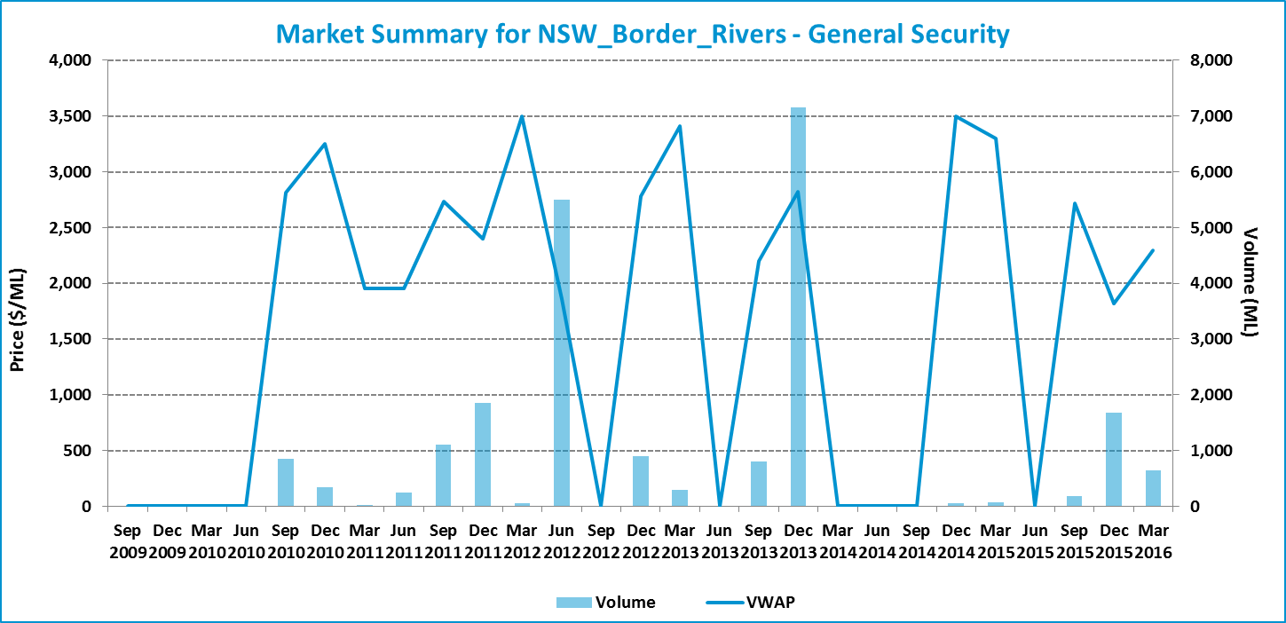

Table 21: Entitlement market prices and volumes
Volume weighted average price ($/ML) |  |  | March 2016 Quarter (in $/ML) |  |  |  |  | Mar 2016 Quarter Volume (ML) | Mar 2016 Quarter # of trades | Broker buy/sell range  ($/ML)
Month of Mar 2016 | Mar 2016 Quarter | YTD | 25th percentile | 75th percentile | Median | Mean | Mode | Mar 2016 Quarter Volume (ML) | Mar 2016 Quarter # of trades | Broker buy/sell range  ($/ML)
2,149 | 2,299 | 2,009 | 2,167 | 2,192 | 2,181 | 2,415 | 2,192 | 639 | 6 | 2,000 – 2,200

Figure 40: Entitlement market price range by volume
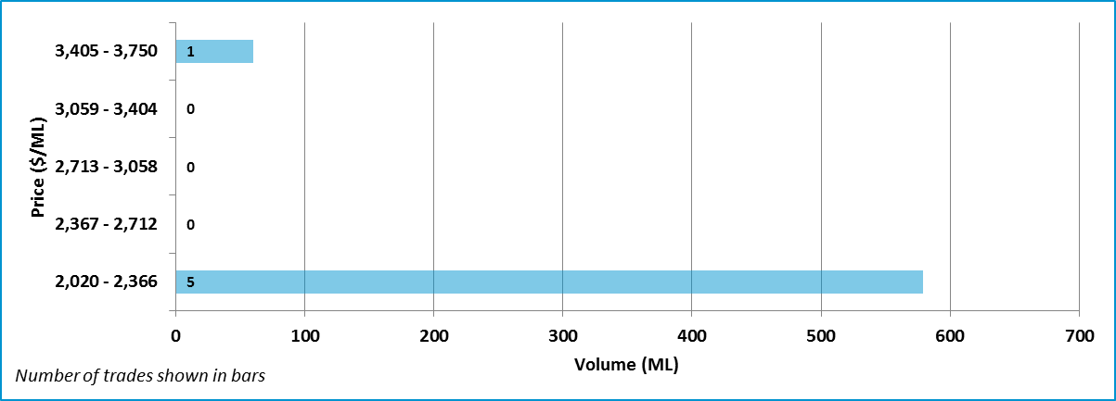

Note: One trade which is within two standard deviations of the average price of water entitlements has been excluded for this region.
Data Sources: NSW Water Register (http://registers.water.nsw.gov.au/wma/WaterShareIntraWSLocSearch.jsp?selectedRegister=WaterShare, http://www.water.nsw.gov.au/water-licensing/registers), Waterfind (www.waterfind.com.au)

  - Barwon Darling: Unregulated
Figure 41: Entitlement market prices and volumes
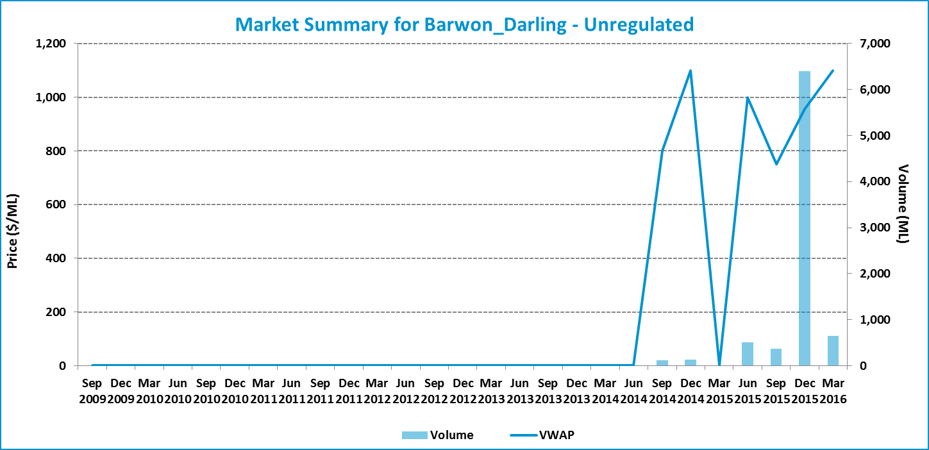

Table 22: Entitlement market prices and volumes
Volume weighted average price ($/ML) |  |  | March 2016 Quarter (in $/ML) |  |  |  |  | Mar 2016 Quarter Volume (ML) | Mar 2016 Quarter # of trades | Broker buy/sell range  ($/ML)
Month of Mar 2016 | Mar 2016 Quarter | YTD | 25th percentile | 75th percentile | Median | Mean | Mode | Mar 2016 Quarter Volume (ML) | Mar 2016 Quarter # of trades | Broker buy/sell range  ($/ML)
1,100 | 1,100 | 958 | - | - | - | - | - | 650 | 1 | No listings

Data Sources: NSW Water Register (http://registers.water.nsw.gov.au/wma/WaterShareIntraWSLocSearch.jsp?selectedRegister=WaterShare, http://www.water.nsw.gov.au/water-licensing/registers), Waterfind (www.waterfind.com.au)

  - Lachlan: General Security
Figure 42: Entitlement market prices and volumes
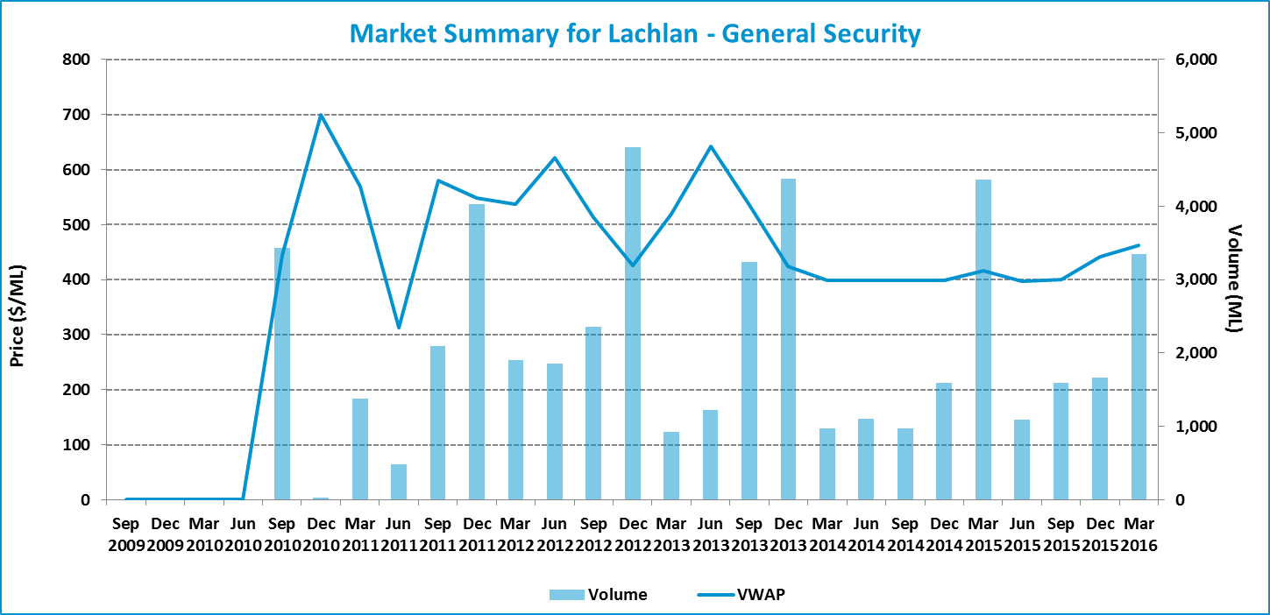

Table 23: Entitlement market prices and volumes
Volume weighted average price ($/ML) |  |  | March 2016 Quarter (in $/ML) |  |  |  |  |  | Mar 2016 Quarter Volume (ML) |  | Mar 2016 Quarter # of trades |  | Broker buy/sell range  ($/ML)
Month of Mar 2016 | Mar 2016 Quarter | YTD | 25th percentile | 75th percentile | Median | Mean | Mode |  |  |  |  |  | Broker buy/sell range  ($/ML)
500 | 462 | 442 | 420 | 470 | 440 | 447 | - | 3,352 |  | 3 |  | 440 – 500

Figure 43: Entitlement market price range by volume
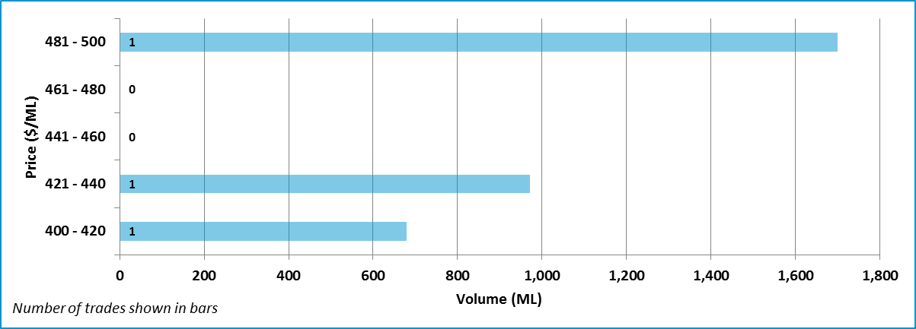

Data Sources: NSW Water Register (http://registers.water.nsw.gov.au/wma/WaterShareIntraWSLocSearch.jsp?selectedRegister=WaterShare, http://www.water.nsw.gov.au/water-licensing/registers), Waterfind (www.waterfind.com.au)

  - Queensland
The markets in Queensland are very thin, with only limited trading of entitlements occurring.
Queensland does not maintain a publicly available trade register. Information on entitlement trades is provided on an aggregated monthly basis.
Table 24: Entitlement market prices and volumes
Resource Operation Plan | Water Supply Scheme / Water Management Area | Type of Entitlement | Volume weighted average price ($/ML) |  |  | Mar 2016 Quarter Volume (ML) | Mar 2016 Quarter  # of trades
Resource Operation Plan | Water Supply Scheme / Water Management Area | Type of Entitlement | Month of Mar 2016 | Mar 2016 Quarter | YTD $/ML | Mar 2016 Quarter Volume (ML) | Mar 2016 Quarter  # of trades
QLD Border Rivers | Border Rivers/ Macintyre Brook | Supplemented | No trade | 2,000 | 599 | 617 | 2
QLD Border Rivers | Border Rivers | Unsupplemented | No trade | 1,800 | 1,800 | 2,120 | 2
Condamine-Balonne | St. George /  Upper Condamine | Supplemented | No trade | 2,556 | 2,479 | 571 | 2
Condamine-Balonne | Condamine Balonne / Lower Balonne / Upper Condamine | Unsupplemented | No trade | 1,600 | 1,506 | 150 | 1
Condamine-Balonne | Upper Condamine | Alluvium Ground-waterª | - | - | - | - | -
Condamine-Balonne | Lower Balonne | Overland Flow | - | - | - | - | -
Note: a. Data is only available up to September 2015 on the QLD Government website: https://www.dnrm.qld.gov.au/__data/assets/pdf_file/0004/217156/central-condamine-alluvium-water-licence-relocation-report.pdf (accessed 20 January 2016)
Data Sources: Queensland Business and industry portal (https://www.business.qld.gov.au/industry/water/managing-accessing/markets-trading/market-information)

Appendix 1: Regions and water sources
Table 25: Water Sources (Southern MDB)
Region | Water Source
SA Murray | River Murray Prescribed Water Course (Class 3a)
VIC Murray above Barmah Choke | 6 Vic Murray Dart to Barmah
Vic Murray below Barmah Choke | 7 Vic Murray Barmah to SA  6B Lower Broken Creek
Goulburn | 1A Greater Goulburn  1B Boort  3 Lower Goulburn
Campaspe | 4A Campaspe Eppalock to WWC  4C Lower Campaspe
Loddon | 5A Loddon – Coliban Channel to Lower Weir Pool (now 5A Loddon - CC/Tull to LWP)  5B Bullarook
NSW Murray | New South Wales Murray Regulated River Water Source
Murrumbidgee | Murrumbidgee Regulated River Water Source
Lower Darling | Lower Darling Regulated River Water Source

Table 26: Water Sources (Northern MDB)
Region | Entitlement Type
Macquarie | Macquarie and Cudgegong Regulated Rivers Water Source
Namoi | Lower Namoi Regulated River Water Source  Upper Namoi Regulated River Water Source
Gwydir | Gwydir Regulated River Water Source
NSW Border Rivers | Border Rivers Regulated River Water Source
Barwon Darling | Barwon Darling Unregulated River Water Source
Lachlan | Lachlan Regulated River Water Source

Appendix 2: Outliers removed
Table 27 shows outliers removed from the trade data in the March 2016 quarter.
Table 27: Outlier removed from trade data
Date | Catchment | ProductName | Volume (ML) | Price ($) | Price Per ML ($/ML)
12/01/2016 | Goulburn | High Reliability | 2.5 | $1,750.00 | $700
23/02/2016 | Goulburn | High Reliability | 12.0 | $4,800.00 | $400
10/03/2016 | Goulburn | High Reliability | 10.0 | $2,900.00 | $290
27/01/2016 | Goulburn | Low Reliability | 0.5 | $250.00 | $500
28/01/2016 | Goulburn | Low Reliability | 8.6 | $860.00 | $100 | *
29/02/2016 | Goulburn | Low Reliability | 30.0 | $4,500.00 | $150 | *
10/03/2016 | Goulburn | Low Reliability | 9.6 | $1,152.00 | $120 | *
2/02/2016 | Loddon | High Reliability | 1.0 | $1.00 | $1
2/02/2016 | Loddon | Low Reliability | 0.4 | $1.00 | $3
9/03/2016 | Murrumbidgee | General Security | 0.0 | $0.00 | $1
22/03/2016 | Murrumbidgee | General Security | 0.0 | $0.00 | $250
18/01/2016 | Murrumbidgee | High Security | 5.0 | $13,325.00 | $2,665
29/02/2016 | NSW_Border_Rivers | General Security | 180.0 | $36,000.00 | $200
29/02/2016 | NSW_Border_Rivers | General Security | 60.0 | $21,000.00 | $350
29/02/2016 | NSW_Border_Rivers | General Security | 987.0 | $394,800.00 | $400
29/02/2016 | NSW_Border_Rivers | General Security | 180.0 | $108,000.00 | $600
22/03/2016 | NSW_Border_Rivers | General Security | 228.0 | $971,508.00 | $4,261 | *
13/01/2016 | NSW_Murray | General Security | 2.0 | $1.00 | $1
19/01/2016 | NSW_Murray | General Security | 80.0 | $0.80 | $0
19/01/2016 | NSW_Murray | General Security | 0.0 | $0.00 | $1
25/01/2016 | NSW_Murray | General Security | 5.0 | $1.00 | $0
15/02/2016 | NSW_Murray | General Security | 0.0 | $0.00 | $250
16/02/2016 | NSW_Murray | General Security | 1.0 | $1.00 | $1
16/03/2016 | NSW_Murray | General Security | 0.0 | $0.00 | $1
17/03/2016 | NSW_Murray | General Security | 0.0 | $0.00 | $1
30/03/2016 | NSW_Murray | General Security | 0.0 | $0.00 | $1
5/01/2016 | NSW_Murray | High Security | 134.6 | $161,460.00 | $1,200 | *
18/01/2016 | NSW_Murray | High Security | 0.0 | $0.00 | $250
8/02/2016 | NSW_Murray | High Security | 190.0 | $299,250.00 | $1,575 | *
17/03/2016 | NSW_Murray | High Security | 0.0 | $0.00 | $1
19/01/2016 | SA_Murray | Class 3a | 25.0 | $25,000.00 | $1,000
28/01/2016 | Vic_Murray_AboveBC | High Reliability | 1.0 | $1,000.00 | $1,000
16/03/2016 | Vic_Murray_AboveBC | High Reliability | 1.0 | $1,100.00 | $1,100
30/03/2016 | Vic_Murray_AboveBC | Low Reliability | 5.8 | $580.00 | $100
11/01/2016 | Vic_Murray_BelowBC | High Reliability | 100.0 | $357,000.00 | $3,570 | *
22/01/2016 | Vic_Murray_BelowBC | High Reliability | 400.0 | $1,280.00 | $3
28/01/2016 | Vic_Murray_BelowBC | High Reliability | 10.0 | $11,275.00 | $1,128
15/02/2016 | Vic_Murray_BelowBC | High Reliability | 2.0 | $2,400.00 | $1,200
25/02/2016 | Vic_Murray_BelowBC | High Reliability | 1.0 | $1.00 | $1
17/03/2016 | Vic_Murray_BelowBC | High Reliability | 103.0 | $61,800.00 | $600
22/03/2016 | Vic_Murray_BelowBC | High Reliability | 84.9 | $101,880.00 | $1,200
30/03/2016 | Vic_Murray_BelowBC | Low Reliability | 1.4 | $1,000.01 | $714
Note: * Trades are within the bounds of two standard deviations for the the respective catchment, but have been excluded.

Water access entitlement is a perpetual or ongoing entitlement to exclusive access to a share of water from a specified consumptive pool as defined in the relevant water plan, Source: Schedule B(ii), Intergovernmental Agreement on a National Water Initiative (NWI)
http://www.mdba.gov.au/what-we-do/managing-rivers/water-trade/water-markets-product-info http://www.mdba.gov.au/what-we-do/managing-rivers/water-trade/southern-connected-trading-zones

