Water Entitlement Market Prices – Summary Report, February 2019

SOUTHERN MURRAY–DARLING BASIN
Figure 1 Southern Murray–Darling Basin higher reliability entitlement VWAPs and transfer volumes, 2016-17 to 2018-19
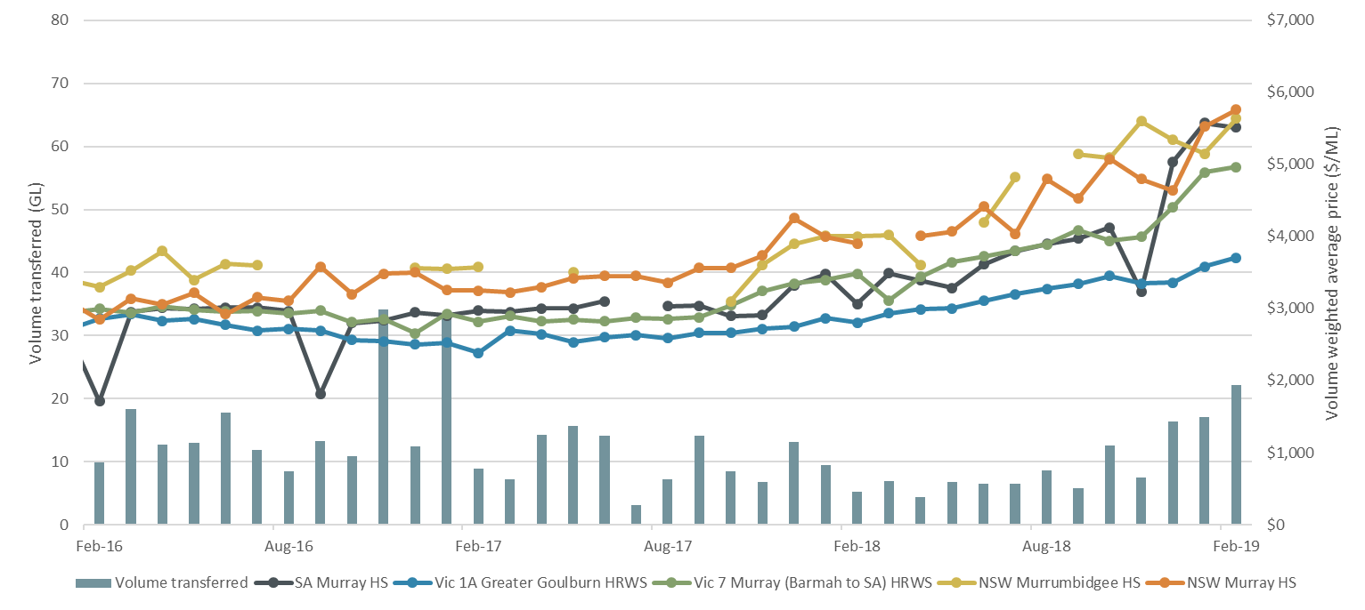
Source: Aither, 2019.
Note: Volume transferred includes all register transactions for zones: NSW Murray HS, NSW Murrumbidgee HS, SA Murray HS, Vic 1A Greater Goulburn HRWS, Vic 6 Murray (Dart to Barmah) HRWS and Vic 7 Murray (Barmah to SA) HRWS.

Figure 2 Southern Murray–Darling Basin lower reliability entitlement VWAPs and transfer volumes, 2016-17 to 2018-19
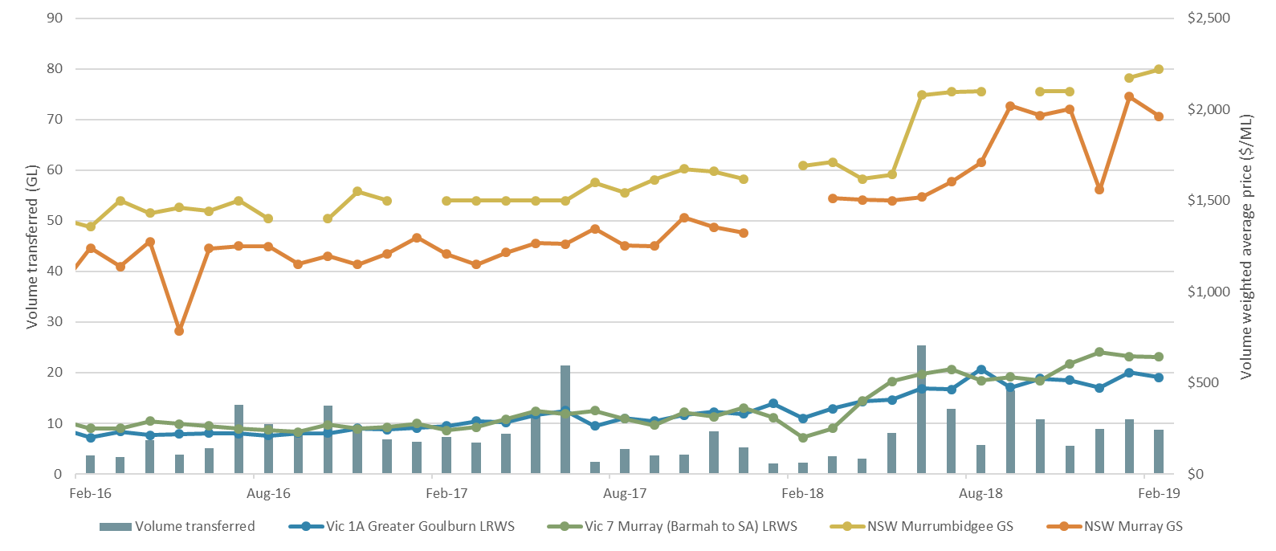
Source: Aither, 2019.
Note: Volume transferred includes all register transactions for NSW Murray GS, NSW Murrumbidgee GS, Vic 1A Greater Goulburn LRWS, Vic 6 Murray (Dart to Barmah) LRWS and Vic 7 Murray (Barmah to SA) LRWS.

Table 1 Southern Murray–Darling Basin trade statistics
Entitlement market | February 2019 VWAP ($/ML)^{1,2} | February 2019 Maximum Price ($/ML)² | February 2019 Number of Transfers³ | February 2019 Volume of Transfers (ML)³ | February 2019 Average Parcel Size (ML)⁴ | Broker spread (Buy/Sell) ($/ML)
SA Murray 3A | $5,512 | $6,000 | 8 | 2,770 | 346 | $6,000 - $6,300
Vic Murray above the Choke HRWS⁶ | $4,149 | $6,585 | 19 | 4,058 | 214 | $4,000 - $4,500
Vic Murray above the Choke LRWS⁶ | $592 | $600 | 13 | 1,495 | 115 | $500 - $600
Vic Murray below the Choke HRWS⁷ | $4,956 | $5,500 | 77 | 11,005 | 143 | $5,100 - $5,300
Vic Murray below the Choke LRWS⁷ | $640 | $665 | 14 | 950 | 68 | $600 - $675
Vic Greater Goulburn HRWS⁸ | $3,697 | $4,723 | 75 | 9,121 | 122 | $4,000 - $4,100
Vic Greater Goulburn LRWS⁸ | $508 | $600 | 34 | 3,960 | 116 | $400 - 500
Vic Campaspe HRWS⁹ | $3,300 | $3,300 | 3 | 34 | 11 | $3,900
Vic Campaspe LRWS⁹ | - | - | - | - | - | $550
Vic Loddon HRWS¹⁰ | $2,000 | $2,000 | 3 | 6 | 2 | -
Vic Loddon LRWS¹⁰ | - | - | - | - | - | -
NSW Murray HS | $5,763 | $6,015 | 3 | 82 | 27 | $5,700 - $6,200
NSW Murray GS | $1,962 | $2,230 | 7 | 1,757 | 251 | $1,595 - $1,600
NSW Murray Irrigation Limited GS⁵ | $1,962 | $2,230 | 22 | 6,656 | 303 | -
NSW Murrumbidgee HS | $5,640 | $5,640 | 1 | 70 | 70 | $6,100 - $6,500
NSW Murrumbidgee GS | $2,221 | $2,250 | 5 | 755 | 151 | $2,000 - $2,150
NSW Lower Darling HS | - | - | - | - | - | -
NSW Lower Darling GS | - | - | - | - | - | -
Note: VWAPs are based on estimates of commercial trades as outlined in Aither’s methodology excluding $0 value transfers (see notes).
Note: ‘Number of Transfers’ and ‘Volume of Transfers (ML)’ incorporate all transfers in the Aither Water Markets Database including $0 value transfers.

NORTHERN MURRAY–DARLING BASIN
Table 2 Northern Murray–Darling Basin trade statistics
Entitlement Market | February 2019 VWAP ($/ML)^{1,2} | February 2019 Maximum Price ($/ML)² | February 2019 Number of Transfers³ | February 2019 Volume of Transfers (ML)³ | February 2019 Average Parcel Size (ML)⁴ | Broker spread (Buy/Sell) ($/ML)
NSW Macquarie GS | - | - | - | - | - | -
NSW Namoi GS¹¹ | - | - | - | - | - | -
NSW Gwydir GS | - | - | - | - | - | -
NSW Border Rivers GS¹² | - | - | - | - | - | -
NSW Barwon Darling Unregulated¹³ | - | - | - | - | - | -
NSW Lachlan GS | $1,250 | $1,250 | 1 | 130 | 130 | $1,000 - $1,250
QLD Condamine-Balonne (St George) Supplemented¹⁵ | $3,961 | - | 3 | 513 | 171 | -
QLD Lower Balonne Overland flow¹⁵ | - | - | - | - | - | -
QLD Condamine Balonne Unsupplemented¹⁵ | $3,000 | $3,000 | 2 | 99 | 49 | -
QLD Condamine Groundwater¹⁴ ¹⁵ | - | - | - | - | - | -
QLD Border Rivers Supplemented¹⁵ | $1,700 | $1,700 | 1 | 11 | 11 | -
QLD Border Rivers Unsupplemented¹⁵ | $1,884 | - | 13 | 5,029 | 387 | -
Note: VWAPs are based on estimates of commercial trades as outlined in Aither’s methodology excluding $0 value transfers (see notes).
Note: ‘Number of Transfers’ and ‘Volume of Transfers (ML)’ incorporate all transfers in the Aither Water Markets Database including $0 value transfers. QLD water trade data relates to trade in January 2019 as more recent trade data was unavailable at the time of publication. In instances where there has been more than one trade for a given month it has not been possible to determine a maximum price due to the nature of the data made available.

Notes
1) This monthly Volume Weight Average Price (VWAP) has been calculated in line with Aither’s calculation methodology which is available upon request.
2) Only trades reported in February 2019 are included in this calculation.
3) The ‘Number of Transfers and ‘Volume of Transfers’ (ML) are calculated based on all trades from state water market registers, including $0 value trades. This is in line with Aither’s calculation methodology which is available upon request.
4) This figure has been determined by taking the total monthly volume of transfers and dividing by the total number of transfers of the given entitlement during the month in question.
5) As trade prices within NSW Murray Irrigation GS are not reported Aither has presented NSW Murray GS on river prices instead given the common characteristics that these entitlements share.
6) Vic Murray Above the Choke is Vic 6 Murray (Dart to Barmah).
7) Vic Murray Below the Choke is an aggregation of the following HRWS and LRWS entitlement types: Vic 7 Murray and Vic 6B Lower Broken Creek.
8) Vic Greater Goulburn is an aggregation of the following HRWS and LRWS entitlement types: Vic 1A Greater Goulburn, Vic 1B Boort and Vic 3 Lower Goulburn.
9) Vic Campaspe is an aggregation of the following HRWS and LRWS entitlement types: Vic 4A Campaspe and Vic 4C Lower Campaspe.
10) Vic Loddon is an aggregation of the following HRWS and LRWS entitlement types: Vic 5A Loddon and Vic 5B Bullarook.
11) NSW Namoi GS is an aggregation of the following HS and GS entitlements: NSW Lower Namoi GS and NSW Upper Namoi GS.
12) NSW Border Rivers is an aggregation of the following GS entitlements: NSW Border Rivers GS A and NSW Border Rivers GS B.
13) NSW Barwon Darling Unregulated is an aggregation of the following entitlements: NSW Barwon-Darling Unregulated A, NSW Barwon-Darling Unregulated B and NSW Barwon-Darling Unregulated C.
14) QLD Condamine Groundwater is an aggregation of the following entitlements: QLD Central Condamine Alluvium Groundwater (1, 2, 3, and 4), QLD Upper Condamine Alluvium Groundwater (Dalrymple Creek) Groundwater and QLD Upper Condamine Alluvium Groundwater (Oakey Creek) Groundwater.
15) QLD water trade data relates to trade in January 2019 as more recent trade data was unavailable at the time of publication. In instances where there has been more than one trade for a given month it has not been possible to determine a maximum price due to the nature of the data made available.

Document history

Background
Aither Pty Ltd was engaged in June 2018 by the Australian Government Department of Agriculture and Water Resources to provide price information on water entitlements across the Murray–Darling Basin. This document provides a summary overview of this data.
A more detailed report can be found at the Department’s website (http://www.agriculture.gov.au/water/markets/market-price-information).

For information on this report:
Please contact: Chris Olszak
Email: watermarkets@aither.com.au

Revision:
Revision no. | 1
Author/s | Edmund Delves
Checked | Kai Wakerman Powell
Approved | Chris Olszak

Distribution:
Issue date | Monday 11 March 2019
Issued to | Department of Agriculture and Water Resources
Description | Final

Citation:
Aither 2019, Murray Darling Basin Water Entitlement Price Summary Report – February 2019, Aither Pty Ltd.
© 2019 Aither Pty Ltd. All rights reserved.
This document has been prepared on the basis of information available to Aither Pty Ltd at the date of publication. Aither Pty Ltd makes no warranties, expressed or implied, in relation to any information contained in this document. This document does not purport to represent commercial, financial or legal advice, and should not be relied upon as such. Aither Pty Ltd does not accept responsibility or liability for any loss, damage, cost or expense incurred or arising by reason of any party using or relying on information provided in this document. Any party that uses information contained in this document for any purpose does so at its own risk.
The information contained in this document is confidential and must not be reproduced, distributed, referred to or used, in whole or in part, for any purpose without the express written permission of Aither Pty Ltd.

