# Water Entitlement Market Prices – Summary Report, October 2018

## SOUTHERN MURRAY–DARLING BASIN

Figure 1 Southern Murray–Darling Basin higher reliability entitlement VWAPs and transfer volumes, 2016-17 to 2017-18

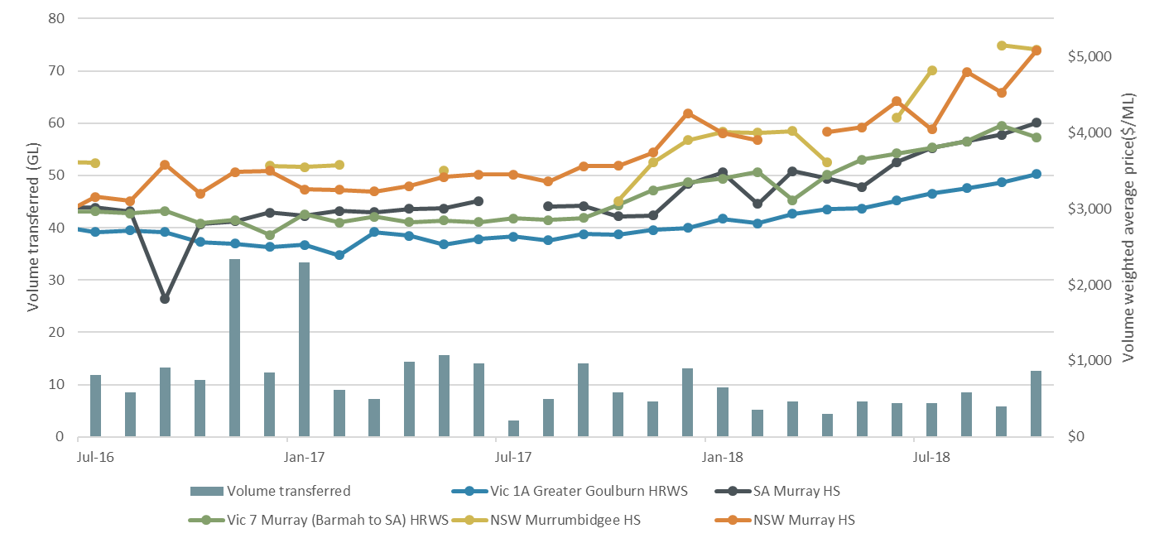

Source: Aither, 2018.  
Note: Volume transferred includes all register transactions for zones: NSW Murray HS, NSW Murrumbidgee HS, SA Murray HS, Vic 1A Greater Goulburn HRWS, Vic 6 Murray (Dart to Barmah) HRWS and Vic 7 Murray (Barmah to SA) HRWS.

Figure 2 Southern Murray–Darling Basin lower reliability entitlement VWAPs and transfer volumes, 2016-17 to 2017-18

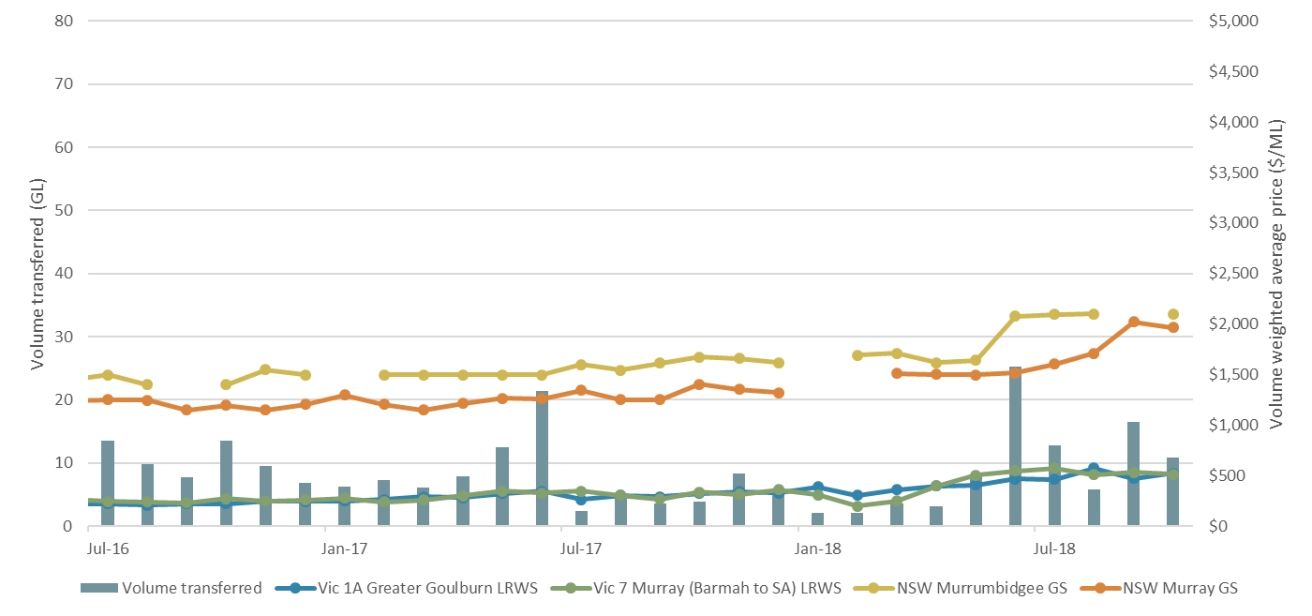

Source: Aither, 2018.

Note: Volume transferred includes all register transactions for NSW Murray GS, NSW Murrumbidgee GS, Vic 1A Greater Goulburn LRWS, Vic 6 Murray (Dart to Barmah) LRWS and Vic 7 Murray (Barmah to SA) LRWS.

Table 1 Southern Murray–Darling Basin trade statistics

|  |  |  |  |  |  |  |
| --- | --- | --- | --- | --- | --- | --- |
| **Entitlement market** | **October 2018 VWAP ($/ML)1,2** | **October 2018 Maximum Price ($/ML)2** | **October 2018 Number of Transfers3** | **October 2018 Volume of Transfers (ML)3** | **October 2018 Average Parcel Size (ML)4** | **Broker spread (Buy/Sell) ($/ML)** |
| SA Murray 3A | $4,128 | $4,700 | 16 | 1,640 | 102 | $3,950 - $8,000 |
| Vic Murray above the Choke HRWS6 | $3,753 | $3,950 | 26 | 1,475 | 57 | $3,800 - $4,200 |
| Vic Murray above the Choke LRWS6 | $528 | $600 | 10 | 554 | 55 | $500 - $600 |
| Vic Murray below the Choke HRWS7 | $3,942 | $5,110 | 117 | 3,576 | 31 | $4,900 - $5,000 |
| Vic Murray below the Choke LRWS7 | $508 | $630 | 28 | 1,739 | 62 | $530 - $630 |
| Vic Greater Goulburn HRWS8 | $3,455 | $3,750 | 106 | 2,804 | 26 | $3,500 - $4,000 |
| Vic Greater Goulburn LRWS8 | $523 | $550 | 46 | 2,678 | 58 | $450 - $550 |
| Vic Campaspe HRWS9 | $2,500 | $2,500 | 6 | 185 | 31 | - |
| Vic Campaspe LRWS9 | - | - | 1 | 59 | 59 | - |
| Vic Loddon HRWS10 | $1,000 | $1,000 | 4 | 10 | 3 | - |
| Vic Loddon LRWS10 | - | - | - | - | - | - |
| NSW Murray HS | $5,079 | $5,195 | 7 | 1,526 | 218 | $5,300 - $5,500 |
| NSW Murray GS | $1,968 | $2,240 | 13 | 4,455 | 343 | $1,800 - $1,950 |
| NSW Murray Irrigation Limited GS5 | $1,968 | $2,240 | 6 | 1,516 | 253 | - |
| NSW Murrumbidgee HS | $5,096 | $5,100 | 4 | 1,410 | 353 | $5,800 - $5,600 |
| NSW Murrumbidgee GS | $2,100 | $2,200 | 4 | 1,367 | 342 | $2,050 - $2,200 |
| NSW Lower Darling HS | - | - | - | - | - | - |
| NSW Lower Darling GS | - | - | - | - | - | - |

Note: VWAPs are based on estimates of commercial trades as outlined in Aither’s methodology excluding $0 value transfers (see notes).

Note: ‘Number of Transfers’ and ‘Volume of Transfers (ML)’ incorporate all transfers in the Aither Water Markets Database including $0 value transfers.

## NORTHERN MURRAY–DARLING BASIN

Table 2 Northern Murray–Darling Basin trade statistics

|  |  |  |  |  |  |  |
| --- | --- | --- | --- | --- | --- | --- |
| **Entitlement Market** | **October 2018 VWAP ($/ML)1,2** | **October 2018 Maximum Price ($/ML)2** | **October 2018 Number of Transfers3** | **October 2018 Volume of Transfers (ML)3** | **October 2018 Average Parcel Size (ML)4** | **Broker spread (Buy/Sell) ($/ML)** |
| NSW Macquarie GS | $1,719 | $1,719 | 1 | 64 | 64 | - |
| NSW Namoi GS11 | - | - | - | - | - | - |
| NSW Gwydir GS | - | - | - | - | - | - |
| NSW Border Rivers GS12 | - | - | - | - | - | - |
| NSW Barwon Darling Unregulated13 | - | - | - | - | - | - |
| NSW Lachlan GS | $885 | $1,100 | 2 | 534 | 267 | $900 - $1,000 |
| QLD Condamine-Balonne (St George) Supplemented | $3,750 | - | 1 | 5 | 5 | - |
| QLD Lower Balonne Overland flow | - | - | - | - | - | - |
| QLD Condamine Balonne Unsupplemented | $2,000 | - | 1 | 30 | 30 | - |
| QLD Condamine Groundwater14 | - | - | - | - | - | - |
| QLD Border Rivers Supplemented | - | - | - | - | - | - |
| QLD Border Rivers Unsupplemented | $1,900 | - | 1 | 515 | 515 | - |

Note: VWAPs are based on estimates of commercial trades as outlined in Aither’s methodology excluding $0 value transfers (see notes).

Note: ‘Number of Transfers’ and ‘Volume of Transfers (ML)’ incorporate all transfers in the Aither Water Markets Database including $0 value transfers.

## Notes

1) This monthly Volume Weight Average Price (VWAP) has been calculated in line with Aither’s calculation methodology which is available upon request.

2) Only trades reported in October 2018 are included in this calculation.

3) The ‘Number of Transfers and ‘Volume of Transfers’ (ML) are calculated based on all trades from state water market registers, including $0 value trades. This is in line with Aither’s calculation methodology which is available upon request.

4) This figure has been determined by taking the total monthly volume of transfers and dividing by the total number of transfers of the given entitlement during the month in question.

5) As trade prices within NSW Murray Irrigation GS are not reported Aither has presented NSW Murray GS on river prices instead given the common characteristics that these entitlements share.

6) Vic Murray Above the Choke is Vic 6 Murray (Dart to Barmah).

7) Vic Murray Below the Choke is an aggregation of the following HRWS and LRWS entitlement types: Vic 7 Murray and Vic 6B Lower Broken Creek.

8) Vic Greater Goulburn is an aggregation of the following HRWS and LRWS entitlement types: Vic 1A Greater Goulburn, Vic 1B Boort and Vic 3 Lower Goulburn.

9) Vic Campaspe is an aggregation of the following HRWS and LRWS entitlement types: Vic 4A Campaspe and Vic 4C Lower Campaspe.

10) Vic Loddon is an aggregation of the following HRWS and LRWS entitlement types: Vic 5A Loddon and Vic 5B Bullarook.

11) NSW Namoi GS is an aggregation of the following HS and GS entitlements: NSW Lower Namoi GS and NSW Upper Namoi GS.

12) NSW Border Rivers is an aggregation of the following GS entitlements: NSW Border Rivers GS A and NSW Border Rivers GS B.

13) NSW Barwon Darling Unregulated is an aggregation of the following entitlements: NSW Barwon-Darling Unregulated A, NSW Barwon-Darling Unregulated B and NSW Barwon-Darling Unregulated C.

14) QLD Condamine Groundwater is an aggregation of the following entitlements: QLD Central Condamine Alluvium Groundwater (1, 2, 3, and 4), QLD Upper Condamine Alluvium Groundwater (Dalrymple Creek) Groundwater and QLD Upper Condamine Alluvium Groundwater (Oakey Creek) Groundwater.

15) Aither’s analysis was conducted on 6 November 2018 and only includes trade data available as of this date.

## 

## Document history

### Background

Aither Pty Ltd was engaged in June 2018 by the Australian Government Department of Agriculture and Water Resources to provide price information on water entitlements across the Murray–Darling Basin. This document provides a summary overview of this data.

A more detailed report can be found at the Department’s website (<http://www.agriculture.gov.au/water/markets/market-price-information>).

### For information on this report:

Please contact: Chris Olszak

Email: watermarkets@aither.com.au

### Revision:

|  |  |
| --- | --- |
| Revision no. | 1 |
| Author/s | Herschell Zang |
| Checked | Kai Wakerman Powell |
| Approved | Chris Olszak |

### Distribution:

|  |  |
| --- | --- |
| Issue date | Friday 9 November 2018 |
| Issued to | Department of Agriculture and Water Resources |
| Description | Final Report |

### Citation:

Aither 2018, Murray Darling Basin *Water Entitlement Price Summary Report – October 2018*, Aither Pty Ltd.

© 2018 Aither Pty Ltd. All rights reserved.

This document has been prepared on the basis of information available to Aither Pty Ltd at the date of publication. Aither Pty Ltd makes no warranties, expressed or implied, in relation to any information contained in this document. This document does not purport to represent commercial, financial or legal advice, and should not be relied upon as such. Aither Pty Ltd does not accept responsibility or liability for any loss, damage, cost or expense incurred or arising by reason of any party using or relying on information provided in this document. Any party that uses information contained in this document for any purpose does so at its own risk.

The information contained in this document is confidential and must not be reproduced, distributed, referred to or used, in whole or in part, for any purpose without the express written permission of Aither Pty Ltd.