the second review of the lake eyre basin intergovernmental agreement

Public consultation document

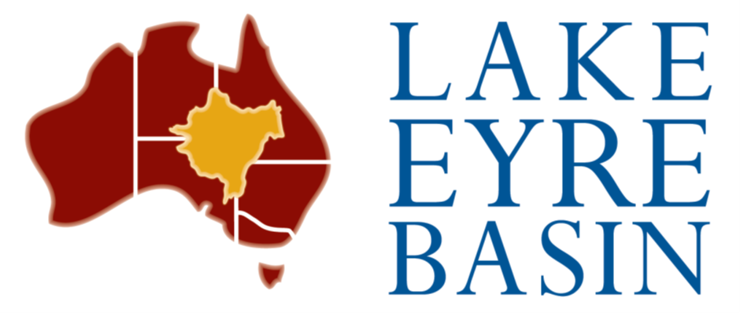Noetic Group  
December 2017

Noetic Group were commissioned on behalf of the Lake Eyre Basin Ministerial Forum to review and prepare a report on the operation of the Lake Eyre Basin Intergovernmental Agreement

© Lake Eyre Basin Ministerial Forum 2018

**Ownership of intellectual property rights**

Unless otherwise noted, copyright (and any other intellectual property rights, if any) in this publication is owned by the Lake Eyre Basin Ministerial Forum.

**Creative Commons licence**

All material in this publication is licensed under a Creative Commons Attribution 3.0 Australia Licence, save for content supplied by third parties, logos and the Commonwealth Coat of Arms.

C:\Documents and Settings\west merryn\Local Settings\Temporary Internet Files\Content.Word\by.png

Creative Commons Attribution 3.0 Australia Licence is a standard form licence agreement that allows you to copy, distribute, transmit and adapt this publication provided you attribute the work. A summary of the licence terms is available from [creativecommons.org/licenses/by/3.0/au/deed.en](http://creativecommons.org/licenses/by/3.0/au/deed.en). The full licence terms are available from [creativecommons.org/licenses/by/3.0/au/legalcode](http://creativecommons.org/licenses/by/3.0/au/legalcode).

Inquiries about the licence and any use of this document should be sent to [copyright@agriculture.gov.au](mailto:copyright@agriculture.gov.au).

The Australian, Queensland, South Australian and Northern Territory governments on behalf of the Lake Eyre Basin Ministerial Forum acting through consultants Noetic Group has exercised due care and skill in preparing and compiling the information and data in this publication. Notwithstanding, the Australian, Queensland, South Australian and Northern Territory governments, its employees and advisers disclaim all liability, including liability for negligence and for any loss, damage, injury, expense or cost incurred by any person as a result of accessing, using or relying upon any of the information or data in this publication to the maximum extent permitted by law.

Table of Contents

Executive Summary 4

Draft Recommendations 6

1. Introduction 7

1.1 Background 7

1.2 Terms of Reference of the Second Review 11

1.3 Methods 12

2. FINDINGS 13

2.1 Achievement of the Agreement’s purpose and objectives 13

Water and related natural resource impacts 15

Key points 16

2.2 Achievements since the 2007 Review 17

2.3 Efficacy of current policies and strategies 19

2.4 Effective management of threats and pressures in the Lake Eyre Basin 23

2.5 Changes that are needed to the Lake Eyre Basin Agreement to account for changed circumstances since the 2007 Review 25

2.6 Alignment of the Agreement with National Water Initiative principles and learnings from Strategic Adaptive Management 30

2.7 Frequency of Analysis of Lake Eyre Basin Rivers Assessment data 34

2.8 Frequency of future review points for the Agreement 35

3. Conclusion 36

Appendices 37

Appendix A 37

Appendix B 38

Appendix C 40

Appendix D 42

# Executive Summary

Noetic Group were commissioned on behalf of the Lake Eyre Basin Ministerial Forum to prepare a report which reviewed the operation of the Lake Eyre Basin Intergovernmental Agreement (the Agreement) in accordance with clause 10.1 of the *Lake Eyre Basin Intergovernmental Agreement Act 2001.* This Review of the Agreement follows a review completed in 2007. The Review has four overarching terms of reference agreed to by the Lake Eyre Basin Ministerial Forum, which are to determine if:

* + 1. the purpose of the Agreement has been achieved
    2. the objectives set out in clause 2.2 of the Agreement have been achieved
    3. the Agreement efficiently addresses the current threats and pressures within the Lake Eyre Basin
    4. the activities of government adequately manage the threats and pressures within the Lake Eyre Basin.

There are a number of considerations to be assessed to address these questions. Data has been gathered from initial stakeholder interviews, a review of governance arrangements and scientific reporting on the Basin. Initial stakeholder consultation has already been carried out with Parties to the Agreement and related stakeholders, but the public consultation will inform a much more detailed and specific assessment of public viewpoints.

The Agreement has eleven Objectives (outlined in Appendix B, Item 7), which allow for Party governments to come together in good faith to enact the terms of the Agreement, consider biodiversity and heritage issues in relation to water management, develop management policies and strategies and facilitate economic development in the Basin. Many stakeholders remarked in the course of this Review that the Agreement is working as a framework and as a process for interaction between the states, the territory and the Commonwealth, but there is room to strengthen the Agreement. There are challenges imposed by the lack of detail in some areas of the Agreement. This includes a lack of definition regarding the roles and responsibilities for Agreement groups such as the Community Advisory Committee and the Scientific Advisory Panel, and of a clear framework outlining decision making and responsibilities. The Agreement supports and has achieved useful cross-jurisdictional negotiations to build consensus and compromise between Party governments, informed by scientific expertise and community views.

The Review found common support for the way the Agreement has been able to harness involvement with Aboriginal communities throughout the Basin. To quote a stakeholder “Aboriginal interests should be a driver for improved natural resources management”. While the Lake Eyre Basin is currently understood to be at low risk of degradation, the geographical distance and spread of the catchment does raise difficulties with water and related resources management. Good management, commensurate with the risk level, will contribute to maintaining the health of the Basin. Frequent engagement with stakeholders is the key to successful governance, and the Agreement provides pathways for this engagement. The Agreement has demonstrated the ongoing value of Aboriginal voices to be heard even in the remote areas of the Basin.

The connections between communities, scientists and government have expanded the depth and range of advice provided to the Lake Eyre Basin Ministerial Forum and the Senior Officers Group to better inform cross-border water management decisions. The Lake Eyre Basin Scientific Advisory Panel and Community Advisory Committee continue to provide an effective mechanism to increase our understanding of the Basin’s biophysical, social, cultural and economic value for a relatively small investment.

The ecology and overall environmental state of the Lake Eyre Basin (the Basin) have experienced no significant issues in the last 10 years, and the Agreement appears to be functioning well. The Lake Eyre Basin Rivers Assessment Program and the State of the Basin Condition Assessment Report*s* (2008, draft 2016) continue to improve the depth of knowledge on hydrology, water quality and fish population parameters. The draft 2016 State of the Basin Condition Assessment Report also evaluated threats and pressures to the Basin from a cross-jurisdictional perspective, allowing for more targeted focus for decision makers.

Since its inception in 2001, the Lake Eyre Basin Ministerial Forum has adopted six policies under the Agreement:

* River Flows Policy
* Water Quality Policy
* Water and Related Natural Resources Policy
* Existing Entitlements and Water Resource Development Policy
* Research and Monitoring Policy
* Whole-of-Basin Approach Policy.

The effectiveness of these policies is unclear from the feedback received so far. Strategies to assist in implementing these policies were actioned through the Lake Eyre Basin Five Year Action Plan, which expired in 2014.

The Lake Eyre Basin, as assessed in the second State of the Basin Condition Assessment (draft 2016), is in reasonably good condition overall. However, some of the threats and pressures outlined in the State of the Basin Condition Assessment (draft 2016) include:

* the impacts of climate change on Lake Eyre Basin hydrology
* groundwater bore extraction
* impacts from resource development such as mining or gas exploration
* further impacts from invasive plants and animals
* land use changes from irrigation developments in upstream locations and greater intensity of agriculture.

The Agreement’s structure in its current form is well set up to react to issues, and to deal with threats and pressures once they arise. However, feedback suggests that the development of proactive measures, supported by Key Performance Indicators as measurement criteria, would allow the Senior Officers Group and Ministerial Forum to prevent issues arising in the first place. A risk-based precautionary approach to managing threats and pressures is the most efficient and effective way to maintain the Basin’s current good health.

The Agreement predates the National Water Initiative, and while states and territories have adopted many National Water Initiative principles, the Agreement provides a formal environment for interstate conversations on elements of the National Water Initiative that relate directly to the Basin. There is alignment between the National Water Initiative and the Intergovernmental Agreement, but room for the Agreement to incorporate accountability frameworks, governance arrangements and financial principles. There is also a view that there is a need for Basin partners to address a clearer coordinated approach to water resources management across the Basin, to assess current and future climate change impacts, current and future water demands from mining (gas), irrigation and other industries and review the current boundaries of the Agreement.

Stakeholders interviewed in this review were generally supportive of an evidence-based approach to Basin planning and management. This demonstrates how different policies lead to outcomes which are supported by measurement criteria. In turn, these measurement criteria can be used to inform policy and improve management.

The Lake Eyre Basin Intergovernmental Review is a useful process to trigger action and improvements. The real issue for many stakeholders was not the frequency of reviews, rather whether or not Governments would heed the results of the review process and take action.

As a result of this Review, the following draft recommendations are made, subject to validation by the public consultation.

### Draft Recommendations

1. Develop a monitoring strategy based on input from the Scientific Advisory Panel that targets prioritised areas and indicators and incorporates the vision for the Lake Eyre Basin.
2. Scientific Advisory Panel and Community Advisory Committee to develop Key Performance Indicators which will allow Agreement processes to act proactively to threats and pressures.
3. Investigate an amendment to the Agreement or a specific Regulation outlining more specific financial arrangements, including budgets and reporting required to operate the governance structures identified within the Agreement
4. Develop a new long-term action plan for the Lake Eyre Basin to address cross-border impacts.
5. Develop a review and reporting process for the efficacy of Policies and Strategies adopted by the Ministerial Forum.
6. Use Key Performance Indicators developed as per Recommendation iii to act as triggers for management actions as part of a risk based precautionary approach.
7. Explore the feasibility and potential benefits of using future scenarios to assess potential threats, pressures and opportunities.
8. Investigate the connections between the Lake Eyre Basin surface water and the Great Artesian Basin groundwater to assess whether there is need for joint management in the future.
9. Investigate the options of amending the Agreement to include outlining the operation of the Scientific Advisory Panel and the Community Advisory Committee, or developing a Regulation to the Agreement to this effect.
10. Create a sub-committee derived from the Scientific Advisory Panel and Community Advisory Committee to advise on any climate change impacts.
11. Assess current and future water demands across the Basin from development, agriculture and other industry.
12. Assess whether current boundaries of the Lake Eyre Basin Intergovernmental Agreement are still suitable for management of the water resources of the Lake Eyre Basin, and if changes are made, whether new parties should be invited to join the Agreement such as New South Wales.
13. Using the Lake Eyre Vision and Strategic Adaptive Management Framework, investigate utility of developing a strategic planning framework to encompass a coordinated basin wide approach for management of the Basin.
14. Revise the roles and responsibilities of the Community Advisory Committee and Scientific Advisory Panel to reflect the role they would take developing Key Performance Indicators and whole-of-Basin management.
15. Expand amendments to Agreement or Regulations to the Agreement to incorporate clearer accountability frameworks and decision making processes.
16. Increase the frequency of the analysis informed by monitoring programs (such as the Lake Eyre Basin Rivers Assessment) based on advice from the Scientific Advisory Panel.
17. Maintain a 10 year review cycle of the Intergovernmental Agreement.

# 1. Introduction

* 1. Background

#### The Lake Eyre Basin

The Lake Eyre Basin covers an area of 1.2 million km2 and is one of the largest internally draining river systems in the world. Around 60,000 people live and work in the Basin, and the area supports a range of social and economic activities such as agriculture, mining and tourism, contributing to economic development of Queensland, South Australia and the Northern Territory.

In addition to containing nationally important natural resources, the Lake Eyre Basin is closely intertwined with the Great Artesian Basin, which means at peak flow the combined systems contain over a quarter of Australia’s fresh water. Rainfall and runoff are highly variable across the Lake Eyre Basin. The Basin ecosystems are unique and diverse, and home to the Malkumba-Coongie Lakes National Park which is incorporated within Coongie Lakes wetland, a recognised Ramsar wetland of international importance.

The coverage of the 2000 Lake Eyre Basin Intergovernmental Agreement includes: the Cooper Creek system (including the Thomson and Barcoo Rivers), the Georgina and Diamantina River systems within Queensland and South Australia ending at Lake Eyre. The Northern Territory portion of the Basin was added in 2004, when the Northern Territory became a signatory to the Agreement. The western South Australian basins were also included at that time.

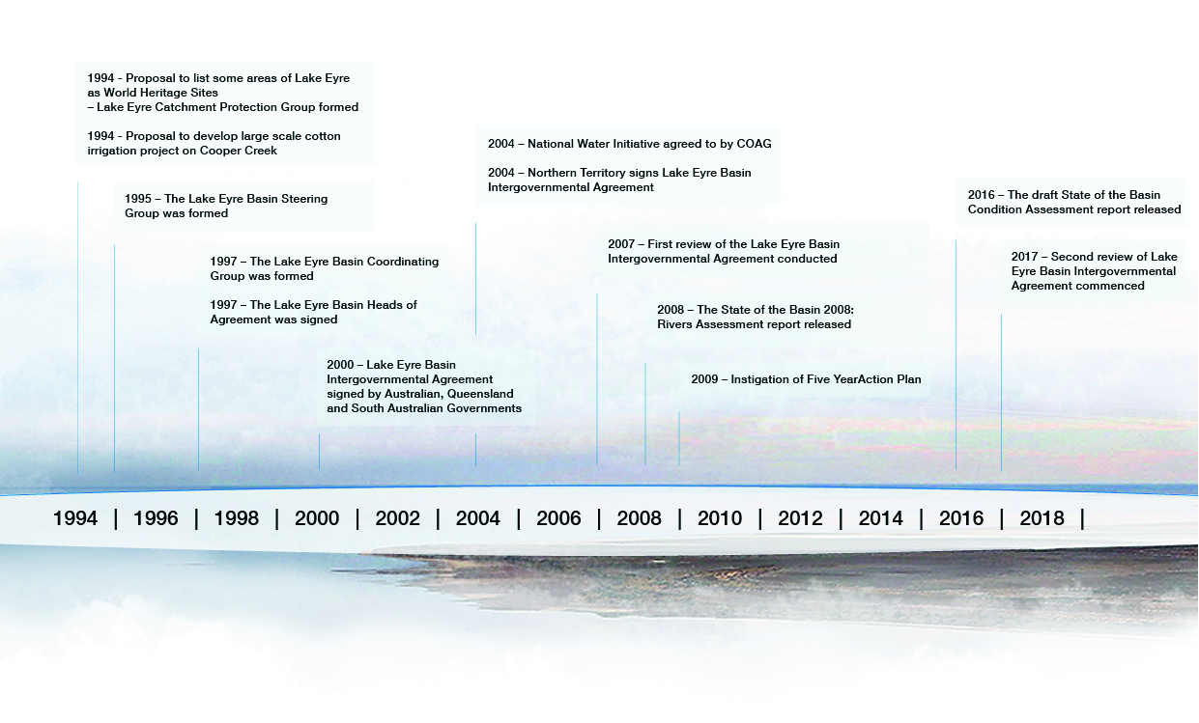See Appendix A for a map of the major river catchments, wetlands and settlements covered by the Agreement.

**Figure 1. Lake Eyre Basin Intergovernmental Agreement chronology**

#### Lake Eyre Basin Intergovernmental Agreement

The Lake Eyre Basin Intergovernmental Agreement is between the Australian, Queensland, South Australian and Northern Territory governments. Figure 1, above, shows the chronology of the agreement up to the date of this review.

The Agreement provides for the sustainable management of the water and natural resources associated with river systems in the Lake Eyre Basin Agreement Area. It also provides for the development and implementation of Policies and Strategies for the region in order to avoid or eliminate adverse cross-border impacts and contributes to governments’ ability to facilitate economic development in the Basin. The Agreement has a collaborative management structure, as outlined in Figure 2 and explained below.

**Figure 2. Lake Eyre Basin Agreement Operational Structure**

##### Ministerial Form

Established under the Agreement, consisting of one Minister from each Party to the Agreement, responsible for adopting Policies and Strategies in accordance with Agreement.

##### Senior Officers Group

Oversees the provision of advice given to the Ministerial Forum and implementation of Ministerial Forum decisions. Though not provided for in the Agreement, this review notes this body exists as an integral role in provision of advice to the Ministerial Forum.

##### Community Advisory Committee

Established by Ministerial Forum (as per provisions in Agreement) to provide representation of the community and groups within the Basin, feedback and advice to the Ministerial Forum on issues of water and related natural resources.

##### Scientific Advisory Panel

Appointed by the Ministerial Forum (as per provisions in Agreement) to provide scientific advice to the Ministerial Forum.

##### Lake Eyre Basin Facilitator (not pictured)

Provides technical and facilitative support to the Community Advisory Committee and Scientific Advisory Panel, assists in maintaining relationships with key bodies to support implementation of Agreement. The facilitator is not provided for in the Agreement, however, this review notes that the role exists to assist the current operation of the Agreement

##### Lake Eyre Basin Secretariat (not pictured)

Provides secretariat and administrative support to Ministerial Forum, Senior Officers Group, Scientific Advisory Panel and Community Advisory Committee. The secretariat is not provided for in the Agreement, however this review recognises that the role is necessary for administration purposes.

*Lake Eyre Basin jurisdictional scientific representatives (not pictured)*

Provides the Scientific Advisory Panel, Community Advisory Committee and the Lake Eyre Basin Secretariat with advice and information about the Basin’s biophysical river monitoring. These representatives are not provided for in the Agreement however this review recognises their role in the operation of the Agreement.

#### Findings of the first review of the Lake Eyre Basin Intergovernmental Review (2007)

A first review of the Agreement was undertaken in 2007. That review found that the Agreement was highly valued by stakeholders as a vehicle to safeguard the integrity of the Basin against the threat of inappropriate land and water management. The 2007 review reported that the Agreement had made good progress on reducing cross-border impacts and had created a whole-of-Basin, integrated natural resources management mindset amongst governments and key land managers and created a cooperative mindset providing an environment for sustainable integrated resources management with the Basin. The Community Advisory Committee had provided an effective platform for stakeholder involvement. The review found that it was too early to recognise improvements in the conditions of the Basin’s natural resources as a result of the Agreement’s activities; that the Agreement had triggered key planning and research activities; and there had been good progress in achieving many of the Agreement’s objectives.

## 1.2 Terms of Reference of the Second Review

This report presents the key findings and initial recommendations of the Second Review (the Review) to aid public consultation, so stakeholders understand the direction of the Review and can contribute to its findings. The Review has four overarching terms of reference which are to determine if:

* The purpose of the Agreement has been achieved.
* The objectives set out in clause 2.2 of the Agreement have been achieved.
* The Agreement efficiently addresses that current threats and pressures within the Lake Eyre Basin.
* The activities of government adequately manage the threats and pressures within the Lake Eyre Basin.

The Review’s terms of reference are attached at Appendix B; this Appendix also outlines the objectives of the Agreement. The Review will consider whether the Agreement has achieved these.

The Agreement includes a 10-year review cycle, with the first taking place in 2007. The Commonwealth, Queensland, South Australian and Northern Territory governments progressed this Second Review in partnership.

The Review process is currently ongoing, and this document is for public consultation. The recommendations presented are draft and subject to amendment based on feedback and data gained from the consultation process.

## 1.3 Methods

The Review was undertaken by Noetic Solutions (Noetic), Canberra. It involved:

* A desktop review of the documentation to provide an up-to-date understanding of the Agreement’s strategic context. This involved, drawing on the information directly provided by the Department of Agriculture and Water Resources, along with other relevant sources such as state and Federal Government reports, non-government organisation reports and evaluations, and academic research papers/evaluations.
* Attendance by Noetic as observers at a joint meeting of the Lake Eyre Basin Community Advisory Committee and Scientific Advisory Panel in Adelaide in April, 2017.
* Engagement with key stakeholders to inform the development of a Discussion Paper, including:
  + the Department’s Project Sponsor and Project Manager
  + members of the Lake Eyre Basin Intergovernmental Review Steering Group
  + other key members of the Great Artesian Basin and Lake Eyre Basin section
  + members of the Lake Eyre Basin Senior Officials Group
  + the Chair of the Lake Eyre Basin Community Advisory Committee
  + the Chair of the Lake Eyre Basin Scientific Advisory Panel.
* The development of a question framework to support more detailed interviews with stakeholders including:
  + the Chair of the Lake Eyre Basin Community Advisory Committee
  + the Chair of the Scientific Advisory Panel
  + state and territory government representatives
  + Lake Eyre Basin facilitator
  + Geoscience Australia
  + Office of Water Science.

This process took the form of semi-structured interviews and targeted questions based on the Discussion Paper.

* Synthesis of the results of these activities presented as this report.

# 2. FINDINGS

## 2.1 Achievement of the Agreement’s purpose and objectives

#### Initial assessment

The Review found that the Agreement is broadly achieving its purpose as stated in Clause 2.2 of the Agreement which outlines its objectives. The Agreement’s objectives focus on a mechanism for the Commonwealth, states and territory governments to come together to raise and address water and related natural resource management issues in the Lake Eyre Basin Agreement Area that have potential or real cross-border impacts.

The current collaborative management structure has been operating effectively so far due to strong relationships and good retention of corporate knowledge. It provides pathways for community and stakeholder engagement and feedback, allows and supports data collection and assessment, and provides a method of communication between stakeholders, senior officers and ministers. However, stakeholders have indicated there is room for improvement within this structure, as current arrangements, including the Community Advisory Committee, Scientific Advisory Panel and the Senior Officers Group, are not explicit in the Agreement.

The Agreement establishes institutional arrangements for the development or adoption of Policies and Strategies and for decision-making and allocation of resources. The focus is on joint promotion of coordinated management of the Lake Eyre Basin Agreement Area, supported by research and monitoring to inform decision making. The Agreement also provides a mechanism to be reviewed from time to time. Lastly, the Agreement aims to raise general public awareness of the special biodiversity and heritage values of the Lake Eyre Basin Agreement Area.

#### Achievement of Objectives

Many Lake Eyre Basin stakeholders remarked that the Agreement is working – both as a framework and as a process for interaction between the states, the territory and the Commonwealth. For example, the Agreement allowed ministers to agree on states’ and territory positions about the impacts of proposed water resource developments. Likewise, the Agreement achieved its purpose by taking a multi-jurisdictional approach and integrating information from the Lake Eyre Basin Scientific Advisory Panel and the Lake Eyre Basin Community Advisory Committee. Stakeholders concurred that the Agreement created a forum for cross-border discussion on a range of water related resource management issues which had not occurred before. However, the lack of specificity in the Agreement regarding funding arrangements was identified as a constraint to monitoring and management of the Lake Eyre Basin.

A significant strength of the Agreement is that it is legislated, providing official avenues and pathways for cross-border engagement regarding Basin issues. However, this also creates restrictions of how specific an intergovernmental agreement can be, especially for an unregulated basin system with episodic water flow.

The Review found that the approach of the Agreement is broad, with a good focus on monitoring but that there is less focus on policy and planning. In addition to non-specific funding arrangements, the Agreement lacks a risk assessment framework, specific financial management or reporting stipulations, and explicit provision for the operation of the Community Advisory Committee or the Scientific Advisory Panel. This lack of detail presents transparency challenges for the operation of the Agreement.

During initial stakeholder consultation, it appeared that the practical implementation of management in the Basin incorporated these elements listed above, although this was largely due to the strong relationships developed between stakeholders, not due to direct requirements outlined in the Agreement.

Several stakeholders commented that they believe in the value of an integrated approach but feel the Agreement does not contain mechanisms for raising cross-border issues and subsequent implementation of solutions. The intrusion of Sleepy Cod (Case Study A) presents a challenge that demonstrates the need for a proactive framework within the Agreement to manage invasive species that present cross-border challenges.

Case Study A: sleepy cod

Sleepy Cod, (*Oxyeleotris lineolata*) although a freshwater tropical fish native to the north of Australia, has been identified as risk to species within the Lake Eyre Basin. They were first observed in the Lake Eyre Basin in 2008, likely originating from the Cooper Creek catchment. Data collected in the Lake Eyre Basin Rivers Assessment Program suggested a front of Sleepy Cod moving downstream from Queensland, and Sleepy Cod has since been observed in Coongie Lakes and Cullyamurra waterhole, located at the bottom of the Lake Eyre Basin Catchment. The Rivers Assessment and the draft State of the Basin Condition Assessment (2016) has reported Sleepy Cod as a potential threat to the Lake Eyre Basin catchment. The speed of spread has been identified as an area of concern, with indications that there is an established population throughout the entire Cooper Creek catchment. The initial introduction into the catchment is likely due to release or escape from fish farms or properties, as they are a popular species for use in aquaculture.

The spread of the Sleepy Cod demonstrates how a potentially invasive aquatic species presents a threat to multiple jurisdictions. Control or eradication of the species in one jurisdiction does not guarantee control or eradication of the species throughout the entire catchment, highlighting the need for a coordinated approach to management to increase the resilience of the Basin overall.

The Purpose and Objectives of the Agreement (cl. 21 and 2.2) refer to addressing water and related natural resource management issues in the Lake Eyre Basin Agreement Area. Although not specifically a water management issue, the Sleepy Cod’s spread and distribution within the Basin cause it to fall within ‘natural related resources’. Within the scope of its Operating Protocols, the Scientific Advisory Panel provides a report to the Ministerial Forum annually, which acts a conduit for raising issues and requesting actions. However, there is no explicit mechanism for raising issues to the Ministerial Forum within the Agreement itself. Pest and weed management falls to individual states and jurisdictions, but when issues related to water and natural related resources arise, the Ministerial Forum could provide a medium for potentially coordinating a management response.

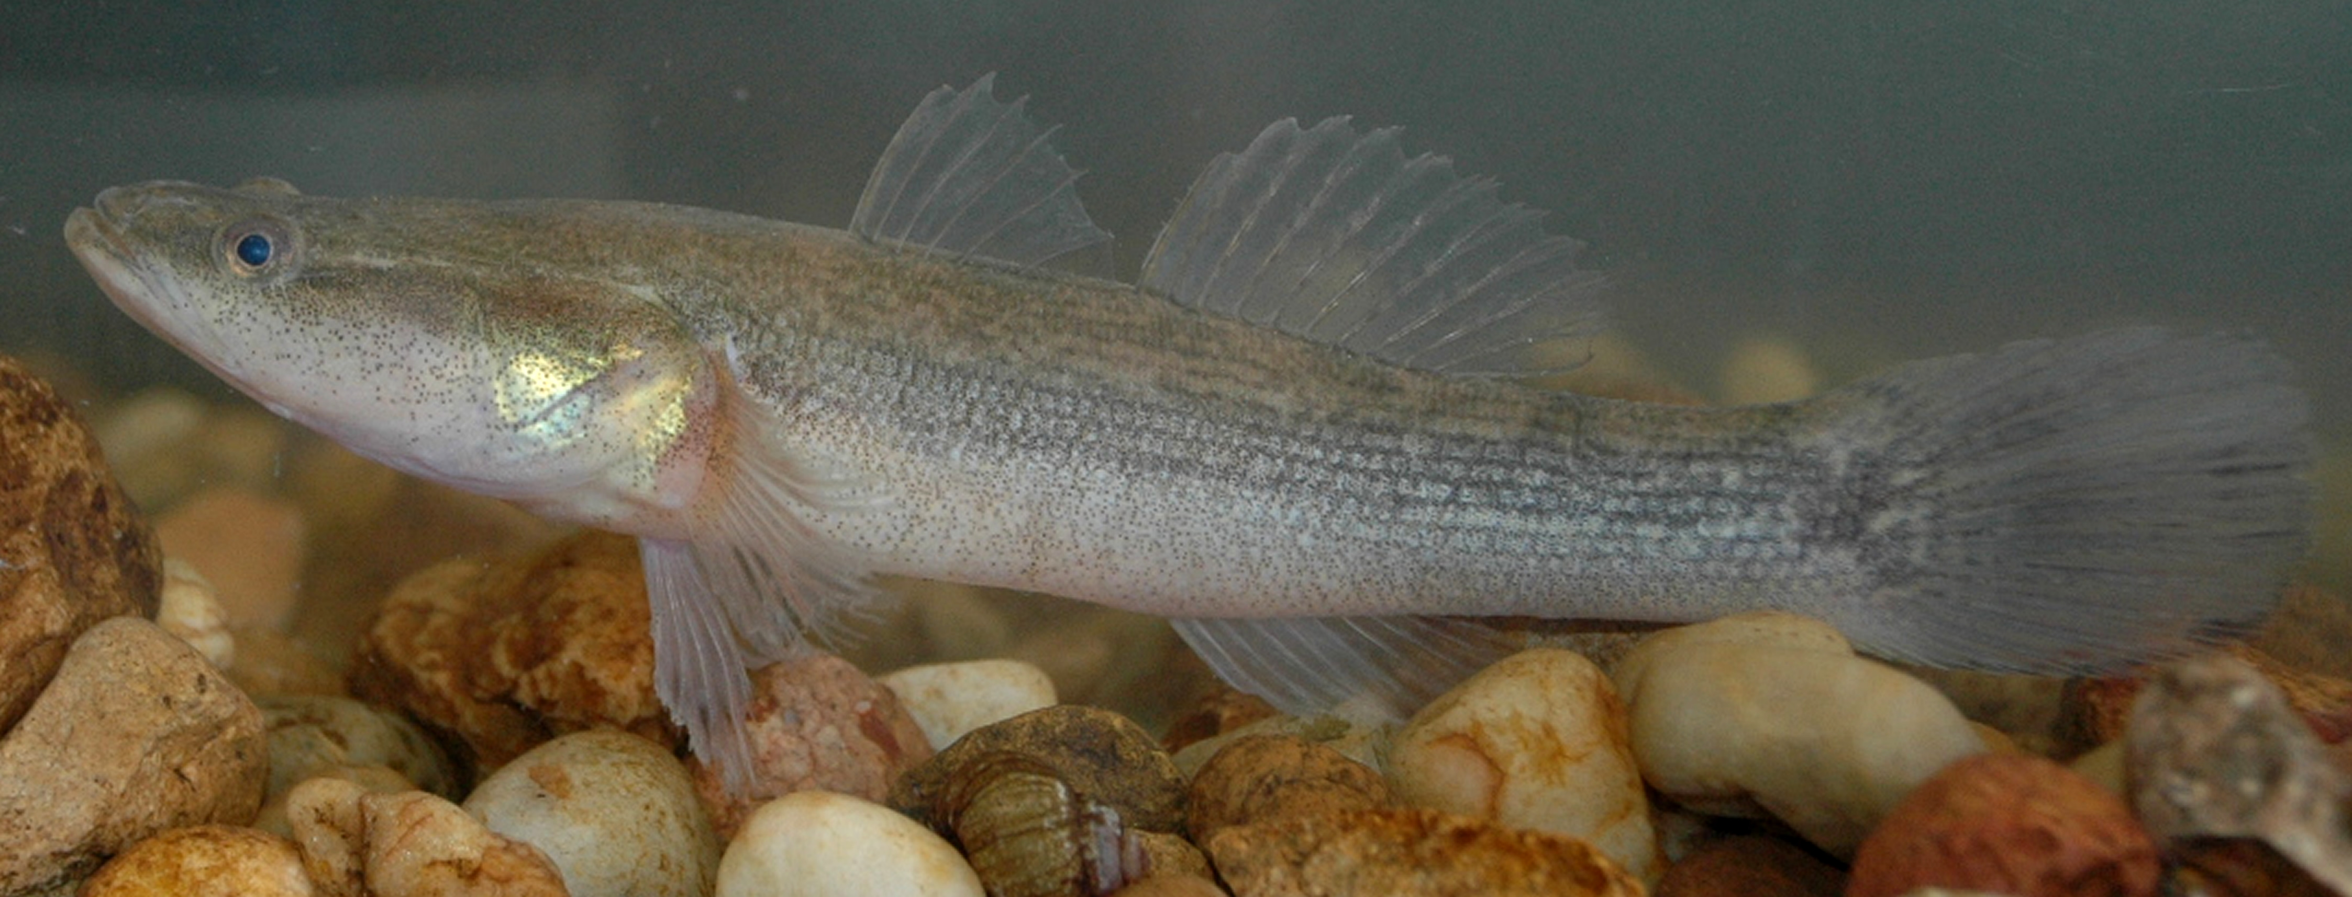

**Sleepy Cod (*Oxyeleotris lineolata*)**

### Water and related natural resource impacts

The continued spread of Sleepy Cod throughout the Lake Eyre Basin presents a number of potential risks to the natural environment, including:

* competing with native fish and aquatic species for habitat, breeding grounds and food
* reducing the biodiversity of Lake Eyre Basin ecosystems, increasing pressure on other vulnerable or threatened species within the Basin
* as a carnivorous species, there is a threat of predation on native species in Lake Eyre Basin aquatic ecosystems, including the endemic Cooper Creek catfish *(Neosiluroides cooperensis*)
* decline in community assets such as healthy waterways and landscapes.

### Key points

* The spread of Sleepy Cod affects South Australia and Queensland, becoming an emerging threat and pressure to the Lake Eyre Basin, made more challenging by the episodic flows that occur within the catchment.
* There is no explicit mechanism within the Agreement to raise cross-border issues such as this.
* Proactive planning could still provide suitable management approaches for controlling the species, potentially coordinated through the Ministerial Forum.



#### Raising emerging cross-border issues on water management and sharing

The current Agreement does not include triggers required to raise and consider management responses to proactively address emerging environmental issues in the Lake Eyre Basin. The absence of an evidence-based escalation mechanism means that ‘weak signals’—which potentially indicate symptoms of a future major negative change or trend—could be overlooked. It also does not include a feedback mechanism to incorporate lessons learnt from economic, social and environmental improvements in the Basin, which could be harnessed in future water and related natural resources management planning.

From initial stakeholder feedback, the ‘Lake Eyre Basin Vision’ has not been emphasised in planning documents and the Agreement does not currently have a formalised vision or a long-term management plan. This could be addressed by considering the arrangements necessary to support the implementation of a second long-term Basin action plan between all party governments and an existing collaborative strategic planning framework to encompass a co-ordinated Basin wide approach.

Key Performance Indicators (KPIs) assessing biophysical, social and economic factors could be used to measure progress in achieving the Agreement’s objectives. These indicators would act as triggers to escalate cross-border water management and related natural resource management issues to the Senior Officers Group and Lake Eyre Basin Ministerial Forum, where decision makers would identify appropriate management responses where needed. The indicators monitored by the Lake Eyre Basin Rivers Assessment are a good foundation to develop KPIs that meet relevant policy and management needs. Indicators could include changes in aquatic species, invasive species distribution, density and dispersal of high priority species, water quality thresholds, hydrological values due to climate change, cultural values and land productivity due to overgrazing.

**Recommendations**

1. Develop a monitoring strategy based on input from the Scientific Advisory Panel that targets prioritised areas and indicators and incorporates the vision for the Lake Eyre Basin.
2. Scientific Advisory Panel and Community Advisory Committee to develop Key Performance Indicators which will allow Agreement processes to act proactively to threats and pressures.

## 2.2 Achievements since the 2007 Review

#### Achievement in stakeholder consultation especially Aboriginal engagement

The Review found common support for the Agreement based on its ability to engage with Aboriginal communities throughout the Basin. To quote a stakeholder “Aboriginal interests should be a driver for improved natural resources management”. While the lack of profile makes Lake Eyre Basin natural resources management difficult, frequent engagement with stakeholders is the key to successful resources management. The Agreement has demonstrated the ongoing value of Aboriginal voices being heard even in the remote and vast areas of the Basin as outlined below.

##### Aboriginal Forum and Indigenous Rangers

Lake Eyre Basin Aboriginal Forums have been held approximately every two years since the establishment of the Agreement. They provide an avenue for building relationships between Aboriginal people and groups within the Lake Eyre Basin. These fora facilitate discussions about Aboriginal involvement in the Agreement, and on the future of the Lake Eyre Basin from an Aboriginal perspective.

The Lake Eyre Basin Community Advisory Committee provides representation of Aboriginal perspectives through its membership and engagement with the Ministerial Forum. Currently six of the seventeen members represent Aboriginal interests from the different states and the territory.

Aboriginal participation in the Agreement also occurs indirectly. Indigenous Rangers and Traditional owners assist with data collection and monitoring to contribute to the Lake Eyre Basin Rivers Assessment.

##### Lake Eyre Basin ‘Aboriginal Way’ Map

The Lake Eyre Basin ‘Aboriginal Way’ Map (the Map) educates readers on the richness, diversity and vibrancy of Aboriginal cultures across the Basin in a way that honours the desire of Aboriginal people to tell their story. The Map is a measure of success for the Agreement, demonstrating what is possible when existing forums under the Agreement are used to highlight the presence and significance of Aboriginal people, places, cultures and histories across the Basin.

The development of the Map was led by the Lake Eyre Basin ‘Aboriginal Way’ Map Steering Committee, which included a number of representatives from the Lake Eyre Basin Community Advisory Committee. The process was supported by the Australian, Queensland, South Australian and Northern Territory governments, Georgina Diamantina Cooper Aboriginal Group, BHP, Santos, South Australian Arid Lands, and Territory Natural Resource Management.

#### Broader engagement and participation

Stakeholder consultation indicated that the Agreement has been successful in achieving the following significant outcomes:

* integrating community views and scientific expertise into the management of the Lake Eyre Basin
* development of a State of the Basin Report which provides a detailed condition assessment of its watercourses and catchments every ten years
* raising scientific interest and producing new knowledge about aquatic ecology and fluvial geomorphology of central Australian desert rivers
* addressing cross-border issues in water sharing such as those which occurred in the Cooper sub-basin
* providing a forum for a multi-jurisdictional approach to assess Lake Eyre Basin and river health.

The Ministerial Forum is the only structure explicitly required in the text Agreement, although provisions are made for the access to advice relating to community feedback and scientific advice provided through the Community Advisory Committee and the Scientific Advisory Panel). There are no clear procedures, roles, or responsibilities of these mechanisms, whereas the Community Advisory Committee and Scientific Advisory Panel both have Operating Protocols, there is no defined procedure for decision making in the Agreement.

While there is a funding provision within the Agreement, there are no explicit details of either the funding arrangements between the parties of the Agreement, or accountability requirements in terms of financial reporting.

The lack of specific funding structures raises the issue of public transparency in regards to public engagement with the Agreement and the management of the Basin as a whole. There are no clear pathways for the public to go to seek further information, and gain a more thorough understanding of the financial arrangements.

#### Quality of scientific advice and stakeholder input

The Agreement led to the creation of a Scientific Advisory Panel, in concert with a Community Advisory Committee, to assess the impacts of decisions and future challenges to the Lake Eyre Basin. They serve separate but mutually supportive roles within the application of the Agreement, the Scientific Advisory Panel provides expert robust analysis of data, while the Community Advisory Committee provides an avenue for stakeholder engagement within the region.

The connections between communities, scientists and government have expanded the depth and range of advice provided to the Lake Eyre Basin Ministerial Forum and the Senior Officers Group to better inform cross-border water management decisions. The Lake Eyre Basin Scientific Advisory Panel and Community Advisory Committee continue to provide an effective mechanism to increase our understanding of the Basin’s biophysical, social, cultural and economic value for a relatively small investment. The collaboration between these bodies has promoted stakeholders’ trust in the purpose and operation of the Agreement.

The Lake Eyre Basin Rivers Assessment Program and the State of the Basin Condition Assessment Reports (2008, draft 2016) continue to improve the depth of knowledge on hydrology, water quality and fish population parameters. The draft 2016 State of the Basin Condition Assessment Report also evaluated threats and pressures to the Basin from a cross-jurisdictional perspective, allowing for more targeted areas of focus for decision makers.

#### Achievements in cross-jurisdictional negotiations

The Agreement supports and has achieved useful cross-jurisdictional negotiations to build consensus and compromise between Party governments, informed by scientific expertise and community views. The proposed developments in Cooper Creek (see Box B) is an example. However, objectives and priorities in state and national water resource management can swing significantly as governments change. Therefore, the effective operation of the Agreement depends on continued financial and operational support from all jurisdictions.

Recommendation

1. Investigate an amendment to the Agreement or a specific Regulation outlining more specific financial arrangements, including budgets, and reporting required to operate the governance structures identified within the Agreement

## 2.3 Efficacy of current policies and strategies

#### Significant Policies

The Lake Eyre Basin Intergovernmental Agreement provides for the Ministerial Forum to develop Policies and Strategies for the sustainable cross-border management of water and related natural resources within the Agreement Area.

Since its inception in 2001, the Lake Eyre Basin Ministerial Forum has adopted six policies under the Agreement, attempting a whole-of-basin approach to cross-border management of water and related natural resources. The aim of these policies is to ensure compatibility between the relevant legislation, policies, and planning processes across the Basin.

1. **River Flows Policy**: Flow regimes of river systems within the Agreement Area will be managed to protect and maintain the ecological integrity and natural function of in-stream and floodplain ecosystems, and the viability of economic, social, cultural and other activities which do not threaten these environmental values.
2. **Water Quality Policy**: Water quality in the river systems within the Agreement Area will be managed to protect and maintain the ecological integrity and natural function of in-stream and floodplain ecosystems and the viability of economic, social, cultural and other activities which do not threaten these environmental values.
3. **Water and Related Natural Resources Policy**: Water and related natural resources associated with the river systems within the Agreement Area should be managed to protect and maintain the ecological integrity and natural function of in-stream and floodplain ecosystems and the viability of economic, social, cultural and other activities which do not threaten these environmental values.
4. **Existing Entitlements and Water Resource Development Policy**: Water resource planning, allocation and management arrangements, including the management of water entitlements, will be compatible with the Lake Eyre Basin Agreement. Efficient use of water will be a fundamental principle of water entitlements and utilisation. Water resource development proposals will be assessed to determine their potential impact on river flows and water quality, and compatibility with the Agreement and relevant water resource plans. These assessments will be based on the best available scientific information and local knowledge (including information from other regions in Australia and overseas).
5. **Research and Monitoring Policy**: Management of water and related natural resources associated with the river systems in the Agreement Area will be guided by the best available scientific information and local knowledge, and by the results of ongoing monitoring and periodic assessment of the condition of these river systems. Targeted research may also be undertaken to address identified knowledge gaps.
6. **Whole-of-Basin Approach Policy**: Water and related natural resources in the Lake Eyre Basin Agreement Area will be managed through a whole-of-basin approach so as to achieve complementary outcomes, through the implementation of state/territory legislation and the plans and associated investment strategies of relevant regional bodies in Queensland, South Australia and the Northern Territory.

#### Efficacy of current policies and strategies

The Agreement has demonstrated enduring value in providing a Basin wide policy dialogue for decision makers, with direct input from stakeholders and supported by expert scientific advice. It provides a framework for addressing cross-border issues and managing the Basin using a multi-jurisdictional approach. This is integral to securing Senior Officer and Ministerial engagement, particularly to resolve urgent and complex cross-border issues between Agreement parties. This dialogue also creates opportunities for governments to facilitate economic development in the Basin while considering ecological and cultural need.

The Review notes that very few stakeholders referred to any of the six Policies and Strategies described above. While absence of evidence is not strongly supportive, it is indicative of the general feeling that the Agreement could do more. There is potentially a lack of understanding among stakeholders that state policies incorporate Agreement objectives, and therefore there is an opportunity for state jurisdictions to demonstrate that their plans consider the Policies and Strategies.

In 2008, the Ministerial Forum endorsed the development of a Five Year Action Plan to implement the Policies and Strategies agreed upon above. The Five Year Action Plan covered the period 2009-14 and has not been updated The majority of government stakeholders consulted were at pains to outline each state’s and territory’s individual polices, which while valuable, only reinforce the view that the Agreement is not operating proactively as the feedback indicated actions are only take in reaction to events. The Review expects that data from public consultation will allow conclusions to be drawn.

The Agreement does not have a long-term plan for the future management of cross-border impacts in the Lake Eyre Basin relevant to these policies. The need for coordinated policy to address this shortfall should be investigated, as well as the efficacy of a process of long-term planning to address the Agreement’s objectives. This process should include assessing future demands for water, how those demands can be addressed across jurisdictions and which demands can be addressed collaboratively.

**Recommendations**

1. Develop a new long-term action plan for the Lake Eyre Basin to address cross-border impacts.
2. Develop review and reporting process for the efficacy of Policies and Strategies adopted by the Ministerial Forum

#### Reactive vs Proactive Operation of the Agreement

Given the joint nature of the Agreement, and the relatively slow pace of change within the Lake Eyre Basin, the majority of actions under the Agreement are reactive. This process has served the area well, and the Review considers that this mode should remain an integral part of the Agreement’s operation.

However, there is room for the Agreement to provide a framework for proactive management. Its Policies and Strategies could aid the development of plans for the Basin’s future, outlining targeted actions (in the form of an updated Action Plan), supported by more knowledge, with a clear funding basis and structure. An opportunity exists for jurisdictions to demonstrate their planning frameworks consider the policies and strategies adopted by the Ministerial Forum. This approach can use existing stakeholder engagement and scientific advice to balance the economic, ecological and cultural needs of the Basin, using a risk based approach to managing threats and pressures. The Basin’s strategic direction should continue to be supported by targeted monitoring to allow integrated hydrological assessment and management of water and related natural resources.

The Policies referred to above, reflected concerns about the state of the Basin’s natural resources and how they should be monitored and managed. Stakeholders’ feedback indicated that despite not having been updated, the Five Year Action Plan still broadly addresses the relevant issues and concerns across the Basin.

In its proactive mode (anticipating changed conditions in the future), the Policies and Strategies of the Agreement stimulate opportunities for regular, meaningful engagement between governments, communities and industry about the health of the Basin, through the Community Advisory Committee and Scientific Advisory Panel. Although this engagement occurs currently within the operation of the Agreement, these processes are not embedded within the wording of the Agreement itself, illustrating an area in which the Agreement can be strengthened.

The Agreement’s proactive mode could be enhanced if it was modified to ensure critical issues are escalated to decision makers before crises emerge. This approach would use existing engagement mechanisms between governments, communities and industry, through its Community Advisory Committee and Scientific Advisory Panel, to recommend preventative actions to the Senior Officers Group and Ministerial Forum. Developing Key Performance Indicators is one way of utilising a risk based precautionary approach to identifying trigger points to activate a response at the appropriate level.

In its reactive mode (responding to issues as they manifest), the Agreement has facilitated effective negotiation and compromise between jurisdictions’ Ministers in the national interest, supported by expert advice from the Scientific Advisory Panel and key stakeholders through the Community Advisory Committee. This demonstrates the reactive element of the Agreement is effective and serves all stakeholders.

Both a proactive and reactive mode are valuable. However, there is value in moving towards a more proactive role as it could potentially prevent costly environmental issues arising in the future and provide a better understanding of the opportunities and constraints of water and land resources developments.

The Cooper Creek, (see Case Study B), example illustrates how the Agreement has worked in a reactive sense in the past. The lower Cooper Creek is located in the southern Queensland section of the Thompson Barcoo Cooper Creek system. It carries runoff from monsoonal rainstorms over the tropical North Australian rangelands of north-western and south-western Queensland towards and into Lake Eyre. The ecology of the Cooper Creek is sensitive to the rates of rise and fall and the amplitude, duration and frequency of floods. Its flood pulse is erratic, consequently aquatic ecosystem functions are tuned to alternating periods of low and high flows.

In 1995, concerns about the cross-border impacts of proposed irrigation development upstream of Lake Eyre on the Cooper Creek led to the formation of the Agreement as well as changes to Queensland water planning (see Appendix D for a summary of key events). The Agreement was a response to threats from irrigation development to the health of aquatic species. Reduction in flows by regulating water in the Cooper Creek were seen then and still are recognised today as the most likely non-sustainable impacts that could significantly impact the health of the Basin in the short to medium term.

The Queensland Government has reacted to development pressures since the mid-1990s to develop a Water Plan (Cooper Creek) 2011, which is implemented through the Cooper Creek Resource Operations Plan (2013) which recognises competing interests in this part of the Basin and the need for a sustainable approach to water resources management.

#### Case Study B. The Cooper Creek Resource Operations Plan

The Queensland Government’s 2013 Cooper Creek Resource Operations Plan (the Plan) implements the Water Plan (Cooper Creek) 2011 which provides for the management of overland flow water as well as water in a watercourse, lake or spring, and sets out monitoring and reporting requirements for the plan area, in line with National Water Initiative principles. The Plan includes conjunctive assessment and use by considering:

* water in a watercourse or lake
* water in springs not connected to artesian water or sub artesian water connected to artesian water
* overland flow water, other than water in springs connected to artesian water, or sub artesian water connected to artesian water.

The Plan uses sustainable development initiatives including:

* fair, orderly and efficient allocation of water to meet community needs
* protecting the biological diversity and health of natural ecosystems that are maintained by the connectivity of water, watercourses, lakes, springs and aquifers
* contributing to the recognition of interests of Aboriginal people and their connection with the landscape in water planning by stating a process for dealing with unallocated water from the Aboriginal reserve
* improving the confidence of entitlement holders regarding the availability and security of water entitlements.
* contributing to increasing community understanding and participation in the sustainable management.

## 2.4 Effective management of threats and pressures in the Lake Eyre Basin

#### Current Condition

The Lake Eyre Basin, as assessed in its second State of The Basin Condition Assessment (draft, 2016), is in reasonably good condition overall. However, the Assessment also identified potential threats and pressures which will need to managed effectively over time, including potential cumulative impacts which could intensify and increase the distribution of the threats and pressures. Therefore, ongoing management and monitoring is required to maintain the Basin’s current good condition.

Stakeholder feedback indicates that threats and pressures to the Basin at a high level include, but are not limited to:

* impacts of climate change on Basin hydrology
* impacts from resource development including mining and petroleum and gas exploration and extraction
* land use changes resulting in land cover changes from irrigation developments in upstream locations and intensification of pastoral industries.

There is some evidence to suggest that the Agreement provides a framework to address ‘weak signals’ in the Basin. This can be seen in the cases of responses to the Sleepy Cod threat and the impacts of proposed Cooper Creek irrigation developments. There is therefore a need to continue effective surveillance monitoring of the Basin’s water resources and the operation of the Agreement.

The question remains as to whether the Agreement effectively addresses current pressures and threats. The design of the Agreement (which does not account for the use of committees, effectiveness of those committees, whether or not the parameters of those committees have been established) indicate a weak structure, but one which is effective with people who are highly skilled and articulate in responding to threats as they arise. If there are changes in staff or a diminution of the Agreement, this capacity to respond will be lost. Consequently, the Agreement parties need to ensure the following issues are considered at the Lake Eyre Basin Senior Officers Group and Ministerial Forum:

* Consistent, effective advice from the community, industry and scientific community on climate change, mining and irrigation development to enable the establishment of cohesive policies that support cross-border interaction and current policies.
* Establishing an effective range of useful indicators of the condition of Basin natural resources which will adequately identify real threats and pressures under the operation of the Agreement; and a stronger process that uses signals from indicators to trigger a response.
* Continuing to engage all stakeholders from government, Natural Resource Management groups, industry and community.
* Encouraging closer work between NRM boards across the Basin at the highest political level.
* Using the Agreement as a mechanism to identify future risks.

#### Managing threats and pressures to Basin health

The sheer size and remoteness of the Basin, and the evolving but still limited depth of scientific data at the sub-catchment level, means its health must be assessed according to imperfect and incomplete information. Despite this, decision makers must be able to identify and assess ‘weak signals’, which indicate symptoms of a future major negative change or trend.

##### Risk based precautionary approach

A risk based precautionary approach to managing threats and pressures is the most effective and efficient way to maintain the Basin’s current good health. This framework uses planning, policy and management activities to reduce the consequence and/or likelihood of particular risks to Basin health, while balancing social and economic drivers for sustainable development. It should also align with community expectations about risks to the Basin. The risk framework would also align with a broader shared vision for the Lake Eyre Basin.

##### Future Scenarios for the Basin

A futures approach to the challenges to the Basin has been enacted previously, with a ’foresight’ workshop taking place in 2011. This workshop considered likely trends and emerging forces relevant to their intersectional points and risk likelihood. This workshop provides a sound basis on which to build future scenario based planning. This planning could identify the potential future Basin landscapes and their associated threats and pressures. This forecasting approach could include identifying opportunities for integrated sustainable development, considering shifts in impacts from tourism, gas exploration, social development, irrigated agriculture and climate change.

This approach would require some additional monitoring and evaluation to support it, including hydrological modelling on interconnected surface and groundwater resources. However, the extent of additional data would depend on the outputs required to inform strategic planning for the Lake Eyre Basin’s future vision and objectives.

**Recommendations**

1. Use Key Performance Indicators as per Recommendation iii to act as triggers for management actions as part of a risk based precautionary approach.
2. Explore the feasibility and potential benefits of using future scenarios to assess potential threats, pressures and opportunities.

## 2.5 Changes that are needed to the Lake Eyre Basin Agreement to account for changed circumstances since the 2007 Review

#### A changing context

The achievement of the Agreement’s objectives must be viewed in the context of a changing institutional environment. Much has changed since the Agreement was created in 2000, including modern water management reforms agreed under the Intergovernmental Agreement by the Council of Australian Governments (COAG) for a national water initiative, proposed development in the Basin, and increasing concerns about climate change impacts.

##### Strengthened state cooperation through the National Water Initiative

Ongoing water reforms have moved towards improved state cooperation initiated by the COAG Agreement and later developments in the early 2000s. The National Water Initiative (NWI) grew from a COAG communiqué in February 1994, which led to the establishment of the water reform framework. The aims of this reform were to manage the nation’s water resources more effectively and ensure both commercial and residential water users were treated fairly and equitably. From this initial framework, the NWI was agreed to in 2004. Its main focus is around pricing, allocation and access to water as a resource, as opposed to the management of the water catchment area. COAG stated its desire to install a system of governance between the Commonwealth and the states and territories in which governments interact cooperatively and collectively to solve common problems. This approach has worked well in the Lake Eyre Basin as it has facilitated a local approach to listening and acting, while keeping a whole-of-basin perspective on water flows.

##### Integrated water resources management

The theoretical understanding of integrated water resources management and strategic adaptive management has continued to evolve, particularly in the context of freshwater ecosystems. There is increasing recognition by decision makers that the health of water resources is closely linked to management decisions and human activity within a broader landscape. Understanding of the extent of climate change impact on the hydrology of the Basin is also evolving. Knowledge has grown including the possible seasonal variations in the location of the mid-latitude subtropical high pressure zone and possible increases in variability and intensity of rainfall-runoff relationships.

Therefore, decision makers need effective frameworks to manage water resources in a cohesive, conjunctive manner, based on a shared future vision of its desired state. This approach needs to balance disparate, often contradictory, social, biophysical, cultural and economic drivers and should harness scientific advice in management decisions.

##### Assessment of current and future climate change impacts

Scientists’ understanding of climate change and its impacts on Australian landscapes like the Lake Eyre Basin continues to improve through advances in monitoring, assessment and modelling. Climate change is very likely to increase the existing high variability in Lake Eyre Basin ecosystems, including increases in annual average temperatures, hot days, changes in rainfall, bushfire weather and evaporation rates and this will place significant pressure on the Basin’s water resources.

The Agreement as it currently stands makes no specific provision for the impacts of long-term climate change. While the application of science to this issue would be of benefit, the Review recognises the difficulty, especially in an area of uncertain climate predictability, to model the future effects of both human impacted and natural process long-term climate change. If the Agreement were to be updated, there is scope to include the threats and pressures identified in the State of the Basin (draft, 2016) such as the impacts of climate change, in Part III ‘Guiding Principles’.

##### Current and future water demands from mining (gas), irrigation and other industries

Changing demands for food, textiles and minerals in national and international markets are potential key drivers for resource use in the Lake Eyre Basin. Gas exploration is an area of potential significant development in the southern Queensland section of the Lake Eyre Basin. On 29 November 2017 the Australian Government announced the Cooper Basin in Queensland and South Australia will be assessed as a potential source of gas. The $30.4 million Geological and Bioregional Assessments Program will evaluate selected priority areas that are prospective for shale and tight gas, aiming not only to boost supply to the eastern states’ gas market, but also to support strong regulation of unconventional gas projects. There are also potential increases from national tourism of the desert interior of Australia (Lake Eyre visitations, wilderness experiences, ‘grey nomad’ touring).

##### Current boundaries of the Basin Agreement

Currently the Lake Eyre Basin Agreement area does not include the entirety of the recognised geographical area of the Basin. Geographically the area stretches further south into South Australia, and East into New South Wales, whereas the Agreement area does not.

The previous review in 2007, made recommendation that ’that the boundary of the Lake Eyre Basin Intergovernmental Agreement Area be expanded to include all of the hydrological Lake Eyre Basin’. Further support to this recommendation comes from the Bureau of Meteorology (BOM) report in 2012, in partnership with the Commonwealth Scientific and Industrial Research Organisation (CSIRO), which recognised the Bulloo Basin as part of the wider Lake Eyre Basin (See Figure 3). This was raised at the Lake Eyre Basin Ministerial Forum, as well as the Scientific Advisory Panel and Senior Officers Group, in 2012, but any decision to expand the Agreement area was delayed pending further scientific analysis of BOM’s findings. As upstream activities inevitably effect the downstream environment, to achieve a co-ordinated basin wide approach, it is optimal that the entirety of the Lake Eyre Basin is incorporated into the Lake Eyre Basin Agreement Area.

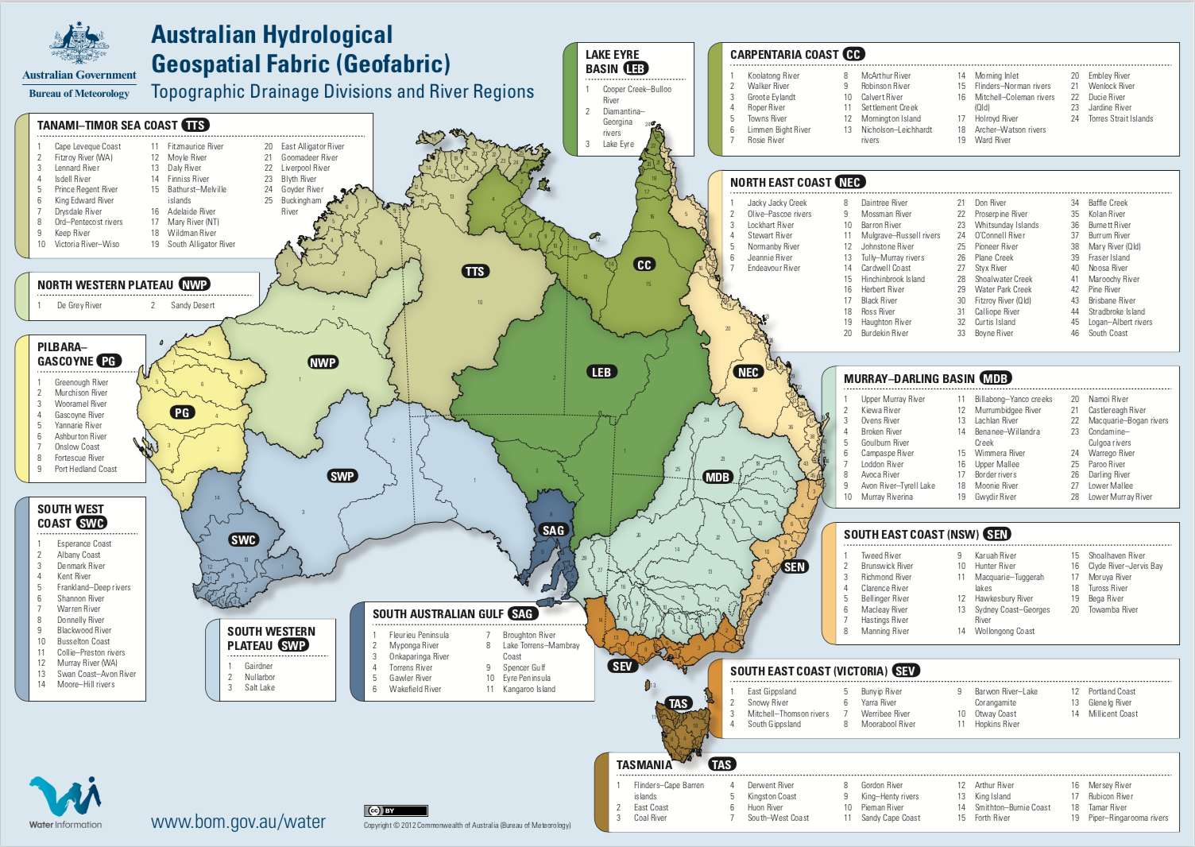

**Figure 3. BOM Topographical Draining Divisions and River Regions**

#### Strengthening the Agreement

As conditions change, there is a need to strengthen the structures of the Agreement to allow it to operate effectively. While the structures in place are sound, the following areas for improvements could be examined:

* improved connections between decision makers, communities, industry and scientists
* maintenance of shared memories about water and related natural resource conditions and trends
* increased analysis of data gathered
* overcoming the challenges of remoteness in such a large Basin
* increased Aboriginal engagement, including Aboriginal engagement forums and the development of the ‘Aboriginal Way’ Map
* strong collaboration between the Scientific Advisory Panel and the Community Advisory Committee, as well as broader community groups, natural resource management boards and scientific expertise
* increase the capacity of the Community Advisory Committee to engage with the communities and groups that they represent, to ensure its members can effectively balance the broad range of interests across the Lake Eyre Basin
* enhance industry engagement (particularly from the resources sector) on the Community Advisory Committee
* consider the most appropriate ways for the Community Advisory Committee and Scientific Advisory Panel to engage Ministers and Senior Officers Group in a proactive way, aligned with a clear forward work agenda and budget
* ensure outcomes from Ministerial Forum and Senior Officers Group meetings are shared in a timely way
* share the outputs of monitoring and assessment activities more broadly to maximise the practical benefits of this research.

This Review acknowledges the inherent difficulties and legal complications in amending a legislative document. Amendment of the Agreement itself may not be necessary to develop stronger and more transparent governance structures within the Agreement’s operation. Subsidiary legislation in the form of Rules, Regulations or Codes are alternative methods of adding to the operation of the Agreement, formalising already existing procedures and committees.

#### Whole-of-Basin approach

##### Connecting water and related natural resource management

The health of the Basin’s water resources is directly linked to the effectiveness of related natural resource management. The draft State of the Basin Report (2016) found that the river systems within the Basin are in relatively good condition. Many of the potential threats and pressures to Basin water resources occur in the broader landscape, for example the impact of terrestrial invasive species, climate change, mining and petroleum activities and other activities that affect natural flow and water quality.

Stakeholders often consider the whole landscape, rather than the area defined by the scope of the Agreement. However, the Agreement is focused on the cross-border management of water and related natural resources. Therefore, it is important for state and territory based natural resource management activities to be aligned with shared principles for the management of the Lake Eyre Basin, rather than managing all elements of the landscape under the guise of the Agreement.

Measured indicators of the biophysical, social and economic health of the Basin can provide a defined way of aligning the management of related natural resources, without skewing the purpose of the Agreement. These indicators can be used as triggers for escalating threats and opportunities to decision makers for an appropriate management response. Indicators would be based on whole-of-Basin modelling, providing the evidence to assess the ongoing health of the system. Given the challenge of monitoring in remote and sometimes inaccessible areas, it is important to choose indicators that provide a reasonable picture of the Basin at the sub-catchment level.

##### Integration of surface and ground water management

Good integrated water management practice brings together the management of ground and surface water resources, as well as related natural resources, to maximise environmental, social and economic outcomes. The Agreement focuses on avoiding and eliminating cross-border impacts on water and related resources in the Basin, which in practice means consideration of surface water only. Therefore, it makes sense to examine the feasibility and benefits of bringing the Lake Eyre Basin and Great Artesian Basin governance, stakeholder engagement and monitoring activities together, to certify that surface and groundwater in the same geographical areas are managed consistently. Numerous Lake Eyre Basin stakeholders highlighted the benefits of collaborative use of surface water and groundwater.

The natural environment is a significant user of both surface water and groundwater, while industry and community both primarily use groundwater. Water managers will need further information on surface water and groundwater interactions, the demands from social and environmental users of surface water throughout the Basin and the economic value of the surface water. Further investigation into these issues would provide state and territory governments with information they can feed into the cross-border discussions enabled by the Agreement and their decision-making processes. As outlined in the Purpose of the Agreement, this would potentially inform any Policies or Strategies discussed by the Ministerial Forum.

Table 1 shows a commonality in approach between the Lake Eyre Basin and Great Artesian Basin governance and management. The common instruments demonstrate how the management of the Great Artesian Basin and Lake Eyre Basin align and where starting points for joint management would lie. An examination of the benefits of integrating some Lake Eyre Basin and Great Artesian Basin arrangements would focus on streamlining and adding value to existing processes (such as reducing costs, enhancing community representation and further aligning with the NWI) rather than applying additional institutional frameworks. An in-depth analysis of the costs would also need to be conducted. An analysis of conjunctive water management would align with the NWI Objective 23x): “recognition of the connectivity between surface and groundwater resources and connected systems managed as a single resource”.

Ideally, the approach would harness the most effective elements of each current approach and combine these in practice initially, and amending legal instruments over time. Senior Officers and Ministers would need to assess the potential legal and constitutional risks of this approach.

|  |  |  |
| --- | --- | --- |
| Lake Eyre Basin |  | Great Artesian Basin |
| Intergovernmental Agreement | *Coordinating Instrument* | **Strategic Management Plan** |
| Lake Eyre Basin Ministerial Forum established under the Agreement | *Ministerial Engagement* | **Originally considered as part of Ministerial Committees under COAG framework with mandate for natural resource, environment and water issues.** |
| Lake Eyre Basin Senior Officers Group established under the Agreement | *Government Engagement* | **Senior Officers committee established in 2014** |
| Lake Eyre Basin Community Advisory Committee established | *Community Engagement* | **Coordinating committee established in 2004** |
| Lake Eyre Basin Scientific Advisory Panel | *Scientific and technical advice* | **Technical working group (now CW)** |

Table 1. Institutional instruments of the Lake Eyre Basin Intergovernmental Agreement and the Great Artesian Basin Strategic Management Plan

Recommendations

1. Investigate the connections between the Lake Eyre Basin surface water and the Great Artesian Basin groundwater to assess whether there is need for joint management in the future.
2. Investigate the options amending the Agreement to include outlining the operation of the Scientific Advisory Panel and the Community Advisory Committee, or developing a Regulation to the Agreement to this effect.
3. Create a sub-committee derived from the Scientific Advisory Panel and Community Advisory Committee to advise on any climate change impacts.
4. Assess current and future water demands across the Basin from development, agriculture and other industry.
5. Assess whether current boundaries of the Lake Eyre Basin Intergovernmental Agreement are still suitable for management of the water resources of the Lake Eyre Basin and if changes are made, whether new parties should be invited to join the Agreement such as New South Wales.
6. Using the Lake Eyre Vision and Strategic Adaptive Management Framework, investigate utility of developing a strategic planning framework to encompass a coordinated basin wide approach for management of the Basin.
7. Revise the roles and responsibilities of the Community Advisory Committee and Scientific Advisory Panel to reflect the role they would take in developing Key Performance Indicators and whole-of-Basin management.

## 2.6 Alignment of the Agreement with National Water Initiative principles and learnings from Strategic Adaptive Management

The Agreement exists within the existing water policy reform environment in Australia and practices adaptive management. In this section, we briefly review that policy environment and comment on how an adaptive management process can be extended into a more rigorous planning process than currently exists.

#### Strategic Planning

Since the Agreement was established, there has been a substantial extension of shared knowledge of Basin hydrological and ecological functioning, stakeholder engagement and trust in the operation of the Agreement. The Agreement has been effective in embedding stakeholder consultation and ongoing engagement in the operation of the Agreement, including some communication and independent advice to Senior Officers and Ministers. This capacity building has been a worthwhile investment by governments, communities, industry and scientists, at a relatively low cost.

In 2010 the Scientific Advisory Panel adopted a Strategic Adaptive Management Framework as a new shared approach to the Lake Eyre Basin Rivers Assessment. This was based on the key principles:

* the long-term nature of the Lake Eyre Basin Rivers Assessment (requiring reporting every 10 years)
* the conviction that monitoring should lead to real management decision
* the clear need to partner with key stakeholders.

This Framework was endorsed in 2010 by the Ministerial Forum as a tool for approaching the Lake Eyre Basin Rivers Assessment. The ’Lake Eyre Vision’ which describes the Lake Eyre Basin as ‘Australia’s unique, natural desert river system; Healthy environments, sustainable industries, vibrant communities, adaptive cultures’ has been a guiding platform to carrying out the Lake Eyre Basin Rivers Assessment within the Framework.

Expanding the scope of this approach to more effectively manage and implement integrated water resource management would allow for the measurement of KPIs. These KPIs would focus on the cultural, economic, hydrological and ecological conditions which would be used as triggers for management intervention.

This strategic planning for the Basin can safeguard the purpose and objectives of the Agreement by:

* defining the desired medium term (10 to 30 years) outlook for the Basin
* supporting a common set of outcomes for decision makers, communities, industry and scientists to work towards, at different scales and across disciplines
* guiding the development of policies, strategies and actions under the Agreement
* identifying triggers for management interventions.

#### Application to the Agreement

Strategic planning would improve the Agreement’s mechanism for collaborative future planning interventions by flagging where and when action is required. The Senior Officers Group, Community Advisory Committee and Scientific Advisory Panel are well placed to work together in a strategic process, as was demonstrated by the development of the Strategic Adaptive Management Framework, to identify future water resources management options for the Basin. This process would involve further community, scientific and industry engagement as required. It would also support the guiding principles of the Agreement (Part III), which are intended to inform all decisions made under the Agreement.

The Agreement is well situated to use strategic planning as a process to bring about changes as cross-border issues arise, using the information in the indicators of Lake Eyre Basin conditions. Escalation of emerging critical issues would be based on likely changes to indicators of the Lake Eyre Basin’s key cultural, economic, hydrological and ecological conditions resulting from threatening processes. This information is usually included in Environmental Impact Statements, which are required as part of state and territory government mining or petroleum/gas project approval processes. The Community Advisory Committee and Scientific Advisory Panel would need to access these assessments to consider how new development projects could impact on the cross-border health of the Basin, and participate in public consultation sessions where suitable.

#### National Water Initiative principles

Through consultation with Basin stakeholders, the Review found little evidence to suggest the NWI principles are well understood by the stakeholders.

##### Overall alignment

The NWI is the blueprint for water reform within Australia. It aims to increase the efficiency of the country’s water use, particularly in over allocated or stressed water systems, and implements the national water reform agenda. Under the NWI, governments across Australia have agreed actions to create a cohesive national approach to the way water is managed sustainably as well as priced and traded. Perspectives vary widely on the benefits of aligning the Agreement to the NWI. Outside of government, most stakeholders are unclear on the role of the NWI and its relevance to the Basin.

The overarching guiding principles for the NWI are to:

* Ensure transparency
* Ensure sustainability, both environmentally and fiscally
* Maximise efficiency
* Establish partnerships and knowledge sharing
* Create a clear and nationally compatible water market system.

Note that the Agreement only aligns with the NWI in certain respects. Table 2 below provides an overview of the ways the Agreement aligns with the NWI Guiding Principles.

|  |  |
| --- | --- |
| National Water Initiative Guiding Principle | Alignment with Lake Eyre Basin Intergovernmental Agreement |
| 1. Ensure sustainability, both environmentally and fiscally | **Purpose:**  2.1 “The purpose of this Agreement is … avoid or eliminate so far as reasonably practicable adverse cross-border impacts.” Avoiding adverse cross-border impacts which negatively impact the Basin is aligned with the sustainability element of the NWI.  **Guiding Principles:**  d. “that the water requirements for ecological processes, biodiversity and ecologically significant areas be maintained, especially by means of flow variability and seasonality” Prioritising the environmental need for water aligns with the sustainability guiding principle in the NWI.  f. “that the storage and use of water both within and away from watercourses, and the storage and use of water from associated ground water, are all linked and should be considered together … should be managed on an integrated basis” Integrated consideration of water resources in the Agreement area ensures decisions can be made considering a coordinated basin approach, allowing for sustainability throughout the catchment.  g. “that precautionary approaches need to be taken….” Precautionary approaches define current sustainable development practices, thus aligning with the NWI.  h. “… decisions need to be made within the context of the National Strategy for Ecologically Sustainable Development…” Framing natural resource management decisions within a national strategy for sustainable development aligns with the sustainability element of the NWI. |
| 1. Establish partnerships and knowledge sharing | **Objectives**:  c. “to establish institutional arrangements …” Embedding institutional arrangements within the Agreement provides a clear way to establish partnerships as per the NWI.  f. “…. a cooperative approach between community, industry and other stakeholders, and all levels of government in the sustainable management ….” This objective clearly emphasises relationship building between stakeholders, aligning with the NWI.    g. to encourage, promote and support water and related resource management practices which are compatible with the spirit and intent of the Agreement  j. “to raise general public awareness of the special biodiversity and heritage values of the Lake Eyre Basin Agreement Area.” This objective speaks to broader knowledge sharing of the Basin within the community, as per the NWI.  **Guiding Principles:**  j. “that decisions need to be based on the best available scientific and technical information together with the collective local knowledge and experience of communities within the Lake Eyre Basin Agreement Area.” This guiding principle clearly states the need for information to be gathered, aligning with the knowledge sharing element of the NWI.  **Part V – Community Advice and Representation 5.9 – 5.13**  Outlines how community advice can be attained, aligned with the knowledge sharing element of the NWI.  **Part VII – Scientific and Technical Advice 7.1 – 7.2**  Outlines how scientific and technical advice can be attained, aligned with the knowledge sharing element of the NWI. |

**Table 2. Alignment of Agreement with NWI Principles**

Three Objectives from the Agreement (See Box A) all provide further avenues for cross-border interaction that the NWI does not specifically encapsulate, allowing for discussions on the management and implementation of policies in the Lake Eyre Basin within a relevant context. It also allows for discussion on ‘related natural resources’.

* **Objective A:** to provide a means for the Parties to come together in good faith to achieve the purposes of the Agreement.
* **Objective B:** to define a process and context for raising and addressing water and related natural resource management issues in the Lake Eyre Basin Agreement Area that have cross-border impacts, particularly those related to water quantity and flow regimes.
* **Objective D:** to provide for each of the Parties, so far as they are able within their respective jurisdictions, to progress the implementation of Policies and Strategies developed or adopted under this Agreement and to make management decisions and allocate resources accordingly.

**Box A. Objectives from Agreement that further cross-border communication.**

The NWI and the Agreement both highlight the need for community engagement and feedback, and the need for technical capacity building. Both documents contain guiding principles for implementation, and reference groundwater as an important element in managing water at the national (NWI) level, and intra-basin management (the Agreement).

The NWI provides a risk assessment framework to assist decision makers, and principles for water plans, regulatory approvals, and trading rules. These are elements of the NWI that the Agreement can draw on to develop accountability for its own decision making processes.

The Agreement lacks its own specific outline of funding and reporting arrangements, which are an integral element to transparent governance. Whilst there is a definitive description for the implementation of the Ministerial Forum, it does not describe the operation of the Community Advisory Committee or the Scientific Advisory Panel. The Agreement could be amended to reflect the structure of the NWI around forward planning, a future vision and budgetary arrangements (including reporting guidelines).

Whilst the Agreement could continue to operate effectively without amendments, best practice would require alignment of regional water management with national policies. As discussed above, the management and implementation of the Agreement functions adequately in its current state. This is in part due to the strong relationships between stakeholders in the area, and the retention of corporate knowledge that is not currently embedded in the Agreement.

During initial stakeholder consultation numerous stakeholders struggled to see the application of the NWI in the Basin.

The NWI is also valued as a means to establish water markets and trading in regulated and developed water basins in Australia by some stakeholders. Given the current low level of development in the Lake Eyre Basin, some see the opportunity to explore how water markets and trading could be applied to this catchment, without the pressure of imminent new developments. The Review however considers this to be a low priority, and suggests it should be considered by the Senior Officers Group at a later time.

Conversely, the NWI principles may be very difficult to apply in a highly episodic, largely unconstrained system like the Lake Eyre Basin, where a regulated water market may not be sustainable. The Lake Eyre Basin may have large flows in some parts due to high runoff but it would be very difficult to transfer these flows across to other areas due to the costs of required infrastructure.

Recommendation

1. Expand amendments to Agreement or Regulations to the Agreement to incorporate clearer accountability frameworks and decision making processes

## 2.7 Frequency of Analysis of Lake Eyre Basin Rivers Assessment data

#### Assessment in a challenging environment

The Lake Eyre Basin Rivers Assessment is a program that was designed with input from the Scientific Advisory Panel to collect data to inform the State of the Basin Condition Assessment. The Agreement stipulates that an assessment of the condition of all watercourses and catchments be completed every ten years within the Lake Eyre Basin Agreement Area.

The nature of the Lake Eyre Basin is episodic, characterised by very high flows contrasted with very low flows. Methodologies used elsewhere in Australia and more globally for assessing rivers and catchments are of limited utility when examining irregular watercourses of a large internal Basin which spans numerous jurisdictions. Therefore, the challenges of creating a rigorous monitoring system are manifold.

#### Establishing an evidence-based approach to inform decision making

There is value in the examining a framework by which resources assessment, research and monitoring needs to be more closely linked. One option is to establish an evidence-based approach which can show how different policies lead to outcomes, reflected in indicators which in turn can be used to reform policy and improve management.

Stakeholders interviewed in this review were generally supportive of this approach and suggested:

* A process be developed that links existing monitoring, using indicators, to the work of NRM bodies in the Basin. These bodies could play a bigger role in monitoring and measuring as well as streamlining a consistent approach across the Basin. The Review notes this already occurs in some states.
* The remoteness of the Basin and the evolving depth of scientific data at the sub-catchment level means its health must be assessed according to imperfect and incomplete information. Despite this, decision makers must be able to identify and assess ‘weak signals’, which indicate symptoms of a future major negative change or trend.
* A risk based, precautionary approach to managing threats and pressures as an efficient and effective way to maintain the Basin’s current good health. This approach uses planning, policy and management activities to reduce the consequence and/or likelihood of particular risks to Basin health, while balancing social and economic drivers for sustainable development. It should also align with community expectations about risks to the Basin. The risk framework should also align with a broader shared vision for the Basin.

Recommendation

1. Increase the frequency of the analysis informed by monitoring programs (such as the Lake Eyre Basin Rivers Assessment) based on advice from Scientific Advisory Panel.

## 2.8 Frequency of future review points for the Agreement

The value of the current Agreement review process is that it identifies areas that require updating, areas where the Agreement may be operating beyond its original scope and objectives, evaluates the efficacy of the Agreement in its current state, and identifies opportunities for improvements and responses as conditions and context progress.

There are real opportunities to trigger change for the good. For a relatively small investment by Australian governments in the Basin, this Review has shown that there have been significant gains. Stakeholder feedback indicated that the review process is valuable, however there was no consensus as to whether the current 10 year cycle was the best solution. The real issue for many was not the frequency, rather that governments heed the results of the review and take action.

There is no current identified need for a more frequent review cycle, and any change should have well costed justifications and efficiency improvements. Other Intergovernmental Agreements, such as the Intergovernmental Agreement on the Environment, and the Intergovernmental Agreement on Commercial Vessel Safety Reform have more frequent review cycles, but there was no identified need in the process up to date for more frequent reviews for the Lake Eyre Basin Intergovernmental Agreement. The Review should continue to be undertaken every ten years to ensure that it is still serving its original purpose.

Recommendation

1. Maintain a 10 year review cycle of the Intergovernmental Agreement.

# 3. Conclusion

* The Review provides a timely opportunity for a fresh look at cross-border water resource management in the Lake Eyre Basin.
* A shared vision of future natural resources management for the Lake Eyre Basin could define the desired medium term (10 to 30 years) outlook for the Basin.

The success of the Agreement to date has been driven by the passion and hard work of communities, natural resource management bodies, scientists and environmental groups, which supports the effective and collegiate work of the Community Advisory Committee, Scientific Advisory Panel, and Senior Officers Group. While there are opportunities to improve connections across stakeholders and Agreement bodies, this is an enviable basis for developing a shared vision and integrated water management approach for the Basin.

The current good condition and low level of imminent economic development in the Basin could risk a shift in attention towards more urgent water management priorities. However, the Agreement does not need to become a higher priority for decision makers if the Basin can be effectively and proactively managed, based on a shared vision and a risk based approach to managing threats and pressures in the Basin.

The effectiveness of this Review depends on the breadth of ideas, opinions, stories and analysis that can be gathered about the efficacy of the Agreement, particularly from communities, landholders, traditional owners and scientists in the Basin. Wherever possible, the findings of the Review need to be supported by key examples that demonstrate the benefits or shortcomings of the Agreement.

# Appendices

## Appendix A

**Map of the Lake Eyre Basin showing major river catchments, wetlands and settlements**

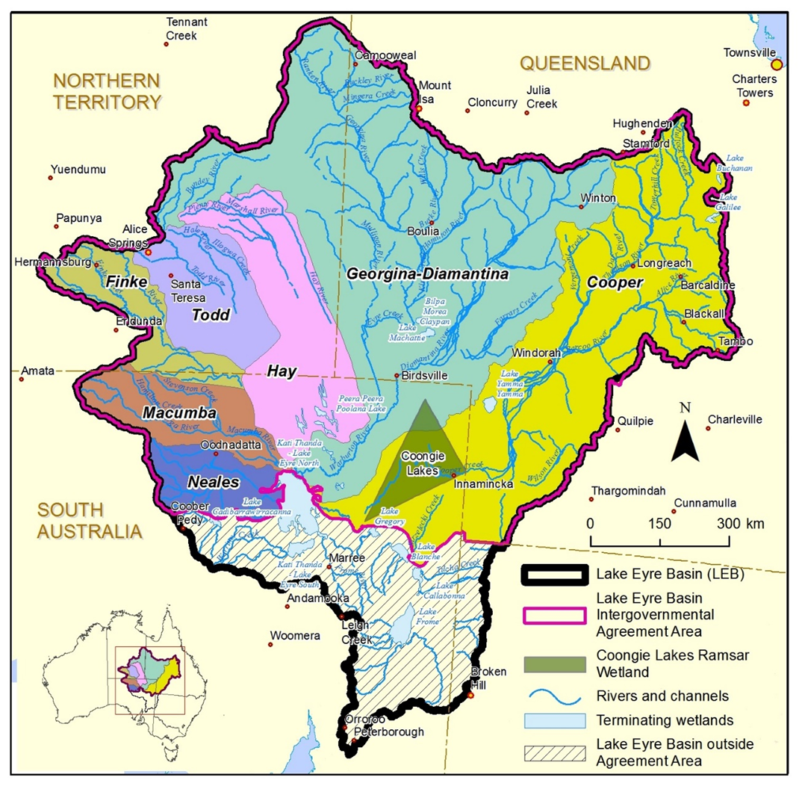

## Appendix B

**Terms of reference for the Review**

1. The purpose of the Lake Eyre Basin Intergovernmental Agreement is to provide for the development or adoption, and implementation of Polices and Strategies concerning water and related natural resources in the Lake Eyre Basin Agreement Area to avoid or eliminate so far as reasonably practicable adverse cross-border impacts.
2. The Government is committed to ongoing water reform including the implementation of the Lake Eyre Basin Intergovernmental Agreement and the National Water Initiative principles.
3. The first Review of the Intergovernmental Agreement (the Review) was produced in 2007. The second Review is required by 2017 to establish the relevance of the Agreement in addressing the current threats and pressures within the Basin through its Polices and Strategies as set out in Part VIII – Policies and Strategies and its Objectives as set out in Clause 2.2.
4. The Review will be undertaken in consultation with the relevant state and territory governments and stakeholders.

**Purpose**

1. The purpose of the Review is to report on the extent:
2. the purpose of the Agreement has been achieved
3. the objectives set out in Clause 2.2 of the Lake Eyre Basin Intergovernmental Agreement have been achieved
4. the current Agreement efficiently addresses the current threats and pressures within the Lake Eyre Basin
5. the activities of government adequately manage the threats and pressures within the Lake Eyre Basin.

**Objectives**

1. The objectives of the Review will be to report on:
2. The operation of the Lake Eyre Basin Intergovernmental Agreement
3. The efficacy of the current Polices and Strategies as outlined within Part V111 of the Agreement
4. The extent to which the Purpose and Objectives as set out in Part II of the Agreement have been achieved
5. The changes that are needed to the Lake Eyre Basin Agreement to account for changed circumstances since 2007
6. The frequency for which analysis of Lake Eyre Basin Rivers Assessment data should be conducted.
7. The current objectives of the Lake Eyre Basin Intergovernmental Agreement, as outlined within Part II of the Agreement, are:
8. to provide a means for the Parties to come together in good faith to achieve the purposes of the Agreement
9. to define a process and context for raising and addressing water and related natural resource management issues in the Lake Eyre Basin Agreement Area
10. the special biodiversity and heritage values that have cross-border impacts, particularly those related to water quantity and quality, and flow regimes
11. to establish institutional arrangements for the development or adoption of Policies and Strategies and for the adoption of any relevant management plans established by a state
12. to provide for each of the Parties, so far as they are able within their respective jurisdictions, to progress the implementation of Policies and Strategies developed or adopted under this Agreement and to make management decisions and allocate resources accordingly
13. to provide a mechanism to review Policies and Strategies
14. to provide for the Parties to jointly promote and support the management of water and related natural resources through a cooperative approach between community, industry and other stakeholders, and all levels of government in the sustainable management of the Lake Eyre Basin Agreement Area
15. to encourage, promote and support water and related resource management practices which are compatible with the spirit and intent of the Agreement
16. to encourage and promote research and monitoring to improve understanding and support informed decision making in the Lake Eyre Basin Agreement Area
17. to provide for the review and, if necessary, revision of the Agreement from time to time
18. to raise general public awareness of the Lake Eyre Basin Agreement Area.
19. The 2016/17 review will also report on:
20. the extent the Agreement aligns with National Water Initiative principles
21. the changes that are required to improve the overall effectiveness of the Agreement
22. The learnings from the implementation of the Strategic Adaptive Management (SAM) approach that are relevant to long term management of the Lake Eyre Basin
23. the appropriate future review points for the Lake Eyre Basin Intergovernmental Agreement.

## Appendix C

**Stakeholder interviews**

|  |  |
| --- | --- |
| 1. Organisation | Name and Position Title |
| Australian Government Department of Agriculture and Water Resources | Richard McLoughlin  *Assistant Secretary, Water Resources Branch*  *Chair of the Lake Eyre Basin Senior Officers Group*  Christopher Biesaga  *Director, Great Artesian Basin and Lake Eyre Basin Section* |
| Queensland Department of Natural Resources and Mines | Darren Moor  *QLD member – Lake Eyre Basin Senior Officers Group* |
| South Australia Department of Environment, Water and Natural Resources | Chris Morony  *SA member – Lake Eyre Basin Senior Officers Group* |
| Northern Territory Department of Environment and Natural Resources | Simon Cruikshank  *NT member – Lake Eyre Basin Senior Officers Group* |
| Lake Eyre Basin Community Advisory Committee | Andrew Drysdale  *Chair* |
| Lake Eyre Basin Scientific Advisory Panel | Steven Morton  *Chair* |
| South Australia Arid Lands Natural Resources Management Board | Janet Brook  *Chair* |
| Desert Channels Queensland | Alun Hoggett  *Digital Producer/Project Manager* |
| Australian Government Office of Water Science | Matthew Dadswell  *Assistant Secretary – Department of Environment and Energy* |
| Geoscience Australia | Baskaran Sundaram  *Director, Regional Groundwater Section* |
| Tourism Australia | Tim Mahony  *General Manager – Government* |
| Minerals Council of Australia  Australian Petroleum Production and Exploration Association | Chris McCombe  *Senior Advisor – Environment*  Matthew Paull  *Policy Director* |
| Australian Conservation Foundation | James Trezise  *Acting Healthy Ecosystems Program Manager* |

## Appendix D

**Events in Cooper Basin irrigation development proposals and responses**

|  |  |
| --- | --- |
| Year | Event |
| 1995 | Proposal for a 3,000ha irrigated cotton development on *Currareva* station with a 42,000 ML annual extraction from the Cooper Creek system.  Lake Eyre Basin Steering Group formed – comprising pastoralists, conservationists, Aboriginal people, local government people, mining and petroleum interests and government agencies. |
| 1996 | Widespread local and national opposition to the development occurs including a workshop in Windorah attended by the local community, the Australian Conservation Foundation and members of the Australian ecological science community jointly recommends that Queensland Government stop irrigation development or other large scale water extraction from the Cooper and other rivers of the Lake Eyre Basin in Queensland; later endorsed by Fifth International Ecological Congress in Perth, Western Australia. |
| 1997 | Lake Eyre Basin Government Heads of Agreement formed and provided for the development of a formal Intergovernmental Agreement. |
| 1998 | Queensland Government introduces a Draft Water Management Plan proposing an extra 22,500 ML of water harvesting irrigation entitlement for the system, specifically in the upstream tributary catchments of the Thomson and Barcoo rivers |
| 1998 | Queensland State election with incoming Labor Minister for Natural Resources rejects the previous Government's draft plan and issues a new plan prohibiting irrigation development |
| 2000 | 1998 plan takes effect; 10 year reviews allow for reconsideration of irrigation development with large "sleeper" license entitlements for the *Currareva* and *Hammond Downs* properties near Windorah, totaling 10000 ML of allocation which can be activated under the National Water Initiative. |
| 2000 | Lake Eyre Basin Agreement signed by Ministers of the Australian, Queensland and South Australian governments in October and which currently applies to:  the Cooper Creek system (including the Thomson and Barcoo Rivers);  the Georgina and Diamantina River systems within Queensland and South Australia, ending at Lake Eyre; and the Northern Territory portion of the Basin. |
| 2001 | Wild Rivers declaration reviews in Queensland. 4th Aboriginal Forum attended by 40 Aboriginal participants and 35 non Aboriginal invitees (scientists, historians, government and NGOs) leads to the Tibooburra Declaration which endorses wild river declarations for the Cooper and Georgina Diamantina Rivers. |
| 2004 | Northern Territory Government signs the Agreement. |
| 2007 | Review of the Lake Eyre Basin Intergovernmental Agreement. Little analysis of the degree to which large scale irrigation proposals are addressed by the Agreement. |
| 2011 | Queensland Government enacts its Water Resource (Cooper Creek) Plan by specifying rules for sustainably managing surface water resources in the plan area. |
| 2013 | Queensland Government enacts the Cooper Creek Resource Operations Plan (November) to implement the Water Resource (Cooper Creek) Plan 2011. |
| 2017 | Review of the Lake Eyre Basin Intergovernmental Agreement (this document) |

Noetic Group

Locked Bag 3001  
Deakin West ACT 2600 Australia

Phone +61 2 6234 7777  
Fax +61 2 6232 6515  
**www.noeticgroup.com**