Heads of Agreement

AN AGREEMENT SUPPORTING THE

VICTORIAN FOOD-BOWL MODERNISATION PROJECT

Outcomes for sustainable irrigation, communities and the environment

The Commonwealth and Victorian Governments are committed to implementing rural water infrastructure projects and water reforms in the Murray Darling Basin which deliver the following outcomes:
- a healthy, working river system in the Murray Darling Basin;
- sustainable food production; and
- strong regional communities
- The largest rural water infrastructure project being funded under the Australian Government’s Water for the Future initiative is Stage 2 of the Northern Victorian Irrigation Renewal Project (NVIRP2). In November 2010, the project was approved by the Australian Government for funding of $953 million, following due diligence assessment of the Victorian business case for the project.
- NVIRP2 has already been assessed as providing water savings of at least 204GL (long term cap equivalent (LTCE)) through modernisation of the irrigation delivery systems and connections in northern Victoria. The project will remove stranded assets, reduce inefficient system losses and provide the improved service levels required by modern on-farm irrigation technology.
- The commitments set out in this Heads of Agreement, implemented together, are intended to support the final Basin Plan and reflect the Parties desire to move to a more outcomes based approach to infrastructure project funding and implementation.
- The commitments will provide a more secure footing for the irrigated agriculture industry and the associated communities in northern Victoria, facilitate the adjustment of the irrigation sector to a future with less water, and build a more resilient sector capable of using water more efficiently and competing on world food markets by:
  - providing irrigators across northern Victoria with the service levels needed to invest in modern, efficient on-farm irrigation technology;
  - providing the certainty necessary for the private investment in sustainable irrigated foods production;
  - increasing the amount of water supplied to the environment from non-productive uses, thereby reducing the amount of water transferred from consumptive to environmental use;
  - reducing the risk of stranded assets; and
  - maintaining the international competitiveness of Victorian irrigators.
- The Commonwealth intends that water sale offer arrangements will be available for Basin State Governments. A schema for how such transactions are intended to work is at Annex A.
- This document sets out the key elements of an agreement associated with a new Victorian Food-Bowl Modernisation Project (VFMP). The VFMP will include:
  - A revised project structure for NVIRP2 which will, by mutual agreement of the Australian and Victorian Governments, be changed to streamline delivery of the project, underpinned by an outcomes-based delivery framework;
  - A commitment of Australian Government funding of $43.7 million (the remainder from the original $1 billion commitment to NVIRP2), for a project re-scoped under the Water Management Partnership Agreement supporting on-farm irrigation modernisation integrated with the roll-out of NVIRP2. This project will yield 10 GL (LTCE) of additional water savings to be transferred, from individual irrigators participating in the project, as water shares to the Commonwealth.
The parties will make every effort to complete a contractual schedule for this project within 20 business days of the signing of this Agreement;
  - A sale offer of 102 GL (LTCE) of water shares by the Victorian Government to the Commonwealth. This water is to be progressively sourced from the NVIRP2 project based on the changed distribution of water savings as per clause 9(b) below;
  - Victoria creating an exemption to allow approval without delay of water trades as set out in item 18 of this Agreement;
  - Victoria continuing to work cooperatively with the Commonwealth Environmental Water Holder to facilitate arrangements for environmental water delivery, which includes the undertaking set out in item 20 of this Agreement;
  - A commitment from the Commonwealth to developing, in consultation with Victoria and other Basin States, a water recovery strategy, including water purchasing, which provides for fair burden sharing between jurisdictions, with a steady pace and proportional volume of water recovery towards meeting the Commonwealth’s ‘bridging the gap’ commitment; and
  - In the meantime, the Commonwealth will continue its water purchase program in Victoria in a way which is consistent with the intent of (f) above, providing for fair burden sharing terms of the pace and volume of water purchase in Victoria in comparison to other Basin States.
- At a later stage, and not necessarily connected with this Agreement, officials will consider options for expenditure of the up to $103 million remaining in Commonwealth funding commitment for Victorian State Priority Projects.

Elements of the VFMP

Agreed change to NVIRP2
- The NVIRP Stage 2 project will proceed as previously approved, with Commonwealth funding of $953m and 102GL of water savings transferred to the Commonwealth, with the following changes to the project structure:
  - The project schedule under the relevant Water Management Partnership Agreement is to be streamlined to provide for annual payments and delivery of water shares and other project outcomes as outlined in the project schedule.
  - The Victorian Government has proposed that the 50% share of water savings previously intended to be shared amongst irrigators in the Goulburn Murray Irrigation District (the ‘second 50% share’) will be retained by the Victorian Government and sold and, in return, irrigators will not be levied with increased water charges to fund Victoria’s $106 million contribution to NVIRP2.
  - Victoria takes full public responsibility for the change to water saving sharing arrangements for NVIRP2 on the basis that it has secured the support of the Victorian irrigation community. In that context, the Commonwealth takes note of the letter from Minister Walsh at Annex B.
- On this basis, the Commonwealth agrees to the water sharing arrangements for NVIRP2 being changed from those which were proposed in the Business Case for the Project and assessed in due diligence.

Standing Invitation for Water Sale Offer
- The Commonwealth has received and considered an offer from Victoria to sell to the Commonwealth the ‘second 50%’ water realised by the restructuring of NVIRP2, as Victorian high and low reliability water shares amounting to 102 GL LTCE at a total cost of $219,221,000 (Annexe C). The Commonwealth has accepted this offer (Annexe D) on the following basis:
  - Any such transaction will be separate and distinct from the conduct of the NVIRP2 State Priority Project, and would form part of the Commonwealth water purchase program;
  - The water shares transferred will be unencumbered, tradeable and sourced from the consumptive pool;
  - The type, trading zone and volume of the transferred water shares, the factors used to convert from LTCE and the terms of the purchase transaction, determined for the transaction as a whole, are set out in Annexe D;
  - The timing, volume, reliability and character of the water savings already agreed to be transferred under the State Priority Project (the ‘first 50%’ from NVIRP2) are not adversely affected;
  - The water from the “second 50% share” of NVIRP2 cannot be offered by way of water transfer to the Commonwealth in relation to any other water infrastructure project for which Victoria is seeking funding.
- Victoria has published the required public notices pursuant to section 33P of the Water Act 1989 (Vic) in accordance with that section.

Delivery of the On-Farm Irrigation Modernisation project
- Victoria has submitted a summary business case for an on farm water efficiency project totalling $48.5 million and yielding 10 GL (LTCE), to be integrated with the roll-out of NVIRP2. The Commonwealth commits funding of up to $43.7 million for this re-scoped project subject to a 10% co-contribution, which will come from individual irrigators participating in the project ($4.8 million). Delivery of this project will be under the Water Management Partnership Agreement, and the parties will make every effort to complete the project schedule for this project within 20 business days of the signing of this Agreement.

Delivery of the NVIRP2 project
- The Commonwealth will provide funding for the NVIRP2 project in a manner that allows appropriate cash flow for the project to be delivered. Apart from reasonable ‘start-up’ funds for this purpose, funding will be provided as annual payments on delivery of water shares and other project outcomes as outlined in the project schedule.
- Victoria will manage program delivery risks and guarantee to provide permanent water shares to the Commonwealth annually from 2012 until 2017, to meet the agreed 102 GL LTCE Commonwealth share of savings from the NVIRP2 project. The timing, high reliability/low reliability mix, and trading zones of all water savings for the project are set out in the Project Schedule for NVIRP2.
- The parties agree that Victoria will provide appropriate reporting on the project progress, water savings and other relevant outcomes. The reporting framework will be consistent with relevant provisions of the Victorian/Commonwealth Water Management Partnership Agreement.
- If long term cap equivalent factors for Victorian high and low reliability water shares are finalised by the Murray Darling Basin Authority for the purposes of the Final Murray Darling Basin Plan and they differ from those used to calculate the water shares for NVIRP2 at the time this agreement is signed, the parties will apply the new factors to calculate the water shares for NVIRP2 from that time forward.

Other Elements of this Agreement
- Victoria will create an exemption to allow for:
  - approval without delay, upon resubmission of new applications by no later than 28 February 2012, for all trades to the Commonwealth which were submitted for the July 2011 ballot and which were not approved due to the application of the 4 per cent limit (this will cover approximately 55 GL of transaction); and
  - approval without delay, upon submission by no later than 28 February 2012, for all remaining trades to the Commonwealth from water purchase tenders in 2010-11 which, when submitted for trade approval during 2011-12, would otherwise not have been approved at the time of submission due to the application of the 4 per cent limit (this will cover approximately 33GL of transactions).
- Victoria agrees to remove the 4 per cent limit on out of district trade by 30 June 2014;
- Subject to Murray-Darling Basin Authority approval of water accounting rules and acceptable third party impacts, Victoria guarantees to allow the transfer, upon request, of allocations granted to the entitlements recovered through NVIRP2, to Victoria’s environmental entitlements to enable return flows to be used multiple times and in line with entitlement conditions.
- The Commonwealth commits to:
  - developing, in consultation with Victoria and other Basin States, a water recovery strategy, including water purchasing, which provides for fair burden sharing between jurisdictions, with a steady pace and proportional volume of water recovery towards meeting the Commonwealth’s ‘bridging the gap’ commitment; and
  - in the meantime, the Commonwealth will continue its water purchase program in Victoria in a way which is consistent with the intent of (a) above, providing for fair burden sharing terms of the pace of water purchase in Victoria in comparison to other Basin States.
- This Agreement will be made publicly available on signature.

Done at ........................................ on ............................

Signed

______________________
Prime Minister of Australia

__________________________
Premier of Victoria

Annexes:
A – Framework for the Consideration of State and Territory Water Sale Offers
B – Letter from Minister Peter Walsh regarding revision of NVIRP stage 2 Package
C – Letter from Minister Peter Walsh proposing water sale offer
D – Letter from Minister Tony Burke accepting water sale offer

Annexe A

Framework for the Consideration of State and Territory Water Sale Offers
Constraints and Exclusions
When considering the purchase of state and territory Government held water entitlements a number of constraints and exclusions are to be applied as follows:

- the minimum parcel size will be twenty (20) gigalitres of entitlements;
- only offers from state and territory Governments within the Murray-Darling Basin will be considered;
- entitlements offered for sale must be permanent, unencumbered and tradeable and be capable of directly contributing to ‘bridging the gap’ to the new sustainable diversion limits under the Basin Plan;
- offers may be for entitlements immediately available for purchase or for entitlements available over a number of years; and
- there is a finite budget for the RtB program. Offers may only be pursued within the available budget for the relevant financial year(s).
Evaluation Criteria
Three criteria are used in the assessment process to determine the extent to which each sell offer represents a value for money acquisition.

1. The extent to which the entitlements offered for sale can meet unmet environmental watering needs

The findings of the Commonwealth Scientific and Industrial Research Organisation (CSIRO) Sustainable Yields Study and the Murray-Darling Basin Commission (MDBC) Sustainable Rivers Audit show that most catchments in the Murray-Darling Basin are highly developed and are in poor or very poor environmental health. Under best estimates, the volume of surface water available for the environment and for consumptive use is forecast to decline in all catchments over the period to 2030 due to climate change and other factors such as the development of farm dams.

The findings of these and other Basin wide scientific studies on water availability and ecosystem health, as well as information on the specific needs of particular environmental assets, will provide guidance on the immediate water needs of the environment and will be considered in the assessment against this criterion.

The Department is seeking to purchase water in those catchments where the best available information, including the MDBA’s draft and final Basin Plan, indicates that additional water needs to be returned to the environment. Consideration will be given to current and anticipated environmental water recovery when assessing unmet environmental needs.

2. The capacity to use water allocated to the entitlements

The Department will consider the immediate and long-term factors that affect the capacity of the Commonwealth Environmental Water Holder to use water entitlements being considered for purchase to protect and restore the environment including:

- whether the entitlement and its allocation is able to provide water where and when it is needed;
- the management arrangements and infrastructure required to deliver and use the water entitlement for environmental benefit;
- possible water losses through seepage, evaporation and extraction by other licensed water users; and
- the relevant state legislation and water sharing plan which govern the use of the water entitlement and provide security over the property right.

3. The cost of purchasing the entitlements, including the offer price, transaction costs, and future storage and delivery costs
This criterion takes into account the following considerations:
- The total price ($/megalitre) nominated by the seller.
- The price benchmark ($/megalitre) for each offered entitlement, which is set by the Department with reference to as appropriate:
- the estimated market value of the entitlement* (see note below);
- the average annual volume of water that the Commonwealth expects to receive from the entitlement into the future;
- the environmental benefits expected from the purchase of the entitlement;
- management costs including delivery costs, as well as the cost of delivering and maintaining partnership arrangements for management of the water; and
- other relevant risks.
- Transaction costs – the costs of obtaining approval for the trade and transferring ownership to the Commonwealth.
- Additional benefits which may arise from the offer.

* Market Price
Prevailing market prices are estimated with reference to market price reports prepared by independent consultants which are based on price information obtained from state registers, irrigation water provider registers, agents and brokers. If the sell offer involves the transfer of entitlements spread over several years, the long run average price of water in the market over the life of the transaction may be considered.

How to respond
In order to facilitate the receipt and timely consideration of a state/territory water sale offer, the following details should be included:

- Volume of water entitlements offered for sale, by catchment and entitlement type, by year (if applicable), please provide figures in megalitres with no rounding applied;
  - If the proposal involves the conversion of an average annual volume of water available for the environment to a parcel of water entitlements, then the proposal should also provide the factors used in that conversion.
- Asking price for parcel of water entitlements, a single asking price is all that is required if the parcel is offered as a single package with no rounding applied
- Proposed timing of water transfers and payments; and
- Statement of any strategic benefits of the water sale offer.

Annexe B
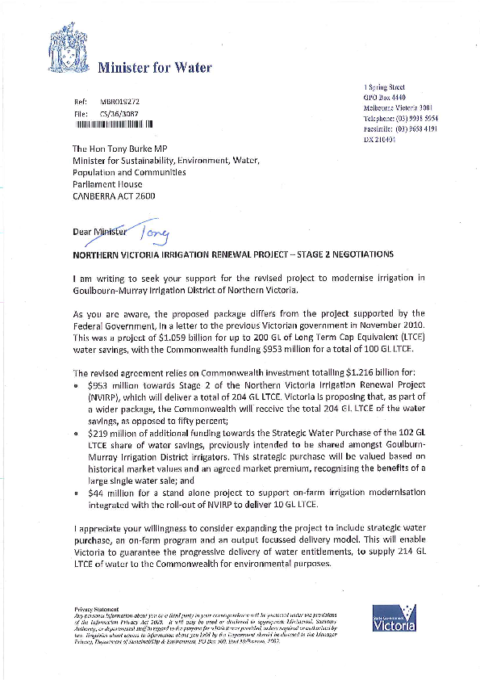
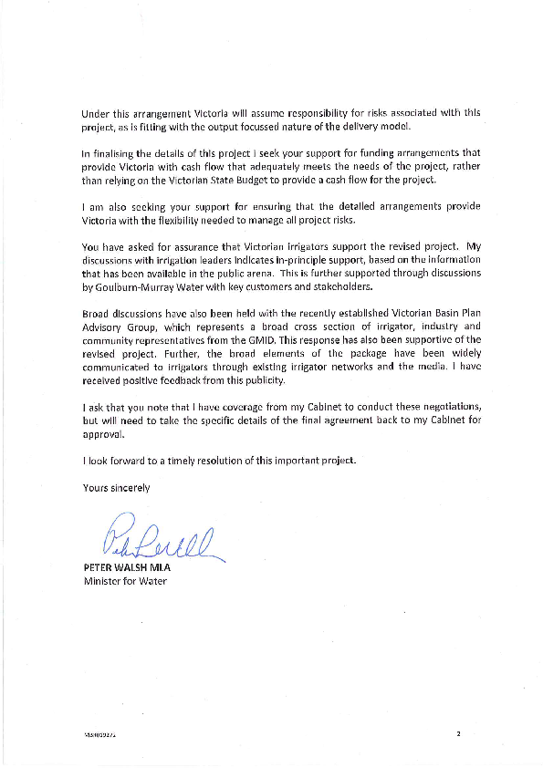

Annexe C

Annexe D

Attachment A

Table 1: Total water offered for sale (ML - LTCE)
 |  | 2011-12 | 2012-13 | 2013-14 | 2014-15 | 2015-16 | 2016-17 | 2017-18 | TOTAL
Goulburn | HRWS | 285 | 853 | 5,968 | 8,886 | 9,556 | 13,396 | 4,244 | 43,187
 | LRWS | 51 | 154 | 1,075 | 1,601 | 1,722 | 2,415 | 765 | 7,782
Murray BC | HRWS | 190 | 571 | 3,998 | 5,953 | 6,401 | 8,980 | 2,843 | 28,937
 | LRWS | 26 | 78 | 545 | 812 | 873 | 1,225 | 388 | 3,949
Murray AC | HRWS | 104 | 312 | 2,182 | 3,248 | 3,493 | 4,900 | 1,551 | 15,791
 | LRWS | 16 | 47 | 325 | 484 | 521 | 730 | 231 | 2,354
Total |  | 672 | 2,014 | 14,095 | 20,983 | 22,566 | 31,646 | 10,023 | 102,000
Payment date |  | 1-Jan-12 | 1-Jul-12 | 1-Jul-13 | 1-Jul-14 | 1-Jul-15 | 1-Jul-16 | 1-Jul-17
Payment ($'000) |  | $ 1,444 | $ 4,329 | $ 30,293 | $ 45,099 | $ 48,501 | $ 68,012 | $ 21,542 | $ 219,221
Table 2: LTCE factors
Goulburn | HRWS | 0.939
 | LRWS | 0.488
Murray BC | HRWS | 0.957
 | LRWS | 0.519
Murray AC | HRWS | 0.957
 | LRWS | 0.519
Table 3: Total water shares offered for sale, converted to water shares (ML)
 |  | LTCE (ML) | Conversion factor | Water shares (ML)
Goulburn | HRWS | 43,187 | 0.939 | 45,993
 | LRWS | 7,782 | 0.488 | 15,947
Murray BC | HRWS | 28,937 | 0.957 | 30,237
 | LRWS | 3,949 | 0.519 | 7,608
Murray AC | HRWS | 15,791 | 0.957 | 16,500
 | LRWS | 2,354 | 0.519 | 4,536
Total |  | 102,000 |  | 120,821
Table 4: Total water shares offered for sale (ML)
 |  | 2011-12 | 2012-13 | 2013-14 | 2014-15 | 2015-16 | 2016-17 | 2017-18 | TOTAL
Goulburn | HRWS | 303 | 908 | 6,356 | 9,463 | 10,177 | 14,266 | 4,520 | 45,993
 | LRWS | 105 | 315 | 2,203 | 3,280 | 3,528 | 4,949 | 1,567 | 15,947
Murray BC | HRWS | 199 | 597 | 4,178 | 6,220 | 6,689 | 9,383 | 2,971 | 30,237
 | LRWS | 50 | 150 | 1,051 | 1,565 | 1,683 | 2,361 | 748 | 7,608
Murray AC | HRWS | 109 | 326 | 2,280 | 3,394 | 3,650 | 5,120 | 1,621 | 16,500
 | LRWS | 30 | 90 | 627 | 933 | 1,003 | 1,407 | 446 | 4,536
Total |  | 796 | 2,386 | 16,695 | 24,855 | 26,730 | 37,486 | 11,873 | 120,821
Note: The volume of water shares will change if the MDBA adopts new conversion factors under the final Basin Plan,
in accordance with any agreement reached under the Heads of Agreement Supporting the VFMP.

Or equivalent concept in the Murray-Darling Basin Plan
See Footnote 1.

