# National Partnership Agreement on Implementing Water Reform in the Murray–Darling Basin

Commonwealth payments to Basin states

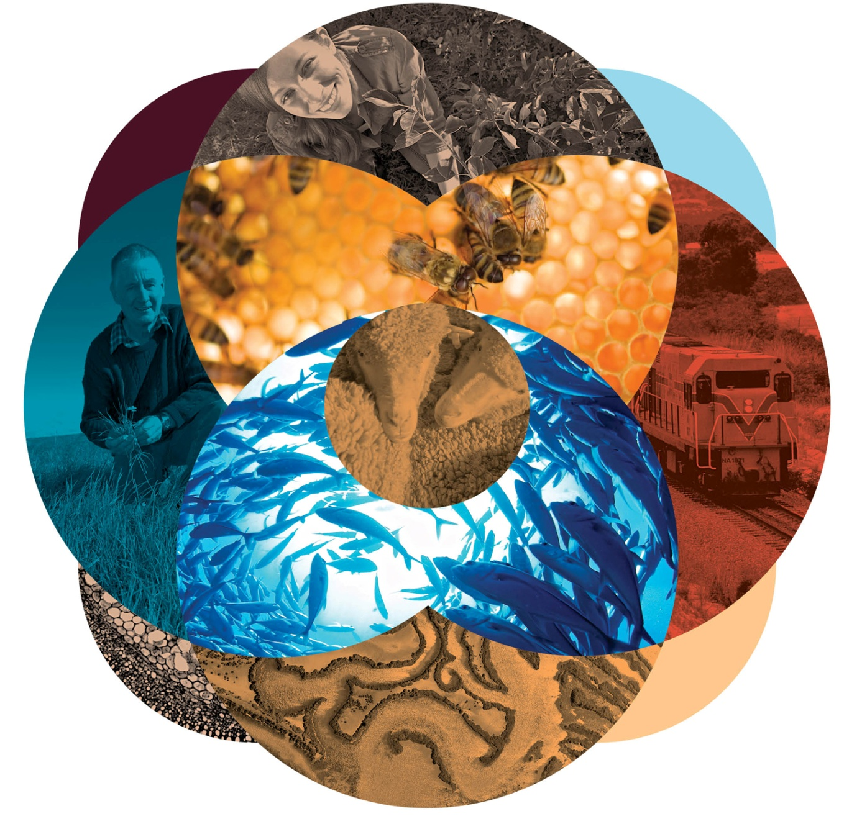

© Commonwealth of Australia 2020

**Ownership of intellectual property rights**

Unless otherwise noted, copyright (and any other intellectual property rights, if any) in this publication is owned by the Commonwealth of Australia (referred to as the Commonwealth).

**Creative Commons licence**

All material in this publication is licensed under a Creative [Commons Attribution 4.0 International Licence](https://creativecommons.org/licenses/by/4.0/legalcode) except content supplied by third parties, logos and the Commonwealth Coat of Arms.

Inquiries about the licence and any use of this document should be emailed to [copyright@agriculture.gov.au](mailto:copyright@agriculture.gov.au).

C:\Documents and Settings\west merryn\Local Settings\Temporary Internet Files\Content.Word\by.png

**Cataloguing data**

This publication (and any material sourced from it) should be attributed as:

Department of Agriculture, Water and the Environment 2020, National Partnership Agreement on Implementing Water Reform in the Murray–Darling Basin: Commonwealth payments to Basin states, Canberra, CC BY 4.0.

This publication is available at [agriculture.gov.au/water/mdb/npa-water-reform-mdb-milestone-reports](http://www.agriculture.gov.au/water/mdb/npa-water-reform-mdb-milestone-reports).

Department of Agriculture, Water and the Environment

GPO Box 858 Canberra ACT 2601

Telephone 1800 900 090

Web [awe.gov.au](http://agriculture.gov.au/)

The Australian Government acting through the Department of Agriculture, Water and the Environment has exercised due care and skill in preparing and compiling the information and data in this publication. Notwithstanding, the Department of Agriculture, Water and the Environment, its employees and advisers disclaim all liability, including liability for negligence and for any loss, damage, injury, expense or cost incurred by any person as a result of accessing, using or relying on any of the information or data in this publication to the maximum extent permitted by law.

## Commonwealth payments to Basin states

The *National Partnership Agreement on Implementing Water Reform in the Murray–Darling Basin* (NPA) provides for Commonwealth payments to the Basin states. The Commonwealth must make these payments in accordance with Schedule D – Payment arrangements of the [Intergovernmental Agreement on Federal Financial Relations](http://www.federalfinancialrelations.gov.au/content/intergovernmental_agreements.aspx). The Commonwealth's estimated financial contribution, as per Clause 28 of the NPA, is shown in Table 1.

Table 1 Estimated Commonwealth financial contributions to Basin states, 2012–13 to 2019–20

| Year | NSW ($) | Vic. ($) | Qld ($) | SA ($) | ACT ($) | Total ($) |
| --- | --- | --- | --- | --- | --- | --- |
| 2012–13 | 2,820,630 | 2,039,997 **a** | 595,452 | 445,863 **a** | 98,058 **a** | 6,000,000 |
| 2013–14 | 3,481,462 **b** | 2,861,453 **b** | 0 | 557,085 **b** | 0 | 6,900,000 |
| 11,568,609 **c** | 8,882,173 **c** | 1,339,767 | 1,838,819 **c** | 220,632 | 23,850,000 |
| 2014–15 | 14,624,291 | 11,092,169 | 1,984,841 | 2,321,837 | 326,862 | 30,350,000 |
| 2015–16 | 12,883,561 | 9,661,442 | 1,984,840 | 2,043,295 | 326,862 | 26,900,000 |
| 2016–17 | 9,402,099 | 6,799,989 | 1,984,840 | 1,486,209 | 326,863 | 20,000,000 |
| 2017–18 | 9,402,099 | 6,799,989 | 1,984,840 | 1,486,210 | 326,862 | 20,000,000 |
| 2018–19 | 9,402,099 | 6,799,989 | 1,984,840 | 1,486,210 | 326,862 | 20,000,000 |
| 2019–20 | 9,402,100 | 6,799,989 | 1,984,840 | 1,486,209 | 326,862 | 20,000,000 |
| **Total** | **82,986,950** | **61,737,190** | **13,844,260** | **13,151,737** | **2,279,863** | **174,000,000** |

**a** Victoria, South Australia and the Australian Capital Territory received their 2012–13 payment under the superseded 2013 National Partnership Agreement (see clause 7). **b** Payment in recognition of 40% of the supply measure project funding component for 2013–14 for which feasibility and business cases were prepared for consideration under the SDL adjustment mechanism. **c** Payment in recognition of Basin state implementation payment component of 2013–14 financial contribution and the remaining 60% of the business case development funding for 2013–14.

Table 2 shows actual Commonwealth payments made under the NPA.

Table 2 Actual Commonwealth financial contributions to Basin states, 2012–13 to 2019–20

| Year | NSW ($) | Vic. ($) | Qld ($) | SA ($) | ACT ($) | Total ($) |
| --- | --- | --- | --- | --- | --- | --- |
| 2012–13 | 0 | 2,039,997 **a** | 0 | 445,863 **a** | 98,058 **a** | 2,583,918 |
| 2013–14 | 3,481,462 **b** | 2,861,453 **b** | 0 | 557,085 **b** | 0 | 6,900,000 |
| 11,568,609 **c** | 8,882,173 **c** | 1,339,767 | 1,838,819 **c** | 220,632 | 23,850,000 |
| 2014–15 | 14,624,291 | 11,092,169 | 1,984,841 | 2,321,837 | 326,862 | 30,350,000 |
| 2015–16 | 12,883,561 | 9,661,442 | 1,984,840 | 2,043,295 | 326,862 | 26,900,000 |
| 2016–17 | 9,402,099 | 6,799,989 | 1,984,840 | 1,486,209 | 326,863 | 20,000,000 |
| 2017–18 | 0 **d** | 6,799,989 | 1,984,840 | 1,486,210 | 326,862 | 10,597,901 |
| 2018–19 | 9,402,099 | 6,799,989 | 1,984,840 | 1,486,210 | 326,862 | 20,000,000 |
| 2019–20 | 9,402,100 | 6,799,989 | 1,984,840 | 1,486,209 | 326,862 | 20,000,000 |
| **Total** | **70,764,221** | **61,737,190** | **13,248,808** | **13,151,737** | **2,279,863** | **161,181,819** |

**a** Victoria, South Australia and the ACT received their 2012–13 payment under the superseded 2013 National Partnership Agreement (see clause 7). **b** Payment in recognition of 40% of the supply measure project funding component for 2013–14 for which feasibility and business cases were prepared for consideration under the SDL adjustment mechanism. **c** Payment in recognition of Basin state implementation payment component of 2013–14 financial contribution and the remaining 60% of the business case development funding for 2013–14. **d** New South Wales did not receive a payment in 2017–18.