# Socio-economic outcomes of investment in on-farm and off-farm water infrastructure improvement: Regional Wellbeing Survey analysis

Report prepared for the Department of Agriculture and Water Resources, 16 August 2015

Author: [Dr Jacki Schirmer](mailto:jacki.schirmer@canberra.edu.au)



Contents

Introduction 3

The Regional Wellbeing Survey 3

Identification of irrigators directly experiencing government funded on-farm or off-farm infrastructure improvement 5

Results 8

Off-farm infrastructure grants 8

Awareness of off-farm infrastructure investment 8

Perceived effects of off-farm infrastructure investment on farm enterprise 9

Farm financial performance 11

Likelihood of farm exit 14

Subjective wellbeing 15

Confidence in future of the local community 17

Perceptions of the Basin Plan 18

On-farm infrastructure grants 21

Receiving an on-farm water infrastructure grant 21

Farm financial performance 23

Likelihood of farm exit 28

Subjective wellbeing 29

Confidence in future of the local community 30

Perceptions of the Basin Plan 32

Discussion & conclusions 35

Key findings 35

Further analysis 36

Future surveys 36

References 38

## Introduction

This document reports results of analysis of data from the Regional Wellbeing Survey. The objective of the analysis was to identify the socio-economic effects of investment in on-farm and off-farm water infrastructure upgrade and modernisation. The report focuses on investments made as part of the Sustainable Rural Water Use and Infrastructure Program (SRWUIP).

The Federal government has invested in providing grants to multiple organisations and farmers for on- and off-farm water infrastructure investments as part of the SRWUIP. These investments enable improved water use efficiency, and through this contribute to achieving the sustainable diversion limit targets set in the Murray Darling Basin Plan.

Upgrading irrigation water supply infrastructure and improving the efficiency of water use on farms are both likely to have socio-economic effects for irrigators and their communities in addition to achieving more efficient water use. This report examines how irrigators who have directly experienced the on-farm and/or off-farm investments made as part of the SRWUIP program (i) view these investments, and (ii) the likely impacts of these investments on the irrigator and their farm enterprise.

The methods section briefly describes the Regional Wellbeing Survey data set, which was used to analyse irrigator experiences, and the methods used to identify irrigators who had experienced on- or off-farm changes due to investments made as part of the SRWUIP.

The results examine whether irrigators who directly experienced the effects of on-farm or off-farm infrastructure investment funded partly or wholly by the SRWUIP during 2009 to 2014:

* Have a positive or negative perception of the on-farm or off-farm infrastructure investment, and how this compared to irrigators who have experienced infrastructure improvement not funded by the SRWUIP; and whether length of time since investment makes a difference in these perceptions
* Report different farm enterprise performance compared to other irrigators/dryland farmers
* Are more or less likely to be planning to leave farming in the near future, compared to other farmers
* Report differing wellbeing to other irrigators, dryland farmers or the general community
* Report different views of their local community’s wellbeing compared to other irrigators, dryland farmers or the general community
* Report different views of the Basin Plan compared to other irrigators, dryland farmers or the general community.

### The Regional Wellbeing Survey

The Regional Wellbeing Survey is an annual survey of rural and regional Australians, conducted by the University of Canberra. Started in 2013, the survey examines the views of several thousand rural and regional residents about their own wellbeing, their quality of life, and the rural or regional community they live in. In 2013, a total of 9,135 people participated in the survey, growing to 12,125 in 2014. Farmers are deliberately oversampled, to enable this group to be examined in detail. In 2013, a total of 2,500 farmers were included in the survey, growing to 3,700 in 2014. Of these farmers, 900 were irrigators in 2013, and 1,000 in 2014.

Farmers are asked multiple questions about their farm, its financial performance, barriers to farm development, and changes in infrastructure. In both 2013 and 2014, these questions included asking irrigators whether they had upgraded their on-farm water infrastructure with the assistance of a grant. In 2013 questions also asked irrigators if their water provider had upgraded water infrastructure in recent years, and if so, the effect of this off-farm infrastructure upgrade on their farm enterprise.

These data were analysed to identify the views of irrigators regarding on- and off-farm infrastructure upgrades. Tables 1 and 2 summarise key survey variables that asked about on- and off-farm infrastructure. More detailed explanation of the specific methodology used to collect data for the Regional Wellbeing Survey are available in Schirmer and Berry (2014) and Schirmer et al. (2015).

Table 1 Key 2013 Regional Wellbeing Survey variables relevant to on- and off-farm water infrastructure upgrade

| Variable name | Description | Measure |
| --- | --- | --- |
| Off-farm water supply infrastructure | Have the following affected your farm enterprise in the last 5 years?  - Investment in off-farm water supply infrastructure (eg your water provider upgrading infrastructure) | Yes, No |
| Off-farm water supply infrastructure investment – perceived effects | How have the following affected your farm enterprise in the last 5 years?  - Investment in off-farm water supply infrastructure (eg your water provider upgrading infrastructure) | Very negatively (1) to very positively (7). |
| Use of on-farm water infrastructure grant | Have you accessed any of the following programs, grants or support in the last 5 years? Indicate if you have or haven't accessed any of the following: Grants/funding to improve your on-farm water infrastructure (e.g. from your CMA or another government agency) | Yes, No |
| Water provider infrastructure upgrade | Has your water provider (e.g. irrigation company) upgraded its infrastructure in recent years? Select one | Yes, No, Unsure |
| Water provider infrastructure upgrade – perceived effects | How has this water infrastructure upgrade affected your farm enterprise? Select one | Asked of those who indicated their water provider had upgraded infrastructure in recent years. Measured from very negatively (1) to very positively (5), with a don’t know option provided. |

Table 2 Key 2014 Regional Wellbeing Survey variables relevant to on- and off-farm water infrastructure upgrade

| Variable name | Description | Measure |
| --- | --- | --- |
| On-farm water infrastructure investment | Have you invested in new or upgraded irrigation / infrastructure in the last 5 years? | Yes, No |
| Investment sources for on-farm water infrastructure investment | If yes, how was the investment funded   * Self-funded * Government grant * Bank loan * Loan from another organisation * Other | Respondents selected all that applied |
| Receipt of grants to improve on-farm water infrastructure | Have you received or participated in any of the following in the last 3 years? - Grants / funding to improve your on-farm water infrastructure | Yes, No |
| Usefulness of grants to improve on-farm water infrastructure | Have you received or participated in any of the following in the last 3 years? Indicate if you have or haven't accessed any of the following : If yes, was it useful?-Grants / funding to improve you on-farm water infrastructure | 1 = not at all useful, 2 = 2, 3 = 3, 4 = 4, 5 = 5, 6 = 6, 7 = very useful |

### Identification of irrigators directly experiencing government funded on-farm or off-farm infrastructure improvement

The Regional Wellbeing Survey asked irrigators if they had improved on-farm water infrastructure with the assistance of a grant, and if their water provider had upgraded infrastructure. However, it did not ask irrigators whether they were recipients of SRWUIP funding. This was principally due to the difficulty many irrigators would have in identifying whether funding they received was from SRWUIP: many received on-farm infrastructure funding from a regional organisation (for example, an NRM agency that was responsible for on-ground operations for infrastructure grants) and may not be aware that the funding ultimately came from SRWUIP, or they may be aware the funding was from the Commonwealth government, but not know the precise name of the grant scheme. Given this, rather than ask irrigators who funded their on-farm or off-farm infrastructure, those who received SRWUIP funding were identified based on identifying whether those who identified receiving funding were living in regions in which grants were funded by SRWUIP at the time.

The Department of Environment provided a list of local government areas (LGAs) in which recipients of grants delivered for on-farm and on-farm water infrastructure improvements between 2009 and 2014 were located, which specified the year the funding agreement was signed for each LGA. The list included identification of whether the grants delivered in that LGA were for off-farm infrastructure, on-farm infrastructure or both.

This list was used as a starting point to identify whether irrigators who reported receiving a grant, or having a water provider upgrade infrastructure, had been the beneficiaries of funding provided under the SWRUIP. However, the list had two limitations:

* First, some grants were recorded as being received in Sydney, Melbourne or Adelaide, but were used to fund infrastructure upgrades in other locations within New South Wales, Victoria and South Australia respectively. Where possible, an indication of the region in which infrastructure upgrades were funded was provided by the Department of Environment. To better identify the locations in which these grants were spent, publicly available information on grants was reviewed online, using tools such as the[Sustainable Rural Water Use and Infrastructure Program – interactive map](http://environment.gov.au/water/policy-programs/map/index.html), and annual reports of irrigation water suppliers.
* Second, off-farm infrastructure investments were recorded based on the location in which infrastructure was upgraded or the water provider was located. However, these investments typically resulted in change for irrigators along channels that often crossed multiple LGA boundaries. The LGAs in which off-farm infrastructure upgrades would likely have had an effect on irrigators were identified by (i) identifying the water provider involved and the LGAs in which their irrigation supply occurs using publicly available online information, (ii) identifying the nature of the infrastructure upgrade, and which LGAs were likely to experience changes in water supply due to the upgrade, and (iii) using this information to identify LGAs in which irrigators were likely to have experienced change due to the off-farm infrastructure investment.

Specifically, in addition to the LGAs specified in information provided by the Department of Environment, the following LGAs were included in the assessment as being in a region in which off-farm infrastructure investment delivered via SWRUIP has had direct effects:

* Wakool, Murray, Corowa and Conargo. Irrigators in these LGAs would have experienced changes as a result of infrastructure upgrades by Murray Irrigation in Deniliquin.
* Campaspe, Gannawarra, Greater Shepparton, Loddon, Moira, Swan Hill. Irrigators in these LGAs are part of the Goulburn Murray Irrigation District which received SRWUIP funding for infrastructure modernisation (following on from earlier state government investment). This is likely to be where investment recorded as occurring in Melbourne was delivered.
* Griffith. Irrigators in Griffith are likely to have experienced change as a result of off-farm infrastructure improvements in the Murrumbidgee Irrigation Area.

It is likely that there are a small number of other LGAs in which some irrigators have experienced change as a result of off-farm infrastructure improvement. However, without further detailed investigation of the exact location of infrastructure investments, and the channels to which water supply changed as a consequence, it is not possible to identify these; and they would include very few of the irrigators who responded to the Regional Wellbeing Survey.

## Results

The results of the analysis are shown for (i) off-farm infrastructure grants, and (ii) on-farm infrastructure grants. These are examined separately, as they may have differing effects. For example, a farmer may receive benefits from an off-farm infrastructure upgrade even if they are not aware it has occurred, requiring a different type of analysis compared to examining the effects of on-farm infrastructure grants for irrigators who have had to actively apply to receive a grant and implement it on their farm.

### Off-farm infrastructure grants

Off-farm infrastructure grants have been used to modernise irrigation infrastructure in multiple regions in the Murray-Darling Basin. The analysis below examines:

* the level of awareness of irrigators of infrastructure upgrades that have occurred in their region as a consequence of SRWUIP funding
* perceived effects of these infrastructure upgrades on the farm enterprise
* farm financial performance of those living within and outside infrastructure upgrade districts
* whether living in a region in which infrastructure upgrade has occurred is associated with differing likelihood of exiting farmer in the next 5 to 10 years
* subjective wellbeing of irrigators living in regions in which off-farm irrigation infrastructure investment has occurred compared to those in which it has not
* perceptions of those living in off-farm infrastructure upgrade regions regarding (i) their community’s future and (ii) the Basin Plan.

#### Awareness of off-farm infrastructure investment

Most irrigators living in areas in which Federal government funding was used to upgrade off-farm water infrastructure were aware the infrastructure had been invested in. Every local government area (LGA) was coded to identify whether off-farm infrastructure investment funded partly or wholly by the SRWUIP had either occurred in that LGA, or had influenced irrigation water supply flowing in channels in that region. The majority of irrigators living in local government areas in which off-farm infrastructure upgrades funded through the SRWUIP have either occurred, or have altered water supply in some way, were aware these infrastructure upgrades had occurred (Figure 1). However, while 71.5% reported being aware of infrastructure upgrades, 21.4% living in regions in which off-farm infrastructure upgrades have occurred believed no upgrade had occurred, and a further 7.1% were unsure if it had occurred. This indicates a reasonably significant minority of irrigators are unaware of investment made into upgrading water supply infrastructure.

Figure 1 Proportion of irrigators aware of off-farm infrastructure investment in their region (2013 Regional Wellbeing Survey)

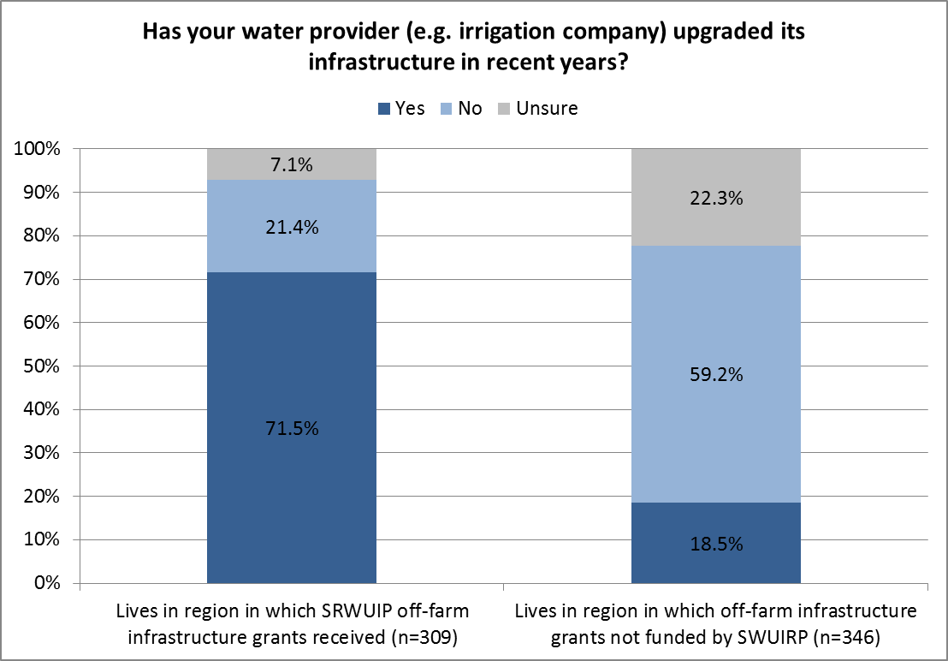

#### Perceived effects of off-farm infrastructure investment on farm enterprise

The 2013 Regional Wellbeing Survey asked irrigators two questions related to off-farm water infrastructure:

* Whether they had experienced the effects of off-farm infrastructure upgrades in the last 5 years (irrespective of whether it was their water provider that had upgraded infrastructure, or another water provider in a nearby district)
* Whether their water provider had upgraded water infrastructure in recent years (a question more specific to the farmer’s own water supply than the first).

When asked the more general question – about the effects of off-farm water infrastructure upgrades in their region in general – irrigators were less likely to report positive effects than when they were asked the more specific question of how they experienced an upgrade of their own water provider’s infrastructure (Figures 2 and 3). When irrigators living in regions in which SRWUIP funding contributed to upgrading of off-farm infrastructure since 2009 were examined, only 42.6% of irrigators living in these regions *and* aware upgrades had occurred felt the upgrades in general were positive for their farm enterprise (Figure 2). However, when asked more specifically if their own water provider had upgraded infrastructure, 63.8% of irrigators who lived in infrastructure grant recipient regions, and who reported their water provider had upgraded infrastructure, felt that the upgrade of infrastructure by their own water provider had a positive impact on their farm enterprise (Figure 3). With only 14.6% reporting infrastructure upgrade by their water provider had a negative impact, this suggests the large majority of irrigators find the effects of off-farm infrastructure upgrade by their water provider to have positive or neutral effects for their farm enterprise.

Figure 2 Perceptions of impacts of off-farm infrastructure *in general* on an irrigator’s farm enterprise

Bar chart showing perceptions of impacts of off-farm infrastructure in general on an irrigator’s farm enterprise. 
When irrigators living in regions in which SRWUIP funding contributed to upgrading of off-farm infrastructure since 2009 were examined, only 42.6% living in these regions and aware upgrades had occurred felt the upgrades in general were positive for their farm enterprise.

Figure 3 Perceptions of impacts of recent off-farm infrastructure upgrades by irrigator’s water provider on the irrigator’s farm enterprise

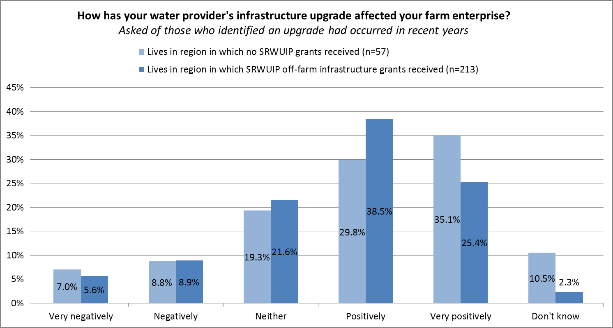

#### Farm financial performance

Farmers who participated in the Regional Wellbeing Survey were asked to self-rate their farm financial performance, by asking them ‘which of these best describes your farm enterprise at the moment’, and asking them to tick one of the following options: Making a large loss, Making a moderate loss, Making a small loss, Breaking even (neither making a profit or loss), Just making a profit, Moderately profitable, Highly profitable.

All types of farmers had a similar distribution of responses, as can be seen in Figure 4, with farmers being most likely to report making a small profit, followed by breaking even, a moderate profit, and a small loss. Very few farmers reported their enterprise was highly profitable, and approximately 5% that it was making a large loss. There is little apparent difference between profitability of irrigators living in regions in which off-farm infrastructure grants were received, and those in region where off-farm infrastructure upgrades have not occurred.

However, the year in which an infrastructure grant is provided is typically not the year in which the benefits of this infrastructure investment flow: it may take one to two years to complete infrastructure upgrades, and the effects of these upgrades is likely to only be reflected in farm profitability in seasons following completion of the investment in off-farm water infrastructure.

To better examine this, irrigation regions were analysed based on whether funding agreements for off-farm infrastructure grants were signed between 2009 and 2011, or in 2012 or later. If a grant agreement was made prior to 2012, it is likely that by the time of the 2013 Regional Wellbeing Survey, irrigators would be experiencing changes as a consequence of the off-farm infrastructure upgrades implemented. For grant agreements signed in 2012 or later, there was a much greater likelihood that the upgrade was either not completed at the time of the 2013 Regional Wellbeing Survey, or that the effects of the upgrade were not yet reflected in farm profitability. If a region had received two grants (for example, one in 2011 and one in 2013), the earlier year was the date used when considering likelihood of farmers experiencing change, as it was likely that the first grant had resulted in upgraded infrastructure by the time the 2013 survey was completed.

If infrastructure upgrades have led to a change in farm profitability, it would therefore be expected that this change would be more apparent in regions in which off-farm infrastructure agreements were made prior to 2012, and less apparent in regions in which grant agreements were made in 2012 or later.

Figure 5 compares irrigators living in regions in which off-farm infrastructure grant agreements were made (i) before 2012 and (ii) post 2012, compared to those that had not received off-farm infrastructure grants, using 2013 Regional Wellbeing Survey data. Those living in regions in which off-farm infrastructure grant agreements were made prior to 2012 were more likely to report their farm was slightly profitable, and less likely to report it was making a loss, compared to other irrigators. This is consistent with SRWUIP leading to some positive outcomes for farms in the region. However, when the same data were examined using data from the 2014 Regional Wellbeing Survey (Figure 6), the same results were not replicated as clearly[1].

Further analysis in which irrigators with off-farm infrastructure upgrades are explicitly compared to similar types of irrigators not experiencing off-farm infrastructure upgrade (for example, matched by farm enterprise type and size and other relevant farm characteristics) would enable more precise estimation of the likely effects of off-farm infrastructure upgrade, but was not possible in this analysis.

Figure 4 Self-rated profitability of farm enterprise, 2013 Regional Wellbeing Survey, for different types of farmers

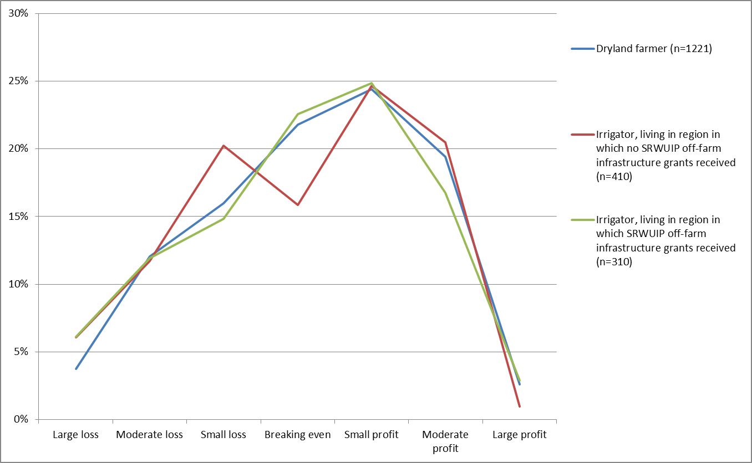

Figure 5 Self-rated profitability of farm enterprise, 2013 Regional Wellbeing Survey, by time period in which off-farm infrastructure grant received

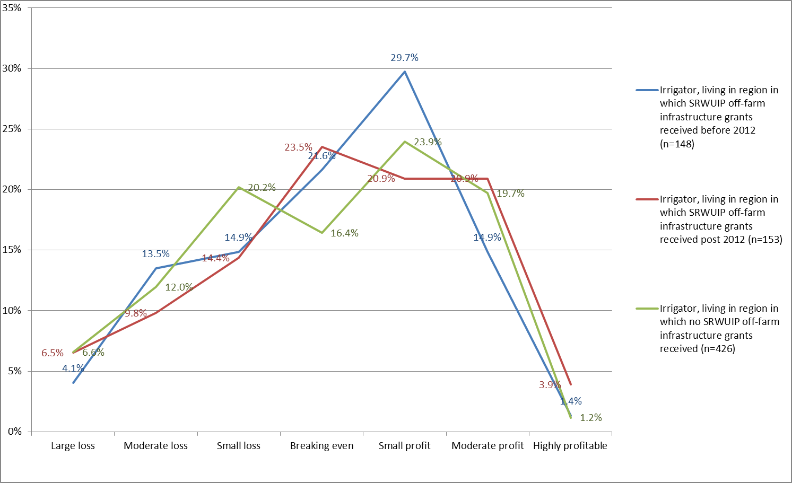

Figure 6 Self-rated profitability of farm enterprise, 2014 Regional Wellbeing Survey, by time period in which off-farm infrastructure grant received

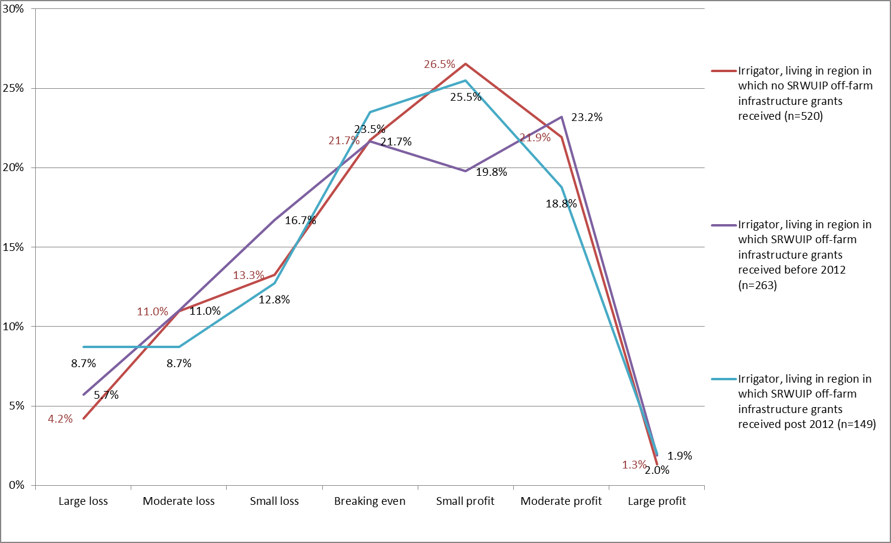

#### Likelihood of farm exit

Farmers were asked how likely they were to leave farming within (i) the next five to 10 years (2013 survey) and (ii) the next five years (2014 survey). Fewer farmers reported being likely to leave in 2014 compared to 2013, however this is principally due to the change in the timeframe asked about in the question rather than any actual shift in proportion of farmers planning to leave farming. Figure 7 compares exit likelihood for farmers living in regions in which SRWUIP off-farm infrastructure grants have and have not been received, using 2013 survey data; Figure 8 shows the same data from the 2014 survey. The data do not show consistent trends across the two years: in the 2013 surveys, those living in regions where off-farm infrastructure grants were received before 2012 were slightly more likely to be planning to leave farming than those where grants were received later; in the 2014 survey, the same group was slightly less likely to be planning to leave farming than those in regions where grants were received later.

Further analysis should be undertaken to control for age of the farmer, and financial stress, to identify if a more consistent pattern is identifiable once these factors are controlled. No definite conclusions can be drawn about the effects of off-farm infrastructure investment without this additional analysis, and ideally a more detailed set of data that better identify the effects of off-farm infrastructure changes for different irrigators.

Figure 7 Likelihood of farm exit, compared for farmers in regions with and without off-farm infrastructure grants (2013 Regional Wellbeing Survey)

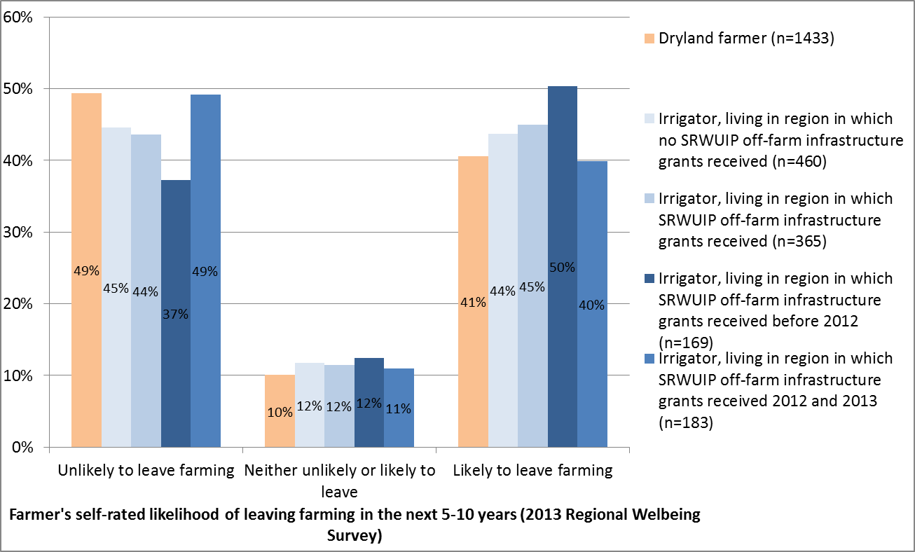

Figure 8 Likelihood of farm exit, compared for farmers in regions with and without off-farm infrastructure grants (2014 Regional Wellbeing Survey)

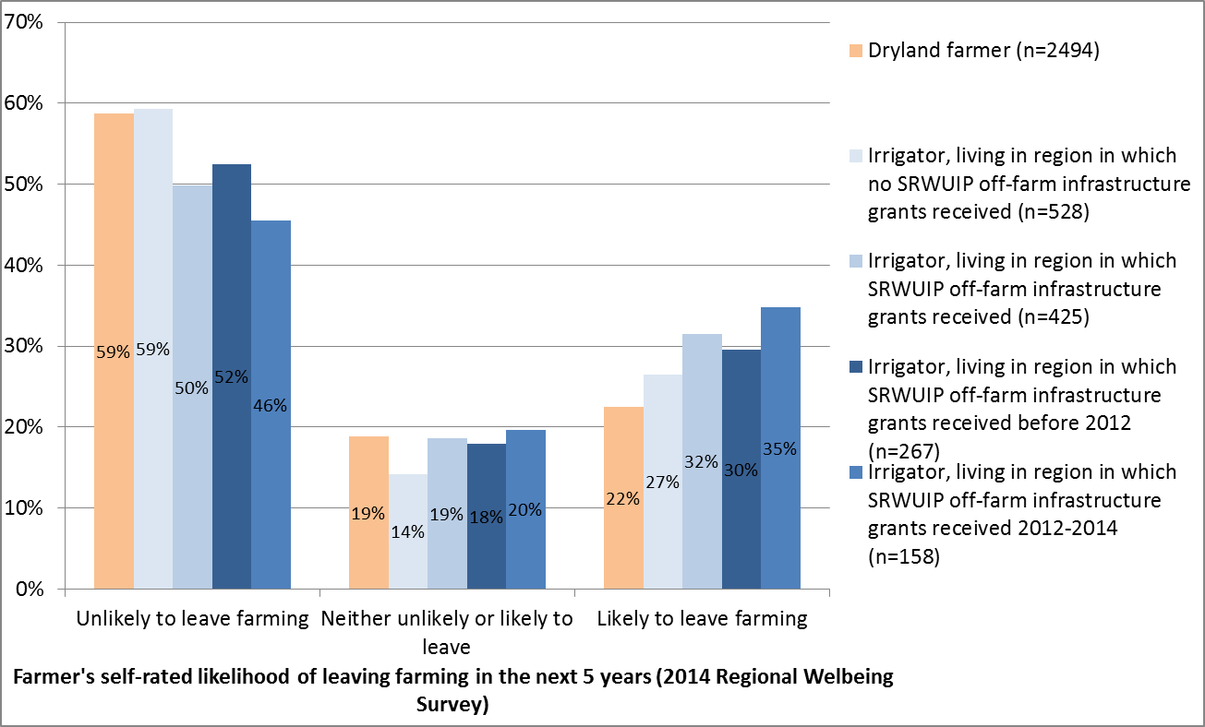

#### Subjective wellbeing

Many factors affect a person’s wellbeing: these range from a person’s relationships, health, standard of living, social connections, and sense of belonging to a community, through to major changes such as shifting house, experiencing work stress, or having a baby. The effects of improved water supply infrastructure on wellbeing are likely to be complex and ‘distal’ – in other words, improved water supply influences wellbeing via a chain of events, in which infrastructure upgrades may influence several factors (such as a person’s income, work stress, certainty about the future) that in turn influence their wellbeing. It is thus considered unlikely that a direct relationship between off-farm infrastructure and an irrigator’s wellbeing will be identifiable in the data.

Figures 9 and 10 compare the ‘life satisfaction’ of irrigators who live in regions with off-farm infrastructure investment, other irrigators, dryland farmers, and the general community. The life satisfaction measure is a commonly used indicator of a person’s overall wellbeing. In both 2013 and 2014, irrigators living in regions in which off-farm infrastructure grants have been delivered reported slightly lower wellbeing compared to irrigators in other regions; this wellbeing level was not significantly different to the average, however. This suggests that while there may be an effect of off-farm infrastructure on wellbeing, this effect is likely to be relatively small compared to the many other factors that influence a person’s wellbeing.

Further examination of the effects of infrastructure upgrades on wellbeing could be done by explicitly asking irrigators how off-farm infrastructure upgrades affect their farm enterprise, their work hours, or other factors that in turn have an influence on their wellbeing. This would enable identification of casual pathways between infrastructure change and irrigator wellbeing.

Figure 9 Subjective wellbeing of rural and regional Australians, by off-farm infrastructure grant region (2013 Regional Wellbeing Survey)

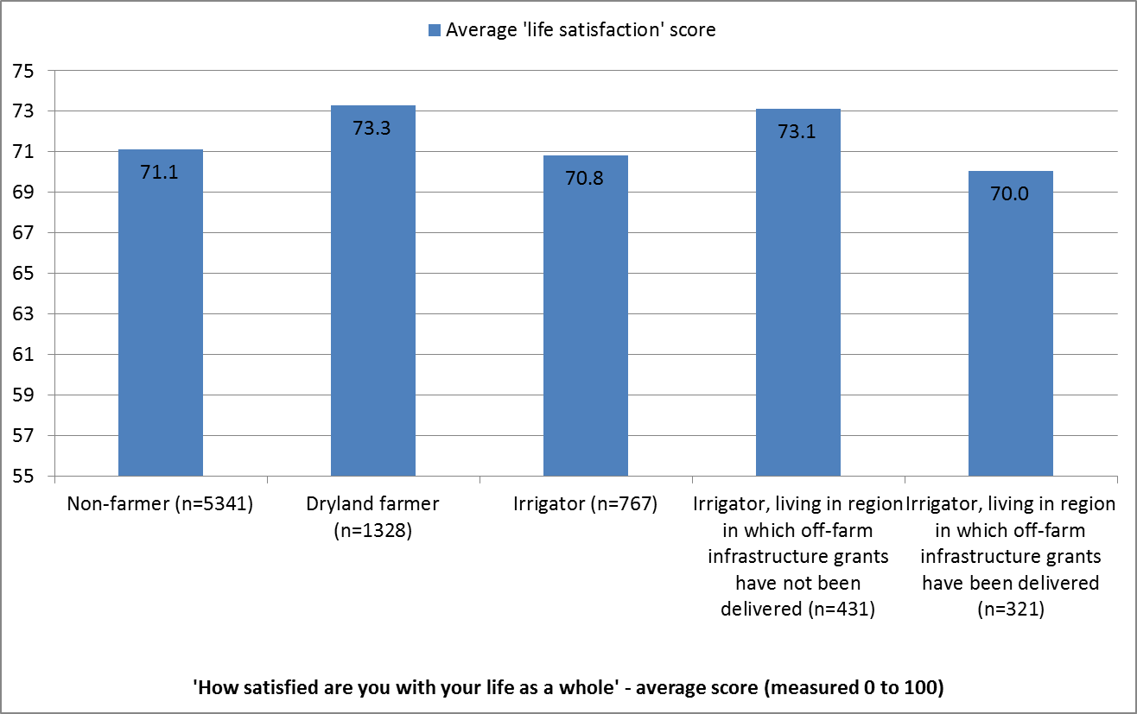

Figure 10 Subjective wellbeing of rural and regional Australians, by off-farm infrastructure grant region (2014 Regional Wellbeing Survey)

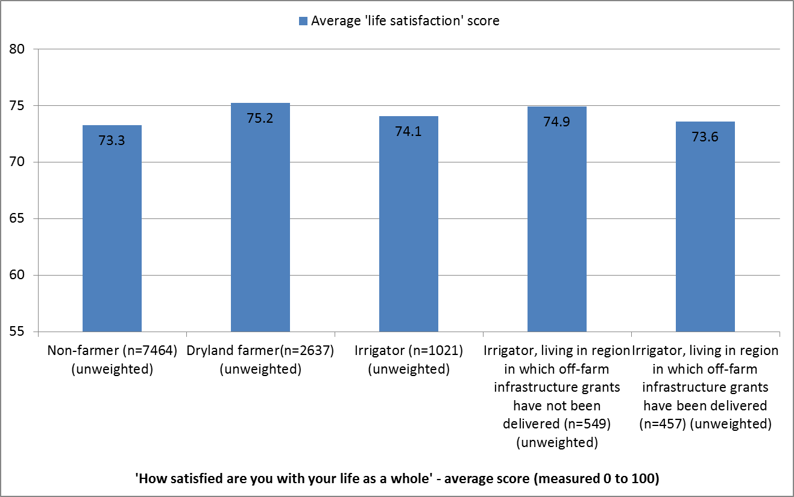

#### Confidence in future of the local community

Irrigators who lived in regions where off-farm infrastructure grants have been delivered were, on average, less likely to agree with the statement ‘this community has a bright future’ compared to other people (Figure 11), although there was an increase in the proportion who agreed with this statement between 2013 and 2014 (Figure 12). Further work is needed to examine why this is the case, and the mix of contributing factors leading to this poorer rating of the community’s future. For example, it is possible that the same factors that led to delivery of the off-farm infrastructure grant to a region (such as higher water recovery requirements) may also have led to the lower than average confidence, or that specific types of agricultural change were occurring in regions with off-farm infrastructure grants (for example, downturns in winegrape markets affected irrigators in several of the regions in which infrastructure grants were also delivered in 2013 and 2014).

Figure 11 Confidence in future of the community, by off-farm infrastructure region (2013 Regional Wellbeing Survey)

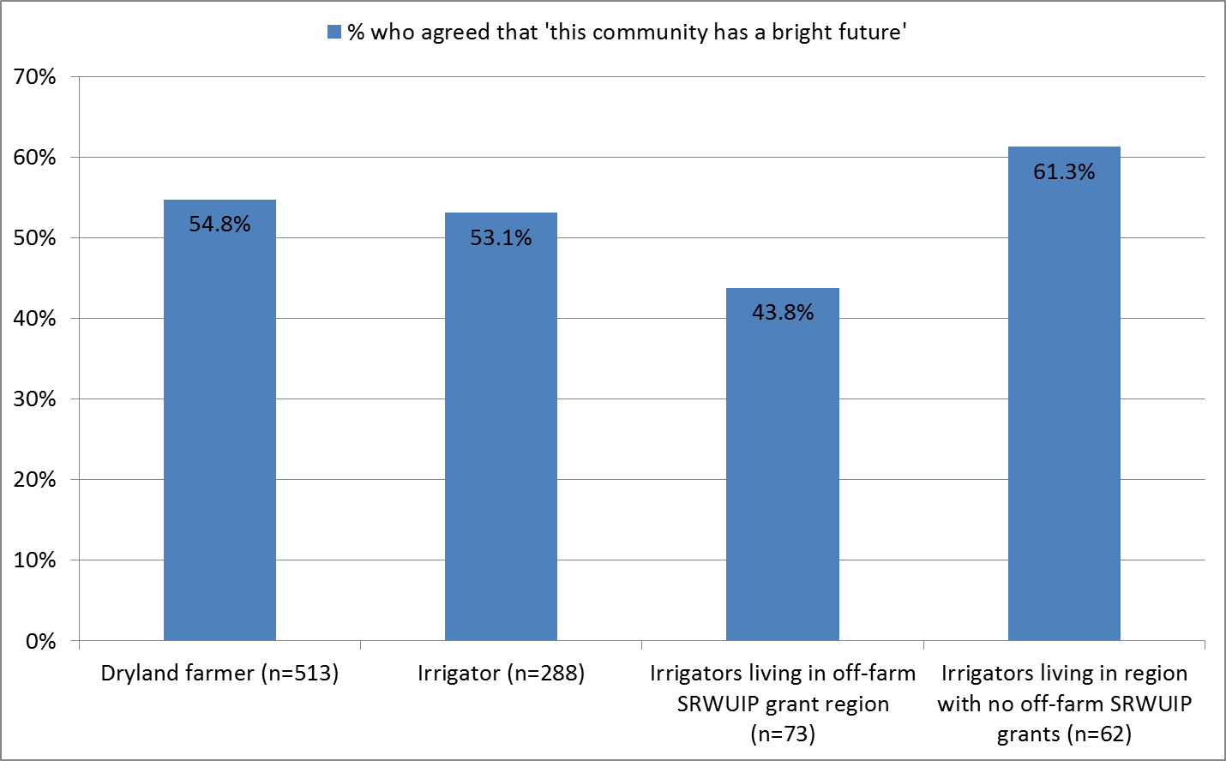

Figure 12 Confidence in future of the community, by off-farm infrastructure region (2014 Regional Wellbeing Survey)

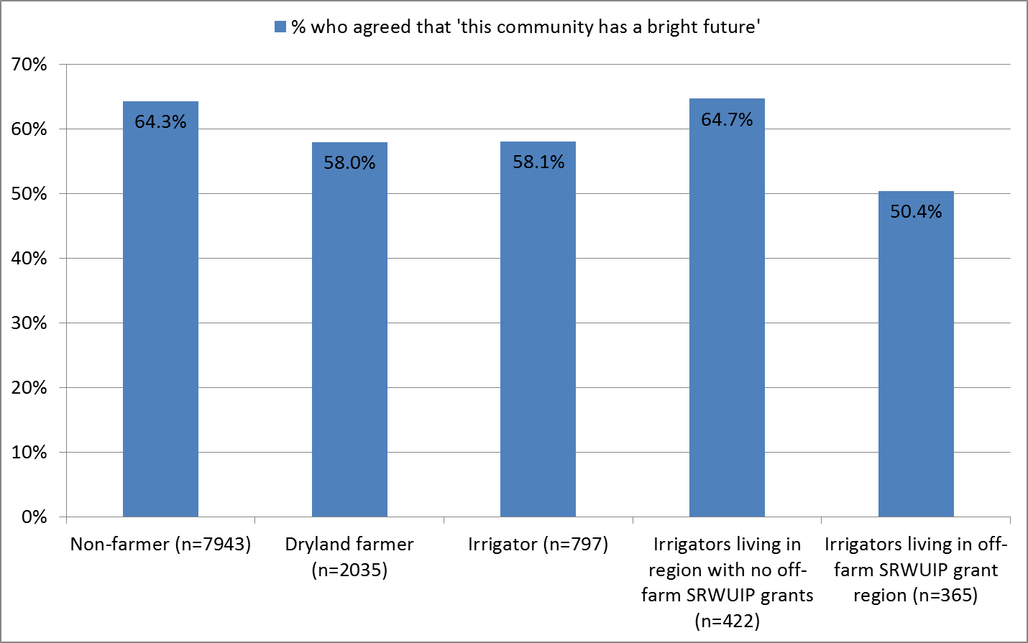

#### Perceptions of the Basin Plan

Regional Wellbeing Survey participants were asked their views about the Basin Plan. Figures 13, 14 and 15 compare views of different respondents about the future effects of the Plan on (i) their own job, (ii) the future of their local community, and (iii) the future of the Basin as a whole, for the 2013 Regional Wellbeing Survey.

Irrigators living in regions in which off-farm infrastructure grants have been implemented were more likely than those living in Basin regions that have not received off-farm infrastructure grants to think the Basin Plan would have a negative effect, but also more likely to think it would have a positive effect, on their own job and their local community. When asked about impacts on the Basin as a whole, irrigators living in regions with off-farm infrastructure investment were more likely to report negative effects and less likely to report positive effects compared to those living in regions with no off-farm infrastructure grants. Irrigators living outside the Basin predominantly believe the Plan will have no effect on them, as do dryland farmers and non-farmers. Data from the 2014 Regional Wellbeing Survey on this topic are not shown, as they are currently in analysis and weighting processes, but preliminary analysis shows a very similar pattern of results.

The higher proportion of both negative and positive perceptions are unlikely to be principally due to the provision of off-farm infrastructure grants, but are more likely to reflect that off-farm infrastructure grants have often been delivered into regions in which there is a higher planned reduction in irrigated water supply under the Plan, which are also the regions in which concern about the Basin Plan is strongest. Therefore there is a correlation between off-farm infrastructure grant provision and negative views of the Plan, but this is not likely to be a causal relationship.

There is a possibility that the higher proportion of positive views (still a minority of irrigators) in off-farm infrastructure regions is in part due to off-farm infrastructure investment. This was explored by identifying whether irrigators who were aware of off-farm infrastructure grants were more or less likely to report positive perceptions of the Basin Plan (Figure 16). The results show that being aware of off-farm infrastructure investment was not associated with more positive perceptions of the Plan.

Figure 13 Perceptions of effects of Basin Plan on person’s own job, by residence within and outside the Basin, and type of respondent, 2013

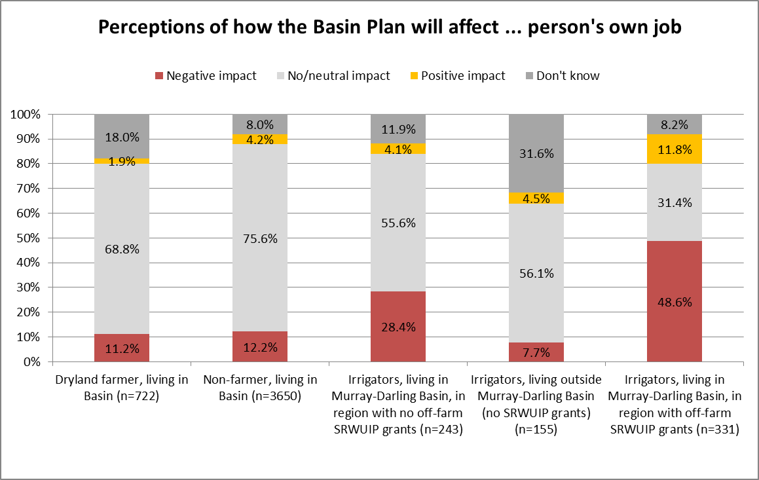

Figure 14 Perceptions of effects of Basin Plan on future of person’s local community, by residence within and outside the Basin, and type of respondent, 2013

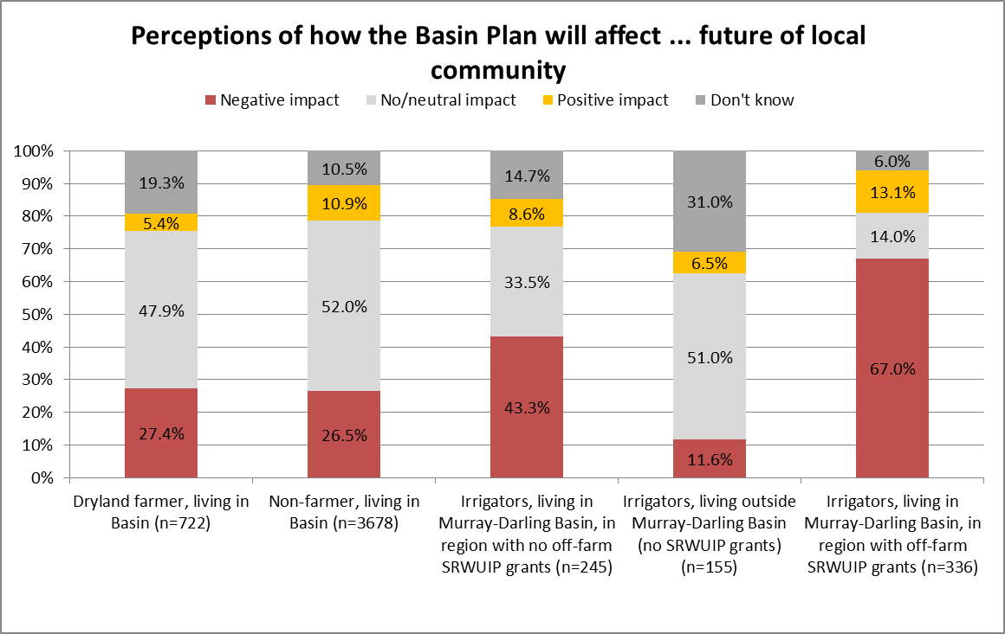

Figure 15 Perceptions of effects of Basin Plan on the Murray-Darling Basin as a whole, by residence within and outside the Basin, and type of respondent, 2013

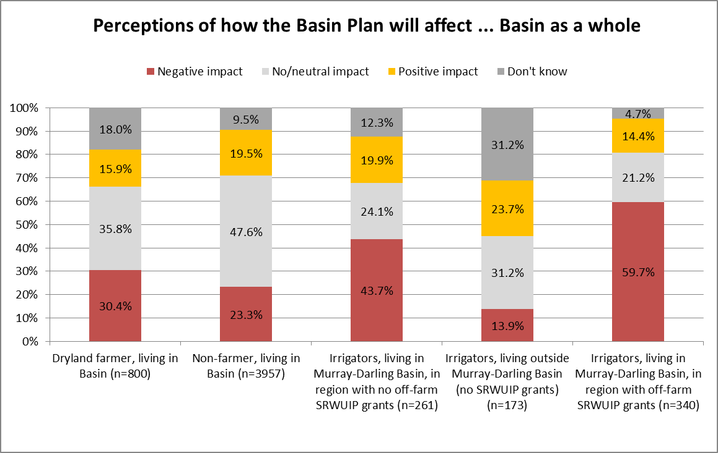

Figure 16 Perceptions of effects of Basin Plan on person’s own job, by whether irrigator was aware of off-farm infrastructure upgrades, 2013

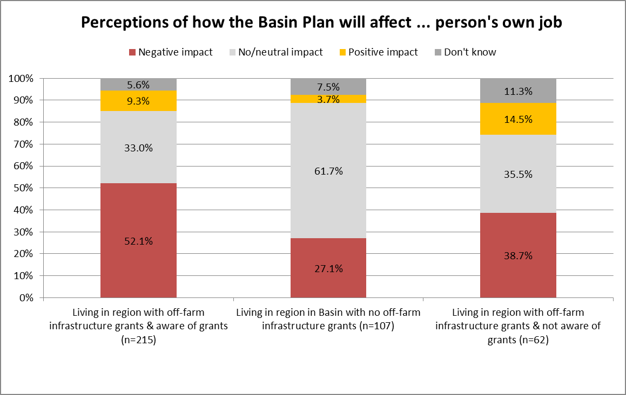

### On-farm infrastructure grants

On-farm infrastructure grants have been used to modernise irrigation infrastructure in multiple regions in the Murray-Darling Basin. The analysis below examines:

* the proportion of irrigators in the Regional Wellbeing Survey who reported having received an on-farm infrastructure grant in the last 5 years
* farm financial performance of those who have and have not accessed an on-farm infrastructure grant funded under the SRWUIP program
* whether receiving an on-farm infrastructure grant was associated with differing likelihood of exiting farmer in the next 5 to 10 years
* subjective wellbeing of irrigators who had and had not received grants to upgrade on-farm water infrastructure
* perceptions of those who had and had not received grants to upgrade on-farm water infrastructure regarding (i) their community’s future and (ii) the Basin Plan.

#### Receiving an on-farm water infrastructure grant

Irrigators living in regions in which SRWUIP on-farm water infrastructure grants were funded between 2009 and 2013 were much more likely to report receiving a grant to improve their on-farm water infrastructure in the past 5 years than those living in regions where no SRWUIP grant funding has been delivered for on-farm water infrastructure improvement (Figure 17, drawing on 2013 Regional Wellbeing Survey data). One third of irrigators who lived in regions with on-farm infrastructure grants available via funding from the Department of Environment reported having received a grant, compared to 12.9% living in other regions.

The 2014 Regional Wellbeing Survey asked irrigators if they had accessed funding or a grant to upgrade on-farm water infrastructure in the last three years. Similar to the 2013 survey, irrigators were more likely to report receiving a grant if they lived in a SRWUIP region (Figure 18). In 2014, those irrigators who reported receiving a grant were also asked how useful they found the grant. The large majority reported that receiving an on-farm infrastructure grant was very useful, particularly those living in SRWUIP regions (Figure 19). All irrigators living in SRWUIP regions found the on-farm infrastructure grant moderately or very useful, with none finding it ‘not useful’.

Figure 17 Proportion of irrigators who reported receiving an on-farm infrastructure grant in the last 5 years, compared for regions in which federal government funding was and was not available between 2009 to 2013 (2013 Regional Wellbeing Survey)

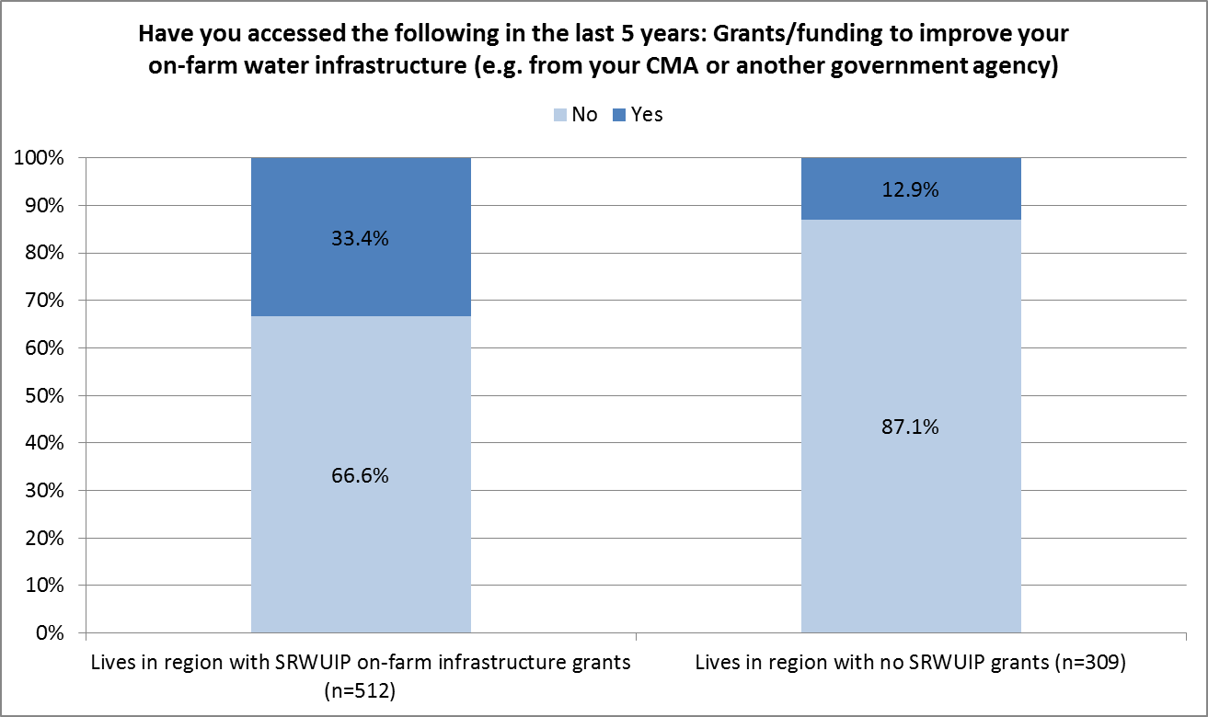

Figure 18 Proportion of irrigators who reported receiving an on-farm infrastructure grant in the last 3 years, compared for regions in which federal government funding was and was not available between 2009 to 2014 (2014 Regional Wellbeing Survey)

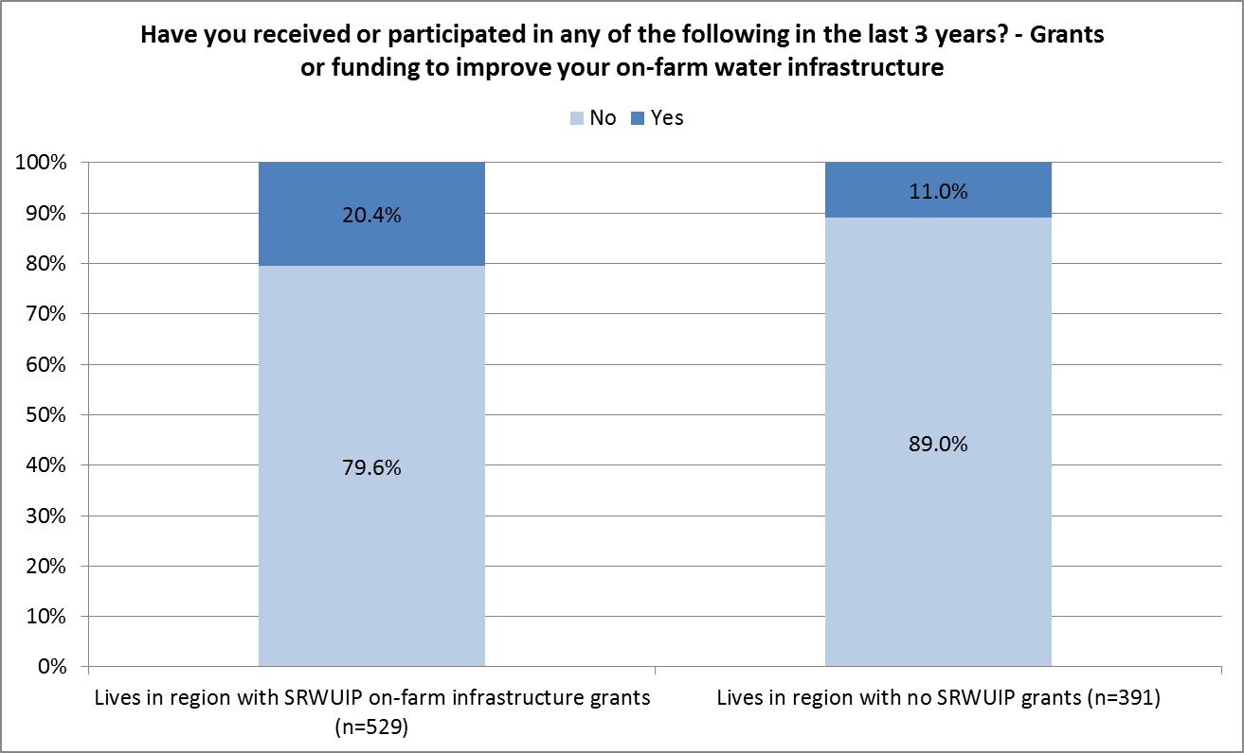

Figure 19 Rating of overall usefulness of grants received to improve on-farm infrastructure in last 3 years, by irrigators who had received them (2014 Regional Wellbeing Survey)

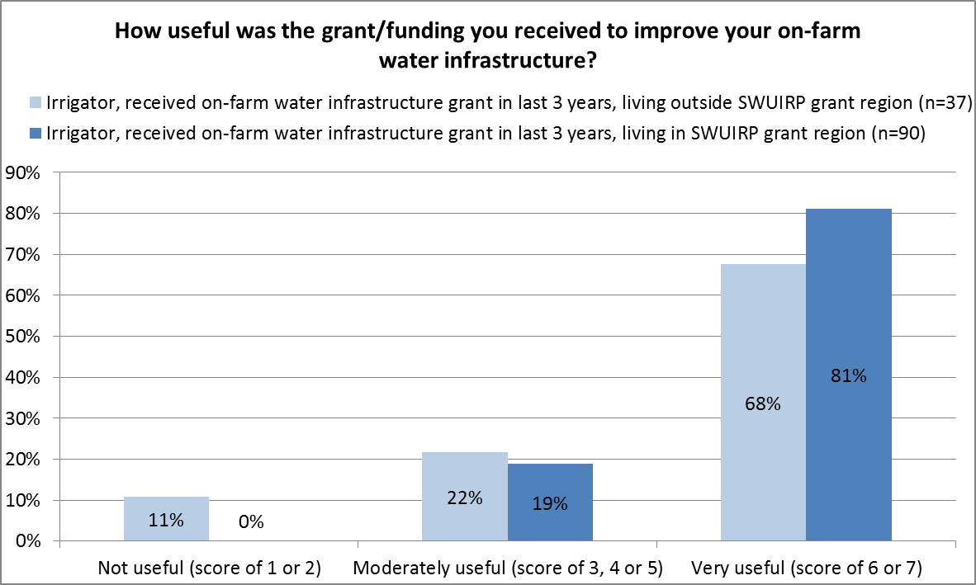

#### Farm financial performance

Farmers who participated in the Regional Wellbeing Survey were asked to self-rate their farm financial performance, by asking ‘which of these best describes your farm enterprise at the moment’, and asking them to tick one of the following options: Making a large loss, Making a moderate loss, Making a small loss, Breaking even (neither making a profit or loss), Just making a profit, Moderately profitable, Highly profitable.

As with the analysis for off-farm infrastructure, all types of farmers had a similar distribution of responses, as can be seen in Figures 20 and 21 (data for 2013 and 2014 surveys respectively), with farmers being most likely to report making a small profit, followed by breaking even, a moderate profit, and a small loss. Very few farmers reported their enterprise was highly profitable, and approximately 5% that it was making a large loss.

To better examine whether irrigators who had received on-farm infrastructure grants reported higher profitability compared to those who had not, the responses of irrigators who lived in regions in which on-farm grants were made available and (i) had received grants, and (ii) had not received grants, were compared. As can be seen in Figures 22 and 23, irrigators who had received on-farm water infrastructure grants were significantly more likely to report their farm enterprise was profitable compared to those who had not received grants who lived in the same regions. Those who received on-farm water infrastructure grants were more likely to report a slightly profitable farm enterprise, and less likely to report making a small or moderate loss, compared to those who had not received on-farm grants.

Irrigators were then compared based on the length of time since they received the grant. When analysing 2013 Regional Wellbeing Survey data, in which there was a larger sample of irrigators who have received on-farm infrastructure grants (due to the question asking about a 5 year period rather than a 3 year period), those who received a grant prior to 2012 reported higher profitability than those who received a grant in later years, consistent with what is expected if on-farm infrastructure improvements are a factor influencing growth in profitability (Figure 24). Similar findings are apparent from the 2014 Regional Wellbeing Survey data (Figure 25), where despite many irrigators living in regions where it was not possible to identify the specific year a grant was received, in general farmers who had received grants regions where grants had been received earlier were more likely to report profits than farmers who were likely to have received grants more recently.

This is strongly supportive of a positive relationship between receipt of on-farm infrastructure grants, and improved profitability once new infrastructure is established and operating for a season. Ideally, this result requires replication over additional years to identify how robust it is.

Figure 20 Self-rated profitability of farm enterprise, 2013 Regional Wellbeing Survey

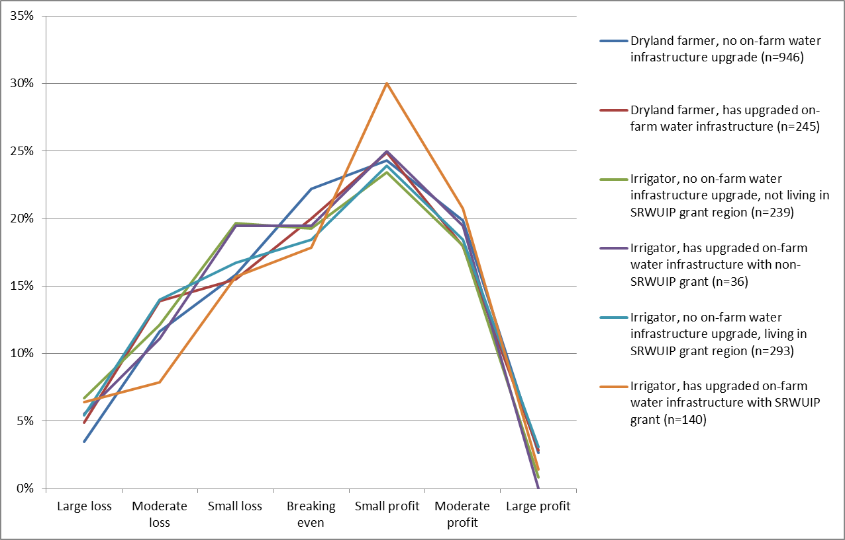

Figure 21 Self-rated profitability of farm enterprise, 2014 Regional Wellbeing Survey

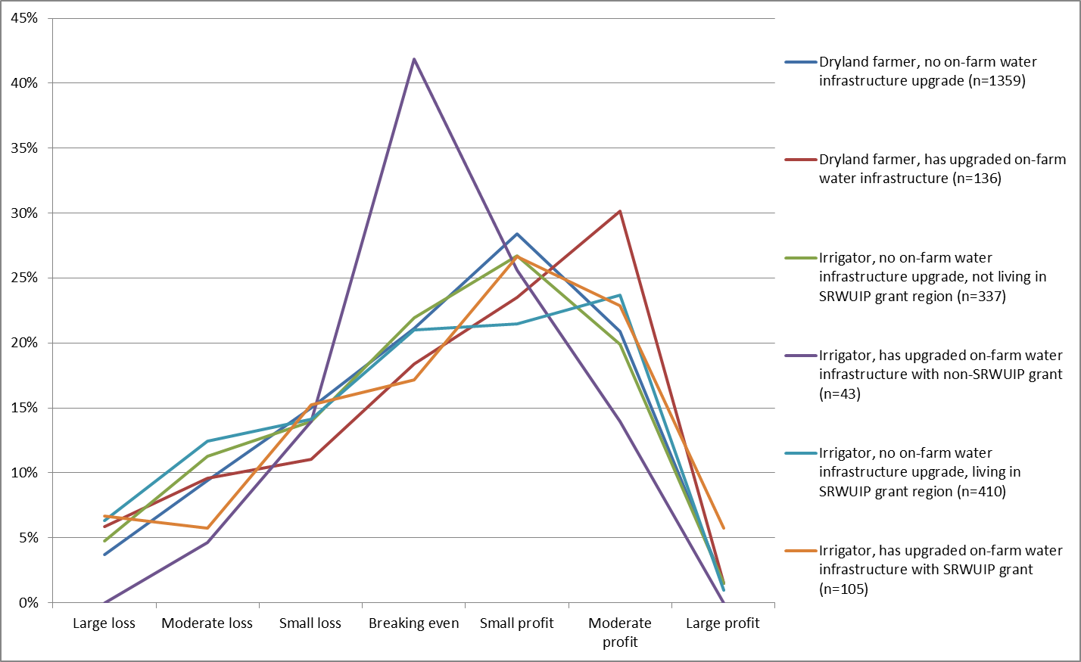

Figure 22 Self-reported farm profitability of irrigators who received an on-farm infrastructure grant in 5 years to 2013 compared to those who did not, living in regions in which on-farm infrastructure grants were made available, 2013 Regional Wellbeing Survey

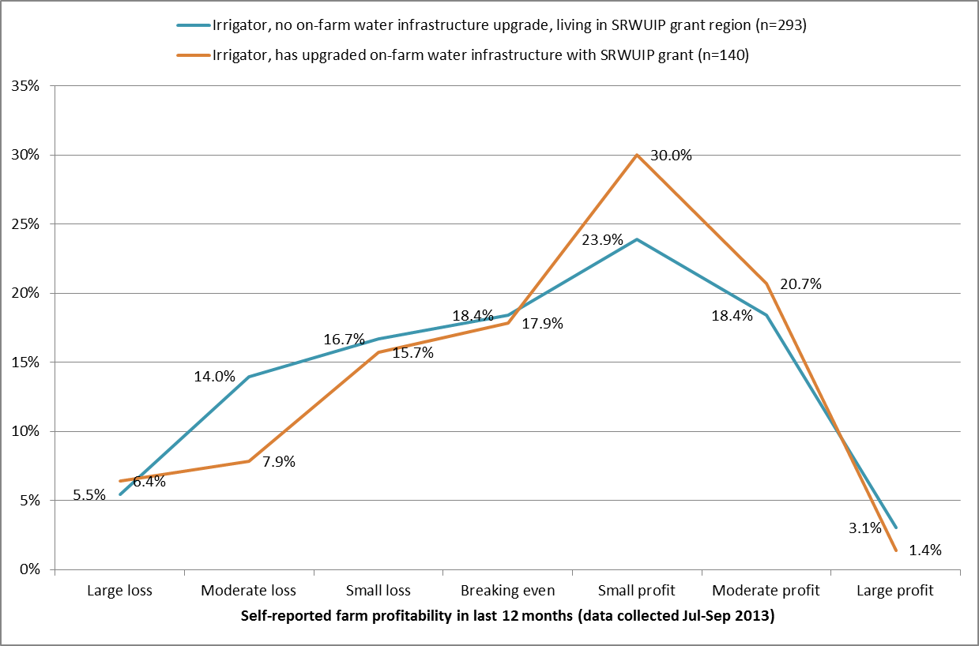

Figure 23 Self-reported farm profitability of irrigators who received an on-farm infrastructure grant in the 3 years to 2014 compared to those who did not, living in regions in which on-farm infrastructure grants were made available, 2014 Regional Wellbeing Survey

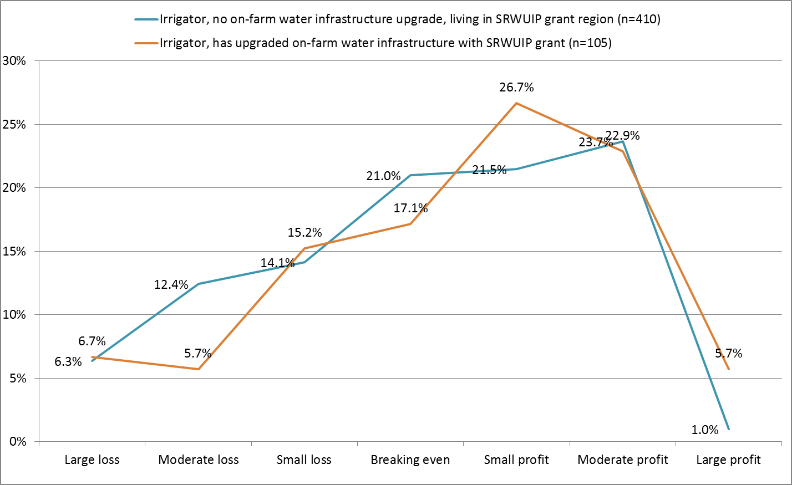

Figure 24 Self-reported farm profitability of irrigators living in regions in which on-farm infrastructure grants were made available, comparing those who received a grant and those who did not, by period in which grant received (2013 Regional Wellbeing Survey)

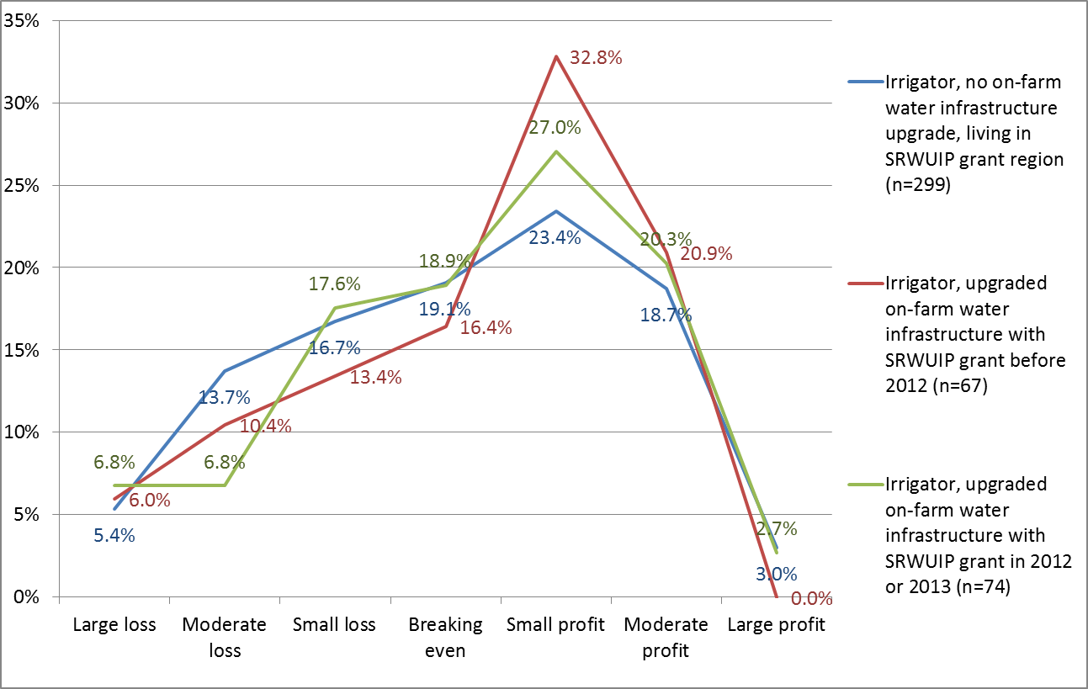

Figure 25 Self-reported farm profitability of irrigators living in regions in which on-farm infrastructure grants were made available, comparing those who received a grant and those who did not, by period in which grant likely to have been received (2014 Regional Wellbeing Survey)

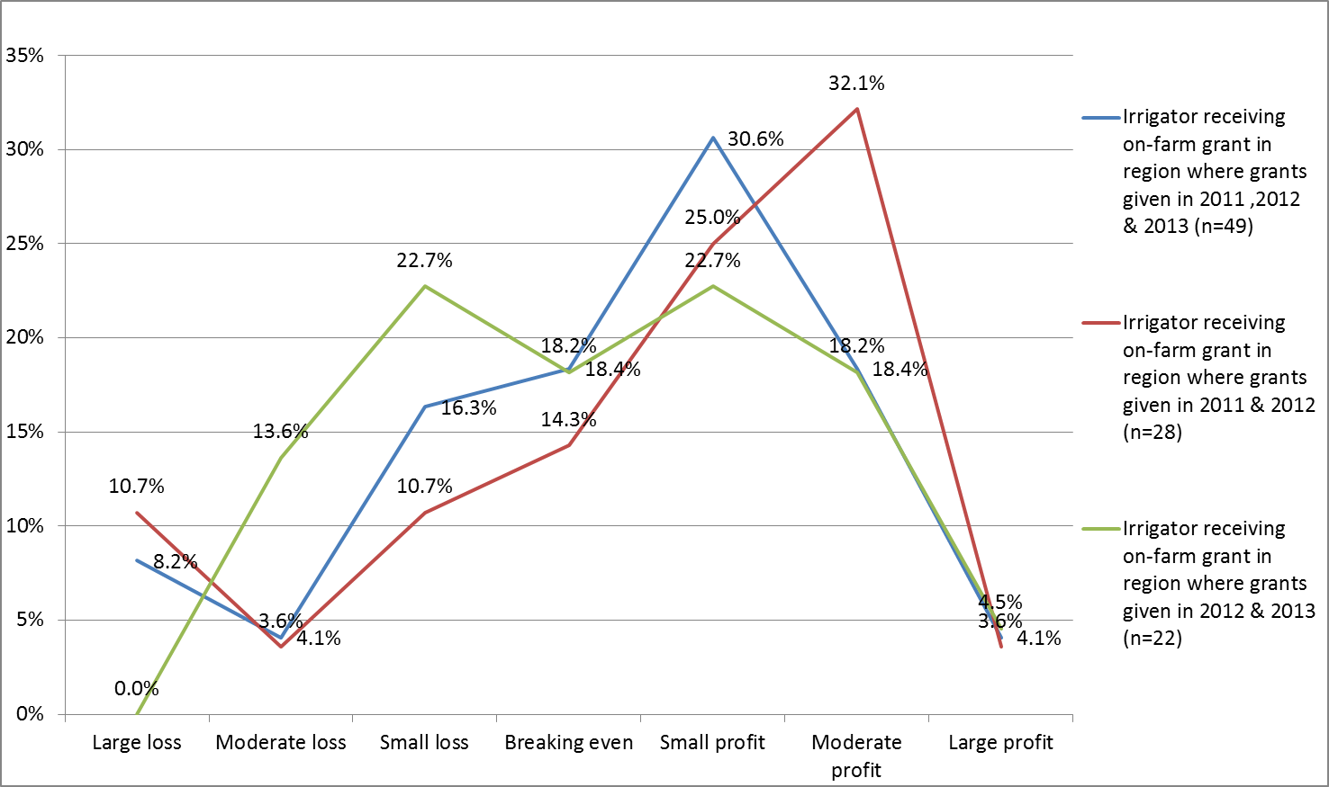

#### Likelihood of farm exit

In 2013, irrigators who had received on-farm water infrastructure grants were no more or less likely than others to be planning to exit farming in the next 5 to 10 years (unlike dryland farmers, where upgrade of water infrastructure was associated with lower likelihood of exit). However, irrigators living in regions in which on-farm infrastructure grants have been available, but who had not accessed these grants, were more likely than others to be planning to leave farming within the next 5 to 10 years (Figure 26). In 2014, irrigators who had received on-farm infrastructure grants were less likely than other irrigators to be planning to leave farming in the next five years (Figure 27).

Further analysis is needed to better identify what role on-farm infrastructure grants have in predicting farm exit. This analysis should control for the many factors known to influence farm exit, such as age and farm financial stress, to better identify what if any role on-farm infrastructure grants may have in influencing likelihood of farm exit.

Figure 26 Likelihood of farm exit, compared for farmers who had and had not received on-farm water infrastructure grants (2013 Regional Wellbeing Survey)

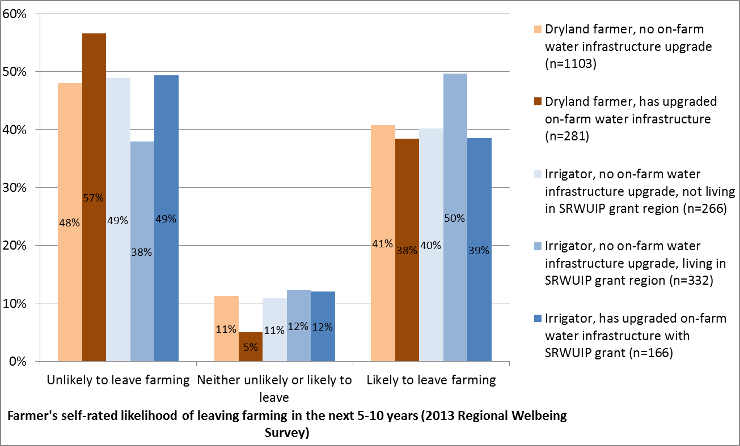

Figure 27 Likelihood of farm exit, compared for farmers who had and had not received on-farm water infrastructure grants (2014 Regional Wellbeing Survey)

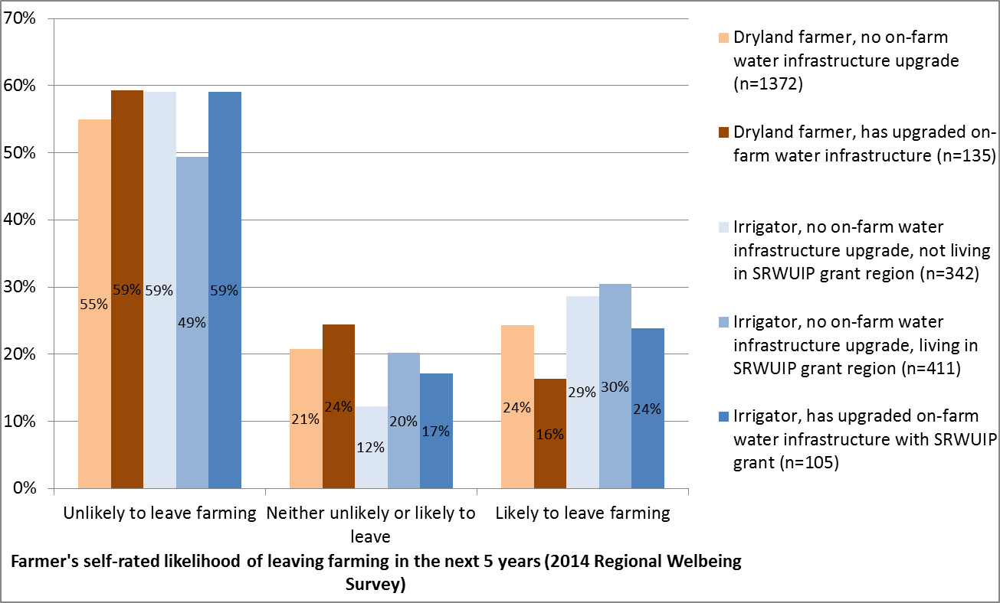

#### Subjective wellbeing

Figures 28 and 29 compare the subjective wellbeing of different rural and regional Australians, including irrigators who have and have not received on-farm infrastructure grants, using data from the 2013 and 2014 Regional Wellbeing Surveys. Those who received on-farm grants reported slightly higher life satisfaction; the difference is small and not significant in the 2013 survey data, and larger in the 2014 data. It suggests there is a possible link between receiving an on-farm infrastructure grant and wellbeing, however the link may take many forms. For example, it is possible irrigators with higher wellbeing have better capacity to successfully apply for on-farm infrastructure grants, just as it is possible that receiving an on-farm infrastructure grant contributes to wellbeing via its effects on farm finances or workload on-farm.

This link could be better understood by explicitly asking irrigators who have received grants what effect the grant has had on their lives, in order to better establish the effects of an infrastructure grant on factors known to influence wellbeing, such as finances, work hours, and confidence in the future, amongst others.

Figure 28 Subjective wellbeing of rural and regional Australians, by on-farm infrastructure grant region (2013 Regional Wellbeing Survey)

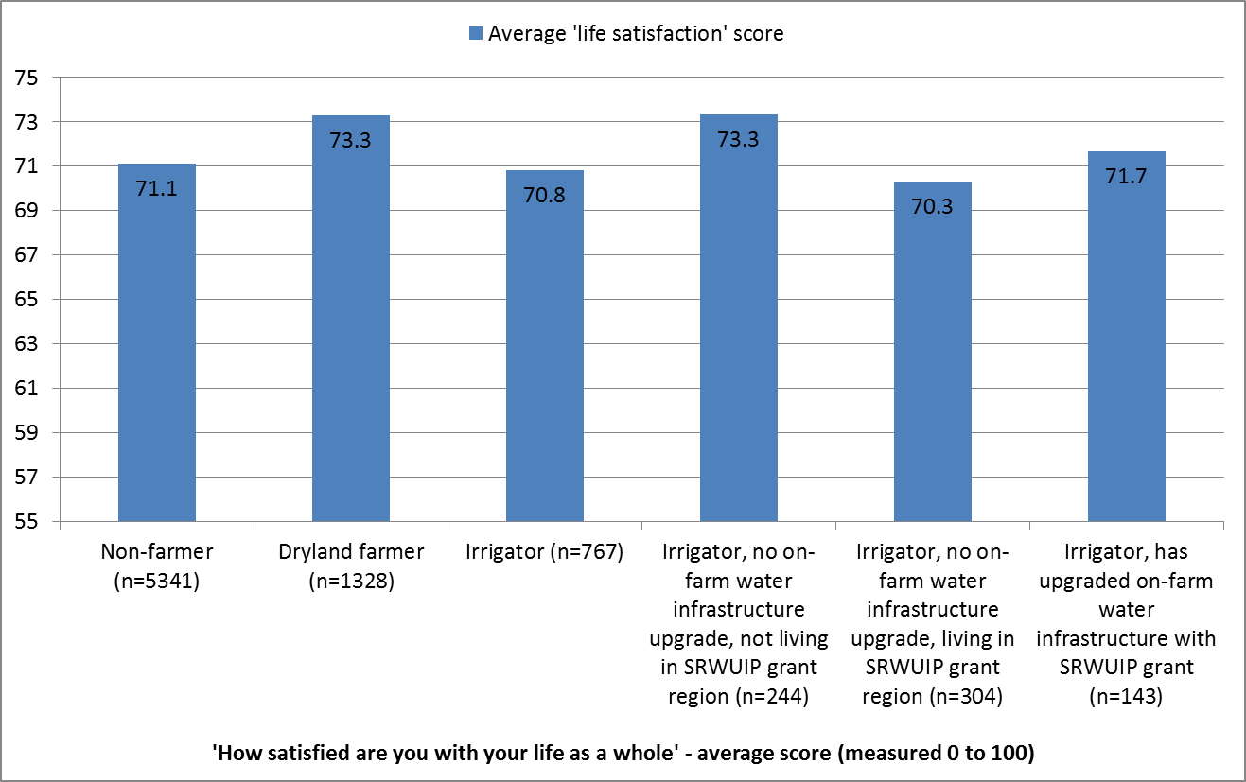

Figure 29 Subjective wellbeing of rural and regional Australians, by on-farm infrastructure grant region (2014 Regional Wellbeing Survey)

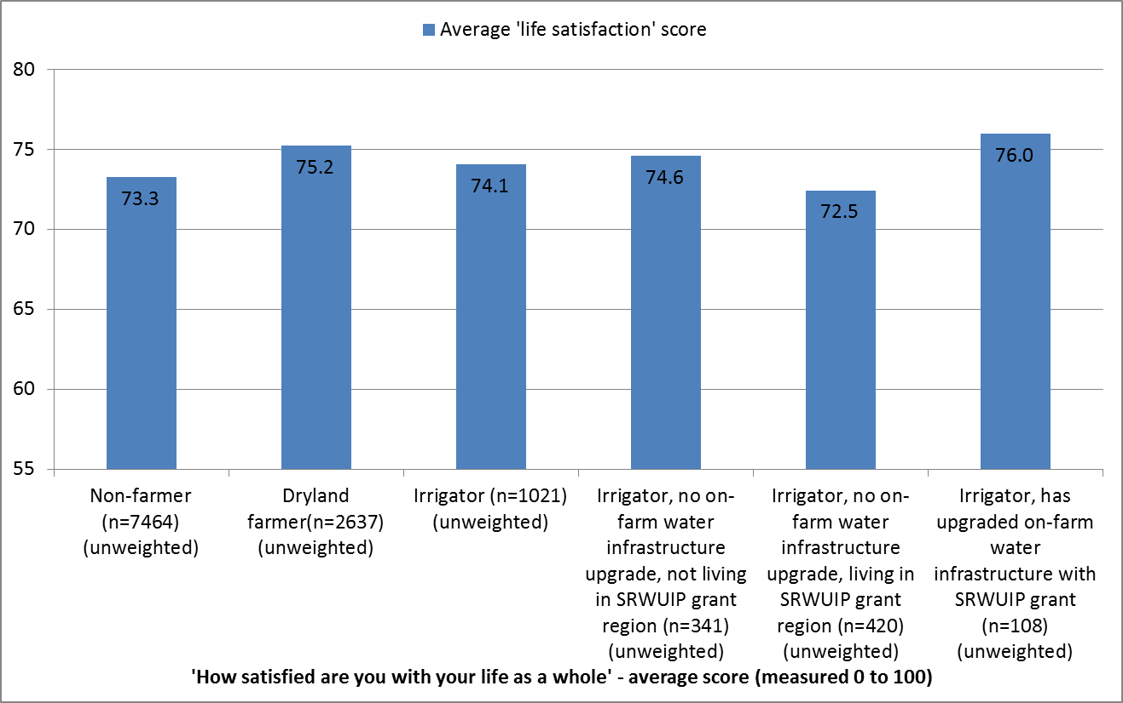

#### Confidence in future of the local community

Irrigators who lived in regions where on-farm infrastructure grants have been delivered were, on average, less likely to agree with the statement ‘this community has a bright future’ compared to other people (Figures 30 and 31), although a majority did agree with this statement, and the proportion who agreed rose between 2013 and 2014. However, those who had received an on-farm infrastructure grant were more confident in their community’s future than those who had not, suggesting that on-farm grants may potentially contribute positively to views about the future of the local community.

Further work is needed to more conclusively demonstrate that receipt of an on-farm infrastructure grant has contributed to the higher confidence of these grant recipients in their community’s future compared to irrigators living in the same region who are not grant recipients. For example, this analysis examine whether the same factors that led to delivery of the grant to a region may also have led to the lower than average confidence of all irrigators in that community in its future; and whether grant recipients have a more positive outlook about their community that made them more interested in applying for a grant, versus whether their receipt of a grant contributed to the more positive outlook.

Figure 30 Confidence in future of the community, by on-farm infrastructure region (2013 Regional Wellbeing Survey)

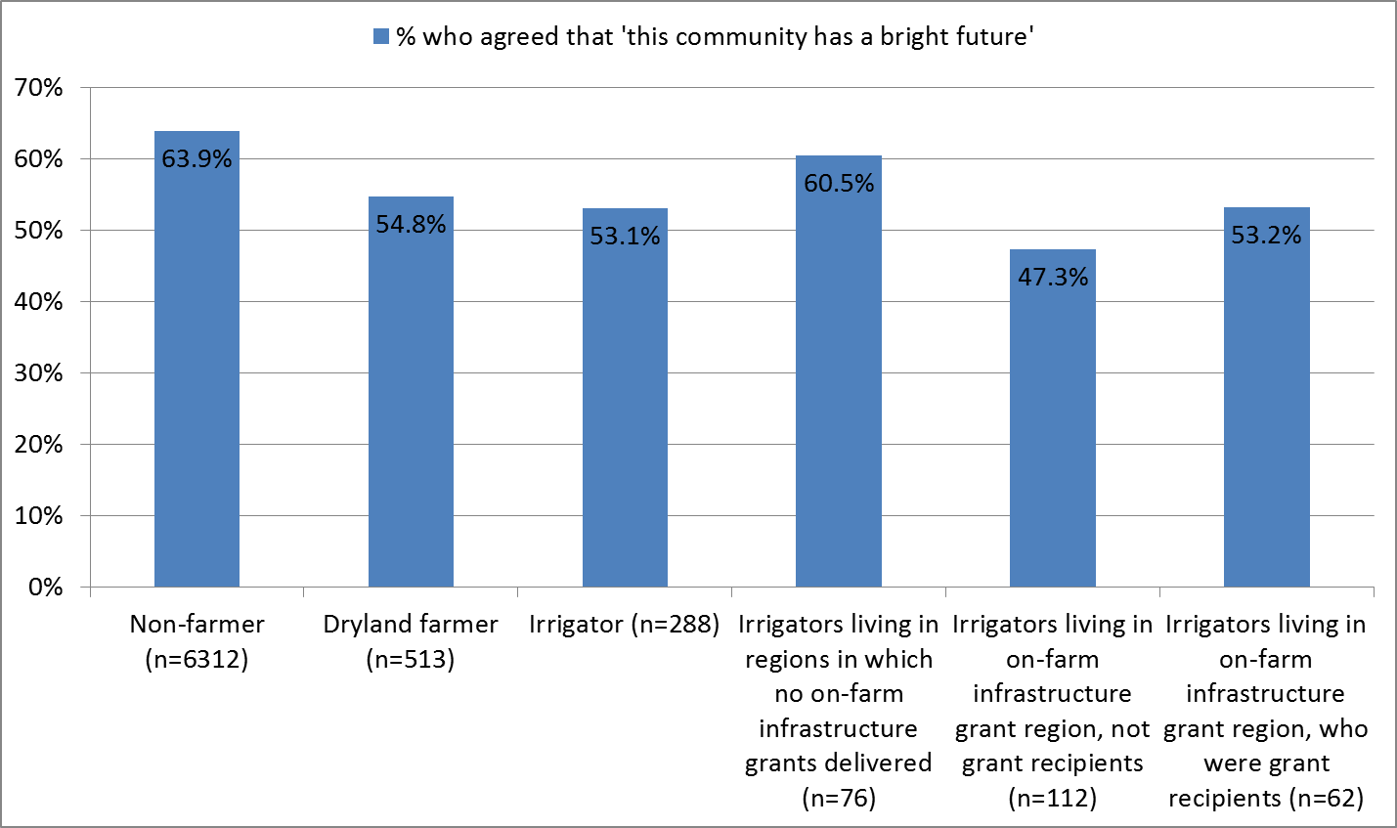

Figure 31 Confidence in future of the community, by on-farm infrastructure region (2014 Regional Wellbeing Survey)

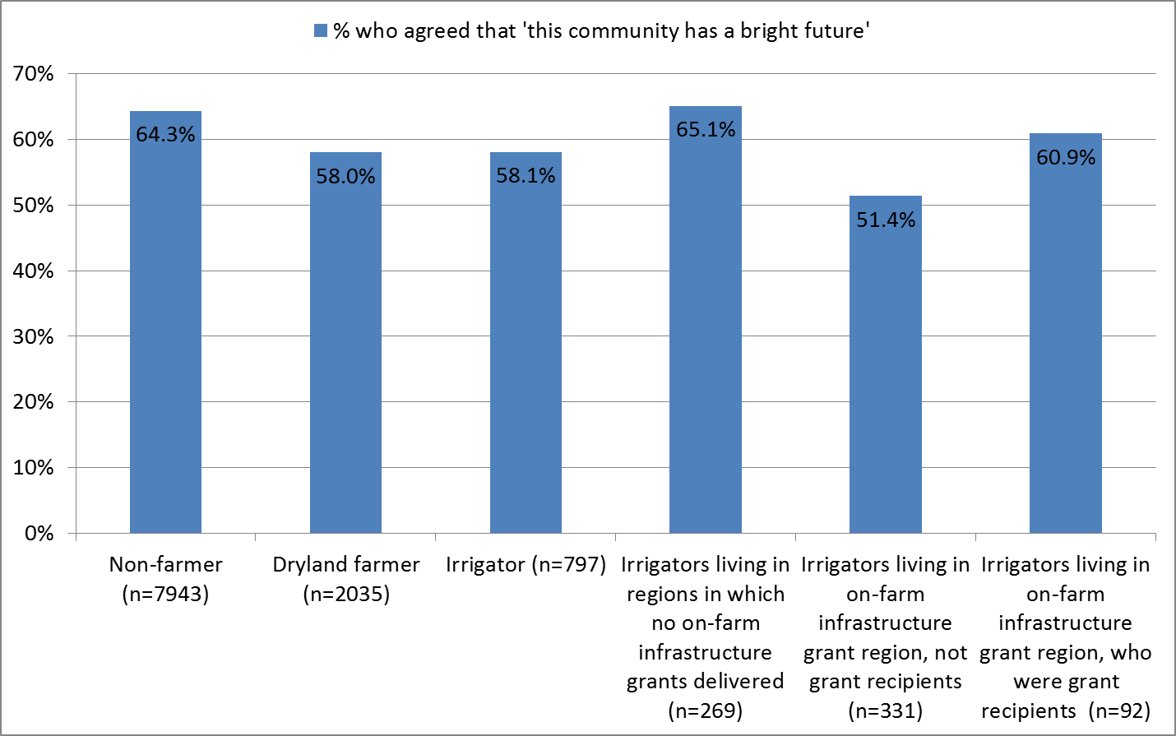

#### Perceptions of the Basin Plan

Regional Wellbeing Survey participants were asked their views about the Basin Plan. Figures 32, 33 and 34 compare views of different respondents about the future effects of the Plan on (i) their own job, (ii) the future of their local community, and (iii) the future of the Basin as a whole, drawing on 2013 Regional Wellbeing Survey data. While there are small differences – in some cases, irrigators who received on-farm infrastructure grants were slightly more likely to be positive about aspects of the Plan compared to those living in the same regions who did not received on-farm infrastructure grants – these differences are too small to be significant. Data from the 2014 Regional Wellbeing Survey are not shown here, but preliminary analysis indicates an identical result, with no significant differences in views of irrigators living within the Basin in regions where on-farm infrastructure grants have been made available, and who have and have not received on-farm infrastructure grants.

Figure 32 Perceptions of effects of Basin Plan on person’s own job, by residence within and outside the Basin, and type of respondent (on-farm water infrastructure grants), 2013

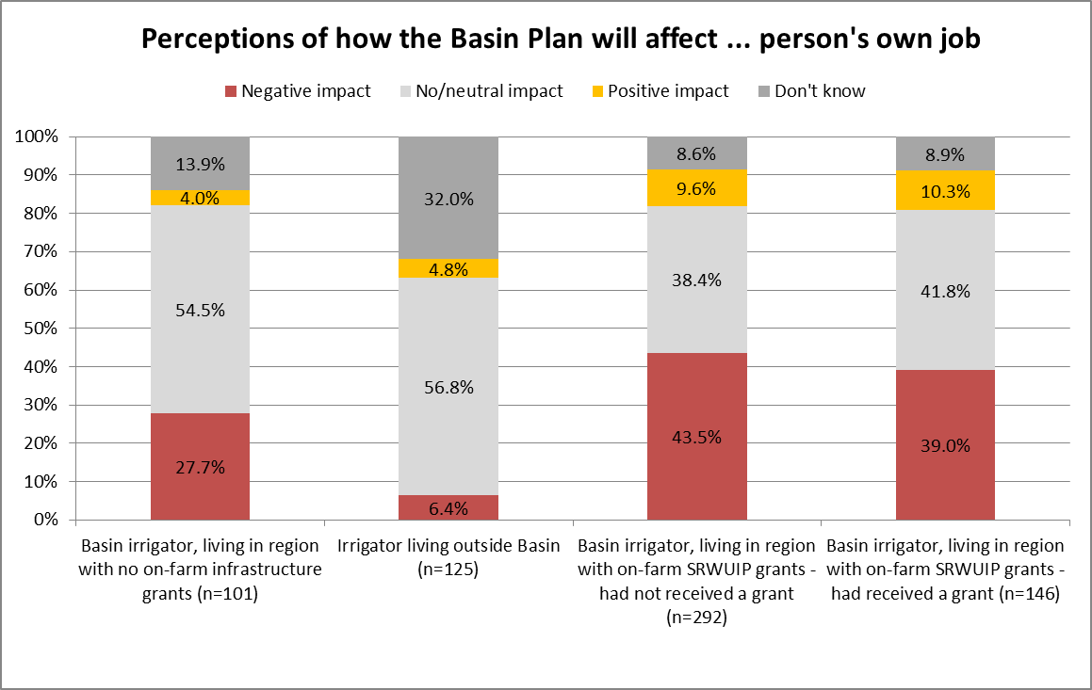

Figure 33 Perceptions of effects of Basin Plan on future of local community, by residence within and outside the Basin, and type of respondent (on-farm water infrastructure grants), 2013

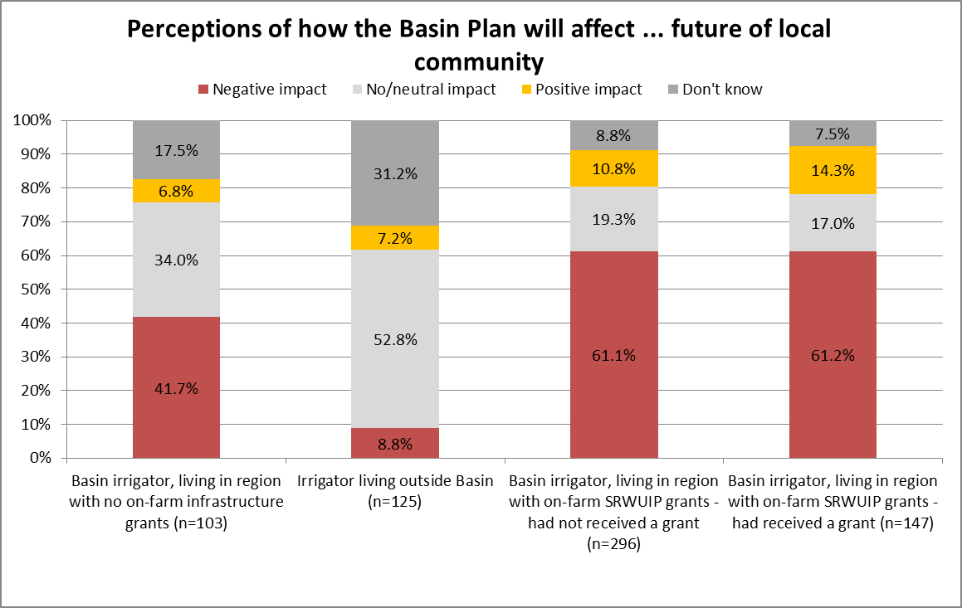

Figure 34 Perceptions of effects of Basin Plan on Murray-Darling Basin as a whole, by residence within and outside the Basin, and type of respondent (on-farm water infrastructure grants), 2013

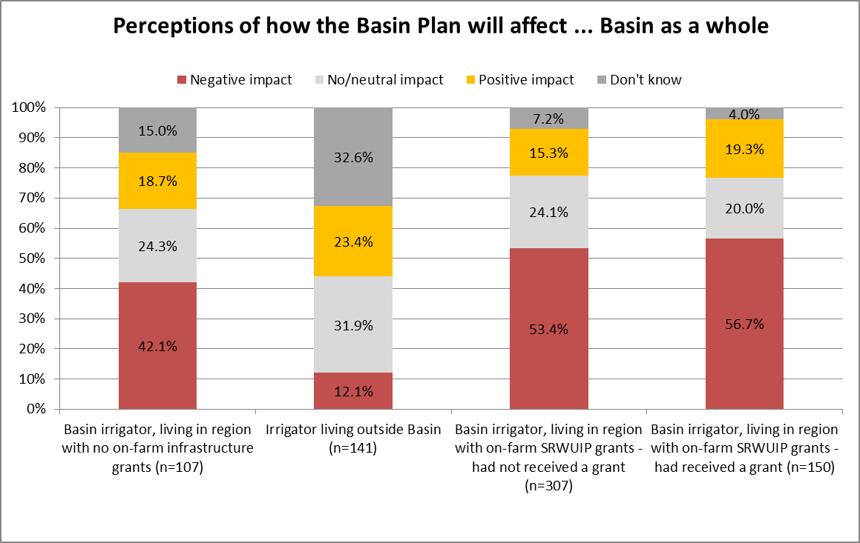

## Discussion & conclusions

This report focused on understanding the outcomes experienced by irrigators who have (i) received on-farm infrastructure SRWUIP grants or (ii) whose water provider has upgraded water delivery infrastructure with SRWUIP grants. Other reports separate to this one examine the experiences of irrigators in the Murray-Darling Basin more broadly (Schirmer and Berry 2014; Schirmer et al. 2015); and their views of water reform (National Water Commission 2014, Schirmer 2014). This section identifies key findings specific to infrastructure investment via the SRWUIP, and further work that could address identified gaps in knowledge.

### Key findings

Our key findings regarding off-farm infrastructure investment are that:

* Most, but not all, irrigators living in regions where investment in off-farm infrastructure investment has occurred are aware of that investment; 71.5% are aware of the grants, while 28.5% either report their water provider has not upgraded infrastructure, or that they are unsure whether they have
* Irrigators whose water providers have upgraded water infrastructure using a SRWUIP grant are mostly positive about the effects of the upgrade on their farm enterprise: 63.8% said it had a positive effect on their farm enterprise, 14.6% that it had a negative effect, and the remainder reported neutral effects
* Investment in off-farm infrastructure upgrades appears to be associated with an improvement in on-farm financial performance, once time lags between making the investment and achieving the benefits of off-farm infrastructure upgrades are taken into account. However, more detailed analysis and tracking over time is needed to confirm this result
* No definite conclusions can be drawn about the effects of off-farm infrastructure investment on likelihood of farmers exiting farming, the subjective wellbeing of farmers, a person’s confidence in the future of their local community, or their views about the Basin Plan (although the finding that views about the Basin Plan are similar irrespective of an irrigator’s access to infrastructure grants suggests irrigators may not be aware of the relationship between the Plan and the grants they have received or benefited from). More detailed analysis that compares irrigators with similar demographic and farm enterprise characteristics is needed to better identify any relationships, and preferably collection of new survey data that includes more specific questions about the effects of off-farm investment

Our key findings regarding on-farm infrastructure investment are that:

* A large majority of recipients of on-farm water infrastructure grants report they were very useful (just over 80%) or moderately useful (just under 20%) for their farm enterprise
* Irrigators who have received on-farm water infrastructure grants reported better farm financial performance than those who had not received grants, and this effect is particularly strong once the time lag between receiving a grant and experiencing benefits from the investment is taken into account
* Irrigators who had received on-farm infrastructure grants were more likely to agree with the statement ‘this community has a bright future’ than those who lived in the same region but had not received on-farm infrastructure grants. This suggests the grants are associated with some improvement in views about the community, although more analysis would be required to better establish the causal direction (whether higher confidence in the community leads to higher likelihood of applying for and receiving a grant, or receiving a grant contributes to improved perceptions of the local community’s future)
* No definite conclusions can be drawn about the effects of on-farm infrastructure investment on likelihood of farmers exiting farming, the subjective wellbeing of farmers, or their views about the Basin Plan.

### Further analysis

Some further analysis of existing survey data is possible. This would involve a more detailed assessment which controlled for factors such as age, farm enterprise type and geographic location more specifically, to better identify whether differences in exposure to water infrastructure investment predict differences in socio-economic outcomes.

### Future surveys

Including a slightly more detailed set of questions about the effects of on-farm and off-farm infrastructure investment in the Regional Wellbeing Survey would enable a more detailed analysis of effects of this investment for irrigators, and more broadly through the communities in which investment has taken place. This would require some investment in the survey to enable up to 1-2 pages of questions to be included, and ideally would involve sending the survey specifically to all recipients of grants, to enable a large sample to be collected.

In particular, questions could include:

* Asking irrigators who have received on-farm infrastructure grants:
* Their views about the effects of the grants on multiple aspects of their enterprise, including their on-farm workload, efficiency of water use, timing of water delivery, debt levels, input costs and productivity
* The specific types of investment made, in order to understand better whether investment in some types of on-farm water infrastructure have greater benefits than others
* Their views on flow-on benefits to the community
* Asking irrigators whose water providers have upgraded off-farm infrastructure
* Their experience of changes in water supply timing, water efficiency, and other effects
* Their views about the effects of the grants on multiple aspects of their enterprise, including their on-farm workload, efficiency of water use, timing of water delivery, debt levels, input costs and productivity
* Changes in costs of water supply, noting that this would need to be framed to understand changes in costs related to markets versus those related to infrastructure investment
* Their views on flow-on benefits to the community
* Asking members of rural communities
* Their level of awareness of the investments
* Views about effects on local economic activity and jobs.
* Their perceptions of linkages between the Basin Plan and irrigation infrastructure investment.

## References

National Water Commission. 2014. [Australia’s water blueprint: national reform assessment 2014](http://www.nwc.gov.au/__data/assets/pdf_file/0008/37673/Part-1-accessible-PDF-for-web-NWC-Australias-water-blueprint_national-reform-assessment-2014.pdf). Canberra.

Schirmer, J. 2014. Community perceptions and experiences of water reform: Analysis of the Regional Wellbeing Survey data to inform the Triennial Assessment, customised analysis of Regional Wellbeing Survey data, produced for the National Water Commission, University of Canberra, Canberra.

Schirmer, J. and Berry, H. 2014. People and place in Australia: the 2013 Regional Wellbeing Survey. University of Canberra, Canberra.

Schirmer, J., Mylek, M., Peel, D. and Yabsley, B. 2015. People and Communities: the 2014 Regional Wellbeing Survey.

1. Limitations of the dataset meant that it was not possible to ‘advance’ the year grants were signed when analysing 2014 Regional Wellbeing Survey data – as many regions had received funding in more than one year, it was not feasible to distinguish those who had received funding in 2013 versus 2012. This might be possible with more detailed data regarding when specific infrastructure upgrade activities were started and completed, versus when agreements were signed.