# Water Reform: Assessing effects of investment in water infrastructure and water entitlement purchase

Report prepared for the Department of Agriculture and Water Resources, October 2016

Author: Dr Jacki Schirmer



Contents

Executive Summary 9

Introduction 19

Methods 22

Designing survey questions 22

Collecting survey data 23

Representativeness of survey responses 23

Representativeness of sample of irrigators 24

Representativeness of community-wide sample 25

Statistical significance & presentation of findings 26

Ethics 26

Results 27

Irrigators in the Murray-Darling Basin 28

On-farm water infrastructure grants 35

Introduction 35

How many irrigators have upgraded on-farm water infrastructure since 2008? 35

Funding sources used to upgrade on-farm infrastructure 36

SRWUIP on-farm infrastructure grant recipients 36

Funding sources used to fund modernisation of on-farm water infrastructure 38

When have irrigators modernised on-farm water infrastructure? 39

Type and area of on-farm modernisation works 39

Drivers of on-farm water infrastructure modernisation 42

Socio-demographic characteristics 42

Farm characteristics 44

External drivers 48

Socio-economic Outcomes of on-farm infrastructure modernisation: direct effects on irrigators 50

Outcomes of on-farm infrastructure modernisation: Farmer’s views 51

Outcomes of on-farm infrastructure modernisation: farm performance and farmer wellbeing 57

Farm profitability 58

Changes on the farm 60

Future farming intentions 62

Farmer wellbeing 62

Effects of on-farm SRWUIP investment on farmers who do not receive grants 64

Off-farm infrastructure grants 66

Introduction 66

Identifying irrigators affected by SWRUIP off-farm grants 66

Awareness of off-farm infrastructure modernisation 66

On-farm outcomes of off-farm infrastructure modernisation 68

Outcomes of off-farm infrastructure modernisation: Farmer’s views 68

Differences in views of off-farm modernisation by year of investment 70

Regional differences in views of off-farm modernisation 70

Farm characteristics – differences in views of off-farm modernisation 71

Socio-economic differences in views of off-farm modernisation 71

Outcomes of off-farm infrastructure modernisation: farm performance 71

Farm profitability 72

Changes on the farm 73

Barriers to farm development 76

Future farming intentions 79

Farmer wellbeing 80

Effects of off-farm SRWUIP investment on farmers living outside modernised areas 81

Water entitlement sales and transfers to government 82

Introduction 82

How many farmers sold and transferred water entitlements to the government? 82

Drivers of entitlement sale 85

Socio-demographic characteristics 85

Farm characteristics 86

Socio-economic outcomes of selling or transferring entitlements 87

Direct effects: Experiences of farmers who sold and transferred entitlements 88

Outcomes of entitlement sale to government: farm performance and farmer wellbeing 92

Farm profitability 92

Changes on the farm 92

Future farming intentions 93

Barriers to farm development 94

Farmer wellbeing 95

Effects of entitlement sale on other irrigators 96

Discussion: Flow-on effects to Basin communities 97

Flow-on effects for communities of on-farm infrastructure investment 97

Flow-on effects for communities of off-farm infrastructure investment 98

Flow-on effects for communities of water entitlement sale to government 98

Further analysis needs 99

Conclusions 101

References 102

Appendix 1: 2015 Regional Wellbeing Survey questions 103

Appendix 2: Outcomes of upgrading on-farm water infrastructure 106

Appendix 3: Outcomes of off-farm modernisation investment 113

Appendix 4: Outcomes of water entitlement sale to government 117

List of Figures

Figure 1 Assessing representativeness of the RWS sample of irrigators living within the Murray-Darling Basin 25

Figure 2 Have you upgraded existing or added new irrigation infrastructure on your farm since 2008? Irrigator responses by region 36

Figure 3 Irrigators who had upgraded on-farm water infrastructure since 2008: Proportion of irrigators who upgraded on-farm infrastructure after 2008 with (i) no grant, (ii) non-SRWUIP grant, (iii) SRWUIP grant 37

Figure 4 Sources of funding used when upgrading/expanding on-farm water infrastructure (respondents could select multiple sources) 38

Figure 5 Types of on-farm works undertaken by irrigators when upgrading/expanding on-farm water infrastructure – comparison of Basin irrigators who were SRWUIP recipients and who did not receive grants 40

Figure 6 Proportion of irrigation area upgraded/expanded as part of works conducted since 2008, by Basin irrigators who did and did not receive SRWUIP grants 41

Figure 7 Proportion of irrigation area upgraded/expanded as part of works conducted since 2008, by region 42

Figure 8 Proportion of irrigators who had upgraded on-farm water infrastructure since 2008, by socio-demographic characteristic 43

Figure 9 Proportion of irrigators who had upgraded on-farm water infrastructure since 2008 who had done so with support from a SRWUIP grant, by socio-demographic characteristic 44

Figure 10 Proportion of irrigators who had upgraded on-farm water infrastructure since 2008, by farm type 46

Figure 11 Proportion of irrigators who had upgraded on-farm water infrastructure since 2008 with assistance from a SRWUIP grant, by farm type 47

Figure 12 Proportion of irrigators who had upgraded on-farm water infrastructure since 2008, and done so with assistance from a SRWUIP grant, by farm planning approach 48

Figure 13 Barriers to farm development experienced by farmers who had and had not upgraded on-farm water infrastructure since 2008 49

Figure 14 Barriers to farm development experienced by farmers who had and had not upgraded on-farm water infrastructure since 2008, by year of upgrade 50

Figure 15 Outcomes of upgrading/expanding on-farm infrastructure – Basin irrigators who did and did not receive SRWUIP grants (i) 51

Figure 16 Outcomes of upgrading/expanding on-farm infrastructure – SRWUIP grant recipients (ii) 53

Figure 17 Comparison of views about impacts of on-farm infrastructure modernisation on (i) farm as a whole and (ii) farm debt – SRWUIP grant recipients 54

Figure 18 Comparison of views about impacts of on-farm infrastructure modernisation on (i) farm as a whole and (ii) farm power costs – SRWUIP grant recipients 54

Figure 19 Outcomes of upgrading/expanding on-farm infrastructure – comparison of SRWUIP grant recipients and those who upgraded without assistance from a grant 55

Figure 20 Comparison of farm financial performance in 2014-15 reported by Basin irrigators who had and had not upgraded on-farm water infrastructure since 2008 58

Figure 21 Proportion of Basin irrigators who reported making a farm financial surplus in 2014-15: comparison of those who had upgraded on-farm infrastructure and those who had not by farm type 60

Figure 22 Irrigation-related farm changes reported by Basin irrigators in the past 12 months, compared for those who had and had not upgraded on-farm water infrastructure since 2008 61

Figure 23 Farm changes in the last 12 months reported by Basin irrigators who had upgraded on-farm infrastructure, by year of upgrade 61

Figure 24 Other farm changes reported by Basin irrigators in the past 12 months, compared for those who had and had not upgraded on-farm water infrastructure since 2008 62

Figure 25 Other farm changes in the last 12 months reported by Basin irrigators who had upgraded on-farm infrastructure, by year of upgrade 63

Figure 26 Future farming intentions of Basin irrigators who had and had not upgraded their on-farm water infrastructure since 2008 64

Figure 27 Personal wellbeing of Basin irrigator who had and had not upgraded on-farm water infrastructure since 2008 64

Figure 28 Has your water provider upgraded their irrigation infrastructure since 2008 – responses of irrigators living in different regions 67

Figure 29 Has your water provider upgraded their irrigation infrastructure since 2008 – responses of irrigators living in regions in which SRWUIP funding agreements were signed in different years 67

Figure 30 Who funded the off-farm water infrastructure upgrade – responses of irrigators 68

Figure 31 Outcomes of off-farm irrigation infrastructure upgrade – by SRWUIP and non-SRWUIP region 69

Figure 32 Outcomes of off-farm irrigation infrastructure upgrade reported by irrigators living in SRWUIP off-farm investment regions who were aware that off-farm works had occurred 70

Figure 33 Farm profitability reported by irrigators living in regions in which SRWUIP-funded off-farm modernisation has and has not occurred 73

Figure 34 Farm changes occurring in the last 12 months – comparison of irrigators living within and outside off-farm SRWUIP regions 74

Figure 35 Future farming intentions – comparison of irrigators living within and outside off-farm SRWUIP regions 79

Figure 36 Proportion of farmers and ex-farmers indicating they had sold or transferred water entitlements to the government in the seven years prior to completing the 2015 Regional Wellbeing Survey 82

Figure 37 Proportion of farmers and ex-farmers who (i) sold and (ii) transferred water entitlements to the government in the seven years prior to completing the 2015 Regional Wellbeing Survey 83

Figure 38 Period in which water entitlements sold or transferred to government (Basin residents only) 84

Figure 39 Proportion of water entitlements sold or transferred to government (Basin residents only) 85

Figure 40 Outcomes of water entitlement sale, experienced by those who sold and remained an irrigator 88

Figure 41 Outcomes of water entitlement transfer, experienced by those who transferred entitlements in order to access on-farm irrigation infrastructure grants 89

Figure 42 Outcomes of water entitlement sale, experienced by those who sold and either switched to dryland farming or exited farming 90

Figure 43 Outcomes of water entitlement sale, experienced by those who subsequently shifted to dryland farming 91

Figure 44 Comparison of farm financial performance in 2014-15 reported by Basin farmers who had and had not sold water entitlements to the government since 2008 92

Figure 45 Farm changes made in last 12 months, reported by Basin irrigators who had and had not sold water entitlements to the government since 2008 93

Figure 46 Future farming intentions of Basin irrigators who had and had not sold water entitlements to the government since 2008 94

Figure 47 Barriers to farm development experienced in past three years – comparison of Basin irrigators who had and had not sold water entitlements to the government since 2008 95

Figure 48 Personal wellbeing of Basin irrigators who had and had not sold water entitlements to the government since 2008 96

List of Tables

Table 1 Farm size of irrigators – gross value of agricultural production and physical area 30

Table 2 Farm type reported by irrigators 31

Table 3 Water use by irrigators 32

Table 4 Socio-demographic characteristics of irrigators 34

Table 5 Years in which irrigators reported completing on-farm water infrastructure upgrade/expansion 39

Table 6 Types of on-farm works undertaken by irrigators when upgrading/expanding on-farm water infrastructure – comparison of irrigators located in different regions 41

Table 7 Average water use, farm size, value of agricultural production, and farm debt of Basin irrigated enterprises that had and had not upgraded on-farm water infrastructure since 2008 45

Table 8 Outcomes of upgrading/expanding on-farm infrastructure – by region 52

Table 9 Farm performance and farmer wellbeing: differences between those who had positive and negative experiences of on-farm water infrastructure modernisation 57

Table 10 Farm changes occurring in the last 12 months – comparison of irrigators living within and outside off-farm SRWUIP regions 75

Table 11 Barriers to farm development – comparison of irrigators living within and outside off-farm SRWUIP regions 77

Table 12 Future farming intentions – comparison of irrigators living within and outside off-farm SRWUIP regions 79

Table 13 Farmer wellbeing – comparison of irrigators living within and outside off-farm SRWUIP regions 81

Table 14 Socio-demographic and farm characteristics of those who sold entitlements 86

Table 15 Actions taken after selling or transferring water entitlements 87

## Executive Summary

**Introduction**

This report examines the socio-economic effects of three aspects of water reform implemented through the Sustainable Rural Water Use and Infrastructure Program (SRWUIP), as part of the Murray-Darling Basin Plan:

* On-farm water infrastructure grants made to irrigators to improve water use efficiency on farm, with associated transfers of water entitlements from irrigators to government
* Off-farm infrastructure grants used to modernise water delivery infrastructure, and
* Government purchases of water entitlements from irrigators.

The socio-economic effects of these three elements of water reform are the subject of public debate, and a commonly noted issue is a lack of evidence regarding the effects of the investments. To help address this gap, the Department of Agriculture and Water Resources (DAWR) commissioned the University of Canberra to collect and analyse data examining the effects of these SRWUIP investments as part of the 2015 Regional Wellbeing Survey, an annual survey of rural and regional Australians. This report examines how irrigators view the outcomes of investment in these three aspects of water reform, and whether those who directly experienced or participated in each reported better or worse outcomes in terms of farm performance and wellbeing compared to those who did not directly experience them.

This report focuses on identifying how people who directly participated in these programs experienced them, and why differing experiences may have occurred. This is a different approach to other assessments. Model-based approaches are commonly used to predict the likely socio-economic outcomes of programs, but by their nature typically assess these outcomes based on an assumption that all other factors other than the program being assessed remain constant. This report complements this type of model-based analysis, by examining the ‘real life’ outcomes that have been experienced as programs were implemented. This enables better identification of how water reform related actions may have interacted with other types of change occurring at the same time for irrigators or rural communities, and whether factors external to water reform have affected the extent to which water reform had positive or negative outcomes for the people and communities involved.

**Methods**

Data from the 2015 Regional Wellbeing Survey (RWS) were used to examine socio-economic effects of the on-farm water infrastructure, off-farm water infrastructure and water entitlement purchase parts of the SRWUIP. The survey collected data from 13,303 people living in rural and regional Australia (defined as all locations other than the major cities of Sydney, Melbourne, Brisbane, Adelaide, Perth-Fremantle and Canberra) during September-November 2015. This included 1,158 irrigators, of which 833 lived in the Murray-Darling Basin.

The survey questions were developed in a multiple step process that involved input from a number of organisations with an interest in water reform, including farming organisation representatives, and representatives of government agencies. The questions were tested in focus groups and revised, and formally pilot tested before launch of the survey.

Survey participants were recruited through flyers and surveys sent to randomly selected households across rural and regional Australia, and promotion of the survey through social networks of a large number of rural and regional organisations. A stratified random sampled was used, with irrigators specifically oversampled.

This report specifically analyses the experiences of irrigators in the Murray-Darling Basin. The geographic location of 833 Basin irrigators who participated in the survey was compared to benchmark data obtained from the Australian Bureau of Statistics (ABS). Based on this comparison, the sample obtained was confirmed as being representative of the geographic distribution of Basin irrigators, other than a small oversampling of irrigators in the New South Wales Southern Basin and small under sampling of irrigators in the New South Wales Northern Basin. As these differences were as likely to result from sampling error in the benchmark data as from sampling variability in the Regional Wellbeing Survey, no weighting of survey responses was used.

**Irrigators in the Murray-Darling Basin**

The characteristics of irrigators living in the Murray-Darling Basin were analysed to provide context for subsequent analyses. Northern Basin irrigators typically operated larger farm enterprises compared to Southern Basin irrigators (in terms of both land area and economic turnover), used larger volumes of water on their farm, were more likely to be irrigating from rivers, and more likely to be pure cropping or mixed crop-beef enterprises. Southern Basin irrigators typically operated smaller enterprises, and were more likely to be irrigating from channels, used smaller volumes of water, and were more to be running horticultural and dairy enterprises.

Those who had received an on-farm water infrastructure grants as part of the SRWUIP program had farms that were larger than average in terms of both physical area and GVAP. Those who lived in regions where SRWUIP funds had been used to upgrade off-farm infrastructure since 2008 reported similar GVAP and slightly smaller farm size compared to the Basin average. This reflects that off-farm modernisation typically occurs in irrigation districts, which have on average smaller property sizes compared to irrigating enterprises not located in irrigation districts. Those who had sold water entitlements to government since 2008 and remained in irrigated agriculture typically had a slightly larger farm size in terms of GVAP and physical area compared to other Basin irrigators.

**On-farm water infrastructure grants**

To examine the effects of on-farm water infrastructure grants, it was first necessary to identify what proportion of Basin irrigators had modernised/upgraded their on-farm water infrastructure since 2008 (when SRWUIP grants began), and how many of these had done so with assistance from a SRWUIP grant. This enabled examination of both the differences between irrigators who modernised versus those who did not, and the differences between those who modernised with and without assistance from a SRWUIP grant. Key findings were that:

* 59% of Basin irrigators had modernised part or all of their on-farm infrastructure since 2008
* Irrigators living in the NSW Southern Basin were most likely to report upgrading (70%), followed by those in South Australia (67%), the NSW Northern Basin (65%), Victoria (51%), and Queensland (50%)
* 32% of Basin irrigators who modernised on-farm water infrastructure between 2008 and 2015 did so with assistance from a SRWUIP grant
* SRWUIP on-farm infrastructure grant recipients were more commonly located in the Southern Basin than the Northern Basin
* Most irrigators self-funded the modernisation works on their farm or used a combination of self-funding and (i) a loan or (ii) a government grant
* The most common type of works undertaken were installing new or upgraded watering systems (67%), improving irrigation area layout or design (53%), upgrading irrigation technology such as automated water systems (29%) and investing in equipment that assists in managing irrigation (20%); there were no significant differences between SRWUIP and non-SRWUIP recipients in the type of works undertaken
* SRWUIP grants enabled farmers to modernise a larger proportion of on-farm infrastructure than would otherwise occur: just over half of SRWUIP recipients upgraded 60% or more of their irrigated area, compared to only 28% of Basin irrigators who upgraded on-farm infrastructure without a SRWUIP grant
* Irrigators were significantly more likely to have modernised on-farm water infrastructure if they were younger (aged 30 to 49), had completed year 12 or higher levels of educational attainment, did not work off-farm, had higher household income, had a larger farm in terms of economic turnover, were rice growers, engaged in active farm planning, and had experienced reduced water allocation and increases in temporary water costs
* SRWUIP grant recipients were more likely than non-SRWUIP grant recipients to be aged 65 and older, work full-time on the farm, not have a university degree, and to be a rice grower, mixed crop-livestock grower, or dairy farmer.

The socio-economic outcomes of on-farm infrastructure modernisation were examined by (i) asking farmers their views of the outcomes they had experienced, and (ii) analysing whether farm performance and farmer wellbeing differed for those who had modernised compared to those who had not.

Of those who modernised infrastructure:

* SRWUIP recipients were highly likely to report local contractors undertook upgrade work, with 70% reporting this compared to 45% of those who received no grant.
* SRWUIP recipients were also more likely to report having increased flexibility of production since the works were undertaken (55% compared to 43% of those who upgraded without a grant).
* 45% of SRWUIP grant recipients and 43% of those who modernised without a grant reported modernising led to a lower on-farm workload
* Of SRWUIP recipients:
* 86% felt the modernisation positively affected their farm enterprise as a whole
* 83% reported positive impacts on their efficiency of water use
* 79% reported positive impacts on their overall farm productivity after completion of works
* 70% reported positive impacts on timing of water delivery to their farm
* 60% reported a positive impact on profitability, and 9% a negative impact
* 53% reported positive impacts on maintenance costs and 15% negative impacts
* There were diverse views about effects on (i) farm productivity while works were undertaken, (ii) electricity/power costs, and (iii) farm debt, with as many or more reporting negative outcomes as positive outcomes
* Irrigators who reported some negative outcomes from on-farm modernisation still typically felt it was positive for their farm overall: for example, 79% of those who reported modernisation had negative impacts on power costs rated the modernisation as having positive impacts on their farm overall.

Those who reported that upgrading on-farm infrastructure was positive for their farm overall were also significantly more likely to have upgraded a large proportion of their irrigated area, have expanded irrigation on their farm in the last year, be managing a large enterprise in terms of economic turnover, report making a profit on their farm in 2014-15, and be earning a large proportion of their household income from their farm. They also reported higher levels of personal wellbeing than those who reported poorer outcomes from modernisation.

When farm profitability, farm enterprise changes, and farmer wellbeing were compared for those who had modernised on-farm infrastructure versus those who had not:

* Those who had upgraded on-farm infrastructure were slightly more likely to report making a financial surplus on their farm in 2014-15 (54%) compared to those who had not upgraded since 2008 (48%). However, this finding varied depending on the type of farm:
* Sheep and beef graziers, crop growers, and fruit/nut growers were significantly more likely to report making a profit if they had upgraded their on-farm infrastructure
* Mixed crop-livestock, dairy and rice growers were slightly more likely to report making a profit if they had upgraded their on-farm infrastructure, but the difference was not statistically significant
* Wine grape growers were significantly less likely to report making a profit if they had upgraded their on-farm infrastructure, and this was identified as likely being a result of market downturn and other pressures preventing wine grape growers from fully utilising the modernised infrastructure, and also potentially from some growers having smaller volumes of water they could sell on the market when experiencing difficult times on-farm.
* In the last 12 months, those who had upgraded on-farm infrastructure were more likely than those who had not to have improved irrigation efficiency on their farm business (74% compared to 38%), and increased the area they irrigated (26% of SRWUIP recipients compared to 12% of those who had not modernised at all)
* Those who had upgraded on-farm infrastructure were less likely to have decreased the area of land they irrigated (18% of SRWUIP recipients, 24% those who modernised without a grant, and 33% of those who had not modernised)
* Those who upgraded on-farm infrastructure were less likely to have reduced farm production (9% of SRWUIP grant recipients compared to 15% of those who had not modernised)
* Those who had upgraded on-farm infrastructure were significantly more likely to be planning to expand or intensify their farm business in the next five years, and less likely to be planning to downsize their farm or leave farming altogether, compared to those who had not modernised
* There were no significant differences in the overall wellbeing of irrigators who had and had not upgraded their on-farm infrastructure.

**Off-farm infrastructure grants**

Off-farm water infrastructure upgrades have been undertaken in many regions with the assistance of SRWUIP grants. Irrigators living in regions where off-farm SRWUIP grants had been delivered were identified based on data supplied by DAWR. Their views about outcomes of off-farm modernisation identified were then analysed, together with comparing farm performance farmer wellbeing of those living in off-farm SRWUIP regions compared to those living in other parts of the Basin.

Overall, views about the effects of off-farm infrastructure modernisation were more mixed than those about the outcomes of investment in on-farm infrastructure works. While more irrigators reported the off-farm modernisation as having a positive than negative impact on their farm enterprise as a whole, many also felt there was no effect, and many more reported negative impacts than did so for on-farm infrastructure works:

* 41% felt the upgrade was positive for their farm enterprise as a whole, 40% that it was neither positive or negative, and 20% that it was negative
* 59% felt the off-farm modernisation positively affected timing of water delivery to their farm, while 10% felt the upgrade negatively impacted timing
* 46% felt the modernisation improved their efficiency of water use, while 14% felt there was a negative impact on efficiency
* 29% felt the off-farm investment resulted in increased flexibility of production on their own farm
* Between 50% to 60% felt the upgrade had no effect on their farm profitability, farm input costs, farm debt levels or overall farm productivity, while for each of these between 10% and 30% felt there were either positive or negative effects
* 51% felt the upgrade had a negative effect on the costs of water delivery, and only 14% that there was a positive effect.

In general, irrigators living in districts in which off-farm modernisation agreements had been signed more recently were less likely to report the investment had positive outcomes for their farm. This likely reflects that in many regions where agreements occurred only in 2014, works were either not yet completed at the time of the 2015 survey, or had not been operating for a long enough time to have a significant effect on the irrigator’s farm. More *positive* perceptions of the effects of off-farm modernisation were reported by irrigators living in the Murrumbidgee (NSW) and Goulburn (VIC) catchments. More *negative* perceptions of the effects of off-farm modernisation were reported by irrigators living in the Victorian Murray (VIC) and NSW Murray (NSW) catchments.

There was no significant difference in the overall profitability of farmers living in regions with and without off-farm infrastructure modernisation works. There were some differences in profitability when irrigators were compared based on the year in which off-farm modernisation works began, however these differences are as likely to reflect differences in market and climatic conditions in the different regions in which works were undertaken in different years, as to be related to the off-farm works.

Irrigators living in off-farm modernisation regions were more likely than those living in regions without off-farm modernisation to report having improved irrigation efficiency on their farm business, and to be decreasing the area of land they irrigated, in the last 12 months. Irrigators living in off-farm SRWUIP investment regions were also much more likely to report experiencing increasing fixed costs of water entitlements, reduced water allocation, and high prices of temporary water, as barriers to farm development, compared to irrigators living outside SRWUIP regions. However, they were *not* more likely to be reducing farm production, or to be reducing their on-farm employment. This suggests that investments in improving irrigation efficiency may be improving productivity for many farmers, enabling maintenance of farm production despite reduction in irrigated area in many cases. Whether this continues in future depends on the relative effects of factors such as rising fixed costs of water delivery (affected not only by off-farm infrastructure modernisation but also many other factors), versus increased farm production efficiency resulting from modernisation works.

Irrigators who lived in SRWUIP off-farm regions reported slightly poorer wellbeing, particularly poorer satisfaction with the security of their future, compared to those living in other regions. While this is likely to be principally a result of factors other than SRWUIP off-farm investment, the factors causing poorer wellbeing may reduce ability of irrigators to take full advantage of opportunities for increased farm production efficiency resulting from modernisation works.

**Water entitlement sales and transfers to government**

The Regional Wellbeing Survey asked all people who indicated they were currently farmers, or that they had once been farmers but no longer were, whether they had sold or transferred water entitlements to the government at some point in the last seven years. The findings were consistent with past studies examining participation in entitlement sale, finding that 13% of farmers and ex-farmers living in the Basin had either sold or transferred water entitlements to the government between 2008 and 2015, including:

* 7% of ex-farmers
* 8% of dryland farmers
* 32% of irrigators: 13% transferred entitlements while 19% sold entitlements.

The sample achieved included a good representation of those who had sold or transferred entitlements and continued farming, but under sampled those who exited farming when they sold entitlements.

When asked what proportion of entitlements they had sold or transferred:

* Those who sold and remained in irrigated agriculture usually sold part but not all their entitlements, with one-third selling less than 30% of their entitlements, and only 18% selling all their entitlements
* Those who transferred entitlements typically transferred less than 30% of their entitlements
* Those who shifted to dryland farming or left farming more often sold 100% of entitlements.

Those who sold or transferred entitlements and stayed in irrigated agriculture were most likely to report using the funds to pay down farm debt, and invest in improving the farm. Dryland farmers who sold entitlements were most likely to pay down debt, while 52% of ex-farmers reported they used the funds to exit farming (the remaining 48% exited at some point after the sale).

Those who had sold or transferred entitlements were asked how it affected a number of aspects of their own lives and, if applicable, their farm enterprise. The outcomes were different depending on a transfer or sale was involved, and whether the person remained in farming:

* Irrigators who sold entitlements and remained in irrigated agriculture reported mostly positive impacts on their farm debt levels (61%), but more varied outcomes for personal stress, their household finances, farm profitability, and workload; overall, just under half rated the sale as being positive for their farm enterprise and life overall, while 57% felt the sale had a negative impact on their community
* Irrigators who transferred water entitlements to the government as part of accessing grants to improve on-farm infrastructure reported more positive outcomes than those who sold entitlements: 63% reported the transfer had a positive impact on their farm enterprise as a whole and 57% for their life as a whole (57%); 49% reported positive effects on farm profitability and 23% negative effects; however, almost half (47%) felt the transfer had a negative effect on their local community
* Those who sold and then switched to dryland farming or subsequently exited farming reported more positive outcomes: between 61% and 69% reported positive effects on their household finances, their life as a whole, their farm debt levels, their workload and their personal stress levels, while 21% or less reported negative effects. However, almost half (48%) felt their sale of water entitlements had negative effects for their local community, and only 12% that it had positive effects.

Those who had sold entitlements to the government were significantly more likely to report the sale had positive outcomes for their life as a whole if there were female, had high levels of overall wellbeing, and had a more profitable farm (if they had stayed in farming). They were significantly more likely to report the sale had positive outcomes for their farm enterprise if they had sold a relatively small proportion of their entitlements, and if they were expanding irrigated area on their farm in the last year.

Irrigators who had sold entitlements were no more or less likely to report making a profit or loss on their farm in 2014-15 compared to irrigators who had not sold entitlements. However, they were more likely to report than in the last 12 months they had:

* Improved irrigation efficiency on their farm business in the last 12 months (67% of those who sold compared to 54% who had not).
* Decreased the area of land they irrigated (42% compared to 31%) and increased the area of dryland farming (32% compared to 22%)
* Changed what they produced on their farm (35% compared to 21%)
* Reduced the number of workers on their farm (34% compared to 24%)
* Reduced farm production, although the difference here was small.

Those who had sold entitlements were more likely to be planning to exit farming, downsize their farm business, and seek additional off-farm work in the next five years, compared to those who had not sold entitlements. They were also more likely to report experiencing water-related barriers to developing their farm in the last three years, particularly increasing costs of temporary water and reduced water allocation.

**Flow-on effects for communities**

In addition to understanding effects on irrigators, the likely flow-on effects of the three areas of water reform for rural communities were considered. These were initially assessed based on extrapolating likely flow-on effects that would result from the direct effects observed for irrigators. Based on this approach, flow-on effects to communities of *on-farm infrastructure investment* are likely to be mostly positive. This is because farmers who had modernised on-farm infrastructure were more likely than those who had not to be expanding their production and less likely to be reducing farm production, suggesting that the flow-on jobs generated by agricultural production are likely to remain similar or grow. They were also not typically reducing farm employment in association with the modernisation, suggesting that downsizing of employment is not typically associated with on-farm infrastructure investment.

*Off-farm infrastructure investment*, however, was more likely to be associated with neutral flow-on effects, as it was not associated with expansion of irrigation or farm production. It was also not associated with decline in farm production: while typically occurring in areas experiencing some contraction in irrigation, farmers living in off-farm investment regions were no more likely to be reducing farm production than those in other regions. However, our data do suggest people living in off-farm infrastructure regions are more likely to be experiencing some types of farming stress, which may reduce their ability to capitalize on potential positive benefits of off-farm infrastructure modernisation. Further work is needed to better understand how external pressures may change the ability of irrigators to take advantage of factors such as improved flexibility of water delivery, and to identify any trade-offs between higher costs of water and this increased flexibility. The flow on-effects of *water entitlement sale to the government* were more difficult to assess. While many who had sold entitlements felt the effects of this sale were negative for their local community, those who sold were only slightly more likely to be downsizing farm production than those who had not. This suggests that flow-on effects to communities from irrigators who remained farming are likely to be relatively small. However, this assessment does not take into account sale of entitlements by those who subsequently left farming. Additional analysis is needed to assess when these changes are likely to have significant flow-on effects for communities, particularly which communities have experienced a large enough volume of sale of entitlements for the effects to be large relative to other factors affecting community wellbeing.

As part of the analysis, the types of data needed to quantitatively analyse flow-on impacts for communities were identified. This type of analysis requires development a robust database that combines external sources of data on water trade, water sales and transfers, and water infrastructure investment, with data on community social and economic wellbeing from the Regional Wellbeing Survey. This would support an integrated analysis enabling better identification of the points at which a community’s ‘exposure’ to different aspects of water reform led to observable change in social and economic confidence and outcomes for that community. This analysis can also be performed using data from the 2016 ABS *Census of Population and Housing* when these data become available in 2017.

**Conclusions**

Our findings show that on-farm infrastructure modernisation has had largely positive socio-economic impacts for the farmers who have received grants, and that flow-on effects for communities are likely to be predominantly positive. The only exception to this occurred when external pressures unrelated to water reform reduced the ability of farmers to fully utilise the on-farm modernisation works to increase efficiency of on-farm production.

Off-farm infrastructure modernisation was more difficult to assess, as irrigators reported a wider range of outcomes from off-farm modernisation. While a majority of irrigators reported better timing of water delivery, just over half also reported increased costs of water delivery. The effects of off-farm modernisation also varied substantially by region, reflecting that the type and nature of off-farm modernisation works has varied by region and so have their outcomes. This highlights the importance of evaluating different off-farm investments individually based on the specific nature of the works undertaken.

Water entitlement sale to government was more varied in its outcomes, with around half of those who sold entitlements rating the overall effects as being positive and half as experiencing neutral or negative effects. Impacts were more positive for those who sold and exited irrigated agriculture than for those who remained in irrigated agriculture.

Further work is needed to undertake an integrated assessment of the flow-on effects of these three water reform actions for communities, and the methodology outlined in this reports provides a basis for undertaking this more in-depth flow-on analysis using either data from the Regional Wellbeing Survey and/or the *Census of Population and Housing*.

## Introduction

The Murray-Darling Basin Plan (Basin Plan) and associated water reforms include a number of actions which contribute to achieving the sustainable diversion limit targets of the Basin Plan. These include government purchase of water entitlements and investment in water infrastructure improvements to increase water use efficiency. Each type of reform to water and water infrastructure associated with the Basin Plan can have socio-economic impacts for irrigators, agriculture dependent businesses, and communities in areas dependent on irrigated agriculture. These impacts may be positive or negative, and will vary depending on what the nature of the reform is, who it affects, and where it is undertaken. Because of this, it is important to assess the effects of different water reform related actions, as well as how they may interact with each other.

This report examines the socio-economic effects of three specific actions taken as part of the Basin Plan, through the Sustainable Rural Water Use and Infrastructure Program (SRWUIP):

(i) On-farm water infrastructure grants

(ii) Off-farm infrastructure grants, and

(iii) Water entitlement purchases.

On-farm water infrastructure grants have been made as part of the On-Farm Irrigation Efficiency Program (OFIEP), part of the SRWUIP. This $626 million program had five rounds of funding, in 2009, 2011, 2012, 2013 and 2015, and aims to assist ‘irrigators within the southern connected system of the Murray-Darling Basin to modernise their on-farm irrigation infrastructure while returning water savings to the environment’ (Department of the Environment 2015a). The ‘southern connected system’ refers to the following catchments: the New South Wales Murray, Victorian Murray, South Australian Murray, Campaspe, Murrumbidgee, Goulburn, Broken, Loddon and the Lower Darling (south of Menindee Lakes). In addition to helping achieve water recovery, the OFIEP investment has been described as ‘helping [a] farmer’s bottom line’, as it is expected to have on-farm benefits for the irrigators who modernise their on-farm water infrastructure (Hunt et al. 2015).

Water infrastructure efficiency improvements have also been invested in as part of the SRWUIP through a number of state priority projects which have invested in modernisation of water delivery infrastructure in several irrigation districts within the Murray-Darling Basin (Basin). Some of these projects include investment in improving both off-farm and on-farm water infrastructure efficiency[1]. Some of these state priority projects are led by the Commonwealth government, and others by State governments, with a number of partners involved (see Department of Environment 2015b for a description of the key projects). These investments aim to improve efficiency of water delivery and achieve water savings in irrigated agriculture.

The SRWUIP grants provided to increase efficiency of water use through on-farm or off-farm infrastructure modernisation typically have a requirement that a proportion of the resulting water savings are handed to the government in the form of transfer of water entitlements. Thus they result in reduced water use in irrigated agriculture, and in transfer of water entitlements to the Australian government.

The Australian Government also directly purchases water entitlements, with the purchased water to be used for environmental purposes (Department of the Environment 2015c). A total of $3.2 billion has been committed under the ‘Restoring the Balance in the Murray-Darling Basin’ part of the SRWUIP for this purpose (Department of the Environment 2015c).

Investments in improving water infrastructure efficiency and purchase of water entitlements are all important aspects of water reforms enacted in recent years. Because they are structured in differing ways they can, however, have differing social and economic effects for the farmers directly involved, and for the irrigation-dependent communities in which they occur. These social and economic effects have been the subject of public debate, and a commonly noted issue is a lack of concrete evidence regarding the effects of the investments. For example, several submissions made to the 2015-2016 Select Committee on the Murray-Darling Basin Plan called for increased assessment of these effects, and the report of the Committee identified a wide range of views about the social and economic effects of different aspects of the Plan (Select Committee on the Murray-Darling Basin Plan, 2016).

To help address this gap, the Department of Agriculture and Water Resources (DAWR) commissioned the University of Canberra to include questions in the 2015 Regional Wellbeing Survey examining the effects of investment in water infrastructure, and purchase of water entitlements, under the SRWUIP.

The Regional Wellbeing Survey was launched in 2013, and is an annual survey of rural and regional Australians. A total of 13,303 people participated in the survey in 2015 (and 12,125 people in 2014). The goal of the survey is to better understand the wellbeing of rural and regional communities, and how the many different types of change often occurring in rural and regional areas affect the wellbeing of people and communities. This includes changes to environmental policies and practices, which can influence the social, economic and environmental wellbeing of people and communities. The survey is conducted by researchers from the University of Canberra, who work in collaboration with a large number of community, government and health organisations to survey people across rural and regional Australia. The survey relies on funding from the University of Canberra and from rural and regional organisations.

The survey covers a wide range of topics. While this report focuses on results relevant to investment in water delivery infrastructure and purchase of water entitlements by the government, multiple reports on other topics covered in the survey are available. These are available at [www.regionalwellbeing.org.au](http://www.regionalwellbeing.org.au).

This report examines findings of the Regional Wellbeing Survey regarding the socio-economic effects of investment in water infrastructure modernisation and of purchase and transfer of water entitlements. It focuses on results of the 2015 survey, which asked a more comprehensive set of questions about these topics than the two previous surveys. Where appropriate, results from the 2015 survey are compared with results of previous years of the survey.

This report focuses on identifying how people who directly participated in these programs experienced them, and why differing experiences may have occurred. This is a different approach to other assessments. Modelling approaches are commonly used to predict the likely socio-economic outcomes of programs. This involves developing models that identify how a given program is likely to change key factors such as farm output or profitability, but which typically assume that all other factors in a farmer’s life and their enterprise remain constant. This enables clear identification of the likely effects of the program, all other things being equal. However, when tracking the ‘real world’ effects of programs, their effects are often not as easy to identify as might be assumed based on the result of model-based impact assessment. This is because in reality, all other factors do not stay the same: farmers, and farming communities, are changing all the time. The different changes going on in a community often mean it is difficult to identify the unique effects a given program has had amongst other forms of change. They can also affect the extent to which a program results in positive or negative effects. For example, a water efficiency project that is implemented during a period of drought may enable farmers to maintain higher levels of production than would otherwise occur, but if implemented during a time of high rainfall may result in a similar level of agricultural production. The sale of a large volume of water entitlements to government might have relatively little effect on agricultural production in a high rainfall year, but a substantial effect in a year of water scarcity in the same region.

This report complements model-based analysis approaches, by examining the ‘real life’ outcomes that have been experienced as different water reform related actions were implemented. This enables better identification of how these actions – investment in modernisation of water infrastructure, and in government purchase of water entitlements - have interacted with other types of change occurring at the same time for irrigators or rural communities, and whether factors external to water reform have affected the extent to which water reform had positive or negative outcomes for the people and communities involved.

This report first briefly details methods used to collect and analyse data, and provides an overview of the sample of irrigators who completed the survey. The following chapters examine the socio-economic effects of (i) on-farm water infrastructure investment, (ii) off-farm water infrastructure investment and (iii) water entitlement purchase. These chapters focus principally on the direct effects experienced by irrigators who take part or are immediately affected by each of these aspects of water reform. The discussion then considers the overall findings in context, focusing on understanding the overall socio-economic benefits and costs of these investments in irrigation-dependent communities of the Murray-Darling Basin, and identifying remaining gaps in knowledge.

## Methods

We used data from the 2015 Regional Wellbeing Survey (RWS) to examine social effects of the on-farm water infrastructure, off-farm water infrastructure and water entitlement purchase parts of the SRWUIP. A detailed description of the methods used to collect data in the 2015 RWS is provided in Schirmer et al. (2016). This chapter provides a brief overview of aspects of the methods relevant to understanding how data on on-farm water infrastructure, off-farm water infrastructure, water entitlement purchase by government, and socio-economic characteristics of irrigators, farms and communities were collected and analysed.

The 2015 Regional Wellbeing Survey collected data from 13,303 people living in rural and regional Australia (defined as all locations other than the major cities of Sydney, Melbourne, Brisbane, Adelaide, Perth-Fremantle and Canberra) during September-November 2015. The Regional Wellbeing Survey is an ‘omnibus survey’, meaning it includes questions on a large number of topics, and water infrastructure and water purchase related questions form only one part of a longer survey. Each year, the survey examines how participants views the liveability of their communities, their own health and wellbeing, their social connections, and how they are experiencing a number of types of change or activities. In 2015, the survey also asked about farm management and planning, and experience of drought in rural communities. The part of the survey that examined water reform included questions identifying how survey participants viewed and experienced the Murray-Darling Basin Plan, water trading, and environmental watering, as well as questions funded by the Department of Agriculture and Water Resources that examined experiences of water infrastructure investment and water entitlement purchase by the government

### Designing survey questions

The survey questions were developed in a multiple step process. First, workshops were held in which a range of people representing organisations with an interest in each survey topic discussed the types of questions they felt should be asked about each topic. These included farming organisations, community groups, health organisations, local government, natural resource management agencies, and state and federal government agencies representing a range of portfolios from social services and health to environment and agriculture. T

Once survey topics were decided, initial survey questions were drafted. In the case of questions focused on water infrastructure and water entitlement purchase, the initial questions were then reviewed by a number of stakeholders including farming organisation representatives, and representatives of government agencies and organisations with a role in water reform. The questions were tested in focus groups and revised, before being reviewed again and formally pilot tested. Only after this were the final questions included in the survey.

This process ensured that during the design of the survey organisations with a range of views on water reform had opportunity to have input regarding the types of questions to be asked, and how they should be asked. Appendix 2 contains the specific survey items included in the survey that asked about the effects of government investment in (i) on-farm water infrastructure grants, (ii) off-farm water infrastructure, and (iii) purchase of water entitlements. In addition, the survey included multiple items measuring key socio-demographic characteristics of respondents, and characteristics of their farm (if they were farmers). These other variables were used in analysis of the effects of water infrastructure investment and purchase of water entitlements.

### Collecting survey data

Regional Wellbeing Survey participants are recruited through a process of sending flyers and direct mail to randomly selected households across rural and regional Australia. Participants can then complete the survey either online or on paper. A number of organisations also promote the survey through their networks, encouraging participation. Participants are offered the opportunity to enter a prize draw to further encourage participation. The majority of participants complete the survey online.

To identify the socio-economic effects of water infrastructure grants and water entitlement purchase by government required achieving a large sample of irrigators living in regions in which grants were made available. To achieve this, irrigators were deliberately oversampled using the following methods:

* A large sample of farmers was identified from the ‘Farmbase’ database, the largest publicly available database of Australian farmers. Farmers who were likely to be irrigators were identified in this database based on a combination of farm type and region, and those living in irrigation districts located in the Murray-Darling Basin were directly sent paper surveys
* Flyers encouraging participation in the survey were sent to all households in irrigation regions in the Murray-Darling Basin, as well as to several major irrigation districts outside the Basin
* Emails were sent through multiple networks of irrigators by (i) water infrastructure operators, (ii) the Department of Agriculture and Water Resources, and (iii) farming organisations representing irrigators.

Options were also explored for directly sending surveys to irrigators who had received infrastructure grants or sold water entitlements to the government. However, it was not possible to access data identifying these irrigators. This limited our ability to achieve a larger sample of these irrigators.

### Representativeness of survey responses

A key issue when analysing data from any survey is being able to make claims about the views of a particular groups of people or community. Data collected via surveys typically has some biases towards particular groups, and the Regional Wellbeing Survey is no different.

In total, 13,303 people took part in the 2015 Regional Wellbeing Survey. Due to the deliberate over-sampling of irrigators (and farmers more broadly), this included 1,158 irrigators, of whom 833 were located within the Murray-Darling Basin. The survey sample also included large numbers of people living in Murray-Darling Basin communities with high dependence on irrigation.

This section examines representativeness of the sample achieved in the survey and analysed in this report: the same of irrigators achieved, and the sample of responses achieved from all residents in the Basin.

#### Representativeness of sample of irrigators

This report analyses the experiences of Basin irrigators to identify whether they have participated in or been affected by the three aspects of water reform examined in this report and, if they have, what the effects of this have been. Conducting this analysis does not require the sample to be exactly representative of irrigators in the Basin, but does require that the sample include irrigators who *have* and *haven’t* been exposed to each aspect of water reform examined, to enable comparison of these groups. While the analysis for this report does not rely on the sample being precisely representative, results will be more robust if the sample achieved is representative of irrigators.

A first step in examining the data was therefore to identify the extent to the sample of irrigators who completed the 2015 RWS were representative of the overall population of irrigators. To do this, we compared the characteristics of irrigators who participated in the 2015 RWS to benchmark data published by the Australian Bureau of Statistics (ABS) in their ‘Water Use on Australian Farms, 2014-15’ report (ABS 2016), which includes estimates of the number of irrigating agricultural enterprises by region and type of production.

There are limitations to this benchmark data. In particular, ABS estimates have relatively large sampling error in some regions: in most Northern Basin catchments, the ABS sampling error is between 10% and 25%, and in Southern Basin catchments it ranges from 3% to 10%. This means that if the RWS irrigator sample varies from ABS estimates by less than 10% in the Southern Basin, and by less than 10-25% within different parts of the Northern Basin, it is likely to be representative of irrigators across the Basin[2]. In addition to the large sampling error in ABS estimates, there are large differences between ABS benchmark estimates and some other estimates[3].

Figure 1 shows the percentage of the irrigators who completed the 2015 RWS who lived in different parts of the Basin, compared to ABS estimates in 2014-15. Sampling error for the ABS data have also been approximated, based on taking the mid-point of the ABS’ reported standard errors for different states and NRM regions (these should be considered indicative only of the actual standard error). The RWS sample is less than 4% different to the actual distribution of irrigated enterprises in all but one of the Basin regions examined, with the NSW Southern Basin over-represented and Northern Basin irrigators slightly underrepresented. Once standard errors are taken into account, the size of the under-sampling in the NSW Northern Basin and oversampling in the NSW Southern Basin and Lachlan is likely to be very small. Given the variability of estimates in irrigator populations, this relatively small difference cannot be confidently said to be a definite under or over sampling. This means that weighting the data set of irrigators may introduce greater error than if unweighted data are used.

Overall, this means the 2015 RWS achieved good representation of irrigators from each major region within the Basin, and that available evidence suggests that weighting of the sample will not improve accuracy of results. Given this, no weightings were applied to analyses of irrigators in this report.

Figure 1 Assessing representativeness of the RWS sample of irrigators living within the Murray-Darling Basin

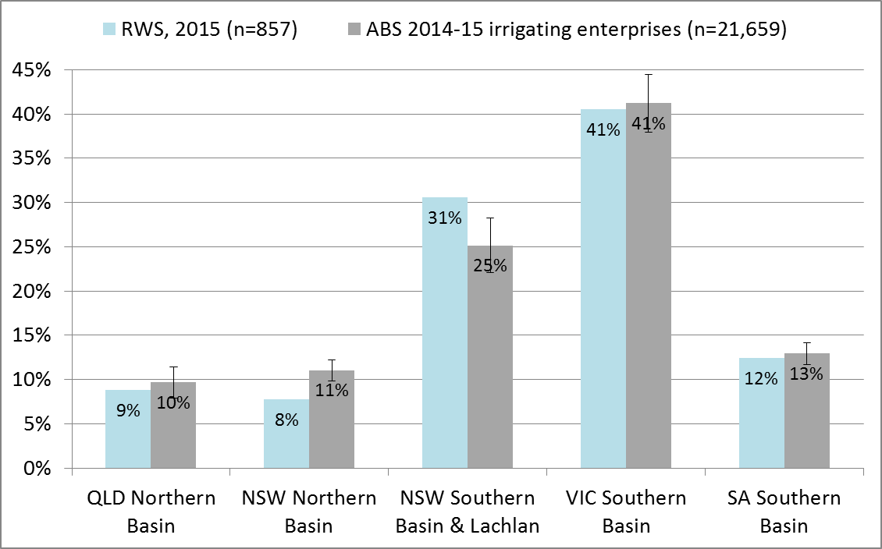

#### Representativeness of community-wide sample

Some analyses in this report examine the views and experiences of the community as a whole in some parts of the Basin, rather than only irrigators. When conducting analysis of the views of the entire adult population living in different communities, it was important to address known biases in the sample achieved: particularly the deliberate oversampling of farmers in the RWS, as well as unintentional oversampling of women and older residents (see Schirmer et al. 2016 for a detailed description of sample bias in the 2015 RWS). To ensure the community-scale findings presented in this report are representative of the true distribution of the population, data weighting was used. ‘Weighting’ refers to a statistical process in which known biases in the responses received are corrected for. Weighting responses involves adjusting the relative contribution each survey respondent contributes to the whole when analysing survey results, so that analysed data from the survey sample more accurately represents the population it was drawn from (in this case, people living in rural and regional Australia). Weighting doesn’t change the answers people gave to survey questions.

When conducting analysis of the community as a whole, data were weighted using GREGWT, a generalised regression weighting procedure developed by the Australian Bureau of Statistics. GREGWT is a SAS macro that generates survey weights so that survey estimates agree with external benchmarks, which we obtained from the 2011 Australian census. For the 2015 Regional Wellbeing Survey, the benchmarks used were age (18-39, 40-54, 55-64, 65+), sex (female, male), agricultural occupation (farmer, not-farmer), and geographical location. Due to the way GREGWT calculates weights, a small number of respondents were allocated unrealistically high weights. This was a consequence of having a small number of observations corresponding to a particular benchmark category. To control for extreme weights, weights were Winsorised at the 95th percentile, thus controlling for unrealistically high weights. Winsorisation was considered an appropriate method of adjusting the data as (i) the source of data bias was known, and (ii) comparison of Winsorised and non-Winsorised datasets against independent benchmarks for key variables showed that the Winsorised data better reflects distributions seen in other datasets.

### Statistical significance & presentation of findings

It is important to note that throughout the report, the sample sizes of some groups limit our ability to state with certainty that their views are different to those of others. In particular, where there is a sample of less than 100 people in a given group, the small sample size means that it is not possible to state their views are significantly different to those of others unless there is a very large difference in views.

Throughout this report, where we can be statistically confident that the views of one group are significantly different to others, we state this by using the term ‘significant’ when describing results. Statistical significance is defined as there being a less than a 5% likelihood that the differences in views occurred by random chance.

Throughout this report, we use the term ‘significantly different’ to identify when one group was statistically more or less likely than others to hold a particular view. In these cases, a footnote is used to identify the specific statistical test used to identify significance. In all cases, a 5% threshold was used, meaning that the test identified whether the likelihood that the difference between responses was due to random change was below 5%.

Additionally, ‘average’ scores are reported for some results in this report. In all cases, unless otherwise specified, the term ‘average’ refers to the mean score for the group of people being analysed (not to the median or mode).

### Ethics

The Regional Wellbeing Survey was approved by the University of Canberra Human Research Ethics Committee, protocol number 12-186.

## Results

Results are presented in four chapters. The first describes the irrigators who responded to the survey, to provide context for subsequent chapters. The second analyses the socio-economic effects of on-farm water infrastructure grants, the third examines off-farm infrastructure grants, and the fourth analyses water entitlement purchase by the government. Each of the second to fourth chapters has the following sub-sections:

* Identifying people directly involved. This section describes how ways people were identified as having been directly involved in receiving an on-farm infrastructure grant or directly experiencing effects of and off-farm infrastructure grant, or selling water entitlements
* Direct effects on irrigators. This section evaluates the experiences of the irrigators directly affected by on-farm infrastructure, off-farm infrastructure and water purchase investment. These direct effects are evaluated to identify if they vary depending on the broader socio-economic circumstances of the irrigators participated in these activities, for example their age, farm size, and other factors; and whether irrigators who have participated in these activities are reporting better or poorer socio-economic outcomes for their household or their farm compared to those who have not participated in the activities.
* Indirect effects on other farmers. This section evaluates whether other irrigators living in regions where grants for on-farm infrastructure and water entitlement purchase occurred, but who did not receive a grant or sell water, experienced flow-on effects as a consequence of other farmers participating in these programs.

The fifth chapter then examines whether it is possible to identify effects of irrigation infrastructure investment or water entitlement purchases at the scale of communities. It examines the potential flow-through effects to communities, and the measures that might differ if the investment in infrastructure or purchase of water entitlements had impacts large enough to change overall socio-economic wellbeing of communities. It then evaluates whether the 2015 RWS data provide any evidence for these potential flow-on effects, focusing on whether communities experiencing more or less investment in infrastructure and/or entitlement sales to government report differing outcomes to each other in terms of overall confidence in community future, community economic outcomes, and other relevant community development measures.

## Irrigators in the Murray-Darling Basin

This chapter provides a brief overview of the farming and socio-demographic characteristics of the irrigators who participated in the 2015 Regional Wellbeing Survey. The sample showed expected differences: Northern Basin irrigators are typically operating larger enterprises (in terms of both land area and economic turnover), more likely to be irrigating from rivers, and more likely to be pure cropping or mixed crop-beef enterprises. Southern Basin irrigators typically operate smaller enterprises, are more likely to be irrigating from channels, and more likely to be running horticultural and dairy enterprises.

**Farm size** (Table 1): Irrigators in the Northern Basin on average had larger farms than those in the Southern Basin, in terms of both physical area and turnover. Those who had upgraded on-farm infrastructure since 2008 on average had higher GVAP compared to other irrigators. Those who had received an on-farm infrastructure grant as part of the SRWUIP program had farms that were larger than average in terms of both physical area and GVAP. Those who lived in regions where SRWUIP funds had been used to upgrade off-farm infrastructure since 2008 reported similar GVAP and slightly smaller farm size compared to the Basin average. This reflects that off-farm modernisation typically occurs in irrigation districts, which have on average smaller property sizes compared to properties not located in irrigation districts. Those who had sold water entitlements to government since 2008 and remained in irrigated agriculture typically had a slightly larger farm size in terms of GVAP and physical area compared to the average.

**Farm type** (Table 2): The most common types of farm production reported by irrigators in the Murray-Darling Basin were wine grape growing, fruit/nut production, dairy farming, and crop growing, but there were a wide range of other production types including beef and sheep grazing and fodder production. Northern Basin irrigators were more likely to report being pure crop growing enterprises or mixed crop-beef enterprises compared to those in the Southern Basin, while those in the Southern Basin were more likely to report dairy farming, fruit/nut growing and wine grape growing.

**Water use** (Table 3): As expected based on farm size, irrigators in the Northern Basin on average reported using a larger volume of irrigation water in the last year compared to those in the Southern Basin. Those who had upgraded on-farm infrastructure (with or without assistance of a grant) reported a higher average volume of water use. Those who received SRWUIP on-farm grants typically reported higher volumes of water use than the average for the Southern Basin, reflecting that their farms are typically larger in terms of both area and economic size. Those living in regions in which off-farm infrastructure modernisation has been funded by SRWUIP typically reported lower water use compared to others in the Basin, reflecting their smaller typical farm size. Those in the Southern Basin were more likely to report using water from irrigation channels than pumping directly from rivers or lakes. Those in the Northern Basin more commonly used water from rivers/lakes than irrigation channels, but where they did draw from irrigation channels, reported higher average volumes of water use compared to Southern Basin irrigators.

**Socio-demographic characteristics** (Table 4): There was relatively little difference in the age or gender distribution of irrigators, with two exceptions: the average age of Northern Basin irrigators was slightly younger than Southern Basin irrigators, and those who had upgraded on-farm infrastructure (with or without assistance from a grant) were on average slightly younger than other irrigators.

Table 1 Farm size of irrigators – gross value of agricultural production and physical area

| Basin irrigators by farm size | Farm size - Gross Value of Agricultural Production (GVAP) Mean1 GVAP | Farm size - Gross Value of Agricultural Production (GVAP) Median1 GVAP | Farm enterprise size (average hectares)2 Mean ha | Farm enterprise size (average hectares)2 Median ha | Farm size  (proportion of irrigators in each property size. Note: the size reported is total size of property, rather than only the irrigated area) 0-50 ha | Farm size  (proportion of irrigators in each property size. Note: the size reported is total size of property, rather than only the irrigated area) 51-200 ha | Farm size  (proportion of irrigators in each property size. Note: the size reported is total size of property, rather than only the irrigated area) 201-1,000 ha | Farm size  (proportion of irrigators in each property size. Note: the size reported is total size of property, rather than only the irrigated area) 1,001-10,000 ha | Farm size  (proportion of irrigators in each property size. Note: the size reported is total size of property, rather than only the irrigated area) >10,000 ha | n |
| --- | --- | --- | --- | --- | --- | --- | --- | --- | --- | --- |
| All irrigators | $200,000-$299,999 | $200,000-$299,999 | 2200ha | 202ha | 31% | 19% | 29% | 19% | 3% | 1147 |
| Murray Darling Basin irrigators | $300,000-$399,999 | $200,000-$299,999 | 1898ha | 250ha | 29% | 17% | 29% | 22% | 3% | 849 |
| Northern Basin irrigators | $300,000-$399,999 | $300,000-$399,999 | 5012ha | 807ha | 15% | 13% | 27% | 34% | 11% | 140 |
| Southern Basin irrigators | $200,000-$299,999 | $200,000-$299,999 | 1103ha | 200ha | 32% | 19% | 30% | 17% | 2% | 651 |
| Basin irrigator, upgraded on-farm infrastructure since 2008 | $300,000-$399,999 | $300,000-$399,999 | 1971ha | 398ha | 23% | 17% | 32% | 25% | 3% | 404 |
| SRWUIP on-farm infrastructure grant recipients | $400,000-$499,999 | $400,000-$499,999 | 1773ha | 462ha | 17% | 17% | 40% | 24% | 2% | 124 |
| Irrigators living in off-farm SRWUIP region | $300,000-$399,999 | $200,000-$299,999 | 1069ha | 210ha | 31% | 18% | 30% | 20% | 1% | 511 |
| Basin irrigators who sold water entitlements to government since 2008 | $300,000-$399,999 | $300,000-$399,999 | 1520ha | 390ha | 23% | 16% | 36% | 24% | 2% | 186 |

1Irrigators were asked to select which range their GVAP fell into. The range report is that into which the 'average' fell.

2A total of eight outliers were removed from the analysis of farm area, for two reasons: to preserve confidentiality, and to remove some data that could not be verified as being entered in hectares rather than acres.

Table 2 Farm type reported by irrigators

| Basin irrigators by farm type | All irrigators | Murray Darling Basin irrigators | Northern Basin irrigators | Southern Basin irrigators | Basin irrigator, upgraded on-farm infrastructure since 2008 | SRWUIP on-farm infrastructure grant recipients | Irrigators living in off-farm SRWUIP region | Basin irrigators who sold water entitlements to government since 2008 |
| --- | --- | --- | --- | --- | --- | --- | --- | --- |
| Beef grazier | 9% | 9% | 18% | 7% | 6% | 7% | 6% | 6% |
| Beef-sheep grazier | 2% | 2% | 1% | 2% | 1% | 2% | 2% | 1% |
| Crop grower | 9% | 11% | 29% | 6% | 12% | 7% | 7% | 11% |
| Dairy farmer | 14% | 11% | 4% | 14% | 13% | 20% | 16% | 19% |
| Fodder grower | 6% | 6% | 5% | 6% | 8% | 11% | 8% | 9% |
| Fruit/nut grower | 13% | 12% | 7% | 13% | 12% | 12% | 12% | 11% |
| Intensive cattle | 2% | 2% | 1% | 2% | 2% | 2% | 2% | 1% |
| Intensive livestock | 1% | 1% | 2% | 1% | 1% | 1% | 1% | 1% |
| Mixed crop-beef | 2% | 3% | 10% | 1% | 4% | 3% | 2% | 2% |
| Mixed crop-sheep | 6% | 7% | 1% | 7% | 7% | 9% | 8% | 6% |
| Rice grower | 5% | 6% | 1% | 8% | 10% | 11% | 9% | 13% |
| Sheep grazier | 6% | 6% | 3% | 7% | 5% | 1% | 5% | 5% |
| Vegetable grower | 5% | 2% | 3% | 2% | 2% | 0% | 2% | 2% |
| Wine grape grower | 12% | 12% | 6% | 14% | 12% | 11% | 12% | 9% |
| Other | 2% | 2% | 2% | 2% | 1% | 0% | 1% | 1% |
| n | 1158 | 858 | 142 | 657 | 418 | 124 | 516 | 193 |

Table 3 Water use by irrigators

| Basin irrigators by water usage | Mode | All irrigators | Murray Darling Basin irrigators | Northern Basin irrigators | Southern Basin irrigators | Basin irrigator, upgraded on-farm infrastructure since 2008 | SRWUIP on-farm infrastructure grant recipients | Irrigators living in off-farm SRWUIP region | Basin irrigators who sold water entitlements to government since 2008 |
| --- | --- | --- | --- | --- | --- | --- | --- | --- | --- |
| Total volume of water use (ML) | Mean | 2679 | 1038 | 1320 | 935 | 1347 | 1242 | 769 | 1275 |
| Total volume of water use (ML) | Median | 180 | 220 | 190 | 234 | 340 | 570 | 300 | 500 |
| % irrigators reporting different volumes of water use | 0-50ML | 30% | 25% | 28% | 24% | 16% | 15% | 19% | 17% |
| % irrigators reporting different volumes of water use | 51-200ML | 24% | 24% | 29% | 24% | 22% | 15% | 25% | 17% |
| % irrigators reporting different volumes of water use | 201-1,000ML | 30% | 33% | 20% | 36% | 39% | 40% | 38% | 37% |
| % irrigators reporting different volumes of water use | >1,000ML | 16% | 17% | 24% | 17% | 23% | 29% | 19% | 29% |
| n | - | 799 | 629 | 80 | 513 | 369 | 112 | 429 | 159 |
| Volume of water used from irrigation channels (ML) | Mean | 965 | 1046 | 2477 | 1020 | 1438 | 992 | 719 | 1116 |
| Volume of water used from irrigation channels (ML) | Median | 250 | 268 | 1800 | 280 | 400 | 490 | 300 | 462 |
| n | - | 426 | 382 | 11 | 352 | 233 | 92 | 339 | 125 |
| Volume of water used from rivers/lakes (ML) | Mean | 680 | 865 | 1608 | 690 | 1075 | 1203 | 679 | 1143 |
| Volume of water used from rivers/lakes (ML) | Median | 100 | 128 | 290 | 120 | 235 | 413 | 185 | 300 |
| n | - | 259 | 181 | 37 | 129 | 108 | 22 | 90 | 38 |
| Volume of water used from ground water (ML) | Mean | 6889 | 364 | 423 | 305 | 516 | 780 | 398 | 595 |
| Volume of water used from ground water (ML) | Median | 100 | 101 | 150 | 100 | 200 | 280 | 169 | 280 |
| n | - | 219 | 151 | 44 | 99 | 87 | 27 | 60 | 32 |

Table 4 Socio-demographic characteristics of irrigators

| Socio-demographic | Category | All irrigators | Murray Darling Basin irrigators | Northern Basin irrigators | Southern Basin irrigators | Upgraded on-farm infrastructure since 2008 | SRWUIP on-farm infrastructure grant recipients | Irrigators living in off-farm SRWUIP region | Irrigators who sold entitlements to government since 2008 |
| --- | --- | --- | --- | --- | --- | --- | --- | --- | --- |
| Gender | Female | 33% | 32% | 35% | 31% | 30% | 32% | 30% | 27% |
| Gender | Male | 67% | 68% | 65% | 69% | 70% | 68% | 70% | 73% |
| Age | <49 years | 19% | 19% | 21% | 18% | 22% | 23% | 20% | 14% |
| Age | 50-64 years | 46% | 45% | 50% | 43% | 48% | 45% | 43% | 52% |
| Age | 65+ | 34% | 36% | 29% | 39% | 30% | 32% | 37% | 34% |
| n | - | 1148 | 852 | 139 | 656 | 415 | 124 | 513 | 193 |

## On-farm water infrastructure grants

### Introduction

Many irrigators invest in improving their on-farm water infrastructure. The goal of the on-farm infrastructure grants delivered as part of the SRWUIP has been to encourage modernisation of infrastructure to improve water use efficiency, enabling transfer of water entitlements to government and contributing to meeting the sustainable diversion limits set as part of the Basin Plan. To examine the effects of on-farm water infrastructure grants, it is necessary to identify:

* Who has modernised/upgraded their on-farm water infrastructure since 2008?
* Of those who modernised/upgraded, how many received support from the SRWUIP to assist them in doing so?
* How do the types of works undertaken with and without SRWUIP funding compare? Has SRWUIP funding made a difference to the nature and extent of modernisation undertaken?
* What have been the outcomes of on-farm modernisation in terms of farm performance and wellbeing of farmers?

### How many irrigators have upgraded on-farm water infrastructure since 2008?

Many irrigators will upgrade their on-farm water infrastructure over time, whether or not they have assistance from a government grant. To understand the effects of the SRWUIP investment therefore requires identifying how many irrigators have upgraded on-farm water infrastructure, and what proportion of these did so with assistance from a SRWUIP grant.

All irrigators who participated in the 2015 Regional Wellbeing Survey were asked whether they had upgraded their on-farm water infrastructure at any point in the seven years prior to completing the survey, a period chosen as it encompassed the full life of the SRWUIP. More than half – 57% - reported having done this (Figure 1)[4]. Irrigators living in the Basin were more likely to have done this (59%) than those outside the Basin (52%). Within the Basin, irrigators in the New South Wales part of the Southern Basin[5] (‘NSW Southern Basin’) were most likely to report upgrading (70%), followed by those living in the South Australian parts of the Basin (SA Basin) (67%), the NSW Northern Basin (65%), Victorian parts of the Basin (VIC Basin) (51%), and Queensland parts of the Basin (QLD Basin) (50%). While those living in the Northern Basin were slightly less likely to report having upgraded infrastructure (56% compared to 60% in the Southern), this difference was not statistically significant.

This result highlights that while many irrigators have invested in upgrading on-farm water infrastructure in the last eight years, more than 40% have not substantially modernised their water infrastructure during this period. The sections below examine what proportion of irrigators modernised with and without assistance of government funding from the SRWUIP program, and compare the farm performance of those who didn’t upgrade on-farm water infrastructure in the last eight years with those who upgraded with and without assistance of a government grant.

Figure 2 Have you upgraded existing or added new irrigation infrastructure on your farm since 2008? Irrigator responses by region

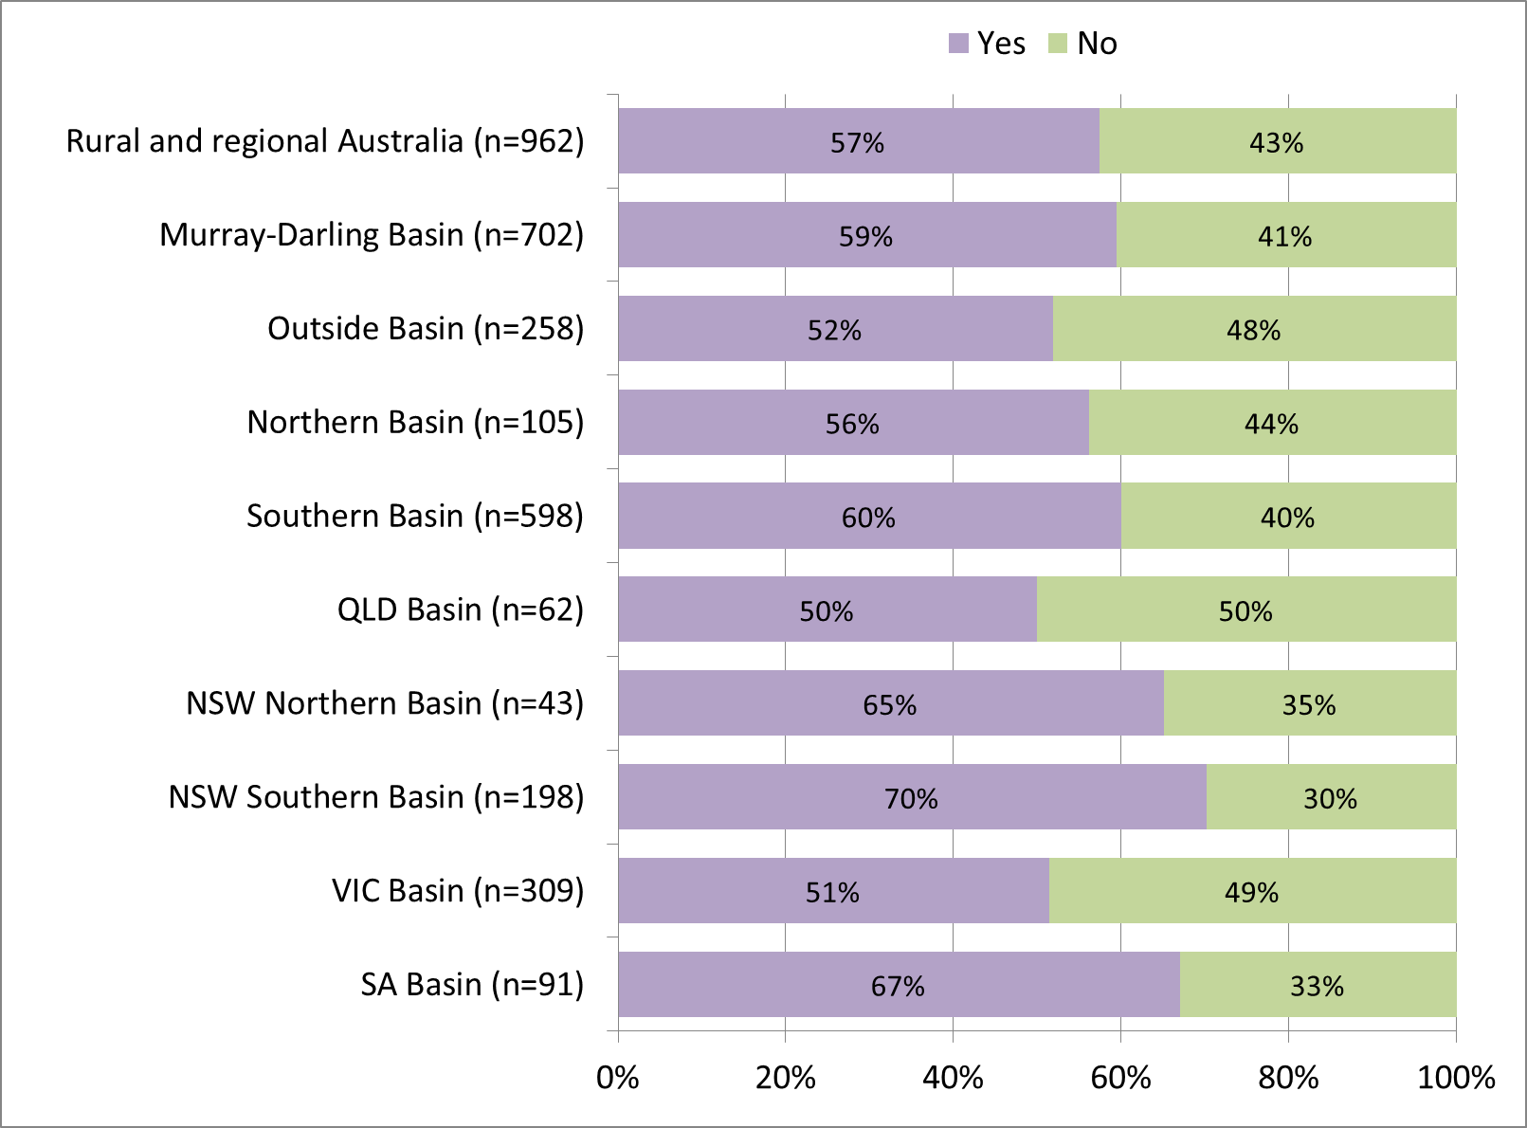

### Funding sources used to upgrade on-farm infrastructure

Not all Basin irrigators who modernised in the last eight years did this with assistance from a SRWUIP grant. Those who did have assistance from a SRWUIP grant also typically invested their own funds into the infrastructure upgrade. Survey data were analysed to identify what proportion of irrigators had upgraded on-farm infrastructure using different sources of funding, focusing on SRWUIP grants and other funding sources.

#### SRWUIP on-farm infrastructure grant recipients

Thirty two per cent of Basin irrigators who upgraded their on-farm infrastructure since 2008 received SRWUIP grants to do so (Figure 3). SRWUIP grant recipients were more commonly located in the Southern Basin than the Northern Basin.

The proportion of irrigators who upgraded on-farm water infrastructure with assistance from a SRWUIP grant was identified by asking those who had upgraded their on-farm infrastructure (i) how the upgrade was funded and (ii) in what year/s upgrade works occurred. This information, together with the geographic location of the survey participant, was then compared with a dataset provided by the DAWR which identified the local government areas in which on-farm grants had been funded in different years as part of the SRWUIP. An irrigator was classified as a SRWUIP recipient if they met three criteria: (i) they reported their in-farm infrastructure was partly or wholly funded by the government or by an organisation contracted to distribute SRWUIP funds, (ii) they lived in a local government area in which SRWUIP funding had been distributed (based on DAWR data), and (iii) they reported undertaking works within two years of the dates in which SRWUIP funding agreements were signed[6].

Figure 3 Irrigators who had upgraded on-farm water infrastructure since 2008: Proportion of irrigators who upgraded on-farm infrastructure after 2008 with (i) no grant, (ii) non-SRWUIP grant, (iii) SRWUIP grant

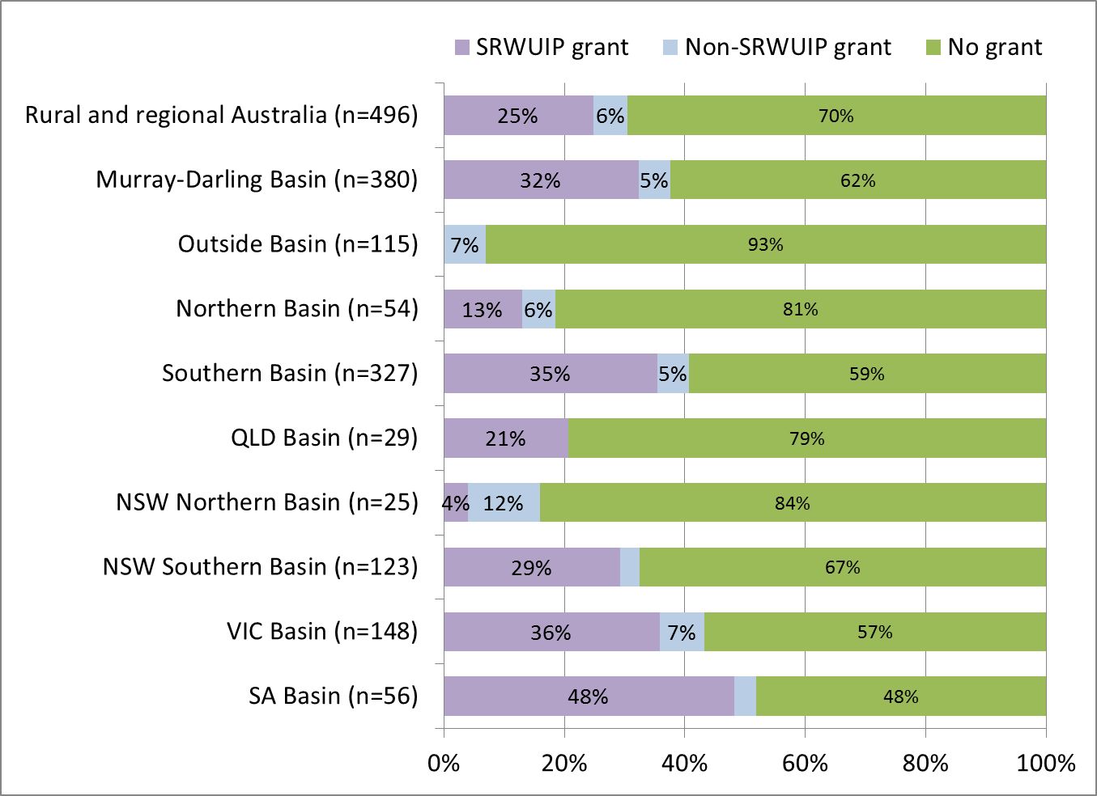

#### Funding sources used to fund modernisation of on-farm water infrastructure

Irrigators who had modernised on-farm water infrastructure since 2008 were asked to nominate how they funded the upgrade works, and could select multiple sources of funding, shown in Figure 4. In many cases, irrigators use multiple sources of funding. The most common combination of funding sources was self-funding in combination with accessing a grant or a loan. This is not surprising, given that many grant programs have conditions requiring irrigators to provide matching funding in order to access grant support. The large majority of irrigators self-funded part or all of their upgrade work, while across Australia 24% accessed a government grant (31% in the Basin), and 16% a loan from a bank or other organisation, while 3% reported receiving a grant from their water provider or farm organisations, and 3% were funded from other sources. Most Basin irrigators who accessed a government grant or a grant from a water provider or farming organisation were subsequently identified as having received a grant originating from the SRWUIP (in some cases, SRWUIP funds were delivered via water providers or farming organisations, and in others via government agencies, meaning farmers might identify any of these as the source of their funding and were not necessarily aware the funding originated from the SRWUIP).

Figure 4 Sources of funding used when upgrading/expanding on-farm water infrastructure (respondents could select multiple sources)

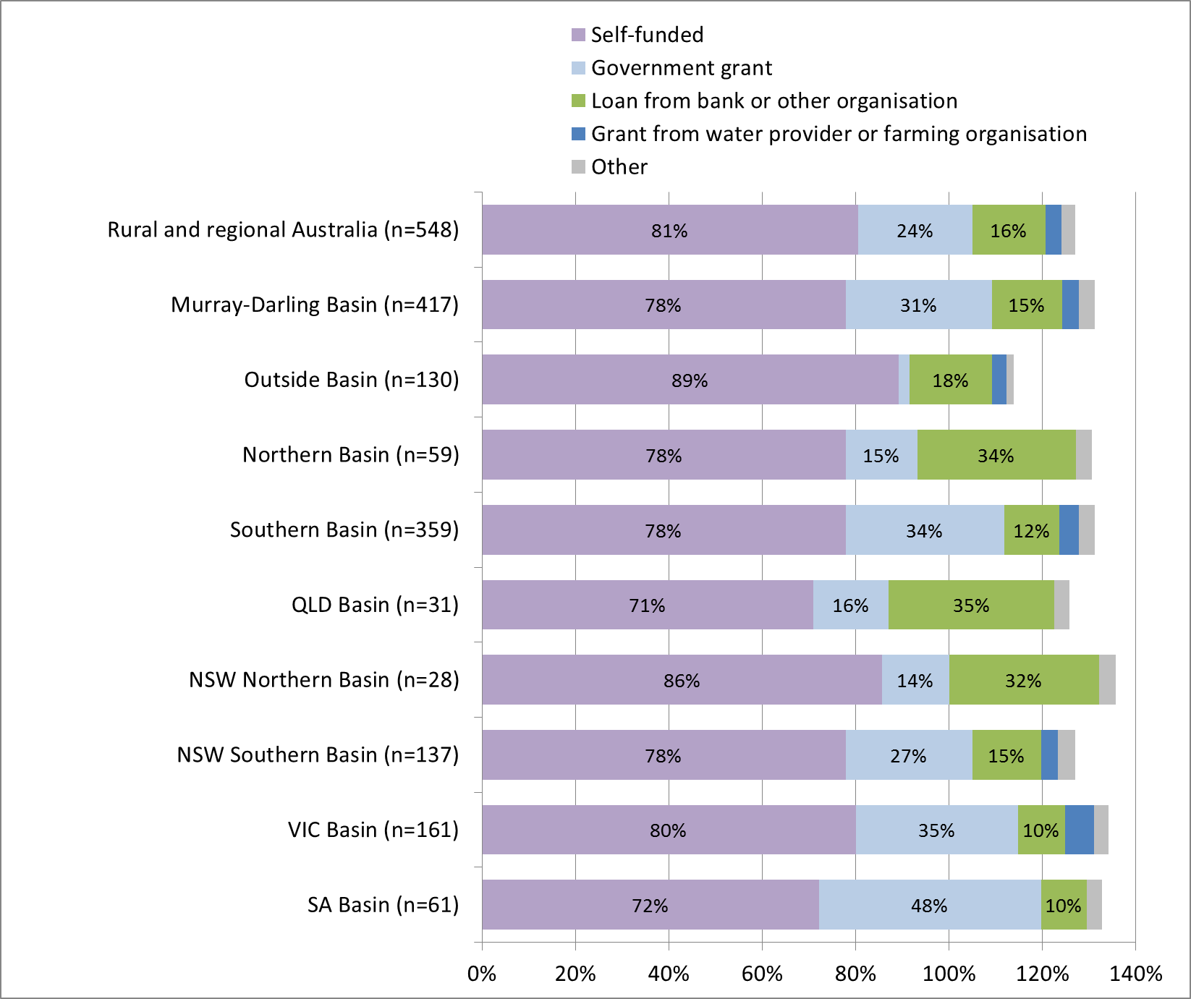

#### When have irrigators modernised on-farm water infrastructure?

The socio-economic outcomes of modernising on-farm infrastructure can take some time to be realised: the modernisation works typically need to be completed and operational for a period before farmers experience their full effects on things such as farm labour requirements, water use efficiency, profitability or electricity costs, to name a few. To ensure the time since works were undertaken could be taken into account when analysing socio-economic outcomes, irrigators were asked in what years they had completed on-farm infrastructure upgrades, shown in Table 5.

Those who reported having upgraded irrigation infrastructure since 2009 mostly reported a single year in which upgrades had occurred. However, 22% reported that they had completed upgrade work in more than one year. When an irrigator had completed multiple upgrades since 2009, the year in which the earliest upgrade was completed was included in Table 1, as it was considered likely that the irrigator would experience benefits and costs of upgrading from the point at which they completed their first upgrade works.

Table 5 Years in which irrigators reported completing on-farm water infrastructure upgrade/expansion

| Basin irrigators by year | 2008 | 2009 | 2010 | 2011 | 2012 | 2013 | 2014 | 2015 |
| --- | --- | --- | --- | --- | --- | --- | --- | --- |
| Rural and regional Australia (n=488) | 7% | 21% | 13% | 6% | 11% | 13% | 15% | 15% |
| Murray-Darling Basin (n=374) | 7% | 22% | 13% | 6% | 11% | 12% | 15% | 14% |
| Outside Basin (n=113) | 5% | 19% | 10% | 4% | 11% | 13% | 18% | 19% |
| Northern Basin (n=54) | 6% | 24% | 19% | 4% | 17% | 11% | 13% | 7% |
| Southern Basin (n=321) | 7% | 21% | 12% | 7% | 10% | 12% | 15% | 15% |
| QLD Basin (n=29) | 3% | 17% | 17% | 7% | 21% | 7% | 17% | 10% |
| NSW Northern Basin (n=25) | 8% | 32% | 20% | 0% | 12% | 16% | 8% | 4% |
| NSW Southern Basin (n=121) | 6% | 15% | 14% | 7% | 12% | 12% | 17% | 17% |
| VIC Basin (n=144) | 8% | 25% | 11% | 9% | 8% | 14% | 17% | 9% |
| SA Basin (n=56) | 9% | 25% | 13% | 2% | 9% | 9% | 7% | 27% |

One in five irrigators indicated having upgraded on-farm infrastructure in more than one year since 2009. When this was the case, the year in which the earliest upgrade was completed is shown in Table 1. Note that when these data were used to identify SRWUIP recipients, all years of completion were included in the analysis.

Respondents who had upgraded on-farm infrastructure prior to 2008 were not considered to have modernised recently enough to be considered part of the sample of irrigators who had upgraded on-farm infrastructure. This was for two reasons: (i) if their most recent upgrade was more than seven years ago, it is likely any effects on their farm enterprise are no longer distinguishable due to the length of time since the upgrade, and (ii) they upgraded prior to the availability of funds under SWRUIP, and hence their inclusion would reduce ability to compare effects of investments undertaken with SRWUIP grants to investments undertaken without grants.

### Type and area of on-farm modernisation works

Irrigators who had upgraded or expanded on-farm infrastructure were asked what types of works had been undertaken. In many cases, irrigators reported they had undertaken multiple types of works when upgrading/expanding, shown in Figure 5, which compares SRWUIP recipients to those who did not have grant assistance.

The most common type of works undertaken was installing new or upgraded watering systems (67% of Basin irrigators), improving irrigation area layout or design (53%), upgrading irrigation technology such as automated water systems (29%) and investing in equipment that assists in managing irrigation (20%). While Figure 5 indicates some small differences between SRWUIP grant recipients and those who received no grant, these differences were not statistically significant.

There were greater differences between regions: those located outside the Basin were much less likely to report they improved irrigation area layout or design, as were those living in the SA Basin. SA Basin irrigators were more likely to report having upgraded irrigation technology compared to those in other regions (Table 6).

While there was little difference in the type of works undertaken, SRWUIP grants have enabled farmers to modernise a larger proportion of on-farm infrastructure than typically occurs when the farmer has to rely on self-funding and loans to fund upgrade works. Irrigators who had expanded/upgraded were asked what percentage of their irrigated land the works were implemented on. SRWUIP grant recipients were much more likely to have upgraded 60% or more of their infrastructure compared to those who had not received a grant (Figure 6): just over half of SRWUIP recipients upgraded 60% or more of their irrigated area, compared to only 28% of Basin irrigators who upgraded on-farm infrastructure without grant assistance. There were fewer differences by region (Figure 7).

Figure 5 Types of on-farm works undertaken by irrigators when upgrading/expanding on-farm water infrastructure – comparison of Basin irrigators who were SRWUIP recipients and who did not receive grants

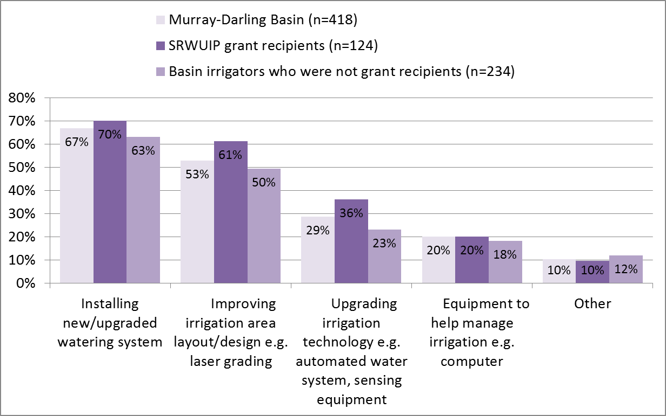

Table 6 Types of on-farm works undertaken by irrigators when upgrading/expanding on-farm water infrastructure – comparison of irrigators located in different regions

| Farm works type | Installing new/ upgraded watering system | Improving irrigation area layout/design e.g. laser grading | Upgrading irrigation technology e.g. automated water system, sensing equipment | Equipment to help manage irrigation e.g. computer | Other |
| --- | --- | --- | --- | --- | --- |
| Rural and regional Australia (n=557) | 68% | 46% | 28% | 20% | 11% |
| Murray-Darling Basin (n=418) | 67% | 53% | 29% | 20% | 10% |
| Southern Basin (n=361) | 66% | 56% | 30% | 20% | 9% |
| Northern Basin (n=58) | 72% | 34% | 17% | 22% | 17% |
| Outside Basin (n=139) | 71% | 24% | 26% | 19% | 14% |
| NSW Northern Basin (n=25) | 88% | 32% | 12% | 12% | 8% |
| NSW Southern Basin (n=139) | 60% | 71% | 25% | 18% | 6% |
| VIC Basin (n=158) | 66% | 59% | 28% | 18% | 11% |
| QLD Basin (n=33) | 61% | 36% | 21% | 30% | 24% |
| SA Basin (n=63) | 79% | 13% | 48% | 27% | 11% |

Figure 6 Proportion of irrigation area upgraded/expanded as part of works conducted since 2008, by Basin irrigators who did and did not receive SRWUIP grants

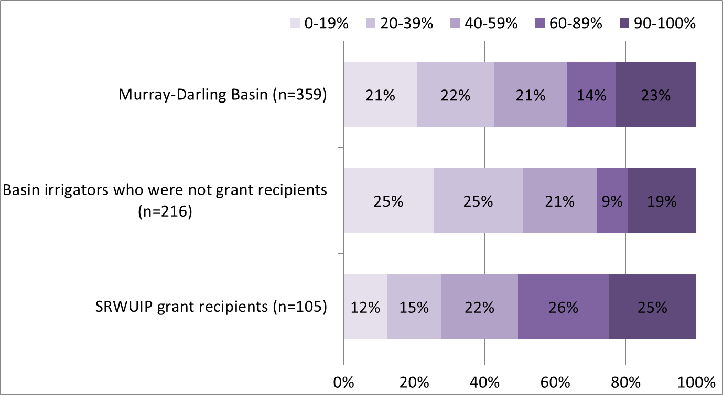

Figure 7 Proportion of irrigation area upgraded/expanded as part of works conducted since 2008, by region

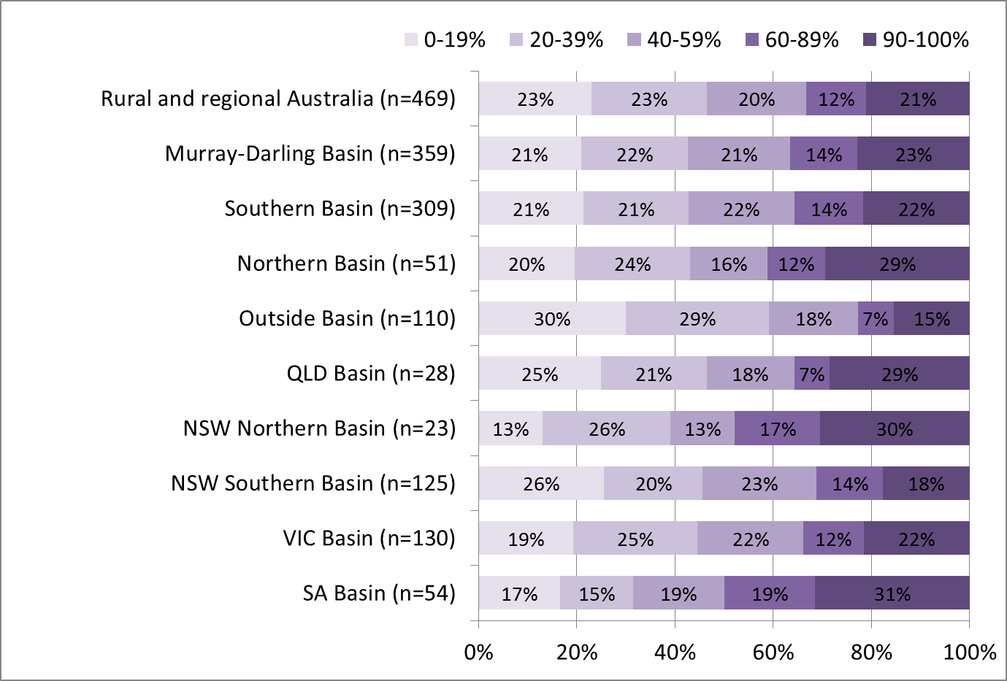

### Drivers of on-farm water infrastructure modernisation

This section examines the ‘drivers’ of on-farm water infrastructure modernisation: in other words, it examines which irrigators were more or less likely to have modernised their on-farm water infrastructure, and to have accessed a SRWUIP grant to do so. The following types of drivers are compared:

* Socio-demographic characteristics of the farmer such as age, gender, educational attainment and off-farm work
* Farm characteristics, such as economic and physical size, commodities produced, and farm management approaches
* External drivers, such as changes in water markets, experience of drought, and changes in input costs.

#### Socio-demographic characteristics

Irrigators were significantly more likely to have upgraded on-farm water infrastructure in the last seven years if they were (Figure 8):

* Younger (aged 30 to 49, shown in Figure 8)
* Had completed year 12 or higher levels of educational attainment (Figure 8), and
* Did not have off-farm work (Figure 8): those who had not upgraded on averaged derived 57% of their household income from their farm, compared to 63% for those who had upgraded.
* Had higher household income: those who upgraded on-farm water infrastructure on average reported household income of $65,000-77,999 in the 2014-15 financial year, while those who did not upgrade had an average household income of $52,000-$64,999.

They were significantly less likely to have modernised on-farm infrastructure if they were aged 65 and over, had not completed high school, and had full-time off-farm work.

Of those who upgraded on-farm water infrastructure, SRWUIP grant recipients were more likely than non-SRWUIP grant recipients to (Figure 9):

* Be aged 65 and older
* Work full-time on the farm: those who accessed a SRWUIP grant earned an average of 68% of their household income from their farm, compared to 62% for those who upgraded without a grant
* Not have a university degree.

There was no difference in the average household income of those who upgraded with and without assistance of a SRWUIP grant.

Figure 8 Proportion of irrigators who had upgraded on-farm water infrastructure since 2008, by socio-demographic characteristic

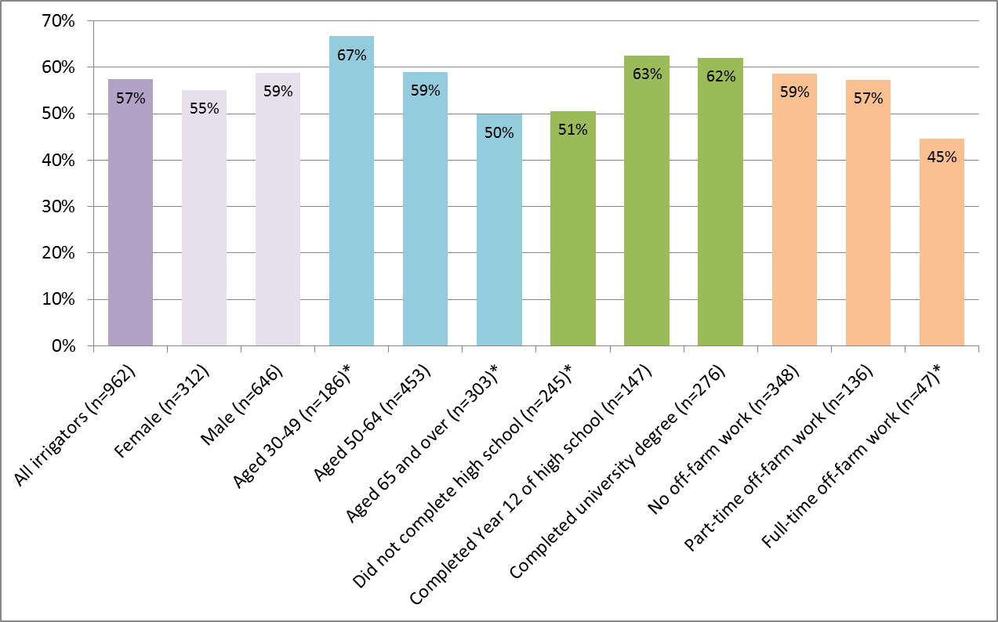

Figure 9 Proportion of irrigators who had upgraded on-farm water infrastructure since 2008 who had done so with support from a SRWUIP grant, by socio-demographic characteristic

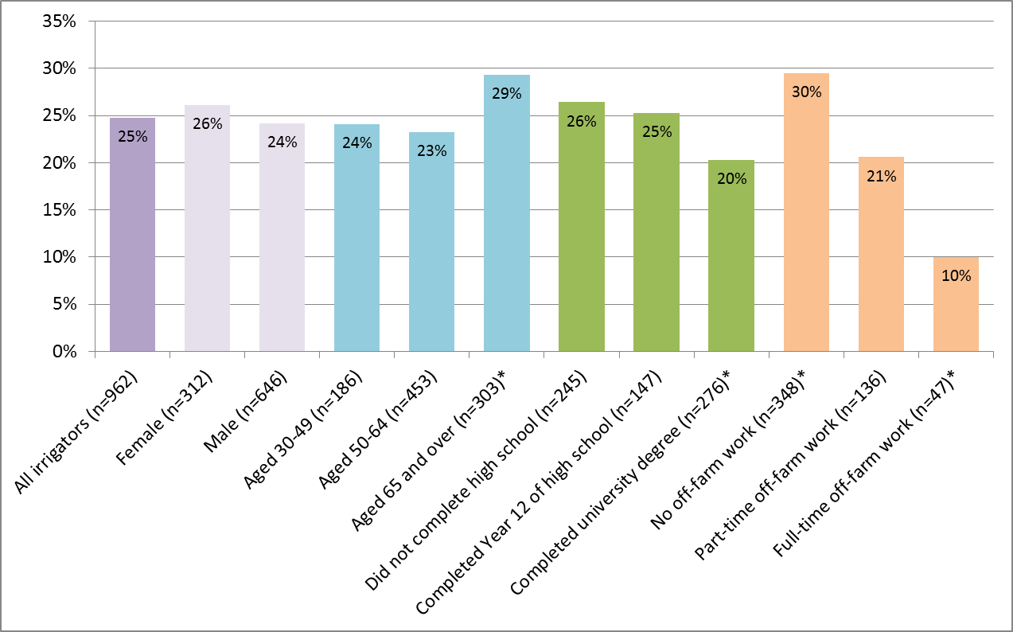

#### Farm characteristics

Irrigators who upgraded on-farm infrastructure typically had a larger economic turnover, were more likely to be rice growers, and least likely to be involved in a pure grazing enterprise, and more likely to engage in active farm planning, compared to those who had not upgraded farm infrastructure.

Irrigators who upgraded on-farm infrastructure typically reported higher GVAP compared to those who did not upgrade, as reported earlier in this report and in Table 7, and those who upgraded with assistance from a SRWUIP grant reported higher GVAP than those who upgraded without a grant. However, those who upgraded with a SRWUIP grant on average reported having a smaller farm in terms of physical area and volume of water use than those who upgraded without a grant (although larger than those who had not upgraded their on-farm infrastructure at all). Those who had upgraded reported larger farm debt on average than those who had not; this corresponds with the overall larger economic size of farms on which upgrades occurred, with farms with higher turnover typically also having larger farm debt (Schirmer et al. 2015).

Rice growers were significantly more likely to report having upgraded their on-farm water infrastructure since 2008, and extensive sheep and beef graziers least likely to, as shown in Figure 10. Of those who upgraded, rice growers, mixed crop-livestock growers, and dairy farmers were more likely than others to have accessed a SRWUIP grant to assist in the upgrade, with 34%-36% of these types of farmers accessing a grant to assist their on-farm modernisation works. Sheep and beef graziers were least likely to access to a SRWUIP grant (Figure 11).

Irrigators who had a written farm plan that included clear business objectives were more likely to have upgraded their on-farm infrastructure than those who did not have a written farm plan (65% compared to 54%), and also more likely to have upgraded with the assistance of a SRWUIP grant (33% compared to 24%) (Figure 12). This suggests an important role for farm planning and business management processes in helping irrigators identify opportunities to achieve their farm objectives through investing in modernisation of infrastructure.

Table 7 Average water use, farm size, value of agricultural production, and farm debt of Basin irrigated enterprises that had and had not upgraded on-farm water infrastructure since 2008

| Average water use, farm size, value of agricultural production, and farm debt | Had not upgraded on-farm water infrastructure since 2008 | Had upgraded on-farm water infrastructure since 2008 | Upgraded with no grant | Upgraded with SRWUIP grant |
| --- | --- | --- | --- | --- |
| Irrigation water used on farm from all sources, 2014-15 (megalitres, mean) | 282MLa | 1348MLa | 1502MLb | 1242MLb |
| Farm area (mean hectares) | 1228haa | 1971haa | 2154hab | 1746hab |
| Gross value of agricultural production 2014-14 (range into which 'average' irrigator fell) | $200,000 - $299,999a | $300,000 - $399,999a | $300,000 - $399,999b | $400,000 - $499,999b |
| Farm debt (average, spring 2015) | $100,000-$199,999a | $300,000 - $399,999a | $300,000 - $399,999 | $300,000 - $399,999 |

a There was a statistically significant difference between those who had and had not upgraded infrastructure

b There was a statistically significant difference between those who had upgraded with no grant and those who upgraded with assistance from a SRWUIP grant

Figure 10 Proportion of irrigators who had upgraded on-farm water infrastructure since 2008, by farm type[7]

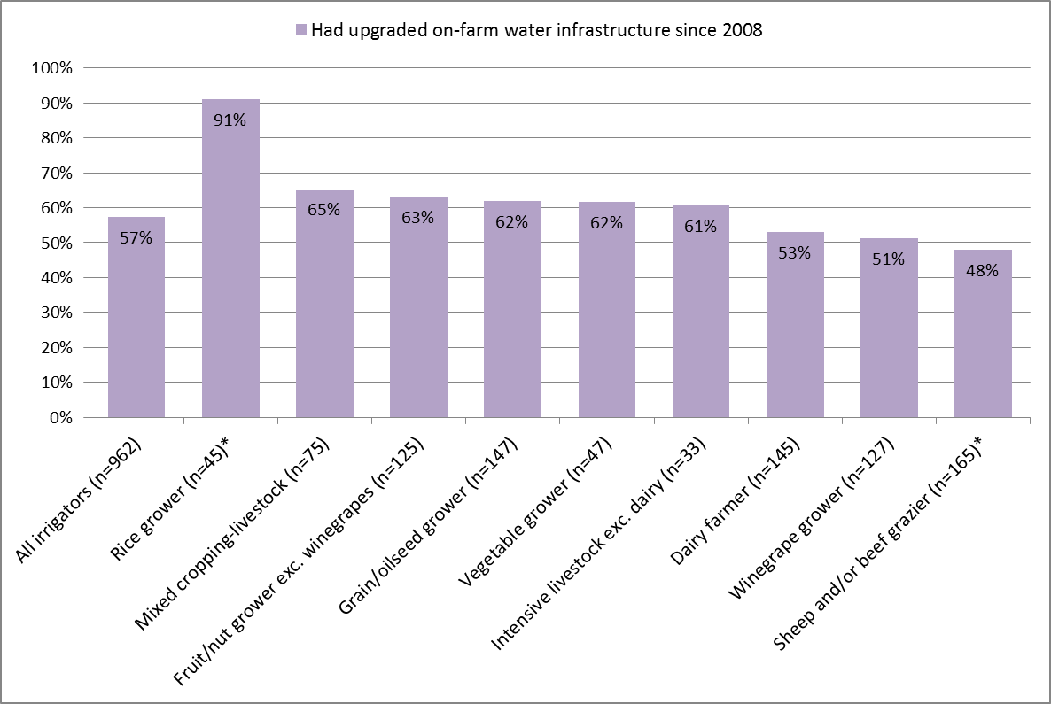

Figure 11 Proportion of irrigators who had upgraded on-farm water infrastructure since 2008 with assistance from a SRWUIP grant, by farm type[8]

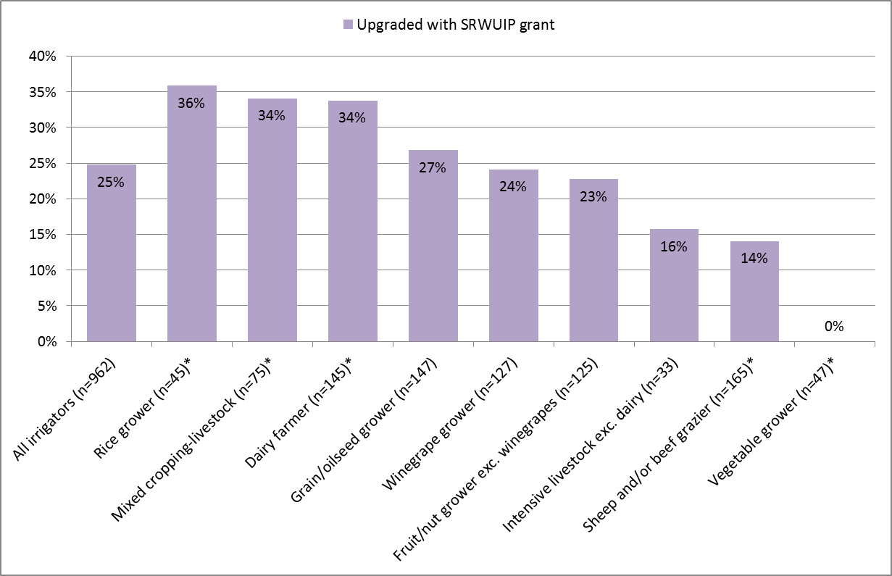

Figure 12 Proportion of irrigators who had upgraded on-farm water infrastructure since 2008, and done so with assistance from a SRWUIP grant, by farm planning approach[9]

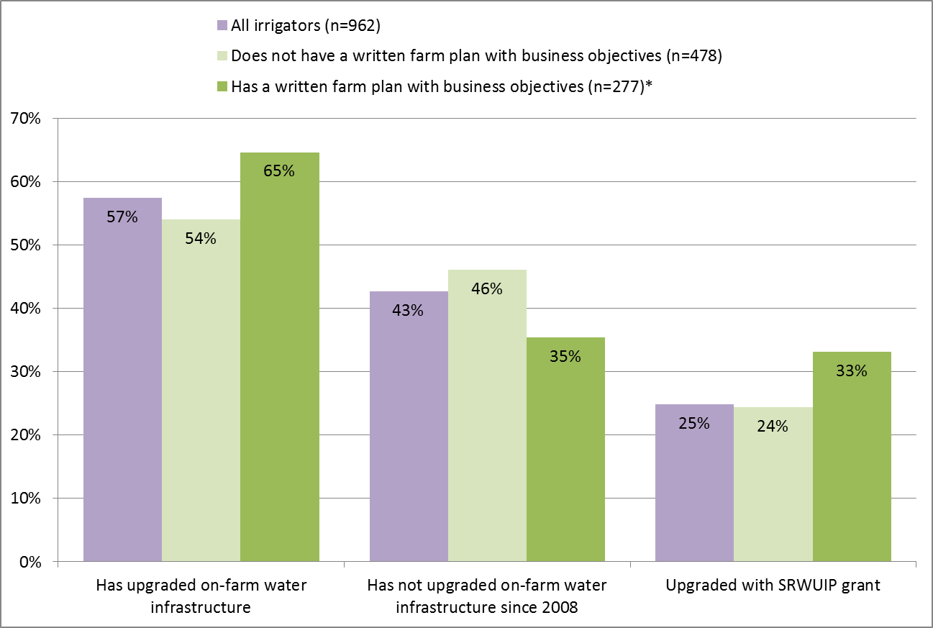

#### External drivers

In addition to socio-demographic and farm characteristics, external drivers may motivate farmers to upgrade on-farm water infrastructure, particularly if they affect the ability of an irrigator to use water on their farm or to be able to farm profitably. All farmers who completed the Regional Wellbeing Survey were asked if, in the last three years, they had experienced any of a number of barriers to developing their farm in the way they wished to. These ranged from experiencing drought or natural disasters such as flood, through to difficulty accessing adequate on-farm labour and difficulty transporting goods to market.

As shown in Figure 13, irrigators who had upgraded on-farm water infrastructure since 2008 were significantly more likely than those who had not to report experiencing reduced water allocation for one or more seasons, increased cost of purchasing temporary water, lack of telecommunications infrastructure, difficulty obtaining labour, difficulty accessing affordable finance, and difficulty transporting produce to market. In addition, they were more likely to report experiencing increases in fixed charges on permanent water entitlements, although in this case the difference was not significant at the 5% threshold. Not all these differences will have specifically motivated an irrigator to modernise on-farm infrastructure, but all are likely to have either directly or indirectly influenced the decision to modernise. For example, difficulty obtaining labour may drive a farmer to invest in modernisation works that reduce labour needs on the farm. Increases in cost of water and reduced water allocation are particularly likely to be direct drivers of investing in modernisation as a way of maintaining farm productivity while using lower volumes of water.

It is possible that some of these factors might be outcomes of modernisation, rather than drivers of the decision to modernise in the first place, particularly as survey data were collected in some cases several years after on-farm modernisation works occurred. To differentiate whether each factor was likely to have driven versus been an outcome of modernisation, the extent to which each was a barrier was compared for those who had upgraded at different points in time, shown in Figure 10. There were no significant differences by year, which suggests the factors identified are more likely to be drivers of modernisation rather than outcomes of it - if they were an outcome, it would be expected that fewer people who upgraded in 2014-15 would report each barrier compared to those who upgraded earlier.

Figure 13 Barriers to farm development experienced by farmers who had and had not upgraded on-farm water infrastructure since 2008

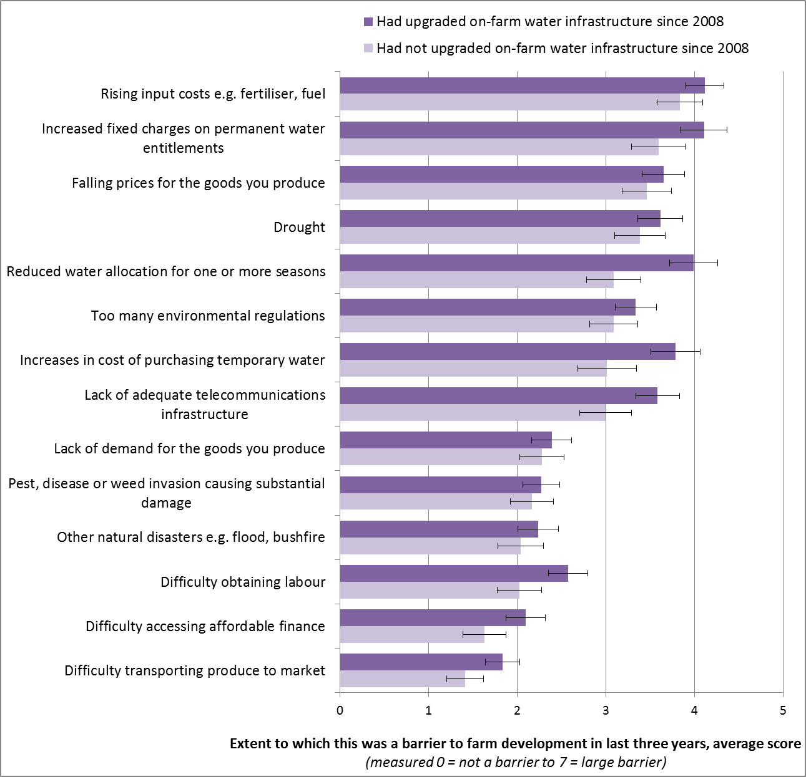

Figure 14 Barriers to farm development experienced by farmers who had and had not upgraded on-farm water infrastructure since 2008, by year of upgrade

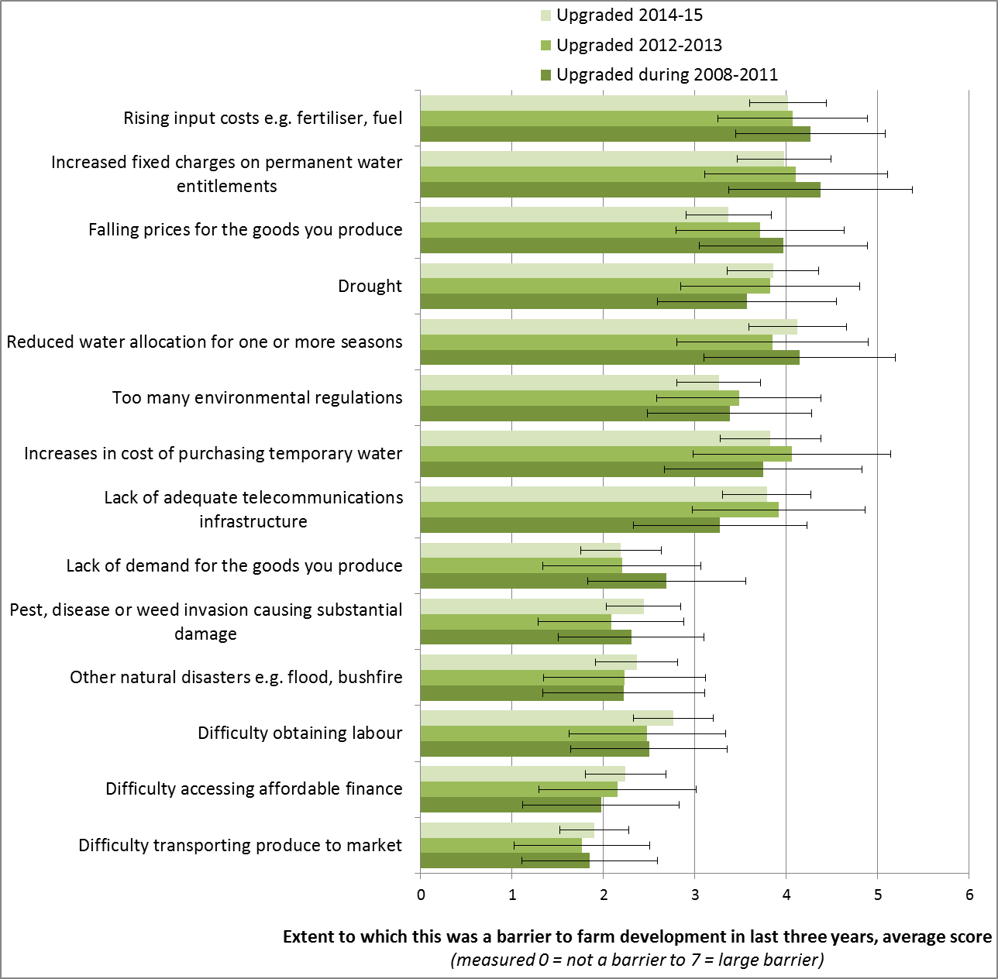

### Socio-economic Outcomes of on-farm infrastructure modernisation: direct effects on irrigators

Previous sections identified that irrigators who modernised their on-farm infrastructure were typically running a larger farm enterprise than those who didn’t, and those who received grants typically modernised a greater proportion of their infrastructure compared to those who didn’t.

This section examines the socio-economic outcomes of modernisation: how often and when did investing in on-farm infrastructure works have benefits or costs for the farmers involved? This was assessed based on (i) the direct views of the farmers themselves, and (ii) comparison of farm outcomes for farmers who did and did not modernise infrastructure.

#### Outcomes of on-farm infrastructure modernisation: Farmer’s views

To assess this, irrigators who had modernised on-farm water infrastructure were asked whether the works had any of a number of effects on their property. First, they were asked if they experienced changes to on-farm workload, flexibility of production, and about employment and contracting (Figure 15). SRWUIP participants were highly likely to report local contractors undertook upgrade work, with 70% reporting this compared to 45% of those who received no grant. They were also more likely to report having increased flexibility of production since the works were undertaken (55% compared to 43% of those who upgraded without a grant). Similar proportions of grant recipients and those who received no grants reported having a lower on-farm workload (45% and 43% respectively), local contractors undertaking maintenance work (25%, 20%) or needing fewer employees to produce the same amount (11%, 10%).

Figure 15 Outcomes of upgrading/expanding on-farm infrastructure – Basin irrigators who did and did not receive SRWUIP grants (i)

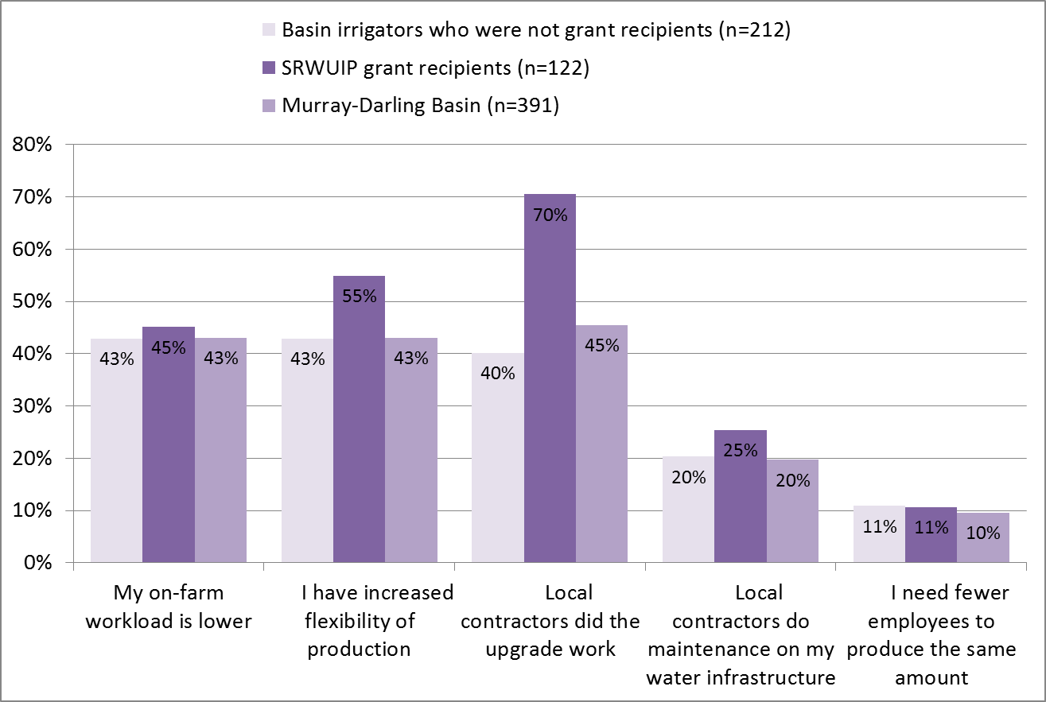

Table 8 shows results by region. While there was some variability in results by region, the only results that were statistically significant (given the small sample sizes in most regions) were that NSW Southern Basin irrigators were more likely to report that modernising infrastructure increased their flexibility of production, and those living outside the Basin were less likely to report beneficial outcomes than those living within the Basin.

Table 8 Outcomes of upgrading/expanding on-farm infrastructure – by region

| Outcomes of upgrading/expanding on-farm infrastructure | My on-farm workload is lower | I have increased flexibility of production | Local contractors did the upgrade work | Local contractors do maintenance on my water infrastructure | I need fewer employees to produce the same amount |
| --- | --- | --- | --- | --- | --- |
| Murray-Darling Basin (n=391) | 45% | 46% | 51% | 22% | 11% |
| Northern Basin (n=56) | 30% | 39% | 36% | 18% | 23% |
| Southern Basin (n=336) | 48% | 46% | 54% | 23% | 9% |
| Outside Basin (n=122) | 37% | 35% | 27% | 11% | 4% |
| NSW Northern Basin (n=26) | 31% | 35% | 27% | 19% | 23% |
| NSW Southern Basin (n=138) | 49% | 57% | 60% | 28% | 15% |
| VIC Basin (n=142) | 49% | 41% | 51% | 19% | 5% |
| QLD Basin (n=30) | 30% | 43% | 43% | 17% | 23% |
| SA Basin (n=55) | 38% | 36% | 45% | 22% | 5% |

When asked about whether the on-farm infrastructure works had a negative or positive impact on various aspects of their farm enterprise (Figure 16), SRWUIP participants were more likely to report positive than negative impacts for most of the areas asked about:

* 70% or more reported the on-farm infrastructure works had a positive impact on their farm enterprise as a whole (86%), their efficiency of water use (83%), their overall farm productivity after completion of works (79%), and timing of water delivery to their farm (70%), while 8% or less reported experiencing a negative impact on any of these areas
* 60% reported a positive impact on their farm profitability, and only 9% a negative impact
* 53% reported a positive impact on the amount spent on maintenance and replacement of irrigation equipment, while 15% reported a negative impact
* When asked about the effect on farm input costs, SRWUIP recipients were equally likely to report a ‘neutral’ (neither negative or positive) or positive impact (41% for each), while 19% reported a negative impact
* There was much more diversity of impact reported regarding effects on farm productivity while works were undertaken, effects on electricity/power costs, and effects on farm debt levels: for all of these, as many or more reported negative impacts as reported positive effects.

Those farmers who reported some negative outcomes still predominantly reported that on-farm infrastructure modernisation was positive for their farm overall. Even those who reported negative effects for their farm debt or power costs – the two areas in which farmers were most likely to report negative impacts – predominantly felt that the on-farm infrastructure works were positive for their farm overall (Figures 17 and 18). Of the 24 farmers who reported that the on-farm infrastructure works had a negative impact on their farm debt, 79% still reported the works were positive for their farm overall, and only 4% that the works had an overall negative impact on their farm. Similarly, of the 28 who reported negative effects on power costs, 79% still felt the modernisation works were positive for their farm overall, and only 11% that the modernisation was negative for their farm overall.

Figure 16 Outcomes of upgrading/expanding on-farm infrastructure – SRWUIP grant recipients (ii)

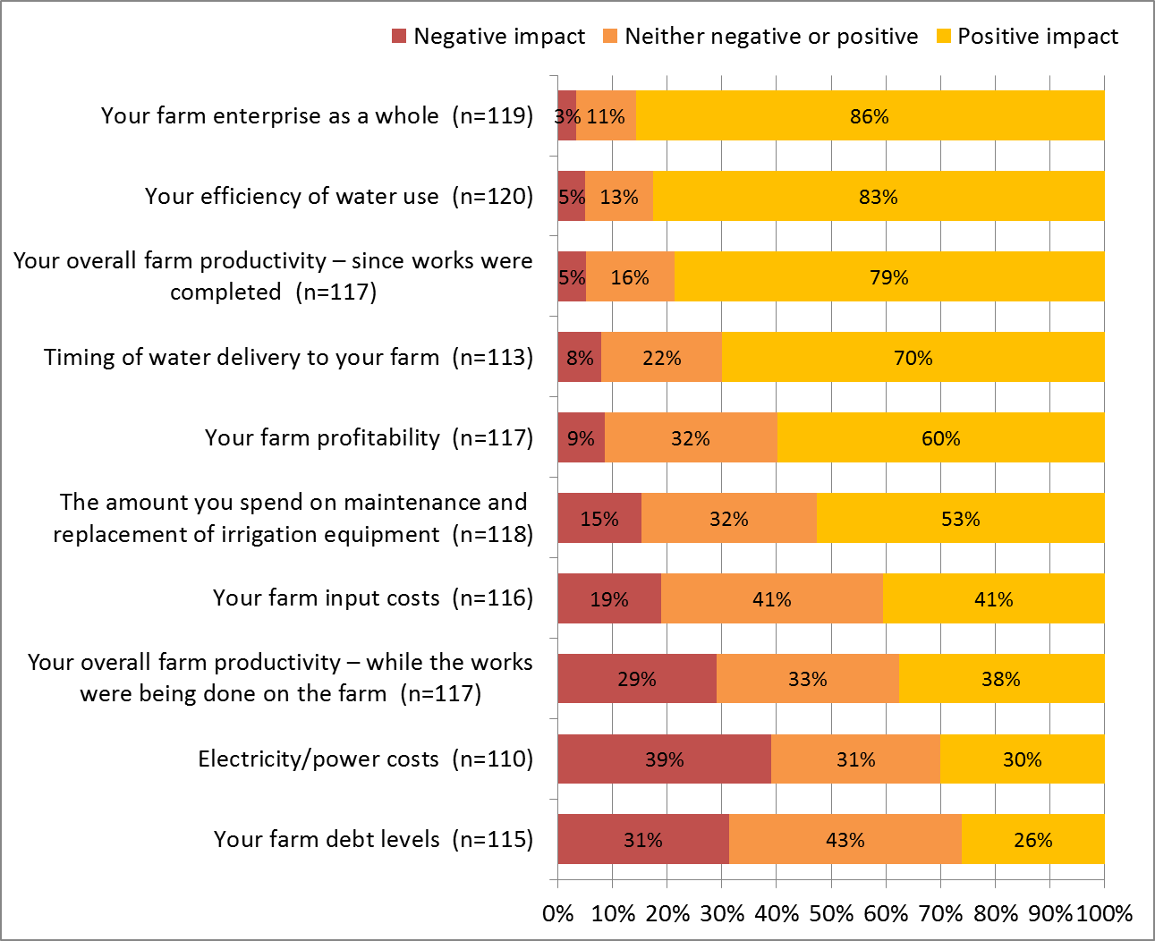

Figure 17 Comparison of views about impacts of on-farm infrastructure modernisation on (i) farm as a whole and (ii) farm debt – SRWUIP grant recipients

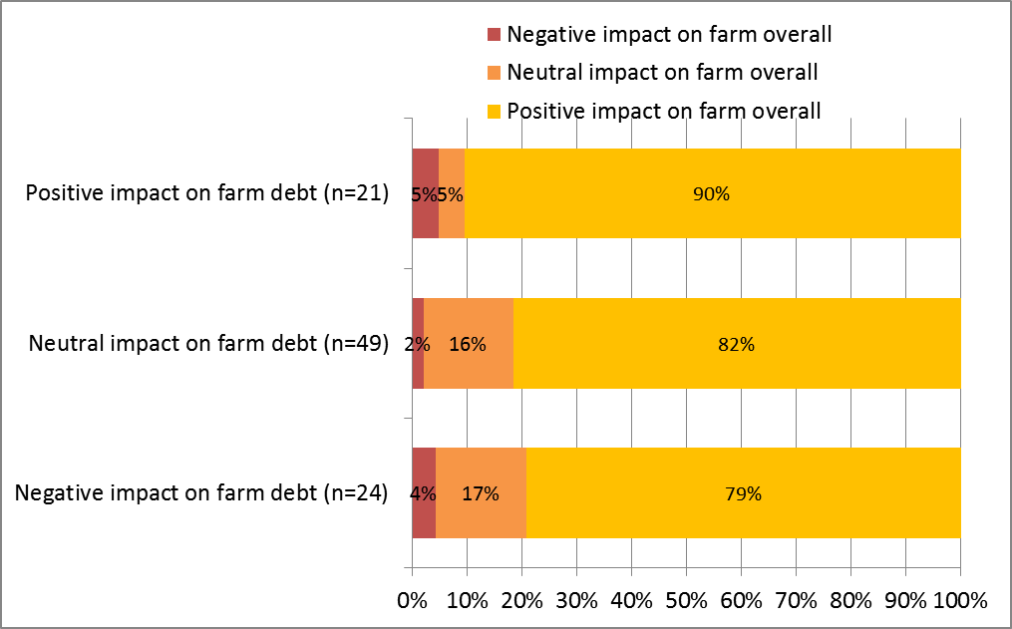

Figure 18 Comparison of views about impacts of on-farm infrastructure modernisation on (i) farm as a whole and (ii) farm power costs – SRWUIP grant recipients

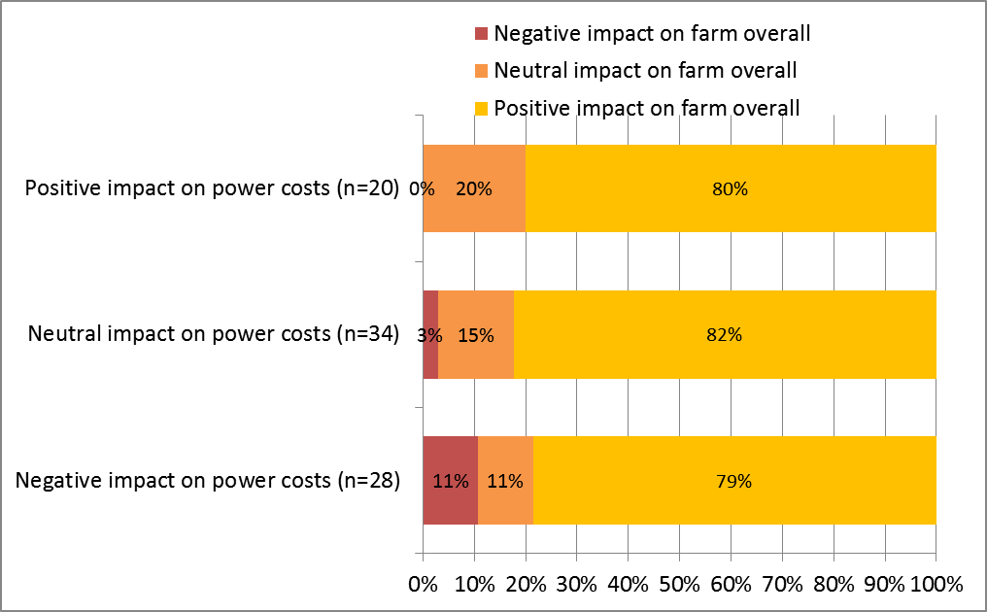

The outcomes reported by irrigators who received a SRWUIP grant, versus those who upgraded without a grant, were compared, shown in Figure 19. Overall there were very few differences between the two groups, with similar outcomes reported. SRWUIP grant recipients were significantly more likely than non-grant recipients to report that the upgrade had a positive effect on the amount of maintenance spending they had to do. They were also slightly more likely than those who had not received a grant to report the upgrade had a positive effect on the timing of water delivery to their farm, and their efficiency of water use, but these differences were not statistically significant.

Figure 19 Outcomes of upgrading/expanding on-farm infrastructure – comparison of SRWUIP grant recipients and those who upgraded without assistance from a grant

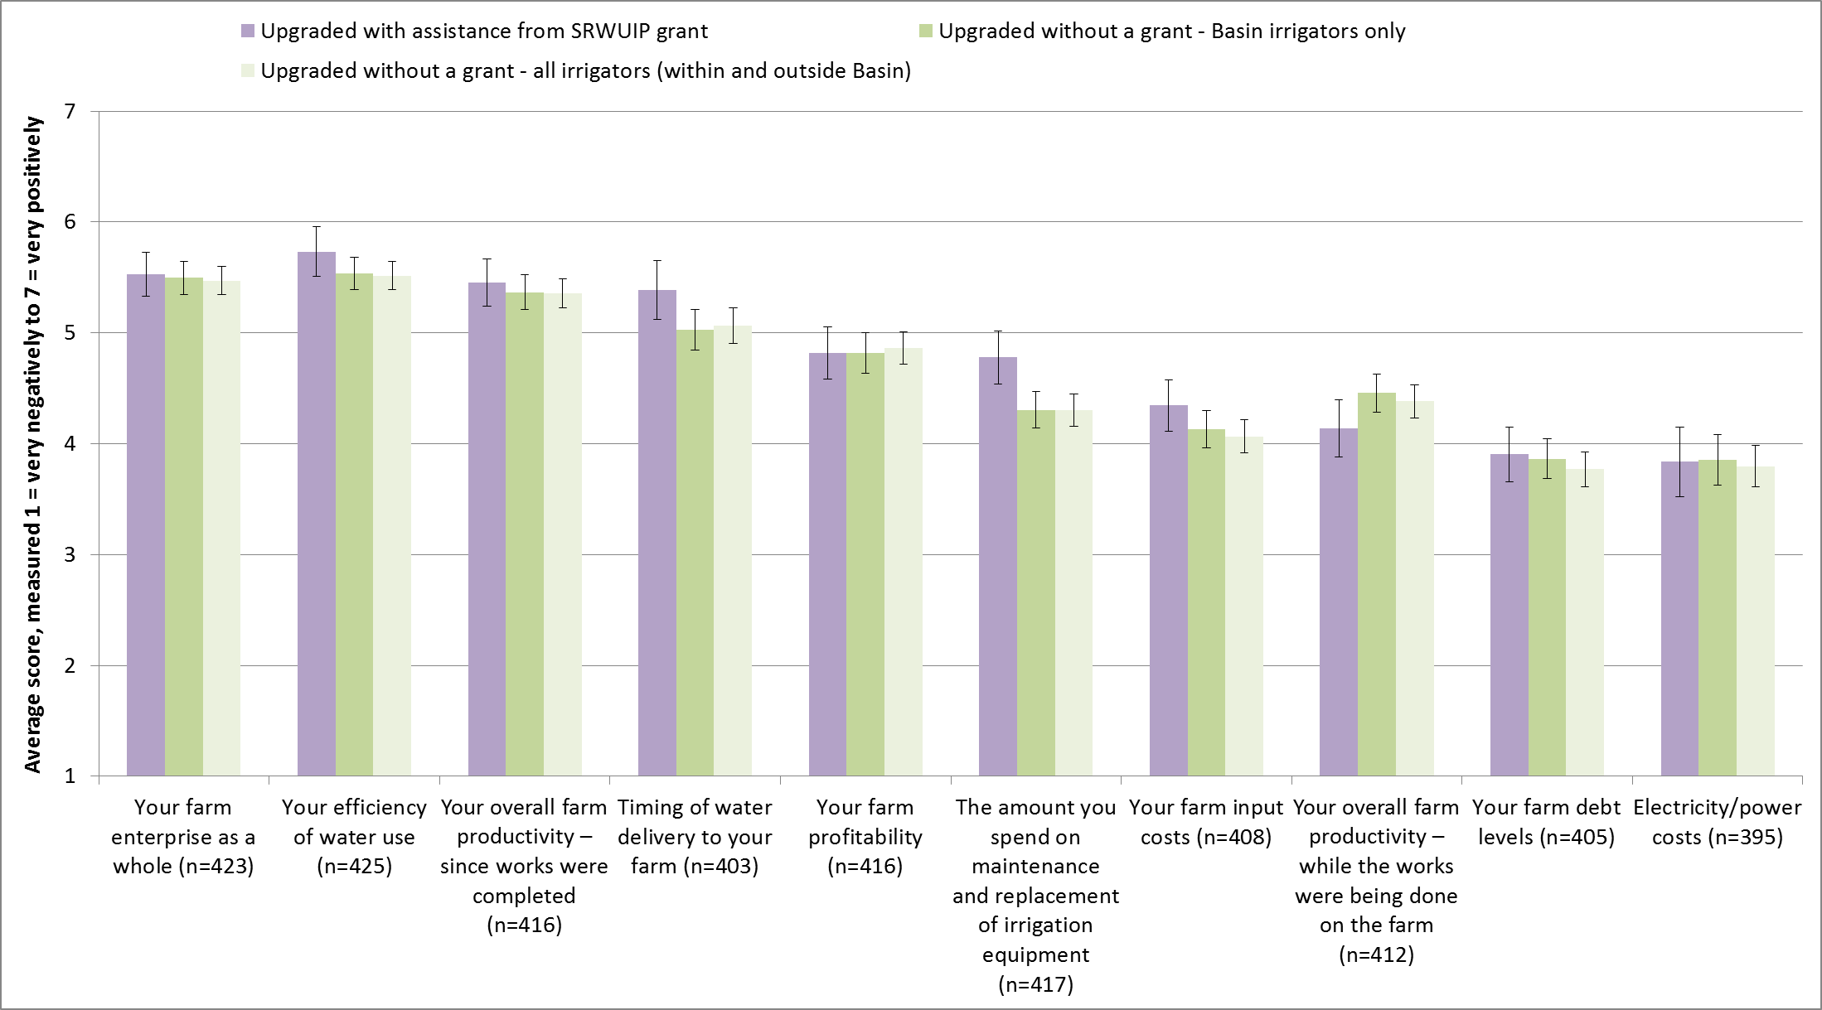

To better understand who experienced positive, neutral or negative outcomes for their farm overall, the socio-demographic and farming characteristics of those who reported more positive and negative outcomes were compared. The data underpinning this analysis, which used two statistical tests (Spearman’s correlation and confidence interval analysis) to identify significance, are provided in Appendix 2.

No significant differences were identified in the outcomes reported by those who ran different types of farms (e.g. dairy, sheep and beef grazing, grain and oilseed cropping, rice growing), or by irrigators of different age or gender. There were some significant differences in other areas, however. These are summarised below, and Table 9 provides some data to illustrate these findings.

Those who reported that upgrading on-farm infrastructure was positive for their farm overall were also significantly more likely to:

* Have upgraded a large proportion of their irrigated area (those who upgraded a smaller proportion were less likely to report positive outcomes)
* Be managing a large farm (average gross value of agricultural production was higher for those who reported positive outcomes than for those who reported less positive outcomes)
* Report making a profit on their farm in 2014-15
* Be earning a large proportion of their household income from their farm (those who earned a lot of their household income off-farm were less likely to report positive outcomes from upgrading on-farm infrastructure)
* Report high levels of personal wellbeing and low levels of psychological distress
* Feel highly satisfied with their ‘future security’ and what they were ‘currently achieving in life’
* Have expanded irrigation on their farm in the last 12 months
* Have invested in new farm equipment or technology in the last 12 months.

Those who reported that upgrading on-farm infrastructure was positive for their farm overall were also slightly less likely to have reduced farm production in the last 12 months, or be planning to exit farming or downsize their farm in the next five years, although the differences here were relatively small.

Table 9 Farm performance and farmer wellbeing: differences between those who had positive and negative experiences of on-farm water infrastructure modernisation

| Farm performance and farmer wellbeing | Percentage | Irrigator rating of the overall effects of on-farm water infrastructure modernisation on their farm  Negative or neutral impact on farm (n=14) | Irrigator rating of the overall effects of on-farm water infrastructure modernisation on their farm  Neither negative or positive impact on farm (n=75) | Irrigator rating of the overall effects of on-farm water infrastructure modernisation on their farm  Positive impact on farm (n=409) |
| --- | --- | --- | --- | --- |
| % irrigation infrastructure upgraded | Less than 60% | 3% | 15% | 82% |
| % irrigation infrastructure upgraded | 60% or more | 1% | 12% | 87% |
| Gross value of agricultural production | Average | $300,000-$399,999 | $200,000-$299,999 | $400,000-$499,999 |
| Farm financial surplus | Making a loss | 2% | 17% | 81% |
| Farm financial surplus | Breaking even | 4% | 20% | 76% |
| Farm financial surplus | Making a profit | 3% | 12% | 86% |
| % income earned from farm | Average | 50% | 52% | 66% |
| % who increased irrigated area in last year | % | 0% | 8% | 25% |
| % who decreased farm production in last year | % | 0% | 15% | 11% |
| % who invested in machinery or new infrastructure in last 12 months | % | 50% | 49% | 60% |
| % who improved water use efficiency on farm in last 12 months | % | 33% | 55% | 78% |
| Psychological distress (K10 measure, higher scores indicate higher distress) | Average (measured 10 to 50) | 16.7 | 16.6 | 15.6 |
| Wellbeing (Global Life Satisfaction measure, higher scores indicate higher wellbeing) | Average (measured 0-100) | 72 | 71 | 75 |

#### Outcomes of on-farm infrastructure modernisation: farm performance and farmer wellbeing

In addition to directly asking grant recipients their views on the outcomes of upgrading or expanding their on-farm water infrastructure, survey data were analysed to identify whether those who were grant recipients reported better outcomes on their farm overall compared to those who either (i) upgraded on-farm water infrastructure without a grant, or (ii) did not upgrade at all. When conducting this analysis, only irrigators located within the Basin were included. The effects examined were farm profitability, farm enterprise changes, and farmer wellbeing.

##### Farm profitability

All farmers who participated in the survey were asked to report whether their farm had made a ‘loss’ or ‘profit’ in 2014-15, with respondents rating farm financial performance on a scale from 1 (very large loss) to 7 (very large profit), with 4 indicating a ‘break even’ result. The responses reflect a rating of farm financial surplus, rather than profit, with most farmers not imputing the value of their own labour when rating their farm financial performance. In 2014, farmer answers to this question were found to correlate strongly with measures of profitability in the ABARES farm survey, after imputing an income for the farmer (Schirmer and Peel 2016).

Basin irrigators who had upgraded on-farm infrastructure were slightly more likely to report making a financial surplus on their farm in 2014-15 (54%) compared to those who had not upgraded since 2008 (48%). Of those who had upgraded, there were not significant differences in the proportion who reported making a surplus versus a loss when those who upgraded with and without assistance from a grant were compared, or when those who upgraded at different points in time were compared (Figure 20).

Figure 20 Comparison of farm financial performance in 2014-15 reported by Basin irrigators who had and had not upgraded on-farm water infrastructure since 2008

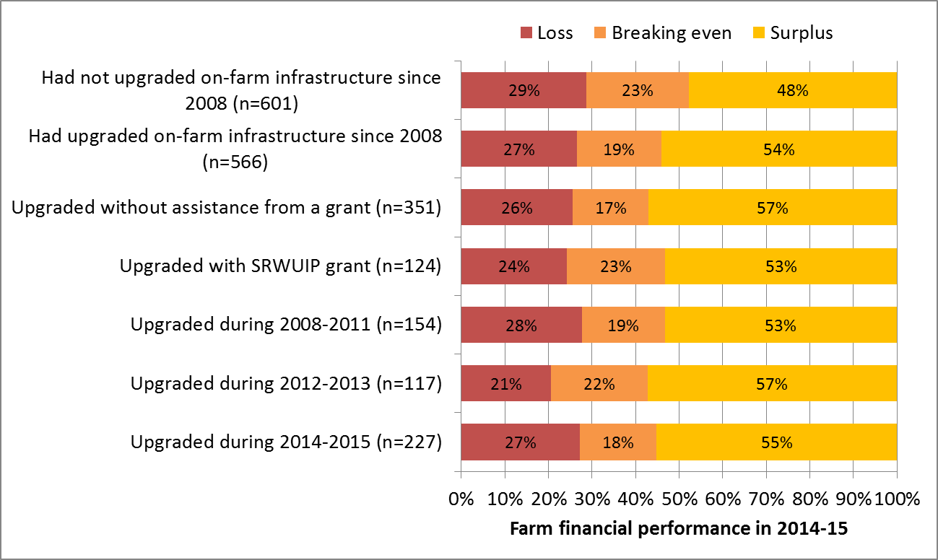

When examined by farm type, the differences in outcomes are more varied, as shown in Figure 21. When those Basin irrigators who had and had not upgraded on-farm water infrastructure were compared by farm type:

* Sheep and beef graziers, crop growers, and fruit/nut growers were significantly more likely to report making a profit if they had upgraded their on-farm infrastructure
* Mixed crop-livestock, dairy and rice growers were slightly more likely to report making a profit if they had upgraded their on-farm infrastructure, but the difference was not statistically significant
* Wine grape growers were significantly less likely to report making a profit if they had upgraded their on-farm infrastructure; intensive livestock growers were also less likely to report a profit, but the difference was not statistically significant.

We consulted three representatives of the wine grape industry and asked for their interpretation of the findings. All three felt that the results reflected that many wine grape growers had been unable to take advantage of the water savings provided by upgraded infrastructure, as severe market downturn in recent years had meant many were not able to find a market for all their produce or were reducing production. Additionally, many wine grape growers had experienced crop loss due to weather events such as frost or heatwave. Finally, many were experiencing significant market downturn such that many growers were being advised to consider substantially downsizing or ceasing production: in these circumstances, with limited market for grapes, many growers were instead reported to be selling their water allocation on the water trade market instead of growing crops with the water. However, those who upgraded with a SRWUIP grant had lower volumes of water to sell due to having transferred some entitlements back as part of the conditions of the grant. These various pressures can also explain why for many grape growers upgrading on-farm infrastructure was associated with lower, rather than higher, profitability: those who had invested in upgrading would not be able to take advantage of the higher water use efficiency to drive on-farm profitability due to the other factors affecting their farms. While these findings are based on discussions with a small number of people, they do highlight that on-farm infrastructure is not positive for all farmers in all situations: if external factors prevent farmers utilising the modernisations they have invested in for their on-farm water infrastructure, they will not achieve beneficial outcomes from their investment, and can experience negative impacts.

Figure 21 Proportion of Basin irrigators who reported making a farm financial surplus in 2014-15: comparison of those who had upgraded on-farm infrastructure and those who had not by farm type

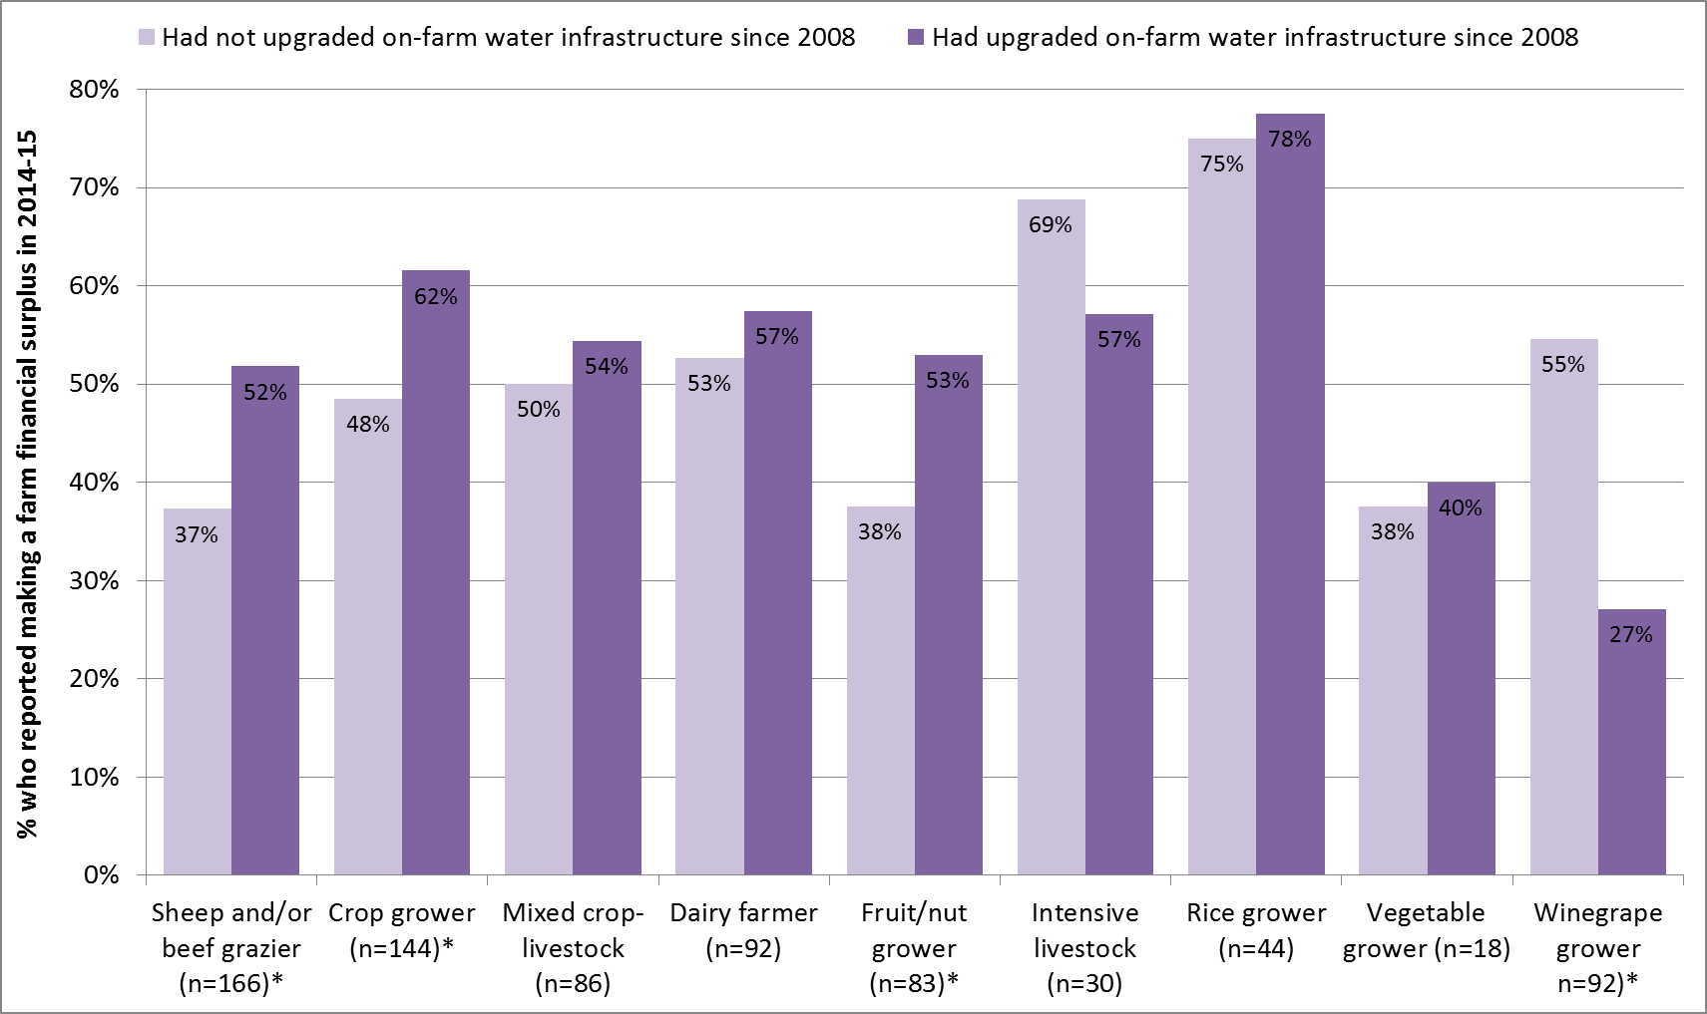

##### Changes on the farm

When asked how their farming had changed in the last 12 months, those who had upgraded on-farm infrastructure since 2008 (Figure 22) were more likely than those who had not upgraded to have:

* Improved irrigation efficiency on their farm business in the last 12 months (74% of those who upgraded compared to 38% who had not).
* Increased the area they irrigated: SRWUIP grant recipients were the most likely to report increasing their irrigated area in the last 12 months (26% compared to 12% of those who had not upgraded).

Meanwhile, they were less likely than those who had not upgraded to have:

* Decreased the area of land they irrigated (24% compared to 33%), with those who received a SRWUIP grant the least likely to have decreased their irrigated area (18%)
* Reduced farm production (9% of SRWUIP grant recipients compared to 15% of those who had upgraded on-farm infrastructure).

These relationships were typically stronger for irrigators who had upgraded on-farm infrastructure in recent years, and weaker for those who had upgraded several years previously (Figure 23), suggesting that they are likely to be a direct outcome of upgrading on-farm infrastructure.

Figure 22 Irrigation-related farm changes reported by Basin irrigators in the past 12 months, compared for those who had and had not upgraded on-farm water infrastructure since 2008

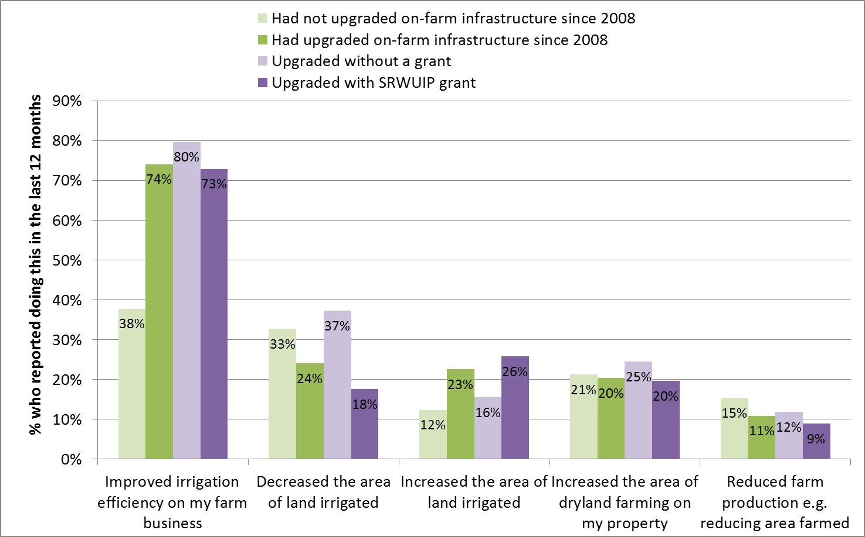

Figure 23 Farm changes in the last 12 months reported by Basin irrigators who had upgraded on-farm infrastructure, by year of upgrade

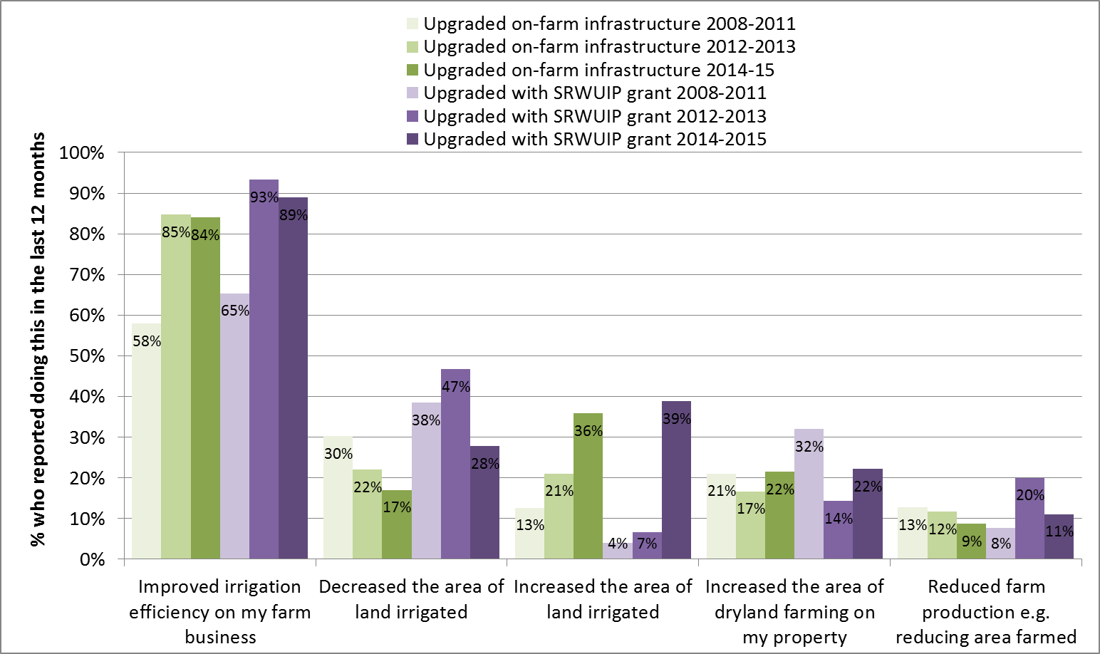

Farmers were also asked whether they had changed what they produced on their farm, or their use of labour, land or other inputs (Figure 24). Those who had upgraded were more likely than those who had not to report having changed what they produce on their farm and found new markets in the last 12 months, and were also slightly more likely to have purchased new land. They were also slightly more likely to have reduced on-farm labour, although this primarily applied to those who upgraded without a SRWUIP grant, with 33% of those who upgraded without assistance from a grant reducing their on-farm labour, compared to 27% of SRWUIP grant recipients, and 24% of those who had not upgraded on-farm infrastructure.

Figure 24 Other farm changes reported by Basin irrigators in the past 12 months, compared for those who had and had not upgraded on-farm water infrastructure since 2008

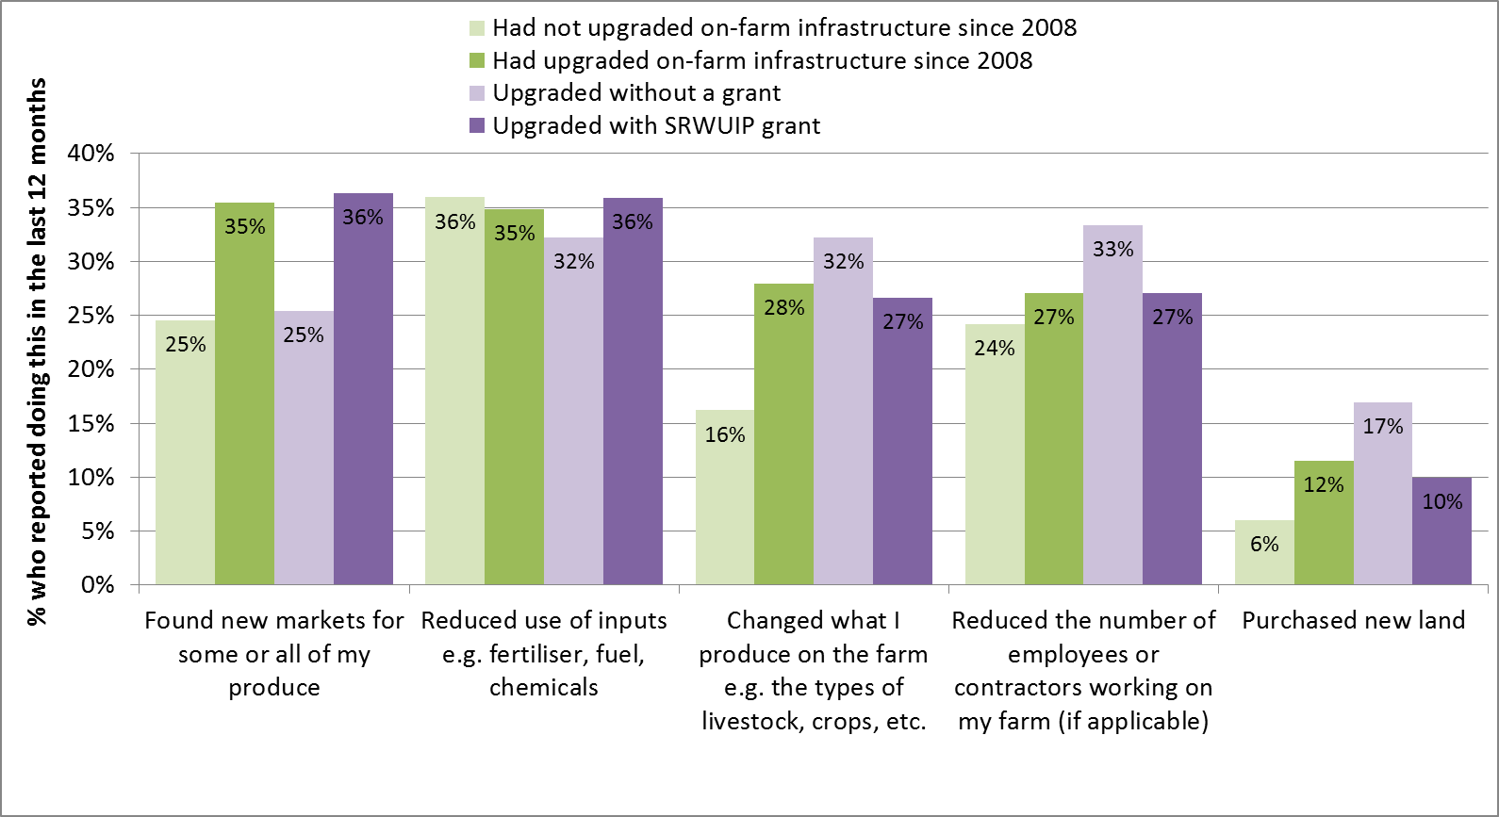

Basin irrigators who had upgraded on-farm water infrastructure more recently were more likely to also report having found new markets, slightly more likely to have changed what they had produced on their farm, and less likely to report reducing use of inputs or reducing labour use on farm (Figure 25). This suggests that upgrading infrastructure is associated with changing production and may reduce the likelihood of a farmer reducing use of labour and inputs in initial years after upgrade.

##### Future farming intentions

The future plans of Basin irrigators who had and had not upgraded their on-farm infrastructure were also compared, to see if investing in infrastructure was associated with differing farming intentions (Figure 26). Those who had upgraded on-farm infrastructure were significantly more likely to be planning to expand their farm business and to be intending to intensify their farm practices, and less likely to be planning to downsize their farm or leave farming altogether, compared to those who had not upgraded.

##### Farmer wellbeing

There were no significant differences in the overall wellbeing of irrigators who had and had not upgraded their on-farm infrastructure since 2008, when compared as a whole. Multiple measures of wellbeing were used, focusing on a person’s overall satisfaction with different aspects of their life (Figure 27). There were also no significant differences when farmers were compared by farm type, or by the year in which they upgraded on-farm infrastructure. This suggests that while upgrading on-farm infrastructure is considered by most who do it to be positive for their farm, and is associated with positive farming outcomes, the effects on overall farmer wellbeing are not strong enough to be observable relative to the many other factors that also influence wellbeing.

Figure 25 Other farm changes in the last 12 months reported by Basin irrigators who had upgraded on-farm infrastructure, by year of upgrade

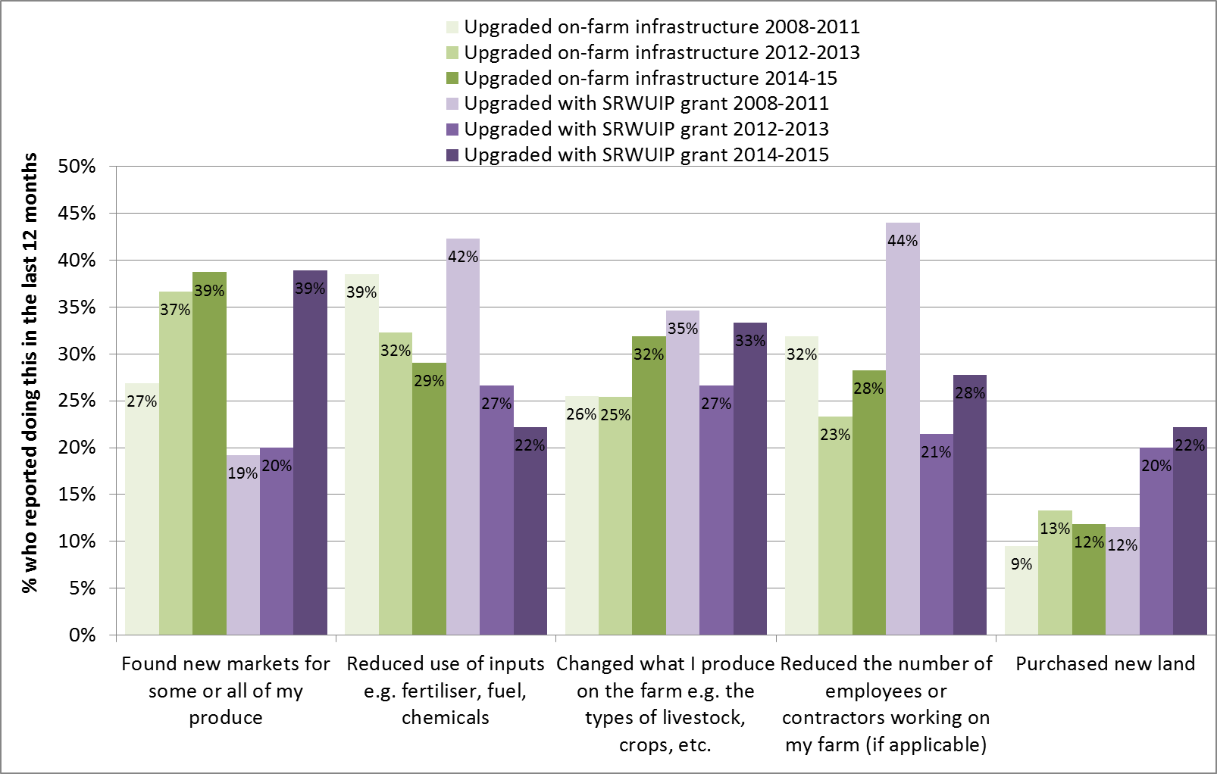

Figure 26 Future farming intentions of Basin irrigators who had and had not upgraded their on-farm water infrastructure since 2008

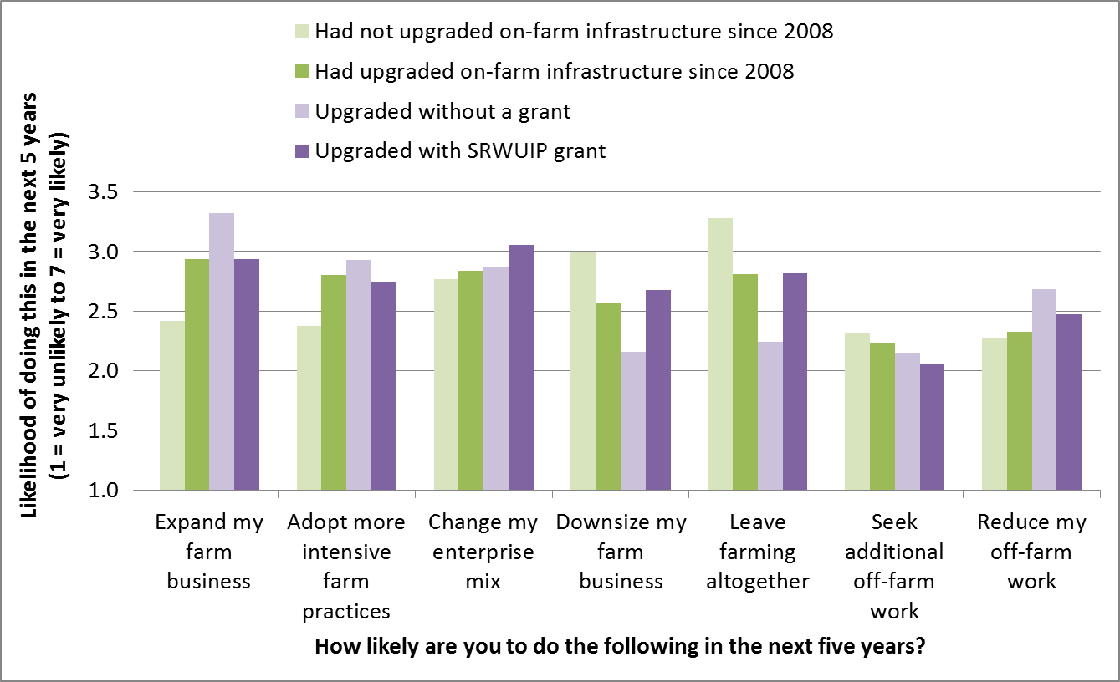

Figure 27 Personal wellbeing of Basin irrigator who had and had not upgraded on-farm water infrastructure since 2008

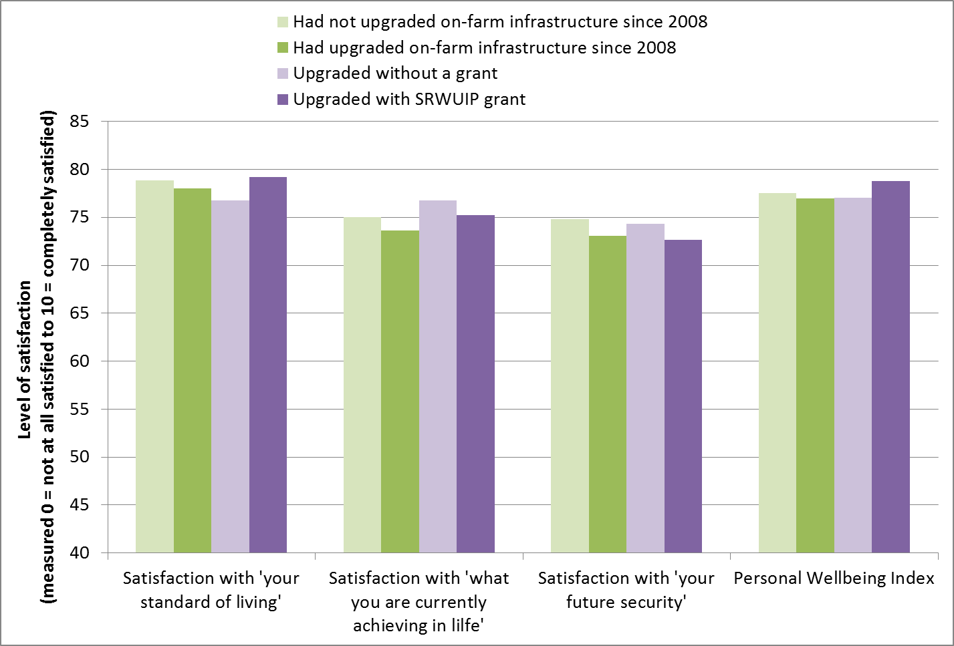

### Effects of on-farm SRWUIP investment on farmers who do not receive grants

Throughout this section, the characteristics of irrigators who have and have not upgraded on-farm infrastructure have been compared. This section considers the potential indirect effects of upgrade of on-farm infrastructure using SRWUIP grants on those irrigators who did not receive grants. Consultation with irrigators during the development of the Regional Wellbeing Survey resulted in suggestions that the following effects could occur for irrigators who did not upgrade:

* No significant effect
* Reduced competitiveness compared to those who had upgraded, making it harder to stay in farming, and lower profitability resulting from not having the ability to produce goods at the same price as those who upgraded
* Increased market opportunities, based on an assumption that many who upgraded would reduce production

The results presented earlier do suggest that those who upgrade are more likely than those who have not to be increasing the area they irrigated, and were more likely to be finding new markets and changing what they produce, compared to those who did not upgrade. They were also more likely to be making a profit on their farm, with the exception of wine grape growers. They were not more likely to be reducing farm production than those who had not upgraded.

This suggests that upgrading on-farm infrastructure is unlikely to result in increased market opportunities for other irrigators, as those who upgrade mostly maintain or grow their on-farm production, rather than decreasing it. Farmers who have not upgraded may be less competitive than those who have upgraded, and are overall less likely to report positive farm financial performance (although differences between those who did and did not upgrade are small for many types of farmers). This suggests that some irrigators who have not modernised on-farm infrastructure are not maintaining competitiveness of farm production relative to those who had invested in upgrading on-farm water infrastructure.

## Off-farm infrastructure grants

### Introduction

Off-farm water infrastructure upgrades have been undertaken in many regions with the assistance of SRWUIP grants. This chapter examines whether this investment is associated with positive or negative outcomes for the irrigators living in these regions. A key caveat for this chapter is that in many cases off-farm modernisation works were ongoing at the time of the survey, meaning that their full outcomes are not yet being experienced. Further follow up work is needed to identify outcomes over time.

### Identifying irrigators affected by SWRUIP off-farm grants

Data provided by the DAWR was used to identify which irrigators were farming in irrigation districts in which off-farm water infrastructure modernisation works had been undertaken using SRWUIP funding. This was done by (i) identifying the irrigation districts in which SRWUIP funding was used to modernise off-farm infrastructure, and (ii) identifying which irrigators participating in the RWS lived in these irrigation districts, using geographic data on location of farms provided by survey participants. Irrigators who responded to the survey were then classified based on whether they lived in a region in which SRWUIP funds had been used to modernise off-farm infrastructure (a ‘SRWUIP off-farm infrastructure region’) or not.

### Awareness of off-farm infrastructure modernisation

Irrigators who participated in the 2015 RWS were asked ‘has your water provider upgraded their irrigation infrastructure since 2008’. As shown in Figure 28, few irrigators living in regions in which SRWUIP funding has not been available reported that their water provider had upgraded irrigation infrastructure since 2008 (23% of irrigators located outside the Basin, and 18% of Basin irrigators not living in a SRWUIP off-farm infrastructure region).

Of the 429 irrigators living in the Basin districts in which SRWUIP grants had funded off-farm infrastructure, 52% answered ‘yes’ to this question. Of the remaining 48%, it is likely a small proportion are irrigators who were in fact not provided water by the specific water providers who upgraded infrastructure despite living in the same local government area in which an irrigation district was located in which modernisation works occurred. For example, two irrigation districts may be located in the same local government area, and modernisation works may only have occurred in one of these. However, even taking this into account, the results suggest there are a proportion of irrigators who are unaware of modernisation works.

To better understand this, an analysis was undertaken of whether awareness differed depending on the length of time since modernisation works occurred, based on dates of funding agreements (Figure 29). This showed that in regions where works occurred four or more years before the survey, fewer irrigators answered ‘yes’, indicating part of the identification issue is difficulty recalling the number of years since modernisation, rather than lack of awareness of modernisation.

Figure 28 Has your water provider upgraded their irrigation infrastructure since 2008 – responses of irrigators living in different regions

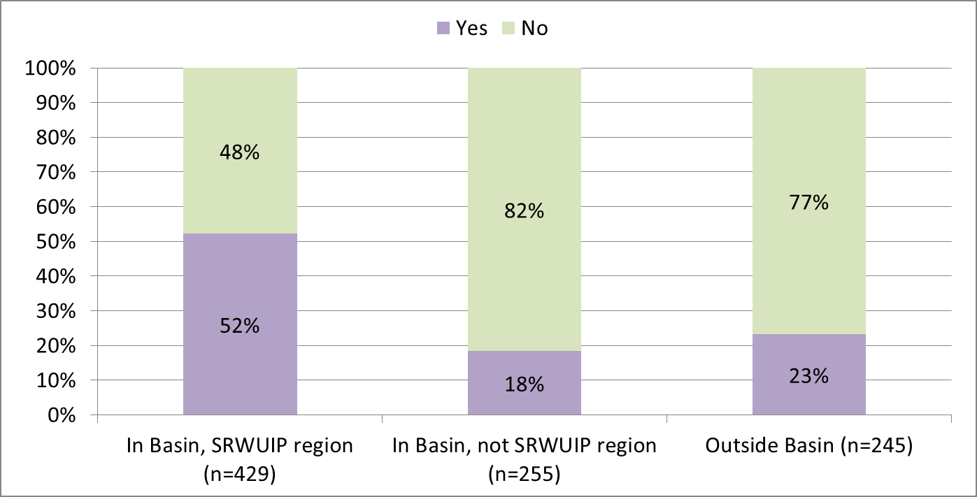

Figure 29 Has your water provider upgraded their irrigation infrastructure since 2008 – responses of irrigators living in regions in which SRWUIP funding agreements were signed in different years

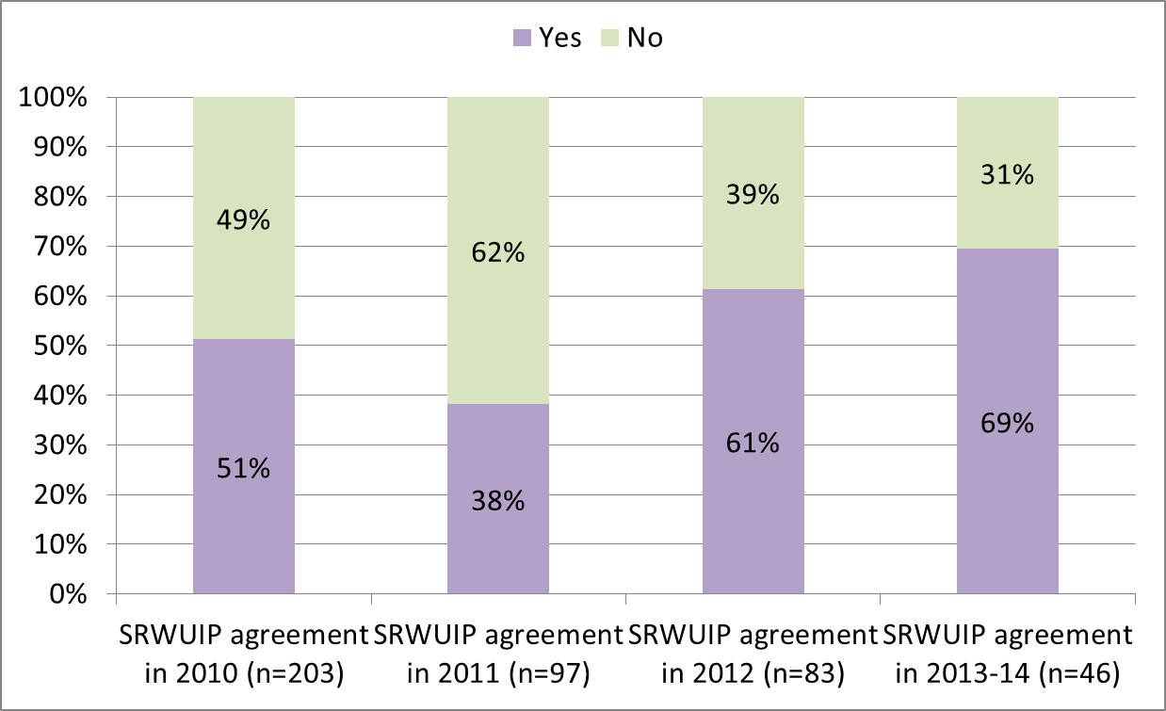

Those who indicated their water provider had upgraded irrigation infrastructure since 2008 were then asked whether they believed any of a number of organisations had funded the infrastructure upgrade. As shown in Figure 28, the most common answer in SRWUIP regions was ‘water provider’ (34%), followed by the SRWUIP program (28%) or other Federal government program (28%). Outside the Basin, state government agencies were most likely to be reported as funders. Many irrigators also responded ‘don’t know’ when asked this question, as shown in Figure 30. This result is expected: irrigators would observe their water provider upgrading infrastructure, but would not necessarily know the name of the specific funding program that had provided a grant towards costs of the upgrade.

Figure 30 Who funded the off-farm water infrastructure upgrade – responses of irrigators

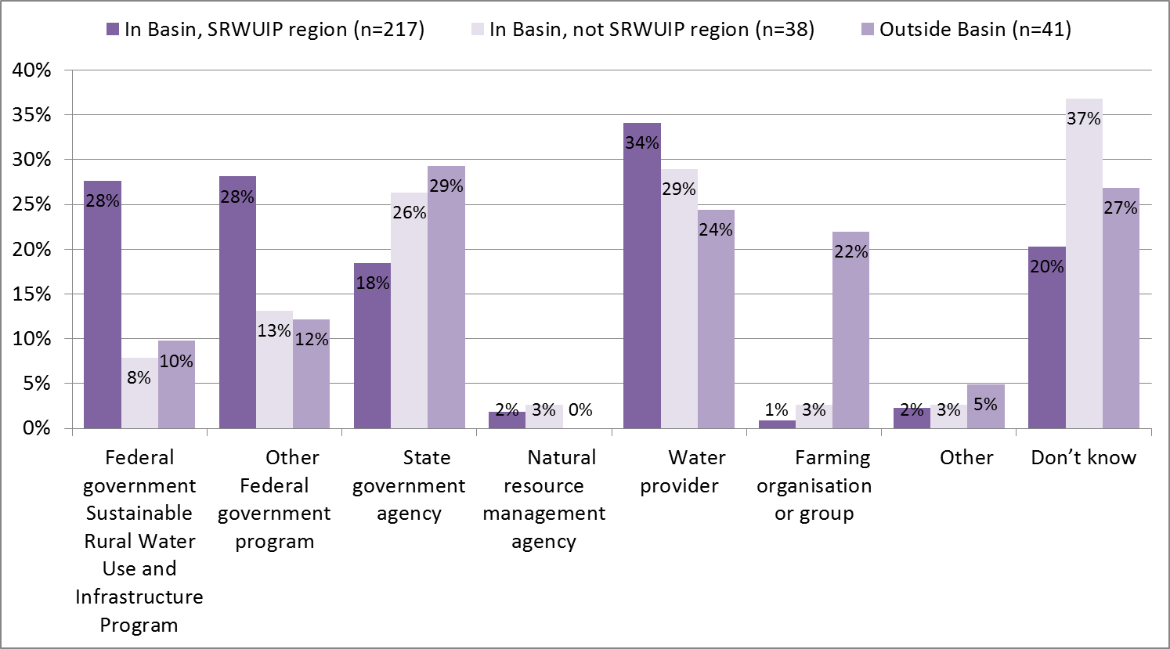

### On-farm outcomes of off-farm infrastructure modernisation

Irrigators who reported that their water provider had upgraded irrigation infrastructure since 2008 were asked their views about outcomes of the upgrade works for their farms. Analysis was also undertaken comparing the farm performance of Basin irrigators who lived in off-farm infrastructure upgrade regions compared to those who did not.

#### Outcomes of off-farm infrastructure modernisation: Farmer’s views

Irrigators who were aware of off-farm works were asked their views about the outcomes of those works. In total, 39% reported that local contractors did the upgrade work, and 29% felt the off-farm investment resulted in increased flexibility of production on their own farm (Figure 31). Views varied regarding whether the works had positive or negative impacts for the farmer’s own farm enterprise (Figure 32). Overall, 41% felt the upgrade was positive for their farm enterprise as a whole, 40% that it was neither positive or negative, and 20% that it was negative. When examining more specific outcomes:

* 59% felt the off-farm modernisation positively affected timing of water delivery to their farm, while 10% felt the upgrade negatively impacted timing
* 46% felt the modernisation improved their efficiency of water use, while 14% felt there was a negative impact on efficiency
* Between 50% to 60% felt the upgrade had no effect on their farm profitability, farm input costs, farm debt levels or overall farm productivity, while for each of these between 10% and 30% felt there were either positive or negative effects
* 51% felt the upgrade had a negative effect on the costs of water delivery, and only 14% that there was a positive effect.

Overall, views about the effects of off-farm infrastructure upgrade are more mixed than those about the outcomes of investment in on-farm infrastructure works. While more irrigators reported the off-farm works as having a positive than negative impact on their farm enterprise as a whole, many also felt there was no effect, and many more reported negative impacts than did so for on-farm infrastructure works.

Figure 31 Outcomes of off-farm irrigation infrastructure upgrade – by SRWUIP and non-SRWUIP region

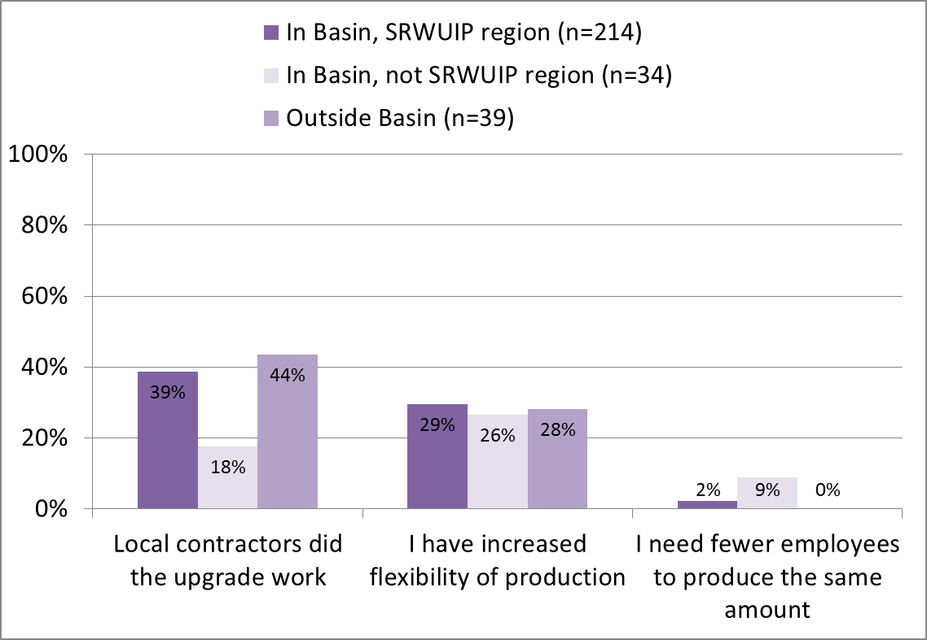

Figure 32 Outcomes of off-farm irrigation infrastructure upgrade reported by irrigators living in SRWUIP off-farm investment regions who were aware that off-farm works had occurred

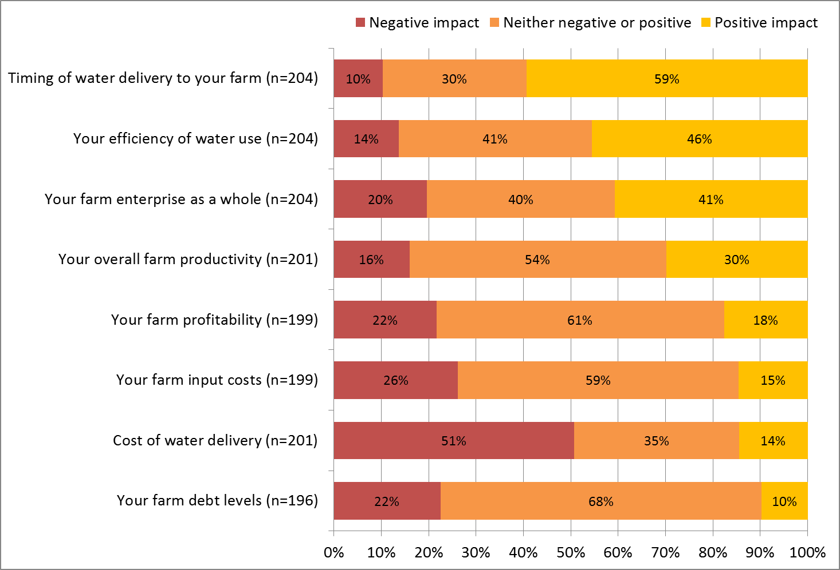

The socio-demographic and farm characteristics of irrigators who reported more positive versus more negative effects of off-farm investment for their farm overall were compared. The data underpinning this analysis, which used two statistical tests (Spearmans Correlation and the Kruskal Wallis H test), are provided in Appendix 3. Significant differences were identified in the views of irrigators living in different regions, with different farm characteristics, and with different socio-demographic characteristics.

##### Differences in views of off-farm modernisation by year of investment

In general, irrigators living in districts in which off-farm modernisation agreements had been signed more recently were less likely to report the investment had positive outcomes for their farm: those where agreements were signed in 2014 reported less positive views about effects compared to those living in regions in which agreements were signed between 2010 and 2012. This likely reflects that in many regions where agreements occurred only in 2014, works were either not yet completed at the time of the 2015 survey, or had not been operating for a long enough time to have a significant effect on the irrigator’s farm.

##### Regional differences in views of off-farm modernisation

There was relatively little difference in overall ratings of the effects of off-farm modernisation when different Basin states were compared. However, irrigators living in the following regions reported differing views:

* More *positive* perceptions of the effects of off-farm modernisation were reported by irrigators living in the Murrumbidgee (NSW) and Goulburn (VIC) catchments, including those living in the local government areas of Greater Shepparton, Campaspe, Loddon, Griffith, and Murrumbidgee
* More *negative* perceptions of the effects of off-farm modernisation were reported by irrigators living in the Victorian Murray (VIC) and NSW Murray (NSW) catchments, particularly irrigators living in the local government areas of Mildura, Swan Hill, Wakool and Moira.

##### Farm characteristics – differences in views of off-farm modernisation

Views about the effects of off-farm modernisation did not vary substantially between different types of farmers: farm profitability, farm size, and the types of changes that had occurred on a person’s farm were not associated with significant differences in views. The only exceptions were that:

* Those who had a larger farm in terms of physical area on average reported more negative views of the effects of off-farm modernisation on their farm, and
* Those who felt that environmental regulations had preventing them developing their farm business the way they wanted to in recent years were less likely to feel off-farm works had a positive effect on their farm business.

##### Socio-economic differences in views of off-farm modernisation

There were no statistically significant differences in the views of male and female irrigators about the effects of off-farm modernisation on their farms, or in the views of people who had better or poorer personal wellbeing. There were some other differences:

* Those aged 50 to 64 reported more positive perceptions, and those aged under 50 or 65 and older reported more negative views
* Those who had a university degree (commonly aged under 50) and those who had not completed high school (commonly aged 65 and older) reported more negative views about the effects of off-farm modernisation
* Those who had completed year 12 of high school, a certificate or diploma, but not a university degree, reported more positive views about the impacts of off-farm modernisation on their farm.

#### Outcomes of off-farm infrastructure modernisation: farm performance

In addition to asking irrigators their views of the outcomes of off-farm infrastructure modernisation, survey data were analysed to compare the farm performance outcomes reported by irrigators living in regions in which SRWUIP grants had facilitated off-farm water infrastructure modernisation works, compared to irrigators living in other parts of the Basin. As much off-farm modernisation work has focused on upgrading infrastructure utilised by irrigators who obtain water from dedicated irrigation channels in irrigation districts, in each analysis the experiences of ‘district irrigators’ (those living in irrigation districts and being delivered water via dedicated irrigation channels) is compared to ‘river irrigators’ (irrigators pumping directly from rivers rather than channels). The following aspects were examined: farm profitability, changes on the farm, future farming intentions, and overall wellbeing of farmers.

##### Farm profitability

There was very little difference in the overall profitability of farmers living in regions with and without off-farm infrastructure modernisation works, as shown in Figure 33. The only difference identified was that those irrigators who lived in irrigation districts without modernisation works were less likely to report making either a loss (22% compared to 28%) or profit (44% compared to 50%) compared to those living in off-farm SRWUIP regions; however, the difference was not statistically significant.

There were, however, differences in profitability when irrigators were compared based on the year in which off-farm modernisation works began. Those living in districts in which modernisation works began in 2012-13 were more likely to report making a profit, followed by those in which modernisation works began in 2010-11. Those living in regions in which modernisation works commenced in 2014 were least likely to report making a profit. It is unclear whether the presence of off-farm modernisation is one of the drivers of these differences, and identifying whether this is the case is complicated by the ongoing nature of many works: in particular, in the Goulburn-Murray region, while works began in 2010-11, there are ongoing off-farm modernisation works. The differences identified between years will be a result of multiple factors: in particular, climatic conditions will vary between geographic regions and can readily drive the differences observed.

Figure 33 Farm profitability reported by irrigators living in regions in which SRWUIP-funded off-farm modernisation has and has not occurred

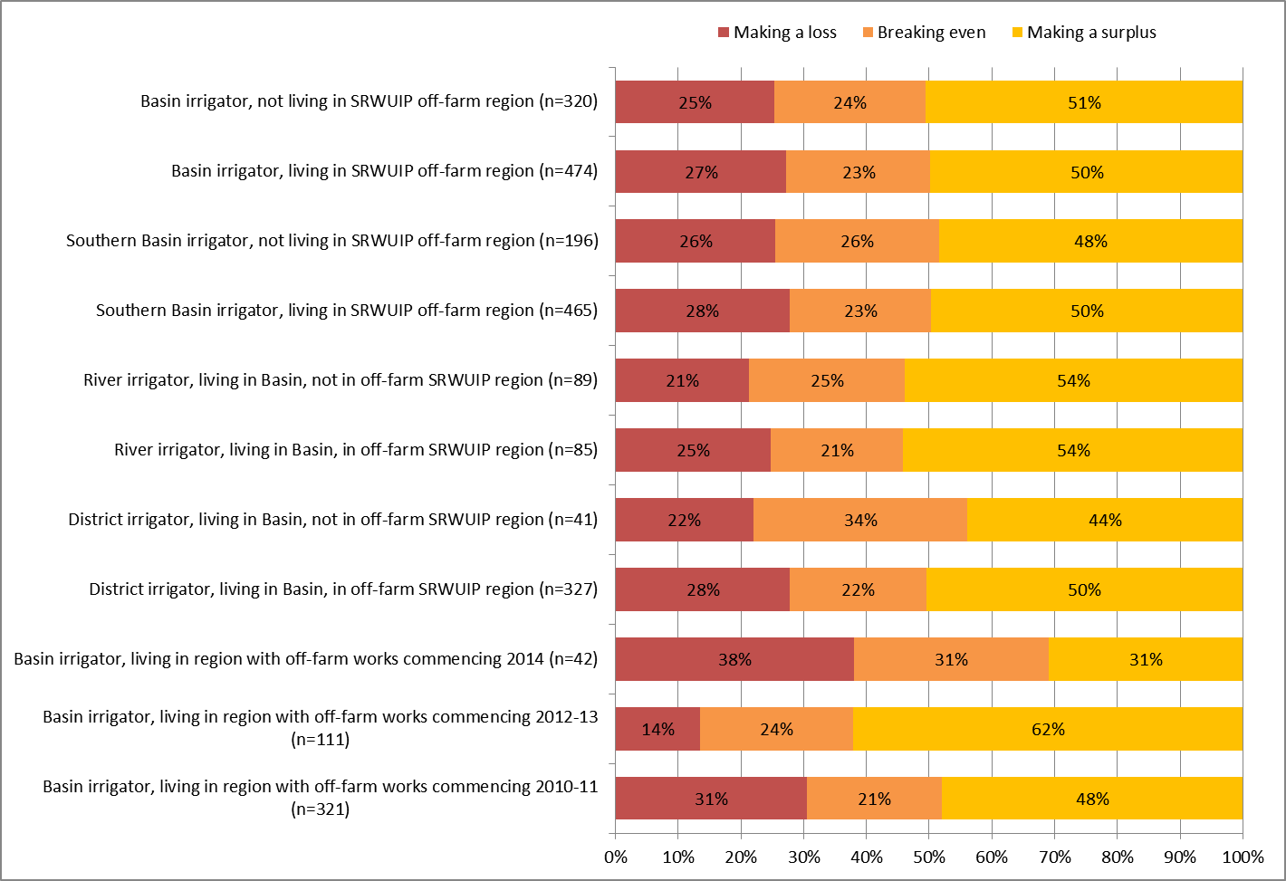

##### Changes on the farm

The changes irrigators reported making on their farm in the last 12 months were compared for irrigators living within and outside SRWUIP off-farm infrastructure regions (Figure 34). Irrigators living in off-farm modernisation regions were more likely than those living in other regions to report improving irrigation efficiency on their farm business, decreasing area of land they irrigated, and increasing the area of dryland farming on their property. They were less likely to have found new markets for their produce, but slightly more likely to report having invested in new farm machinery or infrastructure, and to have increased area of land irrigated. More irrigators reported decreasing the area irrigated than increasing it in both off-farm SRWUIP regions and other regions in the Basin. When more specific groups of irrigators were compared (Table 10), the same differences were observed in most cases, except in cases where sample sizes were too small for the differences observed to be statistically significant.

While those living in off-farm SRWUIP regions were more likely to be decreasing the area of land they irrigated (36% to 27% living outside SRWUIP off-farm regions), they were *not* more likely to be reducing farm production, or to be reducing their on-farm employment. In off-farm SRWUIP regions, 15% of irrigators reported reducing farm production in the last year while 36% reduced the area of irrigated land. However, outside SRWUIP regions 18% reduced farm production while 27% reduced the area of land irrigated. This suggests that investments in improving irrigation efficiency may be improving productivity for many farmers, enabling maintenance of farm production despite reduction in irrigated area in many cases.

Figure 34 Farm changes occurring in the last 12 months – comparison of irrigators living within and outside off-farm SRWUIP regions

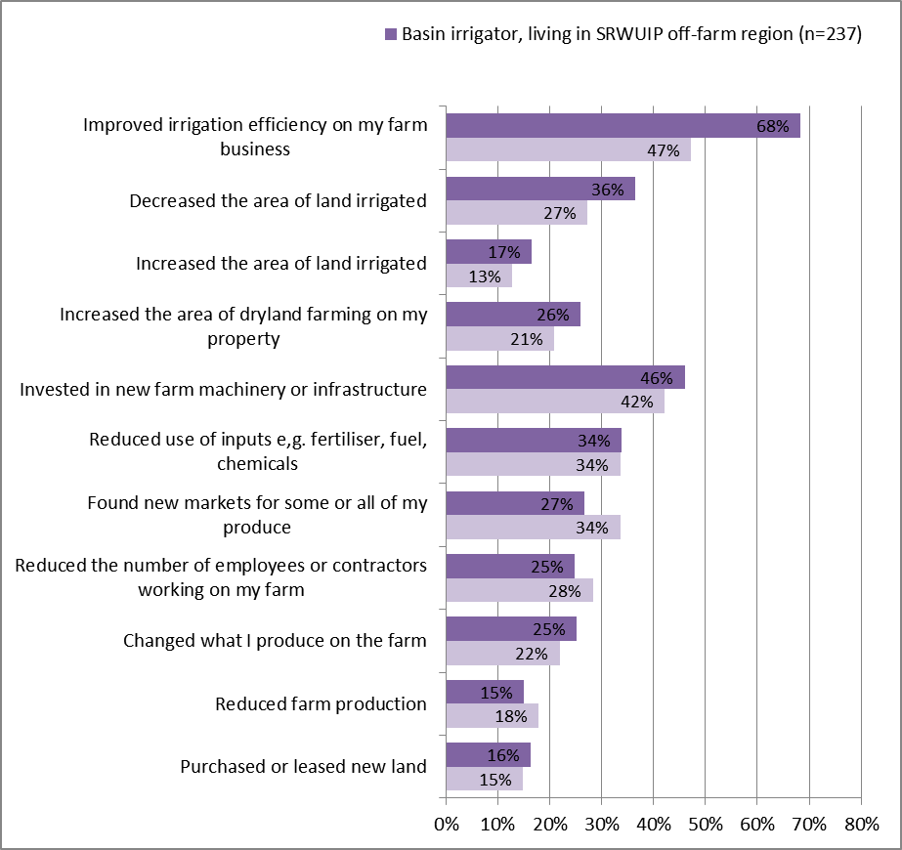

Table 10 Farm changes occurring in the last 12 months – comparison of irrigators living within and outside off-farm SRWUIP regions

| Basin irrigators by regions | Improved irrigation efficiency on my farm business | Decreased the area of land irrigated | Increased the area of land irrigated | Increased the area of dryland farming on my property | Invested in new farm machinery or infra-structure | Reduced use of inputs e,g. fertiliser, fuel, chemicals | Found new markets for some or all of my produce | Reduced number of employees or contractors working on my farm | Changed what I produce on the farm | Reduced farm production | Purchased or leased new land |
| --- | --- | --- | --- | --- | --- | --- | --- | --- | --- | --- | --- |
| **Basin irrigator, not living in SRWUIP off-farm region (n=121)** | **47%** | **27%** | **13%** | **21%** | **42%** | **34%** | **34%** | **28%** | **22%** | **18%** | **15%** |
| **Basin irrigator, living in SRWUIP off-farm region (n=237)** | **68%** | **36%** | **17%** | **26%** | **46%** | **34%** | **27%** | **25%** | **25%** | **15%** | **16%** |
| Southern Basin irrigator, not living in SRWUIP off-farm region (n=80) | 46% | 24% | 14% | 13% | 39% | 36% | 39% | 29% | 19% | 20% | 14% |
| Southern Basin irrigator, living in SRWUIP off-farm region (n=236) | 68% | 36% | 17% | 26% | 46% | 34% | 27% | 25% | 25% | 15% | 17% |
| River irrigator, living in Basin, not in off-farm SRWUIP region (n=39) | 46% | 21% | 5% | 26% | 44% | 33% | 41% | 28% | 21% | 5% | 13% |
| River irrigator, living in Basin, in off-farm SRWUIP region (n=47) | 76% | 29% | 20% | 21% | 49% | 23% | 43% | 21% | 21% | 11% | 6% |
| District irrigator, living in Basin, not in off-farm SRWUIP region (n=15) | 77% | 31% | 25% | 20% | 43% | 7% | 33% | 33% | 33% | 20% | 20% |
| District irrigator, living in Basin, in off-farm SRWUIP region (n=157) | 68% | 39% | 16% | 28% | 48% | 38% | 25% | 28% | 28% | 16% | 20% |
| Basin irrigator, living in region with off-farm works commencing 2014 (n=20) | 65% | 35% | 30% | 20% | 25% | 35% | 40% | 30% | 15% | 25% | 15% |
| Basin irrigator, living in region with off-farm works commencing 2012-13 (n=32) | 84% | 59% | 17% | 44% | 65% | 34% | 33% | 29% | 47% | 19% | 22% |
| Basin irrigator, living in region with off-farm works commencing 2010-11 (n=185) | 66% | 33% | 15% | 23% | 45% | 34% | 24% | 23% | 23% | 13% | 16% |

##### Barriers to farm development

Farmers were asked whether they had experienced any of a number of barriers to farm development in the past three years. Irrigators living in off-farm SRWUIP investment regions were much more likely to report experiencing increasing fixed costs of water entitlements, reduced water allocation, and high prices of temporary water, as barriers to farm development, compared to irrigators living outside SRWUIP regions (Table 11). They were also slightly more likely to report that drought had been a big barrier to achieving their farm development goals. There were fewer differences in the experience of other issues, including changing market demand, pest and disease outbreak, and difficulty accessing transport or farm labour.

These findings show a strong association between living in an off-farm SRWUIP region and experiencing water-related stress, particularly increasing water costs. However, this association is not consistent over time, with those living in regions where modernisation occurred earlier being less likely to report water-related barriers, and those in 2012-13 most likely to. A similar association between off-farm investment and rising fixed water costs has been identified by the Australian Competition and Consumer Commission (ACCC 2016).

Table 11 Barriers to farm development – comparison of irrigators living within and outside off-farm SRWUIP regions

| Basin irrigators by regions | Increases in fixed costs of permanent water entitlements | Reduced water allocation | Increase in price of temporary water | Rising input costs | Drought | Falling prices | Environmental regulations | Lack of adequate telecommunications | Lack of demand for the goods I produce | Difficulty accessing farm labour | Pest or disease outbreak causing damage | Difficulty accessing finance | Other natural disasters e.g. flood, fire | Difficulty accessing transport |
| --- | --- | --- | --- | --- | --- | --- | --- | --- | --- | --- | --- | --- | --- | --- |
| Basin irrigator, not living in SRWUIP off-farm region (n=331) | 3.2 | 2.8 | 2.4 | 3.7 | 3.6 | 3.6 | 3.3 | 3.6 | 2.1 | 2.3 | 2.5 | 1.7 | 2.4 | 1.7 |
| Basin irrigator, living in SRWUIP off-farm region (n=498) | 5.0 | 4.8 | 4.7 | 4.2 | 3.8 | 3.8 | 3.4 | 3.4 | 2.4 | 2.3 | 2.1 | 2.1 | 2.0 | 1.6 |
| Southern Basin irrigator, not living in SRWUIP off-farm region (n=203) | 3.3 | 2.4 | 2.2 | 3.5 | 3.1 | 3.6 | 3.0 | 3.2 | 2.3 | 2.1 | 2.3 | 1.5 | 1.9 | 1.6 |
| Southern Basin irrigator, living in SRWUIP off-farm region (n=489) | 5.0 | 4.8 | 4.7 | 4.2 | 3.8 | 3.8 | 3.4 | 3.4 | 2.4 | 2.4 | 2.1 | 2.1 | 2.0 | 1.6 |
| River irrigator, living in Basin, not in off-farm SRWUIP region (n=90) | 3.8 | 3.4 | 2.9 | 3.6 | 3.6 | 3.7 | 3.5 | 4.1 | 2.3 | 2.4 | 2.2 | 1.8 | 3.0 | 1.5 |
| River irrigator, living in Basin, in off-farm SRWUIP region (n=90) | 4.5 | 4.7 | 4.5 | 3.9 | 3.9 | 3.8 | 3.5 | 3.8 | 2.7 | 2.3 | 2.3 | 1.6 | 2.1 | 1.9 |
| District irrigator, living in Basin, not in off-farm SRWUIP region (n=42) | 4.2 | 3.3 | 3.5 | 3.5 | 3.5 | 3.6 | 3.3 | 3.3 | 2.5 | 2.4 | 2.9 | 1.9 | 2.5 | 2.4 |
| District irrigator, living in Basin, in off-farm SRWUIP region (n=338) | 5.3 | 5.1 | 5.1 | 4.3 | 4.0 | 3.8 | 3.5 | 3.5 | 2.6 | 2.4 | 2.1 | 2.3 | 2.1 | 1.7 |
| Basin irrigator, living in region with off-farm works commencing 2014 (n=44) | 5.4 | 5.1 | 5.1 | 4.6 | 3.8 | 4.4 | 3.7 | 3.4 | 3.7 | 2.6 | 2.3 | 3.0 | 2.7 | 2.3 |
| Basin irrigator, living in region with off-farm works commencing 2012-13 (n=118) | 5.5 | 5.9 | 5.4 | 4.0 | 3.8 | 2.9 | 4.0 | 5.0 | 1.4 | 2.3 | 1.6 | 1.9 | 1.3 | 1.2 |
| Basin irrigator, living in region with off-farm works commencing 2010-11 (n=336) | 4.7 | 4.5 | 4.5 | 4.2 | 3.7 | 3.8 | 3.3 | 3.2 | 2.5 | 2.3 | 2.1 | 2.0 | 2.0 | 1.6 |

##### Future farming intentions

Irrigators living in off-farm modernisation regions were significantly more likely to be planning to leave farming in the next five years compared to those living in other regions (Figure 35), but were not significantly more likely to be planning to either downsize or expand their farm business. However, when results were examined for more specific groups (Table 12), this difference was identified as being more related to whether an irrigator was located in an irrigation district or irrigated directly from a river: river irrigators were overall less likely to be planning to leave farming than district irrigators, irrespective of whether they lived in an off-farm SRWUIP region. This suggests off-farm investment is not currently leading to substantial changes in future farming intentions, but is happening in regions where irrigators are already more likely to be considering leaving farming.

Figure 35 Future farming intentions – comparison of irrigators living within and outside off-farm SRWUIP regions

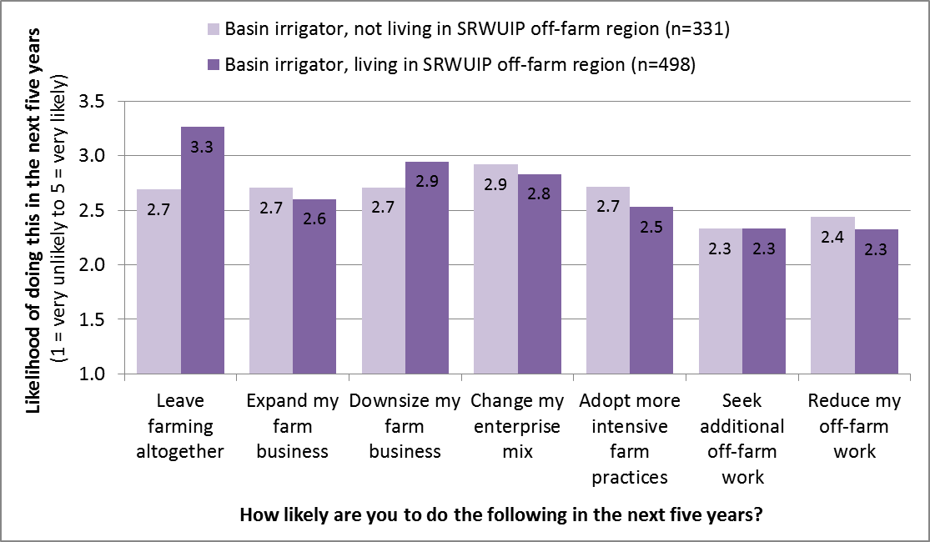

Table 12 Future farming intentions – comparison of irrigators living within and outside off-farm SRWUIP regions

| Basin irrigators by regions | Leave farming altogether | Expand my farm business | Down-size my farm business | Change my enter-prise mix | Adopt more intensive farm practices | Seek additional off-farm work | Reduce my off-farm work |
| --- | --- | --- | --- | --- | --- | --- | --- |
| Basin irrigator, not living in SRWUIP off-farm region (n=331) | 2.7 | 2.7 | 2.7 | 2.9 | 2.7 | 2.3 | 2.4 |
| Basin irrigator, living in SRWUIP off-farm region (n=498) | 3.3 | 2.6 | 2.9 | 2.8 | 2.5 | 2.3 | 2.3 |
| Southern Basin irrigator, not living in SRWUIP off-farm region (n=203) | 2.7 | 2.5 | 2.8 | 2.8 | 2.4 | 2.3 | 2.4 |
| Southern Basin irrigator, living in SRWUIP off-farm region (n=489) | 3.3 | 2.6 | 2.9 | 2.8 | 2.5 | 2.3 | 2.3 |
| River irrigator, living in Basin, not in off-farm SRWUIP region (n=90) | 2.5 | 3.0 | 2.5 | 3.0 | 2.7 | 2.4 | 2.3 |
| River irrigator, living in Basin, in off-farm SRWUIP region (n=90) | 3.1 | 2.8 | 2.2 | 2.9 | 2.7 | 2.5 | 2.2 |
| District irrigator, living in Basin, not in off-farm SRWUIP region (n=42) | 3.2 | 3.0 | 2.7 | 3.3 | 2.6 | 2.3 | 2.0 |
| District irrigator, living in Basin, in off-farm SRWUIP region (n=338) | 3.4 | 2.6 | 3.1 | 2.9 | 2.6 | 2.4 | 2.2 |

##### Farmer wellbeing

Irrigators who lived in SRWUIP off-farm regions reported slightly poorer wellbeing, particularly poorer satisfaction with the security of their future, compared to those living in other regions (Table 13). This difference was greater when district irrigators were compared: those living in off-farm SRWUIP regions reported poorer wellbeing compared to either district irrigators living in other regions, or river irrigators. The association between poorer wellbeing and living in an off-farm region suggest that irrigators living in the districts being modernised are experiencing different pressures compared to those living in other parts of the Basin. The extent to which these pressures result from off-farm modernisation versus other factors is difficult to identify. However, when the year in which modernisation began was examined, there was no clear relationship between year of modernisation and farmer wellbeing: this suggests it is likely that factors other than the off-farm modernisation are having a greater influence on farmer wellbeing than any influence of the off-farm works themselves.

Table 13 Farmer wellbeing – comparison of irrigators living within and outside off-farm SRWUIP regions

| Basin irrigators by regions | Satisfaction with 'your standard of living' | Satisfaction with 'what you are currently achieving in life' | Satisfaction with 'your future security' | Personal Wellbeing Index |
| --- | --- | --- | --- | --- |
| Basin irrigator, not living in SRWUIP off-farm region (n=331) | 80 | 75 | 76 | 78 |
| Basin irrigator, living in SRWUIP off-farm region (n=498) | 78 | 74 | 72 | 77 |
| Southern Basin irrigator, not living in SRWUIP off-farm region (n=203) | 80 | 76 | 76 | 78 |
| Southern Basin irrigator, living in SRWUIP off-farm region (n=489) | 78 | 74 | 72 | 77 |
| River irrigator, living in Basin, not in off-farm SRWUIP region (n=90) | 83 | 79 | 78 | 80 |
| River irrigator, living in Basin, in off-farm SRWUIP region (n=90) | 81 | 77 | 76 | 79 |
| District irrigator, living in Basin, not in off-farm SRWUIP region (n=42) | 84 | 82 | 81 | 82 |
| District irrigator, living in Basin, in off-farm SRWUIP region (n=338) | 77 | 73 | 71 | 76 |
| Basin irrigator, living in region with off-farm works commencing 2014 (n=44) | 74 | 73 | 68 | 72 |
| Basin irrigator, living in region with off-farm works commencing 2012-13 (n=118) | 82 | 76 | 77 | 80 |
| Basin irrigator, living in region with off-farm works commencing 2010-11 (n=336) | 77 | 73 | 71 | 76 |

Each wellbeing measure was measured from 1 (poorest possible wellbeing) to 99 (highest wellbeing). At the population level, wellbeing is highly stable, with the Personal Wellbeing Index typically varying by less than 2 to 3 points year to year unless a substantial event occurs that affects the wellbeing of many people in the population being examined

### Effects of off-farm SRWUIP investment on farmers living outside modernised areas

The findings in this chapter do not provide a clear picture of whether off-farm modernisation works are likely to be affecting those irrigators living in regions where off-farm works have *not* occurred, such as their ability to effectively compete against production from off-farm modernisation regions. As relatively few differences were identified in the outcomes achieved on farm by those living in regions which have and had not had off-farm modernisation investment, it is likely that in the period examined in this report, factors other than off-farm modernisation had greater influence on farm performance.

## Water entitlement sales and transfers to government

### Introduction

The socio-economic effects of water entitlement purchases by the government have been widely debated in the Basin. This debate often centres not so much on effects of selling on the person selling, as the flow-on effects of sale for other irrigators living in the districts in which entitlements have been sold, and the broader community in these regions. The Regional Wellbeing Survey asked all people who indicated they were farmers, or that they had once been farmers but no longer were, whether they had sold or transferred water entitlements to the government at some point in the last seven years. This chapter examines the proportion of farmers and ex-farmers who reported having sold, and their experiences of the outcomes of selling.

### How many farmers sold and transferred water entitlements to the government?

Within the Murray-Darling Basin, 13% of respondents who were farmers or ex-farmers indicated having done either sold or transferred water entitlements to the government between 2008 and 2015, including 7% of ex-farmers, 8% of dryland farmers and 32% of irrigators (Figure 36). Outside the Basin, only 1% indicated doing this (this is expected, with a small number of farmers potentially having sold entitlements in the Basin and subsequently shifted elsewhere).

Figure 36 Proportion of farmers and ex-farmers indicating they had sold or transferred water entitlements to the government in the seven years prior to completing the 2015 Regional Wellbeing Survey

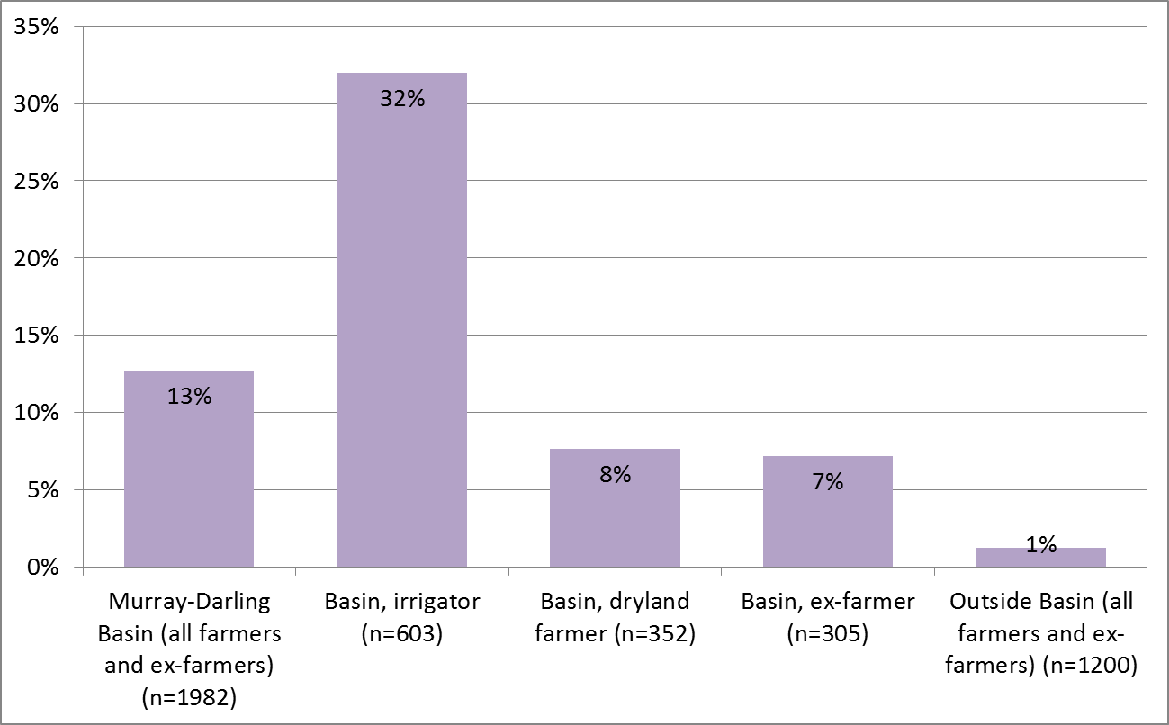

There are important differences between selling water entitlements, and transferring them to the government. Entitlements transfers have typically occurred as part of accessing grants to improve irrigation infrastructure on the farm, in which it is expected that the water efficiency savings achieved from infrastructure improvement compensate for the reduction in water entitlements held by the irrigator. Direct sale, however, is not necessarily accompanied by water efficiency improvements that enable maintenance or increases in agricultural production.

Figure 37 identifies the proportion of those who (i) sold versus (ii) transferred entitlements, based on identifying the proportion of those who subsequently identified that they transferred entitlements in order to access an on-farm infrastructure grant. In total, 13% of Basin irrigators reported transferring entitlements, while 19% reported selling entitlements. These findings are consistent with available estimates of the proportion of Basin irrigators who have sold entitlements: Wheeler et al. (2014) estimated that around one-fifth of irrigators in the Basin sold water entitlements to the Commonwealth government from the beginning of 2008 to the start of 2012. While the 2015 RWS asked about the period 2008 to 2015, entitlement sales were much lower in later parts of that period, suggesting the 19% of Basin irrigators who indicated selling is consistent with the proportion that would be expected to have sold based on other estimates.

Cheesman and Wheeler (2012) identified that, in the period 2008 to 2011, 60% of those who sold entitlements to the government in the Basin remained irrigating, while 10% remained in farming but switched to dryland farming, and 30% existed farming altogether. In the 2015 RWS sample, of the 168 people living in the Basin who reported having sold entitlements to the government since 2008, 67% had remained in irrigated farming, 20% were now dryland farmers, and 13% had left farming. This means the RWS is likely to have under sampled those who exited farming when they sold entitlements. This was due to the limitations of the sampling methodology: while it was possible to deliberately oversample irrigators and dryland farmers and hence increase the likelihood of achieving responses from those who had sold water entitlements, it was not possible to oversample ex-farmers as it was not possible to access specific contact databases that enabled directly targeting of these ex-farmers.

Figure 37 Proportion of farmers and ex-farmers who (i) sold and (ii) transferred water entitlements to the government in the seven years prior to completing the 2015 Regional Wellbeing Survey

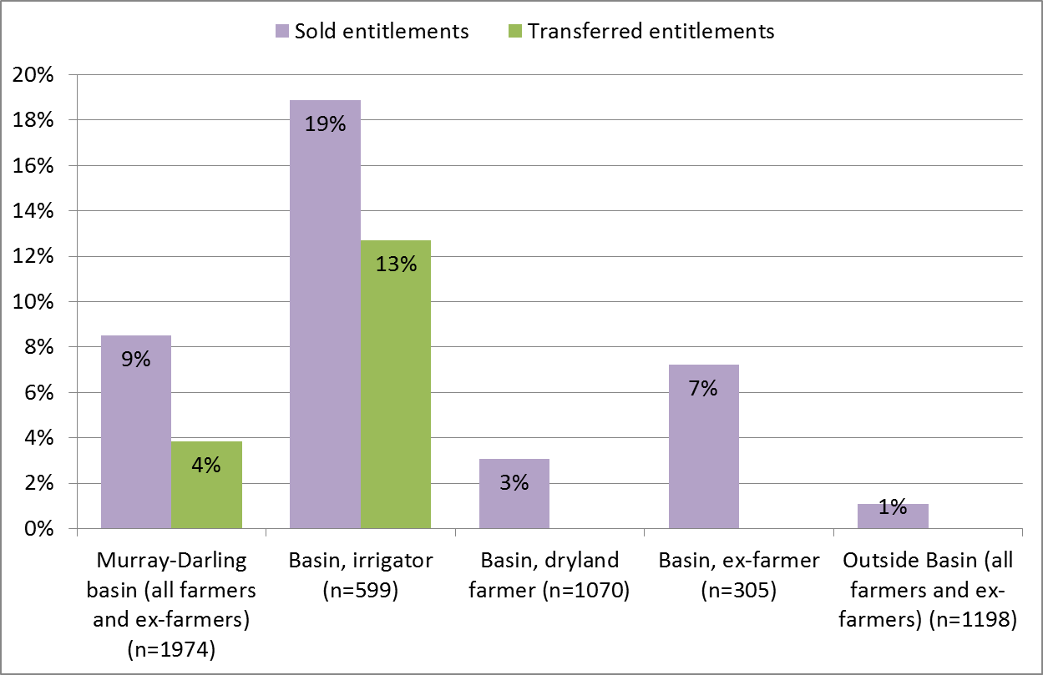

Those who had sold or transferred entitlements were asked in what years they had done so. The large majority (86%) reported only one year, while 14% reported selling or transferring in more than one year. Figure 38 shows the earliest year in which a person reported selling or transferring entitlements. Sale of entitlements was more common in 2008-2010, while transfer of entitlements was more common during 2011-2013.

Figure 38 Period in which water entitlements sold or transferred to government (Basin residents only)

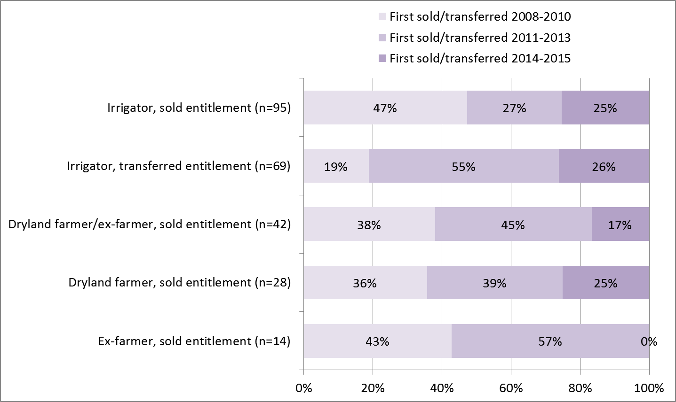

Those who had sold or transferred entitlements were also asked the proportion of their entitlements involved. As shown in Figure 39, transfer of entitlements typically involved less than 30% of entitlements. Of those who sold entitlements, farmers who remained irrigating were slightly more likely to sell less than 60% of entitlement than to sell more than this. Those who exited irrigated agriculture were most likely to have sold 100% of entitlements.

Figure 39 Proportion of water entitlements sold or transferred to government (Basin residents only)

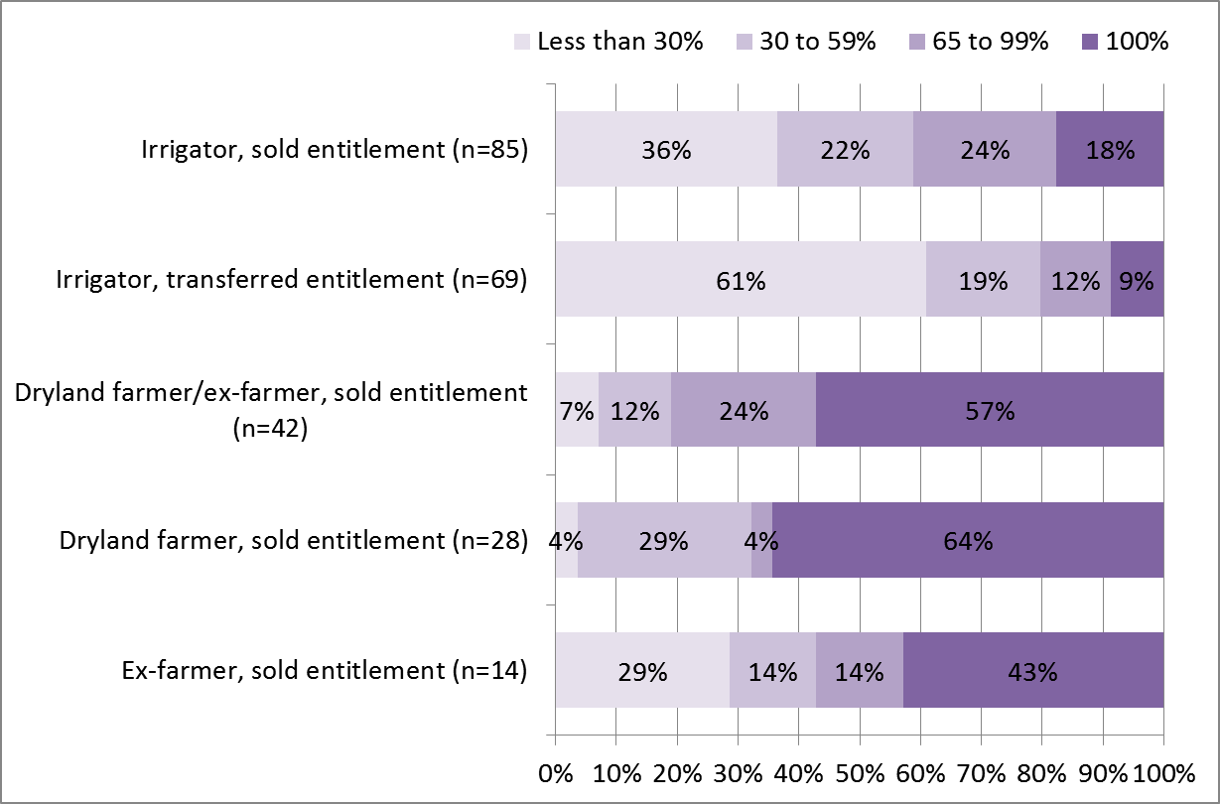

### Drivers of entitlement sale

This section examines the ‘drivers’ of entitlement sale, by identifying which types of farmers/ex-farmers were more or less likely to have sold entitlements. Only entitlement sale is examined, as drivers for entitlement transfer were examined earlier in this report when drivers of investment in on-farm modernisation works that involved entitlement transfer were analysed. The following sections examine whether those who sold versus didn’t sell differed in terms of socio-demographic characteristics and farm characteristics (if they had remained in farming). External farming drivers such as experience of drought were not examined, as most had sold entitlements prior to 2012, and the survey did not ask about drivers extending prior to 2012.

#### Socio-demographic characteristics

When the socio-demographic characteristics of those who sold entitlements versus didn’t sell were compared (Table 14):

* Male irrigators were more likely to report having sold entitlements than female irrigators
* Irrigators aged 50 and over were more likely to have sold entitlements than those aged under 50
* There was no significant difference in household income reported by those who sold versus didn’t sell
* Those who sold were more likely than others not to have completed high school, and less likely to have completed university (this is likely to reflect the differences in age of those who sold)
* Those who sold typically earned a higher proportion of their income from their farm business than those who did not sell.

#### Farm characteristics

As shown in Table 14, when farm characteristics were compared:

* Those who sold entitlements typically had larger farms, in terms of GVAP, compared to those who did not sell
* Crop growers were more likely to report selling entitlements, and fruit/nut growers less likely to
* Those who sold were more likely to report having a written farm plan with business objectives compared to those who did not sell.

Table 14 Socio-demographic and farm characteristics of those who sold entitlements

| Socio-demographic | Percentage | All farmers and ex-farmers  Did not sell entitlements to government | All farmers and ex-farmers  Sold entitlements to government | Irrigators (involved in irrigated agriculture at time of 2015 survey) Did not sell entitlements to government | Irrigators (involved in irrigated agriculture at time of 2015 survey) Sold entitlements to government |
| --- | --- | --- | --- | --- | --- |
| Gender | % Female | 49% | 35% | 38% | 23% |
| Gender | % Male | 51% | 65% | 62% | 77% |
| Age | % aged <40 | 9% | 2% | 9% | 2% |
| Age | % aged 40-49 | 15% | 9% | 15% | 9% |
| Age | % aged 50-64 | 44% | 48% | 43% | 52% |
| Age | % aged 65+ | 32% | 41% | 32% | 38% |
| Household income | Average | $65,000-77,999 | $65,000-77,999 | $65,000-77,999 | $65,000-77,999 |
| Educational attainment | % no high school | 22% | 31% | 24% | 36% |
| Educational attainment | % Year 12 | 15% | 16% | 14% | 16% |
| Educational attainment | % University degree | 36% | 27% | 33% | 25% |
| Off-farm income | % of household income earned off-farm | 41% | 33% | 37% | 32% |
| Farm size - economic | Average GVAP | $200,000-$299,999 | $300,000-$399,999 | $200,000-$299,999 | $300,000-$399,999 |
| Farm type | Cropping | - | - | 7% | 14% |
| Farm type | Fruit/nut | - | - | 15% | 10% |
| Farm type | Beef/sheep | - | - | 8% | 6% |
| Farm planning | % with written farm plan | 26% | 37% | 27% | 38% |

### Socio-economic outcomes of selling or transferring entitlements

Those who had sold/transferred were asked whether they used the sale/transfer to do any of a number of things, including leaving farming, paying off debt, investing in the farm, accessing infrastructure grants, or purchasing more entitlements. As shown in Table 15, many reported doing more than one thing. Those who sold entitlements and stayed in irrigated agriculture were most likely to report paying down farm debt, and investing in improving the farm. Those who transferred entitlements were most likely to report investing in the farm and paying down debt. Dryland farmers who sold entitlements were most likely to pay down debt. Fifty two per cent of ex-farmers reported they used the funds to exit farming (the remaining 48% exited at some point after the sale, but did not report using funds from sale of water entitlements to specifically facilitate their exit from farming).

Table 15 Actions taken after selling or transferring water entitlements

| Entitlement | Leave farming | Pay down farm debt | Invest in improving the farm | Access grant for on-farm water infrastructure | Pay off household (non-farm) debt | Purchase new water entitlements | Other |
| --- | --- | --- | --- | --- | --- | --- | --- |
| Irrigator, sold entitlement (n=108) | 5% | 51% | 29% | 15% | 10% | 6% | 25% |
| Irrigator, transferred entitlement (n=74) | 0% | 22% | 42% | ALL | 3% | 7% | 5% |
| Dryland farmer, sold entitlement (n=31) | 13% | 48% | 29% | 10% | 10% | 0% | 39% |
| Ex-farmer, sold entitlement (n=21) | 52% | 19% | 10% | 10% | 10% | 0% | 19% |

### Direct effects: Experiences of farmers who sold and transferred entitlements

Those who had sold or transferred entitlements were asked how it affected a number of aspects of their own lives and, if applicable, their farm enterprise. The outcomes were very different depending on whether a farmer had transferred or sold the water entitlement, and whether they had remained an irrigator versus shifting to dryland farming or exiting farming altogether.

Irrigators who sold entitlements and continued to operate an irrigated agriculture enterprise commonly reported sale had a positive impact on farm debt levels (61%), but reported a variety of outcomes for personal stress, their household finances, farm profitability, and workload (Figure 40). When asked how the sale affected their life as a whole and their farm enterprise as a whole, one third reported negative impacts, while just under half (45% and 47% respectively) reported positive impacts. A smaller proportion reported there was neither or positive impact (in other words, the sale did not have an effect they considered positive or negative on their life or their farm). When asked about the effects on their community, 57% felt there had been a negative impact on their community, and only 15% that there had been a positive impact.

Figure 40 Outcomes of water entitlement sale, experienced by those who sold and remained an irrigator

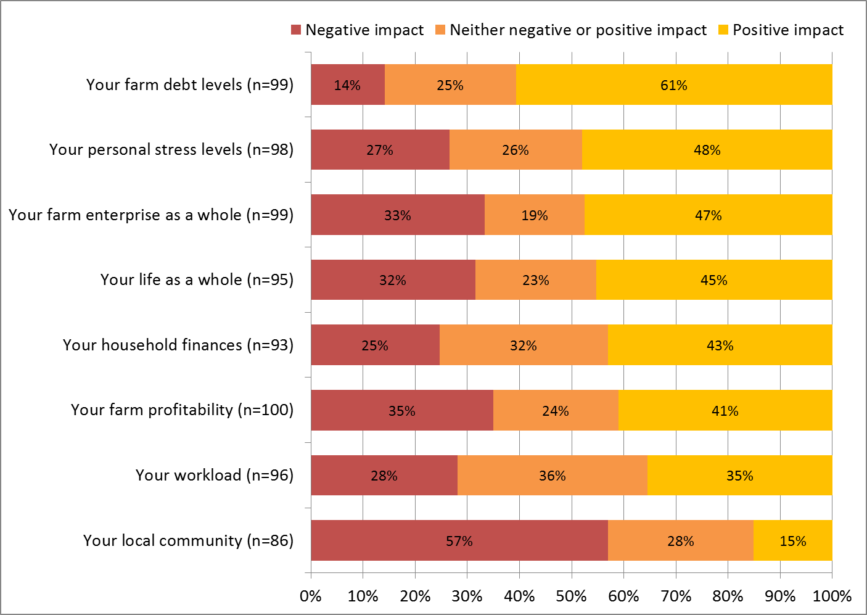

Irrigators who transferred water entitlements to the government as part of accessing grants to improve on-farm infrastructure reported more positive outcomes than those who sold entitlements (Figure 41). A majority reported the transfer had a positive impact on their farm enterprise as a whole (63%), and on their life as a whole (57%), although just under one quarter reported negative impacts on each of these. Almost half (49%) reported positive effects on farm profitability, and 23% negative effects. More reported positive effects on farm debt levels (41%) and household finances (36%) than negative effects (23% for both). When asked about effects of the transfer on workload and personal stress levels, almost equal proportions reported positive, negative and neutral effects. Almost half (47%) felt the transfer had a negative effect on their local community, while 29% reported they felt there was a positive effect.

Figure 41 Outcomes of water entitlement transfer, experienced by those who transferred entitlements in order to access on-farm irrigation infrastructure grants

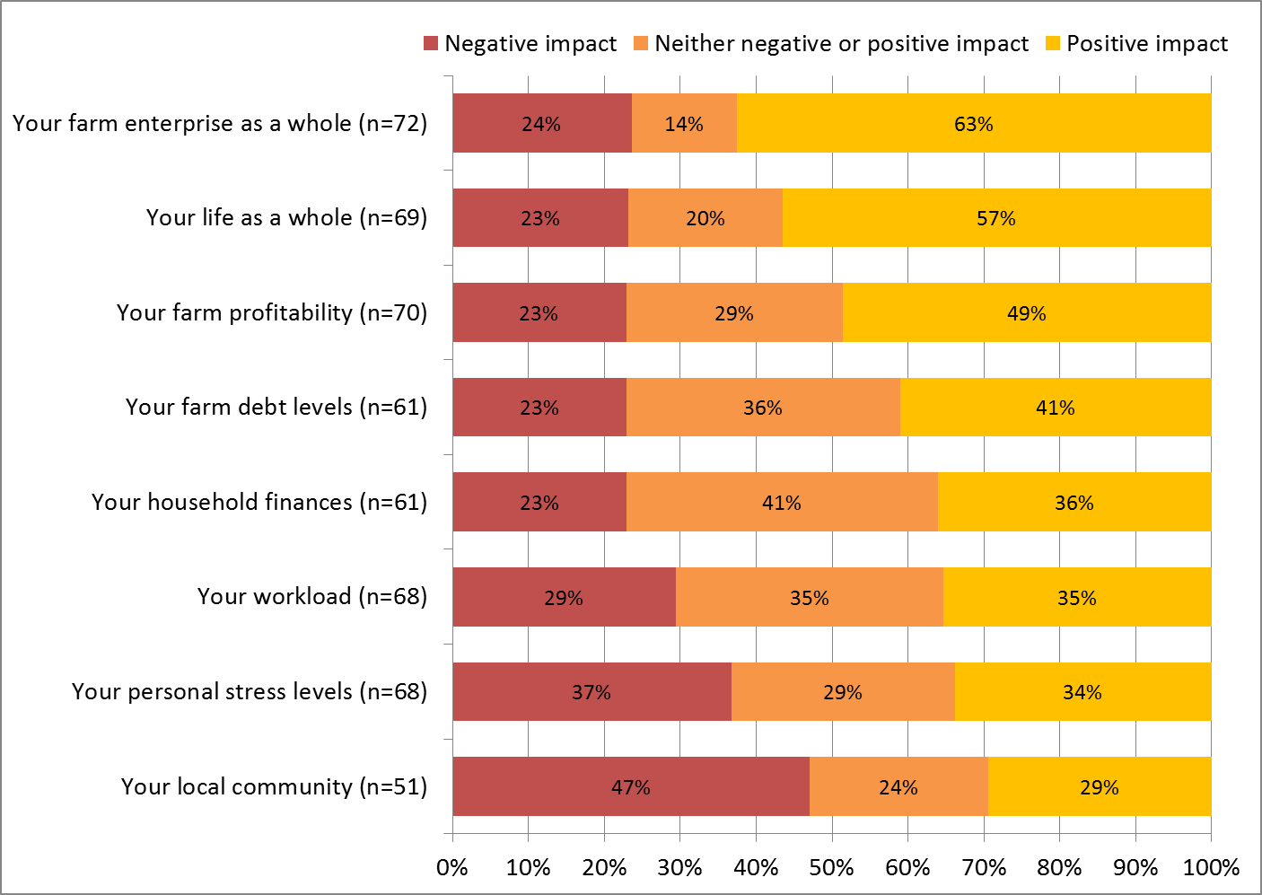

Irrigators who sold entitlements and subsequently switched to dryland farming or exited farming altogether reported different patterns of effects to those who sold and remained in irrigated agriculture (Figure 42 and 43). Findings for those who exited farming are not shown separately as the sample size is too small to present data, however overall patterns of response were very similar for both those who had shifted to dryland farming, and those who had sold and subsequently exited farming (it is important to note that exit from farming was not always a direct consequence of entitlement sale: for example, some left farming some time after the entitlement sale).

Those who sold and then switched to dryland farming or subsequently exited farming were more likely than those who sold and remained in irrigated agriculture to report positive effects on their household finances, their life as a whole, their farm debt levels, their workload and their personal stress levels: between 61% and 69% reported positive effects in each of these areas, while 21% or less reported negative effects. Effects on the farm enterprise were more mixed, with almost as many reporting negative as positive effects. Almost half (48%) felt their sale of water entitlements had negative effects for their local community, and only 12% that it had positive effects. However, many in this group chose not to answer the question about effects on their local community.

Figure 42 Outcomes of water entitlement sale, experienced by those who sold and either switched to dryland farming or exited farming

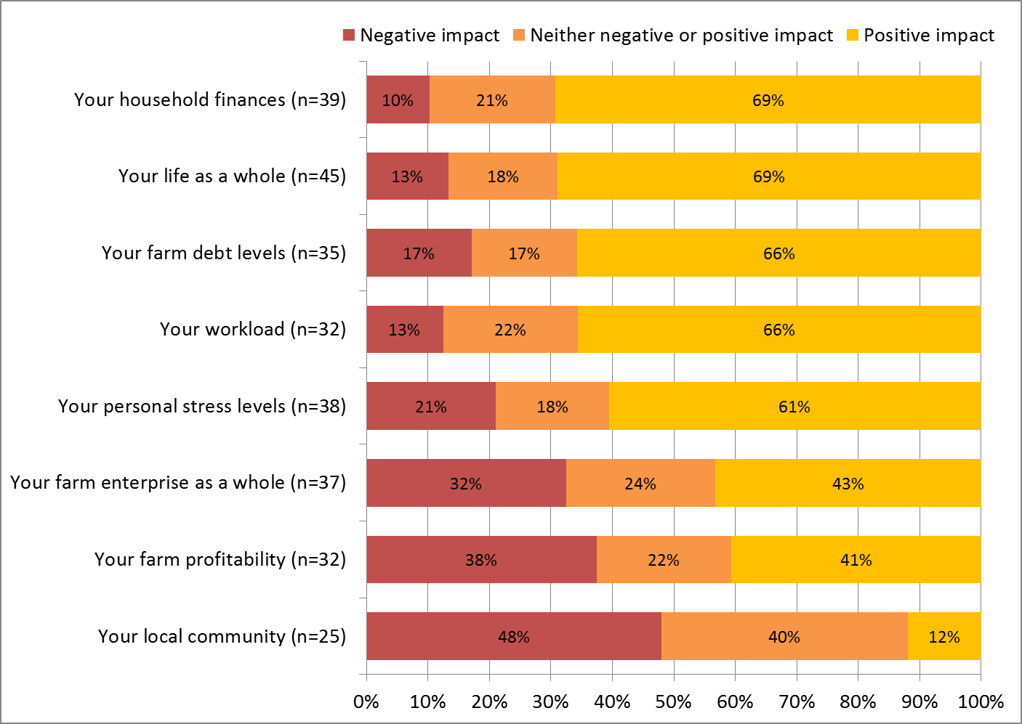

Figure 43 Outcomes of water entitlement sale, experienced by those who subsequently shifted to dryland farming

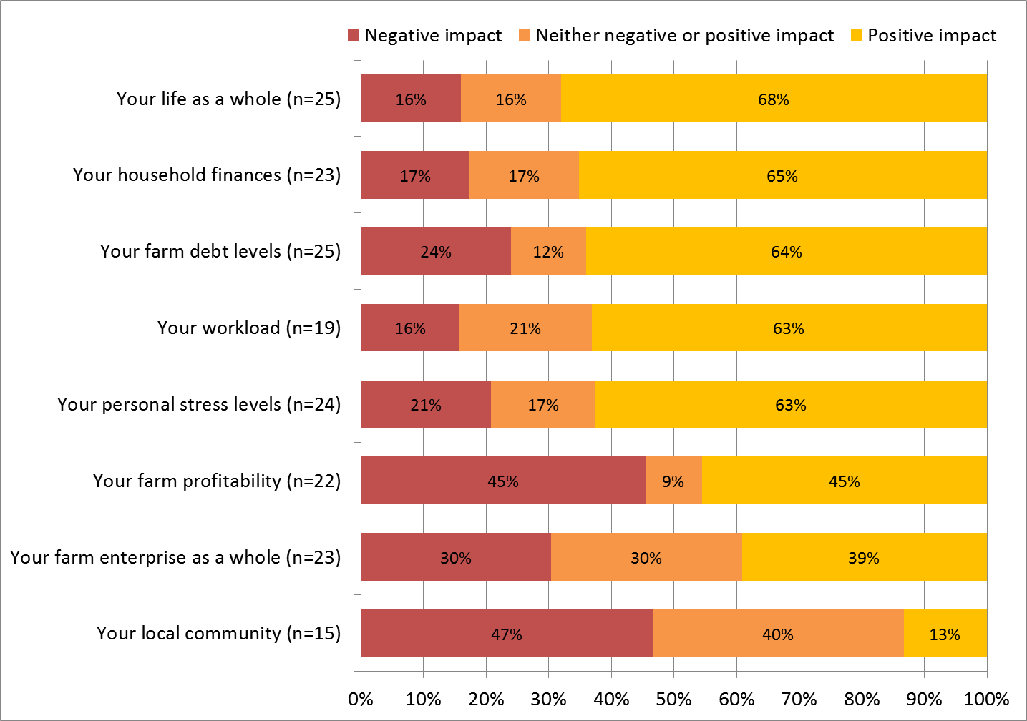

Those who had sold entitlements to the government were significantly more likely to report the sale had positive outcomes for their *life* overall if they also:

* Reported having higher farm profitability (for those who stayed in farming after the sale)
* Reported higher levels of wellbeing
* Were female (men on average were less likely than women to report positive outcomes for their life overall from entitlement sale).

They were significantly more likely to report the sale had positive outcomes for their *farm enterprise* if they also:

* Sold a small proportion of entitlements (those who sold a large proportion of entitlements and remained farming were less likely to report positive outcomes for their farm)
* Had expanded irrigated area on their land in the last year
* Had leased our or sold part of their farm in the last year
* Had not reduced production on their farm in the last year.

There was no difference in the extent to which positive outcomes were reported as a result of entitlement sale, for either a person’s life overall or their farm enterprise, when the following were compared: age, gender, educational attainment, farm type, farm economic size, or the proportion of income earned from the farm. Further detailed analysis is provided in Appendix 4 showing results of the statistical analyses that underpinned these findings.

#### Outcomes of entitlement sale to government: farm performance and farmer wellbeing

In addition to directly asking grant recipients their views on the outcomes of selling entitlements to the government, survey data were analysed to identify whether those who sold entitlements to government had differing farm profitability, farm enterprise changes, future farming intentions, or wellbeing, compared to those who had not sold entitlements. In all cases, the analysis compared people living within the Basin.

##### Farm profitability

Farmers who had sold entitlements were no more or less likely to report making a profit or loss on their farm in 2014-15 compared to irrigators who had not sold entitlements, even when broken down by year of sale, or when examining all farmers (including dryland farmers) versus irrigators only (Figure 44). This suggests similar farm performance in terms of profitability for those who sold entitlements and continued farming, as for those who did not sell entitlement, but does not include the experiences of those who sold entitlements and subsequently left farming. Due to the relatively small sample of farmers who had sold entitlements, it was not possible to examine differences by farm type.

Figure 44 Comparison of farm financial performance in 2014-15 reported by Basin farmers who had and had not sold water entitlements to the government since 2008

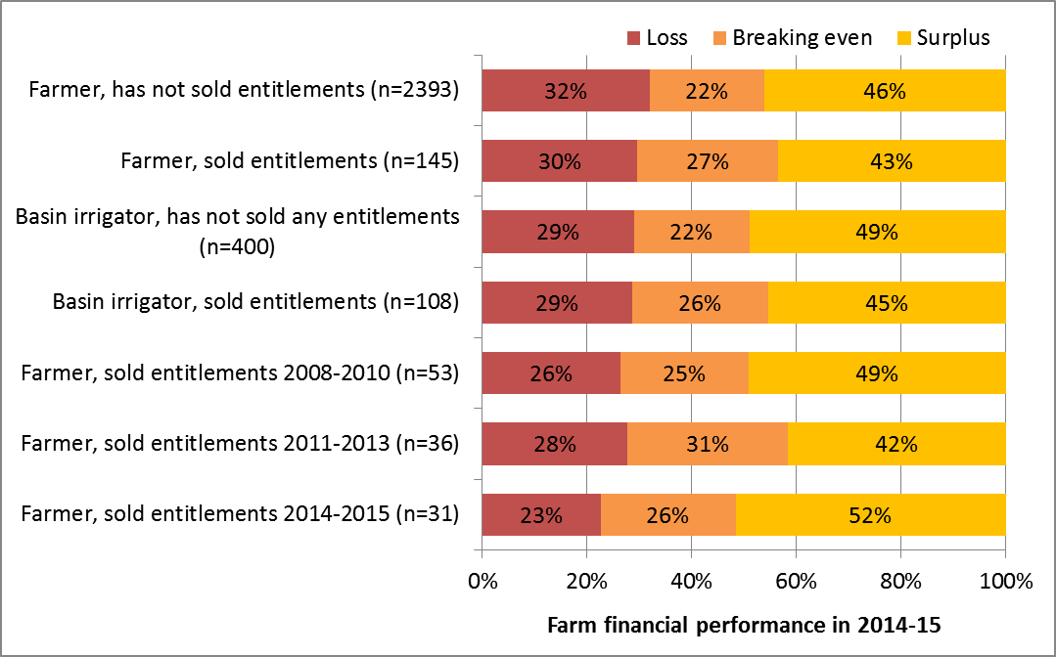

##### Changes on the farm

When asked how their farming had changed in the last 12 months, those Basin irrigators who had sold entitlements and remained in irrigated agriculture differed to Basin irrigators who had not sold entitlements in several ways, as shown in Figure 45. In particular, they were more likely to report having:

* Improved irrigation efficiency on their farm business in the last 12 months (67% of those who sold compared to 54% who had not).
* Decreased the area of land they irrigated (42% compared to 31%) and increased the area of dryland farming (32% compared to 22%)
* Changed what they produced on their farm (35% compared to 21%), and
* Reduced the number of workers on their farm (34% compared to 24%).

Those who had sold were also slightly more likely to have reduced farm production compared to those who had not sold any entitlements, although the difference was not statistically significant.

Figure 45 Farm changes made in last 12 months, reported by Basin irrigators who had and had not sold water entitlements to the government since 2008

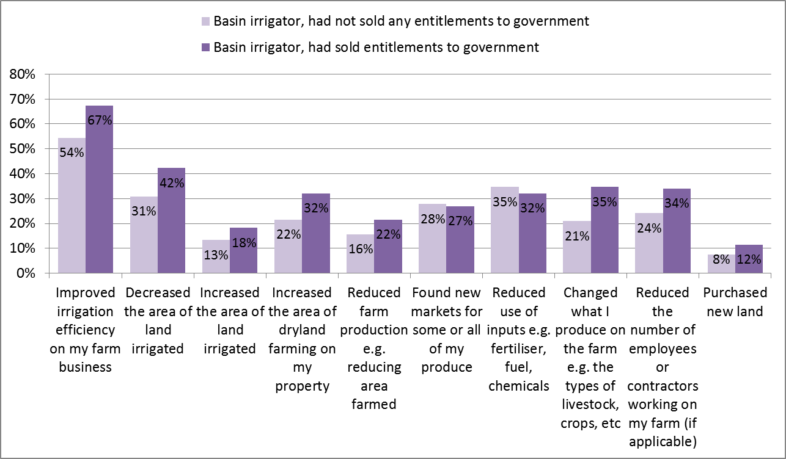

##### Future farming intentions

The future plans of Basin irrigators who had and had not sold water entitlements to the government were also compared, to see if entitlement sale was associated with differing farming intentions (Figure 46). Those who had sold entitlements were more likely to be planning to exit farming, downsize their farm business, and seek additional off-farm work, compared to those who had not sold entitlements.

Figure 46 Future farming intentions of Basin irrigators who had and had not sold water entitlements to the government since 2008

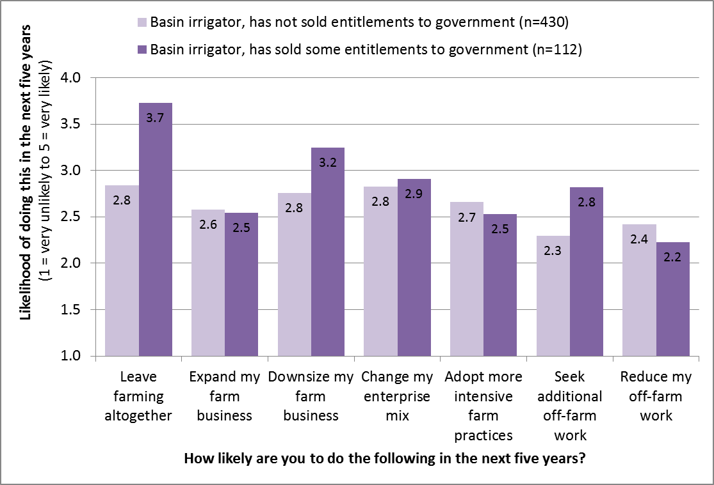

##### Barriers to farm development

Basin irrigators who had sold water entitlements to the government since 2008 were more likely than those who had not sold any entitlements to the government to report experiencing the following barriers to farm development in recent years (Figure 47):

* Increased temporary water prices, likely reflecting that some of those who sold entitlements but stayed in farming shifted to greater reliance on purchasing water on the temporary market
* Reduced water allocation, likely reflecting in part the consequences of entitlement sale

Additionally, they were slightly more likely to report experiencing rising fixed costs of water entitlements and reduced market demand for their produce, although these differences were not statistically significant.

Figure 47 Barriers to farm development experienced in past three years – comparison of Basin irrigators who had and had not sold water entitlements to the government since 2008

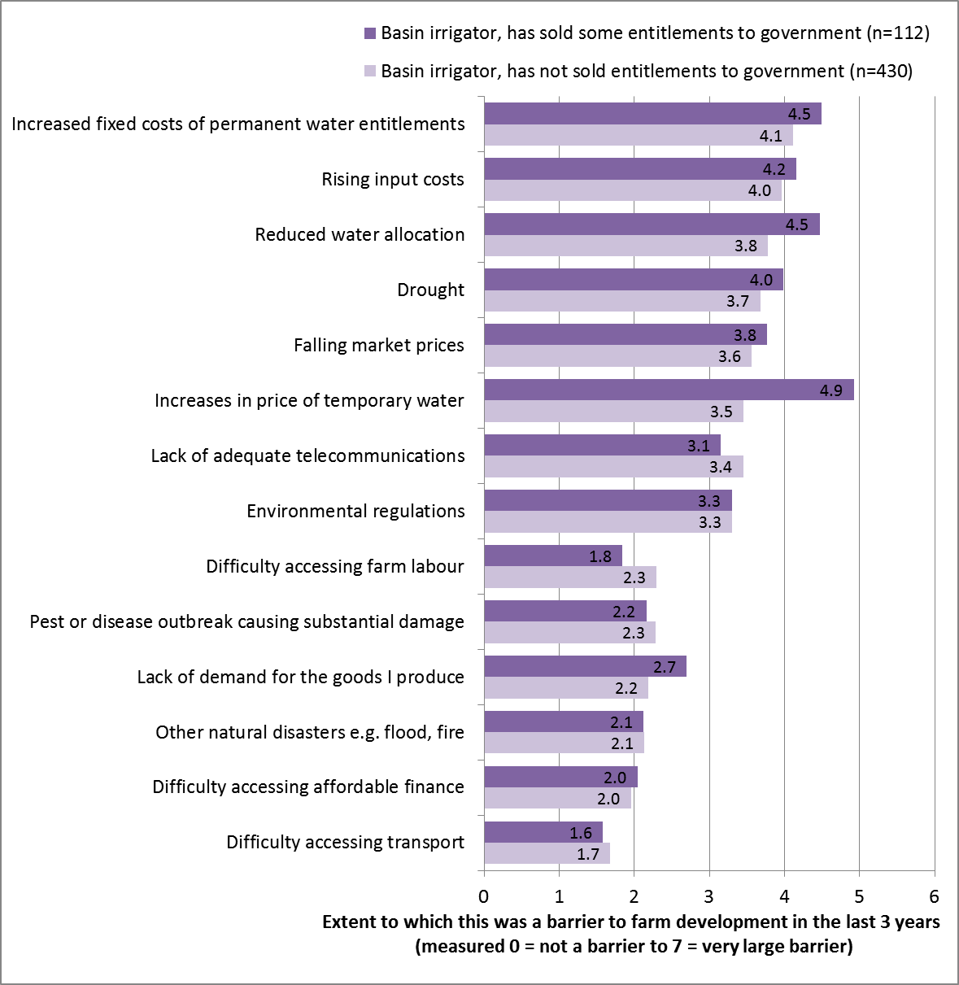

##### Farmer wellbeing

There were no significant differences in the overall wellbeing of irrigators who had and had not sold entitlements to the government (Figure 48). However, those who had sold entitlements to the governments did report poorer satisfaction with their standard of living and what they were achieving in life, although the differences between the two groups were not large enough to be statistically significant.

Figure 48 Personal wellbeing of Basin irrigators who had and had not sold water entitlements to the government since 2008

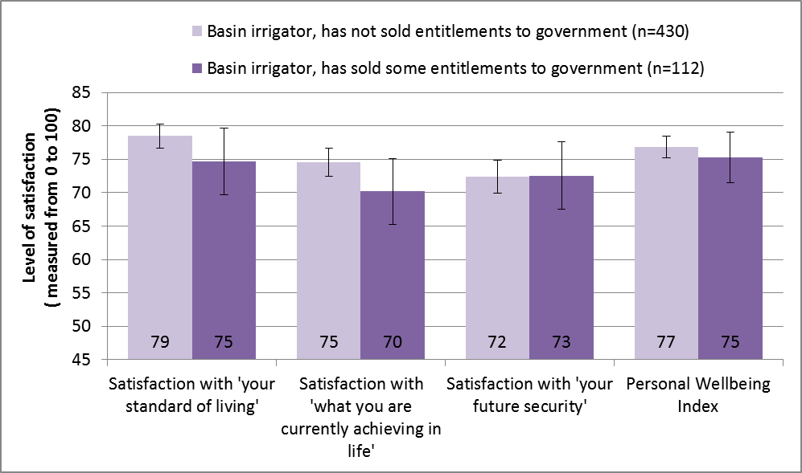

### Effects of entitlement sale on other irrigators

The sale and transfer of water entitlements by irrigators can have effects on other irrigators living in the same district. To fully assess these effects, however, ideally requires having detailed information regarding the proportion of water entitlements sold from different regions to the government at different times, and an understanding of the effect of this sale relative to the effects of other factors such as the volume water trade in and out of different regions in a given year, sale of entitlements to private buyers, availability of temporary water, and the effects of other factors such as a shift to full cost recovery in water pricing occurring in many districts.

To properly analyse the likely effects on other irrigators therefore requires matching of Regional Wellbeing Survey data with datasets from other sources identifying trade of allocation and entitlements relative to total volume of entitlements in a region, as well as how entitlement sale and infrastructure investment have interacted in different regions. This is an area being examined by University of Canberra researchers, who are constructing the databases required for this type of analysis, and aim to produce findings on this topic in late 2016.

## Discussion: Flow-on effects to Basin communities

In addition to understanding effects on irrigators, the likely flow-on effects of the three areas of water reform for rural communities are important to understand. The socio-economic effects of any major change such as water reform can take multiple forms. In particular, these can include:

* Changes in economic activity, which flow on to affect population levels and social interaction
* Changes in stress and wellbeing, which can result both from economic change and from factors such as uncertainty about the future or increased pressure in the farm enterprise.

Water reform is likely to have a flow-on impact for rural communities if it affects the total amount of business activity in a community, for example through increased construction activity during infrastructure development, or through having an effect on either the total volume of agricultural production or the employment required to produce a given volume of agricultural output. It will also have an effect if it results in changes in the location of production of employment dependent on water. Changes in the amount or location of economic activity will in turn lead to changes in population and in social engagement and interaction.

Economic change can affect a person’s levels of stress and wellbeing: these effects range from the well known stresses associated with losing employment, which typically is associated with substantial loss of wellbeing, through to stress associated with factors such as increased work hours. Conversely, if the nature of the economic change reduces stress such as work hours, it may improve wellbeing. However, stress and wellbeing changes occur not only as a result of the economic effects of changes such as water reform: they can also occur as a result of feeling uncertain about the future, and from experiencing increased pressure in a person’s daily life, such as increased or reduced pressures related to the farm enterprise.

Based on the findings of this study, it is possible to identify some of the likely flow-on effects of different types of water reform investment for communities, and this is done below for the three areas of water reform examined. However, this analysis is limited as it covers only the socio-economic changes likely to occur for communities as a direct result of change on the irrigated farm enterprises affected by infrastructure investment and entitlement sale. It does not incorporate analysis of factors such the effect of water reform on certainty about the future, changing on-farm pressures for irrigators not directly participating in infrastructure investments or entitlement sales, or the effect of infrastructure investment on economic activity during construction works. Given this, the final part of this section considers the type of analysis needed to conduct a more comprehensive assessment of flow-on effects to the community.

### Flow-on effects for communities of on-farm infrastructure investment

The results of this study suggest that many of the flow-on effects to communities from on-farm infrastructure are positive. Specifically, this report has identified that irrigators who have received on-farm infrastructure grants are more likely to be increasing irrigated area, and less likely to be reducing production, compared to other irrigators, and were no more likely than other irrigators to be reducing employment on the farm. This suggests that this type of investment is not associated with loss of flow-on employment beyond the farm, as it does not typically result in decreased agricultural production or decreased employment on the farm. Irrigators report mostly positive effects from the investment, and many reported that their own labour hours on the farm had reduced, something that can result in irrigators having greater time to spend with family and participating in community activities.

Overall, because farm production did not contract in association with on-farm infrastructure modernisation, and there was greater investment in expansion of production without reductions in farm labour, the flow-on effects for communities are highly likely to be mostly positive or neutral compared to a situation in which on-farm modernisation grants had not occurred.

The one exception to this would occur in situations in which the full benefits of on-farm modernisation could not be achieved, due to external pressures such as market downturn. Where this occurs, on-farm modernisation will be unlikely to have the positive effects identified above, and more likely to have neutral flow-on effects for communities. In cases where reduced ability to sell water onto the market reduces the options farmers have to cope with difficult times on the farm, it is possible that on-farm infrastructure investment can indirectly deepen negative effects from events such as market downturn, although the findings show this has not typically occurred.

### Flow-on effects for communities of off-farm infrastructure investment

Off-farm infrastructure investment was not associated with expansion of irrigation or farm production, and was in fact more often occurring in areas more likely to be experiencing some contraction in irrigation. While this contraction in irrigation was not a direct outcome of off-farm investment, it was likely to be reducing the ability of irrigators to capitalise on opportunities emerging from better timing of water delivery. In other words, the findings of this report suggest that external pressures being experienced by irrigators in some of the regions in which off-farm infrastructure investment is occurred may be preventing off-farm infrastructure having the positive flow-on effects that would be possible if irrigators were not also experiencing a range of pressures. The data suggest that in many of these regions irrigation is contracting but farm production is being maintained, likely due to investment in improving water use efficiency. If this continues, it would mean that flow-on effects to communities are mostly neutral. However, the higher levels of farm pressure being experienced by district irrigators in many of these regions, particularly with regard to fixed water prices and markets, may place pressure on their ability to maintain production.

### Flow-on effects for communities of water entitlement sale to government

The flow-on effects of water entitlement sale to the government were more difficult to assess, largely because the analysis in this report focuses mostly on the experiences of those irrigators who sold entitlements and remained in agriculture, and under-represents the experiences of those who sold entitlements and exited farming.

While many of those who had sold entitlements felt the effects of this sale were negative for their local community, relatively small proportions of irrigators who sold entitlements and remained in agriculture reported having reduced production levels or employment on their farm enterprise, suggesting that the sales were not necessarily associated with reduction in economic activity in irrigation areas. However, they were more likely than those who had not sold to be planning to leave farming, downsizing their farm enterprise, and were slightly more likely to be decreasing their farm production than those who had not sold entitlements. They were also more likely to report experiencing water-related barriers to farm development, and to report having lower levels of wellbeing, both of which can reduce resilience to difficult times on the farm. These factors mean that, of the three types of water reform examined, direct sale of entitlements is more likely to have some negative flow-on effects to local communities in the form of reduced business activity. However, more comprehensive analysis is needed of the effects of entitlement sale that, for example, takes into account relative levels of investment in a given community in on-farm and off-farm infrastructure modernisation compared to entitlement sale.

### Further analysis needs

To robustly assess the effects to date of infrastructure investment and entitlement sales requires a comprehensive analysis of the extent to which different irrigation-dependent communities across the Basin have been ‘exposed’ to the effect of each of these aspects of water reform, and to other aspect of water reform including reduced barriers to engaging in water trade. It also requires taking into account the ‘external’ factors that may be influencing the capacity of irrigators and irrigation dependent communities to successfully adapt to water reform, such as changes in markets (a farmer experiencing rapid decline in prices for their main commodities, debt stress and rising water prices less likely to be able to invest in modernising infrastructure and improving efficiency of production, for example, than those experiencing strong markets).

To conduct this type of comprehensive analysis in a robust manner requires matching Regional Wellbeing Survey data, which measures factors such as confidence in local economic conditions and certainty about the future of communities, with data that quantifies the extent to which different local communities across the Basin to each aspect of water reform. This is critical as different types of actions undertaken as part of the Basin Plan can have differing socio-economic effects, as shown in this report with differing outcomes reported by irrigators who have modernised on-farm infrastructure, live in an off-farm infrastructure modernisation region, or have sold water entitlements.

Specifically, conducting this analysis requires construction of a database that identifies for different irrigation-dependent communities across the Basin:

* Dependence on irrigated agriculture for local employment (this measures the extent to which changes to irrigated agriculture are likely to impact the local economy).
* Proportion of water entitlements sold to the government: What proportion of water entitlements have been sold, and at what points in time?
* Extent of investment on on-farm infrastructure modernisation and off-farm infrastructure modernisation
* Water trade activity: How much water is typically traded in and out of this community? Are many of the water entitlements located in the community often used in other communities? This analysis applies largely to the Southern connected regions of the Basin in which water trade can result in water being used in very different regions each year, something which also results in shifts in the amount of employment generated each year for local communities in which water is traded to and from
* Market trends for key agricultural commodities
* Climatic data enabling identification of experience of water stress

This data can be matched with the following data enabling comparison of socio-economic wellbeing of communities experiencing greater or lesser exposure to these aspects of water reform:

* Regional Wellbeing Survey data identifying overall community economic confidence and wellbeing
* Once available, data from the 2016 ABS *Census of Population and Housing* identifying extent of population change and employment change by industry for each community.

## Conclusions

Our findings show that on-farm infrastructure modernisation has had largely positive socio-economic impacts for the farmers who have received grants, with very few farmers reporting negative outcomes and almost all reporting that on-farm infrastructure modernisation has been positive for their farm overall. The only exception to this occurred when external pressures had reduced the ability of farmers to fully utilise the on-farm modernisation works to increase efficiency of on-farm production, as appears to be occurring for wine grape growers experiencing market downturn. The flow-on effects of on-farm investments for communities are likely to be predominantly positive.

Off-farm infrastructure modernisation is more likely to be rated as having positive than negative impacts for farms, but had greater trade-offs than on-farm infrastructure: while a majority of irrigators reported better timing of water delivery, most also reported increased costs of water delivery. Reported impacts also varied substantially by region, reflecting that the type and nature of off-farm works has varied by region and so have their outcomes. This highlights the importance of evaluating different off-farm investments individually based on the specific nature of the works undertaken.

Water entitlement sale to government was more varied in its outcomes, with around half of those who sold entitlements rating the overall effects as being positive and half as experiencing neutral or negative effects. Impacts were more positive for those who sold and exited irrigated agriculture than for those who remained in irrigated agriculture.

Further work is needed to undertake an integrated assessment of the flow-on effects of these three water reform actions for communities, and the methodology outlined in this reports provides a basis for undertaking this more in-depth flow-on analysis using either data from the Regional Wellbeing Survey and/or the *Census of Population and Housing*.

## References

ABS (Australian Bureau of Statistics). 2015. Water Use on Australian Farms, 2013-14. Cat No. 4618.0. Australian Bureau of Statistics, Canberra.

ABS (Australian Bureau of Statistics). 2016. Water Use on Australian Farms, 2014-15. Cat No. 4618.0. Australian Bureau of Statistics, Canberra.

ACCC (Australian Competition and Consumer Commission). 2016. ACCC Water Monitoring Report 2014-15. ACCC, Canberra.

Cheesman, J., & Wheeler, S. (2012). Survey of water entitlement sellers under the Restoring the Balance in the Murray-Darling Basin program: Final report prepared for the Department of Sustainability, Environment, Water, Population and Communities. Canberra: Marsden Jacob Associates.

Department of Environment. 2015a. [On-farm irrigation efficiency program](https://www.environment.gov.au/water/rural-water/srwui/on-farm-irrigation-efficiency-program). Department of the Environment. Accessed 24 May 2016

Department of Environment. 2015b. [State Priority Projects](https://www.environment.gov.au/water/rural-water/srwui/state-priority-projects). Department of the Environment. Accessed 24 May 2016.

Department of Environment. 2015c. [Restoring the Balance in the Murray-Darling Basin](https://www.environment.gov.au/water/rural-water/restoring-balance-murray-darling-basin). Department of Environment. Accessed 24 May 2016

Hunt, G., Baldwin, B., McCormack, M., Ley, S., Blair, N., Piccoli, A. 2015. [$263.5 million boost for on-farm irrigation in NSW](https://www.environment.gov.au/minister/hunt/2015/mr20150805.html). MEDIA RELEASE 5 August 2015. Department of the Environment. Accessed 24 May 2016

NSW Trade & Investment (2015) Irrigators’ Surveys 2009/2010 and 2013 – A statewide comparison. NSW Trade and Investment.

Schirmer, J., Yabsley, B., Mylek, M. and Peel, D. 2016. People and communities: the 2015 Regional Wellbeing Survey.

Select Committee on the Murray-Darling Basin Plan. 2016. [Refreshing the Plan: Report of the Select Committee on the Murray-Darling basin Plan](http://www.aph.gov.au/Parliamentary_Business/Committees/Senate/Murray_Darling_Basin_Plan/murraydarling/Report), March 2016. Commonwealth of Australia, Canberra. Accessed 24 May 2016.

Wheeler, S. A., Zuo, A., & Bjornlund, H. (2014). Investigating the delayed on-farm consequences of selling water entitlements in the Murray-Darling Basin. Agricultural Water Management, 145, 72-82.

## Appendix 1: 2015 Regional Wellbeing Survey questions

The following pages show the items included in the 2015 Regional Wellbeing Survey *specifically for this project.* In addition to these, a large number of other items were included in the survey.

**Selling water entitlements to the government**

**In recent years, water entitlements have been sold to the government by many irrigators. If you have sold water entitlements to the government, whether you are still an irrigator or not, please answer the following. If you haven’t sold water entitlements, go to the next page.**

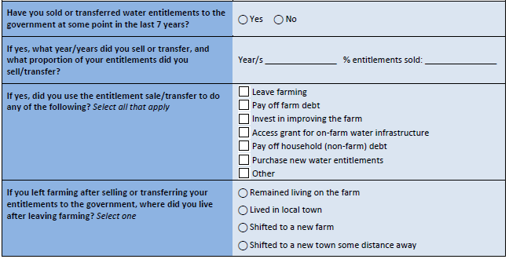

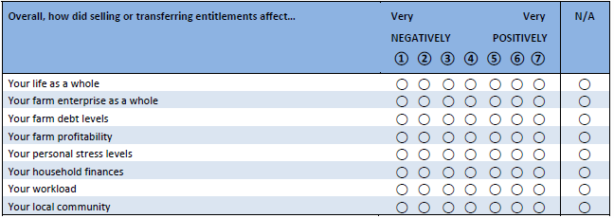

**On-farm water infrastructure**

Upgrading water infrastructure is an important activity for many irrigators. The next questions ask if you have added or upgraded on-farm water infrastructure in recent years and if you have, what benefits and costs it has had for you.

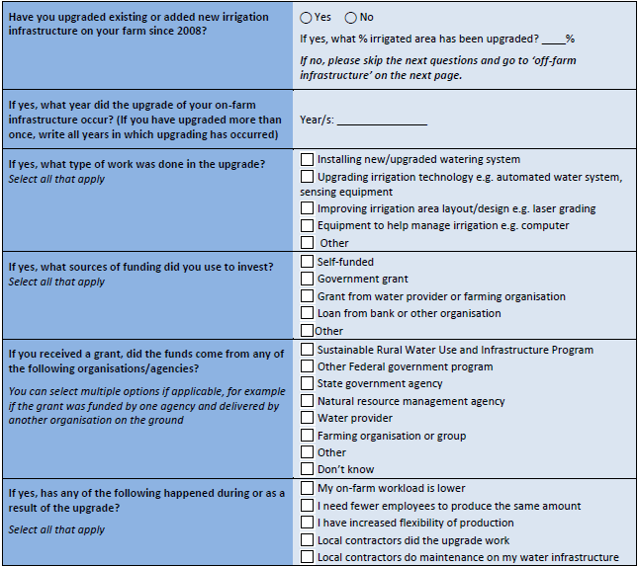

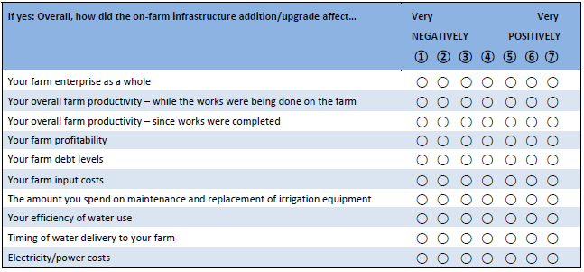

**Off-farm water infrastructure**

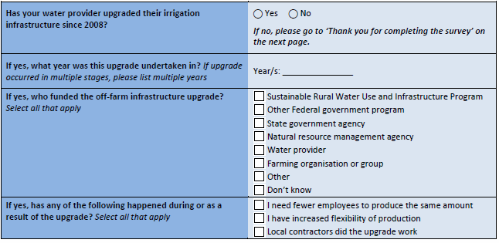

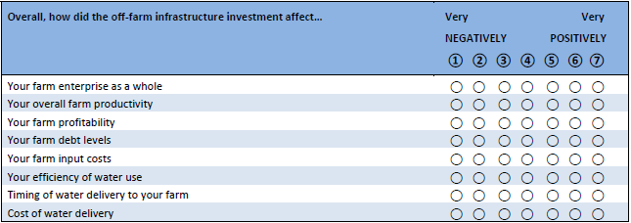

## Appendix 2: Outcomes of upgrading on-farm water infrastructure

This Appendix contains data that was used to assess the factors that may influence whether an irrigator reported experiencing positive or negative outcomes as a consequence of upgrading their on-farm water infrastructure.

**How did the on-farm infrastructure upgrade/addition affect your farm enterprise as a whole?**

| On-farm infrastructure | Correlation coefficient | Significance | n |
| --- | --- | --- | --- |
| Proportion of irrigation infrastructure that was modernised | **.153\*\*** | **.002** | **407** |
| Most recent year in which on-farm water infrastructure was modernised | .022 | .650 | 444 |
| Percentage of irrigated land upgraded or had new infrastructure added | **.138\*\*** | **.005** | **407** |
| Volume of water used from irrigation channels in 2014-15 | .012 | .798 | 481 |
| How much has drought affected you personally in the last 12 months | .092 | .076 | 372 |
| How much has drought affected your farm business in the last 12 months | .055 | .295 | 367 |
| Average cash flow on farm during previous 12 months | .061 | .312 | 274 |
| Farm business is under a lot of financial stress at the moment | .013 | .771 | .081 |
| Satisfied with farm business performance | .081 | .076 | 483 |
| No choice in the price received for products | .063 | .168 | 486 |
| Gross value of agricultural production during financial year 2014-15 (GVAP) | **.168\*\*** | **.000** | **481** |
| Farm business making profit or loss | **.099\*** | **.029** | **490** |
| Level of debt owed by farm business at end June 2015 | **.102\*** | **.024** | **487** |
| Ease/difficulty of servicing farm business debt at the moment | .040 | .410 | 429 |
| Household income from farm business | **.125\*\*** | **.005** | **497** |
| Whether drought has prevented running of farm business in the desired way in the previous 3 years | .035 | .490 | 385 |
| Whether other natural disasters have prevented running of farm business the desired way in the previous 3 years | .061 | .242 | 375 |
| Whether pest, disease or weed invasion has prevented running of farm business the desired way in the previous 3 years | -.028 | .580 | 381 |
| Whether rising input costs have prevented running of farm business the desired way in the previous 3 years | .046 | .371 | 384 |
| Whether lack of demand for goods produced has prevented running of farm business the desired way in the previous 3 years | -.019 | .717 | 387 |
| Whether falling prices for goods produced has prevented running of farm business the desired way in the previous 3 years | .028 | .580 | 387 |
| Whether environmental regulations have prevented running of farm business the desired way in the previous 3 years | .091 | .074 | 385 |
| Whether difficulty in transporting produce to market has prevented running of farm business the desired way in the previous 3 years | -.062 | .223 | 384 |
| Whether difficulty obtaining labour has prevented running of farm business the desired way in the previous 3 years | .099 | .053 | 384 |
| Whether reduced water allocation for one or more seasons has prevented running of farm business the desired way in the previous 3 years | .059 | .248 | 385 |
| Whether increased fixed charges on permanent water entitlements has prevented running of farm business the desired way in the previous 3 years | .079 | .123 | 385 |
| Whether increases in cost of purchasing temporary water has prevented running of farm business the desired way in the previous 3 years | .089 | .081 | 383 |
| Whether lack of adequate telecommunications infrastructure has prevented running of farm business the desired way in the previous 3 years | .054 | .290 | 385 |
| Whether difficulty accessing affordable finance has prevented running of farm business the desired way in the previous 3 years | -.012 | .822 | 381 |
| Likelihood of leaving farming altogether in the next 5 years | **-.125\*\*** | **.009** | **438** |
| Likelihood of expanding farm business in the next 5 years | .054 | .253 | 454 |
| Likelihood of downsizing farm business in the next 5 years | **-.145\*\*** | **.002** | **454** |
| Likelihood of changing enterprise mix in the next 5 years | **-.097\*** | **.039** | **450** |
| Likelihood of changing business structure and management of farm in the next 5 years | -.017 | .720 | 458 |
| Likelihood of adopting more intensive farm practices in the next 5 years | .004 | .935 | 457 |
| Likelihood of seeking additional off-farm work in the next 5 years | -.086 | .068 | 455 |
| Likelihood of reducing off-farm work in the next 5 years | **-.106\*** | **.036** | **391** |
| Proportion of household income earned off-farm in the previous 12 months | **-.103\*** | **.021** | **497** |
| Hours worked on-farm by respondent | **.133\*** | **.010** | **373** |
| Have a written farm plan that includes clear business objectives | **.097\*** | **.035** | **474** |
| Have a farm business plan, but it isn’t written down as a formal document | .045 | .326 | 483 |
| Farm plan includes strategies for coping with drought | .089 | .051 | 484 |
| Farm plan includes assessment of likely risks that could affect the farm, and how to respond to them | **.131\*\*** | **.004** | **478** |
| Hectares of land you own or part-own (including mortgaged land) | .050 | .266 | 495 |
| K10 psychological distress scale | **-.115\*** | **.010** | **497** |
| Age | .000 | .993 | 493 |
| Community Wellbeing Index (CWI) | .055 | .222 | 496 |
| Personal Wellbeing Index (PWI) | **.144\*\*** | **.001** | **496** |
| PWI - Your future security | **.094\*** | **.037** | **496** |
| PWI - What you are currently achieving in life | **.148\*\*** | **.001** | **496** |
| Global Life Satisfaction | **.142\*\*** | **.001** | **496** |
| Household income | .021 | .654 | 459 |
| Financial situation | .065 | .158 | 479 |
| Feeling life is worthwhile | **.120\*** | **.042** | **284** |
| Self-efficacy | **.175\*\*** | **.000** | **495** |

**How did the on-farm infrastructure upgrade/addition affect your farm enterprise as a whole?**

| On-farm infrastructure | Category | Mean score  (from 1 ‘very negatively to 7 ‘very positively) | Confidence interval | n |
| --- | --- | --- | --- | --- |
| Has drought affected your community in the last five years? | No | 5.5 | .2 | 134 |
| Has drought affected your community in the last five years? | Yes | 5.5 | .1 | 337 |
| Have a written farm plan that includes clear business objectives | 1 Strongly disagree | 5.4 | .2 | 104 |
| Have a written farm plan that includes clear business objectives | 2 | 5.4 | .3 | 72 |
| Have a written farm plan that includes clear business objectives | 3 | 5.3 | .3 | 44 |
| Have a written farm plan that includes clear business objectives | 4 | 5.6 | .2 | 88 |
| Have a written farm plan that includes clear business objectives | 5 | 5.4 | .3 | 64 |
| Have a written farm plan that includes clear business objectives | 6 | 5.7 | .3 | 50 |
| Have a written farm plan that includes clear business objectives | 7 Strongly agree | 5.8 | .3 | 52 |
| Farm plan includes strategies for coping with drought | 1 Strongly disagree | 5.3 | .4 | 46 |
| Farm plan includes strategies for coping with drought | 2 | 5.3 | .3 | 36 |
| Farm plan includes strategies for coping with drought | 3 | 5.8 | .3 | 37 |
| Farm plan includes strategies for coping with drought | 4 | 5.4 | .2 | 96 |
| Farm plan includes strategies for coping with drought | 5 | 5.5 | .2 | 98 |
| Farm plan includes strategies for coping with drought | 6 | 5.6 | .2 | 115 |
| Farm plan includes strategies for coping with drought | 7 Strongly agree | 5.8 | .3 | 56 |
| Farm plan includes assessment of likely risks that could affect the farm, and how to respond to them | 1 Strongly disagree | 5.4 | .3 | 42 |
| Farm plan includes assessment of likely risks that could affect the farm, and how to respond to them | 2 | 5.3 | .4 | 35 |
| Farm plan includes assessment of likely risks that could affect the farm, and how to respond to them | 3 | 5.5 | .3 | 46 |
| Farm plan includes assessment of likely risks that could affect the farm, and how to respond to them | 4 | 5.3 | .2 | 100 |
| Farm plan includes assessment of likely risks that could affect the farm, and how to respond to them | 5 | 5.6 | .2 | 109 |
| Farm plan includes assessment of likely risks that could affect the farm, and how to respond to them | 6 | 5.5 | .2 | 98 |
| Farm plan includes assessment of likely risks that could affect the farm, and how to respond to them | 7 Strongly agree | 5.9 | .4 | 48 |
| Off-farm work (for respondent) | No off-farm work | 5.7 | .1 | 182 |
| Off-farm work (for respondent) | Part-time off-farm work | 5.4 | .3 | 69 |
| Off-farm work (for respondent) | Full-time off-farm work | 5.0 | .5 | 18 |
| Off-farm work (for partner/spouse) | No off-farm work | 5.8 | .2 | 99 |
| Off-farm work (for partner/spouse) | Part-time off-farm work | 5.5 | .2 | 75 |
| Off-farm work (for partner/spouse) | Full-time off-farm work | 5.4 | .3 | 42 |
| Decreased the area of land irrigated on farm business in the previous 12 months | No | 5.6 | .2 | 192 |
| Decreased the area of land irrigated on farm business in the previous 12 months | Yes | 5.3 | .3 | 59 |
| Increased the area of land irrigated on farm business in the previous 12 months | No | 5.4 | .2 | 193 |
| Increased the area of land irrigated on farm business in the previous 12 months | Yes | 6.0 | .3 | 53 |
| Improved irrigation efficiency on farm business in the previous 12 months | No | 5.1 | .3 | 67 |
| Improved irrigation efficiency on farm business in the previous 12 months | Yes | 5.7 | .2 | 183 |
| Increased the area of dryland farming on property in the previous 12 months | No | 5.6 | .2 | 204 |
| Increased the area of dryland farming on property in the previous 12 months | Yes | 5.4 | .3 | 48 |
| Purchased new land in the previous 12 months | No | 5.6 | .1 | 228 |
| Purchased new land in the previous 12 months | Yes | 5.8 | .4 | 26 |
| Leased additional land from others in the previous 12 months | No | 5.6 | .1 | 235 |
| Leased additional land from others in the previous 12 months | Yes | 5.8 | .6 | 18 |
| Sold part of farm business in the previous 12 months | No | 5.6 | .1 | 237 |
| Sold part of farm business in the previous 12 months | Yes | 5.4 | .5 | 16 |
| Leased out some land in the previous 12 months | No | 5.6 | .1 | 240 |
| Leased out some land in the previous 12 months | Yes | 5.5 | .7 | 13 |
| Invested in major new farm machinery, technologies or infrastructure in the previous 12 months | No | 5.4 | .2 | 105 |
| Invested in major new farm machinery, technologies or infrastructure in the previous 12 months | Yes | 5.7 | .2 | 147 |
| Found new markets for some or all produce in the previous 12 months | No | 5.5 | .2 | 164 |
| Found new markets for some or all produce in the previous 12 months | Yes | 5.7 | .2 | 90 |
| Changed what produce on the farm in the previous 12 months | No | 5.6 | .2 | 183 |
| Changed what produce on the farm in the previous 12 months | Yes | 5.5 | .2 | 72 |
| Changed how produce on the farm in the previous 12 months | No | 5.6 | .1 | 225 |
| Changed how produce on the farm in the previous 12 months | Yes | 5.4 | .4 | 29 |
| Increased the hours worked on the farm in the previous 12 months | No | 5.6 | .2 | 155 |
| Increased the hours worked on the farm in the previous 12 months | Yes | 5.6 | .2 | 101 |
| Reduced the hours worked on the farm in the previous 12 months | No | 5.6 | .1 | 223 |
| Reduced the hours worked on the farm in the previous 12 months | Yes | 5.4 | .4 | 29 |
| Respondent/partner increased off-farm work in the previous 12 months | No | 5.6 | .2 | 191 |
| Respondent/partner increased off-farm work in the previous 12 months | Yes | 5.4 | .3 | 64 |
| Shared expenses with other farmers in the previous 12 months | No | 5.6 | .1 | 229 |
| Shared expenses with other farmers in the previous 12 months | Yes | 5.1 | .4 | 28 |
| Reduced use of inputs in the previous 12 months | No | 5.6 | .2 | 168 |
| Reduced use of inputs in the previous 12 months | Yes | 5.5 | .2 | 90 |
| Postponed investment in farm capital in the previous 12 months | No | 5.6 | .2 | 123 |
| Postponed investment in farm capital in the previous 12 months | Yes | 5.5 | .2 | 134 |
| Reduced the number of employees or contractors working on farm in the previous 12 months | No | 5.6 | .2 | 182 |
| Reduced the number of employees or contractors working on farm in the previous 12 months | Yes | 5.5 | .2 | 70 |
| Reduced use of professional services in the previous 12 months | No | 5.6 | .2 | 205 |
| Reduced use of professional services in the previous 12 months | Yes | 5.6 | .3 | 50 |
| Reduced farm production in the previous 12 months | No | 5.6 | .1 | 224 |
| Reduced farm production in the previous 12 months | Yes | 5.3 | .4 | 28 |
| Partly or fully destocked in the previous 12 months | No | 5.6 | .2 | 195 |
| Partly or fully destocked in the previous 12 months | Yes | 5.4 | .3 | 57 |
| Stopped watering orchards or vineyards in the previous 12 months | No | 5.6 | .2 | 214 |
| Stopped watering orchards or vineyards in the previous 12 months | Yes | 5.3 | .5 | 15 |
| I drew down on my Farm Management Deposit in the previous 12 months | No | 5.5 | .2 | 198 |
| I drew down on my Farm Management Deposit in the previous 12 months | Yes | 5.9 | .3 | 31 |
| Age | 18-29 | 5.7 | .8 | 7 |
| Age | 30-49 | 5.4 | .2 | 111 |
| Age | 50-64 | 5.6 | .1 | 255 |
| Age | 65plus | 5.4 | .2 | 120 |
| Gender | Female | 5.6 | .2 | 159 |
| Gender | Male | 5.5 | .1 | 339 |
| Level of education | Certificate or diploma | 5.5 | .2 | 138 |
| Level of education | None of these | 5.5 | .2 | 107 |
| Level of education | University degree | 5.5 | .2 | 160 |
| Level of education | Year 12 of high school | 5.5 | .3 | 84 |
| Farmer type | Beef grazier | 5.3 | .5 | 37 |
| Farmer type | Beef-sheep grazier | 5.8 | .5 | 9 |
| Farmer type | Crop grower | 5.6 | .3 | 42 |
| Farmer type | Dairy farmer | 5.8 | .3 | 74 |
| Farmer type | Fodder grower | 5.5 | .4 | 35 |
| Farmer type | Fruit/nut grower | 5.5 | .2 | 66 |
| Farmer type | Intensive cattle | 5.4 | .6 | 12 |
| Farmer type | Intensive livestock | 5.1 | 1.4 | 7 |
| Farmer type | Mixed crop-beef | 5.6 | .6 | 18 |
| Farmer type | Mixed crop-sheep | 5.5 | .5 | 27 |
| Farmer type | Other | 5.3 | 1.1 | 6 |
| Farmer type | Rice grower | 5.5 | .3 | 38 |
| Farmer type | Sheep grazier | 5.4 | .5 | 29 |
| Farmer type | Vegetable grower | 5.4 | .3 | 26 |
| Farmer type | Wine grape grower | 5.3 | .3 | 56 |

## Appendix 3: Outcomes of off-farm modernisation investment

This Appendix contains data that was used to assess the factors that may influence whether an irrigator experienced positive or negative outcomes as a consequence of modernisation of off-farm water delivery infrastructure in their region.

**How did the off-farm infrastructure modernisation affect your farm enterprise as a whole?**

| Off-farm infrastructure | Region and Year | Mean score  (from 1 ‘very negatively to 7 ‘very positively) | Confidence interval | n |
| --- | --- | --- | --- | --- |
| Year in which off-farm modernisation agreement signed | 2010 | 4.3 | .3 | 96 |
| Year in which off-farm modernisation agreement signed | 2011 | 4.7 | .4 | 33 |
| Year in which off-farm modernisation agreement signed | 2012 | 4.3 | .4 | 48 |
| Year in which off-farm modernisation agreement signed | 2014 | 3.9 | .6 | 25 |
| Part of Basin | NSW Southern Basin & Disconnected | 4.3 | .3 | 82 |
| Part of Basin | SA Southern Basin | 5.0 | .8 | 13 |
| Part of Basin | VIC Southern Basin & Disconnected | 4.3 | .3 | 108 |
| Surface Water Sustainable Diversion Limit region | Broken | 3.5 | .3 | 6 |
| Surface Water Sustainable Diversion Limit region | Campaspe | 4.0 | .7 | 11 |
| Surface Water Sustainable Diversion Limit region | Goulburn | 4.9 | 1.0 | 32 |
| Surface Water Sustainable Diversion Limit region | Loddon | 4.5 | .4 | 13 |
| Surface Water Sustainable Diversion Limit region | Murrumbidgee | 4.5 | .4 | 40 |
| Surface Water Sustainable Diversion Limit region | New South Wales Murray | 4.1 | .3 | 42 |
| Surface Water Sustainable Diversion Limit region | South Australian Murray | 4.4 | .5 | 7 |
| Surface Water Sustainable Diversion Limit region | South Australian Non-Prescribed Areas | 5.7 | 1.3 | 6 |
| Surface Water Sustainable Diversion Limit region | Victorian Murray | 3.9 | .7 | 41 |
| Surface Water Sustainable Diversion Limit region | Wimmera–Mallee (Surface Water) | 3.5 | .5 | 2 |
| Local government area | Berrigan (A) | 3.7 | .9 | 13 |
| Local government area | Campaspe (S) | 4.4 | .6 | 25 |
| Local government area | Conargo (A) | 4.3 | 1.4 | 6 |
| Local government area | Deniliquin (A) | 4.9 | 1.2 | 9 |
| Local government area | Gannawarra (S) | 3.7 | .6 | 15 |
| Local government area | Greater Shepparton (C) | 4.6 | .6 | 18 |
| Local government area | Griffith (C) | 4.6 | .5 | 14 |
| Local government area | Leeton (A) | 4.2 | .4 | 5 |
| Local government area | Loddon (S) | 4.7 | .4 | 12 |
| Local government area | Mildura (RC) | 4.1 | 1.0 | 12 |
| Local government area | Moira (S) | 4.2 | .9 | 17 |
| Local government area | Murray (A) | 4.2 | 1.0 | 9 |
| Local government area | Murrumbidgee (A) | 4.5 | .5 | 11 |
| Local government area | Renmark Paringa (DC) | 4.8 | 1.2 | 8 |
| Local government area | Swan Hill (RC) | 4.0 | 1.4 | 6 |
| Local government area | Wakool (A) | 3.9 | .8 | 9 |
| Gender | Female | 4.4 | .3 | 58 |
| Gender | Male | 4.3 | .2 | 145 |
| Age | 30-49 | 4.1 | .4 | 44 |
| Age | 50-64 | 4.6 | .3 | 86 |
| Age | 65plus | 4.2 | .3 | 73 |
| Level of education | Certificate or diploma | 4.8 | .3 | 65 |
| Level of education | None of these | 3.9 | .5 | 53 |
| Level of education | University degree | 4.0 | .3 | 46 |
| Level of education | Year 12 of high school | 4.5 | .5 | 33 |

**How did the off-farm infrastructure upgrade/addition affect your farm enterprise as a whole?**

| Off-farm infrastructure | Correlation coefficient | Significance | n |
| --- | --- | --- | --- |
| Farm business making profit or loss | -.010 | .866 | 284 |
| Gross value of agricultural production during financial year 2014-15 (GVAP) | .000 | .997 | 281 |
| Average cash flow on farm during previous 12 months | -.032 | .689 | 163 |
| Satisfied with farm business performance | .103 | .084 | 283 |
| Farm business is under a lot of financial stress at the moment | -.053 | .378 | 281 |
| Whether drought has prevented running of farm business the desired way in the previous 3 years | -.059 | .378 | 222 |
| Whether other natural disasters have prevented running of farm business the desired way in the previous 3 years | -.067 | .325 | 217 |
| Whether pest, disease or weed invasion has prevented running of farm business the desired way in the previous 3 years | .032 | .643 | 218 |
| Whether rising input costs have prevented running of farm business the desired way in the previous 3 years | -.009 | .895 | 221 |
| Whether lack of demand for goods produced has prevented running of farm business the desired way in the previous 3 years | -.003 | .967 | 221 |
| Whether falling prices for goods produced has prevented running of farm business the desired way in the previous 3 years | -.004 | .958 | 221 |
| Whether environmental regulations have prevented running of farm business the desired way in the previous 3 years | **-.189\*\*** | **.005** | **221** |
| Whether difficulty in transporting produce to market has prevented running of farm business the desired way in the previous 3 years | **-.133\*** | **.049** | **220** |
| Whether difficulty obtaining labour has prevented running of farm business the desired way in the previous 3 years | -.034 | .619 | 219 |
| Whether reduced water allocation for one or more seasons has prevented running of farm business the desired way in the previous 3 years | -.128 | .057 | 223 |
| Whether increased fixed charges on permanent water entitlements has prevented running of farm business the desired way in the previous 3 years | -.097 | .149 | 224 |
| Whether increases in cost of purchasing temporary water has prevented running of farm business the desired way in the previous 3 years | -.115 | .089 | 220 |
| Whether lack of adequate telecommunications infrastructure has prevented running of farm business the desired way in the previous 3 years | -.101 | .134 | 223 |
| Whether difficulty accessing affordable finance has prevented running of farm business the desired way in the previous 3 years | .006 | .932 | 223 |
| Likelihood of leaving farming altogether in the next 5 years | -.053 | .413 | 243 |
| Likelihood of expanding farm business in the next 5 years | .011 | .858 | 254 |
| Likelihood of downsizing farm business in the next 5 years | **-.173\*\*** | **0.006** | **251** |
| Likelihood of changing enterprise mix in the next 5 years | -0.104 | 0.103 | 247 |
| Likelihood of changing business structure and management of farm in the next 5 years | 0.097 | 0.131 | 246 |
| Likelihood of adopting more intensive farm practices in the next 5 years | 0.077 | 0.224 | 249 |
| Likelihood of seeking additional off-farm work in the next 5 years | 0.013 | 0.84 | 253 |
| Likelihood of reducing off-farm work in the next 5 years | -0.118 | 0.081 | 220 |
| Household income from farm business | 0.041 | 0.491 | 290 |
| Proportion of household income earned off-farm in the previous 12 months | -0.036 | 0.546 | 289 |
| Hectares of land you own or part-own (including mortgaged land) | **-.139\*** | **0.018** | **288** |
| Self-efficacy | -0.024 | 0.69 | 289 |
| Global Life Satisfaction | 0.038 | 0.525 | 288 |
| Community Wellbeing Index (CWI) | 0.111 | 0.058 | 290 |
| Personal Wellbeing Index (PWI) only those who completed at least 6 domains | 0.063 | 0.286 | 287 |
| PWI - Your standard of living | 0.016 | 0.787 | 287 |
| PWI - What you are currently achieving in life | 0.072 | 0.223 | 286 |
| PWI - Your personal relationships | 0.085 | 0.151 | 286 |
| PWI - How safe you feel | 0.073 | 0.221 | 286 |
| PWI - Feeling part of your community | 0.075 | 0.203 | 287 |

## Appendix 4: Outcomes of water entitlement sale to government

This Appendix contains data that was used to assess the factors that may influence whether an irrigator experienced positive or negative outcomes as a consequence of selling water entitlements to the government.

**How did selling entitlements affected your life overall?**

| Entitlement | Correlation coefficient | Significance | n |
| --- | --- | --- | --- |
| Personal Wellbeing Index (PWI) | .254** | .000 | 228 |
| Global Life Satisfaction | .246** | .000 | 228 |
| Farm area (hectares) | .108 | .121 | 206 |
| Gross value of agricultural production 2014-15 | -.080 | .268 | 194 |
| Farm financial surplus 2014-15 | .150* | .035 | 198 |
| Proportion of household income earned from farm business | .038 | .590 | 206 |
| Proportion of entitlements sold to government | -.087 | .229 | 192 |

**How did selling entitlements affect your farm enterprise as a whole?**

| Entitlement | Correlation coefficient | Significance | n |
| --- | --- | --- | --- |
| Personal Wellbeing Index (PWI) | .179** | .007 | 226 |
| Global Life Satisfaction | .209** | .002 | 226 |
| Farm area (hectares) | -.027 | .696 | 210 |
| Gross value of agricultural production 2014-15 | .024 | .734 | 198 |
| Farm financial surplus 2014-15 | .185** | .008 | 203 |
| Proportion of household income earned from farm business | .052 | .452 | 210 |
| Proportion of entitlements sold to government | -.271** | .000 | 190 |

**. Correlation is significant at the 0.01 level (2-tailed).

*. Correlation is significant at the 0.05 level (2-tailed).

| Entitlement | Has not sold entitlements | Has sold entitlements | n |
| --- | --- | --- | --- |
| In the last 12 months, have you… | Mean score | Mean score | - |
| Decreased the area of land irrigated | 5.3 | 5.1 | 47 |
| Increased the area of land irrigated | 5.3 | 4.3 | 45 |
| Improved irrigation efficiency on my farm business | 4.8 | 5.3 | 48 |
| Increased the area of dryland farming on my property | 5.0 | 5.1 | 66 |
| Purchased new land | 4.9 | 5.1 | 68 |
| Leased new land | 5.1 | 4.5 | 66 |
| Sold part or all of my farm business | 4.8 | 5.7 | 68 |
| Leased out land to another farmer | 5.0 | 6.5 | 66 |
| Invested in new farm machinery or infrastructure | 5.0 | 4.9 | 70 |
| Found new markets for some or all of my produce | 5.1 | 4.6 | 68 |
| Changed what I produce on the farm | 4.9 | 5.2 | 69 |
| Increased the hours I work on the farm | 5.3 | 4.5 | 69 |
| Reduced the hours I worked on the farm | 5.0 | 5.3 | 67 |
| Increased the hours I work off the farm | 5.3 | 4.4 | 69 |
| Reduced farm production | 5.1 | 4.7 | 67 |

1. This report focuses on investments to irrigated agriculture infrastructure. In addition, some investments have been made in improving water infrastructure in urban areas – the ACT Basin Priority Project, for example, focuses on improving the quality of water flowing from urban Canberra into other parts of the Basin. The socio-economic effects of investments that do not focus on irrigated agriculture are not examined in this report.
2. Additionally, there may be some variance in estimates of irrigator numbers resulting from the way these are compiled from the ABS estimates: numbers of irrigators in different parts of the Basin were calculated based on NRM region reporting, which has slightly different boundaries to the Basin in some regions.
3. For example: in the state of New South Wales (NSW), the ABS recorded a total of 8,630 irrigating enterprises in 2013-14, with a total volume of water use of 4,505 gigalitres (GL) (ABS 2015). NSW Trade and Investment, meanwhile, used data from the NSW Office of Water Licensing System database to estimate that in 2013 there were 24,431 NSW irrigators with total entitlements of 8,755 GL (NSW Trade and Investment 2015). While the large differences between these estimates can be partially explained by the use of different methodologies to estimate numbers of irrigators and water use, they highlight the challenges of finding comprehensive information about irrigators with which to compare the sample achieved in the RWS.
4. A small number (11) indicated they had upgraded on-farm water infrastructure, but subsequently indicated this upgrade occurred more than seven years previously, and as a result their responses were removed when analysing infrastructure investment.
5. NSW Southern Basin figures in this report include the Lachlan catchment, which is a disconnected catchment.
6. SRWUIP grant recipients were identified this way as it was known than many irrigators who not be able to name SRWUIP as the source of funding for their modernisation works. Many irrigators who had received SRWUIP funding were unaware of the name of the program: when those who reported receiving grants were asked to nominate whether this funding had come from, 45% of SRWUIP recipients selected the response ‘Federal government Sustainable Rural Water Use and Infrastructure Program’, while 33% selected ‘other Federal government program’, 18% selected ‘State government agency’, 6% selected ‘natural resource management agency’, 6% nominated ‘natural resource management agency’, 8% selected ‘water provider’, and 3% nominated ‘farming organisation or group’. Two per cent nominated ‘other’ while 4% were unsure where the funding for their grant came from. These results are not surprising, as SRWUIP funding was delivered via multiple organisations, including funding being delivered through on-ground organisations that included all the types of organisations listed above.
7. A * indicates this group was significantly more or less likely to have upgraded on-farm water infrastructure compared to other irrigators.
8. A * indicates this group was significantly more or less likely to have accessed a SRWUIP grant when upgrading compared to other irrigators who had upgraded on-farm infrastructure.
9. A * indicates this group was significantly more or less likely to have upgraded on-farm water infrastructure and to have accessed a SRWUIP grant when upgrading compared to other irrigators.