# Water Reform: Socio-economic effects of investment in water infrastructure

Report prepared for the Department of Agriculture and Water Resources, June 2017

Author: Dr Jacki Schirmer



Contents

Executive Summary 10

Introduction 19

Methods 21

Questionnaire design 21

Recruitment of survey participants 21

Representativeness of irrigator sample 22

Statistical significance & presentation of findings 23

Ethics 24

Results 25

Irrigators in the Murray-Darling Basin 26

On-farm water infrastructure grants 28

Introduction 28

On-Farm Infrastructure Modernisation: Uptake by Landholders Since 2008 28

Who is (and isn’t) modernising their on-farm irrigation infrastructure? 31

Who has already modernised? 31

Who intends to modernise in the next five years? 32

Benefits and costs of modernising on-farm infrastructure 35

Irrigator’s views 35

Socio-economic outcomes on the farm 39

Farm management 40

Barriers to farm development 43

Future farming intentions 45

Farm financial performance 50

Conclusions 52

Off-farm infrastructure modernisation 54

Introduction 54

Benefits and costs of modernising off-farm infrastructure 55

Irrigator’s views 55

Irrigator views – by irrigation district 56

Irrigator views – by farm type and socio-economic characteristics 57

Socio-economic outcomes of off-farm modernisation 58

Farm management 58

Barriers to farm development 60

Future farming intentions 61

Farm financial performance 66

Conclusions 66

Other water reforms 68

Introduction 68

Sale of water entitlements to the government 68

Water trading 70

Access to water trading 71

Use of water trading 71

Water efficiency actions 72

Conclusions 73

Conclusions 75

Appendix 1: Farm and socio-demographic characteristics of irrigators 77

Appendix 2: Uptake of On-Farm Modernisation Works & Future Intentions 85

Appendix 3: Off-farm modernisation 121

Appendix 4: Other water reforms 144

Sale of water entitlements to the government 144

Water trading 158

Water efficiency investments 166

List of Figures

Figure 1 Proportion of irrigation area upgraded/expanded as part of works conducted since 2008, by Basin irrigators who did and did not receive SRWUIP grants 31

Figure 2 Future intentions to modernise on-farm water infrastructure, by region and history of modernisation 33

Figure 3 Future intentions of Basin irrigators to modernise on-farm water infrastructure, by farm type 34

Figure 4 Outcomes of modernising on-farm infrastructure, 2016: Comparison of Basin irrigators who modernised with no assistance from a grant to those who modernised with assistance from a SRWUIP grant 37

Figure 5 Outcomes of modernising on-farm infrastructure, 2016: Comparison of SRWUIP grant recipients in 2015 and 2016 38

Figure 6 Comparison of views about impacts of on-farm infrastructure modernisation on farm as a whole and (i) farm electricity/power costs and (ii) farm debt - SRWUIP grant recipients 39

Figure 7 Farm management changes in the 12 months to spring 2016: comparison of Basin irrigators who had and had not modernised on-farm water infrastructure since 2008 42

Figure 8 Farm management changes in the 12 months to spring 2016: comparison of dairy farmers and other farmers in the Basin 43

Figure 9 Barriers to farm management experienced in the last three years: comparison of Basin irrigators who had and had not modernised on-farm water infrastructure 45

Figure 10 Future farming intentions in the next five years: comparison of Basin irrigators who had and had not modernised on-farm water infrastructure since 2008. 46

Figure 11 Future farming intentions in the next five years: comparison of dairy farmers and other farmers 47

Figure 12 Overall farming outlook: comparison of Basin irrigators who had and had not modernised on-farm water infrastructure since 2008 48

Figure13 Overall farming outlook: comparison of dairy farmers and other farmers 48

Figure 14 On-farm confidence: comparison of Basin irrigators who had and had not modernised on-farm water infrastructure since 2008 49

Figure 15 On-farm confidence: comparison of dairy farmers and other farmers 50

Figure 16 Self-reported farm financial performance: comparison of Basin irrigators who had and had not modernised on-farm water infrastructure since 2008 51

Figure 17 Self-reported farm financial performance: comparison of dairy farmers and other farmers 51

Figure 18 Farm expenditure on water, electricity and salaries/wages: comparison of Basin irrigators who had and had not modernised on-farm water infrastructure since 2008 52

Figure 19 Outcomes of off-farm water infrastructure modernisation reported by irrigators living in SRWUIP off-farm investment regions who were aware that off-farm works had occurred, 2015-2016 56

Figure 20 Outcomes of off-farm water infrastructure modernisation: by irrigation district 57

Figure 21 Farm management changes in the 12 months to spring 2016: comparison of Southern Basin irrigators living in regions with and without off-farm water infrastructure modernisation works 59

Figure 22 Farm management changes in the 12 months to spring 2016: comparison of Southern Basin dairy farmers and non-dairy farmers living in regions with and without off-farm water infrastructure modernisation works 60

Figure 23 Barriers to farm management experienced in last three years: comparison of dairy farmers and other farmers living in the Southern Basin in SRWUIP off-farm modernisation regions and in other regions 63

Figure 24 Future farming intentions: comparison of dairy farmers and other farmers living in the Southern Basin in SRWUIP off-farm modernisation regions and in other regions 64

Figure 25 Overall farming outlook: comparison of dairy farmers and other farmers living in the Southern Basin in SRWUIP off-farm modernisation regions and in other regions 65

Figure 26 Farm financial performance: comparison of Southern Basin irrigators living in SRWUIP off-farm modernisation regions and in other regions 67

List of Tables

Table 1 Sample of irrigators achieved in the Regional Wellbeing Survey, 2014 to 2016 22

Table 2 Representativeness of the RWS sample of irrigators living within the Murray-Darling Basin 23

Table 3 Have you upgraded existing or added new irrigation infrastructure on your farm since 2008? Irrigator responses by region, 2016 29

Table A1.1 Farm size of irrigators – gross value of agricultural production and physical area (Data source: 2016 RWS) 77

Table A1.2 Farm type reported by irrigators (Data source: 2016 RWS) 79

Table A1.3 Water use by irrigators (Data source: 2016 RWS) 81

Table A1.4 Socio-demographic characteristics of irrigators 83

Table A2.1 Participation in modernisation of on-farm irrigation infrastructure since 2008, and sources of funding 85

Table A2.2 Timing and area of on-farm modernisation, and future intentions to modernise 87

Table A2.3 Future intentions to modernise on-farm irrigation infrastructure 89

Table A2.4 Types of irrigators who modernised on-farm infrastructure: Socio-demographic characteristics 91

Table A2.5 Types of irrigators who modernised on-farm infrastructure: Off-farm income 93

Table A2.6 Types of irrigators who modernised on-farm infrastructure: Water use, farm area, and farm turnover 94

Table A2.7 Types of irrigators who modernised on-farm infrastructure: Farm type 96

Table A2.8a Irrigator’s views on effects of modernising on-farm infrastructure – all farmers 97

Table A2.8b Irrigator’s views on effects of modernising on-farm infrastructure – comparison of dairy farmers and non-dairy farmers 98

Table A2.9a Changes in farm management in last 12 months – comparison of farmers who have and have not modernised on-farm infrastructure 99

Table A2.9b Changes in farm management in last 12 months – comparison of farmers who have and have not modernised on-farm infrastructure, by dairy farmers and other farmers 101

Table A2.10a Barriers to farm management experienced in last 3 years – comparison of farmers who have and have not modernised on-farm infrastructure – all irrigators 103

Table A2.10b Barriers to farm management experienced in last 3 years – comparison of farmers who have and have not modernised on-farm infrastructure, and of dairy farmers and other farmers 105

Table A2.11a Future farming intentions – comparison of farmers who have and have not modernised on-farm infrastructure 106

Table A2.11b Future farming intentions – comparison of farmers who have and have not modernised on-farm infrastructure, and of dairy farmers and other farmers 107

Table A2.12a Farming outlook – comparison of farmers who have and have not modernised on-farm infrastructure 108

Table A2.12b Farming outlook – comparison of farmers who have and have not modernised on-farm infrastructure, and of dairy farmers and other farmers 109

Table A2.13 Farming confidence – comparison of farmers who have and have not modernised on-farm infrastructure 110

Table A2.13b Farming confidence – comparison of farmers who have and have not modernised on-farm infrastructure, and dairy farmers and other farmers 111

Table A2.14a Farm financial performance, 2015-16, reported by Basin irrigators who had and had not modernised on-farm water infrastructure 112

Table A2.14b Farm financial performance, 2015-16, reported by Basin irrigators who had and had not modernised on-farm water infrastructure, comparison of dairy farmers and other farmers 114

Table A2.15a Spending on water, electricity, salaries/wages – comparison of farmers who have and have not modernised on-farm infrastructure 117

Table A2.15b Spending on water, electricity, salaries/wages – comparison of farmers who have and have not modernised on-farm infrastructure, and of dairy farmers and other farmers 119

Table A3.1 Awareness of off-farm irrigation modernisation works 121

Table A3.2 Irrigator’s views on effects of modernising off-farm infrastructure – comparison of 2015 and 2016 survey results 122

Table A3.3 Irrigator’s views on effects of modernising off-farm infrastructure on *farm enterprise as a whole* - 2016 123

Table A3.4 Irrigator’s views on effects of modernising off-farm infrastructure on *overall farm productivity* - 2016 124

Table A3.5 Irrigator’s views on effects of modernising off-farm infrastructure on *farm profitability* - 2016 125

Table A3.6 Irrigator’s views on effects of modernising off-farm infrastructure on *efficiency of water use* - 2016 126

Table A3.7 Irrigator’s views on effects of modernising off-farm infrastructure on *timing of water delivery* - 2016 127

Table A3.8 Irrigator’s views on effects of modernising off-farm infrastructure on *cost of water delivery* - 2016 128

Table A3.9 Proportion of Basin irrigators who reported off-farm modernisation works were negative or positive for their ‘farm overall’ – by socio-demographic characteristics 129

Table A3.10 Proportion of Basin irrigators who reported off-farm modernisation works were negative or positive for their ‘farm overall’ – by farm type and economic size 130

Table A3.11 Proportion of Basin irrigators who reported off-farm modernisation works were negative or positive for their ‘farm overall’ – by land area and volume of water use 131

Table A3.12 Changes in farm management in last 12 months – comparison of farmers who do and do not live in areas with off-farm modernisation works 132

Table A3.13 Barriers to farm management experienced in last 3 years – comparison of farmers who do and do not live in areas with off-farm modernisation works 134

Table A3.14 Future farming intentions – comparison of farmers who do and do not live in areas with off-farm modernisation works 136

Table A3.15 Farming outlook – comparison of farmers who do and do not live in areas with off-farm modernisation works 137

Table A3.16 Farming confidence – comparison of farmers who do and do not live in areas with off-farm modernisation works 138

Table A3.17 Farm financial performance, 2015-16, reported by Southern Basin irrigators living in and outside off-farm modernisation areas 139

Table A3.18 Spending on water, electricity, salaries/wages – comparison of Southern Basin irrigators who do and do not live in areas with off-farm modernisation works 142

Table A4.1 Engagement in sale or transfer of water entitlements to government – by region and engagement with water infrastructure modernisation 144

Table A4.2 Engagement in sale or transfer of water entitlements to government – Basin irrigators by socio-demographic characteristics 146

Table A4.3 Engagement in sale or transfer of water entitlements to government – Basin irrigators by farm economic size and farm type 147

Table A4.4 Changes in farm management in last 12 months – comparison of Basin irrigators who have and have not sold/transferred entitlements to the government since 2008 148

Table A4.5 Barriers to farm management experienced in last 3 years – comparison of Basin irrigators who have and have not sold/transferred entitlements to the government since 2008 150

Table A4.6 Future farming intentions – comparison of Basin irrigators who have and have not sold/transferred entitlements to the government since 2008 151

Table A4.7 Farming outlook – comparison of Basin irrigators who have and have not sold/transferred entitlements to the government since 2008 152

Table A4.8 Farming confidence – comparison of Basin irrigators who have and have not sold/transferred entitlements to the government since 2008 153

Table A4.9 Farm financial performance, 2015-16 – comparison of Basin irrigators who have and have not sold/transferred entitlements to the government since 2008 154

Table A4.10 Spending on water, electricity, salaries/wages – comparison of Basin irrigators who have and have not sold/transferred entitlements to the government since 2008 157

Table A4.11 Ability to engage in water trade, by region 158

Table A4.12 Ability to engage in water trade – Basin irrigators by socio-demographic characteristics 160

Table A4.13 Ability to engage in water trade –Basin irrigators by farm economic size and farm type 161

Table A4.14 Irrigation water sources and use of water trade, by region 162

Table A4.15 Irrigation water sources and use of water trade – Basin irrigators by socio-demographic characteristics 164

Table A4.16 Irrigation water sources and use of water trade –Basin irrigators by farm economic size and farm type 165

Table A4.17 Actions taken in the last three years to improve water efficiency – by region and engagement with water infrastructure modernisation 166

Table A4.18 Actions taken in the last three years to improve water efficiency - Basin irrigators by socio-demographic characteristics 167

Table A4.19 Actions taken in the last three years to improve water efficiency - Basin irrigators by farm type, farm size and water use 168

## Executive Summary

**Introduction**

This report examines the socio-economic effects of investments made to improve water-use efficiency as part of the Sustainable Rural Water Use and Infrastructure Program (SRWUIP). These investments have been made as part of the Murray-Darling Basin Plan. Two types of investment are examined:

* On-farm water infrastructure grants made to irrigators to improve water use efficiency on farm, with associated transfers of water entitlements from irrigators to government, and
* Off-farm infrastructure grants used to modernise water delivery infrastructure.

Since 2015, the Department of Agriculture and Water Resources (DAWR) has commissioned the University of Canberra to collect and analyse data examining the socio-economic effects of these SRWUIP investments as part of the annual Regional Wellbeing Survey. This is the third report from these evaluations, and examines data collected in the survey from 2014 to 2016, with a particular focus on the most recent data collected in 2016.

This report, and the two reports produced in 2015 and 2016 respectively, examines how irrigators view the outcomes of investment in these two aspects of water reform, and whether those who directly experienced or participated in each reported better or worse outcomes in terms of farm performance and wellbeing compared to those who did not directly experience them. The data used in this report examine the direct experiences of irrigators living in the Murray-Darling Basin (the Basin), thus ensuring that the real-life outcomes of investment in programs is documented. This enables better identification of how water reform related actions may have interacted with other types of change occurring at the same time for irrigators or rural communities, and whether factors external to water reform have affected the extent to which water reform had positive or negative outcomes for the people and communities involved.

**Methods**

Data from three ‘waves’ of the Regional Wellbeing Survey (RWS) were used to examine socio-economic effects of investment in on-farm and off-farm water infrastructure modernisation in the SRWUIP. A ‘wave’ simply means data collected in a specific year: in this case, data collected in 2014, 2015 and 2016 were analysed. In these years the survey included a sample of 869, 833 and 631 irrigators living in the Basin respectively. The survey also collected data from between 250-450 irrigators living outside the Basin each year.

The survey questions were developed in a multiple step process that involved input from a number of organisations with an interest in water reform, including farming organisation representatives, and representatives of government agencies. The questions were tested in focus groups and revised, and formally pilot tested before launch of the survey.

Survey participants were recruited through flyers and surveys sent to randomly selected households across rural and regional Australia, and promotion of the survey through social networks of a large number of rural and regional organisations. A stratified random sample was used, with irrigators specifically oversampled.

This report specifically analyses the experiences of irrigators in the Murray-Darling Basin. The geographic location of the 631 Basin irrigators who participated in the survey in 2016 was compared to benchmark data obtained from the Australian Bureau of Statistics (ABS). Based on this comparison, the sample obtained was confirmed as being representative of the geographic distribution of Basin irrigators; similarly, data from the 2015 survey were confirmed as representative. The small differences in sampling of irrigators from some parts of the Basin were as likely to result from sampling error in the benchmark data as from sampling variability in the Regional Wellbeing Survey; as such, no weighting of survey responses was used.

**Irrigators in the Murray-Darling Basin**

A wide diversity of irrigated farm enterprises operate in the Basin. Irrigators in the Northern Basin typically operate larger enterprises than those located in the Southern Basin: the median gross value of agricultural production (GVAP) reported by Northern Basin irrigators in 2015-16 was $400,000-$499,999 compared to $200,000-$299,999 for Southern Basin irrigators. The area of land managed is also typically larger in the Northern Basin. Northern Basin irrigators are more likely than Southern Basin irrigators to be pumping water directly from rivers, and more likely to be operating pure cropping or mixed crop-beef enterprises. Southern Basin irrigators are more likely to irrigate from channels within an irrigation district, and to be operating horticultural and dairy enterprises. Irrigators are more likely to be male than female, and most are aged over 50. Northern Basin irrigators reported higher average household income in 2015-16 ($78,000-$103,999) compared to those in the Southern Basin ($52,000-$62,399). Within the Southern Basin, the lowest household incomes were reported in the Lower Murray, Western Murray and Goulburn Murray irrigation districts, with a median household income of $41,600-$51,999 in each. In the Goulburn Murray region, this is likely to in part reflect lower incomes earned by dairy farmers in 2015-16 compared to previous years, with these irrigation regions having larger proportions of dairy farmers compared to other Basin irrigation regions. Those living in the Lower Murray and Western Murray irrigation regions also reported earning more off-farm income (a mean of 41%) compared to irrigators in other parts of the Basin.

One key difference in the irrigators who have experienced on-farm and off-farm infrastructure modernisation is the proportion of dairy farmers: While dairy farmers make up 22% of the Basin irrigators surveyed, they represent 38% of on-farm SRWUIP grant recipients, and 35% of irrigators living in regions where off-farm infrastructure modernisation grants have been made as part of the SRWUIP. Dairy farming experienced a substantial market downturn in 2016, with those living in the Murray-Goulburn irrigation areas within the Basin particularly severely affected. To identify the effect of this on findings, dairy farmers have been separated from other farmers in key analyses in this report.

**On-farm water infrastructure grants**

Analysis of irrigators who have modernised their on-farm water infrastructure identified that those who engaged in on-farm infrastructure modernisation, particularly with a SRWUIP grant, view the outcomes as predominantly positive, and are more likely to be expanding their farm enterprise than those who have not modernised. If they are not experiencing significant market downturn, they are more likely to report making a moderate to large profit, but also more likely to report experiencing farm debt stress. This suggests that modernisation works support improved profitability under normal market conditions. When market conditions are poor, it is possible that the reduced water entitlements associated with receiving a SRWUIP grant reduce potential alternative income earning opportunities, as the farmer has less water available to sell on the water market as an alternative to using it on their farm in times of poor market returns. In the 2016 survey, this finding applied predominantly to dairy farmers; in 2015, a similar finding occurred for wine grape growers who were experiencing significant market downturn.

***Past engagement in modernising on-farm water infrastructure***

In 2016, 56% of Basin irrigators reported having upgraded or added new irrigation infrastructure on their farm since 2008, a similar proportion to the 59% who reported having done so in 2015. Those living in Murray Irrigation Ltd (MIL), Murrumbidgee Irrigation Area (MIA) and Goulburn-Murray Irrigation District (GMID) were more likely to have modernised on-farm water infrastructure than those in other parts of the Basin, while those in the Northern Basin were less likely to have, as were those living in the Lower Murray/Western Murray irrigation regions in NSW and Victoria.

In total, 32% of Basin irrigators who had modernised their on-farm infrastructure since 2008 received SRWUIP grants to do so. Grants were predominantly delivered in the Southern Basin, and irrigators living in the Victorian and South Australian Basin were most likely to have received a SRWUIP grant. Half of the irrigators who had modernised in the GMID were identified as receiving a SRWUIP grant to assist them, compared to 23% in the MIL and 25% in the MIA.

Accessing a SRWUIP grant had a significant effect on the scale of the works undertaken. SRWUIP grant recipients were much more likely to have upgraded 60% or more of their on-farm water infrastructure compared to those who had not received a grant: half of grant recipients had modernised more than 60% of their on-farm infrastructure, compared to only 29% of those who modernised without a grant. This finding was repeated in the 2015 and 2016 Regional Wellbeing Surveys, providing strong evidence that provision of grants has enabled irrigators to expand the scope and scale of their investment in modernising the water infrastructure on their farm compared to what would have likely occurred in the absence of grant funding.

Irrigators were more likely to have modernised on-farm infrastructure if they were aged below 65, had Year 12 or post-school qualifications, did not work off-farm, and operated a larger farm in terms of both economic turnover and water use: 27% of those who had modernised reported gross value of agricultural production of $1 million or more in 2015-16, compared to only 8% of those who had not modernised.

***Future intentions to modernise***

Across the Basin, 52% of irrigators reported they had no plans to modernise or upgrade their on-farm water infrastructure in the next five years, while 24% planned to modernise/upgrade in the next 2 years, and 24% in 3-5 years’ time.

Irrigators were more likely to be planning future works if they had already undertaken works since 2008, with 59% of those who modernised since 2008 planning further works within the next five years. Those living in the MIL and MIA areas were more likely to be planning to modernise, and those in Queensland and Victoria less likely to.

Of different farm enterprise types examined, those engaged in cropping for grain, oilseeds, rice and cotton were most likely to be intending to modernise on-farm water infrastructure, with 60% or more of irrigators engaged in these types of cropping intending to invest in modernisation works in the next five years. Wine grape growers were least likely to be planning to modernise, with only 26% planning to do so within the next five years, followed by beef and sheep graziers (42%), dairy farmers (43%), and fruit and nut growers other than wine grape growers (44%).

When socio-demographic characteristics were examined, younger farmers with little off-farm employment and larger farms (in terms of area, water use and turnover) were most likely to be planning to invest in on-farm water infrastructure modernisation works in the next five years. For example, 38% of those planning to modernise in the next two years had GVAP of $750,000 or more in 2015-16 compared to only 16% of those with no plans to modernise.

Efforts to promote water efficiency through modernisation in future can therefore focus on further effort amongst those who are most interested and willing (younger farmers operating large farms with little off-farm work), but who have often already achieved significant efficiency savings through works undertaken in recent years; or on older irrigators who have off-farm work and operate smaller farms, who are least likely to have invested in modernisation works since 2008 and to be considering doing so.

***Irrigator views of outcomes of on-farm modernisation works***

Overall, 75% of Basin irrigators who had modernised on-farm water infrastructure since 2008 felt the works has a positive impact on their farm enterprise as a whole. For SRWUIP grant recipients, this was higher, with 83% reporting positive impacts in 2016 compared to 72% who modernised without assistance from a grant. More than 70% of SRWUIP grant recipients reported positive impacts for their efficiency of water use, overall farm productivity, ability to respond to changes in farming conditions and timing of water delivery to the farm. More than 60% felt the works had positive impacts on farm profitability (65%) and on-farm workload (63%). Fewer felt there were positive impacts on costs of irrigation water (45%), farm debt levels (25%) or their electricity/power costs (26%).

Irrigators were more likely to report negative than positive impacts of on-farm modernisation in two areas: farm debt (38% reporting negative impacts and 25% positive impacts), and electricity/power costs (43% reporting negative impacts). Dairy farmers were less likely than other farmers to report a positive impact on farm profitability (58% compared to 68%) or farm debt levels (20% compared to 28%), and much more likely to report negative impacts on farm debt levels (66% compared to 20% of other farmers).

Between 2015 and 2016, there was an increase in the proportion of on-farm grant recipients who reported positive impacts on farm profitability (increasing from 60% to 65%) *and* those reporting negative impacts (increased from 9% to 18%), with fewer reporting ‘neither negative or positive impacts’. There was an increase in the proportion reporting negative effects on farm debt levels (increased from 31% to 38%), and negative effects on electricity/power costs (increased from 39% to 43%).

Those who reported negative effects for their farm debt or power costs still predominantly felt that the on-farm infrastructure works were positive for their farm overall. For example, of the 39 irrigators who reported negative effects on power costs, 82% still felt the modernisation works were positive for their farm overall, and only 8% that the modernisation was negative for their farm overall.

***Farm performance outcomes associated with on-farm modernisation works***

In addition to asking irrigators for their views, survey data were analysed to identify whether irrigators who upgraded on-farm infrastructure reported better or poorer farm performance and working conditions. Farm performance and conditions will be affected by multiple factors, of which investing in on-farm water infrastructure modernisation is only one. To better understand whether investing in on-farm infrastructure modernisation has had an effect, Basin irrigators who had modernised were compared to Basin irrigators who had not, and SRWUIP grant recipients were also compared to other Basin irrigators. Additionally, results were compared for dairy farmers and other farmers, to enable exclusion of effects of the dairy industry downturn.

When asked about changes in their farm management in the last 12 months, those who had modernised were significantly more likely than those who had not to have increased the area of land they irrigated (22% compared to 3%, improved on-farm irrigation efficiency (70% compared to 22%), purchased new land (14% compared to 7%), increased the amount produced on their land (27% compared to 17%), and increased hours worked on the farm (40% compared to 26%). These findings suggest that modernising on-farm water infrastructure, with or without assistance from a SRWUIP grant, is associated with a higher likelihood of the farmer expanding their farm enterprise, including the amount produced, together with improving water use efficiency on the farm. This finding applied even for dairy farmers experiencing significant market downturn.

Those who had modernised on-farm infrastructure were more likely than those who had not modernised to report that several issues had been large barriers to their farm management in the last three years. In particular they were more likely to report reduced water allocation (49% of those who modernised compared to 29% of those who had not), high water allocation prices (53% compared to 37%), lack of available allocation to purchase on the market (35% compared to 25%), and difficulty fully utilising farm infrastructure (17% of SRWUIP grant recipients compared to 7% of those who had not modernised on-farm infrastructure). High water delivery costs, high price of temporary water and increased in fixed water entitlement costs were reported more often by non-dairy farmers than dairy farmers. Dairy farmers were more likely than other farmers to report that lack of water allocation on the market was a barrier to running their farm the way they wanted to (56% compared to 23%), particularly if they had modernised on-farm infrastructure (63% of SRWUIP recipient compared to 46% of dairy farmers who had not modernised).

Those who had invested in modernising on-farm infrastructure were more likely than those who had not to report that in the next five years they were likely to expand their farm business, change their enterprise mix and adopt more intensive farm practices (28%, 24% and 20% of those who modernised respectively, compared to 16%, 11% and 11% of those who had not modernised).

Farmers who had modernised their on-farm infrastructure were not more optimistic about their farming future than other farmers, largely due to low optimism among dairy farmers, who were over-represented amongst those who had modernised. This low optimism amongst dairy farmers was not related to the on-farm modernisation, but to the market downturn affecting dairy farming. When asked whether they were confident they could achieve the things they wanted to on the farm, meet farm business objectives, and cope well with most difficult conditions on the farm, those who had modernised reported similar levels of confidence to those who had not.

Irrigators who had upgraded on farm water infrastructure with assistance from a SRWUIP grant were more likely than others to report making a loss on their farm in the last year and over the last three years, and more likely to report finding it difficult to service their farm debt. Dairy farmers who had modernised were more likely to have made a loss in 2015-16 than those who had not modernised, and less likely to have made a profit. Other farmers who had modernised were significantly more likely to report making a profit than those who had not modernised, and slightly less likely to report making a loss; they were also significantly less likely to report having poor cash flow and more likely to report good cash flow. However, non-dairy farmers who had modernised were less likely to report finding it easy to service their farm debt compared to those who had not modernised.

**Off-farm infrastructure modernisation**

Off-farm modernisation works funded by the SRWUIP have been undertaken in multiple locations in the Southern Basin. As these works have involved differing types of modernisation, undertaken at different points in time, it can be difficult to assess their effects: it is likely that different off-farm works have had differing effects depending on the nature, extent and timing of works. That said, these investments do have some common objectives, including achieving improved water use efficiency, often through actions such as better water delivery that can have a range of on-farm benefits.

Irrigators are less aware of off-farm modernisation, and less likely to report that it has had positive effects for their farm enterprise, compared to on-farm modernisation. While positive about effects on water delivery timing, efficiency of water use and farm productivity, many irrigators believe the works result in increased costs to them through increases in costs of water delivery. With water delivery costs being an outcome of a complex range of considerations, it is out of the scope of this report to assess the extent to which increases in water delivery costs in these regions have resulted from off-farm modernisation works versus other factors. What is clear is that a mix of factors are contributing to irrigators in these regions experiencing higher stress related to costs of irrigation water compared to irrigators in other regions: this in itself can potentially reduce the ability of irrigators to benefit from the positive outcomes of modernisation investment.

***Irrigator views of outcomes of off-farm modernisation works***

Irrigators who lived in regions where off-farm infrastructure modernisation had been funded as part of the SRWUIP were asked their views about the outcomes of those works for timing of water delivery, cost of water delivery, and effects on overall farm productivity and profitability. In 2016, irrigators generally reported more positive views compared to 2015, although concerns about some negative impacts remained at similar levels. Just over half (54%) felt the off-farm modernisation works were positive for their farm overall, compared to 41% in 2015; only 13% felt it had negative impacts on the farm, down from 20% in 2015. Sixty three per cent felt modernisation improved timing of water delivery to their farm, 49% that it has positive impacts on efficiency of water use, 41% that it was positive for farm productivity, and 32% that it was positive for farm profitability. However, just over half (51% in both years) reported that modernisation had a negative impact on the cost of water delivery to their farm, and only 16% reported a positive effect*.*

Those living in the Goulburn Murray Irrigation District were both more likely to report that off-farm modernisation works had positive outcomes in the form of improved timing of water delivery and better efficiency of water use, and negative outcomes in the form of increased cost of water delivery. Those in the Murray Irrigation Ltd area were less likely to report positive outcomes, and those in the Murrumbidgee Irrigation Area reported more positive outcomes, although small sample sizes mean these differences cannot be confirmed as significant.

Those aged 50 years and older reported more positive outcomes compared to those aged under 50. Those operating farms of larger economic size and who had no off-farm work were more likely to report positive impacts compared to those operating smaller farms or working full-time off the farm. Dairy farmers and crop growers reported more positive outcomes and beef, sheep and mixed grazing-cropping enterprises less positive outcomes.

***Farm performance outcomes associated with off-farm modernisation works***

Southern Basin irrigators living in off-farm modernisation areas were more likely than those living in other parts of the Southern Basin to have improved on-farm irrigation efficiency in the last 12 months (51% compared to 43%), increased hours worked on the farm (38% compared to 25%), and decreased the area of land they irrigated (36% compared to 25%). They were no more or less likely to have intensified or de-intensified production, increased the area of land irrigated, or sold land. They were more likely to report that in the last three years barriers to managing their farm had included reduced water allocation (50% compared to 35% living in other areas), particularly if they were dairy farmers (66%); high water delivery costs (63% compared to 47%), increases in fixed costs of water entitlements (63% compared to 46%), and high price of water allocation (61% compared to 38%). Those living in modernisation regions were significantly more likely to be considering leaving farming for reasons other than retirement (26% compared to 13%), less likely to be planning to expand their farm business (17% compared to 27%), more likely to be planning to downsize their farm business (21% compared to 15%), and more likely to be planning to change their enterprise mix (21% compared to 13%). They were also less likely to feel confident they could cope well with difficult conditions on the farm such as drought (50% compared to 60%). There were few consistent differences in farm financial performance, although those living in modernisation areas were more likely to report finding it difficult to service farm debt and less likely to find it easy to service debt, compared to other Southern Basin irrigators.

**Other water reforms**

Investment in water infrastructure modernisation is one of several actions being implemented as part of water reforms occurring in the Murray-Darling Basin, both as part of the Basin Plan, and as part of other water reform programs. Sale of water entitlements to the government, engagement in water trade, and actions taken to increase water use efficiency on the farm were briefly examined in addition to on- and off-farm water infrastructure investment.

Those who had sold entitlements but remained in irrigated agriculture (12% of irrigators who participated in the 2016 survey, often operating large farms and dairy enterprises) were investing in improving on-farm irrigation efficiency, but often finding the costs of accessing water allocation and costs of remaining entitlements prohibitive, with around one in four decreasing overall production and just over one in four increasing it, and one in three planning to expand further in the next five years. Those who had sold entitlements and remained in irrigated agriculture were more likely to have decreased the area of land they irrigated in the last 12 months (52% compared to 28% for those who had neither sold or transferred entitlements); more likely to have improved on-farm irrigation efficiency (65% compared to 39%); more likely to have reduced use of inputs other than water (39% compared to 30%); more likely to have experienced reduced water allocation (65% compared to 36%), high water delivery costs (72% compared to 51%) and high prices of water allocation (68% compared to 43%) as barriers to farm management in the last three years.

Those who transferred entitlements, meanwhile (typically as part of receiving an on-farm infrastructure grant), were more likely to be expanding on-farm irrigation and production, while one in four also decreased their number of on-farm workers, and over half found accessing water allocation challenging due to cost and/or availability. Despite being confident they could cope with difficult conditions, and more likely to report being moderately to highly profitable on their farm enterprise, they were also more likely to be experiencing financial stress and finding it difficult to service debt compared to other Basin irrigators.

Access to water trading was very high for Southern Basin irrigators, and relatively low for most in the Northern Basin: 92% of Southern Basin irrigators could easily trade within their district and 74% between irrigation districts, while only 16% of Northern Basin irrigators could trade water between districts. However, 26% of Southern Basin irrigators reported a lack of water on the market reduced their ability to trade, with this a more common experience for those operating in smaller irrigation districts rather than large interconnected districts such as the GMID or MIL. While most irrigators rely at least in part on entitlements they own to provide irrigation water on their farm (more than 90%), many also use purchase of allocation or entitlement leasing to supplement this. Younger irrigators are much more likely to rely on buying allocation and/or leasing to provide water on the farm, as are those with larger economic turnover and with no off-farm income, and those growing annual crop or pasture.

Those who had modernised their on-farm infrastructure were also more likely to have taken other actions to improve water efficiency, including changing timing of water delivery, timing and intensity of seedling/planting, changing how they use inputs other than water, and increasing use of more water efficient crop and pasture varieties. Investment in almost all these types of water efficiency measures was more common amongst irrigators who were aged under 50, operated a farm enterprise with larger economic size, those growing crops (rice, grain, oilseed, and cotton), and in some cases dairy farmers. This is likely to reflect the additional pressure felt by younger farmers and those managing larger farms, who often rely on purchase of water allocation and report pressures from high costs of water. It indicates potential to increase adoption of a wider variety of water efficiency measures on smaller farmers and farms operated by older irrigators.

**Conclusions**

A wide diversity of irrigated farm enterprises operate in the Basin. Given this diversity, it is to be expected that programs seeking to increase water use efficiency through investing in infrastructure modernisation will not affect all irrigators in the same way: some will benefit more from these investments, and others less. Despite the diversity of irrigators, the large majority who have modernised on-farm water infrastructure with assistance from a SRWUIP grant consider this to have been positive for their farm overall, a finding repeated across three years of surveys examining this question. On-farm grants have enabled irrigators undertake works that are larger in scope and scale than would have occurred without access to a grant. Efforts to promote water efficiency through infrastructure modernisation in future can achieve outcomes through both focusing on further effort amongst those who are most interested and willing (younger farmers operating large farms with little off-farm work), but who have often already achieved significant efficiency savings through existing works; or on older irrigators who have off-farm work and operate smaller farms, who are least likely to have invested in modernisation works since 2008 and to be considering doing so.

Off-farm modernisation works funded by the SRWUIP have been undertaken in multiple locations in the Southern Basin. As these works have involved differing types of modernisation, undertaken at different points in time, it can be difficult to assess their effects. Irrigators are less aware of off-farm modernisation, and less likely to report that it has had positive effects for their farm enterprise, compared to on-farm modernisation. While positive about effects on water delivery timing, efficiency of water use and farm productivity, many irrigators believe the works result in increased costs to them through increases in costs of water delivery. The high level of stress reported by farmers in many modernisation regions related to increasing costs of water are likely to reduce their ability to take advantage of positive outcomes of off-farm modernisation, irrespective of the extent to which the off-farm works have contributed to higher costs.

The range of actions taken by irrigators to improve water use efficiency highlight that those who invest in on-farm modernisation also often invest in other action to improve water use efficiency, including changing timing of water delivery, timing and intensity of seedling/planting, changing how they use inputs other than water, and increasing use of more water efficient crop and pasture varieties. It indicates potential to increase adoption of a wider variety of water efficiency measures by Basin irrigators through promoting this wider range of measures.

## Introduction

The Murray-Darling Basin Plan (Basin Plan) and associated water reforms include multiple actions, all of which contribute to achieving the objectives of the Plan. While government purchase of water entitlements is perhaps the most commonly discussed aspect of the Basin Plan, large investments have also been made as part of the Plan in water infrastructure modernisation to increase water use efficiency.

Each of the different actions taken as part of the Basin Plan – whether the action is direct purchase of water entitlements, changes to the water trading environment, or investment in modernisation of on-farm and off-farm irrigation infrastructure – can have socio-economic effects for irrigators and the communities that depend on irrigated agriculture. Because each of these actions is structured differently, each can have different impacts.

This report examines the socio-economic effects of two specific actions taken as part of the Basin Plan, through the Sustainable Rural Water Use and Infrastructure Program (SRWUIP):

(i) On-farm water infrastructure grants, and

(ii) Off-farm infrastructure grants.

On-farm water infrastructure grants have been made as part of the On-Farm Irrigation Efficiency Program (OFIEP), part of the SRWUIP. This program had five rounds of funding and aims to assist ‘irrigators within the southern connected system of the Murray-Darling Basin to modernise their on-farm irrigation infrastructure while returning water savings to the environment’ (Department of the Environment 2015a).

Water infrastructure efficiency improvements have also been invested in as part of the SRWUIP through a number of state priority projects which have invested in modernisation of water delivery infrastructure in several irrigation districts within the Murray-Darling Basin (Basin). Some of these projects include investment in improving both off-farm and on-farm water infrastructure efficiency[1]. Some of these state priority projects are led by the Commonwealth government, and others by State governments, with a number of partners involved (see Department of Environment 2015b for a description of the key projects).

The SRWUIP grants provided to increase efficiency of water use through on-farm or off-farm infrastructure modernisation typically have a requirement that a proportion of the resulting water savings are handed to the government in the form of transfer of water entitlements.

Since 2015, the Department of Agriculture and Water Resources (DAWR) has commissioned the University of Canberra to collect and analyse data examining the socio-economic effects of these SRWUIP investments. Data are collected as part of the Regional Wellbeing Survey, which each year examines the quality of life of 13,000 people living in regional Australia, including the social and economic changes occurring in their lives and their overall wellbeing[2]. This is the third report from these evaluations, and examines data collected in the survey from 2014 to 2016, with a particular focus on the data collected in the most recent survey wave (Spring 2016).

This report, and the two reports preceding it, examines how irrigators are experiencing the socio-economic outcomes of investment in modernisation of on-farm and off-farm water infrastructure. The focus is on understanding the direct experiences of Basin irrigators, thus ensuring that the ‘real-life’ outcomes of investment in programs are documented. This enables identification of how water reform-related actions may have interacted with other types of change occurring at the same time for irrigators or rural communities. In particular, it enables examination of whether factors external to water reform have affected the extent to which water reform has had positive or negative outcomes for the people and communities involved.

This approach complements economic modelling approaches, which typically model the impacts of an investment such as on-farm irrigation modernisation based on the assumption that most or all other factors affecting the farm enterprise remain constant. In reality, farms are changing all the time, and farmers are affected by changes ranging from climatic variability to biosecurity risks and market downturn. These different changes will affect whether a farmer experiences benefits or costs as a result of investment in water infrastructure modernisation. For example, if electricity prices are low, modernisation projects involving increased use of electric pumps may overall benefit farm profitability; if, however, electricity prices rise substantially, the same modernisation project may negatively impact a farmer’s bottom line due to a rapid rise in water delivery costs.

This report first briefly details methods used to collect and analyse data, and provides an overview of the sample of irrigators who completed the survey. The socio-economic effects of on-farm and off-farm water infrastructure investment are then examined, focusing principally on the direct effects experienced by irrigators who take part or are immediately affected by each of these aspects of water reform. Other aspects of water reform that may interact with infrastructure investment are then briefly examined. This is followed by a discussion of the overall findings, including how this report can contribute to assessing the overall socio-economic benefits and costs of the Basin Plan.

## Methods

We used data from the Regional Wellbeing Survey (RWS) to examine social effects of investment in on-farm and off-farm water infrastructure modernisation. The Regional Wellbeing Survey is an ‘omnibus survey’, meaning it includes questions on a large number of topics, with questions related to water infrastructure and water purchase forming only one part of a longer survey. The survey has between 12,000 and 13,000 participants each year, of which around 800-1,100 are irrigators. Each year, the survey examines how participants view the liveability of their communities, their own health and wellbeing, their social connections, and how they are experiencing a number of types of change or activities. Since 2014, the survey has included questions examining how irrigators experience investment in irrigation infrastructure modernisation. A detailed description of the methods used to collect data in the RWS is provided in Schirmer et al. (2015, 2016, forthcoming).

Data from three ‘waves’ of the Regional Wellbeing Survey (RWS) were used to examine socio-economic effects of investment in on-farm and off-farm water infrastructure modernisation in the SRWUIP. A ‘wave’ simply means data collected in a specific year: in this case, data collected in 2014, 2015 and 2016 were analysed. In these years the survey included a sample of 869, 833 and 631 irrigators living in the Basin respectively. The survey also collected data from between 250-450 irrigators living outside the Basin each year.

This chapter provides a brief overview of aspects of the methods relevant to understanding how data on on-farm and off-farm water infrastructure modernisation, and characteristics of irrigators and their farms, were collected and analysed.

### Questionnaire design

Each year, survey questions are developed in a multiple step process that involves input from a number of organisations with an interest in water reform, including farming organisation representatives, and representatives of government agencies. The questions are tested in focus groups and revised, and formally pilot tested before launch of the survey (see Schirmer et al. 2016 for further detail).

### Recruitment of survey participants

Survey participants are recruited through flyers and surveys sent to randomly selected households across rural and regional Australia, and promotion of the survey through social networks of a large number of rural and regional organisations. A stratified random sampled is used, with irrigators specifically oversampled (see Schirmer et al. 2016 for further detail).

* A large sample of farmers was identified from the ‘Farmbase’ database, the largest publicly available database of Australian farmers. Farmers who were likely to be irrigators were identified in this database based on a combination of farm type and region, and those living in irrigation districts located in the Murray-Darling Basin were directly sent paper surveys
* Flyers encouraging participation in the survey were sent to all households in irrigation regions in the Murray-Darling Basin, as well as to several major irrigation districts outside the Basin
* Emails were sent through multiple networks of irrigators by farming organisations representing irrigators.

This process resulted in a large sample of Basin irrigators, as well as a sample of irrigators outside the Basin, in each wave of the survey, as shown in Table 1. However, as also evident from Table 1, there was a decrease in the number of Basin irrigators participating in the survey in 2016 compared to the previous two years. This occurred due to (i) a reduction in funding available to sample irrigators in the 2016 survey compared to the two previous years, and (ii) extensive spring flooding in 2016 which affected irrigators in multiple districts within the Murray-Darling Basin, together with a severe storm that caused damage to many irrigation enterprises in parts of South Australia, north-west Victoria, south-west NSW and parts of Queensland in the same week surveys were mailed to most irrigators. The latter event reduced the sample of irrigators in the Basin in particular as these weather events predominantly affected regions within the Basin.

Table 1 Sample of irrigators achieved in the Regional Wellbeing Survey, 2014 to 2016

| Year | Sample of irrigators living in the Basin | Sample of irrigators living outside the Basin | Total sample of irrigators |
| --- | --- | --- | --- |
| 2014 | 869 | 155 | 1024 |
| 2015 | 833 | 325 | 1,158 |
| 2016 | 631 | 484 | 1,115 |

### Representativeness of irrigator sample

This report analyses the experiences of irrigators in the Murray-Darling Basin. It is therefore important to assess the representativeness of the sample of Basin irrigators achieved in the RWS. While the analysis for this report does not rely on the sample being precisely representative, as much of the focus is on comparing irrigators who have and haven’t experienced water infrastructure modernisation (rather than making claims about all irrigators), results will be more robust if the sample achieved is reasonably representative of irrigators.

In 2015, the sample of irrigators in the RWS was found to be representative (see Schirmer 2016). The 2016 sample was also assessed by comparing the geographic location of the 631 Basin irrigators who participated in the survey to benchmark data published by the Australian Bureau of Statistics (ABS) in their ‘Water Use on Australian Farms, 2014-15’ report (ABS 2016), which includes estimates of the number of irrigating agricultural enterprises by region and type of production. The benchmark data are themselves limited: in most Northern Basin catchments, the ABS estimates its sampling error is between 10% and 25%, and in Southern Basin catchments it ranges from 3% to 10%. This means that if the RWS irrigator sample varies from ABS estimates by less than 10% in the Southern Basin, and by less than 10-25% within different parts of the Northern Basin, it is within the thresholds of representativeness based on accuracy of the available benchmark data. However, the limitations of these benchmark data mean there is still uncertainty about the true representativeness of both ABS data and the RWS data. With no benchmark data available that have higher levels of accuracy, this is the best measure available.

A comparison of the 2016 RWS sample with ABS benchmark data, shown in Table 2, confirmed the RWS sample as being representative of the geographic distribution of Basin irrigators based on available information. There was only one region – South Australia – in which the irrigator sample suggests undersampling, and this undersampling is small. Irrigators in the Victorian Basin were slightly over-sampled, but differences are within margins of error of the ABS benchmark data. The small differences in sampling of irrigators from some parts of the Basin were as likely to result from sampling error in the benchmark data as from sampling variability in the Regional Wellbeing Survey; as such, no weighting of survey responses was used.

Table 2 Representativeness of the RWS sample of irrigators living within the Murray-Darling Basin

| Murray-Darling Basin | Proportion of RWS Basin irrigator respondents living in this region | % of ABS 2014-15 irrigating enterprises in this region of the Basin (data source: Australian Bureau of Statistics) |
| --- | --- | --- |
| QLD Basin | 8% | 10% ±2%a |
| NSW Northern Basin | 11% | 11% ±1% a |
| NSW Southern Basin | 27% | 25% ±3% a |
| SA Basin | 10% | 13% ±1% a |
| VIC Basin | 44% | 41% ±4% a |
| Total | 100% | 100% |

Sampling error for the ABS data have been approximated based on taking the mid-point of the ABS’ reported standard errors for different states and NRM regions (these should be considered indicative only of the actual standard error)

### Statistical significance & presentation of findings

It is important to note that throughout the report, the sample sizes of some groups limit our ability to state with certainty that their views are different to those of others. In particular, where there is a sample of less than 100 people in a given group, the small sample size means that it is only possible to state their views are significantly different to those of others if there is a very large difference in views. Tests of statistical significance were only applied to analyses in which the outcomes experienced by irrigators who had and had not modernised on-farm infrastructure, or who did and did not live in an off-farm modernisation region, were analysed. ‘Outcomes’ means examination of whether irrigators differed in terms of farm profitability, debt, spending on power costs, or other similar outcomes that may be different depending on whether an irrigator received assistance via SRWUIP funded grants or not. Tests of statistical significance were not applied for simple descriptive analyses, for example when examining differences in overall characteristics of irrigators living in the Northern versus the Southern Basin, or identifying what proportion of irrigators had and had not received a SRWUIP grant to undertaken on-farm modernisation works.

Throughout this report, where the analysis identifies high statistical confidence that the views of one group are significantly different to others, we state this by using the term ‘significant’ when describing results, or appending a * to the name of the region or group that is significantly different to others. Statistical significance is defined as there being a less than a 5% likelihood that the differences in views occurred by random chance, and was calculated using 95% confidence intervals.

Additionally, ‘average’ scores are reported for some results in this report. In all cases, unless otherwise specified, the term ‘average’ refers to the mean score for the group of people being analysed (not to the median or mode).

### Ethics

The Regional Wellbeing Survey was approved by the University of Canberra Human Research Ethics Committee, protocol number 12-186.

## Results

Results are presented in four parts. The first briefly describes irrigators in the Basin, to provide context for subsequent chapters. The second analyses the socio-economic effects of on-farm water infrastructure grants, the third examines off-farm infrastructure grants, and the fourth examines other aspects of water reform relevant to the SRWUIP, including sale of water entitlements to the government, water markets, and understanding the effects of Basin Plan water reforms on irrigators and irrigation-dependent communities.

## Irrigators in the Murray-Darling Basin

The socio-economic impacts of water reform on irrigators can differ depending on the nature of their farm enterprise. A wide diversity of irrigated farm enterprises operate in the Basin. Some of the differences between irrigators who operate in different parts of the Basin, and who have experienced on-farm and off-farm infrastructure modernisation, are likely to be relevant to understanding the effects of water reform for different irrigators. Detailed information on the farm and socio-demographic characteristics of Basin irrigators is provided in Appendix 1 (Tables A1.1 to A1.4). Key differences identified are summarised below.

Irrigators in the Northern Basin typically operate larger enterprises than those located in the Southern Basin: the median gross value of agricultural production (GVAP) reported by Northern Basin irrigators in 2015-16 was $400,000-$499,999 compared to $200,000-$299,999 for Southern Basin irrigators. The area of land managed is also typically larger in the Northern Basin, with irrigators managing a median area of 500 hectares compared to 200 hectares for Southern Basin irrigators.

Within the Southern Basin, farm size varied between irrigation districts: the lowest GVAP on average was reported by irrigators living in the Lower Murray and Western Murray irrigation districts (median of $50,000-$99,999), and the highest GVAP by those in the Murray Irrigation Ltd district (median of $400,000-$499,999), while those in the Goulburn Murray Irrigation District had a median of $200,000-$299,999 and those in the Murrumbidgee Irrigation Area $100,000-$199,999.

Northern Basin irrigators are more likely than Southern Basin irrigators to be pumping water directly from rivers, and more likely to be operating pure cropping or mixed crop-beef enterprises. Southern Basin irrigators are more likely to irrigate from channels within an irrigation district, and to be operating horticultural and dairy enterprises: for example, 25% of Southern Basin irrigators participating in the survey were dairy farmers, compared to 4% of Northern Basin irrigators. There is, however, substantial cropping in the Southern Basin, particularly for rice (concentrated in southern NSW) and cotton (cotton production has expanded rapidly in the Southern Basin in recent years). Northern Basin irrigators typically use larger volumes of water on each enterprise compared to the Southern Basin, reflecting the larger average size of farm enterprises in the Northern Basin.

There are few socio-demographic differences between irrigators in different regions: overall, irrigators are more likely to be male than female, and most are aged over 50. However, in the Northern Basin more irrigators were aged 50-64 and fewer were aged 65 and over compared to the Southern Basin. Northern Basin irrigators also reported higher average household income in 2015-16 ($78,000-$103,999) compared to those in the Southern Basin ($52,000-$62,399). Within the Southern Basin, the lowest household incomes were reported in the Lower Murray, Western Murray and Goulburn Murray irrigation districts, with a median household incomed of $41,600-$51,999. In the Goulburn Murray region, this is likely to in part reflect lower incomes earned by dairy farmers in 2015-16 compared to previous years, with these irrigation regions having larger proportions of dairy farmers compared to other Basin irrigation regions. Those living in the Lower Murray and Western Murray irrigation regions also reported earning more off-farm income (a mean of 41%) compared to irrigators in other parts of the Basin.

While examined further in subsequent sections, one key difference in the irrigators who have experienced on-farm and off-farm infrastructure modernisation is important to note. While dairy farmers make up 22% of the Basin irrigators surveyed, they represent 38% of on-farm SRWUIP grant recipients, and 35% of irrigators living in regions where off-farm infrastructure modernisation grants have been made as part of the SRWUIP. The dairy farming industry experienced a substantial market downturn in 2016, with those living in the Murray-Goulburn irrigation areas within the Basin particularly severely affected. The higher representation of dairy farmers in the groups of farmers who received on-farm infrastructure grants and lived in off-farm infrastructure regions may influence the results, as the downturn in the dairy sector is associated with poorer farm performance. To identify the effect of this on findings, dairy farmers have been separated from other farmers in key analyses in subsequent sections of this report, helping ensure any effect of the dairy industry downturn can be separated from effects of on-farm and off-farm infrastructure investment.

## On-farm water infrastructure grants

### Introduction

Many irrigators invest in improving their on-farm water infrastructure. The goal of the on-farm infrastructure grants delivered as part of the OFIEP program within SRWUIP has been to encourage modernisation of infrastructure to improve water use efficiency, enabling transfer of water entitlements to government and contributing to meeting the sustainable diversion limits set as part of the Basin Plan.

This section of the report examines the socio-economic effects of on-farm infrastructure modernisation grants made as part of the SRWUIP. First, uptake of grants is examined, focusing on identifying the extent to which SRWUIP funding has facilitated additional modernisation on irrigated enterprises since grants were first delivered in 2009, and future intentions of irrigators to modernise. Second, farmer views on the socio-economic effects of these grants are examined. Finally, survey results are analysed to identify whether irrigators who modernised on-farm infrastructure with assistance from the SRWUIP program had different on-farm socio-economic outcomes compared to those who did not.

### On-Farm Infrastructure Modernisation: Uptake by Landholders Since 2008

All irrigators who participated in the 2015 and 2016 Regional Wellbeing Surveys were asked whether they had upgraded their on-farm water infrastructure at any point since 2008, a period chosen as it encompassed the full life of the SRWUIP[3]. While many irrigators have invested in upgrading on-farm water infrastructure since 2008, more than 40% have not substantially modernised their water infrastructure during this period. In 2016, 56% of Basin irrigators who participated in the survey reported having upgraded or added new irrigation infrastructure on their farm since 2008[4], a similar proportion to the 59% who reported having done so in 2015[5].

Table 3 shows the proportion of irrigators who reported modernising on-farm water infrastructure since 2008 in (i) 2015 and (ii) 2016. In regions where sample sizes are small, the variance of up to 10% is likely to reflect small sample sizes rather than any actual year-to-year difference. It suggests that irrigators living in the Murray Irrigation Ltd (MIL), Murrumbidgee Irrigation Area (MIA) and Goulburn-Murray Irrigation District (GMID) were more likely than those living in other parts of the Basin to have upgraded on-farm water infrastructure, while those in the Northern Basin were less likely to have, as were those living in the Lower Murray/Western Murray irrigation regions in NSW and Victoria.

Table 3 Have you upgraded existing or added new irrigation infrastructure on your farm since 2008? Irrigator responses by region, 2016

| Have you upgraded existing or added new irrigation infrastructure on your farm since 2008? | Yes - 2016 | Yes - 2015 | n - 2016 | n – 2015 |
| --- | --- | --- | --- | --- |
| Murray Darling Basin irrigators | 56% | 59% | 533 | 702 |
| Irrigators outside Basin | 54% | 52% | 435 | 258 |
| Northern Basin irrigators | 43% | 56% | 84 | 105 |
| Northern Basin irrigators – QLD | 40% | 50% | 30 | 62 |
| Northern Basin irrigators - NSW | 62% | 65% | 127 | 43 |
| Southern Basin irrigators | 58% | 60% | 449 | 91 |
| Southern Basin irrigators – NSW | 62% | 70% | 127 | 198 |
| Southern Basin irrigators – VIC | 57% | 51% | 265 | 309 |
| Southern Basin irrigators - SA | 56% | 67% | 57 | 91 |
| Irrigators living in off-farm SRWUIP region | 64% | Not identified | 264 | Not identified |
| Basin irrigators who sold water entitlements to government since 2008 | 77% | Not identified | 70 | Not identified |
| Irrigation district - Goulburn Murray | 65% | Not identified | 173 | Not identified |
| Irrigation district - Lower Murray/Western Murray | 50% | Not identified | 28 | Not identified |

Irrigators who had modernised on-farm water infrastructure since 2008 identified whether they modernised using one or more of (i) self-funding, (ii) a loan from a bank or other organization, and (iii) a grant from the government, their water provider or another organisation. Not all Basin irrigators who modernised in the last eight years did this with assistance from a SRWUIP grant: in total, 36% of those who modernised reported receiving a grant (compared to 37% in the 2015 RWS). Those who did have assistance from a grant also often invested their own funds into the infrastructure upgrade: the 36% was made up to 19% who reported funding the upgrade wholly from a grant, and 17% who used a combination of self-funding, loans and grant funds.

The 36% of Basin irrigators who had modernised on-farm infrastructure since 2008 and received a grant to do this was composed of 4% who received a grant from a source other than the SRWUIP, and 32% who received a SRWUIP grant. In 2015 RWS survey findings, an almost identical proportion – also rounding to 32% - had modernised with assistance from a SRWUIP grant[6].

Grants were predominantly delivered in the Southern Basin, and irrigators living in the Victorian and South Australian Basin were most likely to have received a SRWUIP grant to assist on-farm infrastructure upgraded (44% and 41% of those who modernised respectively), and those in the NSW Southern Basin less likely to (20% of those who modernised). Half of the irrigators who had modernised in the GMID were identified as receiving a SRWUIP grant to assist them, compared to 23% in the MIL and 25% in the MIA (2016 RWS data).

Accessing a SRWUIP grant had a significant effect on the scale of the works undertaken. SRWUIP grant recipients were much more likely to have upgraded 60% or more of their on-farm water infrastructure compared to those who had not received a grant (Figure 1): half of grant recipients had modernised more than 60% of their on-farm infrastructure, whereas just over half of those who received no grant modernised less than 40%[7]. This finding was repeated in the 2015 and 2016 Regional Wellbeing Surveys with samples that included different irrigators in each year, and this provides strong evidence that provision of grants has enabled irrigators to expand the scope and scale of their investment in modernising the water infrastructure on their farm compared to what would have likely occurred in the absence of grant funding.

Figure 1 Proportion of irrigation area upgraded/expanded as part of works conducted since 2008, by Basin irrigators who did and did not receive SRWUIP grants

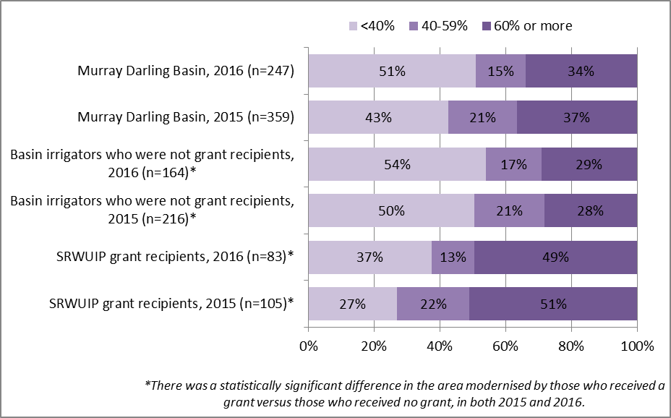

When modernising, whether with assistance from a grant or not, results of the 2015 RWS show that the most common type of works undertaken was installing new or upgraded watering systems (67% of Basin irrigators), improving irrigation area layout or design (53%), upgrading irrigation technology such as automated water systems (29%) and investing in equipment that assists in managing irrigation (20%)[8].

### Who is (and isn’t) modernising their on-farm irrigation infrastructure?

This section examines which types of irrigators were more or less likely to have modernised their on-farm infrastructure since 2008, and which are more and less likely to be intending to do so in future.

#### Who has already modernised?

Findings from both the 2015 and 2016 surveys had identical results regarding which types of irrigators were more likely to be modernising their on-farm infrastructure. Irrigators were more likely to have upgraded on-farm water infrastructure since 2008 if they[9]:

* Were younger than 65
* Had completed year 12 or higher levels of educational attainment
* Did not have off-farm work
* Had larger turnover (gross value of agricultural production)
* Used larger volumes of irrigation water.

The differences between those who upgraded and those who did not were statistically significant for gross value of agricultural production (GVAP) and volume of irrigation water used. Irrigators who upgraded on-farm infrastructure had significantly larger economic turnover than those who had not modernised: 27% of those who had modernised reported gross value of agricultural production of $1 million or more in 2015-16, compared to only 8% of those who had not modernised. At the opposite end of the scale, almost half (49%) of those who had undertaken no on-farm water infrastructure modernisation since 2008 reported GVAP of less than $100,000 in 2015-16, compared to only 26% of those who had undertaken works since 2008. Those who had modernised reported using significantly higher volumes of water in the 2015 water year (a median of 252 megalitres compared to 70 megalitres for those who had undertaken no modernisation works).

Older farmers, those with lower levels of formal education, and those who worked full-time off the farm were less likely to have modernised their on-farm infrastructure. The types of irrigators who were most likely to have modernised their on-farm water infrastructure since 2008 were rice growers (85%), vegetable growers (78%), dairy farmers (66%), and those operating mixed cropping-grazing enterprises (65%). Those who were least likely to have modernised were graziers operating beef or sheep enterprises (39%) and wine grape growers (41%) (Appendix 2, Table A2.7). As noted earlier, dairy farmers were particularly likely to have received a SRWUIP grant.

#### Who intends to modernise in the next five years?

In the 2016 Regional Wellbeing Survey, irrigators were asked about their future plans to modernise their on-farm water infrastructure. Across the Basin, 52% of irrigators reported they had no plans to modernise or upgrade their on-farm water infrastructure in the next five years, while 24% planned to modernise/upgrade in the next 2 years, and 24% in 3-5 years’ time.

Irrigators were more likely to be planning future works if they had already undertaken works since 2008, with 59% of those who modernised since 2008 planning further works within the next five years (Figure 2). Those living in the MIL and MIA areas were more likely to be planning to modernise, and those in Queensland and Victoria less likely to.

Figure 2 Future intentions to modernise on-farm water infrastructure, by region and history of modernisation

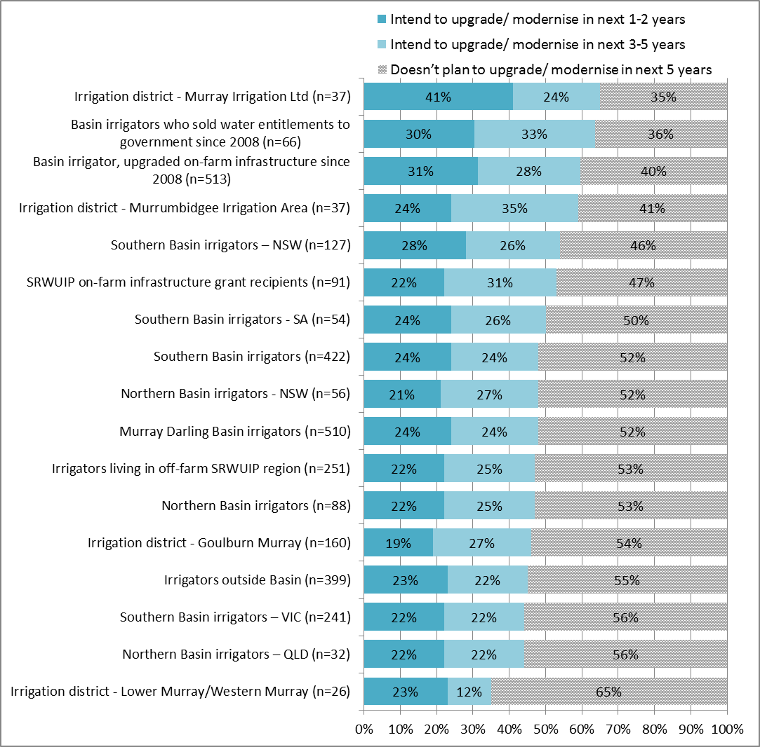

There were substantial differences in the intention of different types of farmers to modernise (Figure 3). Those engaged in cropping for grain, oilseeds, rice and cotton were most likely to be intending to modernise on-farm water infrastructure, with 60% or more of irrigators engaged in these types of cropping intending to invest in modernisation works in the next five years. Wine grape growers were least likely to be planning to modernise, with only 26% planning to do so within the next five years, followed by beef and sheep graziers (42%), dairy farmers (43%), and fruit and nut growers other than wine grape growers (44%).

Figure 3 Future intentions of Basin irrigators to modernise on-farm water infrastructure, by farm type

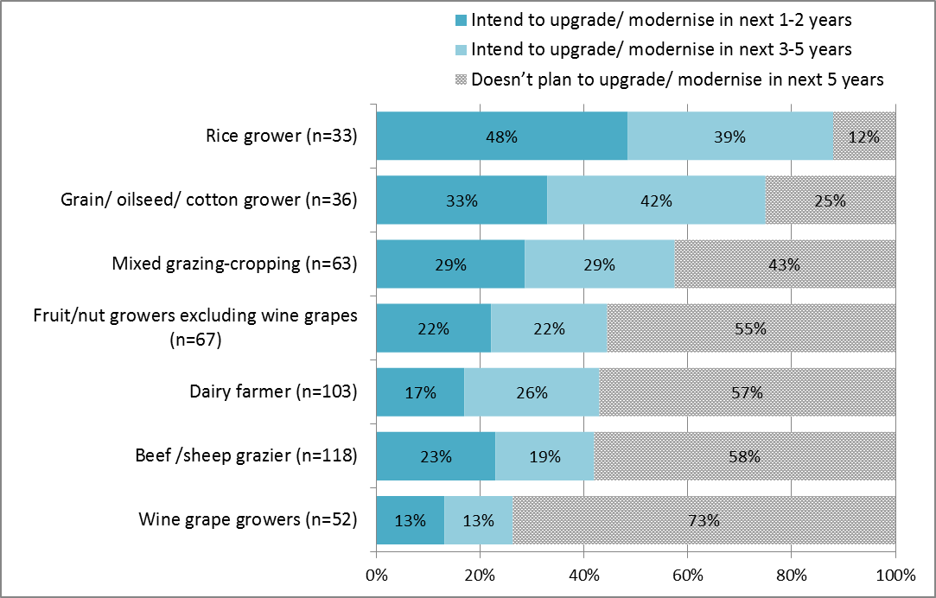

Younger farmers with little off-farm employment and larger farms (in terms of area, water use and turnover) were most likely to be planning to invest in on-farm water infrastructure modernisation works in the next five years[10]:

* Older farmers were significantly less likely to be planning to modernise: 45% of those who had no plans to modernise in the next 5 years were aged 65 or older, compared to only 30% of those who planned to modernise in the next 1-2 years
* Those who had off-farm employment were less likely to be planning to modernise, although the differences were relatively small: 37% of those who had no plans to modernise earned more than half their household income off the farm, compared to 27% of those who planned to modernise within the next 5 years
* Irrigators with larger farms were significantly more likely to be planning modernisation works: the median farm size of those planning to modernise in the next two years was 330 hectares compared to 117 hectares for those not planning to modernise
* Irrigators who used more water were significantly more likely to be planning to modernise: those planning to modernise in the next two years used an average (median) of 300 megalitres of irrigation water in the 2015 water year compared to an average of 80 megalitres for those who had no plans to modernise
* Those with larger farm turnover were significantly more likely to be planning to modernise: 38% of those planning to modernise in the next two years had GVAP of $750,000 or more in 2015-16 compared to only 16% of those with no plans to modernise.

### Benefits and costs of modernising on-farm infrastructure

Modernising on-farm water infrastructure is often done to achieve changes such as reducing overall water use and using available water more effectively and efficiently (for example, through delivering water in a more targeted way to achieve crop growth). Modernisation can have positive outcomes for the farm, through things such as reducing water costs, increasing production, or saving farm labour time. Depending on the relative cost of modernisation relative to the benefits achieved, the works may have benefits or costs overall. These may take the form of monetary benefits and costs (for example, changes in input costs such as electricity and water), changes in labour time, or others. This section examines the socio-economic outcomes of modernising on-farm irrigation infrastructure, focusing on the types of benefits or costs the farmers involved have experienced. Irrigators were asked their views about the socio-economic impacts of on-farm infrastructure modernisation works, and their farm performance was then compared to farmers who had not modernised.

#### Irrigator’s views

Irrigators who had modernised on-farm water infrastructure were asked whether the works had any of a number of effects on their farm enterprise. Figure 4 shows results for 2016, comparing the views of Basin irrigators who (i) modernised on-farm infrastructure with no assistance from a grant, and (ii) modernised with assistance from a SRWUIP grant. Figure 5 compares results for 2015 and 2016 for those questions asked in both of these years.

Overall, 75% of Basin irrigators who had modernised on-farm water infrastructure since 2008 felt the works had a positive impact on their farm enterprise as a whole. This was lower for Basin irrigators who modernised with no assistance from a grant (72%) and significantly higher for SRWUIP grant recipients (83% reporting positive impacts in 2016) (Figure 4). A similar pattern occurred for most aspects asked about, with SRWUIP recipients more likely than irrigators who had modernised without assistance from a grant to report experiencing positive effects for efficiency of water use, overall farm productivity, on-farm workloads, timing of water delivery (where differences between those who upgraded with and without a SRWUIP grant were statistically significant), farm profitability, electricity/power costs, and water costs.

More than 70% of SRWUIP grant recipients reported positive impacts for their efficiency of water use, overall farm productivity, ability to respond to changes in farming conditions and timing of water delivery to the farm. More than 60% felt the works had positive impacts on farm profitability (65%) and on-farm workload (63%). Fewer felt there were positive impacts on costs of irrigation water (45%), farm debt levels (25%) or their electricity/power costs (26%).

Irrigators were more likely to report negative than positive impacts for two aspects of farm management. More irrigators reported modernisation works had negative impacts (38%) than positive impacts (25%) on their farm debt levels. Two in five (43%) of grant recipients, and 39% of those who modernised without assistance from a grant, reported that the modernisation had a negative impact on their electricity/power costs.

The views of dairy farmers and other farmers were compared to identify if there were any differences amongst grant recipients in these groups (Appendix 2, Table A2.8b). Both groups were equally likely to feel on-farm infrastructure modernisation had been positive for their farm overall (82% of non-dairy farmers and 83% of dairy farmers). Dairy farmers were less likely to report a positive impact on farm profitability (58% compared to 68%) or farm debt levels (20% compared to 28%), and much more likely to report negative impacts on farm debt levels (66% compared to 20% of other farmers).

Between 2015 and 2016, views of SRWUIP grant recipients about the positive and negative impacts of their on-farm modernisation remained largely similar. The only changes identified were the following; while none of these were statistically significant shifts, they are noted as they may indicate potential for a change in experiences over time:

* There was an increase in *both* the proportion reporting positive impacts on farm profitability (increasing from 60% to 65%) and those reporting negative impacts (increased from 9% to 18%), with fewer reporting ‘neither negative or positive impacts’. The increase in those reporting negative impacts may be largely due to the larger number of dairy farmers who reported negative impacts on profitability in 2016.
* There was an increase in the proportion reporting negative effects on farm debt levels (increased from 31% to 38%) while fewer reported ‘neither negative nor positive impacts’. This again was largely a result of differences in the effects reported by dairy farmers, which were more negative in 2016 compared to 2015.
* There was a small increase in the proportion reporting negative effects on electricity/power costs (increased from 39% to 43%) and a corresponding decrease in those reporting positive effects.

Figure 4 Outcomes of modernising on-farm infrastructure, 2016: Comparison of Basin irrigators who modernised with no assistance from a grant to those who modernised with assistance from a SRWUIP grant

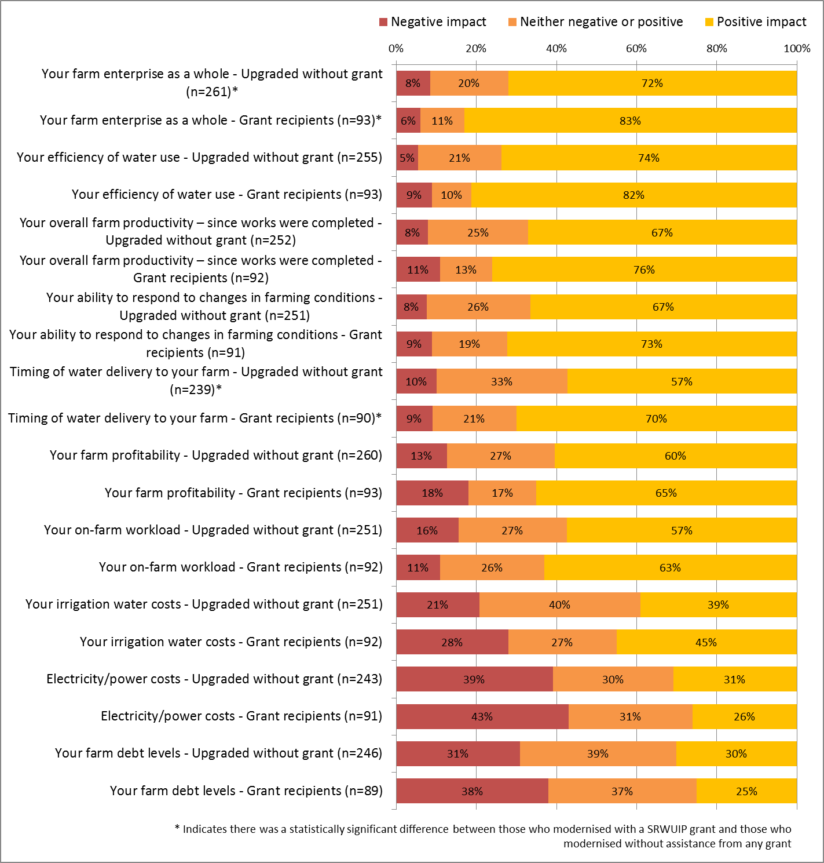

Figure 5 Outcomes of modernising on-farm infrastructure, 2016: Comparison of SRWUIP grant recipients in 2015 and 2016

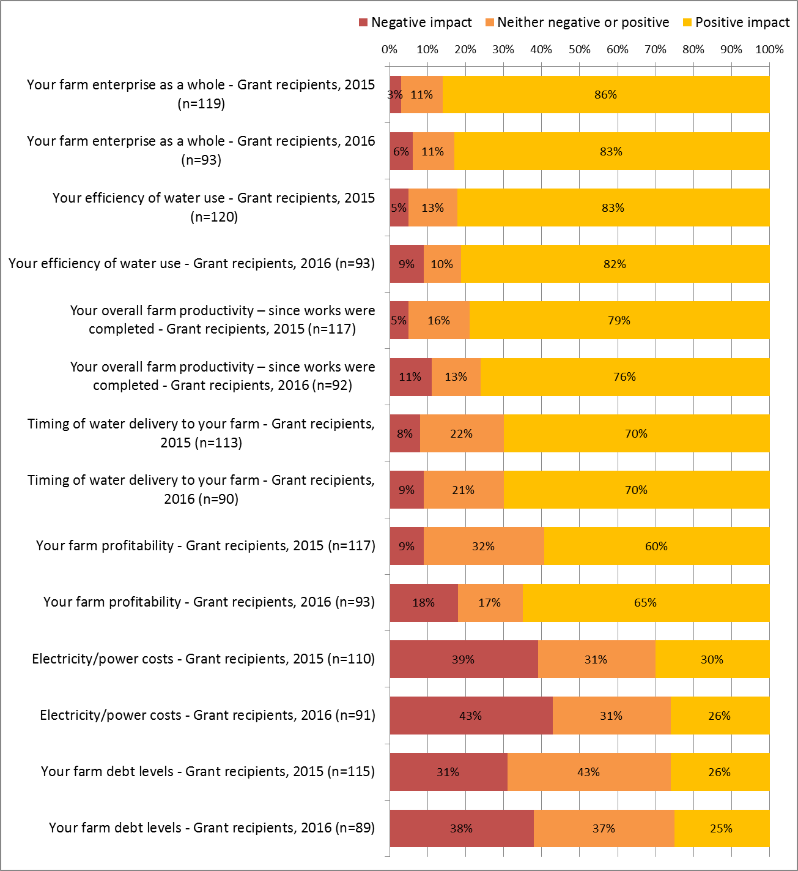

Even those who reported negative effects for their farm debt or power costs – the two areas in which farmers were most likely to report negative impacts – predominantly felt that the on-farm infrastructure works were positive for their farm overall (Figure 6). Of the 39 who reported negative effects on power costs, 82% still felt the modernisation works were positive for their farm overall, and only 8% that the modernisation was negative for their farm overall. Similarly, of the 34 farmers who reported that the on-farm infrastructure works had a negative impact on their farm debt, 79% still reported the works were positive for their farm overall, and only 9% that the works had an overall negative impact on their farm. These findings are almost identical to those from analysis of 2015 survey results, indicating that irrigators in general identify modernisation works as positive for their farm overall based on the many areas in which they experience positive outcomes, with the two areas where negative effects are more common not generally affecting the assessment of the impacts as being positive for the farm overall.

Figure 6 Comparison of views about impacts of on-farm infrastructure modernisation on farm as a whole and (i) farm electricity/power costs and (ii) farm debt - SRWUIP grant recipients

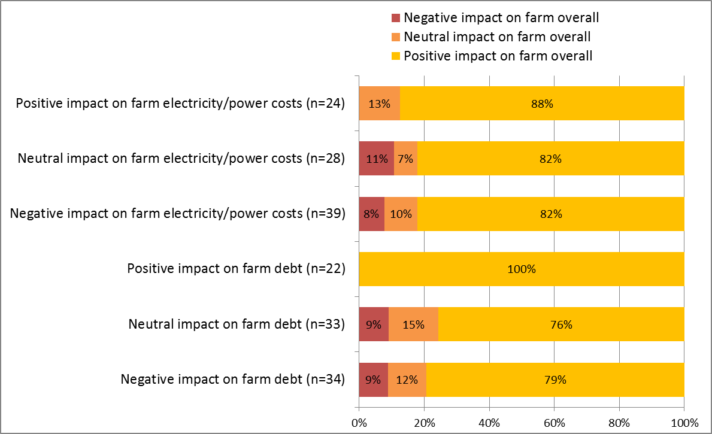

#### Socio-economic outcomes on the farm

In addition to asking irrigators for their views, survey data were analysed to identify whether irrigators who upgraded on-farm infrastructure reported better or poorer farm performance and working conditions, focusing on:

* Farm management
* Change in area of land irrigated
* Change in area of land farmed
* Change in production
* Change in farm work hours
* Change in farm employment
* Barriers to farm development – examining whether the farmer reported any of the following were big barriers to their farm development in the past 3 years
* Drought
* Rising input costs
* Changes in water allocation or costs of water
* Ability to fully utilise farm infrastructure
* Future farming intentions
* Intention to stay in or leave farming
* Intention to expand, downsize or intensity enterprise
* Overall farming outlook
* Confidence in farming future
* Confidence in ability to achieve farming objectives
* Farm financial performance
* Amount of profit or loss made
* Overall profitability
* Farm financial stress level
* Ability to service debt
* Cash flow
* Proportion of expenditure on water inputs

All of these farming outcomes will be affected by multiple factors, of which investing in on-farm water infrastructure modernisation is only one. To better understand whether investing in on-farm infrastructure modernisation has had an effect, in all analyses those who have modernised were compared to those who had not, and SRWUIP grant recipients were also compared to other Basin irrigators. The analyses focused only on Basin irrigators. Additionally, results were compared for dairy farmers and other farmers, to enable exclusion of effects of the dairy industry downturn occurring in 2016 from the analysis.

##### Farm management

Irrigators were asked if in the last 12 months they had increased or decreased their farm activities in a number of areas, including area of land irrigated, area of land managed, amount produced, employment, hours worked, and off-farm work (Figures 7 and 8). Responses were analysed to identify whether modernisation of off-farm infrastructure was associated with particular types of change, particularly related to changing water efficiency, labour efficiency, and overall farm productivity.

When Basin irrigators who had not modernised on-farm water infrastructure were compared to those who had, with or without a SRWUIP grant, several differences were identified (see Appendix 2, Table A2.9a,b, for detailed data). In the 12 months to spring 2016, when compared to those who had not modernised, those who had modernised with a SRWUIP grant were:

* Significantly *more* likely to have increased the area of land they irrigated compared to those who had not modernised (20% of SRWUIP recipients and 22% of those who modernised without a grant, compared to 3% of those who had not modernised). This was the case for both dairy farmers and other farmers, although fewer dairy farmers had increased irrigation compared to other farmers.
* Significantly more likely to report having improved their on-farm irrigation efficiency, defined as the amount produced per unit of water used (69% compared to 22%, with a similar finding for both dairy farmers and other findings)
* More likely to have purchased new land (13% compared to 7%) or expanded the area farmed through leasing or sharefarming (10% compared to 2%): this finding was strong for non-dairy farmers (15% of SRWUIP recipients purchased new land compared to 5% of those who had not modernised) but not present for dairy farmers
* More likely to have increased the amount produced on their land (24% compared to 17%), with this finding applying for both dairy farmers and other farmers
* Slightly but not significantly more likely to have reduced the amount produced on their land (20% compared to 16%). This results differed depending on the type of farmer: 32% of dairy farmers who had SRWUIP grants reduced the amount produced on their land in 2016 compared to 24% of those who had not modernised; for other farmers, 15% of SRWUIP recipients decreased production compared to 17% of those who had not modernised
* Significantly more likely to have increased the hours they worked on the farm (46% compared to 26%), particularly if they were dairy farmers
* Less likely to have increased their off-farm work (4% compared to 12%)
* No more or less likely to have reduced the number of employees or contractors working on the farm (20% compared to 18%).

These findings suggest that modernising on-farm water infrastructure, with or without assistance from a SRWUIP grant, is associated with a higher likelihood of the farmer expanding their farm enterprise, including the amount produced, together with improving water use efficiency on the farm. This finding applied even for dairy farmers experiencing significant market downturn.

Figure 7 Farm management changes in the 12 months to spring 2016: comparison of Basin irrigators who had and had not modernised on-farm water infrastructure since 2008

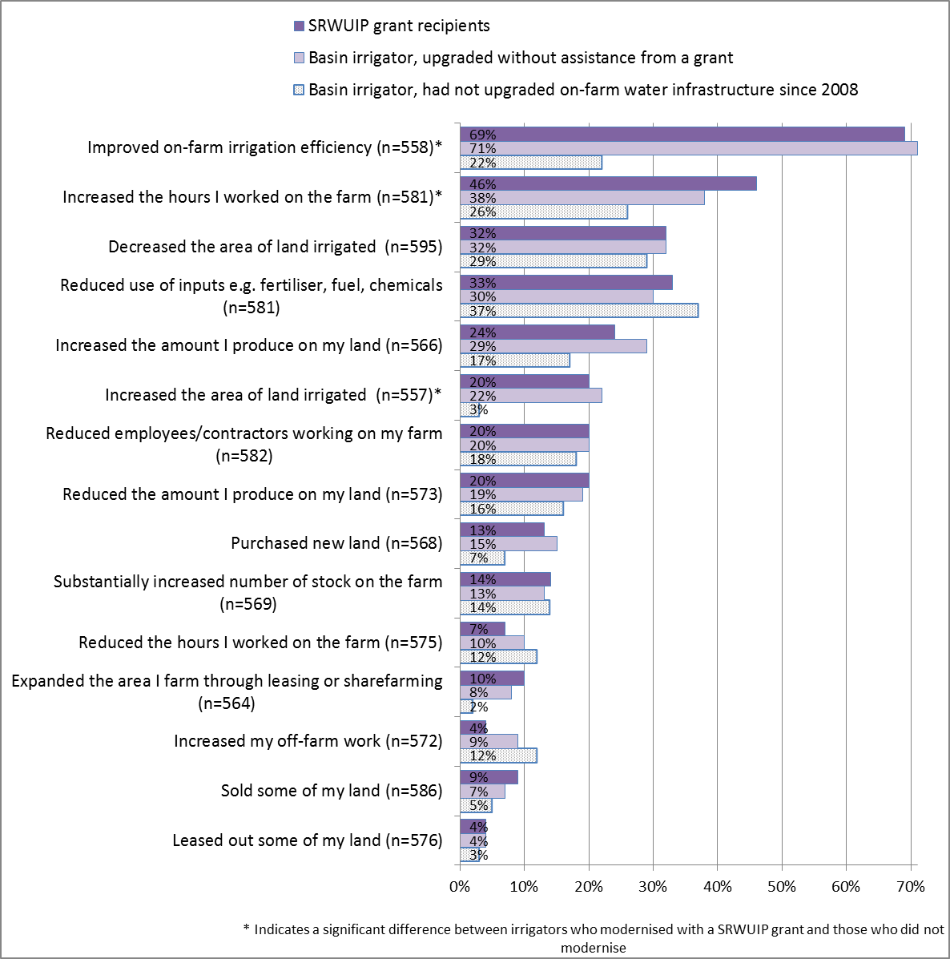

Figure 8 Farm management changes in the 12 months to spring 2016: comparison of dairy farmers and other farmers in the Basin

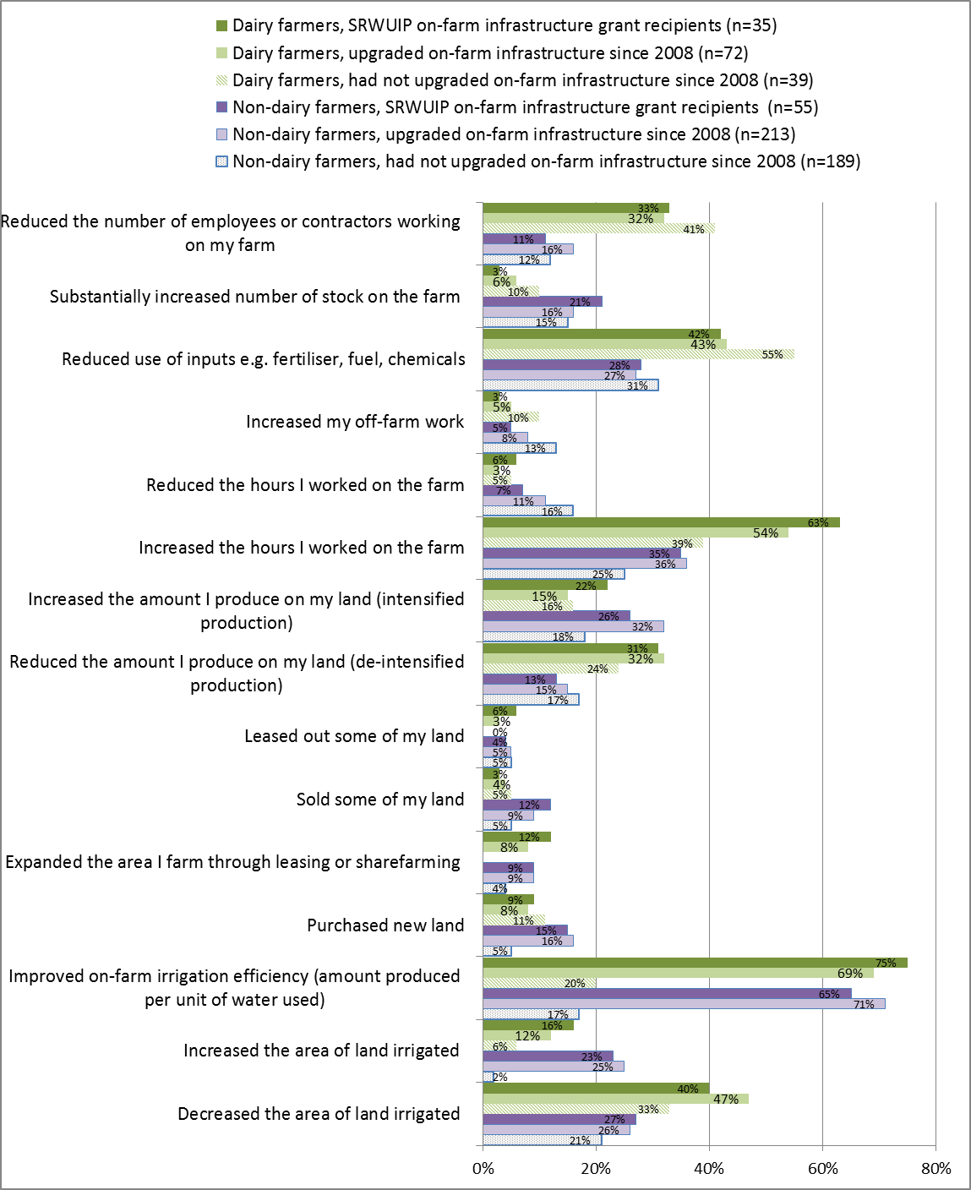

##### Barriers to farm development

Irrigators were asked whether in the last three years any of a number of factors had been a barrier to them being able to run their farm business they way they wanted to, ranging from drought to costs of water and difficulty fully utilising farm infrastructure. Factors that could potentially be influenced by on-farm infrastructure modernisation were analysed to identify if there were differences in the experiences of Basin irrigators who had and had not modernised.

Those who had modernised on-farm infrastructure were no more or less likely than those who had not modernised to report experiencing drought or rising input costs as a large barrier to their farm management. However, they were more likely than those who had not modernised to report that the following had been large barriers (Figure 9, see also Appendix 2, Table A2.10a for detailed data):

* Reduced water allocation (55% of SRWUIP recipients and 49% who modernised without assistance from a grant reported this as a large barrier in the last three years compared to 29% of those who had not modernised)
* High water delivery costs (62% of SRWUIP recipients reported this as an issue compared to 48% of those who had modernised without a grant and 47% who had not modernised since 2008)
* High price of temporary water (66% of SRWUIP recipients and 46% of those who modernised without a grant compared to 37% who did not modernise)
* Lack of water allocation available on the market (37% of SRWUIP recipients and 34% of those who modernised without a grant, compared to 25% of those who had not modernised)
* Inability to fully use farm infrastructure (17% of SRWUIP recipients and 11% of those who had modernised without a grant, compared to 7% of those who had not modernised).

When dairy farmers and other farmers were compared (Appendix 2, Table A2.10b), the same findings applied to both groups in almost all cases – for example, both dairy farmers and other farmers who had modernised on-farm infrastructure were more likely to report having experienced reduced water allocation as a barrier to running their farm business compared to those who had not modernised. There were some exceptions in which the experiences of dairy farmers and other farmers differed, however:

* High water delivery costs, high price of temporary water, and increases in fixed water entitlement costs were more commonly reported by non-dairy farmers than dairy farmers
* Dairy farmers were more likely than other farmers to report that lack of water allocation on the market was a barrier to running their farm the way they wanted to (56% compared to 23%), particularly if they had modernised on-farm infrastructure (63% of dairy farmer SRWUIP recipients compared to 46% of dairy farmers who had not modernised).

Figure 9 Barriers to farm management experienced in the last three years: comparison of Basin irrigators who had and had not modernised on-farm water infrastructure

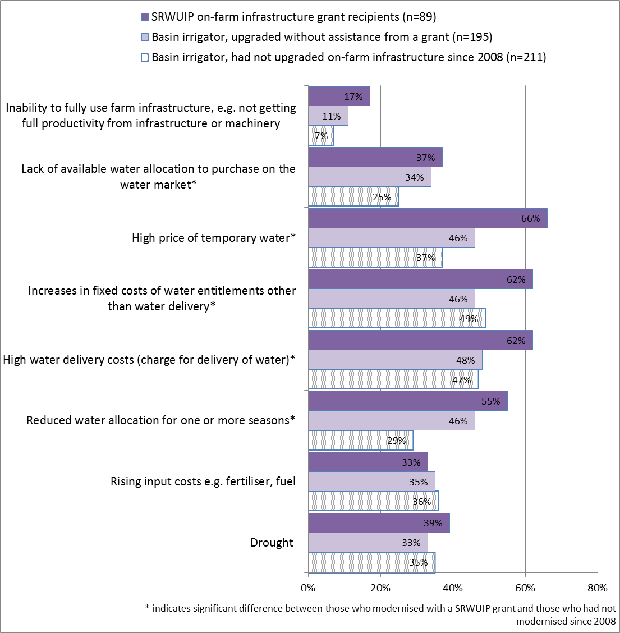

##### Future farming intentions

Irrigators were asked how likely they were to make different types of change in their farming activities in the next five years, ranging from retiring from farming to expanding their farm business. Those who had invested in modernising on-farm infrastructure were significantly more likely than those who had not to report that they were likely to be planning to expand their farm business, leave farming for reasons other than retirement, and change their enterprise mix; they were also more likely (but not significantly so) to be planning to adopt more intensive farm practices (Figure 10). However, some of these differences were due to differences between dairy farmers and others:

* Those who planned to leave farming for reasons other than retirement were most commonly dairy farmers, with 32% of dairy farmers who had modernised reporting they were likely to leave compared to only 22% of those who had not modernised; amongst other farmers, there was little difference between those who had modernised and those who had not with regard to the proportion of those planning to leave
* Non-dairy farmers were more likely to be planning to expand their farm business than dairy farmers (24% of dairy farmers who received SRWUIP grants were likely to expand compared to 14% of those who had not modernised; for other farmers, 30% who had SRWUIP grants planned to expand compared to 18% who hadn’t modernised).

Overall, those who had invested in modernisation were more likely to report planning to intensify and expand their farm business if they were not experiencing significant market stress. If they had both modernised and were experiencing significant market stress, specifically in dairy farming, they were more likely to be planning to leave farming.

Figure 10 Future farming intentions in the next five years: comparison of Basin irrigators who had and had not modernised on-farm water infrastructure since 2008.

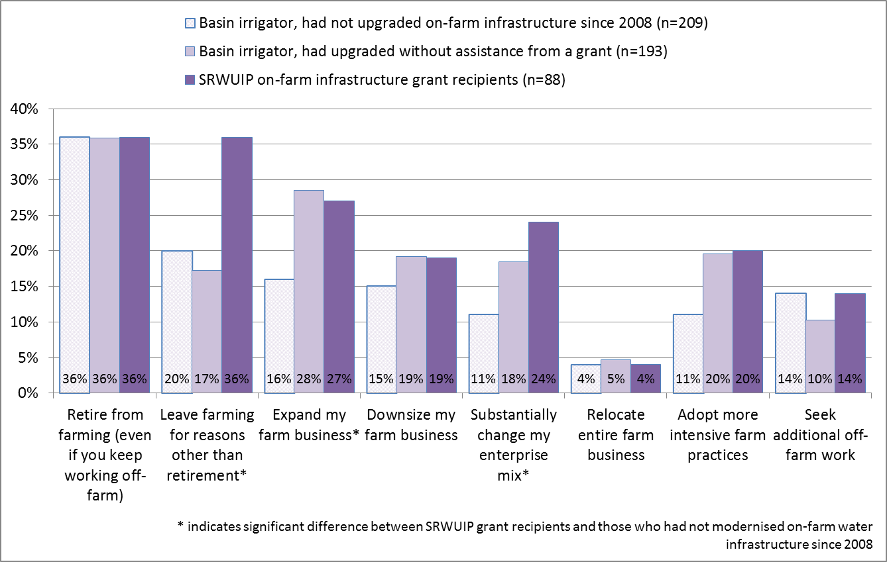

Figure 11 Future farming intentions in the next five years: comparison of dairy farmers and other farmers

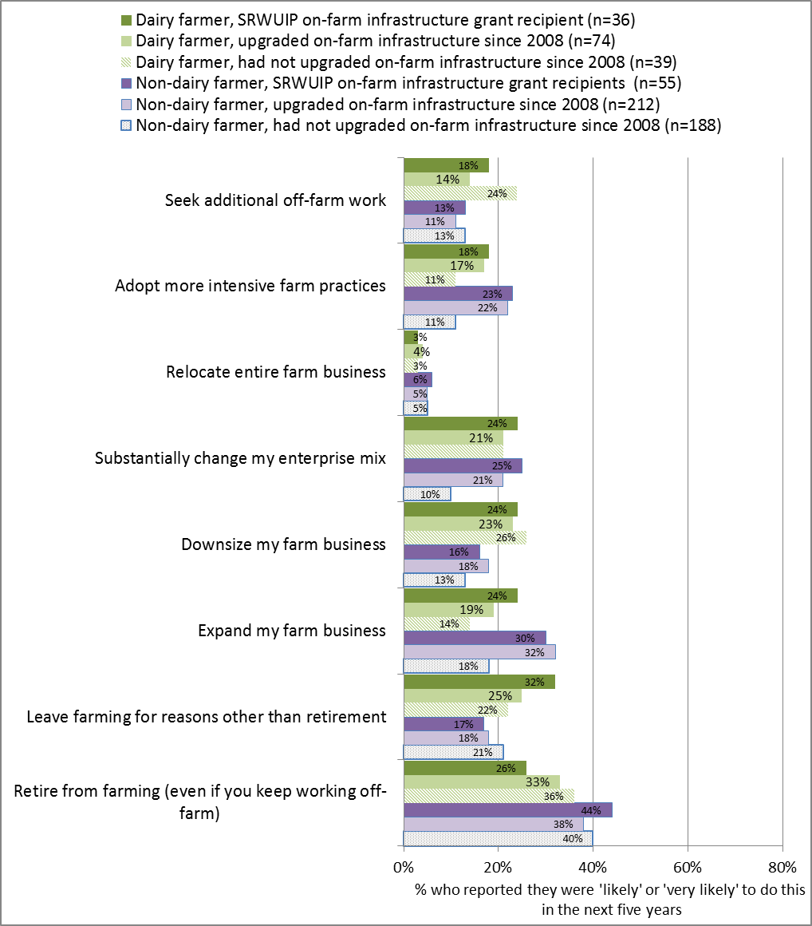

**Overall farming outlook**

Irrigators were asked whether they felt optimistic about their farming future, were satisfied with their farm business performance, and whether their farm business was under a lot of financial stress. Overall, farmers who had modernised their on-farm infrastructure did not differ significantly from those who had not modernised (Figure 12). This was largely due to low optimism among dairy farmers, who reported much lower levels of optimism about their farming future, higher levels of farm financial stress, and lower satisfaction with farm business performance compared to other farmers (Figure 13). Non-dairy farmers who had modernised were more positive about their overall farming future than those who had not modernised, although this difference was not statistically significant.

Figure 12 Overall farming outlook: comparison of Basin irrigators who had and had not modernised on-farm water infrastructure since 2008

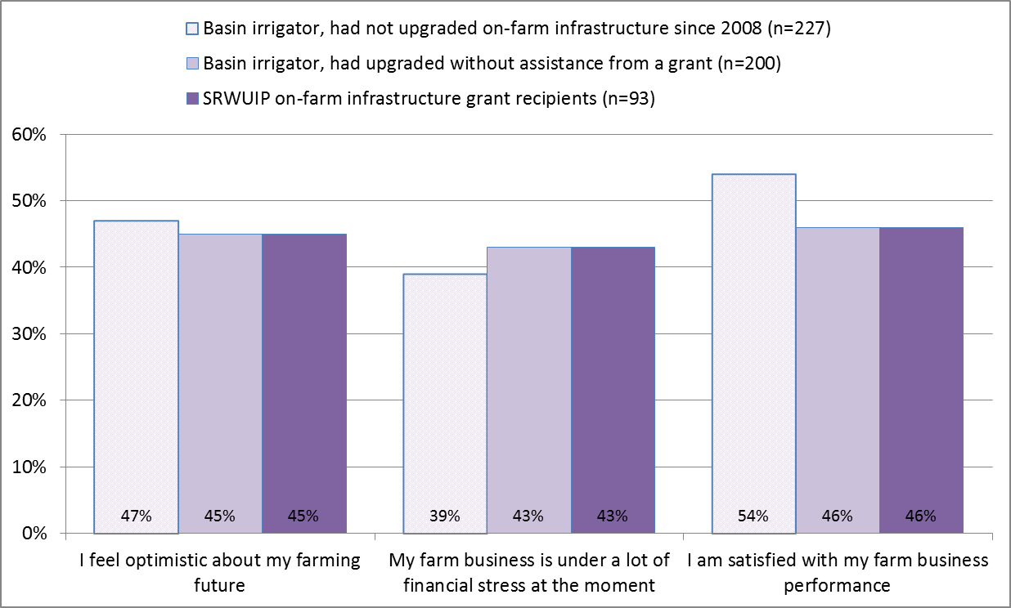

Figure13 Overall farming outlook: comparison of dairy farmers and other farmers

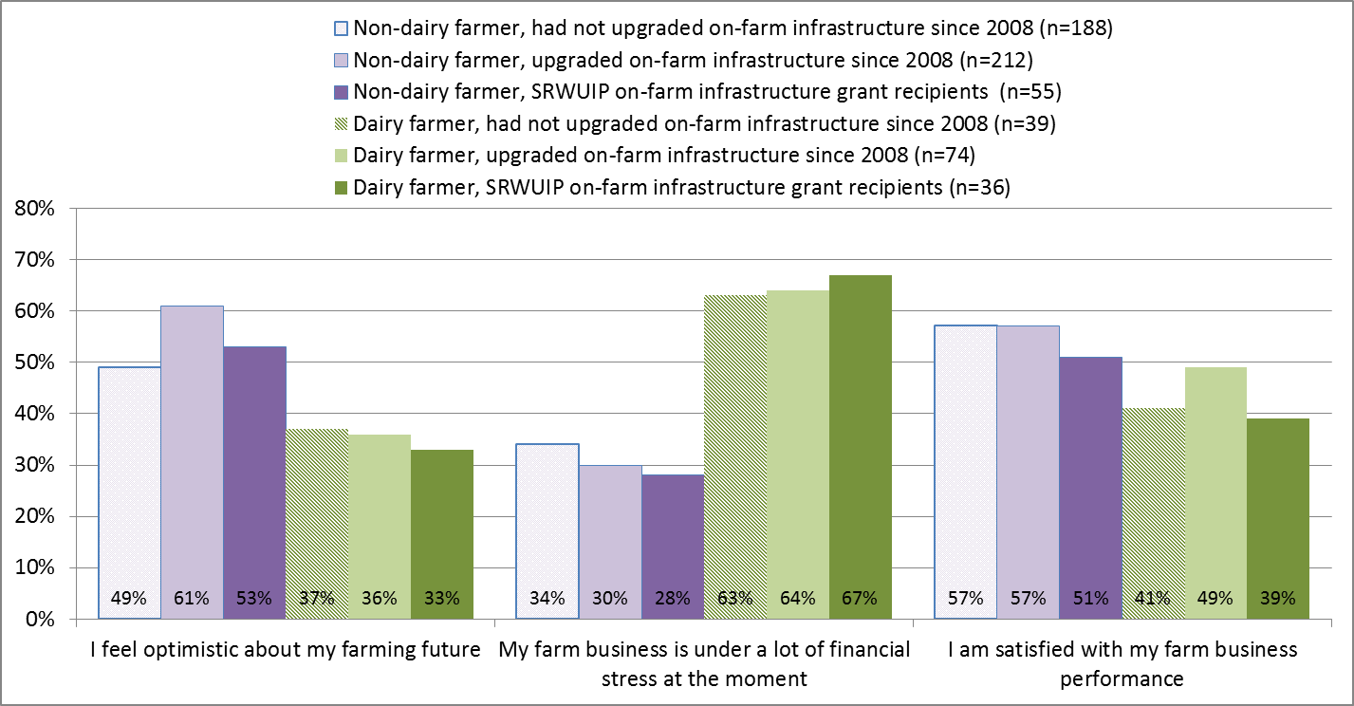

When asked whether they were confident they could achieve the things they wanted to on the farm, meet farm business objectives, and cope well with most difficult conditions on the farm, those who had modernised reported relatively similar levels of confidence to those who had not (Figure 14). When dairy farmers and other farmers were analysed separately (Figure 15), non-dairy farmers who had modernised reported higher levels of confidence compared to non-dairy farmers who had not modernised, while dairy farmers reported lower levels of confidence irrespective of whether or not they had invested in modernising on-farm infrastructure.

Figure 14 On-farm confidence: comparison of Basin irrigators who had and had not modernised on-farm water infrastructure since 2008

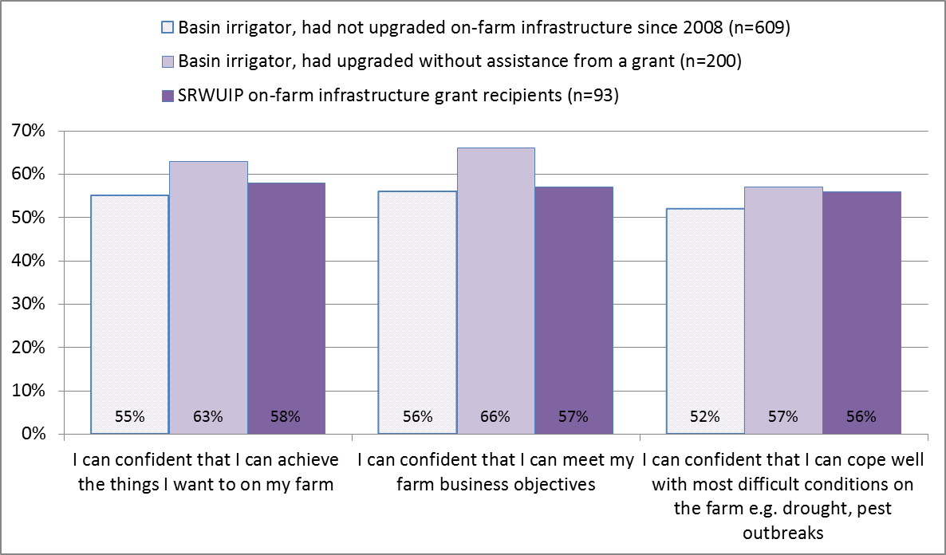

Figure 15 On-farm confidence: comparison of dairy farmers and other farmers

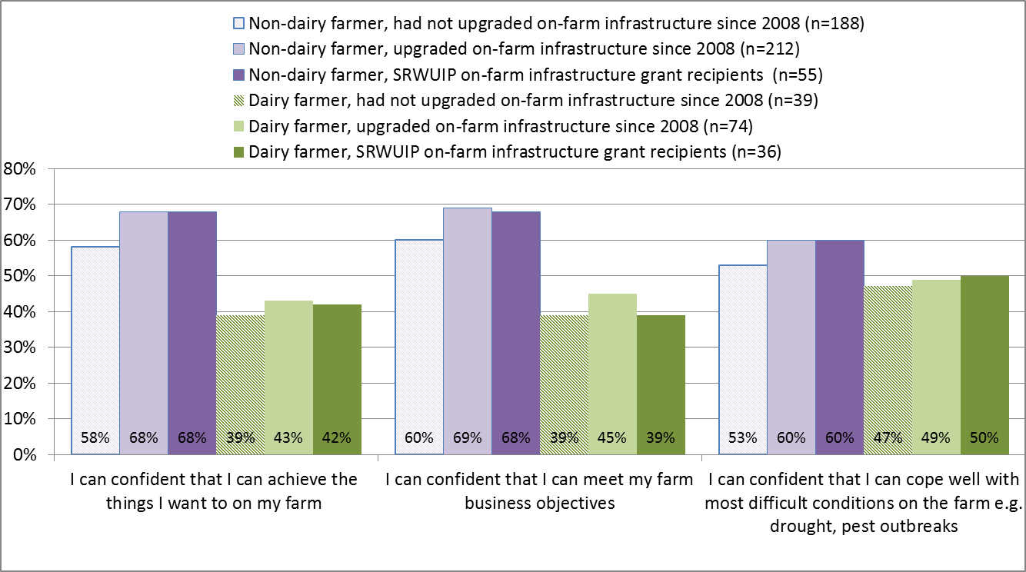

##### Farm financial performance

Irrigators who had upgraded on farm water infrastructure with assistance from a SRWUIP grant were more likely than others to report making a loss on their farm in the last year and over the last three years, and more likely to report finding it difficult to service their farm debt (Figure 16). However, these findings were different for dairy farmers and other farmers.

When dairy farmers were examined (Figure 17), those who had modernised were:

* More likely to have made a loss in 2015-16 than those who had not modernised, and less likely to have made a profit
* A little less likely to report poor cash flow, but no more likely to report good cash flow, than those who had not modernised

When other farmers were examined those who had modernised were:

* Significantly more likely to report making a profit than those who had not modernised, and slightly less likely to report making a loss
* Significantly less likely to report having poor cash flow and more likely to report good cash flow
* Less likely to find it easy to service farm debt compared to those who had not modernised.

Figure 16 Self-reported farm financial performance: comparison of Basin irrigators who had and had not modernised on-farm water infrastructure since 2008

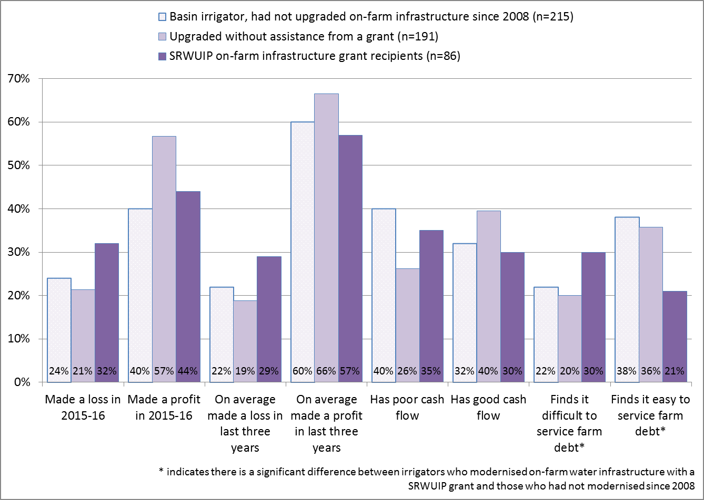

Figure 17 Self-reported farm financial performance: comparison of dairy farmers and other farmers

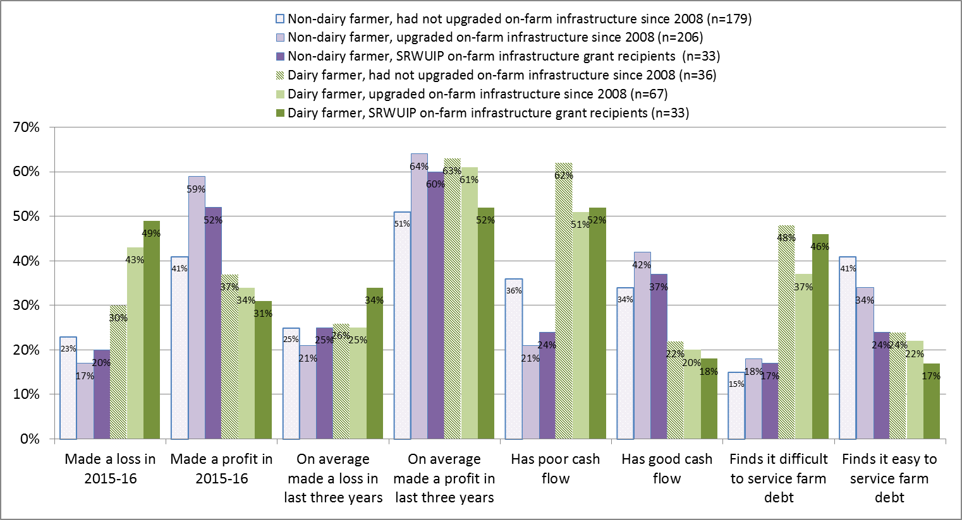

Irrigators were asked what proportion of their farm expenditure was on water for irrigation, electricity/power expenses, and wages/salaries. These were asked about as discussion about the potential benefits and costs of water reform actions such as investment in infrastructure modernisation and purchase of water entitlements has included identification that these actions may change the amount spent on:

* Water, both through potential increases in the cost of accessing water, and also through reducing the amount of water needed on-farm and hence total cost of water
* Electricity, with modernisation works in some cases increasing electricity costs, and
* Wages/salaries, through changing labour needs on the farm.

On average, those who had modernised their on-farm infrastructure spent a slightly higher proportion of farm expenditure on water inputs, but a similar amount on electricity, and slightly higher amount on wages/salaries (Figure 18). This may reflect differences in the types of farms that have modernised: larger farms are both more likely to have invested in modernisation, and to have salaried workers, for example. Dairy farmers also typically spend a higher proportion on water inputs, and were over-represented in the group of farmers who have modernised (see Appendix 2, Table A2.15b).

Figure 18 Farm expenditure on water, electricity and salaries/wages: comparison of Basin irrigators who had and had not modernised on-farm water infrastructure since 2008

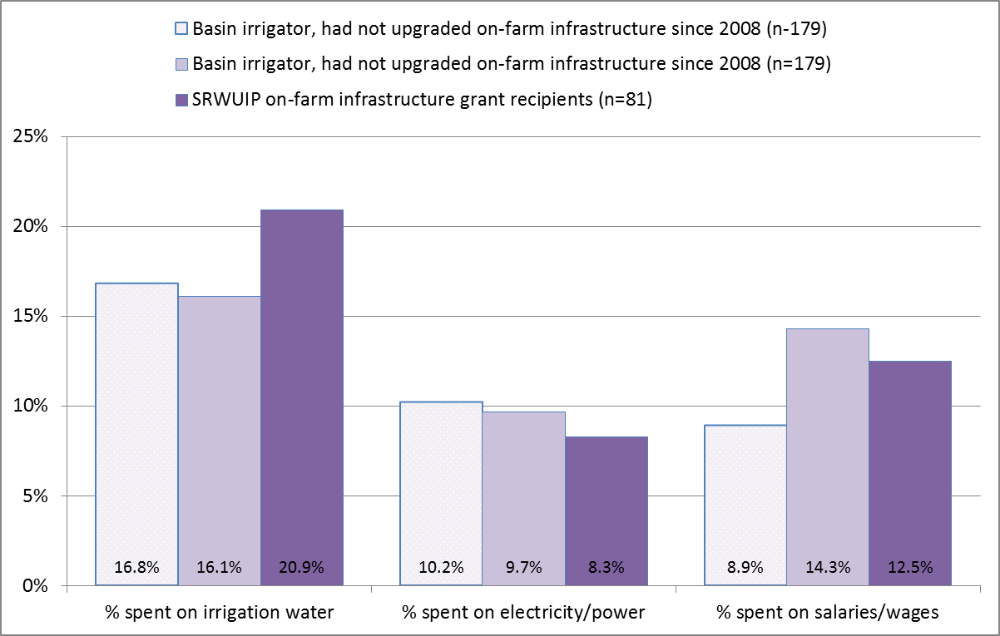

### Conclusions

While 56% of Basin irrigators have engaged in some on-farm water infrastructure modernisation works since 2008, 44% have not, and many of those who have were able to modernise only a small part of their on-farm infrastructure. Just under half of Basin irrigators actively plan to engage in further modernisation works in the next five years, particularly if they have already modernised since 2008, grow large-scale crops, and operate a large farm enterprise. Efforts to promote water efficiency through modernisation in future can therefore focus on further effort amongst those who are most interested and willing (younger farmers operating large farms with little off-farm work), but who have often already achieved significant efficiency savings through works undertaken in recent years; or on older irrigators who have off-farm work and operate smaller farms, who are least likely to have invested in modernisation works since 2008 and to be considering doing so.

Those who engaged in on-farm infrastructure modernisation, particularly with a SRWUIP grant, view the outcomes as predominantly positive, even when they report concerns about impacts on debt or power costs. This was the case even for dairy farmers who elsewhere reported substantially poorer farm performance and lower confidence in their farming future due to market downturn.

Modernising on-farm water infrastructure, with or without assistance from a SRWUIP grant, is associated with a higher likelihood of the farmer expanding their farm enterprise, including the amount produced, together with improving water use efficiency on the farm. This finding applied even for dairy farmers experiencing significant market downturn. It is also associated with high levels of concern about availability and price of water allocation and costs associated with water entitlements. On-farm modernisation was associated with higher profitability and higher debt stress for non-dairy farmers, but not for dairy farmers. This suggests that modernisation works support improved profitability under normal market conditions. When market conditions are poor, it is possible that the reduced water entitlements associated with receiving a SRWUIP grant reduce potential alternative income earning opportunities, as the farmer has less water available to sell on the water market as an alternative to using it on their farm in times of poor market returns. In the 2016 survey, this finding applied predominantly to dairy farmers; in 2015, a similar finding occurred for wine grape growers who were experiencing significant market downturn.

## Off-farm infrastructure modernisation

### Introduction

Off-farm water infrastructure modernisation works have been undertaken in many regions with the assistance of SRWUIP grants. These projects involve a range of activities, often funded in partnership between SRWUIP and state governments. For example:

* The $953 million Goulburn Murray Water Connections project stage 2, co-funded by the Victorian and Australian governments, is being delivered in the Goulburn-Murray Irrigation District, is investing in modernising irrigation channels, with actions including automation of water delivery, upgrading water metering, and realigning layout of irrigation channels to better connect irrigators who had been connected via spur channels (GHD 2015). Delivery of this project is ongoing
* The Wimmera Mallee pipeline project involved converting open water channels to pipelines, and was co-funded by the Victoria and Australian governments; construction is complete
* The Sunraysia Modernisation Project involved converting key areas of open channel to pipeline, upgrading pump stations, automating channels and upgrading metering, with works starting in 2014 and completing in 2016
* NSW State Priority projects include projects funded jointly by the Australian and NSW governments, and include the Southern Valleys Metering Project, which installs new water meters in the Murray, Murrumbidgee and Lower-Darling Valleys, starting in 2015

This chapter examines whether investment in off-farm infrastructure modernisation investment is associated with positive or negative outcomes for the irrigators living in these regions. Data provided by the DAWR was used to identify which irrigators lived in irrigation districts in which off-farm modernisation funded partly or wholly by the SRWUIP had occurred or was underway.

The Regional Wellbeing Survey also asked all irrigators ‘Has your water provider upgraded their irrigation infrastructure since 2008?’ In total, 50% of irrigators living in districts where off-farm modernisation works have occurred answered ‘yes’ to this question (see Appendix 3). Those where the works are ongoing or recently completed were more likely to answer yes: for example, 72% living in the Goulburn-Murray Irrigation District, where off-farm modernisation works are ongoing and have occurred in many parts of the district, answered yes. This indicates moderately high awareness of off-farm works, although there is a substantial minority of irrigators who are either unaware of the works, or who do not consider them to be an upgrading of irrigation infrastructure. This is similar to findings of the 2015 survey, which also identified that some irrigators are unaware of works undertaken in their irrigation district[11].

### Benefits and costs of modernising off-farm infrastructure

Irrigators who reported that their water provider had upgraded irrigation infrastructure since 2008 were asked their views about benefits and costs of the modernisation works for them, focusing on changes in timing of water delivery, cost of water delivery, and effects on overall farm productivity and profitability. The farm performance of irrigators living in regions where modernisation has occurred through funding from SRWUIP was then compared to farmers living in regions where there had not been investment in off-farm modernisation works.

#### Irrigator’s views

Irrigators who were aware of off-farm modernisation works were asked their views about the outcomes of those works for timing of water delivery, cost of water delivery, and effects on overall farm productivity and profitability. The views of those living in SRWUIP off-farm investment regions who were aware of the modernisation works were then analysed. As shown in Figure 19 (which shows findings only for those irrigators living in regions where SRWUIP off-farm modernisation works have occurred), irrigators in 2016 reported overall more positive views compared to those who answered the same questions in 2015, although concerns about some negative impacts remained at similar levels to 2015:

* 54% of irrigators living in SRWUIP off-farm modernisation regions felt the modernisation was positive for their farm overall, compared to 41% in 2015; only 13% felt it had negative impacts on the farm, down from 20% in 2015
* 63% felt modernisation improved timing of water delivery to their farm (similar to the 59% who reported this in 2015)
* 49% reported positive impacts on efficiency of water use (similar to the 46% who reported this in 2015)
* 41% reported positive impacts on overall farm productivity (compared to 30% in 2015)
* 32% felt modernisation was positive for their farm profitability, compared to 18% in 2015, although one in five (21% in 2016 and 22% in 2015) felt the modernisation had a negative effect for their farm profitability
* Just over half (51% in both years) reported that modernisation had a negative impact on the cost of water delivery to their farm, and only 16% reported a positive effect*.*

Figure 19 Outcomes of off-farm water infrastructure modernisation reported by irrigators living in SRWUIP off-farm investment regions who were aware that off-farm works had occurred, 2015-2016

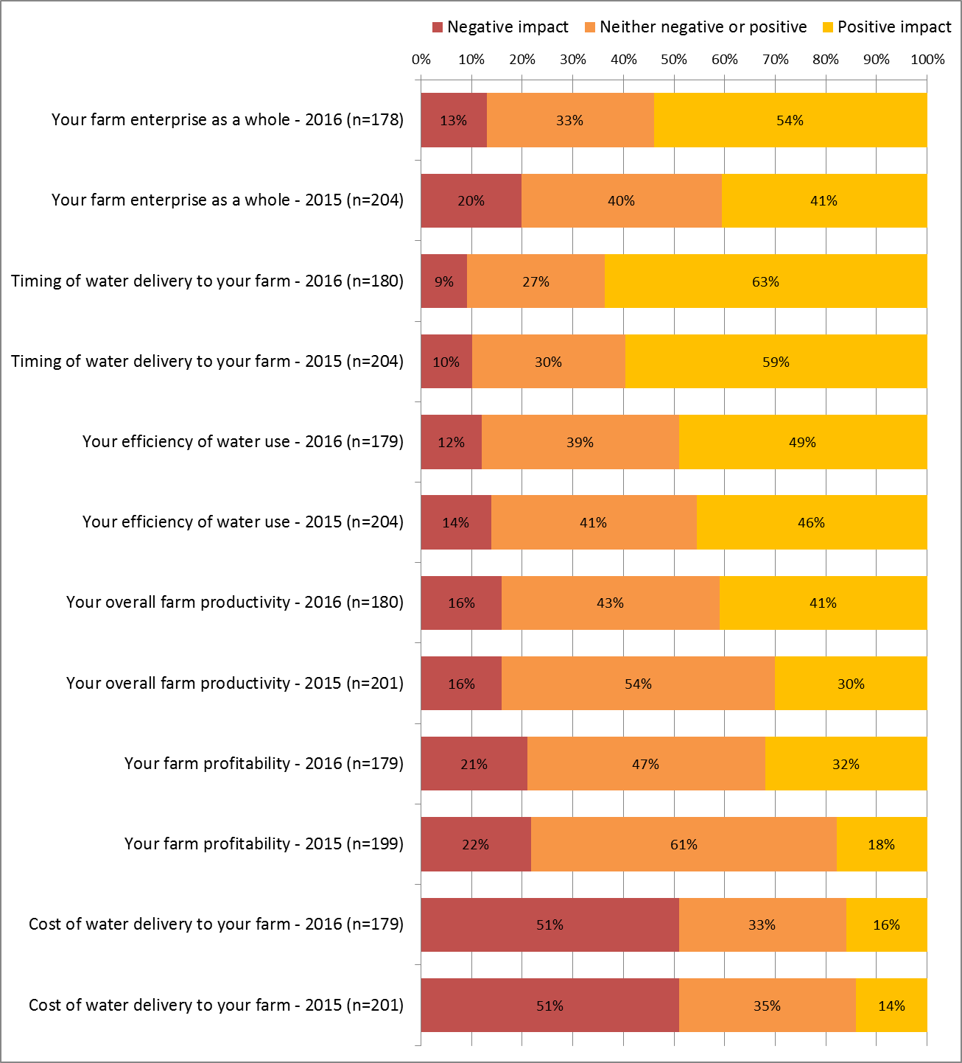

##### Irrigator views – by irrigation district

Those living in the Goulburn Murray Irrigation District were both more likely to report that off-farm modernisation works had positive outcomes in the form of improved timing of water delivery and better efficiency of water use, and negative outcomes in the form of increased cost of water delivery (Figure 20). Those in the Murray Irrigation Ltd area were less likely to report positive outcomes, and those in the Murrumbidgee Irrigation Area reported more positive outcomes, although small sample sizes mean these differences cannot be confirmed as significant.

Figure 20 Outcomes of off-farm water infrastructure modernisation: by irrigation district

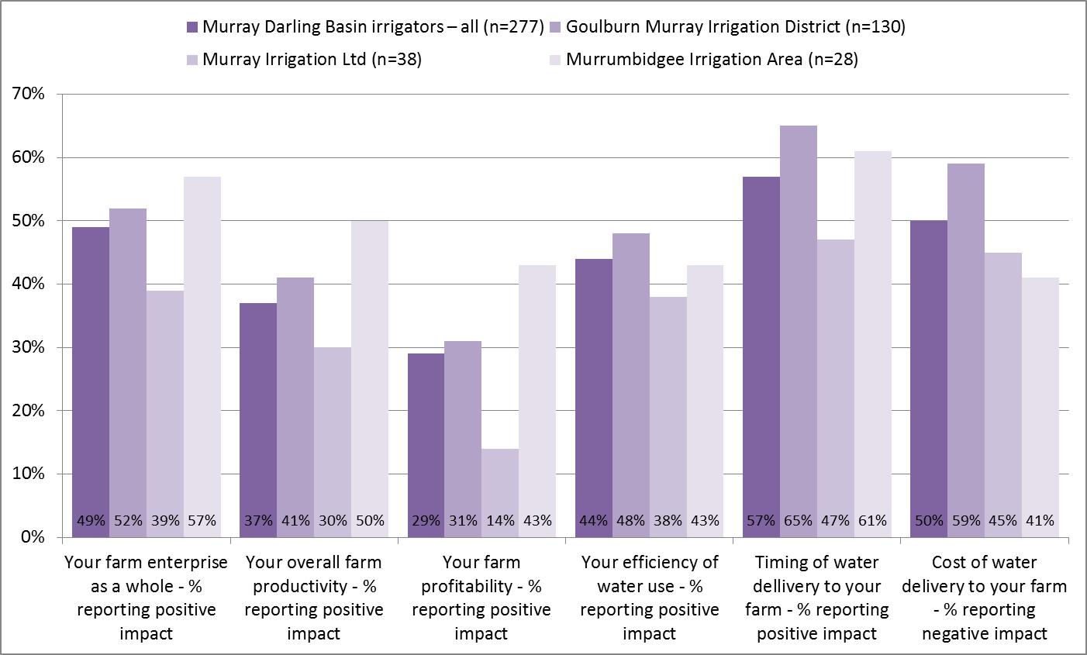

##### Irrigator views – by farm type and socio-economic characteristics

While views about the impacts of off-farm modernisation works did not differ substantially for most types of irrigators, there were some differences (see Appendix 3 for detailed data). When asked their views about how off-farm modernisation works had affected their farm enterprise as a whole, of irrigators living in SRWUIP off-farm modernisation regions:

* Female irrigators were less likely to report positive impacts than male irrigators (43% compared to 57%), however as there was a small sample of female irrigators, this difference was not statistically significant
* Those aged 50 years and older reported more positive outcomes compared to those aged under 50 (61% of those aged 50-64 and 52% of those aged 65 and older reported positive impacts compared to 42% of those aged under 50)
* Those who had no-off farm work reported more positive outcomes compared to those who worked off-farm either part-time or full-time (56% with no off-farm work reported positive outcomes compared to 53% who worked a part-time off-farm job and 41% who worked full-time off the farm)
* Those operating farms of larger economic size were slightly more likely to report positive impacts compared to those operating smaller farms (57% of those with a GVAP of $500,000 or more compared to 50% of those with GVAP of $100,000 to $299,999)
* Dairy farmers and crop growers reported more positive outcomes and beef, sheep and mixed grazing-cropping enterprises less positive outcomes. In all cases, however, the proportion reporting positive outcomes was substantially higher than the proportion reporting negative outcomes (see Table A3.10).
* Those who used larger volumes of irrigation water were more likely to report positive outcomes.

#### Socio-economic outcomes of off-farm modernisation

In addition to asking irrigators for their views, survey data were analysed to identify whether irrigators who lived in districts where water delivery infrastructure had been modernized using SRWUIP funding reported better or poorer farm performance and working conditions compared to those who lived in parts of the Southern Basin in which no off-farm modernisation works had occurred. The analysis focused on:

* Farm financial performance
* Farm management
* Barriers to farm development
* Future farming intentions , and
* Overall farming outlook

##### Farm management

Southern Basin irrigators living in off-farm modernisation areas were more likely than those operating in areas without SRWUIP investment to have done the following in the last 12 months (Figures 21 and 22):

* Improved on-farm irrigation efficiency (51% compared to 43%; result was similar for dairy farmers and other farmers)
* Increased hours worked on the farm (38% compared to 25%, with similar pattern for both dairy and other farmers)
* Reduced use of inputs other than water (37% compared to 28%, mostly driven by dairy farmers with other farmers no more likely to have done this if they modernised compared to if they had not)
* Decreased the area of land they irrigated (36% compared to 25%; there was a much bigger proportion of dairy farmers who had modernised doing this than any other group)
* Reduced farm employees or contractors (24% compared to 15%; however, dairy farmers had typically reduced employees/contractors irrespective of modernisation, while other farmers were more likely to have reduced farm employees/contractors if they lived in a modernisation area).

They were no more or less likely to have intensified or de-intensified production, increased the area of land irrigated, or sold land, and were less likely to have increased stock numbers.

Figure 21 Farm management changes in the 12 months to spring 2016: comparison of Southern Basin irrigators living in regions with and without off-farm water infrastructure modernisation works

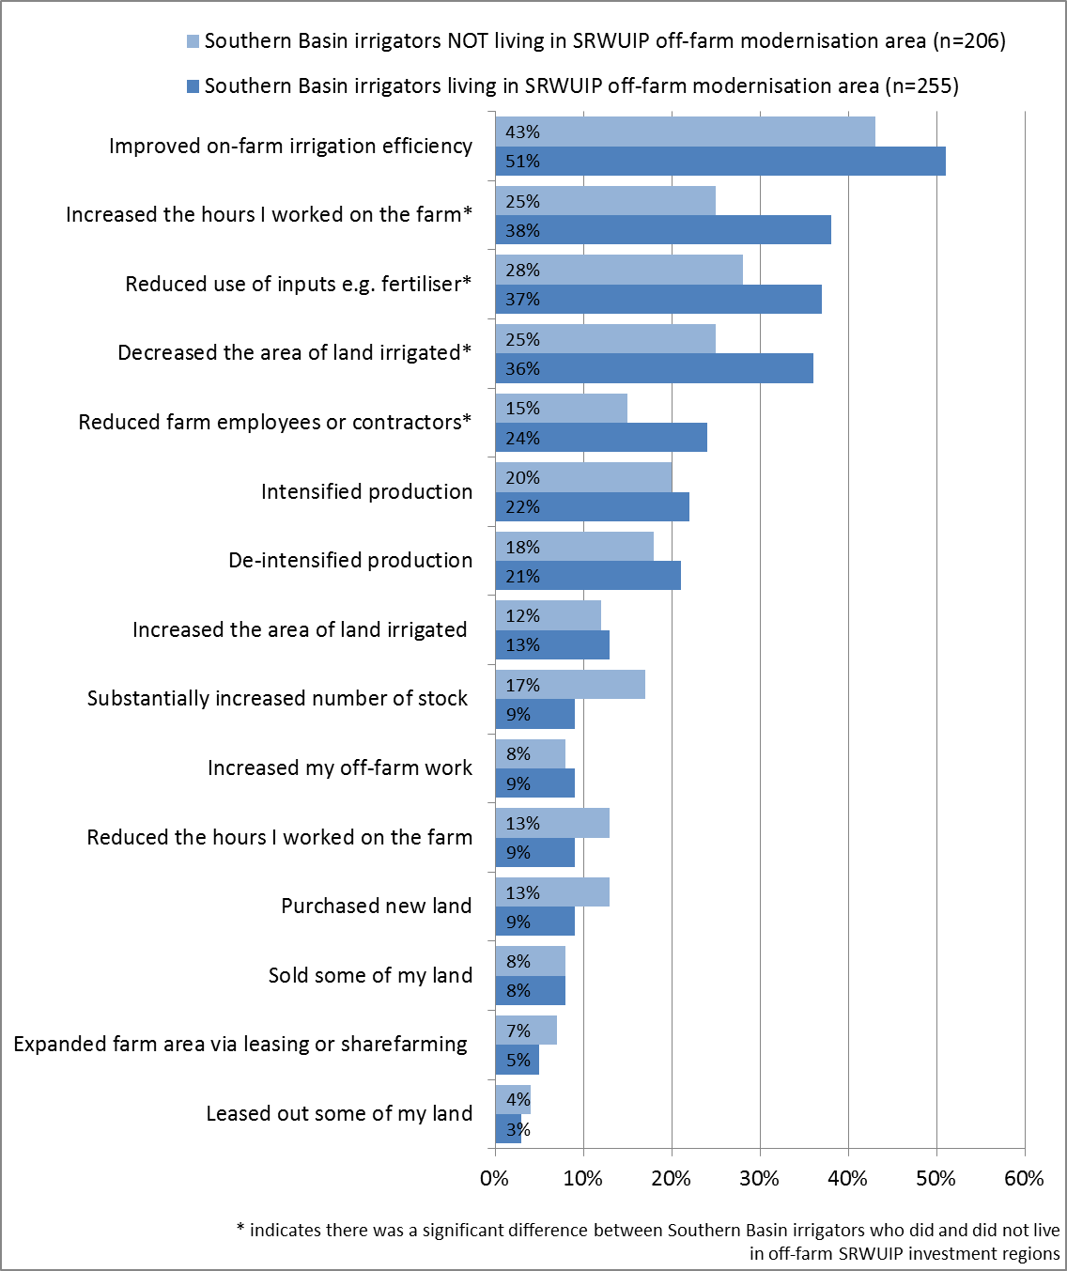

Figure 22 Farm management changes in the 12 months to spring 2016: comparison of Southern Basin dairy farmers and non-dairy farmers living in regions with and without off-farm water infrastructure modernisation works

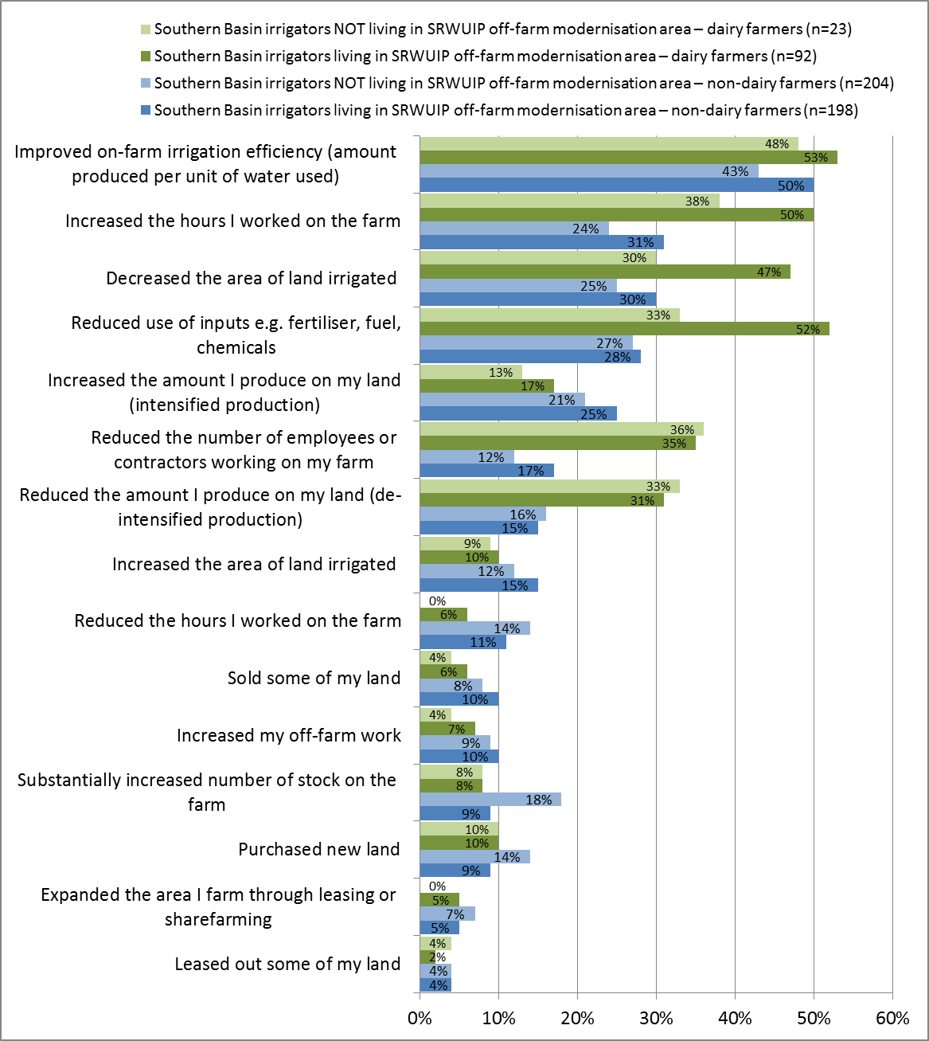

##### Barriers to farm development

When asked about barriers they had experienced to running their farm business, Southern Basin irrigator who lived in SRWUIP off-farm modernisation areas were more likely than Southern Basin irrigators living in areas without off-farm modernisation works to (Figure 23):

* Report reduced water allocation had been a challenge (50% compared to 35% living in other areas), particularly if they were dairy farmers (66%)
* Report high water delivery costs as challenge (63% compared to 47% living in areas without SRWUIP modernisation), particularly dairy farmers (73%)
* Report increases in fixed water entitlements costs created challenges (63% compared to 46% in other areas), particularly dairy farmers (73%)[12]
* Report high price of temporary water as a barrier (61% compared to 38% in non-modernisation areas), particularly if they were dairy farmers (82%).

##### Future farming intentions

Future farming intentions were sometimes different for irrigators living in districts where SRWUIP off-farm modernisation had occurred compared to those in other parts of the Southern Basin. As shown in Figure 24, those living in modernisation regions:

* Were significantly more likely to be considering leaving farming for reasons other than retirement (26% compared to 13%), including dairy farmers and other farmers
* Were significantly less likely to be planning to expand their farm business (17% compared to 27%), with this result applying predominantly to non-dairy farmers, and very few dairy farmers planning to expand irrespective of location
* More likely to be planning to downsize their farm business (21% compared to 15%), with this result applying predominantly to dairy farmers and not to other farmers
* More likely to be planning to change their enterprise mix (21% compared to 13%), particularly if they were a dairy farmer (26% compared to 16%)
* Slightly more likely to be planning to adopt more intensive farm practices (17% compared to 12%), and to seek additional off-farm work (17% compared to 11%)

**Overall farming outlook**

Overall farming outlook was a little different (Figure 25), with dairy farmers and other farmers in the Southern Basin having quite different outlook:

* Dairy farmers living in SRWUIP modernisation areas were more likely to feel able to achieve the things they wanted to on their farm than those living in other areas (41% compared to 30%), but the opposite was true for other farmers, with those living in modernisation areas less confident (55% compared to 66%)
* A similar pattern occurred when farmers’ confidence in being able to achieve their farm business objectives was examined: non-dairy farmers not living in modernisation areas were most confident they would be able to achieve their farming objectives in the next few years (67%), followed by non-dairy farmers living in modernisation areas (60%), dairy farmers in modernisation areas (44%) and dairy farmers in other areas (30%)
* Those living in modernisation regions were less likely to feel able to cope well with difficult conditions on the farm such as drought (50% compared to 60%), with similar results for both dairy farmers and other farmers.

Figure 23 Barriers to farm management experienced in last three years: comparison of dairy farmers and other farmers living in the Southern Basin in SRWUIP off-farm modernisation regions and in other regions

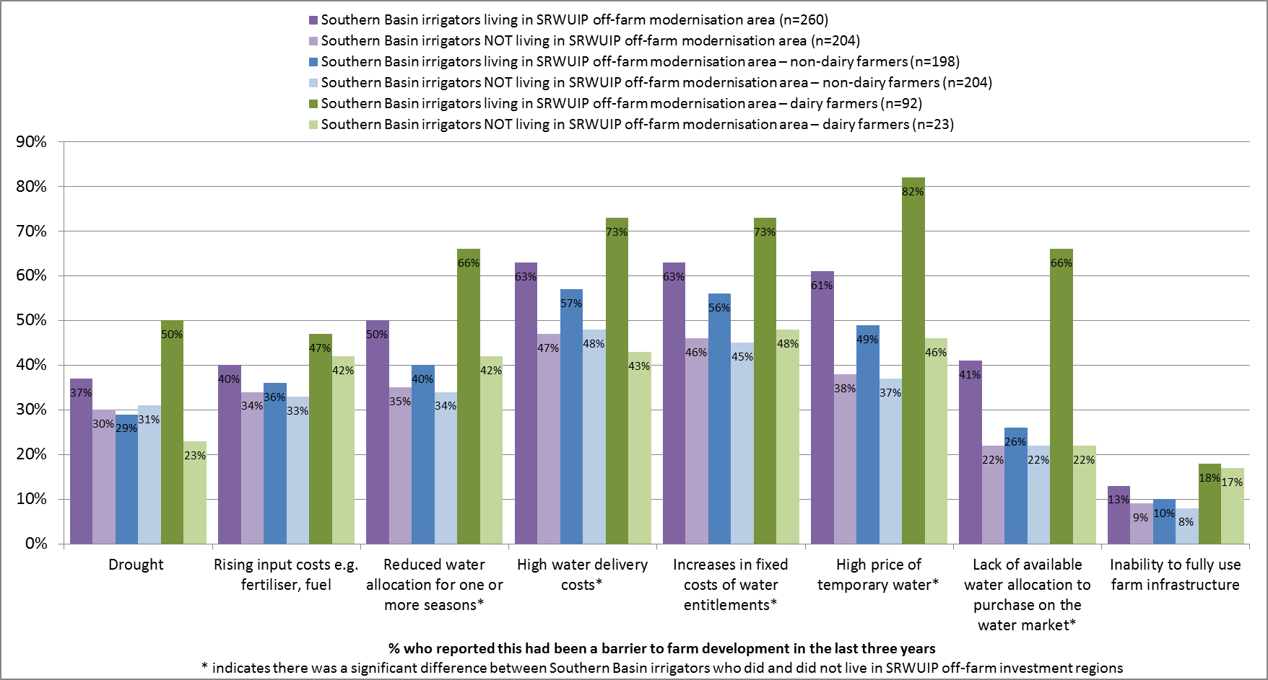

Figure 24 Future farming intentions: comparison of dairy farmers and other farmers living in the Southern Basin in SRWUIP off-farm modernisation regions and in other regions

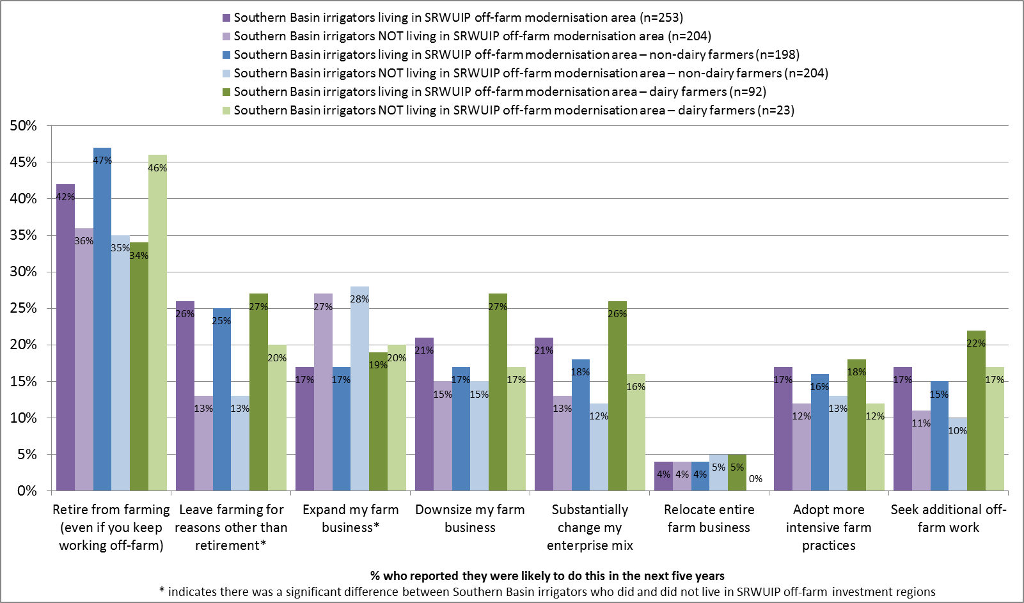

Figure 25 Overall farming outlook: comparison of dairy farmers and other farmers living in the Southern Basin in SRWUIP off-farm modernisation regions and in other regions

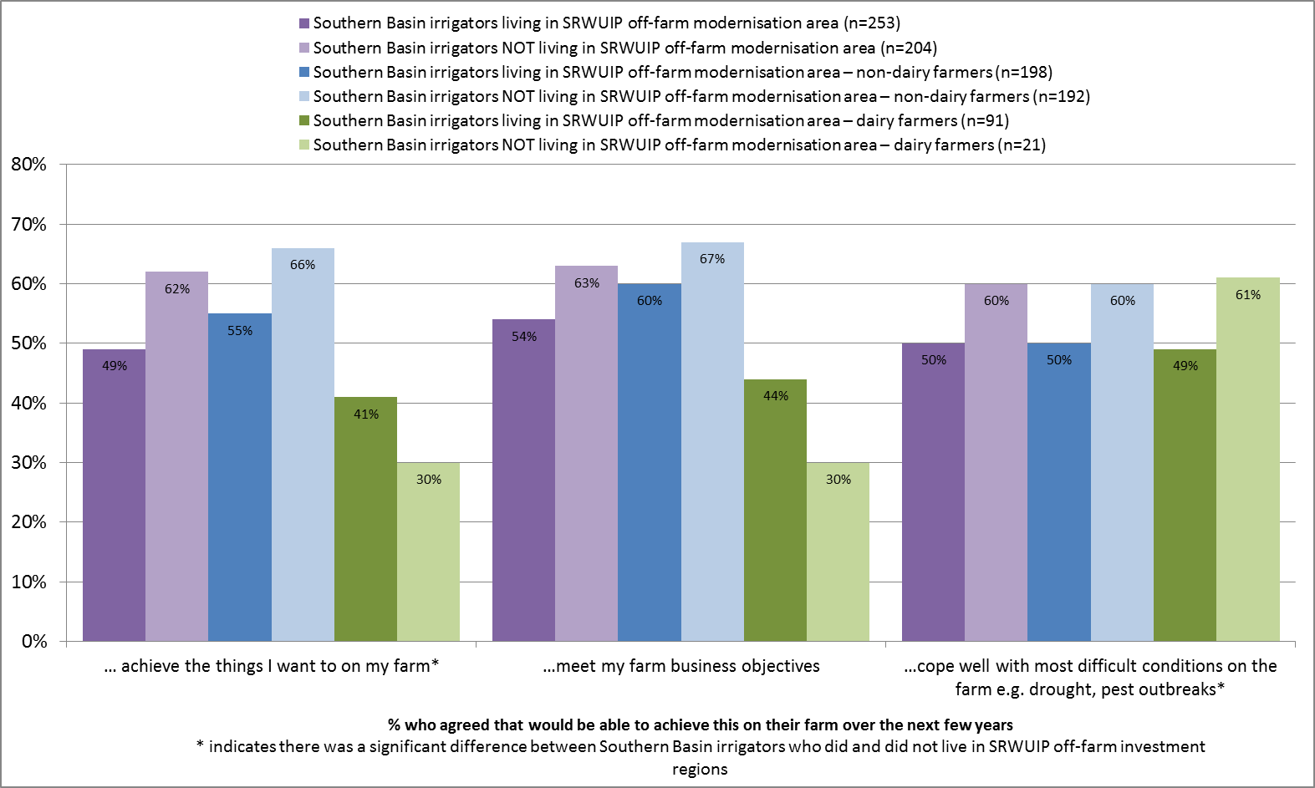

##### Farm financial performance

When farm financial performance was examined (Figure 26):

* Dairy farmers living in SRWUIP off-farm modernisation areas were more likely to report making a loss, and less likely to report making a profit, than dairy farmers living elsewhere. For other farmers there were relatively small and non-significant differences in the proportion reporting making a profit or loss
* Dairy farmers were more likely than other farmers to report poor cash flow, with few differences between those living in modernisation and other areas. Those involved in farming other than dairy typically reported better cash flow if they lived outside a modernisation area
* Those living in modernisation areas were more likely to report finding it difficult to service farm debt and less likely to find it easy to service debt, irrespective of whether they were a dairy farmer or other type of farmer.

#### Conclusions

Off-farm modernisation works funded by the SRWUIP have been undertaken in multiple locations in the Southern Basin. As these works have involved differing types of modernisation, undertaken at different points in time, it can be difficult to assess their effects: it is likely that different off-farm works have had differing effects depending on the nature, extent and timing of works. That said, these investments do have some common objectives, including achieving improved water use efficiency, often through actions such as better water delivery that can have a range of on-farm benefits.

Irrigators are less aware of off-farm modernisation, and less likely to report that it has had positive effects for their farm enterprise, compared to on-farm modernisation. While positive about effects on water delivery timing, efficiency of water use and farm productivity, many irrigators believe the works result in increased costs to them through increases in costs of water delivery. With water delivery costs being an outcome of a complex range of considerations, it is out of the scope of this report to assess the extent to which increases in water delivery costs in these regions have resulted from off-farm modernisation works versus other factors such as requirements to comply with the Commonwealth Water Market and Water Charge Rules, which have resulted in increasing water delivery charges in some irrigation districts in recent years (ACCC 2016). Similarly, it is very difficult to assess whether the slightly less positive farming outcomes reported by irrigators living in off-farm modernisation regions result in part from the modernisation works, or are due to other factors – including potentially that one of the reasons for being selected for funding is a need to undertake works to help support farmers in these regions. What is clear is that a mix of factors are contributing to irrigators in these regions experiencing higher stress related to costs of irrigation water compared to irrigators in other regions: this in itself can potentially reduce the ability of irrigators to benefit from the positive outcomes of modernisation investment, through reducing their ability to take advantage of outcomes such as better water delivery.

Figure 26 Farm financial performance: comparison of Southern Basin irrigators living in SRWUIP off-farm modernisation regions and in other regions

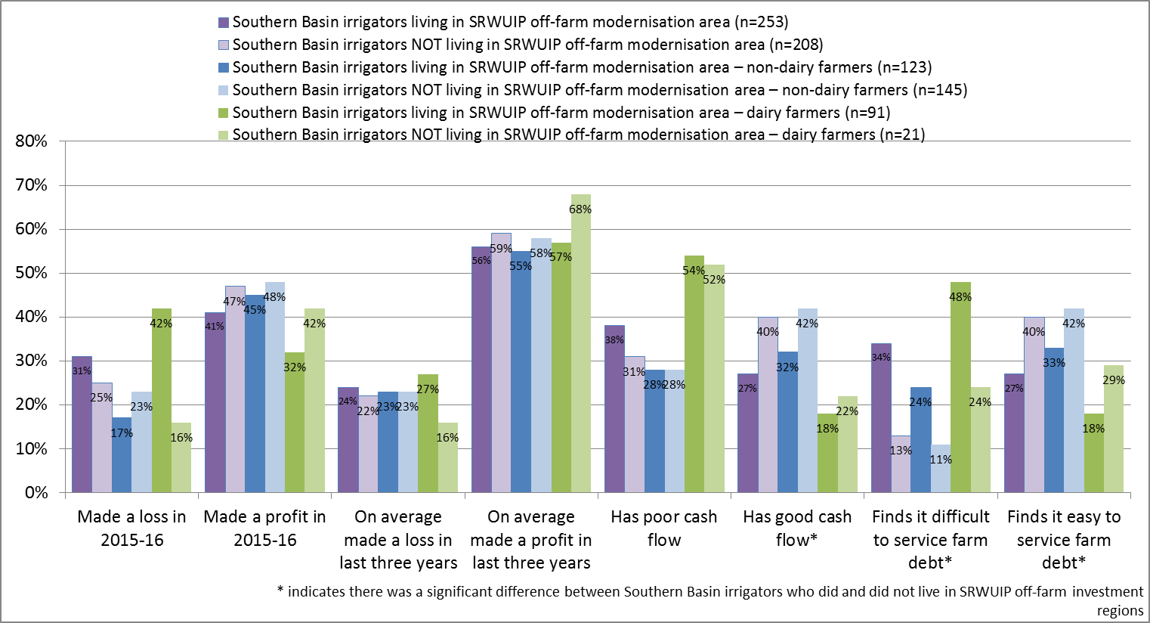

## Other water reforms

### Introduction

Investment in water infrastructure modernisation is one of several actions being implemented as part of water reforms occurring in the Murray-Darling Basin, both as part of the Basin Plan, and as part of other water reform programs. This chapter briefly considers three other aspects of water reform that may affect how irrigators experience infrastructure investments, and the flow-on effects to communities: sale of water entitlements to the government, water trade markets, and other actions taken by farmers to increase their water use efficiency.

### Sale of water entitlements to the government

Irrigators were asked if they had sold or transferred entitlements to the government since 2008. In total, 12% of Basin irrigators reported that they had sold water entitlements to the government, and 12% reported that they had transferred water entitlements (see Appendix 4, Table A4.1 for detailed data). This is fewer than the 19% who reported selling entitlements in the 2015 Regional Wellbeing Survey. It is likely that not all irrigators interpreted the difference between ‘sale’ and ‘transfer’ the same way. The definition of sale is that an irrigator sells water entitlement to the government and receives money in return. The definition of transfer is that an irrigator transfers their entitlement in return for receiving a benefit in the form of a grant for water infrastructure improvement. However, only 45% of on-farm infrastructure grant recipients reported having transferred water entitlements to government, indicating that many did not view the handing of water entitlements to government as part of the conditions of their grant as a ‘transfer’. Additionally, 36% of on-farm infrastructure recipients reported having sold entitlements, and it is likely a small proportion of these actually transferred rather than sold entitlements (while others both sold some entitlements, and also transferred some as part of the receiving their on-farm water infrastructure grant).

Despite these limitations, the data give some indication of which groups were more or less likely to have sold or transferred water entitlements. When examined by region:

* Irrigators were more likely to have sold entitlements if they lived in the GMID (19%), and had modernised on-farm water infrastructure since 2008 (18%), and slightly less likely to have if they were aged under 50 (8%)
* Irrigators were less likely to have sold entitlements if they lived in the Northern Basin (2%), or had not modernised on-farm infrastructure (7%)
* Irrigators were more likely to have transferred entitlements if they lived in South Australia (22%), the GMID (18%), and had upgraded on-farm water infrastructure (22%).

When examined by type of irrigator and farm enterprise:

* Irrigators were less likely to have sold entitlements if they had full-time off-farm work, and slightly less likely to have transferred entitlements
* Those operating larger farms in terms of economic turnover were more likely to have sold (18% of those with a GVAP of $500,000 or more compared to 10% of less for irrigators with smaller farms) and transferred entitlements (21% compared to 14% or less)
* Dairy farmers were more likely to have both sold and transferred entitlements than other types of farmers (22%)

Farm performance of Basin irrigators who had sold or transferred entitlements was compared to those who had not sold or transferred. This analysis has limitations due to the difficulty clearly identifying who had sold versus transferred entitlements, as well as some who had transferred entitlements not identifying having done so as part of receiving an on-farm infrastructure grant. Detailed data are presented in Appendix 4, Tables A4.4 to A4.10.

When those who had sold entitlements were compared to those who had neither sold or transferred entitlements, those who sold entitlements and remained in irrigated agriculture were:

* Significantly more likely to have decreased the area of land they irrigated in the last 12 months (52% compared to 28% for those who had neither sold or transferred entitlements)
* Significantly more likely to have improved on-farm irrigation efficiency in the last 12 months (65% compared to 39%)
* Somewhat more likely to have reduced the amount produced on their land in the last 12 months (25% compared to 17%) but also more likely to have increased the amount produced (28% compared to 20%)
* More likely to have reduced use of inputs other than water (39% compared to 30%)
* Significantly more likely to have experienced reduced water allocation as a barrier to farm management (65% compared to 36%)
* Significantly more likely to have experienced high water delivery costs and increasing fixed water entitlements costs as a barrier to farm management (72% compared to 51%)
* Significantly more likely to report high prices of temporary water allocation as a barrier to farm management (68% compared to 43%), as well as lack of available water allocation to buy on the market (48% compared to 28%)
* More likely to be planning to change their enterprise mix in the next five years (26% compared to 16%), while other future plans were relatively similar for the two groups
* Not substantially different on measures of financial performance such as self-reported profit, cash flow and ability to service farm debt

When compared to those who had neither sold or transferred entitlements, those who had transferred entitlements were:

* More likely to have decreased the area of land they irrigated in the last 12 months (35% compared to 28%)
* More likely to have increased the area of land irrigated in the last 12 months (21% compared to 11%)
* Significantly more likely to have improved on-farm irrigation efficiency in the last 12 months (69% compared to 39%)
* Slightly more likely to have purchased new land (17% compared to 10%) or expanded the area they farmed through leasing or sharefarming (13% compared to 4%)
* More likely to have increased the amount produced on their land (29% compared to 20%)
* Slightly more likely to have decreased the number of employees and contractors working on their farm (26% compared to 17%)
* Significantly more likely to have experienced reduced water allocation as a barrier to farm management (58% compared to 36%)
* More likely to report high prices of temporary water allocation as a barrier to farm management (60% compared to 43%), as well as lack of available water allocation to buy on the market (38% compared to 28%)
* More likely to be planning to expand their farm enterprise in the next 5 years (32% compared to 23%), and to adopt more intensive farm practices (25% compared to 15%), while other future plans were relatively similar for the two groups
* More likely to report their farm was under a lot of financial stress (49% compared to 36%)
* More likely to report they were confident they could cope with difficult conditions on the farm in future such as drought (70% compared to 52%)
* More likely to report making a moderate or large profit on their farm, but also more likely to report finding it difficult to service farm debt.

Overall, this suggests that those who have sold entitlements but remained in irrigated agriculture were investing in improving on-farm irrigation efficiency, but often finding the costs of accessing water allocation and costs of remaining entitlements prohibitive, with around one in four decreasing overall production and just over one in four increasing it, and one in three planning to expand further in the next five years. Those who transferred entitlements, meanwhile, were more likely to be expanding on-farm irrigation and production, while one in four also decreased their number of on-farm workers, and over half found accessing water allocation challenging due to cost and/or availability. Despite being confident they could cope with difficult conditions, and more likely to report being moderately to highly profitable on their farm enterprise, they were also more likely to be experiencing financial stress and finding it difficult to service debt compared to other Basin irrigators.

### Water trading

Irrigators who participate in the Regional Wellbeing Survey are asked about their participation in and views of water trading. While not the principal focus of this report, an irrigator’s ability to access and use water trading may interact with their choices about investing in infrastructure, and affect whether they experience positive or negative outcomes from actions such as investing in modernised on-farm infrastructure. For example: if an irrigator receives a grant to modernise on-farm infrastructure, and in return transfers some water entitlements, they may have less ability to sell water on the water market in times when their main commodities are experiencing a downturn (when some farmers will choose to sell water rather than grow an unprofitable crop). Alternatively, a farmer may reduce their water purchases due to needing less water to produce the same amount of produce.

#### Access to water trading

Irrigators were first asked whether they were able to trade water allocation and entitlements within their irrigations district, or between their district and other districts (for detailed data, see Appendix 4, Table A4.11). In total, 88% of Basin irrigators reported being able to trade allocation, and 86% being able to trade entitlements, within their district; this increased to 92% and 90% for irrigators in the Southern Basin. While 74% of Southern Basin irrigators reported being able to trade water allocation outside their district, and 72% being able to trade entitlements, few Northern Basin irrigators could do this (16% and 19% respectively). Outside the Basin, only 50% of irrigators reported being able to trade water allocation within their district, and only 10% could trade between districts.

When asked about the availability of water on the market, 26% of Basin irrigators said there was often little or no water available to buy on the market at any prices, including 21% of Southern Basin irrigators and 53% of Northern Basin irrigators. In the GMID and MIL districts, only 16% and 11% reported this.

There were some differences in the types of irrigators who reported having access to water trading opportunities. Those who had completed a university degree were more likely to report not being able to trade allocation and entitlements outside their district, and those who had not completed high school more likely to report they could trade outside their district. Those who worked full-time off the farm were also less likely to report being able to engage in most types of water trade, potentially indicating a lack of awareness of water trade opportunities. However, these differences were relatively small in size: for example, 60% of those who had a full-time job off the farm reported they could trade water allocation outside their district, compared to 68% of those who had no off-farm work and earned all their income from the farm.

Dairy farmers were more likely than other types of farmers to report having access to trading of water between districts (77% compared to 67% or less of other types of farmers), likely reflecting that many live in the GMID and MIL districts in which inter-district trade is relatively common.

#### Use of water trading

Irrigators were asked what sources of water they used to irrigate their farm in the 2015-16 water year, and whether they had engaged in buying or selling allocation or entitlements, had carried over water from the 2014-15 water year. If they had carried over water, they were asked if they lost any of that water due to dam spills that occurred during the Spring floods of 2016, an issue raised by irrigators in the process of designing the 2016 Regional Wellbeing Survey.

Water from entitlements they owned was the most common source of water used by Basin irrigators. As shown in Table A4.15 in Appendix 4, water from allocations made to entitlements owned by the farmer/s remains the most common source of irrigation water used on the farm: more than 90% of irrigators of almost all types reported using water from entitlements they owned on their farm. However, those aged under 50 years were less likely to report this (89% compared to 96% of those aged 65 and older), as were those with full-time off-farm work (88% compared to 96% of those who had no off-farm work). However, many who used some of their own entitlements also used water from other sources, such as leasing entitlements or purchasing allocation on the market.

Buying water allocation on the market was used by 31% of Basin irrigators (but only 6% of those outside the Basin where markets often do not exist), including 40% of Victorian Basin irrigators, 53% of those in the GMID and 46% of those in the MIL. Just over half (51%) of irrigators aged under 50 used this, compared to 30% or less of those in older age groups. This was also used more often by those who had no off-farm work (38%) and less often by those working part-time off-farm (30%) or full-time off-farm (21%). Those operating larger farms were more likely to buy water allocation on the market: 16% of those with a GVAP below $100,000 reporting buying allocation compared to 51% of those with a GVAP of $500,000 or more. Use of allocation purchase was much more common for crop growers (51% of those growing rice, grain, oilseed and cotton) and dairy farmers (65%), and less common for fruit/nut/wine grape growers (14%) and graziers or mixed crop-graziers (19%).

Leasing entitlements was less common: 10% used water leased from entitlements owned by other people, with leasing more common in South Australia (16%), those aged under 50 (17% compared to 8% of older irrigators) and rice/grain/oilseed/cotton crop growers (16%), and less common for those who worked full-time off the farm (5%).

While 62% of Basin irrigators carried over some water from the 2014-15 water year, 19% reported losing some of this carry-over in dam spills in 2016, including 62% of those in the Lower Murray Water/Western Murray Irrigation Areas, 32% in the MIL and 34% in the MIA districts.

### Water efficiency actions

In addition to asking about their investments in modernising on-farm water infrastructure, irrigators were asked if they had implemented any of six other actions to increase efficiency of water use on their farm in the last three years: (i) changing on-farm irrigation systems (which may include modernising water infrastructure), (ii) changing timing of water delivery, (iii) changing timing of crop seeding/planting, (iv) changing intensity of crop seed/planting, (v) changing use of inputs others than water such as soil additives and fertiliser, or (vi) switching to more water-efficient crop or pasture varieties.

As detailed in Appendix 4, Tables A4.17 and A4.18:

* 40% had changed on-farm irrigation systems; this included most of those who had modernised on-farm water infrastructure and was more commonly reported in the MIL (57%), by farmers with larger farms (59% of those with a GVAP of $500,000 or more compared to 28% of those with GVAP below $100,000), grain/oilseed/cotton growers (49%) and dairy farmers (47%) and less common in the Northern Basin (31%)
* 24% had changed timing of water delivery, with this more common amongst those who had modernised on-farm infrastructure (34%), those in the Lower Murray/Western Murray Irrigation region (48%), younger farmers (28% of those aged under 50 compared to 18% of those aged 65 and older), those with larger farmers (31% of larger farmers compared to 21% of those with a smaller economic size), dairy farmers and grain/oilseed/cotton growers (31% of both groups)
* 11% had changed timing of crop seeding/planting, particularly in the MIA and MIL areas (16% in each), those who had modernised on-farm infrastructure (19%), those aged under 65 (16% compared to 5% of those aged 65 and over), those with larger farmers (19% compared to 7% of smaller farms), and grain/oilseed/cotton/rice growers (22%).
* 8% had changed intensity of crop seeding/planting, particularly those in the MIL (16%) and who had upgraded on-farm infrastructure (13%), those aged under 50 (15%), those with larger farms (16%) and crop growers (17%)
* 18% had changed use of inputs other than water, for example their use of fertilizer or soil additives, particularly those who had modernised on-farm infrastructure (28%), younger farmers (23% of those aged under 50 compared to 11% of those aged 65 and older), and those with large farms (26%)
* 16% had switched to more water efficient crop/pasture varieties, particularly those who had modernised on-farm infrastructure (26%), younger farmers (24% aged under 50), those with larger farmers (25%), and dairy farmers (31%).

#### Conclusions

Overall, the results suggest that those who have sold entitlements but remained in irrigated agriculture were investing in improving on-farm irrigation efficiency, but often finding the costs of accessing water allocation and costs of remaining entitlements prohibitive, with around one in four decreasing overall production and just over one in four increasing it, and one in three planning to expand further in the next five years. Those who transferred entitlements, meanwhile, were more likely to be expanding on-farm irrigation and production, while one in four also decreased their number of on-farm workers, and over half found accessing water allocation challenging due to cost and/or availability. Despite being confident they could cope with difficult conditions, and more likely to report being moderately to highly profitable on their farm enterprise, they were also more likely to be experiencing financial stress and finding it difficult to service debt compared to other Basin irrigators.

Access to water trading was very high for Southern Basin irrigators, and relatively low for most in the Northern Basin. However, one in five Southern Basin irrigators reported a lack of water on the market reduced their ability to trade, with this a more common experience for those operating in smaller irrigation districts rather than large interconnected districts such as the GMID or MIL. While most irrigators rely at least in part on entitlements they own to provide irrigation water on their farm (more than 90%), many also use purchase of allocation or entitlement leasing to supplement this. Younger irrigators are much more likely to rely on buying allocation and/or leasing to provide water on the farm, as are those with larger economic turnover and with no off-farm income, and those growing annual crop or pasture.

Those who had modernised their on-farm infrastructure were also more likely to have taken other actions to improve water efficiency, including changing timing of water delivery, timing and intensity of seedling/planting, changing how they use inputs other than water, and increasing use of more water efficient crop and pasture varieties. Investment in almost all these types of water efficiency measures was more common amongst irrigators who were aged under 50, operated a farm enterprise with larger economic size, those growing crops (rice, grain, oilseed, and cotton), and in some cases dairy farmers. This is likely to reflect the additional pressure felt by younger farmers and those managing larger farms, who often rely on purchase of water allocation and report pressures from high costs of water. It indicates potential to increase adoption of a wider variety of water efficiency measures on smaller farmers and farms operated by older irrigators.

## Conclusions

A wide diversity of irrigated farm enterprises operate in the Basin. Given this diversity, it is to be expected that programs seeking to increase water use efficiency through investing in infrastructure modernisation will not affect all irrigators in the same way: some will benefit more from these investments, and others less. Despite the diversity of irrigators, the large majority who have modernised on-farm water infrastructure with assistance from a SRWUIP grant consider this to have been positive for their farm overall, a finding repeated across three years of surveys examining this question. On-farm infrastructure investment is predominantly positive for those who receive grants from the SRWUIP project, even when taking into account the higher debt levels and higher power costs some report experiencing as a result of the program. Increases in farm productivity and water use efficiency are believed by the large majority of irrigators to outweigh the smaller number of negative outcomes. Those who undertake modernisation are more likely to be expanding their farm enterprise, as long as they are not experiencing significant market downturn for the commodities they produce. Those experiencing downturn – in 2016, dairy farmers; in previous survey years, wine grape growers – are less able to realise benefits from their on-farm modernisation works, and may experience more negative impacts from a market downturn due to having less water to sell on the water market (a consequence of transferring water entitlements to the government as part of the conditions of receiving a SRWUIP grant).

On-farm grants have enabled irrigators to undertake works that are larger in scope and scale than would have occurred without access to a grant. Around half of all irrigators are planning to undertake modernisation works in the next five years, but these are often those who have already invested in some works. Efforts to promote water efficiency through infrastructure modernisation in future can achieve outcomes through both focusing on further effort amongst those who are most interesting and willing (younger farmers operating large farms with little off-farm work), but who have often already achieved significant efficiency savings through existing works; or on older irrigators who have off-farm work and operate smaller farms, who are least likely to have invested in modernisation works since 2008 and to be considering doing so.

Off-farm modernisation works funded by the SRWUIP have been undertaken in multiple locations in the Southern Basin. As these works have involved differing types of modernisation, undertaken at different points in time, it can be difficult to assess their effects. Irrigators are less aware of off-farm modernisation, and less likely to report that it has had positive effects for their farm enterprise, compared to on-farm modernisation. While positive about effects on water delivery timing, efficiency of water use and farm productivity, many irrigators believe the works result in increased costs to them through increases in costs of water delivery. The high level of stress reported by farmers in many modernisation regions related to increasing costs of water are likely to reduce their ability to take advantage of positive outcomes of off-farm modernisation, irrespective of the extent to which the off-farm works have contributed to higher costs. In many regions with off-farm modernisation works, irrigators have a higher reliance on purchasing water allocation for their farm than in other parts of the Basin, increasing their exposure to any increases in prices of water on the market.

The range of actions taken by irrigators to improve water use efficiency highlight that those who invest in on-farm modernisation also often invest in other action to improve water use efficiency, including changing timing of water delivery, timing and intensity of seedling/planting, changing how they use inputs other than water, and increasing use of more water efficient crop and pasture varieties. Investment in almost all these types of water efficiency measures was more common amongst irrigators who were aged under 50, operated a farm enterprise with larger economic size, those growing crops (rice, grain, oilseed, and cotton), and in some cases dairy farmers. The greater engagement in improving water use efficiency of younger irrigators and those managing larger farmers is likely to reflect the additional pressure felt by these types of irrigators, who rely more on purchase of water allocation and are more likely to report pressures from high costs of water than other irrigators. It indicates potential to increase adoption of a wider variety of water efficiency measures on smaller farms and farms operated by older irrigators.

## Appendix 1: Farm and socio-demographic characteristics of irrigators

Table A1.1 Farm size of irrigators – gross value of agricultural production and physical area (Data source: 2016 RWS)

| Basin irrigators | Farm size - Gross Value of Agricultural Production (GVAP) Mean1 GVAP | Farm size - Gross Value of Agricultural Production (GVAP) Median1 GVAP | Farm enterprise size (average hectares)2 Mean ha | Farm enterprise size (average hectares)2 Median ha | Farm size  *(proportion of irrigators in each property size. Note: the size reported is total size of property, rather than only the irrigated area)* 0-50 ha | Farm size  *(proportion of irrigators in each property size. Note: the size reported is total size of property, rather than only the irrigated area)* 51-200 ha | Farm size  *(proportion of irrigators in each property size. Note: the size reported is total size of property, rather than only the irrigated area)* 201-1,000 ha | Farm size  *(proportion of irrigators in each property size. Note: the size reported is total size of property, rather than only the irrigated area)* 1,001-10,000 ha | Farm size  *(proportion of irrigators in each property size. Note: the size reported is total size of property, rather than only the irrigated area)* >10,000 ha | n |
| --- | --- | --- | --- | --- | --- | --- | --- | --- | --- | --- |
| Murray Darling Basin irrigators | $300,000 – $399,999 | $200,000 – $299,999 | 1394ha | 218ha | 25% | 24% | 32% | 16% | 3% | 600 |
| Irrigators outside Basin | $200,000 – $299,999 | $100,000 – $199,999 | 959ha | 130ha | 33% | 27% | 30% | 9% | 1% | 464 |
| Northern Basin irrigators | $300,000 –$399,999 | $400,000 – $499,999 | 2743ha | 500ha | 18% | 18% | 29% | 29% | 6% | 102 |
| Northern Basin irrigators – QLD | $400,000 – $499,999 | $400,000 – $499,999 | 3811ha | 500ha | 8% | 23% | 36% | 26% | 8% | 39 |
| Northern Basin irrigators - NSW | $300,000 – $399,999 | $300,000 – $399,999 | 2082ha | 407ha | 24% | 14% | 25% | 32% | 5% | 63 |
| Southern Basin irrigators | $200,000 – $299,999 | $200,000 – $299,999 | 1118ha | 200ha | 27% | 25% | 33% | 13% | 2% | 498 |
| Southern Basin irrigators – NSW | $300,000 – $399,999 | $300,000 – $399,999 | 2658ha | 400ha | 22% | 16% | 30% | 26% | 6% | 145 |
| Southern Basin irrigators – VIC | $200,000 – $299,999 | $100,000 – $199,999 | 400ha | 174ha | 26% | 31% | 36% | 7% | 0% | 292 |
| Southern Basin irrigators - SA | $200,000 – $299,999 | $100,000 – $199,999 | 891ha | 94ha | 44% | 16% | 21% | 15% | 3% | 61 |
| Basin irrigator, upgraded on-farm infrastructure since 2008 | $300,000 – $399,999 | $300,000 – $399,999 | 1349ha | 230ha | 21% | 26% | 36% | 15% | 2% | 515 |
| SRWUIP on-farm infrastructure grant recipients | $400,000 – $499,999 | $400,000 – $499,999 | 1325ha | 296ha | 14% | 27% | 44% | 12% | 2% | 90 |
| Irrigators living in off-farm SRWUIP region | $200,000 – $299,999 | $200,000 – $299,999 | 1441ha | 199ha | 29% | 23% | 31% | 14% | 3% | 778 |
| Basin irrigators who sold water entitlements to government since 2008 | $400,000 – $499,999 | $400,000 – $499,999 | 1172ha | 306ha | 16% | 15% | 48% | 18% | 3% | 73 |
| Irrigation district - Goulburn Murray | $300,000 – $399,999 | $200,000 – $299,999 | 382ha | 198ha | 16% | 36% | 41% | 6% | 0% | 190 |
| Irrigation district - Lower Murray/Western Murray | $100,000 – $199,999 | $50,000-$99,999 | 1854ha | 16ha | 74% | 22% | 0% | 0% | 4% | 27 |
| Irrigation district - Murray Irrigation Ltd | $400,000 – $499,999 | $400,000 – $499,999 | 1449ha | 800ha | 4% | 9% | 47% | 38% | 2% | 47 |
| Irrigation district - Murrumbidgee Irrigation Area | $200,000 – $299,999 | $100,000 – $199,999 | 622ha | 101ha | 35% | 23% | 25% | 18% | 0% | 40 |

1Irrigators were asked to select which range their GVAP fell into. The range reported is that into which the 'average' fell.

2Three outliers were removed from the analysis of farm area, for two reasons: to preserve confidentiality, and to remove some data that could not be verified as being entered in hectares rather than acres.

Table A1.2 Farm type reported by irrigators (Data source: 2016 RWS)

| Basin irrigators | Beef | Beef-sheep | Cropping | Dairy | Fodder | Fruit/ nut exc. wine grapes | Intensive cattle | Mixed crop-beef | Mixed crop-sheep | Mixed crop-sheep-beef | Rice | Sheep | Vegetables | Wine grapes | Other | n |
| --- | --- | --- | --- | --- | --- | --- | --- | --- | --- | --- | --- | --- | --- | --- | --- | --- |
| Irrigators outside Basin | 18% | 4% | 8% | 12% | 1% | 19% | 1% | 1% | 3% | 1% | 1% | 6% | 9% | 13% | 2% | 471 |
| Murray Darling Basin irrigators | 11% | 4% | 7% | 22% | 2% | 14% | 1% | 3% | 7% | 2% | 7% | 6% | 2% | 11% | 2% | 620 |
| Northern Basin irrigators | 12% | 7% | 26% | 4% | 1% | 12% | 2% | 8% | 4% | 4% | 0% | 4% | 5% | 12% | 0% | 102 |
| Northern Basin irrigators – QLD | 13% | 5% | 26% | 8% | 0% | 11% | 5% | 3% | 3% | 3% | 0% | 0% | 13% | 11% | 0% | 38 |
| Northern Basin irrigators - NSW | 11% | 8% | 27% | 2% | 2% | 13% | 0% | 11% | 5% | 5% | 0% | 6% | 0% | 13% | 0% | 64 |
| Southern Basin irrigators | 11% | 4% | 3% | 25% | 2% | 14% | 1% | 2% | 8% | 2% | 8% | 7% | 1% | 11% | 2% | 518 |
| Southern Basin irrigators – NSW | 6% | 5% | 4% | 5% | 3% | 18% | 1% | 1% | 7% | 2% | 27% | 11% | 1% | 7% | 2% | 152 |
| Southern Basin irrigators – VIC | 14% | 3% | 3% | 38% | 3% | 10% | 1% | 2% | 10% | 1% | 1% | 4% | 1% | 8% | 2% | 305 |
| Southern Basin irrigators - SA | 3% | 5% | 2% | 8% | 0% | 25% | 0% | 0% | 5% | 3% | 0% | 10% | 5% | 33% | 2% | 61 |
| Basin irrigator, upgraded on-farm infrastructure since 2008 | 11% | 3% | 8% | 21% | 2% | 17% | 1% | 2% | 6% | 3% | 5% | 5% | 6% | 10% | 1% | 530 |
| SRWUIP on-farm infrastructure grant recipients | 11% | 0% | 1% | 38% | 1% | 13% | 1% | 1% | 13% | 2% | 6% | 5% | 1% | 6% | 1% | 95 |
| Irrigators living in off-farm SRWUIP region | 11% | 3% | 5% | 35% | 2% | 12% | 0% | 2% | 5% | 1% | 7% | 4% | 1% | 9% | 2% | 300 |
| Basin irrigators who sold water entitlements to government since 2008 | 9% | 3% | 9% | 39% | 1% | 7% | 0% | 1% | 8% | 3% | 8% | 1% | 3% | 7% | 1% | 75 |
| Irrigation district - Goulburn Murray | 16% | 3% | 4% | 52% | 3% | 5% | 1% | 2% | 10% | 1% | 1% | 2% | 0% | 2% | 1% | 199 |
| Irrigation district - Lower Murray/Western Murray | 7% | 0% | 0% | 0% | 0% | 37% | 0% | 0% | 0% | 0% | 0% | 7% | 7% | 30% | 11% | 27 |
| Irrigation district - Murray Irrigation Ltd | 6% | 6% | 0% | 10% | 4% | 0% | 2% | 4% | 8% | 2% | 46% | 10% | 2% | 0% | 0% | 50 |
| Irrigation district - Murrumbidgee Irrigation Area | 2% | 0% | 5% | 0% | 2% | 29% | 0% | 0% | 0% | 0% | 36% | 10% | 0% | 12% | 5% | 42 |

Table A1.3 Water use by irrigators (Data source: 2016 RWS)

| Basin irrigators | Total volume of water use (ML) Mean | Total volume of water use (ML) Median | % irrigators reporting different volumes of water use (ML) 0-50 | % irrigators reporting different volumes of water use (ML) 51-200 | % irrigators reporting different volumes of water use (ML) 201-1,000 | % irrigators reporting different volumes of water use (ML) >1000 | Volume of water from irrigation channels (ML) Mean | Volume of water from irrigation channels (ML) Median | Volume of water from rivers/lakes (ML) Mean | Volume of water from rivers/lakes (ML) Median | Volume of water from ground water (ML) Mean | Volume of water from ground water (ML) Median | n |
| --- | --- | --- | --- | --- | --- | --- | --- | --- | --- | --- | --- | --- | --- |
| Murray Darling Basin irrigators | 705 | 200 | 25% | 25% | 38% | 12% | 423 | 250 | 412 | 130 | 859 | 86 | 490 |
| Irrigators outside Basin | 4443 | 80 | 44% | 25% | 23% | 8% | 886 | 145 | 881 | 75 | 10080 | 50 | 323 |
| Northern Basin irrigators | 1842 | 140 | 37% | 22% | 23% | 18% | 675 | 675 | 652 | 70 | 1521 | 140 | 65 |
| Northern Basin irrigators – QLD | 3205 | 165 | 38% | 15% | 23% | 23% | 675 | 675 | 505 | 99 | 3802 | 199 | 26 |
| Northern Basin irrigators - NSW | 932 | 87 | 36% | 26% | 23% | 15% | 0 | 0 | 743 | 70 | 338 | 70 | 39 |
| Southern Basin irrigators | 531 | 220 | 23% | 26% | 40% | 11% | 421 | 250 | 357 | 130 | 590 | 80 | 425 |
| Southern Basin irrigators – NSW | 712 | 265 | 22% | 24% | 36% | 19% | 594 | 325 | 574 | 180 | 583 | 100 | 118 |
| Southern Basin irrigators – VIC | 384 | 220 | 22% | 27% | 44% | 7% | 365 | 250 | 182 | 86 | 271 | 80 | 257 |
| Southern Basin irrigators - SA | 855 | 125 | 32% | 24% | 32% | 12% | 294 | 1298 | 421 | 300 | 1893 | 92 | 50 |
| Basin irrigator, upgraded on-farm infrastructure since 2008 | 1049 | 252 | 23% | 21% | 42% | 13% | 519 | 300 | 418 | 154 | 1800 | 135 | 448 |
| SRWUIP on-farm infrastructure grant recipients | 700 | 450 | 9% | 19% | 53% | 19% | 560 | 350 | 409 | 348 | 512 | 200 | 89 |
| Irrigators living in off-farm SRWUIP region | 551 | 279 | 18% | 25% | 46% | 10% | 432 | 260 | 318 | 100 | 611 | 92 | 254 |
| Basin irrigators who sold water entitlements to government since 2008 | 716 | 500 | 12% | 18% | 50% | 21% | 481 | 300 | 655 | 365 | 571 | 250 | 68 |
| Irrigation district - Goulburn Murray | 487 | 320 | 14% | 22% | 55% | 9% | 417 | 300 | 217 | 95 | 315 | 150 | 170 |
| Irrigation district - Lower Murray/Western Murray | 177 | 90 | 22% | 44% | 33% | 0% | 147 | 90 | 251 | 223 | 0 | 0 | 27 |
| Irrigation district - Murray Irrigation Ltd | 902 | 545 | 14% | 14% | 44% | 28% | 618 | 400 | 757 | 600 | 453 | 335 | 36 |
| Irrigation district - Murrumbidgee Irrigation Area | 852 | 325 | 16% | 19% | 44% | 22% | 746 | 330 | 200 | 200 | 854 | 205 | 32 |

Table A1.4 Socio-demographic characteristics of irrigators

| Basin irrigators | Gender  Female | Gender  Male | n | Age  <49 years | Age  50-64 years | Age  65 years and older | n | % household income earned off-farm  Mean | % household income earned off-farm  Median | n | Household income 2015-16 Mean | Household income 2015-16 Median | n |
| --- | --- | --- | --- | --- | --- | --- | --- | --- | --- | --- | --- | --- | --- |
| Murray Darling Basin irrigators | 25% | 75% | 619 | 16% | 45% | 39% | 617 | 29 | 10 | 629 | $52,000-$62,399 | $52,000-$62,399 | 536 |
| Irrigators outside Basin | 24% | 76% | 478 | 16% | 43% | 41% | 479 | 33 | 20 | 479 | $62,400-$77,999 | $62,400-$77,999 | 427 |
| Northern Basin irrigators | 27% | 73% | 103 | 15% | 57% | 28% | 103 | 30 | 13 | 104 | $78,000 - $103,999 | $78,000 - $103,999 | 90 |
| Northern Basin irrigators – QLD | 26% | 74% | 38 | 8% | 59% | 33% | 39 | 27 | 5 | 39 | $62,400-$77,999 | $78,000 - $103,999 | 33 |
| Northern Basin irrigators - NSW | 28% | 72% | 65 | 19% | 56% | 25% | 64 | 32 | 20 | 65 | $78,000 - $103,999 | $78,000 - $103,999 | 57 |
| Southern Basin irrigators | 25% | 75% | 516 | 17% | 42% | 41% | 514 | 29 | 10 | 523 | $52,000-$62,399 | $52,000-$62,399 | 523 |
| Southern Basin irrigators – NSW | 29% | 71% | 153 | 14% | 43% | 44% | 155 | 26 | 10 | 154 | $62,400-$77,999 | $62,400-$77,999 | 154 |
| Southern Basin irrigators – VIC | 23% | 77% | 301 | 18% | 43% | 39% | 298 | 30 | 10 | 306 | $41,600-$51,999 | $41,600-$51,999 | 252 |
| Southern Basin irrigators - SA | 23% | 77% | 62 | 20% | 36% | 44% | 61 | 30 | 3 | 63 | $52,000-$62,399 | $52,000-$62,399 | 53 |
| Basin irrigator, upgraded on-farm infrastructure since 2008 | 22% | 78% | 527 | 19% | 48% | 33% | 524 | 27 | 10 | 529 | $62,400-$77,999 | $62,400-$77,999 | 461 |
| SRWUIP on-farm infrastructure grant recipients | 19% | 81% | 93 | 20% | 42% | 38% | 93 | 21 | 1.5 | 94 | $52,000-$62,399 | $41,600-$51,999 | 77 |
| Irrigators living in off-farm SRWUIP region | 28% | 72% | 299 | 21% | 43% | 36% | 297 | 29 | 10 | 304 | $52,000-$62,399 | $52,000-$62,399 | 249 |
| Basin irrigators who sold water entitlements to government since 2008 | 19% | 81% | 74 | 11% | 47% | 42% | 72 | 22 | 5 | 75 | $52,000-$62,399 | $52,000-$62,399 | 66 |
| Irrigation district - Goulburn Murray | 24% | 76% | 197 | 23% | 43% | 34% | 197 | 27 | 5 | 199 | $52,000-$62,399 | $41,600-$51,999 | 161 |
| Irrigation district - Lower Murray/Western Murray | 17% | 83% | 29 | 4% | 46% | 50% | 28 | 41 | 20 | 29 | $41,600-$51,999 | $41,600-$51,999 | 26 |
| Irrigation district - Murray Irrigation Ltd | 37% | 63% | 49 | 18% | 47% | 35% | 51 | 25 | 10 | 50 | $62,400-$77,999 | $52,000-$62,399 | 46 |
| Irrigation district - Murrumbidgee Irrigation Area | 24% | 76% | 42 | 7% | 43% | 50% | 42 | 28 | 5 | 43 | $52,000-$62,399 | $52,000-$62,399 | 37 |

## Appendix 2: Uptake of On-Farm Modernisation Works & Future Intentions

Table A2.1 Participation in modernisation of on-farm irrigation infrastructure since 2008, and sources of funding

| Basin irrigators | Have you upgraded existing or added new irrigation infrastructure on your farm since 2008? Yes - 2016 | Have you upgraded existing or added new irrigation infrastructure on your farm since 2008? Yes - 2015 | Have you upgraded existing or added new irrigation infrastructure on your farm since 2008? n - 2016 | Sources of funding used to invest by irrigators who modernised? Self-funded | Sources of funding used to invest by irrigators who modernised? Loan from bank/ other organisation | Sources of funding used to invest by irrigators who modernised? Grant from government or other organisation | Sources of funding used to invest by irrigators who modernised? Self-funding + loan | Sources of funding used to invest by irrigators who modernised? Self funding + grant | Sources of funding used to invest by irrigators who modernised? Loan + grant | Sources of funding used to invest by irrigators who modernised? Self-funding + loan + grant | Sources of funding used to invest by irrigators who modernised? n | % of those who modernised who received assistance from a SRWUIP grant  Yes | % of those who modernised who received assistance from a SRWUIP grant  No | % of those who modernised who received assistance from a SRWUIP grant  n |
| --- | --- | --- | --- | --- | --- | --- | --- | --- | --- | --- | --- | --- | --- | --- |
| Murray Darling Basin irrigators | 56% | 59% | 533 | 56% | 6% | 19% | 6% | 13% | 2% | 2% | 298 | 32% | 68% | 298 |
| Irrigators outside Basin | 54% | 52% | 435 | 85% | 13% | 1% | 4% | 3% | 0% | 0% | 235 | 0% | 100% | 235 |
| Northern Basin irrigators | 43% | 56% | 84 | 75% | 11% | 17% | 8% | 6% | 0% | 0% | 36 | 0% | 100% | 36 |
| Northern Basin irrigators – QLD | 40% | 50% | 30 | 67% | 8% | 17% | 8% | 8% | 0% | 0% | 12 | 0% | 100% | 12 |
| Northern Basin irrigators - NSW | 62% | 65% | 127 | 79% | 13% | 17% | 8% | 4% | 0% | 0% | 24 | 0% | 100% | 24 |
| Southern Basin irrigators | 58% | 60% | 449 | 55% | 6% | 19% | 6% | 14% | 2% | 3% | 262 | 36% | 64% | 262 |
| Southern Basin irrigators – NSW | 62% | 70% | 127 | 66% | 9% | 13% | 8% | 8% | 3% | 0% | 79 | 20% | 80% | 79 |
| Southern Basin irrigators – VIC | 57% | 51% | 265 | 50% | 5% | 23% | 5% | 17% | 25 | 4% | 151 | 44% | 56% | 151 |
| Southern Basin irrigators - SA | 56% | 67% | 57 | 53% | 0% | 16% | 6% | 19% | 3% | 3% | 32 | 41% | 59% | 32 |
| Irrigators living in off-farm SRWUIP region | 64% | - | 264 | 50% | 5% | 23% | 7% | 15% | 3% | 4% | 169 | 42% | 58% | 169 |
| Basin irrigators who sold water entitlements to government since 2008 | 77% | - | 70 | 31% | 6% | 33% | 2% | 30% | 4% | 2% | 54 | 63% | 37% | 54 |
| Irrigation district - Goulburn Murray | 65% | - | 173 | 62% | 6% | 35% | 6% | 27% | 4% | 6% | 81 | 50% | 50% | 81 |
| Irrigation district - Lower Murray/Western Murray | 50% | - | 28 | 53% | 0% | 27% | 0% | 7% | 0% | 7% | 15 | 43% | 57% | 15 |
| Irrigation district - Murray Irrigation Ltd | 72% | - | 43 | 71% | 19% | 19% | 14% | 14% | 5% | 0% | 21 | 23% | 77% | 21 |
| Irrigation district - Murrumbidgee Irrigation Area | 69% | - | 35 | 94% | 0% | 33% | 11% | 0% | 6% | 0% | 18 | 25% | 75% | 18 |

Table A2.2 Timing and area of on-farm modernisation, and future intentions to modernise

| Basin irrigators | % of irrigated area upgraded  0-19% | % of irrigated area upgraded  20-39% | % of irrigated area upgraded  40-59% | % of irrigated area upgraded  60-89% | % of irrigated area upgraded  90-100% | % of irrigated area upgraded  n | Year in which most recent upgrade of on-farm irrigation infrastructure occurred  Pre-2008 | Year in which most recent upgrade of on-farm irrigation infrastructure occurred  2008 or 2009 | Year in which most recent upgrade of on-farm irrigation infrastructure occurred  2010 or 2011 | Year in which most recent upgrade of on-farm irrigation infrastructure occurred  2012 or 2013 | Year in which most recent upgrade of on-farm irrigation infrastructure occurred  2014 or 2015 | Year in which most recent upgrade of on-farm irrigation infrastructure occurred  2016 | Year in which most recent upgrade of on-farm irrigation infrastructure occurred  n |
| --- | --- | --- | --- | --- | --- | --- | --- | --- | --- | --- | --- | --- | --- |
| Murray Darling Basin irrigators | 23% | 28% | 15% | 13% | 21% | 247 | 1% | 10% | 10% | 14% | 45% | 20% | 283 |
| Irrigators outside Basin | 24% | 27% | 18% | 11% | 21% | 190 | 0% | 9% | 15% | 15% | 36% | 24% | 228 |
| Northern Basin irrigators | 20% | 37% | 13% | 10% | 20% | 30 | 0% | 0% | 11% | 17% | 33% | 39% | 36 |
| Northern Basin irrigators – QLD | 18% | 45% | 9% | 9% | 18% | 11 | 0% | 0% | 17% | 17% | 8% | 58% | 12 |
| Northern Basin irrigators - NSW | 21% | 32% | 16% | 11% | 21% | 19 | 0% | 0% | 8% | 17% | 46% | 29% | 24 |
| Southern Basin irrigators | 24% | 26% | 15% | 13% | 21% | 217 | 1% | 11% | 10% | 14% | 47% | 17% | 247 |
| Southern Basin irrigators – NSW | 18% | 28% | 17% | 12% | 25% | 65 | 0% | 12% | 11% | 8% | 51% | 18% | 73 |
| Southern Basin irrigators – VIC | 27% | 25% | 16% | 14% | 18% | 128 | 1% | 13% | 10% | 19% | 45% | 12% | 144 |
| Southern Basin irrigators - SA | 25% | 29% | 4% | 13% | 29% | 24 | 0% | 0% | 7% | 7% | 47% | 40% | 30 |
| Basin irrigators who sold water entitlements to government since 2008 | 6% | 21% | 21% | 23% | 28% | 47 | 0% | 6% | 12% | 20% | 45% | 18% | 51 |
| SRWUIP on-farm infrastructure grant recipients | 14% | 23% | 13% | 19% | 30% | 83 | 2% | 13% | 11% | 23% | 41% | 11% | 93 |
| Irrigators living in off-farm SRWUIP region | 28% | 28% | 13% | 14% | 17% | 143 | 1% | 9% | 10% | 16% | 46% | 19% | 164 |
| Irrigation district - Goulburn Murray | 32% | 24% | 12% | 16% | 15% | 98 | 1% | 8% | 12% | 21% | 48% | 10% | 110 |
| Irrigation district - Lower Murray/Western Murray | 21% | 21% | 36% | 0% | 21% | 14 | 7% | 50% | 0% | 14% | 21% | 7% | 14 |
| Irrigation district - Murray Irrigation Ltd | 19% | 50% | 12% | 8% | 12% | 26 | 0% | 4% | 0% | 11% | 67% | 19% | 27 |
| Irrigation district - Murrumbidgee Irrigation Area | 24% | 12% | 24% | 0% | 41% | 17 | 0% | 9% | 18% | 9% | 45% | 18% | 22 |

Table A2.3 Future intentions to modernise on-farm irrigation infrastructure

| Basin irrigators | Future intentions for modernising on-farm infrastructure  Intend to upgrade/ modernise in next 1-2 years | Future intentions for modernising on-farm infrastructure  Intend to upgrade/ modernise in next 3-5 years | Future intentions for modernising on-farm infrastructure  Doesn’t plan to upgrade/ modernise in next 5 years | Future intentions for modernising on-farm infrastructure  n |
| --- | --- | --- | --- | --- |
| Murray Darling Basin irrigators | 24% | 24% | 52% | 510 |
| Irrigators outside Basin | 23% | 22% | 55% | 399 |
| Northern Basin irrigators | 22% | 25% | 53% | 88 |
| Northern Basin irrigators – QLD | 22% | 22% | 56% | 32 |
| Northern Basin irrigators - NSW | 21% | 27% | 52% | 56 |
| Southern Basin irrigators | 24% | 24% | 52% | 422 |
| Southern Basin irrigators – NSW | 28% | 26% | 46% | 127 |
| Southern Basin irrigators – VIC | 22% | 22% | 56% | 241 |
| Southern Basin irrigators - SA | 24% | 26% | 50% | 54 |
| Basin irrigator, upgraded on-farm infrastructure since 2008 | 31% | 28% | 40% | 513 |
| SRWUIP on-farm infrastructure grant recipients | 22% | 31% | 47% | 91 |
| Irrigators living in off-farm SRWUIP region | 22% | 25% | 53% | 251 |
| Basin irrigators who sold water entitlements to government since 2008 | 30% | 33% | 36% | 66 |
| Irrigation district - Goulburn Murray | 19% | 27% | 54% | 160 |
| Irrigation district - Lower Murray/Western Murray | 23% | 12% | 65% | 26 |
| Irrigation district - Murray Irrigation Ltd | 41% | 24% | 35% | 37 |
| Irrigation district - Murrumbidgee Irrigation Area | 24% | 35% | 41% | 37 |
| Basin irrigator by farm type - Beef /sheep | 23% | 19% | 58% | 118 |
| Basin irrigator by farm type - Grain/ oilseed/ cotton | 33% | 42% | 25% | 36 |
| Basin irrigator by farm type - Mixed grazing-cropping | 29% | 29% | 43% | 63 |
| Basin irrigator by farm type - Dairy | 17% | 26% | 57% | 103 |
| Basin irrigator by farm type - Rice | 48% | 39% | 12% | 33 |
| Basin irrigator by farm type - Fruit/nut growers excluding wine grapes | 22% | 22% | 55% | 67 |
| Basin irrigator by farm type - Wine grape growers | 13% | 13% | 73% | 52 |

Table A2.4 Types of irrigators who modernised on-farm infrastructure: Socio-demographic characteristics

| Basin irrigators by Socio-demographic characteristics | Gender  Female | Gender  Male | Gender  n | Age (years) <49 | Age (years) 50-64 | Age (years) 65+ | Age (years) n | Educational attainment  Did not complete high school | Educational attainment  Completed Year 12 | Educational attainment  Completed university degree | Educational attainment  n |
| --- | --- | --- | --- | --- | --- | --- | --- | --- | --- | --- | --- |
| Murray Darling Basin irrigators | 25% | 75% | 619 | 17% | 45% | 39% | 617 | 33% | 39% | 28% | 546 |
| Irrigators outside Basin | 24% | 76% | 478 | 16% | 43% | 41% | 479 | 28% | 39% | 33% | 441 |
| Basin irrigator, had not upgraded on-farm infrastructure since 2008 | 25% | 75% | 426 | 14% | 40% | 47% | 426 | 33% | 37% | 30% | 383 |
| Basin irrigator, upgraded on-farm infrastructure since 2008 | 22% | 78% | 527 | 19% | 48% | 33% | 524 | 28% | 40% | 32% | 476 |
| SRWUIP on-farm infrastructure grant recipients | 19% | 81% | 93 | 20% | 42% | 38% | 93 | 36% | 43% | 21% | 70 |
| Irrigators living in off-farm SRWUIP region | 28% | 72% | 299 | 21% | 43% | 36% | 297 | 38% | 35% | 27% | 246 |
| Basin irrigators who sold water entitlements to government since 2008 | 19% | 81% | 74 | 11% | 47% | 42% | 72 | 41% | 41% | 18% | 61 |
| Intends to upgrade/modernise in next 1-2 years | 23% | 77% | 211 | 21% | 49% | 30% | 210 | 24% | 41% | 35% | 182 |
| Intends to upgrade/modernise in next 3-5 years | 22% | 78% | 209 | 17% | 51% | 32% | 207 | 29% | 43% | 28% | 185 |
| Doesn’t plan to upgrade/modernise in next 5 years | 23% | 77% | 476 | 14% | 41% | 45% | 476 | 33% | 36% | 31% | 444 |
| Irrigation district - Goulburn Murray | 24% | 76% | 197 | 23% | 43% | 34% | 197 | 43% | 34% | 23% | 158 |
| Irrigation district - Lower Murray/Western Murray | 17% | 83% | 29 | 4% | 46% | 505 | 28 | 35% | 57% | 9% | 23 |
| Irrigation district - Murray Irrigation Ltd | 37% | 63% | 49 | 18% | 47% | 35% | 51 | 19% | 44% | 38% | 48 |
| Irrigation district - Murrumbidgee Irrigation Area | 24% | 76% | 42 | 7% | 43% | 50% | 42 | 35% | 45% | 20% | 40 |

Table A2.5 Types of irrigators who modernised on-farm infrastructure: Off-farm income

| Off-farm income | Off-farm work  No off-farm work | Off-farm work  Part-time off-farm work | Off-farm work  Full-time off-farm work | Off-farm work  n | % household income earned off-farm  None (all income earned on-farm) | % household income earned off-farm  1-24% | % household income earned off-farm  24-49% | % household income earned off-farm  50-74% | % household income earned off-farm  75-100% | % household income earned off-farm  n |
| --- | --- | --- | --- | --- | --- | --- | --- | --- | --- | --- |
| Murray Darling Basin irrigators | 68% | 25% | 8% | 611 | 38% | 24% | 7% | 13% | 19% | 627 |
| Irrigators outside Basin | 65% | 23% | 12% | 471 | 32% | 21% | 11% | 16% | 20% | 479 |
| Basin irrigator, had not upgraded on-farm infrastructure since 2008 | 64% | 24% | 13% | 429 | 30% | 23% | 8% | 16% | 23% | 431 |
| Basin irrigator, upgraded on-farm infrastructure since 2008 | 71% | 22% | 7% | 520 | 38% | 23% | 10% | 12% | 16% | 529 |
| SRWUIP on-farm infrastructure grant recipients | 76% | 19% | 5% | 94 | 49% | 26% | 2% | 10% | 14% | 94 |
| Irrigators living in off-farm SRWUIP region | 67% | 23% | 10% | 301 | 40% | 22% | 7% | 11% | 20% | 304 |
| Basin irrigators who sold water entitlements to government since 2008 | 75% | 21% | 4% | 71 | 41% | 25% | 9% | 15% | 9% | 75 |
| Intends to upgrade/modernise in next 1-2 years | 70% | 23% | 8% | 207 | 33% | 29% | 8% | 11% | 18% | 212 |
| Intends to upgrade/modernise in next 3-5 years | 70% | 22% | 7% | 203 | 38% | 26% | 10% | 10% | 15% | 208 |
| Doesn’t plan to upgrade/modernise in next 5 years | 66% | 24% | 11% | 480 | 34% | 20% | 9% | 16% | 21% | 481 |
| Irrigation district - Goulburn Murray | 69% | 24% | 8% | 199 | 42% | 23% | 7% | 9% | 20% | 199 |
| Irrigation district - Lower Murray/Western Murray | 61% | 36% | 4% | 28 | 34% | 17% | 10% | 3% | 34% | 29 |
| Irrigation district - Murray Irrigation Ltd | 70% | 23% | 6% | 47 | 34% | 36% | 4% | 12% | 14% | 50 |
| Irrigation district - Murrumbidgee Irrigation Area | 61% | 24% | 16% | 38 | 42% | 19% | 7% | 16% | 16% | 43 |

Table A2.6 Types of irrigators who modernised on-farm infrastructure: Water use, farm area, and farm turnover

| Water use, farm area, and farm turnover | Water use (ML from all sources) Mean (ML) | Water use (ML from all sources) Median (ML) | Water use (ML from all sources) n | Farm area (ha) Mean (ha) | Farm area (ha) Median (ha) | Farm area (ha) n | Gross value of agricultural production  <$99,999 | Gross value of agricultural production  $100-199,999 | Gross value of agricultural production  $200-299,999 | Gross value of agricultural production  $300-399,999 | Gross value of agricultural production  $400-499,999 | Gross value of agricultural production  $500-749,000 | Gross value of agricultural production  $750-999,999 | Gross value of agricultural production  $1 million or more | Gross value of agricultural production  n |
| --- | --- | --- | --- | --- | --- | --- | --- | --- | --- | --- | --- | --- | --- | --- | --- |
| Murray Darling Basin irrigators | 705 | 200 | 490 | 1394 | 218 | 600 | 36% | 10% | 8% | 8% | 6% | 7% | 8% | 17% | 565 |
| Irrigators outside Basin | 4443 | 80 | 323 | 959 | 130 | 464 | 40% | 13% | 6% | 6% | 5% | 4% | 6% | 19% | 434 |
| Basin irrigator, had not upgraded on-farm infrastructure since 2008 | 3697 | 70 | 332 | 1089 | 135 | 422 | 49% | 13% | 8% | 7% | 5% | 3% | 6% | 8% | 404 |
| Basin irrigator, upgraded on-farm infrastructure since 2008 | 1049 | 252 | 448 | 1349 | 230 | 515 | 26% | 11% | 7% | 6% | 6% | 8% | 9% | 27% | 490 |
| SRWUIP on-farm infrastructure grant recipients | 700 | 450 | 89 | 1325 | 296 | 90 | 24% | 4% | 11% | 10% | 7% | 10% | 14% | 21% | 84 |
| Irrigators living in off-farm SRWUIP region | 551 | 279 | 254 | 585 | 160 | 289 | 40% | 9% | 8% | 5% | 7% | 8% | 9% | 13% | 276 |
| Basin irrigators who sold water entitlements to government since 2008 | 716 | 500 | 68 | 1172 | 306 | 73 | 31% | 3% | 9% | 4% | 4% | 4% | 19% | 25% | 68 |
| Intends to upgrade/modernise in next 1-2 years | 713 | 300 | 175 | 1611 | 330 | 207 | 23% | 10% | 8% | 8% | 8% | 6% | 8% | 30 | 198 |
| Intends to upgrade/modernise in next 3-5 years | 719 | 250 | 176 | 1248 | 300 | 204 | 23% | 12% | 9% | 7% | 5% | 8% | 9% | 28% | 196 |
| Doesn’t plan to upgrade/modernise in next 5 years | 1051 | 80 | 384 | 1042 | 117 | 472 | 46% | 14% | 6% | 6% | 6% | 5% | 6% | 10% | 446 |
| Irrigation district - Goulburn Murray | 487 | 320 | 170 | 382 | 198 | 190 | 38% | 7% | 8% | 8% | 7% | 10% | 9% | 13% | 178 |
| Irrigation district - Lower Murray/Western Murray | 177 | 90 | 27 | 1854 | 16 | 27 | 56% | 15% | 0% | 7% | 7% | 7% | 0% | 7% | 27 |
| Irrigation district - Murray Irrigation Ltd | 902 | 545 | 36 | 1449 | 800 | 47 | 22% | 4% | 13% | 7% | 9% | 9% | 4% | 33% | 46 |
| Irrigation district - Murrumbidgee Irrigation Area | 852 | 325 | 32 | 622 | 101 | 40 | 46% | 11% | 9% | 11% | 3% | 9% | 6% | 6% | 35 |

Table A2.7 Types of irrigators who modernised on-farm infrastructure: Farm type

| % who had modernised since 2008 | % who had modernised since 2008, by farm type  Beef /sheep | % who had modernised since 2008, by farm type  Grain/ oilseed/ cotton | % who had modernised since 2008, by farm type  Mixed grazing-cropping | % who had modernised since 2008, by farm type  Dairy | % who had modernised since 2008, by farm type  Rice | % who had modernised since 2008, by farm type  Fruit/nut growers excluding wine grapes | % who had modernised since 2008, by farm type  Wine grape growers | % who had modernised since 2008, by farm type  Vegetable growers | % who had modernised since 2008, by farm type  Other | % who had modernised since 2008, by farm type  n |
| --- | --- | --- | --- | --- | --- | --- | --- | --- | --- | --- |
| Murray Darling Basin irrigators | 39% | 56% | 65% | 66% | 85% | 61% | 41% | 78% | 46% | 470 |
| Irrigators outside Basin | 42% | 65% | 57% | 72% | 33% | 56% | 52% | 67% | 50% | 400 |
| Irrigators living in off-farm SRWUIP region | 45% | 62% | 68% | 72% | 82% | 70% | 65% | 67% | 42% | 190 |
| Intends to upgrade/modernise in next 1-2 years | 62% | 76% | 84% | 76% | 100% | 81% | 82% | 82% | 100% | 90 |
| Intends to upgrade/modernise in next 3-5 years | 51% | 63% | 76% | 93% | 82% | 83% | 40% | 77% | 83% | 109 |
| Doesn’t plan to upgrade/modernise in next 5 years | 35% | 53% | 42% | 60% | 60% | 47% | 45% | 57% | 35% | 200 |

Table A2.8a Irrigator’s views on effects of modernising on-farm infrastructure – all farmers

| If your on-farm infrastructure has been upgraded/expanded since 2008, how did the on-farm infrastructure upgrade/ addition affect… | Basin irrigator, upgraded on-farm infrastructure since 2008 Negative impact | Basin irrigator, upgraded on-farm infrastructure since 2008 Neither negative or positive | Basin irrigator, upgraded on-farm infrastructure since 2008 Positive impact | Basin irrigator, upgraded on-farm infrastructure since 2008 n | SRWUIP on-farm infrastructure grant recipients  Negative impact | SRWUIP on-farm infrastructure grant recipients  Neither negative or positive | SRWUIP on-farm infrastructure grant recipients  Positive impact | SRWUIP on-farm infrastructure grant recipients  n |
| --- | --- | --- | --- | --- | --- | --- | --- | --- |
| Your farm enterprise as a whole | 8% | 17% | 75% | 354 | 6% | 11% | 83% | 93 |
| Your farm profitability | 14% | 24% | 61% | 353 | 18% | 17% | 65% | 93 |
| Your overall farm productivity – since works were completed | 9% | 22% | 69% | 344 | 11% | 13% | 76% | 92 |
| Your irrigation water costs | 23% | 37% | 41% | 343 | 28% | 27% | 45% | 92 |
| Your farm debt levels | 33% | 39% | 29% | 335 | 38% | 37% | 25% | 89 |
| Your efficiency of water use | 6% | 18% | 76% | 348 | 9% | 10% | 82% | 93 |
| Timing of water delivery to your farm | 10% | 29% | 61% | 329 | 9% | 21% | 70% | 90 |
| Electricity/power costs | 40% | 30% | 30% | 334 | 43% | 31% | 26% | 91 |
| Your on-farm workload | 14% | 27% | 59% | 343 | 11% | 26% | 63% | 92 |
| Your ability to respond to changes in farming conditions | 8% | 24% | 68% | 342 | 9% | 19% | 73% | 91 |

Table A2.8b Irrigator’s views on effects of modernising on-farm infrastructure – comparison of dairy farmers and non-dairy farmers

| If your on-farm infrastructure has been upgraded/expanded since 2008, how did the on-farm infrastructure upgrade/ addition affect… | SRWUIP on-farm infrastructure grant recipients - excluding dairy farmers  Negative impact | SRWUIP on-farm infrastructure grant recipients - excluding dairy farmers  Neither negative or positive | SRWUIP on-farm infrastructure grant recipients - excluding dairy farmers  Positive impact | SRWUIP on-farm infrastructure grant recipients - excluding dairy farmers  n | SRWUIP on-farm infrastructure grant recipients - dairy farmers  Negative impact | SRWUIP on-farm infrastructure grant recipients - dairy farmers  Neither negative or positive | SRWUIP on-farm infrastructure grant recipients - dairy farmers  Positive impact | SRWUIP on-farm infrastructure grant recipients - dairy farmers  n |
| --- | --- | --- | --- | --- | --- | --- | --- | --- |
| Your farm enterprise as a whole | 7% | 11% | 82% | 57 | 6% | 11% | 83% | 36 |
| Your farm profitability | 14% | 18% | 68% | 57 | 25% | 17% | 58% | 36 |
| Your overall farm productivity – since works were completed | 9% | 14% | 77% | 56 | 14% | 11% | 75% | 36 |
| Your irrigation water costs | 25% | 29% | 46% | 56 | 33% | 25% | 42% | 36 |
| Your farm debt levels | 20% | 52% | 28% | 54 | 66% | 14% | 20% | 35 |
| Your efficiency of water use | 5% | 11% | 84% | 57 | 14% | 8% | 78% | 36 |
| Timing of water delivery to your farm | 11% | 22% | 67% | 54 | 6% | 19% | 75% | 36 |
| Electricity/power costs | 34% | 38% | 29% | 56 | 57% | 20% | 23% | 35 |
| Your on-farm workload | 9% | 25% | 66% | 56 | 14% | 28% | 58% | 36 |
| Your ability to respond to changes in farming conditions | 5% | 20% | 75% | 56 | 14% | 17% | 69% | 35 |

Table A2.9a Changes in farm management in last 12 months – comparison of farmers who have and have not modernised on-farm infrastructure

| In the last 12 months have you done any of the following on your farm business? | Basin irrigators  Yes | Basin irrigators  No or N/A | Basin irrigators  n | Basin irrigator, had not upgraded on-farm infrastructure since 2008 Yes | Basin irrigator, had not upgraded on-farm infrastructure since 2008 No or N/A | Basin irrigator, had not upgraded on-farm infrastructure since 2008 n | Basin irrigator, upgraded on-farm infrastructure since 2008 Yes | Basin irrigator, upgraded on-farm infrastructure since 2008 No or N/A | Basin irrigator, upgraded on-farm infrastructure since 2008 n | SRWUIP on-farm infrastructure grant recipients  Yes | SRWUIP on-farm infrastructure grant recipients  No or N/A | SRWUIP on-farm infrastructure grant recipients  n |
| --- | --- | --- | --- | --- | --- | --- | --- | --- | --- | --- | --- | --- |
| Decreased the area of land irrigated | 30% | 71% | 595 | 29% | 71% | 228 | 32% | 68% | 285 | 32% | 68% | 90 |
| Increased the area of land irrigated | 13% | 87% | 557 | 3% | 97% | 210 | 22% | 70% | 269 | 20% | 80% | 84 |
| Improved on-farm irrigation efficiency (amount produced per unit of water used) | 47% | 53% | 558 | 22% | 78% | 203 | 70% | 30% | 279 | 69% | 31% | 91 |
| Purchased new land | 11% | 88% | 568 | 7% | 93% | 213 | 14% | 86% | 271 | 13% | 87% | 86 |
| Expanded the area I farm through leasing or sharefarming | 6% | 90% | 564 | 2% | 98% | 213 | 9% | 91% | 270 | 10% | 90% | 87 |
| Sold some of my land | 7% | 93% | 586 | 5% | 95% | 219 | 7% | 93% | 285 | 9% | 91% | 92 |
| Leased out some of my land | 4% | 96% | 576 | 3% | 97% | 213 | 4% | 96% | 283 | 4% | 96% | 91 |
| Reduced the amount I produce on my land (de-intensified production) | 19% | 81% | 573 | 16% | 84% | 212 | 20% | 80% | 279 | 20% | 80% | 89 |
| Increased the amount I produce on my land (intensified production) | 23% | 77% | 566 | 17% | 83% | 212 | 27% | 73% | 275 | 24% | 76% | 90 |
| Increased the hours I worked on the farm | 33% | 67% | 581 | 26% | 74% | 219 | 40% | 60% | 284 | 46% | 54% | 92 |
| Reduced the hours I worked on the farm | 11% | 90% | 575 | 12% | 88% | 218 | 9% | 91% | 276 | 7% | 93% | 89 |
| Increased my off-farm work | 10% | 90% | 572 | 12% | 88% | 217 | 7% | 93% | 278 | 4% | 96% | 90 |
| Reduced use of inputs e.g. fertiliser, fuel, chemicals | 33% | 67% | 581 | 37% | 63% | 218 | 31% | 69% | 281 | 33% | 67% | 90 |
| Substantially increased number of stock on the farm | 14% | 86% | 569 | 14% | 86% | 214 | 13% | 87% | 275 | 14% | 86% | 86 |
| Reduced the number of employees or contractors working on my farm | 19% | 81% | 582 | 18% | 82% | 217 | 20% | 80% | 284 | 20% | 80% | 91 |

Table A2.9b Changes in farm management in last 12 months – comparison of farmers who have and have not modernised on-farm infrastructure, by dairy farmers and other farmers

| In the last 12 months have you done any of the following on your farm business? | Basin irrigators - non-dairy farmers  All - yes (n=460) | Basin irrigators - non-dairy farmers  Had not upgraded on-farm infrastructure since 2008 - yes (n=189) | Basin irrigators - non-dairy farmers  Upgraded on-farm infrastructure since 2008 - yes (n=213) | Basin irrigators - non-dairy farmers  SRWUIP on-farm infrastructure grant recipients - yes (n=55) | Basin irrigators - dairy farmers  All - yes (n=135) | Basin irrigators - dairy farmers  Had not upgraded on-farm infrastructure since 2008 - yes (n=39) | Basin irrigators - dairy farmers  Upgraded on-farm infrastructure since 2008 - yes (n=72) | Basin irrigators - dairy farmers  SRWUIP on-farm infrastructure grant recipients - yes (n=35) |
| --- | --- | --- | --- | --- | --- | --- | --- | --- |
| Decreased the area of land irrigated | 12% | 21% | 26% | 27% | 41% | 33% | 47% | 40% |
| Increased the area of land irrigated | 6% | 2% | 25% | 23% | 9% | 6% | 12% | 16% |
| Improved on-farm irrigation efficiency (amount produced per unit of water used) | 20% | 17% | 71% | 65% | 49% | 20% | 69% | 75% |
| Purchased new land | 10% | 5% | 16% | 15% | 10% | 11% | 8% | 9% |
| Expanded the area I farm through leasing or sharefarming | 6% | 4% | 9% | 9% | 5% | 0% | 8% | 12% |
| Sold some of my land | 6% | 5% | 9% | 12% | 5% | 5% | 4% | 3% |
| Leased out some of my land | 7% | 5% | 5% | 4% | 3% | 0% | 3% | 6% |
| Reduced the amount I produce on my land (de-intensified production) | 16% | 17% | 15% | 13% | 30% | 24% | 32% | 31% |
| Increased the amount I produce on my land (intensified production) | 21% | 18% | 32% | 26% | 16% | 16% | 15% | 22% |
| Increased the hours I worked on the farm | 27% | 25% | 36% | 35% | 47% | 39% | 54% | 63% |
| Reduced the hours I worked on the farm | 14% | 16% | 11% | 7% | 6% | 5% | 3% | 6% |
| Increased my off-farm work | 11% | 13% | 8% | 5% | 7% | 10% | 5% | 3% |
| Reduced use of inputs e.g. fertiliser, fuel, chemicals | 24% | 31% | 27% | 28% | 47% | 55% | 43% | 42% |
| Substantially increased number of stock on the farm | 16% | 15% | 16% | 21% | 8% | 10% | 6% | 3% |
| Reduced the number of employees or contractors working on my farm | 10% | 12% | 16% | 11% | 34% | 41% | 32% | 33% |

Table A2.10a Barriers to farm management experienced in last 3 years – comparison of farmers who have and have not modernised on-farm infrastructure – all irrigators

| Have any of the following been a barrier to you running your farm business the way you would like to in the last 3 years? | Basin irrigators  No/ low barrier (score 1-2) | Basin irrigators  Moderate barrier (score 3-5) | Basin irrigators  Large barrier (score 6-7) | Basin irrigators  n | Basin irrigator, had not upgraded on-farm infrastructure since 2008 No/ low barrier (score 1-2) | Basin irrigator, had not upgraded on-farm infrastructure since 2008 Moderate barrier (score 3-5) | Basin irrigator, had not upgraded on-farm infrastructure since 2008 Large barrier (score 6-7) | Basin irrigator, had not upgraded on-farm infrastructure since 2008 n | Basin irrigator, upgraded on-farm infrastructure since 2008 No/ low barrier (score 1-2) | Basin irrigator, upgraded on-farm infrastructure since 2008 Moderate barrier (score 3-5) | Basin irrigator, upgraded on-farm infrastructure since 2008 Large barrier (score 6-7) | Basin irrigator, upgraded on-farm infrastructure since 2008 n | SRWUIP on-farm infrastructure grant recipients  No/ low barrier (score 1-2) | SRWUIP on-farm infrastructure grant recipients  Moderate barrier (score 3-5) | SRWUIP on-farm infrastructure grant recipients  Large barrier (score 6-7) | SRWUIP on-farm infrastructure grant recipients  n |
| --- | --- | --- | --- | --- | --- | --- | --- | --- | --- | --- | --- | --- | --- | --- | --- | --- |
| Drought | 29% | 37% | 35% | 582 | 35% | 35% | 35% | 214 | 25% | 40% | 35% | 288 | 23% | 39% | 39% | 93 |
| Rising input costs e.g. fertiliser, fuel | 19% | 45% | 36% | 586 | 24% | 41% | 36% | 214 | 15% | 50% | 34% | 288 | 15% | 52% | 33% | 93 |
| Reduced water allocation for one or more seasons | 38% | 22% | 39% | 576 | 50% | 21% | 29% | 214 | 29% | 22% | 49% | 285 | 23% | 22% | 55% | 91 |
| High water delivery costs (charge for delivery of water) | 22% | 28% | 50% | 570 | 28% | 25% | 47% | 214 | 16% | 32% | 52% | 286 | 8% | 30% | 62% | 93 |
| Increases in fixed costs of water entitlements other than water delivery | 20% | 30% | 50% | 569 | 24% | 27% | 49% | 212 | 15% | 34% | 51% | 283 | 9% | 30% | 62% | 91 |
| High price of temporary water | 34% | 20% | 46% | 561 | 44% | 20% | 37% | 213 | 27% | 21% | 53% | 282 | 17% | 16% | 66% | 92 |
| Lack of available water allocation to purchase on the water market | 42% | 27% | 30% | 548 | 50% | 26% | 25% | 207 | 37% | 28% | 35% | 276 | 31% | 31% | 37% | 89 |
| Inability to fully use farm infrastructure, e.g. not getting full productivity from infrastructure or machinery | 45% | 44% | 10% | 569 | 50% | 44% | 7% | 211 | 42% | 45% | 13% | 285 | 41% | 41% | 17% | 92 |

Table A2.10b Barriers to farm management experienced in last 3 years – comparison of farmers who have and have not modernised on-farm infrastructure, and of dairy farmers and other farmers

| Have any of the following been a barrier to you running your farm business the way you would like to in the last 3 years? | Basin irrigators - non-dairy farmers - % reporting 'large barrier' All (n=458) | Basin irrigators - non-dairy farmers - % reporting 'large barrier' Had not upgraded on-farm infrastructure since 2008 (n=188) | Basin irrigators - non-dairy farmers - % reporting 'large barrier' Upgraded on-farm infrastructure since 2008 (n=212) | SRWUIP on-farm infrastructure grant recipients (n=55) | Basin irrigators - dairy farmers - - % reporting 'large barrier' All (n=130) | Basin irrigators - dairy farmers - - % reporting 'large barrier' Had not upgraded on-farm infrastructure since 2008 (n=39) | Basin irrigators - dairy farmers - - % reporting 'large barrier' Upgraded on-farm infrastructure since 2008 (n=74) | Basin irrigators - dairy farmers - - % reporting 'large barrier' SRWUIP on-farm infrastructure grant recipients (n=36) |
| --- | --- | --- | --- | --- | --- | --- | --- | --- |
| Drought | 32% | 27% | 33% | 37% | 45% | 44% | 42% | 42% |
| Rising input costs e.g. fertiliser, fuel | 34% | 34% | 32% | 31% | 45% | 44% | 42% | 37% |
| Reduced water allocation for one or more seasons | 33% | 25% | 43% | 49% | 60% | 51% | 65% | 64% |
| High water delivery costs (charge for delivery of water) | 45% | 44% | 48% | 63% | 66% | 59% | 65% | 61% |
| Increases in fixed costs of water entitlements other than water delivery | 45% | 46% | 46% | 60% | 66% | 62% | 64% | 64% |
| High price of temporary water | 38% | 31% | 45% | 61% | 73% | 65% | 76% | 75% |
| Lack of available water allocation to purchase on the water market | 23% | 20% | 26% | 20% | 56% | 46% | 58% | 63% |
| Inability to fully use farm infrastructure, e.g. not getting full productivity from infrastructure or machinery | 8% | 6% | 12% | 14% | 17% | 11% | 18% | 23% |

Table A2.11a Future farming intentions – comparison of farmers who have and have not modernised on-farm infrastructure

| How likely are you to do the following in the next 5 years? | Basin irrigators  Unlikely | Basin irrigators  Neither likely/ unlikely or unsure | Basin irrigators  Likely | Basin irrigators  n | Basin irrigator, had not upgraded on-farm infrastructure since 2008 Unlikely | Basin irrigator, had not upgraded on-farm infrastructure since 2008 Neither likely/ unlikely or unsure | Basin irrigator, had not upgraded on-farm infrastructure since 2008 Likely | Basin irrigator, had not upgraded on-farm infrastructure since 2008 n | Basin irrigator, upgraded on-farm infrastructure since 2008 Unlikely | Basin irrigator, upgraded on-farm infrastructure since 2008 Neither likely/ unlikely or unsure | Basin irrigator, upgraded on-farm infrastructure since 2008 Likely | Basin irrigator, upgraded on-farm infrastructure since 2008 n | SRWUIP on-farm infrastructure grant recipients  Unlikely | SRWUIP on-farm infrastructure grant recipients  Neither likely/ unlikely or unsure | SRWUIP on-farm infrastructure grant recipients  Likely | SRWUIP on-farm infrastructure grant recipients  n |
| --- | --- | --- | --- | --- | --- | --- | --- | --- | --- | --- | --- | --- | --- | --- | --- | --- |
| Retire from farming (even if you keep working off-farm) | 52% | 11% | 36% | 589 | 51% | 13% | 36% | 220 | 57% | 7% | 36% | 289 | 58% | 5% | 36% | 91 |
| Leave farming for reasons other than retirement | 70% | 11% | 29% | 574 | 67% | 13% | 20% | 209 | 73% | 8% | 31% | 287 | 74% | 3% | 36% | 90 |
| Expand my farm business | 67% | 11% | 22% | 565 | 74% | 10% | 16% | 209 | 62% | 10% | 28% | 281 | 63% | 10% | 27% | 88 |
| Downsize my farm business | 71% | 11% | 18% | 573 | 73% | 12% | 15% | 212 | 72% | 9% | 19% | 283 | 73% | 8% | 19% | 90 |
| Substantially change my enterprise mix | 72% | 12% | 16% | 571 | 76% | 13% | 11% | 210 | 69% | 10% | 20% | 285 | 66% | 10% | 24% | 90 |
| Relocate entire farm business | 89% | 6% | 5% | 572 | 91% | 5% | 4% | 212 | 89% | 6% | 5% | 283 | 88% | 8% | 4% | 89 |
| Adopt more intensive farm practices | 71% | 14% | 15% | 570 | 78% | 11% | 11% | 210 | 67% | 14% | 20% | 284 | 64% | 16% | 20% | 90 |
| Seek additional off-farm work | 77% | 8% | 14% | 573 | 76% | 9% | 14% | 211 | 83% | 6% | 12% | 285 | 80% | 6% | 14% | 90 |

Table A2.11b Future farming intentions – comparison of farmers who have and have not modernised on-farm infrastructure, and of dairy farmers and other farmers

| How likely are you to do the following in the next 5 years? | Basin irrigators - non-dairy farmers - % reporting 'likely' All (n=458) | Basin irrigators - non-dairy farmers - % reporting 'likely' Had not upgraded on-farm infrastructure since 2008 (n=188) | Basin irrigators - non-dairy farmers - % reporting 'likely' Upgraded on-farm infrastructure since 2008 (n=212) | Basin irrigators - non-dairy farmers - % reporting 'likely' SRWUIP on-farm infrastructure grant recipients (n=55) | Basin irrigators - dairy farmers - % reporting 'likely' All (n=130) | Basin irrigators - dairy farmers - % reporting 'likely' Had not upgraded on-farm infrastructure since 2008 (n=39) | Basin irrigators - dairy farmers - % reporting 'likely' Upgraded on-farm infrastructure since 2008 (n=74) | Basin irrigators - dairy farmers - % reporting 'likely' SRWUIP on-farm infrastructure grant recipients (n=36) |
| --- | --- | --- | --- | --- | --- | --- | --- | --- |
| Retire from farming (even if you keep working off-farm) | 39% | 40% | 38% | 44% | 36% | 36% | 33% | 26% |
| Leave farming for reasons other than retirement | 19% | 21% | 18% | 17% | 25% | 22% | 25% | 32% |
| Expand my farm business | 25% | 18% | 32% | 30% | 19% | 14% | 19% | 24% |
| Downsize my farm business | 17% | 13% | 18% | 16% | 25% | 26% | 23% | 24% |
| Substantially change my enterprise mix | 16% | 10% | 21% | 25% | 23% | 21% | 21% | 24% |
| Relocate entire farm business | 5% | 5% | 5% | 6% | 5% | 3% | 4% | 3% |
| Adopt more intensive farm practices | 16% | 11% | 22% | 23% | 16% | 11% | 17% | 18% |
| Seek additional off-farm work | 13% | 13% | 11% | 13% | 21% | 24% | 14% | 18% |

Table A2.12a Farming outlook – comparison of farmers who have and have not modernised on-farm infrastructure

| Do you agree or disagree with the following statements about your farming? | Basin irrigators  Disagree | Basin irrigators  Neither agree/ disagree | Basin irrigators  Agree | Basin irrigators  n | Basin irrigator, had not upgraded on-farm infrastructure since 2008 Disagree | Basin irrigator, had not upgraded on-farm infrastructure since 2008 Neither agree/ disagree | Basin irrigator, had not upgraded on-farm infrastructure since 2008 Agree | Basin irrigator, had not upgraded on-farm infrastructure since 2008 n | Basin irrigator, upgraded on-farm infrastructure since 2008 Disagree | Basin irrigator, upgraded on-farm infrastructure since 2008 Neither agree/ disagree | Basin irrigator, upgraded on-farm infrastructure since 2008 Agree | Basin irrigator, upgraded on-farm infrastructure since 2008 n | SRWUIP on-farm infrastructure grant recipients  Disagree | SRWUIP on-farm infrastructure grant recipients  Neither agree/ disagree | SRWUIP on-farm infrastructure grant recipients  Agree | SRWUIP on-farm infrastructure grant recipients  n |
| --- | --- | --- | --- | --- | --- | --- | --- | --- | --- | --- | --- | --- | --- | --- | --- | --- |
| I feel optimistic about my farming future | 30% | 19% | 51% | 609 | 34% | 19% | 47% | 229 | 27% | 18% | 55% | 293 | 33% | 22% | 45% | 93 |
| My farm business is under a lot of financial stress at the moment | 47% | 15% | 38% | 611 | 45% | 16% | 39% | 228 | 47% | 14% | 39% | 295 | 42% | 15% | 43% | 93 |
| I am satisfied with my farm business performance | 26% | 21% | 53% | 610 | 26% | 20% | 54% | 227 | 27% | 19% | 55% | 295 | 32% | 22% | 46% | 93 |

Table A2.12b Farming outlook – comparison of farmers who have and have not modernised on-farm infrastructure, and of dairy farmers and other farmers

| Do you agree or disagree with the following statements about your farming? | Basin irrigators - non-dairy farmers - % reporting 'agree' All (n=458) | Basin irrigators - non-dairy farmers - % reporting 'agree' Had not upgraded on-farm infrastructure since 2008 (n=188) | Basin irrigators - non-dairy farmers - % reporting 'agree' Upgraded on-farm infrastructure since 2008 (n=212) | Basin irrigators - non-dairy farmers - % reporting 'agree' SRWUIP on-farm infrastructure grant recipients (n=55) | Basin irrigators - dairy farmers - % reporting 'agree' All (n=130) | Basin irrigators - dairy farmers - % reporting 'agree' Had not upgraded on-farm infrastructure since 2008 (n=39) | Basin irrigators - dairy farmers - % reporting 'agree' Upgraded on-farm infrastructure since 2008 (n=74) | Basin irrigators - dairy farmers - % reporting 'agree' SRWUIP on-farm infrastructure grant recipients (n=36) |
| --- | --- | --- | --- | --- | --- | --- | --- | --- |
| I feel optimistic about my farming future | 55% | 49% | 61% | 53% | 33% | 37% | 36% | 33% |
| My farm business is under a lot of financial stress at the moment | 30% | 34% | 30% | 28% | 66% | 63% | 64% | 67% |
| I am satisfied with my farm business performance | 56% | 57% | 57% | 51% | 42% | 41% | 49% | 39% |

Table A2.13 Farming confidence – comparison of farmers who have and have not modernised on-farm infrastructure

| When I think about my farm over the next few years, I am confident that I can… | Basin irrigators  Disagree | Basin irrigators  Neither agree/ disagree | Basin irrigators  Agree | Basin irrigators  n | Basin irrigator, had not upgraded on-farm infrastructure since 2008 Disagree | Basin irrigator, had not upgraded on-farm infrastructure since 2008 Neither agree/ disagree | Basin irrigator, had not upgraded on-farm infrastructure since 2008 Agree | Basin irrigator, had not upgraded on-farm infrastructure since 2008 n | Basin irrigator, upgraded on-farm infrastructure since 2008 Disagree | Basin irrigator, upgraded on-farm infrastructure since 2008 Neither agree/ disagree | Basin irrigator, upgraded on-farm infrastructure since 2008 Agree | Basin irrigator, upgraded on-farm infrastructure since 2008 n | SRWUIP on-farm infrastructure grant recipients  Disagree | SRWUIP on-farm infrastructure grant recipients  Neither agree/ disagree | SRWUIP on-farm infrastructure grant recipients  Agree | SRWUIP on-farm infrastructure grant recipients  n |
| --- | --- | --- | --- | --- | --- | --- | --- | --- | --- | --- | --- | --- | --- | --- | --- | --- |
| … achieve the things I want to on my farm | 21% | 22% | 57% | 583 | 23% | 22% | 55% | 222 | 17% | 21% | 62% | 287 | 25% | 17% | 58% | 93 |
| …meet my farm business objectives | 33% | 36% | 59% | 579 | 38% | 40% | 56% | 221 | 27% | 32% | 63% | 285 | 38% | 38% | 57% | 92 |
| …cope well with most difficult conditions on the farm e.g. drought, pest outbreaks | 18% | 26% | 55% | 579 | 20% | 28% | 52% | 218 | 18% | 25% | 57% | 287 | 20% | 24% | 56% | 93 |

Table A2.13b Farming confidence – comparison of farmers who have and have not modernised on-farm infrastructure, and dairy farmers and other farmers

| When I think about my farm over the next few years, I am confident that I can… | Basin irrigators - non-dairy farmers - % reporting 'agree' All (n=458) | Basin irrigators - non-dairy farmers - % reporting 'agree' Had not upgraded on-farm infrastructure since 2008 (n=188) | Basin irrigators - non-dairy farmers - % reporting 'agree' All (n=458) | Basin irrigators - non-dairy farmers - % reporting 'agree' Had not upgraded on-farm infrastructure since 2008 (n=188) | Basin irrigators - dairy farmers - % reporting 'agree' All (n=458) | Basin irrigators - dairy farmers - % reporting 'agree' Had not upgraded on-farm infrastructure since 2008 (n=188) | Basin irrigators - dairy farmers - % reporting 'agree' All (n=458) | Basin irrigators - dairy farmers - % reporting 'agree' Had not upgraded on-farm infrastructure since 2008 (n=188) |
| --- | --- | --- | --- | --- | --- | --- | --- | --- |
| … achieve the things I want to on my farm | 62% | 58% | 68% | 68% | 38% | 39% | 43% | 42% |
| …meet my farm business objectives | 65% | 60% | 69% | 68% | 40% | 39% | 45% | 39% |
| …cope well with most difficult conditions on the farm e.g. drought, pest outbreaks | 57% | 53% | 60% | 60% | 50% | 47% | 49% | 50% |

Table A2.14a Farm financial performance, 2015-16, reported by Basin irrigators who had and had not modernised on-farm water infrastructure

| Survey question as presented to farmers | Profit or Loss | Basin irrigators (n=556) | Basin irrigator, had not upgraded on-farm infrastructure since 2008 (n=215) | Basin irrigator, upgraded on-farm infrastructure since 2008 (n=273) | SRWUIP on-farm infrastructure grant recipients (n=86) |
| --- | --- | --- | --- | --- | --- |
| For the period July 1 2015-June 30 2016 what was your estimated farm loss/profit?  Your estimated loss/profit should be based on what remains after taking personal drawings (income for the farm owner/s) from farm returns | Loss of $250,000 or more | 3% | 3% | 4% | 6% |
| For the period July 1 2015-June 30 2016 what was your estimated farm loss/profit?  Your estimated loss/profit should be based on what remains after taking personal drawings (income for the farm owner/s) from farm returns | Loss of $100,000-$249,000 | 4% | 4% | 3% | 5% |
| For the period July 1 2015-June 30 2016 what was your estimated farm loss/profit?  Your estimated loss/profit should be based on what remains after taking personal drawings (income for the farm owner/s) from farm returns | Loss of $50,000-$99,999 | 6% | 5% | 6% | 5% |
| For the period July 1 2015-June 30 2016 what was your estimated farm loss/profit?  Your estimated loss/profit should be based on what remains after taking personal drawings (income for the farm owner/s) from farm returns | Loss of $10,000-$49,999 | 11% | 12% | 12% | 16% |
| For the period July 1 2015-June 30 2016 what was your estimated farm loss/profit?  Your estimated loss/profit should be based on what remains after taking personal drawings (income for the farm owner/s) from farm returns | Break even OR loss/profit <$10,000 | 30% | 37% | 23% | 26% |
| For the period July 1 2015-June 30 2016 what was your estimated farm loss/profit?  Your estimated loss/profit should be based on what remains after taking personal drawings (income for the farm owner/s) from farm returns | Profit of $10,000-$49,999 | 18% | 19% | 18% | 19% |
| For the period July 1 2015-June 30 2016 what was your estimated farm loss/profit?  Your estimated loss/profit should be based on what remains after taking personal drawings (income for the farm owner/s) from farm returns | Profit of $50,000-$99,999 | 10% | 10% | 11% | 14% |
| For the period July 1 2015-June 30 2016 what was your estimated farm loss/profit?  Your estimated loss/profit should be based on what remains after taking personal drawings (income for the farm owner/s) from farm returns | Profit of $100,000-$249,000 | 11% | 9% | 12% | 5% |
| For the period July 1 2015-June 30 2016 what was your estimated farm loss/profit?  Your estimated loss/profit should be based on what remains after taking personal drawings (income for the farm owner/s) from farm returns | Profit of $250,000 or more | 7% | 2% | 12% | 6% |
| Which of these best describes your AVERAGE farm business performance over the last 3 years? | Make a moderate to large loss | 13% | 12% | 10% | 12% |
| Which of these best describes your AVERAGE farm business performance over the last 3 years? | Making a small loss | 11% | 10% | 12% | 17% |
| Which of these best describes your AVERAGE farm business performance over the last 3 years? | Breaking even | 18% | 18% | 15% | 14% |
| Which of these best describes your AVERAGE farm business performance over the last 3 years? | Making a small profit | 33% | 34% | 33% | 31% |
| Which of these best describes your AVERAGE farm business performance over the last 3 years? | Making a moderate or large profit | 25% | 26% | 30% | 26% |
| How would you describe your average cash-flow on the farm over the last 12 months? | Poor cash flow | 33% | 40% | 29% | 35% |
| How would you describe your average cash-flow on the farm over the last 12 months? | Neither good or bad cash flow | 32% | 28% | 35% | 36% |
| How would you describe your average cash-flow on the farm over the last 12 months? | Good farm cash flow | 35% | 32% | 37% | 30% |
| How easy or difficult is it for you to service your farm business debt at the moment? | Difficult to service farm debt | 23% | 22% | 23% | 30% |
| How easy or difficult is it for you to service your farm business debt at the moment? | Neither difficult or easy to service farm debt | 44% | 40% | 46% | 49% |
| How easy or difficult is it for you to service your farm business debt at the moment? | Easy to service farm debt | 33% | 38% | 31% | 21% |

Table A2.14b Farm financial performance, 2015-16, reported by Basin irrigators who had and had not modernised on-farm water infrastructure, comparison of dairy farmers and other farmers

| Survey question as presented to farmers | Profit or Loss | Basin irrigators - non-dairy farmers  All (n=436) | Basin irrigators - non-dairy farmers  Had not upgraded on-farm infrastructure since 2008 (n=179) | Basin irrigators - non-dairy farmers  Upgraded on-farm infrastructure since 2008 (n=206) | Basin irrigators - non-dairy farmers  SRWUIP on-farm infrastructure grant recipients (n=33) | Basin irrigators - dairy farmers  All (n=120) | Basin irrigators - dairy farmers  Had not upgraded on-farm infrastructure since 2008 (n=36) | Basin irrigators - dairy farmers  Upgraded on-farm infrastructure since 2008 (n=67) | Basin irrigators - dairy farmers  SRWUIP on-farm infrastructure grant recipients (n=33) |
| --- | --- | --- | --- | --- | --- | --- | --- | --- | --- |
| For the period July 1 2015-June 30 2016 what was your estimated farm loss/profit?  Your estimated loss/profit should be based on what remains after taking personal drawings (income for the farm owner/s) from farm returns | Loss of $250,000 or more | 2% | 2% | 2% | 4% | 7% | 8% | 8% | 9% |
| For the period July 1 2015-June 30 2016 what was your estimated farm loss/profit?  Your estimated loss/profit should be based on what remains after taking personal drawings (income for the farm owner/s) from farm returns | Loss of $100,000-$249,000 | 3% | 5% | 1% | 2% | 7% | 0% | 8% | 9% |
| For the period July 1 2015-June 30 2016 what was your estimated farm loss/profit?  Your estimated loss/profit should be based on what remains after taking personal drawings (income for the farm owner/s) from farm returns | Loss of $50,000-$99,999 | 5% | 6% | 4% | 0% | 8% | 3% | 10% | 11% |
| For the period July 1 2015-June 30 2016 what was your estimated farm loss/profit?  Your estimated loss/profit should be based on what remains after taking personal drawings (income for the farm owner/s) from farm returns | Loss of $10,000-$49,999 | 9% | 10% | 10% | 14% | 15% | 19% | 17% | 20% |
| For the period July 1 2015-June 30 2016 what was your estimated farm loss/profit?  Your estimated loss/profit should be based on what remains after taking personal drawings (income for the farm owner/s) from farm returns | Break even OR loss/profit <$10,000 | 31% | 37% | 23% | 29% | 27% | 33% | 24% | 20% |
| For the period July 1 2015-June 30 2016 what was your estimated farm loss/profit?  Your estimated loss/profit should be based on what remains after taking personal drawings (income for the farm owner/s) from farm returns | Profit of $10,000-$49,999 | 19% | 20% | 19% | 22% | 14% | 14% | 14% | 14% |
| For the period July 1 2015-June 30 2016 what was your estimated farm loss/profit?  Your estimated loss/profit should be based on what remains after taking personal drawings (income for the farm owner/s) from farm returns | Profit of $50,000-$99,999 | 10% | 11% | 11% | 16% | 11% | 6% | 11% | 11% |
| For the period July 1 2015-June 30 2016 what was your estimated farm loss/profit?  Your estimated loss/profit should be based on what remains after taking personal drawings (income for the farm owner/s) from farm returns | Profit of $100,000-$249,000 | 11% | 8% | 14% | 6% | 9% | 14% | 6% | 3% |
| For the period July 1 2015-June 30 2016 what was your estimated farm loss/profit?  Your estimated loss/profit should be based on what remains after taking personal drawings (income for the farm owner/s) from farm returns | Profit of $250,000 or more | 8% | 2% | 15% | 8% | 2% | 3% | 3% | 3% |
| Which of these best describes your AVERAGE farm business performance over the last 3 years? | Make a moderate to large loss | 12% | 16% | 9% | 7% | 16% | 18% | 15% | 20% |
| Which of these best describes your AVERAGE farm business performance over the last 3 years? | Making a small loss | 11% | 9% | 12% | 18% | 9% | 8% | 10% | 14% |
| Which of these best describes your AVERAGE farm business performance over the last 3 years? | Breaking even | 19% | 23% | 15% | 15% | 16% | 11% | 14% | 14% |
| Which of these best describes your AVERAGE farm business performance over the last 3 years? | Making a small profit | 32% | 32% | 32% | 35% | 39% | 42% | 37% | 26% |
| Which of these best describes your AVERAGE farm business performance over the last 3 years? | Making a moderate or large profit | 26% | 19% | 32% | 25% | 21% | 21% | 24% | 26% |
| How would you describe your average cash-flow on the farm over the last 12 months? | Poor cash flow | 27% | 36% | 21% | 24% | 54% | 62% | 51% | 52% |
| How would you describe your average cash-flow on the farm over the last 12 months? | Neither good or bad cash flow | 34% | 30% | 37% | 39% | 27% | 16% | 29% | 30% |
| How would you describe your average cash-flow on the farm over the last 12 months? | Good farm cash flow | 39% | 34% | 42% | 37% | 20% | 22% | 20% | 18% |
| How easy or difficult is it for you to service your farm business debt at the moment? | Difficult to service farm debt | 17% | 15% | 18% | 17% | 42% | 48% | 37% | 46% |
| How easy or difficult is it for you to service your farm business debt at the moment? | Neither difficult or easy to service farm debt | 46% | 44% | 48% | 60% | 37% | 27% | 41% | 37% |
| How easy or difficult is it for you to service your farm business debt at the moment? | Easy to service farm debt | 37% | 41% | 34% | 24% | 21% | 24% | 22% | 17% |

Table A2.15a Spending on water, electricity, salaries/wages – comparison of farmers who have and have not modernised on-farm infrastructure

| In 2015-16, what % of your farm expenditure was on the following? | Range | Basin irrigators | Basin irrigator, had not upgraded on-farm infrastructure since 2008 | Basin irrigator, upgraded on-farm infrastructure since 2008 | SRWUIP on-farm infrastructure grant recipients |
| --- | --- | --- | --- | --- | --- |
| Water for irrigation (costs of water entitlements & temporary water) | Mean | 17.1% | 16.8% | 17.7% | 20.9% |
| Water for irrigation (costs of water entitlements & temporary water) | Median | 12.0% | 10.0% | 15.0% | 20.0% |
| Water for irrigation (costs of water entitlements & temporary water) | <10% | 35% | 43% | 29% | 12% |
| Water for irrigation (costs of water entitlements & temporary water) | 10-19% | 22% | 17% | 25% | 32% |
| Water for irrigation (costs of water entitlements & temporary water) | 20-29% | 23% | 22% | 25% | 27% |
| Water for irrigation (costs of water entitlements & temporary water) | 30-39% | 9% | 6% | 11% | 17% |
| Water for irrigation (costs of water entitlements & temporary water) | 40% or more | 11% | 12% | 11% | 11% |
| Water for irrigation (costs of water entitlements & temporary water) | n | 500 | 193 | 244 | 81 |
| Electricity/power | Mean | 9.8% | 10.2% | 9.2% | 8.3% |
| Electricity/power | Median | 10.0% | 10.0% | 8.0% | 5.0% |
| Electricity/power | <10% | 50% | 49% | 50% | 54% |
| Electricity/power | 10-19% | 35% | 33% | 37% | 37% |
| Electricity/power | 20-29% | 10% | 11% | 9% | 7% |
| Electricity/power | 30-39% | 3% | 4% | 2% | 0% |
| Electricity/power | 40% or more | 2% | 3% | 1% | 1% |
| Electricity/power | n | 505 | 195 | 247 | 81 |
| Salaries/wages | Mean | 11.4% | 8.9% | 13.7% | 12.5% |
| Salaries/wages | Median | 8.0% | 2.0% | 10.0% | 10.0% |
| Salaries/wages | <10% | 52% | 61% | 42% | 38% |
| Salaries/wages | 10-19% | 22% | 19% | 26% | 36% |
| Salaries/wages | 20-29% | 13% | 8% | 16% | 14% |
| Salaries/wages | 30-39% | 7% | 5% | 9% | 7% |
| Salaries/wages | 40% or more | 7% | 6% | 8% | 4% |
| Salaries/wages | n | 460 | 179 | 221 | 69 |

Table A2.15b Spending on water, electricity, salaries/wages – comparison of farmers who have and have not modernised on-farm infrastructure, and of dairy farmers and other farmers

| In 2015-16, what % of your farm expenditure was on the following? | Range | Basin irrigators - non-dairy farmers  All (n=425) | Basin irrigators - non-dairy farmers  Had not upgraded on-farm infrastructure since 2008 (n=174) | Basin irrigators - non-dairy farmers  Upgraded on-farm infrastructure since 2008 (n=203) | Basin irrigators - non-dairy farmers  SRWUIP on-farm infrastructure grant recipients (n=32) | Basin irrigators - dairy farmers  All (n=116) | Basin irrigators - dairy farmers  Had not upgraded on-farm infrastructure since 2008 (n=35) | Basin irrigators - dairy farmers  Upgraded on-farm infrastructure since 2008 (n=65) | Basin irrigators - dairy farmers  SRWUIP on-farm infrastructure grant recipients (n=32) |
| --- | --- | --- | --- | --- | --- | --- | --- | --- | --- |
| Water for irrigation (costs of water entitlements & temporary water) | Mean | 16 | 17 | 16 | 20 | 20 | 15 | 22 | 22 |
| Water for irrigation (costs of water entitlements & temporary water) | Median | 10 | 10 | 10 | 20 | 20 | 10 | 20 | 20 |
| Water for irrigation (costs of water entitlements & temporary water) | <10% | 40% | 44% | 36% | 15% | 17% | 39% | 8% | 9% |
| Water for irrigation (costs of water entitlements & temporary water) | 10-19% | 19% | 17% | 21% | 33% | 31% | 19% | 35% | 30% |
| Water for irrigation (costs of water entitlements & temporary water) | 20-29% | 21% | 22% | 23% | 23% | 29% | 23% | 29% | 33% |
| Water for irrigation (costs of water entitlements & temporary water) | 30-39% | 8% | 5% | 9% | 17% | 13% | 10% | 15% | 18% |
| Water for irrigation (costs of water entitlements & temporary water) | 40% or more | 11% | 13% | 11% | 13% | 11% | 10% | 12% | 9% |
| Electricity/power | Mean | 10 | 10 | 9 | 9 | 9 | 9 | 9 | 7 |
| Electricity/power | Median | 10 | 10 | 8 | 6 | 10 | 10 | 10 | 5 |
| Electricity/power | <10% | 50% | 49% | 52% | 52% | 48% | 48% | 46% | 58% |
| Electricity/power | 10-19% | 33% | 33% | 34% | 33% | 42% | 36% | 46% | 42% |
| Electricity/power | 20-29% | 11% | 10% | 10% | 13% | 10% | 15% | 6% | 0% |
| Electricity/power | 30-39% | 4% | 4% | 3% | 0% | 1% | 0% | 2% | 0% |
| Electricity/power | 40% or more | 3% | 3% | 2% | 2% | 0% | 0% | 0% | 0% |
| Salaries/ wages | Mean | 12 | 9 | 15 | 13 | 11 | 8 | 11 | 12 |
| Salaries/ wages | Median | 5 | 1 | 10 | 10 | 10 | 10 | 10 | 10 |
| Salaries/ wages | <10% | 53% | 63% | 40% | 40% | 47% | 50% | 45% | 35% |
| Salaries/ wages | 10-19% | 20% | 16% | 27% | 35% | 28% | 38% | 25% | 38% |
| Salaries/ wages | 20-29% | 12% | 8% | 14% | 7% | 16% | 12% | 22% | 27% |
| Salaries/ wages | 30-39% | 8% | 6% | 9% | 12% | 6% | 0% | 7% | 0% |
| Salaries/ wages | 40% or more | 8% | 7% | 10% | 7% | 2% | 0% | 0% | 0% |

## Appendix 3: Off-farm modernisation

Table A3.1 Awareness of off-farm irrigation modernisation works

| Has your water provider upgraded their irrigation infrastructure since 2008? | Yes | No | Don’t know | n |
| --- | --- | --- | --- | --- |
| Murray Darling Basin irrigators | 54% | 27% | 19% | 514 |
| Irrigators outside Basin | 17% | 34% | 49% | 82 |
| Northern Basin irrigators | 15% | 41% | 44% | 78 |
| Northern Basin irrigators – living in modernisation areas | 50% | 25% | 25% | 12 |
| Northern Basin irrigators – not in modernisation area | 9% | 44% | 47% | 66 |
| Southern Basin irrigators | 61% | 25% | 14% | 436 |
| Southern Basin irrigators – living in modernisation area | 69% | 22% | 9% | 256 |
| Southern Basin irrigators – not in modernisation area | 49% | 29% | 21% | 180 |
| Southern Basin irrigators – NSW – living in modernisation area | 73% | 27% | 0% | 37 |
| Southern Basin irrigators – NSW – not in modernisation area | 60% | 22% | 18% | 88 |
| Southern Basin irrigators – VIC – living in modernisation area | 71% | 21% | 8% | 190 |
| Southern Basin irrigators – VIC – not in modernisation area | 41% | 37% | 22% | 78 |
| Southern Basin irrigators – SA – living in modernisation area | 48% | 24% | 28% | 29 |
| Southern Basin irrigators – SA – not in modernisation area | 29% | 36% | 36% | 14 |
| Goulburn Murray Irrigation District | 72% | 21% | 7% | 185 |
| Lower Murray Water/Western Murray Irrigation | 68% | 18% | 14% | 28 |
| Murray Irrigation Ltd | 91% | 7% | 2% | 45 |
| Murrumbidgee Irrigation Area | 69% | 25% | 6% | 36 |

Table A3.2 Irrigator’s views on effects of modernising off-farm infrastructure – comparison of 2015 and 2016 survey results

| If your water provider upgraded water infrastructure, how did this affect… | Basin irrigator, living in area with off-farm SRWUIP investment – 2015 Negative impact | Basin irrigator, living in area with off-farm SRWUIP investment – 2015 Neither negative or positive | Basin irrigator, living in area with off-farm SRWUIP investment – 2015 Positive impact | Basin irrigator, living in area with off-farm SRWUIP investment – 2015 n | Basin irrigator, living in area with off-farm SRWUIP investment – 2016 Negative impact | Basin irrigator, living in area with off-farm SRWUIP investment – 2016 Neither negative or positive | Basin irrigator, living in area with off-farm SRWUIP investment – 2016 Positive impact | Basin irrigator, living in area with off-farm SRWUIP investment – 2016 n |
| --- | --- | --- | --- | --- | --- | --- | --- | --- |
| Your farm enterprise as a whole | 20% | 40% | 41% | 204 | 13% | 33% | 54% | 178 |
| Your overall farm productivity | 16% | 54% | 30% | 201 | 16% | 43% | 41% | 180 |
| Your farm profitability | 22% | 61% | 18% | 199 | 21% | 47% | 32% | 179 |
| Your efficiency of water use | 14% | 41% | 46% | 204 | 12% | 39% | 49% | 179 |
| Timing of water delivery to your farm | 10% | 30% | 59% | 204 | 9% | 27% | 63% | 180 |
| Cost of water delivery to your farm | 51% | 35% | 14% | 201 | 51% | 33% | 16% | 179 |

Table A3.3 Irrigator’s views on effects of modernising off-farm infrastructure on *farm enterprise as a whole* - 2016

| If your water provider upgraded water infrastructure, how did this affect… | Your farm enterprise as a whole  Negative impact | Your farm enterprise as a whole  Neither negative or positive | Your farm enterprise as a whole  Positive impact | Your farm enterprise as a whole  n |
| --- | --- | --- | --- | --- |
| Murray Darling Basin irrigators – all | 15% | 36% | 49% | 277 |
| Basin irrigator living in area with off-farm SRWUIP investment | 13% | 33% | 54% | 178 |
| Basin irrigator not living in area with off-farm SRWUIP investment | 17% | 43% | 40% | 110 |
| Southern Basin irrigators – off-farm SRWUIP investment regions | 12% | 33% | 55% | 172 |
| Southern Basin NSW irrigators – off-farm SRWUIP investment regions | 7% | 45% | 48% | 29 |
| Southern Basin VIC irrigators – off-farm SRWUIP investment regions | 15% | 30% | 55% | 128 |
| Goulburn Murray Irrigation District | 18% | 29% | 52% | 130 |
| Lower Murray Water/Western Murray Irrigation | 18% | 35% | 47% | 17 |
| Murray Irrigation Ltd | 8% | 53% | 39% | 38 |
| Murrumbidgee Irrigation Area | 7% | 36% | 57% | 28 |

Table A3.4 Irrigator’s views on effects of modernising off-farm infrastructure on *overall farm productivity* - 2016

| If your water provider upgraded water infrastructure, how did this affect… | Your overall farm productivity  Negative impact | Your overall farm productivity  Neither negative or positive | Your overall farm productivity  Positive impact | Your overall farm productivity  n |
| --- | --- | --- | --- | --- |
| Murray Darling Basin irrigators – all | 17% | 46% | 37% | 278 |
| Basin irrigator living in area with off-farm SRWUIP investment | 16% | 43% | 41% | 180 |
| Basin irrigator not living in area with off-farm SRWUIP investment | 17% | 53% | 30% | 109 |
| Southern Basin irrigators – off-farm SRWUIP investment regions | 16% | 42% | 43% | 174 |
| Southern Basin NSW irrigators – off-farm SRWUIP investment regions | 10% | 52% | 38% | 29 |
| Southern Basin VIC irrigators – off-farm SRWUIP investment regions | 18% | 38% | 45% | 130 |
| Goulburn Murray Irrigation District | 20% | 39% | 41% | 132 |
| Lower Murray Water/Western Murray Irrigation | 24% | 35% | 41% | 17 |
| Murray Irrigation Ltd | 11% | 59% | 30% | 37 |
| Murrumbidgee Irrigation Area | 7% | 43% | 50% | 28 |

Table A3.5 Irrigator’s views on effects of modernising off-farm infrastructure on *farm profitability* - 2016

| If your water provider upgraded water infrastructure, how did this affect… | Your farm profitability  Negative impact | Your farm profitability  Neither negative or positive | Your farm profitability  Positive impact | Your farm profitability  n |
| --- | --- | --- | --- | --- |
| Murray Darling Basin irrigators – all | 22% | 49% | 29% | 277 |
| Basin irrigator living in area with off-farm SRWUIP investment | 21% | 47% | 32% | 179 |
| Basin irrigator not living in area with off-farm SRWUIP investment | 21% | 55% | 24% | 109 |
| Southern Basin irrigators – off-farm SRWUIP investment regions | 21% | 46% | 33% | 173 |
| Southern Basin NSW irrigators – off-farm SRWUIP investment regions | 17% | 48% | 34% | 29 |
| Southern Basin VIC irrigators – off-farm SRWUIP investment regions | 24% | 43% | 33% | 129 |
| Goulburn Murray Irrigation District | 27% | 42% | 31% | 131 |
| Lower Murray Water/Western Murray Irrigation | 35% | 35% | 29% | 17 |
| Murray Irrigation Ltd | 16% | 70% | 14% | 37 |
| Murrumbidgee Irrigation Area | 11% | 46% | 43% | 28 |

Table A3.6 Irrigator’s views on effects of modernising off-farm infrastructure on *efficiency of water use* - 2016

| If your water provider upgraded water infrastructure, how did this affect… | Your efficiency of water use  Negative impact | Your efficiency of water use  Neither negative or positive | Your efficiency of water use  Positive impact | Your efficiency of water use  n |
| --- | --- | --- | --- | --- |
| Murray Darling Basin irrigators – all | 13% | 43% | 44% | 278 |
| Basin irrigator living in area with off-farm SRWUIP investment | 12% | 39% | 49% | 179 |
| Basin irrigator not living in area with off-farm SRWUIP investment | 14% | 50% | 36% | 111 |
| Southern Basin irrigators – off-farm SRWUIP investment regions | 12% | 38% | 50% | 173 |
| Southern Basin NSW irrigators – off-farm SRWUIP investment regions | 17% | 40% | 43% | 30 |
| Southern Basin VIC irrigators – off-farm SRWUIP investment regions | 12% | 37% | 51% | 129 |
| Goulburn Murray Irrigation District | 15% | 37% | 48% | 130 |
| Lower Murray Water/Western Murray Irrigation | 6% | 39% | 56% | 18 |
| Murray Irrigation Ltd | 10% | 51% | 38% | 39 |
| Murrumbidgee Irrigation Area | 14% | 43% | 43% | 28 |

Table A3.7 Irrigator’s views on effects of modernising off-farm infrastructure on *timing of water delivery* - 2016

| If your water provider upgraded water infrastructure, how did this affect… | Timing of water delivery to your farm  Negative impact | Timing of water delivery to your farm  Neither negative or positive | Timing of water delivery to your farm  Positive impact | Timing of water delivery to your farm  n |
| --- | --- | --- | --- | --- |
| Murray Darling Basin irrigators – all | 11% | 33% | 57% | 280 |
| Basin irrigator living in area with off-farm SRWUIP investment | 9% | 27% | 63% | 180 |
| Basin irrigator not living in area with off-farm SRWUIP investment | 13% | 42% | 46% | 112 |
| Southern Basin irrigators – off-farm SRWUIP investment regions | 9% | 26% | 64% | 174 |
| Southern Basin NSW irrigators – off-farm SRWUIP investment regions | 14% | 31% | 55% | 29 |
| Southern Basin VIC irrigators – off-farm SRWUIP investment regions | 9% | 25% | 66% | 130 |
| Goulburn Murray Irrigation District | 11% | 23% | 65% | 132 |
| Lower Murray Water/Western Murray Irrigation | 6% | 35% | 59% | 17 |
| Murray Irrigation Ltd | 5% | 47% | 47% | 38 |
| Murrumbidgee Irrigation Area | 11% | 29% | 61% | 28 |

Table A3.8 Irrigator’s views on effects of modernising off-farm infrastructure on *cost of water delivery* - 2016

| If your water provider upgraded water infrastructure, how did this affect… | Cost of water delivery to your farm  Negative impact | Cost of water delivery to your farm  Neither negative or positive | Cost of water delivery to your farm  Positive impact | Cost of water delivery to your farm  n |
| --- | --- | --- | --- | --- |
| Murray Darling Basin irrigators – all | 50% | 34% | 16% | 278 |
| Basin irrigator living in area with off-farm SRWUIP investment | 51% | 33% | 16% | 179 |
| Basin irrigator not living in area with off-farm SRWUIP investment | 42% | 36% | 22% | 111 |
| Southern Basin irrigators – off-farm SRWUIP investment regions | 51% | 32% | 16% | 173 |
| Southern Basin NSW irrigators – off-farm SRWUIP investment regions | 45% | 38% | 17% | 29 |
| Southern Basin VIC irrigators – off-farm SRWUIP investment regions | 57% | 29% | 15% | 129 |
| Goulburn Murray Irrigation District | 59% | 27% | 15% | 131 |
| Lower Murray Water/Western Murray Irrigation | 53% | 18% | 29% | 17 |
| Murray Irrigation Ltd | 45% | 47% | 8% | 38 |
| Murrumbidgee Irrigation Area | 41% | 41% | 19% | 27 |

Table A3.9 Proportion of Basin irrigators who reported off-farm modernisation works were negative or positive for their ‘farm overall’ – by socio-demographic characteristics

| If your water provider upgraded water infrastructure, how did this affect… | Your farm enterprise as a whole  Negative impact | Your farm enterprise as a whole  Neither negative or positive | Your farm enterprise as a whole  Positive impact | Your farm enterprise as a whole  n |
| --- | --- | --- | --- | --- |
| Female irrigators | 20% | 37% | 43% | 35 |
| Male irrigators | 12% | 32% | 57% | 139 |
| Aged < 49 years | 10% | 48% | 42% | 31 |
| Aged 50-64 years | 13% | 26% | 61% | 82 |
| Aged 65 years or older | 15% | 33% | 52% | 60 |
| Educational attainment – did not complete high school | 18% | 32% | 50% | 50 |
| Educational attainment – completed high school | 11% | 43% | 46% | 54 |
| Educational attainment – completed university degree | 10% | 39% | 51% | 41 |
| No off-farm work | 11% | 32% | 56% | 117 |
| Part-time off-farm work | 19% | 28% | 53% | 43 |
| Full-time off-farm work | 12% | 47% | 41% | 17 |

Table A3.10 Proportion of Basin irrigators who reported off-farm modernisation works were negative or positive for their ‘farm overall’ – by farm type and economic size

| If your water provider upgraded water infrastructure, how did this affect… | Your farm enterprise as a whole  Negative impact | Your farm enterprise as a whole  Neither negative or positive | Your farm enterprise as a whole  Positive impact | Your farm enterprise as a whole  n |
| --- | --- | --- | --- | --- |
| GVAP $100,000 to $299,999 | 13% | 38% | 50% | 32 |
| GVAP $300,000 to $499,999 | 5% | 40% | 55% | 20 |
| GVAP $500,000 or more | 15% | 28% | 57% | 53 |
| Beef /sheep / mixed cropping-grazing | 23% | 33% | 44% | 48 |
| Rice/Grain/ oilseed/ cotton | 0% | 33% | 67% | 21 |
| Dairy | 12% | 28% | 60% | 65 |
| Fruit/nut and wine grape growers | 3% | 42% | 55% | 33 |
| Other | 27% | 27% | 45% | 11 |

Table A3.11 Proportion of Basin irrigators who reported off-farm modernisation works were negative or positive for their ‘farm overall’ – by land area and volume of water use

| If your water provider upgraded water infrastructure, how did this affect… | Your farm enterprise as a whole  Negative impact | Your farm enterprise as a whole  Neither negative or positive | Your farm enterprise as a whole  Positive impact | Your farm enterprise as a whole  n |
| --- | --- | --- | --- | --- |
| Irrigation water volume used, 2015 water year - mean | 400 ML | 488 ML | 593 ML | 159 |
| Irrigation water volume used, 2015 water year - median | 280 ML | 210 ML | 270 ML | 159 |
| Total area of land managed for farming - mean | 406 ha | 563 ha | 552 ha | 173 |
| Total area of land managed for farming - median | 175 ha | 204 ha | 167 ha | 173 |

Table A3.12 Changes in farm management in last 12 months – comparison of farmers who do and do not live in areas with off-farm modernisation works

| In the last 12 months have you done any of the following on your farm business? | Southern Basin irrigators living in SRWUIP off-farm modernisation area  Yes | Southern Basin irrigators living in SRWUIP off-farm modernisation area  No | Southern Basin irrigators living in SRWUIP off-farm modernisation area  N/A | Southern Basin irrigators living in SRWUIP off-farm modernisation area  n | Southern Basin irrigators NOT living in SRWUIP off-farm modernisation area  Yes | Southern Basin irrigators NOT living in SRWUIP off-farm modernisation area  No | Southern Basin irrigators NOT living in SRWUIP off-farm modernisation area  N/A | Southern Basin irrigators NOT living in SRWUIP off-farm modernisation area  n | Southern Basin irrigators living in SRWUIP off-farm modernisation area – non-dairy farmers (n=198) % Yes | Southern Basin irrigators living in SRWUIP off-farm modernisation area – dairy farmers (n=92) % Yes | Southern Basin irrigators NOT living in SRWUIP off-farm modernisation area – non-dairy farmers (n=204) % Yes | Southern Basin irrigators NOT living in SRWUIP off-farm modernisation area – dairy farmers (n=23) % Yes |
| --- | --- | --- | --- | --- | --- | --- | --- | --- | --- | --- | --- | --- |
| Decreased the area of land irrigated | 36% | 61% | 3% | 277 | 25% | 67% | 8% | 216 | 30% | 47% | 25% | 30% |
| Increased the area of land irrigated | 13% | 81% | 6% | 255 | 12% | 79% | 9% | 206 | 15% | 10% | 12% | 9% |
| Improved on-farm irrigation efficiency (amount produced per unit of water used) | 51% | 43% | 6% | 262 | 43% | 46% | 10% | 207 | 50% | 53% | 43% | 48% |
| Purchased new land | 9% | 85% | 5% | 260 | 13% | 81% | 5% | 210 | 9% | 10% | 14% | 10% |
| Expanded the area I farm through leasing or sharefarming | 5% | 88% | 7% | 260 | 7% | 85% | 8% | 207 | 5% | 5% | 7% | 0% |
| Sold some of my land | 8% | 90% | 1% | 267 | 8% | 88% | 4% | 220 | 10% | 6% | 8% | 4% |
| Leased out some of my land | 3% | 94% | 3% | 263 | 4% | 90% | 6% | 215 | 4% | 2% | 4% | 4% |
| Reduced the amount I produce on my land (de-intensified production) | 21% | 70% | 9% | 263 | 18% | 71% | 11% | 213 | 15% | 31% | 16% | 33% |
| Increased the amount I produce on my land (intensified production) | 22% | 70% | 8% | 261 | 20% | 69% | 10% | 211 | 25% | 17% | 21% | 13% |
| Increased the hours I worked on the farm | 38% | 61% | 1% | 269 | 25% | 70% | 5% | 216 | 31% | 50% | 24% | 38% |
| Reduced the hours I worked on the farm | 9% | 87% | 4% | 262 | 13% | 82% | 5% | 219 | 11% | 6% | 14% | 0% |
| Increased my off-farm work | 9% | 77% | 14% | 261 | 8% | 80% | 12% | 216 | 10% | 7% | 9% | 4% |
| Reduced use of inputs e.g. fertiliser, fuel, chemicals | 37% | 62% | 1% | 266 | 28% | 70% | 2% | 218 | 28% | 52% | 27% | 33% |
| Substantially increased number of stock on the farm | 9% | 79% | 13% | 256 | 17% | 69% | 14% | 216 | 9% | 8% | 18% | 8% |
| Reduced the number of employees or contractors working on my farm | 24% | 56% | 20% | 264 | 15% | 70% | 15% | 220 | 17% | 35% | 12% | 36% |

Table A3.13 Barriers to farm management experienced in last 3 years – comparison of farmers who do and do not live in areas with off-farm modernisation works

| Have any of the following been a barrier to you running your farm business the way you would like to in the last 3 years? | Southern Basin irrigators living in SRWUIP off-farm modernisation area  No/ low barrier (score 1-2) | Southern Basin irrigators living in SRWUIP off-farm modernisation area  Moderate barrier (score 3-5) | Southern Basin irrigators living in SRWUIP off-farm modernisation area  Large barrier (score 6-7) | Southern Basin irrigators living in SRWUIP off-farm modernisation area  n | Southern Basin irrigators NOT living in SRWUIP off-farm modernisation area  No/ low barrier (score 1-2) | Southern Basin irrigators NOT living in SRWUIP off-farm modernisation area  Moderate barrier (score 3-5) | Southern Basin irrigators NOT living in SRWUIP off-farm modernisation area  Large barrier (score 6-7) | Southern Basin irrigators NOT living in SRWUIP off-farm modernisation area  n | Southern Basin irrigators living in SRWUIP off-farm modernisation area – non-dairy farmers (n=198) % who reported this was a large barrier | Southern Basin irrigators living in SRWUIP off-farm modernisation area – dairy farmers (n=92) % who reported this was a large barrier | Southern Basin irrigators NOT living in SRWUIP off-farm modernisation area – non-dairy farmers (n=204) % who reported this was a large barrier | Southern Basin irrigators NOT living in SRWUIP off-farm modernisation area – dairy farmers (n=23) % who reported this was a large barrier |
| --- | --- | --- | --- | --- | --- | --- | --- | --- | --- | --- | --- | --- |
| Drought | 28% | 36% | 37% | 264 | 33% | 37% | 30% | 219 | 29% | 50% | 31% | 23% |
| Rising input costs e.g. fertiliser, fuel | 19% | 41% | 40% | 272 | 21% | 45% | 34% | 218 | 36% | 47% | 33% | 42% |
| Reduced water allocation for one or more seasons | 27% | 23% | 50% | 268 | 44% | 21% | 35% | 214 | 40% | 66% | 34% | 42% |
| High water delivery costs (charge for delivery of water) | 11% | 26% | 63% | 269 | 25% | 28% | 47% | 209 | 57% | 73% | 48% | 43% |
| Increases in fixed costs of water entitlements other than water delivery | 11% | 27% | 63% | 267 | 22% | 33% | 46% | 212 | 56% | 73% | 45% | 48% |
| High price of temporary water | 22% | 17% | 61% | 268 | 41% | 20% | 38% | 205 | 49% | 82% | 37% | 46% |
| Lack of available water allocation to purchase on the water market | 32% | 27% | 41% | 260 | 52% | 26% | 22% | 204 | 26% | 66% | 22% | 22% |
| Inability to fully use farm infrastructure, e.g. not getting full productivity from infrastructure or machinery | 42% | 45% | 13% | 266 | 50% | 40% | 9% | 210 | 10% | 18% | 8% | 17% |

Table A3.14 Future farming intentions – comparison of farmers who do and do not live in areas with off-farm modernisation works

| How likely are you to do the following in the next 5 years? | Southern Basin irrigators living in SRWUIP off-farm modernisation area  Unlikely | Southern Basin irrigators living in SRWUIP off-farm modernisation area  Neither likely/ unlikely or unsure | Southern Basin irrigators living in SRWUIP off-farm modernisation area  Likely | Southern Basin irrigators living in SRWUIP off-farm modernisation area  n | Southern Basin irrigators NOT living in SRWUIP off-farm modernisation area  Unlikely | Southern Basin irrigators NOT living in SRWUIP off-farm modernisation area  Neither likely/ unlikely or unsure | Southern Basin irrigators NOT living in SRWUIP off-farm modernisation area  Likely | Southern Basin irrigators NOT living in SRWUIP off-farm modernisation area  n | Southern Basin irrigators living in SRWUIP off-farm modernisation area – non-dairy farmers (n=198) % who were likely to do this | Southern Basin irrigators living in SRWUIP off-farm modernisation area – dairy farmers (n=92) % who were likely to do this | Southern Basin irrigators NOT living in SRWUIP off-farm modernisation area – non-dairy farmers (n=204) % who were likely to do this | Southern Basin irrigators NOT living in SRWUIP off-farm modernisation area – dairy farmers (n=23) % who were likely to do this |
| --- | --- | --- | --- | --- | --- | --- | --- | --- | --- | --- | --- | --- |
| Retire from farming (even if you keep working off-farm) | 51% | 6% | 42% | 249 | 58% | 6% | 36% | 212 | 47% | 34% | 35% | 46% |
| Leave farming for reasons other than retirement | 68% | 6% | 26% | 241 | 80% | 6% | 13% | 208 | 25% | 27% | 13% | 20% |
| Expand my farm business | 75% | 8% | 17% | 252 | 67% | 6% | 27% | 204 | 17% | 19% | 28% | 20% |
| Downsize my farm business | 71% | 9% | 21% | 253 | 77% | 8% | 15% | 209 | 17% | 27% | 15% | 17% |
| Substantially change my enterprise mix | 70% | 9% | 21% | 249 | 81% | 6% | 13% | 204 | 18% | 26% | 12% | 16% |
| Relocate entire farm business | 92% | 4% | 4% | 253 | 93% | 2% | 4% | 208 | 4% | 5% | 5% | 0% |
| Adopt more intensive farm practices | 77% | 7% | 17% | 246 | 78% | 10% | 12% | 209 | 16% | 18% | 13% | 12% |
| Seek additional off-farm work | 77% | 5% | 17% | 253 | 85% | 4% | 11% | 209 | 15% | 22% | 10% | 17% |

Table A3.15 Farming outlook – comparison of farmers who do and do not live in areas with off-farm modernisation works

| Do you agree or disagree with the following statements about your farming? | Southern Basin irrigators living in SRWUIP off-farm modernisation area  Disagree | Southern Basin irrigators living in SRWUIP off-farm modernisation area  Neither agree/ disagree | Southern Basin irrigators living in SRWUIP off-farm modernisation area  Agree | Southern Basin irrigators living in SRWUIP off-farm modernisation area  n | Southern Basin irrigators NOT living in SRWUIP off-farm modernisation area  Disagree | Southern Basin irrigators NOT living in SRWUIP off-farm modernisation area  Neither agree/ disagree | Southern Basin irrigators NOT living in SRWUIP off-farm modernisation area  Agree | Southern Basin irrigators NOT living in SRWUIP off-farm modernisation area  n | Southern Basin irrigators living in SRWUIP off-farm modernisation area – non-dairy farmers (n=198) % who agreed | Southern Basin irrigators living in SRWUIP off-farm modernisation area – dairy farmers (n=92) % who agreed | Southern Basin irrigators NOT living in SRWUIP off-farm modernisation area – non-dairy farmers (n=204) % who agreed | Southern Basin irrigators NOT living in SRWUIP off-farm modernisation area – dairy farmers (n=23) % who agreed |
| --- | --- | --- | --- | --- | --- | --- | --- | --- | --- | --- | --- | --- |
| I feel optimistic about my farming future | 36% | 21% | 44% | 278 | 28% | 19% | 53% | 227 | 50% | 32% | 56% | 32% |
| My farm business is under a lot of financial stress at the moment | 37% | 16% | 47% | 280 | 53% | 16% | 31% | 228 | 35% | 68% | 27% | 64% |
| I am satisfied with my farm business performance | 30% | 24% | 46% | 278 | 28% | 19% | 54% | 228 | 48% | 41% | 55% | 44% |

Table A3.16 Farming confidence – comparison of farmers who do and do not live in areas with off-farm modernisation works

| When I think about my farm over the next few years, I am confident that I can… | Southern Basin irrigators living in SRWUIP off-farm modernisation area  Disagree | Southern Basin irrigators living in SRWUIP off-farm modernisation area  Neither agree/ disagree | Southern Basin irrigators living in SRWUIP off-farm modernisation area  Agree | Southern Basin irrigators living in SRWUIP off-farm modernisation area  n | Southern Basin irrigators NOT living in SRWUIP off-farm modernisation area  Disagree | Southern Basin irrigators NOT living in SRWUIP off-farm modernisation area  Neither agree/ disagree | Southern Basin irrigators NOT living in SRWUIP off-farm modernisation area  Agree | Southern Basin irrigators NOT living in SRWUIP off-farm modernisation area  n | Southern Basin irrigators living in SRWUIP off-farm modernisation area – non-dairy farmers (n=178) % who agreed | Southern Basin irrigators living in SRWUIP off-farm modernisation area – dairy farmers (n=91) % who agreed | Southern Basin irrigators NOT living in SRWUIP off-farm modernisation area – non-dairy farmers (n=192) % who agreed | Southern Basin irrigators NOT living in SRWUIP off-farm modernisation area – dairy farmers (n=21) % who agreed |
| --- | --- | --- | --- | --- | --- | --- | --- | --- | --- | --- | --- | --- |
| … achieve the things I want to on my farm | 24% | 27% | 49% | 271 | 21% | 17% | 62% | 216 | 55% | 41% | 66% | 30% |
| …meet my farm business objectives | 22% | 25% | 54% | 269 | 18% | 19% | 63% | 214 | 60% | 44% | 67% | 30% |
| …cope well with most difficult conditions on the farm e.g. drought, pest outbreaks | 21% | 29% | 50% | 270 | 16% | 24% | 60% | 213 | 50% | 49% | 60% | 61% |

Table A3.17 Farm financial performance, 2015-16, reported by Southern Basin irrigators living in and outside off-farm modernisation areas

| Survey question as presented to farmers | Profit or Loss | Southern Basin irrigators living in SRWUIP off-farm modernisation area (n=253) | Southern Basin irrigators NOT living in SRWUIP off-farm modernisation area (n=208) | Southern Basin irrigators living in SRWUIP off-farm modernisation area – non-dairy farmers (n=123) | Southern Basin irrigators living in SRWUIP off-farm modernisation area – dairy farmers (n=91) | Southern Basin irrigators NOT living in SRWUIP off-farm modernisation area – non-dairy farmers (n=145) | Southern Basin irrigators NOT living in SRWUIP off-farm modernisation area – dairy farmers (n=21) |
| --- | --- | --- | --- | --- | --- | --- | --- |
| For the period July 1 2015-June 30 2016 what was your estimated farm loss/profit?  Your estimated loss/profit should be based on what remains after taking personal drawings (income for the farm owner/s) from farm returns | Loss of $250,000 or more | 3% | 4% | 1% | 8% | 3% | 4% |
| For the period July 1 2015-June 30 2016 what was your estimated farm loss/profit?  Your estimated loss/profit should be based on what remains after taking personal drawings (income for the farm owner/s) from farm returns | Loss of $100,000-$249,000 | 9% | 6% | 2% | 8% | 4% | 0% |
| For the period July 1 2015-June 30 2016 what was your estimated farm loss/profit?  Your estimated loss/profit should be based on what remains after taking personal drawings (income for the farm owner/s) from farm returns | Loss of $50,000-$99,999 | 5% | 6% | 2% | 9% | 7% | 4% |
| For the period July 1 2015-June 30 2016 what was your estimated farm loss/profit?  Your estimated loss/profit should be based on what remains after taking personal drawings (income for the farm owner/s) from farm returns | Loss of $10,000-$49,999 | 14% | 9% | 12% | 17% | 9% | 8% |
| For the period July 1 2015-June 30 2016 what was your estimated farm loss/profit?  Your estimated loss/profit should be based on what remains after taking personal drawings (income for the farm owner/s) from farm returns | Break even OR loss/profit <$10,000 | 32% | 31% | 37% | 24% | 30% | 42% |
| For the period July 1 2015-June 30 2016 what was your estimated farm loss/profit?  Your estimated loss/profit should be based on what remains after taking personal drawings (income for the farm owner/s) from farm returns | Profit of $10,000-$49,999 | 19% | 16% | 22% | 15% | 17% | 8% |
| For the period July 1 2015-June 30 2016 what was your estimated farm loss/profit?  Your estimated loss/profit should be based on what remains after taking personal drawings (income for the farm owner/s) from farm returns | Profit of $50,000-$99,999 | 10% | 11% | 10% | 9% | 11% | 13% |
| For the period July 1 2015-June 30 2016 what was your estimated farm loss/profit?  Your estimated loss/profit should be based on what remains after taking personal drawings (income for the farm owner/s) from farm returns | Profit of $100,000-$249,000 | 9% | 13% | 9% | 7% | 13% | 13% |
| For the period July 1 2015-June 30 2016 what was your estimated farm loss/profit?  Your estimated loss/profit should be based on what remains after taking personal drawings (income for the farm owner/s) from farm returns | Profit of $250,000 or more | 3% | 7% | 4% | 1% | 7% | 8% |
| Which of these best describes your AVERAGE farm business performance over the last 3 years? | Make a moderate to large loss | 14% | 12% | 11% | 20% | 14% | 0% |
| Which of these best describes your AVERAGE farm business performance over the last 3 years? | Making a small loss | 10% | 10% | 12% | 7% | 9% | 16% |
| Which of these best describes your AVERAGE farm business performance over the last 3 years? | Breaking even | 20% | 18% | 22% | 16% | 19% | 16% |
| Which of these best describes your AVERAGE farm business performance over the last 3 years? | Making a small profit | 36% | 31% | 34% | 39% | 30% | 36% |
| Which of these best describes your AVERAGE farm business performance over the last 3 years? | Making a moderate or large profit | 20% | 28% | 21% | 18% | 28% | 32% |
| How would you describe your average cash-flow on the farm over the last 12 months? | Poor cash flow | 38% | 31% | 28% | 54% | 28% | 52% |
| How would you describe your average cash-flow on the farm over the last 12 months? | Neither good or bad cash flow | 35% | 29% | 39% | 28% | 30% | 26% |
| How would you describe your average cash-flow on the farm over the last 12 months? | Good farm cash flow | 27% | 40% | 32% | 18% | 42% | 22% |
| How easy or difficult is it for you to service your farm business debt at the moment? | Difficult to service farm debt | 34% | 13% | 24% | 48% | 11% | 24% |
| How easy or difficult is it for you to service your farm business debt at the moment? | Neither difficult or easy to service farm debt | 39% | 47% | 43% | 34% | 47% | 48% |
| How easy or difficult is it for you to service your farm business debt at the moment? | Easy to service farm debt | 27% | 40% | 33% | 18% | 42% | 29% |

Table A3.18 Spending on water, electricity, salaries/wages – comparison of Southern Basin irrigators who do and do not live in areas with off-farm modernisation works

| In 2015-16, what % of your farm expenditure was on the following? | Range | Southern Basin irrigators living in SRWUIP off-farm modernisation area | Southern Basin irrigators living in SRWUIP off-farm modernisation area – non-dairy farmers | Southern Basin irrigators living in SRWUIP off-farm modernisation area – dairy farmers | Southern Basin irrigators NOT living in SRWUIP off-farm modernisation area | Southern Basin irrigators NOT living in SRWUIP off-farm modernisation area – non-dairy farmers | Southern Basin irrigators NOT living in SRWUIP off-farm modernisation area – dairy farmers |
| --- | --- | --- | --- | --- | --- | --- | --- |
| Water for irrigation (costs of water entitlements & temporary water) | Mean | 21 | 21 | 22 | 16 | 5 | 10 |
| Water for irrigation (costs of water entitlements & temporary water) | Median | 20 | 20 | 20 | 10 | 0 | 5 |
| Water for irrigation (costs of water entitlements & temporary water) | <10% | 19% | 25% | 10% | 39% | 80% | 54% |
| Water for irrigation (costs of water entitlements & temporary water) | 10-19% | 24% | 19% | 33% | 23% | 8% | 19% |
| Water for irrigation (costs of water entitlements & temporary water) | 20-29% | 27% | 26% | 29% | 23% | 7% | 23% |
| Water for irrigation (costs of water entitlements & temporary water) | 30-39% | 14% | 13% | 15% | 6% | 2% | 4% |
| Water for irrigation (costs of water entitlements & temporary water) | 40% or more | 15% | 17% | 13% | 10% | 3% | 0% |
| Water for irrigation (costs of water entitlements & temporary water) | n | 234 | 145 | 89 | 189 | 163 | 26 |
| Electricity/power | Mean | 10 | 11 | 9 | 9 | 7 | 8 |
| Electricity/power | Median | 10 | 10 | 10 | 5 | 5 | 6 |
| Electricity/power | <10% | 45% | 61% | 49% | 54% | 58% | 44% |
| Electricity/power | 10-19% | 41% | 16% | 27% | 31% | 24% | 33% |
| Electricity/power | 20-29% | 10% | 10% | 19% | 9% | 9% | 7% |
| Electricity/power | 30-39% | 3% | 7% | 4% | 3% | 5% | 11% |
| Electricity/power | 40% or more | 2% | 7% | 1% | 3% | 4% | 4% |
| Electricity/power | n | 236 | 147 | 89 | 190 | 164 | 26 |
| Salaries/wages | Mean | 10 | 10 | 10 | 12 | 9 | 12 |
| Salaries/wages | Median | 5 | 2 | 10 | 10 | 5 | 10 |
| Salaries/wages | <10% | 57% | 43% | 48% | 49% | 68% | 55% |
| Salaries/wages | 10-19% | 20% | 39% | 44% | 24% | 23% | 34% |
| Salaries/wages | 20-29% | 13% | 12% | 7% | 11% | 6% | 10% |
| Salaries/wages | 30-39% | 6% | 4% | 1% | 9% | 2% | 0% |
| Salaries/wages | 40% or more | 5% | 3% | 0% | 7% | 1% | 0% |
| Salaries/wages | n | 208 | 122 | 86 | 176 | 152 | 24 |

## Appendix 4: Other water reforms

### Sale of water entitlements to the government

Table A4.1 Engagement in sale or transfer of water entitlements to government – by region and engagement with water infrastructure modernisation

| Region and engagement with water infrastructure modernisation | Have you sold water entitlements to the government since 2008? Yes | Have you sold water entitlements to the government since 2008? No | Have you sold water entitlements to the government since 2008? n | Have you transferred water entitlements to the government since 2008? Yes | Have you transferred water entitlements to the government since 2008? No | Have you transferred water entitlements to the government since 2008? n |
| --- | --- | --- | --- | --- | --- | --- |
| Murray Darling Basin irrigators | 12% | 88% | 631 | 12% | 88% | 631 |
| Irrigators outside Basin | 0% | 100% | 484 | 0% | 100% | 484 |
| Northern Basin irrigators | 2% | 98% | 105 | 7% | 93% | 105 |
| Southern Basin irrigators | 14% | 86% | 526 | 13% | 87% | 526 |
| Southern Basin irrigators – NSW | 10% | 90% | 157 | 11% | 89% | 157 |
| Southern Basin irrigators – VIC | 15% | 85% | 306 | 13% | 87% | 306 |
| Southern Basin irrigators – SA | 16% | 84% | 63 | 22% | 78% | 63 |
| Goulburn Murray Irrigation District | 19% | 91% | 199 | 18% | 82% | 199 |
| Lower Murray Water/Western Murray Irrigation | 14% | 86% | 29 | 3% | 97% | 29 |
| Murray Irrigation Ltd | 12% | 88% | 51 | 18% | 82% | 51 |
| Murrumbidgee Irrigation Area | 11% | 89% | 44 | 14% | 86% | 44 |
| Living in off-farm SRWUIP modernisation area | 15% | 85% | 303 | 15% | 85% | 303 |
| Has upgraded on-farm water infrastructure since 2008 | 18% | 78% | 298 | 22% | 78% | 298 |
| Has not upgraded on-farm water infrastructure since 2008 | 7% | 93% | 235 | 2% | 98% | 235 |
| Upgraded on-farm water infrastructure without SRWUIP grant | 10% | 90% | 203 | 12% | 88% | 203 |
| SRWUIP on-farm infrastructure grant recipient | 36% | 64% | 95 | 45% | 55% | 95 |

Table A4.2 Engagement in sale or transfer of water entitlements to government – Basin irrigators by socio-demographic characteristics

| Basin irrigators by socio-demographic characteristics | Have you sold water entitlements to the government since 2008? Yes | Have you sold water entitlements to the government since 2008? No | Have you sold water entitlements to the government since 2008? n | Have you transferred water entitlements to the government since 2008? Yes | Have you transferred water entitlements to the government since 2008? No | Have you transferred water entitlements to the government since 2008? n |
| --- | --- | --- | --- | --- | --- | --- |
| Murray Darling Basin irrigators | 12% | 88% | 631 | 12% | 88% | 631 |
| Female irrigators | 9% | 91% | 157 | 10% | 90% | 157 |
| Male irrigators | 13% | 87% | 462 | 13% | 87% | 462 |
| Aged < 49 years | 8% | 92% | 102 | 11% | 89% | 102 |
| Aged 50-64 years | 12% | 88% | 276 | 12% | 88% | 276 |
| Aged 65 years or older | 13% | 87% | 239 | 13% | 87% | 239 |
| Educational attainment – did not complete high school | 14% | 88% | 178 | 12% | 88% | 178 |
| Educational attainment – completed high school | 12% | 88% | 213 | 12% | 88% | 213 |
| Educational attainment – completed university degree | 7% | 93% | 155 | 12% | 88% | 155 |
| No off-farm work | 13% | 87% | 239 | 13% | 87% | 239 |
| Part-time off-farm work | 14% | 86% | 269 | 15% | 85% | 269 |
| Full-time off-farm work | 6% | 94% | 119 | 8% | 92% | 119 |

Table A4.3 Engagement in sale or transfer of water entitlements to government – Basin irrigators by farm economic size and farm type

| Basin irrigators by farm economic size and farm type | Have you sold water entitlements to the government since 2008? Yes | Have you sold water entitlements to the government since 2008? No | Have you sold water entitlements to the government since 2008? n | Have you transferred water entitlements to the government since 2008? Yes | Have you transferred water entitlements to the government since 2008? No | Have you transferred water entitlements to the government since 2008? n |
| --- | --- | --- | --- | --- | --- | --- |
| GVAP < $100,000 | 10% | 90% | 204 | 4% | 96% | 204 |
| GVAP $100,000 to $299,999 | 8% | 92% | 102 | 11% | 89% | 102 |
| GVAP $300,000 to $499,999 | 8% | 92% | 78 | 14% | 86% | 78 |
| GVAP $500,000 or more | 18% | 82% | 181 | 21% | 79% | 181 |
| Beef /sheep / mixed cropping-grazing | 9% | 91% | 194 | 6% | 94% | 194 |
| Rice/Grain/ oilseed/ cotton | 15% | 85% | 87 | 13% | 87% | 87 |
| Dairy | 22% | 78% | 134 | 22% | 78% | 134 |
| Fruit/nut and wine grape growers | 7% | 93% | 153 | 11% | 89% | 153 |
| Other | 10% | 90% | 63 | 13% | 87% | 63 |

Table A4.4 Changes in farm management in last 12 months – comparison of Basin irrigators who have and have not sold/transferred entitlements to the government since 2008

| In the last 12 months have you done any of the following on your farm business? | Basin irrigators who reported they had SOLD entitlements to the government  Yes | Basin irrigators who reported they had SOLD entitlements to the government  No | Basin irrigators who reported they had SOLD entitlements to the government  N/A | Basin irrigators who reported they had SOLD entitlements to the government  n | Basin irrigators who reported they had TRANSFERRED entitlements to the government  Yes | Basin irrigators who reported they had TRANSFERRED entitlements to the government  No | Basin irrigators who reported they had TRANSFERRED entitlements to the government  N/A | Basin irrigators who reported they had TRANSFERRED entitlements to the government  n | Basin irrigator who had not sold or transferred entitlements to the government  Yes | Basin irrigator who had not sold or transferred entitlements to the government  No | Basin irrigator who had not sold or transferred entitlements to the government  N/A | Basin irrigator who had not sold or transferred entitlements to the government  n |
| --- | --- | --- | --- | --- | --- | --- | --- | --- | --- | --- | --- | --- |
| Decreased the area of land irrigated | 52% | 44% | 4% | 71 | 35% | 65% | 0% | 75 | 28% | 45% | 4% | 393 |
| Increased the area of land irrigated | 19% | 73% | 8% | 63 | 21% | 77% | 1% | 71 | 11% | 19% | 4% | 365 |
| Improved on-farm irrigation efficiency (amount produced per unit of water used) | 65% | 26% | 9% | 68 | 69% | 30% | 1% | 74 | 39% | 67% | 5% | 362 |
| Purchased new land | 11% | 82% | 8% | 65 | 17% | 79% | 4% | 72 | 10% | 16% | 2% | 368 |
| Expanded the area I farm through leasing or sharefarming | 9% | 85% | 6% | 66 | 13% | 83% | 4% | 71 | 4% | 9% | 3% | 365 |
| Sold some of my land | 9% | 90% | 1% | 69 | 12% | 85% | 3% | 75 | 6% | 10% | 1% | 382 |
| Leased out some of my land | 6% | 91% | 3% | 69 | 6% | 92% | 3% | 72 | 3% | 6% | 1% | 376 |
| Reduced the amount I produce on my land (de-intensified production) | 25% | 64% | 10% | 67 | 18% | 75% | 7% | 72 | 17% | 27% | 4% | 375 |
| Increased the amount I produce on my land (intensified production) | 28% | 66% | 6% | 67 | 29% | 66% | 6% | 70 | 20% | 33% | 6% | 372 |
| Increased the hours I worked on the farm | 33% | 67% | 0% | 72 | 35% | 62% | 3% | 71 | 32% | 49% | 8% | 381 |
| Reduced the hours I worked on the farm | 13% | 84% | 3% | 69 | 7% | 87% | 6% | 70 | 10% | 16% | 2% | 377 |
| Increased my off-farm work | 10% | 80% | 10% | 70 | 6% | 80% | 14% | 69 | 9% | 15% | 5% | 375 |
| Reduced use of inputs e.g. fertiliser, fuel, chemicals | 39% | 61% | 0% | 70 | 30% | 68% | 1% | 73 | 30% | 49% | 6% | 380 |
| Substantially increased number of stock on the farm | 9% | 79% | 12% | 66 | 10% | 80% | 10% | 70 | 13% | 20% | 4% | 372 |
| Reduced the number of employees or contractors working on my farm | 22% | 64% | 14% | 69 | 26% | 70% | 4% | 73 | 17% | 28% | 5% | 380 |

Table A4.5 Barriers to farm management experienced in last 3 years – comparison of Basin irrigators who have and have not sold/transferred entitlements to the government since 2008

| Have any of the following been a barrier to you running your farm business the way you would like to in the last 3 years? | Basin irrigators who reported they had SOLD entitlements to the government  No/ low barrier (score 1-2) | Basin irrigators who reported they had SOLD entitlements to the government Moderate barrier (score 3-5) | Basin irrigators who reported they had SOLD entitlements to the government  Large barrier (score 6-7) | Basin irrigators who reported they had SOLD entitlements to the government  n | Basin irrigators who reported they had TRANSFERRED entitlements to the government  No/ low barrier (score 1-2) | Basin irrigators who reported they had TRANSFERRED entitlements to the government  Moderate barrier (score 3-5) | Basin irrigators who reported they had TRANSFERRED entitlements to the government  Large barrier (score 6-7) | Basin irrigators who reported they had TRANSFERRED entitlements to the government  n | Basin irrigator who had not sold or transferred entitlements to the government  No/ low barrier (score 1-2) | Basin irrigator who had not sold or transferred entitlements to the government  Moderate barrier (score 3-5) | Basin irrigator who had not sold or transferred entitlements to the government  Large barrier (score 6-7) | Basin irrigator who had not sold or transferred entitlements to the government  n |
| --- | --- | --- | --- | --- | --- | --- | --- | --- | --- | --- | --- | --- |
| Drought | 28% | 31% | 42% | 72 | 27% | 38% | 34% | 73 | 29% | 38% | 33% | 380 |
| Rising input costs e.g. fertiliser, fuel | 17% | 43% | 40% | 72 | 20% | 44% | 36% | 75 | 20% | 45% | 36% | 380 |
| Reduced water allocation for one or more seasons | 21% | 14% | 65% | 71 | 23% | 19% | 58% | 74 | 41% | 23% | 36% | 377 |
| High water delivery costs (charge for delivery of water) | 6% | 22% | 72% | 72 | 9% | 42% | 49% | 74 | 23% | 26% | 51% | 376 |
| Increases in fixed costs of water entitlements other than water delivery | 5% | 24% | 70% | 74 | 8% | 42% | 49% | 73 | 21% | 28% | 51% | 374 |
| High price of temporary water | 14% | 18% | 68% | 72 | 19% | 21% | 60% | 73 | 37% | 19% | 43% | 372 |
| Lack of available water allocation to purchase on the water market | 25% | 27% | 48% | 67 | 32% | 31% | 38% | 72 | 46% | 26% | 28% | 365 |
| Inability to fully use farm infrastructure, e.g. not getting full productivity from infrastructure or machinery | 46% | 38% | 15% | 71 | 45% | 41% | 14% | 73 | 44% | 46% | 10% | 375 |

Table A4.6 Future farming intentions – comparison of Basin irrigators who have and have not sold/transferred entitlements to the government since 2008

| How likely are you to do the following in the next 5 years? | Basin irrigators who reported they had SOLD entitlements to the government  Unlikely | Basin irrigators who reported they had SOLD entitlements to the government  Neither likely/ unlikely or unsure | Basin irrigators who reported they had SOLD entitlements to the government  Likely | Basin irrigators who reported they had SOLD entitlements to the government  n | Basin irrigators who reported they had TRANSFERRED entitlements to the government  Unlikely | Basin irrigators who reported they had TRANSFERRED entitlements to the government  Neither likely/ unlikely or unsure | Basin irrigators who reported they had TRANSFERRED entitlements to the government  Likely | Basin irrigators who reported they had TRANSFERRED entitlements to the government  n | Basin irrigator who had not sold or transferred entitlements to the government  Unlikely | Basin irrigator who had not sold or transferred entitlements to the government  Neither likely/ unlikely or unsure | Basin irrigator who had not sold or transferred entitlements to the government  Likely | Basin irrigator who had not sold or transferred entitlements to the government  n |
| --- | --- | --- | --- | --- | --- | --- | --- | --- | --- | --- | --- | --- |
| Retire from farming (even if you keep working off-farm) | 50% | 10% | 40% | 70 | 55% | 7% | 39% | 75 | 58% | 5% | 36% | 359 |
| Leave farming for reasons other than retirement | 81% | 1% | 18% | 68 | 75% | 3% | 22% | 73 | 75% | 6% | 19% | 346 |
| Expand my farm business | 68% | 4% | 28% | 69 | 61% | 7% | 32% | 71 | 69% | 8% | 23% | 353 |
| Downsize my farm business | 70% | 7% | 22% | 67 | 76% | 7% | 18% | 74 | 75% | 8% | 17% | 362 |
| Substantially change my enterprise mix | 64% | 10% | 26% | 69 | 71% | 10% | 19% | 73 | 76% | 8% | 16% | 358 |
| Relocate entire farm business | 94% | 3% | 3% | 69 | 92% | 5% | 3% | 76 | 93% | 3% | 5% | 360 |
| Adopt more intensive farm practices | 68% | 12% | 21% | 68 | 65% | 10% | 25% | 72 | 75% | 10% | 15% | 357 |
| Seek additional off-farm work | 88% | 1% | 10% | 69 | 83% | 4% | 13% | 75 | 80% | 5% | 15% | 359 |

Table A4.7 Farming outlook – comparison of Basin irrigators who have and have not sold/transferred entitlements to the government since 2008

| Do you agree or disagree with the following statements about your farming? | Basin irrigators who reported they had SOLD entitlements to the government  Disagree | Basin irrigators who reported they had SOLD entitlements to the government  Neither agree/ disagree | Basin irrigators who reported they had SOLD entitlements to the government  Agree | Basin irrigators who reported they had SOLD entitlements to the government  n | Basin irrigators who reported they had TRANSFERRED entitlements to the government  Disagree | Basin irrigators who reported they had TRANSFERRED entitlements to the government  Neither agree/ disagree | Basin irrigators who reported they had TRANSFERRED entitlements to the government  Agree | Basin irrigators who reported they had TRANSFERRED entitlements to the government  n | Basin irrigator who had not sold or transferred entitlements to the government  Disagree | Basin irrigator who had not sold or transferred entitlements to the government  Neither agree/ disagree | Basin irrigator who had not sold or transferred entitlements to the government  Agree | Basin irrigator who had not sold or transferred entitlements to the government  n |
| --- | --- | --- | --- | --- | --- | --- | --- | --- | --- | --- | --- | --- |
| I feel optimistic about my farming future | 32% | 18% | 50% | 72 | 29% | 21% | 50% | 76 | 30% | 19% | 51% | 399 |
| My farm business is under a lot of financial stress at the moment | 43% | 17% | 40% | 72 | 35% | 16% | 49% | 77 | 48% | 16% | 36% | 399 |
| I am satisfied with my farm business performance | 28% | 21% | 51% | 72 | 22% | 26% | 51% | 76 | 26% | 21% | 53% | 399 |

Table A4.8 Farming confidence – comparison of Basin irrigators who have and have not sold/transferred entitlements to the government since 2008

| When I think about my farm over the next few years, I am confident that I can… | Basin irrigators who reported they had SOLD entitlements to the government  Disagree | Basin irrigators who reported they had SOLD entitlements to the government  Neither agree/ disagree | Basin irrigators who reported they had SOLD entitlements to the government  Agree | Basin irrigators who reported they had SOLD entitlements to the government  n | Basin irrigators who reported they had TRANSFERRED entitlements to the government  Disagree | Basin irrigators who reported they had TRANSFERRED entitlements to the government  Neither agree/ disagree | Basin irrigators who reported they had TRANSFERRED entitlements to the government  Agree | Basin irrigators who reported they had TRANSFERRED entitlements to the government  n | Basin irrigator who had not sold or transferred entitlements to the government  Disagree | Basin irrigator who had not sold or transferred entitlements to the government  Neither agree/ disagree | Basin irrigator who had not sold or transferred entitlements to the government  Agree | Basin irrigator who had not sold or transferred entitlements to the government  n |
| --- | --- | --- | --- | --- | --- | --- | --- | --- | --- | --- | --- | --- |
| … achieve the things I want to on my farm | 24% | 17% | 60% | 72 | 20% | 19% | 61% | 74 | 20% | 25% | 56% | 387 |
| …meet my farm business objectives | 18% | 24% | 58% | 72 | 18% | 19% | 64% | 74 | 18% | 23% | 59% | 384 |
| …cope well with most difficult conditions on the farm e.g. drought, pest outbreaks | 15% | 29% | 56% | 72 | 15% | 15% | 70% | 74 | 20% | 28% | 52% | 383 |

Table A4.9 Farm financial performance, 2015-16 – comparison of Basin irrigators who have and have not sold/transferred entitlements to the government since 2008

| Survey question as presented to farmers | Profit or Loss | Basin irrigators who reported they had SOLD entitlements to the government (n=67) | Basin irrigators who reported they had TRANSFERRED entitlements to the government (n=69) | Basin irrigator who had not sold or transferred entitlements to the government (n=362) |
| --- | --- | --- | --- | --- |
| For the period July 1 2015-June 30 2016 what was your estimated farm loss/profit?  Your estimated loss/profit should be based on what remains after taking personal drawings (income for the farm owner/s) from farm returns | Loss of $250,000 or more | 7% | 9% | 2% |
| For the period July 1 2015-June 30 2016 what was your estimated farm loss/profit?  Your estimated loss/profit should be based on what remains after taking personal drawings (income for the farm owner/s) from farm returns | Loss of $100,000-$249,000 | 4% | 7% | 2% |
| For the period July 1 2015-June 30 2016 what was your estimated farm loss/profit?  Your estimated loss/profit should be based on what remains after taking personal drawings (income for the farm owner/s) from farm returns | Loss of $50,000-$99,999 | 9% | 4% | 5% |
| For the period July 1 2015-June 30 2016 what was your estimated farm loss/profit?  Your estimated loss/profit should be based on what remains after taking personal drawings (income for the farm owner/s) from farm returns | Loss of $10,000-$49,999 | 10% | 9% | 11% |
| For the period July 1 2015-June 30 2016 what was your estimated farm loss/profit?  Your estimated loss/profit should be based on what remains after taking personal drawings (income for the farm owner/s) from farm returns | Break even OR loss/profit <$10,000 | 28% | 16% | 32% |
| For the period July 1 2015-June 30 2016 what was your estimated farm loss/profit?  Your estimated loss/profit should be based on what remains after taking personal drawings (income for the farm owner/s) from farm returns | Profit of $10,000-$49,999 | 12% | 18% | 19% |
| For the period July 1 2015-June 30 2016 what was your estimated farm loss/profit?  Your estimated loss/profit should be based on what remains after taking personal drawings (income for the farm owner/s) from farm returns | Profit of $50,000-$99,999 | 16% | 13% | 9% |
| For the period July 1 2015-June 30 2016 what was your estimated farm loss/profit?  Your estimated loss/profit should be based on what remains after taking personal drawings (income for the farm owner/s) from farm returns | Profit of $100,000-$249,000 | 9% | 12% | 12% |
| For the period July 1 2015-June 30 2016 what was your estimated farm loss/profit?  Your estimated loss/profit should be based on what remains after taking personal drawings (income for the farm owner/s) from farm returns | Profit of $250,000 or more | 6% | 12% | 7% |
| Which of these best describes your AVERAGE farm business performance over the last 3 years? | Make a moderate to large loss | 12% | 14% | 13% |
| Which of these best describes your AVERAGE farm business performance over the last 3 years? | Making a small loss | 6% | 10% | 12% |
| Which of these best describes your AVERAGE farm business performance over the last 3 years? | Breaking even | 23% | 13% | 18% |
| Which of these best describes your AVERAGE farm business performance over the last 3 years? | Making a small profit | 35% | 32% | 33% |
| Which of these best describes your AVERAGE farm business performance over the last 3 years? | Making a moderate or large profit | 25% | 32% | 24% |
| How would you describe your average cash-flow on the farm over the last 12 months? | Poor cash flow | 34% | 30% | 33% |
| How would you describe your average cash-flow on the farm over the last 12 months? | Neither good or bad cash flow | 37% | 35% | 31% |
| How would you describe your average cash-flow on the farm over the last 12 months? | Good farm cash flow | 28% | 35% | 36% |
| How easy or difficult is it for you to service your farm business debt at the moment? | Difficult to service farm debt | 22% | 32% | 22% |
| How easy or difficult is it for you to service your farm business debt at the moment? | Neither difficult or easy to service farm debt | 48% | 43% | 44% |
| How easy or difficult is it for you to service your farm business debt at the moment? | Easy to service farm debt | 30% | 25% | 35% |

Table A4.10 Spending on water, electricity, salaries/wages – comparison of Basin irrigators who have and have not sold/transferred entitlements to the government since 2008

| In 2015-16, what % of your farm expenditure was on the following? | Basin irrigators who reported they had SOLD entitlements to the government | Basin irrigators who reported they had TRANSFERRED entitlements to the government | Basin irrigator who had not sold or transferred entitlements to the government |
| --- | --- | --- | --- |
| Water for irrigation (costs of water entitlements & temporary water) – mean % | 20 | 20 | 17 |
| Electricity/power – mean % | 9 | 8 | 10 |
| Salaries/wages – mean % | 12 | 14 | 10 |

### Water trading

Table A4.11 Ability to engage in water trade, by region

| Basin irrigators by region | I can trade water allocation (temporary water) within my irrigation district | I can trade water entitlements (permanent water) within my irrigation district | I can trade water allocation (temporary water) outside my district e.g. buying or selling water between my district and other districts | I can trade water entitlements (permanent water) outside my district e.g. buying or selling water between my district and other districts | I have no access to any kind of water trading opportunities | In my local area, there's often little or no water available to buy on the market (at any price) | In my local area, you can always buy water as long as you can pay the market price | n |
| --- | --- | --- | --- | --- | --- | --- | --- | --- |
| Murray Darling Basin irrigators | 88% | 86% | 66% | 64% | 12% | 26% | 78% | 538 |
| Irrigators outside Basin | 50% | 48% | 10% | 11% | 36% | 41% | 44% | 348 |
| Northern Basin irrigators | 66% | 65% | 16% | 19% | 26% | 53% | 40% | 80 |
| Southern Basin irrigators | 92% | 90% | 74% | 72% | 10% | 21% | 84% | 458 |
| Southern Basin irrigators – NSW | 91% | 90% | 76% | 70% | 14% | 20% | 88% | 137 |
| Southern Basin irrigators – VIC | 92% | 90% | 74% | 72% | 7% | 21% | 84% | 266 |
| Southern Basin irrigators – SA | 89% | 89% | 74% | 75% | 12% | 21% | 78% | 55 |
| Goulburn Murray Irrigation District | 97% | 94% | 84% | 82% | 5% | 16% | 87% | 178 |
| Lower Murray Water/Western Murray Irrigation | 100% | 100% | 85% | 81% | 8% | 12% | 93% | 29 |
| Murray Irrigation Ltd | 100% | 98% | 90% | 85% | 3% | 11% | 90% | 42 |
| Murrumbidgee Irrigation Area | 97% | 95% | 89% | 78% | 19% | 18% | 95% | 39 |
| Living in off-farm SRWUIP modernisation area | 96% | 94% | 85% | 82% | 6% | 17% | 88% | 275 |
| Has upgraded on-farm water infrastructure since 2008 | 93% | 92% | 75% | 74% | 7% | 22% | 80% | 291 |
| Has not upgraded on-farm water infrastructure since 2008 | 82% | 78% | 55% | 52% | 19% | 30% | 74% | 218 |

Table A4.12 Ability to engage in water trade – Basin irrigators by socio-demographic characteristics

| Basin irrigators by socio-demographic characteristics | I can trade water allocation (temporary water) within my irrigation district | I can trade water entitlements (permanent water) within my irrigation district | I can trade water allocation (temporary water) outside my district e.g. buying or selling water between my district and other districts | I can trade water entitlements (permanent water) outside my district e.g. buying or selling water between my district and other districts | I have no access to any kind of water trading opportunities | In my local area, there's often little or no water available to buy on the market (at any price) | In my local area, you can always buy water as long as you can pay the market price | n |
| --- | --- | --- | --- | --- | --- | --- | --- | --- |
| Murray Darling Basin irrigators | 88% | 86% | 66% | 64% | 12% | 26% | 78% | 538 |
| Female irrigators | 87% | 85% | 60% | 56% | 13% | 23% | 76% | 119 |
| Male irrigators | 88% | 87% | 67% | 66% | 12% | 26% | 78% | 408 |
| Aged < 49 years | 88% | 87% | 68% | 63% | 13% | 27% | 78% | 85 |
| Aged 50-64 years | 90% | 89% | 66% | 64% | 10% | 21% | 77% | 244 |
| Aged 65 years or older | 86% | 82% | 65% | 64% | 15% | 30% | 79% | 195 |
| Educational attainment – did not complete high school | 90% | 87% | 68% | 66% | 13% | 28% | 82% | 156 |
| Educational attainment – completed high school | 85% | 84% | 61% | 60% | 14% | 28% | 75% | 175 |
| Educational attainment – completed university degree | 82% | 83% | 55% | 54% | 14% | 28% | 70% | 131 |
| No off-farm work | 89% | 89% | 68% | 64% | 12% | 24% | 83% | 201 |
| Part-time off-farm work | 88% | 85% | 67% | 67% | 12% | 27% | 78% | 234 |
| Full-time off-farm work | 84% | 84% | 60% | 57% | 16% | 27% | 68% | 99 |

Table A4.13 Ability to engage in water trade –Basin irrigators by farm economic size and farm type

| Basin irrigators by farm economic size and farm type | I can trade water allocation (temporary water) within my irrigation district | I can trade water entitlements (permanent water) within my irrigation district | I can trade water allocation (temporary water) outside my district e.g. buying or selling water between my district and other districts | I can trade water entitlements (permanent water) outside my district e.g. buying or selling water between my district and other districts | I have no access to any kind of water trading opportunities | In my local area, there's often little or no water available to buy on the market (at any price) | In my local area, you can always buy water as long as you can pay the market price | n |
| --- | --- | --- | --- | --- | --- | --- | --- | --- |
| GVAP < $100,000 | 90% | 85% | 65% | 64% | 16% | 29% | 78% | 175 |
| GVAP $100,000 to $299,999 | 81% | 83% | 69% | 71% | 14% | 21% | 76% | 89 |
| GVAP $300,000 to $499,999 | 85% | 86% | 68% | 62% | 8% | 19% | 87% | 68 |
| GVAP $500,000 or more | 89% | 88% | 63% | 60% | 9% | 25% | 76% | 167 |
| Beef /sheep / mixed cropping-grazing | 88% | 83% | 65% | 63% | 13% | 33% | 73% | 163 |
| Rice/Grain/ oilseed/ cotton | 97% | 92% | 60% | 58% | 8% | 25% | 82% | 73 |
| Dairy | 93% | 93% | 77% | 73% | 7% | 24% | 84% | 119 |
| Fruit/nut and wine grape growers | 80% | 82% | 61% | 60% | 18% | 20% | 79% | 132 |
| Other | 84% | 83% | 67% | 64% | 11% | 20% | 70% | 51 |

Table A4.14 Irrigation water sources and use of water trade, by region

| Basin irrigators by region | Sources of water used to irrigate farm in 2015-16 water year  Water from entitlements I/we own | Sources of water used to irrigate farm in 2015-16 water year  Water from entitlements leased from other people | Sources of water used to irrigate farm in 2015-16 water year  Water allocation bought on the temporary market | Sources of water used to irrigate farm in 2015-16 water year  Water from other sources | Sources of water used to irrigate farm in 2015-16 water year  I/we didn't irrigate any part of the farm in 2015-16 | Engagement in water trade in 2015-16 water year  I/we bought new permanent water entitlements for the farm | Engagement in water trade in 2015-16 water year  I/we sold or transferred some/all of our permanent water entitlements | Engagement in water trade in 2015-16 water year  I/we sold water allocation on the temporary market | Engagement in water trade in 2015-16 water year  I/we carried some water over from the 2014-15 water year to the 2015-16 water year | Engagement in water trade in 2015-16 water year  I/we lost some or all of our carried over water in 2016 due to dam spills | n |
| --- | --- | --- | --- | --- | --- | --- | --- | --- | --- | --- | --- |
| Murray Darling Basin irrigators | 94% | 10% | 31% | 9% | 9% | 11% | 11% | 27% | 62% | 19% | 528 |
| Irrigators outside Basin | 83% | 6% | 6% | 18% | 9% | 10% | 4% | 10% | 22% | 5% | 361 |
| Northern Basin irrigators | 89% | 6% | 13% | 11% | 11% | 11% | 7% | 16% | 46% | 10% | 79 |
| Southern Basin irrigators | 95% | 10% | 35% | 9% | 8% | 11% | 11% | 28% | 65% | 20% | 449 |
| Southern Basin irrigators – NSW | 95% | 9% | 32% | 11% | 10% | 11% | 12% | 39% | 67% | 25% | 130 |
| Southern Basin irrigators – VIC | 94% | 10% | 40% | 9% | 7% | 9% | 10% | 23% | 65% | 20% | 263 |
| Southern Basin irrigators – SA | 98% | 16% | 16% | 5% | 11% | 22% | 16% | 32% | 55% | 6% | 56 |
| Goulburn Murray Irrigation District | 95% | 10% | 53% | 9% | 4% | 9% | 12% | 21% | 71% | 16% | 175 |
| Lower Murray Water/Western Murray Irrigation | 96% | 12% | 15% | 8% | 8% | 4% | 12% | 38% | 74% | 62% | 26 |
| Murray Irrigation Ltd | 98% | 12% | 46% | 17% | 2% | 13% | 10% | 31% | 88% | 32% | 41 |
| Murrumbidgee Irrigation Area | 97% | 8% | 32% | 5% | 13% | 11% | 19% | 62% | 62% | 34% | 38 |
| Living in off-farm SRWUIP modernisation area | 94% | 11% | 41% | 8% | 6% | 12% | 14% | 28% | 71% | 20% | 268 |
| Has upgraded on-farm water infrastructure since 2008 | 97% | 12% | 43% | 10% | 6% | 16% | 10% | 27% | 70% | 21% | 288 |
| Has not upgraded on-farm water infrastructure since 2008 | 92% | 6% | 17% | 7% | 13% | 5% | 11% | 26% | 52% | 13% | 216 |

Table A4.15 Irrigation water sources and use of water trade – Basin irrigators by socio-demographic characteristics

| Basin irrigators by socio-demographic characteristics | Sources of water used to irrigate farm in 2015-16 water year  Water from entitlements I/we own | Sources of water used to irrigate farm in 2015-16 water year  Water from entitlements leased from other people | Sources of water used to irrigate farm in 2015-16 water year  Water allocation bought on the temporary market | Sources of water used to irrigate farm in 2015-16 water year  Water from other sources | Sources of water used to irrigate farm in 2015-16 water year  I/we didn't irrigate any part of the farm in 2015-16 | Engagement in water trade in 2015-16 water year  I/we bought new permanent water entitlements for the farm | Engagement in water trade in 2015-16 water year  I/we sold or transferred some/all of our permanent water entitlements | Engagement in water trade in 2015-16 water year  I/we sold water allocation on the temporary market | Engagement in water trade in 2015-16 water year  I/we carried some water over from the 2014-15 water year to the 2015-16 water year | Engagement in water trade in 2015-16 water year  I/we lost some or all of our carried over water in 2016 due to dam spills | n |
| --- | --- | --- | --- | --- | --- | --- | --- | --- | --- | --- | --- |
| Murray Darling Basin irrigators | 94% | 10% | 31% | 9% | 9% | 11% | 11% | 27% | 62% | 19% | 528 |
| Female irrigators | 91% | 9% | 32% | 7% | 11% | 13% | 12% | 20% | 56% | 17% | 116 |
| Male irrigators | 95% | 9% | 31% | 10% | 8% | 11% | 11% | 28% | 64% | 19% | 401 |
| Aged < 49 years | 89% | 17% | 51% | 11% | 6% | 19% | 6% | 11% | 60% | 15% | 82 |
| Aged 50-64 years | 94% | 8% | 30% | 9% | 11% | 9% | 13% | 27% | 63% | 17% | 233 |
| Aged 65 years or older | 96% | 8% | 24% | 8% | 8% | 9% | 11% | 32% | 62% | 22% | 199 |
| Educational attainment – did not complete high school | 96% | 8% | 34% | 10% | 6% | 8% | 14% | 29% | 66% | 22% | 155 |
| Educational attainment – completed high school | 93% | 7% | 27% | 6% | 7% | 11% | 8% | 24% | 63% | 23% | 174 |
| Educational attainment – completed university degree | 91% | 7% | 27% | 12% | 10% | 11% | 6% | 22% | 56% | 15% | 134 |
| No off-farm work | 96% | 12% | 38% | 11% | 5% | 10% | 12% | 21% | 60% | 18% | 201 |
| Part-time off-farm work | 95% | 9% | 30% | 9% | 7% | 14% | 9% | 30% | 69% | 20% | 228 |
| Full-time off-farm work | 88% | 5% | 21% | 5% | 20% | 7% | 13% | 29% | 49% | 14% | 95 |

Table A4.16 Irrigation water sources and use of water trade –Basin irrigators by farm economic size and farm type

| Basin irrigators by farm economic size and farm type | Sources of water used to irrigate farm in 2015-16 water year  Water from entitlements I/we own | Sources of water used to irrigate farm in 2015-16 water year  Water from entitlements leased from other people | Sources of water used to irrigate farm in 2015-16 water year  Water allocation bought on the temporary market | Sources of water used to irrigate farm in 2015-16 water year  Water from other sources | Sources of water used to irrigate farm in 2015-16 water year I/we didn't irrigate any part of the farm in 2015-16 | Engagement in water trade in 2015-16 water year  I/we bought new permanent water entitlements for the farm | Engagement in water trade in 2015-16 water year  I/we sold or transferred some/all of our permanent water entitlements | Engagement in water trade in 2015-16 water year  I/we sold water allocation on the temporary market | Engagement in water trade in 2015-16 water year  I/we carried some water over from the 2014-15 water year to the 2015-16 water year | Engagement in water trade in 2015-16 water year  I/we lost some or all of our carried over water in 2016 due to dam spills | n |
| --- | --- | --- | --- | --- | --- | --- | --- | --- | --- | --- | --- |
| GVAP < $100,000 | 92% | 5% | 16% | 6% | 16% | 7% | 13% | 37% | 56% | 21% | 171 |
| GVAP $100,000 to $299,999 | 94% | 10% | 25% | 9% | 3% | 10% | 10% | 25% | 63% | 18% | 87 |
| GVAP $300,000 to $499,999 | 94% | 5% | 38% | 12% | 6% | 7% | 7% | 23% | 64% | 14% | 66 |
| GVAP $500,000 or more | 96% | 16% | 51% | 13% | 7% | 19% | 9% | 18% | 70% | 20% | 163 |
| Beef /sheep / mixed cropping-grazing | 92% | 5% | 19% | 6% | 10% | 7% | 7% | 30% | 65% | 18% | 164 |
| Rice/Grain/ oilseed/ cotton | 97% | 16% | 51% | 12% | 9% | 19% | 9% | 26% | 77% | 20% | 69 |
| Dairy | 95% | 14% | 65% | 16% | 3% | 11% | 15% | 9% | 65% | 12% | 115 |
| Fruit/nut and wine grape growers | 95% | 11% | 14% | 6% | 9% | 13% | 15% | 33% | 50% | 24% | 132 |
| Other | 92% | 2% | 15% | 10% | 17% | 7% | 5% | 42% | 53% | 22% | 48 |

### Water efficiency investments

Table A4.17 Actions taken in the last three years to improve water efficiency – by region and engagement with water infrastructure modernisation

| Have you done any of the following to increase efficiency of water use on your farm in the last 3 years? | Changed on-farm irrigation systems | Changed the timing of water delivery | Changed timing of crop seeding/ planting | Changed intensity of crop seeding/ planting | Changed use of inputs other than water e.g. fertiliser, soil additives | Switched to more water-efficient crop/ pasture varieties | n |
| --- | --- | --- | --- | --- | --- | --- | --- |
| Murray Darling Basin irrigators | 40% | 24% | 11% | 8% | 18% | 16% | 631 |
| Irrigators outside Basin | 35% | 29% | 8% | 6% | 17% | 12% | 484 |
| Northern Basin irrigators | 31% | 17% | 10% | 10% | 17% | 12% | 105 |
| Southern Basin irrigators | 42% | 25% | 12% | 8% | 18% | 17% | 526 |
| Southern Basin irrigators – NSW | 47% | 21% | 11% | 8% | 15% | 15% | 157 |
| Southern Basin irrigators – VIC | 39% | 26% | 12% | 9% | 19% | 20% | 306 |
| Southern Basin irrigators – SA | 44% | 30% | 8% | 6% | 21% | 11% | 63 |
| Goulburn Murray Irrigation District | 46% | 26% | 15% | 9% | 18% | 24% | 199 |
| Lower Murray Water/Western Murray Irrigation | 31% | 48% | 0% | 0% | 17% | 3% | 29 |
| Murray Irrigation Ltd | 57% | 16% | 16% | 16% | 18% | 20% | 51 |
| Murrumbidgee Irrigation Area | 45% | 23% | 16% | 7% | 16% | 11% | 44 |
| Living in off-farm SRWUIP modernisation area | 47% | 28% | 13% | 9% | 20% | 20% | 303 |
| Has upgraded on-farm water infrastructure since 2008 | 72% | 34% | 19% | 13% | 28% | 26% | 298 |
| Has not upgraded on-farm water infrastructure since 2008 | 13% | 19% | 6% | 6% | 12% | 10% | 235 |
| Upgraded on-farm water infrastructure without SRWUIP grant | 67% | 33% | 21% | 14% | 27% | 21% | 203 |
| SRWUIP on-farm infrastructure grant recipient | 85% | 36% | 15% | 13% | 29% | 35% | 95 |

Table A4.18 Actions taken in the last three years to improve water efficiency - Basin irrigators by socio-demographic characteristics

| Basin irrigators by socio-demographic characteristics | Changed on-farm irrigation systems | Changed the timing of water delivery | Changed timing of crop seeding/ planting | Changed intensity of crop seeding/ planting | Changed use of inputs other than water e.g. fertiliser, soil additives | Switched to more water-efficient crop/ pasture varieties | n |
| --- | --- | --- | --- | --- | --- | --- | --- |
| Murray Darling Basin irrigators | 40% | 24% | 11% | 8% | 18% | 16% | 631 |
| Female irrigators | 36% | 22% | 10% | 8% | 13% | 12% | 157 |
| Male irrigators | 41% | 24% | 12% | 9% | 20% | 18% | 462 |
| Aged < 49 years | 46% | 28% | 15% | 15% | 23% | 24% | 102 |
| Aged 50-64 years | 41% | 26% | 16% | 9% | 21% | 16% | 276 |
| Aged 65 years or older | 36% | 18% | 5% | 5% | 11% | 15% | 239 |
| Educational attainment – did not complete high school | 36% | 20% | 11% | 7% | 14% | 16% | 8% |
| Educational attainment – completed high school | 40% | 23% | 11% | 8% | 19% | 16% | 213 |
| Educational attainment – completed university degree | 39% | 26% | 11% | 9% | 19% | 14% | 155 |
| No off-farm work | 42% | 26% | 12% | 10% | 19% | 17% | 239 |
| Part-time off-farm work | 41% | 22% | 13% | 8% | 18% | 18% | 269 |
| Full-time off-farm work | 33% | 23% | 7% | 6% | 14% | 13% | 119 |

Table A4.19 Actions taken in the last three years to improve water efficiency - Basin irrigators by farm type, farm size and water use

| Basin irrigators by farm type, farm size and water use | Changed on-farm irrigation systems | Changed the timing of water delivery | Changed timing of crop seeding/ planting | Changed intensity of crop seeding/ planting | Changed use of inputs other than water e.g. fertiliser, soil additives | Switched to more water-efficient crop/ pasture varieties | n |
| --- | --- | --- | --- | --- | --- | --- | --- |
| GVAP < $100,000 | 28% | 21% | 7% | 4% | 11% | 12% | 204 |
| GVAP $100,000 to $299,999 | 38% | 24% | 11% | 10% | 20% | 16% | 102 |
| GVAP $300,000 to $499,999 | 38% | 18% | 13% | 4% | 21% | 17% | 78 |
| GVAP $500,000 or more | 59% | 31% | 19% | 16% | 26% | 25% | 181 |
| Beef /sheep / mixed cropping-grazing | 36% | 16% | 9% | 6% | 13% | 16% | 194 |
| Rice/Grain/ oilseed/ cotton | 49% | 16% | 22% | 17% | 20% | 21% | 87 |
| Dairy | 47% | 31% | 16% | 11% | 19% | 31% | 134 |
| Fruit/nut and wine grape growers | 36% | 31% | 3% | 2% | 20% | 3% | 153 |
| Other | 37% | 22% | 13% | 14% | 19% | 16% | 63 |

1. This report focuses on investments to irrigated agriculture infrastructure. In addition, some investments have been made in improving water infrastructure in urban areas – the ACT Basin Priority Project, for example, focuses on improving the quality of water flowing from urban Canberra into other parts of the Basin. The socio-economic effects of investments that do not focus on irrigated agriculture are not examined in this report.
2. The survey covers a wide range of topics. While this report focuses on results relevant to investment in water delivery infrastructure and purchase of water entitlements by the government, multiple reports on other topics covered in the survey are available. These are available at [www.regionalwellbeing.org.au](http://www.regionalwellbeing.org.au).
3. The 2014 Regional Wellbeing Survey asked about use of infrastructure grants, but did not identify whether farmers had modernised on-farm infrastructure without a grant.
4. More detailed data are provided in Appendix 2.
5. Earlier years of the Regional Wellbeing Survey did not include questions identifying the proportion of irrigators who had upgraded on-farm infrastructure, and only asked about those who had received grants to do so.
6. Irrigators who reported accessing a grant to fund all or part of their on-farm modernisation were assessed to identify which had received a grant under the SRWUIP program, using data provided by DAWR on the regions in which funding was delivered and delivery partners. The proportion of irrigators who upgraded on-farm water infrastructure with assistance from a SRWUIP grant was identified by asking those who had upgraded their on-farm infrastructure (i) how the upgrade was funded and (ii) in what year/s upgrade works occurred. This information, together with the geographic location of the survey participant, was then compared with a dataset provided by the DAWR which identified the local government areas in which on-farm grants had been funded in different years as part of the SRWUIP. An irrigator was classified as a SRWUIP recipient if they met three criteria: (i) they reported their on-farm infrastructure was partly or wholly funded by the government or by an organisation contracted to distribute SRWUIP funds, (ii) they lived in a local government area in which SRWUIP funding had been distributed (based on DAWR data), and (iii) they reported undertaking works within two years of the dates in which SRWUIP funding agreements were signed. SRWUIP grant recipients were identified this way as it was known that many irrigators may not be able to name SRWUIP as the source of funding for their modernisation works, as SRWUIP funding was delivered via multiple organisations, including funding being delivered through on-ground organisations such as water providers.
7. Note that there was low response to this survey item, with many irrigators who reported having modernised on-farm infrastructure not providing an estimate of the total proportion of their irrigated area the works affected.
8. These data are from the 2015 Regional Wellbeing Survey, which asked irrigators about types of work undertaken, and identified no significant differences between those who modernised with and without assistance from a SRWUIP grant.
9. See Appendix 2 for detailed data from the 2016 survey, and Schirmer et al. 2016 for findings from 2015
10. See Appendix 2, Tables A2.4 to A2.7, for detailed data.
11. The 2015 survey also asked irrigators who had funded modernisation works in their district, and found that while some correctly identified SRWUIP funding, many did not and were unaware that funding had been provided as part of the SRWUIP. Questions about funding sources were not repeated in the 2016 survey.
12. This result is very similar to that for high water delivery costs as in some irrigation districts delivery costs and fixed costs are not clearly separated in charges farmers pay for water