|  |
| --- |
| DEED OF VARIATION  Eleventh Variation to Schedule 2 to the Water Management Partnership Agreement for the South Australian Priority Project SA–05: Riverine Recovery Project Schedule |
| Between:  **THE COMMONWEALTH OF AUSTRALIA** as represented by the Department of Agriculture, ABN 24 113 085 695 (**Commonwealth**)  **THE MINISTER FOR ENVIRONMENT AND WATER**, a body corporate pursuant to section 7 of the *Administrative Arrangements Act* *1994* (SA) as represented by the Department for Environment and Water, ABN 36 702 093 234 (**State**) |
|  |

Details

Parties

1. Commonwealth of Australia as represented by the **Department of Agriculture** ABN 24 113 085 695 of 18 Marcus Clarke Street, Canberra ACT 2601, Australia (**Commonwealth**).
2. **The Minister for Environment and Water** , a body corporate pursuant to section 7 of the *Administrative Arrangements Act* *1994* (SA) as represented by the Department for Environment and Water ABN 36 702 093 234 of Level 10, 81-95 Waymouth Street, Adelaide SA 5000, Australia (**State**).

Recitals

1. The Commonwealth and the State(then using the name of the Minister for Water Security for and on behalf of the Crownin right of the State of South Australia acting through the Department of Water, Land and Biodiversity Conservation) are parties to a Water Management Partnership Agreement dated 4 November 2009 (**Agreement**).
2. In accordance with clauses 5.1.1.b and 16.2.1 of the Agreement, the parties agreed, completed and signed the Project Schedule SA-05 for the Riverine Recovery Project (**Original** **Project Schedule**) dated 17 June 2011, thereby incorporating the Project Schedule into the Agreement as a Priority Project
3. Pursuant to clause 16.3.1 of the Agreement, the parties agree to vary the terms of the Agreement, in accordance with this deed.
4. The parties varied the Original Project Schedule on 29 June 2012 (**First Variation**), on 18 October 2012 (**Second Variation**), on 7 February 2013 (**Third Variation**), on 23 September 2013 (**Fourth Variation**), on 27 March 2014 (**Fifth Variation**), on 6 June 2014 (**Sixth Variation**), on 5 June 2015 (**Seventh Variation**), on 21 June 2016 (**Eighth Variation**), on 7 February 2018 (**Ninth Variation**), and on 18 January 2019 (**Tenth Variation**).
5. The parties have agreed to further amend the terms of the Original Project Schedule, as amended by the First Variation, the Second Variation, Third Variation, Fourth Variation, Fifth Variation, Sixth Variation, Seventh Variation, Eighth Variation Ninth Variation, and Tenth Variation (together comprising the **Project Schedule SA-05**), in accordance with this deed of variation.

Agreed terms

1. Defined terms and interpretation
   1. Defined terms

In this deed, except where the context otherwise requires, defined terms have the same meaning as given to them in the Agreement.

* 1. Interpretation

In this deed, except where the context otherwise requires:

* + 1. the singular includes the plural and vice versa, and a gender includes other genders;
    2. another grammatical form of a defined word or expression has a corresponding meaning;
    3. a reference to a clause, paragraph, schedule or attachment is to a clause or paragraph of, or schedule or attachment to, this deed, and a reference to this deed includes any schedule or attachment;
    4. a reference to a document or instrument includes the document or instrument as novated, altered, supplemented or replaced from time to time;
    5. a reference to AUD, A$, $A, dollar or $ is to Australian currency;
    6. a reference to time is to the local time in Canberra, Australia;
    7. a reference to a party is to a party to this deed, and a reference to a party to a document includes the party's executors, administrators, successors and permitted assigns and substitutes;
    8. a reference to a person includes a natural person, partnership, body corporate, association, governmental or local authority or agency or other entity;
    9. headings are for ease of reference only and do not affect interpretation;
    10. a reference to a statute, ordinance, code or other law includes regulations and other instruments under it and consolidations, amendments, re‑enactments or replacements of any of them;
    11. a word or expression defined in the *Corporations Act 2001* (Cth) has the meaning given to it in the *Corporations Act 2001* (Cth);
    12. the meaning of general words is not limited by specific examples introduced by including, for example or similar expressions;
    13. any agreement, representation, warranty or indemnity by two or more parties (including where two or more persons are included in the same defined term) binds them jointly and severally;
    14. any agreement, representation, warranty or indemnity in favour of two or more parties (including where two or more persons are included in the same defined term) is for the benefit of them jointly and severally; and
    15. a rule of construction does not apply to the disadvantage of a party because the party was responsible for the preparation of this deed or any part of it.

1. Variation to Project Schedule SA-05

With effect from the date of this deed, the Agreement is varied by replacing the Riverine Recovery Project Schedule SA-05 Tenth Variation, dated 18 January 2019, as set out in Attachment A to this deed.

1. Payment acknowledgement

The parties acknowledge that the amount of $xxxxxxxx (GST exclusive) (including overpayment and interest held by SA) and contingency payments of $xxxxxxxx has already been paid by the Commonwealth to the State as part of the Funds payable under the Project Schedule.

1. Continued force and effect of Project Schedule SA-05

The Project Schedule SA-05 continues in full force and effect, as amended by this deed.

1. Miscellaneous
   1. Counterparts

This deed may be executed in counterparts. All executed counterparts constitute one document.

* 1. Governing law and jurisdiction

This deed is governed by the law of the Australian Capital Territory and each party irrevocably submits to the non-exclusive jurisdiction of the courts of the Australian Capital Territory.

* 1. Date of effect

The date of this deed will be on and from the date that the Commonwealth signs the deed.

Execution page

**Executed as a deed**

|  |  |  |
| --- | --- | --- |
| **SIGNED SEALED AND DELIVERED** for and on behalf of the Commonwealth of Australia as represented by the **Department of Agriculture** by a duly authorised representative |  |  |
| Name of authorised representative (print) |  | Name of witness (print) |
| Signature of authorised representative |  | Signature of witness |
|  |  |  |
| Date 11 June 2019 |  | Date 11 June 2019 |

|  |  |  |
| --- | --- | --- |
| **SIGNED SEALED AND DELIVERED** for and on behalf of the **Minister for Environment and Water**, a body corporate pursuant to section 7 of the *Administrative Arrangements Act 1994* (SA) as represented by the **Department for Environment and Water** by a duly authorised representative |  |  |
| Name of authorised representative (print) |  | Name of witness (print) |
| Signature of authorised representative |  | Signature of witness |
|  |  |  |
| Date 11 June 2019 |  | Date 11 June 2019 |

ATTACHMENT A

*to Deed of Variation*

SCHEDULE 2 – PRIORITY PROJECT VIC-02*Victoria* **Riverine Recovery Project   
Schedule SA-05 to the South Australian and Commonwealth Water Management Partnership Agreement**

PROJECT SCHEDULE - SOUTH AUSTRALIAN PRIORITY

SCHEDULE 2 – SOUTH AUSTRALIA PRIORITY PROJECT SA-05 – RIVERINE RECOVERY PROJECT SCHEDULE

* 1. Terminology used in this Project Schedule
     + 1. Except where indicated in Item A.1.2 capitalised terms in this Project Schedule have the same meaning as in clause 18.4 of the Water Management Partnership Agreement between the Commonwealth and the State of South Australia dated 4 November 2009 (the Agreement).
       2. For the purpose of this Priority Project and Project Schedule only, the terms specified in this item have the following meaning:
          1. Activities: means, in respect of a Project Element, the activities specified in or referred to an Attachment that are required to complete that Project Element;
          2. Attachment: means an attachment to this Project Schedule;
          3. Construction Contract: means any contract that the State has with its subcontractors for the construction of Works;
          4. Evaluation Period: means the period that expires 6 months after the completion of the project as specified at Item B.1.5;
          5. Phase 1: means the completion of all of the Project Elements in Attachments A, B, C, D, E, F and H in accordance with this Project Schedule;
          6. Phase 2 Enhanced River Operations and Weir Pool Manipulation: means the first tranche of Phase 2, completion of the Project Element in Attachment G in accordance with this Project Schedule;
          7. Phase 2 Wetlands Projects, Communications, Partnerships and Project Management: means the second tranche of Phase 2, and completion of the Project Element in Attachment I in accordance with this Project Schedule;
          8. Priority Project: means Phase 1 Project Elements, Phase 2 Enhanced River Operations and the Weir Pool Manipulation Project Element and Phase 2 Wetlands Projects, Communications, Partnerships and Project Management;
          9. Project Charter: means the document agreed by the Commonwealth and State specified in Item B.5 of this Project Schedule;
          10. Project Element: means a part of the Priority Project as specified in Attachment A to I to this Project Schedule. A Project Element is a “Component” for the purpose of the Agreement;
          11. Project Element Milestone: means a milestone for the completion of a Project Element;
          12. Project Schedule SA-04: the South Australian Priority Project SA-04 Riverine Recovery Program – Early Works (Yatco Lagoon, Katfish Reach and Pike Floodplain) project, dated 3 March 2011 and now terminated through a Deed of Termination and Release dated June 2014;
          13. Review: means the Commonwealth review of the State’s Phase 2 proposals as outlined in Item B.4;
          14. Transferred Commonwealth Funding: means Funding provided under Project Schedule SA-04 for the Riverine Recovery Program – Early Works (Yatco Lagoon, Katfish Reach and Pike Floodplain) Project and not expended under that agreement and transferred to this Project Schedule SA-05 for the Riverine Recovery Project;
          15. Transferred State Contributions: means State Contributions provided under Project Schedule SA-04 for the Riverine Recovery Program – Early Works (Yatco Lagoon, Katfish Reach and Pike Floodplain) Project and not expended under that agreement and transferred to this Project Schedule SA-05 for the Riverine Recovery Project;
          16. Department of Agriculture: means the Commonwealth Department of Agriculture and its predecessor that took the water policy and resources functions formerly assigned to the Department of the Environment as set out in the Australian Government Administrative Arrangements Order made on 30 September 2015;
          17. Verified Water Savings: means the water savings verified under the *Savings at Wetlands from Evapotranspiration Daily Time Series* (SWET) model;
          18. Works: means any part of this Priority Project that comprises construction and building activities, including the construction and building activities specified in Attachments A to I to this Project Schedule;
          19. Works Locations: means the locations where the Works are to be undertaken including any premises in, or land on, which those Works are to be constructed, including the locations identified in the maps at Attachment J;
          20. Works Purposes: means use of the Works in a manner consistent with the aims and objectives of the Priority Project;
          21. Water Entitlements and Equivalents: means water entitlements to be transferred to the Commonwealth plus offsets to the River Murray sustainable diversion limit;
          22. Agreed Water Savings and Equivalents: means the definition of “Agreed Water Savings” included in this Agreement plus offsets to the River Murray sustainable diversion limit; and
          23. South Australian Riverland Floodplains Integrated Infrastructure Program: means the $xxxx project funded by the Australian Government, being implemented by the South Australian Government.
          24. Interest: interest accrued pursuant to clause 6.1.9 of the Agreement and forms part of the Funds.
  2. Priority Project SA-05: *Riverine Recovery Project*
     1. Summary and duration of the Priority Project
        1. The Commonwealth has approved Funding of up to $83,716,121 for this Priority Project in two phases as outlined in Items B.1.2 to B.1.3 below.
        2. The Commonwealth has agreed to provide up to $xxxxxxxx of Funding to the State for Phase 1 and Phase 2 Enhanced River Operations and Weir Pool Manipulation.

In exchange for this Funding, the State agrees to transfer to the Commonwealth, Water Entitlements of a minimum of 4.2 GL and if savings are realised as evidenced by detailed hydrological modelling, then up to 4.547 GL to reflect the Agreed Water Savings for Phase 1 as per Item E of this Project Schedule.

* + - 1. The Commonwealth has agreed to provide up to $xxxxxxxx of Funding to the State for Phase 2 Wetlands Projects, Communications, Partnerships and Project Management activities in consideration of Water Entitlements and Equivalents totalling up to 9.7752 GL. Subject to Item D.3.3 the State is required to provide the State Contributions as specified in Item D.3.1.
      2. The State is required to ensure that Other Contributions are provided as specified in Item D.5.
      3. This Priority Project commences on the date that this Project Schedule is signed by both parties. End dates for the nine Project Elements are set out in Attachments A to I of this Project Schedule. This Priority Project is to be completed by 31 March 2020.
      4. This Priority Project requires the State to complete the following nine distinct Project Elements:
         1. Pike Floodplain in accordance with Attachment A;
         2. Katfish Floodplain in accordance with Attachment B;
         3. Wetlands Projects in accordance with Attachment C;
         4. Phase 1 - Enhanced River Operations and Weir Pool Manipulation in accordance with Attachment D;
         5. Information Management to Support Decision Making in accordance with Attachment E;
         6. Communication, Partnerships and Project Management in accordance with Attachment F;
         7. Phase 2 - Enhanced River Operations and Weir Pool Manipulation in accordance with Attachment G;
         8. Yatco Lagoon in accordance with Attachment H; and
         9. Phase 2 Wetlands Projects in accordance with Attachment I.
    1. Outcomes of the Priority Project
       1. The Priority Project Activities aims to:
          1. implement an improved riverine management regime for the River Murray from the South Australian / Victorian border to Wellington;
          2. utilise a landscape-scale approach to provide for a more effective, efficient and flexible management of environmental water;
          3. achieve positive environmental outcomes and improved ecosystem health through improved management of wetland and floodplain health and ecosystem functioning;
          4. support regional communities and economies, including through the provision of more secure irrigation water sources; and
          5. deliver Agreed Water Savings and Equivalents of 14.3222 GL, with at least 6.567 GL for transfer to the Commonwealth for environmental purposes.
       2. The outcomes of the Priority Project are to:
          1. Return 14.3222 GL of Water Entitlements and Equivalents to the Commonwealth;
          2. Maintain and improve water dependent ecosystem health, resilience and connectivity;
          3. Optimise conditions for ecological community recovery, distribution and population viability;
          4. Increase community knowledge, understanding and involvement in Riverine Recovery activities; and
          5. Improve the scientific knowledge and understanding for the management of floodplains, wetlands and environmental river management.
       3. The outcomes for the nine Project Elements are set out in Attachments A to I of this Project Schedule.
    2. Priority Project Requirements
       1. The State and the Commonwealth recognise that the State has, prior to the signing of this Project Schedule:
          1. stated that there will be no third party impacts arising from the provision of Water Entitlements to the Commonwealth from the Priority Project and agreed that the State will continue to work with all stakeholders to address their concerns and to increase the transparency of allocation against class 9 water entitlements;
          2. stated that each wetland in which investments are made as part of this Priority Project is subsequently covered by class 9 licence provisions and that at least parity of allocation of class 9 water entitlements transferred to the Commonwealth is maintained with class 3(a) (irrigation) water entitlements, unless otherwise directed by First Ministers;
          3. submitted on 15 February 2016 a phase 2 business case for the South Australian Riverland Floodplains Integrated Infrastructure Program for assessment as a sustainable diversion limit supply measure;
          4. stated that the South Australian Riverland Floodplains Integrated Infrastructure Program will remain a part of the South Australian package of supply measures throughout the sustainable diversion limit adjustment mechanism assessment and implementation process.
       2. The State agrees to suspend and review this Priority Project should the South Australian Riverland Floodplains Integrated Infrastructure Program not deliver the expected sustainable diversion limit adjustment of at least 7.755 GL.
       3. The scope of the review contemplated in item B.3.2 of this Agreement is described in the Project Charter.
       4. The State agrees that:
          1. it is responsible for ensuring the proper and efficient conduct of the Priority Project, in accordance with this Project Schedule;
          2. it will comply, and ensure its subcontractors comply, with all applicable requirements of the Building Codeas set out in Attachment K to this Project Schedule;
          3. it will comply, and ensure its subcontractors comply, with all requirements of the *Work Health and Safety Act 2011* as set out in Attachment L to this Project Schedule; and
          4. it will ensure its Proponents and subcontractors comply, with all requirements of the *Australian Government Building and Construction WHS Accreditation Scheme* as set out in Attachment M to this Project Schedule; and
          5. if requested by the Commonwealth, it will facilitate the Commonwealth’s access to the State’s records, contracts and personnel to enable the Commonwealth to conduct its own independent audit or review of any aspect of the Priority Project.
       5. The State also agrees:

a. to ensure that the Works Locations and the completed Works are used for, and are fit to be used for, the Works Purposes throughout the Evaluation Period;

b. to ensure that the Works are constructed at the Works Locations specified in this Project Schedule (as set out in the maps at Attachment J to this Project Schedule);

c. to ensure that the Works Locations and the Works, (both during and after their completion) are safeguarded against damage and unauthorised use at all times.

* + - 1. If a third party has proprietary or other rights or interests in relation to the Works Locations or the Works, the State agrees prior to commencing the Works to:
         1. enter into binding written agreements under which all such third parties agree to the use of:

the Works Locations to complete the Works; and

the Works Locations and completed Works for the Works Purposes for the duration of the Evaluation Period; and

* + - * 1. not do anything that would give any of these third parties a right to rescind their agreement to that use of the Works Location or the completed Works.
      1. The State agrees to ensure that its subcontractors involved in the performance of the Works take out and maintain insurance that adequately covers the fixed and contingent obligations of those organisations under their Construction Contracts as well as liability for death and injury of persons employed by those organisations. The State agrees to ensure that each Construction Contract contains an undertaking on terms sufficient to ensure the due and proper performance of the Construction Contract and the State agrees to ensure that any such undertaking is enforced as and when necessary to ensure that the Construction Contract is so performed.
      2. The Commonwealth and State agree that:
         1. the Priority Project will be carried out, and the Works Locations and completed Works will be used, in accordance with all applicable laws and regulations (including, but not limited to, planning, environmental, work health and safety, building and regulatory approvals), in particular the *Environment Protection and Biodiversity Conservation Act 1999 (Cth)* andthe *Native Title Act 1993* *(Cth)* and *Natural Resources Management Act 2004 (SA),* and all applicable Australian standards;
         2. this Project Schedule may be signed by the parties in two counterparts, in which case, the two counterparts together will be taken to constitute the one Project Schedule;
         3. for the purposes of clause 16.1 of the Agreement, a variation to this Project Schedule may be signed for and on behalf of the Commonwealth as specified in clause 16.1.2, with the addition that a variation may be signed for and on behalf of the State by its relevant Minister or an authorised State official;
         4. this Priority Project, including all Project Elements and Activities, will be managed by the State in accordance with this Project Schedule and, to the extent that it is consistent with this Project Schedule, the Project Charter; and
         5. any interest earned on the parties’ contributions that have been provided for the Priority Project in accordance with Item D will only be used for this Priority Project.
      3. The State acknowledges that it is responsible for managing and performing this Priority Project and that the Commonwealth has no responsibility for performing any aspect of this Priority Project other than its own due diligence and conveyancing activities to transfer the Water Entitlements specified in Item E of this Project Schedule.
    1. Review
       1. The State will undertake the required investigations, analysis and activities (detailed in Attachments C, D and F) in preparation for the Review. The Review will comprise two parts:
          1. Phase 2 Enhanced River Operations and Weir Pool Manipulation; and
          2. Phase 2 Wetlands Projects, Communications, Partnerships and Project Management.

*Phase 2 Enhanced River Operations and Weir Pool Manipulation*

* + - 1. The State is required to submit its proposal for the Review of the Phase 2 Enhanced River Operations and Weir Pool Manipulation to the Commonwealth by 24 December 2012.
      2. The proposal will include a detailed description, budget and timeframe for each of these proposed activities.
      3. The Commonwealth will assess this proposal against the following criteria:
         1. demonstration of long term benefits that can be sustained over a 20 year horizon;
         2. value for money of the proposal (including an analysis of reasonableness of the proposed cost, budget, technical feasibility, and risk assessment of the proposal and the reasonableness of project management, contingency and indexation costs of the proposed Phase 2 Enhanced River Operations and Weir Pool Manipulation activities);
         3. consistency with best practice and other national approaches and standards; and
         4. evidence of consultation with relevant parties and agreement by critical related parties (including the Murray-Darling Basin Authority) in relation to the proposal.
      4. The Commonwealth will finalise its assessment of the State's proposal by 9 March 2013.
      5. The Commonwealth and the State agree that the parties’ obligations for the Review of the Phase 2 Enhanced River Operations and Weir Pool Manipulation are complete.

*Phase 2 Wetlands Projects, Communications, Partnerships and Project Management*

* + - 1. The State is required to submit its proposal for the Phase 2 Wetlands Projects and the Communications, Partnerships and Project Management proposal to the Commonwealth by 31 July 2014.
      2. The proposal will include a detailed description, budget and timeframe for each of these proposed activities.
      3. The Commonwealth will assess the Phase 2 Wetlands Projects proposal against the following criteria:
         1. analysis of the relevant outcomes of Phase 1 (particularly water savings achieved, actual costs, benefits achieved other than water savings, any negative impacts of the Activities for this Project Element);
         2. demonstration of long term benefits that can be sustained over a 20 year horizon;
         3. value for money of the proposal (including an analysis of the proposed cost, budget, technical feasibility, and risk assessment of the proposed activities and the reasonableness of project management, contingency and indexation costs of the proposed Phase 2 Wetlands Projects activities);
         4. nature and quantum of expected water savings from the proposed activities (including method of calculating water savings, form and class of proposed water savings and capacity of water savings to be used for purposes that reflect the Commonwealth’s environmental priorities);
         5. consistency with best practice and other national approaches and standards; and
         6. evidence of community support.
      4. The Commonwealth will assess the Communications, Partnerships and Project Management proposal (including funding for professional services contracts, corporate overheads, communications and Indigenous partnerships) against the following criteria:  
           
         1. value for money of the proposal (including an analysis of the proposed cost, budget and risk assessment of the proposed activities and the reasonableness of contingency and indexation costs of the proposed Phase 2 Communications, Partnerships and Project Management activities); and
         2. the extent to which outcomes of communications and Indigenous partnership Activities within Phase 1 have been applied to the proposal.
      5. The Commonwealth will finalise the assessment of the Phase 2 Wetlands Projects and Communications, Partnerships and Project Management proposal within three calendar months of receiving it by the State.
      6. Should any further funding be agreed for Phase 2 Enhanced River Operations and Weir Pool Manipulation and/or Phase 2 Wetlands Projects, Communications, Partnerships and Project Management activities, the Commonwealth may choose to apply Phase 1 funding conditions to Phase 2 Enhanced River Operations and Weir Pool Manipulation and/or Phase 2 Wetlands Projects, Communications, Partnerships and Project Management and/or determine new funding conditions for Phase 2 Enhanced River Operations and Weir Pool Manipulation and/or Phase 2 Wetlands Projects, Communications, Partnerships and Project Management.
      7. The Commonwealth and the State agree that the parties’ obligations for the Review of Phase 2 Wetlands Projects and the Communications, Partnerships and Project Management proposal are complete.
    1. Project Charter
       1. A Project Charter for this Priority Project will be agreed and signed between the Commonwealth and the State.
       2. The intent of the Project Charter is to facilitate the parties’ working relationship and provide operational guidelines for the Priority Project.
       3. The parties agree that the Project Charter may be amended by the written agreement (including in an exchange of letters or emails) by:
          1. the Assistant Secretary, Sustainable Water Branch, Department of Agriculture; and
          2. the Group Executive Director, Water, South Australian Department for Environment and Water.

B.5.4 For the avoidance of doubt, if there is any inconsistency between the Project Charter and this Project Schedule, the Project Schedule prevails to the extent of the inconsistency.

* 1. Project Milestones
     + 1. The Project Milestones for the Priority Project Elements are set out in the following table:

| **Project Milestone Number** | **Project Milestone** | **Completion Date for Project Milestone** |
| --- | --- | --- |
| 1. | Signing of Project Schedule by State and Commonwealth | 17 June 2011  (Completed) |
| 2. | Completion of the following Project Element Milestones as identified in Attachments A-F:  A.1 a) & b)  B.1 a) & b)  C.1 a), b) & c)  D.1 a)  E.1 a) & b)  F.1 a) & b)  Signing of Project Charter | 30 September 2011  (Completed) |
| 3. | Completion of the following Project Element Milestones as identified in Attachments A-F:  A.2 a), b), c), d) & e)  B.2 a), b) & c)  C.2 a), b), c), d), e), f), g), h), i), j), k) & l)  D.2 a), b), c), d), e), f), g) & h)  E.2 a), b) & c)  F.2 a), b) & c) | 31 December 2011  (Completed) |
| 4. | Water transfer contract exchanged (if required by the Commonwealth), trade approved, settlement and registration finalised for transfer of 2.1 GL of Water Entitlements to the Commonwealth in accordance with Item E. | 29 February 2012  (Completed) |
| 5. | Completion of the following Project Element Milestones as identified in Attachments A-F:  A.3 a), b), c) & d)  B.3 a) & b)  C.3 a), b), c), d), e), f), g), h) & i)  D.3 a), b), c), d), e) & f)  E.3 a), b), c), d) & e)  F.3 a), b) & c) | 30 June 2012  (Completed) |
| 6. | Completion of the following Project Element Milestones as identified in Attachments A-F:  A.4 a), b), c) & d)  B.4 Nil  C.4 a), b), c), d), e), f), g), h) & i)  D.4 a), b), c), d), e), f) & g)  E.4 a) & b)  F.4 a) & b) | 31 December 2012  (Completed) |
| 7. | Water transfer contract exchanged, trade approved, settlement and registration finalised for the transfer of a minimum of 2.1 GL and, if savings are realised through detailed hydrological modelling, up to 2.447 GL, of Water Entitlements to the Commonwealth, in accordance with Item E of this Project Schedule. | 28 February 2013  (Completed) |
| 8. | Completion of the following Project Element Milestones as identified in Attachments A-F:  A.5 a), b), c) & d)  B.5 a) & b)  C.5 a), b), c), d), e), f), g), h), & i)  E.5 a) & b)  F.5 a), b) & c) | 30 June 2013  (Completed) |
| 8a. | Signing of Variation No 4 which incorporates funding provisions for Phase 2 - Enhanced River Operations and Weir Pool Manipulation element by State and Commonwealth | 30 September 2013  (Completed) |
| 9. | Completion of the following Project Element Milestones as identified in Attachments A-G:  A.6 a) & b)  B.6 a), b), & c)  C.6 a), b), c), d), e), f), g), h), i), j) & k)  E.6 a) & b)  F.6 a), b) & c)  G.1 a), b), c) & d) | 31 December 2013  (Completed) |
| 10. | Completion of the following Project Element Milestones as identified in Attachments A-H:  A.7 a), b), c) & d)  B.7 a), b) & c)C.7 a), b), c), d), e) f), & g)  E.7 a)  F.7 a)  G.2 a), b), c), d) & e)  H. 1.1), 1.2), 1.3) &1.4) | 5 June 2014  (Completed) |
| 11. | Completion of the following Project Element Milestones as identified in Attachments A- H:  A.8 a), b), c & d)  B.8: Nil  C.8 a), b), c), d), e), f) and g)  E.8 a), b) & c  F.8 a)  G.3 a), b), c) & d)  H. 1.5), 1.6) and 1.7) | 31 May 2015  (Completed) |
| 12. | Completion of the following Project Element Milestones as identified in Attachments A- H:  A.9 Nil  B.9 a) & b)  E.9 a) & b)  F.9 a)  G.4 a), b), c), d) & e) | 30 June 2015  (Completed) |
| 13. | Completion of the following Project Element Milestones as identified in Attachments A- H:  A.10 a)  B.10 a)  C.9 a) & b)  E.10 a) & b)  F.10 a)  G.5 a), b), c) & d)  H.1.8 | 31 December 2015  (Completed) |
| 14. | Completion of the following Project Element Milestones as identified in Attachments A- H:  A.11 a)  B.11 a)  C.10 a) & b)  E.11 a) & b)  F.11 a)  G.6 a), b), c), d) & e)  I.1 | 30 June 2016  (Completed) |
| 15. | Signing of Eighth Deed of Variation which incorporates funding provisions for Phase 2 Wetlands Projects, Communications, Partnerships and Project Management. There is no Progress Report required against this Milestone. | 30 June 2016  (Completed) |
| 16. | Completion of the following Project Element Milestones as identified in Attachments A- I:  E.12 a) & b)  F.12 a) & b)  G.7 a) b) & c)  I.2 | 31 December 2016  (Completed) |
| 17. | Completion of the following Project Element Milestones as identified in Attachments A- I:  F.13. A) & b)  G.8 a)  I.3 | 30 June 2017  (Completed) |
| 18. | Completion of the following Project Element Milestones as identified in Attachments A- I:  F.14 a), b) & c)  G.9 a)  I.4 | 31 December 2017  (Completed) |
| 19. | Completion of the following Project Element Milestones as identified in Attachments A- I:  F.15 a), b) & c)  G.10 a)  I.5 | 30 June 2018  (Completed) |
| 20. | Completion of the following Project Element Milestones as identified in Attachments A- I:  A.12 a) & b)  F.16 a), b) & c)  G.11 a) & b) & c)  I.6 | 31 December 2018 |
| 21. | Completion of the following Project Element Milestones as identified in Attachments A- I:  A.13 a) & b)  F.17 a), b) & c)  G.12 a) & b)  I.7 | 15 May 2019 |
| 22. | Completion of the following Project Element Milestones as identified in Attachments A- I:  A.13 a) & b)  F.17 a), b) & c)  G.12 a) & b)  I.7  F.18 a), b) & c)  G.13 a) & b)  I.8 | 30 September 2019 |
| 23. | F.19 a) | 31 December 2019 |

* 1. Project Cost
     1. Project Cost
        1. The maximum GST-exclusive Project Cost for this Priority Project is up to $93,018,125 of which $xxxxxxxx relates to the combined Funding and State Contributions. This is detailed in the following tables.

|  |  |  |  |  |
| --- | --- | --- | --- | --- |
| Project Elements | Commonwealth Funding  $ | State Contribution  $ | Other Contributions  $ | Total Project Cost  $ |
| Pike Floodplain | $xxxxxxxx | $xxxxxxxx | Nil | $xxxxxxxx |
| Katfish Floodplain | $xxxxxxxx | $xxxxxxxx | Nil | $xxxxxxxx |
| Wetlands projects | $xxxxxxxx | $xxxxxxxx | Nil | $xxxxxxxx |
| Phase 1 Enhanced River Operations and Weir Pool Manipulation | $xxxxxxxx | $xxxxxxxx | Nil | $xxxxxxxx |
| Phase 2 Enhanced River Operations and Weir Pool Manipulation | $xxxxxxxx | $xxxxxxxx | Nil | $xxxxxxxx |
| Information Management to Support Decision Making | $xxxxxxxx | $xxxxxxxx | Nil | $xxxxxxxx |
| Communications, Partnerships and Project Management* | $xxxxxxxx | $xxxxxxxx | Nil | $xxxxxxxx |
| Yatco Lagoon | $xxxxxxxx | $xxxxxxxx | $xxxxxxxx | $xxxxxxxx |
| Phase 2 Wetlands | $xxxxxxxx | $xxxxxxxx | Nil | $xxxxxxxx |
| Unallocated | $xxxxxxxx | $xxxxxxxx |  | $xxxxxxxx |
| TOTAL | $xxxxxxxx ** as per Item J of this Project Schedule | $xxxxxxxx as per Item D.4 of this Project Schedule | $xxxxxxxx as per Item D.5 of this Project Schedule | $xxxxxxxx |

* This Project Element includes additional Funding and State Contribution approved through the Phase 2 Wetlands Projects, Communications, Partnerships and Project Management.

** As further explained in Item D.1.6 below, the Commonwealth Funding for this Priority Project includes $xxxxxxxx of overpayment and interest that the State has earned on Funds previously provided by the Commonwealth to the State under the Agreement for the Lower Lakes Integrated Pipelines Priority Projects and the Woodlane Irrigation Board Infrastructure Project.

The Commonwealth Funding for this Priority Project also includes $xxxxxxxx (GST exclusive) associated with payments for Final Milestone 3 and the Final Report of Project Schedule SA-04, transferred from SA-04 Riverine Recovery Project – Early Works as per the Deed of Termination and Release dated 13 May 2013. This is in addition to the Transferred Commonwealth Funding from SA-04 Riverine Recovery Project – Early Works as outlined below.

The State and Other Contribution also includes$xxxxxxxx (GST exclusive) from SA-04 Riverine Recovery Project – Early Works as per the Deed of Termination and Release dated 13 May 2013. This is in addition to the Transferred State Contribution from SA-04 Riverine Recovery Project – Early Works as outlined below.

|  |  |  |  |  |
| --- | --- | --- | --- | --- |
| Yatco Lagoon*** | $xxxxxxxx | $xxxxxxxx | Nil | $xxxxxxxx |
| TOTAL PROJECT COST | $xxxxxxxx ** as per Item J of this Project Schedule | $xxxxxxxx as per Item D.4 of this Project Schedule | $xxxxxxxx as per Item D.5 of this Project Schedule | $93,018,125 |

*** Transferred Commonwealth Funding from SA-04 Riverine Recovery Program – Early Works

* + - 1. The parties acknowledge that the State may earn Interest which will be an amount in addition to the said maximum total Project Cost and will be applied to the Priority Project in accordance with clause 6.1.9 of the Agreement.
      2. The parties acknowledge that Interest earned against Project Schedule SA-04 forms part of the Funding of this Priority Project and will be treated in accordance with Item D.1.2 of this Project Schedule.
      3. The amount of Interest earned, and held by, the State on Funds the Commonwealth has paid in respect of this Priority Project is $xxxxxxxx (90% of $xxxxxxxx) as at 30 April 2019 less the offsets listed in D.1.5. of $xxxxxxxx leaves a balance of $xxxxxxxx. Pursuant to clause 6.1.9 of the Agreement, the Commonwealth notified the State that the amount of the Funds payable under the Agreement will be reduced by interest earned by the State on the Funds the Commonwealth has paid.
      4. As the Interest is already held by the State, the maximum amount of Funds to be physically transferred by the Commonwealth to the State have been applied as offsets to payment instalments as per the following table:

|  |  |  |
| --- | --- | --- |
| Project Schedule Item | Funding Payment Number | Offset Amount (GST exclusive) |
| Item J.1.1. | 17 | $xxxxxxxx |
| Item J.1.1. | 19 | $xxxxxxxx |

* + - 1. As at 31 December 2012 the State had received the overpayment and interest earned on Funds the Commonwealth provided the State under the Agreement for the Lower Lakes Integrated Pipeline Priority Projects and for the Woodlane Irrigation Board Infrastructure Project.

As at 31 December 2012, the total overpayment and interest on the Funding provided by the Commonwealth to the State for the completed projects was $xxxxxxxx (the Overpayment and Interest Amount). Pursuant to clause 6.3.1(e) of the Agreement the State agreed:

* + - * 1. that the Overpayment and Interest Amount of $xxxxxxxx held by the State formed part of the Commonwealth’s Funding for this Priority Project;
        2. to spend the Overpayment and Interest Amount on its performance of this Priority Project (in particular the completion of Milestones 6 and 7) and to account for the Overpayment and Interest Amount as Funds provided by the Commonwealth under this Project Schedule for this Priority Project; and
        3. as this Overpayment and Interest Amount is already held by the State, the maximum amount of Funding physically transferred by the Commonwealth to the State for this Priority Project is reduced as in Item D.1.7.
      1. Taking into account the Interest held by the State as per Item D.1.4 and the Overpayment and Interest Amount in item D.1.6 (both of which are already held by the State) the maximum amount of Funds to be physically transferred by the Commonwealth to the State for the Priority Project is up to $xxxxxxxx (being $xxxxxxxx minus $xxxxxxxx of Interest and $xxxxxxxx of the Overpayment and Interest Amount already held by the State).
    1. Contingency amounts contained in the Project Cost
       1. The Project Cost contains a maximum contingency amount of $xxxxxxxx and comprises the following contingency amount for each Project Element:

|  |  |
| --- | --- |
| **Project Element** | **Contingency provision for Project Element\*** |
| Pike Floodplain | $xxxxxxxx |
| Katfish Floodplain | $xxxxxxxx |
| Wetlands Projects | $xxxxxxxx |
| Phase 1 Enhanced River Operations and Weir Pool Manipulation | $xxxxxxxx |
| Information Management to Support Decision Making | $xxxxxxxx |
| Communications, Partnerships and Project Management** | $xxxxxxxx |
| Phase 2 Enhanced River Operations and Weir Pool Manipulation | $xxxxxxxx |
| Yatco Lagoon | $xxxxxxxx |
| Phase 2 Wetlands:  Construction $xxxxxxxx  General $xxxxxxxx | $xxxxxxxx |
| **Total** | $xxxxxxxx |

* The figures in the above table include both Funding and State Contributions.

** This Project Element includes additional Funding and State Contribution approved through the Phase 2 Wetlands Projects, Communications, Partnerships and Project Management.

* + - 1. The parties agree that over the term of this Project Schedule the State can vary the contingency amount specified in the above table for a Project Element by up to 5 per cent more or less than that amount without the need for the Commonwealth's prior agreement, as long as the total contingency budget is unchanged.
      2. In each Project Report, the State is required to report on any contingency amount it has spent on a Project Element during the relevant reporting period. Once the Commonwealth is satisfied with the evidence provided by the State in relation to the expenditure of the contingency amount, the Commonwealth will reimburse the State for 90 per cent of the contingency amount, with the State to contribute the remaining 10 per cent, as set out in Item J.1.2.
      3. The Commonwealth approval to pay contingency Funds will not be unreasonably withheld.
    1. Contribution Components of Priority Project
       1. The Funding and State Contributions to the Project Cost for the Priority Project as specified in Item D.1 are set out in the following table:

|  |  |
| --- | --- |
| Contribution | Maximum Contribution |
| 1. Commonwealth Funding (including contingency funding) | $xxxxxxxx |
| 1. State Contributions (including contingency funding) | $xxxxxxxx |
| 1. Other Contributions | $xxxxxxxx |
| **Project Cost as set out in Item D.1.1** | $xxxxxxxx |
| **Transfer from SA-04 Riverine Recovery Program – Early Works** | |
| 1. Transferred Commonwealth Funding | $xxxxxxxx |
| 1. Transferred State Contributions | $xxxxxxxx |
| **Total Project Cost** | **$93,018,125** |

* + - 1. If cost savings are achieved in the course of delivering Phase 1 of the Priority Project, the excess Phase 1 Funds and State Contribution and Phase 2 Enhanced River Operations and Weir Pool Manipulation Funds and State Contributions that comprise those cost savings will form part of the Phase 2 Wetlands Projects, Communications, Partnerships and Project Management budget.
      2. The Phase 2 Wetlands Projects, Communications, Partnerships and Project Management proposal identified reserve wetland sites. Should the proposed Works on the approved wetland sites not be feasible or there are cost savings which provides budget capacity to undertake Works on the reserve wetlands, the parties agree to follow the process outlined in the Project Charter to assess reserve wetlands for possible inclusion in this Priority Project. Work on any reserve sites will not commence unless prior agreement has been obtained from the Commonwealth to commence such work.
      3. If cost savings have been achieved by the end of this Priority Project the Project Cost will be deemed to be reduced accordingly and the parties' new financial contributions to that reduced Project Cost for this Priority Project shall be calculated on the parties relative contributions as outlined in D.1.1 of this Project Schedule.
      4. The State acknowledges that the provision of Funding for this Priority Project does not give rise to any Commonwealth obligation to fund any other proposals or expenditure arising from or in relation to the Priority Project.
    1. State Contributions
       1. The State agrees to provide the following cash contributions to the total Project Cost for this Priority Project at the following times:

|  |  |
| --- | --- |
| **GST-exclusive amount of State Contribution** | **Date by which State Contribution is to be provided** |
| $xxxxxxxx  (already provided) | Upon execution of this Project Schedule by both parties |
| $xxxxxxxx  (already provided) | Upon completion of Project Milestone 2 (30 September 2011) and provision of Progress Report No. 1 |
| $xxxxxxxx  (already provided) | Upon completion of Project Milestone 3 (31 December 2011), provision of Progress Report No. 2 and completion of Project Milestone 4 (29 February 2012) |
| $xxxxxxxx  (already provided) | Upon completion of Project Milestone 5 (30 June 2012) and provision of Progress Report No. 3 |
| $xxxxxxxx  (already provided) | Upon completion of Project Milestone 6 (31 December 2012), provision of Progress Report No. 4 and completion of Project Milestone 7 (28 February 2013) |
| $xxxxxxxx  (already provided) | Upon completion of Project Milestone 8 (30 June 2013) and provision of Progress Report No. 5 |
| $xxxxxxxx  (already provided) | Upon completion of Project Milestone 8a (30 September 2013) |
| $xxxxxxxx  (already provided) | Upon completion of Project Milestone 9 (31 December 2013) and provision of Progress Report No. 6 |
| $xxxxxxxx  (already provided) | Upon completion of Project Milestone 10 (30 June 2014) and provision of Progress Report No. 7 |
| $xxxxxxxx  (already provided) | Upon completion of Project Milestone 11 (31 May 2015) and provision of Progress Report No. 8 |
| $xxxxxxxx  (already provided) | Upon completion of Project Milestone 12 (30 June 2015) and provision of Progress Report No. 9 |
| $xxxxxxxx  (already provided) | Upon completion of Project Milestone 13 (31 December 2015) and provision of Progress Report No. 10 |
| $xxxxxxxx  (already provided) | Upon completion of Project Milestone 14 (30 June 2016) and provision of Progress Report No. 11 |
| $xxxxxxxx  (already provided) | Upon completion of Project Milestone 15 |
| $0 | Upon completion of Project Milestone 16 (31 December 2016) and provision of Progress Report No. 12 |
| $xxxxxxxx  (already provided) | Upon completion of Project Milestone 17 (30 June 2017) and provision of Progress Report No. 13 |
| $xxxxxxxx  (already provided) | Upon completion of Project Milestone 18 (31 December 2017) and provision of Progress Report No. 14 |
| $xxxxxxxx  (already provided) | Upon completion of Project Milestone 19 (30 June 2018) and provision of Progress Report No. 15  Note that this payment will be$xxxxxxxxx because$xxxxxxxxx of Funds has already been provided by the State as per Item D.4.4 of this Project Schedule. |
| $xxxxxxxxx | Upon completion of Project Milestone 20 (31 December 2018) and provision of Progress Report No. 16 |
| $xxxxxxxxx | Upon completion of Project Milestone 21 (15 May 2019) and provision of Progress Report No. 17 |
| Up to  $xxxxxxxxx | Upon completion of Project Milestone 22 (30 September 2019) and provision of Progress Report No. 18 |
| **Up to**  $xxxxxxxxx **\*** | **Total** |
| $xxxxxxxxx | **Total amount of State Contingency** |
| $xxxxxxxxx | **Total State Contribution** |

* The total State Contribution includes $xxxxxxxxx (GST exclusive) which was transferred from Project Schedule SA-04, as per the Deed of Termination and Release dated 13 May 2013.

|  |  |
| --- | --- |
| $xxxxxxxxx | Unallocated State Contribution |
| $xxxxxxxxx | Total State Contribution for Project |

|  |  |
| --- | --- |
| $xxxxxxxxx | Transferred State Contributions |
| $xxxxxxxxx | Total State Contribution for Project |

* + - 1. The State agrees that its State Contributions will not include any financial assistance that the State has received from the Commonwealth for this Priority Project.
      2. In Item D.4.2 ‘financial assistance’ means Commonwealth money received under any Commonwealth program.
      3. The amount of interest earned on State Contributions, and held by the State in respect of this Priority Project is $xxxxxxxxx (10% of $xxxxxxxxx) as at 30 April 2019 less the offsets listed in D.4.6. of $xxxxxxxxx leaves a balance of $xxxxxxxxx.
      4. Taking into account the interest in Item D.4.6 already held by the State, the maximum amount of State Contributions provided by the State for the Priority Project is up to $xxxxxxxxx (being $xxxxxxxxx minus Interest of $xxxxxxxxx).
      5. As the interest referred to in D.4.4 is already held by the State, the maximum amount of State Contributions provided by the State have been applied as offsets to payment instalments as per the following table:

|  |  |  |
| --- | --- | --- |
| Project Schedule Item | Date | Offset Amount (GST exclusive) |
| Item D.4.1. | 30 June 2018 | $xxxxxxxxx |
| Item D.4.1. | 30 June 2019 | $xxxxxxxxx |

* + 1. Other Contributions
       1. The other Contributions for this Priority Project are $xxxxxxxxx (excluding GST). The State agrees to ensure that the following contribution sources provide the following cash contributions to this Priority Project at the following times:

| Source of Other Contributions | Item (Description/purpose) | GST-exclusive amount of Other Contributions | Date by which Other Contributions will be provided |
| --- | --- | --- | --- |
| Yatco Irrigation Community | Irrigator Contributions to the performance of the Yatco Lagoon Component of this Priority Project | $xxxxxxxxx | Funds to be provided by 31 December 2015. |

* 1. Transfer of Water Entitlements
     1. Agreed Water Savings
        1. The Agreed Water Savings from Phase 1 of the Priority Project are:

|  |  |
| --- | --- |
| **Agreed Water Savings** | **Water Characteristic** |
| A minimum of 4.2 GL and, if savings are realised through detailed hydrological modelling, up to 4.547 GL from SA Licence 197352 held by Minister for River Murray in the River Murray Prescribed Water Course. | Permanent High Security SA Water Entitlement Class 9. |

* + - 1. In addition, the parties have agreed that as part of this Priority Project, investigations will be undertaken to determine whether any water savings will result from the modifications and relocation undertaken as part of the Yatco Lagoon Component of this Priority Project (Component Milestone H.1.6 Attachment H).
      2. The Agreed Water Savings from Phase 2 Wetlands Project Element of the Priority Project are at least:

|  |  |
| --- | --- |
| **Agreed Water Savings** | **Water Characteristic** |
| 2.02 GL from SA Licence 197352 held by Minister for River Murray in the River Murray Prescribed Water Course. | Permanent High Security SA Water Entitlement Class 9. |

* + 1. The Commonwealth's Proportion of Agreed Water Savings
       1. The Commonwealth's Proportion of the Agreed Water Savings from this Priority Project is 100 per cent of the Agreed Water Savings specified in Item E.1.1.
    2. Transfer of Water Entitlements
       1. Under this Priority Project, the following Water Entitlements, which equal the Commonwealth's Proportion of the Agreed Water Savings, will be transferred to the Commonwealth:

|  |  |  |  |  |  |
| --- | --- | --- | --- | --- | --- |
| Water Entitlement Licence Number | No. of Unit Shares | Water Source | Security of Water Entitlement | Restrictions on Water Entitlement | Date for Transfer |
| Licence No: 197352 | 2,100,000 unit shares | South Australian Prescribed River Murray Watercourse | SA Permanent High Security Share Class 9 | N/A | Transfer to be finalised by 29 February 2012  (Completed) |
| Licence No: 197352 | 2,447,000 unit shares | South Australian Prescribed River Murray Watercourse | SA Permanent High Security Share Class 9 | N/A | Transfer to be finalised by 28 February 2013  (Completed) |
| Licence No: 197352 | 1,370,000 unit shares | South Australian Prescribed River Murray Watercourse | SA Permanent High Security Share Class 9 | N/A | Transfer to be finalised by 30 September 2016  (Completed) |
| Licence No: 197352 | 650,000 unit shares | South Australian Prescribed River Murray Watercourse | SA Permanent High Security Share Class 9 | N/A | Transfer to be finalised by 30 September 2017 (Completed) |

* 1. Sharing Actual Water Savings additional to Agreed Water Savings

F.1 If Verified Water Savings achieved by the Priority Project exceed the Agreed Water Savings of 4.547 GL, and the Commonwealth agrees to provide funding for Phase 2 Wetlands Projects, it will count any additional water savings towards the Agreed Water Savings that are required to be achieved from Phase 2 Wetlands Projects activities.

F.2 If Verified Water Savings achieved by the Priority Project exceed the Agreed Water Savings of 6.567 GL the Commonwealth and State will share any additional water savings of up to 1 GL on a basis commensurate with funding contributions, with the Commonwealth to receive 90 per cent of the savings and the State to receive 10 per cent of the savings. Any additional water savings in excess of 1 GL would be shared on the basis that the Commonwealth receives 50 per cent of the savings and the State receives 50 per cent of the savings.

* 1. Agreement Material and Existing Material relating to this Priority Project

G.1 No variation to clause 11 of the Agreement specified.

* 1. Indemnity
     + 1. Notwithstanding any other provision of this Project Schedule, the State agrees to indemnify, and keep indemnified, the Commonwealth against any cost, liability, loss or expense incurred by the Commonwealth:
          1. in rectifying any environmental damage; or
          2. in dealing with any third party (including Commonwealth Personnel) claims against the Commonwealth, which includes without limitation the Commonwealth’s legal costs and expenses on a solicitor/own client basis and the cost of time spent, resources used and disbursements paid by the Commonwealth,
          3. arising from any act or omission by the State or its Personnel in connection with the Priority Project specified in this Project Schedule.
       2. The State’s liability to indemnify the Commonwealth under this Item H will be reduced proportionally to the extent that any fault on the Commonwealth’s part contributed to the relevant cost, liability, loss or expense. In this Item H.1.2, ‘fault’ means any reckless, negligent or unlawful act or omission or wilful misconduct.
       3. The right of the Commonwealth to be indemnified in this Item H is in addition to, and not exclusive of, any other right, power or remedy provided to the Commonwealth by law, but the Commonwealth is not entitled to be compensated in excess of the relevant cost, liability, loss or expense.
  2. Project Reports
     1. Priority Project Reports
        1. The State is required to prepare and provide the Commonwealth with the following Project Reports:

| Project Reports | | |
| --- | --- | --- |
| Report Type | Details | Date Report Due |
| Progress Report No. 1 | A progress Report that contains the information specified in Item I.2 of this Project Schedule that demonstrates the completion of Project Milestone 2. | 31 October 2011  (Completed) |
| Progress Report No. 2 | A progress Report that contains the information specified in Item I.2 of this Project Schedule that demonstrates the completion of Project Milestone 3. | 31 March 2012  (Completed) |
| Progress Report No. 3 | A progress Report that contains the information specified in Item I.2 of this Project Schedule that demonstrates the completion of Project Milestone 5. | 30 September 2012  (Completed) |
| Progress Report No. 4 | A progress Report that contains the information specified in Item I.2 of this Project Schedule that demonstrates the completion of Project Milestone 6. | 31 March 2013  (Completed) |
| Progress Report No. 5 | A progress Report that contains the information specified in Item I.2 of this Project Schedule that demonstrates the completion of Project Milestone 8. | 30 September 2013  (Completed) |
| Progress Report No. 6 | A progress Report that contains the information specified in Item I.2 of this Project Schedule that demonstrates the completion of Project Milestone 9. | 31 March 2014  (Completed) |
| Progress Report No.7 | A progress Report that contains the information specified in Item I.2 of this Project Schedule that demonstrates the completion of Project Milestone 10. | 5 June 2014  (Completed) |
| Progress Report No. 8 | A progress Report that contains the information specified in Item I.2 of this Project Schedule that demonstrates the completion of Project Milestone 11. | 5 June 2015  (Completed) |
| Progress Report No. 9 | A progress Report that contains the information specified in Item I.2 of this Project Schedule that demonstrates the completion of Project Milestone 12. | 30 September 2015  (Completed) |
| Progress Report No. 10 | A progress Report that contains the information specified in Item I.2 of this Project Schedule that demonstrates the completion of Project Milestone 13. | 31 March 2016  (Completed) |
| Progress Report No. 11 | A progress Report that contains the information specified in Item I.2 of this Project Schedule that demonstrates the completion of Project Milestone 14. | 30 September 2016  (Completed) |
| Progress Report No. 12 | A progress Report that contains the information specified in Item I.2 of this Project Schedule that demonstrates the completion of Project Milestone 16. | 31 March 2017 (Completed) |
| Draft 1 Evaluation Project Report | The State’s provision of a satisfactory draft 1 Evaluation Report that contains the information specified in Item I.5 of this Project Schedule (for activity up to 31 December 2016) | 7 July 2017  (Completed) |
| Draft 1 Final Project Report | The State’s provision of a satisfactory draft 1 Final Project Report that contains the information specified in Item I.3 of this Project Schedule (for activity up to 31 December 2016) | 31 October 2017  (Completed) |
| Progress Report No. 13 | A progress Report that contains the information specified in Item I.2 of this Project Schedule that demonstrates the completion of Project Milestone 17. | 30 September 2017  (completed) |
| Progress Report No. 14 | A progress Report that contains the information specified in Item I.2 of this Project Schedule that demonstrates the completion of Project Milestone 18. | 31 March 2018  (completed) |
| Progress Report No. 15 | A progress Report that contains the information specified in Item I.2 of this Project Schedule that demonstrates the completion of Project Milestone 19. | 30 September 2018 (completed) |
| Progress Report No. 16 | A progress Report that contains the information specified in Item I.2 of this Project Schedule that demonstrates the completion of Project Milestone 20. | 31 March 2019 |
| Progress Report No. 17 | A progress Report that contains the information specified in Item I.2 of this Project Schedule that demonstrates completion (for activity up to 15 May 2019) of Project Milestone 21. | 7 June 2019 |
| Draft 2 Final Project Report | The State’s provision of a satisfactory draft 2 Final Project Report that contains the information specified in Item I.3 of this Project Schedule (for activity up to 15 May 2019) | 31 August 2019 |
| Draft 2 Evaluation Report | The State’s provision of a satisfactory draft 2 Evaluation Report that contains the information specified in Item I.5 of this Project Schedule (for activity up to 15 May 2019). | 31 August 2019 |
| Progress Report No. 18 | A progress Report that contains the information specified in Item I.2 of this Project Schedule that demonstrates the completion of Project Milestone 22 (16 May to 30 September 2019). | 30 November 2019 |
| Final Project Report | A final project Report that contains the information specified in Item I.3 of this Project Schedule (for activity up to 30 September 2019). | 30 November 2019 |
| Evaluation Report | An Evaluation Report that contains the information specified in Item I.5 of this Project Schedule (for activity up to 30 September 2019). | 30 November 2019 |
| Audited Financial Report | An audited financial Report/s as required by Item C of Schedule 4 of this Agreement that contains the information specified in that Item, that covers the financial period of 1 July 2018 to 30 September 2019 | 16 December 2019 |

* + - 1. The Commonwealth’s approval of each Project Report listed in Item I.1.1 is required.
    1. Progress Reports
       1. Each Progress Report must include at a minimum:

1. a description of work undertaken in respect of the Priority Project up to and including the completion of the Project Milestone to which the Report relates that includes:

Priority Project achievements to date, including evidence that each of the Project Element Milestones specified in the relevant Project Milestone have been met;

the initial outcomes of the Priority Project (as specified in Attachments A to I) that have been achieved to date, as evidenced by monitoring and evaluation activities funded through the Priority Project, to the extent possible. This includes a discussion of the extent to which the completed Works are being used for the purpose of the Priority Project’s outcomes; and

an explanation of any difficulties or delays encountered to date in the performance of the Priority Project, including the extent to which the Priority Elements’ expected initial outcomes have not been met.

1. a detailed statement of the State’s receipt and expenditure of the Funds and the State Contributions to date for the Priority Project, including interest earned by the State on the Funds or State Contributions and any contingency funds expended during the report period;
2. details of all promotional activities undertaken in relation to, and media coverage of, the Priority Project during the period that is the subject of the Report and any expected promotional opportunities, during the next reporting period of the Priority Project;
3. a description of the work that will be undertaken to complete the Priority Project;
4. a statement as to whether the Priority Project is proceeding within the Project Cost and if it is not, an explanation as to why the Project Cost is not being met and the action the State proposes to immediately take to address this; and
5. any other items that are agreed by the State and the Commonwealth to be included in the Progress Reports.
   * 1. Final Project Report
        1. The Final Project Report must be a stand-alone document that can be used for public information dissemination purposes regarding this Priority Project.
        2. The Final Project Report for the Priority Project is due on the earliest of:
6. the Final Submission date outlined in Item 1.3.3; or
7. within 60 Business Days of the termination of the Agreement or this Project Schedule.
   * + 1. In recognition of different Project Element completion dates, a cumulative draft final project report will be provided to the Commonwealth for comment at the following intervals:

|  |  |  |  |  |
| --- | --- | --- | --- | --- |
| **Project Elements** | **Project Element Completion Date** | **Draft 1 final project Report due date** | **Draft 2 final report due date** | **Final Report submission date** |
| * Phase 1 Enhanced River Operations and Weir Pool Manipulation * Pike Floodplain * Katfish Reach * Wetlands 1A, 1B and 1C * Information Management to Support Decision Making * Yatco Lagoon | Up to 31 December 2016 | 31 October 2017 | 31 August 2019 | 30 November 2019 |
| * Communications, Partnerships and Project Management * Phase 2 Wetlands Projects * Phase 2 Enhanced River Operations and Weir Pool Manipulation * Pike Floodplain (extension) | Up to 31 December 2019 | n/a | 31 August 2019 | 30 November 2019 |

* + - 1. For the avoidance of doubt, the draft final project reports described in item I.3.3 of this Project Schedule are not deliverables of this Priority Project and the State will use best endeavours to meet the draft final project report due dates. The State will deliver the Final Project Report in accordance with the timeframes in item I.3.2.
      2. The Final Project Report must contain the following information:

1. a description of the conduct, benefits and outcomes of the Priority Project as a whole;
2. an analysis of this Priority Project, including assessing the extent to which the outcomes of the Priority Project (as specified in Item B.2 of this Project Schedule) have been achieved and explaining why any aspect of the Priority Project was not achieved;
3. high level financial information regarding the State’s receipt and expenditure of the Funds and State Contributions to date, a summary of contingency funds expended, and any interest earned by the State on the Funds, for the entire period of the Priority Project;
4. a summary of all promotional activities undertaken in relation to, and media coverage of, the Priority Project;
5. a discussion of any other matters, relating to the Priority Project, which the Commonwealth notifies the State should be included in this Final Project Report at least 20 Business Days before it is due; and
6. any other information that is agreed by the State and the Commonwealth to be included in the Final Project Report.
   * + 1. A separate document to the Final Project Report will be provided in accordance with the timeframes outlined in clause I.4.1. that contains a certified income and expenditure statement signed by the Chief Finance Officer, SA Department for Environment and Water that clearly identifies:

a. the State’s receipt and expenditure of the Funding for this Priority Project, that separately identifies the contingency expenditure paid for by the Funding and confirms the amount of Funding that was expended by the State in accordance with this Project Schedule;

b. the State’s receipt and expenditure of any interest earned by the State on the Funding and State Contributions;

c. the receipt and expenditure of any State Contributions provided by the State for the Priority Project that separately identifies the contingency expenditure paid for by the State Contributions;

e. any cost savings or cost overruns for the Priority Project; and

f. the amount, if any, of Funds paid to the State and the amount of any State Contributions that the State has not spent on this Priority Project in accordance with this Agreement.

* + 1. Audited Financial Reports
       1. Audited Financial Reports are to be provided for the Priority Project as specified in Schedule 4 Item C of the Agreement.
    2. Evaluation Report
       1. An Evaluation Report is to be provided by the State, building on information provided in progress reports for the Priority Project, that clearly demonstrates:
          1. the extent to which the completed Works are being used for the Priority Project outcomes as specified in Item B.2.2 throughout the Evaluation Period;
          2. the extent to which the Priority Project has met, exceeded or fallen short of the Priority Project outcomes as specified in Item B.2.2 during the Evaluation Period; and
          3. any other items that are agreed by the State and the Commonwealth to be included in the Evaluation Report.
       2. The Evaluation Report is due within 40 Business Days of the expiry of the Evaluation Period.
       3. In recognition of different completion dates of the Project Elements, a cumulative draft evaluation report will be provided to the Commonwealth for comment at the following intervals:

|  |  |  |  |  |
| --- | --- | --- | --- | --- |
| **Project Elements** | **Project Element Completion Date** | **Draft evaluation Report 1 due date** | **Draft Evaluation Report 2 due date** | **Final Evaluation Report submission date** |
| * Phase 1 Enhanced River Operations and Weir Pool Manipulation * Katfish Reach * Wetlands 1A, 1B and 1C * Information Management to Support Decision Making * Yatco Lagoon | Up to 31 December 2016 | 7 July 2017 | 31 August 2019 | 30 November 2019 |
| * Communications, Partnerships and Project Management * Phase 2 Wetlands Projects * Phase 2 Enhanced River Operations and Weir Pool Manipulation * Pike Floodplain | Up to 30 June 2019 | n/a | 31 August 2019 | 30 November 2019 |

* + - 1. For the avoidance of doubt, the draft evaluation reports described in item I.5.3 of this Project Schedule are not deliverables of this Priority Project and the State will use best endeavours to meet the draft evaluation report due dates. The State will deliver the Evaluation Report in accordance with the timeframes in item I.5.2.
  1. Payment Schedule for Commonwealth Funding for this Priority Project
     + 1. The maximum GST exclusive amount of Funding for this Priority Project is $xxxxxxxxx which comprises the Interest offset amount of $xxxxxxxxx specified in Item D.1.4 and the Overpayment and Interest Amount of $xxxxxxxxx specified in Item D.1.6 (which is already held by the State) and the$xxxxxxxxx of Funding payable by the Commonwealth to the State as set out in the following tables. The provision of all Funding is subject to the terms of clauses 6 and 17 of the Agreement:

| **Payment Schedule for Commonwealth Funding** | | |
| --- | --- | --- |
| **Funding Payment Number** | **Funding instalment (GST excl)** | **Payment Preconditions for Funding instalment** |
| 1. | $xxxxxxxxx (already paid) | Execution of this Project Schedule by the parties (Milestone No. 1).  The State's provision of an invoice for this payment of Funds and acceptance of that invoice by the Commonwealth. |
| 2. | $xxxxxxxxx (already paid) | The State's completion of Project Milestone No. 2 (30 September 2011) and its provision of Progress Report No. 1 and the Commonwealth's acceptance of that Project Milestone and that Report.  The State's provision of an invoice for this payment of Funds and acceptance of that invoice by the Commonwealth. |
| 3. | $xxxxxxxxx (already paid) | The State's completion of Project Milestone No. 3 (31 December 2011) and its provision of Progress Report No. 2 and the Commonwealth's acceptance of that Project Milestone and that Report.  The State’s completion of Milestone No. 4 (29 February 2012).  The State's provision of an invoice for this payment of Funds and acceptance of that invoice by the Commonwealth |
| 4. | $xxxxxxxxx (already paid) | The State's completion of Project Milestone No. 5 (30 June 2012) and its provision of Progress Report No. 3 and the Commonwealth's acceptance of that Project Milestone and that Report.  The State's provision of an invoice for this payment of Funds and acceptance of that invoice by the Commonwealth. |
| 5. | $xxxxxxxxx (already paid) | The State's completion of Project Milestone No. 6 (31 December 2012) and its provision of Progress Report No. 4 and the Commonwealth's acceptance of that Project Milestone and that Report.  The State’s completion of Milestone 7 (28 February 2013).  The State's provision of an invoice for this payment of Funds and acceptance of that invoice by the Commonwealth. The invoice must clearly note that this payment is $0 rather than $4,877,115.67 because $4,877,115.67 of Funding has already been provided to the State as per Item D.1.6 of this Project Schedule. |
| 6. | $xxxxxxxxx (already paid) | The State's completion of Project Milestone No. 8 (30 June 2013) and its provision of Progress Report No. 5 and the Commonwealth's acceptance of that Project Milestone and that Report.  The State's provision of an invoice for this payment of Funds and acceptance of that invoice by the Commonwealth. |
| 6a. | $xxxxxxxxx (already paid) | The State's completion of Project Milestone No. 8a (30 September 2013).  The State's provision of an invoice for this payment of Funds and acceptance of that invoice by the Commonwealth. |
| 7. | $xxxxxxxxx (already paid) | The State's completion of Project Milestone No. 9 (31 December 2013) and its provision of Progress Report No. 6 and the Commonwealth's acceptance of that Project Milestone and that Report.  The State's provision of an invoice for this payment of Funds and acceptance of that invoice by the Commonwealth. |
| 8. | $xxxxxxxxx (already paid) | The State's completion of Project Milestone No. 10 (5 June 2014) (and its provision of Progress Report No. 7 and the Commonwealth's acceptance of that Project Milestone and that Report.  The State's provision of an invoice for this payment of Funds and acceptance of that invoice by the Commonwealth. |
| 9. | $xxxxxxxxx (already paid) | The State’s transfer to the Commonwealth of any Verified Water Savings in addition to the Agreed Water Savings, if required by Item F of this Project Schedule.  The State's completion of Project Milestone No. 11 (31 May 2015) and its provision of Progress Report No. 8 and the Commonwealth's acceptance of that Project Milestone and that Report.  The State's provision of an invoice for this payment of Funds and acceptance of that invoice by the Commonwealth. |
| 10. | $xxxxxxxxx (already paid) | The State's completion of Project Milestone No. 12 (30 June 2015) and its provision of Progress Report No. 9 and the Commonwealth's acceptance of that Project Milestone and that Report.  The State's provision of an invoice for this payment of Funds and acceptance of that invoice by the Commonwealth. |
| 11. | $xxxxxxxxx (already paid) | The State's completion of Project Milestone No. 13 (31 December 2015) and its provision of Progress Report No. 10 and the Commonwealth's acceptance of that Project Milestone and that Report.  The State's provision of an invoice for this payment of Funds and acceptance of that invoice by the Commonwealth. |
| 12. | $xxxxxxxxx (already paid) | The State's completion of Project Milestone No. 14 (30 June 2016) and its provision of Progress Report No. 11 and the Commonwealth's acceptance of that Project Milestone and that Report.  The State's provision of an invoice for this payment of Funds and acceptance of that invoice by the Commonwealth. |
| 13 | $xxxxxxxxx (already paid) | The State's completion of Project Milestone No. 15 (30 June 2016).  The State's provision of an invoice for this payment of Funds and acceptance of that invoice by the Commonwealth. |
| 14 | $0 | The State's completion of Project Milestone No. 16 (31 December 2016) and its provision of Progress Report No. 12 and the Commonwealth's acceptance of that Project Milestone and that Report.  The State's provision of an invoice for this payment of Funds and acceptance of that invoice by the Commonwealth. |
| 15 | $xxxxxxxxx (already paid) | The State's completion of Project Milestone No. 17 (30 June 2017) and its provision of Progress Report No. 13 and the Commonwealth's acceptance of that Project Milestone and that Report.  The State's provision of an invoice for this payment of Funds and acceptance of that invoice by the Commonwealth. |
| 16 | $xxxxxxxxx (already paid) | The State's completion of Project Milestone No. 18 (31 December 2017) and its provision of Progress Report No. 14 and the Commonwealth’s acceptance of that Project Milestone and that Report.  The State’s provision of an invoice for this payment of Funds and acceptance of that invoice by the Commonwealth. |
| 17 | $xxxxxxxxx (already paid) | The State's completion of Project Milestone No. 19 (30 June 2018) and its provision of Progress Report No. 15 and the Commonwealth’s acceptance of that Project Milestone and that Report.  Upon Commonwealth acceptance of the Project Milestone 19 and the Report, this funding instalment of $450,000 will be sourced from Funding that has already been provided to the State as per Item D.1.4 of this Project Schedule. No additional transfer of Funds between the Commonwealth and the State will be triggered for this milestone. |
| 18 | $xxxxxxxxxx | The State's completion of Project Milestone No. 20 (31 December 2018) and its provision of Progress Report No. 16 and the Commonwealth’s acceptance of that Project Milestone and that Report.  The State’s provision of an invoice for this payment of Funds and acceptance of that invoice by the Commonwealth. |
| 19 | $xxxxxxxxxx | The State’s completion of Project Milestone 21 (for activity up to 15 May 2019) and provision of draft Progress Report No. 17.  Upon Commonwealth acceptance of the Project Milestone 21 and the Report, $900,000 of this funding instalment will be sourced from Funding that has already been provided to the State as per Item D.1.4 of this Project Schedule.  The invoice must clearly note that this payment is $5,081,867 rather than $5,981,867 because $900,000 of Funds has already been provided to the State as per Item D.1.5 of this Project Schedule. |
| 20 (Final Payment) | Up to  $xxxxxxxxxx | The State’s completion of Project Milestone 22 and provision of Final Progress Report No. 18.  The State’s completion of the Final Project Report and the Evaluation Report and its provision of these reports.  The Commonwealth’s acceptance of the Project Milestone and associated reports.  The State’s provision of an invoice for this payment of Funds and acceptance of that invoice by the Commonwealth. |
|  | **Up to $**  $xxxxxxxxxx | **Total** |
|  | $xxxxxxxxxx | **Total available Contingency Funding** |
|  | **Up To** $xxxxxxxxxx | **Total Commonwealth Funding** |

*The maximum total Commonwealth Funding for this Priority Project includes the Interest offset amount of $xxxxxxxxxx specified in Item D.1.4 and the Overpayment and Interest Amount of $xxxxxxxxxx already held by the State as per Item D.1.6. and the $xxxxxxxxxx of Funding payable in instalments by the Commonwealth under this Item J.

**The total Commonwealth Funding payments include$xxxxxxxxxx (GST exclusive) associated with payments for Project Schedule SA-04 Final Milestone 3 and the Final Report which was transferred from Project Schedule SA-04 as per the Deed of Termination and Release dated 13 May 2013.

|  |  |  |
| --- | --- | --- |
|  | $xxxxxxxxxx | Unallocated Commonwealth Funding |
|  | $xxxxxxxxxx | **Total Commonwealth Funding for Project** |

|  |  |  |
| --- | --- | --- |
|  | $xxxxxxxxxx | Transferred Commonwealth Funding |
|  | **$83,716,121\*** | **Total Commonwealth Funding for Project** |

.

* + - 1. In accordance with Items D.2.1 to D.2.4 the Commonwealth may pay up to $xxxxxxxxxx of the Funding as reimbursement for contingency expenditure that the State has incurred in its performance of this Priority Project, with the State to contribute 10 per cent (or up to $xxxxxxxxxx of agreed total contingency costs. The Commonwealth’s contribution will be added to, and included in, the payment that the Commonwealth makes to the State under Item J.1.1 in accordance with Item D.2.3 and D.2.4 once the Commonwealth is satisfied with the contingency expenditure evidence the State has provided.

**ATTACHMENT A**

|  |
| --- |
| **Project Element Name** |
| 1. Pike Floodplain |
| **Project Element Initial Outcomes** |
| Initial outcomes from this Project Element, include:   * implementation of ecologically appropriate hydrological regimes; * collection and storage of ecological and surface water monitoring data to inform operational strategy; and * improvement of the environmental health of the Pike anabranch through increased flows, hydrological connectivity and fish passage and improvement of hydraulics for natural flow events.   The parties acknowledge thatby delivering the Project Element Milestones below, progress is being made towards achieving these initial outcomes. |
| **Project Element Deliverables, Conduct and Conditions** |
| This Project Element requires the State construct / decommission seven structures located within the Pike Floodplain, These are referred to as ‘surface water infrastructure’ within the milestones A. 6, A. 7 and A.8 (below) and comprise of the following activities:   * + the removal of Snake Creek Stock Crossing, Bank H and Coombs Bridge; and   + the replacement of regulating structures at Banks B, B2 and C.   The Commonwealth’s original approval through its Due Diligence for this Project Element also included the replacement of additional structures at Banks D, E, F and F1 that also included a pool riffle fishway. The scope of activities is now defined by this Attachment A. In the event that the *South Australia Riverland Floodplain Integrated Infrastructure Program (SARFIIP)*, administered by the Murray Darling Basin Authority (MDBA) does not deliver the environmental outcomes through the replacement of structures at Banks D, E, F and F1, the parties will need to consider varying the scope of this Project Element.  This Project Element also requires the State to:   * refine hydraulic model and multiple management scenarios with model outputs; * undertake technical investigations and modelling (including hydraulic, groundwater and tree condition) under a range of natural and managed inundation regimes; * undertake ecological risk assessment of infrastructure options involving on-going monitoring programs and ecological surveys; * modify sumps and pumps to allow a variable hydrological regime within the Pike anabranch; * develop a scientifically robust operational strategy; * obtain necessary State and Australian Government approvals as required; * satisfactorily resolve land access agreements with third parties as needed, in accordance with Item B.3.6 of this Project Schedule; * consult with the Murray-Darling Basin Authority and Commonwealth Environmental Water Holder during the development and implementation of the project to ensure consistency of environmental watering operation planning; and * confirm detailed infrastructure costings with Commonwealth once detailed designs are undertaken.   This Project Element also includes also requires the State to complete the following activities:   * replacement of the existing inlet structure at the Deep Creek inlet with a combined inlet regulator, fishway and fish friendly bridge; and * completion of erosion protection measures downstream from the combined inlet structure; and   The proposed combined structure is designed to control the amount of water flowing into the Pike Floodplain. This will provide critical infrastructure for the effective management of environmental flows, fish passage (across all life stages) and habitat for the floodplain.  The erosion protection measures at various points downstream of the inlet structure and along Deep Creek are designed to ensure the increased flow through the new inlet structure reduces the risk of inundation to adjacent properties. |

|  |  |  |
| --- | --- | --- |
| **Project Element Milestone number** | **Project Element Milestones** | **Completion Date** |
| A.1 | 1. Pike Floodplain Implementation Plan developed. 2. Monitoring project management commenced. | 30 September 2011  (Completed) |
| A.2 | 1. Hydraulic modelling commenced with initial outputs provided, landholder negotiations recommenced, all necessary State and Commonwealth approvals prepared and submitted. 2. Service provider for detailed design engaged and detailed design commenced. 3. Service providers engaged and risk assessment (to form part of the operational strategy) commenced. 4. Ecological monitoring commenced, development of surface water monitoring system commenced. 5. Community engagement commenced and initial promotional materials developed. | 31 December 2011  (Completed) |
| A.3 | 1. Hydraulic modelling continuing and all required statutory approvals sought and more than half gained and documented. 2. Continuing ecological and surface water monitoring and data collection. 3. Continuing communication with community and stakeholder groups. 4. Land access issues resolved. | 30 June 2012  (Completed) |
| A.4 | 1. Hydraulic modelling used to inform operation strategies. 2. Detailed design commenced for all infrastructure. 3. Operational strategy developed. 4. Approvals under the *Aboriginal Heritage Act 1988* (SA) and *Native Vegetation Act 1991* (SA) gained and documented. | 31 December 2012  (Completed) |
| A.5 | 1. Detailed design completed, costs confirmed for all infrastructure. 2. Modification of pumps and sumps has commenced. 3. Continuing ecological and surface water monitoring and data collection. 4. Continuing communication with community and stakeholder groups. | 30 June 2013  (Completed) |
| A.6 | 1. Continuing hydraulic modelling. 2. Construction commenced for surface water management infrastructure. | 31 December 2013  (Completed) |
| A.7 | 1. Construction continued for surface water management infrastructure. 2. Continuing ecological and surface water monitoring and data collection. 3. Continuing communication with community and stakeholder groups. 4. Complete procurement and contracting arrangements for the construction of a combined inlet regulator, fishway and fish friendly bridge at Deep Creek and commencement of erosion protection measures at various points downstream of Deep Creek. | 5 June 2014  (Completed) |
| A.8 | 1. Practical completion of surface water management infrastructure. 2. Operational strategy implemented for surface water management infrastructure. 3. Continuing hydraulic modelling undertaken, hydraulic model calibrated with actual surface water data. 4. Commissioning completed of the construction and installation of a combined inlet regulator, fishway and fish friendly bridge at Deep Creek; and completion of erosion protection measures at various points downstream of Deep Creek | 31 May 2015  (Completed) |
| A.9 | Nil | 30 June 2015  (Completed) |
| A.10 | 1. Surface water management infrastructure commissioned. | 31 December 2015  (Completed) |
| A.11 | 1. Completion of ecological response investigations, ecological and surface water monitoring, and communications activities. | 30 June 2016  (Completed) |
| A.12 | a) Planning and design for Pike Floodplain Irrigation Risk Mitigation works.  b) Undertake cultural heritage surveys and site monitoring (as required). | 31 December 2018 |
| A.13 | a) Construction of Pike Floodplain Irrigation Risk Mitigation works.  b) Undertake cultural heritage surveys and site monitoring (as required). | 30 June 2019 |
| **Expected Project Element completion date** | | **30 June 2019** |
| **Funding: Pike Floodplain** | | **TOTAL Project Cost (up to)** |
| Pike Floodplain Deep Creek | | $xxxxxxxxxx |
| Planning, Monitoring & Engagement | | $xxxxxxxxxx |
| Construction Surface Water Infrastructure Works – Pump Modifications, Regulators, Levees, Fishway | | $xxxxxxxxxx |
| Pike Floodplain Irrigation Risk Mitigation works | | $xxxxxxxxxx |
| Project Management | | $xxxxxxxxxx |
| Contingencies  Contingencies - Pike Floodplain Irrigation Risk Mitigation works | | $xxxxxxxxxx  $xxxxxxxxxx |
| **TOTAL\*** (as per Item D of this Project Schedule) | | $xxxxxxxxxx |

* The figures in the above table include both Funding and State Contributions

**ATTACHMENT B**

|  |
| --- |
| **Project Element Name** |
| 1. Katfish Floodplain (Completed) |
| **Project Element Initial Outcomes** |
| Initial outcomes from this Project Element, include:   * implementation of ecologically appropriate hydrological regimes as defined in hydrological operation plan (with site specific objectives targeting ecological characteristics), to facilitate water level variation of 20 km of waterway and associated wetlands; * improved connectivity/transport processes (water, nutrients, biota in particular fish) between wetlands, water courses and river channel with all in stream fish and flow barriers replaced, increasing flows and fish passage through up to 38km of waterway; * collection and storage of ecological and surface water monitoring data to inform hydrological operations planning and increased system knowledge.   The parties acknowledge thatby delivering the Project Element Milestones below, progress is being made towards achieving these initial outcomes. |
| **Project Element Deliverables, Conduct and Conditions** |
| This Project Element requires the State to construct or replace eight hydrological structures to improve flow management and fish movement by removing in-stream fishways and flow barriers. These are referred to as ‘surface water infrastructure’ within the milestones B.7, B.9 and B.10 (below) and comprise of the following activities:   * the construction of Bank, K and N, replacing MDBA structures; and * the construction of South Arm Rd, Eckert Nth Bridge, Eckert’s Main Bridge and Log Crossing to replace State Government Structures.   This Project Element also requires the State to:   * develop ecological and surface water monitoring systems; * develop a hydrological operation plan; * relocate licensed water diverter access points; * obtain necessary State and Australian Government approvals as required; * satisfactorily resolve land access agreements with third parties as needed, in accordance with Item B.3.6 of this Project Schedule; * consult with the Murray-Darling Basin Authority and Commonwealth Environmental Water Holder during the development and implementation of the project to ensure consistency of environmental watering operation planning; and * confirm detailed infrastructure costings with Commonwealth once detailed designs are undertaken.   This Project Element also requires the State to complete and have commissioned the following Works:   * upgrading Murray Hardyhead habitat through installing outfall sumps, regulators and a 3,000 metre pipeline; * restoration of the Katarapko Island saline water disposal basin; and * enhancing floodplain flow and fish passage connectivity. |

|  |  |  |
| --- | --- | --- |
| **Project Element Milestone number** | **Project Element Milestones** | **Completion Date** |
| B.1 | 1. Implementation plan for Katfish Reach finalised. 2. Monitoring project management commenced. | 30 September 2011  (Completed) |
| B.2 | 1. Ecological assessment commenced, hydrological modelling commenced to inform hydrological operation plan and detailed designs. 2. Detailed designs commenced. 3. Ecological monitoring commenced, development of surface water monitoring system commenced. | 31 December 2011  (Completed) |
| B.3 | 1. Hydrological operation plan developed. 2. Continuing ecological and surface water monitoring and communications activities. | 30 June 2012  (Completed) |
| B.4 | 1. Nil. | 31 December 2012  (Completed) |
| B.5 | 1. Detailed designs completed and revised project cost available for surface water management infrastructure with the exception of the Bank J structure. 2. Continuing ecological and surface water monitoring and communications activities. | 30 June 2013  (Completed) |
| B.6 | 1. Construction supervision service provider engaged. 2. Licenced water diverters connected to CIT supply and modification of pump infrastructure. 3. Detailed designs completed and revised project cost available for surface water management infrastructure at Bank J. | 31 December 2013  (Completed) |
| B.7 | 1. Continuing ecological and surface water monitoring and communications activities. 2. Commencement meeting for surface water management infrastructure held with construction supervision service provider. 3. Completion of the construction, installation and commissioning of the Murray Hardyhead habitat, restoration of the Katarapko Island saline water disposal basin and enhancing floodplain flow and fish passage connectivity. | 5 June 2014  (Completed) |
| B.8 | 1. Nil. | 31 May 2015  (Completed) |
| B.9 | 1. Practical completion of surface water management infrastructure. 2. Continuing ecological and surface water monitoring and communications activities. | 30 June 2015  (Completed) |
| B.10 | 1. New surface water management infrastructure tested and commissioned. | 31 December 2015  (Completed) |
| B.11 | a) Completion of ecological response investigations, ecological and surface water monitoring, and communications activities. | 30 June 2016  (Completed) |

|  |  |
| --- | --- |
| **Expected Project Element completion date** | **30 June 2016** |
| **Funding: Katfish Floodplain** | **TOTAL Project Cost (up to)** |
| Planning, Monitoring & Engagement | $xxxxxxxxxx |
| Construction Surface Water Infrastructure Works – Pump Modifications, Regulators, Levees, Fishway, testing & commissioning | $xxxxxxxxxx |
| Project Management | $xxxxxxxxxx |
| Contingencies | $xxxxxxxxxx |
| **TOTAL\*** (as per Item D of this Project Schedule) | $xxxxxxxxxx |

* The figures in the above table include both Funding and State Contributions

**ATTACHMENT C**

|  |
| --- |
| **Project Element Name** |
| 3. Wetland Projects (Phases 1A, 1B & 1C) (Completed) |
| **Project Element Initial Outcomes** |
| Initial outcomes from this Project Element, include   * introduction of ecologically appropriate hydrological regimes (as defined in management plans with site specific objectives targeting wetland characteristics) at targeted wetlands; * improvement in connectivity/transport processes between wetland and river channel; * achievement of environmental water savings to deliver of a minimum of 4.2GL and up to 4.547GL of high security water savings to the Commonwealth through wetland management; * community acceptance of the new management plan objectives; * improved knowledge regarding proposed Phase 2 Wetlands activities.   The parties acknowledge thatby delivering the Project Element Milestones below, progress is being made towards achieving these initial outcomes. |
| **Project Element deliverables, conduct and conditions** |
| This Project Element requires the State to:   * undertake detailed hydrological assessment and modelling; * undertake on-ground works for habitat restoration at target sites; * relocate water access points from wetlands to river channel (if required); * construct or upgrade regulator infrastructure; * review, update or develop wetland management plans for identified sites; * undertake investigations and feasibility studies for between 12 and 37 wetlands (Phase 1C), including:   + consultation;   + baseline surveys;   + detailed hydrological modelling and associated water savings estimates; and   + refining engineering designs and cost estimates; * transfer Agreed Water Savings Entitlement to the Commonwealth; * wetlands management water use and water savings placed on license; * relevant information used from investigations and feasibility studies (Phase 1C) to prepare proposal for Phase 2 Wetlands of the project; * consult with the Murray-Darling Basin Authority and Commonwealth Environmental Water Holder during the development and implementation of the project to ensure consistency of environmental watering operation planning; * obtain necessary State and Australian Government approvals as required; * establish appropriate monitoring and evaluation arrangements that are consistent with relevant national initiatives; * confirm detailed infrastructure costings with Commonwealth once detailed designs are undertaken; and * confirm water savings once detailed hydrological assessment and modelling has been undertaken. |

| **Project Element Milestone number** | **Project Element Milestones** | **Completion Date** |
| --- | --- | --- |
| C.1 | *Phase 1(a)*   1. Implementation Plan for Phase 1(a) activities developed.   *Phase 1(b)*   1. Implementation Plan for Phase 1(b) activities developed.   *Phase 1(c)*   1. Implementation Plan for Phase 1(c) activities developed. | 30 September 2011  (Completed) |
| C.2 | *Phase 1(a)*   1. Bathymetry collected, modelling method and inputs identified, climate data acquired, scenarios determined, detailed modelling commenced. 2. Engineering and geotechnical survey completed and detailed design commenced. 3. Drafting of management plans commenced. 4. Necessary state and Commonwealth approvals related to Habitat Restoration sought.   *Phase 1(b)*   1. Pump survey completed, sites identified for modelling and infrastructure design, modelling methods and inputs endorsed by the State. 2. Infrastructure design commenced. 3. Sites identified for field survey, survey methods identified, initial landholder consultation undertaken, survey underway. 4. Drafting of management plans commenced.   *Phase 1(c)*   1. Landholder consultation commenced, modelling methods and inputs endorsed by the State. 2. Landscape / habitat investigations commenced. 3. Baseline survey methods identified and documented. 4. Initial communications materials developed. | 31 December 2011  (Completed) |
| C.3 | *Phase 1(a)*   1. Detailed modelling of 26 wetlands completed, hydrology in management plans for these wetlands reviewed to ensure aligned with ecological objectives, integrated operational schedule developed, management water needs and water savings estimations quantified and placed on Minister’s licence. 2. Detailed designs completed, detailed costs confirmed, necessary State and Commonwealth approvals sought, construction process commenced for all infrastructure except the new Bunyip Reach regulator. 3. Final management plans for 3 sites endorsed by the State. 4. Habitat restoration works commenced, including the completion of the installation of carp screens at 1 site.   *Phase 1(b)*   1. Detailed modelling of between 5 and 8 wetlands commenced, pump requirements and high level cost estimates for these wetlands established. 2. Engineering and geotechnical survey and detailed designs for between 4 and 7 wetlands commenced. 3. Monitoring and evaluation survey method and results documented and provided to management plan process.   *Phase 1(c)*   1. Bathymetry collection commenced, climate data acquired, pump survey completed, refined list of sites. 2. Baseline survey procurement process commenced for refined list of sites. | 30 June 2012  (Completed) |
| C.4 | *Phase 1(a)*   1. Detailed modelling of 1 wetland completed, hydrology in management plan for this wetland reviewed to ensure aligned with ecological objectives, integrated operational schedule developed, management water needs and water savings estimations quantified and placed on Minister’s licence. 2. Detailed designs completed for 3 new regulating structures at Bunyip Reach (Gilles Inlet, Gilles Outlet and 40 Acre Swamp), continue to seek necessary State and Commonwealth approvals. 3. Construction completed on 1 regulator (Martin’s Bend) and on 1 regulator upgrade (Morgan’s Lagoon – Lower Murray) and asset handover finalised. 4. Habitat restoration works completed, including removal of flow obstruction at 1 site (Murbpook Lagoon) and enhancement of purple-spotted gudgeon habitat enhanced at 1 site (Jury Swamp).   *Phase 1(b)*   1. Management needs and water savings estimations quantified for between 5 and 8 wetlands.   *Phase 1(c)*   1. Concepts and design criteria determined and Infrastructure design process commenced. 2. Landscape / habitat investigation results provided to the management planning process. 3. Management Plan process commenced for refined list of sites. 4. Communications material developed. | 31 December 2012  (Completed) |
| C.5 | *Phase 1(a)*   1. Detail costs confirmed for 3 new regulating structures at Bunyip Reach completed, detailed costs confirmed, necessary State and Commonwealth approvals obtained. 2. Construction commenced for 1 regulator upgrade at Morgan’s Lagoon Conservation Park. 3. Final management plan for Bookmark Creek endorsed by the State   *Phase 1(b)*   1. Engineering and geotechnical survey and detailed designs for between 4 and 7 wetlands continued. 2. Construction process for regulating structures commenced. 3. Construction process for pump relocation commenced (if required).   *Phase 1(c)*   1. Detailed hydrological models created for sites identified on refined list. 2. Landscape / habitat investigation commenced. 3. Baseline survey commenced. | 30 June 2013  (Completed) |
| C.6 | *Phase 1(a)*   1. Construction completed for 1 new regulator at Noonawirra and on new regulators at 4 sites (Bunyip Reach –Gillies Outlet, Braddy’s Inlet, 40 Acre Swamp and Nigra Creek and Schillers Lagoon Complex) and asset handover finalised. 2. Construction completed for 1 regulator upgrade at Morgan’s Lagoon Conservation Park and asset handover finalised   *Phase 1(b)*   1. Response monitoring of sites commenced. 2. All required State and Commonwealth approvals sought for between 4 and 7 wetlands. 3. Engineering and geotechnical survey and detailed designs for between 4 and 7 wetlands completed. 4. Management plans for between 5 and 8 wetlands endorsed by the State and management water needs and water savings estimations quantified and placed on Minister’s licence.   *Phase 1(c)*   1. Engineering and geotechnical survey for Batch 1 Phase 2 wetlands completed. 2. Scenarios determined, management needs and water savings estimations quantified for Batch 1 Phase 2 wetlands. 3. Draft management plans developed for Batch 1 Phase 2 wetlands. 4. Landscape/habitat investigation completed. 5. Baseline survey continued. | 31 December 2013  (Completed) |
| C.7 | *Phase 1(a)*   1. Construction continued for one new regulator at Bunyip Reach – Gillies Inlet, and asset handover finalised.   *Phase 1(b)*   1. Construction of new regulators 75% completed for between 4 and 7 wetlands.   *Phase 1(c)*   1. Engineering and geotechnical survey forthe remainder of Phase 2 wetlands (dependant on landholder engagement and available budget) continued. 2. Final drafts of detailed designs for Batch 1, Phase 2 wetlands completed. 3. Scenarios and management needs determined for the remainder of Phase 2 wetlands (dependant on landholder engagement and available budget). 4. Draft management plans developed for the remainder of Phase 2 wetlands (dependant on landholder engagement and available budget). 5. Baseline survey continued. | 5 June 2014  (Completed) |
| C.8 | *Phase 1(a)*   1. Construction completed for one new regulator at Bunyip Reach – Gillies Inlet, and asset handover finalised.   Phase 1(b)   1. Construction of new regulators completed for between 4 and 7 wetlands. 2. Asset handover for regulating structures.   Phase 1(c)   1. Engineering and geotechnical survey for the remainder of Phase 2 wetlands (dependant on landholder engagement and available budget) completed. 2. Final detailed designs for all Phase 2 wetlands. 3. Water savings estimations quantified for the remainder of Phase 2 wetlands (dependant on landholder engagement and available budget). 4. Management plans finalised for the remainder of Phase 2 wetlands (dependant on landholder engagement and available budget).   Baseline survey completed. | 31 May 2015  (Completed) |
| C.9 | *Phase 1(c)*   1. Continue to finalise the ‘for construction’ designs for 1C Wetlands. 2. Preparation for construction for 1C Wetlands as part of pre-construction activities and preparation of management agreements. | 31 December 2015  (Completed) |
| C.10 | Phase 1(c)   1. Continue to finalise the ‘for construction’ designs for 1C Wetlands. 2. Continue preparation for construction for 1C Wetlands as part of pre-construction activities and preparation of management agreements | 30 June 2016  (Completed) |

|  |  |
| --- | --- |
| **Project Element completion date** | **30 June 2016** |
| **Funding: Wetlands Projects Phase 1A, 1B and 1C** | **TOTAL Project Cost (up to)** |
| **Phase 1A** |  |
| Planning, Monitoring & Engagement | $xxxxxxxxxx |
| Construction -Regulating Structures (1(a)) | $xxxxxxxxxx |
| Project Management | $xxxxxxxxxx |
| Contingencies | $xxxxxxxxxx |
| **Sub - Total Phase 1A** | $xxxxxxxxxx |
| **Phase 1B** |  |
| Planning, Monitoring & Engagement | $xxxxxxxxxx |
| Construction Regulating Structures (1(b)) | $xxxxxxxxxx |
| Project Management | $xxxxxxxxxx |
| **Sub - Total Phase 1B** | $xxxxxxxxxx |
| **Phase 1C** | $xxxxxxxxxx |
| Planning, Monitoring & Engagement | $xxxxxxxxxx |
| Pre-construction and Preliminaries (1(c)) | $xxxxxxxxxx |
| Project Management | $xxxxxxxxxx |
| Contingencies | $xxxxxxxxxx |
| **Sub -Total Phase 1C** | $xxxxxxxxxx |
| **TOTAL OF PHASES 1A, 1B AND 1C\*** (as per Item D of this Project Schedule) | $xxxxxxxxxx |

* The figures in the above table include both Funding and State Contributions.

**ATTACHMENT D**

|  |
| --- |
| **Project Element Name** |
| 1. Phase 1 - Enhanced River Operations and Weir Pool Manipulation (Completed) |
| **Project Element Initial Outcomes** |
| The initial outcome of this Project Element, is:   * increased knowledge of means of improving environmental river management through weir pool manipulation and river operation protocols and practices and community acceptance of proposed new protocols.   The parties acknowledge thatby delivering the Project Element Milestones below, progress is being made towards achieving this initial outcome. |
| **Project Element deliverables, conduct and conditions** |
| This Project Element requires the State to:   * undertake investigations to assess inundation extent to be derived from improved river flow management (including weir pool raising and lowering); * scope the range of environmental flow delivery and options assessment to inform operation strategy; * provide detailed results of the investigations undertaken; * prepare detailed designs and costing of required infrastructure; * complete base line monitoring methodology and identify reference monitoring sites; * consult with the Murray-Darling Basin Authority and the Department of the Environment’s Environmental Water Branch in relation to the Commonwealth Environmental Water Holder throughout the investigations phase; * ensure linkage with proposed monitoring and evaluation activities undertaken by other Commonwealth initiatives; * obtain necessary State and Australian Government approvals as required.   The Parties note that collecting and analysing baseline data to inform future monitoring activities (with funding up to $xxxxxxxxxx) will not be undertaken prior to December 2012 and, further note, that:   * if Phase 2 Enhanced River Operations and Weir Pool Manipulation is agreed, these activities will be undertaken by December 2013; or * if Phase 2 Enhanced River Operations and Weir Pool Manipulation is not agreed, these activities will not be undertaken. |

| **Project Element Milestone number** | **Project Element Milestones** | **Completion Date** |
| --- | --- | --- |
| D.1 | 1. Implementation plan for Enhanced River Operations and Weir Pool Manipulation developed. | 30 September 2011  (Completed) |
| D.2 | 1. Salinity investigations commenced. 2. Pump surveys at Locks 3-4 and Lock 4-5 reaches commenced. 3. Inundation model upgraded to incorporate full extent of weir pool manipulation capacity following lock and weir upgrades. 4. Process commenced for the assessment of environmental flow delivery and options. 5. Risk assessment commenced regarding water use, water quality, acid sulphate soils and navigation issues. 6. Proposed sites for infrastructure construction identified and design process commenced. 7. Base line monitoring scoped. 8. Draft communications plan developed. | 31 December 2011  (Completed) |
| D.3 | 1. Salinity modelling undertaken. 2. Pump surveys underway. 3. Inundation scenarios identified and modelling undertaken. 4. Environmental flow conceptual models developed. 5. Monitoring methods documented. 6. Communications plan finalised. | 30 June 2012  (Completed) |
| D.4 | 1. Salinity investigations completed and risks associated with weir pool manipulation events quantified. 2. Pump survey results added to existing data sets. 3. Completion of inundation model for predetermined manipulation scenarios. 4. Identification and documentation of opportunities for optimising environmental flows. 5. Key risks and water use estimations relating to manipulated events quantified. 6. Detailed designs and costings for proposed secondary regulating structures. 7. Base line monitoring methodology completed and reference monitoring sites identified. | 31 December 2012  (Completed) |

|  |  |
| --- | --- |
| **Project Element completion date** | **31 December 2012** |
| **Funding:**  **Enhanced River Operations and Weir Pool Manipulation** | **TOTAL Project Cost (up to)** |
| Feasibility Investigations | $xxxxxxxxxx |
| Development of monitoring methodology | $xxxxxxxxxx |
| Communication Plan and materials | $xxxxxxxxxx |
| Project Management | $xxxxxxxxxx |
| Corporate Support Services Cost Recovery | $xxxxxxxxxx |
| Contingencies | $xxxxxxxxxx |
| **TOTAL\*** (as per Item D of this Project Schedule) | $xxxxxxxxxx |

* The figures in the above table include both Funding and State Contributions

**ATTACHMENT E**

|  |  |  |
| --- | --- | --- |
| **Project Element Name** | | |
| 1. Information Management to Support Decision Making (Completed) | | |
| **Project Element Initial Outcomes** | | |
| The Information Management to Support Decision Making Project Element is made up of three components which, when combined, aim to improve knowledge and understanding about management for water dependent ecosystems.  **Monitoring and Evaluation (M&E)**  Initial outcomes from this Project Element component, include:   * ensure initial and subsequent decisions and actions for floodplain work, changed wetland management regimes and river operation decisions, are examined and reviewed; * increased knowledge and understanding of water dependant ecosystems.   **Management Action Database (MAD)**  The initial outcome from this Project Element component is:   * improved consistency and coordination of data entry and management of current and historical data through creation of a central repository of data about the River Murray in South Australia.   **Ecological Response Models/Integrated Operations Schedules**  The initial outcome from this Project Element component is:   * improved ability to model long term ecological outcomes from altered hydrological management and water availability scenarios.   The parties acknowledge thatby delivering the component milestones below, progress is being made towards achieving these outcomes. | | |
| **Project Element deliverables, conduct and conditions** | | |
| **Monitoring and Evaluation (M&E)**  In relation to the Monitoring and Evaluation (M&E) component, the State is required to:   * establish on ongoing adaptive monitoring and evaluation system to enable the assessment of the RRP project outcomes for water dependent ecosystems; and * define required monitoring at each site and establish the monitoring, reviewing and reporting requirements and processes to inform future management.   **Management Action Database (MAD)**  In relation to the Management Action Database (MAD) component, the State is required to:   * develop modules of the MAD to provide a repository for current and historical monitoring and management data collected through existing wetland programs as well as those developed under RRP; * scripting database on to new hosting environment and development of database queries; and * host and upgrade / maintain the MAD as required.   **Ecological Response Models/Integrated Operations Schedules**  In relation to the Ecological Response Models component, the State is required to:   * refine the Ecological Response Models to inform long term ecological outcomes from altered hydrological management and water availability scenarios. | | |
| **Project Element Milestone number** | **Project Element Milestones** | **Completion Date** |
| E.1 | *Monitoring and Evaluation*   1. Monitoring and Evaluation Project Implementation Plan developed.   *Management Action Database*   1. MAD Project Implementation Plan developed, including prioritisation of modules. | 30 September 2011  (Completed) |
| E.2 | *Monitoring and Evaluation*   1. Development of the Monitoring and Evaluation Plan commenced.   *Ecological Response Models*   1. Scope Murray Flows Assessment Tool curves to be refined.   *Management Action Database*   1. Development of MAD modules, as per Project Implementation Plan, commenced. | 31 December 2011  (Completed) |
| E.3 | *Monitoring and Evaluation*   1. Development of the Monitoring and Evaluation Plan completed. 2. Assessment of monitoring undertaken and ongoing coordination of monitoring and evaluation activities.   Ecological Response Models   1. Data collection and finalise refinement of Murray Flow Assessment Tool curves. 2. Implement new Murray Flow Assessment Tool curves and operate.   Management Action Database   1. Update the MAD with historical data. | 30 June 2012  (Completed) |
| E.4 | *Monitoring and Evaluation*   1. Annual review of the Monitoring and Evaluation Plan and refinement as necessary.   *Management Action Database*   1. Development of MAD modules as determined by the Implementation Plan, completed. | 31 December 2012  (Completed) |
| E.5 | *Monitoring and Evaluation*   1. Assessment of monitoring undertaken and ongoing coordination of monitoring and evaluation activities. 2. *Integrated Operations Schedule -* Run the model to inform decision making. | 30 June 2013  (Completed) |
| E.6 | *Monitoring and Evaluation*   1. Annual review of the Monitoring and Evaluation Plan and refinement as necessary.   *Management Action Database*   1. Population of data. | 31 December 2013  (Completed) |
| E.7 | *Monitoring and Evaluation*   1. Assessment of monitoring undertaken and ongoing coordination of monitoring and evaluation activities. | 5 June 2014  (Completed) |
| E.8 | *Monitoring and Evaluation*   1. Annual review of the Monitoring and Evaluation Plan and refinement as necessary. 2. *Integrated Operations Schedule* Re-run the model to inform decision making.   *Management Action Database*   1. Population of data. | 31 May 2015  (Completed) |
| E.9 | *Monitoring and Evaluation*   1. Assessment of monitoring undertaken and ongoing coordination of monitoring and evaluation activities. 2. *Integrated Operations Schedule* Re-run the model to inform decision making. | 30 June 2015  (Completed) |
| E.10 | *Monitoring and Evaluation*   1. Annual review of the Monitoring and Evaluation Plan and refinement as necessary.   *Management Action Database*   1. Population of data. | 31 December 2015  (Completed) |
| E.11 | *Monitoring and Evaluation*   1. Assessment of monitoring undertaken and ongoing coordination of monitoring and evaluation activities. 2. *Integrated Operations Schedule* Re-run the model to inform decision making. | 30 June 2016  (Completed) |
| E.12 | *Monitoring and Evaluation*   1. Annual review of the Monitoring and Evaluation Plan and refinement as necessary.   *Management Action Database*   1. Population and analysis of data. | 31 December 2016  (Completed) |

|  |  |
| --- | --- |
| **Expected Project Element completion date** | **31 December 2016** |
| **Funding:**  Information Management to Support Decision Making | **TOTAL Project Cost (up to)** |
| Planning, Monitoring & Engagement | $xxxxxxxxxx |
| Project Management | $xxxxxxxxxx |
| Contingencies | $xxxxxxxxxx |
| **TOTAL\*** (as per Item D of this Project Schedule) | $xxxxxxxxxx |

* The figures in the above table include both Funding and State Contributions

**ATTACHMENT F**

|  |
| --- |
| **Project Element Name** |
| 1. Communication, Partnerships and Project Management |
| **Project Element Initial Outcomes** |
| Initial outcomes from this Project Element component, include:   * coordinated development and implementation of Priority Project Components; * increased understanding, awareness and engagement of stakeholders; * provide ongoing communications, consultation and engagement with stakeholders; and * establish effective Indigenous, community and Government partnerships for delivery of the Priority Project.   The parties acknowledge thatby delivering the Project Element Milestones below, progress is being made towards achieving these initial outcomes. |
| **Project Element deliverables, conduct and conditions** |
| This Project Element requires the State to:   * develop and implement an integrated communications plan; * develop and utilise promotional materials and maintain a Riverine Recovery website presence; * scope requirements and strategies for negotiating Indigenous partnership arrangements; * engage Indigenous communities in the delivery of the Priority Project; * undertake consultation with stakeholders; and * consider the Commonwealth’s request for transferring entitlements saved under the project from Class 9 to Class 3, as part of the review of the River Murray Water Allocation Plan. * engage community participation in wetland management. * facilitate partnerships with Local Action Planning groups and Natural Resources South Australia Murray-Darling Basin to assist with building community capacity for future wetland management. * develop communications products to showcase how the management of the river is contributing to desired environmental and river outcomes. * facilitate the development of tools that landholders can use to track wetland health and weir pool impacts. * develop and facilitate ‘Community Connecting’ events to bring together communities that were involved in Phase 1 and expand to include those to be involved in Phase 2 Enhanced River Operations and Weir Pool Manipulation and Phase 2 Wetlands and other interested community members. |

|  |  |  |
| --- | --- | --- |
| **Project Element Milestone number** | **Project Element Milestones** | **Completion Date** |
| F.1 | *Communications*   1. Commence the development of an overarching Communications Plan.   *Project Management*   1. Implementation Plan for the Communications, Partnerships and Project Management Element developed. | 30 September 2011  (Completed) |
| F.2 | *Communications*   1. Completed the development of an overarching Communications Plan.   *Partnerships*   1. Commence development of partnership arrangements with Indigenous Nations.   *Project Management*   1. Ongoing coordination and management of Riverine Recovery project. | 31 December 2011  (Completed) |
| F.3 | *Communications*   1. Ongoing communications activities with stakeholders.   *Partnerships*   1. Review and assess partnership arrangements.   *Project Management*   1. Ongoing coordination and management of Riverine Recovery project. | 30 June 2012  (Completed) |
| F.4 | *Communications*   1. Ongoing communication activities with stakeholders.   *Project Management*   1. Ongoing coordination and management of Riverine Recovery project. | 31 December 2012  (Completed) |
| F.5 | *Communications*   1. Ongoing communications activities with stakeholders.   *Partnerships*   1. Review and assess partnership arrangements.   *Project Management*   1. Ongoing coordination and management of Riverine Recovery project. | 30 June 2013  (Completed) |
| F.6 | 1. South Australia considers the Commonwealth’s request for transferring entitlements saved under the project from Class 9 to Class 3, as part of the review of the River Murray Water Allocation Plan.   *Communications*   1. Ongoing communication activities with stakeholders.   *Project Management*   1. Ongoing coordination and management of Riverine Recovery project. | 31 December 2013  (Completed) |
| F.7 | *Project Management*   1. Ongoing coordination and management of Riverine Recovery project. | 5 June 2014  (Completed) |
| F.8 | *Project Management*   1. Ongoing coordination and management of Riverine Recovery project. | 31 May 2015  (Completed) |
| F.9 | *Project Management*   1. Ongoing coordination and management of Riverine Recovery project. | 30 June 2015  (Completed) |
| F.10 | *Project Management*   1. Ongoing coordination and management of Riverine Recovery project. | 31 December 2015  (Completed) |
| F.11 | *Project Management*   1. Ongoing coordination and management of Riverine Recovery project. | 30 June 2016  (Completed) |
| F.12 | *Communications*   1. Ongoing communication activities with stakeholders.   *Project Management*  b) Ongoing coordination and management of Riverine Recovery project. | 31 December 2016  (Completed) |
| F.13 | *Communications*   1. Ongoing communication activities with stakeholders.   *Project Management*  b) Ongoing coordination and management of Riverine Recovery project. | 30 June 2017  (Completed) |
| F.14 | *Communications*   1. Ongoing communication activities with stakeholders.   *Partnerships*   1. Deliver partnership arrangements.   *Project Management*  c) Ongoing coordination and management of Riverine Recovery project. | 31 December 2017  (Completed) |
| F.15 | *Communications*   1. Ongoing communication activities with stakeholders.   *Partnerships*   1. Deliver partnership arrangements.   *Project Management*  c) Ongoing coordination and management of Riverine Recovery project. | 30 June 2018 (Completed) |
| F.16 | *Communications*   1. Ongoing communication activities with stakeholders.   *Partnerships*   1. Deliver partnership arrangements.   *Project Management*  c) Ongoing coordination and management of Riverine Recovery project. | 31 December 2018 |
| F.17 | *Communications*   1. Ongoing communication activities with stakeholders.   *Partnerships*   1. Deliver partnership arrangements.   *Project Management*  c) Ongoing coordination and management of Riverine Recovery project. | 30 June 2019 |
| F.18 | *Communications*   1. Ongoing communication activities with stakeholders.   *Partnerships*   1. Deliver partnership arrangements.   *Project Management*  c) Ongoing coordination and management of Riverine Recovery project. | 30 September 2019 |
| F.19 | *Project Management*  a) Ongoing coordination and management of Riverine Recovery project. | 31 December 2019 |

|  |  |
| --- | --- |
| **Expected Project Element completion date** | **31 December 2019** |
| **Funding:** Communication, Partnerships and Project Management | **TOTAL Project Cost (up to)** |
| Planning, Monitoring & Engagement | $xxxxxxxxxx |
| Project Management | $xxxxxxxxxx |
| Contingencies | $xxxxxxxxxx |
| **TOTAL\*** (as per Item D of this Project Schedule) | $xxxxxxxxxx |

* The figures in the above table include both Funding and State Contributions and includes additional Funding and State Contribution approved through the Phase 2 Wetlands Projects, Communications, Partnerships and Project Management.

**ATTACHMENT G**

|  |
| --- |
| **Project Element Name** |
| 1. Phase 2 - Enhanced River Operations and Weir Pool Manipulation |
| **Project Element Initial Outcomes** |
| The initial outcome of this Project Element, is:   * increased knowledge of means of improving environmental river management through weir pool manipulation and community acceptance of manipulations. * improved lateral connectivity/transport process (water, nutrients, biota) between the river and the floodplain fringe. * collection and storage of ecological monitoring data to inform weir pool manipulations and increased system knowledge.   The parties acknowledge thatby delivering the Project Element Milestones below, progress is being made towards achieving this initial outcome. |
| **Project Element deliverables, conduct and conditions** |
| This Project Element requires the State to:   * undertake investigations to assess inundation extent to be derived from improved river flow management (including weir pool raising and lowering); * construct required infrastructure to facilitate weir pool manipulations; * complete base line monitoring and ongoing monitoring of weir pool manipulations for each year of the project ; * consult with the Murray-Darling Basin Authority and the Commonwealth Environmental Water Office in relation to the Commonwealth Environmental Water Holder; * ensure linkage with proposed monitoring and evaluation activities undertaken by other Commonwealth initiatives; * Complete a risk assessment at the beginning of the project and at the end of each year’s weir pool manipulations; * obtain necessary State and Australian Government approvals as required. |

| **Project Element Milestone number** | **Project Element Milestones** | **Completion Date** |
| --- | --- | --- |
| G.1 | 1. Undertake baseline monitoring. 2. Commence Phase 2 communications with the community and stakeholder groups. 3. Commence one or more tender processes for secondary infrastructure upgrades. 4. Identify which weirs will undergo Year 1 weir pool manipulation and the expected outcomes for each weir pool. | 31 December 2013  (Completed) |
| G.2 | 1. Complete necessary modelling and/or investigations to support Year 1 weir pool manipulations. 2. Continue tender processes for secondary infrastructure upgrades. 3. Undertake Year 1 weir pool manipulations subject to suitable conditions. 4. Implement communications plan for Year 1 weir pool manipulations subject to suitable conditions. 5. Continue communications with the community and stakeholder groups. | 5 June 2014  (Completed) |
| G.3 | 1. Undertake monitoring of Year 1 weir pool manipulation events and confirm outcomes for each weir pool. 2. Continue communications with the community and stakeholder groups. 3. Identify which weirs will undergo Year 2 weir pool manipulation and the expected outcomes for each weir pool. 4. Commence the necessary secondary infrastructure upgrades | 31 May 2015  (Completed) |
| G.4 | 1. Complete necessary modelling and/or investigations to support Year 2 weir pool manipulations. 2. Continue with the necessary secondary infrastructure upgrades. 3. Undertake Year 2 weir pool manipulations subject to suitable conditions. 4. Implement communications plan for Year 2 weir pool manipulations subject to suitable conditions. 5. Continue communications with the community and stakeholder groups. | 30 June 2015  (Completed) |
| G.5 | 1. Continue with the necessary secondary infrastructure upgrades. 2. Undertake monitoring of Year 2 weir pool manipulation events and confirm outcomes for each weir pool. 3. Continue communications with the community and stakeholder groups. 4. Identify which weirs will undergo Year 3 weir pool manipulation and the expected outcomes for each weir pool. | 31 December 2015  (Completed) |
| G.6 | 1. Complete necessary modelling and/or investigations to support weir pool manipulations. 2. Undertake Year 3 weir pool manipulations subject to suitable conditions. 3. Implement communications plan for Year 3 weir pool manipulations subject to suitable conditions. 4. Continue communications with the community and stakeholder groups. 5. Continue the necessary secondary infrastructure investigations and upgrades. | 30 June 2016  (Completed) |
| G.7 | 1. Complete final monitoring report which confirms Year 3 weir pool manipulation outcomes for each weir pool and details the overall outcomes for the Phase 2 weir pool manipulation project and outlines likely long term outcomes of the project. 2. Continue communications with the community and stakeholder groups (as required). 3. Continue the necessary secondary infrastructure investigations and upgrades. | 31 December 2016  (Completed) |
| G.8 | 1. Continue the necessary secondary infrastructure investigations and upgrades. | 30 June 2017  (Completed) |
| G.9 | 1. Continue the necessary secondary infrastructure investigations and upgrades. | 31 December 2017  (Completed) |
| G.10 | 1. Continue the necessary secondary infrastructure investigations and upgrades. | 30 June 2018 (Completed) |
| G.11 | 1. Complete the necessary secondary infrastructure upgrades. 2. Complete handover 3. Commence additional secondary infrastructure works | 31 December 2018 |
| G.12 | 1. Continue additional secondary infrastructures works 2. Continue handover of additional secondary structures | 30 June 2019 |
| G.13 | 1. Complete additional secondary infrastructures works 2. Complete handover of additional secondary structures | 30 September 2019 |

|  |  |
| --- | --- |
| **Project Element completion date** | **30 September 2019** |
| **Funding:**  **Phase 2 - Enhanced River Operations and Weir Pool Manipulation** | **TOTAL Project Cost (up to)** |
| Planning, Monitoring & Engagement | $xxxxxxxxxx |
| Construction of Infrastructure | $xxxxxxxxxx |
| Project Management | $xxxxxxxxxx |
| Contingencies | $xxxxxxxxxx |
| **TOTAL\*** (as per Item D of this Project Schedule) | $xxxxxxxxxx |

* The figures in the above table include both Funding and State Contributions**ATTACHMENT H**

|  |  |  |
| --- | --- | --- |
| **Project Element Name** | | |
| 8. Yatco Lagoon (Completed) | | |
| **Priority Project Component Key Aims and Objectives** | | |
| * Protect a high priority wetland at Yatco Lagoon. * To improve environmental health and water use efficiency through improved management of the Yatco Lagoon. * Transfer the Agreed Water Savings to the Commonwealth. | | |
| **Priority Project Component Description** | | |
| This Component of the Priority Project requires the State to complete the Yatco Lagoon project, as detailed in the Business Case, including:   * relocation of existing irrigation pumps from the lagoon to the River Murray to allow proper wetting and drying regimes for the wetland at the lagoon. | | |
| **Component Milestones summarised below, as detailed in the RRP Early Works Business Case** | | **Completion Date** |
| H.1.1 | Detailed designs completed for pump modifications, blocking bank and causeway. | 5 June 2014  (Completed) |
| H.1.2 | State and Commonwealth approvals obtained (pump modifications, regulators – blocking bank and causeway). | 5 June 2014  (Completed) |
| H.1.3 | Commencement of Pump relocation Works | 5 June 2014  (Completed) |
| H.1.4 | Completion and commissioning of the works to Construct blocking bank and causeway regulators | 5 June 2014  (Completed) |
| H.1.5 | Completion of Monitoring and Evaluation Plan. | 31 May 2015  (Completed) |
| H.1.6 | Investigation of further irrigation efficiency gains through pump modifications/relocation completed. | 31 May 2015  (Completed) |
| H.1.7 | Practical completion of pump relocation Works. | 31 May 2015  (Completed) |
| H.1.8 | Commissioning for pump relocation Works completed. | 31 December 2015  (Completed) |

|  |  |
| --- | --- |
| **Project Cost attributable to this Component** | **$** |
| Relocation of pumps | $xxxxxxxxxx |
| Contingency | $xxxxxxxxxx |
| **TOTAL PROJECT COST attributable to this Component** (as per Item D of this Project Schedule) | $xxxxxxxxxx |

* The figures in the above table include Funding, State Contributions, Other Contributions and transfers from SA-04 Riverine Recovery Program – Early Works.

**ATTACHMENT I**

|  |  |  |
| --- | --- | --- |
| **Project Element Name** | | |
| 9. Phase 2 Wetlands | | |
| **Project Element Outcomes** | | |
| Outcomes from this Project Element, include   * restore hydrological and ecological functions at targeted wetlands and associated water courses (e.g. through re-introduced wetting and drying regimes), contributing to landscape management; * integrate wetland restoration efforts to ensure a representative mosaic of wetland types at an appropriate landscape scale which contribute to the provision of habitat for native species; * provide environmental water through the development and application of ecologically appropriate hydrological management regimes; * improve hydrological connectivity of targeted wetlands and water courses with the River Murray and surrounding habitats, especially where existing infrastructure does not meet current best practice; and * engage community participation in wetland management.   The parties acknowledge thatby delivering the Project Element Milestones below, progress is being made towards achieving these outcomes. | | |
| **Project Element deliverables** | | |
| The construction of infrastructure to deliver wetland management projects at the following wetlands:   * Murtho-Weila (N/A) * Woolenook Bend (N/A) * Goat Island and Paringa Paddock (N/A) * Pyap Horseshoe (0.049 GL/yr) * Sugar Shack (0.291 GL/yr) * Silver Lea (0.089 GL/yr) * Big Bend (0.095 GL/yr) * North Caurnamont (0.057 GL/yr) * Teal Flat (0.034 GL/yr) * Teal Flat Hut (0.027 GL/yr).   The reserve wetlands sites are as follows:   * Donald Flat (0.037 GL/yr) * Kroehns Landing (0.068 GL/yr) * Caurnamont (0.041 GL/yr) * Irwin Flat (0.008 GL/yr) | | |
| **Project Element conduct and conditions** | | |
| This Project Element requires the State to:   * undertake on-ground works for habitat restoration at the listed wetland sites in this Attachment I; * relocate water access points from wetlands to river channel (if required); * construct or upgrade regulator infrastructure; * transfer Agreed Water Savings to the Commonwealth; * place wetlands management water use and water savings on licence; * liaise with the Murray-Darling Basin Authority and Commonwealth Environmental Water Holder as required, to ensure consistency of environmental watering operation planning; * obtain necessary State and Australian Government approvals as required; and * establish appropriate monitoring and evaluation arrangements that are consistent with relevant national initiatives;   The State is required to prepare a work plan for Phase 2 Wetland management projects. The work plan is to cover the full period of the Phase 2 Wetland projects.  At a minimum the work plan must include:   * a description the work to be undertaken to achieve the Project Element Deliverables; * activities for each six month reporting period (1 July to 31 December and 1 January to 30 June) that contribute to the achievement of Project Element Deliverables * detailed budget for the relevant year that complies with the relevant Activities listed in the plans; and * the work plan must be approved by the Commonwealth.   The State is required to submit, for Australian Government approval, a detailed construction budget for each site against the construction categories: wetland management infrastructure; technical support and construction management. | | |
| **Project Element Milestone number** | **Project Element Milestones** | **Completion Date** |
| I.1 | a) Phase 2 Wetlands projects Work Plan approved | 30 June 2016  (Completed) |
| I.2 | a) Delivery of project in accordance with agreed Work Plan | 31 December 2016  (Completed) |
| I.3 | a) Delivery of project in accordance with agreed Work Plan | 30 June 2017  (Completed) |
| I.4 | a) Delivery of project in accordance with agreed Work Plan | 31 December 2017  (Completed) |
| I.5 | a) Delivery of project in accordance with agreed Work Plan | 30 June 2018  (Completed) |
| I.6 | a) Delivery of project in accordance with agreed Work Plan | 31 December 2018 |
| I.7 | a) Delivery of project in accordance with agreed Work Plan | 30 June 2019 |
| I.8 | a) Delivery of project in accordance with agreed Work Plan | 30 September 2019 |

|  |  |
| --- | --- |
| **Project Element completion date** | **30 September 2019** |
| **Funding:**  **Phase 2 Wetlands** | **TOTAL Project Cost (up to)** |
| Construction | $xxxxxxxxxx |
| Monitoring, Evaluation and Communications | $xxxxxxxxxx |
| Project Management | $xxxxxxxxxx |
| Contingency – Construction | $xxxxxxxxxx |
| Contingency – General | $xxxxxxxxxx |
| **TOTAL\*** (as per Item D of this Project Schedule) | $xxxxxxxxxx |

**Riverine Recovery Works Maps**

**Pike Floodplain**

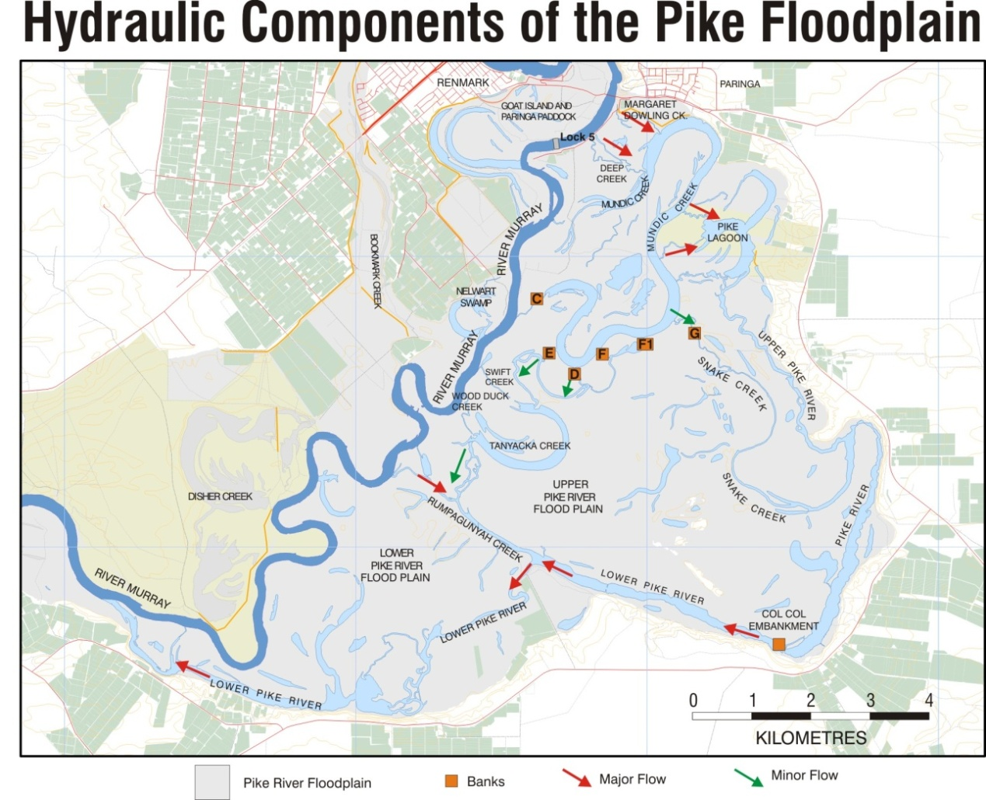

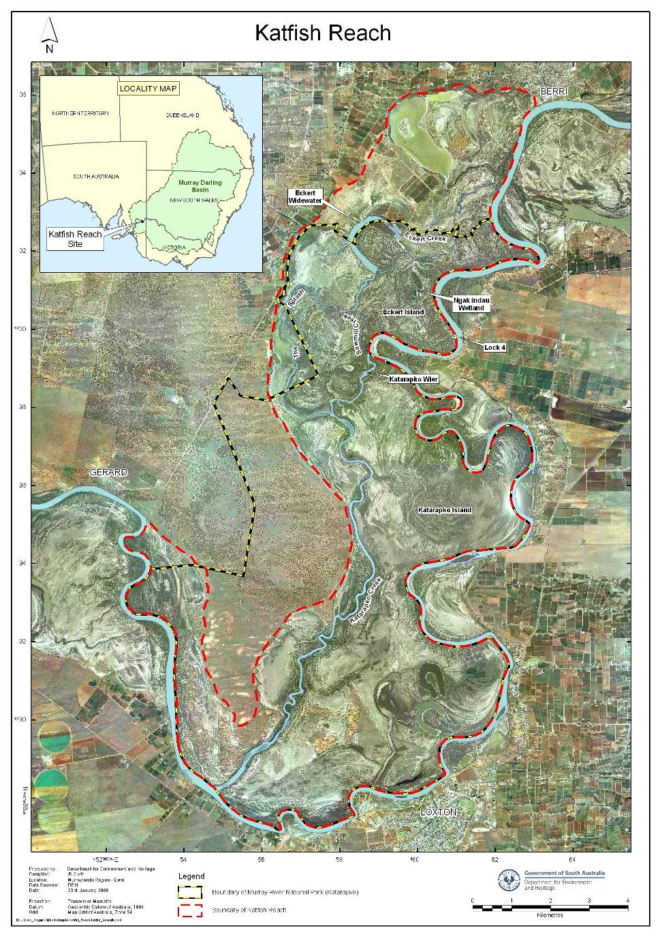

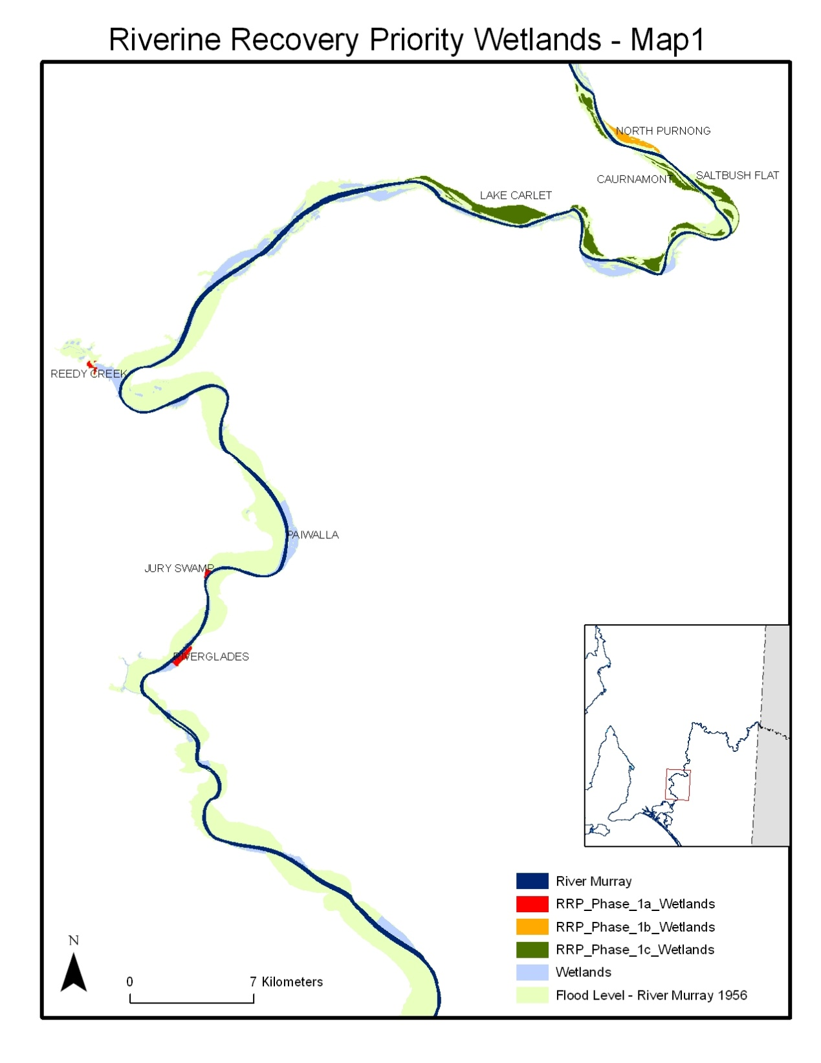

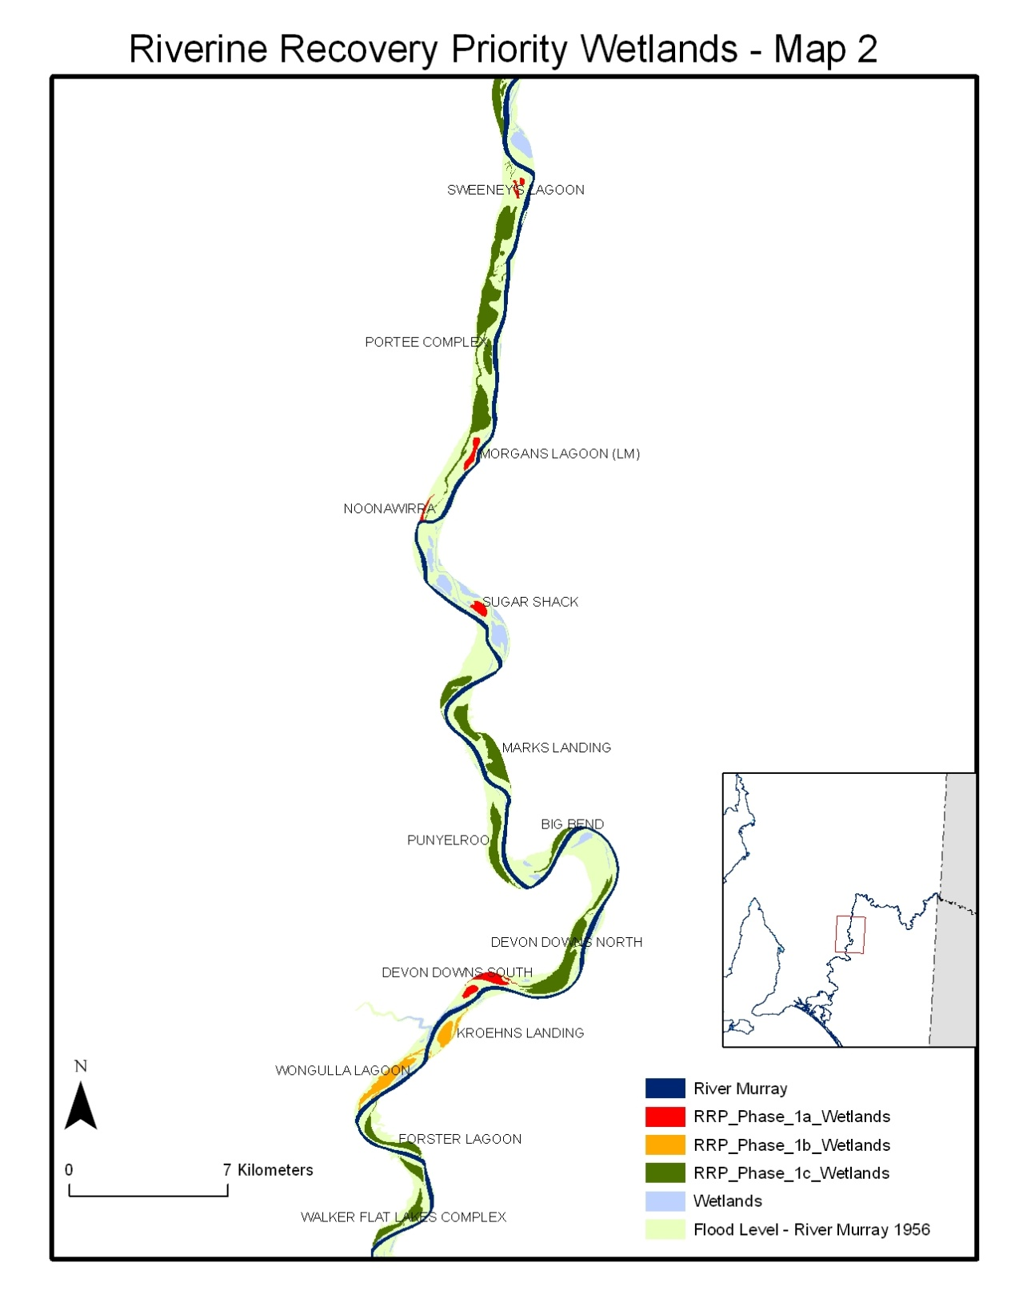

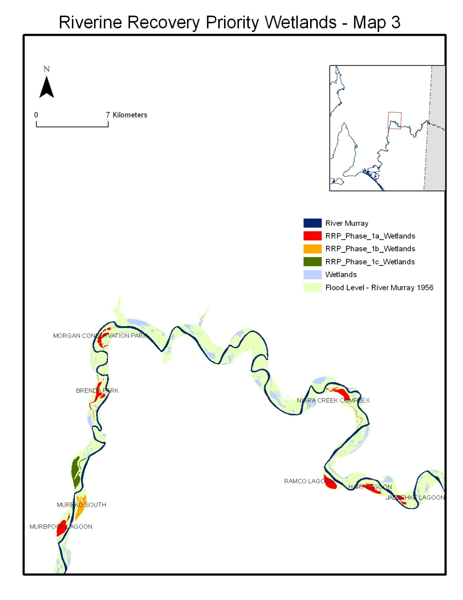

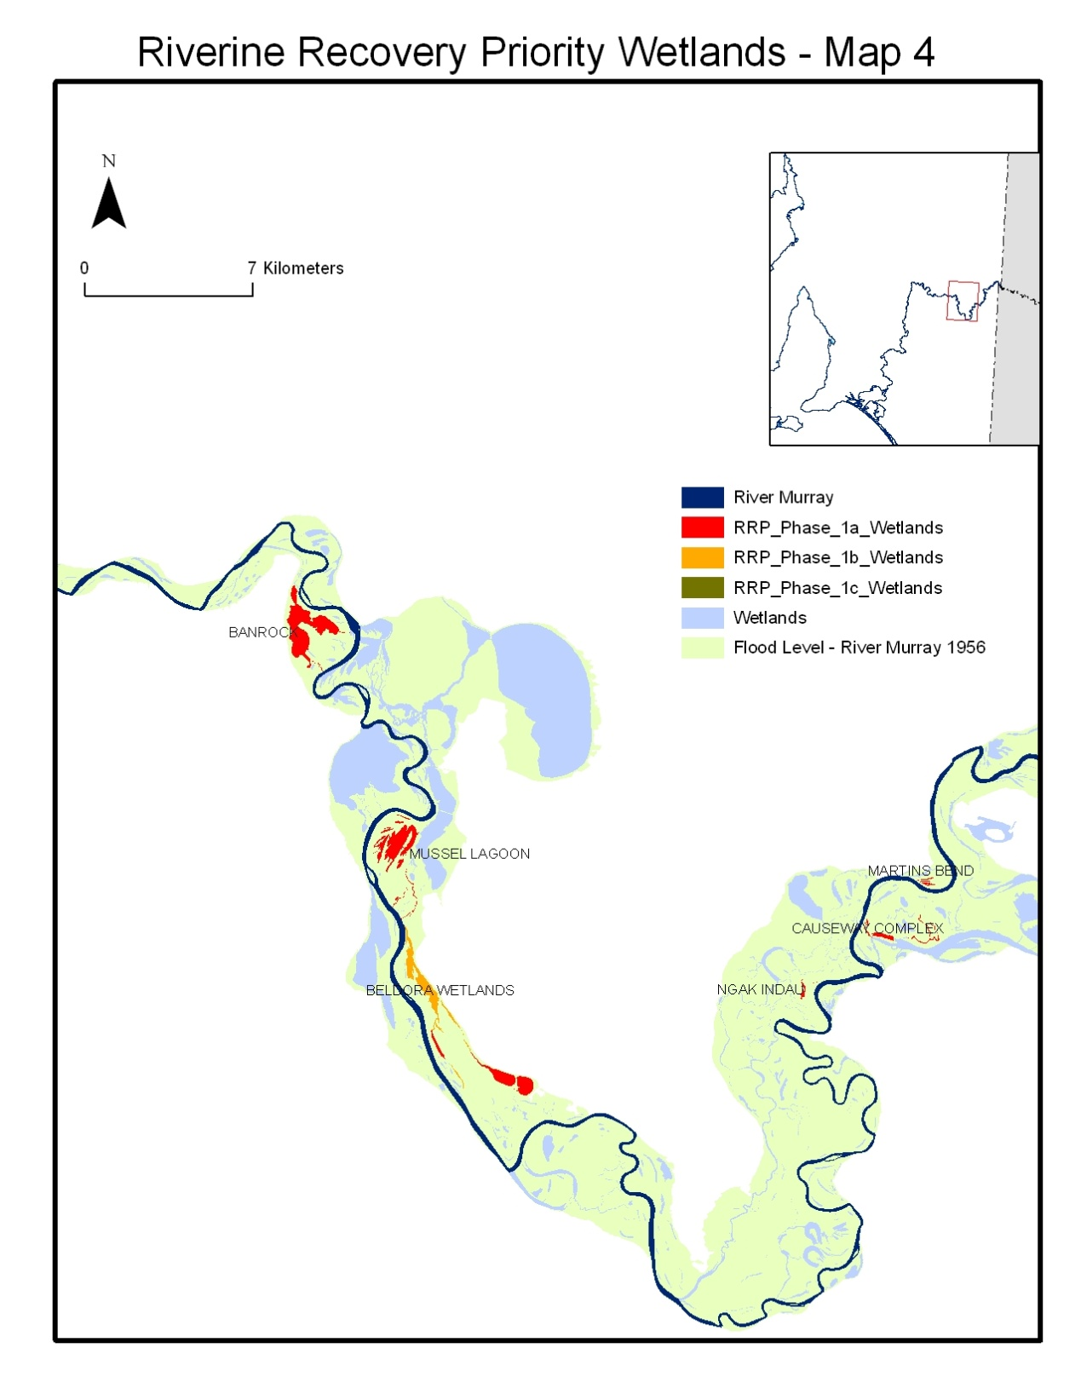

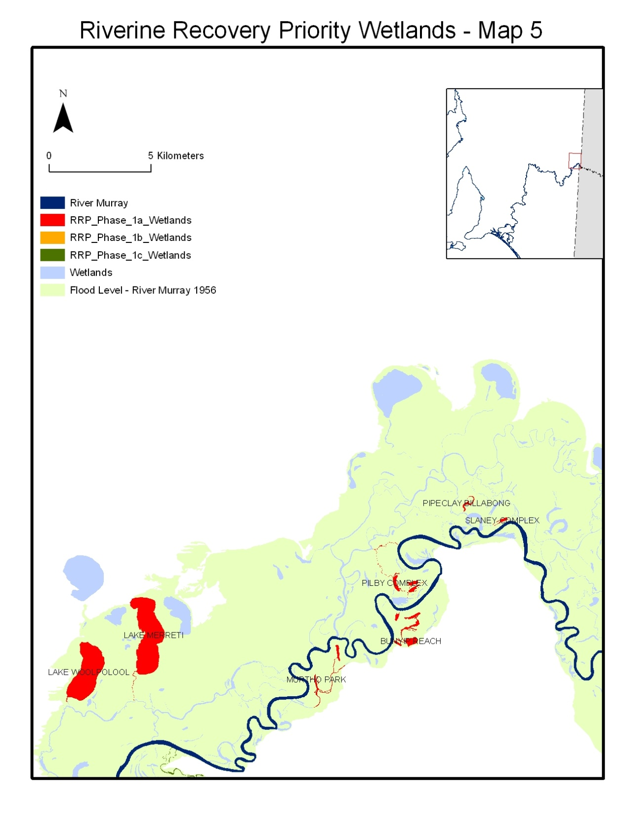

**Yatco Lagoon**

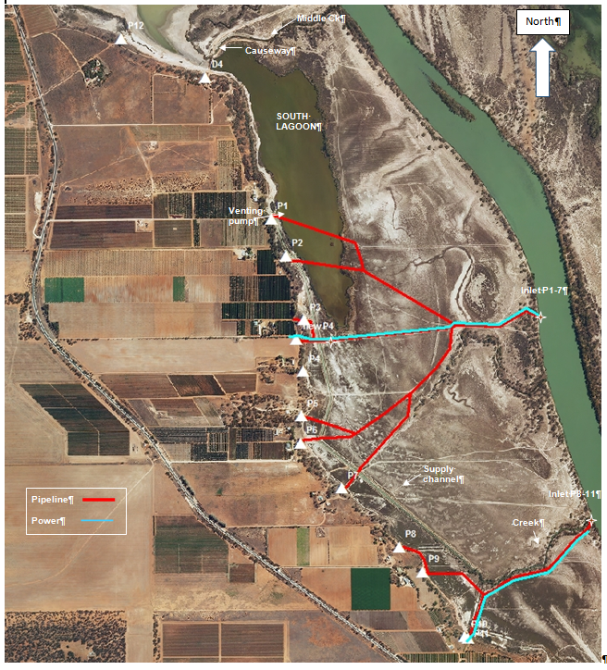

**Phase 2 Wetlands – Map 7**

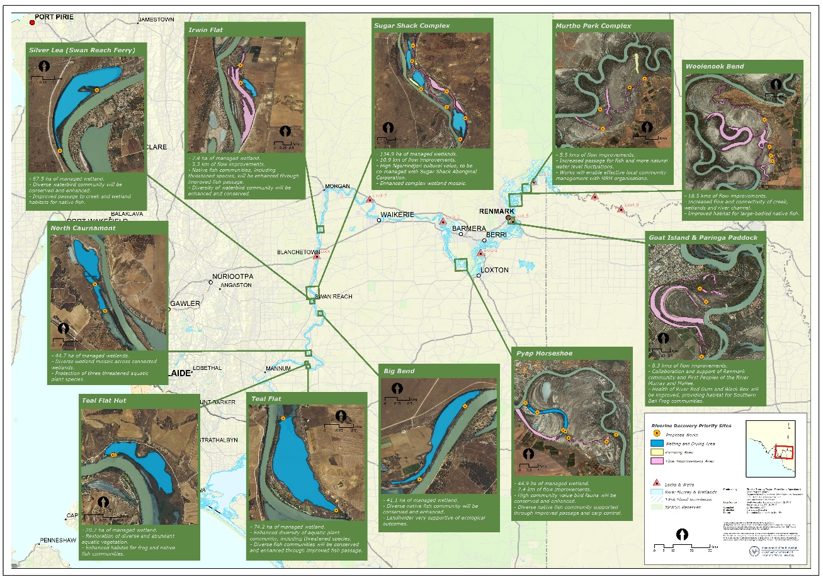

**ATTACHMENT K**

REQUIREMENTS RELATING TO THE BUILDING CODE

1 In this attachment K:

1. ‘**ABCC’** means the Australian Building and Construction Commission referred to in subsection 29(2) of the Act;
2. ‘**Act’** means the *Building and Construction Industry (Improving Productivity) Act 2016*;
3. ‘**Building Code 2013**’ means the *Building Code 2013* which is available at <http://employment.gov.au/building-code>;
4. ‘**Building Code 2016**’ means the *Code for the Tendering and Performance of Building Work 2016*, which is available at <http://employment.gov.au/building-code>;
5. ‘**Building Code 2013 contractor**’ means a Project Party who submitted an expression of interest or tender (however described) before 2 December 2016 for Commonwealth funded building work;
6. **‘Commonwealth funded building work’** means work in items 1–8 of Schedule 1 of the Building Code 2013;
7. ‘**Project Parties**’ means all building contractors and building industry participants who perform work in relation to the Activity, the Project or a Sub-Project, and where applicable, may include Proponents, subcontractors, consultants and employees; and
8. ‘**Supporting Guidelines**’ means the Supporting Guidelines for Commonwealth Funding Entities to the Building Code 2013 which are available at <https://employment.gov.au/building-code>.

2 Where the Funding relates to Commonwealth funded building work, the State must apply the Building Code 2013 and Supporting Guidelines to the extent applicable.

3 In respect of all requests for expressions of interest or tenders (however described) issued in relation to the works and made by the State, or any of the Project Parties, the State must:

1. ensure that all requests for expressions of interest or tender (however described):
2. include the following clause in the advertisement: *“By submitting an expression of interest in, or tender for, this project, you will become subject to the Building Code 2016”;* and
3. do not require an ABCC Letter of Compliance or self-declaration with the Building Code 2013 or the Building Code 2016; and
4. as soon as practicable after a request for expressions of interest or tender (however described) for the Works is issued, inform the ABCC.

4 The State must notify the ABCC of the following information when a Project Party has been awarded a contract to undertake Commonwealth funded building work:

(a) the name and contact details of the Contractor;

(b) a description of the work;

(c) the location of the proposed work;

(d) the cost of the project; and

(e) proposed project start and completion dates.

5 The State must maintain adequate records of compliance by it, and each of the Project Parties, with any obligations it may have under this clause. The State must permit the Commonwealth and those authorised by the Commonwealth, including a person occupying a position in the ABCC, full access to the premises and records of the State and Project Parties to:

(a) inspect any work, material, machinery, appliance, article or facility;

(b) inspect and copy any record relevant to the Activity, the Project, Sub-Projects and works governed by this Agreement; and

(c) interview any person,

as is necessary to monitor compliance with the Building Code 2013.

6 Additionally, the State undertakes that it and each of the Project Parties will agree to a request from the Commonwealth, including a person occupying a position in the ABCC, to produce a specified document within a specified period, in person, by fax or by post.

7 The Commonwealth and those authorised by it may publish or otherwise disclose information in relation to compliance by the State and Project Parties with the Building Code 2013 and any relevant supporting legislation. The State must obtain the consent of the Project Parties to the publication or disclosure of information under this clause.

8 The State must ensure that where a Building Code 2013 Contractor is proposing to engage, or otherwise engages a Project Party to undertake the works, the relevant Project Party:

* 1. is provided with the ABCC Information Statement to Subcontractors available at  [https://www.abcc.gov.au/building-code/building-code-resources/contractor-resources](https://www.abcc.gov.au/building-code/funding-entities-and-recipients%20%20) in place of using the Building Code 2013 or Building Code 2016 model clauses in any contractual arrangement;
  2. is provided with the *Model Clauses Type C (Model Clauses for Code Covered Entities when engaging Subcontractors on Head Contractor Building Code 2013 Projects)* available from https://www.abcc.gov.au/building-code/building-code-resources/contractor-resources for use if they further subcontract the building work; and

the Building Code 2013 contractor has otherwise complied with any other transitionary guidance made available by the ABCC.

**ATTACHMENT L**

WORK HEALTH AND SAFETY

1. In this Attachment to the Project schedule:
   * 1. **corresponding WHS law** has the meaning given in section 4 of the WHS Act;
     2. **Regulator** means an authority referred to in a WHS Law as the relevant authority for work health and safety complaints, queries or investigations;
     3. **WHS Act** means the *Work Health and Safety Act 2011* (Cth);
     4. **WHS entry permit holder** has the meaning given in the WHS Act;
     5. **WHS Law** means the WHS Act, WHS Regulations and any corresponding WHS law; and
     6. **WHS Regulations** means the regulations made under the WHS Act.
2. The State must in carrying out its obligations under this Agreement, comply and use reasonable endeavours to ensure that its Subcontractors and each Proponent complies, with the provisions of all relevant statutes, regulations, by-laws and requirements of any Commonwealth, State, Territory or local authority including those arising under a WHS Law in respect of work health and safety.
3. The State must, in carrying out its obligations under this Agreement, comply, and use reasonable endeavours to ensure that its Subcontractors and each Proponent complies, with any of the Commonwealth’s work, health and safety policies as notified, referred to, or made available, by the Commonwealth to the State in writing.
4. If the State or a Proponent is required by a WHS Law to report to a Regulator an incident arising out of the Activities or a Project:

(a) at the same time, or as soon as is possible in the circumstances, the State must give notice of such incident, and a copy of any written notice provided to a Regulator, to the Department; and

(b) the State must provide to the Department, within such time as is specified by the Department, a report detailing the circumstances of the incident, the results of investigations into its cause, and any recommendations or strategies for prevention in the future.

1. The State must inform the Department of the full details of:

(a) any suspected contravention of a WHS Law relating to the Activities or a Project, within 24 hours of becoming aware of any such suspected contravention;

(b) any cessation or direction to cease work relating to any Activities or a Project, due to unsafe work, immediately upon the State being informed of any such cessation or direction;

(c) any workplace entry by a WHS entry permit holder, or an inspector, to any place where the Activities or a Project are being performed or undertaken, within 24 hours of becoming aware of any such workplace entry; and

(d) any proceedings against the State or a Proponent or their officers, or any decision or request by a Regulator given to the State or a Proponent or their officers, under a WHS Law, within 24 hours of becoming aware of any such proceedings, decision or request.

1. The State agrees, when using the Department’s premises or facilities, to comply with all reasonable directions and procedures relating to work health, safety and security in effect at those premises or in regard to those facilities, as notified by the Department or as might reasonably be inferred from the use to which the premises or facilities are being put.
2. The State must ensure that its contractual arrangements with Subcontractors and Proponents reflect and will allow the State to comply with the requirements of this clause 25.

**ATTACHMENT M**

Requirements relating to the Australian Government building and construction WHS Accreditation Scheme

1.1 Interpretation

1.1.1 In this Attachment:

|  |  |
| --- | --- |
| the Act | means the *Building and Construction Industry (Improving Productivity) Act 2016 (Cth).* |
| Builder | has the meaning given in section 43(8) of the Act. |
| Building Work | has the meaning given to it in section 6 of the Act. |
| Regulations | means the *Fair Work (Building Industry – Accreditation Scheme) Regulation 2016*. |
| Scheme | means the Scheme described at section 43 of the Act. |
|  |  |

1.2 Scheme requirements

1.2.1 Subject to the exclusions specified in the Regulations, construction projects that utilise funds provided under this Project Schedule are bound by the application of the Scheme.

1.2.2 The State must ensure it complies with item 1.2.3 below for all contracts that it enters into as part of the Priority Project, and all contracts that its subcontractors enter into as part of the Priority Project, where:

1. the head contracts for Building Work are greater than $4 million or more (GST inclusive); and
2. the value of the Commonwealth’s contribution is at least $6 million and represents at least 50 per cent of the total construction project value; or
3. the Commonwealth’s contribution is $10 million or more, irrespective of the proportion of the Commonwealth funding.

1.2.3For contracts that are subject to the above item 1.2.2, the following conditions must be satisfied:

1. those contracts are notified to the Office of the Federal Safety Commissioner at the earliest possible opportunity; and
2. contain a requirement that the Builder:
   * + - 1. is accredited under the Scheme;
         2. maintains Scheme accreditation for the life of the contract; and
         3. must comply with all conditions of the Scheme accreditation.

1.2.4 The State agrees to notify the Commonwealth immediately if that Builder has ceased, or is likely to cease, to meet the accreditation requirements in paragraph 1.2.3(b) above.

1.2.5 The State must maintain adequate records of compliance by it, and each of its subcontractors, with the Scheme.

Australian Government Building and Construction OHS Accreditation Scheme

1. In this Attachment M to the Project Schedule:
   * + 1. ‘the Act’ means the *Fair Work (Building Industry) Act 2012* (Cth);
       2. ‘Builder’ has the same meaning as it has in section 35 of the Act;
       3. ‘Building Work’ has the same meaning as it has in section 5 of the Act;
       4. ‘the Regulations’ means the Fair Work (Building Industry - Accreditation Scheme) Regulations 2005; and
       5. ‘Scheme’ means the Australian Government Building and Construction OHS Accreditation Scheme established under the Act.
2. Subject to exclusions specified in the Regulations, construction projects that use funds provided under this Project Schedule are bound by the application of the Scheme.
3. The State must ensure that all contracts that it enters into, and all contracts that its subcontractors enter into, for Building Work as a part of the Activities that are valued at $3 million or more:
   * + 1. are notified to the Office of the Federal Safety Commissioner at the earliest possible opportunity (that is, when approaching the market); and
       2. contain a requirement that the Builder:
          1. is accredited under the Scheme;
          2. maintains Scheme accreditation for the life of the contract; and
          3. must comply with all conditions of the Scheme accreditation.
4. The State agrees to notify the Commonwealth immediately if that Builder has ceased, or is likely to cease, to meet the accreditation requirements in paragraph 3(b) above.
5. The State must maintain adequate records of compliance by it, and each of its subcontractors, with the Scheme.